**Modelling and simulation of H2-H2O bubbly flow through a stack of three cells in a pre-pilot filter press electrocoagulation reactor**

Miguel A. Sandovala, b, Rosalba Fuentesa, Tzayam Péreza, Frank C. Walshc, José L. Navad*, Carlos Ponce de Leónc

a Universidad de Guanajuato, Departamento de Ingeniería Química, Norial Alta S/N, 36050 Guanajuato, Guanajuato, México. E-mail: ma.sandovallopez@ugto.mx; rosalba@ugto.mx; t.perezsegura@ugto.mx

b Universidad de Santiago de Chile USACH, Facultad de Química y Biología, Departamento de Química de los Materiales, Laboratorio de Electroquímica Medio Ambiental, LEQMA, Casilla 40, Correo 33, Santiago, Chile. E-mail: miguel.sandoval@usach.cl

c Electrochemical Engineering Laboratory, Energy Technology Research Group, Engineering Sciences, University of Southampton, Highfield, Southampton, SO17 1BJ, United Kingdom. E-mail: [F.C.Walsh@soton.ac.uk](mailto:F.C.Walsh@soton.ac.uk); capla@soton.ac.uk

d Universidad de Guanajuato, Departamento de Ingeniería Geomática e Hidráulica, Av. Juárez 77, Zona Centro, 36000 Guanajuato, Guanajuato, México. E-mail: jlnm@ugto.mx

*Corresponding author: [jlnm@ugto.mx](mailto:jlnm@ugto.mx)

Tel: + 52-4731020100 ext. 2289; fax: + 52-4731020100 ext. 2209.

**Abstract**

Computational fluid dynamics simulations were carried out to describe the hydrodynamic characteristics of a two-phase bubbly flow in a filter-press flow reactor stack of three cells, which is typically used in electrocoagulation (EC). The hydrogen evolution reaction (HER) took place at the cathode; dissolution of aluminium occurred at the anode. The fundamental transport equations of momentum and electrical potential were simultaneously were solved to simulate the H2-H2O flow. Continuous (H2O) and dispersed phase (H2) velocity fields were modelled via the Euler-Eulerian approach, using the biphasic Reynolds Averaged Navier-Stokes (RANS) equations and the standard *k−ε* turbulence model. The influence of volumetric flow rate (1.7 ≤ *Q* ≤ 15 cm3 s–1) and applied current density (–28 ≤ *j* ≤ –5 mA cm–2) was systematically addressed to calculate the fraction of dispersed phase and current distribution along the electrodes. The evolved H2 bubbles were transported away from the electrode by the liquid flow. The dispersion of H2 through the electrode gap showed a modest bubble curtain profile due to the liquid flow rate. A homogeneous current distribution along the electrode length was experienced due to the geometrical design of the electrochemical cell and the low degree of H2 dispersion. The velocity profiles of the H2-H2O mixture were different in each cell due to the change of flow direction. H2 bubbles increased the velocity of the liquid phase but the gas fraction of such bubbles resulted in a higher pressure drop. Good agreement between theoretical and experimental residence time distribution curves was achieved; the experimental aluminium dose released by the anode agreed well with the simulations.

**Keywords:** biphasic turbulent flow; current distribution; Euler-Eulerian approach; hydrogen evolution reaction; multi-electrode stack.

**1. Introduction**

Filter-press electrochemical reactors with vertical parallel plate electrodes are commonly used in industrial practice due to their effectiveness in a diverse range of applications such as electrosynthesis of chemicals, metal ion removal, energy storage, environmental remediation, and drinking water treatment [1-3]. Many industrial processes involve gas bubble generation as the main, side, or counter-electrode reaction [4]. For example, in the chloro-alkali process, chlorine and hydrogen gases are produced at the anode and cathode, respectively. In electrocoagulation (EC), anodic dissolution of metal takes place and the counter electrode process is usually the hydrogen evolution reaction (HER).

In vertical parallel plate electrode reactors, electrode off gases are released into the electrolyte as small, dispersed bubbles, whose behavior and significance in the vicinity of the electrode depend on the current density [4]. When their local concentration exceeds saturation, bubbles form by heterogeneous nucleation. Once the bubbles reach a sufficient size, they leave the electrode surface, moving upwards under buoyancy to form a two-phase layer near the electrode, namely, the ‘bubble curtain’ [4, 5]. The gas released into the interelectrode gap in the cell affects the liquid flow distribution and ionic transport to the electrode surfaces, which can have a considerable effect on cell performance [6]. Moreover, the liquid-gas mixture in the electrode gap determines the apparent electrolytic conductivity and the current and potential distributions [7]. The later also affects the current efficiency and energy consumption during electrolysis [8].

Two main approaches have been used to simulate liquid-gas flow in electrochemical reactors and interactions between gas and liquid phases: the Euler-Eulerian (EE) and Euler-Lagrangian (EL) methods [9]. The latter solves Newton's second law of motion for the location of an individual fluid particle to identify its possible pathways, in the former approach, the phases are treated as a continuum providing average quantities [10]. The modelling and simulation of two phase (gas-liquid) flow in electrochemical reactors has been carried out by means of EL and EE computational fluid dynamics (CFD) approaches using commercial and open software, which provides clear information and an understanding of biphasic phenomena [11-18]. Euler-Eulerian and Euler-Lagrangian CFD models have been used to characterize the fundamental physics of turbulent gas-liquid bubble flows [6] but it is important to emphasize that theoretical studies of gas-liquid flow in multi-electrode filter press flow electrolysers has not been published in the literature.

In our previous work, CFD simulations were carried out for single-phase flow in a pre-pilot filter-press flow reactor using a stack of three cells (16 cm × 4 cm × 0.6 cm each cell), where the variation of the cross-sectional area induces velocity field modifications in an irregular manner, generating jet flows, vortex and rotational flow structures, so-called turbulent eddies [19]. Turbulence models can be used to accurately simulate flow patterns in complex geometries [13, 18-22].

This paper involves the numerical simulation of H2 gas evolution at the cathode and release of Al3+ ions at the anode, in a filter-press flow reactor stack composed of three cells, which is typically used in electrocoagulation (EC) [23]. The biphasic flow system is considered simply as H2-H2O. The two-phase flow is solved by the biphasic Reynolds Averaged Navier-Stokes (RANS) equations with the *k*-*ε* turbulence model through the EE approach. As the rate of the HER depends on the local current distribution, the momentum and Laplace equations were simultaneously solved. In the same manner, Al3+ concentrations were obtained solving the averaged diffusion-convection equation. The present study systematically addressed the influence of applied current density and volumetric flow rate on the dispersed phase fraction and current distribution along the electrodes. Experimental aluminium ion concentration and residence time distribution were compared with CFD simulations.

In this work, the formation of the aluminium floc, such as Al(OH)3(s) and Al2O3(s), is not modeled, since the reactor operates in the continuous mode and coagulation-flocculation is carried out outside the reactor, in a flocculator-clarifier. The modelling of pollutant removal forms part of a future research program. The modelling of bubble rupture and coalescence are beyond the scope of this paper; future research should consider these important effects.

**2. Methods and materials**

*2.1 Description of the reactor and electrode reactions*

Figure 1 shows the FM01-LC cell with a stack of three cells; the detailed description of the reactor can be consulted elsewhere [19, 23]. It is important to highlight that during the EC process, the massive production of H2 bubbles at the cathode has a negative effect on the process as they cause breaking of the flocs [24]. The characterization of H2-H2O flow opens an opportunity to optimize the reaction environment in future cells.

The electrochemical reactions can be concisely stated (potentials being stated with respect to the standard hydrogen electrode (SHE):

Hydrogen gas is evolved at the aluminium cathodes:

$3H_{2}O+3e^{-}→1.5H_{2}+3{OH}^{-}$ E = –0.830 V *vs*. SHE (1)

while anodic dissolution generates aluminium cations:

${Al}_{(s)}→{Al}^{3+}+3e^{-}$ E = –1.662 V *vs*. SHE (2)

in preference to the oxygen evolution reaction (OER).

$H_{2}O→2H^{+}+0.5O_{2}+2e^{-}$ E = 1.229 V *vs*. SHE (3)

Both H2 and Al3+ are convectively transported away from the electrode surfaces to the bulk solution by the electrolyte flow provided by a centrifugal pump.

The electrodes were mounted in a vertical position and they were electrically connected in a monopolar configuration. Table 1 shows the geometrical parameters of the filter-press multielectrode stack reactor. Four aluminium plate electrodes (99.7% purity), which were used as anodes and cathodes, were fitted between polypropylene separators acting as fluid distributors to form a stack of three cells.

The electrolytic solution flowed upwards past the vertical electrodes within three parallel rectangular flow channels, Figure 1. The electrolyte was fed through a 1.3 cm diameter circular tube which acted on the front face of the first fluid distributor, at the back of the third cell. Each fluid distributor contains five inlet manifolds which take the electrolyte across the interelectrode gap (0.6 cm). At the top, five outlet manifolds direct the electrolyte out through a 1.3 cm diameter circular tube. The total length of the bottom and upper linking pipe (between polypropylene separators and electrodes) was 7 and 10 cm, respectively.

*2.2 Experimental details.*

*2.2.1 Residence time distributions experiments.*

Residence time distributions (RTD) measurements were performed at volumetric inflow rates comprised between 8.3 ≤ *Q* ≤ 15 cm3 s–1 during the electrolysis trials performed at constant current density of −7 mA cm−2, where the H2 bubbles are generated at the cathode by means of Eqn (1). Drinking water containing 1 mg dm–3 NaOCl at pH 7 with an electrolytic conductivity value of 540 µS cm–1 was used in RTD measurements. Tracer injections of 1 cm3 of Na2SO4 (1 M) were made at the reactor entrance and the conductivity was determined at the reactor exit with an Oakton meter (ECTestr type).

The stimulus-response technique was applied to determine the RTD of the mixture H2-H2O. A schematic diagram of the system used for the experimental RTD and pressure drop measurements is described elsewhere [19]. 1 cm3 of Na2SO4 (1 M) was injected by a syringe at 1.5 cm from the reactor inlet, with an injection time of approximately 1 s. At the reactor outlet, the Na2SO4 concentration was quantified online by the conductivity meter reading the conductivity values every second. This technique was sufficiently sensitive to capture the electrolyte conductivity changes at the reactor outlet.

*2.2.2 Aluminium ion concentration*

Aluminium concentrations were quantified by atomic absorption (after addition of sulfuric acid to reach pH = 2) using a Perkin Elmer AAnalyst™ 200 atomic absorption spectrometer at a wavelength of 309.27 nm and with a detection limit of 0.1 mg L−1.

*2.2.3 Pressure drop experiments*

Pressure drop measurements were performed under similar experimental conditions to that employed for RTD trials. The pressure drop measurements were performed through a 60-cm U-tube vertical glass manometer, using a water/gel mixture as the fluid. The manometer was connected by silicone tubing to a T-piece located as close as possible to the reactor inlet or outlet.

**3. Formulation of the numerical simulation**

The H2-H2O bubbly flow is produced on one hand by the HER at the cathode, and by the volumetric liquid inflow rate (*Q*) imposed on the multielectrode stack. In this context, the momentum and Laplace equations must be solved simultaneously to simulate the biphasic flow characteristics. Continuous (H2O) and dispersed phase (H2) velocity fields were modelled via the Euler-Eulerian approach as described below.

The volumetric liquid inflow rates (*Q*) studied here were 8.3, 10, 11.7, 13.3 and 15 cm3 s−1 allowing mean linear liquid flow velocities (*u,*evaluated using the cross-sectional area of the three parallelepiped flow channels) of 1.2, 1.4, 1.6, 1.8, and 2.1 cm s−1. These mean linear flow velocities correspond to Reynolds numbers (*Re=udh/υ*) ranging from 125 to 219 for the continuous phase, where *dh* is the hydraulic diameter of the rectangular channel and *υ* is the kinematic viscosity of the electrolyte. In the multi-electrode stack reactor, there are abrupt changes in the cross-sectional area and the direction of the flow, which create variations of the velocity field in a random fashion. In that connection, the H2-H2O flow was simulated solving the biphasic RANS equations with the k-*ε* turbulence model via the EE approach, even at such low Re values (< 250). Such an approach was guided by previous literature [12, 18-22].

The following assumptions were considered to model and simulate the two-phase flow: i) an Euler-Eulerian CDF approach to solve the average volume fraction, in our case, average dispersed fraction less than < 3.9%, ii) two continuous and fully interpenetrating, and incompressible phases, iii) the Euler-Eulerian CDF approach solves transport equations for the turbulence quantities using a mixture averaged turbulence model (RANS, standard *k−ε* turbulence), iv) the drag model (phases interchange momentum) is described by the Shiller-Naumann method which is valid for rigid spheres, i.e. not consider coalescence and break up phenomena, v) the dynamic viscosity of Krieger type is used which is appropriate for dispersed phase that not form any pure phase region. A brief description of the model with key equations, based on these assumptions, is given in *section* 3.2.

*3.1 Current distribution model.*

In dilute solutions, the current density vector, ***j***, can be calculated from the local potential gradient, according to Ohm’s law [25]:

$j=-k_{eff}∇Ф$ (4)

where *keff* is the effective electrolytic conductivity which, in the case of biphasic flow, depends on the pure electrolyte conductivity, *k0*, modified by the fraction of the dispersed phase ($α_{g}$) according to the Bruggeman equation [26]:

$k_{eff}=k_{0}{(1-α_{g})}^{3/2}$ (5)

The electric potential, $Ф$ at any point in the cell can be described by the Laplace equation [20]:

$∇∙(k_{eff}∇Ф)=0$ (6)

Hydrogen gas released at the cathode, reaction (1), and the electrodissolution of aluminium at the anode, reaction (2), are represented by a secondary current distribution model, since water and aluminium are in excess. Therefore, the boundary conditions used to solve equation (6) are expressed as follows:

At the cathode and anode, the overpotential is adequately related to the magnitude of local current density through the Tafel approximation:

$-k_{eff}\frac{∂ϕ}{∂ξ}=-j_{o,c}exp\left(\frac{-η}{b_{c}}\right)$ (7)

$-k_{eff}\frac{∂ϕ}{∂ξ}=j_{o,a}exp\left(\frac{η}{b_{a}}\right)$ (8)

where $ξ$ is the distance normal to the electrode surface, $j_{o, c}$ and $j_{o, a}$ are the exchange current densities for the cathodic and anodic reactions, while *bc* and *ba* are the cathodic and anodic Tafel slopes, respectively. Finally, the local overpotential (*η*) at the electrodes describes the local current density and is related to other potentials by:

$η=Ф_{m}-Ф-E_{0}$ (9)

where $Ф$ is the potential of the solution adjacent to the electrode and, and *E0* are the metal and equilibrium electrode potentials.

For the insulating walls, zero flux:

$-k_{eff}\frac{∂ϕ}{∂ξ}=0$ (10)

Variables $Ф$ and $α_{g}$ were solved simultaneously by coupling the Ohm's law, using an Euler-Eulerian biphasic approach, as explained below.

*3.2 The Euler-Eulerian CFD approach.*

A statistical description of multiphase flow is useful to characterize the dispersed phase particles. In statistical theories of single-phase turbulent flow, the Eulerian velocity is represented by a random vector field. Unlike single-phase flow, velocity and pressure fields, even in laminar multiphase flow, show variability and are significantly represented by random fields [27]. An analogous methodology can be assumed for biphasic (gas-liquid) flows. However, it is necessary to specify the location and shape of the dispersed phase (hydrogen bubbles). In the Euler–Eulerian approach, both gas and liquid phases are treated as a continuum, which can interpenetrate with the other fluid phase.

The theoretical determination of the distribution of bubbles, and mixture velocity in the inter-electrode space were calculated by solving, simultaneously, the Laplace, and the biphasic RANS equations with the k-*ε* turbulence model. For all simulations, an isothermal system was supposed and, consequently, the energy equation was not considered. In this paper, the mass transfer between phases and chemical reactions were disregarded.

The momentum and continuity equations for continuous and dispersed phases in the steady state are:

$α_{l}ρ_{l}\left[\frac{∂}{∂t}\left(u_{l}\right)+u_{l}∇∙\left(u_{l}\right)\right]={-α}_{l}∇P+{α_{l}ρ}_{l}g+α_{l}∇∙σ_{l}+M_{i,l}$ (11)

$\frac{∂}{∂t}\left(α_{l}ρ_{l}\right)+∇∙\left(α_{l}ρ_{l}u_{l}\right)=0$ (12)

$α_{g}ρ_{g}\left[\frac{∂}{∂t}\left(u_{g}\right)+u_{g}∇∙\left(u_{g}\right)\right]={-α}_{g}∇P+{α_{g}ρ}_{g}g+α_{g}∇∙σ_{g}+M_{i,g}$ (13)

$\frac{∂}{∂t}\left(α_{g}ρ_{g}\right)+∇∙\left(α_{g}ρ_{g}u_{g}\right)=0$ (14)

where ***u*** is the averaged velocity vector, *P* is the pressure shared by two phases, *ρ* is the density, *σ* is the total stress tensor and *Mi* is the interface momentum exchange, which is usually divided into several different components, such as drag force, virtual mass forces, interfacial pressure, lift force, and the Basset force [6]. The relationship between the volume fractions can be expressed as: $α_{l}=1-α_{g}$. The subscripts *l* and *g* in the equations are referred to water (continuous phase) and hydrogen (dispersed phase), respectively.

*3.2.1 Biphasic turbulence model*

In this paper, the standard *κ*−*ε* turbulence model was used to calculate the fluid flow turbulence [28, 29]. The transport of the turbulence quantities (the turbulent kinetic energy, *κ*, and the turbulent energy dissipation rate, *ε*) which are based on the mixture velocity, $\left[u_{m}=\left(1/{ρ_{m}}\right)\left(u_{l}α_{l}ρ_{l}+u_{g}α_{g}ρ_{g}\right)\right]$ where $ρ_{m}$ is the mixture density ($ρ_{m}=α_{l}ρ_{l}+α_{g}ρ_{g}$) and $μ_{m}$ is the volume averaged mixture viscosity $(μ_{m}=α_{l}μ_{l}+α_{g}μ_{g})$, stated according the Eqns (15)–(16).

$ρ_{m}u_{m}∙∇κ=∇∙\left(\left(μ_{m}+\frac{μ_{T}}{σ_{κ}}\right)∇κ\right)+P_{κ}-ρ_{m}ε$ (15)

$ρ_{m}u_{m}∙∇ε=∇∙\left(\left(μ_{m}+\frac{μ_{T}}{σ_{ε}}\right)∇ε\right)+C_{ε1}\frac{ε}{κ}P_{κ}-C_{ε2}ρ_{m}\frac{ε^{2}}{κ}$ (16)

where *Pκ* is the energy production term ($P_{κ}=μ_{T}\left[∇u_{m}:\left(∇u_{m}+{\left(∇u_{m}\right)}^{T}\right)-\frac{2}{3}{\left(∇∙u_{m}\right)}^{2}\right]-\frac{2}{3}ρ_{m}κ∇∙u_{m}$), and *Cµ* (0.09)*, Ce1* (1.44)*, Ce2* (1.92)*, σk* (1)*, σε* (1.3) are dimensionless constant values obtained by data fitting over a wide range of turbulent flow conditions [30].

The resulting turbulent viscosity is defined as:

$µ_{T}=ρ_{m}C_{µ}\frac{κ^{2}}{ε}$ (17)

The total stress tensors for each phase are:

$σ_{l}={(μ}_{l}+μ_{T})\left(∇u_{l}+{\left(∇u_{l}\right)}^{T}-\frac{2}{3}\left(∇u_{l}\right)I\right)-\frac{2}{3}ρ_{l}κI$ (18)

$σ_{g}={(μ}_{g}+μ_{T})\left(∇u_{g}+{\left(∇u_{g}\right)}^{T}-\frac{2}{3}\left(∇u_{g}\right)I\right)-\frac{2}{3}ρ_{g}κI$ (19)

where ***I*** is the unity tensor, $μ$ is the dynamic viscosity, and $μ_{T}$ is the turbulent viscosity defined according the *k*−*ε* turbulence model. The notation *()T* indicates the transpose of ∇***u***, which should not be confused with a turbulent suffix.

Finally, assuming mixture turbulence, the transport equation for the dispersed phase fraction is:

$∇∙\left(α_{g}u_{g}\right)=∇{∙(D}_{mg}∇α_{g})$ (20)

where *Dmg* () is the turbulent diffusion coefficient (additional diffusion produced by turbulent vortexes) which is defined from the turbulent viscosity and the turbulent bubble Schmidt number (${Sc}_{b}=0.35$) [31].

*3.2.2 Viscosity model and interphase momentum transfer.*

Empirical and analytical models for the dynamic viscosity of the two-phase mixture ($μ_{lg}$) have been developed usually as a function of the dispersed volume fraction. It is assumed that turbulence effects in both continuous and dispersed phases can be modeled by solving the relationship that describe the turbulence in the mixture. A simple dynamic mixture viscosity expression that covers a wide range of particle concentrations is the Krieger type model [32]:

$μ_{lg}=μ_{l}{\left(1-\frac{α_{g}}{α_{g,max}}\right)}^{-2.5α_{g,max}\frac{μ_{g}+0.4μ_{l}}{μ_{g}+μ_{l}}}$ (21)

where *αg,max* is the maximum packing limit (equal to 1 for bubbles).

As described in section 3.2, there are several interaction forces between the two phases during the interphase momentum exchange. Nevertheless, the main interaction force is due to the drag force caused by the slip between phases [33]. The interphase force contemplated in this study is the drag force between liquid and gas phases, while other forces (virtual mass force, turbulent dispersion force, lift force, and the Basset force) were neglected. It is reported that adding these forces did not bring any obvious refinement to the simulation results instead, only provokes convergence difficulties [13]. Bubble phenomena, such as bubble breakup and coalescence, are not considered in the mathematical model proposed here. Future research should consider these phenomena.

The drag force between phases added to the momentum equations (11, 13), is represented by [34]:

$M_{D_{l}}={-M}_{D_{g}}=β\left(u_{g}-u_{l}\right)$ (22)

where $M_{D}$ is the drag force and $β$ is the drag force coefficient:

$β=\frac{3}{4}\frac{C_{D_{l,g}}}{d_{b}}α_{g}α_{l}ρ_{l}\left|u_{g}-u_{l}\right|$ (23)

where *db* is the bubble diameter and $C_{D_{l,g}}$ is the drag coefficient which is determined by the Schiller-Naumann correlation [33]:

$C_{D_{l,g}}=\frac{24}{{Re}_{p}}\left(1+0.15{Re}_{p}^{0.687}\right), {Re}_{p}≤1000$ (24)

In general, the drag coefficient is a function of the particle Reynolds number (*Rep*), defined by [35]:

${Re}_{p}=\frac{ρ_{l}d_{b}u_{g}-u_{l}}{μ_{l}}$ (25)

Electrogenerated bubbles are not similar. The bubble diameter is affected by factors such as physicochemical properties (e.g., superficial tension), operating parameters (e.g., type of electrode) and hydrodynamic conditions such as the geometry of the reactor [4]. The Euler-Eulerian CFD approach assumes homogeneous bubble distribution within each control volume. The bubble diameter employed in this paper was set at a typical value of 50 × 10−2 cm, which was obtained from experimental studies and has been widely used for numerical simulations [4, 16].

*3.2.3 Boundary conditions*

The turbulence model is applicable for disordered flows, and even for small Reynolds numbers, as is the case study in this paper, where the fluid flow in the multielectrode stack is disturbed. In this context, the near-wall zones, where the velocity decreases promptly, are inaccessible by this model. To overcome this problem, the logarithmic wall function is employed.

$u^{+}=2.5lny^{+}+5.5$ (26)

where *u+* is the normalized velocity component corresponding to the turbulent layer, *y+* is the dimensionless distance from the wall, *y+= ρuτy/μ*, where *uτ* is the friction velocity ($u_{τ}=C_{μ}^{1/4}\sqrt{k}$) and *y* is the distance from the wall [36].

The boundary conditions to solve Eqns (4)-(26) are:

* At the inlet, $α_{g}=0$ with a normal liquid velocity ***ul*** *= −u⋅****n***, where ***n*** is the unit normal vector and *u* is the mean linear inflow velocity. In this simulation, the initial values of *κ0* and *ε0* were obtained from the turbulent intensity (*IT*), and the turbulent length scale (*LT*), through the following simple forms: $κ_{o}={(3}/2{)(u_{l}I_{T})}^{2}$ and $ε_{o}={C_{μ}^{3/4}κ^{3/2}}/{L_{T}}$. The turbulent intensity for fully turbulent flows has dimensionless values between 0.05 and 0.1, while the turbulent length scale can be obtained as a function of the pipe radius by means of $L_{T}=0.07r$, where *r* is the inlet pipe radius [37]. In this work, *IT* and *LT* were defined at 0.05 and 0.0455 cm, respectively.
* At the cathodes: H2 bubble formation occurs, by means of a dispersed phase mass flux ($\dot{m_{d}}=\frac{j m}{F z}$), with ***u****g* = 0, where *j* is the adjacent local current density (C s–1 m–2) obtained from Eqn 7 ($-j_{o,c}exp\left(\frac{-η}{b_{c}}\right)$), *m* is the molar mass of hydrogen gas (2.02 × 10–3 kg mol–1), *z* is the electron stoichiometry (= 2) according to Eqn (1), and *F* is the Faraday constant (96,485 C mol–1).
* At the anode, the boundary condition is considered in section 3.4.1.
* A normal stress equal to the pressure at the outlet, $\left[-P+\left(μ+μ_{T}\right)\left(∇u_{m}+{\left(∇u_{m}\right)}^{T}\right)∙n\right]=-P_{0}∙n$, where *P0* is the pressure at the electrolyte exit. This equation represents that the turbulent characteristic of whatever is outside the computational domain is guided by the flow inside the computational domain [38]. Such assumption is physically reasonable as long as relatively small amounts of fluid enter the system. Moreover, at the electrolyte outlet, $∇ε∙n=0$ and $∇κ∙n=0$.
* For all other boundaries, a velocity *u*+ given by Eqn (26). The value of *y+* was set at 11.1 after validating the solution at different values of *y+* and step sizes. This value is in the turbulent region, where the turbulent stresses and fluxes are more important [39].

*3.3 Simulation of the residence time distribution*

The tracer mass transport inside the multielectrode stack, in transient and turbulent regime, was simulated using the averaged convection-diffusion equation (Eqn 27). The mass transport was simulated at different volumetric liquid inflow rates of 8.3, 10, 11.7, 13.3 and 15 cm3 s−1.

(27)

where *C* is the concentration of tracer, *t* is the time, *D* is the diffusion coefficient of the tracer, and *DT*is the turbulent diffusivity which can be obtained from the turbulent Schmidt number (${Sc}_{T}=μ_{T}/(ρ_{m}D_{T})$) described by the Kays–Crawford model [19, 29] according to Eqn (28). The mixture velocity vector is obtained by the solution of momentum equations.

$Sc_{T}={\left(\frac{1}{2Sc_{T∞}}+\frac{0.3}{\sqrt{Sc_{T∞}}}\frac{μ_{T}}{ρ_{m}D}-\left(0.3\frac{μ_{T}}{ρ_{m}D}\right)\left(1-exp\left(-\frac{ρ_{m}D}{0.3μ_{T}\sqrt{Sc_{T∞}}}\right)\right)\right)}^{-1}$ (28)

where the Schmidt number at infinity (*ScT*∞) takes a value of 0.85 [28]. In this paper, Na2SO4 was employed as a tracer, the diffusion coefficient of sulphate ions, $D_{{SO}_{4}^{2-}}$ = 0.08 × 10–9 m2 s–1 [40].

*3.3.3 Boundary conditions.*

If we consider a perfect mixing condition both before the inlet and after the outlet of the reactor, the boundary, and the initial conditions to solve the Eqn (27) can be summarized as follows:

* At the reactor inlet, $-n∙N=u_{0}C_{0}$, where ***N*** is the flux of tracer, *C0* and *u*0 are the initial tracer concentration and the inlet liquid velocity. Tracer injection was simulated in the time interval by a Gaussian pulse function, this function was varied from 3 to 4 s using a standard deviation, *σ* from 1.5 to 2.7. In this study, an initial concentration of sodium sulfate of 1000 mol m–3 (1 M), was employed as a tracer. A Gaussian pulse function was used to simulate the tracer pulse injection:

$C=C_{0}\left(\frac{1}{σ\sqrt{2π}}e^{\frac{-{\left(t-t_{o}\right)}^{2}}{{2σ}^{2}}}\right)$ (29)

$t>0$ were used for numerical simulations.

Before the tracer injection (*t =* 0), the tracer concentration is zero, *C0* = 0.

* At the electrolyte outlet, $n∙\left(-\left(D+D_{iT}\right)∇C+u_{m}∙∇C\right)=0$, (zero mass flux, only convective flux).
* For all other boundaries, $-n∙N=0$.

RTD curve, *E(t),* is obtained from data by normalization, the curve describes the tracer distribution in certain time periods at the electrolyte outlet [41]:

$E_{\left(t\right)}=\frac{C_{\left(t\right)}}{\int_{0}^{∞}{C_{\left(t\right)}dt}}$ (30)

where *C(t)* is the time-dependent concentration response takingfrom Eqn (27).

A dimensionless function *E(θ)* can be defined as:

$E_{(θ)}=τE_{(t)}$ (31)

This function can be plotted *vs*. the dimensionless time $θ=t/τ$, where *τ* is the spatial residence time (*V/Q*), and *V* is the electrolyte volume inside the reactor. In this study, *V* = 130 cm3, this volume includes the volume where tracer was injected and where its output was recorded. More details of the simulation domain can be consulted elsewhere [19].

*3.4 Simulation of the anodic dissolution of aluminium*

In this paper, the formation of aluminium flocs are not included in the model, since the reactor operates in continuous mode, and the coagulation-flocculation processes take place at the exit of the multielectrode stack, in a flocculator-clarifier [24]. Moreover, the modelling of the pollutant’s removal, was beyond of the scope of this paper. In this context, we only simulate the concentration of Al3+ considering no chemical reaction and negligible effects of the electrical field. Therefore, the mass transport was simulated by using the Eqn (27), in the steady state, at different volumetric liquid inflow rates of 1.7, 3.3, 5, 6.7, and 8.3 cm3 s–1. The diffusion coefficient of aluminium ions, *DAl3+* = 1.01 × 10–9 m2 s–1 [42].

*3.4.1 Boundary conditions*

The boundary conditions to solve the Eqn (27) are expressed as:

* At the anodes, the electrogenerated Al3+ occurs at the anode surfaces involves a mass flux , $\dot{m_{Al}}=\frac{j}{F z_{Al}}$, where *j* is the local current density (C s–1 m–2) positively coupled and obtained from Eqn (8), (= $j_{o,a}exp\left(\frac{η}{b_{a}}\right)$), and *zAl* is the electron stoichiometry (= 3) according to Eqn (2). At this contour *u* = 0.
* At the cathode, see boundary condition in section 3.2.3.
* At the electrolyte outlet, $n∙\left(-\left(D+D_{iT}\right)∇C+u_{m}∙∇C\right)=0$.
* At all other boundaries, $-n∙N=0$.

*3.5 Simulation*

The Laplace and momentum equations were solved simultaneously in 3D by the finite element method, using the software COMSOL Multiphysics® 5.5 on a computer with two Intel® Xeon ™ 2.30 GHz processor, 96 GB of RAM, and 64-bit operating system. Table 2 resumes the parameters, electrolyte, and gas properties, employed in the simulations.

Based on the results of the sensitivity analysis, a fine element size was set in the computational domain; this mesh built 207,273 elements. It is important to highlight that a high-quality mesh at walls after the refinement was considered due to the biphasic turbulent model employed herein. The simulation run times of Laplace and momentum equations were around 720 minutes depending on the inflow rate and the current density. The simulations of the mass transport problem lasted around 240 minutes. The solver employed was iterative, GMRES, and a relative tolerance of accuracy of the CFD simulations applied a convergence criterion below 1 × 10–5.

**4. Results and discussion**

*4.1 Simulation of the current distribution*

Figure 2 displays a cross-sectional plot (in the plane *x-y*) of the current distribution on the cathode and anode located in the second cell, at average current density of *jave* = –7 mA cm–2 and *Q* = 8.3 cm3 s–1. A quasi-uniform distribution is observed at the entire electrode surface area except in the vicinity near to the beginning and end, being more evident at the last one. Figure 3a) and b) show the normalized current distribution profiles along the *x*-coordinate from the cathode and anode, respectively, at different average current densities (–7, –14 and –28 mA cm–2) at *Q* = 8.3 cm3 s–1. As can be seen, at the cathode, the electrogenerated hydrogen bubbles affected the current distribution in a greater fashion (in the order of 10–3) than in the anode (in the order of 10–4), close to the exit of the cell, at *x*/*L*=1. As *j*ave increased, at the cathode, the current distribution increases at the exit of the cell, at *x*/*L*=1. This is attributable to the increase in hydrogen bubbles concentration, as discussed below, giving values of the dispersed phase of approx. 0.039, 0.076, and 0.144, at current densities of –7, –14, and –28 mA cm–2, respectively (Table 3). The quasi-uniform secondary current distribution on the anode was due to the geometry of the reactor. Similar results were found at the cathode and anode surfaces in the first and third cells (not shown here).

Figure 3c) (cathode) and 3d) (anode) displays the normalized current distribution on the electrode surfaces at different *Q* (11.7, 13.3 and 15 cm3 s–1), at *jave* = –7 mA cm–2. The current distribution did not depend significantly on the flow rate, at the cathode and anode, due to the small variation of the dispersed phase values (0.026, 0.023 and 0.020, at 11.7, 13.3 and 15 cm3 s–1, respectively), shown in Table 3. Similar behavior was noted at the anode and cathode surfaces of cells 1 and 3 (not shown).

*4.2 Simulation of H2-H2O bubbly flow*

Figure 4 shows the velocity magnitude field of the H2-H2O mixture inside the multielectrode stack at *Q**=* 13.3 cm3 s–1 and *jave* = –7 mA cm–2; these values were chosen to reflect operating parameters used in electrocoagulation [43]. The H2-H2O mixture starts to flow at the parallelepiped zone, where the electrodes are located (cell length of 16 cm); the electrochemical cells initiates at the end of the inlet manifold. At the electrolyte inlet, the velocity field showed the effects of the common manifold; these effects are associated with the variations in the cross-sectional area. Afterwards, in the three-parallelepiped zones, the mixture velocity remains heterogeneous along the *x-*coordinate. Higher velocity magnitudes can be seen in cell 3, which is more evident when the flow contours are displayed (inset of Figure 4). At the electrolyte outlet, the flow contours show that the cell linking pipe causes a spiral flow pattern where the maximum values are found at the center, it means that the upper linking pipe acts as a fluid mixer. The mixture velocity magnitude field shows values slightly higher compared to the velocity magnitude field obtained for a single-phase flow (water) found in a previous paper by our group [19], which is attributed to the H2 bubbles concentration exerting a drag force. The velocity profiles of the mixture (H2-H2O) were constructed to analyze the hydrodynamic behavior inside the three cells within the stack.

Figure 5 shows the mixture velocity magnitude profiles in the cell width (*y−*coordinate) taking at different heights along the cell (*x-*coordinate), these profiles were constructed at a depth of 0.3 cm (*z−*coordinate) in the inter-electrode gap. The inset in Figure 5 (at *x* = 15), displays the sensitivity analysis bearing in mind the mixture velocity magnitude at the reactor outlet (just in the middle of the pipe). The mixture velocity was considered unchanged using a fine mesh (207,223 elements).

At 0.3 cm height, random velocities appeared. However, maximum values are observed due to the jet flows originated by the inlet manifolds reaching velocities from 0.19 to 4.2 cm s–1. The magnitude of the mixture velocity profiles was different at each cell due to the turbulence created by the change of flow direction and by the electrogenerated bubbles at each cathode. The mixture velocity magnitude increases according the following order cell 1 < cell 2 < cell 3. The latter was originated from turbulence generated by the change of flow direction in the third cell, see bottom flow contour in Figure 4. From 3 to 8 cm height, the mixture velocity profiles are attenuated at each cell presenting the maximum values at the end of each cell width. After building several velocity profiles between 8 < *x* < 15 cm, it is possible to confirm that a quasi-plug flow pattern is achieved at 15 cm height in each cell. This flow pattern was the same for the other *Q* comprised between 1.7−15 cm3 s–1, at *j* = –7 mA cm–2.

In vertical parallel plate reactors, as the flow progresses, the dispersed fraction in the vicinity of the hydrogen-producing cathodes increases in the upward direction due to the accumulation of the bubbles [44, 45]. Moreover, the hydrogen bubbles generated are dispersed throughout the inter-electrode space. Figure 6 shows the volumetric bubble fraction (percentage) across the channel width (*y-*coordinate) at a 0.3 cm depth (*z-*coordinate), at different heights in the *x-coordinate*. The dispersed phase fraction profiles show that the H2 fraction increases in the upward direction (*x-coordinate*) due to the accumulation of void fraction (hydrogen bubbles); this explains the higher values observed of *j*/*j*ave at the exit of the cell, *x*/*L* > 0.8 (Figure 3a) and c). As seen in Figure 6, there are two different dispersed fraction profiles. The hydrogen bubbles concentration inside the cell 1 and cell 3 recorded the higher void fraction values compared with cell 2. This is attributed to the position of the cathode, which is located at the opposite side of the cell and, consequently, the position of the inlet manifolds. In accordance with the mixture velocity profiles, and the change of the flow direction, the accumulation of hydrogen bubbles in cell 3 is less than the cell 1 because as the mixture velocity increases the bubble build up decreases. Figure 7a) shows the H2 bubbles fraction along each cell (*x*-coordinate) through the inter-electrode gap. At the lowest section, the void fraction observed in cell 1 and 3 are quite similar due to the position of the cathodes. However, in cell 3, hydrogen bubbles concentration decreased slightly because of the mixture velocity values. Since dispersed phase (H2) appears at the cathodes, an apparent bubble curtain spread was observed. Dahlkild reported that the widening of bubbles curtains is dependent on the bubble diameter [46]. In addition, Wedin and Dahlkild observed that as the dispersed fraction increases the flow rate does and, consequently, the bubble curtain is thicker [47]. At higher inflow velocities, the hydrogen bubbles curtain is less evident due to both the diminution of dispersed fraction, Table 3, and the quicker evacuation of hydrogen bubbles. Figure 7b) displays the dispersed phase fraction field inside the stack, the volumetric average $α_{g}$ values in cell 1, 2, and 3 were 2.68%, 1.85%, and 2.31%, respectively. Table 3 shows that the average dispersed fraction increases with current density due to increasing H2 bubbles but decreases with volumetric inflow rate due to rapid release of H2 bubbles with liquid flow rate.

*4.3. Theoretical and experimental analysis of RTD*

The validation of the mathematical modelling developed in this study was carried by biphasic RTD experiments which were compared with RTD obtained from CFD simulations. Figure 8 shows the comparison between the experimental and modeled RTD curves at different volumetric flow rates comprised between 8.3 ≤ *Q* ≤ 15 cm3 s−1 during the cathodic production of H2 bubbles. Simulated RTD curves describe adequately the experimental behavior of experimental RTD. As the mean volumetric flow rate increases, the dimensionless curves, *E(θ)* − *θ*, become slimmer, and the maximum values of *E(θ)* become larger, appearing at *θ <* 1. This means that some tracer elements leave the reactor earlier than the average residence time; these biphasic RTD experiments compared with the monophasic RTD assays, reported in a previous paper [19], confirm that hydrogen bubbles slightly increase the velocity of the liquid phase. At the lowest volumetric flow rate, the agreement between the calculated RTD by the model and the experimental RTD results is poor. This might be explained due to the bubble’s characteristics (size, shape) and its interaction (coalescence or breakup) possibly originated along the cell and inside the upper cell linking pipe. Additionally, the RTD curves tend to the left with flow rate and the tail decreases as the volumetric flow rate increases; this indicates a better trend towards a continuous mixing flow pattern. The velocity profiles behavior showed in Figure 4 would suppose a quasi-plug flow pattern in the RTD curves (i.e., obtaining the maximum values of the RTD curves at *θ* = 1). However, the upper connecting pipe acted as a fluid mixer, modifying the shape of the RTD curves.

*4.4 Theoretical and experimental analysis of the electrodissolution of aluminium*

A comparison between the experimental aluminium ion concentration with those values obtained from the numerical simulations is shown in Figure 9. The experimental aluminium ion concentration values were obtained from our previous work [23]. The aluminium concentration profiles are displayed at different *j*ave of –5, –6, and –7 mA cm−2 as a function of the volumetric inflow rate (*Q* = 1.7, 3.3, 5, 6.7, and 8.3 cm3 s–1). It is worth mentioning that the electrodissolution of aluminium, at the anodes (Eqn 2), occurs at the same magnitude of *j*ave but with current flow in the opposite direction. The numerical aluminium concentrations were obtained at the electrolyte outlet of the filter-press reactor. As can be seen in Figure 9, the experimental aluminium dose was partially different to the numerical one at some flow rates (i.e. 1.7, 3.3, and 8.3 cm3 s–1). However, this discrepancy was reduced at volumetric flow rate of 5 cm3 s–1. The discrepancies might be attributed to chemical dissolution of the anodes at the beginning of the experimental trials.

*4.5. Pressure drop*

In H2-H2O bubbly flow, the hydrodynamics improved due to the appearance of the H2 bubbles formed on the cathode. However, the fraction of the bubbles increases the pressure drop what is related to the pumping costs. Several experimental results have proposed that the pressure drop (*ΔP*) is a logarithmic function of the flow velocity, expressed in terms of the Reynolds number via an empirical power law:

$∆P=a{Re}^{b}$ (33)

The experimental and theoretical logarithmic-logarithmic plots of pressure drop as a function of the Reynolds’ number for the two-phase flow in the multi-electrode stack are shown in Figure 10. On the same graph, studies reported in the literature are shown for single-phase flow in the multi-electrode stack [19] and single-phase flow for empty single cell and filled single cell with turbulence promoter [48] are plotted. Table 4 summarizes the experimental parameters reported in the literature for single-phase flow using different flow configurations in comparison to those obtained in this work. In this paper, the *a* value (associated with the geometry) decreases and the *b* index (associated with flow pattern) increases in comparison with the value obtained for the stack of three cells in single-phase flow, the one empty cell, and the cell with turbulence promoter. The experimental pressure drop was higher to that obtained in single-phase flow owing to the dispersed fraction of the electrogenerated H2 bubbles. Values of *b* increase in the order: empty unit cell (single-phase flow) < filled unit cell with turbulence promoter (single-phase flow) < stack of three cells (single-phase flow) < stack of three cells (biphasic flow), from values of 1.39 to 3.49, Table 4. This confirms that, in such filter press flow cell arrangements, the turbulent flow predominates (considering that *b* = 1 for fully laminar flows, and *b* → 2 when the flow becomes turbulent). The higher values of *b* (2.88 and 3.49 during the monophasic and biphasic flows, respectively) corroborate that flow dispersion (i.e., variations of the velocity in a random fashion, apparition of jet flows, vortex and rotational flow structures) is provoked by the abrupt changes in the cross-sectional area and the direction of the flow. Close agreement was attained between the experimental pressure drop and CFD simulation; the small pressure variation is attributed to the experimental method used to measure pressure drop. Finally, the energy required to impose the biphasic fluid flow becomes greater than the obtained in a single-phase flow, with a higher pumping power requirement.

**5. Conclusions**

A theoretical analysis of the electrogeneration of hydrogen bubbles was carried out using a multi-coupled numerical simulation consisting in secondary current distribution, the two-phase (H2-H2O) flow and mass transport by convection-diffusion in a pre-pilot filter press flow electrolyser with a stack of three cells. At vertical, parallel electrode plates, the secondary current distribution was uniform along the working electrodes and the counter electrodes.

The Euler-Euler turbulent two-phase model successfully described the complex H2O-H2 flow behavior in the stack of three cells. Several flow behaviors inside each cell were observed. At the entrance of each channel, CFD simulations showed a great dispersion in the mixture velocity while an apparent plug flow pattern was developed at lengths beyond 12 cm. An increment of mixture velocity magnitude was observed in the following order cell 1 < cell 2 < cell 3. This latter is due to the turbulence caused by the change of flow direction in the third cell. Dispersed phase profiles constructed along each cell and across the inter-electrode space showed a pseudo bubble curtain profile. Here, the bubbles released from the cathode are transported away from the electrode by the velocity of the liquid. H2 bubbles increases the velocity of the liquid phase but the void fraction of such bubbles also increases pressure drop. The simulated biphasic RTD curves were in good agreement with the experimental ones. Finally, the model predicted reasonably well the anodic dissolution of aluminium. Further studies should consider the concomitant coagulation-flocculation and their mechanisms.

The model proposed in this paper could be extended to other biphasic systems such as O2-H2O, Cl2-H2O, among others, over a wider range of operating conditions.

**Acknowledgments**

Miguel A. Sandoval is grateful to CONACYT (Mexico) for granting the postdoctoral scholarship, No. 386022. J.L. Nava acknowledges Universidad de Guanajuato (Mexico) for financial support through the project No. CIIC 113/2020.

**References**

[1] F.F. Rivera, C. Ponce de León, J.L. Nava, F.C. Walsh, The filter-press FM01-LC laboratory flow reactor and its applications, Electrochim. Acta 163 (2015) 338–354.

[2] F.C. Walsh, L.F. Arenas, C. Ponce de León, Developments in plane parallel flow channel cells, Curr. Opin. Electrochem. 16 (2019) 10-18.

[3] L.F. Arenas, C. Ponce de León, F.C. Walsh, The versatile plane parallel electrode geometry.J. Electrochem. Soc. 167 (2020) 023504.

[4] R. Hreiz, L. Abdelouahed, D. Fünfschilling, F. Lapicque, Electrogenerated bubbles induced convection in narrow vertical cells: A review, Chem. Eng. Res. Des. 100 (2015) 268–281.

[5] R. Hreiz, L. Abdelouahed, D. Fünfschilling, F. Lapicque, Electrogenerated bubbles induced convection in narrow vertical cells: PIV measurements and Euler–Lagrange CFD simulation, Chem. Eng. Sci. 134 (2015) 138–152.

[6] A. Alexiadis, M.P. Dudukovic, P. Ramachandran, A. Cornell, J. Wanngard, A. Bokkers, Liquid–gas flow patterns in a narrow electrochemical channel, Chem. Eng. Sci. 66 (2011) 2252–2260.

[7] Ph. Mandin, A.A. Aissa, H. Roustan, J. Hamburger, G. Picard, Two-phase electrolysis process: From the bubble to the electrochemical cell properties, Chem. Eng. Process. 47 (2008) 1926–1932

[8] F.F. Rivera, C. Ponce de León, F.C. Walsh, J.L. Nava, The reaction environment in a filter-press laboratory reactor: the FM01-LC flow cell, Electrochim. Acta 161 (2015) 436–452.

[9] L.F. Castañeda, F.F. Rivera, T. Pérez, J.L. Nava, Mathematical modelling and simulation of the reaction environment in electrochemical reactors, Curr. Opin. Electrochem. 16 (2019) 75-82.

[10] S. Ich Ngo, Y. Lim, Multiscale Eulerian CFD of chemical processes: A review, ChemEngineering. 4 (2020) 23.

[11] B. Ashraf Ali, S. Pushpavanam, Analysis of unsteady gas–liquid flows in a rectangular tank: Comparison of Euler–Eulerian and Euler–Lagrangian simulations, Int. J. Multiphas. Flow. 37 (2011) 268–277.

[12] J.A. Ramírez, A. Rodríguez, F.F. Rivera, F. Castañeda, Experimental study and mathematical modelling of two-phase flow with a Eulerian approach in a continuous gas evolving electrochlorinator, Chem. Eng. Res. Des. 144 (2019) 538–549.

[13] H. Wang, X. Jia, X. Wang, Z. Zhou, J. Wen, J. Zhang, CFD modelling of hydrodynamic characteristics of a gas–liquid two-phase stirred tank, Appl. Math. Model. 38 (2014) 63–92.

[14] J. Ding, X. Wang, X. Zhou, N. Ren, W. Guo, CFD optimization of continuous stirred-tank (CSTR) reactor for biohydrogen production, Bioresource. Technol. 101 (2010) 7005–7013.

[15] L. Abdelouahed, G. Valentin, S. Poncin, F. Lapicque, Current density distribution and gas volume fraction in the gap of lantern blade electrodes, Chem. Eng. Res. Des. 92 (2014) 559–570.

[16] K. Wadaugsorna, S. Limtrakula, T. Vatanathama, P.A. Ramachandran, Hydrodynamic behaviours and mixing characteristics in an internal loop airlift reactor based on CFD simulation, Chem. Eng. Res. Des. 113 (2016) 125–139.

[17] L. Abdelouahed, R. Hreiz, S. Poncin, G. Valentin, F. Lapicque, Hydrodynamics of gas bubbles in the gap of lantern blade electrodes without forced flow of electrolyte: Experiments and CFD modelling, Chem. Eng. Sci. 111 (2014) 255–265.

[18] L. Castañeda, René Antaño, Fernando F. Rivera, José L. Nava, Computational fluid dynamic simulations of single-phase flow in a spacer-filled channel of a filter-press electrolyzer, Int. J. Electrochem. Sci., 12 (2017) 7351–7364.

[19] M.A. Sandoval, R. Fuentes, F.C. Walsh, J.L. Nava, C. Ponce de León, Computational fluid dynamics simulations of single-phase flow in a filter-press flow reactor having a stack of three cells, Electrochim. Acta 216 (2016) 490–498.

[20] T. Pérez, C. Ponce de León, F.C. Walsh, J.L. Nava, Simulation of current distribution along a planar electrode under turbulent flow conditions in a laboratory filter-press flow cell, Electrochim. Acta 154 (2015) 352–360.

[21] E.P. Rivero, M.R. Cruz-Díaz, F.J. Almazán-Ruiz, I. González, Modelling the effect of non-ideal flow pattern on tertiary current distribution in a filter-press-type electrochemical reactor for copper recovery, Chem. Eng. Res. Des. 100 (2015) 422–433.

[22] A. Frías-Ferrer, J. González-García, V. Sáez, C. Ponce de León, F.C. Walsh, The effects of manifold flow on mass transport in electrochemical filter-press reactors, AIChE J. 54 (2008) 811–823.

[23] M.A. Sandoval, R. Fuentes, J.L. Nava, O. Coreño, Y. Li, J.H. Hernández, Simultaneous removal of fluoride and arsenic from groundwater by electrocoagulation using a filter-press flow reactor with a three-cell stack. Sep. Pur. Technol. 208 (2019) 208-216.

[24] M.A. Sandoval, R. Fuentes, J.L. Nava, I. Rodríguez, Fluoride removal from drinking water by electrocoagulation in a continuous filter press reactor coupled to a flocculator and clarifier, Sep. Purif. Technol. 134 (2014) 163–170.

[25] A.D. Villalobos-Lara, T. Pérez, A.R. Uribe, J.A. Alfaro-Ayala, J.J. Ramírez-Minguela, J.I. Minchaca-Mojica, CFD simulation of biphasic flow, mass transport and current distribution in a continuous rotating cylinder electrode reactor for electrocoagulation process, J. Electroanal. Chem. 858 (2020) 113807.

[26] Ph. Mandin, J. Hamburger, S. Bessou, G. Picard, Modelling and calculation of the current density distribution evolution at vertical gas-evolving electrodes, Electrochim. Acta 51 (2005) 1140–1156.

[27] S. Subramaniam, Lagrangian-Eulerian methods for multiphase flows, Prog. Energ. Combust. 39 (2013) 215-245.

[28] M.R. Cruz-Díaz, E.P. Rivero, F. Almazán-Ruiz, Á. Torres-Mendoza, I. González, Design of a new FM01-LC reactor in parallel plate configuration using numerical simulation and experimental validation with residence time distribution (RTD), Chem. Eng. Process. 85 (2014) 145–154.

[29] L. Vázquez, A. Alvarez-Gallegos, F.Z. Sierra, C. Ponce de León, F.C. Walsh, Simulation of velocity profiles in a laboratory electrolyser using computational fluid dynamics, Electrochim. Acta 55 (2010) 3437–3445.

[30] P.S. Bernard, J.M. Wallace, Turbulent flow: Analysis, measurement and prediction, first ed., John Wiley & Sons, New Jersey, 2002.

[31] Y. Tominaga, T. Stathopoulos, Turbulent Schmidt numbers for CFD analysis with various types of flow field, Atmos. Environ. 41 (2007) 8091–8099.

[32] Y. Gorb, O. Mierk, L. Rivkind, D. Kuzmin, Finite element simulation of three-dimensional particulate flows using mixture models, J. Comput. Appl. Math. 270 (2014) 443–450.

[33] K.M. Abd Ali, CFD Simulation of bubbly flow through a bubble column, IJSER 5 (2014) 904-910.

[34] A.R Khophkar, A.R. Rammohan, V.V. Ranade, M.P. Dudukovic, Gas-liquid flow generated by a Rushton turbine in stirred tank vessel: CAPRT/CT measurements and CFD simulations, Chem. Eng. Sci. 60 (2005) 2215.

[35] L. Zhongqiu, L. Baokuan, Scale-adaptive analysis of Euler-Euler large eddy simulation for laboratory scale dispersed bubbly flows, Chem. Eng. J. 338 (2018) 465–477.

[36] H.K. Versteeg, W. Malalasekera, An introduction to computational fluid dynamics: The finite volume method, second ed., Prentice Hall, London, 1995.

[37] J. Szekely, Fluid flow phenomena in metals processing, Academic Press Ind. New York, 2012.

[38] D.C. Wilcox, Turbulence Modelling for CFD, DCW Industries Inc, California, 1998.

[39] H. Schlichting, Boundary-Layer Theory, seventh ed., MC Graw-Hill, New York, 1979.

[40] O. Annunziata, J.A. Rard, J.G. Albright, L. Paduano, D.G. Miller, Mutual diffusion coefficients and densities at 298.15 K of aqueous mixtures of NaCl and Na2SO4 for six different solute fractions at a total molarity of 1.500 mol dm−3 and of aqueous Na2SO4, J. Chem. Eng. 45 (2000) 936–945.

[41] H.S. Fogler, Elements of chemical reaction engineering, fourth ed., Prentice Hall, New Jersey, 2005.

[42] J. Lu, Z. Wang, X. Ma, Q. Tang, Y. Li, Modelling of the electrocoagulation process: a study on the mass transfer of electrolysis and hydrolysis products, Chem. Eng. Sci. 165 (2017) 165–176.

[43] M.A. Sandoval, R. Fuentes, A. Thiam, R. Salazar, Arsenic and fluoride removal by electrocoagulation process: A general review, Sci. Total Environ. 753 (2021) 142108.

[44] K. Aldas, N. Pehlivanoglu, M.D. Mat, Numerical and experimental investigation of two-phase flow in an electrochemical cell, Int. J. Hydrog. Energy 33 (2008), 3668–3675.

[45] K. Aldas, Application of a two-phase flow model for hydrogen evolution in an electrochemical cell, Appl. Math. Comput. 154 (2004), 507–519.

[46] A.A. Dahlkild, Modelling the two-phase flow and current distribution along a vertical gas-evolving electrode, J. Fluid. Mech. 428 (2001), 249–272.

[47] R. Wedin, A.A. Dahlkild, On the transport of small bubbles under developing channel flow in a buoyant gas-evolving electrochemical cell, Ind. Eng. Chem. Res. 40 (2001), 5228–5233.

[48] C.J. Brown, D. Pletcher, F.C. Walsh, J.K. Hammond, D. Robinson, Studies of space-average mass transport in the FM01-LC laboratory electrolyser, J. Appl. Electrochem. 23 (1993) 38–43.

**Table 1.** Geometrical parameters of the electrochemical reactor stack containing three undivided cells.

|  |  |
| --- | --- |
| Volume*, *V* /cm3 | 130 |
| Cell width, *B* /cm | 4.0 |
| Cell thickness, *S* /cm | 0.6 |
| Cell length, *L* /cm | 16.0 |
| Number of cells | 3 |
| Equivalent diameter of flow cell thickness, *dh* = 2*BS*/(*B*+*S)* /cm | 1.04 |
| Anode area, in each cell, in contact with solution /cm2 | 64 |
| Cathode area, in each cell, in contact with solution /cm2 | 64 |

*Including the volume of the cell connecting pipes plus fluid manifolds.

**Table 2.** Simulation parameters including liquid and gas properties

|  |  |
| --- | --- |
| Electrolyte temperature, T/K | 298.15 |
| Kinematic viscosity of electrolyte, *υ* /m2 s–1 | 1 × 10–6 |
| Global diffusion coefficient of SO42–, /m2 s–1 [40] | 0.08 × 10–9 m2 s–1 |
| Global diffusion coefficient of Al3+, *DAl*/m2 s–1 [42] | 1.01 × 10–9 |
| Dynamic viscosity of electrolyte, *μ*/Pas–1 | 0.001 |
| Hydrogen density, ρg/kg m–3 | 0.083 |
| Bubble diameter, *db*/cm [4, 16] | 50 × 10–2 |
| Density of electrolyte, *ρl*/kg m–3 | 1000 |
| Electrolytic conductivity, *k0*/μS cm–1 | 540 |
| Anode open circuit potential, *Ea, 0* vs SHE / V | −0.68 |
| Cathode open circuit potential, *Ec, 0*/ vs SHE / V | 0.57 |
| Cathodic Tafel slope, *bc*/V dec–1 | 0.12 |
| Exchange current density, *j0*/A m–2 | 48.5 |
| Anodic Tafel slope, *ba*/V dec–1 | 0.28 |

**Table 3.** Averaged dispersed fraction values inside the FM01-LC reactor at different applied current densities and volumetric flows rates

|  |  |  |  |  |  |  |  |  |
| --- | --- | --- | --- | --- | --- | --- | --- | --- |
|  | Volumetric flow rates / cm3 s−1 | | | | | | | |
|  | 1.7 | 3.33 | 5 | 8.33 | 10 | 11.7 | 13.33 | 15 |
| *j*ave  / mA cm−2 | Averaged dispersed fraction | | | | | | | |
| −5 | 0.14 | 0.074 | 0.049 | 0.028 | 0.022 | 0.019 | 0.016 | 0.014 |
| −6 | 0.17 | 0.088 | 0.058 | 0.033 | 0.027 | 0.023 | 0.02 | 0.017 |
| −7 | 0.19 | 0.1 | 0.068 | 0.039 | 0.031 | 0.026 | 0.023 | 0.02 |
| −14 | 0.35 | 0.193 | 0.131 | 0.076 | 0.062 | 0.052 | 0.045 | 0.039 |
| −28 | 0.59 | 0.34 | 0.239 | 0.144 | 0.118 | 0.1 | 0.087 | 0.075 |

**Table 4.** Experimental values of pressure drop over the FM01-LC reactor (using the empirical power law *ΔP=aReb*)

|  |  |  |  |
| --- | --- | --- | --- |
| Configuration | *a* / ×102 Pa | *b* | Reference |
| Stack of three undivided cells (two-phase flow) | 0.030 | 3.49 | This work |
| Stack of three undivided cells (single-phase flow) | 0.028 | 2.88 | [19] |
| Empty unit cell | 0.69 | 1.39 | [48] |
| Filled unit cell with PTFE turbulence promoter type D | 1.69 | 1.54 | [48] |

**Figure captions**

**Figure 1.** Sketch of the FM01-LC reactor with a four-electrode stack of three undivided cells. The electrodes are switched in monopole configuration.

**Figure 2.** Surface plot (plane *xy*) of the secondary current distribution on the cathode and anode surface located in cell 2 at *jave* = –7 mA cm–2 and *Q* = 8.3 cm3 s–1.

**Figure 3.** Influence of the normalized current distribution profiles along the cathode (a) and anode (b) in the *x*-coordinate at *Q* = 8.3 cm3 s–1. Influence of the mean linear inflow rate along the cathode (c) and anode (d) at *jave* = −7 mA cm−2. The profiles were constructed at *y* = 2 cm.

**Figure 4.** Mixture (H2-H2O) velocity magnitude field inside the stack, at *Q* = 13.3 cm3 s-1, *j* = −7 mA cm−2 and bubble diameter *d*b= 50 × 10−2 cm. The insets illustrate the flow contours. 70 levels were plotted at the inlet and the exit of the stack.

**Figure 5.** Mixture velocity magnitude profiles along the channel width (in the *y-coordinate*) at different heights in the *x-coordinate*, evaluated at 0.3 cm of depth in the *z*-coordinate. The inset shows the sensitivity analysis using element size from extremely coarse to extremely fine. Data taken from the simulation trials from Figure 4.

**Figure 6**. Dispersed phase fraction profiles along the channel width (in the *y-coordinate*) at different heights (in the *x-coordinate*)across each cell and evaluated at 0.3 cm of depth (in the *z*-coordinate). Data taken from the simulation trials from Figure 4.

**Figure 7**. a) Dispersed phase fraction profiles along the height (*x*-coordinate) of each cell at 2 cm of width in the *y*-coordinate. The profiles are referred to the thickness of each cell. b) Dispersed phase fraction field inside the stack. Data taken from the simulation trials from Figure 4.

**Figure 8.** Comparison between theoretical (⎯) and experimental (●) RTD curves at different inflow volumetric rates showed in the figure. The experimental biphasic RTD curves were performed during the electrolysis of water to yield H2 at *j* = −7 mA cm−2.

**Figure 9**. Comparison of experimental and numerical aluminium concentrations at different current densities (*j* = 5, 6, and 7 mA cm−2) as a function of the inflow volumetric rates (*Q* = 1.7, 3.3, 5, 6.7, and 8.3 cm3 s–1).

**Figure 10**. Logarithmic plot of the pressure drops versus Reynolds number for the FM01-LC reactor containing a stack of three empty cells in two-phase flow (O; this work, experimental) and (●; this work, CFD simulation); this is compared with a single-phase flow in the multi-electrode stack reactor () [19], an empty single cell (Δ) [48], and a filled single cell with PTFE turbulence promoter type D () [48]. For the experiments performed here the pressure drop was performed during the electrolysis of water to evolve H2 at *j* = −7 mA cm−2; the same conditions were used for CFD simulations.

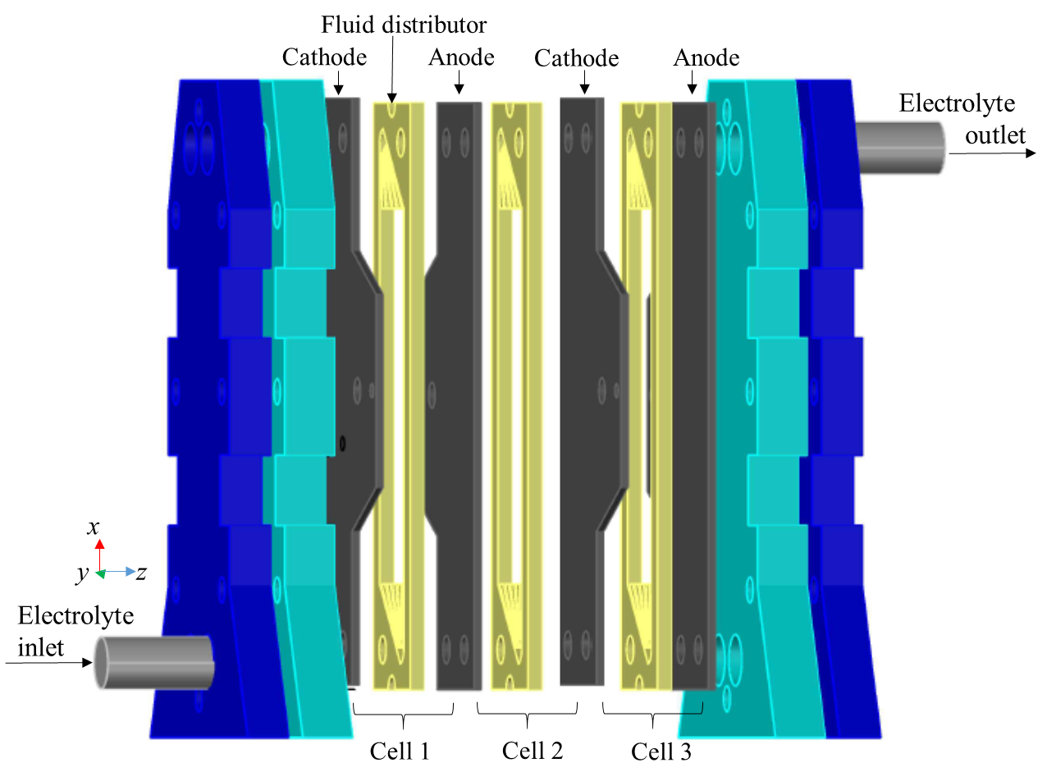

**Figure 1**



**Figure 2**



**Figure 3**

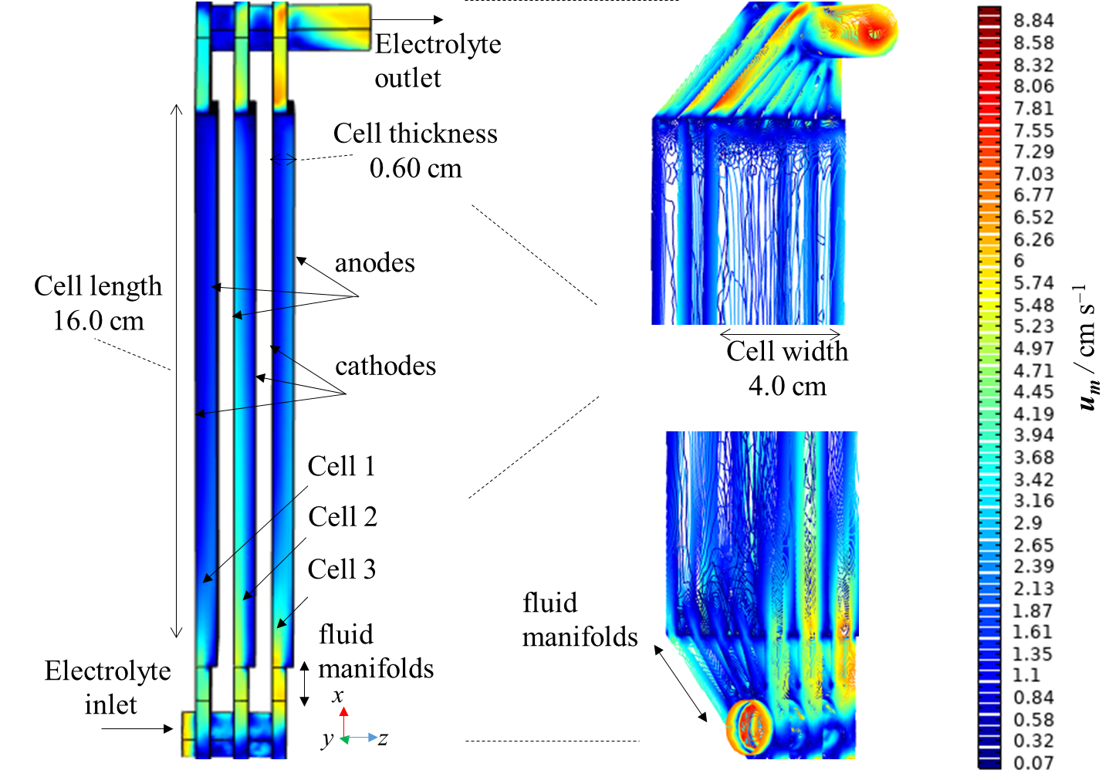

**Figure 4**



**Figure 5**

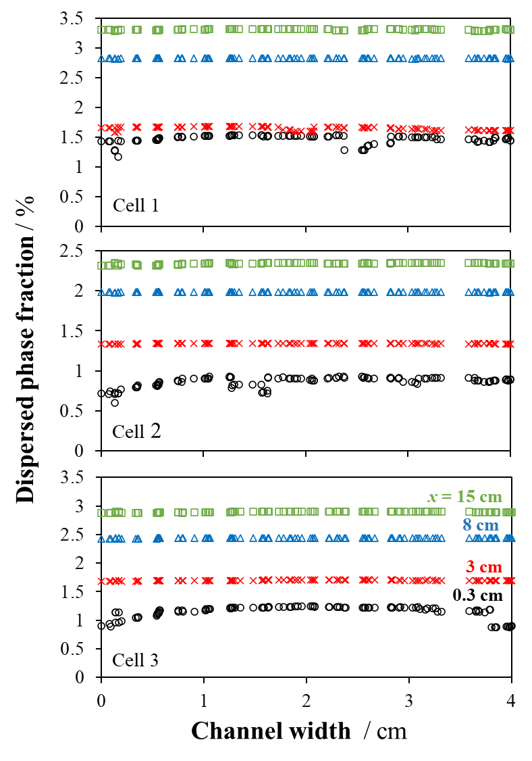

**Figure 6**



**Figure 7**

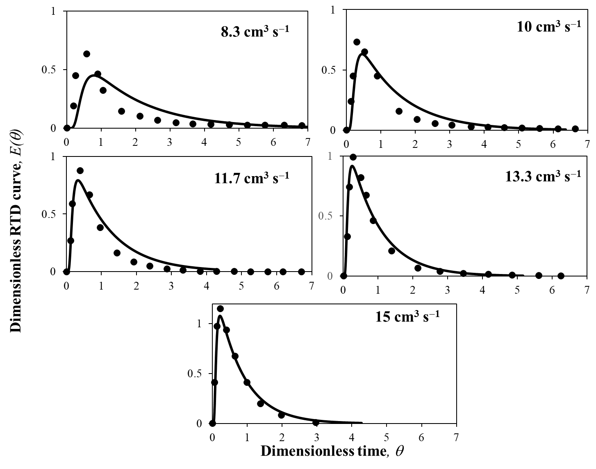

**Figure 8**

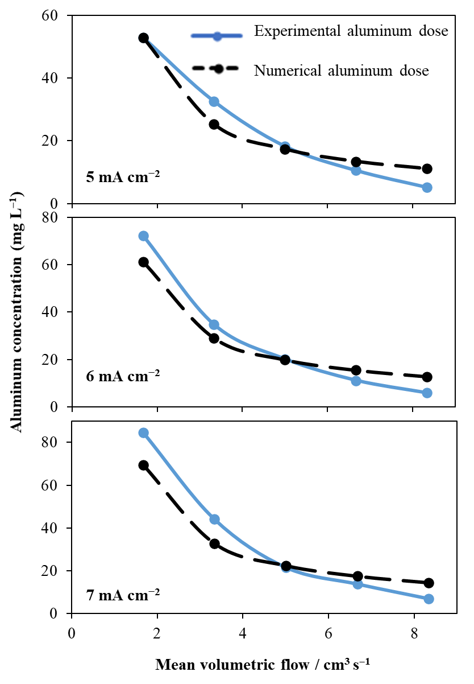

**Figure 9**



**Figure 10**