Using locally available fertilisers to enhance the yields of swidden farmers in Papua New Guinea

Author details
Mirjam Hazenbosch^{a *} ✉ , Shen Sui^{b}, Brus Isua^{b}, Emilie Beauchamp^{a,c}, Jan Frouz^{d}, Kiole Imale^{b}, Mavis R. Jimbudo^{b}, E.J. Milner-Gullandª, Vojtěch Novotný^{e,f}, Hana Veselá^{d}, Rebecca J. Morris^{g}

ª BSc, PhD, PhD - Department of Zoology, University of Oxford, Oxford, OX1 3SZ, United Kingdom
^{b} BSc, No degree, BSc, MSc - The New Guinea Binatang Research Centre, PO Box 604, Madang, Papua New Guinea
^{c} PhD - International Institute for Environment and Development, London, WC1X 8NH, United Kingdom
^{d} PhD, PhD - Institute for Environmental Studies, Faculty of Science, Charles University, Benátská 2, CZ12800 Praha, Czech Republic
^{e} PhD - Biology Centre of the Czech Academy of Sciences, Institute of Entomology, Branišovská 1160/31, 370 05, České Budějovice, Czech Republic
^{f} PhD - Faculty of Science, University of South Bohemia, Branišovská 1760, 370 05, České Budějovice, Czech Republic
^{g} PhD - School of Biological Sciences, University of Southampton, Southampton, SO17 1BJ, United Kingdom

* Corresponding author at: Department of Zoology, University of Oxford, Oxford, OX1 3SZ, United Kingdom
✉ mirjam.hazenbosch@gmail.com and +44 7334 513244

Abstract

- Context Swidden agriculture (a type of small-scale agriculture) is crucial to the livelihood and food security of millions of people in tropical regions. Social-ecological changes, including population growth and anti-swidden policies, are putting pressure on the existing swidden system to increase agricultural productivity in a sustainable way. Enhancing soil fertility is a promising option for increasing crop yields and extending lifetimes of agricultural fields, thereby reducing the demand to clear new land. However, there is limited information on how swidden farmers can best maintain soil fertility.
- Objective Our aim was to investigate whether using locally available fertilisers can increase soil quality, crop yields and lifetimes of swidden fields.
- Methods We established experimental gardens on the land of swidden farmers in the Lowlands of Papua New Guinea, where the majority of the population depends on swidden agriculture. Gardens were set up on two types of sites; five were established on new sites that had just been prepared for gardening by cutting and burning vegetation after a fallow period, whereas another five were prepared on garden sites that were just being fallowed. We applied three treatments; i) compost consisting of decaying banana peels, ii) chicken manure, and iii) NPK fertiliser to different plots within each garden; and tracked soil quality and yields of sweet potato over 12 months (three post-intervention cropping periods). We also conducted in-depth interviews with local farmers to understand their perspective on soil management.
- Results and Conclusions Few farmers typically used compost, chicken manure or NPK fertiliser. Many were keen to try these fertilisers, provided they had more information. The performance of treatments depended on the type of garden with chicken manure increasing tuber yields in fallowed gardens but not new gardens, and banana peel compost also increasing tuber yields in fallowed gardens although not significantly. NPK fertiliser was the best option because it was the only fertiliser that increased yields in both new and fallowed gardens, produced tubers of similar quality and taste to control plots and was financially profitable. Treatments affected yield through increasing available nitrogen and reducing soil moisture. We also found that farmers fallow their gardens despite adequate sweet potato yields, so whether using fertilisers can enhance the lifetime of fields will depend on additional factors such as labour input needed.
- Significance Our work shows how swidden agriculture can potentially be adapted so that it continues to be a sustainable way of farming and living.

Introduction

Large areas of tropical forest landscapes are occupied by swidden cultivation (Padoch and Pinedo-Vasquez, 2010). Within this type of agriculture, forest is converted to agricultural land by cutting and subsequently burning trees, the ashes being used to enhance soil fertility (Gay-des-Combes et al., 2017). After a short duration of cultivation (usually one or two years), farmers move to farm a new area while the old area is fallowed (Padoch, 2018). The main reasons for leaving a field to fallow include severe weed infestation, high pressures of pests and pathogens and soil nutrient exhaustion (Sirén, 2007). Parts of the fallow areas are often planted with useful tree crops either for subsistence or cash income (Mertz et al., 2009b). After a comparatively long fallow period (which usually lasts more than two years, depending on the region) swidden farmers return to the same area, and clear and crop it again (Padoch, 2018). Swidden agriculture plays a crucial role in sustaining the livelihoods of many people living in tropical forests, with estimates ranging from 40 million to one billion people (Mertz et al., 2009a).
Going forward swidden farming needs to adapt to demographic and political pressures. Swidden systems will have to continue to adapt to larger populations (van Vliet et al., 2012). As populations have increased, swidden farmers have often decreased the length of the fallow period (Dressler et al., 2016; Sirén, 2007). Reduced fallow periods have been shown to reduce soil quality and productivity in swidden fields (Bruun et al., 2017; Fujinuma et al., 2018), although it is unlikely that shorter fallow periods will eventually lead to a collapse of the swidden system (Mertz et al., 2008). There has also been a rise in anti-swidden policies, including prohibitions for conservation purposes (Fox et al., 2009). Swidden agriculture has often been criticised for driving deforestation and forest degradation (Heinimann et al., 2017). However, there is growing evidence that when swidden cultivation is discontinued it is often replaced by intensified land uses such as sedentary agriculture or commercially driven large scale plantations with higher environmental impacts (van Vliet et al., 2012). Swidden cultivation itself can actually harbour high levels of biodiversity (Padoch and Pinedo-Vasquez, 2010). So, there is a place for swidden cultivation in conservation landscapes, but swidden farmers may have to further limit the impact on their surroundings. Improving the productivity and sustainability of the existing swidden system is thus necessary so that it can continue to be a viable livelihood.
Enhancing soil fertility is a promising option for increasing crop yields and extending the lifetime of a field, thereby reducing the demand to clear new land (Fujinuma et al., 2018; Gay-des-Combes et al., 2017). At the moment there is limited information on the impact of swidden agriculture on essential nutrients and how soil fertility can best be maintained within the swidden system (Mukul and Herbohn, 2016). Currently, burning of fields is widely practiced because, besides clearing the land of remaining vegetation, it improves the physiochemical properties of the soils and thus favours crop growth (Kukla et al., 2019). The effects on the soil are, however, short-lived. During the burning process considerable amounts of nitrogen (N) and carbon (C) are lost to the atmosphere (Demeyer et al., 2001). The nutrients which are retained in ash patches are considered at risk of being lost through both leaching and erosion, with potassium (K) being particularly vulnerable to leaching and phosphorus (P) to erosion of ashes (Menzies and Gillman, 2003). Hence, there are limits to the extent ash fertilisation can sustain crop yields, especially in the long term, and there is merit in exploring additional soil fertilisation methods (Gay-des-Combes et al., 2017).
Research to improve the productivity of the swidden system is needed across the tropics (Mertz et al., 2008). It is especially necessary in Papua New Guinea (PNG), because more than 75% of the population depends almost entirely on swidden agriculture (Conservation and Environment Protection Authority, 2019). The population in PNG has grown from 2.3 million people in 1960 to 8.9 million people in 2020, and the annual population growth is currently 2% (The World Bank Group, 2020). Increasing food production of swidden farmers in PNG is thus essential, even if existing yields are adequate for the current population. At the same time, PNG contains the third largest area of tropical forest worldwide. The country is home to circa 7% of the world’s biodiversity and at least 30% of species are thought to be endemic (Conservation and Environment Protection Authority, 2019; UNDP, 2021). There is thus limited land available for expansion by swidden farmers in PNG, other than mainly high conservation value areas. Swidden agriculture in PNG generally involves a family (5-10 people, including children) clearing and burning up to three small primary or secondary forest areas surrounding their village each year. The resulting fields are called ‘food gardens’ in which a combination of food crops, such as sweet potato and banana, is grown. Increasingly, cash crops, such as coffee and cacao, are planted alongside food crops, which are mostly sold on informal markets (Bourke and Harwood, 2009). In addition, people may prepare a couple of small plots closer to their house where they mainly grow vegetables (Sillitoe, 1999). After 1-5 rounds of crop planting, gardens are left to fallow for usually 5-15 years (Bourke and Harwood, 2009). So far most farmers in PNG have responded to the increased need for land to grow food and cash crops by reducing their fallow periods (Fujinuma et al., 2018; Hoover et al., 2017). This has caused a reduction in soil fertility and decreased yields, which are both very likely to worsen in the future because further land-use intensification is anticipated (Fujinuma et al., 2018). Therefore, investigating how soil quality can be enhanced in swidden fields in PNG so that crop yields and the lifetime of food gardens can be increased, could benefit both food security and biodiversity conservation.
Most data on the effect of soil fertility on yield in PNG comes from research stations, with very few recordings from village gardens, especially in the Lowlands (< 600 m elevation; Hartemink & Bourke, 2000). Also, most research so far has focused on newly prepared gardens and not on fallowed ones, even though fallowed gardens will have to be reused soon in order to address the issues of land shortage. We define fallowed gardens as gardens which are less intensively managed. People may still return to a fallowed garden to harvest longer-lived crops or useful tree species, but no longer regularly clean and weed the area (Vira et al., 2015). Finally, so far studies in PNG have focused on the effect of inorganic fertiliser on crop yields (Hartemink and Bourke, 2000). However, it is useful to develop a wide range of soil fertility management tools as farmers may differ in their attitudes towards certain practices or be restricted in the type of fertiliser that they can acquire due to a lack of cash or access to markets (Bourke and Harwood, 2009; Fujinuma et al., 2018). The use of plant materials and manure from livestock has been identified by PNG’s National Agricultural Research Institute as promising fertilisers, and thus warrant further investigation (Askin, 2019).
Our aim in this study was therefore to investigate whether using locally available fertilisers can enhance soil quality and increase crop yields in both new gardens and gardens that have been fallowed for one or two years. We addressed four questions. First, how do different types of locally accessible fertilisers (compost made up of decaying banana peels, chicken manure, and NPK fertiliser) influence soil quality in new and fallowed gardens? Second, do these fertilisers increase crop yields compared to control plots in new and fallowed gardens? Third, what are the relationships between treatment, soil quality and yield? Fourth, are local farmers interested in using these soil management techniques, and what are the barriers to taking-up these practices? We set up experimental gardens on the land of swidden farmers in the PNG Lowlands, in which we grew sweet potato. This crop was chosen because it is an important staple food in PNG (Bourke and Harwood, 2009). We applied compost in the form of decaying banana peels, chicken manure and NPK fertiliser to different plots in the experimental gardens, and tracked soil quality and crop yields over three subsequent cropping periods spanning over 12 months. We also conducted in-depth interviews with local farmers to better understand their perspective on using compost, chicken manure and NPK fertiliser.
We hypothesised that decaying banana peel compost, chicken manure, and NPK fertiliser would increase soil nutrients, specifically the nitrogen, phosphorus and potassium content of soil. Nitrogen, phosphorus and potassium are important macronutrients for sweet potato (O’Sullivan et al., 1997). Nitrogen and potassium are most likely to influence sweet potato yields. Nitrogen levels in PNG soil are often too low for sweet potato to yield well (Hartemink and Bourke, 2000). Sweet potato has a high requirement for potassium and especially soils which have seen several rounds of crop plantings already may be potassium deficient (O’Sullivan et al., 1997). Phosphorus, on the other hand, is less likely to determine yields as sweet potato is an effective phosphorus scavenger (Sillitoe, 1996). Besides increasing soil nutrients, we expected decaying banana peel compost and chicken manure to increase soil moisture (Amanullah et al., 2010; Gay-des-Combes et al., 2017). This is because organic materials have been shown to improve soil physical properties, for example by reducing bulk density, which consequently increase the soil water content (Bassouny and Chen, 2015). NPK fertiliser, on the other hand, was not expected to directly affect soil moisture (Bassouny and Chen, 2015; Tadesse et al., 2013). However, fertilisers can have indirect effects on soil moisture via plant growth; increased plant biomass stores more water and increases evapotranspiration, causing soil moisture to decrease (Bhatt and Hossain, 2019). A volumetric soil moisture level of 17-20% is ideal for sweet potato tuber development (Gajanayake et al., 2013), so depending on the soil moisture conditions present, decreased or increased soil moisture levels may be beneficial. As a result of soil physical and chemical improvements, we predicted that adding composting banana peels, chicken manure or NPK fertiliser would increase the nutrient status of plants and tubers, sweet potato yields and crop quality.

- Materials and Methods

  - Study site

Field sampling was conducted in Ohu (S 05°13.081’, E 145°40.735’, 150 m elevation), which is 12 km west of the town of Madang, on the North coast of PNG (Fig. 1). Ohu was selected because the village is representative of other landscapes in Madang province and Lowland PNG in general. The original mosaic of primary and secondary forest around the village has changed since the 1980s into a more intensely managed landscape with food gardens, young secondary forest on fallowed food gardens, family plantations and village settlements (Sam et al., 2014). Some of the remaining fragments of primary forest are being preserved as a community-based protected area, supervised by village landowners, where hunting, logging and gardening are forbidden (Weiblen and Moe, 2016). However, population growth is putting pressure on these forest fragments. The average rainfall in the Madang area is 3558 mm, with a moderately dry season from July to September. Mean air temperature is 26.5°C and varies little throughout the year (McAlpine et al., 1983). Soils in Ohu are a mixture of dystropepts and eutropepts inceptisols (Bryan and Shearman, 2008).

  - Local practices in Ohu

At the start of the experiment in August 2018, we conducted in-depth interviews with local farmers in Ohu in which we asked about past, current and future diets, crops planted in food gardens, past and current land use and agricultural techniques used in food gardens. We interviewed a total of 23 people and selected participants with the help of a village leader. We asked both young (18-40 years) and old (> 40 years) people, and men and women to participate, as the use and distribution of resources in PNG can differ between these groups. Free prior-informed consent was given by all participants before the start of the interview. The average length of an interview was 60 minutes. The protocol was approved by the University of Oxford’s Research Ethics Committee under permit number R58337/RE001.

  - Experimental gardens

    - Design

Ten experimental gardens were set up in Ohu on the land of local farmers in August 2018. Five gardens were set up on sites that had just been prepared for gardening by clearing and burning the area. Five other gardens were set up on sites that had been prepared in 2015 or 2016, used for food production by farmers afterwards and had just been fallowed (Fig. 1). Landowners were compensated for the use of their land. At the start of the experiment, we removed all vegetation in and around the experimental gardens, and deposited it at least 50 meters away from the site.
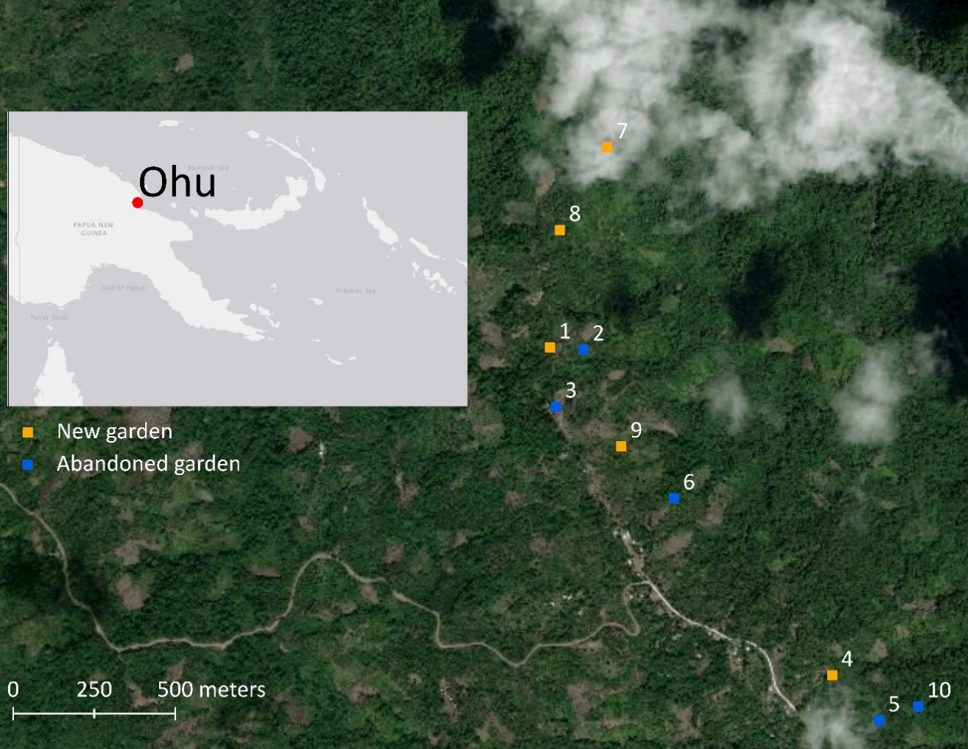
New garden
Fallowed garden
Figure 1: Overview of the geographical locations of the experimental gardens in Ohu, PNG.

Within each experimental garden, four 3.5 x 3.5 m plots were randomly allocated to one of the following treatments; control, compost, manure and NPK fertiliser (Fig. 2A). These fertilisers were chosen as they contain either nitrogen or potassium or both in high amounts, and these nutrients are important determinants of sweet potato yields (Table 1). All fertilisers were sourced locally, and could potentially be used by farmers themselves. For compost we collected fresh banana peels from the food waste of local farmers and left them to decay for a maximum of two months (this treatment is from here on called compost only), fresh chicken manure was sourced from a local farmer, and NPK fertiliser (12% - 12% - 17%) was bought in a shop in Madang town. The fresh chicken manure was dried in the sun for 2-3 weeks before it was used to reduce ammonia emissions which can harm roots, and to kill unwanted weed seeds and pathogens present in the manure.
Recommendations for the application of potassium fertilisers to sweet potato generally lie between 80 to 200 kg K/ha and for nitrogen fertilisers between 30 and 90 kg N/ha (O’Sullivan et al., 1997). Therefore, in the compost treatment we aimed to add 200 kg K/ha, and in the chicken manure and NPK fertiliser treatments 40 kg N/ha (Table 1). We determined the nitrogen, phosphorus, potassium and water content in compost, chicken manure and NPK fertiliser at the start of the experiment and calculated application rates based on these values (Appendix, Table 1).

Table 1: Estimated inputs of N, P and K in kg/ha for each treatment, based on the weight of material applied and estimated using the data in the Appendix, Table 1.
Treatment | Input N  (kg/ha) | Input P  (kg/ha) | Input K  (kg/ha)
Control | 0 | 0 | 0
Compost | 9.6 | 1.2 | 200
Chicken manure | 40 | 17 | 119
NPK fertiliser | 40 | 40 | 57

Within each plot we made 25 mounds of 0.7 x 0.7 x 0.4 m, following local practices (Fig. 2B). In the compost treatment we added 358 grams of decayed banana peels to each mound 4-6 days before planting, and at the same time we applied 68 grams of dried chicken manure in the manure treatment. In the NPK fertiliser treatment we administered 16 grams of NPK fertiliser to each mound at the time of planting, as this type of fertiliser does not need to be broken down before nutrients become available to plants, which is different from compost and chicken manure.
At the start of each planting in August 2018, December 2018 and April 2019, we planted three sweet potato vines in each mound, again following local practices. We used a local sweet potato Ipomoea batatas (L.) Lam variety called ‘wan mun kaukau’. The species has a growth cycle of approximately 90 days in Ohu and thus harvests were completed in November 2018, March 2019 and July 2019. Plots were weeded by farmers throughout the experiment, following local practices.
Measurements were taken only on the nine mounds inside a plot. The 16 mounds at the edge of each plot were not measured as they could have been influenced by spill over effects from neighbouring plots or food gardens.
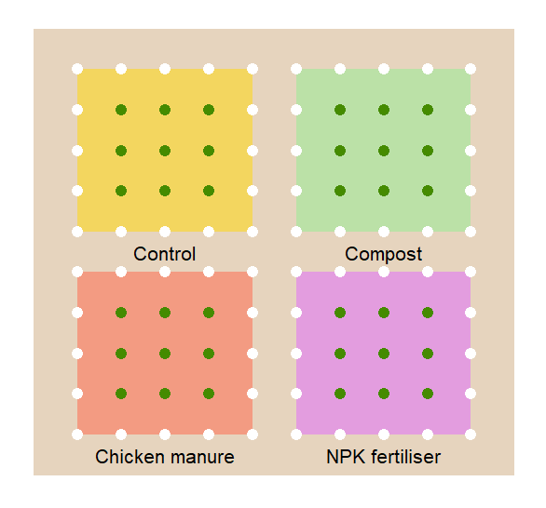
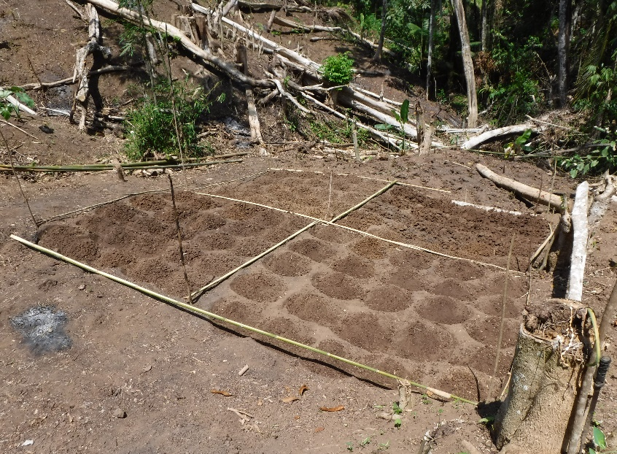
Figure 2: Schematic overview of an experimental garden. Each dot represents a sweet potato mound with white dots indicating mounds in the guard rows which were ignored, and green dots indicating mounds inside a plot from which measurements were taken (A). Photo of the set up in the field (B).
A
B

    - Soil nutrient content

Soil samples (circa 500 g) were collected at 10 cm depth within each plot at the start of the experiment and before each harvest. One sample was collected from the base of the mound and another sample was collected from in between mounds. Five sub-samples (circa 100 g) were taken, separated by a minimum distance of 1 m, pooled together to reduce heterogeneity and oven dried at 105°C for approximately 8 hours. Dried soil samples were shipped, under permit, to Charles University in the Czech Republic for laboratory analyses.
Soil samples were analysed for their conductivity, pH, total nitrogen, phosphorus, potassium and carbon, and available nitrogen, phosphorus and potassium. Conductivity and pH were determined in a 1:5 soil:water suspension using a glass and potentiometric electrode. Samples of dry soil were milled and homogenized by a ball mill (Retsch MM 400 Mixer Mill). Then samples were dried at 40°C for 12 hours. For measuring total nitrogen and carbon content, samples were weighed (Mettler-Toledo MX5) and put into capsules. Total nitrogen and carbon content were determined using an elemental analyser (Flash 2000 Thermo Fisher Scientific). For measuring total phosphorus and potassium content, samples were mineralised in nitric acid for 30 minutes and in perchloric acid for 3 hours. Total phosphorus was measured by colorimetric analysis using a spectrophotometer at 889 nm (UV VIS Genesys 10, Thermo Fisher Scientific) following Murphy and Riley (1962). Total potassium (383 nm) was quantified by flame atomic absorption spectrophotometry (PerkinElmer 306). Inorganic nitrogen (NO₃⁻) was measured in a 1:5 soil:water suspension and determined using a spectrophotometer at 210 nm (GenesysTM 10S UV-Vis, Thermo Fisher Scientific). Available forms of phosphorus (PO₄³⁻) were quantified after extraction in a Mehlich III solution with a 1:10 soil:Mehlich ratio using ascorbic acid and ammonium molybdate as a reducing agent following Murphy and Riley (1962), and then using a spectrophotometer at 889 nm (GenesysTM 10S UV-Vis, Thermo Fisher Scientific). Available potassium (383 nm) was quantified by flame atomic absorption spectrophotometry (PerkinElmer 306).

    - Soil moisture

Volumetric soil moisture was measured within each plot at the start of the experiment, and again before each harvest. Measurements were taken in between mounds and at the base of mounds at 10 cm depth with a SM150 Soil Moisture Sensor (Delta-T) using the pre-set mode for mineral soil which is accurate to ± 3%. Five measurements separated by a minimum distance of 1 m were taken within each plot.

    - Plant- and tuber nutrient content

The first fully developed leaf from the apex was collected from four different vines within each plot at the time of harvest. Also, four tubers were collected from every treatment, and a 1 cm slice was cut from the middle of the tuber. The leaves and slices were dried using silica gel (Sigma-Aldrich), packed into plastic bags and transported, under permit, to Charles University for further laboratory analysis.
Leaves and tubers were analysed for their total nitrogen, phosphorus, potassium and carbon content. Samples of dry biomass were milled and homogenised using a ball mill (Retsch MM 400 Mixer Mill). In case samples had taken up water from the air during milling, they were dried again at 40°C for 12 hours. Samples were then weighed (Mettler-Toledo MX5) and put into capsules. Total nitrogen and carbon content were determined using an Elemental Analyzer (Flash 2000 Thermo Fisher Scientific). For measuring total phosphorus and potassium content samples were mineralised in nitric acid for 30 minutes followed by perchloric acid for 3 hours. Total phosphorus was measured by colorimetric analysis using a spectrophotometer at 889 nm (UV VIS Genesys 10S, Thermo Fisher Scientific), following Murphy and Riley (1962). Total potassium (383 nm) was quantified by flame atomic absorption spectrophotometry (PerkinElmer 306).

    - Yield of leaves, vines and tubers

Approximately 90 days after planting, mounds were harvested, and sweet potato tubers, leaves and vines were collected. First, we collected leaves and vines from each mound, separated the two and weighed them individually on a digital scale (Heston Blumenthal). Next, we destroyed the mounds and collected all the tubers. Tubers were washed and their skin dried before being weighed. The yield of leaves, vines and tubers was calculated per mound.

    - Quality of tubers

Each tuber was assessed visually by local farmers and ranked as either ‘unfit for human consumption’ if the tuber would have to be thrown away or could only be fed to livestock or pets, or ‘fit for human consumption’ if the tuber could be consumed by humans or sold on local markets. Factors that determined the ranking of a tuber included tuber size and the extent to which it had been attacked by insects, earthworms, rats or pathogens.

    - Taste test

A blind tasting experiment was performed at the end of each harvest. During harvests we collected one marketable tuber from each plot from every garden. The tubers were put in different pots based on the treatment they had been grown in. One cook, who was unaware of which pot related to which treatment, prepared the tubers for consumption by peeling them, cutting them in equal-sized slices, and boiling them in water without adding any flavours, spices or other food. Participants, also blind to which pot represented which treatment, were subsequently asked to eat a slice from each pot, describe the taste of each slice and why or why not they liked it, and rank the slices from the different pots among each other. A total of 51 participants took part in the tasting experiment.

  - Statistical analyses

The goal of the analyses was to (1) examine the effect of treatment (control, compost, chicken manure or NPK fertiliser) on soil quality and yield in both new and fallowed gardens, (2) investigate whether treatments had different effects in new versus fallowed gardens, and (3) understand the causal relationships between treatment, soil quality and yield.
To examine the effect of treatment in new and fallowed gardens on soil chemical properties, soil moisture and the yield of sweet potato leaves, vines and tubers, we split the data set into two based on whether it was a new or fallowed garden. Analyses were run on the two data sets independently with treatment included as a fixed effect. To correct for temporal pseudo-replication, harvest number was included as a fixed effect. Plot number nested within garden number was included as a random intercept effect where data was collected at the mound level (for soil moisture and yield data), and garden number only was included where data was collected at the plot level (for soil chemical properties data). In 5.6% of the mounds a combination of two different varieties of sweet potato, as judged by the colour and shape of the leaves and tubers, was accidently planted, although both varieties have a growth cycle of approximately 90 days. In the models for yield we included whether a mound contained only the main variety of sweet potato or a combination of the two varieties as a fixed factor to control for this. For a full overview of the specification of the models, see Appendix, Table 2.
To investigate how the effect of treatment differed between new and fallowed gardens we ran the analyses on the full data set including both new and fallowed gardens. We included an interaction effect between treatment and garden type as fixed effects, and we corrected for pseudo-replication in time and space and the presence of a different variety similarly to described above. We fitted this model to data on soil, plant and tuber chemical properties, the yield of sweet potato leaves, vines and tubers, and tuber quality. For the taste test analysis we included treatment as a fixed effect, as well as harvest number to correct for temporal pseudo-replication. For a full overview of the specification of the models, see Appendix, Table 3.
To examine the links between soil quality and yield we built an a priori conceptual model of hypothesized causal relationships within a path model (Appendix, Table 4). We then used structural equation modelling (SEM) to directly test the supposed causal structure. SEM was designed for continuous variables that are normally distributed and it is advised to convert factors into dummy variables. Thus we included treatment and the type of garden as dummy variables with control and new gardens as the respective reference levels. In this model we again corrected for temporal and spatial pseudo-replication by including harvest number as a fixed effect and garden number as a random intercept effect. For a full overview of the specification of the SEM model, see Appendix, Table 5. To check whether the hypothesized relationships were consistent with the data we calculated Fisher’s C and its associated p-value.
All statistical analyses were done in R version 4.0. For soil, plant and tuber chemical data the data was normally distributed and we fitted a linear mixed model using the ‘lmer’ function in the lme4 package (Bates et al., 2019). Soil moisture measurements were recorded in percentages, and thus we used a beta distribution to fit the model. For the data set on the yield of sweet potato leaves, vines and tubers we opted for a gamma distribution because the yield data were bounded at zero and positively skewed. Counts of tubers per mound were analysed using a Poisson distribution. For beta, gamma and Poisson distributed models we used the ‘gamlss’ function in the gamlss package (Stasinopoulos et al., 2020). Tuber quality followed a binary distribution and we conducted a logistic regression using the ‘glmer’ function in the lme4 package (Bates et al., 2019). Results from the taste test were analysed using the ‘clm’ function from the ordinal package (Christensen, 2019). Where appropriate collinearity between independent variables was tested using the variable inflation factor. For the structural equation model we used the ‘psem’ function in the piecewiseSEM package (Lefcheck et al., 2019). We only included a few unrelated independent variables in our models, so we report values from the full models. Means are reported with standard errors.

- Results

  - Local practices in Ohu

All 23 interviewees indicated that they relied on their gardens for their daily food. People complemented their garden food with foraging in the forests and buying food (mainly rice) from stores. Families maintained an average of 1.5 ± 0.13 food gardens (range zero to two) and 1.3 ± 0.29 smaller vegetable gardens (range zero to six). A variety of crops were intercropped in food gardens with banana, Chinese taro, taro and sweet potato being planted most often.
Interviewees pointed out that within their lifetime (the average age of interviewees was 42 years) fallow times have decreased from an average of 8.5 ± 1.3 years to 3.6 ± 0.25 years, and that the lifespan of a garden has increased from 2.0 ± 0.20 years to 2.3 ± 0.20 years. When discussing this and without being prompted, the majority of people indicated that they had seen yields declining in their lifetime.
At the time of the interview, none of the interviewees used NPK fertiliser. Fifty-two percent of interviewees sometimes applied compost in the form of food waste and 35% animal manure, but only in their smaller vegetable gardens. Only 4% of respondents used compost or animal manure in their food gardens. The most often cited reason for not using compost, animal manure or NPK fertilisers in their food gardens was that people were not always sure how to use these fertilisers. All interviewees were keen to try out animal manure, 87% compost and 83% NPK fertiliser, provided they had more information on how to use these fertilisers.

  - Experimental gardens

Before the start of the experiment, the amount of soil nutrients and level of soil moisture did not differ between the control plots and treatment plots. Only the level of total potassium was significantly higher in NPK fertiliser plots in fallowed gardens compared to control plots. However, this is unlikely to have influenced our results because the level of available potassium has a more direct influence on plant growth compared to total potassium, and available potassium did not differ between NPK fertiliser and control plots. Also, the levels of available and total potassium were high in all plots and above the threshold for sweet potato to grow well (Nicholaides III et al., 1985). New gardens contained a higher amount of available nitrogen, available and total phosphorus and available and total potassium compared to fallowed gardens, whereas fallowed gardens had higher levels of total nitrogen and soil moisture (Appendix, Table 6).

    - Soil nutrient content

The amount of soil nutrients was significantly higher in mounds than between mounds (Appendix, Table 7). Since sweet potato plants were planted in mounds and since their roots spread around 15 cm deep in the soil, only results based on measurements taken from mounds are reported below.
The application of treatments significantly affected the soil nutrient status compared to the control condition. Compost significantly increased the amount of available potassium in the soil (Fig. 3E). Chicken manure, on the other hand, did not affect soil potassium levels, but increased the amount of available and total nitrogen, and available and total phosphorus in new gardens (Fig. 3A-F). In fallowed gardens, chicken manure had less of an effect (Table 2), and only increased the level of soil available phosphorus (Fig. 3C). NPK fertiliser, similar to chicken manure, increased the amount of available and total phosphorus in new gardens (Fig. 3C-D). Also NPK fertiliser had less of an effect in fallowed gardens (Table 2), and only increased the amount of total phosphorus (Fig. 3D). Contrary to chicken manure, NPK fertiliser did not affect soil available or total nitrogen levels in either new or fallowed gardens (Fig. 3A-B). Soils in fallowed gardens contained on average less available potassium than in new gardens (Table 2).

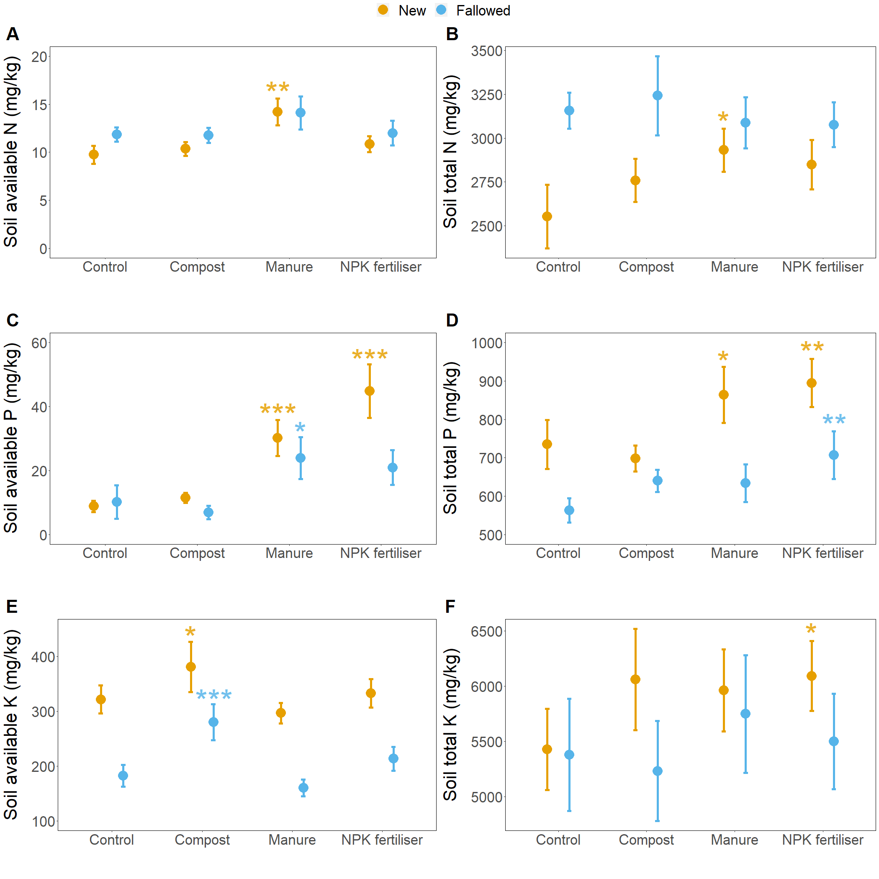
Figure 3: Available nitrogen (A), total nitrogen (B), available phosphorus (C), total phosphorus (D), available potassium (E) and total potassium (F) in mg/kg for different treatments. Orange indicates new gardens and blue fallowed gardens. Mean ± s.e. are shown. For full results, see Appendix, Table 8.

    - Soil moisture

Soil moisture was significantly lower in plots treated with NPK fertiliser compared to control plots in both new and fallowed gardens (Fig. 4). Compost only lowered the level of soil moisture in fallowed gardens, whereas chicken manure only lowered soil moisture in new gardens (Fig. 4). Fallowed gardens, overall, had a significantly lower percentage soil moisture compared to new gardens (Table 2).
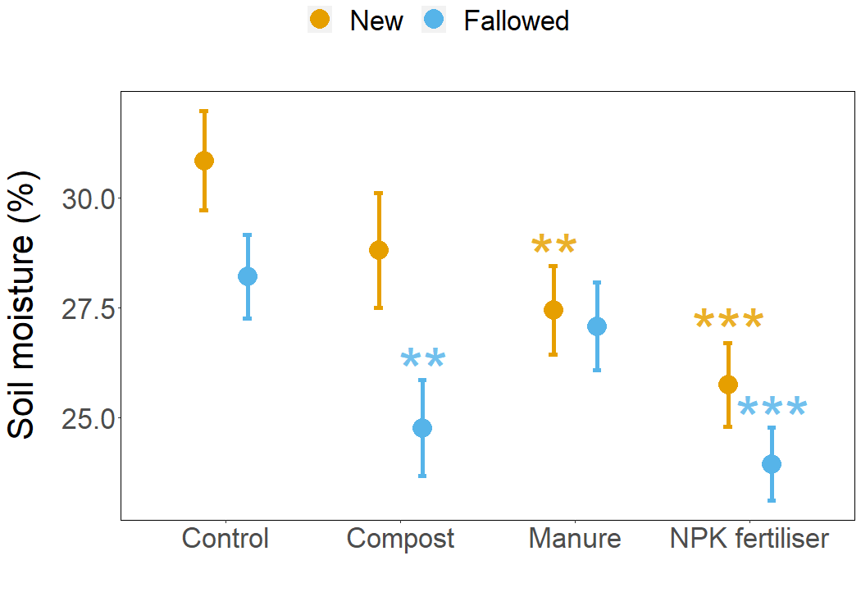
Figure 4: Percentage of volumetric soil moisture for different treatments. Orange indicates new gardens and blue fallowed gardens. Mean ± s.e. are shown. For full results, see Appendix, Table 8.

Table 2: Summary of the model results for soil nutrients and soil moisture. ‘ns’ = non-significant; ‘+’/ ‘-‘ = p < 0.05; ‘++’/’—‘= p < 0.01; ‘+++’/’---‘ = p < 0.001, with ‘+’ indicating a positive effect and ‘-‘ a negative effect. Reference levels are given in grey shading for each variable. For full results, see Appendix, Table 9.
 |  | Soil  available N | Soil  total N | Soil  available P | Soil  total P | Soil  available K | Soil  total K | Soil moisture
Treatment | Control
 | Compost | ns | ns | ns | ns | + | ns | ns
 | Manure | ++ | + | +++ | ++ | ns | ns | --
 | NPK fertiliser | ns | ns | +++ | +++ | ns | ns | ---
Garden type | New
 | Fallowed | ns | ns | ns | ns | - | ns | -
Harvest | Harvest 1
 | Harvest 2 | ++ | -- | + | ns | + | ns | +++
 | Harvest 3 | ns | ns | + | ns | ns | ns | ---
Treatment * Garden type | Control : New
 | Compost : Fallowed | ns | ns | ns | ns | ns | ns | ns
 | Manure : Fallowed | ns | - | ns | ns | ns | ns | ns
 | NPK fertiliser : Fallowed | ns | ns | -- | ns | ns | ns | ns

    - Plant and tuber nutrient content

The application of treatments did not significantly affect the amount of nutrients in plants or tubers. Plants in fallowed gardens contained a significantly lower amount of total nitrogen compared to new gardens (Appendix, Table 10 and 11).

    - Yield of leaves, vines and tubers

In control plots, the yield of leaves, vines and tubers did not differ significantly between new and fallowed gardens (Table 3). However, the application of treatments significantly affected the yield of leaves, vines and tubers, and the effects differed for new versus fallowed gardens (Fig. 5A-D).
The compost treatment significantly decreased leaf and vine yields compared to the control treatment, but more so in new gardens compared to fallowed gardens (Table 3). Contrary to this, chicken manure and NPK fertiliser increased leaf and vine yields in new gardens. In fallowed gardens, chicken manure and NPK fertiliser only increased vine yields, but not leaf yields (Fig. 5A-B).
In new gardens that were treated with compost, tuber yields declined, similar to the leaf and vine yields. In fallowed gardens, however, tuber yields increased when treated with compost, although not significantly (Table 3). Chicken manure significantly increased tuber yields in fallowed gardens, but had no effect in new gardens. NPK fertiliser was the only fertiliser that increased tuber yields in both new and fallowed gardens, and had a greater effect in fallowed gardens compared to chicken manure (Fig. 5C).
The increase in yield was due to an increase in tuber number, rather than an increase in the mean average weight of a tuber. In control plots, we harvested an average of 4.8 tubers per mound. In fallowed gardens, compost increased the average number of tubers per mound by 0.85 tubers, while chicken manure led to 1.4 additional tubers on average. NPK fertiliser increased the average number of tubers per mound by 2.5 tubers in fallowed gardens and 1.4 tubers in new gardens (Fig. 5D). None of the treatments increased the average weight per tuber. Compost even decreased the average weight per tuber, by 8.9 grams, in new gardens (Appendix, Table 12).

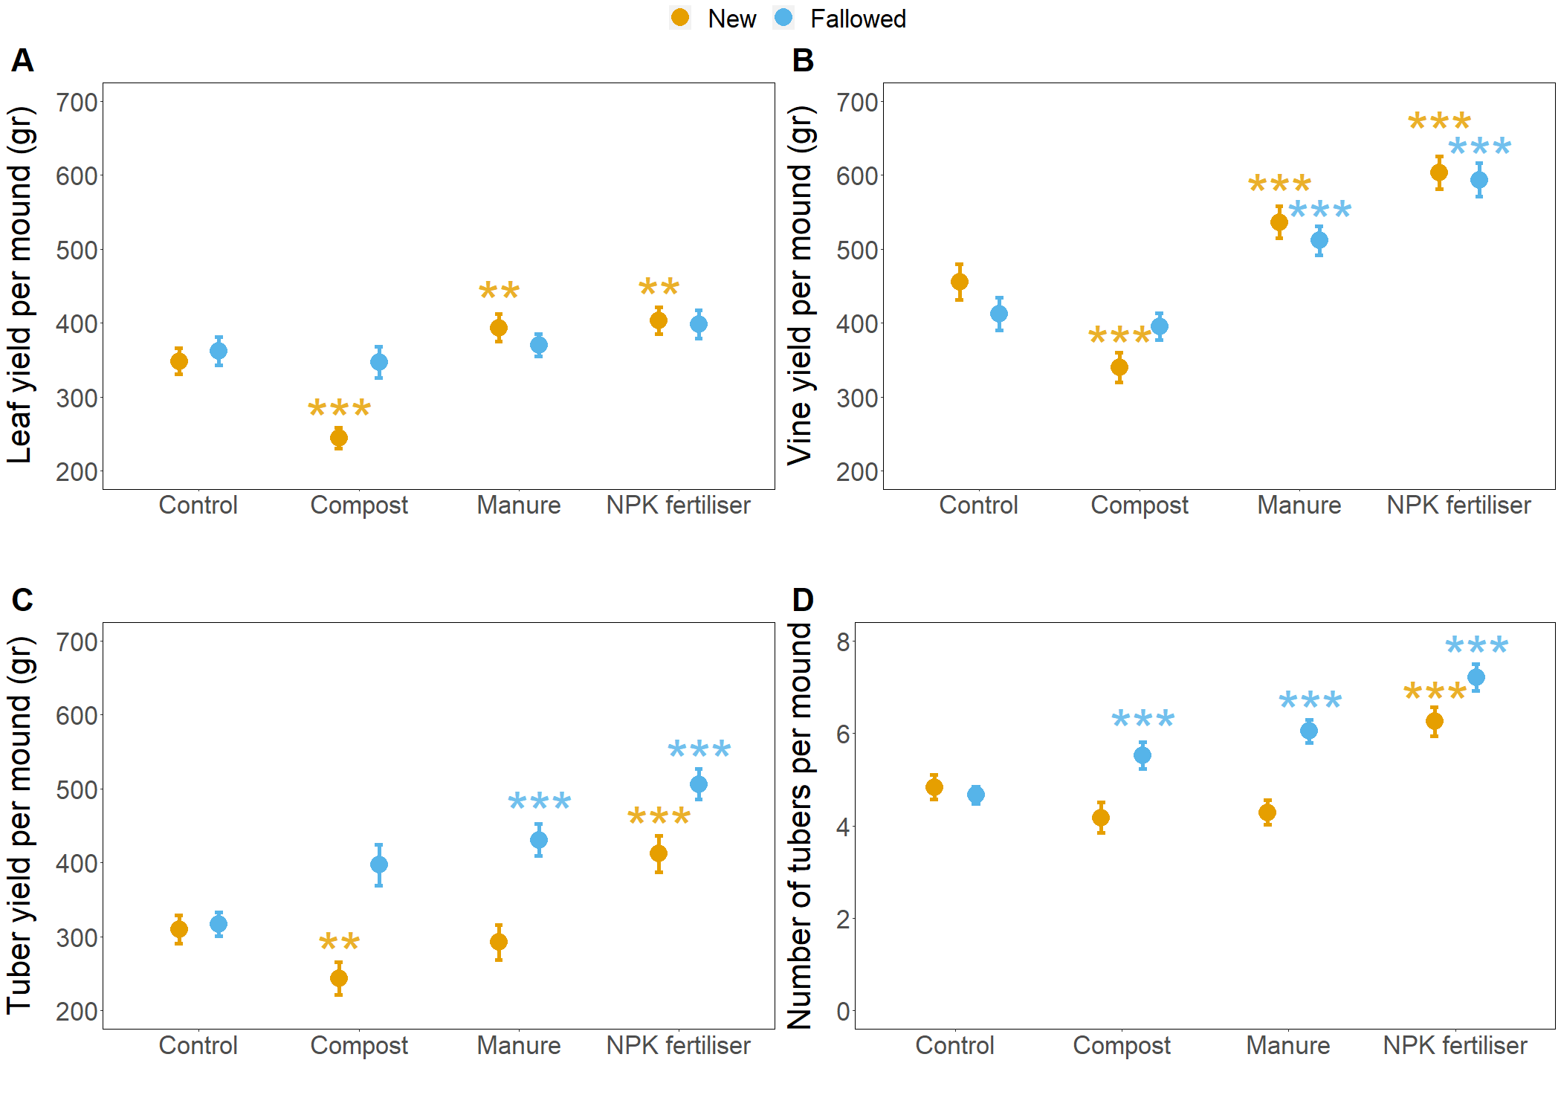
Figure 5: Yield of leaves (A), vines (B) and tubers (C) in grams per mound, and number of tubers per mound (D) for the different treatments. Orange indicates new gardens and blue fallowed gardens. Mean ± s.e. are shown. For full results, see Appendix, Table 12.

    - Quality of tubers

In the control condition, 62% of sweet potato tubers were classified as being fit for human consumption. Treatment with compost lowered the probability of sweet potato tubers being acceptable for human consumption by 39%. The application of chicken manure and NPK fertiliser did not significantly affect tuber quality. Tuber quality also did not differ between new and fallowed gardens (Table 3).

Table 3: Summary of the model results for soil nutrients and soil moisture. ‘ns’ = non-significant; ‘+’/ ‘-‘ = p < 0.05; ‘++’/’—‘= p < 0.01; ‘+++’/’---‘ = p < 0.001, with ‘+’ indicating a positive effect and ‘-‘ a negative effect. Reference levels are given in grey shading for each variable. For full results, see Appendix, Table 13.
 |  | Leaf yield | Vine yield | Tuber yield | Weight per tuber | No. of tubers | Tuber quality
Treatment | Control
 | Compost | --- | --- | -- | -- | ns | -
 | Manure | ++ | +++ | ns | ns | ns | ns
 | NPK fertiliser | ++ | +++ | +++ | ns | +++ | ns
Garden type | New
 | Fallowed | ns | ns | ns | + | ns | ns
Tuber type | Red
 | Mix | + | ns | ns | ns | - | -
Harvest | Harvest 1
 | Harvest 2 | ns | -- | ns | +++ | --- | +++
 | Harvest 3 | --- | --- | --- | +++ | --- | -
Treatment * Garden type | Control : New
 | Compost : Fallowed | + | + | ++ | ns | + | ns
 | Manure : Fallowed | - | ns | + | ns | +++ | ns
 | NPK fertiliser : Fallowed | ns | ns | ns | ns | ns | ns

    - Taste test

Tubers grown in compost and NPK fertiliser plots were ranked similarly compared to tubers grown in control plots, but tubers from chicken manure plots were ranked significantly lower (Fig. 6 and Appendix, Table 14). Participants remarked that these tubers tasted less sweet and contained roots on their skin, which was why they did not prefer these tubers.

Figure 6: Overview of how tubers from different treatments got ranked among each other, with ‘1’ indicating a participant’s favourite sweet potato slice, and ‘4’ indicating a participant’s least preferred slice.

    - Relationships between treatments, soil quality and tuber yields

Using structural equation modelling we analysed how treatments influenced the amount of soil available nitrogen, phosphorus and potassium, and soil moisture, and how these variables then influenced tuber yields. This analysis therefore had the advantage of directly testing the supposed causal structure of the effects of treatment on yield. The SEM fitted adequately to the data (Fisher’s C = 25.52 with p = 0.11 on 18 degrees of freedom). The effect of treatments on soil chemical properties and soil moisture confirmed the above-described analyses. Increased plant biomass (as calculated by the total of leaf, vine and tuber yield) decreased soil moisture. Compost and NPK fertiliser also affected soil moisture via additional pathways. Of all soil properties, higher levels of soil available nitrogen had a positive effect on tuber yields, while higher levels of soil moisture decreased tuber yields (Fig. 7). Thus, the SEM indicated that the main path by which treatments affected yield was through increasing available nitrogen and reducing soil moisture. It also suggested that treatment-induced increases in available phosphorus and potassium did not directly affect tuber yield.

Compost |  | NPK fertiliser |  | Manure
Soil available K | Soil moisture |  | Soil available P |  | Soil available N
Total plant biomass | Tuber yield

Figure 7: Graphical depiction of the structural equation model with indicating a positive correlation, and a negative correlation with p < 0.05. Compost increased the amount of soil available potassium, NPK fertiliser and manure the amount of soil available phosphorus, and manure also the amount of soil available nitrogen. An increase in total plant biomass decreased soil moisture. Compost and NPK fertiliser also decreased soil moisture via additional pathways. Soil moisture and soil available nitrogen directly influenced tuber yields, with soil available nitrogen having a positive effect while soil moisture having a negative effect. For full results, see Appendix, Table 15.

- Discussion

We found that banana peel compost, chicken manure and NPK fertiliser affected soil nutrient status, soil moisture and sweet potato yields and quality, and that these effects differed between new gardens and fallowed gardens. Overall, NPK fertiliser had the largest positive effects.

  - Effect of treatments on soil properties

The amount of nitrogen, phosphorus and potassium in the soil fell within the range of values previously recorded in new and fallowed gardens in PNG (Fujinuma et al., 2018; Kukla et al., 2019; Sillitoe, 1996). The level of available and total nitrogen in Ohu was relatively low compared to other regions in PNG, whereas the amount of available and total phosphorus was average. The amount of available potassium was high compared to Highland sites (Fujinuma et al., 2018; Sillitoe, 1996), but low compared to other Lowland sites (Kukla et al., 2019).
Treatments increased the amount of available nutrients in the soil, with the increases corresponding to their different inputs. Compost increased the amount of available potassium, which was expected since banana peels contain high levels potassium and low levels of nitrogen and phosphorus. Chicken manure increased the amount of available nitrogen and phosphorus, which again followed expectations. NPK fertiliser, which is high in phosphorus, increased the amount of available phosphorus in new gardens and total phosphorus in new and fallowed gardens. Since NPK fertiliser also contains large amounts of nitrogen we expected soil available nitrogen to increase as well, but this was not the case. It is likely that the available nitrogen provided by NPK fertiliser was taken up by the sweet potato plants before we took our soil measurements at the end of the cropping period, which is probably why we did not find an effect of NPK fertiliser on soil available nitrogen. NPK fertiliser plots had an average increase in leaf, vine and tuber yields of 356 grams per mound (7.3 t/ha) compared to control plots. Estimated nitrogen removal by sweet potato vines and roots for this increase is 32 kg N/ha (O’Sullivan et al., 1997), which is close to the 40 kg/ha of fertiliser which we applied.
Soil moisture levels were relatively high compared to levels recorded in the fields of shifting farmers in Madagascar (Gay-des-Combes et al., 2017) and Bangladesh (Miah et al., 2014). PNG is one of the wettest places in the world, and thus these high soil moisture levels are not surprising (The World Bank Group, 2021). At the start of the experiment, levels of soil moisture were higher in fallowed gardens compared to new gardens. This was expected, as measurements were taken 1-2 weeks after the vegetation in fallowed gardens had been cut, whereas in new gardens removal of vegetation had happened 1-2 months earlier, allowing the soil to dry out more (Miah et al., 2014). However, over the cropping seasons we found that mounds in fallowed gardens had lower soil moisture levels compared to new gardens. Atchley et al. (2018) found that fires of low to moderate burn severity, as applied in new gardens, within a year will result in increased soil water due to a reduction in evapotranspiration, which could explain the higher levels of soil moisture in new gardens. Applying banana peel compost, chicken manure and NPK fertiliser decreased soil moisture, with compost reducing soil moisture in fallowed gardens, chicken manure in new gardens and NPK fertiliser in both new and fallowed gardens. These results can in part be explained by the fact that treatments increased the yields of leaves, vines or tubers, causing the plants to take up more water from the soil and increasing the amount of water lost through transpiration (Bourke and Harwood, 2009). However, as shown in the SEM, compost and NPK also decreased soil moisture via additional pathways, which was unexpected and we can only speculate about the underlying mechanisms. It may have been that compost and NPK fertiliser improved soil structure, and soils with better structures have larger volumes of macropores that drain more easily (Weil and Brady, 2017). Decayed organic matter is known to increase soil porosity (Kranz et al., 2020). NPK fertiliser may have increased soil macroporosity by increasing the number of sweet potatoes, which enhances rooting depth and root proliferation, and roots are able to increase soil porosity (Scholl et al., 2014). Increased volumes of macropores may have caused water to drain from the mounds deeper into the soil, and with that allow compost and NPK fertiliser to reduce volumetric soil moisture in the mounds.

  - Effect of soil treatments on sweet potato yield

In control plots the mean tuber yield per mound was 313 grams, or 6.4 t/ha. Worldwide, the average yield of sweet potato in 2019 was 12 t/ha, and in PNG 5.1 t/ha (FAO, 2021). Thus, sweet potato yields reported here are relatively high for PNG standards, but low compared to global standards and could thus potentially be increased.
Our results show that one way to achieve this is by applying soil treatments, including chicken manure and NPK fertiliser (but not compost). How well a treatment performed in terms of increasing tuber yield depended on whether a garden was new or fallowed, with chicken manure only having an effect in fallowed gardens. This may be explained by the fact that organic fertilisers, including chicken manure, need to be broken down by micro-organisms before their nutrients can be taken up by plants (Amanullah et al., 2010). The fire that is used to prepare new gardens reduces bacterial and fungal populations in the soil (Miah et al., 2014), which may, temporarily, decrease the effect of organic fertilisers. NPK fertiliser, on the other hand, can be taken up directly by plants (Heeb et al., 2006), and could thus increase yields in both new and fallowed gardens.
One of the main pathways through which treatments affected yield in our experiment was through increasing available nitrogen. This is not surprising given that the amount of nitrogen in the soil in Ohu was low. Nitrogen has been shown to increase leaf area, which in turn increases mean tuber weight and hence tuber yield (Bourke, 1985). However, too much nitrogen can cause luxuriant growth of vines at the expense of storage root yield. Therefore, recommendations for application of nitrogen fertilisers to sweet potato generally lie between 30 and 90 kg N/ha (O’Sullivan et al., 1997), and our application of 40 kg N/ha falls within these bounds. We expected potassium to influence sweet potato yields as well, but we did not find evidence for this. This may be because the amount of available potassium in Ohu was well above the critical threshold for sweet potato of 31 mg/kg (Nicholaides III et al., 1985), and further increases may not improve yields. Phosphorus also did not influence yields. The threshold for deficiency of phosphorus levels for sweet potato has been estimated to range from 5 to 7 mg/kg (O’Sullivan et al., 1997). The phosphorus levels in the soils in Ohu were above this threshold, which explains why phosphorus did not affect yields.
The other pathway through which treatments affected yield was through soil moisture. Soil moisture has been shown to have an important effect on sweet potato tuber development (Gajanayake et al., 2013) with both water deficits and excesses decreasing tuber yields (O’Sullivan et al., 1997). Volumetric soil moisture levels of 17-20% have been found to be optimal for root development (Gajanayake et al., 2013), and soil moisture levels in compost, chicken manure and NPK fertiliser plots were closer to this optimal level than in the controls, where the level of soil moisture was recorded to be an average of 30%.
Application of banana peel compost caused tubers to be less likely to be suitable for human consumption. Compost made from the grass Ischaemum polystachyum has been shown to improve sweet potato yields by increasing tuber initiation rather than promoting tuber bulking (Sillitoe, 1996), and we find the same here; compost treatment decreased the average weight of tubers, especially in new gardens. If tubers are too small, farmers will deem them unsuitable for human consumption, and are likely to feed the tubers to their livestock instead (Sillitoe, 1996).
Application of chicken manure decreased the taste of tubers. The application of chicken manure may have increased the water content of roots making the tubers taste less sweet (Sowley et al., 2015) and increased the production of non-tuberous roots on its skin (Magagula et al., 2010). Especially in Ohu where food is not in critically low supply, taste may be an important consideration for farmers when deciding to adapt a fertiliser.

  - Looking forward

We found that soil moisture and available nitrogen play an important role in determining sweet potato yields. Farmers in PNG already employ strategies to optimise these factors. For example, they often plant sweet potatoes in mounds, which allows excess moisture to drain away from the root zone (Bourke and Harwood, 2009). In parts of the Highlands where sweet potato is an especially important food crop, farmers rotate sweet potato with leguminous crops such as peanut or winged beans which can increase soil nitrogen levels (Bourke and Harwood, 2009).
Our study shows that in the Lowlands it is also possible to enhance soil quality and yields using nitrogen-containing fertilisers such as chicken manure and NPK fertiliser, with their relative effectiveness depending on whether the garden is new or fallowed. We expect other fertilisers, which are also capable of increasing available nitrogen and reducing soil moisture, to increase yields too, but this would need further research. Alternative fertilisers may be more appropriate in places where soil properties differ.
In Ohu, out of banana peel compost, chicken manure and NPK fertiliser, NPK fertiliser came out as the best option as it was the only fertiliser that increased yields in both new and fallowed gardens. Unlike chicken manure, NPK fertiliser produced tubers which taste similarly good compared to tubers from control plots. The use of NPK fertiliser was also financially profitable in Ohu (Appendix, Table 16), although only marginally so and only makes a real difference if farmers sell large quantities of sweet potato. However, excessive use of NPK fertiliser can have negative effects on the environment, including eutrophication and contamination of aquatic systems, soil acidification and a reduction of plant species richness in neighbouring herbaceous communities (Shoji et al., 2001; Soons et al., 2017). Here we applied nitrogen and phosphorus at a rate of 12 g/m²/year, which is unlikely to have a significant negative effect on biodiversity (Soons et al., 2017), but it will be important to monitor possible negative consequences of NPK fertiliser in this context, especially when it is used over longer time periods.
Whether the use of fertilisers can enhance the lifetime of a garden, will depend on multiple factors. At the moment, farmers in Ohu leave their gardens to fallow despite adequate sweet potato yields. This may at first seem surprising given that starting a new garden requires significant labour and time inputs (Sillitoe, 1999). However, sweet potatoes are known to produce adequate yields on soils that may be too poor for other crops (O’Sullivan et al., 1997), so farmers may choose to fallow a garden so they can grow a variety of crops rather than just sweet potato. In addition, it may be that in fallowed gardens the pressure from weeds, pests and diseases become too high, reducing the return to labour ratio and thus making it worthwhile to switch to a new garden (Sirén, 2007). Especially in Ohu, starting a new garden is relatively easy compared to other regions in PNG as people mainly cut young secondary forest and they do not fence their gardens against pigs, which can promote the quick turnaround in gardens. If soil quality is improved and yields enhanced, yields may outweigh labour inputs for longer, which could potentially encourage farmers to prolong the lifetime of their garden but this would need to be confirmed.
Currently, farmers in Ohu are typically not using compost, animal manure or NPK fertilisers in their food gardens. Using fertilisers requires additional knowledge, more work such as having to acquire and transport materials to gardens, and in the case of NPK fertiliser also money, which are barriers to taking-up these practices (Zhang et al., 2020). However, in Ohu there is great interest in these techniques as farmers are seeing their fallow times, soil fertility and yields decline.

  - Conclusion

Social-ecological changes, including demographic and political transitions, are putting pressure on the existing swidden system. Our research shows that locally available fertilisers can improve soil quality and enhance the yields of swidden farmers: Chicken manure increased sweet potato tuber yields in fallowed gardens, as did banana peel compost although this result was not statistically significant. NPK fertiliser increased yields in both new and fallowed gardens, produced tubers of similar quality and taste to control plots and was financially profitable, and hence came out as the best option. Treatments affected yield through increasing available nitrogen and reducing soil moisture. Farmers were keen to consider modifying their current soil management practices, provided they had more information on how to use these fertilisers. Thus, there is both feasibility and scope for swidden farming to be adapted in the Lowlands of PNG, so that it can continue to be a viable and sustainable way of farming and living.

- Data accessibility

Data from the experimental gardens is deposited in the Mendeley Data repository: http://dx.doi.org/10.17632/vybb4wcbb7.1. Interview data is available on request from the corresponding author.

- Acknowledgements

We are in debt to landowners in Ohu who allowed us to set up experimental gardens on their land. We are also very grateful for the support that we received from our assistants in Ohu. Thank you to staff of The New Guinea Binatang Research Centre, especially Jaspar Billy, Heveakore Maraia, Cliffson Idigel and Dr. Francesca F. Dem. We also very much appreciate the input of Professor Sir Charles Godfray and Professor Owen T. Lewis on experimental design, Dr. Bjorn J. M. Robroek on soil sampling, and Dr. Chris Terry and Thomas Pienkowski on statistical analyses. This project was financially supported by the Biotechnology and Biological Sciences Research Council (BBSRC) [grant number BB/M011224/1].

- References

Amanullah, M.M., Sekar, S., Muthukrishnan, P., 2010. Prospects and potential of poultry manure. Asian J. Plant Sci. 9, 172–182.
Askin, D., 2019. Sustainable gardens in Papua New Guinea - A manual for trainers.
Atchley, A.L., Kinoshita, A.M., Lopez, S.R., Trader, L., Middleton, R., 2018. Simulating surface and subsurface water balance changes due to burn severity. Vadose Zo. J. 17, 1–13. https://doi.org/10.2136/vzj2018.05.0099
Bassouny, M., Chen, J., 2015. Effect of long-term organic and mineral fertilizer on physical properties in root zone of a clayey Ultisol. Arch. Agron. Soil Sci. 62, 819–828. https://doi.org/10.1080/03650340.2015.1085649
Bates, D., Maechler, M., Bolker, B., Walker, S., Christensen, R.H.B., Singmann, H., Dai, B., Scheipl, F., Grothendieck, G., Green, P., Fox, J., 2019. Linear mixed-effects models using “Eigen” and S4.
Bhatt, R., Hossain, A., 2019. Concept and consequence of evapotranspiration for sustainable crop production in the era of climate change. Adv. Evapotranspiration Methods Appl. https://doi.org/10.5772/intechopen.83707
Bourke, R.M., 1985. Influence of nitrogen and potassium fertilizer on growth of sweet potato (Ipomoea batatas) in Papua New Guinea. F. Crop. Res. 12, 363–375. https://doi.org/https://doi.org/10.1016/0378-4290(85)90081-4
Bourke, R.M., Harwood, T.A. (Eds.), 2009. Food and agriculture in Papua New Guinea. ANU E Press, Canberra.
Bruun, T.B., de Neergaard, A., Burup, M.L., Hepp, C.M., Larsen, M.N., Abel, C., Aumtong, S., Magid, J., Mertz, O., 2017. Intensification of upland agriculture in Thailand: Development or degradation? L. Degrad. Dev. 28, 83–94. https://doi.org/10.1002/ldr.2596
Bryan, J.E., Shearman, P.L., 2008. Papua New Guinea resource information system handbook, 3rd ed. University of Papua New Guinea, Port Moresby.
Christensen, R.H.B., 2019. Regression models for ordinal data.
Conservation and Environment Protection Authority, 2019. Papua New Guinea 6th national report to the Convention on Biological Diversity.
Demeyer, A., Voundi Nkana, J.C., Verloo, M.G., 2001. Characteristics of wood ash and influence on soil properties and nutrient uptake: An overview. Bioresour. Technol. 77, 287–295. https://doi.org/10.1016/S0960-8524(00)00043-2
Dressler, W.H., Wilson, D., Clendenning, J., Cramb, R., Keenan, R., Mahanty, S., Bruun, T.B., Mertz, O., Lasco, R.D., 2016. The impact of swidden decline on livelihoods and ecosystem services in Southeast Asia: A review of the evidence from 1990 to 2015. Ambio 46, 291–310. https://doi.org/10.1007/s13280-016-0836-z
FAO, 2021. FAOSTAT [WWW Document]. URL http://www.fao.org/faostat/en/#data/QC (accessed 1.11.21).
Fox, J., Fujita, Y., Ngidang, D., Peluso, N., Potter, L., Sakuntaladewi, N., Sturgeon, J., Thomas, D., 2009. Policies, political-economy, and swidden in Southeast Asia. Hum. Ecol. 37, 305–322. https://doi.org/10.1007/s10745-009-9240-7
Fujinuma, R., Kirchhof, G., Ramakrishna, A., Sirabis, W., Yapo, J., Woruba, D., Gurr, G., Menzies, N., 2018. Intensified sweetpotato production in Papua New Guinea drives plant nutrient decline over the last decade. Agric. Ecosyst. Environ. 254, 10–19. https://doi.org/10.1016/j.agee.2017.11.012
Gajanayake, B., Raja Reddy, K., Shankle, M.W., Arancibia, R.A., 2013. Early-season soil moisture deficit reduces sweetpotato storage root initiation and development. HortScience 48, 1457–1462. https://doi.org/10.21273/hortsci.48.12.1457
Gay-des-Combes, J.M., Sanz Carrillo, C., Robroek, B.J.M., Jassey, V.E.J., Mills, R.T.E., Arif, M.S., Falquet, L., Frossard, E., Buttler, A., 2017. Tropical soils degraded by slash-and-burn cultivation can be recultivated when amended with ashes and compost. Ecol. Evol. 7, 5378–5388. https://doi.org/10.1002/ece3.3104
Hartemink, A.E., Bourke, R.M., 2000. Nutrient deficiencies of agricultural crops in Papua New Guinea. Outlook Agric. 29, 97–108. https://doi.org/https://doi.org/10.5367/000000000101293103
Heeb, A., Lundegårdh, B., Savage, G., Ericsson, T., 2006. Impact of organic and inorganic fertilizers on yield, taste, and nutritional quality of tomatoes. J. Plant Nutr. Soil Sci. 169, 535–541. https://doi.org/10.1002/jpln.200520553
Heinimann, A., Mertz, O., Frolking, S., Christensen, A.E., Hurni, K., Sedano, F., Chini, L.P., Sahajpal, R., Hansen, M., Hurtt, G., 2017. A global view of shifting cultivation: Recent, current, and future extent. PLoS One 12, 1–21. https://doi.org/10.1371/journal.pone.0184479
Hoover, J.D., Leisz, S.J., Laituri, M.E., 2017. Comparing and combining landsat satellite imagery and participatory data to assess land-use and land-cover changes in a coastal village in Papua New Guinea. Hum. Ecol. 45, 251–264. https://doi.org/10.1007/s10745-016-9878-x
Kranz, C.N., McLaughlin, R.A., Johnson, A., Miller, G., Heitman, J.L., 2020. The effects of compost incorporation on soil physical properties in urban soils – A concise review. J. Environ. Manage. 261, 110209. https://doi.org/10.1016/j.jenvman.2020.110209
Kukla, J., Whitfeld, T., Cajthaml, T., Baldrian, P., Veselá-Šimáčková, H., Novotný, V., Frouz, J., 2019. The effect of traditional slash-and-burn agriculture on soil organic matter, nutrient content, and microbiota in tropical ecosystems of Papua New Guinea. L. Degrad. Dev. 30, 166–177. https://doi.org/10.1002/ldr.3203
Lefcheck, J., Byrnes, J., Grace, J., 2019. Piecewise structural equation modeling.
Magagula, N.E.M., Ossom, E.M., Rhykerd, R.L., Rhykerd, C.L., 2010. Chicken manure affects sweetpotato (Ipomoea batatas (L.) Lam.) nutrient element concentrations in tubers and leaves in Swaziland 1, 8–16.
McAlpine, J.R., Keig, G., Falls, R., 1983. Climate of Papua New Guinea. ANU Press.
Menzies, N.W., Gillman, G.P., 2003. Plant growth limitation and nutrient loss following piled burning in slash and burn agriculture. Nutr. Cycl. Agroecosystems 65, 23–33. https://doi.org/10.1023/A:1021886717646
Mertz, O., Leisz, S.J., Heinimann, A., Rerkasem, K., Dressler, W., Pham, V.C., Vu, K.C., Schmidt-Vogt, D., Colfer, C.J.P., Epprecht, M., Padoch, C., Potter, L., 2009a. Who counts? Demography of swidden cultivators in Southeast Asia. Hum. Ecol. 37, 281–289. https://doi.org/10.1007/sl0745-009-9249-y
Mertz, O., Padoch, C., Fox, J., Cramb, R.A., Leisz, S.J., Lam, N.T., Vien, T.D., 2009b. Swidden change in southeast Asia: Understanding causes and consequences. Hum. Ecol. 37, 259–264. https://doi.org/10.1007/s10745-009-9245-2
Mertz, O., Wadley, R.L., Nielsen, U., Bruun, T.B., Colfer, C.J.P., de Neergaard, A., Jepsen, M.R., Martinussen, T., Zhao, Q., Noweg, G.T., Magid, J., 2008. A fresh look at shifting cultivation: Fallow length an uncertain indicator of productivity. Agric. Syst. 96, 75–84. https://doi.org/10.1016/j.agsy.2007.06.002
Miah, S., Haque, S.M.S., Sumi, W., Hossain, M.M., 2014. Effects of shifting cultivation on biological and biochemical characteristics of soil microorganisms in Khagrachari hill district, Bangladesh. J. For. Res. 25, 689–694. https://doi.org/10.1007/s11676-014-0453-2
Mukul, S.A., Herbohn, J., 2016. The impacts of shifting cultivation on secondary forests dynamics in tropics: A synthesis of the key findings and spatio temporal distribution of research. Environ. Sci. Policy 55, 167–177. https://doi.org/10.1016/j.envsci.2015.10.005
Murphy, J., Riley, J.P., 1962. A modified single solution method for the determination of phosphate in natural waters. Anal. Chim. Acta 27, 31–36. https://doi.org/10.1016/S0003-2670(00)88444-5
Nicholaides III, J.J., Chancy, H.F., Mascagni Jr, H.J., Wilson, L. G., &, Eaddy, D.W., 1985. Sweet potato response to K and P fertilization. Agron. J. 77, 466–470.
O’Sullivan, J., Asher, C., Blamey, F., 1997. Nutrient disorders of sweet potato. ACIAR Monogr. 48, 1–36.
Padoch, C., 2018. Swidden cultivation. Int. Encycl. Anthropol. 1–4. https://doi.org/10.1002/9781118924396.wbiea2324
Padoch, C., Pinedo-Vasquez, M., 2010. Saving slash-and-burn to save biodiversity. Biotropica 42, 550–552. https://doi.org/10.1111/j.1744-7429.2010.00681.x
Sam, K., Koane, B., Jeppy, S., Novotny, V., 2014. Effect of forest fragmentation on bird species richness in Papua New Guinea. J. F. Ornithol. 85, 152–167. https://doi.org/10.1111/jofo.12057
Scholl, P., Leitner, D., Kammerer, G., Loiskandl, W., Kaul, H.P., Bodner, G., 2014. Root induced changes of effective 1D hydraulic properties in a soil column. Plant Soil 381, 193–213. https://doi.org/10.1007/s11104-014-2121-x
Shoji, S., Delgado, J., Mosier, A., Miura, Y., 2001. Use of controlled release fertilizers and nitrification inhibitors to increase nitrogen use efficiency and to conserve air and water quality. Commun. Soil Sci. Plant Anal. 32, 1051–1070. https://doi.org/10.1081/CSS-100104103
Sillitoe, P., 1999. Where to next? Garden site selection in the Papua New Guinea Highlands. Oceania 69, 184–208. https://doi.org/10.1002/j.1834-4461.1999.tb02712.x
Sillitoe, P., 1996. A place against time: Land and environment in the Papua New Guinea Highlands. Harwood Academic Publishers GmbH, Amsterdam.
Sirén, A.H., 2007. Population growth and land use intensification in a subsistence-based indigenous community in the Amazon. Hum. Ecol. 35, 669–680. https://doi.org/10.1007/s10745-006-9089-y
Soons, M.B., Hefting, M.M., Dorland, E., Lamers, L.P.M., Versteeg, C., Bobbink, R., 2017. Nitrogen effects on plant species richness in herbaceous communities are more widespread and stronger than those of phosphorus. Biol. Conserv. 212, 390–397. https://doi.org/10.1016/j.biocon.2016.12.006
Sowley, E.N.K., Neindow, M., Abubakari, A.H., 2015. Effect of poultry manure and NPK on yield and storability of orange-and white-fleshed sweet potato [Ipomoea batatas (L.) Lam]. ISABB J. Food Agric. Sci. 5, 1–6. https://doi.org/10.5897/ISABB-JFAS2014.0005
Stasinopoulos, D.M., Rigby, B., Voudouris, V., Akantziliotou, C., Enea, M., Kiose, D., 2020. Generalised additive models for location scale and shape.
Tadesse, T., Dechassa, N., Bayu, W., Gebeyehu, S., 2013. Effects of farmyard manure and inorganic fertilizer application on soil physico-chemical properties and nutrient balance in rain-fed Lowland rice ecosystem. Am. J. Plant Sci. 04, 309–316. https://doi.org/10.4236/ajps.2013.42041
The World Bank Group, 2021. Climate change knowledge portal [WWW Document]. URL https://climateknowledgeportal.worldbank.org/country/papua-new-guinea/climate-data-historical (accessed 1.11.21).
The World Bank Group, 2020. Health nutrition and population statistics: Population estimates and projections [WWW Document]. URL http://databank.worldbank.org/data/reports.aspx?source=health-nutrition-and-population-statistics:-population-estimates-and-projections (accessed 1.11.21).
UNDP, 2021. About Papua New Guinea [WWW Document]. URL http://www.pg.undp.org/content/papua_new_guinea/en/home/countryinfo.html (accessed 1.11.21).
van Vliet, N., Mertz, O., Heinimann, A., Langanke, T., Pascual, U., Schmook, B., Adams, C., Schmidt-Vogt, D., Messerli, P., Leisz, S., Castella, J.C., Jørgensen, L., Birch-Thomsen, T., Hett, C., Bruun, T.B., Ickowitz, A., Vu, K.C., Yasuyuki, K., Fox, J., Padoch, C., Dressler, W., Ziegler, A.D., 2012. Trends, drivers and impacts of changes in swidden cultivation in tropical forest-agriculture frontiers: A global assessment. Glob. Environ. Chang. 22, 418–429. https://doi.org/10.1016/j.gloenvcha.2011.10.009
Vira, B., Wildburger, C., Mansourian, S. (Eds.), 2015. Forests and food: Addressing hunger and nutrition across sustainable landscapes. OpenBook Publishers, Cambridge, UK. https://doi.org/10.11647/OBP.0085
Weiblen, G.D., Moe, A., 2016. WIAD conservation - A handbook of traditional knowledge and biodiversity. University of Minnesota Printing Services, Minneapolis.
Weil, R.R., Brady, N.C., 2017. The nature and properties of soil, 15th ed. Pearson Education, Inc.
Zhang, A.J., Matous, P., Tan, D.K.Y., 2020. Forget opinion leaders: The role of social network brokers in the adoption of innovative farming practices in North-western Cambodia. Int. J. Agric. Sustain. 1–19. https://doi.org/10.1080/14735903.2020.1769808

Appendix

Table 1: Amount of nitrogen, phosphorus, potassium and water in banana peels, chicken manure and NPK fertiliser.
 | N (%) | P (%) | K (%) | H₂O (%)
Banana peels | 0.81 | 0.10 | 17 | 84
Chicken manure | 2.9 | 1.2 | 8.6 | 79
NPK fertiliser | 12 | 12 | 17 | -

Table 2: Overview of the models run on the split data set for new and fallowed gardens.
Response | Type of data | Distribution | Model
 |  |  | Fixed effects |  |  | Random effect
 |  |  | Treatment | Mound type | Harvest | Garden | Plot
Soil moisture | Percentage per mound / 100  Semi-continuous | Beta | X | - | X | X | X
Soil nutrients | pH, available N, P and K, and total N, P and K  Semi-continuous | Normal | X | - | X | X | -
Leaf yield | Weight in grams per mound  Semi-continuous | ZA gamma | X | X | X | X | X
Vine yield | Weight in grams per mound  Semi-continuous | ZA gamma | X | X | X | X | X
Tuber yield | Weight in grams per mound  Semi-continuous | ZA gamma | X | X | X | X | X
Tuber number | Number of tubers per mound  Count | ZA poisson | X | X | X | X | X

Table 3: Overview of the models run on the full data set with an interaction effect between treatment and garden type where applicable.
Response | Type of data | Distribution | Model
 |  |  | Fixed effects |  |  |  | Interaction effect | Random effect
 |  |  | Treatment | Garden type | Mound type | Harvest | Treatment * Garden type | Garden | Plot | Mound
Soil moisture  Time 0 | Percentage per mound / 100  Semi-continuous | Beta | X | X | - | - | - | X | X | -
Soil moisture | Percentage per mound / 100  Semi-continuous | Beta | X | X | - | X | X | X | X | -
Soil nutrients  Time 0 | pH, available N, P and K, and total N, P and K  Semi-continuous | Gamma | X | X | - | - | - | X | - | -
Soil nutrients | pH, available N, P and K, and total N, P and K  Semi-continuous | Normal | X | X | - | X | X | X | - | -
Plant nutrients | Total N, P, K and C  Semi-continuous | Normal | X | X | - | X | X | X | - | -
Tuber nutrients | Total N, P, K and C  Semi-continuous | Normal | X | - | - | X | - | - | - | -
Tuber quality | Rank on a 0-1 scale per tuber  Factorial | Binomial logistic | X | X | X | X | X | X | X | X
Leaf yield | Weight in grams per mound  Semi-continuous | ZA gamma | X | X | X | X | X | X | X | -
Vine yield | Weight in grams per mound  Semi-continuous | ZA gamma | X | X | X | X | X | X | X | -
Tuber yield | Weight in grams per mound  Semi-continuous | ZA gamma | X | X | X | X | X | X | X | -
Weight per tuber | Weight in grams per tuber  Semi-continuous | ZA gamma | X | X | X | X | X | X | X | X
Tuber number | Number of tubers per mound  Count | ZA poisson | X | X | X | X | X | X | X | -
Taste | Rank  Ordinal | Ordinal | X | - | - | X | - | - | - | -

Table 4: Hypothesized mechanisms based on a-priori knowledge with indicating a positive correlation, no effect, and a negative correlation.
Path |  |  | Hypothesized mechanisms
Treatments |  | Soil nutrients | We expected compost to mainly increase the amount of available potassium, chicken manure the amount of available nitrogen and NPK fertilizer the amount of available nitrogen and phosphorus.
Treatments |  | Soil moisture | Compost and chicken manure increase soil moisture (Amanullah et al., 2010; Gay-des-Combes et al., 2017), while NPK fertilizer does not affect soil moisture (Bassouny and Chen, 2015; Tadesse et al., 2013).
Soil moisture |  | Tuber yield | Too dry or to wet conditions inhibit tuber development. Soil moisture of 17-20% is ideal for sweet potato tuber development (Gajanayake et al., 2013).
Soil nutrients |  | Tuber yield | Tuber formation is mainly depended upon nitrogen (Bourke, 1985).
Total plant biomass |  | Soil moisture | Increased plant biomass stores more water and increases evapotranspiration causing soil moisture to decrease (Bhatt and Hossain, 2019).

Table 5: Regressions included in the structural equation model. Treatment and garden type were coded as dummy variables with “Control” and “New gardens” as the reference levels. A linear distribution had to be fitted to the soil moisture data, as it is currently not possible to fit a beta distribution in the piecewiseSEM package (Lefcheck et al., 2019).
Response | Distri-bution | Fixed effects |  |  |  |  |  |  |  |  |  |  | Random effect
 |  | Compost | Manure | NPK fertiliser | Fallowed garden | Harvest 2 | Harvest 3 | Total plant biomass | Soil available N | Soil available P | Soil available K | Soil moisture | Garden
Soil available N | Normal | X | X | X | X | X | X |  |  |  |  |  | X
Soil available K | Normal | X | X | X | X | X | X |  |  |  |  |  | X
Soil available P | Normal | X | X | X | X | X | X |  |  |  |  |  | X
Soil moisture | Normal | X | X | X | X | X | X | X |  |  |  |  | X
Tuber yield | Gamma | X | X | X | X | X | X | Correlated | X | X | X | X | X

Table 6: Model results from the models on soil nutrients and soil moisture at the start of the experiment, before fertilisers were applied or sweet potato plants planted. Reference levels are given in grey shading for each variable.
 |  | Available N | Total N | Available P | Total P | Available K | Total K | Soil moisture
Treatment | Control
 | Compost | ß = -0.19  t(35) = -1.3  p = 0.20 | ß = -0.014  t(27) = -0.26  p = 0.80 | ß = 0.0075  t(26) = 0.034  p =0.97 | ß = 0.21  t(31) = 1.9  p = 0.071 | ß = -0.065  t(26) = -0.91  p = 0.37 | ß = -0.0086  t(26) = -0.12  p = 0.90 | ß = -0.058  t(176) = -1.6  p = 0.10
 | Chicken manure | ß = -0.052  t(35) = -0.36  p = 0.72 | ß = -0.013  t(27) = -0.24  p = 0.81 | ß = 0.31  t(26) = 1.4  p = 0.17 | ß = 0.22  t(31) = 1.9  p = 0.061 | ß = -0.021  t(26) = -0.30  p = 0.77 | ß = 0.12  t(26) = 1.7  p = 0.10 | ß = -0.0023  t(176) = -0.064  p = 0.95
 | NPK fertiliser | ß = -0.12  t(35) = -0.82  p = 0.42 | ß = 0.018  t(27) = 0.34  p = 0.74 | ß = 0.38  t(26) = 1.7  p = 0.094 | ß = 0.21  t(31) = 1.9  p = 0.073 | ß = 0.055  t(26) = 0.77  p = 0.45 | ß = 0.18  t(26) = 2.6  p = 0.015 | ß = -0.045  t(176) = -1.3  p = 0.21
Garden type | New
 | Fallowed | ß = -0.30  t(35) = -2.9  p = 0.0059 | ß = 0.086  t(27) = 2.3  p = 0.028 | ß = -1.1  t(26) = -6.5  p < 0.001 | ß = -0.17  t(31) = -2.1  p = 0.043 | ß = -0.54  t(26) = -11  p < 0.001 | ß = -0.12  t(26) = -2.4  p = 0.026 | ß = 0.095  t(176) = 3.8  p < 0.001

Table 7: Model results from the model which tests the effect of location of measurement on soil nutrients and soil moisture. The reference level is given in grey shading.
 |  | Available N | Total N | Available P | Total P | Available K | Total K | Soil moisture
Location | In between mounds
 | Mounds | ß = 4.2  t(226) = 9.5  p < 0.001 | ß = 499  t(226) = 6.2  p < 0.001 | ß = 14  t(226) = 7.2  p < 0.001 | ß = 175  t(226) = 8.9  p < 0.001 | ß = 51  t(226) = 5.9  p < 0.001 | ß = 785  t(226) = 5.1  p < 0.001 | ß = -0.78  t(1135) = -41  p < 0.001

Table 8: Model results from the models on soil nutrients and soil moisture in new gardens and fallowed gardens separately at harvests 1, 2 and 3. Reference levels are given in grey shading for each variable.
 |  | Available N | Total N | Available P | Total P | Available K | Total K | Soil moisture
New gardens
Treatment | Control
 | Compost | ß = 0.60  t(47) = 0.46  p = 0.65 | ß = 205  t(47) = 1.4  p = 0.18 | ß = 2.6  t(47) = 0.44  p = 0.66 | ß = -37  t(47) = -0.64  p = 0.52 | ß = 60  t(47) = 2.1  p = 0.043 | ß = 633  t(47) = 2.0  p = 0.056 | ß = -0.086  t(281) = -1.7  p = 0.089
 | Chicken manure | ß = 4.3  t(47) = 3.2  p = 0.0023 | ß = 409  t(47) = 2.7  p = 0.010 | ß = 22  t(47) = 3.6  p < 0.001 | ß = 154  t(47) = 2.7  p = 0.011 | ß = -16  t(47) = -0.55  p = 0.59 | ß = 507  t(47) = 1.5  p = 0.13 | ß = -0.16  t(281) = -3.3  p = 0.0011
 | NPK fertiliser | ß = 0.84  t(47) = 0.61  p = 0.55 | ß = 309  t(47) = 2.0  p = 0.054 | ß = 37  t(47) = 5.9  p < 0.001 | ß = 194  t(47) = 3.3  p = 0.0020 | ß = 17  t(47) = 0.57  p = 0.57 | ß = 733  t(47) = 2.2  p = 0.035 | ß = -0.24  t(281) = -4.8  p < 0.001
Harvest | Harvest 1
 | Harvest 2 | ß = 1.2  t(47) = 1.1  p = 0.28 | ß = -278  t(47) = -2.1  p = 0.037 | ß = 5.5  t(47) = 1.0  p = 0.30 | ß = -21  t(47) = -0.42  p = 0.67 | ß = 38  t(47) = 1.5  p = 0.13 | ß = 461  t(47) = 1.6  p = 0.11 | ß = 0.18  t(281) = 4.1  p < 0.001
 | Harvest 3 | ß = -1.7  t(47) = -1.4  p = 0.15 | ß = -129  t(47) = -0.94  p = 0.35 | ß = 6.9  t(47) = 1.3  p = 0.21 | ß = 88  t(47) = 1.7  p = 0.094 | ß = -12  t(47) = -0.48  p = 0.64 | ß = 262  t(47) = 0.89  p = 0.38 | ß = -0.30  t(281) = -6.6  p < 0.001
Fallowed gardens
Treatment | Control
 | Compost | ß = -0.094  t(50) = -0.066  p = 0.95 | ß = 85  t(50) = 0.48  p = 0.64 | ß = -3.2  t(50) = -0.52  p = 0.61 | ß = 77  t(50) = 1.8  p = 0.077 | ß = 97  t(50) = 3.8  p < 0.001 | ß = -146  t(50) = -0.32  p = 0.75 | ß = -0.18  t(271) = -3.0  p = 0.0026
 | Chicken manure | ß = 2.3  t(50) = 1.6  p = 0.12 | ß = -69  t(50) = -0.39  p = 0.70 | ß = 14  t(50) = 2.2  p = 0.034 | ß = 71  t(50) = 1.7  p = 0.10 | ß = -23  t(50) = -0.88  p = 0.39 | ß = 369  t(50) = 0.80  p = 0.43 | ß = -0.065  t(271) = -1.2  p = 0.25
 | NPK fertiliser | ß = 0.15  t(50) = 0.10  p = 0.92 | ß = -81  t(50) = -0.45  p = 0.65 | ß = 11  t(50) = 1.7  p = 0.092 | ß = 144  t(50) = 3.4  p = 0.0015 | ß = 31  t(50) = 1.2  p = 0.24 | ß = 122  t(50) = 0.26  p = 0.79 | ß = -0.22  t(271) = -3.8  p < 0.001
Harvest | Harvest 1
 | Harvest 2 | ß = 3.3  t(50) = 2.7  p = 0.0097 | ß = -277  t(50) = -1.8  p = 0.078 | ß = 10  t(50) = 1.9  p = 0.064 | ß = -28  t(50) = -0.74  p = 0.46 | ß = 44  t(50) = 2.0  p = 0.056 | ß = -733  t(50) = -1.8  p = 0.073 | ß = 0.15  t(271) = 3.1  p = 0.0023
 | Harvest 3 | ß = 0.71  t(50) = 0.57  p = 0.57 | ß = -243  t(50) = -1.6  p = 0.12 | ß = 8.9  t(50) = 1.6  p = 0.11 | ß = 1.6  t(50) = 0.042  p = 0.97 | ß = 14  t(50) = 0.65  p = 0.52 | ß = 78  t(50) = 0.20  p = 0.85 | ß = -0.22  t(271) = -4.2  p < 0.001

Table 9: Model results from the models with an interaction between treatment and garden type on soil nutrients and soil moisture at harvests 1, 2 and 3. Reference levels are given in grey shading for each variable.
 |  | Available N | Total N | Available P | Total P | Available K | Total K | Soil moisture
Treatment | Control
 | Compost | ß = 0.60  t(99) = 0.44  p = 0.66 | ß = 205  t(99) = 1.3  p = 0.21 | ß = 2.6  t(99) = 0.43  p = 0.67 | ß = -37  t(99) = -0.73  p = 0.47 | ß = 60  t(99) = 2.2  p = 0.029 | ß = 633  t(99) = 1.5  p = 0.13 | ß = -0.088  t(550) = -1.6  p = 0.10
 | Chicken manure | ß = 4.3  t(99) = 3.1  p = 0.0029 | ß = 405  t(99) = 2.4  p = 0.017 | ß = 22  t(99) = 3.5  p < 0.001 | ß = 152  t(99) = 3.0  p = 0.0038 | ß = -15  t(99) = -0.56  p = 0.58 | ß = 519  t(99) = 1.2  p = 0.22 | ß = -0.16  t(550) = -3.1  p = 0.0023
 | NPK fertiliser | ß = 0.82  t(99) = 0.57  p = 0.57 | ß = 302  t(99) = 1.8  p = 0.080 | ß = 37  t(99) = 5.9  p < 0.001 | ß = 189  t(99) = 3.6  p < 0.001 | ß = 18  t(99) = 0.65  p = 0.52 | ß = 756  t(99) = 1.8  p = 0.080 | ß = -0.24  t(550) = -4.5  p < 0.001
Garden type | New
 | Fallowed | ß = 2.1  t(27) = 1.2  p = 0.24 | ß = 605  t(13) = 2.1  p = 0.058 | ß = 1.3  t(20) = 0.15  p = 0.88 | ß = -172  t(11) = -1.5  p = 0.16 | ß = -139  t(11) = -2.4  p = 0.034 | ß = -48  t(11) = -0.051  p = 0.96 | ß = -0.12  t(550) = -2.3  p = 0.023
Harvest | Harvest 1
 | Harvest 2 | ß = 2.3  t(99) = 2.7  p = 0.0080 | ß = -278  t(99) = -2.8  p = 0.0067 | ß = 7.9  t(99) = 2.1  p = 0.037 | ß = -24  t(99) = -0.79  p = 0.43 | ß = 41  t(99) = 2.5  p = 0.015 | ß = -136  t(99) = -0.54  p = 0.59 | ß = 0.17  t(550) = 5.0  p < 0.001
 | Harvest 3 | ß = -0.53  t(99) = -0.61  p = 0.54 | ß = -190  t(99) = -1.9  p = 0.067 | ß = 7.9  t(99) = 2.1  p = 0.042 | ß = 42  t(99) = 1.3  p = 0.18 | ß = 1.7  t(99) = 0.098  p = 0.92 | ß = 183  t(99) = 0.71  p = 0.48 | ß = -0.26  t(550) = -7.5  p < 0.001
Treatment * Garden type | Control: New
 | Compost : Fallowed | ß = -0.70  t(99) = -0.36  p = 0.72 | ß = -120  t(99) = -0.52  p = 0.60 | ß = -5.9  t(99) = -0.68  p = 0.50 | ß = 114  t(99) = 1.6  p = 0.11 | ß = 38  t(99) = 0.98  p = 0.33 | ß = -779  t(99) = -1.3  p = 0.18 | ß = -0.094  t(550) = -1.2  p = 0.23
 | Chicken manure : Fallowed | ß = -2.0  t(99) = -1.0  p = 0.30 | ß = -474  t(99) = -2.0  p = 0.045 | ß = -8.3  t(99) = -0.95  p = 0.34 | ß = -81  t(99) = -1.1  p = 0.26 | ß = -7.2  t(99) = -0.19  p = 0.85 | ß = -150  t(99) = -0.26  p = 0.80 | ß = 0.096  t(550) = 1.3  p = 0.20
 | NPK fertiliser : Fallowed | ß = -0.67  t(99) = -0.34  p = 0.74 | ß = -383  t(99) = -1.6  p = 0.11 | ß = -27  t(99) = -3.0  p = 0.0033 | ß = -45  t(99) = -0.63  p = 0.53 | ß = 12  t(99) = 0.31  p = 0.75 | ß = -634  t(99) = -1.1  p = 0.29 | ß = 0.020  t(550) = 0.27  p = 0.79

Table 10: Model results from the models with an interaction between treatment and garden type on plant nutrients at harvests 1, 2 and 3. Reference levels are given in grey shading for each variable.
 |  | Total N | Total P | Total K | Total C
Treatment | Control
 | Compost | ß = 240  t(102) = 0.17  p = 0.86 | ß = 371  t(102) = 1.1  p = 0.26 | ß = 2904  t(102) = 1.9  p = 0.055 | ß = -2741  t(102) = -0.67  p = 0.51
 | Chicken manure | ß = 820  t(102) = 0.58  p = 0.56 | ß = 578  t(102) = 1.8  p = 0.079 | ß = 2333  t(102) = 1.6  p = 0.12 | ß = -1639  t(102) = -0.40  p = 0.69
 | NPK fertiliser | ß = -1040  t(102) = -0.74  p = 0.46 | ß = 303  t(102) = 0.93  p = 0.35 | ß = 2089  t(102) = 1.4  p = 0.17 | ß = 821  t(102) = 0.20  p = 0.84
Garden type | New
 | Fallowed | ß = -5144  t(23) = -2.7  p = 0.012 | ß = -1128  t(15) = -2.1  p = 0.057 | ß = -1363  t(17) = -0.60  p = 0.56 | ß = 5992  t(16) = 0.92  p = 0.37
Harvest | Harvest 1
 | Harvest 2 | ß = -1338  t(102) = -1.6  p = 0.12 | ß = 1.8  t(102) = 0.009  p = 0.99 | ß = 7003  t(102) = 7.6  p < 0.001 | ß = 11358  t(102) = 4.5  p < 0.001
 | Harvest 3 | ß = -4314  t(102) = -5.0  p < 0.001 | ß = -1946  t(102) = -9.8  p < 0.001 | ß = -6950  t(102) = -7.6  p < 0.001 | ß = 17407  t(102) = 6.9  p < 0.001
Treatment * Garden type | Control: New
 | Compost : Fallowed | ß = 952  t(102) = 0.48  p = 0.63 | ß = -269  t(102) = -0.58  p = 0.56 | ß = -2858  t(102) = -1.4  p = 0.18 | ß = 4853  t(102) = 0.84  p = 0.41
 | Chicken manure : Fallowed | ß = 525  t(102) = 0.26  p = 0.79 | ß = 325  t(102) = 0.71  p = 0.48 | ß = -2829  t(102) = -1.3  p = 0.18 | ß = 4101  t(102) = 0.71  p = 0.48
 | NPK fertiliser : Fallowed | ß = 1700  t(102) = 0.85  p = 0.40 | ß = -260  t(102) = -0.57  p = 0.57 | ß = -3128  t(102) = -1.5  p = 0.14 | ß = -268  t(102) = -0.046  p = 0.96

Table 11: Model results from the models on tuber nutrients at harvests 1, 2 and 3. Reference levels are given in grey shading for each variable.
 |  | Total N | Total P | Total K | Total C
Treatment | Control
 | Compost | ß = 128  t(6) = 0.16  p = 0.88 | ß = 93  t(6) = 0.40  p = 0.70 | ß = 322  t(6) = 0.18  p = 0.87 | ß = -1543  t(6) = -0.79  p = 0.46
 | Chicken manure | ß = 163  t(6) = 0.20  p = 0.85 | ß = 346  t(6) = 1.5  p = 0.19 | ß = 414  t(6) = 0.23  p = 0.83 | ß = -4375  t(6) = -2.2  p = 0.067
 | NPK fertiliser | ß = -524  t(6) = -0.64  p = 0.55 | ß = -227  t(6) = -0.97  p = 0.37 | ß = -3021  t(6) = -1.7  p = 0.15 | ß = -1359  t(6) = -0.69  p = 0.51
Harvest | Harvest 1
 | Harvest 2 | ß = -3042  t(6) = -4.3  p = 0.0053 | ß = -870  t(6) = -4.3  p = 0.0050 | ß = -817  t(6) = -0.52  p = 0.62 | ß = 11246  t(6) = 6.6  p < 0.001
 | Harvest 3 | ß = -1010  t(6) = -1.4  p = 0.21 | ß = -959  t(6) = -4.8  p = 0.0031 | ß = -4877  t(6) = -3.1  p = 0.021 | ß = 25092  t(6) = 15  p < 0.001

Table 12: Model results from the models on leaf yield, vine yield, tuber yield and tuber quality in new gardens and fallowed gardens separately at harvests 1, 2 and 3. Reference levels are given in grey shading for each variable.
 |  | Leaf yield | Vine yield | Tuber yield | Weight per tuber | Number of tubers per mound
New gardens
Treatment | Control
 | Compost | ß = -0.30  t(461) = -4.7  p < 0.001 | ß = -0.21  t(462) = -3.5  p < 0.001 | ß = -0.26  t(479) = -2.7  p = 0.0074 | ß = -0.19  t(2737) = -3.4  p < 0.001 | ß = -0.011  t(485) = -0.17  p = 0.86
 | Chicken manure | ß = 0.19  t(461) = 3.1  p = 0.0018 | ß = 0.26  t(462) = 4.6  p < 0.001 | ß = -0.0079  t(479) = -0.088  p = 0.93 | ß = 0.020  t(2737) = 0.40  p = 0.69 | ß = -0.054  t(485) = -0.91  p = 0.36
 | NPK fertiliser | ß = 0.19  t(461) = 3.2  p = 0.0017 | ß = 0.34  t(462) = 6.0  p < 0.001 | ß = 0.33  t(479) = 3.7  p < 0.001 | ß = 0.066  t(2737) = 1.4  p = 0.16 | ß = 0.29  t(485) = 5.4  p < 0.001
Tuber type | Red
 | Mix | ß = -0.0023  t(461) = -0.025  p = 0.98 | ß = -0.15  t(462) = -1.7  p = 0.093 | ß = -0.16  t(479) = -1.2  p = 0.22 | ß = 0.045  t(2737) = 0.66  p = 0.51 | ß = -0.15  t(485) = -1.9  p = 0.055
Harvest | Harvest 1
 | Harvest 2 | ß = 0.16  t(461) = 2.7  p = 0.0064 | ß = -0.16  t(462) = -3.0  p = 0.0027 | ß = 0.021  t(479) = 0.25  p = 0.80 | ß = 0.39  t(2737) = 8.7  p < 0.001 | ß = -0.25  t(485) = -4.9  p < 0.001
 | Harvest 3 | ß = -0.048  t(461) = -0.82  p = 0.41 | ß = -0.34  t(462) = -6.3  p < 0.001 | ß = -0.21  t(479) = -2.5  p = 0.013 | ß = 0.33  t(2737) = 7.0  p < 0.001 | ß = -0.42  t(485) = -7.7  p < 0.001
Fallowed gardens
Treatment | Control
 | Compost | ß = -0.056  t(465) = -0.89  p = 0.37 | ß = -0.044  t(463) = -0.81  p = 0.42 | ß = 0.13  t(471) = 1.6  p = 0.12 | ß = -0.0018  t(3039) = -0.034  p = 0.97 | ß = 0.20  t(481) = 3.3  p < 0.001
 | Chicken manure | ß = -0.014  t(465) = -0.25  p = 0.81 | ß = 0.19  t(463) = 3.9  p < 0.001 | ß = 0.27  t(471) = 3.8  p < 0.001 | ß = 0.056  t(3039) = 1.2  p = 0.24 | ß = 0.22  t(481) = 4.1  p < 0.001
 | NPK fertiliser | ß = 0.061  t(465) = 1.1  p = 0.28 | ß = 0.36  t(463) = 7.4  p < 0.001 | ß = 0.44  t(471) = 6.1  p < 0.001 | ß = 0.056  t(3039) = 1.2  p = 0.22 | ß = 0.40  t(481) = 7.6  p < 0.001
Tuber type | Red
 | Mix | ß = 0.34  t(465) = 3.2  p = 0.0015 | ß = 0.19  t(463) = 2.1  p = 0.039 | ß = -0.20  t(471) = -1.5  p = 0.14 | ß = -0.093  t(3039) = -1.1  p = 0.28 | ß = -0.14  t(481) = -1.4  p = 0.15
Harvest | Harvest 1
 | Harvest 2 | ß = 0.014  t(465) = 0.25  p = 0.80 | ß = -0.055  t(463) = -1.2  p = 0.25 | ß = 0.15  t(471) = 2.2  p = 0.031 | ß = 0.26  t(3039) = 6.3  p < 0.001 | ß = -0.11  t(481) = -2.3  p = 0.021
 | Harvest 3 | ß = -0.23  t(465) = -4.3  p < 0.001 | ß = -0.079  t(463) = -1.7  p = 0.090 | ß = -0.30  t(471) = -4.4  p < 0.001 | ß = 0.050  t(3039) = 1.2  p = 0.24 | ß = -0.34  t(481) = -6.9  p < 0.001

Table 13: Model results from the models with an interaction between treatment and garden type on leaf yield, vine yield, tuber yield and tuber quality at harvests 1, 2 and 3. Reference levels are given in grey shading for each variable.
 |  | Leaf yield | Vine yield | Tuber yield | Weight per tuber | Number of tubers per mound | Tuber quality
Treatment | Control
 | Compost | ß = -0.29  t(929) = -4.6  p < 0.001 | ß = -0.22  t(928) = -3.9  p < 0.001 | ß = -0.27  t(955) = -3.1  p = 0.0022 | ß = -0.18  t(5778) = -3.2  p = 0.0014 | ß = -0.015  t(968) = -0.23  p = 0.82 | ß = -0.45  t(5340) = -2.6  p = 0.011
 | Chicken manure | ß = 0.19  t(929) = 3.1  p = 0.0018 | ß = 0.25  t(928) = 4.5  p < 0.001 | ß = -0.011  t(955) = -0.13  p = 0.89 | ß = 0.024  t(5778) = 0.46  p = 0.64 | ß = -0.056  t(968) = -0.95  p = 0.34 | ß = -0.073  t(5340) = -0.44  p = 0.66
 | NPK fertiliser | ß = 0.18  t(929) = 3.1  p = 0.0020 | ß = 0.33  t(928) = 6.1  p < 0.001 | ß = 0.32  t(955) = 4.0  p < 0.001 | ß = 0.059  t(5778) = 1.3  p = 0.21 | ß = 0.28  t(968) = 5.4  p < 0.001 | ß = -0.072  t(5340) = -0.46  p = 0.65
Garden type | New
 | Fallowed | ß = 0.095  t(929) = 1.6  p = 0.11 | ß = -0.058  t(928) = -1.1  p = 0.27 | ß = 0.11  t(955) = 1.3  p = 0.18 | ß = 0.12  t(5778) = 2.4  p = 0.017 | ß = -0.013  t(968) = -0.23  p = 0.82 | ß = 0.49  t(5340) = 1.9  p = 0.054
Tuber type | Red
 | Mix | ß = 0.14  t(929) = 2.0  p = 0.046 | ß = 0.0039  t(928) = 0.062  p = 0.95 | ß = -0.18  t(955) = -1.9  p = 0.053 | ß = -0.031  t(5778) = -0.59  p = 0.55 | ß = -0.13  t(968) = -2.1  p = 0.036 | ß = -0.26  t(5340) = -2.0  p = 0.041
Harvest | Harvest 1
 | Harvest 2 | ß = 0.079  t(929) = 2.0  p = 0.051 | ß = -0.11  t(928) = -3.0  p = 0.0025 | ß = 0.086  t(955) = 1.6  p = 0.11 | ß = 0.31  t(5778) = 10  p < 0.001 | ß = -0.17  t(968) = -4.9  p < 0.001 | ß = 0.26  t(5340) = 3.7  p < 0.001
 | Harvest 3 | ß = -0.15  t(929) = -3.7  p < 0.001 | ß = -0.21  t(928) = -5.8  p < 0.001 | ß = -0.26  t(955) = -4.8  p < 0.001 | ß = 0.17  t(5778) = 5.3  p < 0.001 | ß = -0.37  t(968) = -10  p < 0.001 | ß = -0.19  t(5340) = -2.5  p = 0.012
Treatment * Garden type | Control: New
 | Compost : Fallowed | ß = 0.23  t(929) = 2.5  p = 0.013 | ß = 0.19  t(928) = 2.4  p = 0.019 | ß = 0.40  t(955) = 3.2  p = 0.0016 | ß = 0.15  t(5778) = 1.9  p = 0.056 | ß = 0.22  t(968) = 2.5  p = 0.013 | ß = 0.12  t(5340) = 0.50  p = 0.62
 | Chicken manure : Fallowed | ß = -0.20  t(929) = -2.3  p = 0.020 | ß = -0.050  t(928) = -0.66  p = 0.51 | ß = 0.28  t(955) = 2.5  p = 0.014 | ß = 0.031  t(5778) = 0.44  p = 0.66 | ß = 0.28  t(968) = 3.5  p < 0.001 | ß = -0.29  t(5340) = -1.2  p = 0.21
 | NPK fertiliser : Fallowed | ß = -0.13  t(929) = -1.5  p = 0.13 | ß = 0.034  t(928) = 0.45  p = 0.66 | ß = 0.12  t(955) = 1.0  p = 0.31 | ß = 0.00041  t(5778) = 0.006  p = 1.0 | ß = 0.11  t(968) = 1.5  p = 0.13 | ß = -0.29  t(5340) = -1.3  p = 0.18

Table 14: Model results from the taste test. Reference levels are given in grey shading for each variable.
 | Rank
Control
Compost | ß = -0.30  z(196) = -0.82  p = 0.41
Chicken manure | ß = -0.97  z(196) = -2.7  p = 0.0074
NPK fertiliser | ß = -0.41  z(196) = -1.1  p = 0.26
Harvest 1
Harvest 2 | ß = -0.35  z(196) = -1.1  p = 0.27
Harvest 3 | ß = -0.36  z(196) = -1.2  p = 0.23

Table 15: Model results from the SEM. Reference levels are given in grey shading for each variable.
 | Soil available N | Soil available P | Soil available K | Soil moisture | Tuber yield
Control
Compost | ß = 0.26  df = 101  p = 0.79 | ß = -0.30  df = 101  p = 0.95 | ß = 78  df = 101  p < 0.001 | ß = -2.9  df = 100  p = 0.010 | ß = -0.37  df = 97  p = 0.010
Chicken manure | ß = 3.3  df = 101  p = 0.0012 | ß = 18  df = 101  p < 0.001 | ß = -19  df = 101  p = 0.32 | ß = -1.5  df = 100  p = 0.19 | ß = -0.099  df = 97  p = 0.50
NPK fertiliser | ß = 0.64  df = 101  p = 0.52 | ß = 24  df = 101  p < 0.001 | ß = 25  df = 101  p = 0.20 | ß = -3.3  df = 100  p = 0.010 | ß = 0.11  df = 97  p = 0.47
New garden
Fallowed garden | ß = 1.2  df = 8  p = 0.38 | ß = -8.7  df = 8  p = 0.22 | ß = -128  df = 8  p = 0.040 | ß = -2.0  df = 8  p = 0.59 | ß = 0.41  df = 8  p = 0.21
Harvest 1
Harvest 2 | ß = 2.4  df = 101  p = 0.0053 | ß = 8.2  df = 101  p = 0.039 | ß = 41  df = 101  p = 0.014 | ß = 3.7  df = 100  p < 0.001 | ß = 0.14  df = 97  p = 0.26
Harvest 3 | ß = -0.54  df = 101  p = 0.53 | ß = 7.4  df = 101  p = 0.065 | ß = 1.4  df = 101  p = 0.93 | ß = -5.1  df = 100  p < 0.001 | ß = -0.59  df = 97  p < 0.001
Total plant biomass |  |  |  | ß = -0.0033  df = 100  p = 0.031 | Correlated  ß = 0.34  df = 116  p < 0.001
Soil available N |  |  |  |  | ß = 0.032  df = 97  p = 0.019
Soil available P |  |  |  |  | ß = -0.0020  df = 97  p = 0.49
Soil available K |  |  |  |  | ß = 0.0005  df = 97  p = 0.41
Soil moisture |  |  |  |  | ß = -0.053  df = 97  p < 0.001

Financial profitability when not using any type of fertiliser
- When not using any type of fertiliser farmers harvest, on average, 4.8 sweet potato tubers per mound (Fig. 5).
- There is a 62% chance that the tuber is fit for human consumption and can be marketed, so farmers can sell 2.9 tubers per mound.
- A farmer in Ohu tends on average 55 sweet potato mounds, from which he can harvest approximately three times a year, depending on the exact variety of sweet potato planted.
- The average price of a sweet potato on the Madang market is 0.20 per tuber.
- So, a farmer in Ohu can earn 0.59 PGK per sweet potato mound or 97 PGK per year.
Costs of NPK fertiliser
- The price of NPK fertiliser in Madang town is 26.50 PGK for 5 kg.
- If you apply 16.3 grams of fertiliser per mound (as done in the experiment), the cost of NPK fertiliser comes to 0.086 PGK per mound
Profit of NPK fertiliser
- On average you harvest an additional two tubers per mound when applying NPK fertiliser compared to the control condition (Fig. 5).
- There is a 62% chance that the tuber is fit for human consumption and can be marketed, so when using NPK fertiliser you harvest, on average, 1.2 more tubers that can be sold on the market.
- The average price of a sweet potato on the Madang market is 0.20 per tuber.
- The maximum profit you can make when using NPK fertiliser comes to 0.25 PGK per mound.
Balance
- On balance, a farmer can earn a maximum of 0.16 PGK more per mound when using NPK fertiliser.
- A farmer in Ohu tends on average 55 sweet potato mounds, from which he can harvest approximately three times a year, depending on the exact variety of sweet potato planted.
- Thus, in a year a farmer could make a maximum additional profit of 26 PGK per year if he or she uses NPK fertiliser on sweet potato mounds. This is a 27% increase in income from not using any type of fertiliser.
Table 16: Financial feasibility of using NPK fertiliser.

In January 2021, 1 PGK converted to 0.21 GBP.
To put this amount in its context, the price of one kilo of rice in PNG currently ranges between 3.50 – 5 PKG.

