Reducing optimism bias in the driver’s seat: Comparing two interventions

Clara Alida Cutello¹, Clare Walsh¹, Yaniv Hanoch² & Elizabeth Hellier¹

¹School of Psychology, University of Plymouth, Plymouth, Devon, UK
²Business School, University of Southampton, Southampton, UK

Send correspondence to: Clara Alida Cutello (clara.cutello@plymouth.ac.uk)

Abstract
Optimism bias combined with sensation-seeking and risky driving have been proposed to be the main contributing factors to young drivers’ involvement in road traffic collisions. The present study aimed to evaluate how two brief interventions, one based on an unambiguous definition of “good” driving and the other on a hazard perception test, might reduce young drivers’ optimism bias. One hundred and twenty-eight university students were randomly allocated to one of three groups: standard definition, hazard perception or control. Measures evaluating optimism bias were completed before and after the intervention, and questions regarding their sensation-seeking and past risk-taking tendencies were asked at follow-up. Both brief interventions reduced optimism bias levels, but hazard perception had the strongest effect. The effectiveness of the two interventions also differed across individuals depending on their sensation-seeking and past risky driving tendencies. The results provide evidence for the effectiveness of brief interventions to reduce optimism bias.

Keywords: Young drivers, optimism bias, road safety, risky-driving behaviours, hazard perception

Introduction
﻿ Worldwide, road traffic collisions are the leading cause of death and serious injuries among young adults – aged 18 to 25 years— accounting for 48% of road deaths each year worldwide (World Health Organization, 2019). De facto, novice drivers are twice as likely to have a collision compared to drivers aged 40-49 (Department of Transport, 2017) and road deaths account for 25% of deaths amongst 16-25-year olds, compared to 0.5% deaths in the wider population. These alarming statistics raise two important and related questions. First, what are the factors that contribute to young drivers’ high involvement in (fatal) collision(s). And, second, what can be done to tackle this grave problem. In this paper, we examine whether we can alter one important variable—namely optimism bias—that has been shown to contribute to young drivers’ risky driving.
1.1. Factors contributing to road collisions
Researchers have proposed several factors to explain the vulnerability of young drivers in road traffic collisions (Borowsky et al., 2013; Cestac, Paran, & Delhomme, 2011). For instance, risk-taking, insufficient skills and a lack of driving experience have frequently been regarded as contributors to collisions in this age group (Fisher et al., 2002; Underwood, 2007). Young drivers are more likely to drive too fast, follow too closely and overtake too dangerously, compared to older and more experienced drivers (Ulleberg, 2001). ﻿Research also suggests that compared to more experienced drivers, young drivers’ cognitive skills in handling complex traffic situations are still developing due to maturational constraints (O’Neal & Plumert, 2018). Furthermore, ample evidence links the propensity to engage in risk-taking behaviours to sensation seeking. ﻿Sensation-seeking refers to “the seeking of varied, novel, complex, and intense sensations and experiences, and the willingness to take physical, social, legal, and financial risks for the sake of such experiences” (Zuckerman 1994, p. 27). Several studies have reported a relationship between sensation-seeking and risky driving, which includes excessive speeding, frequent overtaking, reckless lane-changing, and driving under the influence of alcohol or drugs (Arnett, 1996; Jonah, 1997; Schwebel et al., 2006; Wagner, 2001). Moreover, based on a review of 40 studies examining the relationship between sensation seeking and risky driving, Jonah, Thiessen and Au-Yeung (2001) concluded that self-reported high sensation seekers are more likely than low sensation seekers to speed, not wear seatbelts, drive under the influence of alcohol and be aggressive whilst driving (see also Dahlen et al., 2005, Iversen & Rundmo, 2002).
Importantly, previous research has also revealed an association between young drivers’ risky driving behaviours and optimism bias (Fernandes et al., 2007; Harré & Sibley, 2007; Horswill et al., 2004). Optimism bias refers to the belief that one is ﻿more skilled and less likely to experience negative events compared to one’s peers (Weinstein & Klein, 1996). This biased evaluation of risk and skills leads individuals to underestimate the likelihood of a negative event taking place and to overestimate their ability to control the outcome (Causse et al., 2004; Delhomme, 2009). This phenomenon has been shown to be present in a multitude of situations that may threaten well-being, including the risk of being involved in a road traffic collision (Weinstein, 1980, 1984). Several researchers have suggested that while the majority of drivers acknowledge the possible risks associated with driving, novice drivers are more inclined to behave recklessly on the wheel because they believe that these risks do not apply to them but do apply to their peer group (DeJoy, 1989; Delhomme et al., 2009; White et al., 2011). As a result, young drivers perceive themselves at a reduced risk in comparison to others. Furthermore, research has found that young drivers’ higher propensity for driving too fast, overtake too dangerously and losing control of a vehicle is correlated with an overestimation of their safety margins as well as their capability to react in time to prevent collisions from happening (Kinnear et al., 2013; Myntinnen et al. 2009). Similarly, young drivers are also reported to take more risks and to portray more negative and less compliant attitude towards traffic rules and traffic safety regulations compared to other drivers (Bergdahl, 2005; Laapotti & Keskinen, 2004; Kweon & Kockelman, 2006).
Drivers’ optimism bias has commonly been measured by asking participants to rate their perceived risk of being involved in or being responsible for a car crash and their perception of their driving skills and capabilities compared to others (see Delhomme et al., 2009; Gosselin et al., 2010; McKenna, 1993). For instance, White et al. (2011) have reported that young drivers perceived themselves to be more skilled and less likely to be involved in a car crash compared to their cohort and hence fostering a sense of invulnerability. Thus, novice drivers’ overestimation of their own abilities combined with their lack of driving experience and heightened risk-taking tendencies are considered to be the chief factors contributing to their lack of road safety behaviours and involvement in collisions (Mairen & Havârneanu, 2018).
1.2. Optimism bias: The bias blind spot
Optimism bias might be motivated by the fact that people hold more positive opinions about themselves than about others, and the belief that they are above average generates an illusion of superiority (Garrett & Sharot, 2017). With regards to driving behaviours, young drivers may believe that others would likely agree with their higher self-assessments due to a “bias blind spot” where they recognize bias in others but not in themselves (Dunning, Johnson, Ehrlinger, & Kruger, 2003).
This bias blind spot might be due to egocentrism, where people have extensive knowledge about their own beliefs and thoughts but possess limited knowledge and insights into that of others’ (Kruger & Dunning, 1999). In relation to driving, the bias blind spot could lead people to think that others view them as they view themselves (i.e., good drivers) because, at least in their own minds, they are above average drivers. In fact, research has shown that young drivers are not adept at spotting the limits of their road knowledge and driving expertise (Horswill et al., 2017), and where they lack skill and knowledge, they greatly overestimate their ability to overcome dangerous driving situations.
A second possibility is that the bias blind spot emerges in young drivers because the competence or skill that they are asked to judge is unclear. When a competence is unclear, people tend to use subjective, or idiosyncratic, criteria and draw on divergent behavioural evidence to place themselves in a positive light. The use of idiosyncratic definitions can booster the sense of optimism bias, and this is particularly poignant when tasks or traits are ambiguous, enabling people to generate and then evaluate their performance against definitions that best highlight their strengths (Dunning, Leuenberger, & Sherman, 1995). For example, and this is critical for the present research, there is no universally agreed upon definition for “good” driving abilities, suggesting that young people might be using individual (subjective) definitions to judge their own driving skills (Chambers, 2010) and of what it means to be a “good” driver (Roy & Liersch, 2013). Indeed, one person may believe that it is more important to be a safe and law-abiding driver, while another might believe it is more important to be a fast but efficient driver. Also, people may shape or construe the definition of good driving abilities to best fit their skills and think that these skills make them superior drivers (Chambers, 2004). Thus, if people are unaware that their high self-assessment is due to their use of idiosyncratic definitions of driving ability, this opens the possibility that a common definition of “good driving” abilities might lower their optimism bias. In fact, a study by Dunning et al. (1989) has found that when the skill being assessed is unambiguous, presumably making it more difficult to maintain idiosyncratic definitions of good performance, the optimism bias effect can be attenuated. However, there is still only partial support for the effectiveness of unambiguous definitions interventions in reducing optimism bias (Dunning, Leuenberger, & Sherman, 1995).
In precis, young drivers’ optimism bias could be due to a bias blind spot. That is, on one hand, young drivers think that the opinion of others is consistent with their opinion of themselves. On the other hand, their individual (subjective) definition of what it means to be a “good” driver is ambiguous and its shaped to best fit their skills. Hence, the present research to assess whether an unambiguous definition of “good” driving could attenuate young drivers’ optimism bias.
1.3. Driving intervention programs
To address the high rate of collision among young drivers, researchers have offered a range of interventions to improve young drivers’ attitudes towards driving. However, despite the abundance of schemes, and the increased emphasis on evaluation (Elvik & Vaa, 2004; Hauer, 2007; McKenna, 2010), there is little consensus on which approach(es), if any, are more effective in affecting road-user behaviour. The few evaluations that have been carried out reported that educational interventions aimed at decreasing risky-driving behaviours reduce young drivers’ engagement in risky driving, at least in the short-term (see Cutello et al., 2020; King et al, 2008; Nelson et al, 2005). Furthermore, a review on the effectiveness of 13 different educational interventions reported that approximately half of them resulted in a positive, albeit small, change in intentions towards risky driving (Hardeman et al., 2002; Poulter & McKenna, 2010). Although evaluations of road safety interventions have demonstrated a small change in young drivers’ risky driving behaviours, ﻿there are still few evaluations on the efficiency of safety interventions on drivers’ optimism bias (see Kreuter & Strecher, 1995; McKenna & Myers, 1997, for two exceptions).
One of the few interventions that has been carried out to reduce optimism bias is hazard perception training. Hazard perception training aims to make participants more aware of their own limitations in critical situations (i.e., increasing their insight into their own skill deficits in demanding driving situations), and focusing their attention by providing them with a difficult task to reflect on, hence reducing optimism bias in later estimates (Gregersen, 1996). In one study, Perrissol et al. (2011) examined the effect of a two-day, hazard perception training program ﻿with the aim of fostering safer driving behaviour through the study of hazards in specific driving situations. Before and after the participants attended the two-day training program, they were asked to complete questions regarding ﻿their perceived probability of having a car collision and their optimism bias. The researchers found that the hazard training program increased personal collision risk perceptions among a group of 25–44-year olds. There is, however, a pressing need to examine whether hazard perception training could be used to reduce young drivers’ optimism bias about their skills and driving abilities. Specifically, McKenna and Farrand (1999) have raise the concern that hazard perception test, and skill-based trainings in general, can actually increase young drivers’ risk-taking behaviours, because they might feed optimism bias, due to the fact that young drivers who have undergone hazard perception training might feel safer after the training period and, therefore, tend to underestimate driving risks (Helman et al., 2013; Williams, 2006; Williams et al., 2007). Lastly, there is also a demanding need to assess whether the usage of hazard perception tests to reduce young drivers’ optimism bias can be done using briefer, cheaper forms that could be utilized routinely in licensing programs.
In summary, risky-driving behaviours, sensation-seeking, and optimism bias are important risk factors in young drivers’ involvement in road traffic collisions. Yet, there are limited evaluations on the effectiveness of interventions aimed at decreasing young drivers’ risky-driving behaviours. Specifically, there is a paucity of evidence to date regarding ways to reduce young adults’ optimism bias about their driving ability and skills. In response, the current study adds to literature by comparing the extent to which two different manipulations, one based on an unambiguous definition of “good” driving and the other based on a hazard perception test, might improve young drivers’ optimism bias. Furthermore, this study also examines how individual factors such as sensation seeking, and risky driving behaviour may impact on the effectiveness of the two interventions. Based on the reviewed literature it was hypothesized that participants in the two manipulation conditions would display lower levels of optimism bias after the interventions than before the manipulations and compared to the control group.

Methods

2.2.1. Participants
One hundred and twenty-eight participants (F= 103; M= 25) took part in the study and they were all University students. The only inclusion criterion was a valid full driver’s license for less than 5 years - as participants could therefore be classified as young novice drivers. Participants were allocated randomly to one of three experimental conditions: a) Standardised Definition Group (n= 42; F= 34, M= 8), b) Hazard Perception Group (n = 40; F= 32, M=8) and c) Control Group (n= 46; F= 37, M= 9). The sample size included 95% of participants aged 18-25 and 5% aged 26-34. No age differences were found between groups, X²(2, N = 128) = 1.26, p > .05. Furthermore, 16% of participants reported having less than 1 year of driving experience, 45% 1-2 years, 24% 2-3 years, and 15% 3-4 years. These frequencies were significantly different between groups, X² (3, N=128) = 17.5, p=.02. An a priori power analysis showed that 30 participants per condition should have 80% power to detect an effect size (f) of 0.50.

2.2.2 Measures
Hazard Perception Test. In the Hazard Perception condition, the participants were asked to complete the ‘Official UK government Driving and Vehicle Standard Agency (DVSA) Hazard Perception Test’ on a computer screen. The hazard perception was a 20-minute test where participants had to click whenever they detected a hazard. Specifically, the participants viewed 20 video clips which depicted traffic situations filmed from the driver’s perspective and included potentially dangerous situations (i.e., accidents). The test’s instructions ﻿directed participants to use the mouse to click on road users (such as other vehicles, pedestrians, motorcyclists, or cyclists) as soon as they predicted that their car was likely to be involved in a dangerous situation. A response latency was calculated by measuring the time between the first moment that the dangerous conflict could be detected and the first time that the participants clicked on the relevant road user. At the end, the test would provide a score based on how many correct hazards the participants had detected.
Unambiguous Definition of “Good Driving”. In the Standardised Definition condition, the participants were supplied with an unambiguous definition of good driving. This definition was taken from the Royal Society of Prevention and Collisions (ROSPA), and presented the 7 most important qualities to be considered a good driver (see Table 1.1.).
Table 1.1. Unambiguous definition of “Good Driving”.
According to The Royal Society of Prevention and Accident (ROSPA), the most important characteristics of good driving are:
Safety first
Respecting other road users
Following the rules of the road (e.g., speed limits)
Being aware of your surroundings
Driving within the law
Anticipating dangers that could be caused by other driver, or the environment (i.e., weather)
Being cautious, aware and responsible
Optimism Bias Questionnaires (OB, α= .92) Participants were asked to complete two sets of questionnaires related to comparative optimism and their driving perception, which were clustered to create the optimism bias questionnaire. Comparative optimism refers to the tendency of individuals to estimate that they are less susceptible to risks than others, and it has been previously employed in research on driving (Perrisol et al., 2011; del Valle, 2019). Participants were asked to complete the Comparative Optimism Scale (CO; Gosselin, 2010) by reading nine driving related events (i.e. yielding the right-of-way, changing lanes, crossing an intersection, merging onto the highway, driving on winding roads, driving at night, reacting quickly to unexpected events, driving when tired, and driving in poor weather conditions) and were asked to compare themselves to an average driver of their same sex and age on a 5-point Likert scale (1= much higher than average; 5= much lower than average). Furthermore, participants were asked to complete the Driving Skill Questionnaire (DSQ; McKenna & Myers, 1997), concerning participants’ perceptions of their driving and previous research has used the DSQ in the driving domain (e.g., Abele et al., 2018; 2019). Participants were asked to rate how good they are on 17 driving skills, compared to the average driver of their same sex and age on a 5-point Likert scale (1= much higher than average; 5= much lower than average).
Brief Sensation Seeking Scale (BSSS, α= .78; Hoyle at al., 2002). The 8-item questionnaire was used to measure participants’ self-reported levels of sensation seeking. Several studies have previously used the BSS to measure self-reported levels of sensation seeking (Eachus, 2004; Primi et al., 2011; Stephenson et al., 2011; Vallone et al., 2007). Participants were asked to indicate how much they (dis)agreed with 8 statements (e.g., “I get restless when I spend too much time at home”, “I prefer friends who are excitingly unpredictable”) on a five-point scale (1=Strongly Disagree, 5= Strongly Agree), where higher scores indicate higher levels of sensation seeking.
Driver Behaviour Questionnaire (DBQ, α = .93 ; Reason et al, 1990). The 50-item version of the DBQ was used to measure participants’ self-reported engagement in risky driving behaviours. Each item belongs to one of three subscales: “violations”, “errors”, or “lapses”. Violations are defined as behaviours that deliberately break the law (e.g., “deliberately disregard the speed limits late at night or very early in the morning”). Errors indicate potentially dangerous failures in observation or judgment (e.g., “turn left on to a main road into the path of an oncoming vehicle that you hadn’t seen, or whose speed you had misjudged”). Lapses are errors that cause embarrassment and inconvenience rather than risk (e.g., Lock yourself out of your car with the keys still inside). Self-reported risky driving measured by the DBQ has been shown to correlate with collision liability (Parker, Reason, Manstead, & Stradling, 1995) and self-reported crashes (Wåhlberg, Dorn, & Kline, 2009). Participants were asked to indicate how often they committed each of the 50 behaviours on a five-point scale (1 = Never, 5 = Almost always), where higher scores indicate higher risk-taking tendencies.

2.2.3. Procedure
The study received ethical approval from the Human Ethics Committee of the first author’s institution (ref. 18/19-1078), and participants provided informed consent before participating. The participants were recruited through the University’s point system, according to which they were allowed to receive credit points for their participation in the study. The participants were invited to come to the experimental lab at the University. At the start of the study, all the participates first completed an online version of the OB questionnaire (Gosselin, 2010; McKenna, & Myers, 1997). Next, participants were assigned randomly to one of the three experimental conditions. In the Standardised Definition conditions the participants were supplied with an online standard ‘by the book’ definition of what it means to be a good driver, and the main characteristics of a good driver. After they read the definition carefully, they were asked to complete again the online version of the OB questionnaire and to complete the BSSS and the DBQ, also online. In the Hazard Perception conditions the participants were asked to complete the online version of the ‘Official DVSA Hazard Perception Test’. After the Hazard Perception test, the participants completed again the online version of the OB questionnaire and completed the online version of the BSSS, and the DBQ. Finally, in the Control condition, the participants were asked to complete the online questionnaires without any manipulation. Table 1.2. illustrates the study design diagram.
 | Pre-Intervention | Manipulation | Post-Intervention
Standardised Definition (DG) | OB | ‘By the book’ definition of good driving | OB, BSSS, DBQ
Hazard Perception (HP) | OB | Hazard Perception test with a score at the end | OB, BSSS, DBQ
Control (CO) | OB, BSSS, DBQ
Table 1.2. The data collection schedule for each group at each time point.

Results

3.1 The effect of the manipulations on Optimism Bias
All analyses were performed in R version 2.15.3. A one-sample T-Test with a central value of 3 ﻿ (i.e., neither optimistic nor pessimistic) demonstrated that our sample showed significant levels of OB (Mean= 98.7) when comparing themselves to an average driver (t(209) = 80.35, p<.01, d = 0.5). A One-way ANOVA demonstrated that there were no differences in OB scores and its subscales between the three conditions (Standardised Definition M= 110, SD=3.3; Hazard Perception M= 118, SD= 5.9; or Control M= 106, SD= 7.1) at pre-test F(1,126)= 2.329 p>.08, η²=0.6 (see Table 1.3.). The internal consistency of the OB questionnaire, BSSS scale and DBQ was determined by calculating the Cronbach’s α scores for the items of each domain (OB α= .92; BSSS α= .78; DBQ α = .93).
Table 1.3. Mean scores for Optimism Bias (OB) and its subscales for each condition before and after the intervention

 | Pre-Intervention Mean (SD) |  | Post- Intervention Mean (SD)
Standardised Definition | OB-Total | 110 (3.3) | OB-Total | 81.4 (3.7)
 | OB-CO | 38 (1.8) | OB-CO | 29.8 (3.3)
 | OB-DSQ | 71.9 (2.9) | OB-DSQ | 51.5 (1.6)
Hazard Perception | OB-Total | 118.3 (5.9) | OB-Total | 76.1 (4.8)
 | OB-CO | 40.2 (3.6) | OB-CO | 25. 9 (4.2)
 | OB-DSQ | 78 (3.5) | OB-DSQ | 50.2 (5.4)
Control Group | OB-Total | 106.7 (7.1)
 | OB-CO | 32.9 (4.4)
 | OB-DSQ | 73.8 (6.5)

Table 1.4. Mean scores for Sensation Seeking (BSSS), the Driving Behaviour Questionnaire (DBQ) and its subscales for each condition after the intervention

 | Post- Intervention Mean (SD)
Standardised Definition | BSSS | 25.9 (4.8)
 | DBQ-Total | 213.7 (22.7)
 | DBQ-Slips  DBQ-Violations  DBQ-Errors | 87.4 (10.4)  88.1 (9.8)  37.8 (4)
Hazard Perception | BSSS | 28.8 (5.9)
 | DBQ-Total | 220 (13.6)
 | DBQ-Slips  DBQ-Violations  DBQ-Errors | 90.1 (6.3)  90.8 (7.1)  38.3 (3.6)
Control Group | BSSS | 34.6 (1.6)
 | DBQ-Total | 221.7 (12.8)
 | DBQ-Slips  DBQ-Violations  DBQ-Errors | 90.3 (5.4)  92.1 (6.3)  39.1 (3.1)

Preliminary analyses showed no gender differences in initial optimism bias or in the effect of the intervention. Hence, analyses reported here are collapsed across gender. We examined changes in OB using a 3x2 ANOVA with the between-subject factor of Intervention (Standardised Definition, Hazard Perception or Control) and the within-subject factor Time of testing (pre-test, follow-up). In addition, age and years of driving were inserted as covariates. There was a main effect of Time F(2, 197) = 1798.763, p<.001, η_{p}²= 0.9 with lower OB scores after the intervention than before. Furthermore, there was also a main effect of Intervention F(2, 197) = 69.773, p<.001, η_{p}²= 0.4. Tukey HSD post-hoc comparison revealed higher overall OB scores in the Control Perception condition (mean= 106.7, p<.001) than in the Standardised Definition condition (mean = 81.4, p < .001) and the Hazard Perception condition (mean = 76.1, p < .001). There were also higher OB scores in the Standardised definition condition than in the Hazard perception condition (mean = 81.4) Most importantly, there was a significant interaction of Time x Intervention, F(1, 197) = 65.796, p<.001, η_{p}²= 0.5. Tukey HSD post-hoc comparisons revealed a significant pre-to-post decrease in participants’ optimism bias in both the Standardised Condition (mean change = -28.61, p<.001) and in the Hazard Perception Condition (mean change = -42.17, p<.001) compared to the control condition. Moreover, the decrease in OB scores was greater in the Hazard Perception condition than in the Standardised Definition Condition (p<.001; See Figure 1). No effects of age (p=0.7) or years of driving (p=0.8) were found.
Due to the fact that we clustered the Comparative Optimism Scale and the Driver Skills Questionnaire to create the OB scale, we analysed the two OB subscales separately to see if the interventions were effective in changing both. Concerning the Comparative Optimism Scale (CO scores), a 3x2 ANOVA revealed a significant main effect of Time F(2, 197) = 374.7501, p<.001, η_{p}²= 0.6, with lower scores after the intervention than before. However, there was no main effect of intervention (p=.19). Again, most importantly, there was a significant interaction of Time x Intervention F(1, 197) = 28.5206, p<.001, η_{p}²= 0.3. Tukey HSD post-hoc comparison displayed a decrease in both the Hazard Perception condition (mean change in CO = -16.96) and the Standardised Definition Condition (mean change in CO = -13.03) at follow-up compared to control (p < .001 and p < .001 respectively). Furthermore, there was a greater decrease in CO scores in the Hazard Perception condition than in the Standardised Definition Condition (p<.001).
Similarly, a 3x2 ANOVA on the Driver Skills Questionnaire (DSQ scores) revealed a significant main effect of Time F(2, 187) = 164.870, p<.001, η_{p}²= 0.8, with lower scores after the intervention compared to before. Furthermore, there was a significant interaction of Time x Intervention F(1, 197) = 26.9129, p<.001, η_{p}²= 0.2. Tukey HSD post-hoc comparison displayed a decrease in both the Hazard Perception condition (mean change in CO = -23.6) and the Standardised Definition Condition (mean change in CO = -22.3) at follow-up compared to control (p < .001 and p < .001 respectively). However, the two intervention groups did not differ at follow-up (p=.07).

Figure 1. Participants’ mean OB scores over time, split by Manipulation. Bars represent confidence intervals.
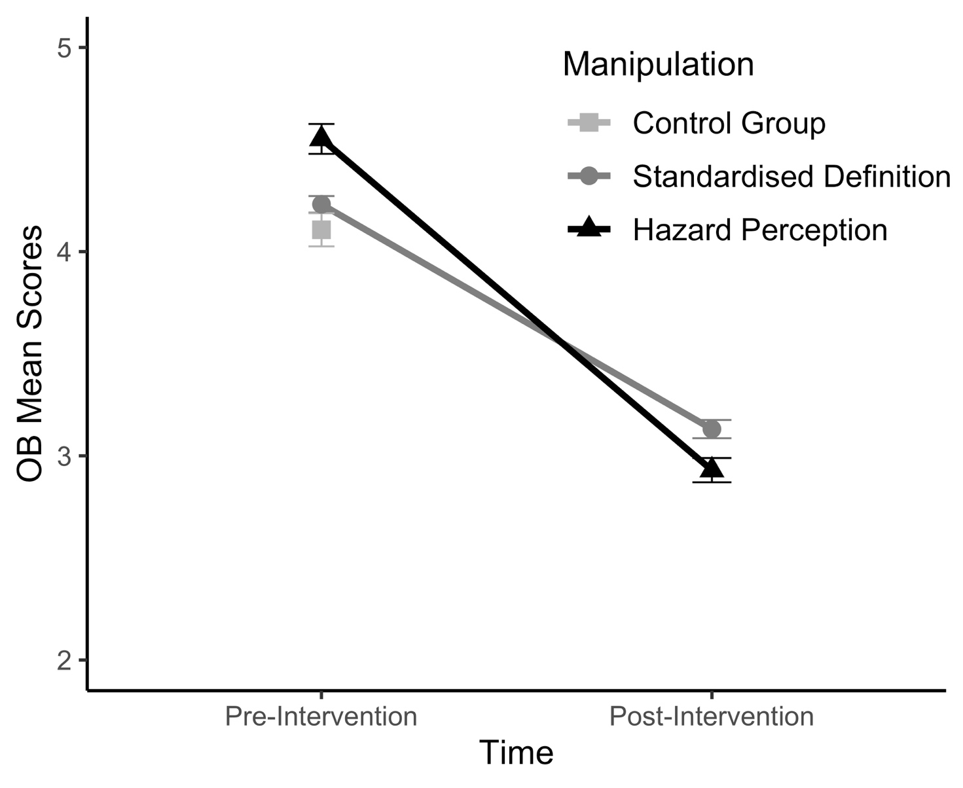
3.3. Correlations
﻿Pearson correlations were computed to explore the interrelations between past risky driving behaviours (DBQ scores) and the change in OB scores in both intervention conditions. These revealed that providing a Standard Definition produced a greater reduction in OB scores for those with lower DBQ scores (r(38)= .39, p=.013) whereas the effectiveness of the Hazard Perception training was unrelated to participants’ DBQ scores (r =(37) = -.23, p=.16; see Figure 2).
Figure 2. Scatterplot interrelations between past risky driving behaviours (DBQ scores) and the change in OB scores (post – pre-intervention), split by manipulation.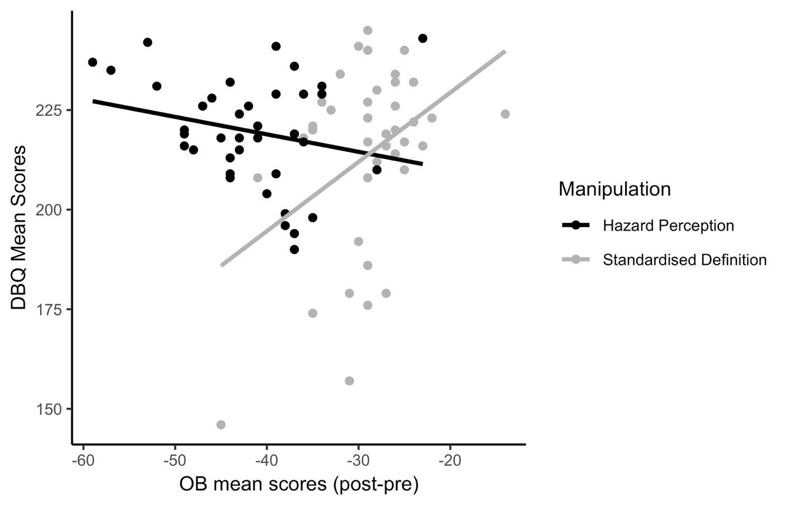

Finally, Pearson correlations examined the relationship between sensation-seeking behaviours (BSSS scores) and the change in OB scores (post – pre-intervention). These revealed that Hazard Perception training produced a greater reduction in OB scores for those with lower sensation-seeking scores (r(39)= .30, p=.06), whereas the effectiveness of the Standard Definition was unrelated to participants’ sensation-seeking scores (r(39) = -.08, p=.62; see Figure 3).

Figure 3. Scatterplot of interrelations between sensation-seeking (BSSS scores) and the change in OB scores (post – pre-intervention), split by manipulation.

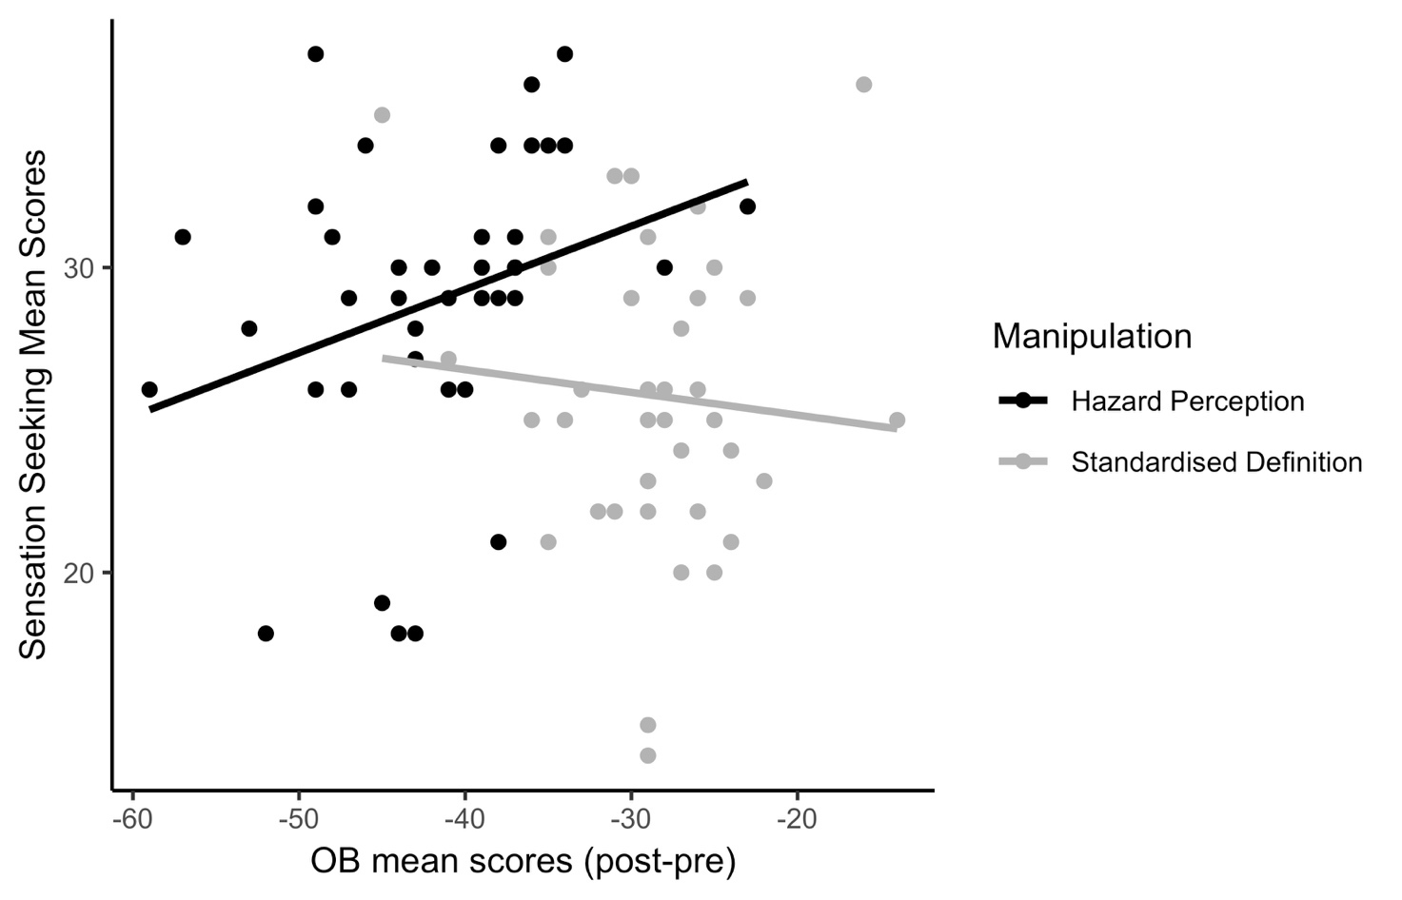

- Discussion
Previous literature has identified risky-driving behaviour, sensation-seeking, and optimism bias as the key risk factors in explaining young drivers’ overrepresentation in road traffic collisions. Yet, there is limited evidence on interventions aimed at addressing and tackling these risk factors. Indeed, while there are driving intervention programmes that have directly addressed young drivers’ risk-taking tendencies, there is a paucity of evidence regarding ways to reduce young drivers’ optimism bias. The current study was specifically designed to focus on this matter, by directly comparing the extent to which two different manipulations—an unambiguous definition of “good” driving and a hazard perception test—could improve young drivers’ optimism bias.
First, we expected that the participants, in both conditions, would display lower levels of optimism bias after the manipulation compared to before; we also predicted that in both conditions they would exhibit lower optimism bias compared to the control group. Our findings reveal that both the Standard Definition and the Hazard Perception test were effective in lowering participants’ levels of optimism bias. Indeed, both manipulations led to a decrease in optimism bias tendencies. These results are in accordance with McKenna’s (1993) and Perrissol et al.’s (2011) findings, who found that hazard perception test training could moderate participants’ levels of optimism bias in highly controlled situations. Our results also mirror Horswill et al.’s (2017), who found that hazard perception test training reduced young drivers’ self-enhancement biases of their own hazard perception ability in contrast to a control group. Correspondingly, our results are in line with previous results which showed that unambiguous definitions make it more difficult to maintain idiosyncratic ideas and thus attenuate the levels of optimism bias (Chambers, 2010; Dunning et al., 1989; Gregersen, 1996; Sedikides et al., 2002).
Our data not only provide further evidence for the effectiveness of using a brief intervention technique to address young drivers’ optimism bias, but also illustrate that even a simple intervention (i.e. reminding young drivers what the definition of good driving is or administering a hazard perception test) is sufficient to impact participants optimism bias. This has one practical implication. As novice drivers around the world often need to display a sign indicating that they are new drivers, they might also be required to post a definition of what it means to be a good driver inside the car. This can serve as a constant ‘nudge’ or a reminder. Needless to say, this possibility would require further empirical support. In addition, Sheppard et al. (2013) have suggested that just a few studies have linked optimism bias to actual behaviour, and whether optimism bias can have different behavioural consequences. Our results, therefore, increase knowledge in that direction testing whether optimism bias can be manipulated and can influence potential behaviours (or intention).
Together, our data seem to pose a challenge to Delhomme’s (2000) assertion that optimism bias is quite challenging to modify when it is associated with risk perceptions in traffic collisions. Instead, our results suggest that both manipulations led young drivers to become increasingly aware of their limited ability to drive safely compared to the average driver of the same sex and age, providing promising results regarding our ability to reduce optimism bias among this important age group.
Second, our findings demonstrate variations in the effectiveness of the two interventions depending on individual differences in optimism bias and past risky driving tendencies and sensation-seeking. That is, the standardised definition was marginally more effective in reducing optimism bias for those with lower risky driving tendencies. In addition, hazard perception produced the greatest reduction in optimism bias in individuals with lower sensation-seeking tendencies. Yet, the findings strongly suggest that the hazard perception intervention showed better promise overall, both with participants with low risky driving tendencies and high sensation-seeking. These findings add significant contributions to the idea that sensation seeking-seeking and past risky driving tendencies may be a barrier to effective educational interventions, as they are conceptualised as stable personality traits (Cross et al., 2013; Gianfranchi et al., 2017; Pizam et al., 2004; Zuckerman, 2007). Our findings suggest that these interventions may be best effective if tailored to these personalities. DBQ is likely to reflect risk taking specifically in the driving domain. Individual with high scores seem more resistant to the Standard Definition approach perhaps because the definition is most different from their current behaviour. Individuals with lower sensation-seeking scores gained most from more experiential training. One possible explanation is that these individuals are most sensitive to and ready to learn from potential hazards. More work needs to be done to understand the mechanisms underlying these findings. In fact, as this was an exploratory study on how sensation-seeking and risky driving behaviour might influence optimism bias, future research should investigate more in depth how these personality factors influence tailored road safety interventions. Nevertheless, our finding that an unambiguous definition of “good” driving can be particularly successful in decreasing optimism bias with groups who are less risky, and that hazard perception training can be particularly successful in decreasing optimism bias in groups who are less thrill-seekers, offers promise for the success of tailored behavioural intervention. In addition, it also provides insight into how different interventions could target specific population (or individuals with certain personality characteristics) to decrease young drivers’ involvement in road traffic collisions, and decrease young drivers’ levels of optimism bias.
This study has several limitations. First, the use of immediate post-intervention data could have created a response bias. To mitigate this limitation, the study used pre-validated scales to enhance the reliability of the data obtained from the participants. Nevertheless, future research would need to evaluate whether similar interventions have a long-lasting effect. At this point, we are unable to indicate how long our manipulation would last. Second, we are aware that the intervention group completed the assessment twice while the control group only completed it once – which can create the confound that the intervention group changed their optimism bias (at least partially) because the two attempts have allowed them more time to reflect on their ratings. Future studies should keep this in mind and have the control group do the assessment twice, so that the only thing that differs between them is the intervention (or the lack thereof). Third, our sample was not balanced according to gender. Previous research has found that females are safer drivers and more likely to accept the recommendation of educational interventions compared to males (Goldenbeld, Twisk & Houwing, 2008; Tay & Ozanne, 2002). Consequently, future work should focus on gender differences in the implementation of unambiguous definition of “good” driving and the other based on a hazard perception test in mitigating optimism bias. And fourth, the present investigation only measured intention and not actual driving behaviour. However, several papers have reported that a linkage between intentions and driving behaviour (Ba et al., 2016; Gianfranchi, et al., 2017), thus it possible to predict that the implications of both optimism bias, sensation seeking in driving behaviours as revealed in this work might be replicable also when considering real-on road context.
In summary, reducing risky driving behaviour, and thus collisions, offers not only the opportunity to save lives, but also to reduce injuries and financial cost. This research not only found direct effects of two different interventions in improving young drivers’ optimism bias, of tailored interventions that could be more effective towards high risk-takers and high sensation-seekers, but also provided promising results for easy and cheap interventions that could help decrease young drivers’ overrepresented in road traffic collisions. As an example, one suggestion might be that all new drivers who have would need to post in their car a sign that includes the definition of a good driver. A second possibility is that all novice drivers undergo a hazard perception training test twice a year for the first 2 years of driving. Nevertheless, while we focused solely on driver safety, it is important that future studies extend our results to other domains.

The authors declared that they had no conflicts of interest with respect to their authorship or the publication of this article.

References
Abele, L., Haustein, S., Moller, M., Martinussen, L.M., (2018). Consistency between subjectively and objectively measured hazard perception skills among young male drivers. Accident Analysis and Prevention, 118, 214-220 https://doi.org/10.1016/j.aap.2018.02.022
Abele, L., Haustein, S., Martinussen, L.M., Moller, M., (2019). Improving drivers’ hazard perception in pedestrian-related situations based on a short simulator-based intervention. Transportation Research Part F: Traffic Psychology and Behaviour, 62, 1-10 https://doi.org/10.1016/j.trf.2018.12.01o
Arnett, J.J., (1996.) Sensation seeking, aggressiveness, and adolescent reckless behavior. Personality and Individual Differences, 20, 6, 693-702.
Bergdahl, J. (2005). Sex differences in attitudes toward driving: A survey. The Social Science Journal, 42, 595–601. doi: 10.1016/j.soscij.2005.09.006
Borowsky, A., & Oron-Gilad, T. (2013). Exploring the effects of driving experience on hazard awareness and risk perception via real-time hazard identification, hazard classification, and rating tasks. Collision Analysis and Prevention, 59, 548 – 565
Causse, P., Kouabenan, D.R., & Delhomme, P., 2004. Perception du risque d’collision lié à l’alcool chez des jeunes automobilistes : quelques déterminants de l’optimisme comparatif. Le travail humain. 67, 235–256
Cestac, J., F. Paran, F., & Delhomme, P., (2011). Young Drivers’ Sensation Seeking, Subjective Norms, and Perceived Behavioral Control and Their Roles in Predicting Speeding Intention: How Risk-Taking Motivations Evolve with Gender and Driving Experience. Safety Science, 49, 424-432
Chambers, J. R., & Windschitl, P. D. (2004). Biases in social comparative judgments: The role of nonmotivated factors in above-average and comparative optimism effects. Psychological Bulletin, 130, 813–838.
Chambers, J. R. (2010). Why the parts are better (or worse) than the whole: The unique-attributes hypothesis. Psychological Science, 21, 252–259.
Cutello, C.A., Hellier, E., Stander, J., & Hanoch, Y., (2020). Evaluating the effectiveness of a young driver-education intervention: Learn2Live. Transportation Research Part F: Traffic Psychology and Behaviour. 69, 375-384. 10.1016/j.trf.2020.02.009.
Dahlen, E.R., Martin, R.C., Ragan, K. & Kuhlman, M.M., (2005). Driving anger, sensation seeking, impulsiveness, and boredom proneness in the prediction of unsafe driving. Collision Analysis and Prevention, 37, 341–348.
Del Valle, C.H.C., (2019). Cognitive profile of optimistic and pessimistic drivers attending re-education courses. Transportation Research Part F: Traffic Psychology and Behaviour, 65, 598-609 https://doi.org/10.1016/j.trf.2018.04.018
DeJoy, D.M., (1989). The optimism bias and traffic collision risk perception. Collision Analysis and Prevention. 21 (4), 333–340. http://dx.doi.org/10.1016/0001-4575(89)90024-9.
Delhomme, P., (2000). Optimisme comparatif chez les usagers de la route : une protection contre le risque ? : Bien-être subjectif et facteurs de protection. Pratiques psychologiques, (1):99-109.
Delhomme, P., Verlhiac, J.F., & Martha, C., (2009). Are Drivers' Comparative Risk Judgments about spending Realistic? Journal of Safety Research. 40, 333-9. 10.1016/j.jsr.2009.09.003.
Department of Transport. (2017). Annual Report and Accounts 2017 to 2018. Retrieved from: https://assets.publishing.service.gov.uk/government/uploads/system/uploads/attachment_data/file/74168 5/dft-annual-report-18-tagged.pdf
Dunning, D., Johnson, K., Ehrlinger, J., & Kruger, J., (2003). Why people fail to recognize their own incompetence. Current Directions in Psychological Science. 12:83 DOI: 10.1111/1467-8721.01235
Dunning, D., Leuenberger, A., & Sherman, D. A. (1995). A new look at motivated inference: Are self-serving theories of success a product of motivational forces? Journal of Personality and Social Psychology, 69(1), 58–68. https://doi.org/10.1037/0022-3514.69.1.58
Dunning, D., Meyerowitz, J. A., & Holzberg, A. D. (1989). Ambiguity and self-evaluation: The role of idiosyncratic trait definitions in self-serving assessments of ability. Journal of Personality and Social Psychology, 57, 1082–1090.
Eachus, P., (2004). Using the Brief Sensation Seeking Scale (BSSS) to predict holiday preferences. Personality and Individual Differences, 36(1), 141-153 https://doi.org/10.1016/S0191-8869(03)00074-6
Elvik, R., & Vaa, T. (2004). The Handbook of road safety measures. Amsterdam: Elsevier
﻿Fernandes, R., Job, R. F. S., & Hatfield, J. (2007). A challenge to the assumed generalizability of prediction and countermeasure for risky driving: Different factors predict different risky driving behaviours. Journal of Safety Research, 38(1), 59-70. doi: 10.1016/j.jsr.2006.09.003
Fisher, D. L., Laurie, N. E., Glaser, R., Connerney, K., Pollatsek, A., Duffy, S. A., et al. (2002). Use of a fixed-base driving simulator to evaluate the effects of experience and PC-based risk awareness training on drivers' decisions. Human Factors, 44, 287−302
Garrett, N., & Sharot, T., (2017). Optimistic update bias holds firm: Three tests of robustness following Shah et al. Consciousness and Cognition. 50, 12-22 https://doi.org/10.1016/j.concog.2016.10.013
Gianfranchi, E., Tagliabue, M., Spoto, A., & Vidotto, G. (2017). Sensation Seeking, Non-contextual Decision Making, and Driving Abilities as Measured through a Moped Simulator. Frontiers in Psychology, 1-12. https://doi.org/10.3389/fpsyg.2017.02126
Gosselin, D., Gagnon, S., Stinchcombe, A., & Joanisse, M., (2010). Comparative optimism among drivers: An intergenerational portrait. Collision Analysis and Prevention. 42. 734-40. 10.1016/j.aap.2009.11.001.
Gregersen, N. P. (1996). Young drivers' overestimation of their own skill—An experiment on the relation between training strategy and skill. Collision Analysis and Prevention, 28(2), 243–250. https://doi.org/10.1016/0001-4575(95)00066-6
Hardeman, W., Johnston, M., Johnston, M., et al. (2002) Application of the theory of planned behaviour in behaviour change interventions: A systematic review. Psychology and Health, 17, 123-158. doi:10.1080/08870440290013644a
Harré, N., & Sibley, C. G. (2007). Explicit and implicit self-enhancement biases in drivers and their relationship to driving violations and crash-risk optimism. Collision Analysis and Prevention, 39(6), 1155–1161. https://doi.org/10.1016/j.aap.2007.03.001
Hauer, E. (2007). A case for evidence-based road safety delivery. American Automobile Association Foundation for Traffic Safety
Helman, S., Kinnear, N.A.D., McKenna, F.P., Allsop, R.E., & Horswill, M.S., (2013). Changes in self-reported driving intentions and attitudes while learning to drive in Great Britain. Accident Analysis and Prevention, 59, 425-431. http://dx.doi.org/10.1016/j.aap.2013.06.038 doi: 10.1016/j.aap.2013.06.038
﻿Horswill, M. S., Waylen, A. E., & Tofield, M. I. (2004). Drivers' ratings of different components of their own driving skill: A greater illusion of superiority for skills that relate to collision involvement. Journal of Applied Social Psychology, 34(1), 177-195. doi: 10.1111/j.1559-1816.2004.tb02543.x
Horswill, M. S., Garth, M., Hill, A., & Watson, M. O. (2017). The effect of performance feedback on drivers' hazard perception ability and self-ratings. Accident Analysis and Prevention, 101, 135-142. doi:10.1016/j.aap.2017.02.009
Hoyle, R., Stephenson, M., Palmgreen, P., Lorch, E., & Donohew, L., (2002). Reliability and Validity of a Brief Measure of Sensation Seeking. Personality and Individual Differences. 32. 401-414. 10.1016/S0191-8869(01)00032-0.
Iversen, H. & Rundmo, T. (2002). Personality, risky driving and collision involvement among norwegian drivers. Personality and Individual Differences, 33, 1251–1263.
﻿Jonah, B.A., Thiessen, R., & Au-Yeung, E. (2001.) Sensation seeking, risky driving and behavioral adaptation. Collision Analysis and Prevention, 33, 679-684.
Kinnear, N., Kelly, S. W., Stradling, S., & Thomson, J. (2013). Understanding how drivers learn to anticipate risk on the road: A laboratory experiment of affective anticipation of road hazards. Accident Analysis and Prevention, 50, 1025– 1033. Retrieved from http://dx.doi.org/10.1016/j.aap.2012.08.008 doi: 10.1016/j.aap.2012.08.008
King, K.A., Vidourek, R.A., Love, J., Wegley, S., Alles-White, M. (2008). Teaching adolescents safe driving and passenger behaviours: Effectiveness of the You Hold the Key Teen Driving Countermeasure. Journal of Safety Measure, 39, 19 – 24
﻿Kreuter, M., & Strecher, V.J., (1995). Changing inaccurate perceptions of health risk: results from a randomized trial. Health Psychology 14, 56–61 10.1037//0278-6133.14.1.56
Kruger, J., & Dunning, D. (1999). Unskilled and unaware of it: How difficulties in recognizing one's own incompetence lead to inflated self-assessments. Journal of Personality and Social Psychology, 77(6), 1121–1134. https://doi.org/10.1037/0022-3514.77.6.1121
Kweon, Y.-j., & Kockelman, K. M. (2006). Driver Attitudes and Choices: Speed Limits, Seat Belt Use, and Drinking-and-Driving. Journal of the Transportation Research Forum, 45(3), 39–56.
Laapotti, S., & Keskinen, E., (2004). Has the difference in accident patterns between male and female drivers changed between 1984 and 2000 ? Accident Analysis and Prevention, 36, 577–584. doi: 10.1016/S0001-4575(03)00064-2
Mairen, C., & Havarneanu, C.E., (2018). The relationship between drivers’ illusion of superiority, aggressive driving, and self-reported risky driving behaviors. Transportation Research Part F: Traffic Psychology and Behaviour. 5, 167-174 https://doi.org/10.1016/j.trf.2018.02.037
McKenna, F. P. (1993). It won't happen to me: Unrealistic optimism or illusion of control? British Journal of Psychology, 84(1), 39–50. https://doi.org/10.1111/j.2044-8295.1993.tb02461.x
McKenna, F.P., & Myers, L.B. (1997). Illusory self-assessments- Can they be reduced? British Journal of Psychology, 88 (1) 39-51.
Mckenna, F. P., & Farrand, P. (1999). The role of Automaticity in Driving (G. Grayson,
Ed.). Crowthrone: Transport Research Laboratory.
McKenna, F. P. (2010). Education in road safety. Are we getting it right? Report number 10/113. RAC Foundation
Mynttinen, S., Sundström, A., Koivukoski, M., Hakuli, K., Keskinen, E., & Hen- riksson, W. (2009). Are novice drivers overconfident? A comparison of self- assessed and examiner-assessed driver competences in a Finnish and Swedish sample. Transportation Research Part F: Traffic Psychology and Behaviour. doi: 10.1016/j.trf.2008.09.002
Nelson, E., Leibenluft, E., McClure, E., & Pine, D., (2005). The social re-orientation of adolescence: A neuroscience perspective on the process and its relation to psychopathology. Psychological Medicine. 35, 163–174.
O'Neal, E., & Plumert, J., (2018). How do parents teach children to cross roads safely? a study of parent-child road-crossing in an immersive pedestrian simulator. Injury Prevention, 24:A17-A18. 10.1136/injuryprevention-2018-safety.48.
Parker, D., Reason, J. T., Manstead, A. S., & Stradling, S. G. (1995). Driving errors, driving violations and accident involvement. Ergonomics, 38(5), 1036-1048. https://doi.org/10.1080/00140139508925170
Person, M., Murphy, E., & Doane, A., (2013) Impulsivity-like Traits and Risky Driving Behaviors among College Students. Collision Analysis and Prevention. 54, 142-148. 10.1016/j.aap.2013.01.009.
Perrissol, S., Smeding, A., Laumond, F., & Le Floch, V., (2011). Effect of a road safety training program on drivers' comparative optimism. Collision Analysis and Prevention. 43. 478-82. 10.1016/j.aap.2010.08.023.
Pizam, A., Jeong, G.-H., Reichel, A., van Boemmel, H., Lusson, J. M., Steynberg, L., … Montmany, N. (2004). The Relationship between Risk-Taking, Sensation-Seeking, and the Tourist Behavior of Young Adults: A Cross-Cultural Study. Journal of Travel Research, 42(3), 251–260. https://doi.org/10.1177/0047287503258837
Poulter, D., & McKenna, F., (2010). Evaluating the effectiveness of a road safety education intervention for pre-drivers: An application of the Theory of Planned Behaviour. British Journal of Educational Psychology, 80, 163-181
Primi, C., Narducci, R., Benedetti, D., Donati, M., Chiesi, F., (2011). Validity and reliability of the italian version of the brief sensation seeking scale (BSSS) and its invariance across age and gender. TPM-Testing, Psychometric, Methodology in Applied Psychology, 18, 231-241
Reason, J., Manstead, A., Stradling, S., Baxter, J., & Campbell, K. (1990). Errors and violations: a real distinction? Ergonomics, 33, 1315-1332.
Roy, M., & Liersch, M., (2013). I Am a Better Driver Than You Think: Examining Self-Enhancement for Driving Ability. Journal of Applied Social Psychology. 43. 10.1111/jasp.12117.
Schwebel, D., Severson, J., Ball, K., & Rizzo, M., (2006). Individual difference factors in risky driving: The roles of anger/hostility, conscientiousness, and sensation-seeking. Collision Analysis and Prevention, 38, 801-10. 10.1016/j.aap.2006.02.004.
Sheppard, J., Klein, W., Waters, E.A., & Weinstein, N. D., (2013). Taking Stock of Unrealistic Optimism. Perspectives on Psychological Science, 8(4) ﻿395-411 10.1177/1745691613485247.
Stephenson, M.T., Hoyle, R.H., Palmgreen, P., Slater, M.D., (2003). Brief measures of sensation seeking for screening and large-scale surveys. Drug and Alcohol Dependence, 72(3), 279-286 https://doi.org/10.1016/j.drugalcdep.2003.08.003
Ulleberg, Pål. (2001). Personality subtypes of young drivers. Relationship to risk-taking preferences, collision involvement, and response to a traffic safety campaign. Transportation Research Part F: Traffic Psychology and Behaviour, 4, 279-297 10.1016/S1369-8478(01)00029-8.
Underwood, G. (2007). Visual attention and the transition from novice to advanced driver Ergonomics, 50, 1235–1249
Vallone, D., Allen, J.A., Clayton, R.R., Xiao, H., (2007). How reliable and valid is the Brief Sensation Seeking Scale (BSSS-4) for youth of various racial/ethnic groups? Addiction, 102 (2), 71-78 doi:10.1111/j.1360-0443.2007.01957.x
Wagner, M., (2001). Behavioral characteristics related to substance abuse and risk-taking, sensation-seeking, anxiety sensitivity, and self-reinforcement. Addictive Behaviors, 26, 115-20. 10.1016/S0306-4603(00)00071-X.
Weinstein, N. D. (1980). Unrealistic optimism about future life events. Journal of Personality and Social Psychology, 39(5), 806–820. https://doi.org/10.1037/0022-3514.39.5.806
Weinstein, N.D., (1984). Why it won’t happen to me: perceptions of risk factors and susceptibility. Health Psychology 3, 431–457. DOI: 10.1037//0278-6133.3.5.431
Weinstein, N.D., & Klein, W.M., (1996). Unrealistic optimism: present and future. Journal of Social and Clinical Psychology. 15 (1), 1–8. http://dx.doi.org/10.1521/jscp.1996.15.1.1.
Wåhlberg, A. E., Dorn, L., & Kline, T. (2010). The effect of social desirability on self-reported and recorded road traffic accidents. Transportation Research Part F: Traffic Psychology and Behaviour, 13(2), 106-114. https://doi.org/10.1016/j.trf.2009.11.004
White, M.J., Cunningham, L.C., & Titchener, K., (2011). Young drivers’ optimism bias for collision risk and driving skill: Accountability and insight experience manipulations. Collision Analysis and Prevention. 43(4), 1309-1315 https://doi.org/10.1016/j.aap.2011.01.013
WHO (2019). Road traffic injury report. Retrieved from: https://www.who.int/news-room/fact-sheets/detail/road-traffic-injuries
Williams, A. F. (2006). Young driver risk factors: Successful and unsuccessful approaches
for dealing with them and an agenda for the future. Injury Prevention,
12(SUPPL. 1), 4–8. doi: 10.1136/ip.2006.011783
Williams, A. F., Ferguson, S. A., & McCartt, A. T. (2007). Passenger effects on teenage
driving and opportunities for reducing the risks of such travel. Journal of Safety Research,
38(4), 381–390. doi: 10.1016/j.jsr.2007.03.009
Zuckerman, M. (2007). Sensation seeking and risky behavior. American Psychological Association. https://doi.org/10.1037/11555-000
Zuckerman, M. (1994). Behavioral expressions and biosocial bases of sensation seeking. Cambridge, MA: Cambridge University Press.

