Iterative envelope mean fractal dimension filter for the separation of crackles from normal breath sounds

Ravi Pal, Anna Barney
Institute of Sound and Vibration Research (ISVR), University of Southampton, Southampton, United Kingdom

Abstract— This paper presents a new method of separating pulmonary crackles from normal breath sounds: the iterative envelope mean fractal dimension (IEM-FD) filter. Crackles are an important physiological parameter for evaluating lung condition of an individual and their automatic separation from normal breath sounds can provide an objective way of diagnosing or monitoring different cardiopulmonary diseases. The filter combines the new iterative envelope mean (IEM) method with the established fractal dimension (FD) technique. The IEM method estimates the non-stationary and stationary parts of the lung sound signal and then the FD technique is applied to the estimated non-stationary output of the IEM method for further refining the separation process. The IEM-FD filter is tested using a publicly available dataset and, compared with an established crackle separation technique. The IEM-FD achieves high accuracy for crackle detection in the presence of noise with SNR >= -1 dB for fine crackles and SNR > +1 dB for coarse crackles, and has low computational cost, with minimal under- or over-estimation and good preservation of crackle morphology. The method is shown to have an overall performance suitable for automated analysis to determine accurately the number and characteristics of pulmonary crackles in a recorded lung sound.

Keywords— Crackles, Normal breath sounds, Iterative envelope mean fractal dimension (IEM-FD) filter.

1. Introduction
In this paper, we present a new method for separating pulmonary crackles from normal breath sounds.
During breathing, turbulence in the large airways induces vibrations in the airway walls which are transmitted through the lung tissue and chest wall. These sounds are referred to as normal breath sounds and include bronchial sounds, bronchovesicular sounds and vesicular sounds. Crackles are discontinuous, non-harmonic lung sounds, superimposed on the normal breath sounds, which can be an indication of lung abnormality or pulmonary disease [1]. Crackles are thought to be generated by the sudden opening or closing of airways [2, 3]. Normal breath sounds and crackles are both audible through a stethoscope placed against the wall of the thorax.
Crackles are generally described as explosive sounds, being of short time duration, typically 20 ms or less, and having broad frequency content ranging from 100 to 2000 Hz or even higher [4]. They may be characterized into fine (high pitched) and coarse (low-pitched) based on their time domain features including their initial deflection width (IDW), two cycle deflection width (2CD) and, occasionally, largest deflection width (LDW) [5]. According to the American Thoracic Society, fine crackles have on average IDW = 0.7 ms and 2CD = 5 ms, whereas coarse crackles have on average IDW = 1.5 ms and 2CD = 10 ms [5]. Fine crackles are usually heard in the mid to late inspiratory breath phase and are thought to be generated by the explosive opening of small airways [6]. Coarse crackles are thought to be generated due to air bubbling through sputum in larger airways and can be heard in the early inspiratory and also the expiratory breath phase [7].
Fine crackles may be related to congestive heart failure, lung fibrosis and pneumonia whereas coarse crackles are associated with chronic obstructive pulmonary disease, chronic bronchitis and bronchiectasis. The timing, number and place of generation of pulmonary crackles has been shown to vary with the underlying disease and with its severity. Crackle characteristics can therefore be used in diagnosis and in monitoring of disease progression [8].
Auscultation with a conventional stethoscope placed against the exterior chest wall can be used to identify the presence of crackles, but this approach is subjective and assessment of the number of crackles present and identification of their type (fine or coarse) is highly dependent on clinician hearing ability and expertise. More recently, electronic stethoscopes have offered the facility to record lung sounds and many methods for automatic processing have been developed [9].
As an initial processing stage, automatic separation of crackles from normal breath sounds can lead to better crackle characterization. On the timescale of a crackle (typically 10-20 ms) normal breath sounds may be considered quasi-stationary and therefore separation into estimates of the non- stationary and stationary elements of a lung sound signal generally sends crackle components to the non-stationary signal estimate and the majority of components associated with normal breath sounds to the stationary signal estimate. Separation can reveal not only large amplitude crackles but also small amplitude crackles, which are often significantly masked by the normal breath sounds. Many recent studies have reported development and testing of such separation methods.
Visual Time Expanded Waveform analysis (VTEWA) [10] can be used to identify crackles from the time domain lung sound signal, but this approach is subjective, time consuming and has high inter-observer variability [11], and therefore automated techniques are preferred.
Level slicers and high pass filters (LS & HPFs) can separate crackles from normal breath sounds to some extent, but these methods are insufficient for separating out small amplitude crackles and further, can distort the crackle signal in the process. Katila et al. [12] presented a case study of the effect of high pass filtering on the morphology of crackles. It was observed that both the high pass filter cut-off frequency and the filter type influenced the crackle waveform.
Hadjileontiadis et al. [13] proposed the wavelet transform stationary non-stationary (WTST-NST) filter. This method is based on an iterative multiresolution decomposition and multiresolution reconstruction (MRD-MRR) scheme, which separates the stationary and non-stationary parts of a signal. The WTST-NST filter can be used to separate crackles from breath sounds on the basis that explosive events in the time domain, such as crackles, have large components at many wavelet scales whereas the components due to relatively stationary signals, such as breath sounds, reduce with increasing wavelet scale. This allows separation, through their amplitude, of wavelet transform coefficients related to crackles from those related to normal breath sounds at each wavelet scale using some threshold value. At each wavelet scale, the threshold value is based on the standard deviation of the wavelet transform coefficients and an empirical multiplication factor. This method can achieve separation with all crackle signals directed to the non-stationary output in most cases, but the morphology of the crackles is not generally well preserved. Further, its computational complexity makes the WTST-NST unsuitable for clinical applications where high processing speed is advantageous [11, 14].
The wavelet transform fractal dimension (WT-FD) filter [15, 16] has comparable outcomes to the WTST-NST filter for locating the crackle peaks, but is somewhat better at preserving the morphology of the extracted crackles [16]. In applying the WT-FD filter, firstly, the input signal is decomposed into approximation and detail coefficient vectors using the WT and then the FD technique [17] is applied to the approximation and detail coefficient vectors to separate the WT coefficients related to crackles from those related to normal breath sounds. Although this method separates both fine and coarse crackles into the non-stationary output with high sensitivity [16], the choice of base wavelet and number of WT decomposition scales is critical to its success in separating the crackles [18]. A need to optimize these parameters for any given data set prior to use in a clinical setting would be less than ideal.
More recently, Hadjileontiadis [18] proposed the empirical mode decomposition fractal dimension (EMD-FD) filter. In this method, firstly the input signal is adaptively decomposed into multiple intrinsic mode functions (IMFs) and a residual component using the EMD technique [19]. Next, an energy-based threshold is used for selecting the number of IMFs containing significant elements of crackle sound and then, on those selected IMFs, the FD technique [17] is applied to further refine the separation to leave just the crackles. EMD-FD was shown to perform comparably to WT-FD, but with the advantage that, since, unlike WT-FD, EMD has no underlying assumption of orthogonality, it can be applied to both linear and non-linear data. Further, as a data driven process the number of a priori parameter choices is minimized whereas for the WT-FD filter the choice of wavelet and number of scales must be made in advance of processing. In addition, EMD-FD was shown to be robust against the presence of extraneous environmental noise. However, the selection of the number of independent mode functions containing crackle information requires the setting of an empirical threshold. Use of too many IMFs may add components of normal breath sound to the separated signal (over estimation) whereas too few may result in crackles missing from the separated signal (under-estimation) or in distorted crackle morphology. We note also that EMD is, in general, a rather slower analysis method that WT due to its relatively high computational complexity.
Other automated methods such as the stationary non-stationary (ST-NST) filter [20], mST-NST filter [21], fuzzy stationary non-stationary (FST-NST) filter [22], generalized fuzzy stationary non-stationary (GFST-NST)) filter [11], orthogonal least square fuzzy (OLSF) filter [23], the wavelet packet transform (WPT) filter [24], neurofuzzy filter [14], and Independent component analysis (ICA) [25] have also all been proposed for automatic crackle separation. Although, these methods can provide crackle separation with low computational cost, they do so with reduced sensitivity or lower quality in the reconstruction of the crackle morphology. A summary of the strengths and weaknesses of each method is given in Table 1.
Table 1
Technical characteristics for good crackle separation compared for different published separation methods.
Methods | ACC | UOE | POC | CCX | NRB | OBJ
VTEWA [10] | + | x | x | -- | -- | --
LS & HPFs [12] | - | - | -- | + | x | +
ST-NST [20] | - | - | - | x | x | --
mST-NST [21] | + | x | x | x | + | --
WTST-NST [13] | + | + | - | - | + | -
WT-FD [15, 16] | ++ | + | + | + | + | -
EMD-FD [18] | + | + | + | -- | + | --
FST-NST [22] | + | + | - | + | x | -
GFST-NST [11] | + | + | - | + | x | -
OLSF [23] | + | + | - | + | x | -
Neurofuzzy filter [14] | + | x | x | + | x | -
WPT [24] | + | x | x | + | + | -
ICA [25] | + | x | x | x | x | -
ACC: Accuracy (number of crackles correctly separated); UOE: Under-, over-estimation; POC: Preservation of crackle morphology; CCX: Analysis speed (computational complexity); NRB: Robustness to additive/environmental noise; OBJ: Objectivity (need to set hard thresholds and/or make decisions about process based on the data and/or requirement of training phase for estimation of the optimum model parameters); ++ = strong attribute; + = acceptable attribute; - = weak attribute; - - = very weak attribute; x = attribute not reported.
Latterly, separation has received less emphasis as machine learning systems have been tested for classification of lung sounds without this pre-processing step (e.g. [26]). However, such systems might have their ability to classify accurately enhanced by using separation as a pre-processing step.
Auscultation of pulmonary crackles has been used in clinical assessment of patients for diagnosis and for monitoring of disease progression for many years. For diagnosis, an initial consideration may be the presence or absence of an unusual number of crackles [27, 28]. This assessment may be confounded by the increased prevalence of crackles with age in the healthy population [29]. Further, low amplitude crackles may frequently be masked by the breath noise leading to an underestimate of the true number. Thus, an accurate assessment of the number of crackles present can assist with the diagnostic decision. In a clinical environment, background noise may also be a problem in aural assessment of crackles [30, 31, 32] so a system robust to added noise is also preferred. New methods may be more readily adopted clinically when they adapt traditional auscultation methods [33], especially if they can be carried out at the same time as traditional auscultation or with limited additional time commitment [34]. Differential diagnosis between lung conditions may be additionally facilitated by classification of the crackles into fine and coarse or by inspection of the crackle morphology in the recorded sound signal [35, 36]. This requires an analysis process which gives a representation of the crackle with minimal distortion to allow its temporal characteristics to be accurately measured. For monitoring, number, classification as coarse or fine and crackle morphology are again critical parameters [37, 38]. An optimal process for crackle separation should therefore have high accuracy for the number of crackles detected, high robustness to noise, low computational complexity (high processing speed), separation without significant under- or over-estimation of the crackle waveform and the ability to preserve crackle morphology after separation.
Respiratory monitoring remains a current clinical interest [39, 40]. Building on a concept initially developed by Murphy et al. [41], many recent studies (e.g. [42]) have considered multi-channel recordings and analysis to identify the presence of abnormal lung sounds. Garcia et al. [25] have recently used Independent Component Analysis (ICA) on a 25 channel recording system to separate crackles from normal breath sounds. However, the specialist equipment required for a multichannel approach differs substantially from the traditional stethoscope, ubiquitous in a clinical setting, leading to poor uptake of such devices in practice. The simplicity of processes that align with well-established auscultation techniques are therefore to be preferred.
In this paper, we present a new automatic single channel crackle separation technique known as the iterative envelope mean fractal dimension (IEM-FD) filter. The iterative envelope mean (IEM) method divides a signal into initial estimates of its stationary and non-stationary parts. The FD technique [17], applied to the non-stationary signal estimate, removes further elements related to normal breath sounds to refine the separation. To evaluate our new method, we compare it with, the WT-FD filter [15, 16]. The WT-FD filter was used for comparison due to its high accuracy for the number of crackles detected, shown in [16] to be 100 % in both fine and coarse crackles, and good ability to meet the other advantageous criteria.
The rest of the paper is arranged as follows. Section 2 describes the IEM-FD filter. Section 3 presents the test dataset and the quantitative evaluators used to assess the outcome and Section 4 details the parameters selected for the separation filters. The experimental results are presented in Section 5 where a comparison is made with WT-FD performance on the same dataset. Section 6 presents the discussion of results and Section 7 the conclusions.
2. Iterative envelope mean fractal dimension filter
The IEM-FD filter combines two techniques: the new IEM method and the more established FD technique [17]. The IEM
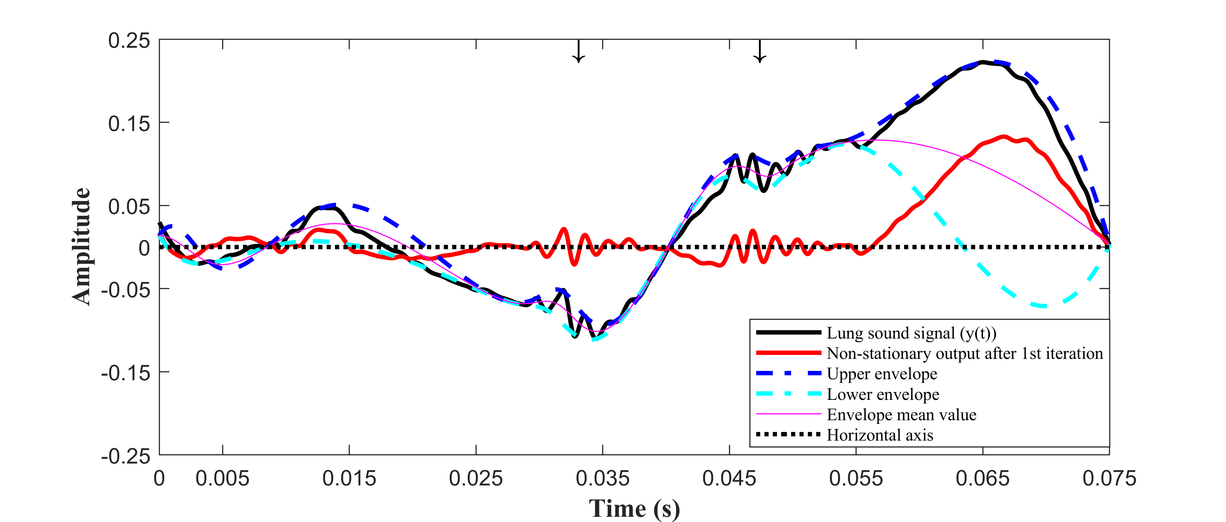
(a)
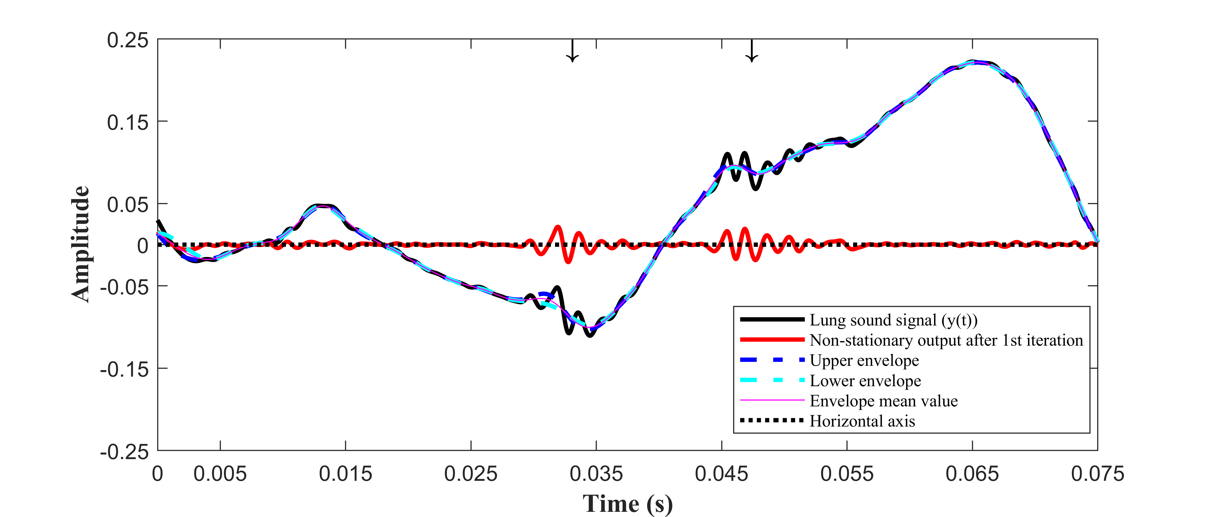
(b)
Fig. 1. Illustration of the iterative envelope mean method applied to a section of 0.075 s of lung sound data recorded from a patient with idiopathic pulmonary fibrosis; (a) estimation of the upper, lower and mean envelopes and the non-stationary signal estimate after one iteration using extrema points of the smoothed lung sound signal; (b) estimation of the upper, lower and mean envelopes and the non-stationary signal estimate after one iteration using extrema locations of the first derivative of the smoothed lung sound signal.

method estimates the stationary and non-stationary parts of the lung sound signal and, the FD technique is then applied to the non-stationary output of the IEM method to refine the separation process further.
2.1. Iterative envelope mean method
The lung sound signal is a combination of normal breath sounds and any added sounds, such as crackles, and is typically recorded over between three and twenty breath cycles depending on respiratory rate and recording duration. The IEM method subtracts the envelope mean value of the smoothed lung sound signal from the original lung sound signal. The envelope mean signal is the mean of the upper and lower envelopes of the smoothed lung sound signal. The resulting signal can then be used as the input for a subsequent iteration. After a number of iterations, Q, the IEM method will provide an estimate of the non-stationary part of the lung sound signal and also, through the summation of the envelope means from each iteration, an estimate of its stationary part.
In detail, the IEM method proceeds as follows: In the first step, a smoothed version of the lung sound signal is generated and its first and second derivatives are calculated using a filter from the Savizky-Golay (SG) family. The SG filter parameters are selected according to the guidelines proposed by Vannuccini et al. [43] with degree of fitting polynomial $p_{f}$= 4 and number of coefficients$n_{c}$ equal to approximately one to two times the half-width of the shortest-duration feature of interest in the signal. In the case of crackles, the first cycle of the crackle is the shortest cycle and generally has a duration of less than 2 ms. In our data, where the sampling frequency of the lung sound signal is 44,100 Hz, the half width is less than 88 samples. The SG filter parameters used here are therefore $p_{f}$= 4, $n_{c}$ = 89 and order of derivation ($d_{o}$) = 0, 1 and 2 for smoothing the lung sound signal, and for estimating first and second derivative of that smoothed signal, respectively.
Next all the local extrema of the first derivative ($y_{s}^{'}\left(n\right)$) are identified and classified as maxima or minima using sign changes over the second derivative ($y_{s}^{''}\left(n\right)$) of the smoothed lung sound signal ($y_{s}\left(n\right)$).
The coordinates of the smoothed lung sound signal at the location of each of the first derivative local maxima and minima are then calculated. A cubic spline interpolation is used to connect the maxima in the smoothed lung sound signal to define the upper envelope (${UP}_{env}(n)$), and correspondingly, the local minima are connected with each other to extract the lower envelope (${Lw}_{env}\left(n\right)$). The envelope mean value is then calculated using the estimated upper and lower envelopes of the smoothed lung sound signal:
$$m_{q}\left(n\right)=\frac{{{UP}_{env}}_{q}\left(n\right)+{{LW}_{env}}_{q}(n)}{2}$$ | (1)

where n is the sample index in the input signal i.e. n = 1, 2, ….N and q is the iteration number where q=1, 2,…, Q. The envelope mean value is then subtracted from the lung sound signal to get an estimate of the non-stationary signal$R_{q}(n)$:
$$R_{q}\left(n\right)=y_{q}\left(n\right)-m_{q}(n)$$ | (2)

where $y_{q}\left(n\right)$ is the lung sound signal at iteration q.
Note that for each iteration, q, the envelope mean value is calculated using the smoothed lung sound signal ($y_{s_{q}}\left(n\right)$), and its derivatives, which is then subtracted from the un-smoothed lung sound signal $y_{q}\left(n\right)$.
To end the iterative process, a stopping criterion STC1_{q} is calculated:
$${STC1}_{q}=|E\left\{R_{q-1}^{2}\left(n\right)\right\}-E\left\{R_{q}^{2}\left(n\right)\right\}|$$ | (3)

where $E\{.\}$ is the expected value and has an initial value of $R_{q-1} = 0.$
The stopping criterion ($STC1_{q}$) is compared with accuracy level$β1$: {1 >$β1$> 0}. In this study the value of $β1$ is empirically set equal to 0.01.
If ${STC1}_{q}≥β1$, a new input lung sound signal $y_{q+1}\left(n\right)=R_{q}\left(n\right)$ is defined and the process is repeated (usually one or two iterations are sufficient (see Table 3). Note that for the IEM method the stopping criterion is the same as that defined in [13], [15], [17] and [18].
When the stopping criterion is met, the estimates of the non-stationary and stationary parts of the lung sound signal are calculated using equations (4) and (5), respectively where Q is the total number of iterations made:
$$NSTS\left(n\right)= R_{Q}(n)$$ | (4)
$$STS\left(n\right)=\sum_{q=1}^{Q}{m_{q}}(n)$$ | (5)
Note that the first derivative local maxima and minima locations on the smoothed lung sound signal are used for estimating the upper and lower envelopes rather than using local maxima and minima points directly from the smoothed lung sound signal. If the upper and lower envelopes, using local maxima and minima of the smoothed lung sound signal itself are used, an inefficiency arises. The upper and lower envelopes can have large separation for regions with infrequently occurring extrema points (low frequency variation), which may require a large number of iterations for separating the lung sound signal. Using instead the upper and lower envelopes derived from the local maxima and minima of the first derivative of the smoothed lung sound signal reduces this inefficiency and consequently the number of iterations needed.
As an example, Fig. 1 shows a section of duration 0.075 s of a lung sound signal recorded from a patient with idiopathic pulmonary fibrosis (Table 2, Case RBFC) where the location of the crackles has been audio-visually identified by an experienced pulmonary acoustics researcher and marked with arrowheads. Fig. 1 (a) displays the non-stationary output of the IEM process after the 1st iteration, the upper and lower envelopes and the envelope mean value where upper and lower envelopes are estimated using directly the smoothed lung sound signal extrema points. It can be observed that between 0.055 s and 0.075 s, the separation between the upper and lower envelopes is large. As a result, when the envelope mean value is subtracted from the lung sound signal that region changes its shape but the non-stationary output not only contains the crackles but also consists of a large portion of normal breath sound after the first iteration. On the other hand, in Fig. 1(b) where upper and lower envelopes are estimated using the first derivative local maxima and minima locations on the smoothed lung sound signal, we observe that the envelope mean is a closer fit to the lung sound signal and when it is subtracted, the contribution of normal breath sound to the non-stationary estimate is very much less. Note that the lung sound signal is smoothed using the SG filter prior to calculating the upper and lower envelopes to remove the impulsive spikes without affecting the crackle waveform.
Huang et al. [19] proposed the EMD technique for adaptively decomposing a signal into its IMFs and a residual component in decreasing order of frequency. Although the IEM method is superficially similar to the EMD method in that processing of each iteration begins with an estimation of the upper and lower envelopes of a signal based on the local extrema, which is then subtracted from the input signal, there are distinct differences between the two methods. In particular, the EMD method continues each iteration until the output meets the strict criteria that define an IMF [19] whereas the IEM method ceases when the stopping criterion (3) reduces to the required precision.
2.2. Fractal dimension technique
The IEM method makes a good estimate of the stationary and non-stationary parts of the lung sound signal as can be seen from Fig. 2(b), however it is not usually sufficient by itself to ensure optimal separation. To minimise the remaining elements of normal breath sounds in the non-stationary signal estimate ($NSTS\left(n\right)$) the FD technique is applied following the same steps as described [17]. For our study the sampling frequency of the non-stationary signal estimate is $f_{s}$= 44,100 Hz and using a multiplication factor $m_{f}$= 0.006 following [17], the length of the fractal dimension window$W_{FD}=264$ samples.

2.3. Iterative envelope mean fractal dimension filter
The IEM-FD filter is implemented using the IEM method followed by the FD technique. Two iteration loops are used in the IEM-FD filter: a loop related to IEM method q=1, 2,…, Q, and a loop for the combination of the IEM- and FD processes k=1, 2,…, K.
The IEM-FD filter working process is shown in Fig. 2. First the IEM method estimates the non-stationary ($NSTS\left(n\right)$) (see Fig 2(b)) and stationary ($STS\left(n\right)$) parts of the lung sound signal. Next point-to-point FD values of the estimated non-stationary output are calculated and the fractal dimension peak peeling ($FDPP$) algorithm [17] is applied to automatically detect those peaks of the estimated $FD(n)$ which may correspond to crackles (Fig. 2(c)). Then, using the estimated FDPP sequence, two binary thresholds are calculated: the non-stationary binary threshold:
$${NBTH}^{k}\left(n\right)=\left\{\begin{aligned}1 if {FDPP}^{k}\left(n\right)≠1 \\ 0 if{FDPP}^{k}\left(n\right)=1\end{aligned}\right\}$$ | (6)

and the stationary binary threshold :
${SBTH}^{k}(n)$ = [1- ${NBTH}^{k}(n)$] | (7)

as displayed in Fig. 2(d) and Fig. 2(e), respectively.
The non-stationary output of the IEM method is multiplied by non-stationary binary threshold $NBTH\left(n\right)$ to get the refined non-stationary estimate $NST\left(n\right)$ and the non-stationary estimate of the IEM method is multiplied by $SBTH\left(n\right)$ to obtain the remaining normal breath sound signal $SSR(n)$ from the $NSTS\left(n\right)$:
The summation of the STS (5) and the SSR gives the estimate of the stationary output, ${SSF}^{k}\left(n\right)$ of the IEM-FD filter at iteration k.
To end the IEM-FD filter, a stopping criterion based on the stationary output can be calculated and compared with accuracy level ($β2$).
The stopping criterion:
$${STC2}^{k}=\left|E\left\{{\left({SSF}^{k-1}\right)}^{2}\left(n\right)\right\}-E\left\{{\left({SSF}^{k}\right)}^{2}\left(n\right)\right\}\right|$$ | (8)
where $E \left\{.\right\}$ is the expected value and the initial value of ${SSF}^{k-1}=0$. STC2^{k} is compared with accuracy level $β2,$ where, 1 >$β2$> 0. If ${STC2}^{k}≥β2$, input signal$y^{k+1}\left(n\right)={SSF}^{k}\left(n\right)$, otherwise $k$ = $K$ and the iterative loop ends. Here the value of the $β2$ is empirically set equal to 0.1 and $K$ represents
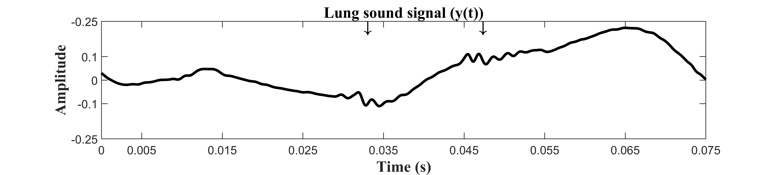
(a)
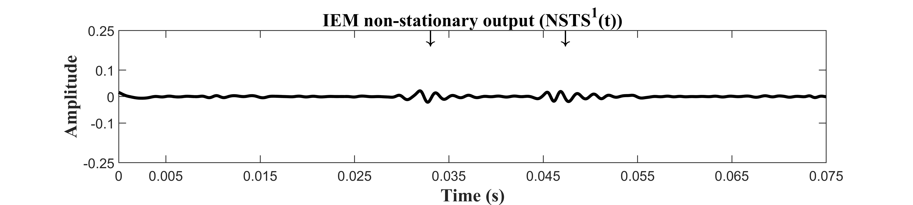
(b)
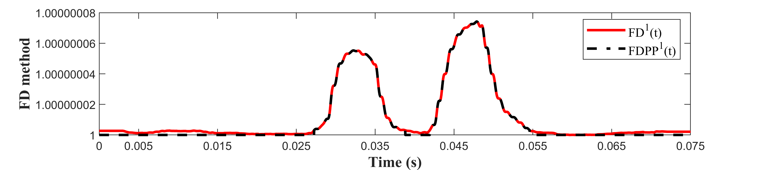
(c)
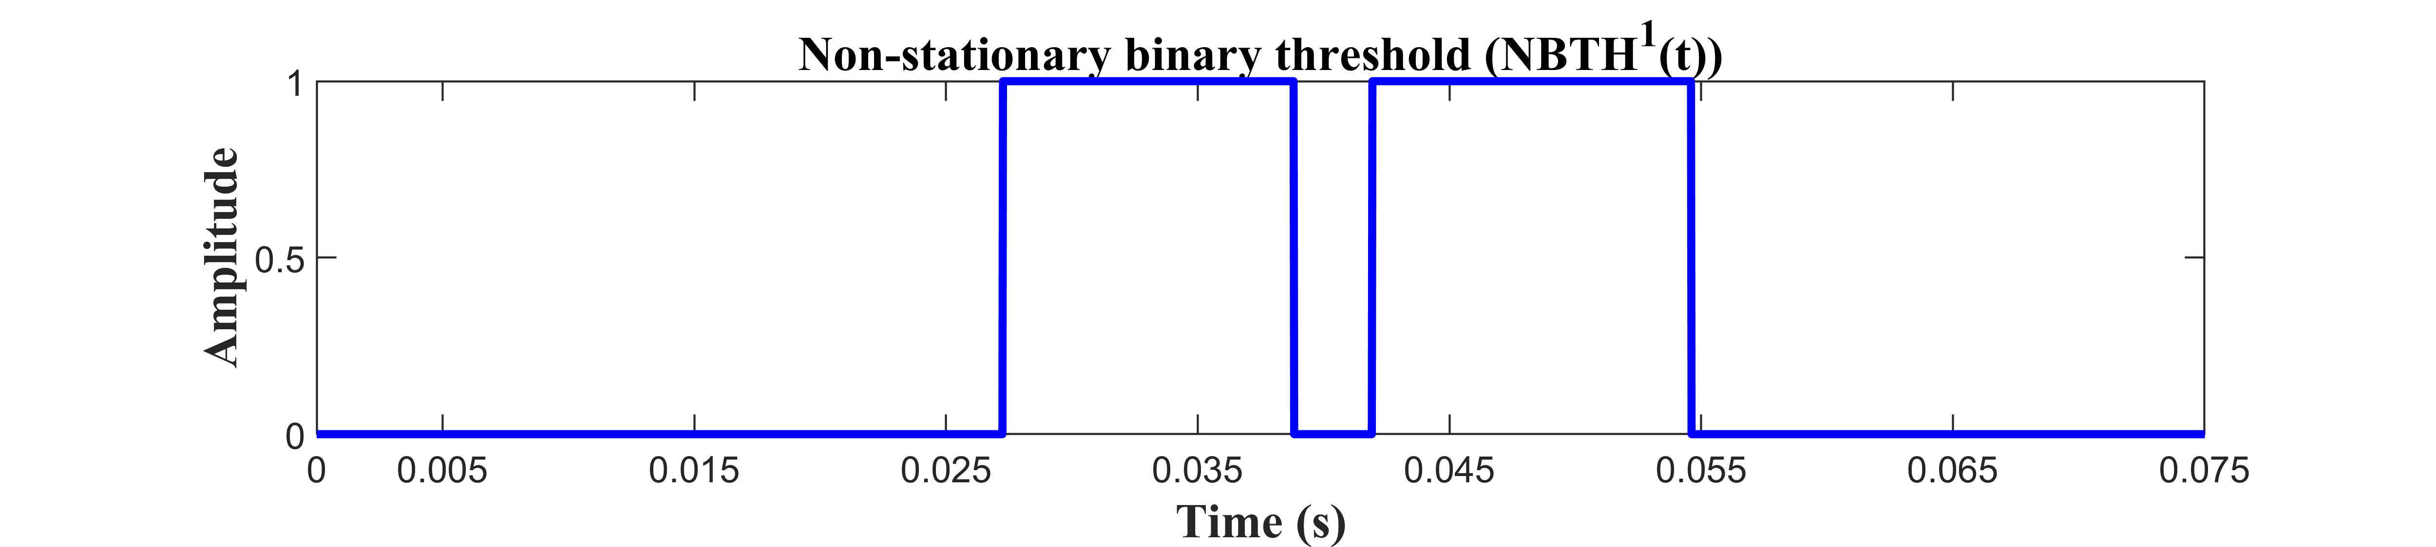
(d)
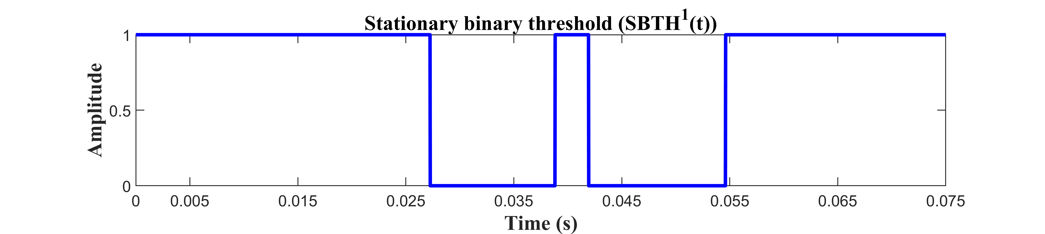
(e)
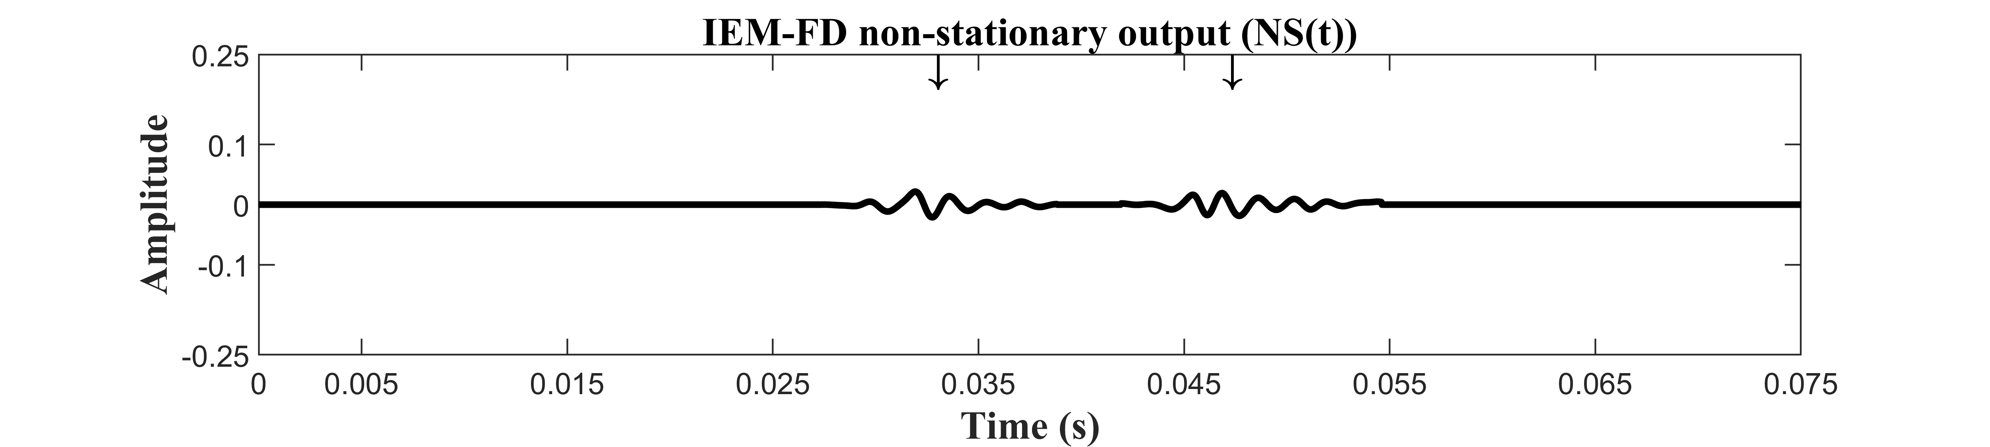
(f)
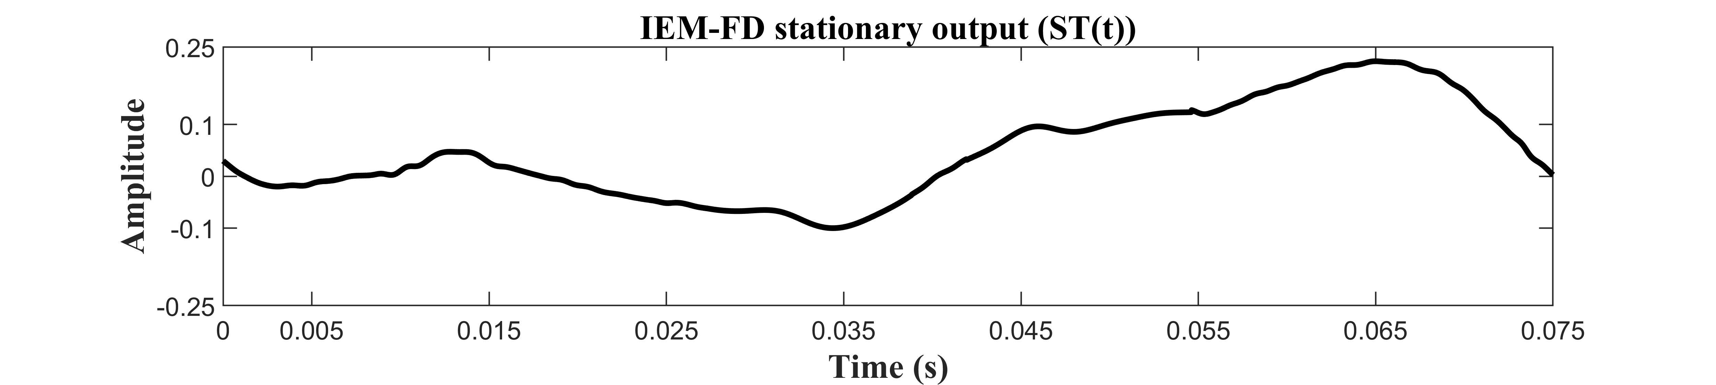
(g)
Fig. 2. A worked example of the proposed IEM-FD filter: (a) A time section of 0.075 s lung sound data recorded from a patient with idiopathic pulmonary fibrosis $\left(y\left(t\right)\right),$ where location of the crackles is marked with arrowheads; (b) Non-stationary output of the IEM method$({NSTS}^{1}\left(t\right))$; (c) The FD of the IEM method non-stationary output $({FD}^{1}\left(t\right))$ and the FDPP algorithm for estimating FD valid peaks $({FDPP}^{1}\left(t\right))$; (d) The non-stationary binary threshold $({NBTH}^{1}\left(t\right))$; (e) The stationary binary threshold $({SBTH}^{1}\left(t\right))$; (f) The non-stationary output of the IEM-FD filter $(NS\left(t\right))$; (g) The stationary output of the IEM-FD filter $(ST\left(t\right))$.
the maximum iteration level. In the final step, the non-stationary and stationary parts of the signal are calculated when k=K, using:
$$NS\left(n\right)=\sum_{k=1}^{K}{{NST}_{k}}(n)$$ | (9)
$$ST\left(n\right)= {SSF}_{\left(at k=K\right)}(n)$$ | (10)
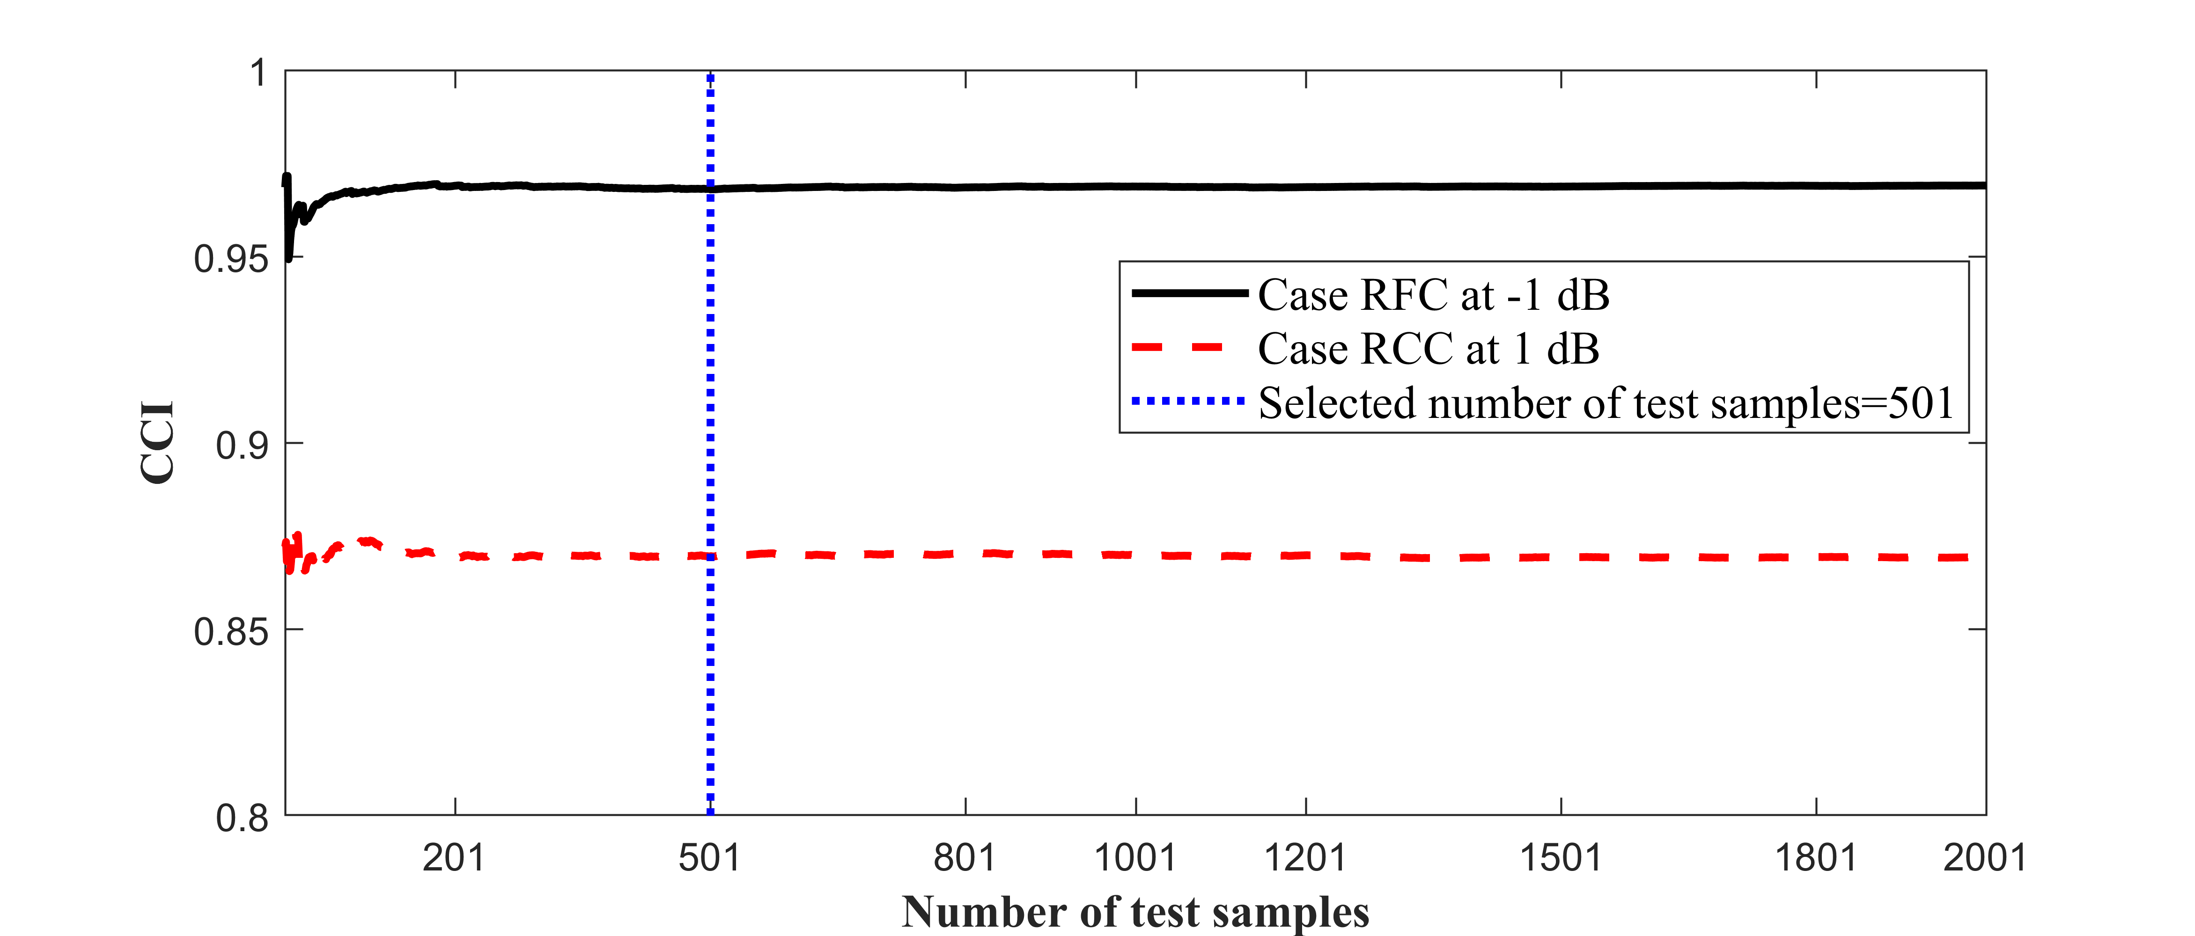
Fig. 3. Selection of number of test samples to eliminate random variation of the IEM-FD filter crackle separation due to variations in local SNR using real fine crackles (RFC) case at -1 dB and real coarse crackles (RCC) case at 1 dB.
The non-stationary and stationary outputs of the IEM-FD method are shown in Figs 2(f) and 2(g) respectively.
3. Analysis
In this section, the test data set is described and quantitative measures for evaluating how well each algorithm separates the crackles from the breath sounds are discussed.
3.1. Dataset and test samples
A previously published test dataset (Table 2) [44] is used for evaluating the crackle separation. The dataset consists of: simulated fine (SFC) and coarse (SCC) crackles for which the IDW and 2CD may be selected; real fine (RFC) and coarse (RCC) crackles with a variety of IDW and 2CD values extracted from recorded lung sound signals; noise simulated to have the spectral characteristics of breath noise (referred to hereafter as ‘breath noise’) (BR_{N}) two real lung sound signals, one with predominantly fine crackles (RBFC) from a patient with idiopathic pulmonary fibrosis (IPF) and one with mostly coarse crackles (RBCC) from a patient with Bronchiectasis (Br), both recorded with an electronic stethoscope. Further details of the dataset may be found in [44] and the data used here is summarized in Table 2.
To explore the robustness of the separation process to noise, test samples were generated by burying 10 simulated or 10 real crackles within a simulated breath noise sample (BR_{N}). Average SNR was varied from -10 to 10 dB in steps of 1 dB.
The local SNR for any given crackle in a test signal varies randomly, which may affect the separation, therefore for each set of crackles and each average SNR, 501 test samples were generated each with its own sample of BR_{N}. The use of 501 test samples at each SNR is justified in section 4.1. All test signals are sampled at 44,100 Hz.
3.2. Quantitative Evaluators
Successful separation must meet three criteria: extracting all the embedded crackles, minimizing the inclusion of non-crackle components and preserving crackle morphology after separation. We refer to the failure to extract all crackles or loss of some portion of the crackle in the output signal as under-estimation, and the inclusion of non-crackle components
Table 2
Summary of the test dataset.
Cases | N_{C} | Diagnosis | IDW&  2CD  (ms) | BN | SNR
SFC | 10 | NA | 0.7&5 [5] | BR_{N} | -10 to  10 dB  in  steps  of 1 dB
 | 10 | NA | 0.5&3.3 [45] | BR_{N}
 | 10 | NA | 0.9&6 [46] | BR_{N}
SCC | 10 | NA | 1.5&10 [5] | BR_{N}
 | 10 | NA | 1&5.1 [45] | BR_{N}
 | 10 | NA | 1.25&9.5 [46] | BR_{N}
RFC | 10 | IPF | ND | BR_{N}
RCC | 10 | B_{r} | ND | BR_{N}
RBFC | ND | IPF | ND | NBS | ND
RBCC | ND | B_{r} | ND | NBS | ND
SFC: Simulated fine crackles; RFC: Real fine crackles; SCC: Simulated coarse crackles; RCC: Real coarse crackles; RBFC: Real breath sound with fine crackles; RBCC: Real breath sound with coarse crackles; N_{C}: Number of crackles; ND: Not defined; NA=Not applicable; IPF: Idiopathic pulmonary fibrosis; B_{r}: Bronchiectasis; BN: Background noise; BR_{N}: Breath noise; NBS: Normal breath sound.
as over-estimation.
The separation of the IEM-FD was evaluated against reference test signals and against the separation of the WT-FD filter [15, 16], chosen for its excellent accuracy in separating both fine and coarse crackles [16]. For the synthesized test signals, the time series of the crackles in the absence of breath noise was used as a reference signal. In the test samples measured in patients (RBFC and RBCC), an experienced pulmonary acoustics researcher had previously marked the location of each crackle.
Separation was evaluated using several different metrics: To measure the similarity between the estimated non-stationary output of the IEM-FD separation process and the crackle reference signal, the cross-correlation index (CCI) was used; the outcome of crackle separation was assessed by two quantitative evaluators proposed by Hadjileontiadis et al. [13]: Rate of Detectability (D_{R}), and Total Performance (TD_{R}); To quantify over- or under-estimation in the separation, the Quality Factors (QFs) proposed by Hadjileontiadis et al. [13] were adapted to benefit from the existence in our test data of the reference signals; To evaluate the ability of the separation process to preserve crackle morphology the 2CD percentage error (${PE}_{2CD}$) was calculated.
The process for calculating each metric is as follows:

3.2.1. Cross Correlation Index (CCI)

The cross-correlation index (CCI) indicates the ability of the IEM-FD and the WT-FD filters to separate all the crackles into the non-stationary signal estimate for a given SNR. The CCI was calculated using Pearson’s correlation coefficient:
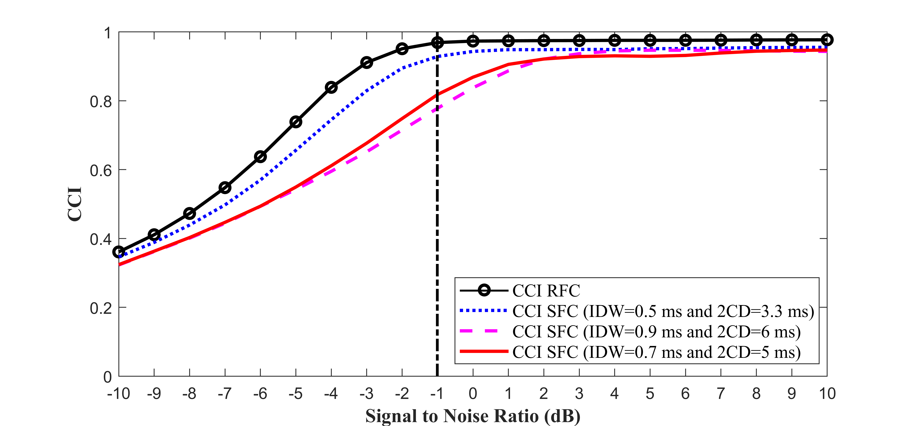
(a)
(i)
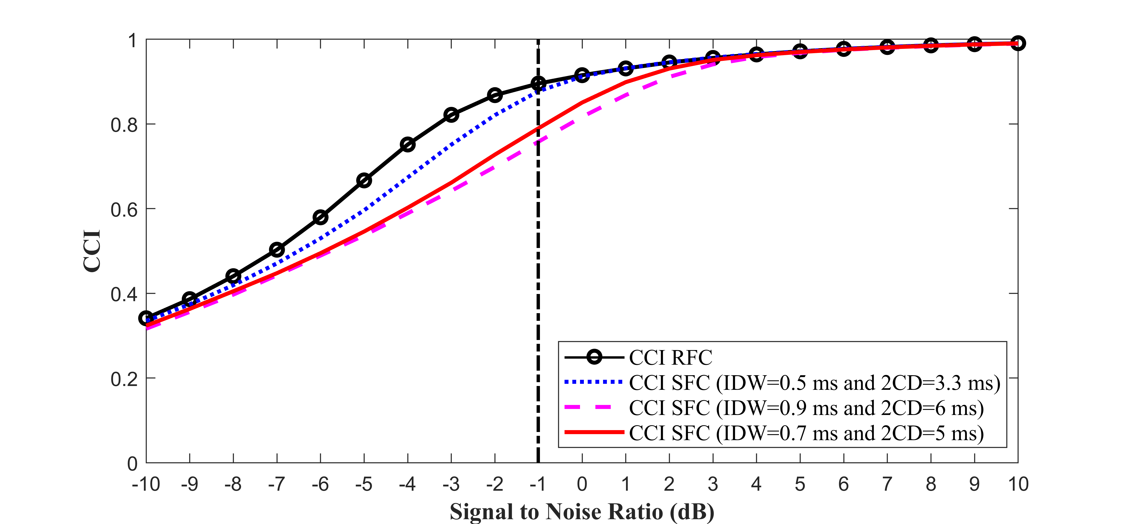
(a)
(ii)
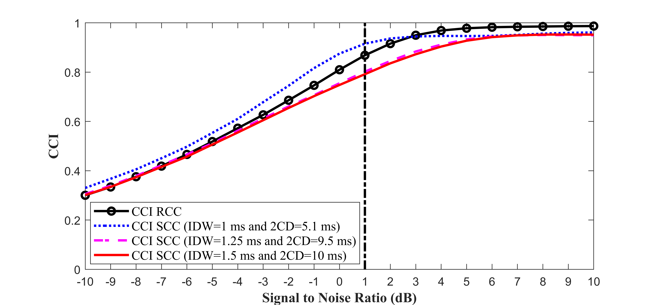
(b)

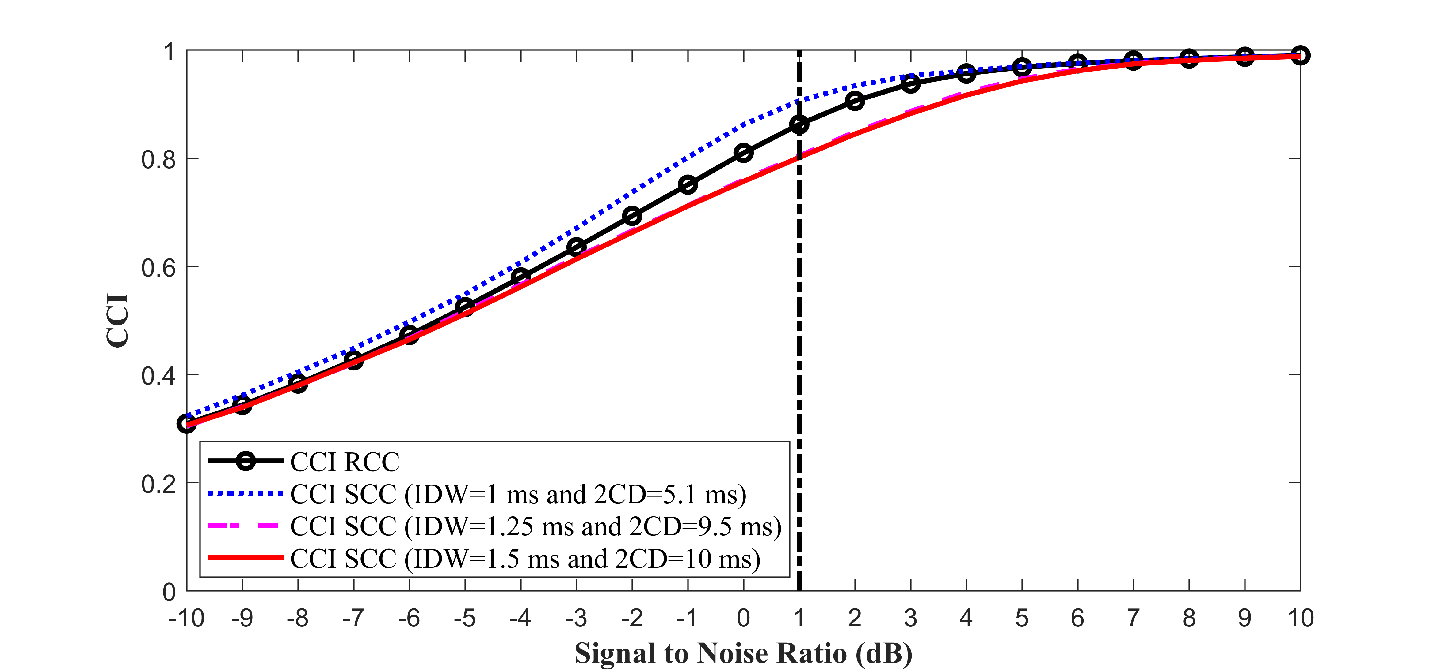
(b)

Fig. 4. Cross correlation index (CCI) plots for breath noise cases with a signal to noise ratio in the range of -10 to 10 dB (Table 2). (i) The IEM-FD filter, (a) RFC (real fine crackles) and SFC (simulated fine crackles) cases; (b) RCC (real coarse crackles) and SCC (simulated coarse crackles) cases. (ii) The WT-FD filter, (a) RFC (real fine crackles) and SFC (simulated fine crackles) cases; (b) RCC (real coarse crackles) and SCC (simulated coarse crackles) cases.
$$CCI=\frac{\sum_{n=1}^{N}{(R_{C}\left(n\right)-{\overline{R}}_{C}})(NS\left(n\right)-\overline{NS})}{\sqrt{\sum_{n=1}^{N}{{(R_{C}\left(n\right)-{\overline{R}}_{C})}^{2}}}\sqrt{\sum_{n=1}^{N}{{(NS\left(n\right)-\overline{NS})}^{2}}}}×100$$
(11)
where${ R}_{C}\left(n\right)$ is the crackle reference signal, $NS\left(n\right)$ is the non-stationary output of the separation method, n is the sample index (n=1, 2…N), and ${\overline{R}}_{C}$ and $\overline{NS}$ are the average values of the crackle reference signal and non-stationary output, respectively.
3.2.2 Rate of detectability
The Rate of Detectability ($D_{R}$) measures the ability of the IEM-FD and WT-FD filters to separate the correct number of crackles at the correct locations into their non-stationary outputs. D_{R} was calculated using (12).
$$D_{R} \text{=} \frac{N_{E}}{N_{R}}\text{×100 \%}$$ | (12)
where $N_{E}$ is the number of crackles in the non-stationary output of a separation algorithm and $N_{R}$ is the number of crackles in the input signal. For test signals: SFC, RFC, SCC and RCC, where a reference signal exists, each the non-stationary output was correlated with the reference signal and only those crackles with CCI ≥ 0.5, where the cut-off CCI value was empirically selected, were counted as contributing to $N_{E}$. For RBFC and RBCC where crackle reference signals do not exist, the number of crackles in the output was counted manually by comparing their location with the marked crackles in the input signal. $D_{R}$ was calculated for each test signal. The mean value and standard deviation over all tests are reported.
3.2.3 Total Performance (${TD}_{R}$)
The Total Performance (${TD}_{R}$) also measures accuracy in terms of number and temporal location of crackles in the non-stationary output by the IEM-FD and the WT-FD filters. ${TD}_{R}$ is the $D_{R}$ calculated separately for all fine and for all coarse crackles (${TD}_{R}^{FC} and {TD}_{R}^{CC})$. As for $D_{R}$ the mean and standard deviation over all test signals (SFC, RFC and RBFC for fine crackles and SCC, RCC and RBCC for coarse crackles) is reported.
3.2.4 Quality Factors (QFs)
Quality Factors measure over- and under-estimation in the non-stationary output signal. Building on [13, 16] but noting that our test data set provides us with reference signals, we define four Quality Factors: a Reference Quality Factor (${\text{R}}_{{QF}_{U}}$) for under-estimation, an Estimated Quality Factor (${\text{E}}_{{QF}_{U}}$) for under-estimation, a Reference Quality Factor (${\text{R}}_{{QF}_{O}}$) for over-estimation and an Estimated Quality Factor (${\text{E}}_{{QF}_{O}}$) for over-estimation. To calculate the QFs, firstly two thresholds are

Table 3
Evaluation of separation of IEM-FD filter in the case of fine and coarse crackles.

 |  |  |  |  |  |  | IEM-FD |  |  |  | WT-FD
Cases |  | BN | D_{g} | SNR  (dB) | $$N_{R}$$ | NOTS | $$K$$  (min-max) | $$Q$$  (min-max) | $$N_{E}$$  (min-max) | $${\overline{D}}_{R}(SD)$$  (%) | $$K$$  (min-max) | $$N_{E}$$  (min-max) | $${\overline{D}}_{R}(SD)$$  (%)
SFC | A_{F} | BR_{N} | NA | -1  -1  -1  -1 | 10 | 501 | 1-1 | 2-2 | 10-10 | 100 (0) | 1-1 | 10-10 | 100 (0)
 | H_{F} | BR_{N} | NA |  | 10 | 501 | 1-1 | 1-2 | 10-10 | 100(0) | 1-1 | 10-10 | 100 (0)
 | C_{F} | BR_{N} | NA |  | 10 | 501 | 1-1 | 2-2 | 10-10 | 100 (0) | 1-1 | 10-10 | 100 (0)
RFC |  | BR_{N} | IPF |  | 10 | 501 | 1-1 | 1-1 | 10-10 | 100 (0) | 1-1 | 9-10 | 99.48 (2.22)
RBFC |  | NBS | IPF | ND | 32 | 1 | 1 | 1 | 21 | 65.63 | 1 | 20 | 62.50
SCC | A_{C} | BR_{N} | NA | 1  1  1  1 | 10 | 501 | 1-1 | 2-2 | 10-10 | 100 (0) | 1-1 | 10-10 | 100 (0)
 | H_{C} | BR_{N} | NA |  | 10 | 501 | 1-1 | 2-2 | 10-10 | 100 (0) | 1-1 | 10-10 | 100 (0)
 | C_{C} | BR_{N} | NA |  | 10 | 501 | 1-1 | 2-2 | 10-10 | 100 (0) | 1-1 | 10-10 | 100 (0)
RCC |  | BR_{N} | B_{r} |  | 10 | 501 | 1-1 | 1-1 | 9-10 | 99.18 (2.74) | 1-1 | 8-10 | 96.73 (5.18)
RBCC |  | NBS | B_{r} | ND | 6 | 1 | 1 | 1 | 6 | 100 | 1 | 6 | 100
Total Performance  (${TD}_{R}^{XX}$, ${SD}_{{TD}_{R}}^{XX}$) |  |  | Fine crackles (SFC, RFC and RBFC) |  |  |  | $${TD}_{R}^{FC}=99.98 \%,$$  $${SD}_{{TD}_{R}}^{FC}=0.77 \%$$ |  |  |  | $${TD}_{R}^{FC}=99.85 \%,$$  $${SD}_{{TD}_{R}}^{FC}=1.41 \%$$
 |  |  | Coarse crackles (SCC, RCC and RBCC) |  |  |  | $${TD}_{R}^{CC}= 99.80\%,$$  $${SD}_{{TD}_{R}}^{CC}=1.42 \%$$ |  |  |  | $${TD}_{R}^{CC}=99.18 \%,$$  $${SD}_{{TD}_{R}}^{CC}=2.95 \%$$
SFC: Simulated fine crackles; A_{F}: IDW=0.7 ms & 2CD=5 ms [5]; H_{F}: IDW= 0.5 ms & 2CD= 3.3 ms [45]; C_{F} : IDW=0.9 ms & 2CD=6 ms [46]; RFC: Real fine crackles; SCC: Simulated coarse crackles; A_{C}: IDW= 1.5 ms & 2CD=10 ms [5]; H_{C}: IDW=1 ms & 2CD= 5.1 ms [45]; C_{C}: IDW=1.25 ms & 2CD=9.5 ms [46]; RCC: Real coarse crackles; RBFC: Real breath sound with fine crackles; RBCC: Real breath sound with coarse crackles; BN: Background noise; BR_{N}: Breath noise; NBS: Normal breath sound; IPF: Idiopathic pulmonary fibrosis; B_{r}: Bronchiectasis; D_{g}: Diagnosis; SNR: Signal to noise ratio; NOTS: number of test samples;${\overline{D}}_{R}:$Mean of Rate of Detectability;$SD$: Standard deviation; NA: Not applicable; ND: Not defined; $N_{R}$: Real number of crackles;$N_{E}$: Separated crackles; ${TD}_{R}^{XX}$: Total Performance;${SD}_{{TD}_{R}}^{XX}$ : Standard deviation; $XX$ stands $FC$ for fine crackles and $CC$ for coarse crackles; K and Q : number of iterations; min: Minimum value; max: Maximum value; In all cases number of samples (N)=32,768.

defined:
$${TH}_{1}\left(n\right)=\left\{\begin{aligned}1 ifR_{C}\left(n\right)≠0 \\ 0 if R_{C}\left(n\right)=0\end{aligned}\right\}$$ | (13)
${TH}_{2}(n)$ = [1 - ${TH}_{1}$(n)] | (14)
where $R_{C}\left(n\right)$ is the crackle reference signal and n is the sample index with $n=1,2……N$. Secondly, the threshold ${ TH}_{2}\left(n\right)$ is multiplied by the input signal $y(n)$, to calculate a background noise reference signal$R_{BN}(n)$.
Thirdly, the non-stationary output of the chosen separation filter $NS\left(n\right)$ is divided into two parts: non-stationary signal with only crackle portion $({NS}_{C}\left(n\right))$ and remaining non-stationary part (${NS}_{R}(n)$), according to (15) and (16).
${NS}_{C}\left(n\right)$=$NS\left(n\right){ TH}_{1}\left(n\right)$ | (15)
$${NS}_{R}\left(n\right)=NS\left(n\right) {TH}_{2}\left(n\right)$$ | (16)
Next QFs for under-estimation are calculated using the area under the input signal$y(n)$, area under the crackle reference signal${ R}_{C}\left(n\right)$ and area under the crackle portion of the non-stationary signal ${NS}_{C}(n)$. Similarly, the two Quality Factors for over-estimation are evaluated using the area under the input signal$y(n)$, area under the background noise reference signal $R_{BN}(n)$ and area under the remaining non-stationary part${NS}_{R}(n)$.
$${\text{R}}_{{QF}_{U}} \text{=} \frac{\sum_{1}^{N}{\left|y(n)\right|}∆n- \sum_{1}^{N}{\left|R_{C}(n)\right|}∆n }{\sum_{1}^{N}{\left|y(n)\right|}∆n}$$ | (17)
$${\text{E}}_{{QF}_{U}} \text{=} \frac{\sum_{1}^{N}{\left|y(n)\right|}∆n- \sum_{1}^{N}{\left|{NS}_{C}(n)\right|}∆n }{\sum_{1}^{N}{\left|y(n)\right|}∆n}$$ | (18)
$${\text{R}}_{{QF}_{O}} \text{=} \frac{\sum_{1}^{N}{\left|y(n)\right|}∆n\text{ - }\sum_{1}^{N}{\left|R_{BN}(n)\right|}∆n }{\sum_{1}^{N}{\left|y(n)\right|}∆n}$$ | (19)
$${\text{E}}_{{QF}_{O}} \text{=} \frac{\sum_{1}^{N}{\left|y(n)\right|}∆n-\sum_{1}^{N}{\left|{NS}_{R}(n)\right|}∆n }{\sum_{1}^{N}{\left|y(n)\right|}∆n}$$ | (20)
where $\left|.\right|$ represents the absolute value and Δn is the sample period in seconds. The maximum value of area under$\left|{NS}_{C}(n)\right|$ was set equal to the area under $\left|R_{C}(n)\right|$.${ \text{E}}_{{QF}_{U}}$ in the range ${\text{R}}_{{QF}_{U}}<{\text{E}}_{{QF}_{U}}≤1$ represents under-estimation and a value close to 1 indicates high under-estimation. Similary${\text{E}}_{{QF}_{O}}$in the range ${\text{R}}_{{QF}_{O}}≤$ ${\text{E}}_{{QF}_{O}}<1$ represents over-estimation and a value close to ${\text{R}}_{{QF}_{O}}$ shows high over-estimation. Hence, a value of ${\text{E}}_{{QF}_{U}}$ close to ${\text{R}}_{{QF}_{U}}$ with a value of ${\text{E}}_{{QF}_{O}}$ near to 1 represents crackle separation without either high under- or high over-estiamation.
    - 2CD percentage error (${PE}_{2CD}$)
The 2CD percentage error assesses the ability of an algorithm to preserve crackle morphology after separation from background noise. The percentage error in 2CD following separation is calculated using:
$${PE}_{2CD}=\left|\frac{{AC}_{2CD}-{EC}_{2CD}}{{AC}_{2CD}}\right|×100 \%$$ | (21)
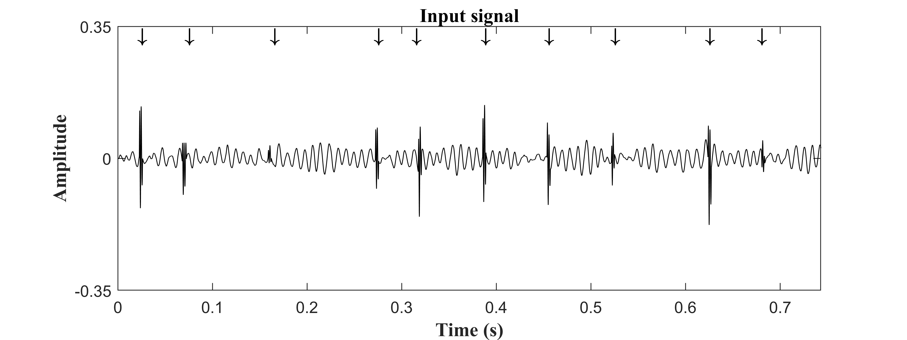 (a)
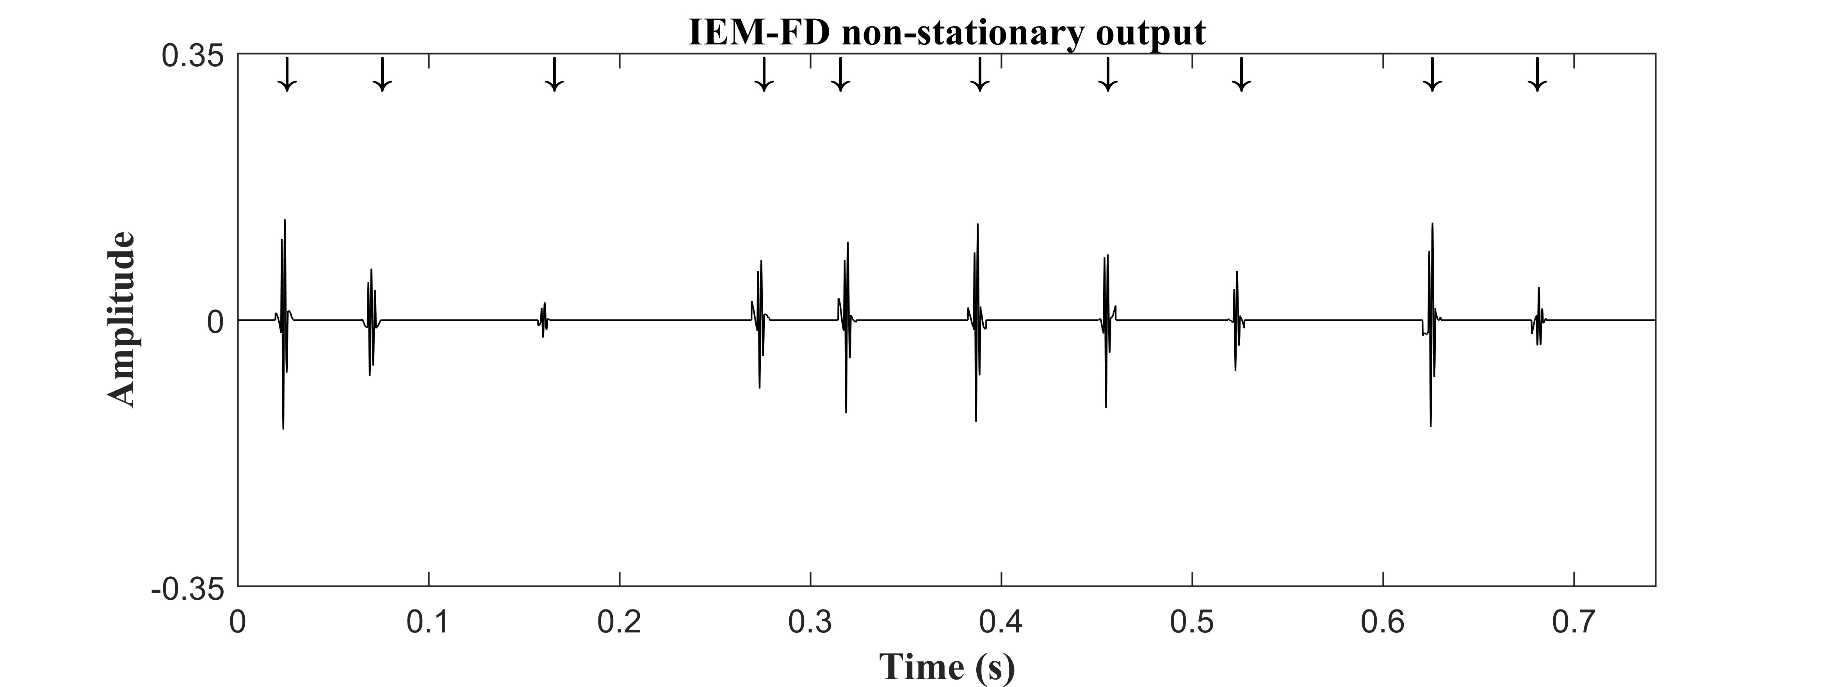 (b)
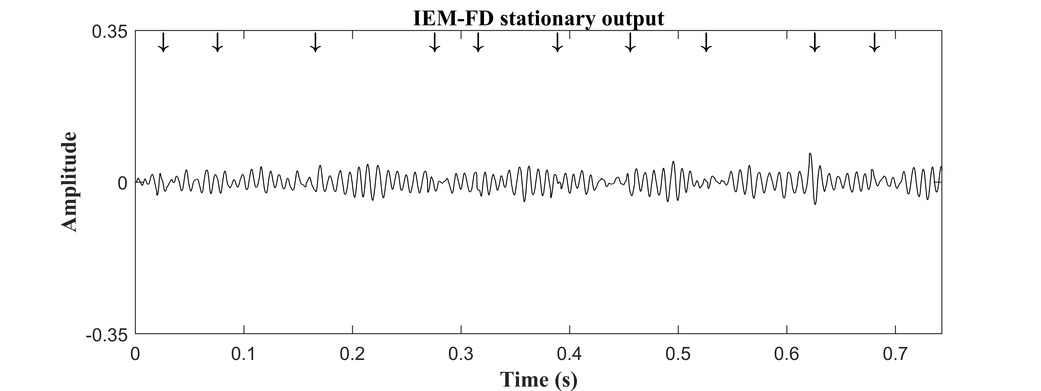 (c)
(i)
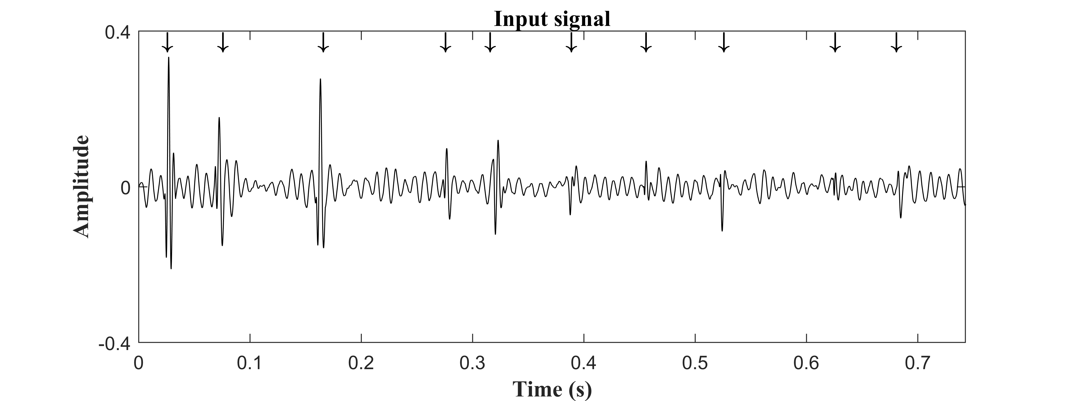 (a)
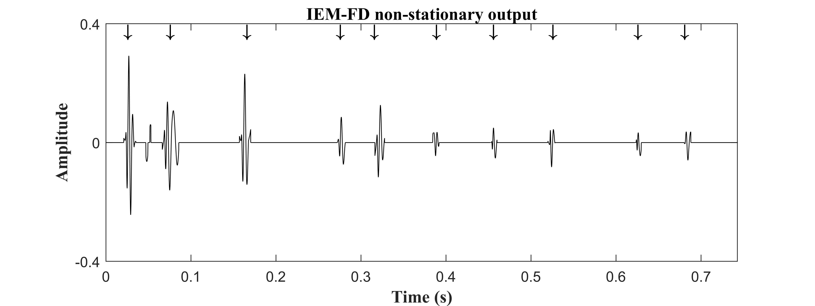 (b)
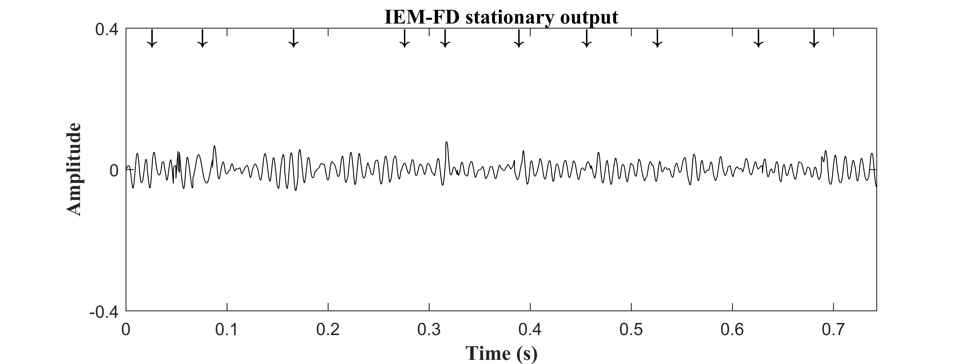 (c)
(ii)
Fig. 5. (i): (a) Input signal with real fine crackles (Table 3, Case RFC one test sample out of 501); (b) IEM-FD filter non-stationary output; (c) IEM-FD filter stationary output. (ii): (a) Input signal with real coarse crackles (Table 3, Case RCC one sample out of 501); (b) IEM-FD filter non-stationary output; (c) IEM-FD filter stationary output.

where $\left|.\right|$ represents the absolute value, ${AC}_{2CD}$ is the actual crackle 2CD calculated from the crackle reference signal $R_{C}(n)$ and ${EC}_{2CD}$ is the estimated crackle 2CD calculated from the non-stationary filter output ($NS\left(n\right)$). The 2CD was calculated using the first five zero crossings of the crackle.
For the RBFC and the RBCC signals, where a crackle reference signal does not exist, the crackle separation of the two filters was not evaluated using the QFs or the ${PE}_{2CD}$.
4. Filter Parameters
The parameters used for the new IEM-FD filter and the previously published WT-FD filter [15, 16] are shown in Table 4.
4.1. Selection of number of test samples
As mentioned in Section 3.1, 501 test samples are generated for each simulated test signal to account for the effect of random variation of the local SNR around any given crackle.
For each SNR, the same 10 crackles embedded in 501 unique noise signal samples are passed through each separation filter and the resulting CCIs are averaged to get one CCI value for each SNR point for each filter.
Fig. 3 shows the average CCI for the IEM-FD filter for real fine crackles (RFC) at an SNR of -1 dB and real coarse crackles

Table 4
Parameters used for different separating methods.
Parameters |  | IEM-FD | WT-FD
Number of samples (N) |  | 32,768 | 32,768
Number of decomposition levels (M) |  | NA | M =1 [16]
Type of wavelet |  | NA | DB4 [16]
Sampling frequency (f_{S}) |  | 44,100 Hz | 44,100 Hz
Accuracy level (β) | $$β_{1}$$ | 0.01 | NA
 | $$β_{2}$$ | 0.1 | 0.1
 | $$β_{3}$$ | 0.01 [17] | 0.01 [16]
Multiplication factor |  | $m_{f}$=0.006[17] | $m_{f}$=0.006 [16]
NA: not applicable; DB4: Daubechies quadrature mirror filters (QMFs) of eight coefficients; M: Number of WT decomposition levels; $m_{f}:$Multiplication factor$;{ β}_{1}$: Accuracy level for the Iterative envelope mean method;${ β}_{2}$: Accuracy level for desired stationary and non-stationary outputs;${ β}_{3}$: Accuracy
level for the fractal dimension peak-peeling algorithm.
(RCC) at an SNR of 1 dB when the number of test samples is increased from 1 to 2001 in steps of 1. The choice of SNR for these plots is discussed in section 5. We note that for more than 501 samples, the CCI is approximately constant in both cases. The selected number of 501 test samples is marked on Fig. 3.
5. Experimental results
This section presents the results obtained using the IEM-FD filter and provides systematic comparison with the WT-FD filter [15, 16]. Both the separation techniques are implemented

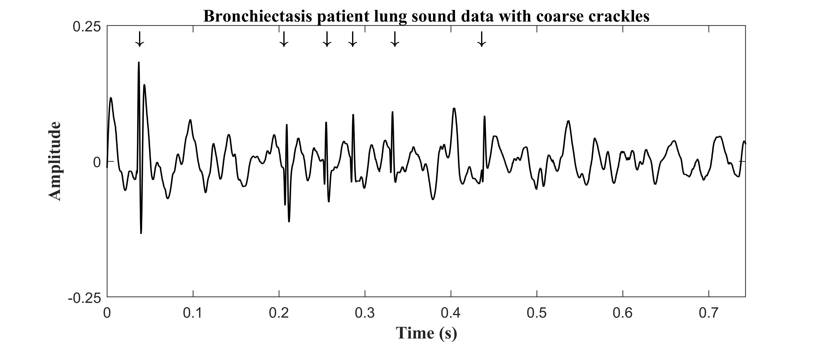
(i)

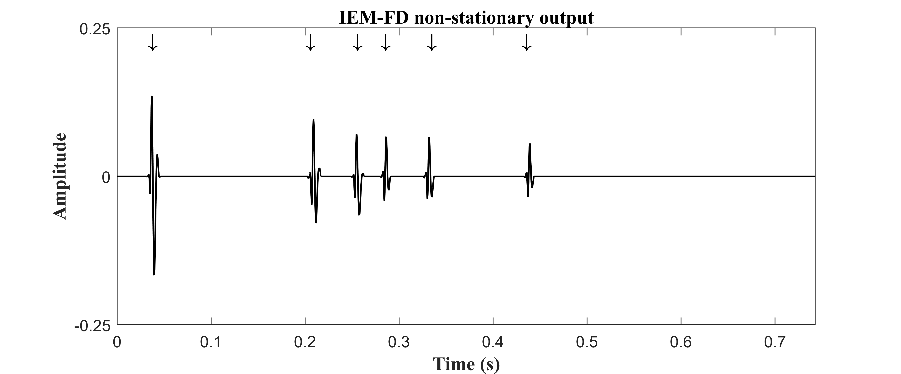
(a)
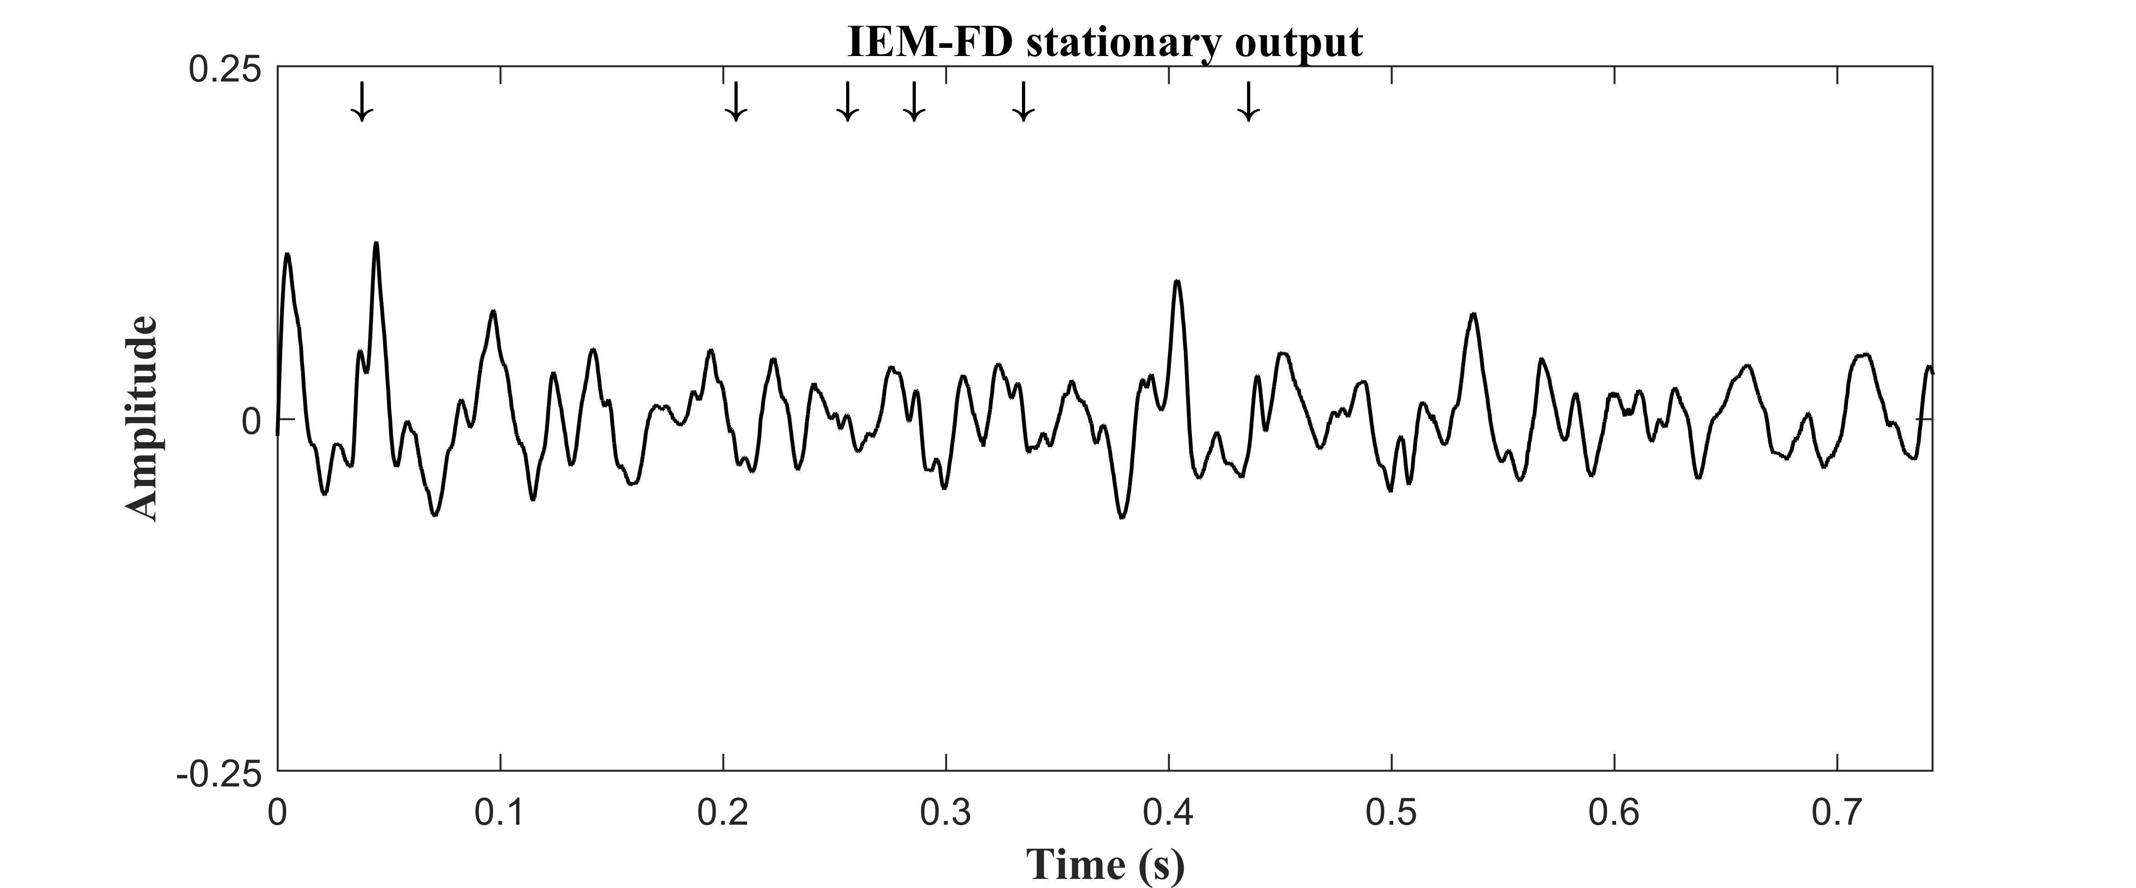
(b)
(ii)
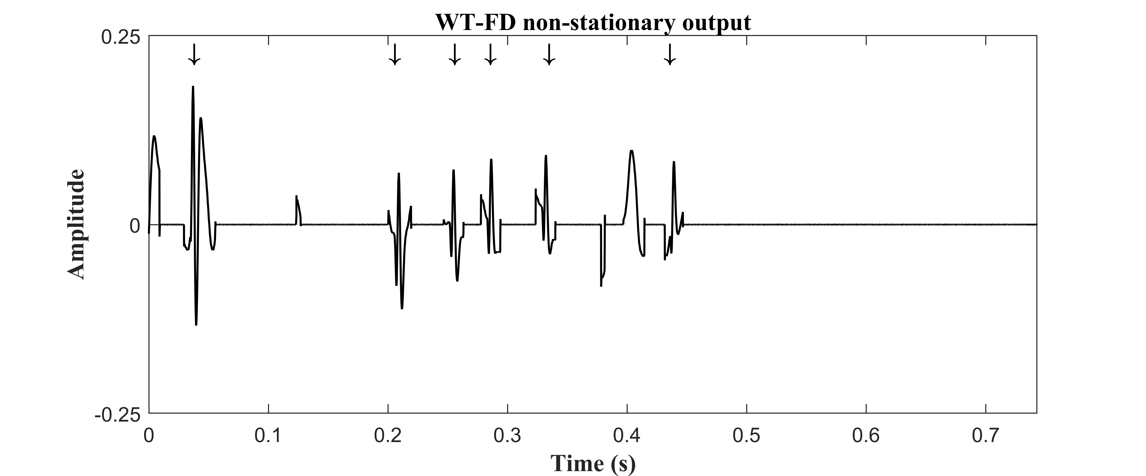 (a)
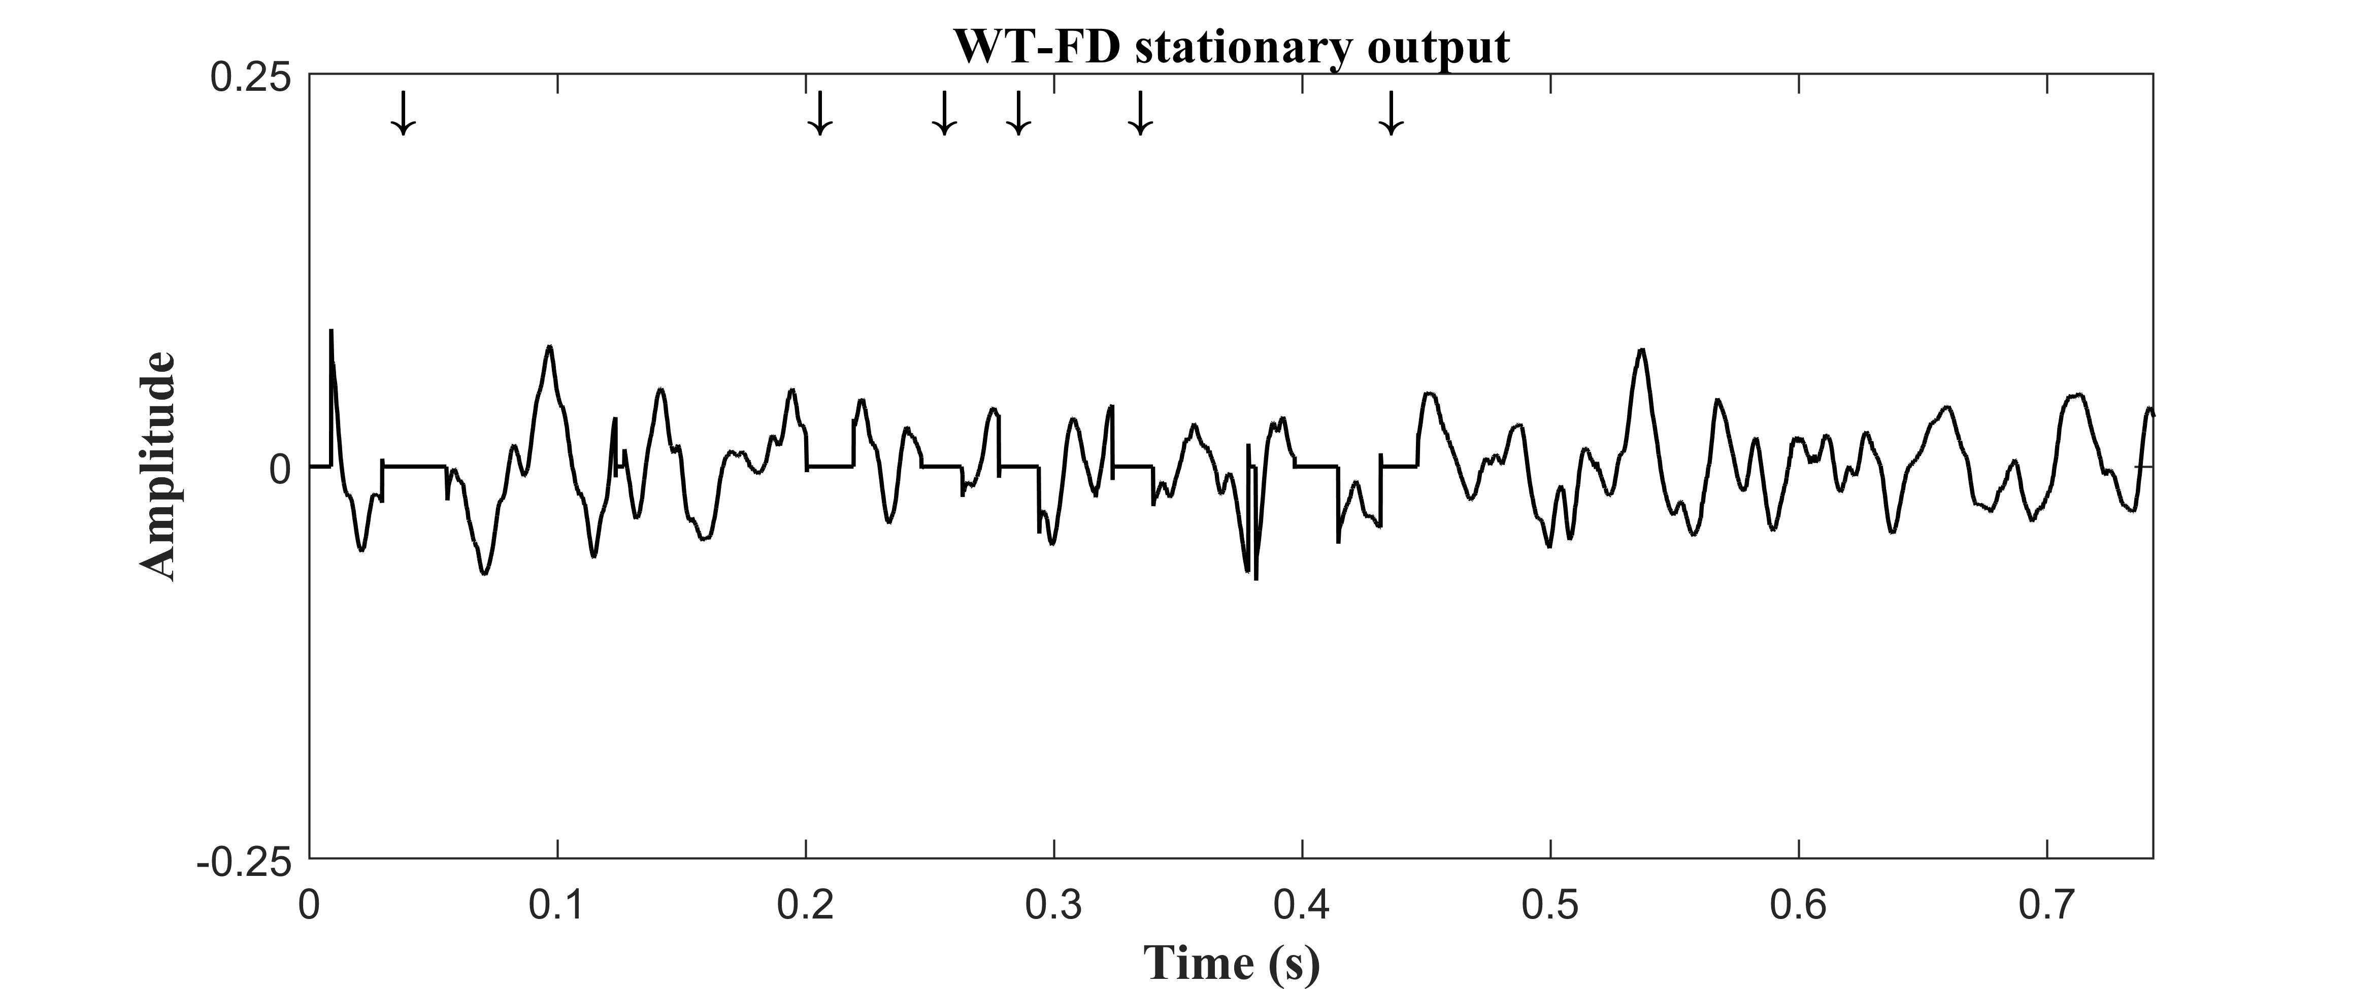
(b)
(iii)
Fig. 6. Comparison between crackle separation of the IEM-FD filter and the WT-FD filter; (i) Time section of 0.743 s of real breath sound with coarse crackles (Table 3, Case RBCC) recorded from a patient with bronchiectasis. (ii): (a) IEM-FD filter non-stationary output; (b) IEM-FD filter stationary output. (iii): (a) WT-FD filter non-stationary output; (b) WT-FD filter stationary output.

using the Matlab (R2019a) programming language.
5.1. Separation by the IEM-FD filter

Figure 4 shows plots of CCI averaged over all 501 test signals against SNR using i) the IEM-FD filter and ii) the WT-FD filter for the separation. Plots labelled (a) show curves for simulated fine crackles with three different values of IDW/2CD and real fine crackles; plots labelled (b) show curves for simulated coarse crackles with three different values of IDW/2CD, and real coarse crackles.
Taking CCI >= 0.8 to indicate strong correlation between the separated signal and the test signal, strong correlation occurs for all fine crackle test signals with SNR greater than -1 dB except for SFC with 2CD = 6 ms for both IEM-FD and WT-FD. For SFC with 2CD = 6 ms the CCI is just below 0.8 at SNR = - 1 dB but is above at SNR = 0 dB. For coarse crackles strong correlation occurs for SNR >= 1 dB. The plots therefore suggest two threshold SNRs above which good separation can be achieved by both filters: SNR = - 1 dB for fine crackles and SNR = 1 dB for coarse crackles.
Comparative evaluation of the IEM-FD filter and the WT-FD filter [15, 16] was made using the synthesized signals at these threshold SNR values supplemented by the real breath sound with fine crackles (RBFC) and the real breath sound with coarse crackles (RBCC) using the quantitative evaluators described in section 3.2.2 to 3.2.5.
Separation by the IEM-FD filter into non-stationary and stationary estimates for test signals using two randomly selected, real crackle cases at the threshold SNRs, one for fine and one for coarse crackles (Table 3, cases RFC and RCC) are shown in Fig. 5-i (a-c) and Fig. 5-ii (a-c), respectively. The location of the crackles before inserting into the background noise is marked with arrowheads. Fig 5 (a) displays the input signals. The non-stationary and stationary signal estimates after applying the IEM-FD filter are shown in Fig. 5 (b) and (c), respectively. Comparing these with the input signal, we can clearly see that for both fine and coarse crackle samples, all the fine and coarse crackles are separated from breath noise into the non-stationary signal estimate with their time duration and morphology preserved. For both fine and coarse crackles, the breath noise is retained in the stationary estimate with its proper shape and amplitude.
5.2. Comparison of the IEM-FD filter with the WT-FD filter

The separation of the IEM-FD filter was compared with the previously published WT-FD filter [15, 16] in terms of Rate
Table 5
Quality Factor for crackle separation by the IEM-FD filter.
 |  |  |  |  |  |  |  | IEM-FD |  | WT-FD
Cases |  | BN | D_{g} | SNR  (dB) | NOTS | $${\overline{R}}_{{QF}_{U}}(SD)$$ | ${\overline{R}}_{{QF}_{O}}$ (SD) | $${\overline{E}}_{{QF}_{U}}(SD)$$ | $${\overline{E}}_{{QF}_{O}}(SD)$$ | $${\overline{E}}_{{QF}_{U}}(SD)$$ | $${\overline{E}}_{{QF}_{O}}(SD)$$
SFC | A_{F} | BR_{N} | NA | -1  -1  -1  -1 | 501 | 0.817 (0.004) | 0.198 (0.005) | 0.817 (0.004) | 0.888 (0.032) | 0.817 (0.004) | 0.729 (0.036)
 | H_{F} | BR_{N} | NA |  | 501 | 0.848 (0.003) | 0.161 (0.004) | 0.848 (0.003) | 0.958 (0.015) | 0.848 (0.003) | 0.847 (0.032)
 | C_{F} | BR_{N} | NA |  | 501 | 0.801 (0.004) | 0.217 (0.006) | 0.801 (0.004) | 0.828 (0.036) | 0.801 (0.004) | 0.664 (0.033)
RFC |  | BR_{N} | IPF |  | 501 | 0.828 (0.003) | 0.177 (0.005) | 0.839 (0.003) | 0.959 (0.008) | 0.829 (0.003) | 0.872 (0.014)
SCC | A_{C} | BR_{N} | NA | 1  1  1  1 | 501 | 0.704 (0.006) | 0.325 (0.012) | 0.705 (0.006) | 0.770 (0.036) | 0.704 (0.006) | 0.650 (0.038)
 | H_{C} | BR_{N} | NA |  | 501 | 0.777 (0.004) | 0.236 (0.005) | 0.779 (0.005) | 0.932 (0.025) | 0.777 (0.004) | 0.854 (0.031)
 | C_{C} | BR_{N} | NA |  | 501 | 0.710 (0.005) | 0.316 (0.010) | 0.711 (0.006) | 0.790 (0.033) | 0.710 (0.005) | 0.653 (0.036)
RCC |  | BR_{N} | B_{r} |  | 501 | 0.731 (0.006) | 0.292 (0.010) | 0.747 (0.008) | 0.871 (0.033) | 0.732 (0.006) | 0.803 (0.041)
SFC: Simulated fine crackles; A_{F}: IDW=0.7 ms & 2CD=5 ms [5]; H_{F}: IDW= 0.5 ms & 2CD= 3.3 ms [45]; C_{F} : IDW=0.9 ms & 2CD=6 ms [46]; RFC: Real fine crackles; SCC: Simulated coarse crackles; A_{C}: IDW= 1.5 ms & 2CD=10 ms [5]; H_{C}: IDW=1 ms & 2CD= 5.1 ms [45]; C_{C}: IDW=1.25 ms & 2CD=9.5 ms [46]; RCC: Real coarse crackles; BN: Background noise; BR_{N}: Breath noise; IPF: Idiopathic pulmonary fibrosis; B_{r}: Bronchiectasis; D_{g}: Diagnosis; SNR: Signal to noise ratio; NOTS: number of test samples;${\overline{R}}_{{QF}_{U}}$: Mean of reference under-estimation Quality Factor; ${\overline{E}}_{{QF}_{U}}$: Mean of estimated under-estimation Quality Factor; ${\overline{R}}_{{QF}_{O}}$: Mean of reference over-estimation Quality Factor; ${\overline{E}}_{{QF}_{O}}$: Mean of estimated over-estimation Quality Factor; $SD$: Standard deviation; NA: Not applicable; In all cases number of samples (N)=32,768.

of Detectability ($D_{R}$), Total Performance (${TD}_{R}^{XX})$, Quality Factors for of crackle separation (over- or under- estimation), 2CD percentage error (${PE}_{2CD}$) and computational complexity.
5.2.1. Rate of detectability ($D_{R}$) and Total Performance (${TD}_{R}^{XX})$

Table 3 shows the Rate of Detectability ($D_{R}$) and the Total Performance (${TD}_{R}^{XX})$ for the IEM-FD filter and the WT-FD filter for test samples at SNR = -1 dB for real and simulated fine crackles, and at SNR = 1 dB for real and simulated coarse crackles and for a real breath sound with fine crackles and a real breath sound with coarse crackles. We note that for both methods ($D_{R}$) is the same except for RFC, RCC and RBFC where the IEM-FD give higher values than the WT-FD leading to an overall higher (${TD}_{R}^{XX})$ for the IEM-FD. For RBFC both filters show a lower $D_{R}$ than for other signals and this is due to crackles remaining in the stationary signal. This can be rectified either by changing the FDPP algorithm accuracy level ($β_{3}$) or by changing the accuracy level ($β_{2}$) for stopping iteration of the IEM-FD, but only at the cost of increasing over-estimation.
5.2.2. Quality Factors
Table 5 shows the Quality Factors for crackle separation of the IEM- FD filter and the WT-FD filter in terms of over- or under-estimation. We observe that the average under-estimation Quality Factor (${\overline{E}}_{{QF}_{U}}$) for both filters is either very close or equal to the average reference under-estimation Quality Factor (${\overline{R}}_{{QF}_{U}}$) indicating that there is very little under-estimation. For over-estimation, we observe that the average over-estimation Quality Factor (${\overline{E}}_{{QF}_{O}}$) of the IEM-FD filter is generally much closer to 1 compared to that for the WT-FD filter in all cases of fine and coarse crackles, indicating less over estimation in the proposed IEM-FD filter compared to the WT-FD filter. A comparison between the outputs of the two filters is shown in Fig. 6 for a 0.743-second section of the RBCC signal. The location of the crackles was audio-visually identified by an experienced pulmonary acoustics researcher and marked with arrowheads. The non-stationary and stationary parts after applying the IEM-FD filter are shown in Fig. 6-ii (a) and (b), respectively. Comparing these results with the input signal, we note that all the coarse crackles are separated from normal breath sound into the non-stationary signal estimate with their time duration and morphology preserved, and that the normal breath sound is retained in the stationary estimate with its proper shape and amplitude. For the same input signal, the non-stationary and stationary outputs of the WT-FD filter are displayed in Fig. 6-iii (a) and (b), respectively. Here we see that the non-stationary output (Fig. 6-iii (a)) of the WT-FD filter contains the crackles but also a part of the normal breath sound due to over-estimation. Moreover, in the stationary output (Fig. 6-iii (b)) at the location of crackles, normal breath sound segments are missing. This occurs due to domination in magnitude of WT coefficients related to crackles over the WT coefficients corresponding to normal breath sounds [16]. Although over-estimation does not alter the number of crackles in the non-stationary signal, it can affect the morphology of the crackles and therefore is not ideal if crackle characteristics (IDW, 2CD), rather than just number, are important.
5.2.3. 2CD percentage error (${PE}_{2CD}$)
Table 6 shows the separation outcomes of the IEM-FD and the WT-FD filters in terms of 2CD percentage error. For the IEM-FD filter, the average 2CD percentage error is no more than 27 % for fine crackles (SFC and RFC) and less than 11 % for coarse crackles (SCC and RCC). For the WT-FD filter, the average 2CD percentage error is between 46 % and 88 % for fine crackles (SFC and RFC) and between 19 % and 59 % for coarse crackles (SCC and RCC). The increased error in the output from the WT-FD filter relates to uncertainties introduced by the over-estimation.
5.2.4. Computational cost
The computational cost for the FD technique is ${2(N-W}_{FD}+1)\left[2\left(W_{FD}+L1\right)+1\right]+4L1+1$additions and $2\left(N-W_{FD}+1\right)\left(W_{FD}+L1+2\right)+8L1$ multiplication [16, 17], where, $N$ is the number of samples in the input signal, $W_{FD}$ is the fractal dimension window length and $L1$ is the maximum number of peeling levels in the FDPP algorithm. The IEM
Table 6
Evaluaton of IEM-FD filter separation in terms of 2CD percentage error.

 |  |  |  |  |  |  |  | IEM-FD |  | WT-FD
Cases |  | BN | D_{g} | SNR  (dB) | NOTS | NOC | $${\overline{AC}}_{2CD}(SD)$$  (ms) | $${\overline{EC}}_{2CD}(SD)$$  (ms) | $${\overline{PE}}_{2CD}(SD)$$  (%) | $${\overline{EC}}_{2CD}(SD)$$  (ms) | $${\overline{PE}}_{2CD}(SD)$$  (%)
SFC | A_{F} | BR_{N} | NA | -1  -1  -1  -1 | 501 | 5010 | 5 (0) | 5.580 (0.510) | 12 (10.058) | 7.410 (2.254) | 58.088 (31.972)
 | H_{F} | BR_{N} | NA |  | 501 | 5010 | 3.3 (0) | 4.159 (0.612) | 26.496 (18.601) | 5.871 (2.748) | 87.678 (73.919)
 | C_{F} | BR_{N} | NA |  | 501 | 5010 | 6 (0) | 6.419 (0.404) | 7.910 (5.940) | 8.427 (1.883) | 46.733 (21.604)
RFC |  | BR_{N} | IPF |  | 501 | 5010 | 3.519 (0.103) | 3.446 (0.085) | 2.375 (0.865) | 5.637 (2.555) | 63.853 (69.716)
SCC | A_{C} | BR_{N} | NA | 1  1  1  1 | 501 | 5010 | 10 (0) | 9.297 (0.505) | 7.824 (3.308) | 11.425 (2.602) | 21.078 (21.120)
 | H_{C} | BR_{N} | NA |  | 501 | 5010 | 5.1 (0) | 5.594 (0.512) | 10.160 (10.051) | 7.719 (2.095) | 58.953 (30.445)
 | C_{C} | BR_{N} | NA |  | 501 | 5010 | 9.5 (0) | 8.907 (0.394) | 6.754 (2.828) | 10.866 (2.352) | 19.552 (21.153)
RCC |  | BR_{N} | B_{r} |  | 501 | 5010 | 8.406 (1.532) | 8.316 (1.427) | 10.068 (7.702) | 11.107 (2.682) | 36.707 (32.675)
SFC: Simulated fine crackles; A_{F}: IDW=0.7 ms & 2CD=5 ms [5]; H_{F}: IDW= 0.5 ms & 2CD= 3.3 ms [45]; C_{F} : IDW=0.9 ms & 2CD=6 ms [46]; RFC: Real fine crackles; SCC: Simulated coarse crackles; A_{C}: IDW= 1.5 ms & 2CD=10 ms [5]; H_{C}: IDW=1 ms & 2CD= 5.1 ms [45]; C_{C}: IDW=1.25 ms & 2CD=9.5 ms [46]; RCC: Real coarse crackles; BN: Background noise; BR_{N}: Breath noise; IPF: Idiopathic pulmonary fibrosis; B_{r}: Bronchiectasis; D_{g}: Diagnosis; SNR: Signal to noise ratio; NOTS: number of test samples; NOC: Number of crackles (10 crackles in each test sample);${\overline{AC}}_{2CD}$: Mean of actual crackles 2CD width; ${\overline{EC}}_{2CD}$: Mean of estimated crackles 2CD width; ${\overline{PE}}_{2CD}$: Mean of 2CD width percentage error; $SD$: Standard deviation; NA: Not applicable; In all cases number of samples (N)=32,768.
method requires at least O (QN) operations for number of iterations Q and signal length of$N.$On the other hand, the MRD-MRR procedure in the WT-FD filter requires O (KN log N) [16] operations for the number of iterations K and signal length of$N$. In our analysis for number of samples $N=32,768$ and maximum number of iterations $Q_{max}=2$ the IEM method requires O (65,536) operations, whereas for the same number of samples and for maximum number of iterations $K_{max}=1,$ the WT in the WT-FD filter requires O (147,962) operations.
6. Discussion
Separation of crackles from normal breath sounds is an initial processing stage towards good estimation of number of crackles and their time domain features. The separation of crackles from normal breath sounds with low over- or under-estimation aids accurate measurement of crackle time domain features which can help to differentiate between cardio-pulmonary diseases with high sensitivity and specificity. For example, Flietstra et al. [35] showed that based on their different crackle features (number of crackles in inspiratory phase, number of zero-line crossings, and first half period of the crackle) idiopathic pulmonary fibrosis patients can be differentiated from patients with pneumonia and congestive heart failure. Munakata et al. [6] identified that baseline drift over the duration of a crackle (a consequence of over-estimation) may introduce errors when calculating IDW and 2CD leading to incorrect classification of crackle type (fine or coarse) and increasing the potential for misdiagnosis.
The automatic separation of crackles from lung sounds using the IEM-FD filter shows good potential for a single channel, computer-based separation of crackles from breath sounds with low over- and under-estimation, high Rate of Detectability, good robustness to noise above SNRs of -1 dB for fine crackles and 1 dB for coarse crackles, well preserved morphology and high processing speed.
In comparison with the established WT-FD filter, [15, 16] the IEM-FD filter has an equally high Rate of Detectability for both fine and coarse crackles except for test signals RFC, RCC and RBFC where the IEM outperforms WT-FD leading to a significantly better Total Performance for both fine (t(8016) = 5.12, p < 0.000) and coarse crackles (t(8016) = 11.99, p < 0.000). In addition, the IEM-FD had less over-estimation, a lower 2CD percentage error and lower computational complexity. Further, the IEM-FD filter has fewer data-dependent optimization parameters than the WT-FD filter making it generally applicable to signals recorded from cardiopulmonary patients with different diagnoses without the need for data dependent customization to optimize the separation.
Recently Garcia et al. [25] have showed that ICA coupled with a statistical measure offers a promising crackle separation technique and, coupled with spectral analysis, allows the number of crackles present to be identified. However, ICA requires simultaneous measurements from at least as many separate recording channels as there are independent sound generation mechanisms, and therefore requires a bespoke recording system, whereas our analysis can be carried out on a single recording channel for example from an electronic stethoscope.
However, the IEM-FD filter, has several limitations: First, the selection of the smoothing filter (Savizky-Golay) parameters in the IEM method is not adaptive which may mean that, in the presence of high frequency background noise, the envelope mean value is not properly estimated; Second, the dependency of the IEM-FD filter stopping criteria on three non-adaptive accuracy levels : $β_{1}$ for the IEM method, $β_{2}$ for the IEM-FD filter and $β_{3}$ for the FDPP algorithm may affect whether all crackles are separated and whether there is over- or under-estimation.
7. Conclusions
This paper presented an automatic technique for separating pulmonary crackles from breath sounds: the IEM-FD filter. The IEM-FD filter was evaluated using a publicly available dataset for systematic testing of crackle separation techniques and compared with the previously published WT-FD filter. Key findings of this study were: (1) The IEM-FD filter can achieve high accuracy for the number of crackles detected with $99.98 \%$ of fine crackles and $99.80 \%$ of coarse crackles detected in our test samples; (2) The IEM-FD filter has low computational cost compared to the established WT-FD filter; (3) The IEM-FD filter can provide crackle separation with less over-estimation compared to the WT-FD filter and (4) The IEM-FD filter can better preserve crackle morphology after separation compared to the WT-FD filter in both fine and coarse crackle test signals.
We concluded that the IEM-FD filter would be suitable for use in a clinical context for estimating number of crackles or as a first step in classifying crackles (fine or coarse) on the basis of their time domain features. This in turn can assist with diagnosing lung diseases and in monitoring disease progression. Future research will focus on developing filter parameters that are fully adaptive and on evaluating the operation of the IEM-FD on a more diverse dataset recorded from cardiopulmonary patients, which can further test its ability to detect crackles in different pulmonary conditions.
Acknowledgments
This work was supported by the NIHR Southampton Biomedical Research Centre, the Engineering and Physical Sciences Research Council (EPSRC), and the AAIR Charity.
Declaration of Competing Interest
None declared.
References
[1] P. Forgacs, Crackles and Wheezes, The Lancet. 290 (7508) (1967) 203–205.
[2] A. Vyshedskiy, R. M. Alhashem, R. Paciej, M. Ebril, I. Rudman, J. J. Fredberg, R. Murphy, Mechanism of inspiratory and expiratory crackles, Chest. 135 (1) (2009) 156–164.
[3] B. Y. Lu, M. Liu, M. L. Hsueh, P. A. Lin, X. W. Li, H. D. Wu, Preliminary Study on Production of Coarse and Fine Crackles in Respiration Using a Model of Communication Theory, Proc. 22nd Int. Conf. on Adv. Commu. Tech. (ICACT), PyeongChang, Korea (South). (2020) 461-464.
[4] A. R. A. Sovijarvi, L. P. Malmberg, G. Charbonneau, J. Vanderschoot, F. Dalmasso, C. Sacco, M. Rossi, J. E. Earis, Characteristics of breath sounds and adventitious respiratory sounds, Eur. Respir. Rev. 10 (77) (2000) 591–596.
[5] G. Charbonneau, E. Ademovic, B. M. G. Cheetham, L. P. Malmberg, J. Vanderschoot, A. R. A. Sovijarvi, Basic techniques for respiratory sound analysis, Eur. Respir. Rev. 10 (77) (2000) 625–635.
[6] M. Munakata, H. Ukita, I. Doi, Y. Ohtsuka, Y. Masaki, Y. Homma, Y. Kawakami, Spectral and waveform characteristics of fine and coarse crackles, Thorax. 46 (9) (1991) 651–657.
[7] R. X. A. Pramono, S. Bowyer, E. Rodriguez-Villegas, Automatic adventitious respiratory sound analysis: A systematic review, PLoS ONE. 12 (5) (2017).
[8] P. Piirila, A. R. A. Sovijarvi, Crackles: Recording, analysis and clinical significance, Eur. Respir. J. 8 (12) (1995) 2139–2148.
[9] B. A. Reyes, N. Olvera-Montes, S. Charleston-Villalobos, R. Gonzalez-Camarena, M. Mejia-Avila, T. Aljama-Corrales, A Smartphone-Based System for Automated Bedside Detection of Crackle Sounds in Diffuse Interstitial Pneumonia Patients, Sensors (Basel). 18 (11) (2018).
[10] R. L. H. Murphy, S. K. Holford, W. C. Knowler, Visual Lung-Sound Characterization by Time-Expanded Wave-Form Analysis, N. Engl. J. Med. 296 (1977) 968–971.
[11] Y. A. Tolias, L. J. Hadjileontiadis, S. M. Panas, Real-time separation of discontinuous adventitious sounds from vesicular sounds using a fuzzy rule-based filter, IEEE Trans. Info. Tech. Bio. 2 (3) (1998) 204–215.
[12] T. Katila, P. Piirilä, K. Kallio, E. Paajanen, T. Rosqvist, A. R. Sovijärvi, Original waveform of lung sound crackles: a case study of the effect of high-pass filtration, J. Appl. Physiol. 71 (6) (1991) 2173–2177.
[13] L. J. Hadjileontiadis, S. M. Panas, Separation of discontinuous adventitious sounds from vesicular sounds using a wavelet-based filter, IEEE Trans. Biomed. Eng. 44 (12) (1997) 1269–1281.
[14] G. Kandilogiannakis, P. Mastorocostas, Neurofuzzy Modelling of Lung Sounds, Cont. Engi. Sci. 11 (98) (2018) 4879–4890.
[15] L. J. Hadjileontiadis, Wavelet-based enhancement of lung and bowel sounds using fractal dimension thresholding - Part I: Methodology, IEEE Trans. Biomed. Eng. 52 (6) (2005) 1143–1148.
[16] L. J. Hadjileontiadis, Wavelet-based enhancement of lung and bowel sounds using fractal dimension thresholding - Part II: Application results, IEEE Trans. Biomed. Eng. 52 (6) (2005) 1050–1064.
[17] L. J. Hadjileontiadis, I. T. Rekanos, Detection of explosive lung and bowel sounds by means of fractal dimension, IEEE Signal Process. Lett. 10 (10) (2003) 311-314.
[18] L. J. Hadjileontiadis, Empirical Mode Decomposition and Fractal Dimension Filter: A Novel Techinque for Denoising Explosive Lung Sounds, IEEE Eng. Med. Biol. Mag. 26 (1) (2007) 30–39.
[19] N. E. Huang, Z. Shen, S. R. Long, M. C. Wu, H. H. Shih, Q. Zheng, N. C. Yen, C. C. Tung, H. H. Liu, The empirical mode decomposition and the Hilbert spectrum for nonlinear and nonstationary time series analysis, Proc. R. Soc. Lond. A. 454 (1971) (1998) 903–995.
[20] M. Ono, K. Arakawa, M. Mori, T. Sugimoto, H. Harashima, Separation of fine crackles from vesicular sounds by a nonlinear digital filter, IEEE Trans. Biomed. Eng. 36 (2) (1989) 286–291.
[21] L. J. Hadjileontiadis, S. M. Panas, Nonlinear separation of crackles and squawks from vesicular sounds using third-order statistics, Proc. IEEE 18th EMBS Conf. (EMBS’96), Amsterdam, The Netherlands. 5 (1996) 2217–2219.
[22] Y. A. Tolias, L. J. Hadjileontiadis, S. M. Panas, A fuzzy rule-based system for real-time separation of crackles from vesicular sounds, Proc. 19th Annu. Int. Conf. IEEE Eng. Med. Biol. Soc.- EMBS'97, Chicago, IL. (1997) 1115–1118.
[23] P. A. Mastorocostas, Y. A. Tolias, J. B. Theocharis, L. J. Hadjileontiadis, S. M. Panas, An Orthogonal Least Squares-Based Fuzzy Filter for Real-Time Analysis of Lung Sounds, IEEE Trans. Biomed. Eng. 47 (9) (2000) 1165–1176.
[24] X. Lu, M. Bahoura, An integrated automated system for crackles extraction and classification, Biomed. Signal Process. Control. 3 (3) (2008) 244–254.
[25] M. E. R. Garcia, S. C. Villalobos, N. C. Villa, A. J. Gonzalez, R. G. Camarena, T. A. Corrales, Automated extraction of fine and coarse crackles by independent component analysis, Health Technol. 10 (2020) 459-463.
[26] D. Bardou, K. Zhang, S. M. Ahmad, Lung sounds classification using convolutional neural networks, Artif. Intell. Med. 88 (2018) 58-69.
[27] L. Arts, E. H. T. Lim, P. M. van de Ven, L. Heunks, P. R. Tuinman, The diagnostic accuracy of lung auscultation in adult patients with acute pulmonary pathologies: a meta-analysis, Sci. Reports. 10 (1) (2020) 7347.
[28] T. Fukumitsu, Y. Obase, Y. Ishimatsu, S. Nakashima, H. Ishimoto, N. Sakamoto, K. Nishitsuji, S. Shiwa, T. Sakai, S. Miyahara, K. Ashizawa, H. Mukae, R. Kozu, The acoustic characteristics of fine crackles predict honeycombing on high-resolution computed tomography, BMC Pulm. Med. 19 (153) (2019).
[29] H. Kataoka, O. Matsuno, Age-Related Pulmonary Crackles (Rales) in Asymptomatic Cardiovascular Patients, Ann. Fam. Med. 6 (3) (2008) 239-245.
[30] S. Gaydos, Clinical auscultation in noisy environments, J. Emerg. Med. 43 (3) (2012) 492–493.
[31] D. Emmanouilidou, M. Elhilali, Characterization of Noise Contaminations in Lung Sound Recordings, Proc. 35th Annu. Int. Conf. IEEE EMBS, Osaka, Japan. (2013) 2551-2554.
[32] G.-C. Chang, Y.-F. Lai, Performance evaluation and enhancement of lung sound recognition system in two real noisy environments, Comput. Methods Progr. Biomed. 97 (2) (2010) 141-150.
[33] National Institute for Health Research, Diagnostic Technology: Automated lung sound analysis for asthma, Horizon Scan Report 0016. (2011).
[34] A. J. Young, New technologies and general practice, Brit. J. Gen. Pract. 66 (653) (2016) 601–602.
[35] B. Flietstra, N. Markuzon, A. Vyshedskiy, R. Murphy, Automated analysis of crackles in patients with interstitial pulmonary fibrosis, Pulm. Med. 2011 (9) (2010) 1-7.
[36] G. Sgalla, S. L. F. Walsh, N. Sverzellati, S. Fletcher, S. Cerri, B. Dimitrov, D. Nikolic, A. Barney, F. Pancaldi, L. Larcher, F. Luppi, M. G Jones, D. Davies, L. Richeldi, “Velcro-type” crackles predict specific radiologic features of fibrotic interstitial lung disease, BMC Pulm. Med. 18 (103) (2018).
[37] P. Piirila, Changes in crackle characteristics during the clinical course of pneumonia, Chest. 102 (1) (1992) 176-183.
[38] A. Marques, A. Bruton, A. Barney, The reliability of lung crackle characteristics in cystic fibrosis and bronchiectasis patients in a clinical setting, Physiol Meas. 30 (9) (2009) 903-912.
[39] K. Jafarian, M. Amineslami, K. Hassani, M. Navidbakhsh, M. N. Lahiji, D. J. Doyle, A multi-channel acoustics monitor for perioperative respiratory monitoring : preliminary data, J. Clin. Monit. Comput. 30 (2016) 107–118.
[40] K. Jafarian, K. Hassani, D. J. Doyle, M. N. Lahiji, O. M. Moghaddam, A. Saket, M. Majidi, F. Lzadi, Color spectrographic respiratory monitoring from the external ear canal, Clin. Scien. 132 (24) (2018) 2599–2607.
[41] R. L. Murphy, A. Vyshedskiy V.-A. Power, D. Bana, P. Marinelli, A. W.-Tse, R. Paciej, Automated Lung Sound Analysis in Patients With Pneumoni, Chest. 124 (4) (2003) 190S.
[42] M. A. Islam, I. Bandyopadhyaya, P. Bhattacharyya, G. Saha, Multichannel lung sound analysis for asthma detection, Comput. Methods Progr. Biomed. 159 (2018) 111-123.
[43] L. Vannuccini, M. Rossi, G. Pasquali, A new method to detect crackles in respiratory sounds, Technol. Health Care. 6 (1) (1998) 75-79.
[44] R. Pal, A. Barney, A dataset for systematic testing of crackle separation techniques, Proc. 41st Annu. Int. Conf. IEEE Eng. Med. Biol. Soc.- EMBS'19, Berlin. (2019) 4690–4693.
[45] J. Hoevers, R. G. Loudon, Measuring crackles, Chest. 98 (5) (1990) 1240-1243.
[46] A. Cohen, Signal Processing Methods for Upper Airway and Pulmonary Dysfunction Diagnosis, IEEE Eng. Med. Biol. Mag. 9 (1) (1990) 72–75.

