Synergistic impacts of anthropogenic fires and aridity on plant diversity in the Western Ghats: Implications for management of ancient social-ecological systems
Charuta Kulkarni¹, Walter Finsinger², Pallavi Anand³, Sandra Nogué^{4,5}, and Shonil A. Bhagwat^{1,5}
¹Department of Geography and OpenSpace Research Centre, The Open University, Milton Keynes MK7 6AA, United Kingdom.
²ISEM, Univ Montpellier, CNRS, EPHE, IRD, 34095 Montpellier Cedex 5, France.
³School of Environment, Earth and Ecosystem Sciences, The Open University, Milton Keynes MK7 6AA, United Kingdom.
⁴School of Geography and Environmental Science, University of Southampton, Highfield, Southampton SO17 1BJ, United Kingdom.
⁵Oxford Long-Term Ecology Laboratory, Department of Zoology, University of Oxford, Oxford OX1 3SZ, United Kingdom.
*Corresponding author. Email address: ckulkarni@gradcenter.cuny.edu (C. Kulkarni).

This work is a product of Project EARNEST “Examining the Agroforestry Landscape Resilience in India to inform Social- Ecological Sustainability in the Tropics”, funded through Marie Skłodowska-Curie Actions Individual Fellowship under the European Commission’s Horizon 2020 Programme (Grant number 795557). It is freely available to read via EcoEvoRxiv at https://doi.org/10.32942/osf.io/b7vt9.

Abstract
Identifying the impacts of anthropogenic fires on biodiversity is imperative for human-influenced tropical rainforests because: i) these ecosystems have been transformed by human-induced fires for millennia; and ii) their effective management is essential for protecting the world’s terrestrial biodiversity in the face of global environmental change. While several short-term studies elucidate the impacts of fires on local plant diversity, how plant diversity responds to fire regimes over long timescales (>100 years) is a significant knowledge gap, posing substantial impediment to evidence-based management of tropical social-ecological systems. Using wet evergreen forests of the Western Ghats of India as a model system, we discuss the synergistic effects of anthropogenic fires and enhanced aridity on tropical plant diversity over the past 4000 years by examining fossil pollen-based diversity indices (e.g., pollen richness and evenness, and temporal β-diversity), past fire management, the intervals of enhanced aridity due to reduced monsoon rainfall and land use history. By developing a historical perspective, our aim is to provide region-specific management information for biodiversity conservation in the Western Ghats. We observe that the agroforestry landscape switches between periods of no fires (4000-1800 yr BP, and 1400-400 yr BP) and fires (1800-1400 yr BP, and 400-0 yr BP), with both fire periods concomitant with intervals of enhanced aridity. We find synergistic impacts of anthropogenic fires and aridity on plant diversity uneven across time, pointing towards varied land management strategies implemented by the contemporary societies. For example, during 1800-1400 yr BP, diversity reduced in conjunction with a significant decrease in the canopy cover related to sustained use of fires, possibly linked to large-scale intensification of agriculture. On the contrary, the substantially reduced fires during 400-0 yr BP may be associated with the emergence of sacred forest groves, a cultural practice supporting the maintenance of plant diversity. Overall, notwithstanding apparent changes in fires, aridity, and land use over the past 4000 years, present-day plant diversity in the Western Ghats agroforestry landscape falls within the range of historical variability. Importantly, we find a strong correlation between plant diversity and canopy cover, emphasising the crucial role of maintenance of trees in the landscape for biodiversity conservation. Systematic tree management in tropical social-ecological systems is vital for livelihoods of billions of people, who depend on forested landscapes. In this context, we argue that agroforestry landscapes can deliver win-win solutions for biodiversity as well as people in the Western Ghats and wet tropics at large.

Keywords
Agroforestry; Biodiversity conservation; Evidence-based policymaking; Fire management; Social-ecological systems; Wet tropics
- Introduction
One important objective for conservation managers is to mitigate past environmental degradation and simultaneously strive to design resilient future ecosystems (Society for Ecological Restoration International Science & Policy Working Group, 2004). The value of the palaeoecological approach in the field of conservation has been widely recognised (Jackson, 2007; Froyd and Willis, 2008; Gillson, 2015; Whitlock et al., 2018) because of the insights it lends into past ecological information relevant to management frameworks (e.g., baseline conditions, historic land management). For instance, fires have often been viewed as a damaging disturbance in several forest ecosystems and, therefore, fire prevention is routinely implemented as a mechanism for landscape restoration and biodiversity conservation (Wright and Heinselman, 1973; Gadgil and Guha, 1993; Tacconni et al., 2007). However, diverse lines of palaeoecological research (e.g., Swain, 1973; Clark et al., 1989; Dunwiddie, 2001; Burrows, 2008; Leys et al., 2014; Anderson and Keeley, 2018) suggest that fires are a fundamental ecological process in most ecosystems and strict fire prevention could be detrimental to biodiversity (Colombaroli et al., 2019; McLauchlan et al., 2020). While such scientific understanding has led to comprehensive fire management and conservation plans in some parts of the world (e.g., Brown et al., 1991; Keeley, 2006), there currently is a shortfall in evidence-based policymaking for effective biodiversity conservation in human-influenced tropical landscapes (Karanth and DeFries, 2010; Juárez-Orozco et al., 2017; Nogueira et al., 2019). Considering the close association between tropical landscapes and fires since prehistoric times (Bowman et al., 2009; Roberts et al., 2017), it is important to identify the impacts of fires on biodiversity in these ancient social-ecological systems. How tropical plant diversity responds to fire regimes over long timescales is a significant knowledge gap that needs to be addressed for sustainable management of these human-influenced landscapes (Driscoll et al., 2010; Seddon et al., 2014).
Among human-influenced landscapes, agroforestry – a practice of planting crops under or alongside native shade trees – holds special promise for biodiversity conservation (McNeely and Schroth, 2006; Bhagwat et al., 2008). Agroforestry landscapes promote intentional management of trees in productive agriculture and support the livelihoods of people including those living in world’s biodiversity hotspots (Ashley et al., 2006; Miller and Nair, 2006; Fisher and Christopher, 2007; Chavan et al., 2015). The rainforests of the Western Ghats of India (Fig. 1) is one such biodiversity hotspot with ancient agroforestry systems and well-established fire management practices (Asouti and Fuller, 2008; Krishna and Morrison, 2010). Notably, fires in these forests rarely occur naturally because, first, there is a very low coincidence of lightning with climate conditions suitable to carry fire, and secondly, even if a fire is initiated, the high fuel moisture in these rainforest ecosystems generally prevents propagation (Kodandapani et al., 2008; Bowman et al., 2011). However, anthropogenic fires i.e. those ignited by small-scale farmers who typically burn fallow land very locally, can spread over wide areas during exceptionally hot and dry years (Kodandapani et al., 2004; Cochrane, 2011; Silvério et al., 2019). The intensification of fires is particularly alarming in light of the projected weakening of the Indian Summer Monsoon (henceforth, monsoon), which is expected to excarbate rainfall extremeties in the Indian Subcontinent, extending the length of hot-dry months (Sinha et al., 2011; Roxy et al., 2015; Mishra et al., 2020 but see Bhowmick et al., 2019). Such enhanced regional aridity could mean drier fuel loads, resulting in more frequent spread of fires beyond agricultural lands. In this context, we examine the combined effects of anthropogenic fires and aridity on plant diversity in the Western Ghats agroforestry landscapes over the past 4000 years, a period known for incipient weakening of monsoon and enhanced aridity in the Subcontinent (Dixit et al., 2014; Kathayat et al., 2017). By developing a historical perspective, our aim is to provide region-specific management information for biodiversity conservation in the Western Ghats and wet tropical agroforestry landscapes at large. Thus, we address the following questions:
- How has the plant diversity changed over the past 4000 years?
- What are the synergistic effects of anthropogenic fires and the weakening of monsoon (enhanced aridity) on plant diversity and vegetation composition?
- What are the potential implications of historical fire regimes in sustaining plant diversity in a tropical social-ecological system?
These questions are relevant for understanding transformation of tropical forests into intricate social-ecological systems, assessing the role of fire management and its effects on plant diversity under current and future environmental change.
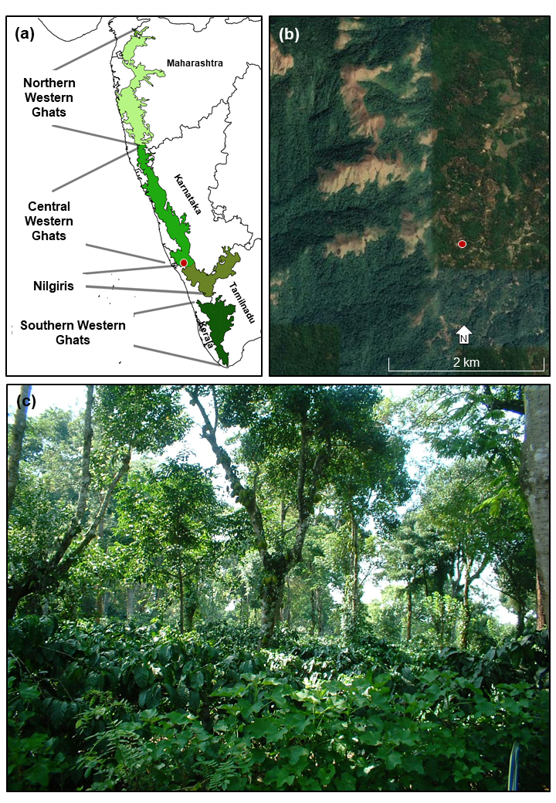
Figure 1: (a) The Western Ghats of India (after Mirza et al., 2014). The circle represents the location of the study site in the Central part of the Western Ghats, located in Kodagu District, Karnataka. (b) Google image of the Kodagu region; the sedimentary sequence under study (12°9'14"N, 75°42'47"E; shown with a circle) is derived from a coffee agroforestry setting from the middle reaches of the Western Ghats (Data source: https://earth.google.com/). The site is less than 10 km away from a forest reserve currently under government protection. (c) An example of a coffee plantation grown under the shade of native trees in Kodagu, Western Ghats, India. A layer of coffee bushes is seen in the understorey and a canopy of native trees is seen above this layer. Such plantations of shade-grown coffee in many tropical regions have canopy structure similar to that of secondary forests. The shade of native trees provides habitat for many forest-dwelling species in otherwise highly human-dominated landscapes (Image credit: Shonil A. Bhagwat).

- Materials and methods
  - The study site in the Western Ghats
The Western Ghats is a mountain range running along the west coast of peninsular India (Fig. 1a). The mid-elevation (500–1500 m asl) terraces constitute over 90% of the Western Ghats, presenting a mosaic of wet evergreen rainforest and grasslands shaped by human activities, particularly fire (Premathilake, 2006; Kodandapani et al., 2009). Here we utilised one such mid-elevational sedimentary sequence (hereafter, Agroforest-1), derived from the Kodagu district of Karnataka i.e. the central part of the Western Ghats (Figs. 1a-b). The Kodagu district boasts the extensive network of wet evergreen rainforest reserves primarily of Mesua-Palaquium type (Ramesh and Pascal, 1997), occupying about 30% of the landscape (Fig. 1b; Bhagwat et al., 2005a). In addition to these formally protected forests, 10% of the landscape is under rice cultivation while c. 60% of the landscape is managed as agroforestry with high tree-canopy shading coffee plantations (Bhagwat et al., 2005b). Coffee (Coffea arabica var. robusta) is often planted in the understorey of shade trees (Fig. 1c), many of which are representative of native vegetation mixed with betel nut palm (Areca catechu; Bhagwat et al., 2012). Extracted from a small swamp situated in one of the coffee estates (12°09'14" N, 75°42'47" E; 910 m asl; Fig. 1), the Agroforest-1 sedimentary sequence is among the two overlapping cores, which was sub-sampled and processed in the laboratory for pollen and charcoal analyses (Bhagwat et al., 2012; Nogué et al., 2018). The robust age-depth model was established using several ¹⁴C dates and ²¹⁰Pb dates (Bhagwat et al., 2012; Nogué et al., 2018). The further details on the sediment core extraction, processing and chronology can be found in Supplementary Material.
  - Extent and components of canopy cover
We classified Agroforest-1 fossil pollen taxa into three groups: canopy-forming woody taxa (i.e. arboreal pollen types including trees, shrubs, lianas, climbers), grassland taxa (Poaceae and Cyperaceae), and herbaceous understorey taxa (all other non-arboreal pollen types). While only pollen-based landcover modelling applications can translate pollen taxa percentages into forested and non-forested fractions (e.g. REVEALS model by Sugita, 2007), the lack of key parameters (e.g., pollen productivity estimates, pollen fall speeds) in tropical regions, including India, does not yet allow landcover modelling (Anupama et al., 2019). However, recent modern pollen dispersal studies in India (Quamar and Kar, 2020 and references therein) attest that there is a good correlation between the abundance of pollen and extant vegetation in tropical wet evergreen forests with certain ‘indicator’ taxa (e.g., Mesua, Elaeocarpus, Ilex, Garcinia) well-represented in the pollen assemblages. Following this lead, we estimated the extent of canopy cover, grassland, and herbaceous understorey in the Western Ghats agroforestry landscape based on the collective abundance of canopy-forming woody taxa, grassland taxa, and herbaceous understorey taxa respectively. Additionally, we calculated the relative abundance of 20 long-lived habitat-specialist evergreen trees that are indicative of low disturbance and closed-canopy forest in the Western Ghats (Laurance et al., 2007; Nogué et al., 2018). We also juxtaposed the relative abundance of commonly cultivated plant taxa (e.g. Coffea) to differentiate the anthropogenic component of the canopy cover.
  - Plant diversity
Pollen richness can accurately reflect plant richness and landscape structure within one vegetation or climatic region (Birks et al., 2016 and references therein). To eliminate the bias due to variable pollen-count sums, we rarified the terrestrial pollen dataset by repeated random re-sampling 1000 times without replacement to a constant base-sum (E(S_{n})=243; Felde et al., 2015), using a custom-made computer code (https://github.com/wfinsinger/rrarefy.record; Finsinger et al., 2017) and the ‘vegan’ package in the R environment (Oksanen et al., 2013; R Core Team, 2014). We quantified plant richness i.e. plant diversity using Hill numbers (Hill, 1973) i.e. N₀: the effective total number of taxa present, N₁: the effective number of common taxa, N₂: the effective number of dominant taxa. These measures provide easily interpretable data based on how rare and abundant taxa are weighted. We also calculated the pollen evenness as the ratio of dominant taxa relative to all taxa present in an assemblage (N₂/N₀; Hill, 1973; Odgaard, 2008; Tuomisto, 2012). Considering the size of the swamp under study (<1 ha) and corresponding small-intermediate pollen source area (~10-20 km; Prentice, 1985; Sugita, 1993), our record would more likely show a high correlation between pollen richness and evenness (e.g. Colombaroli et al., 2013). To estimate diversity of the canopy-forming woody taxa, we applied the same re-sampling approach exclusively to the arboreal pollen sum (E(S_{n})=39).
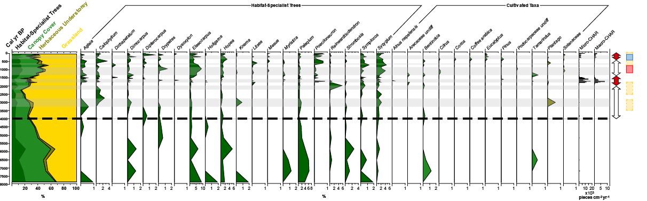
Figure 2: The abundances (%) of canopy-forming woody taxa, grassland, and herbaceous understorey are juxtaposed with those of individual habitat-specialist trees (indicative of low disturbance) and cultivated plant taxa including Coffea arabica (representative of the present-day agroforestry landscape). Anthropogenic fires are represented by Micro-CHAR and Macro-CHAR (pieces cm⁻²yr⁻¹) values. The years 1780±60 yr BP, 1436±60 yr BP, and 359±30 yr BP mark the switches among the no-fire and fire periods (white and red arrows respectively). Yellow bars highlight the intervals of enhanced aridity. Pink and blue bars indicate the Medieval Warm Period (MWP) and the Little Ice Age (LIA). Grey areas highlight periods of societal transitions i.e. changes in land management (see Fig. 3 and Sections 3-4 for details). The dotted line delimits the period of the last 4000 years focused in this work

  - Change in vegetation composition over time
In palaeoecological time series, temporal β-diversity is a measure of change in vegetation composition between adjacent samples that can be quantified using rate-of-change (Birks, 2007). To calculate rate-of-change, we linearly interpolated the pollen percentages on equal time intervals and subsequently estimated dissimilarity between adjacent samples using the chord distance of square-root transformed percentage values (Birks and Birks, 2008). Chord distance values range between zero (no change in vegetation composition) and two (complete change in vegetation composition, i.e. the two assemblages have no species in common). Due to the varying sample resolution across the 4000-yr long sequence (range = 22- 670 years; mean=121 years; 3rd quartile=120 years; see Fig. S1), we calculated two sets of temporal β-diversity records selecting an interpolation-window width greater than the third quartile of the sampling-resolution distribution. Thus, the β-diversity record for the entire 4000-yr period is at 260-yr resolution while another is for the last 2200 yr at 150-yr resolution (see details in Supplementary Material). Employing a shorter interpolation-window width for the past 2200 years allows us to visualise transformations in vegetation composition associated with intensified burning and land use change. The trends are illustrated by a LOESS-smoothed curve (Cleveland and Devlin, 1988).
  - Past fire management
We pooled our new macroscopic charcoal record (particles >150 µm) with the existing dataset by Nogué et al., (2018) that covered only the past 1000 years, extending the fire history up to 4000 yr BP. In addition, we utilised microscopic charcoal dataset previously quantified in tandem with pollen analysis of the Agroforest-1 core (Bhagwat et al., 2012). We discussed the associated chemical and analytical procedures in detail in Supplementary Material. We transformed charcoal concentrations to charcoal accumulation rates (CHAR; pieces cm⁻²yr⁻¹) to account for variations in sediment accumulation rates. Overall, macroscopic charcoal (<600 µm) and microscopic charcoal pieces can be dispersed over large distances (up to 30-50 km; Tinner et al., 1998; Oris et al., 2014; Adolf et al., 2018). Thus, the low-frequency background component of macroscopic charcoal (CHAR_{back}) and the microscopic charcoal trends are considered as proxies for the fire activity at the landscape-scale (Marlon et al., 2008; Adolf et al., 2018). We estimated the background component by interpolating the macro-charcoal record using a constant temporal resolution of 13 years (i.e. the median sediment accumulation rate), followed by LOWESS smoothing.
  - Monsoon variability and intervals of enhanced aridity
The annual monsoon precipitation cycle in the Indian Subcontinent is a manifestation of the seasonal migration of the intertropical convergence zone with ~80% of yearly rainfall between June and September (JJAS; Webster et al., 1998; Sinha et al., 2015). The study area, the Central Western Ghats, in particular, receives c. 2000 mm of average rainfall during JJAS (Ambinakudige and Sathish, 2009). While February-March can be the driest months, the pre-monsoon months (April-May) bring a small amount of rainfall (c. 200 mm/month; Sukumar et al., 2004). We used two independent lines of evidence to detect the intervals of enhanced aridity in response to reduced monsoon rainfall. First, using a Community Climate System Model-based PaleoView (Fordham et al., 2017), we obtained mean JJAS rainfall for the Kodagu region at 20-yr resolution. Although the absolute JJAS rainfall values are lower than the instrumental average (1300 vs. 2000 mm), it is the relative changes in rainfall that we focus on for identifying past intervals of enhanced aridity on the regional scale. In addition, we employed a fine-resolution (c. 1.8 years on average) speleothem record from North India to identify the weakening of the monsoon in the Indian Subcontinent (Kathayat et al., 2017). Despite possible regional heterogeneities within the subcontinent, we compared both records to identify common arid intervals across the past 4000 years.
  - Land use history
The Western Ghats has a long history of human occupation and modification as early as 800000 yr BP (Pappu and Deo, 1994; Gaillard et al., 2010). While the roots of agriculture-pastoralism in the region can be traced back to c. 5000 yr BP (Fuller et al., 2004), the agroforestry systems in particular is thought to be in existence for the past 2000 years (Krishna and Morrison, 2010). Based on the review of archaeological and environmental history literature (e.g., Rice, 1878; Chandran, 1997; Asouti and Fuller, 2008; Krishna and Morrison, 2010), we compiled a summary of land use history of the Kodagu region through notable ecological, social and political changes. The key societal transitions and changes in land management through intensification of existing strategies as well as through introduction of new means help us explore the historic roots of fires in the Western Ghats.
2.8 Statistical analyses
To examine the inter-relationships among fires, plant diversity, and canopy cover, we conducted simple linear regressions and time-series (cross-correlation) analyses for the entire 4000 yr timeline. We calculated the coefficients of determination (R²), identifying the strength of association between the independent and the dependent variables for each scatterplot. To explore lag effects of one variable on another (Green, 1981; Tinner et al., 1999; Rey et al., 2019), we computed cross correlations between key variables including fire (macro-CHAR values), plant diversity (total number of terrestrial taxa present (N₀)), diversity of canopy-forming woody taxa (total number of woody taxa present (N₀)), and canopy cover (arboreal pollen %) in R (R Core Team, 2014). As cross-correlation analysis requires evenly spaced data points, we resampled the records at regular intervals using LOESS smoothing (span=0.2). To avoid inflating the sampling resolution for the entire 4000-yr dataset (see Fig. S1), we estimated the correlation coefficients at 260 yr-intervals and presented with 95% confidence intervals (p < 0.05).

Figure 3: Temporal transformation of the Western Ghats agroforestry landscape over the past 4000 years:
(a) The extent (%) of the canopy cover (solid green) and the abundance of herbaceous understorey (dashed);
(b) Plant diversity using the pollen richness (N₀) of all terrestrial taxa;
(c) Temporal β-diversity (expressed in chord distance) suggestive of the change in vegetation composition over time, calculated at 260-yr resolution (dotted) and 150-yr resolution;
(d-e) Anthropogenic fires based on macroscopic (CHAR; pieces cm⁻²yr⁻¹) and microscopic (CHAR; x10³ pieces cm⁻²yr⁻¹) charcoal analysis; the thick brown line in macro-charcoal record is a 13-yr wide LOWESS-smoothing depicting charcoal background;
(f) Regional monsoonal months (JJAS) rainfall (mm) at 20-yr interval;
(h) δ¹⁸O speleothem record from North India demonstrating Indian Summer Monsoon (ISM) intensity (after Kathayat et al. 2017).
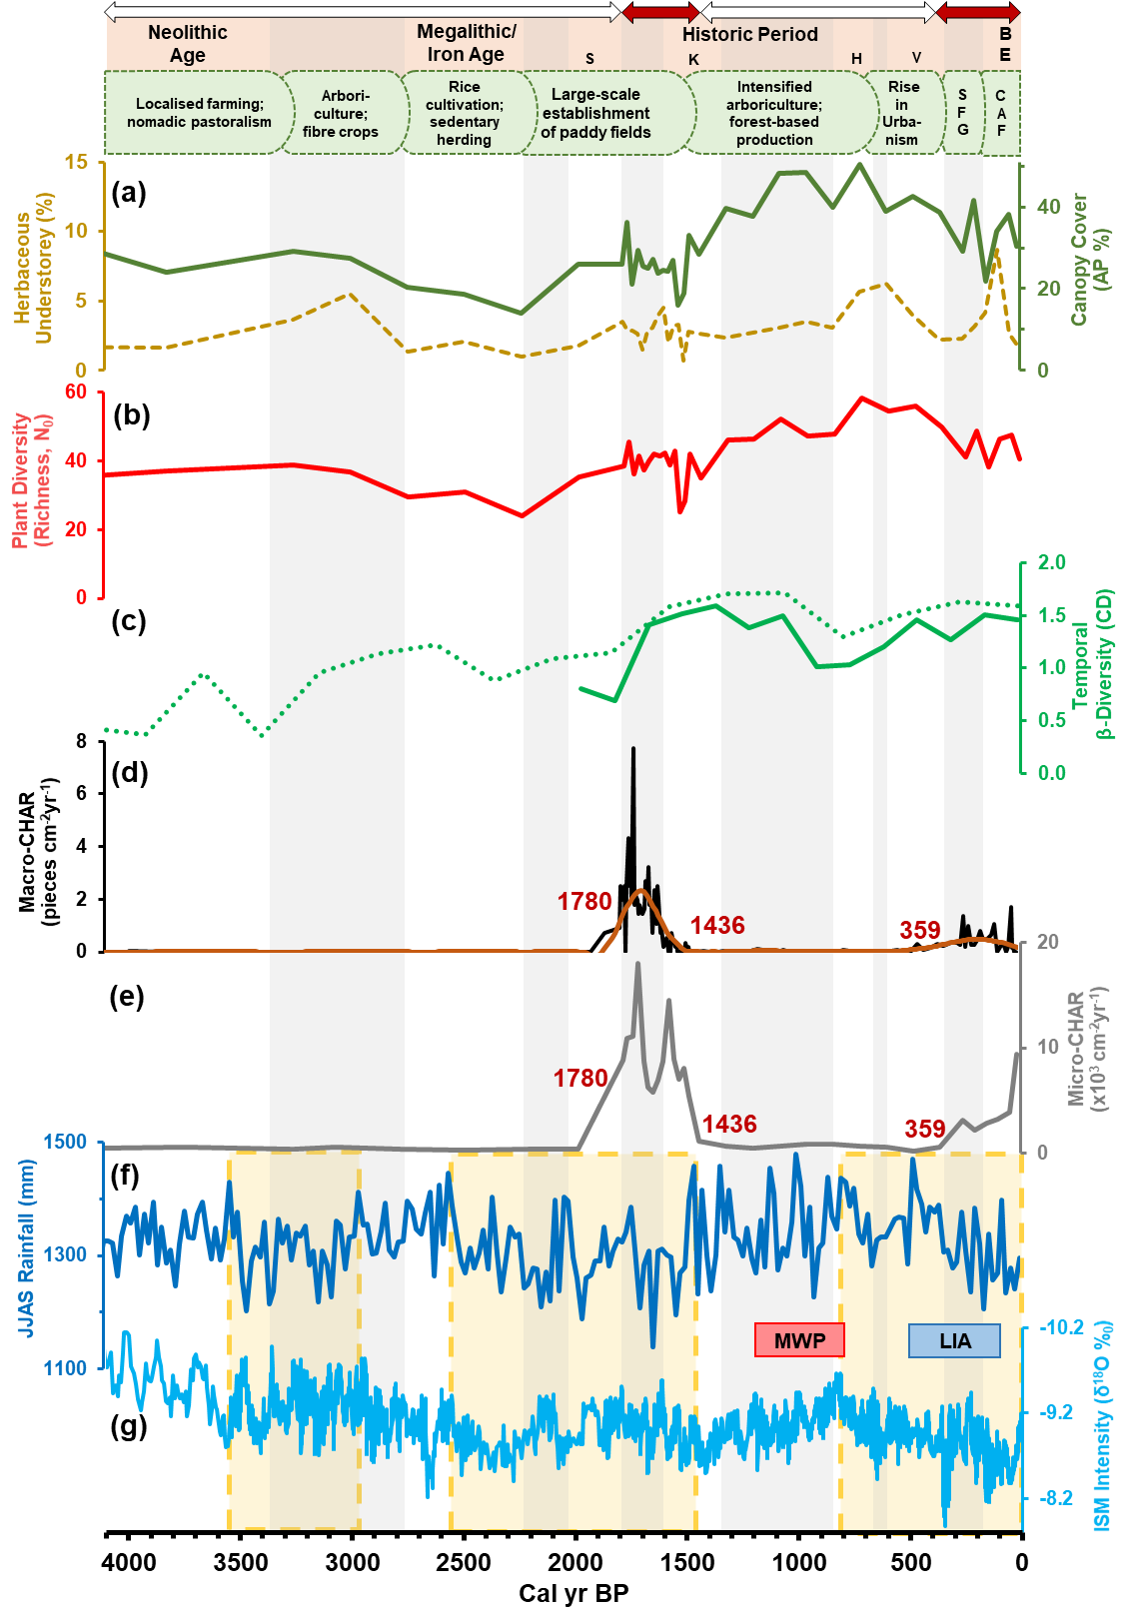
Yellow bars highlight the intervals of increased aridity. Pink and blue bars indicate the Medieval Warm Period (MWP) and the Little Ice Age (LIA). The top panel shows the summary of land use history of the Kodagu region through notable ecological, social and political changes (based on Rice, 1878; Chandran, 1997; Asouti and Fuller, 2008; Krishna and Morrison, 2010). Within the Historic Period, S = Satavahana Dynasty (2050-1800 yr BP), K = Kadamba Dynasty (1600-1350 yr BP), H = Hoyasala Kingdom (850-650 yr BP), V = Vijayanagara Empire (600-350 yr BP), and BE = British Era (150-0 yr BP). SFG stands for sacred forest groves while CAF stands for coffee agroforestry. Grey areas highlight periods of societal transitions i.e. changes in land management either through intensification of existing strategies and/or through introduction of new means. The years 1780±60 yr BP, 1436±60 yr BP, and 359±30 yr BP mark the switches between the no-fire and fire periods (white and red arrows respectively) and are considered as points of major transformations in the system.

- Results
  - Trends in canopy cover and plant diversity
The canopy cover exhibits considerable changes over the past 4000 years (Figs. 2-3a). It substantially declines from initially stable (23-29%) to its lowest value (14%) c. 2250 yr BP. Subsequently, a notable increase in canopy cover is visible until 2000 yr BP (~28%), followed by a series of fluctuations between 2000 and 1450 yr BP. Over the next 850 years, the canopy cover substantially increases, reaching its peak (48-51%) c. 1100-750 yr BP. From 600 yr BP onwards, it gradually shrinks to constitute c. 30% of the present-day landscape (Figs. 2-3a).
The pollen richness (N₀ = 24-58) and evenness (N₂/N₀ = 0.07-0.13) show largely analogous trends, collectively identifying plant diversity changes over time (Fig. 4). Starting from intermediate values (N₀ = 35-37), the pollen richness consistently declines reaching its minima (N₀ = 24) c. 2250 yr BP and the evenness shows modest fluctuations between 0.08 and 0.1. During 2250-1450 yr BP, richness recovers to a stable state (N₀ = 35-42 except 25 c. 1550 yr BP) whereas the evenness decreases until 1550 yr BP before increasing to 0.1. A perpetual rise is visible in both richness and evenness during 1450 and 1050 yr BP; both reach the highest values (N₀ = 58 and N₂/N₀ = 0.13) around 700 yr BP. While richness remains high until 450 yr BP, the evenness starts to drop. Subsequently, both indices show an overall declining trend. The present-day pollen richness value (N₀= 41) is slightly lower than its immediate no-fire counterpart in the Historic Period but higher than its oldest, no-fire counterpart (Figs. 3 and 5). Importantly, except a visible setback c. 1550 yr BP, the number of canopy-forming woody taxa hardly varies over the past four millennia (Fig. 4).
In case of vegetation composition, there is an overall increasing trend in temporal β-diversity (Fig. 3c). During 4000-2350 yr BP, it increases and decreases between 0.4 to 1.22, followed by an upward trend until 1050 yr BP (visible in both curves; more peculiar the 2200-yr curve in Fig. 3c). There is a modest drop in the temporal β-diversity during 1000-700 yr BP, however, it successively stabilises to constitute the present-day value of 1.5.
  - Anthropogenic fires and intervals of enhanced aridity
We find no evidence of fire occurrence between 4000 and 1800 yr BP (Figs. 3d-e). Fires first appear in the Western Ghats landscape c. 1800 yr BP and continue until 1400 yr BP. Negligible fires are noted over the period of next ~1000 years. Fires reappear in the landscape c. 400 yr BP, albeit at a much lower degree (Figs. 3d-e). Comparing regional JJAS rainfall and the overall monsoon intensity (Figs. 3e-f), three pronounced aridity intervals are observed: regional aridity during 3550-2950 yr BP, subcontinental aridity during 2550-1450 yr BP and the last 800 yr BP (except a short, wet regional spell c. 500 yr BP). The warm interval of the Medieval Warm Period is observed to be overall wet while the cooler Little Ice Age conditions are coterminous with substantial aridity and rainfall variability.
3.3 Relationships among plant diversity, canopy cover and fire activity
Canopy cover is significantly and positively correlated with the overall plant diversity (Figs. 6d and S2), its correlation with the diversity of woody taxa is rather weak (Fig. 6e). Canopy cover and plant diversity show positive responses to fire at lags > +2, corresponding to c. 500-750 years (Figs. 6a and 6c respectively). There is also a positive correlation between fire and the diversity of woody taxa but with a shorter lag (+1; ~260 years; Fig. 6b).

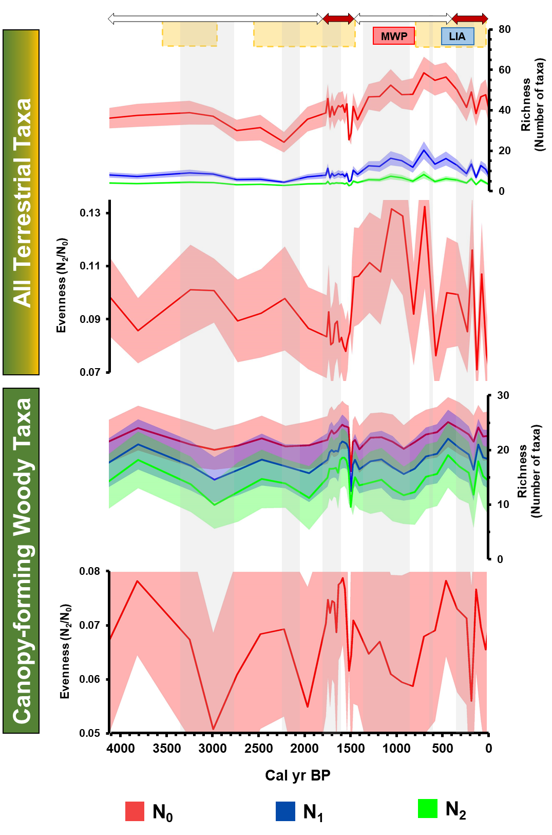
Figure 4: The pollen richness (N₀ = Total number of taxa present; N₁ = Total number of common taxa present; N₂ = Total number of dominant taxa present) and evenness (N₂/N₀) values of all terrestrial taxa and those of canopy-forming woody taxa from the Western Ghats. Shaded areas indicate the width of the 95% confidence interval around estimates. The no-fire and fire periods are shown by white and red arrows respectively. Yellow bars highlight the intervals of enhanced aridity. Pink and blue bars indicate the Medieval Warm Period (MWP) and the Little Ice Age (LIA). Grey areas highlight major periods of societal transitions i.e. changes in landscape management (see Fig. 3 and Sections 3-4 for details).

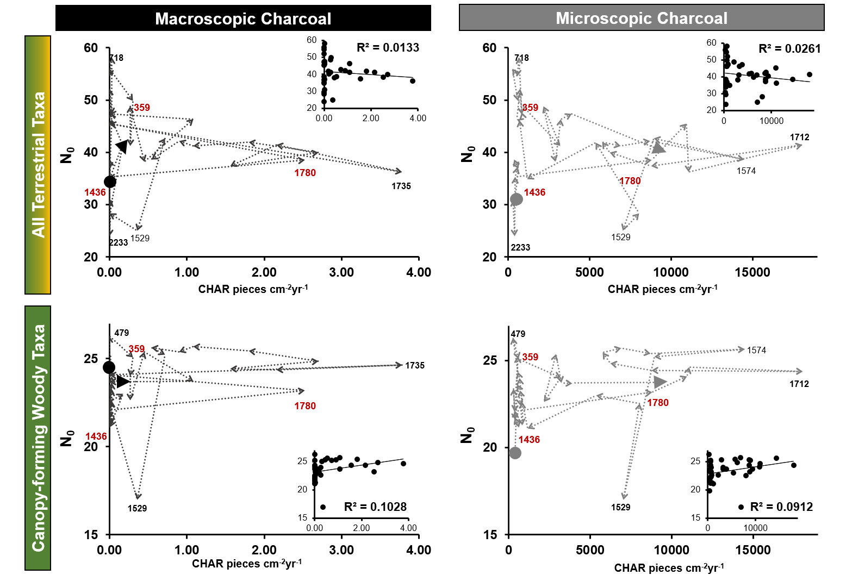
Figure 5: A relationship between plant diversity and anthropogenic fires in the Western Ghats agroforestry landscape. The pollen richness (N₀) values for all terrestrial taxa and canopy-forming woody taxa are plotted against macro- and micro-CHAR values (pieces cm⁻²yr⁻¹) and the points are connected in a chronological sequence. The solid circle represents the initial (oldest) plant diversity value in the sequence while the triangle shows the present-day value. Two fire periods, 1800-1400 yr BP and 400-0 yr BP are visible in Figs. 2-4: the years 1780±60 yr BP, 1436±60 yr BP, and 359±30 yr BP mark the switches among the no-fire and fire periods. The years associated with highest and lowest points in plant diversity and significant biomass burning events are also shown. Insets represent scatterplots of variables and the coefficients of determination (R²) show the strength of association. Note: The sample interval for pollen-based plant diversity indices and microscopic charcoal is 4-cm while that of for macroscopic charcoal is 1-cm. Thus, the corresponding macroscopic charcoal dataset in this comparative analysis resulted in a different CHAR ranges (0-4 cm⁻²yr⁻¹) as compared to the complete data range (0-8 cm⁻²yr⁻¹) seen in Figs. 2-3.

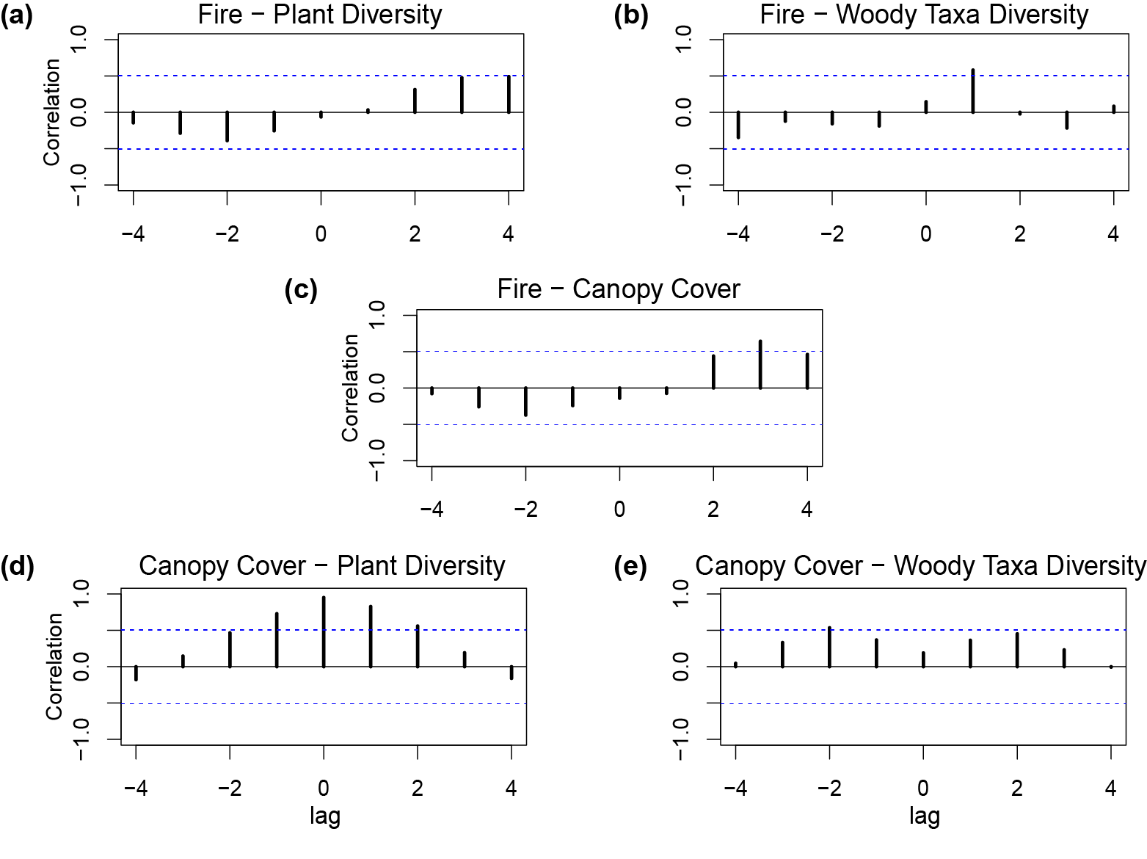
Figure 6: Cross-correlation analysis for the Western Ghats agroforestry sequence calculated at 260-yr intervals: (a) fire activity (macro-charcoal influx; cm⁻²yr⁻¹) and plant diversity (total number of terrestrial taxa present (N₀)); (b) fire activity and the diversity of canopy-forming woody taxa (total number of woody taxa present (N₀)); (c) fire activity and canopy cover (arboreal pollen %); (d) canopy cover and the overall plant diversity; and (e) canopy cover and the diversity of canopy-forming woody taxa. Cross-correlation coefficients are presented for maximum lag numbers corresponding to one‐fourth of the sample number n (lag number ≤ n/4). 1 lag = ~260 years. The dashed blue lines mark the significance level (p < 0.05).

- Discussion
In the Western Ghats agroforestry landscapes, we find two distinct periods of fire i.e. 1800-1400 yr BP and 400-0 yr BP that are concomitant with enhanced aridity (Fig. 3). As fire and aridity together could exacerbate drying of these wet tropical landscapes, we interpret the switches between the fire and no-fire periods in this record as points of major landscape transformations (Figs. 2-5) and explore their relationships with plant diversity and canopy cover. We subsequently interpret these results in the context of past landscape management and future conservation strategies for the Western Ghats and human-influenced social-ecological systems in the wet tropics.
  - Linkages between plant diversity and the canopy cover in the Western Ghats
We find a strong correlation between plant diversity and canopy cover: higher the canopy cover, higher the number of taxa in the landscape (Figs. 6d and S2). The high canopy cover could also favor the diversity of woody taxa (Fig. 6e). In human-influenced tropical landscapes, high canopy cover could mean less fragmented landscape (Chazdon, 2003). Tree canopies often reduce the severity of microclimatic changes including higher temperatures, increased wind speed, lower humidity, and lower soil moisture (Kapos et al., 1997; Freidenburg, 1998). As a result, there may be less edge-related disturbance and more habitat availability for forest-dwelling species and less for non-forest-dwelling species (Bhagwat et al., 2005b; Muthuramkumar et al., 2006). The congruence between the extent of canopy cover and plant diversity (Fig. 6d) is suggestive of the contribution of forest-dwelling herbaceous understorey in the plant diversity, especially with a stable number of woody taxa in this record over the past 4000 years. Overall, the maintenance of plant diversity in this tropical social-ecological system is closely linked with the extent of canopy cover i.e. landscape fragmentation.
  - Synergistic effects of anthropogenic fires and enhanced aridity on plant diversity and vegetation transformation
Over the course of 4000 years, plant diversity changes lag behind fires by as many as 250-500 years (Fig. 6a-b). Amid the first fire period (1800-1400 yr BP), the plant diversity substantially decreased around 1550 yr BP inclusive of the only significant decline in the woody taxa (Fig. 4). Considering the strong positive correlation between the canopy cover and the plant diversity (Fig. 6d), we argue that the sustained biomass burning coupled with enhanced aridity during 1800-1400 yr BP could have resulted in landscape fragmentation and a consequent reduction of both woody and herbaceous taxa. By opening and increasing canopy gaps and creating snags and deadwood patches, the prolonged use of fire can increase the number of potential ecological niches (Pausas and Keeley, 2019). In keeping with this, we find a greater temporal β-diversity during this fire period, indicating a higher degree of ecological transformation in response to fires, increased seasonality, and the extensive establishment of rice cultivation in the Western Ghats (Fig. 3).
Overall, the loss of plant diversity, especially that of woody taxa, c. 1550 yr BP could have had serious implications for contemporary societies. In this context, the reduction in fires c. 1400 yr BP onwards, perhaps associated with the emergence of arboriculture, and subsequent substantial upsurge in the diversity of woody taxa and in overall plant diversity over the next 850 years is interesting (Figs. 3c-e). Indeed, during this no-fire period (1400-400 yr BP), several habitat-specialist trees also found their way back after long hiatuses (e.g., Dipterocarpus, Myristica) while some made their first appearance (e.g., Dichapetalum, Poeciloneuron) in this Western Ghats agroforestry sequence, indicating a post-disturbance transition towards a closed canopy evergreen forest (Figs. 2-3a). Interestingly, temporal β-diversity remained high until 1000 yr BP, c. 400 years after the end of the first fire period (Fig. 3c), suggestive of a long vegetation recovery time or of other factors (e.g. land use) that had been critical in forest transformation. Overall, the increased plant diversity and canopy cover during the no-fire period seem to be coterminous with organised slash-and-burn agriculture, intensification of arboriculture, and later with the onset of agroforestry during the wet Medieval Warm Period (Fig. 3 top panel; Asouti and Fuller, 2008). A collective strategy for curtailing the use of fire (e.g., infrequent, very localised burns) and planting trees and shrubs on productive agricultural land could have played an important role in invigorating plant diversity in the region (Figs. 3 and 5). Such large-scale changes could be achievable largely due to paradigm shifts in land use by the local communities (e.g., Luoga et al., 2005; Dalle et al., 2006). This could have included changes in their attitude towards forests in recognising their value as a provider of key resources essential for their subsistence including medicinal herbs, culturally important plants, and water (Bhagwat et al., 2014). Appreciating the importance of forests, native trees, and their ability to foster biodiversity in connection with certain ‘ecosystem services’ could be attributed to a timely response to changing climate (i.e. the Medieval Warm Period) from predominantly agro-pastoral societies. The subsequent reduction of canopy cover and loss of plant diversity over the course of Vijayanagara Empire (Figs. 3a-b and top panel), however, could indicate deleterious impacts of intensified urbanism and consequent resource pressures on the Western Ghats rainforests (Morrison, 2013).
Lastly, the return of fires c. 400 yr BP is in concurrence with the enhanced aridity the emergence of sacred forest groves in the Kodagu region (Fig. 3; Bhagwat et al., 2014). Although created as dedicated places of worship, the formation of sacred forest patches could have led to the protection and conservation of native trees (see the highest extent (16%) of habitat-specialist trees in Fig. 2; Bhagwat and Rutte, 2006). In maintaining sacred forest groves, a strict demarcation of forested and agricultural land parcels was implemented by the local dynasty and indigenous communities living under its rule (Belliappa, 2008), which could have effectively resulted into increased canopy cover in the region (Fig. 2). Thus, more coherent social-ecological systems in the Western Ghats can be attributed to the communities actively managing the landscape through a moderated use of fires and through maintenance as well as restoration of trees (Nogué et al., 2018).
The British occupation of India over the past 150 years established commercial agroforestry as well as state forestry, setting the new tone for forestry operations and overall landscape management (Chandran, 1997). The completely novel forest management plans, essentially modelled after European forestry systems, were extensively adopted (Rangarajan, 1996; Ribbentrop, 1900), streamlining the production of large timber volumes and generation of revenue from forest resources (Guha, 1983; Rajan, 1998). The colonial view of forests as a commodity also resulted in banning of the slash-and-burn practice, which came in direct conflict with traditional forest management practices (Gadgil and Guha, 1993). Under such completely altered land management strategy, the Kodagu region experienced the establishment of commercial coffee estates c. 100 yr BP (1854 CE; Ambinakudige and Choi, 2009). Forests were first substantially cleared to plant coffee but later shade grown coffee became the cultivation practice as coffee plants could not survive heavy monsoon rains (Ambinakudige and Sathish, 2009). Both the phases of reduction and revival of the canopy cover and that of plant diversity are visible in this Western Ghats agroforestry sequence, so is the gradual rise in vegetation transformation (Figs. 3a-c). Despite the banning of slash-and-burn practice, fires continued to occur in the Western Ghats landscape, perhaps as a societal response to the reduced rainfall (Fig. 3) and/or resistance towards colonial forest management (Thekaekara et al., 2017). The overall degree of biomass burning during this fire period (400-0 yr BP), however, has been much lower than that of during the previous fire period (1800-1400 yr BP; Figs. 3d-e). From a historic perspective, the present-day plant diversity in the Western Ghats falls within the range of historical variability: while the present-day plant diversity values are slightly lower than those in the previous fire period, they are higher in comparison with their oldest (no-fire) counterparts (Fig. 5). In other words, extensive coffee cultivation in the Western Ghats may have reduced the plant diversity to an extent (Fig. 3). However, due to the practice of maintaining native canopy cover, this cash-crop intensification may also have paved the way to reviving plant diversity when the conditions allowed. Today’s landscape under shade-grown coffee cultivation (c. 60% of the landscape) where native shade trees constitute a major share of the evergreen forest canopies (Fig. 1c).
  - Implications for ecological management in the Western Ghats and tropical agroforestry landscapes
    - Importance of conservation beyond forest reserves
Alongside other long-term, pollen-based diversity studies (e.g., Weng et al., 2006; Figueroa-Rangel et al., 2012; Palazzesi et al., 2014; Birks et al., 2016b; Rodríguez-Zorro et al., 2018), the relationship between canopy cover and plant diversity in the Agroforest-1 record echoes the unique ecological character of the tropics: the tree-covered matrix is an important determinant of sustaining biodiversity in the tropics. From a conservation point of view, our results further underline the need for maintaining trees in human-influenced tropical landscapes. While forest reserves in the tropics are strictly protected for biodiversity conservation, such areas might fall short of fulfilling their purpose without conservation management in the landscapes surrounding them (DeFries et al., 2010; Karanth and DeFries, 2010). Tree management in tropical landscapes under mounting anthropogenic pressures is challenging, calling for pragmatic solutions that support both biodiversity and people. As envisaged in India’s National Agroforestry Policy (Chavan et al., 2015), increasing area under agroforestry would be one of the most practical ways to do so – its potential in providing habitats outside formally protected land, connecting nature reserves, and alleviating resource-use pressure on conservation areas is already substantiated (Bhagwat et al., 2008; Schroth et al., 2004). Interestingly, positive canopy cover-biodiversity correlation is already visible in the modern-day coffee-dominated agroforestry landscapes in the Western Ghats (Kushalappa et al., 2019) and in other kinds of tropical agroforestry systems elsewhere (Tscharntke et al., 2011; Acabado and Martin, 2018; Ticktin et al., 2018), providing region-specific analogues for wider implementation.
Furthermore, the Agroforest-1 record (Fig. 2) shows that habitat-specialist trees have persisted in the landscape over the past 4000 years (e.g., Eleocarpus, Syzygium), reappeared at <1000-yr intervals (e.g., Holigarna, Myristica, Reinwardtiodendron), or even “arrived” during the first fire period (e.g., Poeciloneuron, Litsea). Throughout the record, these habitat-specialist trees continue to constitute c. 25-33% of the Western Ghats wet evergreen forest cover (Fig. 2), suggesting the resilience of old-growth trees towards varying degrees of fire management and land use. While a few of them (e.g., Dipterocarpus, Hopea, and Palaquium) are already part of historic baselines that conservationists value in planning and restoration of the Western Ghats (Muthuramkumar et al., 2006), our long-term pollen record provides further, empirical support to this assumption. Patches of native trees on agroforestry landscapes would, thus, be natural places to focus organised conservation and restoration efforts beyond forest reserves. However, to sustain the conservation potential of agroforestry systems, a balance between production and protection of natural features in the landscape is essential (Bhagwat et al., 2008). Thus, keeping remnants of such forests within agroforestry plantations and redesigning annual croplands to include features of old-growth trees (e.g. hedgerows) can contribute to landscape-level connectivity, thereby making biodiversity conservation more effective (Bobo et al., 2006; Morel and Nogué, 2019).
    - Towards effective fire management
We find a complex relationship between anthropogenic fires and plant diversity in the wet evergreen forests of the Western Ghats (Figs. 5-6): a significant impact on the diversity of woody and herbaceous taxa seems to be associated with intensified canopy openings through continued, extensive use of fires. Importantly, the relationship between fires and the diversity of woody taxa (Fig. 5) provides a new perspective to look at slash-and-burn agriculture, which is a localised, short-term burning practice. In the Indian Subcontinent, it is practiced as a fertilising process by burning of crop residues and returning some nutrients back to soil before the onset of the pre-monsoon rainfall during the months of April and May (Sukumar et al., 2004). While fire is restricted to agricultural lands, the probability of spread of fire from agricultural lands into forest lands increases with the fragmentation of the landscape and dryness of fuels (Kodandapani et al., 2004). This often leads to conflicts between rural, indigenous communities and the Indian Forestry Departments (IFDs), resulting into incendiarism, rapid fragmentation of landscape and loss of forests that IFDs hope to avoid (Singh, 2008; Thekaekara et al., 2017). Bringing past analogues of indigenous people’s practices to curb fires and subsequent recovery of the Western Ghats rainforest and plant diversity, we demonstrate that the limited, planned use of fires on agricultural land on localised scales may not leave a negative impact on plant diversity including canopy-forming woody taxa (see the discussion on sacred forest groves in Section 4.2). Since agroforestry landscapes hold promise of connecting nature reserves by increasing tree cover in the landscape (Bhagwat et al., 2008), we propose that low intensity biomass burning on agricultural lands would be a more practical solution, accommodating both traditional practice and avoidance of fires into forest reserves in the Western Ghats. These could be considered as “prescribed burns” on agroforestry landscapes, an evidence-based land management for collective engagement of two key actors in executing National Agroforestry Policy. We argue that such measures will sincerely help facilitate the effective implementation of this economically and ecologically important policy and its desired positive social-ecological outcomes.

5. Conclusions
The synergistic impacts of anthropogenic fires and enhanced aridity on plant diversity in one of world’s ancient social-ecological systems point out the complex relationship between plant diversity and fire activity. While there are examples of reduced plant diversity because of the combine effects of fire and enhanced aridity, our work also brings positive narratives where the limited, localised use of fires could have promoted the revival of plant diversity in the Western Ghats. Despite apparent changes in fires, aridity, and land use, the present-day plant diversity in the Western Ghats agroforestry landscape falls within the range of historical variability. Interestingly, the diversity of the canopy-forming woody taxa remained almost constant over the course of past 4000 years, indicating the contribution of forest-dwelling herbaceous understorey in plant diversity in this tropical landscape. Furthermore, in accordance with other tropical records, our data demonstrate that the canopy cover is the crucial determinant of sustaining plant diversity in a tropical landscape. Thus, the tree-covered matrix, even if fragmented, is one key landscape feature that needs to be conserved because of its role in providing refugia for important elements of tropical biodiversity (Bhagwat et al., 2012). Therefore, biodiversity conservation in the tropics needs to go beyond reserves; strictly protected areas might be inadequate to fulfil their purpose without conservation management in the landscapes surrounding them (Karanth and DeFries, 2010). Under mounting anthropogenic pressures, tree management in the tropical social-ecological systems calls for pragmatic solutions that support both ecological and social components of the landscape. Through the use of palaeoecological data from the Western Ghats, we show that people can play an active role in forest conservation and in sustaining plant diversity through reduced biomass burning and intentional woodland management. Thus, we argue that for the success of ecological management in human-influenced tropical regions, it is important to recognise that people are part of the landscape. Conservation-restoration efforts for sustaining biodiversity in the face of future monsoon variability can succeed only if they are planned in tandem with careful, evidence-based incorporation of traditional land management practices. Our work demonstrates that ancient tropical agroforestry systems form a good practice example of such collaborative efforts and have the potential to benefit both biodiversity and people.

Acknowledgments
Our work is part of ‘EARNEST: Examining the Agroforestry Landscape Resilience in India to inform Social-Ecological Sustainability in the Tropics’, a project funded by the European Union Horizon 2020 research and innovation programme through a Marie Skłodowska-Curie Actions Individual Fellowship awarded to Charuta Kulkarni, under the grant agreement no. 795557. We thank T. Brncic for help with coring, C.G. Kushalappa, and the College of Forestry for field assistance. We are grateful to R. Premathilake, K. Anupama, S. Prasad, and the Palynology Laboratory at the French Institute, Pondicherry, for their help with pollen identification. We thank D. Sinclair, Oxford Long Term Ecology Laboratory for her help in sub-sampling of the core, and S. Subitani and I. Figueiral from ISEM, Montpellier for their help in macroscopic charcoal processing and identification. Special thanks to P. Rodríguez-Zorro, R. Cassino, S. Yoshi Maezumi for interesting outlooks on ecology and fire regimes in other parts of the tropics. We extend our deep gratitude towards K. J. Willis, C. G. Kushalappa, and R. Premathilake regarding their insightful comments on the early stages of this work.

References
Acabado, S., Martin, M., 2018. The Ifugao agrocultural system: bridging culture and nature to enhance tropical biodiversity, in: Exploring Frameworks for Tropical Forest Conservation: Integrating Natural and Cultural Diversity for Sustainability - a Global Perspective. UNESCO, Mexico City, Mexico., pp. 228–253. https://doi.org/https://doi.org/http://creativecommons.org/licenses/by-sa/3.0/igo/
Adolf, C., Wunderle, S., Colombaroli, D., Weber, H., Gobet, E., Heiri, O., van Leeuwen, J.F.N., Bigler, C., Connor, S.E., Gałka, M., La Mantia, T., Makhortykh, S., Svitavská-Svobodová, H., Vannière, B., Tinner, W., 2018. The sedimentary and remote-sensing reflection of biomass burning in Europe. Glob. Ecol. Biogeogr. 27, 199–212. https://doi.org/10.1111/geb.12682
Ambinakudige, S., Choi, J., 2009. Global coffee market influence on land-use and landcover change in the Western Ghats of India. L. Degrad. Dev. 20, 327–335. https://doi.org/10.1002/ldr
Ambinakudige, S., Sathish, B.N., 2009. Comparing tree diversity and composition in coffee farms and sacred forests in the Western Ghats of India. Biodivers. Conserv. 18, 987–1000. https://doi.org/10.1007/s10531-008-9502-5
Anderson, M.K., Keeley, J.E., 2018. Native Peoples’ Relationship to the California Chaparral, in: Underwood, E.C. (Ed.), Valuing Chaparral. Springer International Publishing, pp. 79–121. https://doi.org/10.1007/978-3-319-68303-4_4
Anupama, K., Gaillard, M.-J., Prasad, S., Morrison, K.D., 2019. Holocene land cover and land use in South and Southeast Asia for climate modeling. PAGES Mag. 27, 75. https://doi.org/10.22498/pages.27.2.75
Ashley, R., Russell, D., Swallow, B., 2006. The policy terrain in protected area landscapes: Challenges for agroforestry in integrated landscape conservation. Biodivers. Conserv. https://doi.org/10.1007/s10531-005-2100-x
Asouti, E., Fuller, D.Q., 2008. Trees and Woodlands of South India: Archaeological Perspectives. Left Coast Press, Walnut Creek, California.
Belliappa, C.P., 2008. Nuggets from Coorg History. Rupa Publications, New Delhi, India.
Bhagwat, S.A., Kushalappa, C.G., Williams, P.H., Brown, N.D., 2005a. A landscape approach to biodiversity conservation of sacred groves in the Western Ghats of India. Conserv. Biol. 19, 1853–1862. https://doi.org/10.1111/j.1523-1739.2005.00248.x
Bhagwat, S.A., Kushalappa, C.G., Williams, P.H., Brown, N.D., 2005b. The role of informal protected areas in maintaining biodiversity in the Western Ghats of India. Ecol. Soc. 10, 8. https://doi.org/10.1111/j.1523-1739.2005.00248.x
Bhagwat, S.A., Nogué, S., Willis, K.J., 2014. Cultural drivers of reforestation in tropical forest groves of the Western Ghats of India. For. Ecol. Manage. 329, 393–400. https://doi.org/10.1016/j.foreco.2013.11.017
Bhagwat, S.A., Nogué, S., Willis, K.J., 2012. Resilience of an ancient tropical forest landscape to 7500 years of environmental change. Biol. Conserv. 153, 108–117. https://doi.org/10.1016/j.biocon.2012.05.002
Bhagwat, S.A., Rutte, C., 2006. Sacred groves : potential for biodiversity management. Ecol. Soc. Am. 9295, 519–524. https://doi.org/10.1890/1540-9295(2006)4
Bhagwat, S.A., Willis, K.J., Birks, H.J.B., Whittaker, R.J., 2008. Agroforestry: a refuge for tropical biodiversity? Trends Ecol. Evol. 23, 261–267. https://doi.org/10.1016/j.tree.2008.01.005
Bhowmick, M., Sahany, S., Mishra, S.K., 2019. Projected precipitation changes over the south Asian region for every 0.5 °C increase in global warming. Environ. Res. Lett. 14, 054005. https://doi.org/10.1088/1748-9326/ab1271
Birks, H.J.B., 2007. Estimating the amount of compositional change in late-Quaternary pollen-stratigraphical data. Veg. Hist. Archaeobot. 16, 197–202. https://doi.org/10.1007/s00334-006-0079-1
Birks, H.J.B., Birks, H.H., 2008. Biological responses to rapid climate change at the Younger Dryas–Holocene transition at Krakanes, western Norway. The Holocene 18, 19–30.
Birks, H.J.B., Felde, V.A., Bjune, A.E., Grytnes, J.-A., Seppä, H., Giesecke, T., 2016a. Does pollen-assemblage richness reflect floristic richness? A review of recent developments and future challenges. Rev. Palaeobot. Palynol. 228, 1–25. https://doi.org/10.1016/j.revpalbo.2015.12.011
Birks, H.J.B., Felde, V.A., Seddon, A.W.R., 2016b. Biodiversity trends within the Holocene. Holocene 26, 994–1001. https://doi.org/10.1177/0959683615622568
Bobo, K.S., Waltert, M., Sainge, N.M., Njokagbor, J., Fermon, H., Mühlenberg, M., 2006. From forest to farmland: Species richness patterns of trees and understorey plants along a gradient of forest conversion in Southwestern Cameroon. Biodivers. Conserv. 15, 4097–4117. https://doi.org/10.1007/s10531-005-3368-6
Bowman, D.M.J.S., Balch, J., Artaxo, P., Bond, W.J., Cochrane, M.A., D’Antonio, C.M., Defries, R., Johnston, F.H., Keeley, J.E., Krawchuk, M.A., Kull, C.A., Mack, M., Moritz, M.A., Pyne, S., Roos, C.I., Scott, A.C., Sodhi, N.S., Swetnam, T.W., 2011. The human dimension of fire regimes on Earth. J. Biogeogr. 38, 2223–2236. https://doi.org/10.1111/j.1365-2699.2011.02595.x
Bowman, D.M.J.S., Balch, J.K., Artaxo, P., Bond, W.J., Carlson, J.M., Cochrane, M.A., D’Antonio, C.M., DeFries, R.S., Doyle, J.C., Harrison, S.P., Johnston, F.H., Keeley, J.E., Krawchuk, M.A., Kull, C.A., Marston, J.B., Moritz, M.A., Prentice, I.C., Roos, C.I., Scott, A.C., Swetnam, T.W., Van Der Werf, G.R., Pyne, S.J., 2009. Fire in the earth system. Science 324, 481–484. https://doi.org/10.1126/science.1163886
Brown, P.J., Manders, P.T., Bands, D.P., Kruger, F.J., Andrag, R.H., 1991. Prescribed burning as a conservation management practice: A case history from the Cederberg mountains, Cape Province, South Africa. Biol. Conserv. 56, 133–150. https://doi.org/10.1016/0006-3207(91)90014-Z
Burrows, N.D., 2008. Linking fire ecology and fire management in south-west Australian forest landscapes. For. Ecol. Manage. 255, 2394–2406. https://doi.org/10.1016/j.foreco.2008.01.009
Chandran, M.D.S., 1997. On the ecological history of the Western Ghats. Curr. Sci. 73, 146–155. https://doi.org/10.2307/24098268
Chavan, S.B., Keerthika, A., Dhyani, S.K., Handa, A.K., Newaj, R., Rajarajan, K., 2015. National Agroforestry Policy in India: A low hanging fruit. Curr. Sci. 108, 1826–1834.
Chazdon, R.L., 2003. Tropical forest recovery: Legacies of human impact and natural disturbances. Perspect. Plant Ecol. Evol. Syst. 6, 51–71. https://doi.org/10.1078/1433-8319-00042
Clark, J.S., Merkt, J., Muller, H., 1989. Post-glacial fire, vegetation, and human history on the northern alpine forelands, south-western Germany. J. Ecol. 897–925. https://doi.org/10.2307/2260813
Cleveland, W.S., Devlin, S.J., 1988. Locally Weighted Regression: An Approach to Regression Analysis by Local Fitting. J. Am. Stat. Assoc. 83, 596–610.
Cochrane, M.A., 2011. The past, present, and future importance of fire in tropical rainforests, in: Bush, M.B., Flenley, J.R., Gosling, W.D. (Eds.), Tropical Rainforest Responses to Climatic Change. Springer-Verlag Berlin Heidelberg, pp. 213–240. https://doi.org/10.1007/978-3-642-05383-2_7
Colombaroli, D., Beckmann, M., van der Knaap, W.O., Curdy, P., Tinner, W., 2013. Changes in biodiversity and vegetation composition in the central Swiss Alps during the transition from pristine forest to first farming. Divers. Distrib. 19, 157–170. https://doi.org/10.1111/j.1472-4642.2012.00930.x
Colombaroli, D., Mistry, J., Milner, A., Vannière, B., Adolf, C., Bilbao, B.A., Carcaillet, C., Connor, S., Daniau, A.L., Hawthorne, D., Jeffers, E., Larson, E., Petrokofsky, G., Power, M.J., Sinnadurai, P., Berrio, J.C., Cassino, R., Gildeeva, O., Grosvenor, M., Hardiman, M., Hennebelle, A., Kuosman, N., Lestiennne, M., Portes, M.C., Rockell, G., Tsakiridou, M., Walsh, A., 2019. Diverse knowledge informing fire policy and biodiversity conservation. DiverseK Policy Brief. Royal Holloway University of London, UK.
Dalle, S.P., Blois, S. De, Caballero, J., Johns, T., 2006. Integrating analyses of local land-use regulations , cultural perceptions and land-use/land cover data for assessing the success of community-based conservation. For. Ecol. Mana 222, 370–383. https://doi.org/10.1016/j.foreco.2005.10.052
DeFries, R., Karanth, K.K., Pareeth, S., 2010. Interactions between protected areas and their surroundings in human-dominated tropical landscapes. Biol. Conserv. 143, 2870–2880. https://doi.org/10.1016/j.biocon.2010.02.010
Dixit, Y., Hodell, D.A., Petrie, C. a., 2014. Abrupt weakening of the summer monsoon in northwest India ~4100 yr ago. Geology 42, 339–342. https://doi.org/10.1130/G35236.1
Driscoll, D.A., Lindenmayer, D.B., Bennett, A.F., Bode, M., Bradstock, R.A., Cary, G.J., Clarke, M.F., Dexter, N., Fensham, R., Friend, G., Gill, M., James, S., Kay, G., Keith, D.A., MacGregor, C., Russell-Smith, J., Salt, D., Watson James, J.E.M., Williams Richard J., R.J., York, A., 2010. Fire management for biodiversity conservation: Key research questions and our capacity to answer them. Biol. Conserv. 143, 1928–1939. https://doi.org/10.1016/j.biocon.2010.05.026
Dunwiddie, P.W., 2001. Using Historical Data in Ecological Restoration: A Case Study from Nantucket, in: Egan, D., Howell, E.A. (Eds.), Historical Ecology Handbook. Island Press, Washington, D.C., pp. 367–390.
Felde, V.A., Peglar, S.M., Bjune, A.E., Grytnes, J.A., Birks, H.J.B., 2015. Modern pollen–plant richness and diversity relationships exist along a vegetational gradient in southern Norway. Holocene 26, 163–175. https://doi.org/10.1177/0959683615596843
Figueroa-Rangel, B.L., Willis, K.J., Olvera-Vargas, M., 2012. Late-Holocene successional dynamics in a transitional forest of west-central Mexico. Holocene 22, 143–153. https://doi.org/10.1177/0959683611414929
Finsinger, W., Morales-Molino, C., Gałka, M., Valsecchi, V., Bojovic, S., Tinner, W., 2017. Holocene vegetation and fire dynamics at Crveni Potok, a small mire in the Dinaric Alps (Tara National Park, Serbia). Quat. Sci. Rev. 167, 63–77. https://doi.org/10.1016/j.quascirev.2017.04.032
Fisher, B., Christopher, T., 2007. Poverty and biodiversity: Measuring the overlap of human poverty and the biodiversity hotspots. Ecol. Econ. 62, 93–101. https://doi.org/10.1016/j.ecolecon.2006.05.020
Fordham, D.A., Saltré, F., Haythorne, S., Wigley, T.M.L., Otto-Bliesner, B.L., Chan, K.C., Brook, B.W., 2017. PaleoView: A tool for generating continuous climate projections spanning the last 21 000 years at regional and global scales. Ecography (Cop.). 40, 001–011. https://doi.org/10.1111/ecog.03031
Freidenburg, L.K., 1998. Physical Effects of Habitat Fragmentation, in: Fielder, P.L., Kareiva, P.M. (Eds.), Conservation Biology for the Coming Decade. Chapman and Hall, New York, New York, USA., pp. 66–79. https://doi.org/10.1007/978-1-4757-2880-4
Froyd, C.A., Willis, K.J., 2008. Emerging issues in biodiversity & conservation management: The need for a palaeoecological perspective. Quat. Sci. Rev. 27, 1723–1732. https://doi.org/10.1016/j.quascirev.2008.06.006
Fuller, D., Korisettar, R., Venkatasubbaiah, P.C., Jones, M.K., 2004. Early plant domestications in southern India: Some preliminary archaeobotanical results. Veg. Hist. Archaeobot. 13, 115–129. https://doi.org/10.1007/s00334-004-0036-9
Gadgil, M., Guha, R., 1993. This Fissured Land: An Ecological History of India. University of California Press, Berkley. https://doi.org/10.1093/acprof:oso/9780198077442.001.0001
Gaillard, C., Mishra, S., Singh, M., Deo, S., Abbas, R., 2010. Lower and Early Middle Pleistocene Acheulian in the Indian sub-continent. Quat. Int. 223–224, 234–241. https://doi.org/10.1016/j.quaint.2009.08.021
Gillson, L., 2015. Biodiversity conservation and environmental change: using palaeoecology to manage dynamic landscapes in the Anthropocene. Oxford University Press, Oxford, UK.
Green, D.G., 1981. Time‐series and post‐glacial forest ecology. Quat. Res. 265–277. https://doi.org/10.1016/0033-5894(81)90030-2
Guha, R., 1983. Forestry in British and Post-British India: an historical analysis. Econ. Polit. Wkly. 17, 1882–1896.
Hill, O., 1973. Diversity and Evenness : A unifying notation and its Consequences. Ecology 54, 427–432.
Jackson, S.T., 2007. Looking forward from the past: history, ecology, and conservation. Front. Ecol. Environ. 5, 455. https://doi.org/10.1890/1540-9295(2007)5[455:LFFTPH]2.0.CO;2
Juárez-Orozco, S.M., Siebe, C., Fernández y Fernández, D., 2017. Causes and effects of forest fires in Tropical Rainforests: a bibliometric approach. Trop. Conserv. Sci. 10, 1–14. https://doi.org/10.1177/1940082917737207
Kapos, V., Wandelli, E., Camargo, J.L., Ganade, G., 1997. Edge-related changes in environment and plant responses due to forest fragmentation in Central Amazonia, in: Laurance, W.F., Bierregaard, R.O. (Eds.), Tropical Forest Remnants: Ecology, Management and Conservation of Fragmented Communities. The University of Chicago Press, Chicago, Illinois, US, pp. 33–44.
Karanth, K.K., DeFries, R., 2010. Conservation and management in human-dominated landscapes: Case studies from India. Biol. Conserv. 143, 2865–2869. https://doi.org/10.1016/j.biocon.2010.05.002
Kathayat, G., Cheng, H., Sinha, A., Yi, L., Li, X., Zhang, H., Li, H., Ning, Y., Edwards, R.L., 2017. The Indian monsoon variability and civilization changes in the Indian subcontinent. Sci. Adv. 3, e1701296. https://doi.org/10.1126/sciadv.1701296
Keeley, J.E., 2006. Fire management impacts on invasive plants in the western United States. Conserv. Biol. 20, 375–384. https://doi.org/10.1111/j.1523-1739.2006.00339.x
Kodandapani, N., Cochrane, M.A., Sukumar, R., 2009. Forest fire regimes and their ecological effects in seasonally dry tropical ecosystems in the Western Ghats, India, in: Cochrane, M.A. (Ed.), Tropical Fire Ecology: Climate Change, Land Use and Ecosysem Dynamics. Springer Praxis Books, pp. 335–354. https://doi.org/10.1191/030913300667747149
Kodandapani, N., Cochrane, M.A., Sukumar, R., 2008. A comparative analysis of spatial, temporal, and ecological characteristics of forest fires in seasonally dry tropical ecosystems in the Western Ghats, India. For. Ecol. Manage. 256, 607–617. https://doi.org/10.1016/j.foreco.2008.05.006
Kodandapani, N., Cochrane, M.A., Sukumar, R., 2004. Conservation threat of increasing fire frequencies in the Western Ghats, India. Conserv. Biol. 18, 1553–1561. https://doi.org/10.1111/j.1523-1739.2004.00433.x
Krishna, K.R., Morrison, K.D., 2010. History of South Indian Agriculture and Agroecosystems, in: Krishna, K.R. (Ed.), Agroecosystems of South India: Nutrient Dynamics, Ecology and Productivity. Brown Walker Press, Boca Raton, Florida, pp. 1–51.
Kushalappa, C.G., Bhavya, C.K., Raghuramulu, Y., Vaast, P., Garcia, C., Konerira, N., 2019. Can coffee based agroforestry conserve biodiversity? Evidence of exotics replacing native trees, in: The 4th World Congress on Agroforestry. Montpellier, France.
Laurance, W.F., Nascimento, H.E.M., Laurance, S.G., Andrade, A., Ewers, R.M., Harms, K.E., Luizão, R.C.C., Ribeiro, J.E., 2007. Habitat fragmentation, variable edge effects, and the landscape-divergence hypothesis. PLoS One 2, e1017. https://doi.org/10.1371/journal.pone.0001017
Leys, B., Finsinger, W., Carcaillet, C., 2014. Historical range of fire frequency is not the Achilles’ heel of the Corsican black pine ecosystem. J. Ecol. 102, 381–395. https://doi.org/10.1111/1365-2745.12207
Luoga, E.J., Witkowski, E.T.F., Balkwill, K., 2005. Land cover and use changes in relation to the institutional framework and tenure of land and resources in eastern Tanzania Miombo woodlands. Environ. Dev. Sustain. 7, 71–93. https://doi.org/10.1007/s10668-003-4013-8
Marlon, J.R., Bartlein, P.J., Carcaillet, C., Gavin, D.G., Harrison, S.P., Higuera, P.E., Joos, F., Power, M.J., Prentice, I.C., 2008. Climate and human influences on global biomass burning over the past two millennia. Nat. Geosci. 1, 697–702. https://doi.org/10.1038/ngeo313
McLauchlan, K.K., Higuera, P.E., Miesel, J., Rogers, B.M., Schweitzer, J., Shuman, J.K., Tepley, A.J., Varner, J.M., Veblen, T.T., Adalsteinsson, S.A., Balch, J.K., Baker, P., Batllori, E., Bigio, E., Brando, P., Cattau, M., Chipman, M.L., Coen, J., Crandall, R., Daniels, L., Enright, N., Gross, W.S., Harvey, B.J., Hatten, J.A., Hermann, S., Hewitt, R.E., Kobziar, L.N., Landesmann, J.B., Loranty, M.M., Maezumi, S.Y., Mearns, L., Moritz, M., Myers, J.A., Pausas, J.G., Pellegrini, A.F.A., Platt, W.J., Roozeboom, J., Safford, H., Santos, F., Scheller, R.M., Sherriff, R.L., 2020. Fire as a fundamental ecological process : Research advances and frontiers. J. Ecol. 1–23. https://doi.org/10.1111/1365-2745.13403
McNeely, J.A., Schroth, G., 2006. Agroforestry and biodiversity conservation - Traditional practices, present dynamics, and lessons for the future. Biodivers. Conserv. 15, 549–554. https://doi.org/10.1007/s10531-005-2087-3
Miller, R.P., Nair, P.K.R., 2006. Indigenous agroforestry systems in Amazonia: From prehistory to today. Agrofor. Syst. 66, 151–164. https://doi.org/10.1007/s10457-005-6074-1
Mirza, Z.A., Sanap, R. V., Bhosale, H., 2014. Preliminary review of indian eumenophorinae (Araneae: Theraphosidae) with description of a new genus and five new species from the Western Ghats. PLoS ONE 9, e87928. https://doi.org/10.1371/journal.pone.0087928
Mishra, V., Thirumalai, K., Singh, D., Aadhar, S., 2020. Future exacerbation of hot and dry summer monsoon extremes in India. npj Clim. Atmos. Sci. 3, 1–9. https://doi.org/10.1038/s41612-020-0113-5
Morel, A.C., Nogué, S., 2019. Combining Contemporary and Paleoecological Perspectives for Estimating Forest Resilience. Front. For. Glob. Chang. 2, 1–17. https://doi.org/10.3389/ffgc.2019.00057
Morrison, K.D., 2013. The Human Face of the Land: Why the past matters for India’s environmental future. Nehru Memorial Museum and Library, New Delhi, India.
Muthuramkumar, S., Ayyappan, N., Parthasarathy, N., Mudappa, D., Raman, T.R.S., Selwyn, M.A., Pragasan, L.A., 2006. Plant community structure in tropical rain forest fragments of the Western Ghats, India. Biotropica 38, 143–160. https://doi.org/10.1111/j.1744-7429.2006.00118.x
Nogué, S., Tovar, C., Bhagwat, S.A., Finsinger, W., Willis, K.J., 2018. Exploring the Ecological History of a Tropical Agroforestry Landscape Using Fossil Pollen and Charcoal Analysis from Four Sites in Western Ghats, India. Ecosystems 21, 45–55. https://doi.org/10.1007/s10021-017-0132-1
Nogueira, D.S., Marimon, B.S., Marimon-Junior, B.H., Oliveira, E.A., Morandi, P., Reis, S.M., Elias, F., Neves, E.C., Feldpausch, T.R., Lloyd, J., Phillips, O.L., 2019. Impacts of Fire on Forest Biomass Dynamics at the Southern Amazon Edge. Environ. Conserv. 46, 258–292. https://doi.org/10.1017/S0376892919000110
Odgaard, B. V., 2008. Species richness of the past is elusive — evenness may not be. Terra Nostra 2, 209.
Oksanen, J., Blanchet, F., Kindt, R., Legendre, P., Minchin, P., O’Hara, R., Simpson, G., Solymos, P., Stevens, M., Wagner, H., 2013. Vegan: Community Ecology Package. R Packag. Version 2.0-10. https://doi.org/10.4135/9781412971874.n145
Oris, F., Ali, A.A., Asselin, H., Paradis, L., Bergeron, Y., Finsinger, W., 2014. Charcoal dispersion and deposition in boreal lakes from 3 years of monitoring: Differences between local and regional fires. Geophys. Res. Lett. 41, 6743–6752. https://doi.org/10.1002/2014GL060984
Palazzesi, L., Barreda, V.D., Cuitiño, J.I., Guler, M. V., Tellería, M.C., Ventura Santos, R., 2014. Fossil pollen records indicate that Patagonian desertification was not solely a consequence of Andean uplift. Nat. Commun. 5, 1–8. https://doi.org/10.1038/ncomms4558
Pappu, R.S., Deo, S.G., 1994. Man-land relationships during Palaeolithic times in the Kaladgi Basin, Karnataka. Deccan College Post-Graduate and Research Institute, Pune, India.
Pausas, J.G., Keeley, J.E., 2019. Wildfires as an ecosystem service. Front. Ecol. Environ. 17, 289–295. https://doi.org/10.1002/fee.2044
Premathilake, R., 2006. Relationship of environmental changes in central Sri Lanka to possible prehistoric land-use and climate changes. Palaeogeogr. Palaeoclimatol. Palaeoecol. 240, 468–496. https://doi.org/10.1016/j.palaeo.2006.03.001
Prentice, I.C., 1985. Pollen representation, source area, and basin size: Toward a unified theory of pollen analysis. Quat. Res. 23, 76–86. https://doi.org/10.1016/0033-5894(85)90073-0
Quamar, M.F., Kar, R., 2020. Modern pollen dispersal studies in India: a detailed synthesis and review. Palynology 44, 217–236. https://doi.org/10.1080/01916122.2018.1557274
R Core Team, 2014. R: a language and environment for statistical computing.
Rajan, R., 1998. Imperial environmentalism or environmental imperialism? European forestry, colonial foresters and the agendas of forest management in British India 1800–1900, in: Groves, R.H., Damodaran, V., Sangwan, S. (Eds.), Nature and the Orient: The Environmental History of South and Southeast Asia. Oxford University Press, New Delhi, India.
Ramesh, B.R., Pascal, J.P., 1997. Atlas of endemics of the Western Ghats (India): distribution of tree species in the evergreen and semi-evergreen forests. Institut francais de Pondichery, Pondicherry, India.
Rangarajan, M., 1996. Fencing the Forest: Conservation and Ecological Change in India’s Central Provinces 1860-1914. Oxford University Press, New Delhi.
Rey, F., Gobet, E., Schwörer, C., Wey, O., Hafner, A., Tinner, W., 2019. Causes and mechanisms of synchronous succession trajectories in primeval Central European mixed Fagus sylvatica forests. J. Ecol. 1392–1408. https://doi.org/10.1111/1365-2745.13121
Ribbentrop, B., 1900. Forestry in British India. Calcutta Government Press, Calcutta, India.
Rice, B.L., 1878. Mysore and Coorg: gazetteer compiled for the Government of India. Vol. III Coorg. Mysore Government Press, Bangalore.
Roberts, P., Hunt, C., Arroyo-Kalin, M., Evans, D., Boivin, N., 2017. The deep human prehistory of global tropical forests and its relevance for modern conservation. Nat. Plants 3, 17093. https://doi.org/10.1038/nplants.2017.93
Rodríguez-Zorro, P.A., Turcq, B., Cordeiro, R.C., Moreira, L.S., Costa, R.L., McMichael, C.H., Behling, H., 2018. Forest stability during the early and late Holocene in the igapó floodplains of the Rio Negro, northwestern Brazil. Quat. Res. 89, 75–89. https://doi.org/10.1017/qua.2017.99
Roxy, M.K., Ritika, K., Terray, P., Murtugudde, R., Ashok, K., Goswami, B.N., 2015. Drying of Indian subcontinent by rapid Indian ocean warming and a weakening land-sea thermal gradient. Nat. Commun. 6, 7423. https://doi.org/10.1038/ncomms8423
Schroth, G., Fonseca, G. a. B. Da, Harvey, C. a., Vasconcelos, H.L., Goscon, C., Izar, A.-M.N., 2004. Agroforestry and biodiversity conservation in Tropical Landscapes. Island Press. https://doi.org/10.1007/s10457-006-9011-z
Seddon, A.W.R., Mackay, A.W., Baker, A.G., Birks, H.J.B., Breman, E., Buck, C.E., Ellis, E.C., Froyd, C.A., Gill, J.L., Gillson, L., Johnson, E.A., Jones, V.J., Juggins, S., Macias-Fauria, M., Mills, K., Morris, J.L., Nogués-Bravo, D., Punyasena, S.W., Roland, T.P., Tanentzap, A.J., Willis, K.J., Aberhan, M., van Asperen, E.N., Austin, W.E.N., Battarbee, R.W., Bhagwat, S.A., Belanger, C.L., Bennett, K.D., Birks, H.H., Bronk Ramsey, C., Brooks, S.J., de Bruyn, M., Butler, P.G., Chambers, F.M., Clarke, S.J., Davies, A.L., Dearing, J.A., Ezard, T.H.G., Feurdean, A.N., Flower, R.J., Gell, P., Hausmann, S., Hogan, E.J., Hopkins, M.J., Jeffers, E.S., Korhola, A.A., Marchant, R., Kiefer, T., Lamentowicz, M., Larocque-Tobler, I., López-Merino, L., Liow, L.H., Mcgowan, S., Miller, J.H., Montoya, E., Morton, O., Nogué, S., Onoufriou, C., Boush, L.P., Rodriguez-Sanchez, F., Rose, N.L., Sayer, C.D., Shaw, H.E., Payne, R., Simpson, G., Sohar, K., Whitehouse, N.J., Williams, J.W., Witkowski, A., 2014. Looking forward through the past: Identification of 50 priority research questions in palaeoecology. J. Ecol. 102, 256–267. https://doi.org/10.1111/1365-2745.12195
Silvério, D. V., Brando, P.M., Bustamante, M.M.C., Putz, F.E., Marra, D.M., Levick, S.R., Trumbore, S.E., 2019. Fire, fragmentation, and windstorms: A recipe for tropical forest degradation. J. Ecol. 107, 656–667. https://doi.org/10.1111/1365-2745.13076
Singh, P.P., 2008. Exploring biodiversity and climate change benefits of community-based forest management. Glob. Environ. Chang. 18, 468–478. https://doi.org/10.1016/j.gloenvcha.2008.04.006
Sinha, A., Berkelhammer, M., Stott, L., Mudelsee, M., Cheng, H., Biswas, J., 2011. The leading mode of Indian Summer Monsoon precipitation variability during the last millennium. Geophys. Res. Lett. 38, 2–6. https://doi.org/10.1029/2011gl047713
Sinha, A., Kathayat, G., Cheng, H., Breitenbach, S.F.M., Berkelhammer, M., Mudelsee, M., Biswas, J., Edwards, R.L., 2015. Monsoon rainfall over the last two millennia. Nat. Commun. 6, 6309. https://doi.org/10.1038/ncomms7309
Sugita, S., 2007. Theory of quantitative reconstruction of vegetation I: Pollen from large sites REVEALS regional vegetation composition. Holocene 17, 229–241. https://doi.org/10.1177/0959683607075837
Sugita, S., 1993. A Model of Pollen Source Area for an Entire Lake Surface. Quat. Res. 39, 239–244. https://doi.org/10.1006/qres.1993.1027
Sukumar, R., Suresh, H.S., Dattaraja, H.S., John, R., Joshi, N.V., 2004. Mudumalai forest dynamics plot, India., in: Losos, E.C., Leigh, Jr., E.G. (Eds.), Tropical Forest Diversity and Dynamism, Findings From a Large-Scale Plot Network. University of Chicago Press, Chicago.
Swain, A.M., 1973. A history of fire and vegetation in northeastern Minnesota as recorded in lake sediments. Quat. Res. 3, 383–396.
Tacconni, L., Moore, P.F., Kaimowitz, D., 2007. Fires in tropical forests – what is really the problem? Lessons from Indonesia. Mitig. Adapt. Strateg. Glob. Chang. 21, 55–66. https://doi.org/10.1007/s11027-006-9040-y
Thekaekara, T., Vanak, A.T., Hiremath, A., Rai, N.D., Ratnam, J., Sukumar, R., 2017. Notes from the Other Side of a Forest Fire. Econ. Polit. Wkly. 52, 22–25.
Ticktin, T., Quazi, S., Dacks, R., Tora, M., McGuigan, A., Hastings, Z., Naikatini, A., 2018. Linkages between measures of biodiversity and community resilience in Pacific Island agroforests. Conserv. Biol. 32, 1085–1095. https://doi.org/10.1111/cobi.13152
Tinner, W., Conedera, M., Ammann, B., Gäggeler, H.W., Gedye, S., Jones, R., Sägesser, B., 1998. Pollen and charcoal in lake sediments compared with historically documented forest fires in southern Switzerland since AD 1920. Holocene 8, 31–42. https://doi.org/10.1191/095968398667205430
Tinner, W., Hubschmid, P., Wehrli, M., Ammann, B., Conedera, M., 1999. Long‐term forest fire ecology and dynamics in southern Switzerland. J. Ecol. 87, 273–289. https://doi.org/10.1046/j.1365‐2745.1999.00346.x
Tscharntke, T., Clough, Y., Bhagwat, S.A., Buchori, D., Faust, H., Hertel, D., Hölscher, D., Juhrbandt, J., Kessler, M., Perfecto, I., Scherber, C., Schroth, G., Veldkamp, E., Wanger, T.C., 2011. Multifunctional shade-tree management in tropical agroforestry landscapes - A review. J. Appl. Ecol. 48, 619–629. https://doi.org/10.1111/j.1365-2664.2010.01939.x
Tuomisto, H., 2012. An updated consumer’s guide to evenness and related indices. Oikos 121, 1203–1218. https://doi.org/10.1111/j.1600-0706.2011.19897.x
Webster, P.J., Magana, V.O., Palmer, T.N., Shukla, J., Tomas, R.A., Yanai, M.U., Yasunari, T., 1998. Monsoons: Processes, predictability, and the prospects for prediction. J. Geophys. Res. 103, 14451–14510. https://doi.org/10.1029/97JC02719
Weng, C.Y., Hooghiemstra, H., Duivenvoorden, J.F., 2006. Challenges in estimating past plant diversity from fossil pollen data: statistical assessment, problems, and possible solutions. Divers. Distrib. 12, 310–318. https://doi.org/10.1111/j.1366-9516.2006.00230.x
Whitlock, C., Colombaroli, D., Conedera, M., Tinner, W., 2018. Land-use history as a guide for forest conservation and management. Conserv. Biol. 32, 84–97. https://doi.org/10.1111/cobi.12960
Wright, H.E., Heinselman, M.L., 1973. The ecological role of fire in natural conifer forests of western and Northern North America–Introduction. Quat. Res. 3, 319–328. https://doi.org/10.1007/bf03400628

Supplementary Material

Western Ghats Agroforest-1 sedimentary sequence
Core retrieval and lithological description
Using a GeoCore sediment coring system, two 172-cm long overlapping sediment sequences were retrieved from a small swamp (12° 9' 14"N, 75° 42' 47"E; 910 m asl), situated at the confluence of two perennial streams in a coffee estate (Bhagwat et al., 2012). Both sedimentary sequences are composed of alternating sequences of clay and silty clay varying between yellowish brown and dark brown hues with a sporadic appearance of sand lenses and granules.

Chronology
The chronology of the Agroforest-1 core is based on five radiocarbon dates (Bhagwat et al., 2012) and four ²¹⁰Pb dates (Nogué et al., 2018a). Radiocarbon dates were measured at the Oxford Radiocarbon Accelerator Unit and ¹⁴CHRONO Centre at Queens University Belfast and were calibrated using the IntCal13 data set (Reimer et al., 2013). ²¹⁰Pb dating was carried out at School of Geography and Environment, University of Oxford. The age-depth model was established using Clam (Blaauw, 2010) and can be found as Figure S1(a) in Nogué et al., (2018b). The current study utilises the top 150 cm of Agroforest-1 sequence, which is equivalent to 4000 yr BP.

Pollen and charcoal extraction and analysis
Sediment cores were sub-sampled at 4-cm intervals. Pollen and microscopic charcoal particles were extracted using standard palynological methods (Bennett and Willis, 2001). Known quantities of an exotic marker, Lycopodium spores were added to each sample prior to chemical treatment to calculate pollen-charcoal concentration and influxes (Stockmarr, 1971). A minimum of 500 terrestrial pollen grains was counted for each depth, except for 76 cm and 140 cm due to slightly poor pollen preservation. As many as 225 pollen taxa were identified and classified into arboreal pollen types (e.g., trees, shrubs, lianas, climbers), grassland taxa (Poaceae and Cyperaceae), and herbaceous taxa inclusive of all other non-arboreal pollen types. The percentage abundances of the above groups were interpreted as the extents of the canopy cover, grassland, and herbaceous understorey in this study. In Figure 2, the pollen and other datasets are plotted using TILIA Graph (Grimm, 1992).
Microscopic charcoal pieces were counted on the Agroforest-1 pollen slides (Bhagwat unpublished data) using a point-counting method (Clark, 1982). For macroscopic charcoal (<150 µm), this study extends the existing Agroforest-1 macroscopic-charcoal record (Nogué et al., 2018b) that covered only the past 1000 years, to 4000 years. Thus, the core was sampled at 1-cm intervals (~28 years sample⁻¹ on average) for the top 150 cm. Following Finsinger et al., (2014), 1 cm³ of sediments were deflocculated and bleached overnight with a 10% sodium hexametaphosphate + 5% sodium hypochloride mixture followed by wet sieving through a 150 µm mesh. The samples were then suspended in 15% hydrogen peroxide for 15-20 minutes followed by wet sieving. Macroscopic charcoal pieces in each sample were manually counted under a binocular microscope. To ensure the consistency in data collection, we re-analysed the macro-charcoal data from 0-56 cm (0-1197 yr BP) utilised in Nogué et al., (2018b).
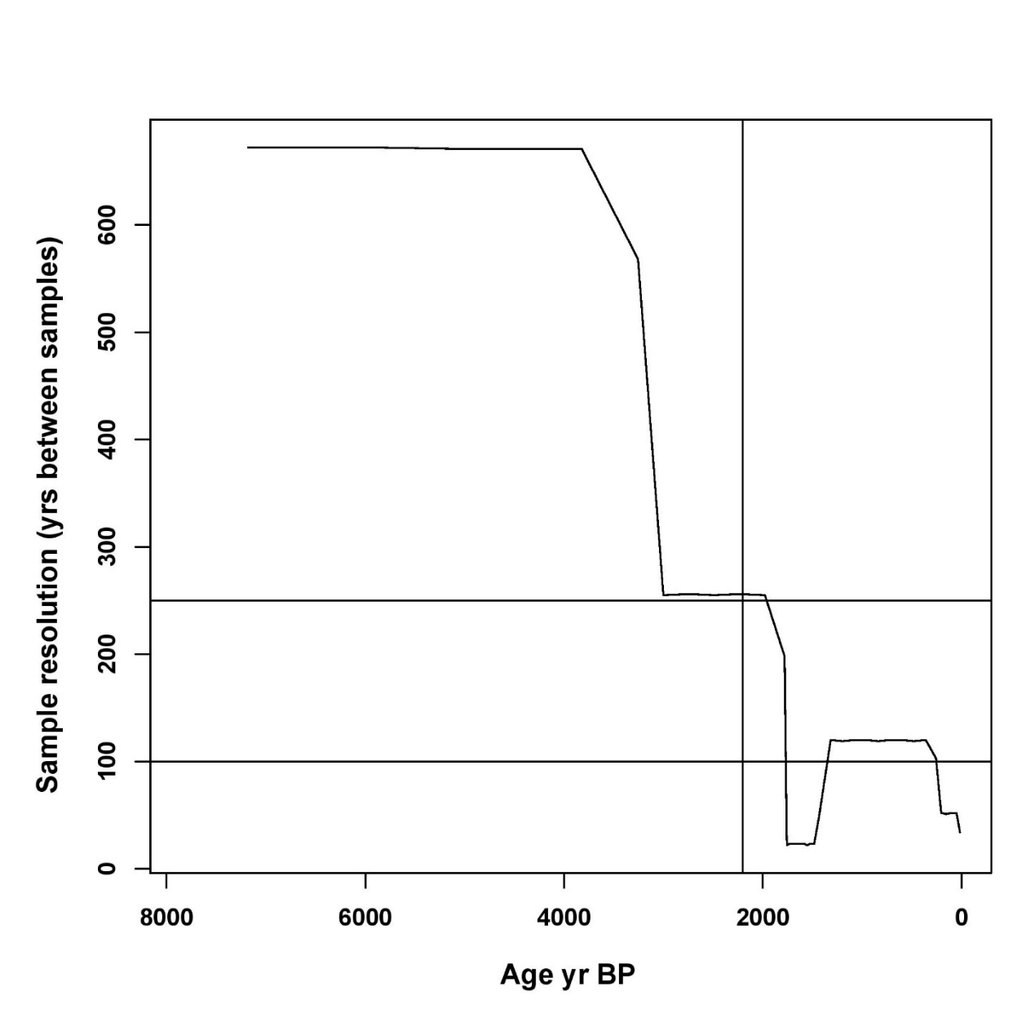
Supplementary Figure 1: Variation in the sample resolution across the Agroforest-1 sequence. For the entire timescale under study (last 4000 years; 4500-15 cal yr BP), the sample resolution ranges between 22 and 671 years with mean=121 years, median=52 years, and 3rd quartile=120 years whereas for the higher resolution section (2200-15 cal yr BP) where the sampling resolution is less variable (range=22-198 years; mean=65 years; median=49 years; 3rd quartile=120 years). For calculating temporal β-diversity, we purposely select two interpolation-window widths of 260 years (for the entire 4000-yr period) and 150 years (for the last 2200 yr) that are greater than the third quartile of the sampling-resolution distributions, thereby avoiding sampling resolution inflection. We also use the 260-yr window for performing cross-correlation analysis for the entire timeline of the study.
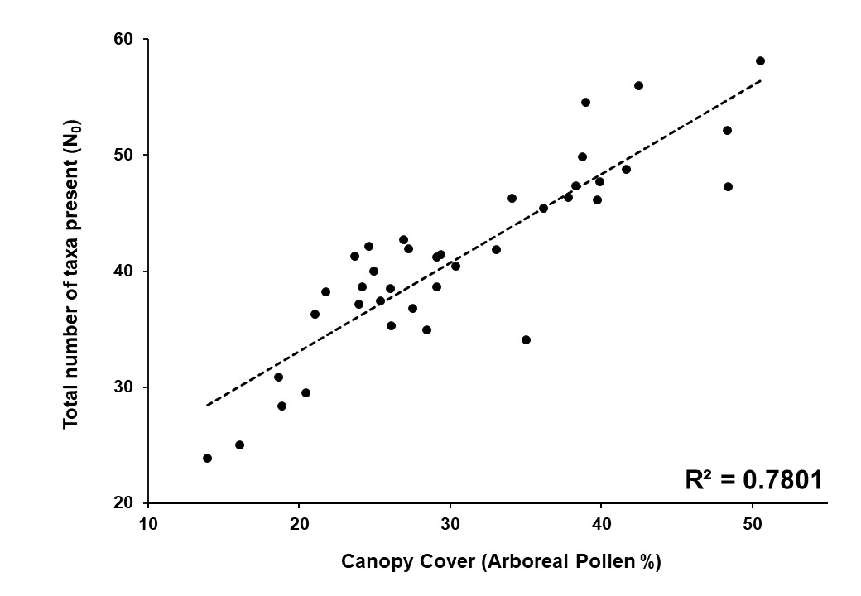
Supplementary Figure 2: Regression plot shows the high strength of association (R² = 0.78) between the canopy cover (Arboreal Pollen %) and the overall plant diversity (total number of terrestrial taxa present (N₀)) in the Western Ghats agroforestry landscape.
References
Bennett, K.D., Willis, K.J., 2001. Pollen, in: Smol, J.P., Birks, H.J.B., Last, W.M. (Eds.), Tracking Environmental Change Using Lake Sediments. Volume 3: Terrestrial, Algal, and Siliceous Indicators. Springer, Dordrecht, pp. 5–32.
Bhagwat, S.A., Nogué, S., Willis, K.J., 2012. Resilience of an ancient tropical forest landscape to 7500 years of environmental change. Biol. Conserv. 153, 108–117. https://doi.org/10.1016/j.biocon.2012.05.002
Blaauw, M., 2010. Methods and code for “classical” age-modelling of radiocarbon sequences. Quat. Geochronol. 5, 512–518. https://doi.org/10.1016/j.quageo.2010.01.002
Clark, R.L., 1982. Point count estimation of charcoal in pollen preparations and thin sections of sediments. Pollen et Spores 24, 523–535.
Finsinger, W., Kelly, R., Fevre, J., Magyari, E.K., 2014. A guide to screening charcoal peaks in macrocharcoal-area records for fire-episode reconstructions. The Holocene 24, 1002–1008. https://doi.org/10.1177/0959683614534737
Grimm, E.C., 1992. Tilia and Tilia-Graph Software, Version 2.0. [WWW Document].
Nogué, S., Tovar, C., Bhagwat, S.A., Finsinger, W., Willis, K.J., 2018a. Exploring the Ecological History of a Tropical Agroforestry Landscape Using Fossil Pollen and Charcoal Analysis from Four Sites in Western Ghats, India. Ecosystems 21, 45–55. https://doi.org/10.1007/s10021-017-0132-1
Nogué, S., Tovar, C., Bhagwat, S.A., Finsinger, W., Willis, K.J., 2018b. Supplementary Information for Exploring the ecological history of tropical agroforestry landscape using fossil pollen and charcoal analysis from four sites in Western Ghats, India. Ecosystems 21, 45–55. https://doi.org/10.1007/s10021-017-0132-1
Reimer, P., Bard, E., Bayliss, A., 2013. IntCal13 and Marine13 Radiocarbon Age Calibration Curves 0–50,000 Years cal BP. Radiocarbon 55, 1869–1887. https://doi.org/10.2458/azu_js_rc.55.16947
Stockmarr, J., 1971. Tablets with spores used in absolute pollen analysis. Pollen et Spores 13, 615–621.

