Electrokinetic Remediation for Nuclear Site Decommissioning - the UK's TRANSCEND Consortium – 21238

Jamie M. Purkis*, Phil E. Warwick*, James Graham**, Shaun D. Hemming*,
Andrew B. Cundy*
* School of Ocean and Earth Sciences University of Southampton, National Oceanography Centre, European Way, Southampton, SO14 3ZH, United Kingdom (UK)
** National Nuclear Laboratory (NNL), Sellafield, Cumbria, CA20 1PG, UK

ABSTRACT
Electrokinetic Remediation, EKR, is an environmental remediation technology that uses electricity to remove pollutants from contaminated materials. It is a flexible and low-energy (< 1 V.cm⁻¹) technique, that operates effectively in low permeability substrates (clayey soils, cements, etc.) which are often difficult to remediate by conventional means (e.g. soil washing, pump-and-treat). It can be combined with renewable power inputs and operate in-situ, providing effective, safe and sustainable solutions in which worker exposure to hazardous materials is minimized while high remediation efficiencies are retained. However, EKR is limited mostly to the laboratory or pilot scale for nuclear industry applications, with reliable, meter-plus scale studies in real operating environments still lacking.
Here, we discuss EKR and its potential uses at nuclear sites. We begin by summarizing the key advantages offered by EKR over other, conventional remediation methods and, from this, review how EKR, singly or in combination with other technologies, can be or has been applied practically. We illustrate this using real examples at selected nuclear sites of international importance. Finally, we examine perspectives on tools to help the decision-making process for remediation at active nuclear sites, and how these tools could be used to support practical deployment of EKR for nuclear site decommissioning.

INTRODUCTION

Nuclear sites undergoing decommissioning contain many complex materials of varying physical and chemical characteristics. These include cements, concretes, soils (clayey to gravelly), sludges, and other anthropogenic materials which exist in various, often challenging, states of weathered and eroded decay. Remediation of these sites is further impeded by the uniquely hazardous mix of organic, inorganic and radionuclide contaminants, making remediating these sites laborious and extremely expensive. Continuing the pipeline of new technologies available to remediators at such sites is therefore essential, to ensure both the duration and costs of new and ongoing remediation projects are kept as low as possible.

In electrokinetic remediation, EKR, a voltage is applied through implanted electrodes to mobilize contaminants within a material or cell. The electrolysis of pore water creates a pH gradient, from which anodic acid and cathodic basic conditions cause the mobilization of contaminants. These species are then transported through a variety of electromotive processes (electromigration, electro-osmosis, electrophoresis), respectively causing ionic, water or particulate contaminants to move to user-desired points in the remediation cell (usually the electrodes). Figure 1 highlights these processes in a typical EKR cell. EKR is a waste minimization technique, in which contaminants are concentrated in certain parts of the cell and can be removed as desired. These contaminants can then also be sequestered and immobilized on (in-situ) barrier materials or in impermeable membranes.
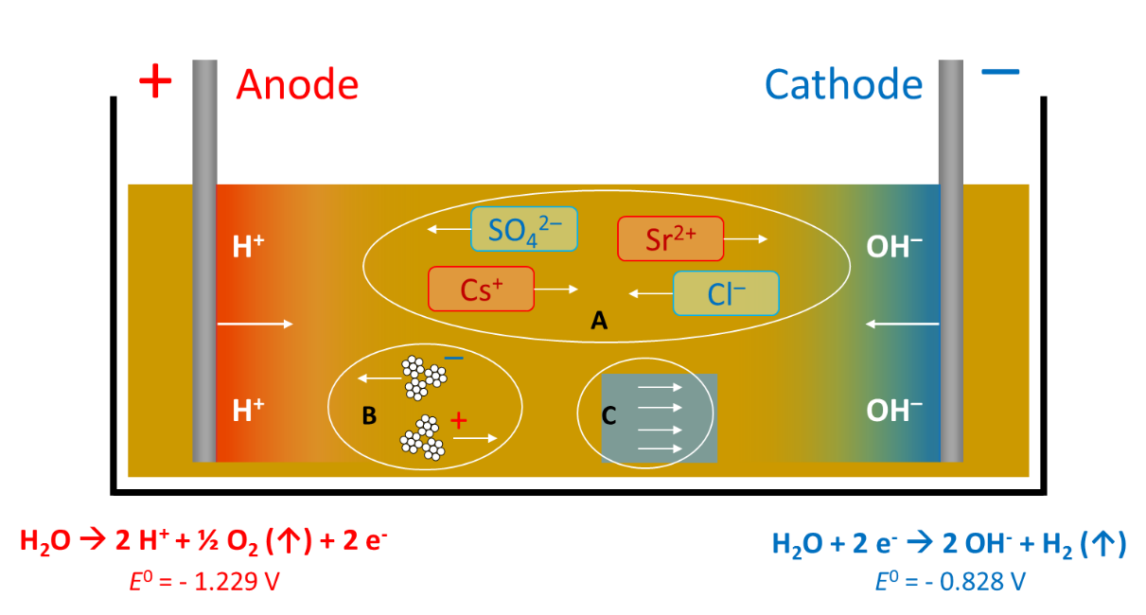
Figure 1. EKR processes in a simplified cell, with acidic and basic fronts developing from the anodes and cathodes, respectively; A, electromigration of ions; B, electrophoresis of particulates (clays, etc.); and C, electro-osmosis of pore water. E⁰ values for the water electrolysis half-cell are quoted against the standard hydrogen electrode.
Although EKR is not a new technology – it is widely applied in non-nuclear mining, civil engineering and other applications¹ – in the remediation of radioactively contaminated sites, its use is limited at scale. In this paper, we summarize our perspectives on the practical challenges required to bring EKR to scale at active nuclear sites, with emphasis on translating the unique advantages offered by this technology into convenient, workable solutions.

DISCUSSION
1. Comparison of EKR to Existing Remediation Technologies
Many remediation technologies are available to site managers and operators, with the mix of technologies employed depending on the conditions present at a given site. Key factors can include the type(s) of contamination ((in)organic, radionuclide, etc.), the timescale over which remediation must be completed, technological maturity, cost, type of material to be remediated, and the possibility of in- vs. ex-situ operation.² We summarize the key aspects of some simple remediation technologies, with EKR, in Table I.
TABLE I. Overview of common remediation technologies for contamination at nuclear sites, including EKR. PRB = permeable reactive barrier; MNA = monitored natural attenuation; ISCO = in-situ chemical oxidation; I/O/R = inorganic/organic/radionuclide; $ - $$$ = cost, low ($) to high ($$$).

Technique | In-, ex-situ,  or both? | Solids, water,  or both? | Contamination?  (I/O/R) | Timescale? | Cost? | Maturity?
PRBs | In-situ | Water | All | Long | $$ | Medium
Bioremediation | Both | Both | All | Medium-long | $ | Medium
MNA | In-situ | Water | All | Long | $ | High
Flushing (washing) | Both | Both | All | Medium | $$$ | Medium
Ion Exchange | Ex-situ | Water | I/R | Long | $$$ | High
Redox (ISCO) | Both | Both | O | Medium-long | $$ | Medium
Excavation | Ex-situ | Solids | All | Short | $$$ | High
EKR | Both | Solids | All | Variable | $ | Low

Although EKR is technologically immature (Technology Readiness Level: 3-6),³ it can work both in- and ex-situ and is effective in transporting many forms of contamination ((in)organic and radionuclide) common at nuclear sites. The main advantages of EKR include flexibility in the set-up, low-energy requirements (under some configurations) and, most importantly, an ability to work in low permeability substrates around surface and subsurface infrastructure. In contrast to soil flushing and similar techniques, EKR is effective in clays, silts and may be applied to varied tills, alluvial and lacustrine deposits, and loess, in addition to various process sludges and other materials.
- Flexibility
A key advantage of EKR is its flexibility. Because so many parameters can be controlled (electrode placement, voltages, conducting materials, electrolyte duration, etc., Table II), EKR can easily be modified to provide solutions in many scenarios. It is known to operate effectively in gravelly,⁴ sandy,⁵ clayey,⁶ and waterlogged soils,⁷ concretes⁸ and saline⁹ and organic-rich environments,¹⁰ as well as effectively on organic, inorganic and radionuclide contaminants.¹¹ Further, many electrode arrangements are possible (rectangular, circular, hexagonal, horizontal and vertical sheet electrodes, etc.),^{12, 13} enabling EKR to adapt effectively for both the active (remediate existing) or passive (prevent new) control of contamination. Examples here include the Lasanga™ process¹⁴ (horizontal arrangements of electrodes between the contamination) and ‘electrokinetic fencing’, which involves the installation of electrodes around an incipient plume to retard contaminate flow before it can spread. This latter technique is known for the removal of organic contaminants at scale (pesticides in a 175 liter test cell)¹⁵ and has even proposed as an alternative method of groundwater control at the Fukushima-Daiichi Nuclear Power Plant (FDNPP) to limit the spread of Cs-137 contamination at the site.¹⁶ The potential to use EKR to remediate mixed waste systems that mimic those found at nuclear sites is an active and ongoing area of research.
- In- or ex-situ?
Owing in large part to its flexibility, EKR can operate equally as effectively both in- and ex-situ. This is beneficial on sites where minimal worker exposure to hazardous pollutants is critical, such as nuclear sites. The ability to operate in-situ also reduces cost, as expensive material processing steps, such as concrete crushing, are mitigated or circumvented entirely.
MNA, bioremediation and flushing are examples of existing technologies that operate in-situ. However, MNA, while often cheap and convenient, is limited by the timescales of decay of the problem nuclides (usually Sr-90 and Cs-137) and therefore can take many years, as for Chernobyl. Bioremediation, while significantly accelerated compared to MNA, is limited by the growth lifecycles of organisms, and does not work in environments where these do not grow. Flushing also only works in high permeability systems, compared to EKR, which operates effectively in both low and high permeability materials. EKR can also be adapted (via use of increased voltages) to operate more quickly or combined with other techniques (e.g. electrokinetic bioremediation), to ameliorate the individual disadvantages associated with each of these technologies. We discuss this further in section 2, below.
- Cost
Graphite electrodes, which are a common choice for EKR, are cheap and readily available (Amazon.com sells packs of 5 electrodes, 10 cm long, for less than $10), and power inputs can be coupled with renewable sources (e.g. solar PV) where sustainability is a key concern. EKR retains excellent remediation efficiencies³ at low field strengths (e.g. Agnew et al. used voltage gradients of just 0.08 V/cm to obtain effective remediation of Pu-contaminated soils).¹⁷ Further, the electrolyte required to carry current is often free (groundwater) but can, where necessary, be enhanced using benign, cheap additives including citric acid, or even something as common as table salt. For organic additives, these metabolites can occur naturally and so their use may actually help existing biota in these situations. This is a particular advantage over techniques such as ISCO, that uses toxic additives¹⁸ that kill existing soil biota.
TABLE II. Common variables that can be controlled when designing an EKR scheme.

Variable | Key consideration(s)
Voltage? | Higher voltages generate stronger pH gradients, may cause unexpected redox (e.g. Pu^{V} to Pu^{IV}), and increase energy consumption. But decrease duration
Electrode placement? | Field strength not always uniform; electrical ‘dead zones’ are common. Careful placement of electrodes can avoid this
Electrode material? | Graphite is common but steel also used; can be used for to generate in-situ PRBs and sorptive barriers
Number of electrodes? | More electrodes only marginally increase cost and give greater control over contaminant movement, and can use larger cells
Duration? | Longer remediation times may be required depending on wasteform permeability (e.g. clayey soils with entrained Cs-137)
Electrolyte/ Additives? | Groundwater often sufficient but additives such as seawater or acids may be needed to increase electrolyte strength for strongly sorbed contaminants
In- or ex-situ | In-situ preferred for safety and convenience but not always possible

- Technological Maturity
Compared to many other techniques, the key limitation of EKR is the lack of real-world application. Unlike, for example, PRBs (which have been deployed at the Hanford Site, USA)¹⁹ or ion exchange (used commercially at the site ion-exchange effluent plant, SIXEP, at Sellafield, UK), we are not aware of any site-scale remediation solutions incorporating EKR at nuclear sites. We have previously estimated the readiness of EKR as limited to pilot-scale studies but ex-situ,³ that is, not yet fully and routinely operational in a working environment.
The current state-of-the-art of EKR at nuclear sites is limited to laboratory or pilot-scale studies, which have been performed over the last 30 years. In 1994, Buehler et al. demonstrated that Cs-137 and Co-60 contaminated Hanford Site soil (0.74 MBq Cs-137, 1.85 MBq Co-60) could be made observably free of radionuclides by γ-spectroscopy (200 V electric field, 7 V/cm, 23 cm-long cell).²⁰ This experiment was expanded in 2015 by Jung et al., who, after 68 days of EKR at 23 V in a 25 cm cell (ca. 1 V/cm) observed reductions of Cs-133 of up to 55% as determined by X-ray fluorescence in real Hanford site sediments.²¹ In the UK, work in our and other laboratories is the subject of an upcoming article, discussed further in Section 2 (and Figures 2a and 2b). More recently, we have used EKR to remediate plutonium contaminated wastes at a working nuclear site undergoing decommissioning, at a 4-ton scale, showing that over two months at ca. 19 V, 60% of monitored soil could be considered free of contamination.¹⁷
In order to address issues of scale and mitigate the technological immaturity of EKR while exploiting unique advantages, there current impetus is to use combined approaches in which EKR is partnered with an existing technology, to overcome existing deployment barriers for EKR use at nuclear sites.
2. Combination of EKR with Existing Remediation Technologies
Existing technologies that rely the transport of chemicals or contaminants to specific areas of a remediation cell are most likely to benefit from a combined approach with EKR. This is as EKR can be used to increase the speed or efficiency with which reagents are diffused through a medium; PRBs, bio- and -phytoremediation, nanotechnologies and grouting, where the respective movement of reagents, nutrients, nanoparticles and (silica) gel precursors can be enhanced. Although in-situ, we discount ISCO as it involves the use of toxic reagents that negate the safety advantages inherent to in-situ technologies.
- EKR and in-situ reactive barriers
The combination of EKR with in-situ growth of reactive barriers has been demonstrated at scale. Ferric iron remediation and stabilization (FIRS) is a technique where iron-rich (cf. steel) electrodes are used to deliver current, and under the developing pH gradients, dissolve, to leach and precipitate iron-rich bands into the treated soil. This is shown in Figure 2a, along with an example from our laboratories, Figure 2b, of an iron-rich barrier being generated in real material from a nuclear site in the UK.
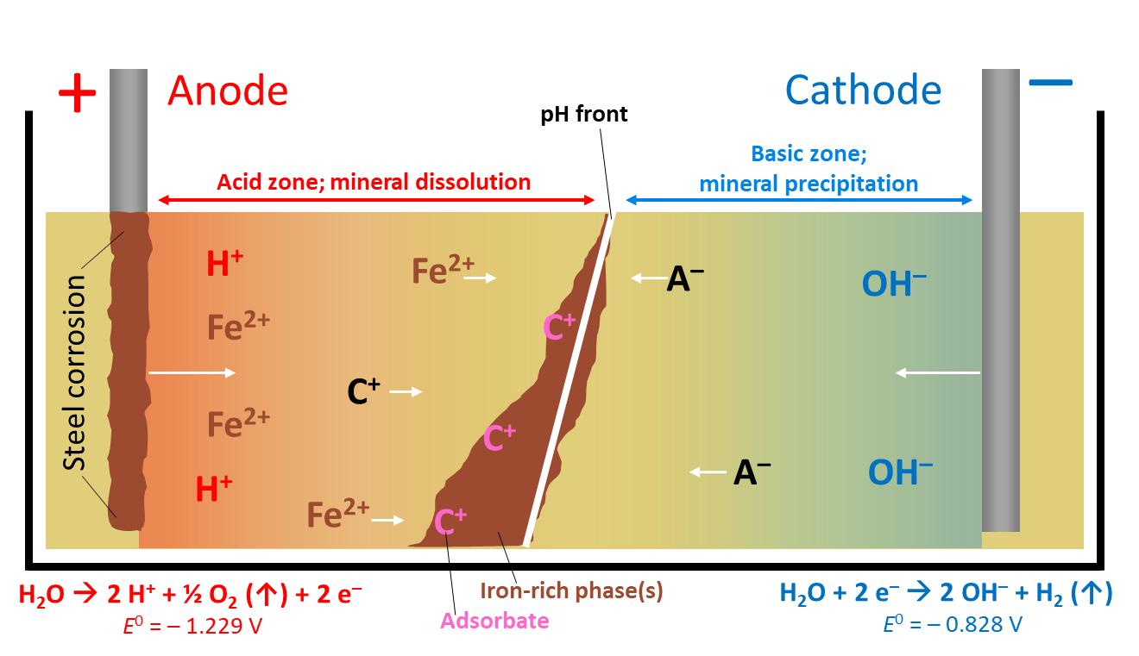
Figure 2a. The FIRS technique. Movement of cations (C⁺) and anion (A–) is shown onto the sorption of the iron-rich phase(s). Half-cell values are vs. the SHE.
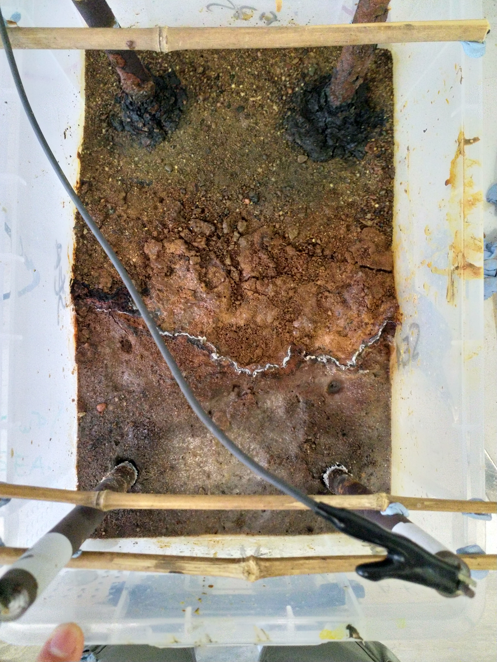
CATHODES
ANODES
Fe-rich phase(s)
Figure 2b. The generation of iron-rich phases – here, in our laboratories – is clearly visible at the surface of the cell undergoing remediation. The iron-rich phases are ‘rust’-colored due to high concentrations of hematite and other iron (oxy)hydroxides. Cell is 30 cm long by 18 cm wide.
Experiments in our laboratories are ongoing. For example, we have been examining the scalability of the FIRS work, where EKR has been deployed at Sellafield on scales up to 1 meter,²² to generate, in-situ, sorptive and iron-rich phases in the FIRS technique, Figure 2b. These iron-rich phases are both sorptive and redox active, immobilizing and/or degrade pollutants at nuclear sites. This technique has been used previously in estuarine sediments contaminated with Co-60, where treatment of the 16.5 cm cell using just 1.5 V (0.1 V/cm) over 17 days resulted in a 2 cm iron-band that aided in reducing anodic concentrations of Co-60 by up to 30% in which Co-60 was immobilised and sequestered on the surface of the iron barrier.²³ We are also currently investigating combined electrokinetic-grouting technologies with collaborators at the University of Strathclyde, UK.
- Electrokinetic bio- and -phytoremediation
Phytoremediation for the clean-up of radionuclides is well-known.²⁴ As recently as 2019, EKR-enhanced phytoremediation was employed to remediate uranium-contaminated Mississippi Delta soil using sunflowers coupled with a low energy (1 V/cm) field gradient. Without EKR between 1 and 4 % of uranium was removed from the soils after 60 days; with EKR, this increased to ca. 60% after only 9 days.²⁵ Similarly, the combination of EKR with bioremediation remains popular at the laboratory and pilot scales, and although we are not aware of any site-scale studies, organic contaminants such as phthalates and polychloroethylenes (PCEs) are problematic at nuclear sites. Studies on the removal of PCEs from a disused Danish industrial site have illustrated that inducing the movement of organics with EKR compared to diffusion alone increases the PCE degradation by up to five times.²⁶ For both EKR-enhanced phyto- or bio-remediation, we see no reason why this could not be applied on sites where the remediation timescales are longer. We discuss avenues towards this in Section 3, below.
3. Decision Support Tools for EKR
The implementation of any new technology relies on the advantages of that technology being disseminated in a form that is convenient and understandable to end-users, and which can readily be incorporated into site decision making processes (including remediation options appraisal). Decision support tools (‘DSTs’, also known as decision support systems) are models designed to help achieve this, ensuring stakeholders have access to the widest possible pool of possible solutions, in a form convenient to them, to help support the remediation process. Several DSTs over the last decade or so have been produced to supplement the (sustainable) remediation of contaminated land,²⁷⁻²⁹ and in the UK, the NNL have examined a number of emerging technologies for implementation at scale, including EKR. In our view, EKR, which is limited by a lack of site-scale studies, risks being overlooked by users unless convenient models are developed for its implementation at scale.
We are actively developing DSTs towards EKR use at scale, within the TRANSCEND consortium project (see Acknowledgements). Table III, below, outlines our assessment of the key parameters that must be modelled in a successful DST, which we divide into three key questions; for a specific site, ‘will EKR work?’, ‘how long will it take?’, and ‘how much will it cost?’.

TABLE III. Key factors affecting the success, duration and cost of EKR
Will it work?
Soil type (sand, clay, etc.) | If soil predominantly sandy/gravelly, EKR unlikely to outcompete existing technologies, unless for “fencing” applications.
Redox potential | If radionuclide or inorganic contamination, ensure groundwater does not promote precipitation; EKR requires mobile contaminants (e.g. if uranium contamination, avoid reducing conditions (U^{IV}O₂ precipitation)).
Water table depth | Works best if high water table; phreatic, not vadosic, soils best. Or high rainfall.
Borehole depth | Related to water table depth; deep boreholes possible but not advantageous.
How long will it take?
Wasteform electrical conductivity | Conductive waste forms best; organic rich clayey soils (Fukushima), sands (Hanford, Sellafield). Cements feasible, may need ionic enhancement.
Buffering capacity | Related to soil carbonate content; if high, pH gradient slower to form. May need longer remediation if so.
Contaminant mobility | Highly mobile contaminants better.
Soil permeability | Higher permeability systems are treated more rapidly but, compared to existing techniques, EKR excels in lower permeability soils.
Field strength | Lower is better (less energy use; sustainable), but higher needed if large cell or low ionic strength electrolyte
Electrode placement | Avoid electrical ‘dead zones’; related to size of cell. Larger cells have more dead zones – more electrodes needed
How much will it cost?
Additives | Generally cheap (weak acids, mineral salts) but require modelling if ionic additives combined with electrolyte.
Electricity used | Comparative contribution to cost is low at lower voltages but accounting needed to ensure costs minimized overall.
Electrode materials | Comparative cost also generally small, unless highly specialized electrodes used; variety of options available, cost varies depending on selected electrode
Labor costs | Biggest contribution to cost, by far. Larger cells require more operatives. Salaries, equipment, insurance, etc.

With our collaborators, we have previously developed DSTs for gentle remediation options (e.g. phytoremediation) at contaminated sites. Provided to end-users in a simple Microsoft Excel workbook, the ‘GREENLAND’ DST uses a tiered approach from phases 1 to 3 through which end-users arrived at decision points (yes = move to higher phase; no = return to options appraisal) of increasing complexity and time investment in response to their needs. Questions at all stages were simple, designed to maximize stakeholder engagement and guide users through the decision-making process. Recommendations (outputs) were based on existing site data (from other contaminated sites), existing best practice guidelines, end-user inputs and underpinning scientific and technical data (e.g. plant growth rates). An example output window of the GREENLAND DST is given in figure 3.
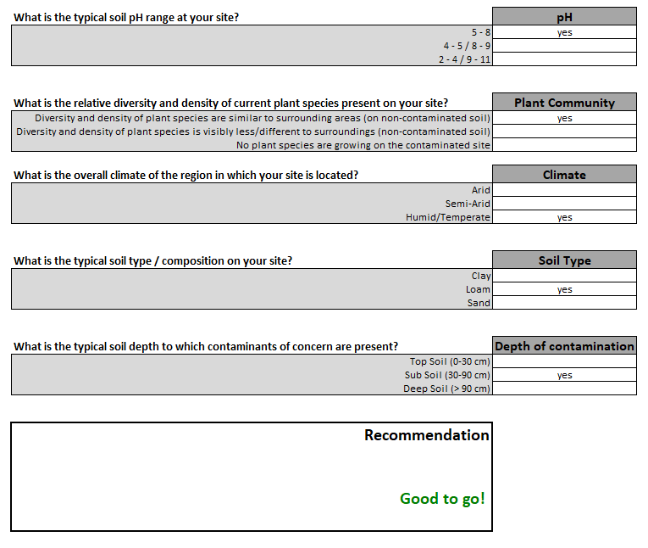
FIGURE 3. Example of an output window in the GREENLAND DST, here, assessing whether phytoextraction of contaminated groundwater is feasible with exemplar inputs.
We will use an equivalent structure to the GREENLAND DST model as a generic template to unify the complex, underpinning electrochemical equations, cost analyses, technical data and other EKR inputs into a simple, user-friendly interface, suitable for stakeholders of all technical abilities at contaminated (including nuclear) sites. Although our first iteration targets ex-situ EKR solutions (ex-situ systems are easier to model given the fewer and more controlled variables), we will extend our DSTs to in-situ systems once we have a working model. This remains an area of considerable activity in our laboratories and we aim to have a full, working DST for in-situ EKR for test deployment ready within the next calendar year.
CONCLUSIONS
Although EKR and associated electrochemical technologies have many benefits over existing techniques, particularly in low-permeability substrates, use at scale remains limited. While this is slowly being remedied³⁰, at nuclear sites, where hazards and accompanying regulations are necessarily stricter, its use remains unproven and thus untested. In our view, this is likely overcome by combining EKR with existing technologies, particularly ones that operate in-situ, as sustainable remediation and worker safety remain key priorities for the remediation sector. Examples include EKR with bio- or phyto-remediation, reactive barrier and grouting technologies, which we are actively investigating in our laboratories. The dissemination of evidence-based tools to help assessors during options appraisals will undoubtedly help increase the profile of EKR, and through our efforts to develop convenient models – namely, DSTs – we hope that EKR will become an increasingly attractive option for the remediation of nuclear and other sites.
REFERENCES
1. J. Colin, L.-B. John, H. David, A. David and G. Stephanie, Electrokinetic geosynthetics: from research to hype to practice, Proc. Instit. Civil Eng. - Civil Engineering, 2017, 170, 127-134.
2. Remediation Technologies for Radioactive Contaminated Land on Nuclear Licensed Sites, Report NT/7225002059/R2043, TÜV SÜD – Nuclear Technologies Division and Office of Nuclear Regulation (ONR), UK, 2020.
3. J. M. Purkis, P. E. Warwick, J. Graham, S. D. Hemming and A. B. Cundy, Submitted to J. Haz. Mater.
4. G.-N. Kim, U.-R. Park, S.-s. Kim, W.-S. Kim, J.-K. Moon and J.-h. Hyun, Decontamination of gravels contaminated with uranium, Ann. Nucl. Energy, 2014, 72, 367-372.
5. G. Asadollahfardi and M. Rezaee, Electrokinetic remediation of diesel-contaminated silty sand under continuous and periodic voltage application, Environ. Eng. Res., 2019, 24, 456-462.
6. T. Suzuki, M. Niinae, T. Koga, T. Akita, M. Ohta and T. Choso, EDDS-enhanced electrokinetic remediation of heavy metal-contaminated clay soils under neutral pH conditions, Colloids Surf. A Physicochem. Eng. Asp., 2014, 440, 145-150.
7. W.-S. Kim, E.-K. Jeon, J.-M. Jung, H.-B. Jung, S.-H. Ko, C.-I. Seo and K. Baek, Field application of electrokinetic remediation for multi-metal contaminated paddy soil using two-dimensional electrode configuration, Environ. Sci. Pollut. Res., 2014, 21, 4482-4491.
8. A. J. Parker, M. J. Joyce and C. Boxall, Remediation of 137Cs contaminated concrete using electrokinetic phenomena and ionic salt washes in nuclear energy contexts, J. Haz. Mater., 2017, 340, 454-462.
9. S. H. Hamdan, G. F. Molelekwa and B. Van der Bruggen, Electrokinetic Remediation Technique: An Integrated Approach to Finding New Strategies for Restoration of Saline Soil and to Control Seawater Intrusion, ChemElectroChem, 2014, 1, 1104-1117.
10. J. M. Purkis, A. Tucknott, I. W. Croudace, P. E. Warwick and A. B. Cundy, submitted to Appl. Geochem.
11. K. R. Reddy and C. Cameselle, Overview of Electrochemical Remediation Technologies, in Electrochemical Remediation Technologies for Polluted Soils, Sediments and Groundwater, eds. K. R. Reddy and C. Cameselle, John Wiley & Sons, Inc., 2009, ch. 1, pp. 1-28.
12. R. S. Putra, Development of electrokinetic remediation for caesium: A feasibility study of 2D electrode configuration system, IOP Conf. Ser.: Mater. Sci. Eng., 2016, 107, 012015.
13. A. N. Alshawabkeh, R. J. Gale, E. Ozsu-Acar and R. M. Bricka, Optimization of 2-D Electrode Configuration for Electrokinetic Remediation, J. Soil Contamin., 1999, 8, 617-635.
14. S. V. Ho, C. Athmer, P. W. Sheridan, B. M. Hughes, R. Orth, D. McKenzie, P. H. Brodsky, A. Shapiro, R. Thornton, J. Salvo, D. Schultz, R. Landis, R. Griffith and S. Shoemaker, The Lasagna Technology for In Situ Soil Remediation. 1. Small Field Test, Environ. Sci. Technol., 1999, 33, 1086-1091.
15. R. López-Vizcaíno, C. Risco, J. Isidro, S. Rodrigo, C. Saez, P. Cañizares, V. Navarro and M. A. Rodrigo, Scale-up of the electrokinetic fence technology for the removal of pesticides. Part II: Does size matter for removal of herbicides?, Chemosphere, 2017, 166, 549-555.
16. R. Lageman, Preliminary assessment of the application of an electrokinetic ring fence for the removal of radionuclides from groundwater at Fukushima Daiichi Nuclear Power Plant, Lambda Consult (Netherlands), 2014.
17. K. Agnew, A. B. Cundy, L. Hopkinson, I. W. Croudace, P. E. Warwick and P. Purdie, Electrokinetic remediation of plutonium-contaminated nuclear site wastes: Results from a pilot-scale on-site trial, J. Haz. Mater., 2011, 186, 1405-1414.
18. B. G. Petri, N. R. Thomson and M. A. Urynowicz, Fundamentals of ISCO Using Permanganate, in In Situ Chemical Oxidation for Groundwater Remediation, eds. R. L. Siegrist, M. Crimi and T. J. Simpkin, Springer New York, New York, NY, 2011, pp. 89-146.
19. V. R. Vermeul, J. E. Szecsody, B. G. Fritz, M. D. Williams, R. C. Moore and J. S. Fruchter, An Injectable Apatite Permeable Reactive Barrier for In Situ 90Sr Immobilization, Groundwater Monit. Remed., 2014, 34, 28-41.
20. M. F. Buehler, J. E. Surma and J. W. Virden, In situ soil remediation using electrokinetics (PNL-SA-24081) presented in part at the Thirty-Third Hanford Symposium on Health and the Environment, Richland, Washington, USA, 1994.
21. H. B. Jung, J.-S. Yang and W. Um, Bench-scale electrokinetic remediation for cesium-contaminated sediment at the Hanford Site, USA, J. Radioanal. Nucl. Chem., 2015, 304, 615-625.
22. J. M. Purkis, D. Trivedi, J. Graham, P. E. Warwick, L. Hopkinson and A. B. Cundy, Manuscript in preparation.
23. A. B. Cundy and L. Hopkinson, Electrokinetic iron pan generation in unconsolidated sediments: implications for contaminated land remediation and soil engineering, Appl. Geochem., 2005, 20, 841-848.
24. S. Dushenkov, Trends in phytoremediation of radionuclides, Plant Soil, 2003, 249, 167-175.
25. J. Li, J. Zhang, S. L. Larson, J. H. Ballard, K. Guo, Z. Arslan, Y. Ma, C. A. Waggoner, J. R. White and F. X. Han, Electrokinetic-enhanced phytoremediation of uranium-contaminated soil using sunflower and Indian mustard, Int. J. Phytoremed., 2019, 21, 1197-1204.
26. C. Riis, M. Bymose, E. Cox, J. Wang, D. Gent and M. Terkelsen, Successful pilot test of electrokinetic enhanced bioremediation (EK-BIO) as an innovative remedial approach for PCE/DNAPL source area presented in part at the NORDROCS 2012: 4th Nordic Joint Meeting on Remediation of Contaminated Sites, Oslo, Norway, 2012.
27. K. Onwubuya, A. Cundy, M. Puschenreiter, J. Kumpiene, B. Bone, J. Greaves, P. Teasdale, M. Mench, P. Tlustos, S. Mikhalovsky, S. Waite, W. Friesl-Hanl, B. Marschner and I. Müller, Developing decision support tools for the selection of “gentle” remediation approaches, Sci. Total Environ., 2009, 407, 6132-6142.
28. L. Huysegoms and V. Cappuyns, Critical review of decision support tools for sustainability assessment of site remediation options, J. Environ. Manage., 2017, 196, 278-296.
29. A. Cundy, P. Bardos, M. Puschenreiter, N. Witters, M. Mench, V. Bert, W. Friesl-Hanl, I. Müller, N. Weyens and J. Vangronsveld, Developing Effective Decision Support for the Application of “Gentle” Remediation Options: The GREENLAND Project, Remed. J., 2015, 25, 101-114.
30. E. Lacasa, S. Cotillas, C. Saez, J. Lobato, P. Canizares and M. A. Rodrigo, Environmental applications of electrochemical technology. What is needed to enable full-scale applications?, Curr. Opin. Electrochem., 2019, 16, 149-156.
ACKNOWLEDGEMENTS

The TRANSCEND consortium (Transformative Science and Engineering for Nuclear Decommissioning, https://transcendconsortium.org/) is a £9.4 million (ca. $12.2 million), 11 university research program of 40 research projects across industry and academia, to address some of the key challenges remaining in nuclear decommissioning and waste management. It is funded by the UK’s Engineering and Physical Sciences Research Council, EPSRC, under grant EP/S01019X/1.

