Clinical & Experimental Dermatology
- Correspondence – 500 words, 2 figures, 5 references.

Cutaneous leukocytoclastic vasculitis secondary to Cabozantanib therapy for renal cell carcinoma

George Coltart^{1,2}, Jonathan Sutton¹, Heather Roche¹, Matthew Sommerlad¹, Simon Crabb^{1,3}, Eugene Healy^{1,2}
¹University Hospital Southampton NHS Foundation Trust, Tremona Road, Southampton. SO16 6YD; ²Dermatopharmacology, Clinical and Experimental Sciences, Faculty of Medicine, University of Southampton, UK; ³Cancer Sciences Unit, University of Southampton, Faculty of Medicine, University of Southampton, UK.

Correspondence: ehealy@soton.ac.uk

Conflict of interest: the authors declare that they have no conflict of interest

A 54-year old male with newly diagnosed poor-risk metastatic clear cell renal cell carcinoma was started on first line palliative Cabozantinib. Five weeks after commencing treatment, he developed “red spots” on his lower legs. On examination he had multiple purpuric papules, predominantly distributed over the lower legs, but with scattered lesions over the thighs, and lower abdomen. Several papules had superficial ulceration with a purulent exudate. The clinical appearances were consistent with a cutaneous vasculitis with superficial bacterial infection (Figure 1). Cabozantinib was discontinued, however the rash continued to progress over the next 3 weeks.

The patient’s platelets were 198x10⁹/L, his CRP 16mg/L, and white cell count was normal. A full vasculitic screen was negative and there was no clinical or biochemical evidence of a systemic vasculitis. Urine dipstick was clear. Swab for microbiology showed heavy growth of Staphylococcus aureus. A lesional skin biopsy demonstrated a leukocytoclastic vasculitis (Figure 2) and direct immunofluorescence was negative.

The vasculitis subsequently improved with conservative management, without the need for topical or systemic corticosteroids. The superficial infection component improved with oral clindamycin. Unfortunately, treatment options for his metastatic clear cell renal cell carcinoma were limited; therefore, following full resolution of his skin lesions, he was restarted on Cabozantanib at a lower dose. Regrettably, this led to a recurrence of the vasculitis, and so the drug was suspended permanently.

To our knowledge, this is the first report of Cabozantanib causing cutaneous vasculitis. Cabozantinib is a small molecule tyrosine kinase inhibitor (TKI) licensed for the treatment of advanced/metastatic renal cell carcinoma and medullary thyroid carcinoma. It targets multiple tyrosine kinases, particularly c-MET (hepatocyte growth factor receptor) and VEGFR2 (vascular endothelial growth factor receptor). It is reported to cause adverse skin reactions in over 70% of patients, including hand-foot skin reactions, xerosis, depigmentation, scrotal irritation, and nail splinter haemorrhages.¹ The half-life of Cabozantanib is ~120h,² which could account for the progression of the vasculitis in this patient’s case despite the initial discontinuation of the drug.

Other TKIs have been reported to induce a cutaneous vasculitis, including erlotinib, osimertinib, and gefitinib. Onset of symptoms ranges from 14 – 240 days, and resolution of symptoms occur within 14-49 days. Interestingly, in several cases rechallenge with reduced dose erlotinib and osimertinib did not induce further leukocytoclastic vasculitis,^{3,4} however recurrence of symptoms did occur in one case following rechallenge with gefitinib ⁵ and likewise, in this report, with cabozantanib.

The mechanism underlying cutaneous leukocytoclastic vasculitis induced by TKIs is unknown, and in some cases may be dose-dependent.³
Putative mechanisms include the direct effect of vascular endothelial growth factor inhibition (VEGF), deposition of immune complexes in the blood, or possibly a paraneoplastic phenomenon resulting from neoantigen exposure during tumour treatment with the TKI.

It is clear that cutaneous side-effects with TKIs are common and may be severe, and that TKIs can cause cutaneous vasculitis, therefore careful skin examination should be a key part of monitoring patients who are on these medications.

References:

1. Zuo RC, Apolo AB, DiGiovanna JJ, et al. Cutaneous adverse effects associated with the tyrosine-kinase inhibitor cabozantinib. JAMA Dermatol 2015; 151: 170-7.

2. Lacy SA, Miles DR, Nguyen LT. Clinical pharmacokinetics and pharmacodynamics of cabozantinib. Clin Pharmacokinet 2017; 56: 477-91.

3. Fekete GL, Fekete L. Cutaneous leukocytoclastic vasculitis associated with erlotinib treatment: A case report and review of the literature. Exp Ther Med 2019; 17: 1128-31.

4. Hamada K, Oishi K, Okita T, et al. Cutaneous vasculitis induced by osimertinib. J Thorac Oncol 2019; 14: 2188-9.

5. Ko JH, Shih YC, Hui RC, Yang CH. Necrotizing vasculitis triggered by gefitinib: an unusual clinical presentation. J Clin Oncol 2011; 29: e169-70.

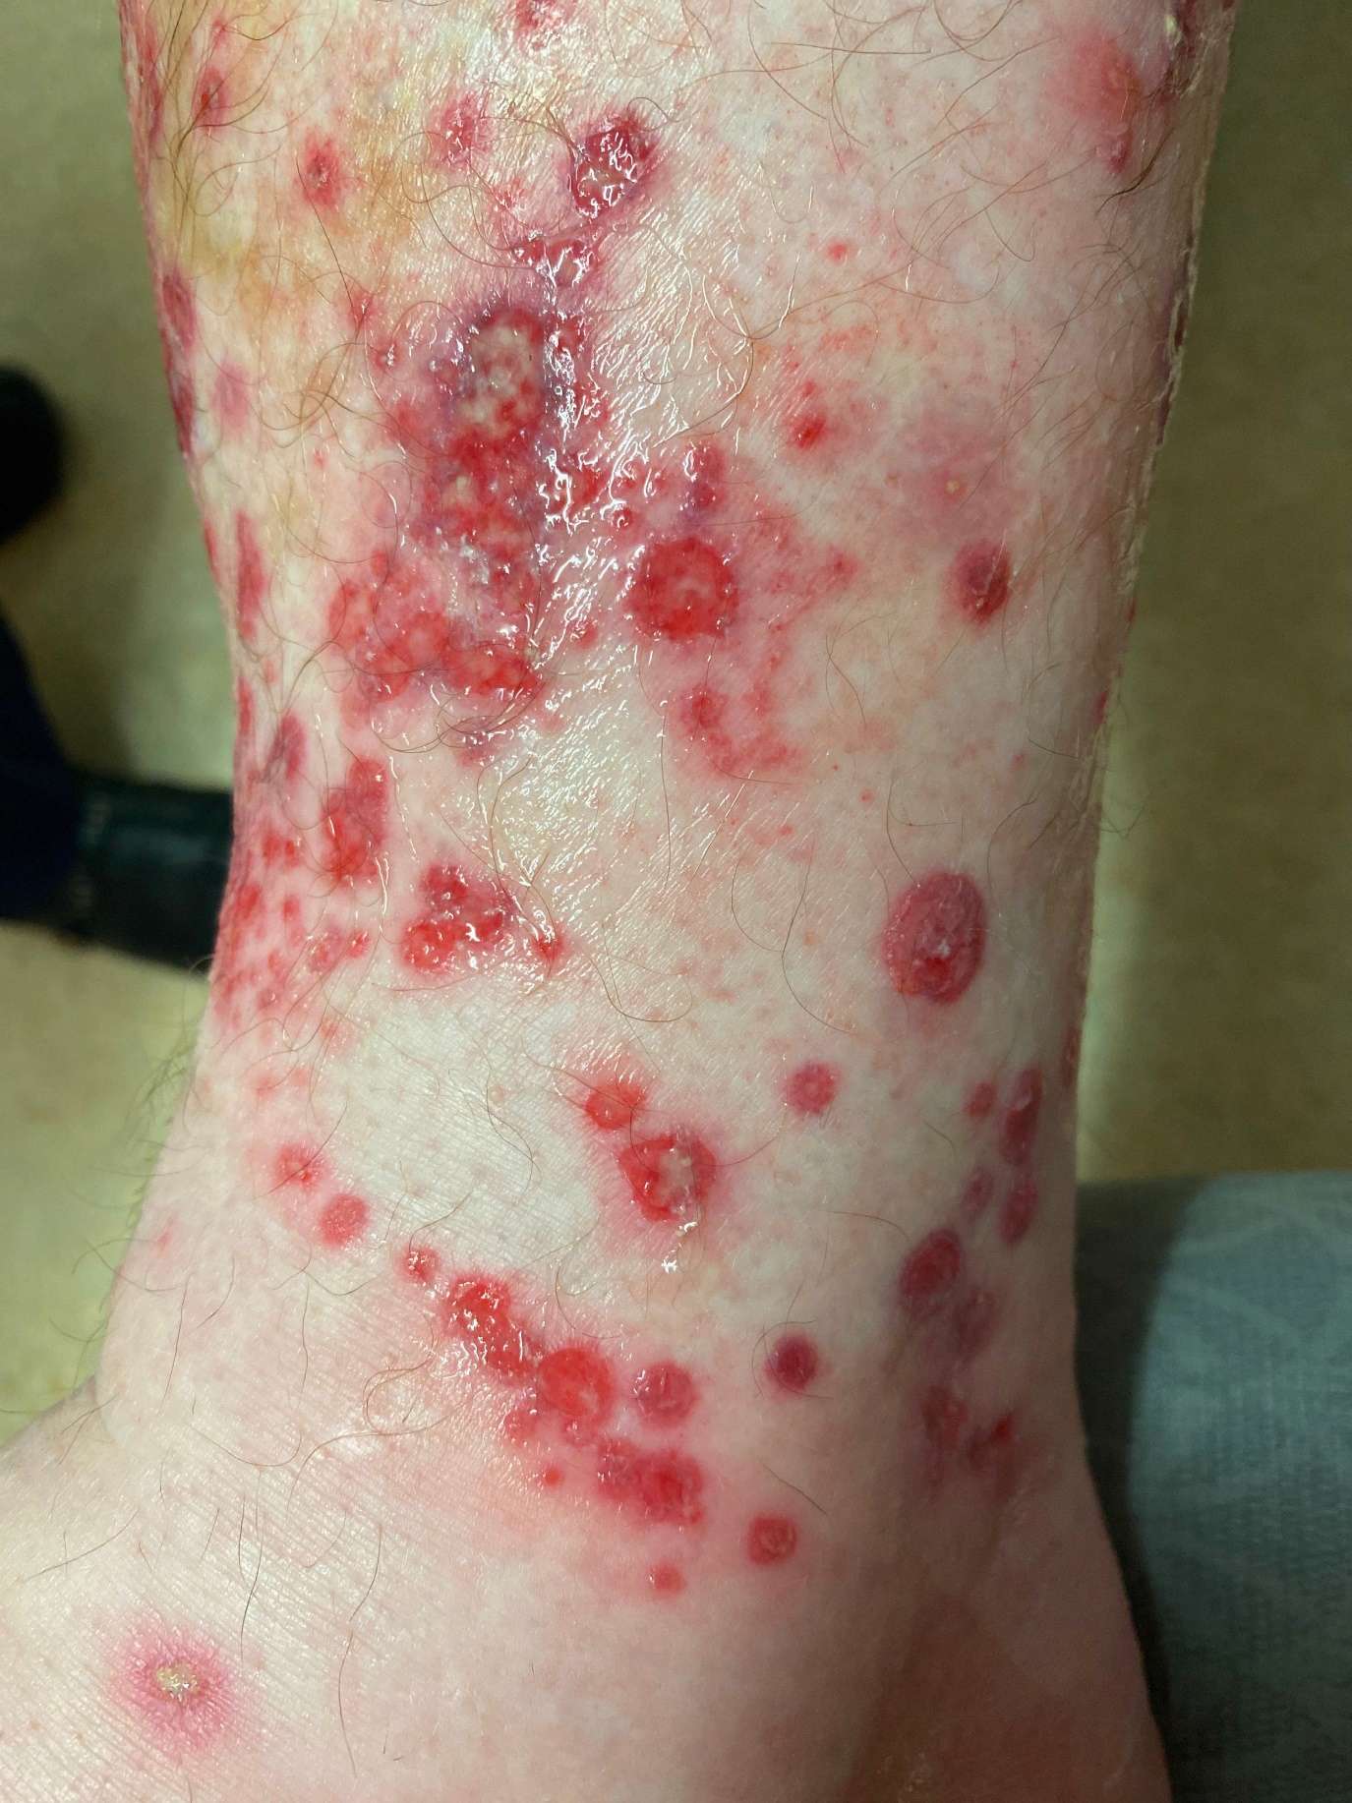
Figure 1: Skin of the right lower leg showing a numerous purpuric areas on the lower leg with localised ulceration and necrosis.

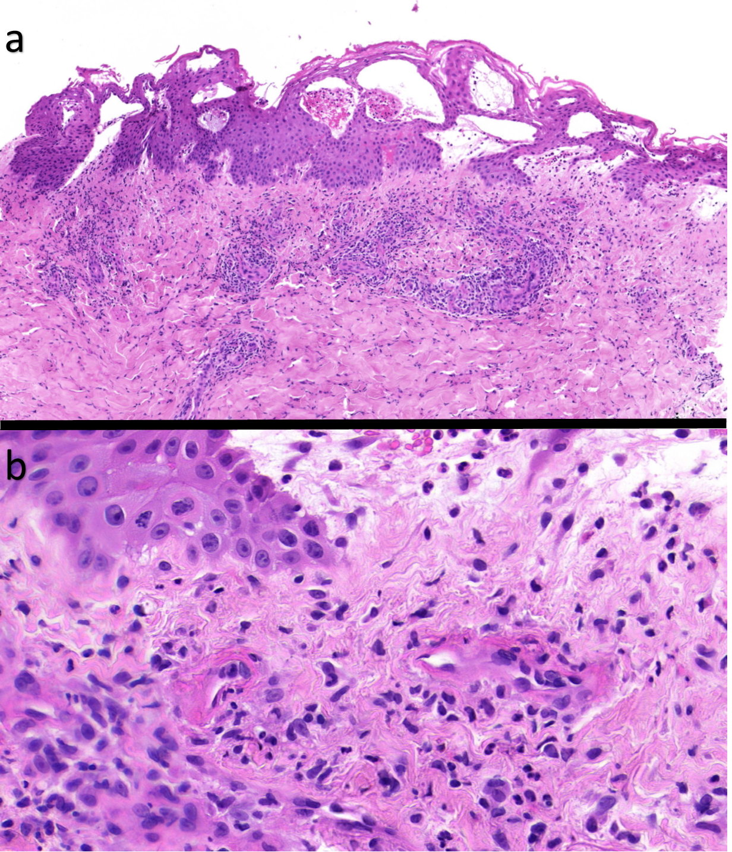
Figure 2 – Haematoxylin & Eosin staining of 4mm lesional skin biopsy demonstrating at 4x (a) a brisk perivascular infiltrate and at 40x (b) endothelial swelling, fibrin deposition, and leukocytoclasis, in keeping with leukocytoclastic vasculitis.

