The effects of a “black swan” event (COVID-19) on herding behavior in cryptocurrency markets

Abstract

This paper analyses herding in cryptocurrency markets in the time of the COVID-19 pandemic. We employ a combination of quantitative methods to hourly prices of the four most traded cryptocurrency markets - USD, EUR, JPY and KRW - for the period from 1st January 2019 to 13th March 2020. While there are several strong theoretical reasons to observe the “black swan” effect on cryptocurrency herding, our results suggest that COVID-19 does not amplify herding in cryptocurrency markets. In all markets studied, herding remains contingent on up or down markets days, but does not get stronger during the COVID-19. These results are important for cryptocurrency investors and regulators to enhance their understanding of cryptocurrency markets and the financial effects of the COVID-19 pandemic.

Keywords: COVID-19, black swan effect, herding, cryptocurrency, Bitcoin.

- Introduction
The spread of the COVID-19 pandemic generated strong contagion effect across financial markets around the globe, while the scale of its social and economic consequences is still hard to estimate and predict. There are ongoing debates regarding the nature of the continuing crisis with some experts comparing it to the Global Financial Crisis of 2008, and others likening it to war events, terror attacks, natural disasters and past epidemics. The COVID-19 has resulted in unprecedented measures to stop the spread of the virus, such as international and local travel restrictions, lockdowns and quarantines that have caused immediate and long-term damage to a vast majority of industries, and businesses of different sizes. Some may refer to this crisis as a “black swan” event, given that it was hard to predict and has never previously occurred. This makes a precise prediction of its impact rather challenging for all existing risk management models.
In the context of cryptocurrency markets, which are relatively new and unexplored financial assets, the COVID-19 proved to be an unprecedented shock. Barely a decade old, the Bitcoin has traditionally experienced periods of high volatility without being susceptible to any major systematic crisis. Cryptocurrencies as financial assets have not yet demonstrated their safe haven properties during any major economic crisis and recession, and early evidence suggests that Bitcoin failed to display hedging opportunities and flight to safety properties during the COVID-19 pandemic (Conlon and McGee, 2020; Corbet et al., 2020d). Given this finding, we assume that the COVID-19 can have a black swan effect on cryptocurrency, resulting in behavioral anomalies such as investor herding. To better understand the role of investor sentiment and panic in driving herding behaviour in the light of the COVID-19 pandemic, we study both unconditional herding, as well as that conditional on up and down market days (to capture investor optimism and pessimism).
Herding behavior is a particularly interesting direction of research during the crisis periods, when investors may share similar fears and be susceptible to large-scale financial panic. However, till date, there is limited evidence available on herding behavior during the COVID-19 pandemic. Espinosa-Mendez and Arias (2020) analyze the impact of COVID-19 on herding in European equity markets and provide strong evidence of herding behavior because of the pandemic. Chang et al (2020) suggest that the increase in herding in energy markets during the COVID-19 pandemic can be explained by extremely low oil prices. The paper closest to ours in terms of contribution is the very recent Philippas et al. (2020) that provides a comprehensive analysis of herding behavior in cryptocurrency markets. However, our paper differs from them in that we focus specifically on herding behavior during the COVID-19 pandemic, that provides us with the unprecedented opportunity to add to this line of literature, providing novel evidence of the black swan effects on herding.
Therefore, in this paper, we aim to specifically answer the question: Does the COVID-19 pandemic amplify herding behavior in cryptocurrency markets? For this, we use hourly close prices for the main cryptocurrencies traded in USD, Euro, JPY and KRW, for the period starting 00 a.m. on 1st January 2019 till 8:00 p.m. of 13th March 2020. We analyze unconditional herding and herding conditional on up/down market days by means of the Chang et al. (2000) approach. The parameters are estimated using several methods.
First, we apply the Newey-West (Newey & West, 1987) Heteroscedasticity and Autocorrelation consistent (HAC) estimators to linear regressions using Bartlett kernel weights as described in Newey & West (1987, 1994). Applying these methods to estimate covariance matrices in regression analysis allows us to account for conditional heteroskedasticity of regression disturbances that may be of an unknown form. Statistical inference that rests on standard errors not robust to heteroskedasticity can be strongly misleading. Our choice of using estimators from the variance-covariance matrix addresses this issue.
To verify our results, we estimate a robust linear Bayesian model with priors estimated as in Lewandowski et al. (2009) and Markov-Switching regressions using the EM (Expectation-Maximization) algorithm proposed by Dempster et al. (1977), Hamilton (1989, 1994) and Goldfeld and Quantd (2005) to check for the presence of herding given different regimes. Markov-switching models are widely applied in literature starting with Hamilton 1989 and Kim, 1994; and further developed by Kim, Nelson, and Startz 1998; Guidolin, 2007. 2009, 2011; Alexander and Kaeck, 2008; Hahn et al. 2010; Liu 2011; Ang and Timmermann 2011; etc. Guidolin (2012) shows that these type of models effectively capture volatility clustering, excess kurtosis, and heavy tails. The regimes allow for distinguishing Regime 1 (given the higher absolute value of the coefficient on x2), Regime 2 is more persistent in terms of the probability of switching to another regime.
Quantile regression (Sim and Zhou, 2015) is applied to test the behavior of the coefficients across quantiles. This approach allows us to address non-linearity in the relationship as well as to estimate the effects of the quantiles of one variable on those of another. This class of models provides more detailed results across different part of the distribution than the standard quantile regression (Matkovskyy and Jalan, 2020).
Time-Varying Regressions, TVR (Bollerslev et al., 2016; Casas et al., 2018) are estimated to assess evolution of herding over time. These type of models, first introduced by Robinson (1989) for stationary processes were further generalized to nonstationary processes and correlated errors by Chang and Martinez-Chombo (2003), Cai (2007), Corsi (2009), Chen et al. (2017) etc. The TVR framework allows for a “natural” way of parameter estimation for the herding model. The time-varying coefficients are obtained by applying the local polynomial kernel estimator (e.g., Nadaraya-Watson estimator). This preserves the bias, variance, and automatic good boundary behavior properties of the local linear estimator, ensuring flexibility and robustness (Cai, 2001). Compared with the local linear method, these estimators are consistent and asymptotically normal. Comparing the TVR to state-space models, we see that the latter represent complex and nonlinear models that come with increased complexity and harder calibration. Application of the Kalman filter can provide an initial state estimate and covariance that is inconsistent with the true system state. Also, potential "outliers" can cause negative outcomes, leading to a non-positive semi-definite covariance matrix after update.
To detect the unknown structural break points under heteroskedasticity, the Mumtaz, Gulfam & Asad (2017) test is applied. This test has an advantage over other tests such as the sup F test that is widely used for structural change and assumes homoskedasticity. It checks simultaneously for breaks in regression coefficients as well as variance and its results help us detect the effects of the COVID-19 on changes in herding levels in the selected markets.
And finally, time-varying correlation among selected markets in terms of herding is estimated by means of the time-varying parameter copula models (GAS models with conditional multivariate Student–t distribution and time–varying correlations as in Creal et al., 2011, 2013; Harvey 2013). The motivation to use Student–t distribution is that the time-series of herding coefficients is relatively short. GAS models can be estimated in a rather straightforward manner and offer several advantages such as allowing for time-varying parameters for a great variety of nonlinear models and their ability to exploit the complete density structure (Matkovskyy 2019).
This paper contributes to the literature in two main ways. First, it contributes to the growing body of literature on the financial effects of the COVID-19 pandemic (Corbet et al. 2020a, d; Conlon and McGee, 2020; Goodell, 2020; Sharif et al. 2020). Second, it contributes to the literature on herding behavior in cryptocurrency markets, providing novel evidence of the black swan effect on herding (Bouri et al., 2019; Vidal-Tomás et al. 2019 Philippas et al. 2020, among others). Our results indicate unconditional herding in all selected markets, except the cryptocurrency KRW market using hourly data. In terms of mean values, we observe conditional herding on both up/down market days in the USD and JPY cryptocurrency markets, and on only up-market days in the Euro market. In a nutshell, our results show that for the selected cryptocurrency markets, herding behavior exists largely during stable times. In addition, our results provide supporting evidence of the asymmetry in herding on up and down-market days, suggesting panic-driven herding on days with high value-drops in the cryptocurrency market.
Quantile regression estimates indicate stronger herding in higher quantiles of return variation in the euro and USD cryptocurrency markets. For the JPY and KRW markets, it is quite the opposite – herding is absent in higher quantiles. In general, we observe a decreasing trend in herding in the recent times, particularly in the USD and euro cryptocurrency markets. This can be attributed to shocks in conventional expansionary policy and non-standard policy supporting the hypothesis of Krokida et al. (2020). Generally, COVID-19 does not cause a significant shock to herding in the cryptocurrency markets except the JPY crypto market for which a structural break can be observed. Time-varying correlation in herding is noted. Herding in the USD -JPY and Euro-JPY cryptocurrency markets is cyclical, peaking twice a month. For the pair USD -Euro cryptocurrency markets, correlation increased during the first half of February 2020 and is rather constant over time.
The remainder of the paper is organized as follows. Section 2 discusses the theoretical background of this paper. Section 3 explains data and methodology. Section 4 reports and discusses empirical results. Section 5 concludes.

- Background Literature
Herding behavior among investors can explain some of the behavioral anomalies against the efficient market hypothesis. Fama (1970) suggests that in efficient markets, prices fully reflect all available information, making it impossible for an investor to generate abnormal returns using publicly available information. Many studies highlight the presence of herding behavior in financial markets, that tends to occur when some investors have access to private information and make investment decisions that are not in line with the general market trend. While it is hard to define what private information is and what it consists of, the actions of the investors in possession of such information can provide signals to other market participants, without any direct sharing or revelation. If market participants believe that others may be privy to useful private information, they may end up getting influenced by their decisions, consequently herding on their investment decisions, i.e., imitating the behavior of other investors. This can lead to deviation in prices away from fundamental values, resulting in high volatility and consequent destabilization of markets.
Early studies by Morris and Shin (1999), Persaud (2000), and Shiller (1990), to name but a few, find that herding and institutional risk management strategies may amplify volatility in financial markets. Herding behavior has been studied extensively for equity markets (e.g., Christie and Huang, 1995; Chang et al., 2000). If investors herd, stock returns should correlate with market returns. This behavior, however, should be distinguished from “spurious herding”, where market participants facing similar information can make similar decisions. Evidence in favor of herding behavior in stock markets is still mixed and inconclusive, with many studies reporting the absence of herding (Galariotis et al. 2016; Lee, 2017). Much less empirical evidence is available for herding in cryptocurrency markets (e.g., Bouri et al., 2019; Kaiser and Stöckl, 2019; Kallinterakis and Wang, 2019). The study of herding behavior in cryptocurrency markets is important given that cryptocurrencies have been in the limelight owing to their impressive historical returns and since their inception, have attracted the attention of many investors who never before participated in financial markets before their arrival.
The COVID-19 pandemic provides a unique opportunity to investigate herding behavior in cryptocurrency markets during this unprecedented “black swan” event. However, some may argue that for traditional financial markets, this event is not entirely “black swan”, given that there exist other historical events that have had similar impact on economies and markets in equity, commodity, and other financial derivatives. There are studies that have discussed the risk of pandemics and infectious diseases on the economy before the emergence of the COVID-19 crisis. For example, Bloom et al. (2018) discuss the economic risks of epidemics citing managerial and policy implications, while Fan et al (2018) provide predictions of expected losses due to pandemics. Much earlier, Saker et al. (2004) discuss the impact of globalization on the spread of infectious diseases, highlighting that stronger economic ties between countries could affect the prevalence, spread, geographical range and control of many infections. Studies of previous epidemics, such as SARS, Ebola, Zika, and H1N1, or HIV/AIDS provide some empirical evidence on the impact of epidemics, associated risks and costs, and mitigation strategies (Haacker, 2004; Hoffman and Silverberg, 2018). Furthermore, there is an emerging field of literature comparing the impact of COVID-19 to that of past pandemics (Correia et al. 2020; Eichenbaum et al., 2020; Ma et al., 2020), and the reaction of financial markets to its growth and spread (Backer et al., 2020a,b).
While it might be expected to observe reduced risk-taking and flight-to-safety behavior among investors, early evidence from COVID-19 shows surprising trading patterns. Ortmann et al. (2020) report a significant increase in trading activities during the outbreak, where the average weekly trading intensity increases by 13.9% as the number of COVID-19 cases doubles. Furthermore, their results show an absence of flight-to-safety behavior among investors or a tendency to invest in more speculative assets, such as cryptocurrencies. Chiah and Zong (2020) also document a surge in trading volumes in 37 equity markets analyzed, where trading activity increased the most in wealthier nations, and among markets with better corporate governance and legal systems. Heo et al. (2020) analyse risk tolerance during the pandemic and report the existence of two clusters of investors – the first with lower levels of both financial knowledge and risk tolerance, and the second comprising those with both higher financial knowledge and risk tolerance.
Bitcoin remains the cryptocurrency market leader and other cryptocurrencies often mimic its behavior (Corbet et al., 2020b, c). In cryptocurrency literature, Bitcoin has often been compared to gold, though evidence of the safe haven properties of this digital asset remains mixed (Corbet et al., 2019). Specifically, in analyses of the COVID-19 crisis, Goodell and Goutte (2020), Le et al. (2020) suggest that Bitcoin can be considered as a safe haven asset during the first four months of the pandemic. These results contradict those of Corbet et al. (2020d) and Conlon and McGee (2020) who claim that Bitcoin did not act as a safe haven or diversifier during the early stage of the pandemic. Furthermore, Conlon et al. (2020) report that Bitcoin and other cryptocurrencies such as Ethereum and Tether, have failed to demonstrate safe haven properties for international equity markets during the same period. In contrast, Mariana et al. (2020) claim that cryptocurrencies are short-term safe havens during the first months of the COVID-19 pandemic, with Ethereum acting as a better safe haven than the Bitcoin.
While hedging and safe haven properties of cryptocurrencies remains a dominant theme of the early COVID-19 literature in finance (e.g., Corbet et al., 2020a, Conlon and McGee, 2020), substantial empirical evidence has also been collected to suggest financial contagion and spillover effect between various financial assets (e.g., Akhtaruzzaman et al., 2020; Okorie and Lin, 2020; Yarovaya et al.., 2020a,b), reaction and recovery of financial markets from the COVID-19 shock (e.g., Ashraf, 2020; Seven and Yilmaz, 2020; Heyden and Heyden, 2020; Mazur et al., 2020; Topcu and Gulal, 2020; Yarovaya et al., 2020c); predictability (Ciner, 2020); hedge funds performance (e.g. Yarovaya et al., 2021), among others. However, only a few papers have analyzed herding behavior during the COVID-19 pandemic (Aziz et al., 2020; Espinosa-Mendez and Arias, 2020; Chang et al., 2020), and to the best of our knowledge, our paper is the first to analyze herding in cryptocurrency markets during the COVID-19.

- Theory development
Cryptocurrencies in general, and Bitcoin in particular, have attracted a huge amount of attention from investors (e.g., Urquhart, 2018; Philippas et al., 2019) due to its innovative Blockchain technology and the unprecedented opportunity to generate abnormal returns. For equity markets, it is evident that attention-based trading strategies are not always able to outperform well-diversified portfolios (Barber and Odean, 2008). However, evidence from cryptocurrency literature suggests that even small allocations to Bitcoin could substantially improve portfolio returns (Platanakis and Urquhart, 2019). Matkovskyy et al. (2019) show that the top 10 cryptocurrencies can enhance portfolio returns of the 10 worst-performing stocks in the S&P600, S&P400 and S&P100 indexes, to match those of the 10 best-performing stocks therein. Prices in cryptocurrency markets are also sensitive to macroeconomic news and FOMC announcements, though cryptocurrency investors may not always correctly interpret this news, resulting in differences between responses of cryptocurrency and traditional financial markets (Corbet et al. 2020b, c).
While all major theories in economics and finance assume that investors are rational, fully informed, and that their decisions are based on all publicly available information, empirical evidence seems to suggest that investors often behave irrationally, thereby creating noise in financial markets with their decisions (Shleifer and Summers, 1990). This could be especially pronounced for new and immature cryptocurrency markets, and more so in times of increased uncertainty (Kahneman and Tversky, 1973), such as that created by the COVID-19 crisis.
Sharif et al. (2020) analyze the impact of the COVID-19 pandemic on the Economic Policy Uncertainty (EPU) index, oil prices, and the US stock market and find that the COVID-19 had the most pronounced impact on EPU, increasing uncertainty to unprecedented levels. Knowing that rationality is bounded to the extent of available information and cognitive abilities of the individual (Simon, 1997), we can assume that limited information on the COVID-19 virus, and limited understanding of its effects, coupled with potentially low computing capacity to estimate its impact using standard forecasting models, the behavior of Bitcoin investors during the period from January 2020 to March 2020 could be irrational. This forms the key motivation of our paper.
To examine irrationality and consequent herding behavior in cryptocurrency markets following the uncertainty induced by the COVID-19, we specify and test the following hypotheses:
Hypothesis 1: There is herding in cryptocurrency markets during the COVID-19 pandemic.
Furthermore, taking into account that cryptocurrency markets are highly volatile, it is important to investigate whether herding is impacted by investor optimism and pessimism, i.e., by up and down markets days. This leads to our second hypothesis:
Hypothesis 2: This herding behavior is contingent upon up and down-market days.
A confirmation of Hypothesis 1 will provide evidence of herding in cryptocurrency markets during the early months of COVID-19 crisis, while that of Hypothesis 2 will highlight the relationship between herding and investor sentiment, i.e., optimism and pessimism following market periods with rising and declining prices.
It is worth mentioning here that although in most cases herding behavior is considered irrational, herding could be rational too. Rational herding occurs when investors simply mimic each other’s decisions, even when doing so contradicts their own beliefs, expectations and interpretation of available information (Bikhchandani et al., 1992), resulting in an information cascade. Thus, even if Bitcoin investors believe that the cryptocurrency market will remain relatively unaffected by the COVID-19 shock, they could mimic the behavior of larger investors, or follow expert opinion suggesting continuing consequences of the pandemic on cryptocurrency prices. This could prompt them to choose to cash out, rather than remain invested. This strategy could be considered as rational herding during the early months of the COVID-19 pandemic.
There are several approaches to examine herding in the cryptocurrency market during the COVID-19 pandemic. Two primary models of investor herding behavior have been employed in recent publications. The first approach, the Lakonishok, Shleifer and Vishny (1992) (LSV), accounts for the number of transactions by investors with respect to a specific security (e.g., Lakonishok et al., 1992; Grinblatt et al.,1995; Wermers, 1999; Wylie, 2005). These studies empirically document the existence of herding in the stock market, with more evidence of herding in buying stocks. The second popular approach is the cross-sectional standard dispersion (CSSD) model of Christie and Huang (1995) and its improved version, the CSAD model of Chang et al. (2000). This approach can be considered as the benchmark in the literature on stock market herding (Fang et al., 2017).
Herding in traditional financial markets across countries show mixed and inconclusive results. Using both daily and monthly returns, Christie and Huang (1995) analyse market participants in the U.S equity market during periods of market stress and document inconsistency in herding during periods of large price movements. Using intraday NYSE stock data during 1998 -2000, Patterson and Sharma (2007) provide evidence of some level of herding. Chang et al. (2000) use cross-sectional absolute deviation and document significant evidence of herding for South Korea and Taiwan, partial evidence for Japan, and no evidence for US and Hong Kong. Hwang and Salmon (2004) find significant movements and persistence of herding in US and South Korea. Litimi et al. (2016) analyse American companies listed on NYSE/AMEX/NASDAQ from 1985 to 2013 and document the presence of herding behaviour in the U.S stock market. They also show that while market volatility decreases with increases in herding behaviour, the latter contributes to different financial crises and bubbles. Choe et al. (1999) document herding in the Korean financial market.
For other financial assets, results point towards the presence of herding behaviour. For instance, Galariotis et al. (2016) document herding in the European financial market, particularly in bond trading during the crisis. Demirer et al. (2015) find significant evidence of herding behavior in grains only during the high volatility state. De Souza Raimundo Júnior et al (2019) document a high degree of herding in the commodities market. Bernales et al. (2016) analyse equity option contracts traded in the US between 1996 and 2012 and report herding behavior during periods of market stress.
In cryptocurrency markets, research on herding in is its infancy, with only a few papers available till date. Bouri et al. (2019) employ the Chang et al. (2000) approach and find evidence of insignificant herding or statistically significant anti-herding behavior in the static model. Mild herding activity is observed in the second half of 2016, which the authors attribute to an increase in economic uncertainty. Applying cross-sectional absolute standard deviations (CSAD) and cross-sectional standard deviation of returns (CSSD) to cryptocurrency markets from January 2015 to February 2017, Vidal-Tomás et al. (2019) document herding. Using cross-sectional absolute deviation (CSAD) and state-space models over the longer period January 2015 to March 2019, Kaiser and Stöckl (2019) also confirm the existence of herding behavior in the cryptocurrency market.
A more extensive analysis of herding in cryptocurrency markets is undertaken by Kallinterakis and Wang (2019) who use daily prices, market capitalization and volume of the top 296 cryptocurrencies for the 12/2013–07/2018 window. Results indicate significant herding in the cryptocurrency market (even without the Bitcoin), which is stronger during up-market, low volatility and high-volume days. Da Gama Silva et al. (2019) apply cross-sectional absolute deviation (CSAD) and cross-sectional standard deviation (CSSD) tests to daily data for the 50 most-liquid and capitalized currencies from March 2015 to November 2018 and find that herding behavior is present mainly in down market days.
Philippas et al. (2020) examine how informative signals from exogenous factors contribute to herding intensity in the cryptocurrency market. They use the following main groups of indicators that generate information signals: (i)benchmark market-based indices; (ii) risk (volatility) indicators as expectation of risk attitude (the volatility index, VIX, the treasury yields volatility index, TYVIX, the volatility risk premium, VP, as a proxy for market sentiments); (iii) uncertainty indicators (the Economic Policy Uncertainty, EPU, index, the global equity markets’ and global foreign exchange markets’ connectedness measures); (iv) media attention indicators to capture information demand and supply and its cumulative sentimental influence (the Google Trends daily and the daily volume of Twitter hashtag ‘btc’); and (v) commodities (the returns on gold and crude oil due to their safe haven characteristics). They document herding behavior of cryptocurrency investors and attribute it to the fact that contrary to equities or fixed income securities, cryptocurrency prices are more likely to be influenced by market sentiment owing to lack of a fundamental basis. They also show that higher the Bitcoin returns, higher the motivation for investors to be independent from the market. They also find that the major cryptocurrencies do not herd with the minor ones.
Although the period considered by Philippas et al. (2020) from January 2016 to May 2018-end includes some periods of increased volatility in Bitcoin market, it cannot directly be compared to the COVID-19 crisis, given the unprecedented levels of panic and uncertainty that investors are currently exposed to. Furthermore, previous literature on herding during crises is ambiguous, for example, Chiang and Zheng (2010) find that in most cases, there are no differences in herding coefficients during crisis and tranquil periods, except for the US and Latin America. Economou et al. (2011) and Mobarek et al. (2014) document that herding behavior is more prominent during crisis periods. Therefore, there is need for further research on herding in cryptocurrency markets during the crisis, and the COVID-19 pandemic offers a unique opportunity to investigate this question and contribute to this growing stream of literature.

- Data and Methodology
We collect hourly observations of close prices for the main cryptocurrencies traded in USD, Euro, JPY and KRW, which are the top 4 currencies by trading volume, for the period from 00 a.m. 1st January 2019 to 8:00 p.m. of 13th March 2020. Since the primary objective of the paper is to study herding during the COVID-19 pandemic and given that its first wave is not long enough in terms of adequacy of observations, we face the issue of selecting an appropriate sampling frequency between the noisier higher-frequency data and the much less informative, low frequency data.
To address this issue, we apply a volatility signature to test for overall volatility for different frequencies of Bitcoin close prices. This is in line with Andersen et al. (1998), who argue that for the purpose of calculating realized volatility of asset returns, the ideal frequency is that which minimises both microstructural bias and sampling error. This is made possible with the help of a volatility signature plot that represents average realized volatility against various sampling intervals, with the ideal frequency being the one at which one observes a relative stabilization of overall volatility.
Since their introduction, volatility signature plots have been used widely to address data frequency issues (see for instance, Corsi et al. 2008, Degiannakis and Floros, 2013 and for cryptocurrencies, Akyildirim et al., 2020; Jalan et al., 2020).
Our estimated volatility signature using one-minute data shows that the variance is stabilized at 1-hour intervals. Particularly:
- during the first 10 minutes, bitcoin volatility decreases from 0.54 to 0.053 (about 90%);
- between 11-60 minutes, it decreases to 0.015 (70% decrease);
- between 61-180 minutes, volatility drops to 0.004 (20% decrease), but the variance itself is not significant.
On this basis, we conclude that in terms of data frequency, hourly intervals are the best-suited for this study.
Table 1 presents information on cryptocurrencies considered and data sources, i.e., exchanges used to collect data across the four markets.
[Table 1 here]
Figures A1, A5, A9, A13 display price dynamics for selected cryptocurrencies during the observation period. Here one can see that post-COVID, the worst 24-hour drop in cryptocurrencies is observed on 12.03.2020 (average drop in value - 38%) (see the graphs in Appendix). Compared to its maximum value in 2020, the Bitcoin suffers a value drop of about 53%, while Ethereum and Litecoin lose 61 and 64% of their highest values, respectively. This highlights the general impact of the COVID-19 on the otherwise resilient cryptocurrency market.
We estimate herding behavior by means of the Chang et al. (2000) approach. Despite the availability of alternative models (Bohl et al. 2013; Lee, 2017; Clements et al., 2017), we choose this approach given its wide use in prior literature to be able to ensure comparability of our results with those of prior studies.
Thus, the following specification for estimates is used:

 | $${CSAD}_{m,t}=β_{0}+β_{1}\left|R_{m,t}\right|+β_{2}R_{m,t}^{2}+e_{t}$$ | (1)

where $R_{m,t}$ is the average absolute market return of all actively traded selected cryptocurrencies in each currency market, i.e., cryptocurrency USD, euro, JPY and KRW at time t, ${CSAD}_{m,t}$ is the Cross-Sectional Absolute Deviation of returns and is calculated as follows:

 | $${CSAD}_{m,t}=\frac{\sum_{i=1}^{n}{\left|R_{i,t}-R_{m,t}\right|}}{n}$$ | (2)

where $R_{i,t}$ is the first logarithmic difference of closing prices for cryptocurrency i at time t

 | $$R_{i,t}={InP}_{t}-{InP}_{t-1}$$ | (3)

If herding is not present in a market, the relationship between the cross-sectional return dispersion, ${CSAD}_{m,t}$, and absolute market returns, $\left|R_{m,t}\right|$, would be expected to be positive and linear, implying that $β_{1}$ would be expected to be significantly positive, while $β_{2}$ insignificant. On the contrary, in the presence of herding, when values of $\left|R_{m,t}\right|$ are high and thus substantial market movements are observed, the relationship between ${CSAD}_{m,t}$ and $\left|R_{m,t}\right|$ would be non-linear, implying that $β_{2}$ would be negative and significant. Thus, herding lowers cross-sectional dispersion of returns compared to the case of rational pricing. Bernales et al. (2019) postulate that herding is stronger when $β_{1}$ is negative, implying a negative relationship between the cross-sectional deviation of the cryptocurrency’s return and the magnitude of respective market returns.
To assess herding on up/down market days, Eq. (1) is extended following Cui et al. (2019), to:
 | $${CSAD}_{m,t}=β_{0}+β_{1}D^{up}\left|R_{m,t}\right|+β_{2}\left(1-D^{up}\right)\left|R_{m,t}\right|+β_{3}D^{up}R_{m,t}^{2}+β_{4}(1-D^{up})R_{m,t}^{2}+e_{t}$$ | (4)

where $D^{up}$is equal to one (zero) on days with positive (negative) values of $R_{m,t}$. Significantly negative values of $β_{3} (β_{4})$ would indicate the presence of herding on days of positive (negative) average cryptocurrency market performance.
These parameters are estimated using several methods. First, we apply the classic Newey-West (Newey & West, 1987) Heteroscedasticity and Autocorrelation consistent (HAC) estimators to linear regressions using Bartlett kernel weights as described in Newey & West (1987, 1994). To corroborate these estimates, we estimate a robust linear Bayesian model with priors estimated as in Lewandowski et al. (2009). We also estimate Markov-Switching regressions using the EM algorithm as in Hamilton (1989;1994), Goldfeld and Quantd (2005) to check for the presence of herding given different regimes.
Quantile regression (Sim and Zhou 2015) is applied to test the behaviour of the coefficients across quantiles. Eq (3) – Eq (4) are modified as follows:

 | $${CSAD}_{m,t}=β_{0}^{θ}+β_{1}^{θ}\left|R_{m,t}\right|+β_{2}^{θ}R_{m,t}^{2}+e_{t}^{θ}$$  $${CSAD}_{m,t}=β_{0}^{θ}+β_{1}^{θ}D^{up}\left|R_{m,t}\right|+β_{2}^{θ}\left(1-D^{up}\right)\left|R_{m,t}\right|+β_{3}^{θ}D^{up}R_{m,t}^{2}+β_{4}^{θ}(1-D^{up})R_{m,t}^{2}+e_{t}^{θ}$$ | (5)  (6)
where θ is the θth quantile of the conditional distribution of the average absolute market return of all actively traded selected cryptocurrencies per currency market, $e_{t}^{θ}$ is the error term with a zero θ-quantile.
Then, Time-Varying Regressions, TVR (Bollerslev et al., 2016; Casas et al., 2018) are estimated to assess evolution of herding over time. Given that a classical linear model can be expressed as $y_{t}=x_{t}^{T}β+u_{t}$, where t=1,…, T, $y_{t}$ is a dependent variable ${CSAD}_{m,t}$, $x_{t}={(x_{1t}, x_{2t},…, x_{dt})}^{T}$ is a vector of repressors at time t, $β={\left(β_{0},β_{1}, …,β_{d}\right)}^{T}$ is a vector of coefficients and $u_{t}$ is the error term. If the coefficients are allowed to vary over time, the time-varying coefficient model (TV-LM) can be specified as follows:

 | $$y_{t}=x_{t}^{T}β\left(z_{t}\right)+u_{t}, t=1,…,T$$ | (5)

where $z_{t}$ is the smoothing variable, transforming coefficients to be a function of $z_{t}$: $β(z_{t})={\left(β_{0}(z_{t}),β_{1}(z_{t}), …,β_{d}(z_{t})\right)}^{T}$. $z_{t}$ can be defined in two ways. First, as an unknown function of time,$β(z_{t})=f(τ)$, as proposed in Robinson (1989), and further developed by Cai (2007) and Chen et al. (2017). Second, this variable can be defined as an unknown function of a random variable, $β(z_{t})=f(z_{t})$, developed by Hastie and Tibshirani (1993), Cai et al. (2000); Chang and Martinez-Chombo (2003), Cai et al. (2009), and Gao and Phillips (2013). The estimation is done by combining OLS and the local polynomial kernel estimator (Fan and Gijbels 1996). Given that $β(∙)$ is twice differentiable, an approximation of$β\left(z_{t}\right)$ can be expressed by means of the Taylor rule, $β\left(z_{t}\right)=β\left(z\right)+β{\left(z\right)}^{\left(1\right)}(z_{t}-z)$, where $β^{(1)(z)}=dβ(z)/dz$ is the first derivative. The following minimization problem should then be solved:

 | $$\arg{\min_{θ_{0},θ_{1} }{\sum_{t=1}^{T}{{\left[y_{t}-x_{t}^{T}θ_{0}-\left(z_{t}-z\right)x_{t}^{T}θ_{1}\right]}^{2}K_{b}(z_{t}-z)}}}$$ | (6)

This approach can be fit to a set of weighted local regressions with an optimally chosen window size, defined by the bandwidth b. Using the weights derived from the kernel $K_{b}\left(z_{t}-z\right)=b^{-1}K\left(\frac{z_{t}-z}{b}\right)$, yields the following local estimator:

 | $$\left(\begin{matrix}{\hat{β}}_{t} \\ {\hat{β}}_{t}^{(1)}\end{matrix}\right)={\left(\begin{matrix}S_{T,0}(z_{t}) & S_{T,1}^{T}(z_{t}) \\ S_{T,1}(z_{t}) & S_{T,2}(z_{t})\end{matrix}\right)}^{-1}\left(\begin{matrix}T_{T,0}(z_{t}) \\ T_{T,1}(z_{t})\end{matrix}\right)$$ | (7)

where,

 | $$S_{T,s}\left(z_{t}\right)=\frac{1}{T} \sum_{i=1}^{T}{X_{i}^{'}X_{i}{\left(z_{i}-z_{t}\right)}^{S}K\left(\frac{z_{i}-z_{t}}{h}\right)}$$  $$T_{T,s}\left(z_{t}\right)=\frac{1}{T} \sum_{i=1}^{T}{X_{i}^{'}{\left(z_{i}-z_{t}\right)}^{S}K\left(\frac{z_{i}-z_{t}}{h}\right)y_{i}}$$ | (8)  (9)

To detect the unknown structural break points under heteroskedasticity, the Mumtaz, Gulfam & Asad (2017) test is applied:

 | $$MZ=\left(T-k\right)\log{{\hat{σ}}_{0}^{2}}-\left\{\left(T_{1}-k\right)\log{{\hat{σ}}_{1}^{2}}+\left(T_{2}-k\right)\log{{\hat{σ}}_{2}^{2}}\right\}$$  $$\sup{MZ=\max_{a≤j≤b}{{MZ}_{j}}}, k<a≤j≤b<T-k$$ | (10)  (11)

where there are two subgroups with $T_{1}$ and $T_{2}$ observations respectively, k is the number of parameters $(β, σ^{2})$, ${\hat{σ}}_{i}^{2}=Y_{i}-\frac{X_{i}{\hat{β}}_{i}^{2}}{T_{i}-k}, i=1,2$, indicating periods before and after the structural break, respectively, while a and b are time periods before and after the breakpoint that occurs at t=j.
Time-varying correlation among the selected markets in terms of herding is estimated by means of the time-varying parameter copula models, i.e., GAS models with conditional multivariate Student–t distribution and time–varying correlations (Creal et al. 2011, 2013; Harvey 2013). These models allow for time-varying parameters in copulas and thus help exploit the complete density structure of the data, rather than merely means and higher moments. The time-varying coefficients from time-varying regressions are used as inputs. We therefore estimate how these parameters are correlated across markets.
These parameters are updated over time by applying the scaled score of the likelihood function. The evolution in the time-varying parameter vector $θ_{t}$ can be specified as follows (see Creal et al. 2011 and Creal et al. 2013 for technical details):
 | $θ_{t+1}=κ+As_{t}+Bθ_{t}$, | (12)

where $κ,A$ and $B$ are matrices that contains coefficients, particularly, $κ and A$ control for the level and the persistence of the mean reverting process for $θ_{t}$), $s_{t}$ is a vector proportional to the score of $y_{t}|y_{1:t-1}\sim p\left(y_{t};θ_{t}\right)$, where $y_{1:t-1}≡\left(y_{1}^{'},…,y_{t-1}^{'}\right)$ and $θ_{t}∈Θ⊆R^{J}$ and is defined as
 | $s_{t}≡S_{t}(θ_{t})∇_{t}(y_{t},θ_{t})$, | (13)

where $S_{t}$ is a $J×J$ positive defined scaling matrix known at time t, $∇_{t}(y_{t},θ_{t})$is the score of $y_{t}|y_{1:t-1}\sim p\left(y_{t};θ_{t}\right)$ estimated as $∇_{t}(y_{t},θ_{t})≡\frac{∂\log{p(y_{t},θ_{t})}}{∂θ_{t}}$.
The updated equation for $θ_{t}$ is specified as:
 | $$θ_{t}≡Λ\left({\tilde{θ}}_{t}\right)$$  ${\tilde{θ}}_{t}≡κ+A{\tilde{s}}_{t}+B{\tilde{θ}}_{t-1}$, | (14)  (15)
where ${\tilde{s}}_{t}≡{\tilde{S}}_{t}({\tilde{θ}}_{t}){\tilde{∇}}_{t}(y_{t},{\tilde{θ}}_{t})$. Jacobian matrix estimated at ${\tilde{θ}}_{t}$ is $J({\tilde{θ}}_{t})≡\frac{∂Λ\left({\tilde{θ}}_{t}\right)}{∂{\tilde{θ}}_{t}}$. Finally, the matrices $κ,A$ and $B$ are used to estimate $ξ$, by means of maximum likelihood (ML) approach:
 | $\tilde{ξ}≡\arg{\max_{ξ}{L\left(ξ;y_{1:T}\right)}}$, | (16)

where $L\left(ξ;y_{1:T}\right)≡\log{p\left(y_{1};θ_{1}\right)+\sum_{t=2}^{T}{\log{p\left(y_{t};θ_{t}\right)}}}$, $θ_{1}≡{\left(I-B\right)}^{-1}κ$, and $θ_{t}≡θ\left(y_{1:t-1},ξ\right)$.

- Empirical results and discussion
5.1. Helicopter view
The results for unconditional herding behavior across the four markets are presented in Table 2 below. Here one observes positive and significant (at 1%) coefficients for β1 across all markets. These are not directly interpreted to assess herding behavior. However, negative and significant β2 values indicate strong herding behavior. Coefficients on β2 are negative and significant at 1% for all markets except for KRW, which is positive with a significance level of 95%. This seems to indicate the presence of unconditional herding for all markets except the KRW, providing supporting evidence for Hypothesis 1. While our results support the finding of Ballis and Drakos (2019), Bouri et al. (2019), Vidal-Tomás et al. (2019), among others, who report the presence of herding in cryptocurrency markets, they contradict those of Stavroyiannis and Babalos (2019), who document lack of herding. Herding behavior in cryptocurrency markets can be explained by the dominating role of irrational individual investors in the most traded cryptocurrencies (Kaiser and Stöckl, 2019).
As Bernales et al. (2019) note, herding would be even stronger if the relationship between the cross-sectional deviation of asset returns and the magnitude of market returns would be negative. This would require β1 to be negative. However, β1 is found to be positive in our study across various specifications, which implies that strong herding as defined by Bernales et al. (2019), is not detected in our sample.
[Table 2 here]
Detection of the unknown structural break points under Heteroskedasticity (Mumtaz et al., 2017) reveals only one day for each of the USD, JPY and KRW cryptocurrency markets. The break is detected on 2019-07-15 at 01:00:00 for the cryptocurrency USD. Similarly, for the JPY cryptocurrency market, the structural break occurs on 2019-04-21 at 01:00:00 and on 2019-01-29 at 04:00:00 for the cryptocurrency KRW market. A careful look at the dates for structural breaks above suggests that they lie before the COVID-19 struck and hence, the pandemic did not cause any significant change in herding levels in these markets.
For the cryptocurrency euro market, a break in hedging behavior is detected on 2020-03-09 at 10:00:00. This makes the cryptocurrency euro market the only one in our sample that experienced a significant change in herding patterns due to the COVID-19 pandemic. This result is in line with the general finding in literature that herding increases with the level of uncertainty, in addition to being consistent with papers that have analyzed herding in financial markets during the previous crisis shocks (e.g. Galariotis et al., 2016; Demirer et al., 2015; Bernales et al. 2019). Furthermore, Markov-Switching regressions for two regimes also suggest statistically significant herding behavior in the selected cryptocurrency markets (see Appendix).
For the cryptocurrency USD market, one notes that while herding is stronger in Regime 1 (given the higher absolute value of the coefficient on x2), Regime 2 is more persistent in terms of the probability of switching to another regime (88% versus 61% for Regime 1). For the cryptocurrency euro market, Regime 2 is not only more persistent (just like the USD), but unlike the latter, also depicts stronger herding behavior. The cryptocurrency JPY market shows patterns similar to the cryptocurrency euro market except that herding in Regime 2 is found to be significantly higher than that in Regime 1 based on the size of the coefficient on x2. For the cryptocurrency KRW markets, even when Regime 2 is more persistent, herding behavior therein is not significant. For the USD, JPY and KRW markets, even when herding behavior is significantly different across regimes, we can make no inference with respect to the impact of COVID-19 thereon. Studies by Balcilar and Demirer (2015) and Bouri et al (2019) report that herding in cryptocurrency markets tends to occur when uncertainty increases. This, however, is not evident in our results for all cryptocurrency markets analyzed, and there is no evidence of increase in herding that can be attributed to the COVID-19 uncertainty.
To better understand the dynamics of herding, we employ quantile regressions to examine the impact of various quantiles of return variation on those of herding behavior. Results for unconditional herding demonstrate significantly higher levels of herding behavior at higher quantiles of return variation for the USD and Euro cryptocurrency markets.
Conditional herding on the other hand, is highly responsive to higher levels of return variation and increases drastically on low-market days for the USD and Euro cryptocurrency market. This seems to suggest panic-driven herding on days with high value-drops in the cryptocurrency market. Previous studies, for example, by Vidal-Tomás et al. (2019), document herding only during down-market days, while Kallinterakis and Wang (2019) find that herding is stronger during up-market days. Ballis and Drakos (2019) further demonstrate that the up-events market dispersion follows market movements at a faster pace compared to the down events. For up-market days, however, herding does increase with higher quantiles of return variation, but remains much less sensitive compared to down-market days. This difference in behavior seems to suggest that herding behavior is most likely a response to market panic. Gurdgiev and O’Loughlin (2020) discuss herding from the perspective of fear and uncertainty, and document that bullishness/bearishness of markets has an asymmetric impact on cryptocurrency prices. In that sense, our results provide additional evidence in support of the asymmetry in herding on up and down-market days. For the JPY and KRW cryptocurrency markets, one observes that herding increases significantly at higher quantiles of return variation, though at very high levels of variation in return (94th percentile and above for JPY and roughly the 70th percentile for KRW), herding behavior stops. This lack of herding in very high quantiles for the JPY and KRW Bitcoin is observed for both up and down-market states.
Figure 2 below displays unconditional herding behavior using time-varying coefficients for the period 01/01/2019 - 13/03/2020 using hourly data.
The objective is to identify trends in herding during and the pre-COVID period. The USD market shows high volatility in herding behaviour during the period studied. Very high herding is observed at the beginning of 2019, which gradually dissipates in April-May, only to increase again starting July 2019. Herding remains absent between November 6th-December 8th, 2019, after which it increases again and can be observed till the end of the sample period. However, declining herding levels are noted after middle of February 2020 on an average.
[Figure 2 here]
An examination of cryptocurrency price behavior in the USD for the same period suggests an enormous increase in bitcoin prices from $5,265 to $8,900 (increase of 67%) for the first time in May 2019. Prices continue to rise, attaining their maximum of $18,175 on 10 July 2019, after which a decline sets in. During July-August 2019, bitcoin was being traded in the range of $9,462.50 - $11,815.04, when its biggest drop is observed on October 24, taking the price down to $7421.20. In merely three days however, Bitcoin prices bounce back to attain both the month and quarter high at $9595.34. Bitcoin remained relatively stable during the first few days of November 2019 with prices tumbling again from $9,396.19 to $8,771.30 from November 4 to November 9, reaching $7,026.83 on November 24. From mid-November to mid-December, the cryptocurrency market remained stressed with issues experienced by several exchanges that eventually led to wiping out the October rally. Correlating herding behavior in cryptocurrency USD market with volatility swings, one can infer that periods of high price volatility generally resulted in a decrease in herding levels in the market. In other words, the market exhibited herding behavior largely during stable times, implying general rationality in market participants’ behavior. Therefore, for the cryptocurrency USD market, while our findings contradict prior studies that attribute herding in cryptocurrency markets to a large number of irrational investors and high explosivity of these markets (e.g. Kaiser and Stöckl, 2019; Kallinterakisand and Wang, 2019), they support those of Stavroyiannisand and Babalos (2019).
Similar trends are observed in the cryptocurrency euro market, except that herding seems to disappear after February 2020 and continues to decrease. Herding in the cryptocurrency JPY market is observed throughout the sample period but herding levels seem to decrease after July 2019. For the KRW cryptocurrency however, no significant herding is observed in 2019. In fact, small levels of herding are observed only around February, 2020.
We further report estimates of herding behaviour conditional on up/down market days (see Table 3 below), and our results provide evidence of significant herding behaviour on up-market days in the USD, Euro and JPY cryptocurrency markets, but on down-market days, herding is observed for USD and JPY markets only, supporting the asymmetry in herding behaviour during bullish and bearish markets (Gurdgiev and O’Loughlin, 2020)

[Table 3 here]
A significantly negative value of β3 (β4) can suggest the presence of herding on days of positive (negative) average performance for the cryptocurrency market. In the case of the Bitcoin USD market, both β3 and β4 are negative and statistically significant, implying herding on both positive and negative average market performance, though that on positive market performance is stronger (absolute value of β3 > absolute value of β4). Applying a quantile regression to test the results, one can observe that absolute values of β3 are higher for all quantiles, implying that herding is more pervasive during positive average market performance. During February, maximum herding conditional on market performance is observed, after which it starts to decrease.
Figure 3 below displays results for conditional herding using time-varying coefficients for the period from 01/01/2019 to 13/03/2020, using hourly data. A close analysis of the USD market in Figure 3 suggests higher levels of herding on up-market days. Even when herding is observed for both up and down-market days, the magnitude of herding levels on up-market days remains significantly higher. The only exception to this observation is May 2019 when down-market herding seems to dominate and October-December 2019, when only down-market herding exists without any up-market herding. Both up and down-market herding are observed for the COVID-19 period starting January 2020, though up-market herding dominates. A similar trend is observed for the euro Bitcoin market except that starting February 2020, no significant down-market herding exists and even up-market herding shows a declining trend. The JPY cryptocurrency market shows consistent up and down-market herding from July 2019 before which only down-market herding seems to exist. Post July 2019, levels of both types of herding remain very close to each other till the beginning of March 2020, after which up-market herding begins to dominate. Interestingly, no significant up-market herding is noted for the KRW market throughout the sample period. Down-market herding becomes mildly significant only after September 2019 after which it remains stable through the end of the sample period.
5.2. A closer look at 2020
The objective is to analyse trends in conditional and unconditional herding during the uncertainty prevalent in the COVID-19 period, we plot patterns in herding behaviour in the four geographical markets exclusively for the year starting January 1, 2020. Figure 4 presents results for unconditional herding. Here we can observe high volatility in unconditional herding for the USD cryptocurrency market. Herding levels increase significantly after roughly the end of the first week of January and thereafter continue to decline, remaining significant. Herding levels in the JPY remain rather stable across 2020 but increase slightly after mid-March. The cryptocurrency euro market opens with significant levels of herding in 2020, which begin to decline starting roughly mid-January. This decline continues until herding levels become insignificant in the start of February. In the KRW market, herding is observed after mid-February after which it continues to increase.
[Figure 4 here]
Figure 5 presents results for herding conditional on up and down-market days, respectively. The USD cryptocurrency market opens with a significantly high level of up-market herding at the start of 2020, but levels continue to decline throughout, still remaining significant. A similar pattern is observed for the euro cryptocurrency market except that at the end of the sample period, up-market herding levels become almost insignificant. The JPY cryptocurrency market shows consistently stable levels of up-market herding since the start of 2020, though levels tend to rise after roughly the third week of February 2020. The KRW cryptocurrency market shows virtual absence of any up-market herding in 2020.
[Figure 5 here]
The USD cryptocurrency market shows significant down-market herding starting roughly January 10 after which levels first increase and starting February, begin to decline. This trend continues till the end of the sample period though herding levels remain significant. For the euro cryptocurrency market, down-market herding continuously declines in 2020 until it turns insignificant in mid-January. Down-market herding for the JPY cryptocurrency market remains largely consistent and significant throughout 2020, though a small decline in levels is noted after end of February 2020. For the KRW, no significant down-market herding is observed before end of February 2020. Levels however, remain small.
To summarize, the USD cryptocurrency market exhibits both up and down-market herding in 2020, with levels falling throughout. The Euro cryptocurrency market shows declining levels of both up and down-market herding that end up reaching insignificant levels. The JPY cryptocurrency market shows rather stable levels of up and down-market herding in 2020 with the former increasing and the latter decreasing towards the end of February. Only small levels of down-market herding are observed for the KRW starting after February-end with no evidence of any up-market herding.
Figure 6 shows the time evolution of the pair-wise correlation in unconditional herding across markets. Here one notices that the correlation in unconditional herding behaviour between the euro-USD is consistently high and increases even further starting end of January. This seems to suggest a rather symmetrical herding reaction to the COVID-19 in these two markets.
[Figure 6 here]
The pairs of the USD-JPY and euro-JPY cryptocurrency markets reveal a cyclical pattern of correlation, with alternate peaks and troughs throughout the sample period that demonstrate agreement in herding-related sentiments. The only disagreement is observed in the period which falls right after the introduction of the CME options on 14/01/2020. The USD-JPY correlation falls sharply starting March 23 and reaches a value of 0 in merely 4 days, after which it becomes negative.
- Conclusion
This paper provides novel empirical evidence on cryptocurrency market herding during the COVID-19 pandemic. We analyse hourly closing prices for the four highest-traded cryptocurrencies in USD, EURO, JPY and KRW, that represent the highest trading volume for the period from 00 a.m. 1st January 2019 to 8:00 p.m. of 13th March 2020, using the well-known CSAD measure, estimated using several approaches to ensure robustness of our results.
While daily data shows insignificant herding, using hourly data we find significant evidence of unconditional herding in all selected markets, except the cryptocurrency KRW market. The results also indicate the existence of conditional herding on both up/down market days in the USD market. While herding is observed only for up-market days for the euro cryptocurrency market, for the JPY and KRW cryptocurrency markets, herding is observed only for down-market days. These findings are consistent with previous literature that suggests asymmetry in herding during up and down-market states (e.g. Phillipas et al. 2020; Gurdgiev and O’Loughlin, 2020; Kaiser and Stöckl, 2019; Kallinterakisand and Wang, 2019; Vidal-Tomás et al., 2019). Particularly, we document the highest herding activity during the negative average performance in the KRW market. Application of quantile regressions reveals stronger herding in higher quantiles of return variation in the Euro and USD cryptocurrency markets, while absence of herding is noted for higher quantiles in the JPY and KRW markets.
While the COVID-19 pandemic increased volatility in cryptocurrency markets, we observe a decreasing trend in herding in the recent times, particularly in the USD and euro cryptocurrency market. This can be attributed to shocks in conventional expansionary policy and non-standard policy supporting the hypothesis of Krokida et al. (2020). Furthermore, these findings contradict the popular belief that herding is stronger during times of heightened uncertainty. Thus, we report that COVID-19 does not significantly amplify herding in the cryptocurrency markets. A notable exception is the euro cryptocurrency market for which we observe a structural break during the COVID-19 crisis. Finally, our results show that correlation in herding is time-varying. Specifically, herding in the USD and JPY cryptocurrency markets is cyclical, peaking twice a month, whereas for the USD and Euro cryptocurrency markets, correlation increased during the first half of February 2020.
The results of this study have important implications for policy makers, academics, and investors in cryptocurrency markets. The first implication arises in the form of a better understanding of the rather nascent crypto markets, which continue to be opaque in terms of investor composition. Hsin and Tseng (2012) suggest that herding propensity is likely to decrease when the number of informed investors relatively to uninformed investors in a market is large. In that sense, our results of plummeting herding levels despite the heightened uncertainty caused by the pandemic highlight the dominance of informed and probably institutional investors in the crypto market. Our results are in line with Feng et al. (2018) who find evidence of informed trading in the Bitcoin market prior to large events.
Second, our results highlight the importance of a careful analysis of liquidity in the cryptocurrency market that could potentially explain the lower propensity to herd. Liquidity of crypto markets is a well-researched area but it may be worthwhile to investigate the link between lack of liquidity in these markets to the peculiar herding patterns observed in this study. This thought is motivated from the results of Galariotis et al. (2016) who document evidence of herd behaviour only for highly liquid stocks in mature markets. A recent paper by Jalan et al. 2020 document a statistically significant positive effect of the introduction of Bitcoin futures on USD Bitcoin spot market liquidity, though not large enough to stabilize the highly illiquid market.
Third, given that herding behaviour is an extremely complex psychological phenomenon influenced by several factors such as uncertainty (e.g. Lin, 2018) and fear (e.g. Economou et al., 2018) and the fact that herding has been held responsible for different financial bubbles and crises over time (for instance, Litimi et al., 2016), our results in the context of cryptocurrency markets can be useful for asset allocation, diversification and potential spill-over effect analysis for these markets. This can help not only for portfolio management using cryptos but also predict the impact of future crises and black swan events on the cryptocurrency market.
We would like to acknowledge that this paper is one of the first papers that examines herding behaviour during the COVID-19 pandemic and therefore suggest that the presented results be interpreted with caution taking into account the early stage of the pandemic and amount of data available to date. Despite this, the paper builds a strong foundation for further research in this area, which will be of immense benefit to regulators and policy makers as new events in the COVID story unfold.

References
Akhtaruzzaman, M., Boubaker, S., Sensoy, A. (2020). Financial contagion during COVID–19 crisis. Finance Research Letters. https://doi.org/10.1016/j.frl.2020.101604
Akyildirim, E., Corbet, S., Lucey, B., Sensoy, A., Yarovaya, L. (2020). The relationship between implied volatility and cryptocurrency returns. Finance Research Letters 33.
Alexander, C., and A., Kaeck, (2008). Regime Dependent Determinants of Credit Default Swap Spreads. Journal of Banking and Finance 32, 1008-1021.
Andersen, T. G., & Bollerslev, T. (1998). Answering the skeptics: Yes, standard volatility models do provide accurate forecasts. International Economic Review, 39(4), 885-905.
Ang, A., and A., Timmermann (2011). Regime Changes and Financial Markets. NBER Working paper No. 17182.
Ashraf, B.N. (2020). Stock markets’ reaction to COVID-19: Cases or fatalities? Research in International Business and Finance, 54. https://doi.org/10.1016/j.ribaf.2020.101249
Aziz, S., Jalan, A., Matkovskyy, R., Bouraoui, T. (2020). Does religious philosophy affect investor behaviour in the COVID-19 times: Evidence .from herding in (non-)Shariah compliant energy firms. Available at ResearchGate.net.
Baker, S., N. Bloom, S. J. Davis and S. J. Terry (2020b). COVID-Induced Economic Uncertainty. paper available on the link: http://www.policyuncertainty.com/media/COVID-Induced%20.pdf. 04-04-2020
Baker, S.R., N. Bloom, S. J. Davis, K. Kost, M. Sammon and T. Viratyosinm, (2020a). The Unprecedented Stock Market Reaction to COVID-19. Available on the link: https://www.policyuncertainty.com/media/StockMarkets_COVID.pdf-24-03-2020.
Balcilar, M., Demirer,R., (2015). Impact of global shocks and volatility on herd behaviour in an emerging market: evidence from Borsa Istanbul. Emerging Markets Finance Trade, 51, 140–159.
Ballis, A., Drakos, K. (2019). Testing for herding in the cryptocurrency markket. Finance Research Letters, https://doi.org/10.1016/j.frl.2019.06.008
Barber, B.M, Odean, T. (2008). All That Glitters: The Effect of Attention and News on the Buying Behavior of Individual and Institutional Investors. The Review of Financial Studies, 21, 785–818.
Bernales, A , Verousis, T. , Voukelatos, N. (2019). Do investors follow the herd in option markets? Journal of Banking and Finance. Forthcoming https://doi.org/10.1016/j.jbankfin.2016.02.002
Bikhchandani, S., Hirshleifer, D., Welch, I., (1992). A theory of fads, fashion, custom, and cultural change as informational cascades. Journal of Political Economy, 100(5), 992-1026.
Bloom, D. E. , Cadarette, D., Sevilla, J.P. (2018). Epidemics and economics: New and resurgent infectious diseases can have far-reaching economic repercussions. Finance and Development, 55 (2) ,46-49.
Bohl, M.T., Klein, A.C., Siklos, P.L. (2013). Are short sellers positive feedback traders? Evidence from the global financial crisis. Journal of Financial Stability, 9(3), 337-346.
Bollerslev, T., Patton, A. J. and Quaedvlieg, R. (2016). Exploiting the errors: A simple approach for improved volatility forecasting. Journal of Econometrics, 192, 1-18.
Bouri, E., Gupta, R., Roubaud, D. (2019). Herding behaviour in cryptocurrencies. Finance Research Letters 29, 216–221.
Cai, Z. (2001). Weighted Nadaraya–Watson regression estimation. Statistics & Probability Letters 51(3), 307-318.
Cai, Z. (2007). Trending time-varying coeffcient time series with serially correlated errors. Journal of Econometrics, 136, 163-188.
Cai, Z. (2007). Trending time-varying coefficient time series with serially correlated errors. Journal of Econometrics 136, 163-188.
Cai, Z., Fan, J., Yao, Q. (2000). Functional-Coeffcient Regression Models for Nonlinear Time Series. Journal of the American Statistical Association, 95, 941956.
Cail, Z., Li, Q., Park, J. (2009). Functional-coefficient models for nonstationary time series data. Journal of Econometrics, 148 (2), 101-113.
Casas, I., Mao, X. and Veiga, H. (2018) Reexamining financial and economic predictability with new estimators of realized variance and variance risk premium. Url= http://pure.au.dk/portal/files/123066669/rp18_10.pdf
Chang, C.-L., McAleer, M., Wang, Y.-A. (2020). Herding behaviour in energy stock markets during the Global Financial Crisis, SARS, and ongoing COVID-19. Renewable and Sustainable Energy Reviews, 134. https://doi.org/10.1016/j.rser.2020.110349
Chang, E.C. , Cheng, J.W. , Khorana, A. (2000). An examination of herd behavior in equity markets: an international perspective. Journal of Banking and Finance, 24, 1651–1679.
Chang, Y., Martinez-Chombo, E. (2003). Electricity Demand Analysis Using Cointegration and Error-Correction Models with Time Varying Parameters: The Mexican Case. https://econpapers.repec.org/paper/eclriceco/2003-08.htm
Chang, Y., Martinez-Chombo, E. (2003). Electricity Demand Analysis Using Cointegration and Error-Correction Models with Time Varying Parameters: The Mexican Case. Working papers, Rice University, Department of Economics.
Chen, X.B., Gao, J., Li, D., Silvapulle, P. (2017). Nonparametric Estimation and Forecasting for Time-Varying Coefficient Realized Volatility Models. Journal of Business & Economic Statistics, online, 1-13.
Chen, X.B., Gao, J., Li, D., Silvapulle, P. (2017). Nonparametric Estimation and Forecasting for Time-Varying Coefficient Realized Volatility Models. Journal of Business & Economic Statistics, 1-13.
Chiah, M., Zhong, A. (2020). Trading from home: The impact of COVID-19 on trading volume around the world. Finance Research Letters. https://doi.org/10.1016/j.frl.2020.101784
Chiang, T.C., Zheng, D. (2010). An empirical analysis of herd behavior in global stock markets. Journal of Banking and Finance, 34, 1911–1921.
Choe H., Kho B.C., R.M. Stulz (1999) Do foreign investors destabilize stock markets? The Korean experience in 1997. Journal of Financial Economics, 54, 227-264.
Christie, W. G., & Huang, R. D. (1995). Following the pied piper: Do individual returns herd around the market? Financial Analysts Journal, 31–37.
Ciner, C. (2020). Stock return predictability in the time of COVID-19. Finance Research Letters. https://doi.org/10.1016/j.frl.2020.101705
Clements, A., Hurn, S., Shi, S. (2017). An empirical investigation of herding in the US stock market. Economic Modelling, 67, 184-192.
Conlon, T., Corbet, S., McGee, R. (2020). Are cryptocurrencies a safehaven for equity markets? An international perspective from the COVID-19 pandemic. Research in International Business and Finance, 54. https://doi.org/10.1016/j.ribaf.2020.101248
Conlon, T., McGee, R. (2020) Safe Haven or Risky Hazard? Bitcoin during the COVID-19 Bear Market (March 24, 2020). Finance Research Letters, 35. https://doi.org/10.1016/j.frl.2020.101607
Corbet et al. 2020a Corbet, S., Hou, G., Yang, H., Lucey, B. M., Les, O. (2020). Aye Corona! The Contagion Effects of Being Named Corona during the COVID-19 Pandemic. Economics Letters, 194. https://doi.org/10.1016/j.econlet.2020.109377
Corbet et al. 2020b Corbet, S., Larkin, C., Lucey, B.M., Meegan, A. & Yarovaya, L. (2020). The impact of macroeconomic news on Bitcoin returns. The European Journal of Finance. https://doi.org/10.1080/1351847X.2020.1737168
Corbet et al. 2020c Corbet, S., Larkin, C., Lucey, B.M., Meegan, A. & Yarovaya, L. (2020). Cryptocurrency reaction to FOMC Announcements: Evidence of heterogeneity based on blockchain stack position. Journal of Financial Stability, 46.
Corbet et al. 2020d Corbet, S., Larkin, C., Lucey,B. (2020) The contagion effects of the COVID-19 pandemic: Evidence from Gold and Cryptocurrencies. Finance Research Letters, 35. https://doi.org/10.1016/j.frl.2020.101554
Corbet, S., Lucey, B, Urquhart, A., Yarovaya, L. (2019). Cryptocurrencies as a financial asset: A systematic analysis. International Review of Financial Analysis, 62, 182-199, https://doi.org/10.1016/j.irfa.2018.09.003
Correia, S., Luck, S., Verner, E. (2020). Pandemics Depress the Economy, Public Health Interventions Do Not: Evidence from the 1918 Flu. Technical report. Available at SSRN: http://dx.doi.org/10.2139/ssrn.3561560.
Corsi, F. (2009). A Simple Approximate Long-Memory Model of Realized Volatility. Journal of Financial Econometrics 7(2), 174-196.
Corsi, F., Mittnik, S., Pigorsch, C. & Pigorsch, U. (2008) The Volatility of Realized Volatility, Econometric Reviews 27:1-3, 46-78.
Creal, D., Koopman, S. J. and Lucas, A., (2013). Generalized autoregressive score models with applications. Journal of Applied Econometrics, 28, 777–795.
Creal, D., Koopman, S.J. and Lucas, A. 2011. A Dynamic Multivariate Heavy–Tailed Model for Time–Varying Volatilities and Correlations. Journal of Business & Economic Statistics 29(4), 552–563.
Cui, Y., Gebka, B., Kallinterakis, V. (2019). Do closed-end fund investors herd? Journal of Banking and Finance 105, 194-206.
Da Gama Silva, P.V.J., Klotzle, M.C., Figueiredo Pinto, A.C., Lima Gomes, L. (2019) Herding ehavior and contagion in the cryptocurrency market. Journal of Behavioral and Experimental Finance, 22, 41-50.
De Souza Raimundo Júnior, G., Palazzi, R.B., Klotze, M.C., Figueiredo Pinto, A.C. (2019) Analyzing herding behavior in commodities markets – an empirical approach. Finance Research Letters, In press, https://webaccess.esc-rennes.fr/https/esc-rennes/gw-esc-rennes/doi.org/10.1016/j.frl.2019.08.033
Degiannakis, S., Floros, C. (2013). Modeling CAC40 volatility using ultra-high frequency data. Research in International Business and Finance 28, 68-81.
Demirer, R. Lee, H-T, Lien D. (2015). Does the stock market drive herd behavior in commodity futures markets? International Review of Financial Analysis, 39, 32-44.
Dempster, A., N., Laird, and Rubin, D. (1977). Maximum Likelihood from Incomplete Data via the EM Algorithm. Journal of the Royal Statistical Society B, 39, 1-38.
Discussion Papers 1911, Cowles Foundation for Research in Economics, Yale University.
Economou, F., Hassapis, C., & Philippas, N. (2018). Investors’ fear and herding in the stock market. Applied Economics, 50(34-35), 3654-3663
Economou, F., Kostakis, A., Philippas, N. (2011). Cross-country effects in herding behaviour: evidence from four south European markets. Journal of International Financial Markets, Institutions and Money, 21, 443–460.
Eichenbaum, M.S., Rebelo, S., Trabandt, M. (2020). The Macroeconomics of Epidemics. National Bureau of Economic Research, 26882.
Espinosa-Mendez, C., Arias, J. (2020). COVID-19 effect on herding behaviour in European capital markets. Finance Research Letters. https://doi.org/10.1016/j.frl.2020.101787
Fama, E. (1970). Efficient Capital Markets: A Review of Theory and Empirical Work. The Journal of Finance, 25(2), 383-417.
Fan, J., Gijbels, I. (1996). Local Polynomial Modeling and Its Applications. hapman and Hall, London.
Fan, V. Y., Jamison, D.T., Summers, L.H. (2018). Pandemic risk: how large are the expected losses?, Bulletin of the World Health Organization 96 (2),129-134.
Fang, H., Shen, C.-H., Lee, Y.-C. (2017). The dynamic and asymmetric herding behavior of US equity fund managers in the stock market. International Review of Economics and Finance 49, 353-369.
Feng, W., Wang, Y., Zhang, Z. (2018). Informed trading in the Bitcoin market. Finance Research Letters 26, 63-70.
Galariotis,E. Krokida, S.-I., Spyrou, S. (2016) Bond market investor herding: evidence from the European financial crisis. International Review of Financial Analysis, 48, 365-375.
Gao, J., Phillips, P. (2013). Functional coefficient nonstationary regression. Cowles Foundation
Goldfeld, S., Quantd, R. (2005). A Markov model for switching Regression, Journal of Econometrics, 135, 349-376.
Goodell, J. (2020). COVID-19 and ﬁnance: Agendas for future research. Finance Research Letters, forthcoming. https://doi.org/10.1016/j.frl.2020.101512
Goodell, J.W., Goutte, S. (2020). Co-movement of COVID-19 and Bitcoin: Evidence from wavelet coherence analysis. Finance Research Letters. https://doi.org/10.1016/j.frl.2020.101625
Grinblatt, M., Titman, S., & Wermer, R. (1995). Momentum investment strategies, portfolio performance, and herding: A study of mutual fund behavior. American Economic Review, 85, 1088–1105.
Guidolin, M. (2011). Markov Switching in Portfolio Choice and Asset Pricing Models: A Survey, Advances in Econometrics 27 Part 2:87-178.
Guidolin, M. (2012). Markov Switching Models in Empirical Finance, CEPR, NBER and Università Bocconi, Working Paper n. 415, June, 2012.
Guidolin, M.. (2009). Detecting and Exploiting Regime Switching ARCH Dynamics in US Stock and Bond Returns.” In: G. Gregoriou (Ed.), Stock Market Volatility. Chapman Hall: LondonGuidolin,M., and A., Timmermann, (2007). Asset Allocation under Multivariate Regime Switching. Journal of Economic Dynamics and Control 31, 3503-3544.
Gurdgiev,C., O’Loughlin, D. (2020). Herding and anchoring in cryptocurrency markets: Investor reaction to fear and uncertainty. Journal of Behavioural and Experimental Finance, 25. https://doi.org/10.1016/j.jbef.2020.100271
Haacker, M. (2004). The Impact of HIV/AIDS on Government Finance and Public Services (International Monetary Fund, Washington).
Hahn, M., Fr¨uuhwirth-Schnatter, S., and J., Sass, (2010). Markov Chain Monte Carlo Methods for Parameter Estimation in Multidimensional Continuous Time Markov Switching Models. Journal of Financial Econometrics 8, 88-121.
Hamilton J.D. (1989). A New Approach to the Economic Analysis of Nonstionary Time Series and the Business Cycle. Econometrica, 57, 357-384
Hamilton, J. D. (1989). A New Approach to the Economic Analysis of Nonstationary Time Series and the Business Cycle. Econometrica 57, 357-384
Hamilton, J. D. (1990). Analysis of Time Series Subject to Changes in Regime. Journal of Econometrics 45, 39-70.
Hamilton, J.D. (1994). Time Series Analysis. Princeton University Press.
Harvey, A. C., 2013. Dynamic Models for Volatility and Heavy Tails: With Applications to Financial and Economic Time Series. Cambridge University Press.
Hastie, T., Tibshirani, R. (1993). Varying-Coefficient Models. Journal of the Royal Statistical Society. Series B (Methodological), 55, 757-796.
Heo, W., Rabbani, A., Grable, J.E. (2020). An Evaluation of the Effect of the COVID-19 Pandemic on the Risk Tolerance of Financial Decision Makers. Finance Research Letters. https://doi.org/10.1016/j.frl.2020.101842
Heyden, K.J., Heyden, T. (2020). Market reactions to the arrival and containment of COVID-19: An event study. Finance Research Letters. https://doi.org/10.1016/j.frl.2020.101745
Hoffman, S.J., Silverberg, S.L. (2018): Delays in global disease outbreak responses: lessons from H1N1, Ebola, and Zika. American journal of public health, 108, 329–333.
Hsin, C,W., and Tseng, P.W. (2012). Stock price synchronicities and speculative trading in emerging markets. J. Multinatl. Financ. Manag., 22 (3), 82-109.
https://doi.org/10.1016/j.jfs.2019.100706
Hu, Y., Hou, Y.G., Oxley, L. (2020). What role do futures markets play in Bitcoin pricing? Causality, cointegration and price discovery from a time-varying perspective? International Review of Financial Analysis 72 (in Press).
Hwang, S., Salmon, M. (2004). Market stress and herding. Journal of Empirical Finance, 11(4), 585-616
Jalan, A., Matkovskyy, R., Urquhart, A. (2020) What effect did the introduction of Bitcoin futures have on the Bitcoin spot market? The European journal of finance (in press).
Kahneman, D., Tversky, A. (1973). On the psychology of prediction. Psychological Review, 80(4), p.237.
Kaiser, L., Stöckl, S. (2019). Cryptocurrencies: Herding and the transfer currency. Finance Research Letters (in Press), https://doi.org/10.1016/j.frl.2019.06.012
Kallinterakis, V. and Wang, Y. (2019) Do investors herd in cryptocurrencies – and why? Research in International Business and Finance, 50, 240-245.
Kim, C.-J. (1994). Dynamic Linear Models with Markov Switching. Journal of Econometrics 64, 1-22.
Kim, C.J., Nelson, C.R., and Startz, R. (1998). Testing for mean reversion in heteroscedastic data based on Gibbs sampling augmented randomization. Journal of Empirical Finance 5, 131-154.
Krokida, S.-I., Makrychoriti, P., Spyrou, S. (2020) Monetary policy and herd behavior: International evidence. Journal of Economic Behavior and Organization, 170, 386–417.
Lakonishok, J., Shleifer, A., & Vishny, R. W. (1992). The impact of institutional trading on stock prices. Journal of Financial Economics, 32(1), 23–43.
Le, T.H., Do, H.X., Nguyen, D.K., Sensoy, A. (2020). Covid-19 pandemic and tail-dependency networks of financial assets. Finance Research Letters. https://doi.org/10.1016/j.frl.2020.101800
Lee, K. (2017). Herd behaviour of the overall market: Evidence based on the cross-sectional comovement of returns. The North American Journal of Economics and Finance, 42, 266-284.
Lewandowski, D., Kurowicka, D., Joe, H. (2009). Generating Random Correlation Matrices Based on Vines and Extended Onion Method. Journal of Multivariate Analysis, 100(9), 1989–2001.
Lin, M. C. (2018). The impact of aggregate uncertainty on herding in analysts’ stock recommendations. International Review of Financial Analysis, 57, 90-105.
Litimi, H., BenSaïda, A. and Bouraoui, O. (2016). Herding and excessive risk in the American stock market: a sectoral analysis”, Research in International Business, 38, 6-21.
Litimi, H., BenSaida, A., Bouraoui, O. (2016). Herding and excessive risk in the American stock market: a sectorial analysis. Resesearch in International Business and Finance, 38, 6–21.
Liu, H. (2011). Dynamic Portfolio Choice under Ambiguity and Regime Switching Mean Returns. Journal of Economic Dynamics and Control 35, 623-640.
Ma, C., Rogers, J. H., Zhou, S. (2020) Global Economic and Financial Effects of 21st Century Pandemics and Epidemics. Available at SSRN: https://ssrn.com/abstract=
Mariana, C.D., Ekaputra, I.A., Husondo, Z. A. (2020). Are Bitcoin and Ethereum safe-havens for stocks during the COVID-19 pandemic? Finance Resarch Letter. https://doi.org/10.1016/j.frl.2020.101798
Matkovskyy, R. (2019). Extremal Economic (Inter)Dependence Studies: A Case of the Eastern European Countries. Journal of Quantitative Economics 17, 667–698.
Matkovskyy, R. and Jalan, A. (2020). Can Bitcoin Be an Inflation Hedge? Evidence from a Quantile-on-Quantile Model. Economic Review, In press.
Matkovskyy, R., Jalan, A., Dowling, M., Bouraoui, T. (2019). From bottom ten to top ten: the role of cryptocurrencies in enhancing portfolio return of poorly performing stocks. Finance Research Letters (In press), https://doi.org/10.1016/j.frl.2019.101405
Mazur, M, Dang, M., Vega, M. (2020). COVID-19 and the march 2020 stock market crash. Evidence from S&P1500. Finance Research Letters. https://doi.org/10.1016/j.frl.2020.101690
Mobarek , A., Mollah, S., Keasey, K. (2014). A cross-country analysis of herd behaviorin Europe. Journal of International Financial Markets, Institutions and Money, 32, 107-127.
Morris, S. and Hyun S., S. (1999). Risk Management with Interdependent Choice. Oxford Review of Economic Policy, 15(3), 52–62.
Mumtaz A., Gulfam H. & Asad Z. (2017). Detecting structural change with heteroskedasticity. Communications in Statistics - Theory and Methods 46(21), 10446-10455.
Newey, W. K., & West, K. D. (1987). A Simple, Positive Semi-definite, Heteroskedasticity and Autocorrelation Consistent Covariance Matrix. Econometrica, 55(3), 703–08.
Newey, W. K., & West, K. D. (1994). Automatic Lag Selection in Covariance Matrix Estimation. Review of Economic Studies, 61, 631–653.
Okorie, D.I., Lin, B. (2020). Stockmarkets and the COVID-19 fractal contagion effects. Finance Research Letters. https://doi.org/10.1016/j.frl.2020.101640
Ortmann, R., Pelster, M., Wengerek, S.T. (2020). COVID-19 and investor behaviour. Finance Research Letters. https://doi.org/10.1016/j.frl.2020.101717
Patterson, D.M., Sharma, V. (2007). Did herding cause the stock market bubble of 1998–2001? University of Michigan-Dearborn. Working Paper
Persaud, A. (2000). Sending the Herd Off the Cliff Edge: The Disturbing Interaction Between Herding and Market-Sensitive Risk Management Practices, in “Jacques de Larosiere Essays on Global Finance”, (Washington: Institute of International Finance).
Philippas, D., Philippas, N., Tziogkidis, P. , Rjiba, H. (2020) Signal-herding in cryptocurrencies Journal of International Financial Markets, Institutions & Money (In press), doi: doi.org/10.1016/j.intfin.2020.101191
Philippas, D., Rjiba, H., Guesmi, k., Goutte, S. (2019). Media attention and Bitcoin prices. Finance Research Letters, 30, 37-43.
Platanakis, E., Urquhart, A. (2019). Should investors include Bitcoin in their portfolios? A portfolio theory approach. The British Accounting Review, forthcoming. https://doi.org/10.1016/j.bar.2019.100837
Robinson, P (1989). Nonparametric estimation of time-varying parameters. In P Hackl (ed.), Statistical Analysis and Forecasting of Economic Structural Change. Springer, Berlin.
Saker, L., Lee, K., Cannito,B., Gilmore, A. (2004) Globalisation and infectious diseases: A review of the linkages. World Health Organization on Belhalf of the Special Programme for Research and Training in Tropical Diseases, in Special Topics in Social, Economic and Behavioural Research series.
Seven, U., Yilmaz, F. (2020). World Equity Markets and COVID-19: Immediate Response and Recovery Prospects. Research in International Business and Finance. https://doi.org/10.1016/j.ribaf.2020.101349
Sharif, A., Aloui, C., Yarovaya, L. (2020). COVID-19 pandemic, oil prices, stock market and policy uncertainty nexus in the US economy: fresh evidence from the wavelet-based approach (April 13, 2020). Available at SSRN: https://ssrn.com/abstract=
Shiller, R.t J. (1990). Investor Behavior in the October 1987 Stock Market Crash: Survey Evidence. In Market Volatility, (Cambridge, Massachusetts: MIT Press).
Shleifer, A, Summers. L. H. (1990). The Noise Trader Approach to Finance, Journal of Economic Perspectives, 4 (2), pp. 19-33.
Sim, N., Zhou, H. (2015). Oil prices, US stock return, and the dependence between their quantiles. Journal of Banking and Finance, 55, 1–8.
Simon, H.A. (1997). Models of bounded rationality: Empirically grounded economic reason (Vol. 3). MIT press.
Simon, H.A., (1997). Models of bounded rationality: Empirically grounded economic reason (Vol. 3). MIT press.
Stavroyiannis, S., Babalos. V. (2019). Herding behavior in cryptocurrencies revisited: Novel evidence from a TVP model. Journal of Behavioral and Experimental Finance, 22, 57-63.
Tan, L., Chiang, T.C., Mason, J.R., Nelling, E. (2008). Herding behavior in Chinese stock markets: An examination of A and B shares. Pacific-Basin Finance Journal, 16, 61-77.
Topcu, M., Gulal, O.S. (2020) The impact of COVID-19 on emerging stock markets. Finance Research Letters, 36. https://doi.org/10.1016/j.frl.2020.101691
Urqhuhart, A. (2018). What causes the attention of Bitcoin. Economics Letters, 166, 40-44.
Vidal-Tomás, D., Ibáñez, A.M., Farinós, J.E. (2019). Herdingin the cryptocurrency market: CSSD and CSAD approaches. Finance Research Letters, 30, 181-186.
Wermers, R. (1999). Mutual fund herding and the impact on stock prices. Journal of Finance, 54(2), 581–622.
Wylie, S. (2005) Fund Manager Herding: A Test of the Accuracy of Empirical Results Using UK Data. The Journal of Business, 78, 381-403.
Yarovaya et al. (2020a). Yarovaya, L., Brzeszczynski, J., Goodell, J. W., Lucey, B. M., Lau, C. K. (2020a). Rethinking Financial Contagion: Information Transmission Mechanism During the COVID-19 Pandemic. (May 16, 2020). Available at SSRN: https://ssrn.com/abstract=3602973 or http://dx.doi.org/10.2139/ssrn.3602973
Yarovaya et al. (2020b). Yarovaya, L. Elsayed, A.H., Hammoudeh, S. M. (2020). Searching for Safe Havens during the COVID-19 Pandemic: Determinants of Spillovers between Islamic and Conventional Financial Markets. Available at SSRN: https://ssrn.com/abstract=3634114 or http://dx.doi.org/10.2139/ssrn.3634114
Yarovaya et al. (2020c). Yarovaya, L., Matkovskyy, R., Jalan, A. (2020). The COVID-19 black swan crisis: Reaction and recovery of various financial markets (May 27, 2020). Available at SSRN: https://papers.ssrn.com/sol3/papers.cfm?abstract_id=3611587
Yarovaya, L., Mirza, N., Abaidi, J. Hasnaoui, A. (2021). Human Capital efficiency and equity funds’ performance during the COVID-19 pandemic. International Review of Economics and Finance, 71, 584-591. https://doi.org/10.1016/j.iref.2020.09.017

Tables and Figures.
Table 1. Data used in the study
 | USD cryptocurrency market | Euro cryptocurrency market | JPY cryptocurrency market | KRW cryptocurrency market
Exchanges | Binance, Bitbay, BitFinex, Bitstamp, Bittrex, Cexio, CoinBase, Gemini, Kraken, Poloniex | Bitbay, Bitstamp, Exmo, Kraken, CoinBase | OKOIN, Zaif, Bitflyer, Kraken | Bithumb
Cryptocurrencies | BTC, LTC, ETH | BTC, LTC, ETH | BTC, BCH, LTC, ETH, MONA, XEM, ZAIF | BTC , ETH, LTC, BTG, XMR , XRP
Note: Data source: http://www.cryptodatadownload.com/

Table 2. Herding behavior estimates
 | (Intercept) | β1 | β2
Cryptocurrency USD market  (std.error, t-stat) | 0.001***  (0.0005, 25.5881) | 0.2527***  (0.011, 22.0579) | -0.891***  (0.130, -6.8484)
Cryptocurrency JPY market  (std.error, t-stat) | 0.0033***  (0.0001, 32.7129) | 0.502***  (0.025, 19.82) | -1.703***  (0.389, -4.3784)
Cryptocurrency Euro market  (std.error, t-stat) | 0.0014 ***  (0.000044, 32.495) | 0.23***  (0.01, 19.383) | -0.35***  (0.155, -2.272)
Cryptocurrency KRW market  (std.error, t-stat) | 0.002***  (0.000, 23.519) | 0.287***  (0.038, 7.620) | 2.223(.)  (1.279, 1.738)
Note: 1. The Newey-West Heteroscedasticity and Autocorrelation consistent (HAC) estimators are provided for linear regressions; Signif. codes: 0 ‘***’ 0.001 ‘**’ 0.01 ‘*’ 0.05 ‘.’ 0.1 ‘ ’ 1
2. We also estimated using aggregated daily data, but the results are statistically insignificant.
3. The models were also estimated by means of the robust linear Bayesian model with the priors estimated as in Lewandowski, Kurowicka, and Joe (2009). The coefficients have the same sign and magnitude as those reported above.

Table 3. Conditional on up/down market days Herding behavior estimates
 | (Intercept) | β1 | β2 | β3 | β4
Cryptocurrency USD  (std.error, t-stat) | 0.001***  (0.000, 25.058) | 0.300***  (0.014, 21.5) | 0.215***  (0.011, 18.837) | -1.56*** (0.106, -14.658) | -0.499***  (0.079, -6.306)
Cryptocurrency JPY  (std.error, t-stat) | 0.003***  (0.000, 33.614) | 0.549***  (0.031, 17.978) | 0.452***  (0.022, 20.430) | -1.774(.)  (1.044, -1.699) | -1.388***  (0.375, -3.701)
Cryptocurrency Euro  (std.error, t-stat) | 0.001***  (0.000, 33.055) | 0.271***  (0.014, 19.433) | 0.193***  (0.012, 16.666) | -0.916***  (0.161, -5.678) | 0.101  (0.198, 0.510)
Cryptocurrency KRW  (std.error, t-stat) | 0.002***  (0.000, 22.757) | 0.352***  (0.060, 5.896) | 0.217***  (0.039, 5.539) | 2.095  (2.935, 0.714) | 2.683*  (1.264, 2.123)
Note: 1. The Newey-West Heteroscedasticity and Autocorrelation consistent (HAC) estimators are provided for linear regressions; Signif. codes: 0 ‘***’ 0.001 ‘**’ 0.01 ‘*’ 0.05 ‘.’ 0.1 ‘ ’ 1
2. We also estimated the parameters by using aggregated daily data, but the results are statistical insignificant.
3. The models were also estimated by means of the robust linear Bayesian model with the priors estimated as in Lewandowski, Kurowicka, and Joe (2009). The coefficients have the same sign and magnitude.

Figure 2 Unconditional Herding in cryptocurrency markets, time-varying regression.
Cryptocurrency USD market | Cryptocurrency Euro market
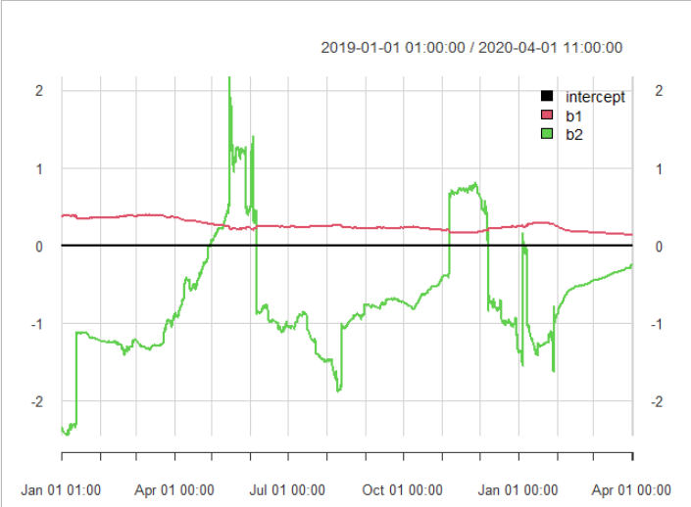 | 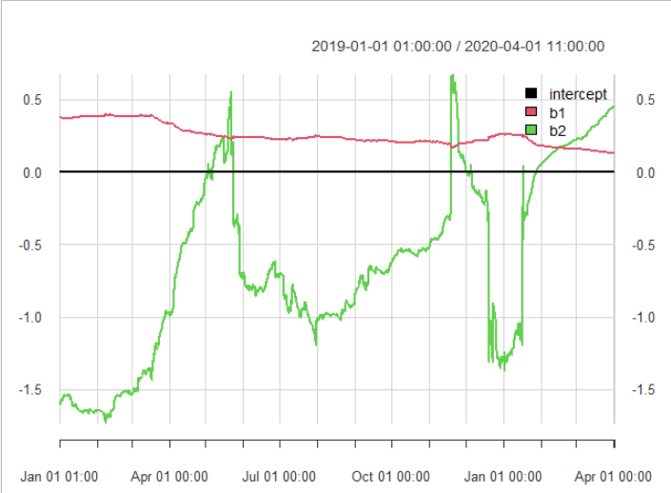
Cryptocurrency JPY market | Cryptocurrency KRW market
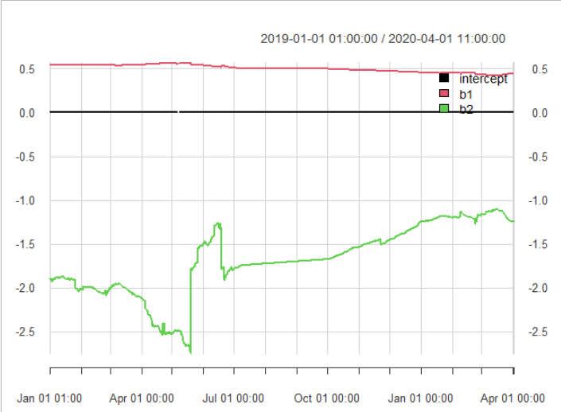 | 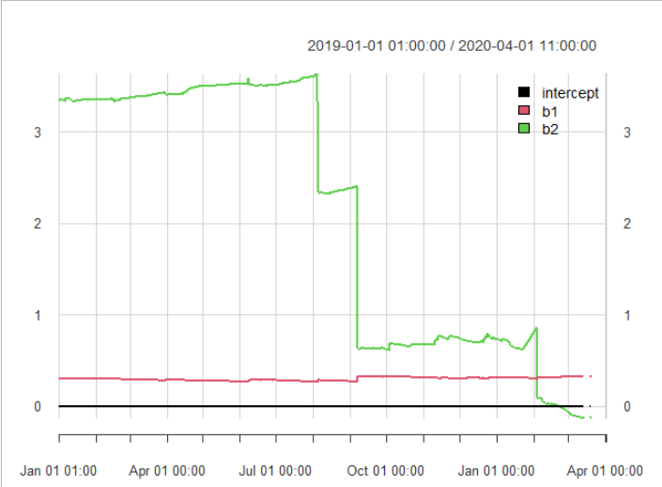

Figure 3. Conditional Herding on up/down market days, cryptocurrency USD market (time-varying regression)
Cryptocurrency USD market | Cryptocurrency Euro market
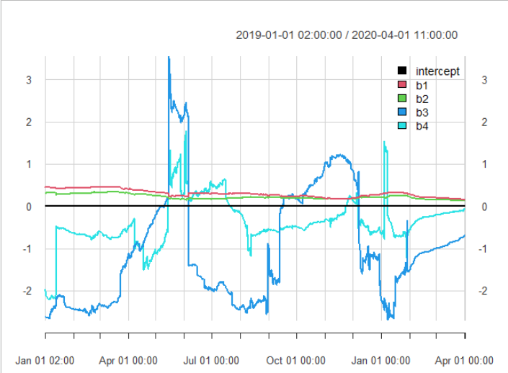 | 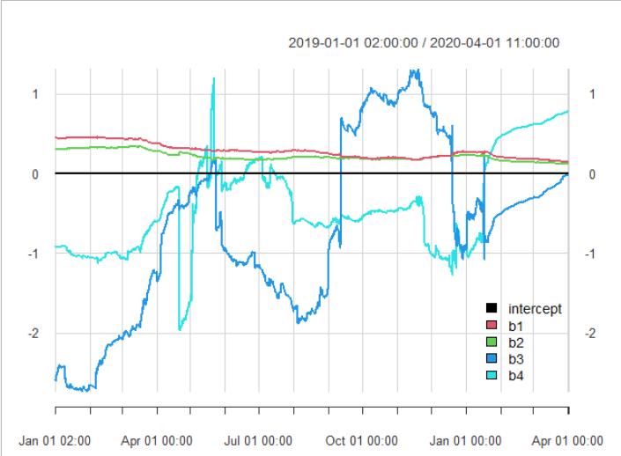
Cryptocurrency JPY market | Cryptocurrency KRW market
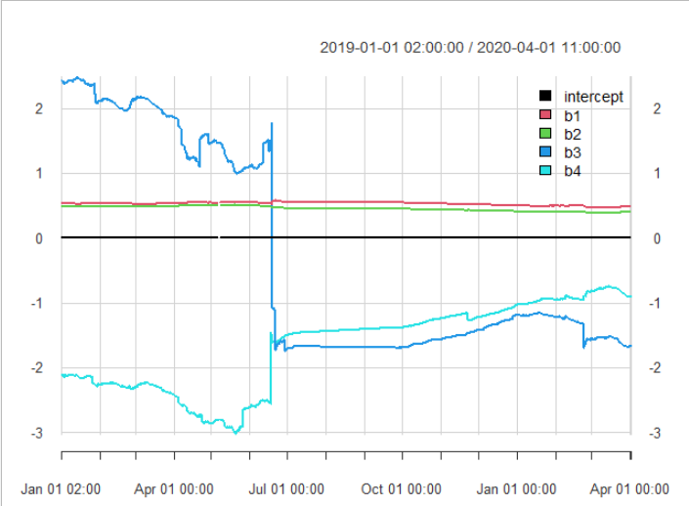 | 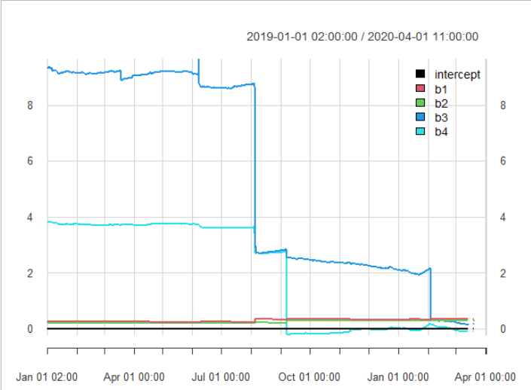
Figure 4. β2 coefficients of unconditional herding in 2020 for the selected cryptocurrency markets
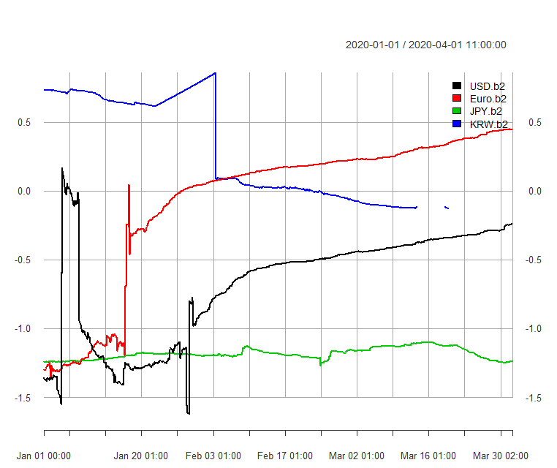

Figure 5. Coefficients of Conditional herding on up and down-market days (β3) in 2020 for the selected cryptocurrency markets
Up market days | Down market days
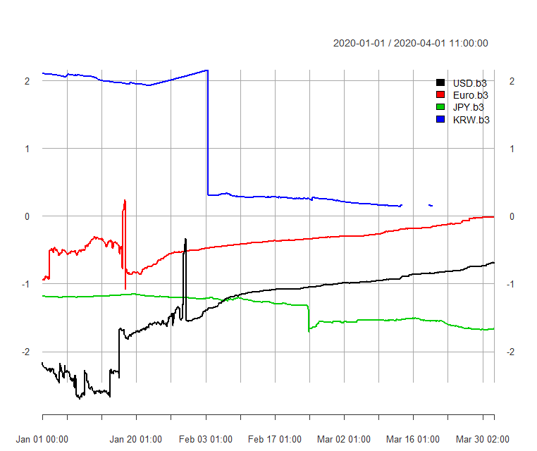 | 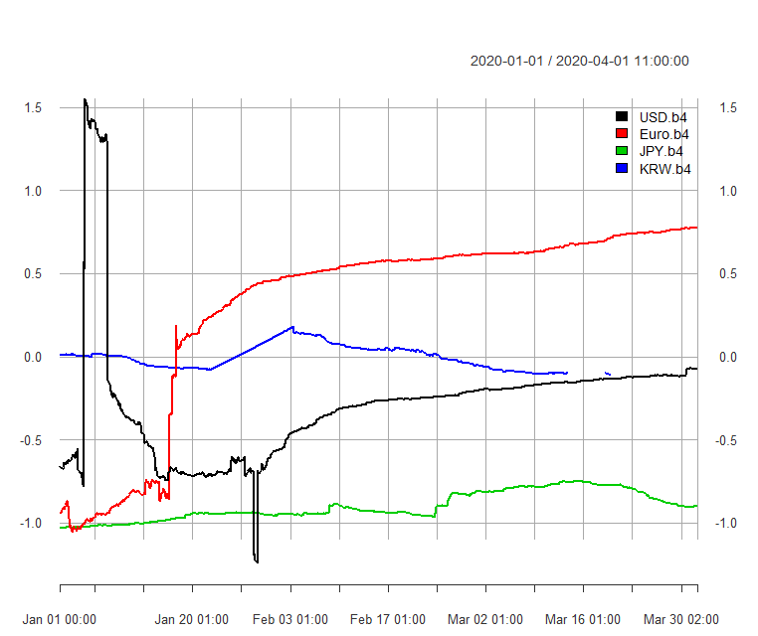

Figure 6. TV correlation of the unconditional herding (β2), Time-varying copula model.
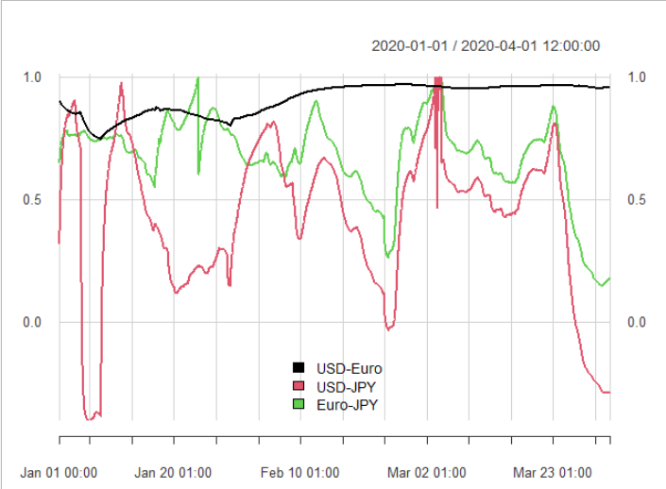

Appendix
Cryptocurrency USD market

Figure A1. Close prices in the cryptocurrency USD market
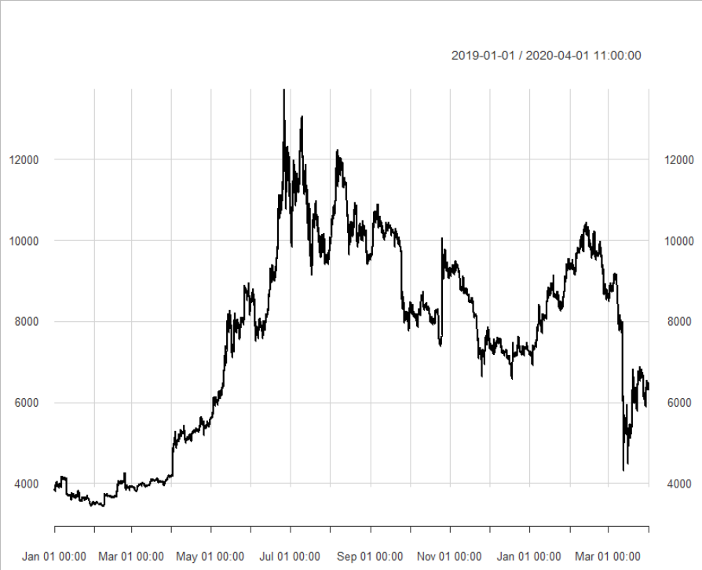
Panel a. BTC-USD close prices.
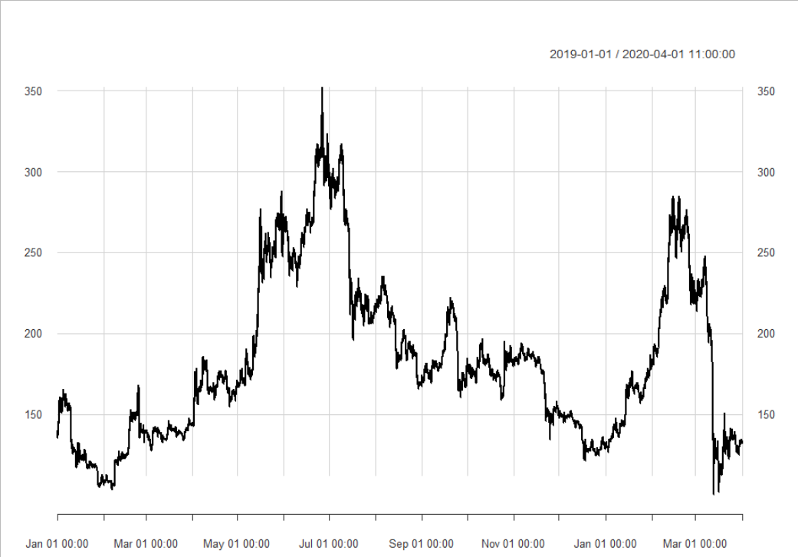
Panel b. ETH -USD close prices.
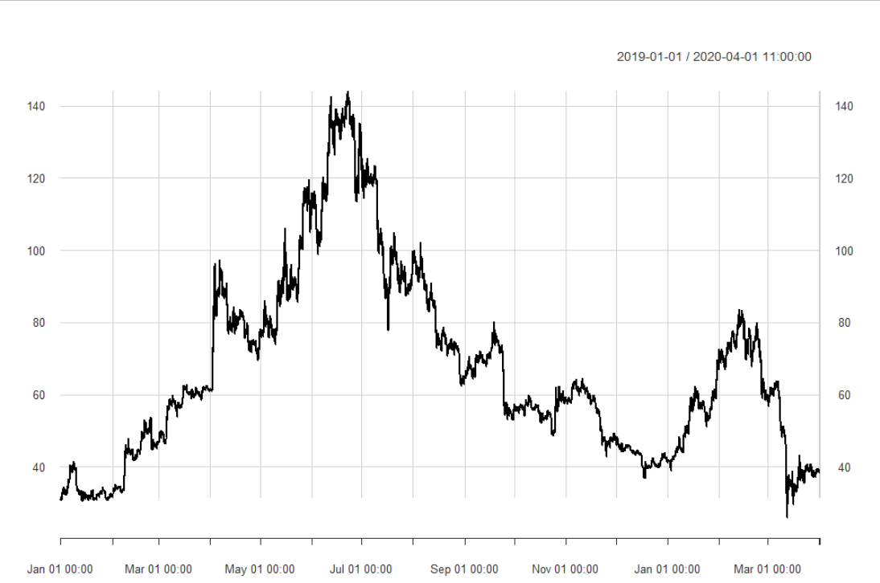
Panel b. LTC-USD close prices.

Table A1. Descriptive statistics of closing prices in the cryptocurrency USD market
 | min | max | range | median | mean | SE mean | CI mean 0.95 | Variance | Std dev
Bitfinex BTCUSD | 3430.10 | 13728.00 | 10297.90 | 7995.82 | 7575.61 | 23.36 | 45.80 | 5979661.61 | 2445.33
Bitfinex ETHUSD | 100.14 | 352.03 | 251.89 | 174.38 | 182.53 | 0.47 | 0.93 | 2468.80 | 49.69
Bitfinex LTCUSD | 25.87 | 143.98 | 118.11 | 60.96 | 67.07 | 0.25 | 0.48 | 667.85 | 25.84
Bitstamp BTCUSD | 3430.10 | 13728.00 | 10297.90 | 7995.82 | 7575.61 | 23.36 | 45.80 | 5979661.61 | 2445.33
Bitstamp ETHUSD | 100.14 | 352.03 | 251.89 | 174.38 | 182.53 | 0.47 | 0.93 | 2468.80 | 49.69
Bitstamp LTCUSD | 25.87 | 143.98 | 118.11 | 60.96 | 67.07 | 0.25 | 0.48 | 667.85 | 25.84
Coinbase BTCUSD | 3430.10 | 13728.00 | 10297.90 | 7995.82 | 7575.61 | 23.36 | 45.80 | 5979661.61 | 2445.33
Coinbase ETHUSD | 100.14 | 352.03 | 251.89 | 174.38 | 182.53 | 0.47 | 0.93 | 2468.80 | 49.69
Coinbase LTCUSD | 25.87 | 143.98 | 118.11 | 60.96 | 67.07 | 0.25 | 0.48 | 667.85 | 25.84
Kraken BTCUSD | 3430.10 | 13728.00 | 10297.90 | 7995.82 | 7575.61 | 23.36 | 45.80 | 5979661.61 | 2445.33
Kraken ETHUSD | 100.14 | 352.03 | 251.89 | 174.38 | 182.53 | 0.47 | 0.93 | 2468.80 | 49.69
Kraken LTCUSD | 25.87 | 143.98 | 118.11 | 60.96 | 67.07 | 0.25 | 0.48 | 667.85 | 25.84

Table A2. Descriptive statistics, returns, cryptocurrency USD market
 | min | max | range | median | mean | SE mean | CI mean 0.95 | Variance | Std deviation
Bitfinex BTCUSD | -0.17881 | 0.182841 | 0.361647 | 4.26E-05 | 4.52E-05 | 7.95E-05 | 0.000156 | 6.92E-05 | 0.008317
Bitfinex ETHUSD | -0.23083 | 0.162843 | 0.39367 | 0 | -2.98E-06 | 9.41E-05 | 0.000184 | 9.69E-05 | 0.009845
Bitfinex LTCUSD | -0.20449 | 0.175404 | 0.379899 | 0 | 1.94E-05 | 0.000105 | 0.000206 | 0.000121 | 0.011016
Bitstamp BTCUSD | -0.17881 | 0.182841 | 0.361647 | 4.26E-05 | 4.52E-05 | 7.95E-05 | 0.000156 | 6.92E-05 | 0.008317
Bitstamp ETHUSD | -0.23083 | 0.162843 | 0.39367 | 0 | -2.98E-06 | 9.41E-05 | 0.000184 | 9.69E-05 | 0.009845
Bitstamp LTCUSD | -0.20449 | 0.175404 | 0.379899 | 0 | 1.94E-05 | 0.000105 | 0.000206 | 0.000121 | 0.011016
Coinbase BTCUSD | -0.17881 | 0.182841 | 0.361647 | 4.26E-05 | 4.52E-05 | 7.95E-05 | 0.000156 | 6.92E-05 | 0.008317
Coinbase ETHUSD | -0.23083 | 0.162843 | 0.39367 | 0 | -2.98E-06 | 9.41E-05 | 0.000184 | 9.69E-05 | 0.009845
Coinbase LTCUSD | -0.20449 | 0.175404 | 0.379899 | 0 | 1.94E-05 | 0.000105 | 0.000206 | 0.000121 | 0.011016
Kraken BTCUSD | -0.17881 | 0.182841 | 0.361647 | 4.26E-05 | 4.52E-05 | 7.95E-05 | 0.000156 | 6.92E-05 | 0.008317
Kraken ETHUSD | -0.23083 | 0.162843 | 0.39367 | 0 | -2.98E-06 | 9.41E-05 | 0.000184 | 9.69E-05 | 0.009845
Kraken LTCUSD | -0.20449 | 0.175404 | 0.379899 | 0 | 1.94E-05 | 0.000105 | 0.000206 | 0.000121 | 0.011016

Note: Tables A1 presents general statistics for the raw data on the selected cryptocurrency USD markets. Tables A2 presents general statistics for the first-differenced natural logarithm for the same variables.

Figure A2. Regimes in the USD cryptocurrency market, Markov-Regime Switching regression
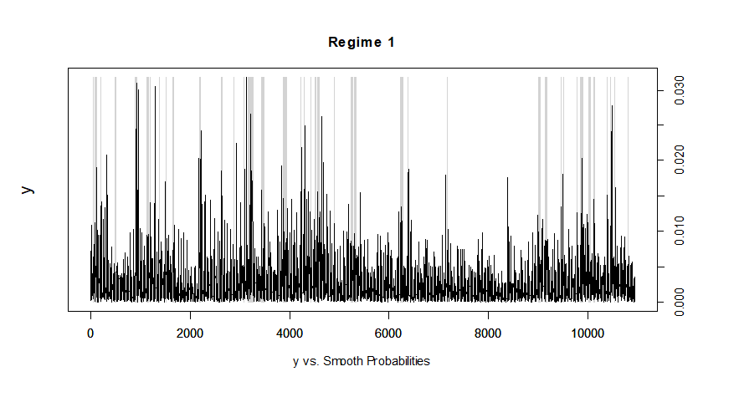
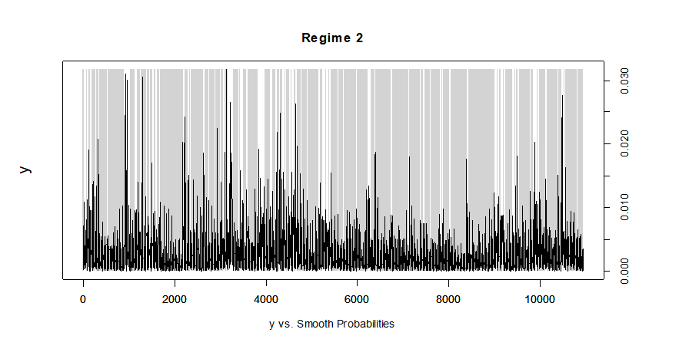
Note: The Markov-Regime Switching regression is estimated using the Expectation-Maximization algorithm. Coefficients on β2 are negative and significant at 1% for two regimes indicating herding (Regime 1 β2 = -1.26, Regime 2, β2 =-0.57), while β1s are positive. Residual standard errors - Regime 1: 0.002, Regime 2: 0.0008. The received transition probabilities are the following:

 | Regime 1 | Regime 2
Regime 1 | 0.6102499 | 0.118657
Regime 2 | 0.3897501 | 0.881343

Figure A3. Quantile regression of unconditional herding in the USD cryptocurrency market
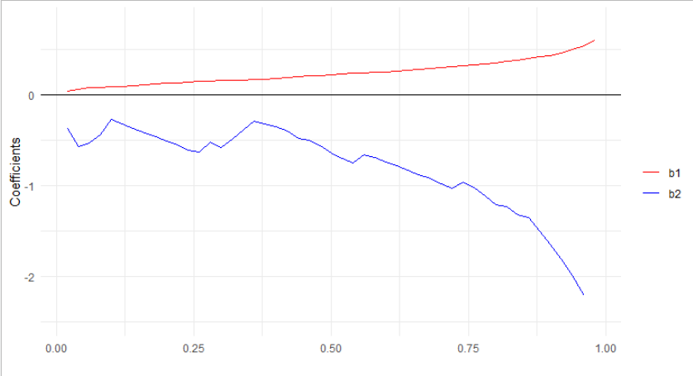
Note: Figure A3 depicts quantile regression (Sim and Zhou 2015) results for unconditional herding for the USD cryptocurrency market. Coefficients and quantiles appear on the y and x axis, respectively. (Eq. 5-6). Lower herding in the USD cryptocurrency market is observed in the lower quantiles of the average absolute market return of the selected actively traded cryptocurrencies. This implies higher levels of unconditional herding behavior at higher quantiles of return variation for this market.

Figure A4. Quantile regression of herding, conditional on market performance in the USD cryptocurrency market
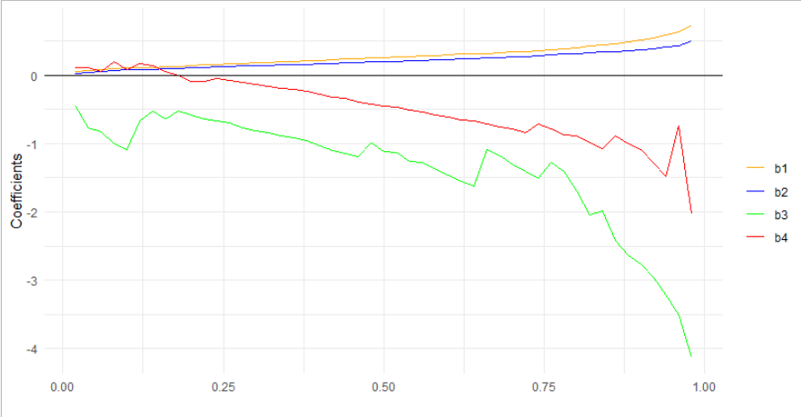
Note: Figure A4 depicts quantile regression (Sim and Zhou 2015) results for herding conditional on up-down market days for the USD cryptocurrency market. Coefficients and quantiles appear on the y and x axis, respectively. (Eq. 5-6). Lower herding in the USD cryptocurrency market is observed in the lower quantiles of the average absolute market return of the selected actively traded cryptocurrencies. This implies higher levels of conditional herding behavior at higher quantiles of return variation for this market during up-market days.

Cryptocurrency Euro market

Figure A5. Close price dynamics in the cryptocurrency euro market
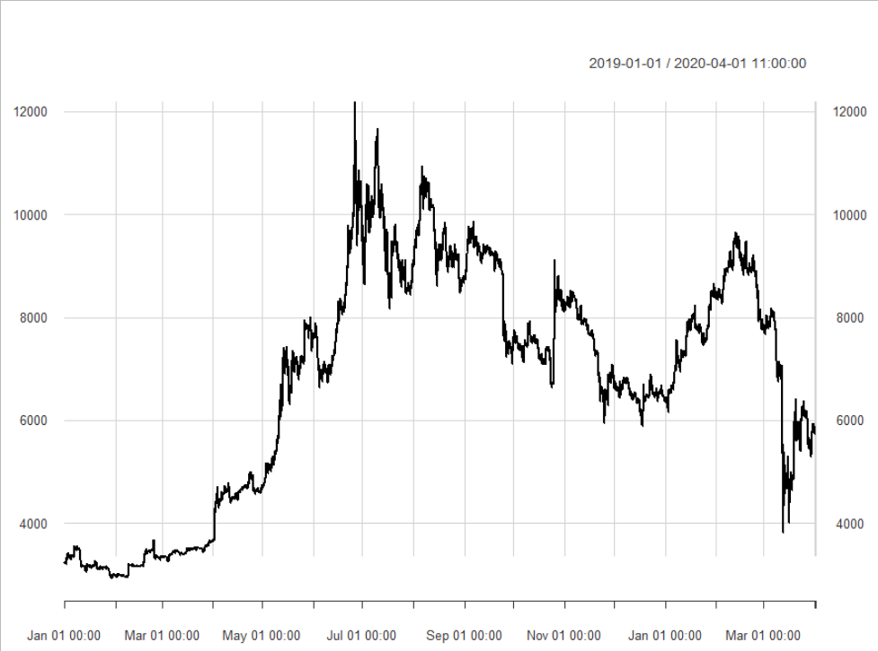
Panel a. BTC-Euro close prices.
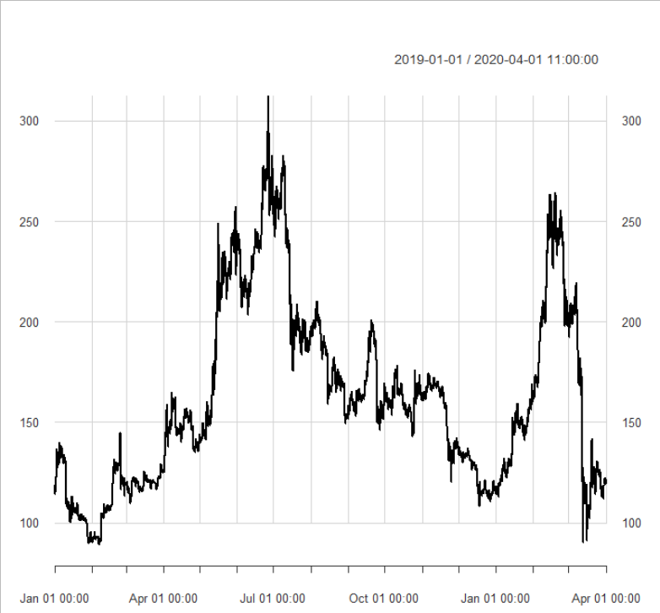
Panel b. ETH-Euro close prices.
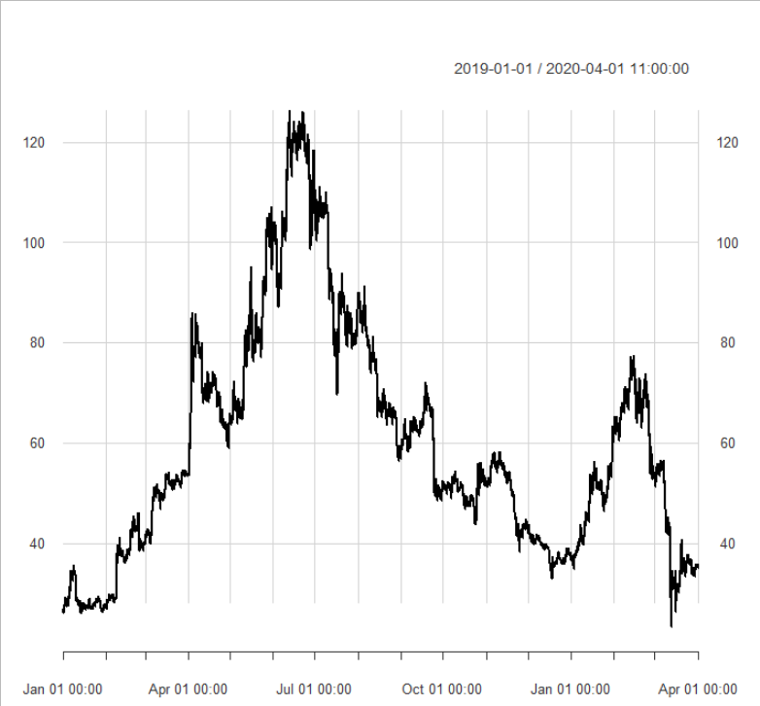
Panel c. LTC-Euro close prices.

Table A4. Descriptive statistics of close prices, the cryptocurrency euro market
 | min | max | range | median | mean | SE mean | CI mean 0.95 | Variance | Std dev
Bitstamp BTCEUR | 2934.24 | 12176.5 | 9242.26 | 7168.235 | 6774.499 | 21.5055 | 42.1546586 | 5066076.21 | 2250.795
Bitstamp ETHEUR | 89.11 | 312.31 | 223.2 | 155.945 | 162.7474 | 0.433397 | 0.849537235 | 2057.52634 | 45.35996
Bitstamp LTCEUR | 23.25 | 126.21 | 102.96 | 53.89 | 59.74098 | 0.220237 | 0.431704371 | 531.316689 | 23.05031
Exmo BTCEUR | 2934.24 | 12176.5 | 9242.26 | 7168.235 | 6774.499 | 21.5055 | 42.1546586 | 5066076.21 | 2250.795
Exmo ETHEUR | 89.11 | 312.31 | 223.2 | 155.945 | 162.7474 | 0.433397 | 0.849537235 | 2057.52634 | 45.35996
Exmo LTCEUR | 23.25 | 126.21 | 102.96 | 53.89 | 59.74098 | 0.220237 | 0.431704371 | 531.316689 | 23.05031
Kraken BTCEUR | 2934.24 | 12176.5 | 9242.26 | 7168.235 | 6774.499 | 21.5055 | 42.1546586 | 5066076.21 | 2250.795
Kraken ETHEUR | 89.11 | 312.31 | 223.2 | 155.945 | 162.7474 | 0.433397 | 0.849537235 | 2057.52634 | 45.35996
Kraken LTCEUR | 23.25 | 126.21 | 102.96 | 53.89 | 59.74098 | 0.220237 | 0.431704371 | 531.316689 | 23.05031

Table A5. Descriptive statistics of returns, the cryptocurrency euro market
 | min | max | range | median | mean | SE mean | CI mean 0.95 | Variance | Std dev
Bitstamp BTCEUR | -0.17785 | 0.165688 | 0.343536 | 9.09E-05 | 5.23E-05 | 8.14E-05 | 0.000159 | 7.25E-05 | 0.008515
Bitstamp ETHEUR | -0.18947 | 0.168422 | 0.35789 | 0 | 3.86E-06 | 9.59E-05 | 0.000188 | 0.000101 | 0.010036
Bitstamp LTCEUR | -0.1404 | 0.171873 | 0.312276 | 0 | 2.64E-05 | 0.000107 | 0.00021 | 0.000125 | 0.011197
Exmo BTCEUR | -0.17785 | 0.165688 | 0.343536 | 9.09E-05 | 5.23E-05 | 8.14E-05 | 0.000159 | 7.25E-05 | 0.008515
Exmo ETHEUR | -0.18947 | 0.168422 | 0.35789 | 0 | 3.86E-06 | 9.59E-05 | 0.000188 | 0.000101 | 0.010036
Exmo LTCEUR | -0.1404 | 0.171873 | 0.312276 | 0 | 2.64E-05 | 0.000107 | 0.00021 | 0.000125 | 0.011197
Kraken BTCEUR | -0.17785 | 0.165688 | 0.343536 | 9.09E-05 | 5.23E-05 | 8.14E-05 | 0.000159 | 7.25E-05 | 0.008515
Kraken ETHEUR | -0.18947 | 0.168422 | 0.35789 | 0 | 3.86E-06 | 9.59E-05 | 0.000188 | 0.000101 | 0.010036
Kraken LTCEUR | -0.1404 | 0.171873 | 0.312276 | 0 | 2.64E-05 | 0.000107 | 0.00021 | 0.000125 | 0.011197

Note: Tables A4 presents general statistics for the raw data on the selected cryptocurrency euro market. Tables A2 presents general statistics for the first-differenced natural logarithm for the same variables.

Figure A6. Regimes of the cryptocurrency euro market, Markov regime switching model
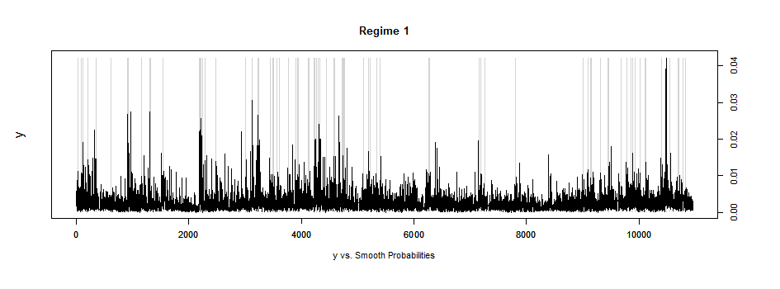
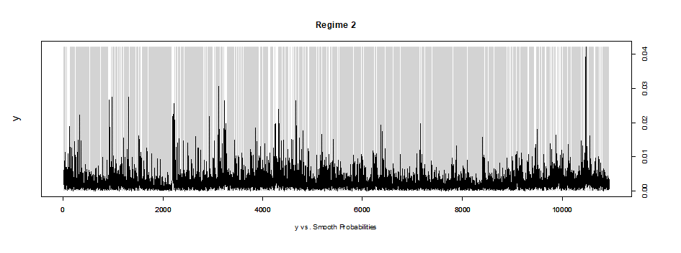
Note: The Markov-Regime Switching regression is estimated using the Expectation-Maximization algorithm Coefficients on β2 are negative and significant at 1% for two regimes indicating herding (Regime 1 β2 = -1.0552, Regime 2, β2 =-1.8669), while β1s are positive. Residual standard errors - Regime 1: 0.0027, Regime 2: 0.00097. The received transition probabilities are the following:

 | Regime 1 | Regime 2
Regime 1 | 0.6125029 | 0.1070718
Regime 2 | 0.3874971 | 0.8929282

Figure A7. Quantile regression of unconditional herding in the euro cryptocurrency market
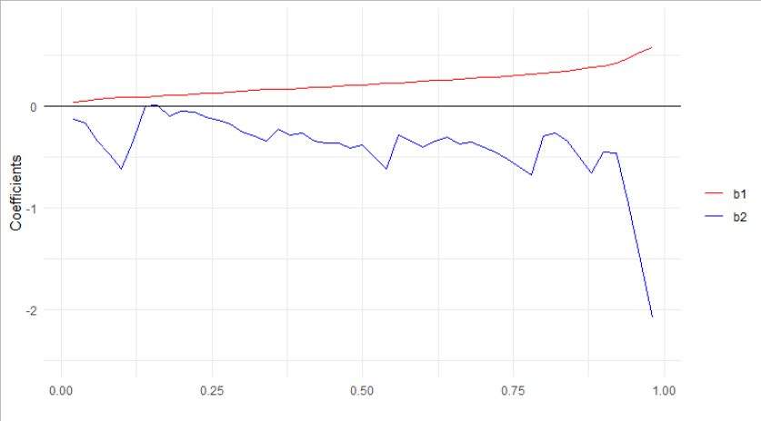
Note: Figure A7 depicts quantile regression (Sim and Zhou 2015) results for unconditional herding for the euro cryptocurrency market. Coefficients and quantiles appear on the y and x axis, respectively. (Eq. 5-6). On average, lower herding in the euro cryptocurrency market is observed in the lower quantiles of the average absolute market return of the selected actively traded cryptocurrencies. This implies higher levels of unconditional herding behavior at higher quantiles of return variation for this market.

Figure A8. Quantile regression of herding, conditional on market performance (up/down market days) in the euro cryptocurrency market
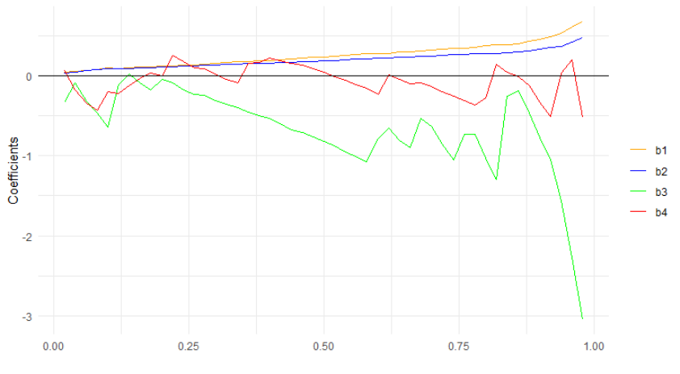
Note: Figure A8 depicts quantile regression (Sim and Zhou 2015) results for herding conditional on up-down market days for the euro cryptocurrency market. Coefficients and quantiles appear on the y and x axis, respectively. (Eq. 5-6). Lower herding in the euro cryptocurrency market is observed in the lower quantiles of the average absolute market return of the selected actively traded cryptocurrencies. This implies higher levels of conditional herding behavior at higher quantiles of return variation for this market during up-market days but this remains much less sensitive compared to down-market days.

Cryptocurrency JPY market

Figure A9. Close prices in the cryptocurrency JPY market
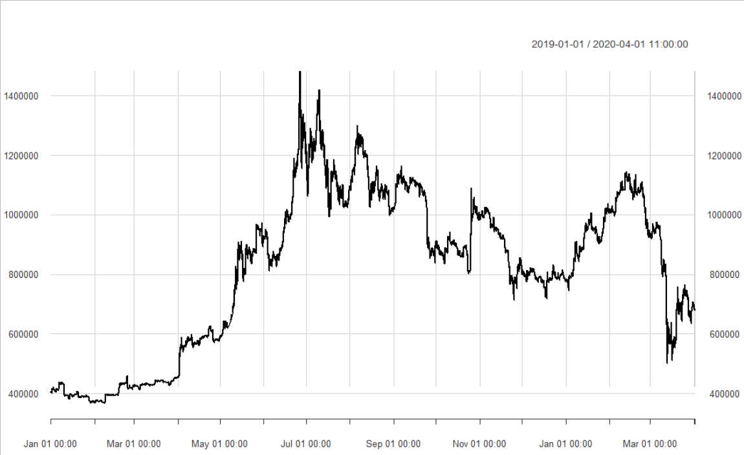
Panel a. BTC-JPY close prices
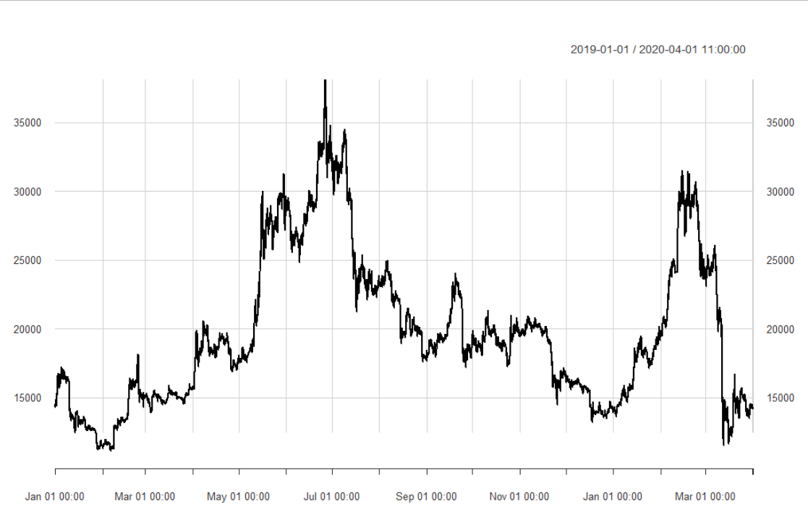
Panel b. LTC-JPY close prices
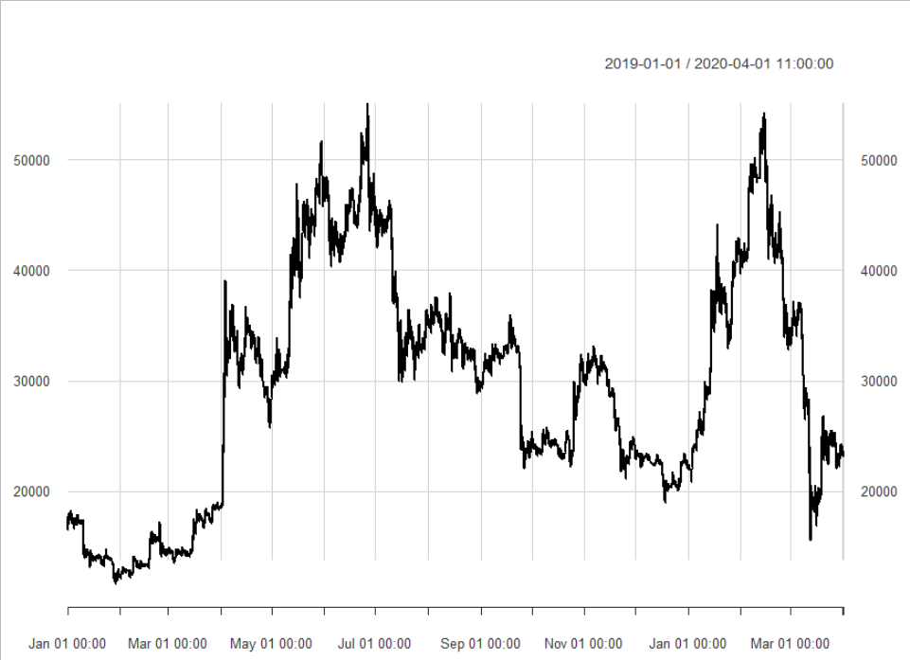
Panel c. BCH-JPY close prices
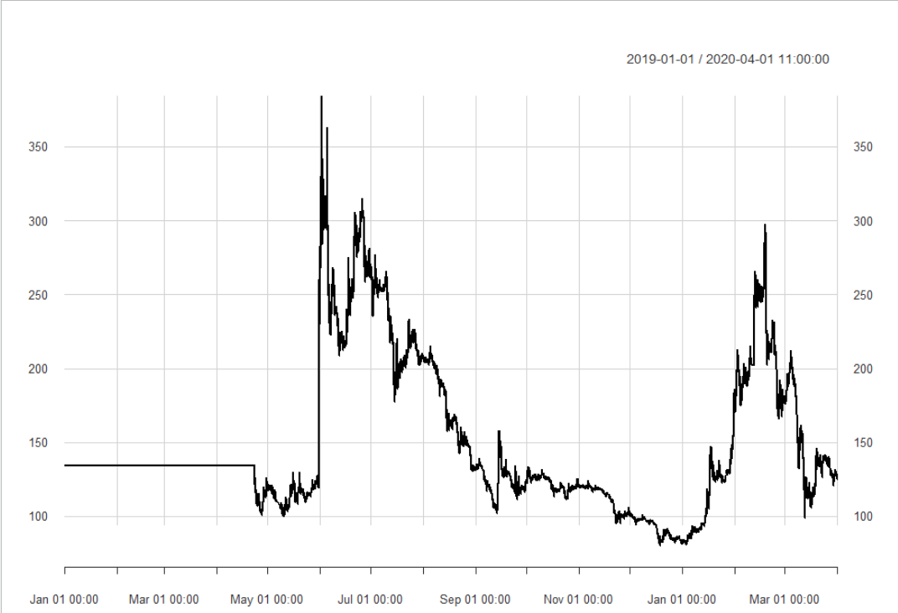
Panel d. MONA-JPY close prices
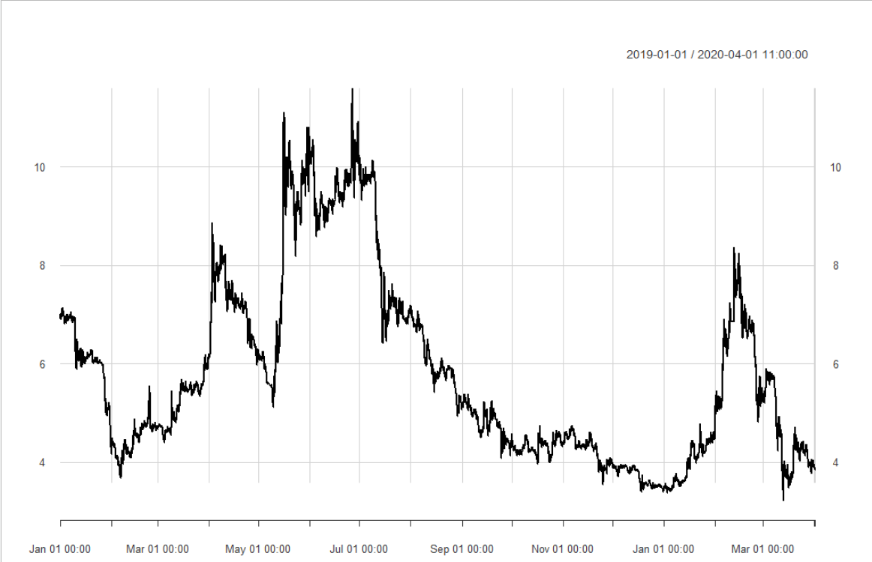
Panel d. XEM -JPY close prices.
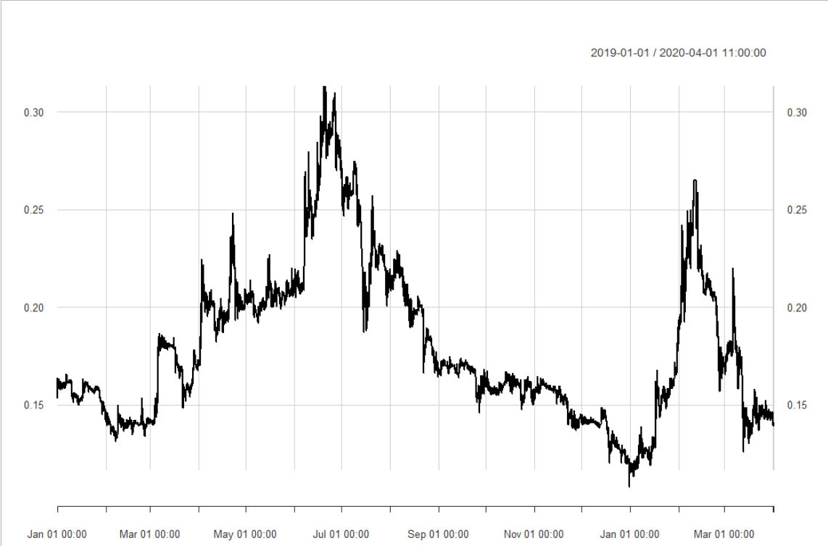
Panel e. ZAIF -JPY close prices.

Table A6. Descriptive statistics of close prices, cryptocurrency JPY market
 | min | max | range | median | mean | SE.mean | CI.mean.0.95 | Variance | Std dev
Zaif BCH | 11555 | 55125 | 43570 | 30445 | 29422.07 | 100.0983 | 196.2108375 | 109244448 | 10452.01
Zaif BTC | 367400 | 1482000 | 1114600 | 870425 | 820175 | 2527.84 | 4955.025301 | 6.967E+10 | 263950.6
Zaif ETH | 11110 | 38100 | 26990 | 18850 | 19750.4 | 52.05439 | 102.0360519 | 29543414.2 | 5435.385
Zaif MONA | 80 | 384 | 304 | 134 | 148.5429 | 0.482876 | 0.946524395 | 2542.24274 | 50.42066
Zaif XEM | 3.22 | 11.59 | 8.37 | 5.259 | 5.785543 | 0.017922 | 0.035130401 | 3.50202799 | 1.871371
Zaif ZAIF | 0.1078 | 0.3133 | 0.2055 | 0.1679 | 0.179261 | 0.000378 | 0.000741413 | 0.00155982 | 0.039495

Table A7. Descriptive statistics of returns, cryptocurrency JPY market
 | min | max | range | median | mean | SE.mean | CI.mean.0.95 | Variance | Std dev
Zaif BCH | -0.1876 | 0.15286 | 0.340458 | 0 | 3.15E-05 | 0.000131 | 0.000258 | 0.000188 | 0.013727
Zaif BTC | -0.16145 | 0.141362 | 0.302812 | 5.06E-05 | 4.73E-05 | 7.74E-05 | 0.000152 | 6.53E-05 | 0.00808
Zaif ETH | -0.18084 | 0.114105 | 0.294942 | 0 | -1.41E-06 | 9.65E-05 | 0.000189 | 0.000102 | 0.01008
Zaif MONA | -0.24256 | 0.343574 | 0.586136 | 0 | -5.72E-06 | 0.000128 | 0.000251 | 0.000179 | 0.013379
Zaif XEM | -0.0831 | 0.155193 | 0.238289 | 0 | -5.35E-05 | 9.89E-05 | 0.000194 | 0.000107 | 0.010328
Zaif ZAIF | -0.10367 | 0.219629 | 0.323302 | 0 | -8.54E-06 | 0.000133 | 0.000262 | 0.000194 | 0.013934

Note: Tables A6 presents general statistics for the raw data on the selected cryptocurrency JPY market. Tables A7 presents general statistics for the first-differenced natural logarithm for the same variables.

Figure A10. Regimes in the JPY cryptocurrency market, Markov-Switching model
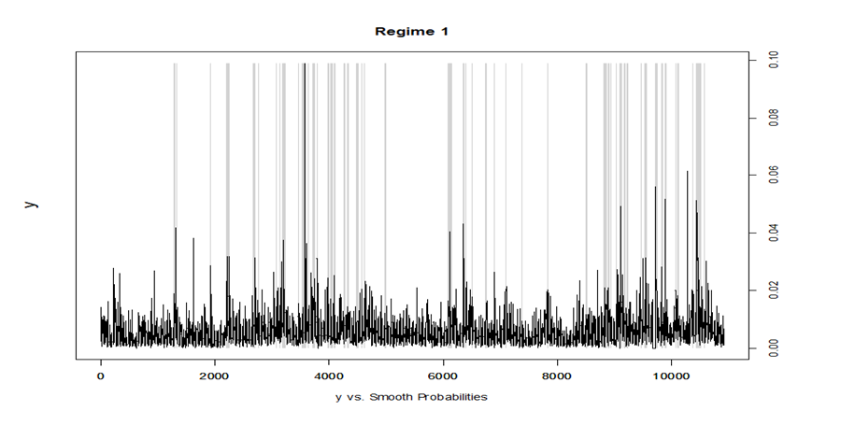
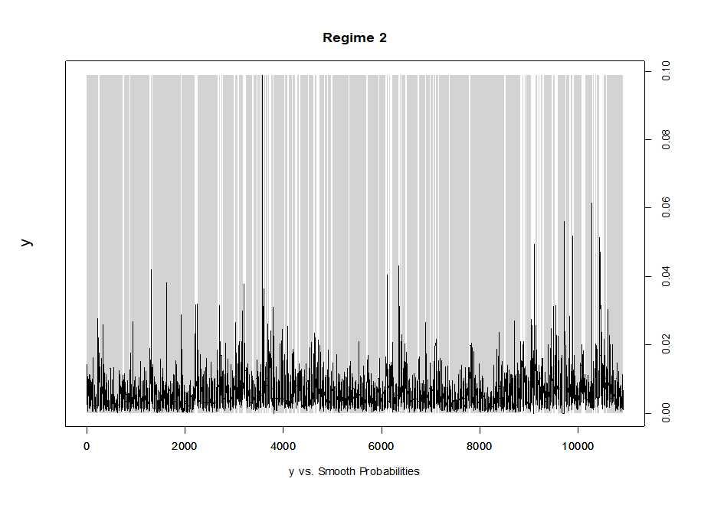
Note: The Markov-Regime Switching regression is estimated using the Expectation-Maximization algorithm. Coefficients on β2 are negative and significant at 1% for two regimes indicating herding (Regime 1 β2 = -1.367, Regime 2, β2 =-11.7047), while β1s are positive. Residual standard errors - Regime 1: 0.005, Regime 2: 0.002. The received transition probabilities are the following:

 | Regime 1 | Regime 2
Regime 1 | 0.7556031 | 0.06703607
Regime 2 | 0.2443969 | 0.93296393

Figure A11. Quantile regression of unconditional herding in the JPY cryptocurrency market
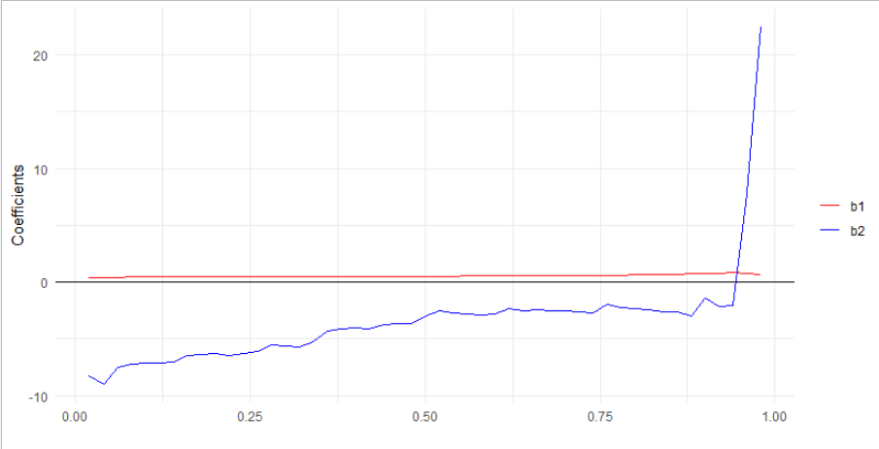
Note: Figure A11 depicts quantile regression (Sim and Zhou 2015) results for unconditional herding for the JPY cryptocurrency market. Coefficients and quantiles appear on the y and x axis, respectively. (Eq. 5-6). Lower herding in the JPY cryptocurrency market is observed in the higher quantiles of the average absolute market return of the selected actively traded cryptocurrencies. This implies lower levels of unconditional herding at higher quantiles of return variation in the market.

Figure A12. Quantile regression of herding, conditional on market performance (up/down market days) in the JPY cryptocurrency market
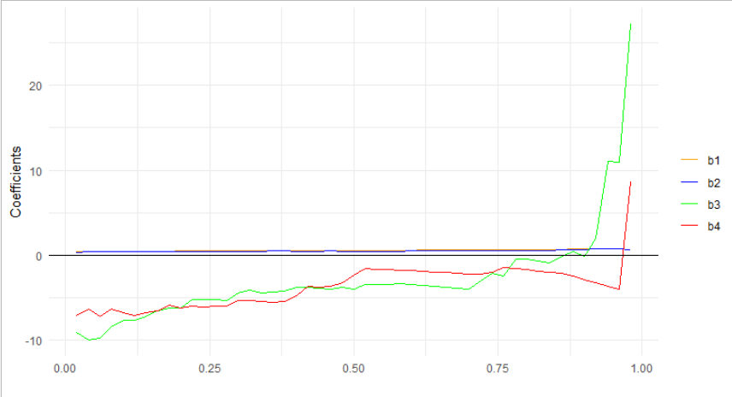
Note: Figure A12 depicts quantile regression (Sim and Zhou 2015) results for herding conditional on up-down market days for the JPY cryptocurrency market. Coefficients and quantiles appear on the y and x axis, respectively. (Eq. 5-6). Higher herding in the JPY cryptocurrency market is observed in the lower quantiles of the average absolute market return of the selected actively traded cryptocurrencies. This implies lower levels of conditional herding behavior at higher quantiles of return variation regardless of market days.

Cryptocurrency KRW market

Figure A13. Close prices in the cryptocurrency KRW market
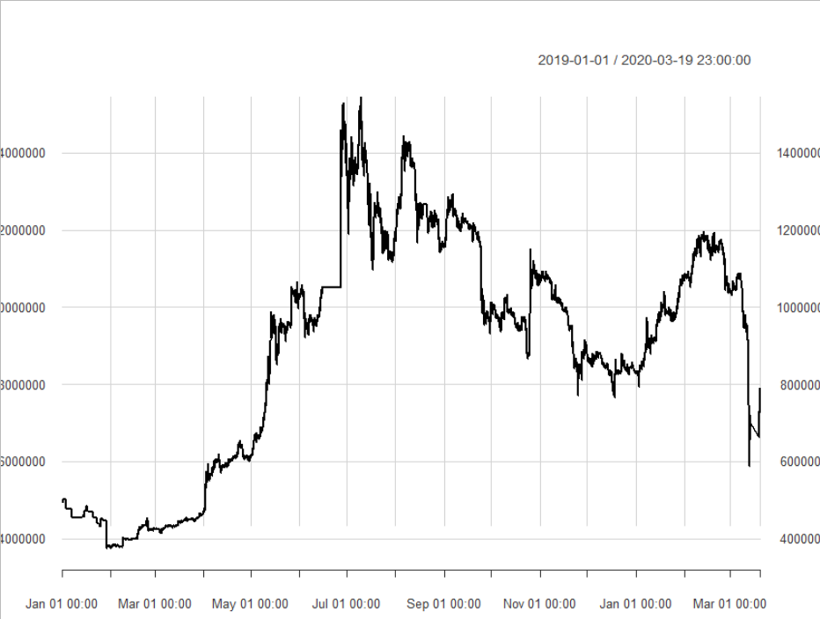
Panel a. BTC-KRW close prices.
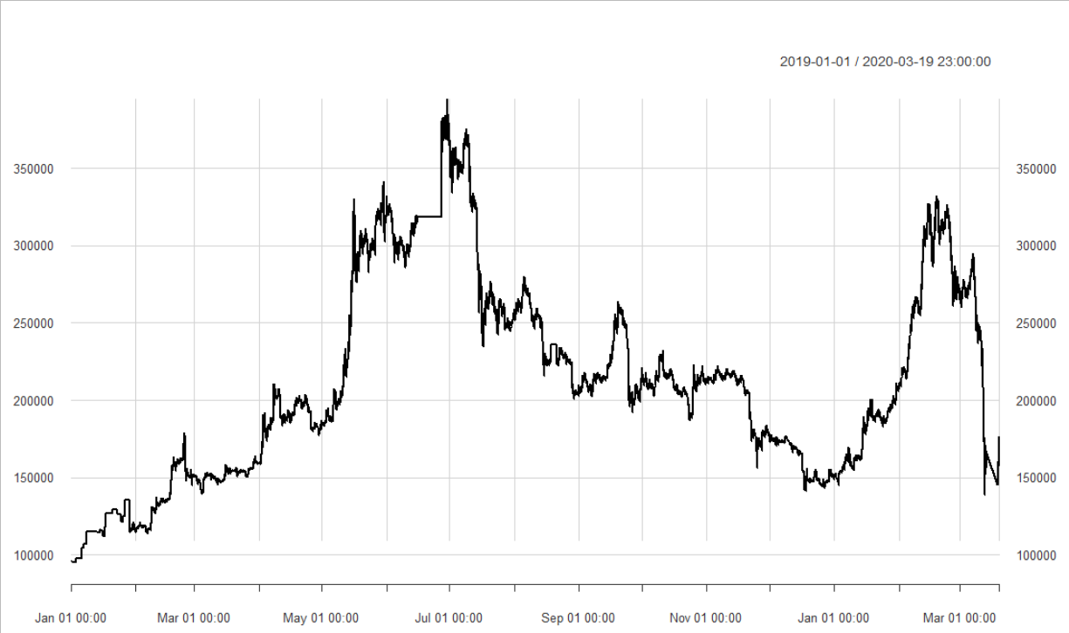
Panel b. ETH-KRW close prices.
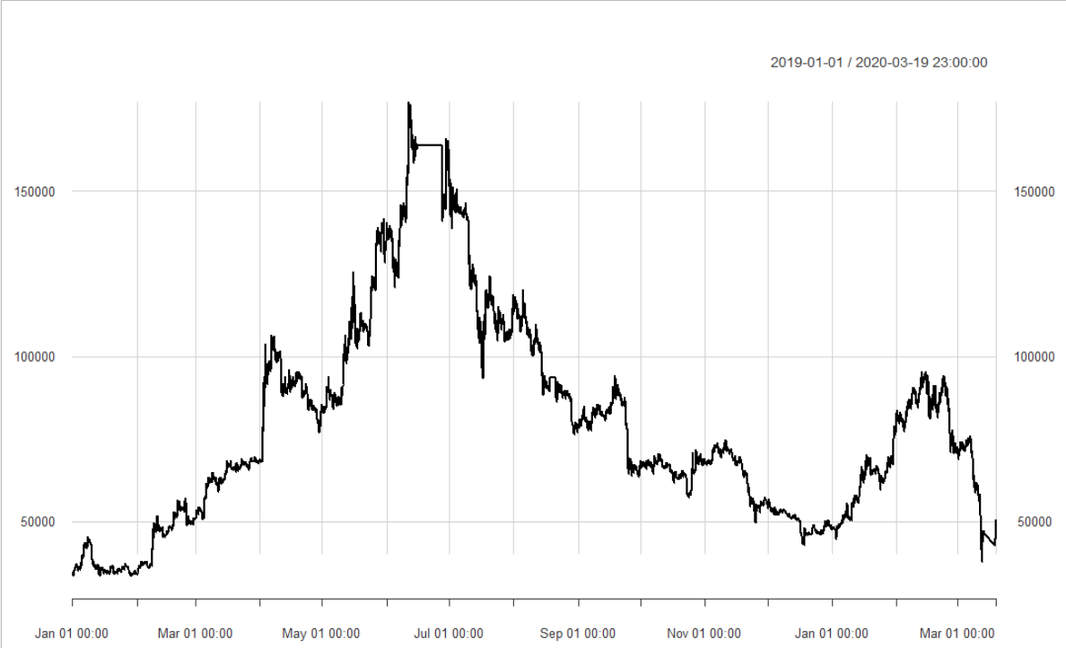
Panel c. LTC-KRW close prices.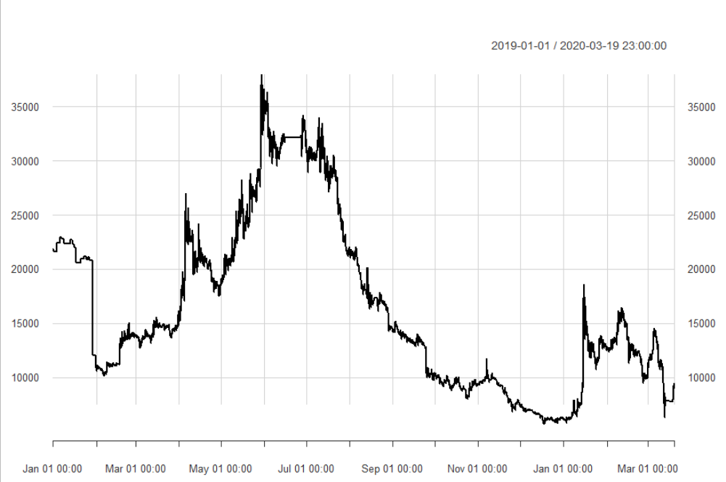
Panel d. BTG-KRW close prices.

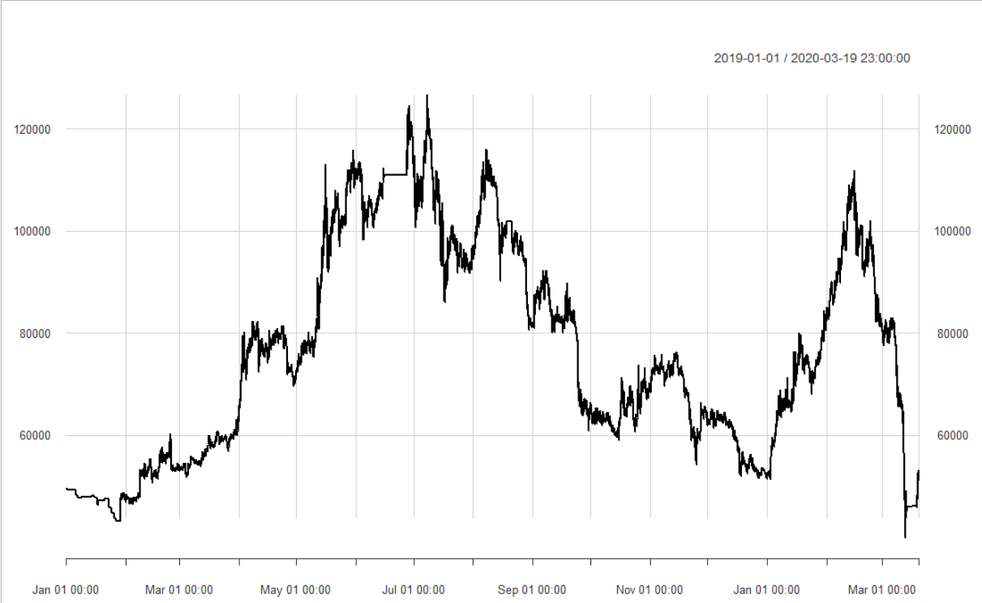
Panel e. XMR -KRW close prices.

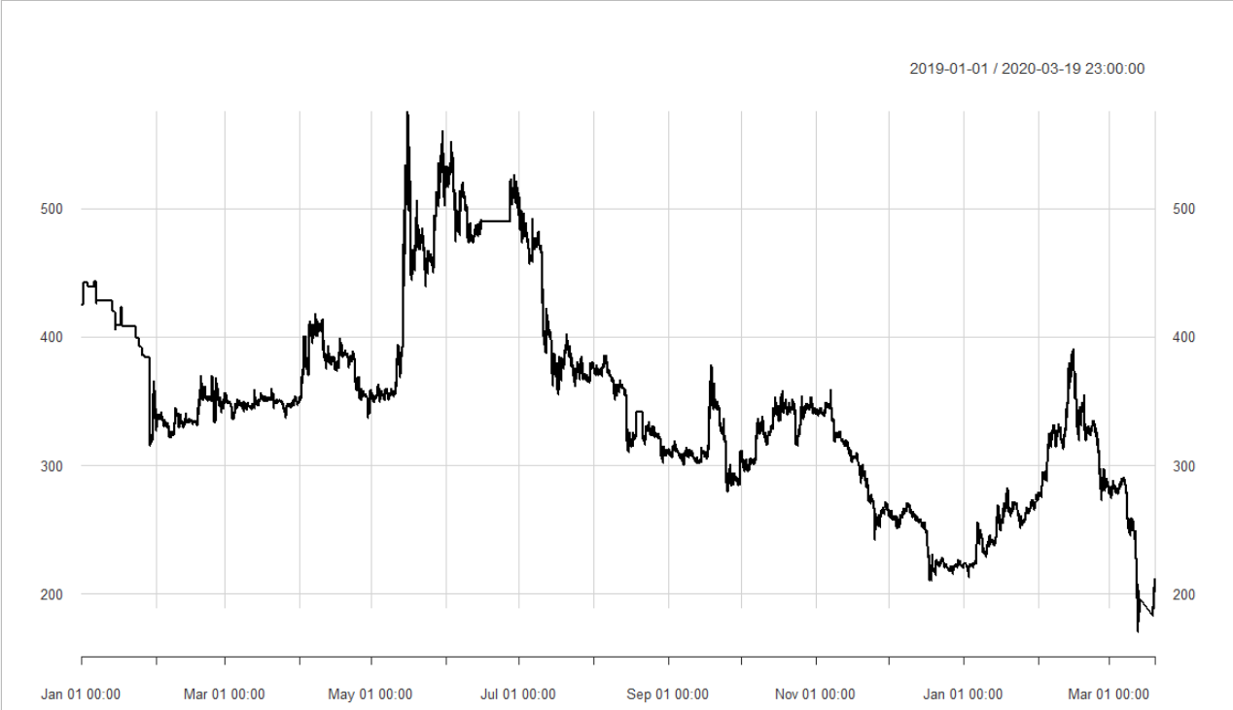
Panel f. XRP -KRW close prices.

Table A9. Descriptive statistics of close prices, Cryptocurrency KRW market
 | min | max | range | median | mean | SE.mean | CI.mean.0.95 | Variance | Std dev
Bithumb BTC | 3745000 | 15448000 | 11703000 | 9610000 | 8924713 | 29167.3 | 57173.43 | 8.9574E+12 | 2992883
Bithumb BTG | 5705 | 37970 | 32265 | 14030 | 16428.51 | 75.59833 | 148.187036 | 60174363.2 | 7757.214
Bithumb ETH | 95200 | 394500 | 299300 | 206000 | 212805.2 | 623.4706 | 1222.120369 | 4092786067 | 63974.89
Bithumb LTC | 33490 | 177000 | 143510 | 71000 | 79812.94 | 311.5646 | 610.7256493 | 1022076492 | 31969.93
Bithumb XMR | 40000 | 126600 | 86600 | 73800 | 76680.7 | 199.4572 | 390.9738238 | 418876931 | 20466.48
Bithumb XRP | 170.5 | 575 | 404.5 | 344 | 349.0285 | 0.723149 | 1.417509146 | 5506.08383 | 74.20299

Table A10. Descriptive statistics of returns, cryptocurrency KRW market
 | min | max | range | median | mean | SE.mean | CI.mean.0.95 | Variance | Std dev
Bithumb BTC | -0.16496 | 0.323085 | 0.488044 | 0 | 4.31E-05 | 7.40E-05 | 0.000145 | 5.77E-05 | 0.007598
Bithumb BTG | -0.5479 | 0.237547 | 0.785447 | 0 | -8.20E-05 | 0.000141 | 0.000275 | 0.000208 | 0.014417
Bithumb ETH | -0.16105 | 0.177338 | 0.338385 | 0 | 5.42E-05 | 8.43E-05 | 0.000165 | 7.49E-05 | 0.008654
Bithumb LTC | -0.12268 | 0.107128 | 0.22981 | 0 | 3.38E-05 | 9.87E-05 | 0.000193 | 0.000102 | 0.010123
Bithumb XMR | -0.16084 | 0.196514 | 0.357358 | 0 | 3.48E-06 | 9.43E-05 | 0.000185 | 9.35E-05 | 0.009671
Bithumb XRP | -0.17609 | 0.077558 | 0.253649 | 0 | -6.93E-05 | 7.77E-05 | 0.000152 | 6.36E-05 | 0.007973

Note: Tables A9 presents general statistics for the raw data on the selected cryptocurrency KRW market. Tables A10 presents general statistics for the first-differenced natural logarithm for the same variables.

Figure A14. Regimes in the cryptocurrency KRW market
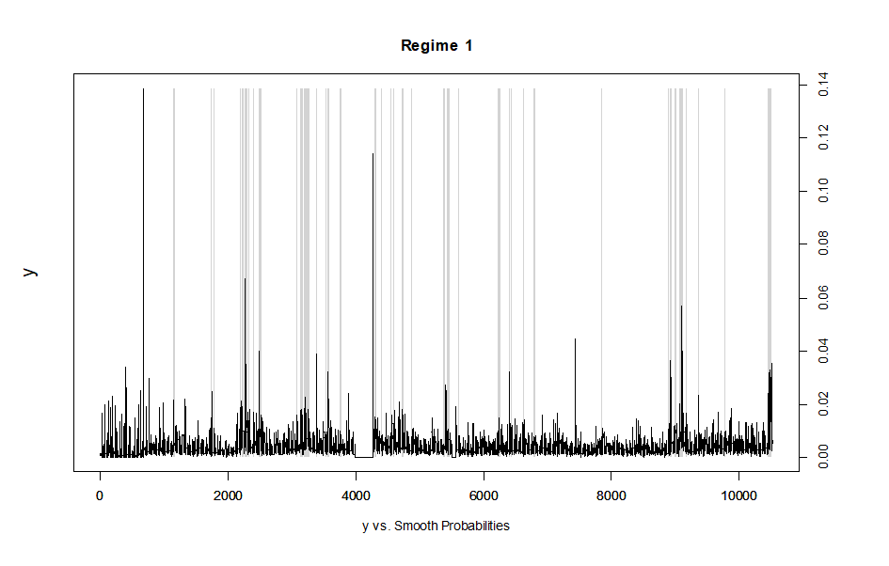
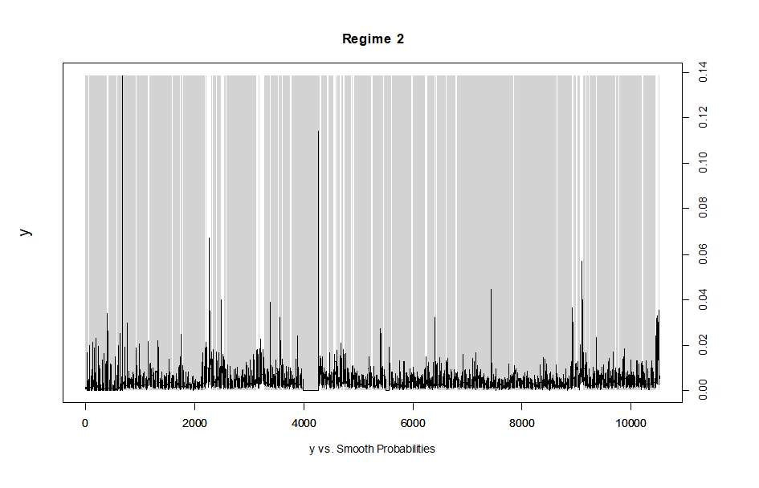
Note: The Markov-Regime Switching regression is estimated using the Expectation-Maximization algorithm. Coefficients on β2 indicate no herding (Regime 1 β2 = 3.6509, Regime 2, β2 =-0.0119, not significant), while β1s are positive. Residual standard errors - Regime 1: 0.005, Regime 2: 0.001. The received transition probabilities are the following:

 | Regime 1 | Regime 2
Regime 1 | 0.7180615 | 0.0455367
Regime 2 | 0.2819385 | 0.9544633

Figure A14. Quantile regression of unconditional herding in the KRW cryptocurrency market
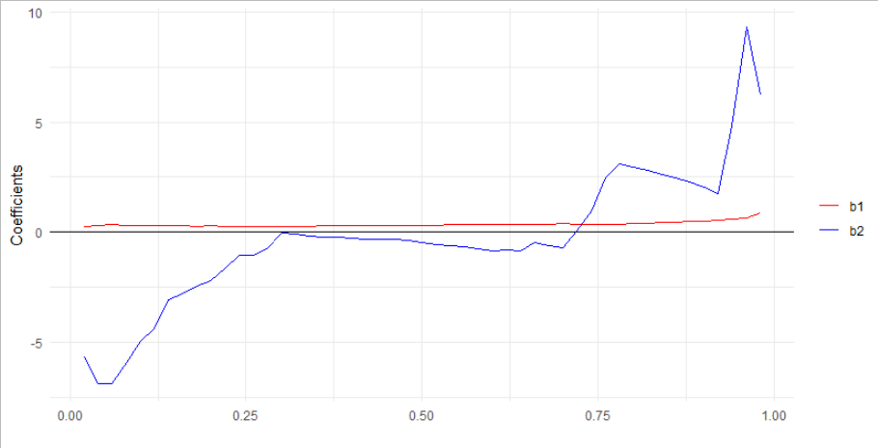
Note: Figure A14 depicts quantile regression (Sim and Zhou 2015) results for unconditional herding for the KRW cryptocurrency market. Coefficients and quantiles appear on the y and x axis, respectively. (Eq. 5-6). Herding in the KRW cryptocurrency market is observed in the lower quantiles of the average absolute market return of the selected actively traded cryptocurrencies.

Figure A15. Quantile regression of herding, conditional on market performance (up/down market days) in the KRW cryptocurrency market
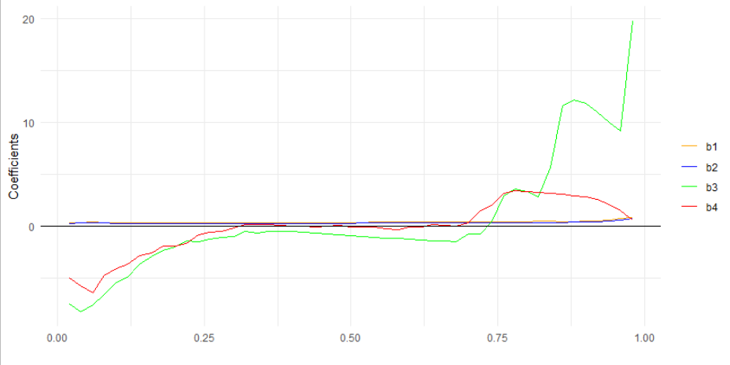
Note: Figure A15 depicts quantile regression (Sim and Zhou 2015) results for herding conditional on up-down market days for the KRW cryptocurrency market. Coefficients and quantiles appear on the y and x axis, respectively. (Eq. 5-6). Herding in the KRW cryptocurrency market is observed in the lower quantiles of the average absolute market return of the selected actively traded cryptocurrencies regardless of market conditions.

Please see Corbet et al. (2019) for a systematic review of cryptocurrency literature.

