Synthesis, properties and structural features of molybdenum(V) oxide trichloride complexes with neutral chalcogenoether ligands

Danielle E. Smith, William Levason, James Powell and Gillian Reid*
School of Chemistry, University of Southampton. Southampton SO17 1BJ, UK; Email: G.Reid@soton.ac.uk

Abstract
Complexes of oxotrichloromolybdenum(V) with neutral group 16 donor ligands, [MoOCl₃(L-L)] (L-L = RS(CH₂)₂SR, R = ^{i}Pr, Ph; MeS(CH₂)₃SMe; MeSe(CH₂)₂SeMe; MeSe(CH₂)₃SeMe), [{MoOCl₂(EMe₂)}₂(µ-Cl)₂] (E = S, Se, Te), [(MoOCl₃)₂{o-C₆H₄(EMe)₂}]_{n} (E = Se or Te) and [(MoOCl₃)₂{MeTe(CH₂)₃TeMe}]_{n}, have been obtained by reaction of the ligands with [MoOCl₃(thf)₂] or MoOCl₃ in either CH₂Cl₂ or toluene, and characterised by microanalysis, IR and UV-visible spectroscopy and magnetic measurements. The telluroethers are the first examples containing Mo in a positive oxidation state. X-ray crystal structures are reported for the six-coordinate fac-[MoOCl₃{MeS(CH₂)₃SMe}], mer- [MoOCl₃{^{i}PrS(CH₂)₂S^{i}Pr}] and mer-[MoOCl₃{MeSe(CH₂)₂SeMe}], as well as the six-coordinate chloride-bridged dimers, [{MoOCl₂(SMe₂)}₂(µ-Cl)₂] and [{MoOCl₂(SeMe₂)}₂(µ-Cl)₂]. The structure of the mixed-valence decomposition product, [Mo^{IV}Cl{o-C₆H₄(TeMe)₂}₂(µ-O)Mo^{V}OCl₄], was also determined.
In toluene solution MoOCl₄ is reduced by MeS(CH₂)₃SMe to produce the Mo(V) complex, [MoOCl₃{ MeS(CH₂)₃SMe}].
Crystal structures of the previously unknown diphosphine analogue, [MoOCl₃{Me₂P(CH₂)₂PMe₂}], and the mixed-valence derivative [Mo^{IV}Cl{Me₂P(CH₂)₂PMe₂}₂(µ-O)Mo^{V}OCl₄] are also reported for comparison and help to clarify earlier contradictory literature reports. In contrast to the EMe₂ dimers, [{MoOCl₂(EMe₂)}₂(µ-Cl)₂], PMe₃ forms the monomeric complex, fac-[MoOCl₃(PMe₃)₂].

Introduction
The coordination chemistry of high oxidation state molybdenum halides and oxide halides was first explored in some detail in the 1970’s, with the emphasis on neutral N- and O-donor ligands^{1,2,3,4} and with much of the impetus coming from modelling of the metal sites in molybdenum enzymes and applications in catalysis.^{4,5,6} Interest in high oxidation molybdenum complexes bearing sulfur donor ligands stems in part from the presence of Mo-S coordination in the molybdenum-containing enzymes, nitrate reductase, sulfite oxidase and Fe-Mo nitrogenases which involve (anionic) cysteine or sulfide ligands.^{4,5,6} The chemistry with neutral P- and As-donor ligands with Mo(V) has also been investigated,^{7,8,9,10,11} but sulfur-based ligands were mostly represented by charged thiolate and dithiocarbamate ligands.^{2,3,4} More recent work has reported a series of extremely moisture sensitive Mo(VI) complexes [MoO₂X₂(dithioether)] (X = Cl or Br; dithioether = RS(CH₂)₂SR, R = Me, Et, ^{i}Pr), which have distorted octahedral structures with the sulfur donor atoms trans to Mo=O;^{12,13} there are also some thia-macrocyclic analogues.^{14,15} Complexes of the type [MoOCl₃(dithioether)] were briefly described in the 1970s, characterised only by microanalysis and IR spectroscopy, but the structures and isomer(s) present were not established.^{15,16} There is a single preliminary report of a selenoether complex of MoOCl₃,¹⁷ but no known telluroether complexes.
We have recently examined the complexes of WOCl₄, WOCl₃, WSCl₄ and WSCl₃ with mono- and di-thio- and -seleno-ethers, and found that W(VI) or W(V) complexes could be isolated depending upon the reaction conditions. We also showed that selected dithioether complexes, for example [(WSCl₄)₂(μ-^{i}PrSCH₂CH₂S^{i}Pr)], can function as single source LPCVD (low pressure chemical vapour deposition) reagents for the growth of thin films of WS₂, an important semiconducting material.¹⁸ In contrast, very little data on the molybdenum chalcogenide halides or their coordination complexes exists.¹⁹ The crystal structures of two forms of MoSCl₃ obtained from crystals grown at high temperature found that both contain Mo(IV) as Mo₂ units and disulfide groups, and not Mo(V).²⁰ It is unclear if MoSCl₃ prepared at low temperatures from MoCl₅ and S(SiMe₃)₂ or Sb₂S₃ contains Mo(V),^{21,22} while MoSCl₄ is unknown.¹⁹
In order to allow comparisons with the WOCl₄, WOCl₃, WSCl₄ and WSCl₃ chemistry, we have examined the chemistry of MoOCl₃ with neutral chalcogenoethers and report here complexes of mono- and bi-dentate thio-, seleno- and telluro-ethers. Data on diphosphine analogues, which clarifies some of the (inconsistent) earlier studies,^{7,8,9} is also presented.
Results and Discussion
Scheme 1 shows the range of chalcogenoether complexes of Mo(V) prepared in this study and the different structure types observed.
Scheme. 1. Methods for the synthesis of the Mo(V) chalcogenoether complexes obtained from MoOCl₃. Note that for some of the alkyl-substituted dithioether and diselenoether complexes [MoOCl₃(thf)₂] was used as the Mo(V) source – see discussion below and Experimental.

Dithio- and diseleno-ether complexes: The reaction of [MoOCl₃(thf)₂] with MeS(CH₂)₃SMe or ^{i}PrS(CH₂)₂S^{i}Pr in dry CH₂Cl₂ produced moisture sensitive green [MoOCl₃(dithioether)] complexes. Structures of both species were determined and revealed that [MoOCl₃{MeS(CH₂)₃SMe}] (six-membered chelate ring) was the fac isomer, whilst [MoOCl₃{^{i}PrS(CH₂)₂S^{i}Pr}] (five-membered chelate ring) was the mer-isomer (Fig. 1). The reason for the different isomers with the five- and six-membered rings is unclear, although the difference in the S-Mo-S chelate angles of ~20° is notable. The behaviour replicates that found with the tungsten(V) analogues, fac-[WOCl₃{MeS(CH₂)₃SMe}] and mer-[WOCl₃{MeS(CH₂)₂SMe}].¹⁸ The bond lengths within the two structures show the expected short Mo=O of ~ 1.67 Å and that the Mo-Cl and Mo-S trans to Mo=O are longer than the other bonds of each type, indicating the high trans-influence of the Mo=O bond.
The reaction of MoOCl₄ with MeS(CH₂)₃SMe in dry toluene gave a green product with an identical IR spectrum to that of mer-[MoOCl₃{MeS(CH₂)₃SMe}] and the X-ray structure determination of a crystal obtained from the MoOCl₄ synthesis route (Method 2) indeed confirmed it to be the Mo(V) complex. The structural data were identical to that in Table S1, and hence are not reported, but confirm that thioether ligands reduce MoOCl₄ to MoOCl₃ complexes, similar to the behaviour reported with some O- and N-donor ligands.²³
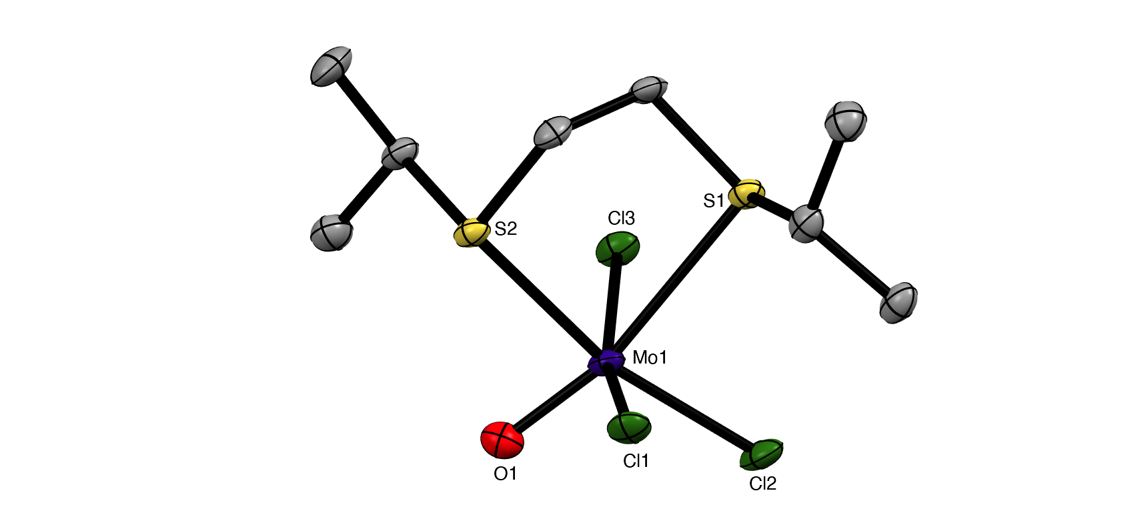
(a) (b)
Fig. 1. Crystal structures of fac-[MoOCl₃{MeS(CH₂)₃SMe}] (a) and mer-[MoOCl₃{^{i}PrS(CH₂)₂S^{i}Pr}] (b) showing the atom numbering scheme. Ellipsoids are shown at 50% probability, hydrogen atoms omitted for clarity. Selected bond lengths (Å) and angles (°): (a) Mo1-Cl1 = 2.4540(2), Mo1-Cl2 = 2.3451(2), Mo1-Cl3 = 2.3451(4), Mo1-O1 = 1.674(1), Mo1-S1 = 2.5388(3), Cl1-Mo1-Cl2 = 94.52(2), Cl2-Mo1-Cl3 = 92.55(3), Cl2-Mo1-O1 = 101.87(4), Cl3-Mo1-O1 = 101.87(4), S1-Mo1-S1 = 97.95(2); (b) Mo1-Cl1 = 2.3578(8), Mo1-Cl2 = 2.3378(8), Mo1-Cl3 = 2.3618(7), Mo1-O1 = 1.671(2), Mo1-S1 = 2.8298(8), Mo1-S2 = 2.5665(7), Cl1-Mo1-Cl2 = 91.25(3), Cl1-Mo1-O1= 98.99(8), Cl1-Mo1-Cl3 = 89.69(3), Cl2-Mo1-O1 = 98.99(8), S1-Mo1-S2 = 78.83(2).
The weaker σ-donor PhS(CH₂)₂SPh failed to displace the thf from [MoOCl₃(thf)₂], but it reacted with a suspension of MoOCl₃ in CH₂Cl₂ to form brown [MoOCl₃{PhS(CH₂)₂SPh}]. The crystal structure of this complex showed it to be the mer-isomer (Fig. 2), which suggests that the ability to form a five-membered chelate ring with a smaller chelate angle (S1-Mo1-S2 = 78.55(3)°) may be an important factor influencing the isomer formed. The structure also reveals a very markedly longer Mo-S_{transO} = 2.911(1) Å, which compares with Mo-S_{transCl} = 2.531(1) Å, showing the high trans-influence of the Mo=O bond on the weaker aryl thioether donor ligand.
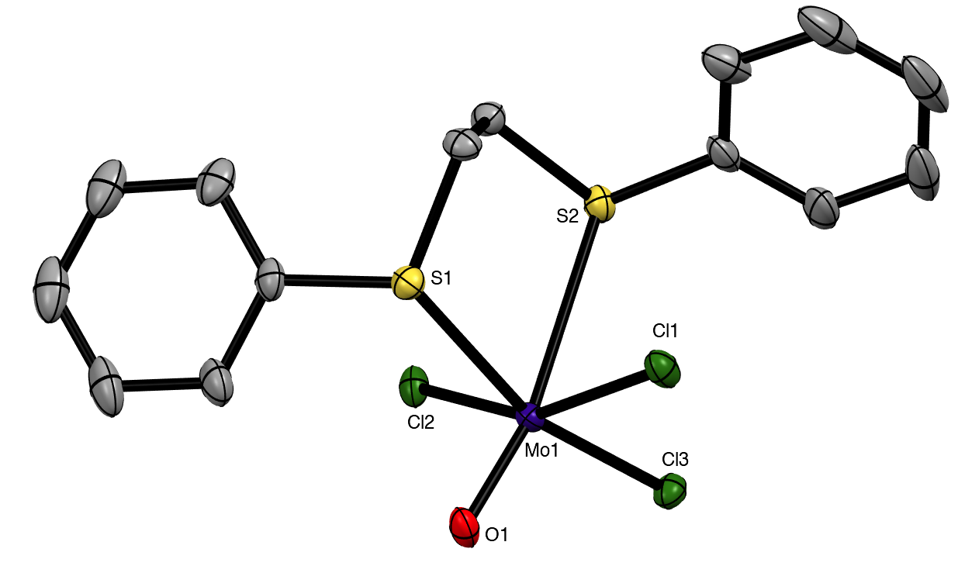
Fig. 2. Crystal structure of mer-[MoOCl₃{PhS(CH₂)₂SPh}] showing the atom numbering scheme. Ellipsoids are shown at 50% probability and hydrogen atoms are omitted for clarity. Note that the O/Cl exhibited disorder, which was modelled with split atom sites, refined to occupancies of 0.53:0.47. Only the major form is shown. Selected bond lengths (Å) and angles (°): Mo1-Cl1 = 2.324(1), Mo1-Cl2 = 2.394(1), Mo1-Cl3 = 2.311(3), Mo1-O1 = 1.706(2), Mo1-S1 = 2.531(1), Mo1-S2 = 2.911(1), Cl1-Mo1-Cl3 = 89.93(7), Cl1-Mo1-O1 = 102.2(5), O1-Mo1-Cl2 = 101.1(5), O1-Mo1-Cl3 = 106.6(3), Cl2-Mo1-Cl3 = 91.28(7), Cl2-Mo1-S1 = 88.39(4), Cl1–Mo1–S2 = 81.49(4), S1-Mo1-S2 = 78.55(3).
Brownish diselenoether complexes, [MoOCl₃(diselenoether)] (diselenoether = MeSe(CH₂)₂SeMe, MeSe(CH₂)₃SeMe), were obtained from reaction of the ligands with MoOCl₃ or [MoOCl₃(thf)₂] in a 1:1 molar ratio, but o-C₆H₄(SeMe)₂ did not displace thf from [MoOCl₃(thf)₂]. The reaction of MeSeCH₂SeMe with MoOCl₃ produced a black oily decomposition product. However, the 1:1 reaction of o-C₆H₄(SeMe)₂ with MoOCl₃ in CH₂Cl₂ gave a brown product for which the microanalytical data indicated a 2:1 MoOCl₃:diselenoether stoichiometry. This is discussed along with the similar ditelluroether complexes below. The X-ray crystal structure of mer-[MoOCl₃{MeSe(CH₂)₂SeMe}] was obtained (Fig. 3).
Fig. 3. Crystal structures of mer-[MoOCl₃{MeSe(CH₂)₂SeMe}] showing the atom numbering scheme. Ellipsoids are shown at 50% probability and hydrogen atoms are omitted for clarity. Selected bond lengths (Å) and angles (°): (a) Mo1-Cl1 = 2.3553(5), Mo1-Cl2 = 2.3517(5), Mo1-Cl3 = 2.3453(5), Mo1-O1 = 1.673(1), Mo1-Se1 = 2.6564(2), Mo1-Se2 = 2.8937(3), Cl1-Mo1-Cl3 = 90.35(2), Cl1-Mo1-O1 = 98.98(5), Cl2-Mo1-Cl3 = 90.65(2), Cl3-Mo1-O1 = 107.36(5), Se1-Mo1-Se2 = 79.76(1).
The five complexes described have room temperature magnetic moments of ~ 1.7 B.M., similar to other MoOCl₃ complexes, ^{1,2,8,9} and close to the spin-only value for a d¹ complex. This indicates that any orbital contribution is quenched by the very asymmetric field of the molybdenum environment.²⁴ The IR spectra show very strong single bands due to υ(Mo=O) in the range 950-980 cm⁻¹, as well as strong overlapping bands at 355-300 cm⁻¹ assigned as Mo-Cl modes, but do not appear to readily distinguish the isomer present. The UV/visible spectra of the solids show a clear band at 13,000-14,000 cm⁻¹ and a second band or shoulder at ~19,000-21,000 cm⁻¹. Assuming C_{4v} symmetry (the actual metal centre symmetry is lower) and placing Mo=O as the dominant contribution along the four-fold axis, leads to the assignment as the d-d bands as ²B₂ → ²E and ²B₂ → ²B₁, respectively.²⁵ The intense absorptions > 20,000 cm⁻¹, assigned as charge transfer bands, are less clearly resolved, but based upon the usual ligand electronegativities,²⁵ we assign the first intense feature (~ 21,000-22,000 cm⁻¹) as S/Se(π)→Mo(d) and the broad overlapping features at ~ 25,000-30,000 cm⁻¹ as Cl(π)→Mo(d). The complexity of the electronic spectra in compounds of this type is shown by a combined UV/visible absorption, MCD and DFT study of [MoOCl₃{Ph₂P(CH₂)₂PPh₂}];²⁶ here we are using the spectra to confirm the presence of Mo(V) in the isolated complexes.

Dimethylchalcogenides (EMe₂, E = S, Se, Te): Neither SMe₂ or SeMe₂ was found to displace thf from [MoOCl₃(thf)₂]. However, reaction of a suspension of MoOCl₃ in dry CH₂Cl₂ with 2 equivalents of EMe₂ produced complexes with a 1:1 Mo:EMe₂ empirical composition, MoOCl₃(EMe₂) (E = S, Se). There was no evidence for the formation of the 1:2 [MoOCl₃(EMe₂)₂] complexes. Crystals of both MoOCl₃(EMe₂) (E = S, Se) complexes were obtained and the structures, which are isomorphous (Fig. 4), showed them to be chloride-bridged dimers, with six-coordinate Mo(V) centres, i.e. [{MoOCl₂(EMe₂)}₂(μ-Cl₂)] (E = S, Se).
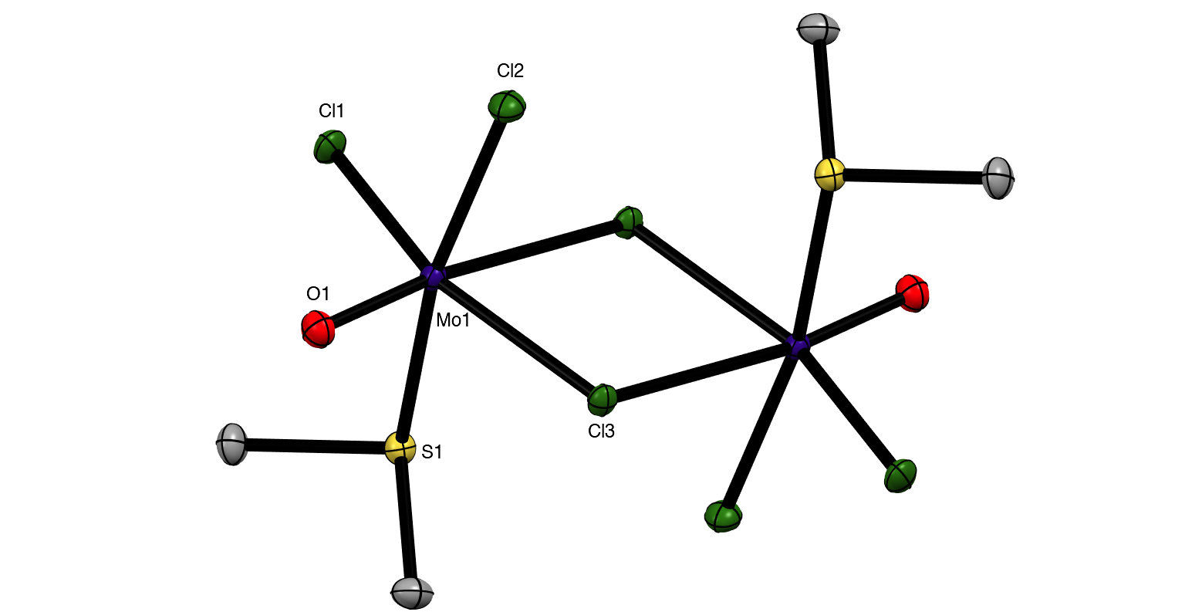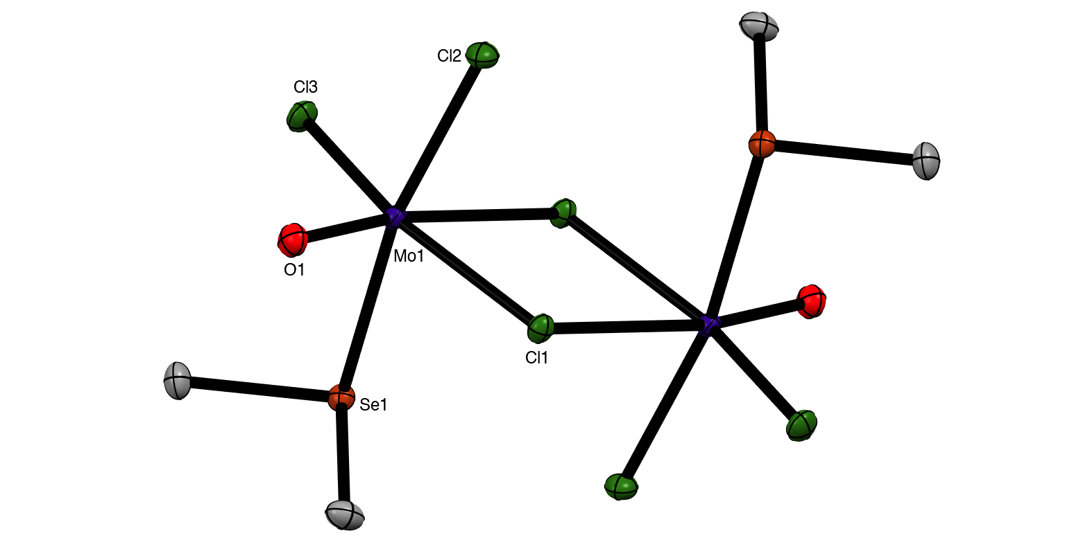
(a) (b)
Fig. 4. Crystal structures of [{MoOCl₂(SMe₂)}₂(µ-Cl)₂] (a) and [{MoOCl₂(SeMe₂)}₂(µ-Cl)₂] (b) showing the atom numbering scheme. Ellipsoids are shown at 50% probability and hydrogen atoms are omitted for clarity. Selected bond lengths (Å) and angles (°): (a) Mo1-Cl1 = 2.3264(2), Mo1-Cl2 = 2.3341(3), Mo1-Cl3 = 2.3953(3), Mo1-Cl3’ = 2.7942(2), Mo1-O1 = 1.6515(8), Mo1-S1 = 2.5537(3), Cl1-Mo1-O1 = 102.48(1), Cl2-Mo1-O1 = 102.08(3), Cl3-Mo1-O1 = 99.55(3), Cl2-Mo1-Cl3 = 85.77(1), Cl1-Mo1-Cl3 = 92.340(9), Cl1-Mo1-S1 = 85.233(9), O1-Mo1-S1 = 92.67(3), Cl3-Mo1-Cl3 = 77.520(8); (b) Mo1-Cl1 = 2.4024(4), Mo1-Cl2 = 2.3385(4), Mo1-Cl3 = 2.3299(4), Mo1-Cl1’ = 2.7927(4), Mo1-O1 = 1.653(1), Mo1-Se1 = 2.6647(3), Cl1-Mo1-O1 = 98.89(4), Cl2-Mo1-O1 = 103.10(4), Cl3-Mo1-O1 = 102.38(4), Cl2-Mo1-Cl3 = 92.32(2), Se1-Mo1-Cl1 = 78.76(1), Se1-Mo1-Cl1 = 87.438(10), O1-Mo-1-Se1 = 92.89(4).
The Mo=O bonds (~1.65 Å) are trans to asymmetrically bound (by ~ 0.4 Å) bridging chlorides, with the EMe₂ groups arranged anti and perpendicular to the Mo₂Cl₄O₂ plane. The geometries are very similar to those found in [(MoOCl₂L)₂(µ-Cl)₂] (L = O=C(H)OMe, thf, O=CEt₂).^{27,28,29}
The reaction of MoOCl₃ with TeMe₂ in toluene produced brown [{MoOCl₂(TeMe₂)}₂(µ-Cl)₂], which is the first Mo(V) complex with a neutral tellurium donor ligand. Crystals were not obtained from this complex due to poor solubility and limited stability in solution, but spectroscopically it is very similar to the other EMe₂ complexes. The failure to produce [MoOCl₃(EMe₂)₂] even in the presence of excess EMe₂, shows that the molybdenum(V) prefers to bind a chloride from another molecule, creating the bridged dimer structure, and is consistent with the weak donor properties of the EMe₂. The dimers are clearly distinguished from the [MoOCl₃(dichalcogenoether)] monomers by their IR spectra, with the dimers showing a strong υ(Mo=O) vibration in the range at 985 – 1005 cm⁻¹ (higher frequency than in the monomeric [MoOCl₃(dichalcogenoether)] type) and terminal Mo-Cl modes 360-310 cm⁻¹; weaker bands in the region ~ 270-250 cm⁻¹ and absent in the spectra of the [MoOCl₃(dichalcogenoether)] monomers, may be due to the chloride bridges. The magnetic moments of ~ 1.7 B.M./Mo confirm the Mo(V) assignment and the absence of any magnetic interactions between the molybdenum centres.
Ditelluroethers : The reaction of o-C₆H₄(SeMe)_{2,} o-C₆H₄(TeMe)₂ and MeTe(CH₂)₃TeMe (L-L) with MoOCl₃ in a 1:1 molar ratio in CH₂Cl₂ failed to produce the expected [MoOCl₃(L-L)] type complexes. Instead, dark brown complexes, identified by microanalysis as [(MoOCl₃)₂(L-L)], were obtained. Once isolated the compounds are very poorly soluble in CH₂Cl₂ and many attempts to produce crystals for an X-ray structure determination have been unsuccessful. However, the magnetic moments of ~ 1.7 B.M./Mo and the UV-visible spectra of these solids are consistent with their formulation as six-coordinate oxo-molybdenum(V) complexes.
The UV-visible spectra of the ditelluroether complexes show a d-d band at ~ 14,000 cm⁻¹ (²B₂ → ²E); a second more intense feature 18,000-20,000 cm⁻¹ may be the second d-d band (²B₂ → ²B₁), but given the lower electronegativity of Te ²⁴ is probably the Te(π) → Mo(d) charge transfer transition, which obscures the d-d band.
The IR spectra are significantly different to those of [MoOCl₃(L-L)] (L-L = dithioether or diphosphine),^{8,9} but are similar to those of [{MoOCl₂(EMe₂)}₂(µ-Cl)₂]. In particular, the ν(Mo=O) vibrations are at higher frequency (985-1000 cm⁻¹), and in addition to several terminal ν(Mo-Cl) modes ~320-300 cm⁻¹, also show a peak ~250 cm⁻¹, probably due to a chloride bridge. In the absence of a crystal structure, the geometries cannot be established unequivocally, but the spectroscopic data (and insolubility) are consistent with a structure type similar to those in [{MoOCl₂(EMe₂)}₂(µ-Cl)₂], with the EMe₂ ligands replaced by bridging ditelluroethers, leading to the formulation as an oligomer, [(MoOCl₂)₂(µ-Cl)₂(µ-ditelluroether)]_{n}. There are several literature examples of Group 16 ligands with o-phenylene backbones adopting a bridging mode, authenticated by X-ray crystal structures.^{30,31,32}

The brown solution from the preparation of [{MoOCl₃}₂{o-C₆H₄(TeMe)₂}]_{n} also deposited a few dark green crystals, which were shown by X-ray crystallographic analysis to be the mixed valence complex, [Mo^{IV}Cl{o-C₆H₄(TeMe)₂}₂(µ-O)Mo^{V}OCl₄] (Fig. 5). This complex contains a Mo(IV) centre coordinated to two chelating ditelluroethers, a terminal chloride and an Mo=O group, which forms a very asymmetric bridge to a square pyramidal MoOCl₄⁻ anion, with Mo1-O1 = 1.705(4) Å and Mo2-O1 = 2.368(4) Å. These bond distances may be compared with the terminal Mo=O bond distance (Mo2-O2 = 1.659(5) Å) in the latter. This complex appears to be the first structurally characterised molybdenum-ditelluroether complex in a positive formal oxidation state of the metal; all previously reported complexes are substituted carbonyls.^{33,34} Analogous complexes with some diphosphine and diarsine ligands have been reported,^{8,9} and the structure of (the previously unknown) [MoCl{Me₂P(CH₂)₂PMe₂}₂(µ-O)(MoOCl₄)] is discussed below. The crystals of [Mo^{IV}Cl{o-C₆H₄(TeMe)₂}₂(µ-O)Mo^{V}OCl₄] result from a redox reaction, and its structure is not consistent with the spectroscopic data on the bulk [{MoOCl₃}₂{o-C₆H₄(TeMe)₂}]_{n}. The failure to isolate mononuclear [MoOCl₃(L-L)] complexes with chelating o-C₆H₄(SeMe)_{2,} o-C₆H₄(TeMe)₂ and MeTe(CH₂)₃TeMe, seems analogous to the case of [{MoOCl₂(EMe₂)}₂(µ-Cl)₂], where the Mo(V) centre prefers to form chloride bridges rather than coordinate to a second, weakly donating chalcogenenoether.
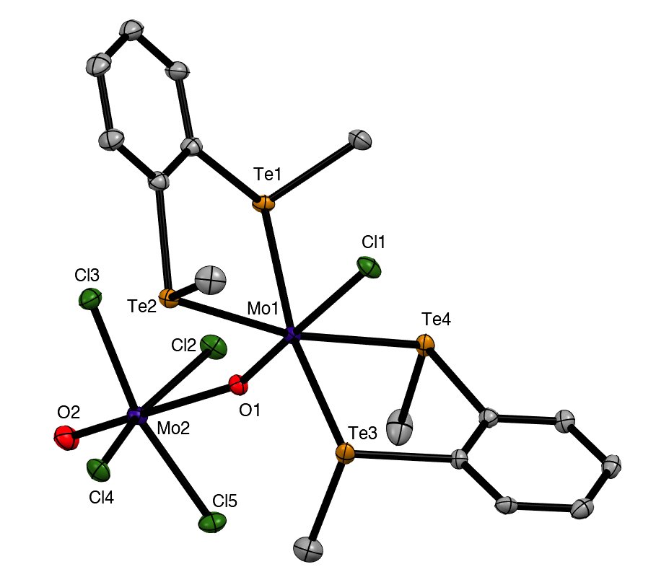
Fig. 5. Crystal structure of [MoCl{o-C₆H₄(TeMe)₂}₂(µ-O)MoOCl₄]⋅CH₂Cl₂ showing the atom numbering scheme. Ellipsoids are shown at 50% probability and hydrogen atoms and solvent are omitted for clarity. Selected bond lengths (Å) and angles (°): Mo1-Cl1 = 2.4486(7), Mo2-Cl2-5 = 2.3640(7)-2.3930(7), Mo1-Te1-4 = 2.7432(3)-2.7822(3), Mo1-O1 = 1.704(2), Mo2-O1 = 2.370(2), Mo2-O2 = 1.655(2), O2-Mo2-Cl2-5 = 78.4(1)-82.2(1), Te-Mo1-Te_{(chelate)} = 85.316(8), 86.185(8), Te1-4-Mo1-Cl1 = 79.647(18)–89.939(18), Cl1-Mo1-O1 = 177.91(7), Mo1-O1-Mo2 = 159.63.1(11).
Phosphine complexes
The coordination behaviour of the chalcogenoether ligands to MoOCl₃ has both significant analogies and differences to that of some phosphine ligands, making for informative comparisons. Pink or red complexes [MoOCl₃(diphosphine)] (diphosphine = Ph₂P(CH₂)₂PPh₂, cis-Ph₂PCH=CHPPh₂, o-C₆H₄(PPh₂)₂, ) were reported in the 1970’s and confirmed by IR, UV/visible spectroscopy and magnetic measurements as Mo(V) compounds.^{7,8,9} No structures were obtained, but EPR spectra supported fac octahedral isomers.^{8,9} A second (brown) form with Ph₂P(CH₂)₂PPh₂ and cis-Ph₂PCH=CHPPh₂ obtained by refluxing the red form in alcohol for several hours, had similar, but not identical, spectroscopic properties; Isovitsch et. al.,¹⁰ confirmed the crystal structure of the red form of the Ph₂P(CH₂)₂PPh₂ complex as the fac isomer. In the present work we prepared the new complex [MoOCl₃{Me₂P(CH₂)₂PMe₂}] from [MoOCl₃(thf)₂] and confirmed the fac geometry by a crystal structure (Fig. 6). The spectroscopic data on this complex (Experimental section) are in good agreement with that of the red isomers with other diphosphines.^{7,8,9} Notably, the five-membered chelate ring diphosphine complexes are fac isomers, contrasting with the mer-[MoOCl₃(dichalcogenoether)] described above.
The nature of the brown “isomers” is not entirely clear, but the original study⁸ of the red and brown forms of [MoOCl₃{cis-Ph₂PCH=CHPPh₂}] showed they had identical EPR spectra with coupling to equivalent phosphorus donors, i.e. were both fac forms. Hence the brown form seems likely to be the red isomer co-crystallised with a second complex, probably an EPR silent Mo(IV) species. The presence of varying amounts of a co-crystallised second species would account for the various (small) differences reported by other workers.^{7,8,10} Similar problems, including X-ray structures with a variety of bond lengths for apparently the same complex, led to the proposal of bond-stretch or distortional isomerism in some other early d-block complexes, a concept subsequently considered to be erroneous.³⁵
Pink or purple complexes with microanalyses indicating a [MoCl_{2.5}O(diphosphine)] were isolated in some systems^{7,8,9} and were formulated as the ionic Mo(IV)-Mo(V) species [Mo^{IV}OCl(diphosphine)₂][Mo^{V}OCl₄], based upon spectroscopic data, and the observation that metathesis with NaBPh₄ gave [Mo^{IV}OCl(diphosphine)₂][BPh₄].

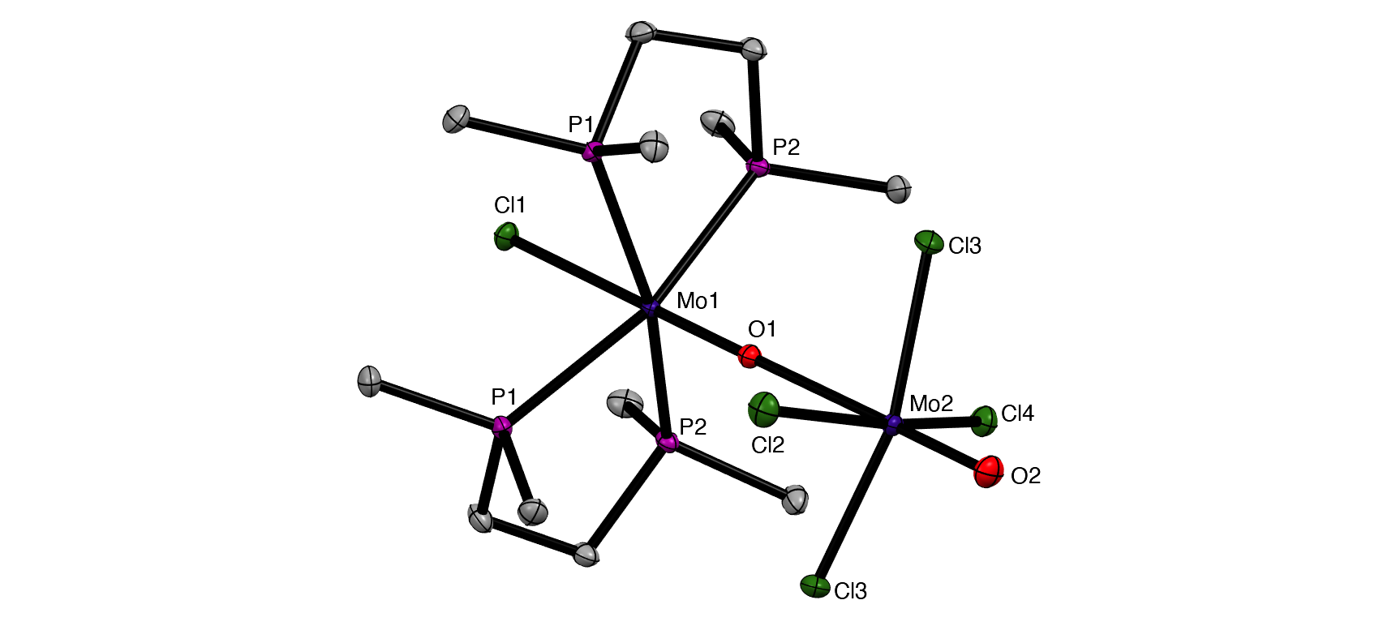 (a) (b)
Fig. 6. Crystal structures of [MoOCl₃(Me₂PCH₂CH₂PMe₂)] (a) and [MoCl(Me₂PCH₂CH₂PMe₂)₂(µ-O)MoOCl₄] (b) showing the atom numbering scheme. Ellipsoids are shown at 50% probability and hydrogen atoms are omitted for clarity. Selected bond lengths (Å) and angles (°): (a) Mo1-Cl1 = 2.3824(9), Mo1-Cl2 = 2.383(1), Mo1-Cl3 = 2.5011(8), Mo1-O1 = 1.680(2), Mo1-P1 = 2.5260(2), Mo1-P2 = 2.5250(8), Cl1-Mo1-Cl2 = 96.98(3), Cl1-Mo1-O1= 100.19(8), Cl2-Mo1-Cl3 = 88.76(3), Cl2-Mo1-O1 = 104.66(8), P1-Mo1-P2 = 78.84(3); (b) Mo1-Cl1 = 2.5186(2), Mo1-O1 = 1.703(4), Mo1-P1 = 2.5131(2), Mo1-P2 = 2.5139(3), Mo2-O1 = 2.394(2), Mo2-O2= 1.657(8), Mo2-Cl2-5 = 2.3573(4) – 2.3824(3), Cl1-Mo1-P1 =78.92(2), Cl1-Mo1-P2 = 83.26(4), O2-Mo2-Cl2-5 = 97.57(2) – 98.89(4), P1-Mo1-P2 = 80.16(4), Mo1- O1- Mo2 = 178.05(8).
During attempts to grow crystals of orange-yellow [MoOCl₃{Me₂P(CH₂)₂PMe₂}], a few deep purple crystals were also isolated that were confirmed by an X-ray structure (Fig. 6) to be [MoCl{Me₂P(CH₂)₂PMe₂}₂(µ-O)(MoOCl₄)], analogous to [MoCl{o-C₆H₄(TeMe)₂}₂(µ-O)(MoOCl₄)] described above. Both molybdenum centres are in a distorted octahedral geometry and linked by a very asymmetric oxide bridge, Mo1-O1 = 1.703(4), Mo2-O1 = 2.394(2) Å, which may be compared with Mo2-O2 = 1.657(8) Å for the terminal Mo=O unit. The original formulation^{7,8} was as ionic salts, [Mo^{IV}OCl(diphosphine)₂][Mo^{V}OCl₄]. The reformulation as neutral µ-oxido dimers in the solid state is likely to apply to all the reported examples, with the long Mo-O bond easily cleaved to give ions in solution.
Red fac-[MoOCl₃(PMe₃)₂] was obtained by Limberg et. al.⁷ as one product from reaction of the alkoxide complex, [Cl₂OMo(µ-OEt)₂(µ-EtOH)MoOCl₂] with PMe₃; we obtained the same complex directly from [MoOCl₃(thf)₂] and PMe₃ in CH₂Cl₂. Our X-ray structure and the spectroscopy (Experimental section) are in good agreement with published data,⁷ and are not discussed further here. The interest lies in the formation of a discrete pseudo-octahedral 1:2 Mo:PMe₃ monomer with the strong σ-donor alkyl phosphine, which contrasts with the formation of chloride-bridged dimers, [{MoOCl₂(EMe₂)}₂(µ-Cl)₂] (E = S, Se, Te), with the weaker donor chalcogenoethers discussed above.
Experimental
Syntheses were performed using standard Schlenk and glovebox techniques under a dry N₂ atmosphere. Solvents were dried by distillation from CaH₂ (CH₂Cl₂) or Na/benzophenone ketyl (toluene, n-hexane, diethyl ether). MoCl₅ and O(SiMe₃)₂ were obtained from Sigma-Aldrich. The monodentate ligands (SMe₂, PMe₃, SeMe₂) were obtained from Sigma-Aldrich or Strem and dried over molecular sieves. TeMe₂ was made by the method of Kuhn et. al.³⁶ The dithioethers,³⁷ diselenoethers^{38,39} and ditelluroethers^{40,41} were prepared as described or by minor modifications thereof. MoOCl₃ was prepared from MoCl₅ and O(SiMe₃)₂,^{42.} and MoOCl₄ obtained from Climax Molybdenum.
Infrared spectra were recorded on a Perkin Elmer Spectrum 100 spectrometer in the range 4000–200 cm⁻¹, with samples prepared as Nujol mulls between CsI plates. UV/visible spectra were recorded on powdered solids using the diffuse reflectance attachment of a PerkinElmer 750S spectrometer. Magnetic measurements were made using a Johnson Matthey magnetic balance. Microanalyses on new compounds were undertaken by London Metropolitan University or Medac Ltd.
Mer-[MoOCl₃(thf)₂]:
Prepared following the literature method.⁴³ Yield: 87%. IR spectrum (Nujol, v/cm⁻¹): 982s Mo=O, 1117s, 833s br thf, 342s, 315m Mo-Cl. UV/Vis spectrum (diffuse reflectance) ν/cm⁻¹: 32,550, 26,200, 22,000, 13,250. μ_{eff}: 1.71 B.M.
Fac-[MoOCl₃{MeS(CH₂)₃SMe}]:
Method 1. [MoOCl₃(thf)₂] (0.150 g, 0.41 mmol) was suspended in CH₂Cl₂ (3 mL) and a solution of MeS(CH₂)₃SMe (0.056 g, 0.41 mmol) in CH₂Cl₂ (2 mL) was added slowly and the solution left to stir for 1 h. The brown solution formed was then concentrated to 3 mL in vacuo and the green solid which precipitated, was filtered off and dried in vacuo. Yield: 0.070 g, 40 %. Required for C₅H₁₂Cl₃MoOS₂ (354.58): C, 16.94; H, 3.41. Found: C, 17.02; H, 3.39%. IR spectrum (Nujol, v/cm⁻¹): 955s Mo=O, 348s, 327s, 306m Mo-Cl. UV/Vis spectrum (diffuse reflectance) ν/cm⁻¹: 27,400, 26,000, 21,150, 18,350, 13,700. μ_{eff}: 1.71 B.M.
Method 2. MoOCl₄ (0.150 g, 0.59 mmol) was suspended in toluene (5 mL) and a solution of MeS(CH₂)₃SMe (0.081 g, 0.59 mmol) in toluene (2 mL) was slowly added and the green solution left to stir for 1 h. The green solution was concentrated to 3 mL in vacuo to produce a green precipitate that was filtered off and dried in vacuo. The green solid was washed in hexane (3 x 5 mL) and dried. Yield: 0.153 g, 70%. Required for C₅H₁₂Cl₃MoOS₂⋅0.2C₇H₈ (373.00): C, 20.61; H, 3.67. Found: C, 20.82; H, 3.77 %. The complex was spectroscopically identical to that made by Method 1. Green crystals suitable for X-ray crystallography were grown from CH₂Cl_{2.}
Mer-[MoOCl₃{^{i}PrS(CH₂)₂S^{i}Pr}]
[MoOCl₃{^{i}PrS(CH₂)₂S^{i}Pr}] was prepared similarly to Method 1 above, and isolated as a pale green solid. Yield: 62%. Required for C₈H₁₈Cl₃MoOS₂ (396.66): C, 24.22; H, 4.57. Found: C: 24.45; H, 4.15%. IR spectrum (Nujol, v/cm⁻¹): 979s Mo=O, 349s, 312m Mo-Cl. UV/Vis spectrum (diffuse reflectance) ν/cm⁻¹: 32,300, 30,400, 27,700, 23,000sh, 21,500sh, 13,600. μ_{eff}: 1.69 B.M.
Mer-[MoOCl₃{PhS(CH₂)₂SPh}]
MoOCl₃ (0.150 g, 0.69 mmol) was suspended in CH₂Cl₂ (3 mL) and a solution of PhS(CH₂)₂SPh (0.170 g, 0.69 mmol) in CH₂Cl₂ (2 mL) was added slowly and the resulting green solution left to stir for 1 h. The resulting brown solution was concentrated to 3 mL in vacuo and filtered, and the orange-brown solid dried in vacuo. Yield: 0.244 g, 76%. Required for C₁₄H₁₄Cl₃MoOS₂ (464.69): C, 36.19; H, 3.04. Found: C, 35.97; H, 3.18 %. IR spectrum (Nujol, v/cm⁻¹): 966s Mo=O, 354s, 319m Mo-Cl. UV/Vis spectrum (diffuse reflectance) ν/cm⁻¹: 32,200, 26,900, 22,600, 21,300, 18,500sh, 13,000. μ_{eff}: 1.71 B.M.
[{MoOCl₂(SMe₂)}₂(µ-Cl)₂]
MoOCl₃ (0.150 g, 0.69 mmol) was suspended in CH₂Cl₂ (3 mL) and a solution of SMe₂ (0.085 g, 1.38 mmol) in CH₂Cl₂ (2 mL) was added slowly and the green solution left to stir for 1 h. The clear green solution was then concentrated to 3 mL in vacuo and layered with hexane (3 mL). The green crystals formed were isolated via filtration and dried in vacuo. Yield: 0.73 g, 38%. Required for C₄H₁₂Cl₆Mo₂O₂S₂ (560.86): C, 8.57; H, 2.16. Found: C, 8.98; H, 2.37%. IR spectrum (Nujol, v/cm⁻¹): 1004s Mo=O, 356s, 319s, 268m Mo-Cl. UV/Vis spectrum (diffuse reflectance) ν/cm⁻¹: 26,000, 22,300, 19,600sh, 13,800. μ_{eff}: 1.72 B.M./Mo
[{MoOCl₂(SeMe₂)}₂(µ-Cl)₂]
MoOCl₃ (0.150 g, 0.69 mmol) was suspended in CH₂Cl₂ (3 mL) and a solution of SeMe₂ (0.150 g, 1.38 mmol) in CH₂Cl₂ (2 mL) was slowly added and the green solution left to stir for 1h. The red solution formed was concentrated to 3 mL in vacuo and layered with hexane (3 mL). The dark brown crystals were isolated via filtration, and dried in vacuo. Yield: 0.154 g, 68 %. Required for C₄H₁₂Cl₆Mo₂O₂Se₂ (654.65): C, 7.34; H, 1.85 %. Found: C, 7.43; H, 1.93 %. IR spectrum (Nujol, v/cm⁻¹): 1004s Mo=O, 368sh, 351s, 313m Mo-Cl. UV/Vis spectrum (diffuse reflectance) ν/cm⁻¹: 32,500, 26,500, 20,700, 14,100. μ_{eff}: 1.68 B.M./Mo.
Mer-[MoOCl₃{MeSe(CH₂)₂SeMe}]
[MoOCl₃(thf)₂] (0.150 g, 0.41 mmol) was suspended in CH₂Cl₂ (3 mL) and a solution of MeSe(CH₂)₃SeMe (0.089 g, 0.41 mmol) in CH₂Cl₂ (2 mL) was added slowly and the green solution left to stir for 1 h. The resulting brown solution was concentrated to 3 mL in vacuo and filtered, then the solid dried in vacuo, isolating a dark brown solid. Crystals grown from CH₂Cl₂ were dark green. Yield: 0.160 g, 90%. Required for C₄H₁₀Cl₃MoOSe₂ (434.34): C, 11.06; H, 2.32. Found: C, 11.60; H, 2.50%. IR spectrum (Nujol, v/cm⁻¹): 960s Mo=O, 342s, 310m Mo-Cl. UV/Vis spectrum (diffuse reflectance) ν/cm⁻¹: 25,800, 21,500, 19,300, 14,600. μ_{eff}: 1.71 B.M.
[MoOCl₃{MeSe(CH₂)₃SeMe}]
MoOCl₃ (0.150 g, 0.69 mmol) was suspended in CH₂Cl₂ (3 mL) and a solution of MeSe(CH₂)₃SeMe (0.158 g, 0.69 mmol) in CH₂Cl₂ (2 mL) was slowly added and the red/brown solution left to stir for 1 h. The brown solution was concentrated to 3 mL in vacuo and filtered and the dark brown solid isolated was dried in vacuo. A deep orange-brown crystalline solid was obtained from CH₂Cl₂ solution. Yield: 0.178 g, 58%. Required for C₅H₁₂Cl₃MoOSe₂⋅CH₂Cl₂ (533.30): C, 13.51; H, 2.65. Found: C, 13.96; H, 2.95%. IR spectrum (Nujol v/cm⁻¹): 954s Mo=O, 346s vbr, Mo-Cl. UV/Vis spectrum (diffuse reflectance) ν/cm⁻¹: 32,000sh, 27,00br, 21,400, 19,500, 14,000. μ_{eff}: 1.70 B.M.
[(MoOCl₃)₂{o-C₆H₄(SeMe)₂}]_{n}
MoOCl₃ (0.150 g, 0.69 mmol) was suspended in dichloromethane (3 mL) and a solution of o-C₆H₄(SeMe)₂ (0.226 g, 0.69 mmol) in dichloromethane (2 mL) was added slowly and the dark red/brown solution left to stir for 1 h. The brown solution was then concentrated to 3 mL in vacuo, producing a brown precipitate, which was washed with OEt₂ (3 x 5 mL), then the brown-pink solid was dried in vacuo. Yield: 0.170 g, 53% Required for C₈H₁₀Cl₆Mo₂O₂Se₂ (700.68): C, 13.71; H, 1.44. Found: C, 13.43; H, 1.53%. IR spectrum (Nujol, v/cm⁻¹): 999s br Mo=O, 351w, 302s, 292sh, 256m Mo-Cl. UV/Vis spectrum (diffuse reflectance) ν/cm⁻¹: 29,500sh, 24,900, 20,900, 14,300. μ_{eff}: 1.69 B.M./Mo.
[{MoOCl₂(TeMe₂)}₂(µ-Cl)₂]
MoOCl₃ (0.150 g, 0.69 mmol) was suspended in toluene (3 mL) and a solution of TeMe₂ (0.217 g, 1.38 mmol) in toluene (2 mL) was added slowly and the purple solution left to stir for 1 h. The deep purple solution was concentrated to 3 mL in vacuo and filtered, then the dark brown solid was dried in vacuo. Yield: 0.203 g, 78%. Required for C₄H₁₂Cl₆Mo₂O₂Te₂ (751.93): C, 6.39; H, 1.61. Found: C, 6.76; H, 2.06%. IR spectrum (Nujol, v/cm⁻¹): 985s br Mo=O, 327, 302s br, 256m Mo-Cl. UV/Vis spectrum (diffuse reflectance) ν/cm⁻¹: 34,500, 29,700sh, 27,150, 26,100, 20,900, 19,500, 14,400. μ_{eff}: 1.68 B.M./Mo.
[(MoOCl₃)₂{MeTe(CH₂)₃TeMe}]_{n}
MoOCl₃ (0.150 g, 0.69 mmol) was suspended in dichloromethane (3 mL) and a solution of MeTe(CH₂)₃TeMe (0.217 g, 0.69 mmol) in dichloromethane (2 mL) was added slowly and the brown solution left to stir for 1 h. The brown solution was concentrated to 3 mL in vacuo, producing a brown precipitate which was washed with OEt₂ (3 x 5 mL), then the dark brown solid was dried in vacuo. Yield: 0.322 g, 61%. Required for C₅H₁₂Cl₆Mo₂O₂Te₂ (763.95): C, 7.86; H, 1.58. Found: C, 7.20; H, 1.38%. IR spectrum (Nujol, v/cm⁻¹): 988m Mo=O, 303s, 292m, 249m Mo-Cl. UV/Vis spectrum (diffuse reflectance) ν/cm⁻¹: 26,500, 21,700, 18,600, ~13,000. μ_{eff}: 1.68 B.M./Mo.
[(MoOCl₃)₂{o-C₆H₄(TeMe)₂}]_{n}
MoOCl₃ (0.150 g, 0.69 mmol) was suspended in dichloromethane (3 mL) and a solution of o-C₆H₄(TeMe)₂ (0.249 g, 0.69 mmol) in dichloromethane (2 mL) was added slowly and the dark brown solution left to stir for 1 h. The brown solution was concentrated to 3 mL in vacuo, producing a brown precipitate which was washed with OEt₂ (3 x 5 mL), and dried in vacuo. Yield: 0.285 g, 52%. Required for C₈H₁₀Cl₆Mo₂O₂Te₂ (797.96): C, 12.04; H, 1.26. Found: C, 12.27; H, 1.43%. IR spectrum (Nujol, v/cm⁻¹): 992s br Mo=O, 343m, 328m, 302s, 254m Mo-Cl. UV/Vis spectrum (diffuse reflectance) ν/cm⁻¹: 32,500, 25,000sh, 21,000, 19,200, 14,500. μ_{eff}: 1.70 B.M./Mo.
Fac-[MoOCl₃(PMe₃)₂]
[MoOCl₃(thf)₂] (0.150 g, 0.41 mmol) was suspended in CH₂Cl₂ (3 mL) and a solution of PMe₃ (0.063 g, 0.82 mmol) in CH₂Cl₂ (3 mL) was added slowly and the dark green solution left to stir for 1 h. The red solution produced was then concentrated to 3 mL in vacuo and filtered, and the red solid dried in vacuo. Yield: 0.047 g, 31%. Required for C₆H₁₈Cl₃MoOP₂ (370.45): C, 19.45; H, 4.90. Found: C, 19.28; H, 4.74%. IR spectrum (Nujol, v/cm⁻¹): 957s Mo=O, 352sh, 324s, 305m Mo-Cl. UV/Vis spectrum (diffuse reflectance) ν/cm⁻¹: 29,600, 26,500, 21,600, 20,500sh, 15,500.
Fac-[MoOCl₃{Me₂P(CH₂)₂PMe₂}]
[MoOCl₃(thf)₂] (0.150 g, 0.41 mmol) was suspended in CH₂Cl₂ (3 mL) and a solution of Me₂PCH₂CH₂PMe₂ (0.165 g, 0.41 mmol) in CH₂Cl₂ (3 mL) was added slowly and the solution left to stir for 1 h. The was concentrated to 3 mL in vacuo, filtered and then the solid was dried in vacuo. Yield: 0.131 g, 81%. Required for C₆H₁₆Cl₃MoOP₂ (368.44): C, 19.56; H, 4.38. Found: C, 19.83; H, 4.26%. IR spectrum (Nujol, v/cm⁻¹): 951s Mo=O, 362m, 325s, 306s Mo-Cl. UV/Vis spectrum (diffuse reflectance) ν/cm⁻¹: 29,600, 26,500sh, 21,600, 20,000, 15,500. μ_{eff}: 1.72 B.M.
X-Ray Experimental
Crystals were grown from slow evaporation of saturated solutions in CH₂Cl₂ or by liquid-liquid diffusion using CH₂Cl₂ and hexane. Data collections used a Rigaku AFC12 goniometer equipped with an enhanced sensitivity (HG) Saturn724+ detector mounted at the window of an FR-E+ SuperBright molybdenum (λ = 0.71073 Å) rotating anode generator with VHF Varimax optics (70 micron focus) with the crystal held at 100 K (N₂ cryostream). Crystallographic parameters are presented in Table S1. Structure solution and refinement were performed using SHELX(T)-2018/2, SHELX-2018/3 through Olex2⁴⁴ and were mostly straightforward. H atoms were added and refined with a riding model. Where additional restraints were required, details are provided in the cif file for each structure found on CCDC.
Conclusions
A range of MoOCl₃ complexes with thio- and seleno-ethers have been prepared from [MoOCl₃(thf)₂] and the ligands in anhydrous CH₂Cl₂ solution. The more weakly coordinating PhS(CH₂)₂SPh, SMe₂ and SeMe₂ fail to displace the thf, but complexes of these can be obtained using a suspension of MoOCl₃ in CH₂Cl₂. The reaction of MoOCl₄ with dithioethers results in reduction to Mo(V) as [MoOCl₃(dithioether)], behaviour which contrasts with that of WOCl₄ or WSCl₄, where either W(VI) or W(V) complexes can be obtained depending upon the reaction conditions.¹⁸ The stabilising effect of two oxido-groups on molybdenum(VI) is shown by the successful isolation of [MoO₂X₂(dithioether)] (X = Cl or Br).^{12,13} The limited affinity of the hard MoOCl₃ for the weaker donor monochalcogenoethers is reflected in the formation of 1:1 adducts, which achieve six-coordination by forming chloride bridges, as in [{MoOCl₂(E’Me₂)}₂(µ-Cl)₂] (E’ = S, Se), rather than by coordinating a second neutral donor ligand. The same explanation accounts for the formation of oligomeric complexes, [(MoOCl₃)₂(L-L)]_{n} with o-C₆H₄(SeMe)₂, o-C₆H₄(TeMe)₂ and MeTe(CH₂)₃TeMe, postulated to have a structure with only one chalcogen donor atom on each molybdenum, and where six-coordination is achieved via bridging chlorides and bridging dichalcogenoethers (Scheme 1). Although bridging behaviour might seem unexpected for chelates with o-C₆H₄-backbones, the presence of aryl groups makes these ligands weaker donors to hard metal centres – compare PhS(CH₂)₂SPh and ^{i}PrS(CH₂)₂S^{i}Pr. There are several literature examples of o-phenylene-based dichalcogenoethers adopting a bridging coordination mode.^{30,31,32} The behaviour contrasts with that of o-C₆H₄-based group 15 ligands, where o-C₆H₄(PMe₂)₂ or o-C₆H₄(AsMe₂)₂ can produce seven- or eight-coordination in tungsten(VI) complexes, such as [WOCl₄{o-C₆H₄(PMe₂)₂}] or [WF₄{o-C₆H₄(PMe₂)₂}₂]²⁺.^{45,46} The present work has also reported the first examples of Mo(V) telluroether complexes. Although the large soft tellurium centres are not usually thought to be good ligands for high valent d-block metals, a range of compounds has been reported in the last few years, including examples with NbCl₄,⁴⁷ NbCl₅⁴⁸ and TaCl₅,⁴⁸ although the complexes reported here are the first examples in Group 6. Also notable is the X-ray structural characterisation of the mixed valence [Mo^{IV}Cl{o-C₆H₄(TeMe)₂}₂(µ-O)Mo^{V}OCl₄] and of the diphosphine analogue [Mo^{IV}Cl{Me₂P(CH₂)₂PMe₂}₂(µ-O)(Mo^{V}OCl₄)]; complexes of the latter type were reported in the 1970s^{7,8} but this is the first structural authentication.
The work has provided detailed characterisation of MoOCl₃-chalocogenoether complexes, and comparison with the W(VI) and W(V) analogues, and lays the basis for exploration of corresponding molybdenum sulfide chloride complexes,¹⁹ which may provide single source LPCVD reagents for deposition of MoS₂ thin films. The sulfide chloride systems will form the basis of future work.
Conflicts of interest
The authors have no conflicts to declare.
Acknowledgements
We thank the EPSRC for support (EP/P025137/1) and for a studentship to D. E. S. (EP/N509747/1).
Electronic Supplementary Information (ESI)
Crystallographic parameters (Table S1), IR and UV/visible spectra for the new complexes. CCDC 2050667: [{MoOCl₂(SeMe₂)}(µ-Cl)₂], 2050668: [MoOCl₃(Me₂P(CH₂)₂PMe₂)], 2050669: [MoOCl₃(PhS(CH₂)₂SPh)], 2050670: [MoOCl₃(MeSe(CH₂)₂SeMe)], 2050671: [MoOCl₃(^{i}PrS(CH₂)₂S^{i}Pr)], 2050672: [{MoOCl₂(SMe₂)}(µ-Cl)₂], 2050673: [MoCl{Me₂P(CH₂)₂PMe₂}₂(µ-O)(MoOCl₄)], 2050674: [MoOCl₃(MeS(CH₂)₃SMe)] 2050891: [MoCl{o-C₆H₄(TeMe)₂}₂(µ-O)MoOCl₄]⋅CH₂Cl₂. For ESI and crystallographic data in CIF or other electronic format see DOI: XXXX
References
1. E. I. Stiefel, Prog. Inorg. Chem. 1977, 22, 1.
2. E.I. Stiefel, Comprehensive Coordination Chemistry; G. Wilkinson, R. D. Gillard and J. A. McCleverty (Eds), Pergamon, Oxford, 1987, Chapter 36.5, 1375.
3. C. D. Garner and J. M. Charnock, Comprehensive Coordination Chemistry; G. Wilkinson, R. D. Gillard and J. A. McCleverty (Eds), Pergamon, Oxford, 1987, Chapter 36.4, 1329.
4. C. G. Young, Comprehensive Coordination Chemistry II, J. A. McCleverty and T. J. Meyer (Eds), Elsevier, Oxford, 2004, 4, 415.
5. C. D. Garner, Comprehensive Coordination Chemistry, G. Wilkinson, R. D. Gillard and J. A. McCleverty (Eds), Pergamon, Oxford, 1987, Chapter 36.6 pp 1421.
6. A. Sigel and H. Sigel (Eds), Molybdenum and Tungsten: Their Roles in Biological Processes. Marcel Dekker, New York, 2002.
7. A. V. Butcher and J. Chatt, J. Chem. Soc. (A), 1971, 2356.
8. W. Levason, C. A. McAuliffe and B. J. Sayle, J. Chem. Soc., Dalton Trans., 1976, 1177.
9. C. A. McAuliffe, B. J. Sayle and W. Levason, J. Chem. Soc, Dalton Trans., 1977, 2055.
10. R. A. Isovitsch, F. R. Fronczec and A. W. Maverick, Polyhedron, 1998, 17, 1617.
11. C. Limberg, M. Buechner, K. Heinze and O. Walter, Inorg. Chem., 1997, 36, 872.
12. M. D. Brown, M. B. Hursthouse, W. Levason and R. Ratnani, G. Reid, Dalton Trans., 2004, 2487.
13. M. F. Davis, W. Levason, M. E. Light, R. Ratnani, G. Reid, K. Saraswat and M. Webster, Eur. J. Inorg. Chem., 2007, 1903.
14. D. Sevdic and I. Fekete, Inorg. Chim. Acta, 1982, 57, 111.
15. C. A. McAuliffe and B.J. Sayle, Inorg. Chim. Acta, 1978, 30, 35.
16. W. Levason, C. A. McAuliffe, F. P. McCullough, S.G. Murray and C.A. Rice, Inorg. Chim. Acta, 1977, 22, 227.
17. C. A. McAuliffe and B. J. Sayle, Inorg. Chim. Acta, 1982, 64, L19.
18. D. E. Smith, V. K. Greenacre, A. L. Hector, R. Huang, W. Levason, G. Reid, F. Robinson and S. Thomas, Dalton Trans., 2020, 49, 2496.
19. V. K. Greenacre, W. Levason, G. Reid and D. E. Smith, Coord. Chem. Rev., 2020, 424, 213512.
20. S. M. Islam, K. S. Subrahmanyam, C. D. Malliakis and M. G. Kanatzidis, Chem. Mater., 2014, 26, 5151.
21. V. C. Gibson, T. P. Kee and A. Shaw, Polyhedron, 1990, 9, 2293.
22. G. W. A. Fowles, R. J. Hobson, D. A. Rice and K. J. Shanton, J. Chem. Soc. Chem. Commun., 1976, 552.
23. M. I. Larson and F. W. Moore, Inorg. Chem., 1966, 5, 801.
24. B. N. Figgis and J. Lewis, Prog. Inorg. Chem., 1967, 6, 1.
25. A. B. P. Lever, Inorganic Electronic Spectroscopy, Elsevier, Amsterdam, 1984.
26. A. Westphal, H. Broda, P. Kurz, F. Neese and F. Tuczek, Inorg. Chem., 2012, 51, 5748.
27. S. Dolci, F. Marchetti, G. Pampaloni and S. Zacchini, Eur. J. Inorg. Chem., 2013, 1371.
28. L. Favero, F. Marchetti, G. Pampaloni and S. Zacchini, S. Dalton Trans., 2014, 43, 495.
29. F. Marchetti, G. Pampaloni and S. Zacchini, Dalton Trans., 2013, 42, 2477.
30. J. R. Black, N. R. Champness, W. Levason and G. Reid, Inorg. Chem., 1996, 35, 1820.
31. W. Levason, S. Maheshwari, R. Ratnani, G. Reid, M. Webster, and W. Zhang, Inorg. Chem., 2010, 49, 9036.
32. A. L. Hector, A. Jolleys, W. Levason and G. Reid, Dalton Trans., 2012, 41, 10988
33. W. Levason, S. D. Orchard and G. Reid, Coord. Chem. Rev., 2002, 225, 159.
34. A. J. Barton, W. Levason and G. Reid, J. Organometal. Chem., 1999, 597, 235.
35. G. Parkin, Chem. Rev., 1993, 93, 887.
36. N. Kuhn, P. Faupel and E. Zauder, J. Organomet. Chem., 1986, 302, C4.
37. F.R. Hartley, S.G. Murray, W. Levason, H.E. Soutter and C.A. McAuliffe, Inorg. Chim. Acta., 1979, 265, 35.
38. D. J. Gulliver, E. G. Hope, W. Levason, S. G. Murray, D. M. Potter and G. L. Marshall, J. Chem. Soc., Perkin Trans. II, 1984, 429.
39. E. G. Hope, T. Kemmitt and W. Levason, J. Chem. Soc. Perkin Trans. II, 1987, 487.
40. T. Kemmitt and W. Levason, Organometallics, 1989, 8, 1303.
41. E. G. Hope, T. Kemmitt, and W. Levason, Organometallics, 1988, 7, 78.
42. V. C. Gibson, A. Shaw and D. N. Williams, Polyhedron, 1989, 8, 549.
43. K. Feenan and G. W. A. Fowles, Inorg. Chem., 1962, 4, 310.
44. (a) G. M. Sheldrick, Acta Crystallogr., Sect. C: Struct. Chem., 2015, 71, 3; (b) G. M. Sheldrick, Acta Crystallogr., Sect. A: Found. Crystallogr., 2008, 64, 112; (c) O. V. Dolomanov, L. J. Bourhis, R. J. Gildea, J. A. K. Howard and H. Puschmann, J. Appl. Crystallogr., 2009, 42, 339.
45. W. Levason, G. Reid, D. E. Smith and W. Zhang, Polyhedron, 2020, 179, 114372.

46. W. Levason, F. M. Monzittu, G. Reid and W. Zhang, Chem. Commun., 2018, 54, 11681.
47. Y-P. Chang, W. Levason, M. E. Light and G. Reid, Dalton Trans., 2016, 45, 16262.
48. S. L. Benjamin, Y-P. Chang, C. Gurnani, A. L. Hector, M. Huggon, W. Levason and G. Reid, Dalton Trans., 2014, 43, 16640.

