Super-resolved polarisation-enhanced second harmonic generation for direct imaging of nanoscale changes in collagen architecture
Peter Johnson^{1,5}, Artemis Karvounis², H. Johnson Singh³, Christopher J. Brereton⁴, Konstantinos Bourdakos^{1,5}, Kerry Lunn⁶, James JW Roberts⁶, Donna E Davies^{4,5} , Otto L. Muskens³, Mark G Jones^{4,5} and Sumeet Mahajan^{1,5}*
1: School of Chemistry, Faculty of Engineering and Physical Sciences, University of Southampton, Southampton, United Kingdom;
2: Optoelectronics Research Centre and Centre for Photonic Metamaterials, University of Southampton, UK
3: Physics and Astronomy, Faculty of Engineering and Physical Sciences, University of Southampton, Southampton, UK
4: NIHR Southampton Biomedical Research Centre, Clinical and Experimental Sciences, Faculty of Medicine, University of Southampton, Southampton, United Kingdom
5: Institute for Life Sciences, University of Southampton, Southampton, United Kingdom
6: Synairgen Research Ltd, Southampton, United Kingdom
*s.mahajan@soton.ac.uk

Abstract:
Super-resolution (SR) optical microscopy has allowed the investigation of many biological structures below the diffraction limit, however, most of the techniques are hampered by the need for fluorescent labels. Non-linear label-free techniques such as Second Harmonic Generation (SHG) provide structurally specific contrast without the addition of exogenous labels, allowing observation of unperturbed biological systems. We use the photonic nanojet (PNJ) phenomena to achieve super-resolution SHG (SR-SHG). A resolution of ~λ/6 with respect to the fundamental wavelength, that is, a ~2.3-fold improvement over conventional or diffraction-limited SHG under the same imaging conditions is achieved. Crucially we find that the polarisation properties of excitation are maintained in a PNJ. This is observed in experiment and simulations. This may have widespread implications to increase sensitivity by detection of polarisation-resolved SHG (p-SHG) by observing anisotropy in signals. These new findings allowed us to visualise biological SHG-active structures such as collagen at an unprecedented and previously unresolvable spatial scale. Moreover, we demonstrate that the use of an array of self-assembled high-index spheres overcomes the issue of a limited field of view for such a method, allowing PNJ-assisted SR-SHG to be used over a large area. Dysregulation of collagen at the nanoscale occurs in many diseases and is an underlying cause in diseases such as lung fibrosis. Here we demonstrate that pSR-SHG allows unprecedented observation of changes at the nanoscale that are invisible by conventional diffraction-limited SHG imaging. The ability to non-destructively image SHG-active biological structures without labels at the nanoscale with a relatively simple optical method heralds the promise of a new tool to understand biological phenomena and drive drug discovery.
© 2020 Optical Society of America under the terms of the OSA Open Access Publishing Agreement

List of abbreviations
Second Harmonic Generation (SHG), Super-resolution (SR), Barium Titanate Glass (BTG), Photonic Nanojet (PNJ), Point Spread Function (PSF)

Introduction
The Abbe “diffraction limit” states that the resolution of an optical microscope is limited by its wavelength to ~λ/(2NA) with NA being the numerical aperture of the imaging system. In biological microscopy, this poses a major limitation as a wealth of processes occur on a scale below the diffraction limit. Many techniques now exist to surpass this limit both in the far field: STimulated Emission Depletion (STED) microscopy, localisation microscopies such as PALM/STORM ,Structured Illumination Microscopy (SIM) and in the near field: Near-field Scanning Optical Microscopy (NSOM) [1,2], Solid immersion microscopy [3]. Collectively referred to as super-resolution (SR) techniques [4]. However, these techniques are either complex to implement or rely on the properties of fluorescent labels, or both. As such, achieving SR using label-free techniques such as SHG microscopy would be of great interest, but so far this modality has not seen the same success. SHG microscopy is a structurally specific technique that highlights non-centrosymmetric features without the addition of exogenous and potentially perturbative labels. SHG active materials include certain crystals such as Barium Titanate (BaTiO₃) and biological macromolecules including the actin-myosin complex, microtubules and fibrillar collagen. The ability to perform far-field label-free SHG imaging with sub diffraction-limited resolution therefore holds significant potential for biomedical research as changes in collagen structure and function underlie many diseases including fibrosis and cancers.
To realise label-free SR-SHG imaging we have employed the photonic nanojet (PNJ) phenomena, as it does not rely on fluorescent switching/blinking and is simple to implement. A PNJ is a localised focus of light with an intensity cross section narrower than the diffraction limit that is able to propagate over multiple wavelengths [5]. Initial demonstrations of the phenomena used high refractive index spheres or cylinders to generate the PNJ and this is still the most common experimental implementation however, theoretical studies have investigated cuboids [6], cones, prism structures [7] and spheres with multiple/graded refractive indices [8]. Typically, dielectric spheres of sizes between 5 μm-100 µm in diameter are placed on the surface of a sample to focus the light into a PNJ, decreasing the illumination point spread function of the system [9]. By scanning the illuminating beam over the sphere, the PNJ is scanned over the sample forming a virtual image which is detected in the far-field using the illumination objective (Figure 1A). Whispering gallery modes [10] ,elements of solid immersion lens theory [11,12]and near field effects [13–15] have also been suggested as contributing to the SR imaging capability of PNJ generating microspheres.
The focal spot of a PNJ, when generated using a microsphere is dependent on multiple parameters including sphere size, imaging wavelength and the refractive index contrast with the surrounding medium [16]. For biological imaging, the contrast has to be ideally maximised against the microscope immersion medium. Imaging with PNJs (Figure 1A) has been typically performed in a widefield configuration, using both brightfield and epifluorescence [17,18]. It has also been demonstrated in a laser-scanning configuration [19] and is amenable to SHG microscopy [20].
SHG interrogates the 2nd order polarizability of materials and detects non-centrosymmetric structures. It is widely used to image fibrillar collagen in bioimaging [21]. SHG is polarisation sensitive; intensities depend on the relative orientation between the excitation and the SH active structure. Thus, polarisation resolved SHG (p-SHG) is used to acquire information about the orientation and degree of organisation of harmonophores, for example, to calculate the helical pitch angle of collagen fibrils [22] and the tilt angle of the helices relative to the fibril axis [23]. It has also been used to understand the differences between collagen types in tissues [24], and investigate the effect of mechanical stretching [25] on collagen disorder within tendon tissue. Collagen and its deposition/accumulation plays a critical role in many diseases especially fibrotic diseases such as liver fibrosis and idiopathic lung fibrosis [26–28]. The ability to resolve SHG-active structures at the nanoscale is vital as changes occur at the level of molecular-structures and assemblies such as the actin-myosin complex [29], microtubules [30] and fibrillar collagen [31–33] all of which are SHG-active. SHG has already proved to be a valuable tool for biomedical and biophysical investigations however, sub-diffraction limited resolution has not been achieved preventing nanoscopic analysis.
Here we present the first demonstration of super-resolution SHG (SR-SHG) microscopy. We use PNJs generated using a microsphere to achieve SR-SHG imaging in the far-field and demonstrate a route to extended field of view of super-resolved SHG imaging. We investigate the origin of SR imaging using PNJs highlighting a critical near-field component. Most importantly, we find that polarisation properties of the excitation are maintained in a photonic nanojet. This unexpected finding crucially enabled polarisation resolved SR-SHG (pSR-SHG) that further enhances resolution. In an unprecedented and highly relevant application we show that nanoscopic anisotropy analysis enabled by pSR-SHG allows the detection of underlying nanoscale changes in collagen during the development of lung fibrosis. Overall, our work heralds the role that label-free super-resolution techniques can play to unravel underlying biological phenomena and improve our understanding of disease mechanisms.

Results and Discussion
Achieving super-resolution SHG (SR-SHG) imaging can have applications in understanding nanoscale biology and evolution of SHG active materials such as in disease processes. Here, we used the photonic nanojet phenomena to achieve SR-SHG (Figure 1A). The SHG signals observed by exciting via a PNJ showed the expected 2nd order dependence on power on imaging barium titanate nano-crystals (Figure S1 A-B). In the context of SHG from single collagen fibres it has been shown that with higher excitation power, sensitivity to smaller fibre diameters is achieved [34]. We clearly also see that at higher power the signal to noise ratio improves in PNJ assisted SHG (Supplementary Figure S1 C-E). Since SNR is inherently linked to resolution, further experiments were conducted at the highest excitation power possible (typically ~30 mW) within the damage threshold of the sample to obtain the highest resolution within the imaging conditions.
We acquired images of the same location of the sample without and with PNJ excitation of SHG to investigate the extent of improvement over conventional diffraction-limited SHG. A clear improvement in resolution is apparent in SHG signals from Barium titanate nanocrystals (Figure S2) and a lung tissue section (Figure 1B,C), that was verified to have an abundance of fibrillar collagen (Figure S3). We demonstrated that PNJ assisted SHG imaging allowed the distinction of individual fibres and their directionality, an observation that was not possible with conventional diffraction-limited imaging. A typical collagen fibre is between 12 and 500 nm (age dependent) in diameter as determined previously by electron microscopy [35]. The diffraction limited resolution of our SHG microscope at the fundamental wavelength (800 nm) is ~288 nm (0.61λ/√2N.A) [36], whereas the ultimate diffraction limit in an aqueous medium is a~259 nm. Hence, the ability to resolve fibres at this separation suggests the super-resolution capability of PNJ excited SHG.
In order to quantitatively determine the resolution limit for SR-SHG a patterned silicon sample was fabricated of 5 individual cuts etched on a thin silicon membrane using a focussed ion beam. The width of each cut is 100 nm whilst the spacing between them is 125 nm (λ/6.4) verified by TEM (Figure 1D_{iii}). Figure 1D_{i} shows an image of the silicon sample acquired using diffraction limited SHG, D_{ii} shows the same FOV acquired through a 14 µm diameter sphere to generate a PNJ. The relationship between size and magnification is shown in Figure S4; smaller spheres can achieve better resolution due to their narrower PNJ [9]. As shown in Figure 1E (Figure S5) the slits can be well resolved satisfying the Rayleigh criterion for slits (81% of peak) [37,38]. This shows that SR-SHG can be achieved with at least 125 nm resolution which is 1.68 times better than anything achieved in SHG microscopy [39]. In our experiments, the limitation was due to lack of available SHG-active standards and the fabricated sample exploited surface-SHG that is significantly weaker than bulk-SHG [40]. This could not be surmounted by applying higher laser power given the damage threshold for such thin samples. Hence, the actual achievable resolution with our PNJ-assisted SR-SHG method may be even higher.
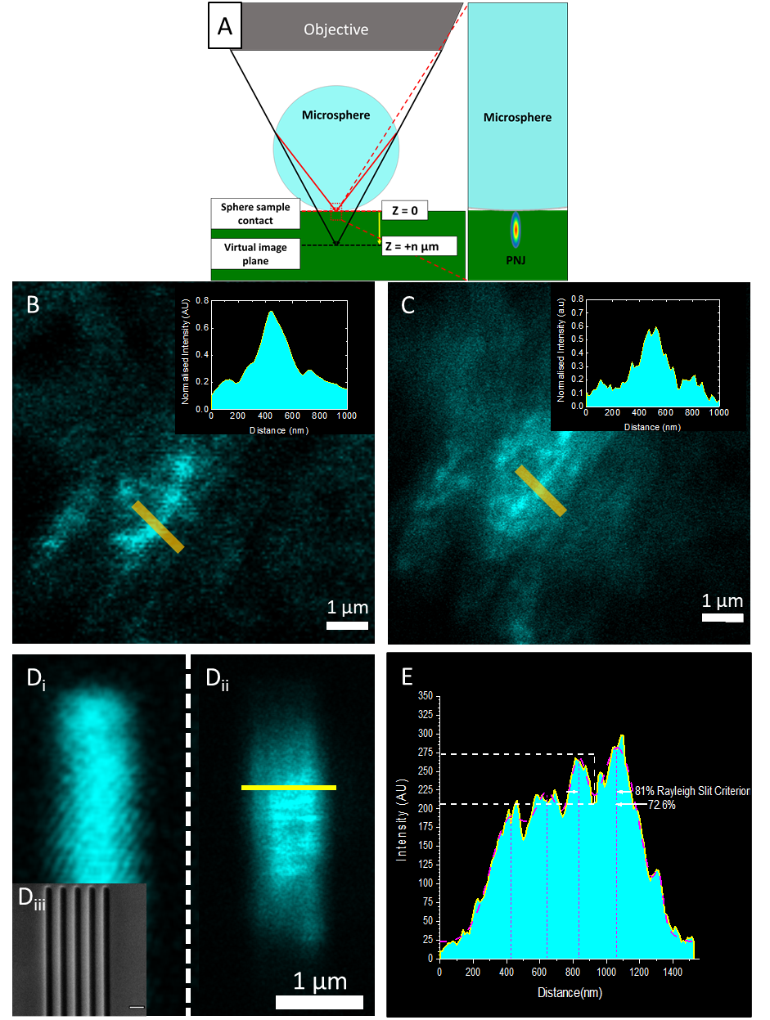
Figure 1 Establishing the limit of resolution of SR-SHG.A: A diagram depicting imaging using PNJs generated using a microsphere in a microscope setup. The microsphere is located on the surface of the sample and acts to focus the light to a sub-diffraction-limited spot. By scanning the illumination laser beam the PNJ is scanned on the sample forming a super resolution virtual image at distance z on the shadow side of the sphere. B: Diffraction limited SHG signal from a fibrotic lung tissue sample containing collagen. C: SHG image of the same region taken using a PNJ. It is possible to resolve more fibres and their directionality. Insets show intensity plots taken over the yellow lines in B/C, More peaks are resolved in the PNJ image compared to the diffraction limited image. D_{iii}: An SEM image of a the silicon sample, each dark slit is 100 nm wide and the slits are separated by 125 nm D_{i}: Diffraction limited image of the silicon slit sample, the sub-diffraction limited features are resolved. The reduced FOV of the high resolution microsphere is apparent. D_{ii}: Image taken through a 14 µm sphere of the silicon slit sample, the sub-diffraction limited features are resolved. E: An intensity plot taken across the yellow line in D_{ii}. The plot shows 4 peaks corresponding to slits the peaks can be resolved with a drop to 72.6% intensity, satisfying the Rayleigh Criterion.
Despite imaging occurring in the far field it has been proposed that the super-resolution effect of PNJs has a strong near field component [41,42]. To further understand this phenomenon simulations were performed for both 14 µm and 60 µm diameter spheres using Gaussian beam illumination with a numerical aperture (NA) of 1.2 as used in experiments. The PNJ is observed both under plane wave and focused illumination conditions (Figure 2), however it is seen that the PNJ maximum moves much closer to the surface of the sphere under focused Gaussian illumination (Figure 3 A). This behaviour can be understood as the effect of a compound lens consisting of both microscope objective and the microsphere where the effective focus is shifted towards the sphere. Here the distance of the sphere with respect to the focus of the microscope is a critical parameter, z representing the distance of the microsphere end-surface from the objective focus position in absence of the microsphere.
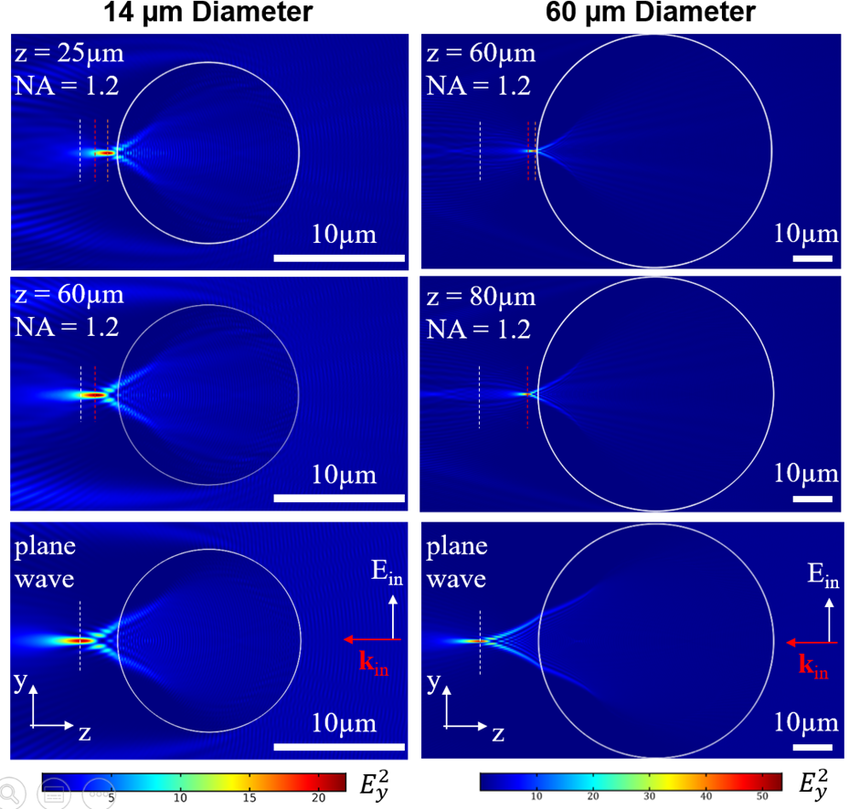
Figure 2 Simulations (2D) of photonic nanojet formation under plane wave vs Gaussian illumination using a numerical aperture (N.A.) of 1.2 for 60 μm diameter (left column) and 14 μm diameter (right column) spheres. Colour maps indicate field intensity in the y-polarization component E_{y}² for different illumination conditions corresponding to plane wave illumination (bottom) and a focused Gaussian beam with NA = 1.2. Different distances of the illumination focus from the sphere end surface, z, are shown in middle and top rows as indicated in the figure. Coloured dashed lines represent the position of the maximum intensity of the PNJ for the three conditions for each sphere. Scale bars, 10 μm.
As the PNJ moves closer to the sphere surface, the contribution of near-field components increases, resulting in a reduced spot size (Figure 3 B). The smallest achievable single photon PNJ waist sizes in our simulations are 285 nm and 235 nm for the 60 µm and 14 µm diameter spheres respectively, due to the square-law dependence of SH generation the size of the effective point-spread function will be reduced by a factor of √2, giving approximate SHG spot sizes of 201 nm and 166 nm respectively. The diffraction limited SHG resolution for a 1.2 NA objective is 288 nm and therefore the achieved spot sizes from simulations are well below the diffraction limit for this system and provide an explanation for the improved resolution observed in the experiments, this is in line with previously published results [9].
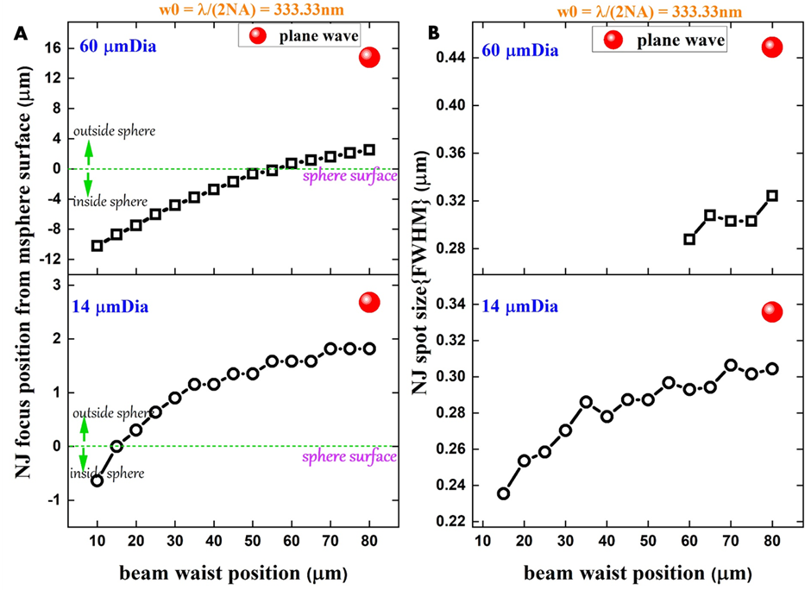
Figure 3 Analysis of simulations of nanojet formation under Gaussian illumination. A: Nanojet focus position as a function of illuminating beam waist position. For a 60 µm diameter sphere the nanojet first forms outside of the microsphere when the illuminating beam is focussed 60 µm from the sphere surface as the illumination focus is moved further from the sphere the nanojet focus also moves further from the sphere surface. The same trend is true for smaller spheres however the nanojet focus first forms outside of the sphere when the illumination focus is ~15 µm below the sphere surface. B: Nanojet spot size as a function of illumination focus position. The nanojet produced by both sizes of sphere is narrowest when the illuminating beam is focussed close to the microsphere surface. The narrowest achievable spots are 285 nm and 235 nm for 60 µm and 14 µm diameter spheres respectively. Spots of a narrower width than this form inside of the microsphere and therefore cannot be used for imaging.
Whilst super-resolution is clearly demonstrated with PNJ-assisted SHG, a potential limitation is the restriction of the field-of-view (FOV) given by one sphere. Figure 1D shows 4 distinguishable stripes due to the location of the sphere on the sample as the field of view is limited by the sphere size. We applied a simple multiplexing technique to allow rapid acquisition of multiple SR-SHG images using self-assembled ordered arrays of spheres (Figure 4 inset) to overcome this limitation. The magnification achieved is dependent on the size of the sphere used and the focal plane z-position (Figure S4). Therefore, if taken with an array of spheres, the image from neighbouring spheres can overlap and hence needs to be optimised. With a 60 µm diameter sphere a focal position of z=70 µm was found to be the optimum to maximise resolution whilst avoiding overlap of images (Figure 4). The close packing of spheres allows for maximal effective imaging FOV without moving the sphere array. The FOV of a single sphere is smaller than the diameter of the sphere (Ø~15 μm for Ø = 60 μm sphere) thus there are unimaged portions between spheres. Although not demonstrated for SR-SHG, multiple spheres and image stitching has been used to reconstruct composite FOVs [43–45] and can be applied to our approach. Our approach retains the advantage of simplicity whilst offering increased speed of data acquisition relative to single sphere approaches and most importantly is demonstrated for label-free laser-scanning nanoscopy (specifically SR-SHG).
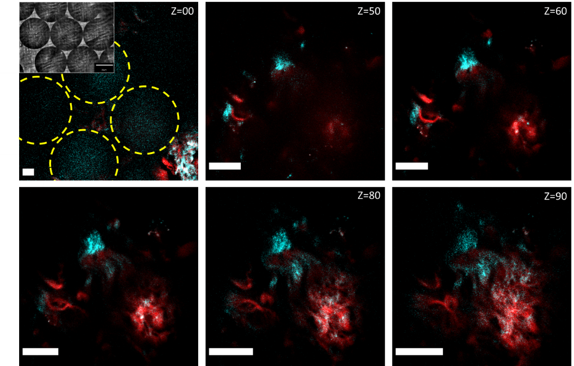
Figure 4: Arrayed spheres allow simultaneous acquisition of multiple images. Images shown of a group of spheres deposited on a lung tissue sample, cyan signal is SHG, red signal is two photon excited fluorescence. In the Z=00 image the locations of 4 neighbouring spheres can be seen indicated by yellow circles, 3 of these contribute to clear FOVs when imaging through the spheres. As the focal position is changed (Z is increased) the magnification increases as does the resolution. At Z = 70 µm magnification is maximised whilst ensuring non-overlapping FOVs, at greater values of Z overlap confounds image information from each sphere. Inset: Representative brightfield image showing 6 spheres packed together. Scale Bars 10 µm.
Having shown that SR-SHG is possible using the PNJ-approach and the FOV can be expanded, we sought to investigate ways to achieve ultra-high resolution and develop a technique that can be used for distinction at the nanoscale level. Hence we examined the property that in SHG, signals are dependent on the relative orientation of harmonophores vs the polarisation of the excitation [46]. Furthermore, the relative orientation of neighbouring harmonophores both to each other and to the excitation heavily influence the ability to resolve these structures. We conducted experiments with different polarisations with a multiple slit sample the same as that shown in Figure 1. The results show that with alignment of orientation, the slits are resolved (Supplementary Figure S6C). A similar result is obtained with two closely spaced barium titanate crystals (Supplementary Figure S6D-E).). Moreover, this dependence has been used previously to achieve super-resolution using SHG labels [47]. To demonstrate this sensitivity to polarisation we used a mouse tail tendon that contains a high density of aligned collagen fibres (Figure 5). The polar plots (Figure 5C,F) showed the dumbbell shape as expected for polarisation dependent SHG signals [48]. However, this strong polarisation dependent behaviour of SHG observed even through a microsphere was intriguing. The experimental result suggests that polarisation is maintained despite complex propagation conditions (whispering gallery modes, near-fields etc) that are taking place in the microspheres and that are responsible for the tight focussing [2-9]. This was unexpected and hence to verify this result we performed 3D numerical simulations and the polarisation state of the photonic nanojet of a microsphere was investigated. Figure 5G and H shows the x and y components of the electric field (||E/E₀||²) respectively when the sphere is illuminated with linearly polarised light in the x plane. The intensity of the y component in the PNJ is approximately 2 orders of magnitude smaller than the x component indicating that the polarisation state of the illumination is not significantly affected when focussed into a PNJ. These results indicate that it should be possible to perform super-resolution polarisation resolved SHG measurements.
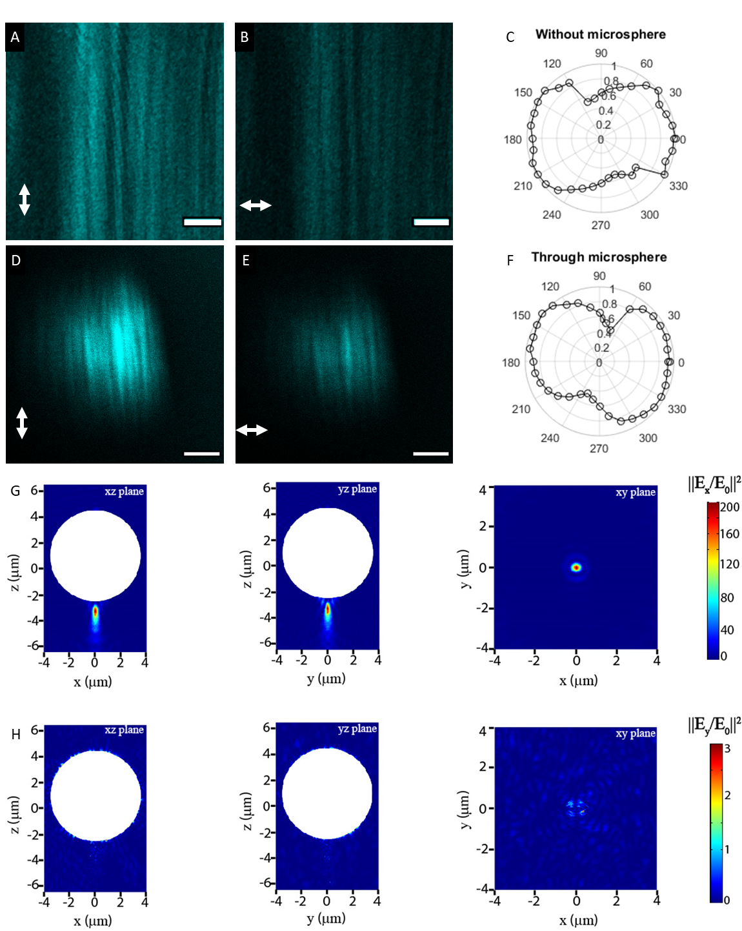
Figure 5: PNJs maintain the polarisation of light. A and B, images of collagen fibres in mouse tail tendon with the excitation polarisation aligned parallel and perpendicular to the fibre orientation respectively. D and E, the same situation as A and B with imaging performed using PNJs, in both cases the intensity is at a maximum when fibres and excitation polarisation are aligned and at a minimum when they are perpendicular. C and F show polar plots of signal intensity against excitation polarisation for the diffraction limited and PNJ cases respectively, the shape of the plots are the same showing that polarisation is maintained through microspheres. Scale bars 3 μm. G: Simulation results - Colour map plot of the x-component of the electric field intensity (||E/E0||2) in various planes. The incident light was x-polarised. The white shaded circular region represents the microsphere. The xz and yz corresponds to planes passing through the centre of the microsphere while the xy plane is plotted passing through the focal point of the generated PNJ, H: same as G but for the y component. The intensity of the y component is approximately 2 orders of magnitude smaller than the x component indicating that the polarisation state of the illumination is not significantly affected when focussed into a PNJ.
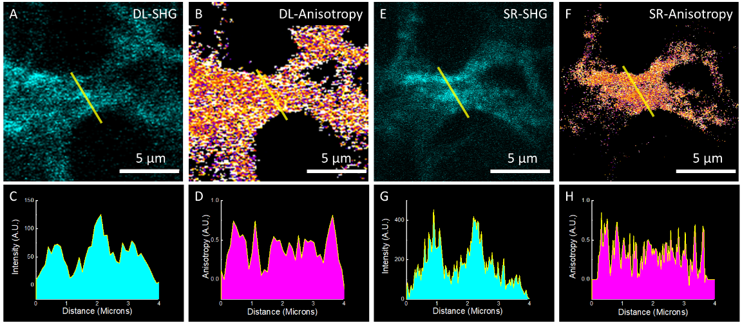
Figure 6: Polarisation anisotropy reveals features that cannot be identified by intensity alone. Diffraction limited SHG Intensity (A) and Anisotropy (B) images of collagen in a lung cell spheroid. (C) An intensity plot taken through the yellow line in A shows clear peaks from collagen fibrils. The corresponding anisotropy measurement (D) reveals new features at finer spatial resolution than the intensity alone. (E) SR-SHG measurement of the same FOV as (A) reveals many finer features (G). SR-Anisotropy measurements (F) show that PNJs allow greater resolution of changes in anisotropy (H).
Polarisation dependent changes can be measured by polarisation anisotropy, $r = (I_{∥} –I_{⊥})/ (I_{∥}+{2I}_{⊥})$, where $I_{∥}$ and $I_{⊥}$are the intensities recorded parallel or perpendicular to incident polarisation. Polarisation anisotropy can vary between -0.5 and 1 where 0 is completely random emission and 1 is emission completely aligned with the excitation polarisation. Pixel-wise calculation of anisotropy was performed to generate images (Figure 6 B/D) that show the spatial distribution of disorder within the collagen ultrastructure. The changes in disorder can occur at a sub-fibre scale thus, it is possible to observe changes that are not detectable using intensity alone; different features showing higher frequency changes can be seen in collagen fibres on using polarisation anisotropy on the same sample (Supplementary Figure S7). The same location taken from a sample containing collagen fibrils (lung cell culture model, Materials and Methods) was imaged. Figure 6A and B show the diffraction-limited while Figure 6E and F show the PNJ-assisted SHG intensity and corresponding polarisation anisotropy images. Line profile plots show increased number of peaks and reveal hidden features in both diffraction-limited and PNJ-assisted SHG imaging. The narrower width of the PNJ vs the diffraction limited PSF allows the resolution of both finer fibre features via intensity (Fig6C vs G) and further identification of sub-fibre changes via anisotropy (Fig6 D vs H). This demonstrates that polarisation resolved SHG, herein using the anisotropy offers sensitivity to super-resolution structural changes; we term these set of techniques as pSR-SHG. Polarisation has been used previously to improve the resolution of diffraction-limited fluorescence images [49,50] by improving the localisation accuracy of the dye molecules used for labelling biological samples. Here, however, we crucially show that polarisation anisotropy not only increases resolution of SHG but allows resolution of neighbouring nanoscale collagen fibrils improving both the sensitivity and the resolution even in PNJ-assisted (hence, super-resolved) SHG measurements whilst providing additional structural information and maintaining the benefits of label free imaging. The anisotropy of polarisation sensitive SHG diffraction-limited imaging itself is powerful and can be used to delineate different stages of ovarian cancer [51] and differentiate between different collagen isoforms [52]. However, in many cases the changes are much more subtle and occur at the nanoscale such as in idiopathic lung fibrosis [53]. Here we applied our simple super-resolved SHG imaging approach, particularly, pSR-SHG to see whether such nanoscale changes in collagen could be observed directly.
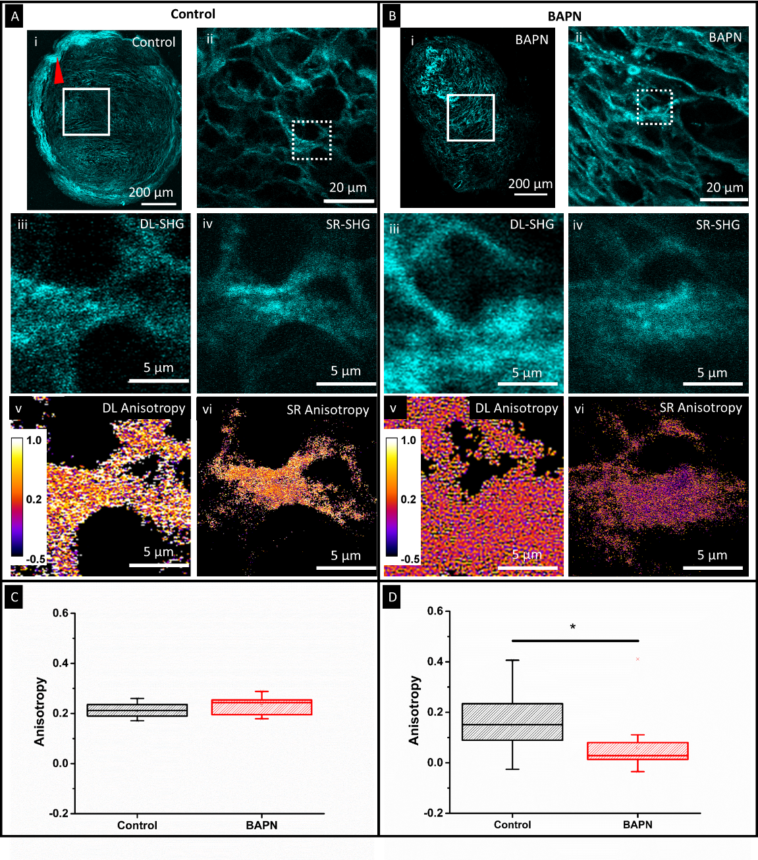
BAPN Ma-SHG
Control Ma-SHG
5210 Ma-SHG
5210 Anisotropy
Figure 7: SR SHG polarisation anisotropy measurements reveal nanoscale differences in collagen ultra-structure under treatment with LOX/LOXL inhibitors. SHG imaging of Lung spheroids shows differing collagen morphology at the edge of the spheroid (loss of ordered collagen indicated by red arrowhead (Ai vs Bi)). A/Bii: Zoomed view of white boxed region in A/Bi. Similar collagen morphology occurs within the central region of the spheroid between Control and treatment with LOX/LOXL inhibitor BAPN. When observed at higher magnification (dashed squares A/Bii) using either diffraction limited (A/Biii) or SR-SHG (A/Biv) the collagen morphology remains similar. Diffraction limited anisotropy images show that the measured anisotropy is unchanged between the treatments (Av vs Bv), which is quantified in C mean anisotropies being 0.2132 and 0.2322 for control and BAPN treated respectively (15 FOVs for control and BAPN),. The SR-anisotropy images (A/B vi) and measurements (D) highlight a significant difference in the mean anisotropy. Control: 0.1471(29 spheres) BAPN: 0.0600 (20 spheres). BAPN reduces the anisotropy. Significance tested using a one way ANOVA, P = 0.0131.
Diffraction limited as well as PNJ-assisted SHG images of sections from a tissue spheroid model of the fibrotic lung disease, Idiopathic Pulmonary Fibrosis (IPF) were acquired (Figure 7). We have previously shown using transmission electron microscopy (Figure S8) that in this model the collagen ultrastructure changes significantly following treatment with lysyl-oxidase/ lysyl-oxidase-like (LOX/LOXL) inhibitor BAPN (ƅ-aminoproprionitrile) which inhibits cross-linking of collagen fibres [53]. Figure 7 shows diffraction limited SHG images for both the control (A) and BAPN treated (B) sections. We have previously demonstrated that the macroscopic collagen architecture becomes more disordered upon treatment with BAPN [53] and here this can be seen by the loss of the high intensity collagen ring at the edge of the sphere (Figure 7Ai red arrow). However, the central regions of the spheroids show very similar collagen architecture when viewed at the diffraction limit, which was further verified via image analysis of fibres using a number of parameters such as fibre length and width (Figure S9). The polarisation anisotropy measured from diffraction-limited images is unchanged (Figure 7C). SR-SHG images taken of the same spheroid samples also show that the collagen architecture is similar between the control and on BAPN treatment (Figure 7A/Biv, Figure S9). However, SR-SHG indicated that the mean fibre widths for control and BAPN treated samples were 119 and 158 nm respectively. This increase is in agreement with electron microscopy analysis (Figure S8). These widths are much narrower than the ~ 550 nm widths measured by diffraction limited imaging. We propose that this is due to the measurement of bundled fibres that cannot be resolved at the diffraction limit but can be resolved using PNJs. SR-SHG analysis also showed shorter fibre lengths (1 – 3 μm) for both control and BAPN treated spheroids than diffraction limited imaging (>3 μm). The range of fibre lengths is above the diffraction limited resolution of our system (288 nm) and therefore the shorter fibres shown by SR-SHG is intriguing. It has been shown that the segmented-fibre structure observed in epi-detected SHG is a result of the fibril size and their packing density in the axial direction [54]. The axial extent of the PNJ is 1.4 μm (Figure S9), ~2x as long as the diffraction limited PSF of 0.657 μm calculated based on [55]. Thus, the PNJ method can probe a larger axial distribution of SHG harmonophores giving rise to different observed fibre lengths due to increased sensitivity. Furthermore, pSR-SHG shows that there is a significant difference between the control and BAPN treated sample (Figure 7D). This is consistent with our previous observation using transmission electron microscopy of dysregulation of collagen fibril nano-structure throughout the spheroid model [53]. We attribute the improved sensitivity to changes in collagen ultrastructure to the tight focussing of the PNJ. The sub-diffraction limited width of the PNJ allows detection of changes in anisotropy on a finer spatial scale (Figure6 H). In addition the PNJ extends for ~2x as long as the diffraction-limited focus (Figure S10). Thus, the PNJ is able to probe a greater number of fibres in the axial direction whilst maintaining sub-diffraction-limited lateral resolution, increasing sensitivity to SHG-polarisation-anisotropy and by extension their changes as a result of drug treatment or disease.
Currently imaging of such nanoscale changes in collagen is carried out by electron microscopy (EM) [56] and occasionally with atomic force microscopy (AFM) [57].While higher resolution is possible with these methods, none allow for the simplicity and hence can match the throughput of optical techniques. Using (p)SR-SHG methods demonstrated in this work, significantly high resolution can be achieved without the complexity of sample preparation or sophisticated equipment. Furthermore, in electron microscopy heavy metal stains need to be used to generate contrast [58] while for AFM analysis the collagen needs to be isolated [59] and analysis of native tissue is unrealistic.

Conclusions
SR-SHG is able to improve the resolution of a conventional SHG microscope and facilitate label-free super-resolution imaging in a simple and cost effective way. In this work, we showed both qualitatively and quantitatively that PNJ-assisted SR-SHG can be achieved. We demonstrated a ~2.3X improvement over diffraction limited imaging. While imaging in the far-field we show that near-field components of the photonic nanojet contribute to the sub-diffraction limited spot sizes to enable super-resolution SHG observed with this method. However, we note the important difference of our technique with conventional scanning near-field probes, which is that in our application the probe is not scanned mechanically nor does it capture the near-field feedback or signal, but rather a far-field confocal laser scanning is used to obtain useful sample information. This makes the nanojet much more versatile for imaging in complex soft 3D samples. With the availability of suitable resolution standards for SHG imaging and using smaller spheres to generate PNJs even higher resolutions could be achieved. The key parameters affecting SR-SHG imaging were characterised and optimised including the effect of sphere size, and distance from the focal plane. We presented a way to increase FOV by using an array of self-assembled spheres. In a significant new finding we show that despite the tight focussing properties of microspheres the polarisation state is maintained in PNJs allowing pSR-SHG imaging, wherein polarisation anisotropy of SHG signals can be measured. We believe the preservation of polarisation in a photonic nanojet will have widespread applications in a number of imaging modalities including fluorescence to enhance contrast and/or sensitivity to changes. In our case pSR-SHG improved sensitivity further over both diffraction limited as well over normal PNJ-assisted SR-SHG. In another significant result for a highly relevant application, we were able to observe nanoscale changes in collagen disorder in exemplar biological samples (lung tissue spheroid sections) that were invisible to diffraction-limited SHG imaging. Our (p)SR-SHG technique overcomes the issues of sample preparation and sophisticated instrumentation associated with AFM and EM techniques and is label-free. It can be performed on cells, native tissues (and their sections) directly making it highly suitable for biomedical research and clinical translation. (p)SR-SHG can provide unprecedented nanoscale insight into biological harmonophoric-structures such as collagen and thus has the potential to transform our understanding of a wide range of diseases and effects of treatments including in cancers and fibrosis.

Materials and methods
SHG imaging system
Second harmonic generation imaging was performed on a home-built multiphoton imaging system consisting of a femtosecond pulsed laser (MaiTai, Spectra physics) that generates 120 fs pulses with a 80 MHz repetition rate, coupled into a Leica DMRB upright microscope stand. Laser scanning is performed using a pair of galvanometric mirrors (Cambridge Instruments).The beam is expanded using a telescope to overfill the objective back aperture (Leica 63x, 1.2 NA, water immersion) and is directed into the objective using a dichroic mirror (Semrock FF685-DI02-25X36). Signal is collected in the backwards direction and separated from the excitation laser by the same dichroic mirror, then cleaned using a short pass filter with a 694 nm cut-off. SHG was excited at 800 nm for all non-polarisation based images and at 808 nm for all polarisation based images. SHG separated from other signals using a dichroic mirror (Semrock, FF458-Di02) and detected after through a band pass filter centred at 400±20nm (Thorlabs, FB400-40). Detection was performed by focussing onto a PMT (Hamamatsu, H10722-01). For polarisation anisotropy measurements, an analyser (Thorlabs, LPVISE100-A) was placed directly in front of the PMT. The excitation polarisation was controlled using a combination of a half wave-plate (Thorlabs, WPH10M-808) to rotate the linearly polarised output of the laser and a quarter waveplate (Thorlabs, zero order 808nm) to pre-compensate for ellipticity induced by the scanning mirrors and excitation dichroic. The polarisation state of the fundamental beam at the sample was determined using a linear polariser (analyser) and power meter. For a given orientation of the analyser the extinction ratio was maximised at the linear polarisation of the fundamental deemed to be orthogonal to the analyser transmission axis.
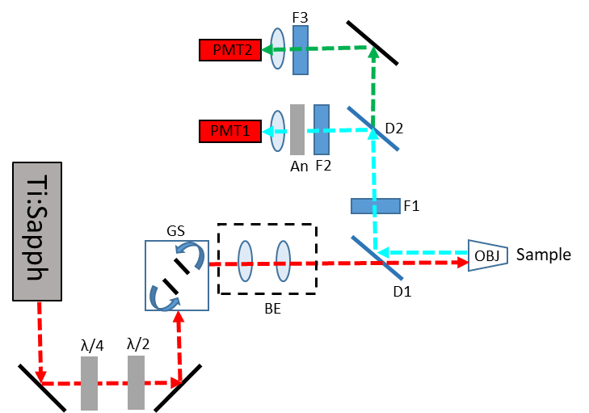
Scheme 1. Schematic of the SHG imaging system. The linearly polarised output of a femtosecond pulsed laser (Ti:Sapph) is passed through a quarter(λ/4) and half waveplate(λ/2) to provide pre-compensation of induced ellipticity and to rotate the linear polarisation respectively. The beam is scanned by a pair of galvanometric mirrors, excitation is separated from emission via a dichroic mirror (D1) and signal cleaned using a short pass filter (D2). SHG signal is separated using a dichroic mirror (D2) and filtered (F2) before being focussed onto PMT1. For polarisation sensitive detection and analyser (An) was placed immediately after F2. Longer wavelength signals were detected on PMT 2 after filtering with an appropriate band pass filter (F3). GS: Galvo scanner, BE: Beam expander
PNJ generation for imaging
Spheres made of Barium Titanate glass (BTG, refractive index of 1.9) were used. Their high refractive index contrast allowed them to be used with water (n=1.33) to form a photonic nanojet in water immersion medium with corresponding objectives commonly used for biological and multiphoton applications. Amorphous Barium titanate (BaTiO₃) microspheres were purchased from Cospheric (Santa Barbara, CA, USA) in two size ranges of 5-22 μm and 53-63 μm. Spheres were suspended in water by rapid pipetting and a drop of the water deposited onto the sample surface. Microspheres rapidly sunk to the sample surface and the water droplet formed the immersion medium for imaging. Self-assembled sphere arrays were formed by allowing the droplet of sphere suspension to dry where surface tension act to pull the spheres into an array. A droplet of clean water (not containing spheres) was then gently deposited on top of the array to act as the immersion medium.
Barium Titanate Sample preparation
Barium Titanate nanocrystals <100nm specified size(Sigma-Aldrich)were suspended in ethanol, ultrasonicated for 10 minutes to break up aggregates, then a 10μL drop was placed onto a clean microscope slide and left to air dry.
Mouse tendon sample preparation
All mouse experiments were carried out in accordance with the Animals (Scientific Procedures) Act 1986 set out by the UK Home Office. Female C57BL/6 mice aged between 4-6 months were culled via CO2 and cervical dislocation. The tail was removed using scissors and the tendon removed using a pair of forceps and was fixed in 4% paraformaldehyde for 6-8 hours. They were then washed in Phosphate Buffered Saline (PBS) immediately before being mounted on a microscope slide and sealed under a coverslip (#1.5; 0.17 mm thick) before imaging.
Lung tissue
Dewaxed formalin-fixed paraffin-embedded human lung tissue sections (5 μm) were from tissue surplus to clinical requirements from lung biopsies of patients with a subsequent diagnosis of idiopathic pulmonary fibrosis (IPF) under the approval of the Southampton and South West Hampshire and the Mid and South Buckinghamshire Local Research Ethics Committees (ref 07/H0607/73). All subjects gave written informed consent.
Spheroid sample preparation
Details of spheroid growth have been described in detail previously [53]. Briefly: Primary lung fibroblasts from a patient with IPF were seeded in Transwell inserts under normal conditions for 24 hours before the media was replaced with that containing BAPN or control conditions. After 6 weeks of growth under these conditions the spheroids were harvested, fixed in 4% paraformaldehyde, paraffin embedded, and 5µm sections cut ready for imaging. For transmission electron microscopy(TEM) spheroids were fixed in 3% glutaraldehyde in 0.1M caco-dylate buffer at pH 7.4.
Transmission electron microscopy
As previously described [53] spheroids were post-fixed sequentially in osmium/ferocyanide fixative thiocarbohydrazide solution, osmium tetroxide, uranyle acetate and Walton’s lead aspartate solution before dehydration in graded ethanol and acetonitrile. Samples were embedded in Spurr resin and 100nm ultra-thin sections visualised using an FEI Tecnai 12 transmission electron microscope (FEI Company, Hillsboro,OR,USA).
SHG Resolution standard fabrication
Silicon membranes were commercially sourced (Norcada, Inc.), 200 nm thick polycrystalline silicon membrane 1x1mm, 200µm Silicon frame 5x5mm. FIB was performed on an FEI Helios NanoLab 600 FIB system. Each cut was formed by using an ion beam of Ga+ ions, with an acceleration voltage of 30 keV and beam current of 28 pA.
Simulations
Numerical simulations were carried out using COMSOL Multiphysics 5.4, a FEM (finite element method) based numerical software to investigate light propagation through the barium titanate microsphere (refractive index was assumed to be nms =1.9). We adopted full field formalism with periodic boundary conditions (Floquet) applied on all the four sides of the computational geometry assuming an infinite 2D periodic structure in the x-y plane, solving the wave equation in a three-dimensional model. The incident beam was assumed to be a plane wave, linearly polarised along x axis propagating from the front side of the microsphere ie along the z direction and the excitation wavelength was set at 800 nm. The size of the microsphere was taken to be 7 µm and was positioned at the centre of the computational window and also assumed to be embedded in water medium (n = 1.33). The relative permeability was taken to be µr =1. The entire structure was divided into domains and sub-domains, and each domain was meshed using free tetrahedral meshing of maximum element size 6 elements per wavelength outside the microsphere and extremely fine meshing within the sphere. Direct solver method was adopted to solve for the wave equation.
Calculation of Polarisation anisotropy
Polarisation anisotropy images were created using a home written Fiji macro in which the key steps are as follows: A difference image was generated by (I_{par} – I_{perp}), this was divided by a total intensity image (I_{par} + 2I_{perp}). The total intensity image was used to select the region of the image containing signal and for display all pixels outside of this region were set to 0. Only the regions containing signal were used for further anisotropy analysis.
Collagen fibre analysis
Collagen fibre analysis was performed using CT-FIRE V1.3. SHG intensity images were converted to 8bit format before being batch processed using default parameters. Four parameters were measured to describe fibre morphology, width, length, straightness and angle.

Funding

Disclosures
The authors declare no conflicts of interest.
See Supplement 1 for supporting content

References:
1. A. Bouhelier, "Nanoscale Optical Imaging and Spectroscopy," Ref. Modul. Mater. Sci. Mater. Eng. 1–12 (2016).
2. Zayats, Nano-Optics and Near-Field Optical Microscopy (2009).
3. S. M. Mansfield and G. S. Kino, "Solid immersion microscope," Appl. Phys. Lett. 57, 2615–2616 (1990).
4. S. J. Sahl, S. W. Hell, and S. Jakobs, "Fluorescence nanoscopy in cell biology," Nat. Rev. Mol. Cell Biol. 18, 685–701 (2017).
5. Z. Chen, A. Taflove, and V. Backman, "Photonic nanojet enhancement of backscattering of light by nanoparticles: a potential novel visible-light ultramicroscopy technique," Opt. Express 12, 1214 (2004).
6. C. Y. Liu, T. P. Yen, O. V. Minin, and I. V. Minin, "Engineering photonic nanojet by a graded-index micro-cuboid," Phys. E Low-Dimensional Syst. Nanostructures 98, 105–110 (2018).
7. I. V. Minin, O. V. Minin, and Y. E. Geints, "Localized em and photonic jets from non-spherical and non-symmetrical dielectric mesoscale objects: Brief review," Ann. Phys. 527, 491–497 (2015).
8. H. S. Patel, P. K. Kushwaha, and M. K. Swami, "Generation of highly confined photonic nanojet using crescent-shape refractive index profile in microsphere," Opt. Commun. 415, 140–145 (2018).
9. H. Yang, R. Trouillon, G. Huszka, and M. A. M. Gijs, "Super-Resolution Imaging of a Dielectric Microsphere Is Governed by the Waist of Its Photonic Nanojet," Nano Lett. 16, 4862–4870 (2016).
10. S. Zhou, Y. Deng, W. Zhou, M. Yu, H. P. Urbach, and Y. Wu, "Effects of whispering gallery mode in microsphere super-resolution imaging," Appl. Phys. B 123, 236 (2017).
11. A. Darafsheh, N. I. Limberopoulos, J. S. Derov, D. E. Walker, and V. N. Astratov, "Advantages of microsphere-assisted super-resolution imaging technique over solid immersion lens and confocal microscopies," Appl. Phys. Lett. 104, (2014).
12. S. Lee, L. Li, Y. Ben-Aryeh, Z. Wang, and W. Guo, "Overcoming the diffraction limit induced by microsphere optical nanoscopy," J. Opt. 15, 1–7 (2013).
13. A. Devilez, N. Bonod, J. Wenger, D. Gérard, B. Stout, H. Rigneault, and E. Popov, "Three-dimensional subwavelength confinement of light with dielectric microspheres," Opt. Express 17, 2089–2094 (2009).
14. A. Devilez, N. Bonod, and B. Stout, "Near field dielectric microlenses," in Proceedings of SPIE,, Optical Modelling and Design, F. Wyrowski, J. T. Sheridan, J. Tervo, and Y. Meuret, eds. (2010), Vol. 7717, p. 771708.
15. X. Hao, X. Liu, C. Kuang, Y. Li, Y. Ku, H. Zhang, H. Li, and L. Tong, "Far-field super-resolution imaging using near-field illumination by micro-fiber," Appl. Phys. Lett. 102, 1–4 (2013).
16. H. S. Patel, P. K. Kushwaha, and M. K. Swami, "Photonic nanojet assisted enhancement of Raman signal: Effect of refractive index contrast," J. Appl. Phys. 123, 023102 (2018).
17. Z. Wang, W. Guo, L. Li, B. Luk’yanchuk, A. Khan, Z. Liu, Z. Chen, and M. Hong, "Optical virtual imaging at 50 nm lateral resolution with a white-light nanoscope," Nat. Commun. 2, 1–6 (2011).
18. H. Yang, N. Moullan, J. Auwerx, and M. A. M. Gijs, "Super-resolution biological microscopy using virtual imaging by a microsphere nanoscope," Small 10, 1712–1718 (2014).
19. Y. Yan, L. Li, C. Feng, W. Guo, S. Lee, and M. Hong, "Microsphere-coupled scanning laser confocal nanoscope for sub-diffraction-limited imaging at 25 nm lateral resolution in the visible spectrum," ACS Nano 8, 1809–1816 (2014).
20. K. F. Tehrani, A. Darafsheh, L. J. Mortensen, and S. Phang, "Resolution enhancement of 2-photon microscopy using high-refractive index microspheres," in Proceedings of SPIE Multiphoton Microscopy in the Biomedical Sciences XVIII (SPIE, 2018), Vol. 1049833, pp. 1049833(1–7).
21. F. S. Pavone and P. J. Campagnola, Second Harmonic Generation Imaging (CRC Press, 2014).
22. P. J. Su, W. L. Chen, Y. F. Chen, and C. Y. Dong, "Determination of collagen nanostructure from second-order susceptibility tensor analysis," Biophys. J. 100, 2053–2062 (2011).
23. A. E. Tuer, S. Krouglov, N. Prent, R. Cisek, D. Sandkuijl, K. Yasufuku, B. C. Wilson, and V. Barzda, "Nonlinear optical properties of type I collagen fibers studied by polarization dependent second harmonic generation microscopy," J. Phys. Chem. B 115, 12759–12769 (2011).
24. E. I. Romijn, A. Finnøy, and M. B. Lilledahl, "Analyzing the feasibility of discriminating between collagen type I and II using polarization resolved second harmonic generation," J. Biophotonics 12, e201800090 (2018).
25. I. Gusachenko, V. Tran, Y. G. Houssen, J. Allain, and M.-C. Schanne-Klein, "Polarization-Resolved Second-Harmonic Generation in Tendon upon Mechanical Stretching," Biophys. J. 102, 2220–2229 (2012).
26. R. M. Kottmann, J. Sharp, K. Owens, P. Salzman, G. Xiao, R. P. Phipps, P. J. Sime, E. B. Brown, and S. W. Perry, "Second harmonic generation microscopy reveals altered collagen microstructure in usual interstitial pneumonia versus healthy lung," Respir. Res. 16, 1–13 (2015).
27. Tilbury, J. Hocker, B. L. Wen, N. Sandbo, V. Singh, and P. J. Campagnola, "Second harmonic generation microscopy analysis of extracellular matrix changes in human idiopathic pulmonary fibrosis," J. Biomed. Opt. 19, 086014(1–8) (2014).
28. Q. Peng, S. Zhuo, P. T. C. So, and H. Yu, "Improving liver fibrosis diagnosis based on forward and backward second harmonic generation signals," Appl. Phys. Lett. 106, 0837011–0837015 (2015).
29. S. V Plotnikov, A. C. Millard, P. J. Campagnola, and W. A. Mohler, "Characterization of the myosin-based source for second-harmonic generation from muscle sarcomeres.," Biophys. J. 90, 693–703 (2006).
30. D. a Dombeck, K. a Kasischke, H. D. Vishwasrao, M. Ingelsson, B. T. Hyman, and W. W. Webb, "Uniform polarity microtubule assemblies imaged in native brain tissue by second-harmonic generation microscopy," Proc. Natl. Acad. Sci. 100, 7081–7086 (2003).
31. V. Lutz, M. Sattler, S. Gallinat, H. Wenck, R. Poertner, and F. Fischer, "Impact of collagen crosslinking on the second harmonic generation signal and the fluorescence lifetime of collagen autofluorescence," Ski. Res. Technol. 18, 168–179 (2012).
32. P. J. Campagnola and C. Y. Dong, "Second harmonic generation microscopy: Principles and applications to disease diagnosis," Laser Photonics Rev. 5, 13–26 (2011).
33. M. Strupler, A. Pena, M. Hernest, P. Tharaux, J. Martin, E. Beaurepaire, M. Schanne-Klein, P. J. Campagnola, A. C. Millard, M. Terasaki, P. E. Hoppe, C. J. Malone, W. A. Mohler, G. Cox, E. Kable, A. Jones, I. Fraser, K. Marconi, M. D. Gorrell, T. Boulesteix, A. M. Pena, N. Pagès, G. Godeau, M. Sauviat, M. C. Schanne-Klein, S. Lin, R.-J. Wu, H. Tan, W. Lo, W. Lin, T. Young, C. Hsu, J. Chen, S. Jee, A. Fabre, D. Débarre, J. Marchal-Somme, B. Crestani, W. Teng, K. H. Kim, H. Chen, H. Lee, Y. Chen, P. T. C So, and C. Dong, "Second harmonic imaging and scoring of collagen in fibrotic tissues," Opt. Express 15, 4054–4065 (2007).
34. S. Bancelin, C. Aimé, I. Gusachenko, L. Kowalczuk, G. Latour, T. Coradin, and M.-C. Schanne-Klein, "Determination of collagen fibril size via absolute measurements of second-harmonic generation signals," Nat. Commun. 5, 4920 (2014).
35. D. A. D. Parry, G. R. G. Barnes, and A. S. Craig, "A comparison of the size distribution of collagen fibrils in connective tissues as a function of age and a possible relation between fibril size distribution and mechanical properties," Proc. R. Soc. London - Biol. Sci. 203, 305–321 (1978).
36. R. Gauderon, P. B. Lukins, and C. J. R. Sheppard, "Three-dimensional second-harmonic generation imaging with femtosecond laser pulses," Opt. Lett. 23, 1209 (1998).
37. E. Hecht, Optics, 4th ed. (Addison Wesley, 2001).
38. M. Born, E. Wolf, A. B. Bhatia, P. C. Clemmow, D. Gabor, A. R. Stokes, A. M. Taylor, P. A. Wayman, and W. L. Wilcock, Principles of Optics, 7th ed. (Cambridge University Press, 1999).
39. N. Tian, L. Fu, and M. Gu, "Resolution and contrast enhancement of subtractive second harmonic generation microscopy with a circularly polarized vortex beam," Sci. Rep. 5, 13580 (2015).
40. R. W. Boyd, Nonlinear Optics, Third (Academic Press, Inc, 2008).
41. J. Zhu and L. L. Goddard, "All-dielectric concentration of electromagnetic fields at the nanoscale: The role of photonic nanojets," Nanoscale Adv. 1, 4615–4643 (2019).
42. Y. Ben-Aryeh, "Superresolution observed from evanescent waves transmitted through nano-corrugated metallic films," Appl. Phys. B Lasers Opt. 109, 165–170 (2012).
43. G. Huszka and M. A. M. Gijs, "Turning a normal microscope into a super-resolution instrument using a scanning microlens array," Sci. Rep. 8, 601 (2018).
44. Y. Yan, C. Xing, Y. Jia, Y. Zeng, Y. Zhao, and Y. Jiang, "Self-assembled dielectric microsphere array enhanced Raman scattering for large-area and ultra-long working distance confocal detection," Opt. Express 23, 25854–25865 (2015).
45. T. Zhang, P. Li, H. Yu, F. Wang, X. Wang, and T. Yang, "Fabrication of Flexible Microlens Arrays for Parallel Super-Resolution Imaging," Appl. Surf. Sci. 504, 144375 (2019).
46. N. Mazumder, G. Deka, W. W. Wu, A. Gogoi, G. Y. Zhuo, and F. J. Kao, "Polarization resolved second harmonic microscopy," Methods 128, 105–118 (2017).
47. J. Liu, I. Cho, Y. Cui, and J. Irudayaraj, "Second Harmonic Super-resolution Microscopy for Quanti fi cation of mRNA at Single Copy Sensitivity," ACS Nano 8, 12418–12427 (2014).
48. T. Yasui, Y. Tohno, and T. Araki, "Determination of collagen fiber orientation in human tissue by use of polarization measurement of molecular second-harmonic-generation light," Appl. Opt. 43, 2861–2867 (2004).
49. T. J. Gould, M. S. Gunewardene, M. V. Gudheti, V. V. Verkhusha, S. R. Yin, J. A. Gosse, and S. T. Hess, "Nanoscale imaging of molecular positions and anisotropies," Nat. Methods 5, 1027–1030 (2008).
50. N. Hafi, M. Grunwald, L. S. Van Den Heuvel, T. Aspelmeier, J. H. Chen, M. Zagrebelsky, O. M. Schütte, C. Steinem, M. Korte, A. Munk, and P. J. Walla, "Fluorescence nanoscopy by polarization modulation and polarization angle narrowing," Nat. Methods 11, 579–584 (2014).
51. K. R. Campbell, R. Chaudhary, J. M. Handel, M. S. Patankar, and P. J. Campagnola, "Polarization-resolved second harmonic generation imaging of human ovarian cancer," J. Biomed. Opt. 23, 066501 (2018).
52. K. Tilbury, C. H. Lien, S. J. Chen, and P. J. Campagnola, "Differentiation of col I and Col III isoforms in stromal models of ovarian cancer by analysis of second harmonic generation polarization and emission directionality," Biophys. J. 106, 354–365 (2014).
53. M. G. Jones, O. G. Andriotis, J. J. W. Roberts, K. Lunn, V. J. Tear, L. Cao, K. Ask, D. E. Smart, A. Bonfanti, P. Johnson, A. Alzetani, F. Conforti, R. Doherty, C. Y. Lai, B. Johnson, K. N. Bourdakos, S. V. Fletcher, B. G. Marshall, S. Jogai, C. J. Brereton, S. J. Chee, C. H. Ottensmeier, P. Sime, J. Gauldie, M. Kolb, S. Mahajan, A. Fabre, A. Bhaskar, W. Jarolimek, L. Richeldi, K. M. A. O’Reilly, P. D. Monk, P. J. Thurner, and D. E. Davies, "Nanoscale dysregulation of collagen structure-function disrupts mechano-homeostasis and mediates pulmonary fibrosis," Elife 7, 1–24 (2018).
54. R. LaComb, O. Nadiarnykh, S. S. Townsend, and P. J. Campagnola, "Phase matching considerations in second harmonic generation from tissues: Effects on emission directionality, conversion efficiency and observed morphology," Opt. Commun. 281, 1823–1832 (2008).
55. W. R. Zipfel, R. M. Williams, and W. W. Webb, "Nonlinear magic: Multiphoton microscopy in the biosciences," Nat. Biotechnol. 21, 1369–1377 (2003).
56. T. Starborg, N. S. Kalson, Y. Lu, A. Mironov, T. F. Cootes, D. F. Holmes, and K. E. Kadler, "Using transmission electron microscopy and 3View to determine collagen fibril size and three-dimensional organization.," Nat. Protoc. 8, 1433–48 (2013).
57. C. K. Wen and M. Cynthia Goh, "Fibrous Long Spacing Type Collagen Fibrils Have a Hierarchical Internal Structure," Proteins 64, 227–233 (2006).
58. M. Tzaphlidou, J. A. Chapman, and K. M. Meek, "A study of positive staining for electron microscopy using collagen as a model system-I. Staining by phosphotungstate and tungstate ions," Micron 13, 119–131 (1982).
59. P. K. Viji Babu, C. Rianna, U. Mirastschijski, and M. Radmacher, "Nano-mechanical mapping of interdependent cell and ECM mechanics by AFM force spectroscopy," Sci. Rep. 9, 12317 (2019).

