**Techno-economic assessment of reversible Solid Oxide Cell integration to renewable energy systems at building and district scale  
Mario Lamagnaa, Benedetto Nastasib**, **Daniele Groppia, Caroline Rozainc, Massimiliano Manfrend,\***, **Davide Astiaso Garciab**

a Department of Astronautical, Electrical and Energy Engineering (DIAEE), Sapienza University of Rome, Via Eudossiana, 18 – 00184 Rome, Italy

b Department of Planning, Design, Technology of Architecture, Sapienza University of Rome, Via Flaminia 72 – 00196 Rome, Italy

c Sylfen, France

d Faculty of Engineering and Physical Sciences, University of Southampton, Boldrewood Campus – SO16 7QF Southampton, United Kingdom

*Corresponding author. Email: m.manfren@soton.ac.uk

# Abstract

Hydrogen is assuming a crescent role in the decarbonising initiatives. Moreover, hydrogen can supply the 3 most energy intense sectors, i.e. transport, heat and electricity, allowing the sector coupling. To do so, a production unit, the electrolyser, and a consumer one, the fuel cell, are needed. Actually, reversible Solid Oxide Cell technology presents the possibility to install only one device acting bi-directionally. It offers different advantages thank to its (i) compact design, thus ensuring space and cost savings; (ii) ability to meet thermal and electric demand, thus reducing emissions in both those sectors; (iii) possibility to store, the electricity excess coming from renewable sources in form of hydrogen, ensuring an unlimited and seasonal storage possibility.

In this study, the deployment of a real reversible Solid Oxide Cell was simulated in different scenarios considering the data recorded in one year in the island of Procida, Italy. Up to date, the use of this technology was mostly relegated to the industrial sector or to prototype tests. While, this research aimed to analyse the functioning of near commercialization technology in civil environments such as hotels, offices and hospitals to understand its feasibility in this new context. It wants to be proved that advantages of this emerging technology can be exploited as well in the civil environment. Three economic indicators, i.e. Payback Period, Internal Return Rate and Net Present Value were selected to evaluate the simulated scenarios, while, the primary energy saving, the emission reduction and its storage efficacy were studied to evaluate the environmental achievements. To perform the simulations, the MATLAB model ConfigDym built by Sylfen was used. Finally, a sensitivity analysis in terms of economics was carried out. The results show an important decrease in emissions and an energy self-sufficiency increase of at least 29% and 58% respectively, differently the economic analysis returns a payback period currently near to its lifetime, while for the future a three years period is reachable.

**Highlights**

* The Smart Energy Hub system is presented;
* A reversible Solid Oxide Cell is coupled with battery and hydrogen tank;
* The system operation is investigated in real buildings integration;
* An increase of self-sufficiency is achieved to balance the weak connection to the Grid;
* CAPEX and OPEX learning curves are considered for the economic analysis.

**Keywords**

Hybrid energy storage system; solar hydrogen integration in buildings; island sustainability; rSOC electrolyser and fuel cell; small scale power to gas.

**Word count**

9680 words

**Nomenclature**

CAPEX Capital Expenditure ($)

Cf Net annual positive Cash Flow (€)

CO2 sav Carbon dioxide emission saved in new scenarios (%)

FC*el* Electricity produced by the rSOC using green hydrogen (kWh)

Integration Integration of PV source in total building consumptions (%)

*i* Discount rate(%)

IRR Internal Return Rate (%)

LCS Levelised Cost of Storage (€/kWh)

NPV Net Present Value (€)

OPEX Operative Expenditure (€/y)

PBP Pay Back Period (y)

PES Primary Energy Saving (%)

REScons Consumption supplied by renewable source (%)

Rt  Net annual cash inflow-outflow (€)

*t* Time period (y)

To Grid PV production sent to the Power Grid (%)

*List of abbreviations*

BTP Buoni del Tesoro Pluriennali (Italian Bond)

CHP Combined Heat and Power

DHW Domestic Hot Water

LCS Levelized Cost of Storage

Li-ion Lithium-ion battery

NG Natural Gas

OE Optimization Engine

PEM Proton Exchange Membrane

PV Photovoltaic panels

RES Renewable Energy Source

rSOC reversible Solid Oxide Cell

SEH Smart Energy Hub

SOR Switch Operation Restriction

SOC Solid Oxide Cells

SOEC Solid Oxide EleCtrolyser

SOFC Solid Oxide Fuel Cell

TRL Technology Readiness Level

VPP Virtual Power Plant

*Chemical symbols*

CO2 Carbon Dioxide

H2  Hydrogen

**1. Introduction**

Energy conversion with fuel cells technologies have been reported since 1839 [1], but in the recent years a renewed interest took place due to their unique characteristics as solutions for the energy transition [2]. In particular, the development of hydrogen-based technologies has been pushed actively by public authorities and will accelerate further thanks to the implementation of the European Hydrogen Alliance [3]. Hydrogen (H2) is considered fundamental to cut harmful emissions in transport, industry and building sectors [4] being the optimal energy vector to store excess production from renewable energy sources (RES) [5]. It can be an answer to medium-term and seasonal needs [6] for storage along with the supply of decarbonized fuel for mobility [7]. The motivations behind this new interest are related to the high efficiency in converting the hydrogen chemical energy into electricity, the noiseless operation [8], the almost total absence of harmful emissions for man and the environment during its operation [9], and the possibility to produce hydrogen locally satisfying a domestic demand, without resorting on import from abroad increasing the energy system sufficiency and resilience [10]. Among the various hydrogen conversion technologies, one of the most interesting options is certainly represented by Solid Oxide Cell (SOC) technology as they offer several advantages in comparison to Proton Exchange Membrane (PEM) and alkaline solutions although they have a higher initial cost [11]. The advantages are: (i) higher overall efficiencies linked to their high operating temperatures, between 650 and 1000 °C [12], (ii) the possibility to jointly produce power and high temperature heat, i.e. Combined Heat and Power (CHP) system, and (iii) the lowest Levelized Cost of Storage (LCS) [13] in reversible mode (rSOC) i.e. electrolysis and fuel cell functions within the same unit allowing to store external energy excess in form of hydrogen, and, then, to reuse it to produce electricity and heat when it is most needed [14]. Furthermore, they also offer (iv) the possibility to supply power and heat not only using pure hydrogen as fuel, but also exploiting Natural Gas (NG) or hydrocarbons fuel [15], thanks to their ability to reform the fuel directly within the fuel cell with the thermal power produced [16] without neglecting the possible carbon deposition issue during the operations [17]. This feature should not be underestimated since it offers a great fuel management flexibility. Nevertheless, considering the expected NG role in the energy transition regarding RES integration [18], the SOCs are in an advantageous position for the next integrated energy system designs. Additionally, it should be emphasized that combining two devices allows the reduction of initial investment and maintenance costs along with the overall encumbrance. Solid Oxide Fuel Cell (SOFC) applicative examples can already be found, implemented in Rankine [19], Brayton [20], or Organic Rankine [21] cycles for energy production or for residential applications [22] up to even a National domestic sector [23]. Solid Oxide Electrolyser (SOEC) and rSOC technologies have lower Technology Readiness Level (TRL) and few laboratory machines are reported in [24] as well as a very limited number of available field tests.

Buildings, counting for more than 40% of the total consumption and Carbon Dioxide (CO2) country emission [25] are now switching from pure consumer to prosumer thus becoming a nodal point of the energy transition [26]. Energy management systems to match on time production and demand can be coupled with technologies such as rSOC systems, with its unique features of storage and generation. At present, there is a limited literature involving their use [27].

Although other studies examined similar strategies, a link between the available technology and its direct application in a real building is still missing or weak. In literature it is possible to find different laboratory tests and modelling dedicated to improving the rSOC performances [28], or to analyse its integration in larger energy systems as performed in [29] and [30].

Nevertheless, it is possible to find some research where the deployment of this technology has been analysed, for example the work done in [31], where the focus was the implementation of an optimization function to lower operation and maintenance costs for a rSOC installed in an office with photovoltaic (PV) panels on the rooftop. Besides, NG consumption was not considered and the rSOC outputs were fixed according to a ratio 1kW to 4 kW in SOFC and SOEC modes, respectively, giving no information about purchase costs and real models availability. Similarly, in [32] a rSOC functioning is analysed as the core of a polygeneration smart grid, but in this case, although if based on a real model developed by Sunfire[33], the entire project is grid oriented and does not reflect the technology deployment in an individual building. Likewise, in [34] the rSOC, reconstructed from chemical balances presented in [35] which works in SOFC only with hydrogen gas, is studied in a microgrid made by RESs supplying a virtual load represented by a residential complex made of twenty units, 5 electric and 2 hydrogen vehicles. In [36] a commercially available rSOC based on DLR – German Aerospace Centre studies [37] and [38] is modelled and tested in a self-sustaining system configuration designed to gauge its round-trip efficiency and the internal thermal valorisation efficacy. Nevertheless, during the simulations performed no mention to NG blend with hydrogen is declared and neither a characterization of real demand is underpinned. In [39], a rSOC model based on the studies conducted in [40] is used to test the balance of plant and system partial load. In the study the NG use as well as thermal storage options were considered, even if no reference to a building or industries demand was assessed since it is outside the scope of their study.

The novelty of the presented work is to study a model of commercially available rSOC, and to evaluate its performances not at industrial or laboratory scale but in a real building environment by means of dedicated software able also to consider fuel flexibility, battery coupling and thermal valorisation which brings an additional added value to the presented investigation.

The main objective of this paper is, therefore, to study the feasibility of using a rSOC technology to increase energy and emissions savings in buildings. Three buildings have been selected as representative consumption loads, namely an office, a hospital and a hotel. The office shows an energy consumption during working hours, the hospital must always maintain high constant operation standard and the hotel is characterized by strong seasonality and variable attendance during the week, often in counter-phase with the office profile [41]. These different demand curves will be an interesting element to test the operation of a real rSOC in different end-users working as a Virtual Power Plant (VPP) [42]. Furthermore, their combination in a micro-grid is of interest to expect the best performance due to their diverse hourly distribution of the loads[43]. Technical data are obtained from Sylfen, French company that is developing the Smart Energy Hub, an all-in-one storage and cogeneration solution based on rSOC and battery [44]. Several scenarios are simulated using Sylfen’s proprietary simulation software called ConfigDym® in combination with MS Excel tools developed by the authors.

**2. Material and Methods**

In this section, an outlook on the selected technology is given along with the description of the use cases for the scenarios to simulate. Likewise, information about the piloting strategies implemented in the ConfigDym® software is specified to give a wider comprehension of the implemented functioning. The model is based on the findings of the lab test analyses performed by Sylfen at the Engie Lab reported in [45].

*2.1. Smart Energy Hub and hybrid storage*

The Smart Energy Hub (SEH) developed by Sylfen is composed of three modular elements that can be tailored to the building energy needs: (i) Lithium-ion (Li-ion) battery modules, which with their high reversing speed ensure short term response [46], (ii) rSOC energy processor modules for long-term storage and additional back-up power through NG CHP and (iii) hydrogen compression and storage unit to store large quantity of energy without any self-discharge in the form of hydrogen [47]. The energy processor module stores energy at maximum power (for the first generation) of 40.9 kWe and generates 6.7 kWe producing 4 kWth in both modes. It is possible to integrate up to 6 rSOC modules and, thus, to accumulate their power to precisely adapt to the user’s needs.

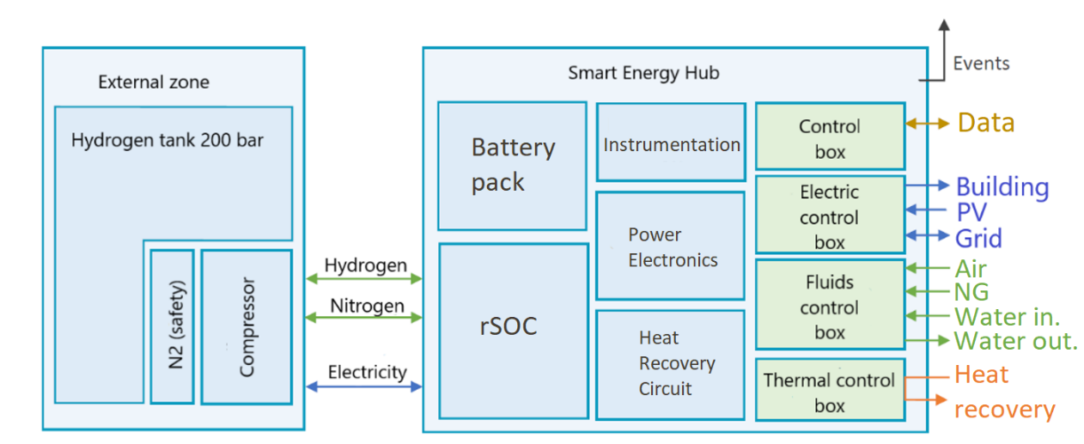

**Figure 1**. SEH scheme

The high temperature heat continuously produced by the energy processor (80°-90°C) is used to produce Domestic Hot Water (DHW) and for space heating purposes but, it can be also used into a district heating network resulting in an efficient system, especially considering an old building refurbishment [48]. Figure 1 reports how, schematically, the SEH is composed and the data flow interchanged with the building, and the Power and Gas Grids. All these flows are considered to simulate the actual rSOC operation within the building.

|  |  |
| --- | --- |
| **Storage system** | **1 module** |
| Battery capacity [kWh] | 50 |
| Battery charging power [kW] | 50 |
| Battery electrical efficiency – charging mode [%] | 90 |
| rSOC storage power [kW] | 9.9-40.8 |
| Hydrogen production [kg/h] | 0.25-0.9 |
| rSOC Electrical storage efficiency [%] | 65-80 |
| rSOC Thermal power [kWth] | 1-4 |
| Storage Pressure [bars] | 30-200 |
| Hydrogen storage [kg] | 10 |

Table 1. SEH storage characteristics

The hydrogen storage size is defined for each use case depending mainly on the available excess electrical capacity that needs to be stored. The hydrogen compression unit is dimensioned according to the number of rSOC module i.e. the produced hydrogen storage.

|  |  |
| --- | --- |
| **Production system** | **1 module** |
| Battery discharging power [kW] | 50 |
| Battery electrical efficiency – discharging mode [%] | 90 |
| rSOC power supply [kW] | 2.1- 6.7 |
| Max hydrogen consumption [kg/h] | 0.4 |
| Max natural gas consumption [kg/h] | 0.8 |
| rSOC Thermal power [kWth] | 1- 4 |
| rSOC Electrical production efficiency [%] | 40-50 |

Table 2. SEH supply characteristics

*2.2. ConfigDym® software for components sizing*

Sylfen developed an in-house simulation software in MATLAB, i.e. ConfigDym®, that estimates in real time the energy optimization strategies for its SEH according to the renewable energy production, the buildings electricity and heat consumptions and their forecasted amounts.

To describe the building demand, 4 vectors are defined (i) miscellaneous electric consumption (ii) heating provided by fossil fuels, (iii) heating provided by electricity, and (iv) cooling provided by electricity. These vectors represent the building hourly energy requests to the Power and Gas Grids. The software can work with a prefixed time length, adjustable according to the circumstances of the analysis. For this work, a time length of one year is taken as reference period on hourly resolution. Similarly, a vector describing the RES production is needed with hourly resolutions. The National Renewable Energy Laboratory PVwatts calculator [49] is used to estimate the hourly solar production for Procida location. Standard PV modules with a 30° inclination (15% efficiency) are used for the simulations.

The SEH performances are already coded in the software, the only information needed to characterize the virtual machine is the number of modules (from 1 to 6), the battery pack size with its safety charge level thresholds, settled to avoid hysteresis effects, and with its efficiency and finally the hydrogen storage size with the related pressure settings. The energy needed to store the hydrogen in the compressed tank is already evaluated in SOEC energy consumption.

Then, there is the fuel selection part enabled to select 3 types of supply: hydrogen coming from the tank, NG coming from the National Grid, or a mix of both fuels. Indeed, the rSOC outputs change according to fuel selection as well as related emissions. The software logic is reported in Figure 2.

The operation mode is determined from the net power balance, and from the battery state of charge. When a surplus of energy production occurs, and the batteries are charged over the defined threshold value, the rSOC is authorized to operate in the SOEC mode. The SEH still works in this mode until three conditions are verified: (i) the tank is not full, (ii) the battery state of charge does not go outside the indicated safety charge level to avoid the hysteresis effects and (iii) the building does not need the stored energy. In this latter condition, if the Switch Operation Restriction (SOR) is respected, the SEH changes its operation in SOFC mode while, the battery is still supplying the building, otherwise the energy need will be purchased from the National Power Grids or by battery only.

The SOR is already coded in the software and it limits the number of changes from a mode to another in once every in four hours. The restriction imposed in this simulation is defined to preserve the rSOC lifetime, reducing the thermal and mechanical solicitations verified when a change mode is taking place.

The rSOC module can store electricity in electrolysis mode within the range shown in Table1.

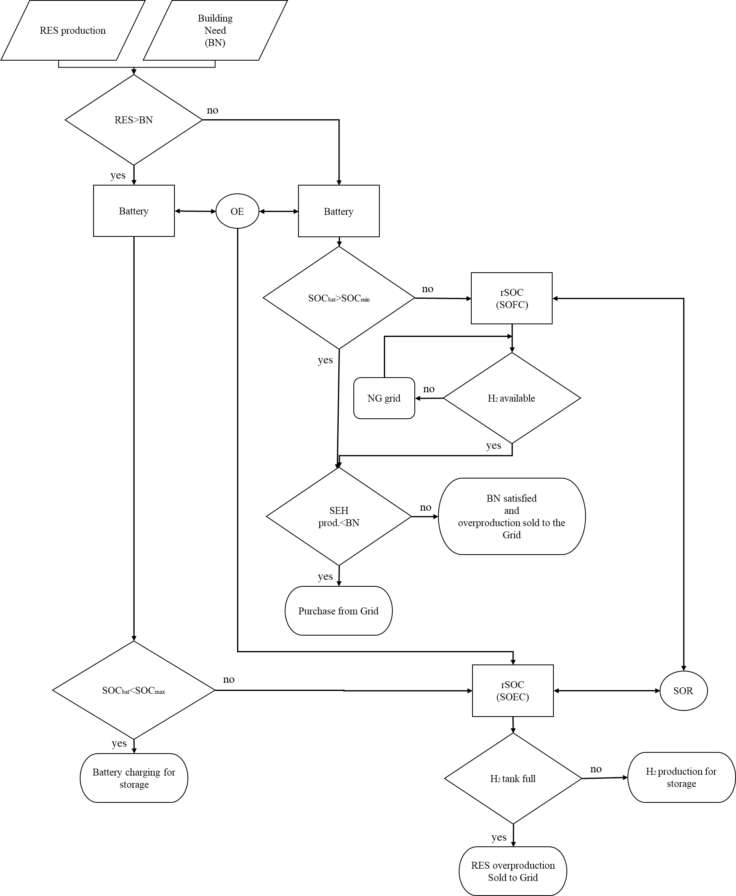

**Figure 2**. SEH Synoptic piloting strategy

If the net power is superior to the minimum power to trigger the SOEC mode then, the rSOC is set to convert this energy excess into hydrogen. If the net power is inferior to the minimum power for SOEC but, with some energy stored in the battery then, the rSOC switches to electrolyser mode to store the excess coming from PV in hydrogen form with additional power coming from battery. If any of those conditions cannot be respected, and the batteries are already charged, the excess is sent to the Power Grid.

At each time step there is an Optimization Engine (OE) calculating the best battery strategy operation according to the PV production, the building needs, and the battery state of charge. When it is possible to change mode respecting the SOR, the OE decides if the battery can contribute to supply alongside with RES the SOEC mode. The OE studies a parallel loop verifying the building needs over the next 12 hours. Thus, if in the next hours the battery will be needed to supply the building peak power and their future state of charge will not be adequate, the OE stops the battery from supplying the SOEC. The forecast performed by the OE is based on statistical assumptions made on the consumptions already recorded in terms of building needs and RES production while the battery functioning is evaluated by the software itself. When possible, the switch takes place in far less than one hour thus it is not directly appreciable during this hourly simulation resolution based on the quality of the available data. Similarly, the maintenance and the start-up operations needed by the rSOC require few days to be completed, since the annual duration of the simulation those day are neglected.

*2.3. Description of the use cases*

Procida is the smallest of the three major islands of Naples’ Province and the closest to the mainland, only 3.4 km from the Phlegraean peninsula, in fact although very weakly, the island is connected to the national water, electric and gas Grids. Thanks to the collaboration with the local municipality, it was possible to gather consumption data to study three different type of buildings: an hotel, a hospital and an office. Mediterranean Islands have a great renewable energy potential, but generally they still have large local fossil fuels use that is expensive and even more pollutant when emitted nearby protected or confined areas [50].

2.3.1. Hotel

The building relies only on electricity-driven appliances and systems as most of the buildings in the island. Its management authority provided the energy bills. The received bills are used to make first a monthly profile consumption and then, throughout a linear normalization with a known profile [51] the necessary hourly vector for the software is assessed following the procedures reported by some of the authors in [52]. The resulting vector for the year 2018 is reported in Figure 3. Since no indications about consumptions breakdown is given by bills, it is assumed that the space conditioning is the 42% of total consumption while the 26% is used for heating purposes, the residual is consumed by other appliances as stated in [53]. The total available surface for installing a PV plant would be 725 m2 and thus 90 kWp power has been considered in the simulations.

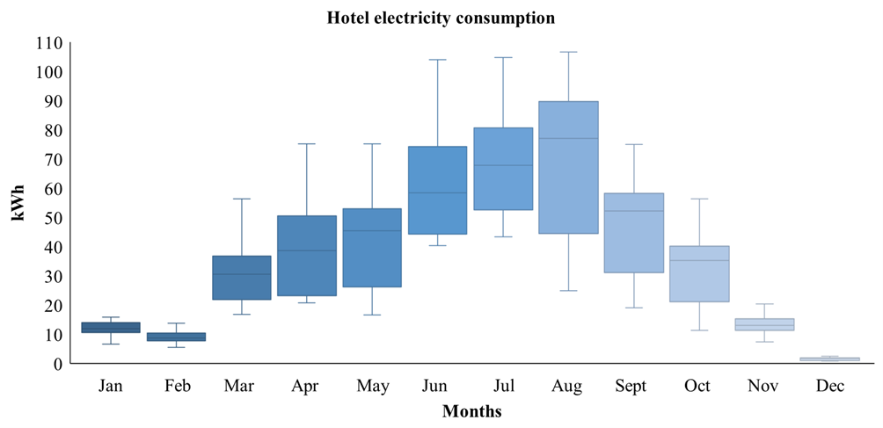

**Figure 3**. Hotel annual electricity consumption

2.3.2. Hospital

The heating and DHW systems are supplied by a diesel boiler and a thermal storage tank with a capacity of 800 L. The efficiency of the boiler is stated at 90.7%[54]. The diesel consumption declared by the hospital is 3,000 L/months during wintertime and between 400 or 500 L/months during summer season. The heating system is on 24/7 and it is regulated by room temperature sensors. Once obtained the utility bills data, by using linear normalization of an existing profile on similar building typology [55], the hourly vectors are calculated as in the first case and reported in Figure 4 for the electric load profile and in Figure 5 for the thermal one. To assess the different hourly consumptions subdivision the instructions given by [56]and [57] are used. The available surface for installing PV panels is 960 m2 which could offer a power installed peak of 168 kW, of which 80 kW on roof and the remaining power in the surrounding garden.

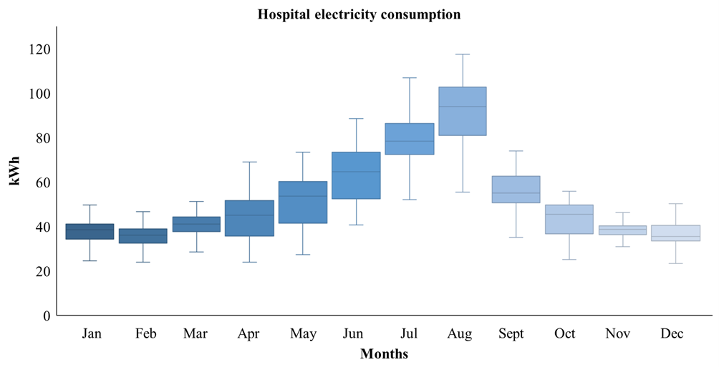

**Figure 4**. Hospital annual electricity consumption

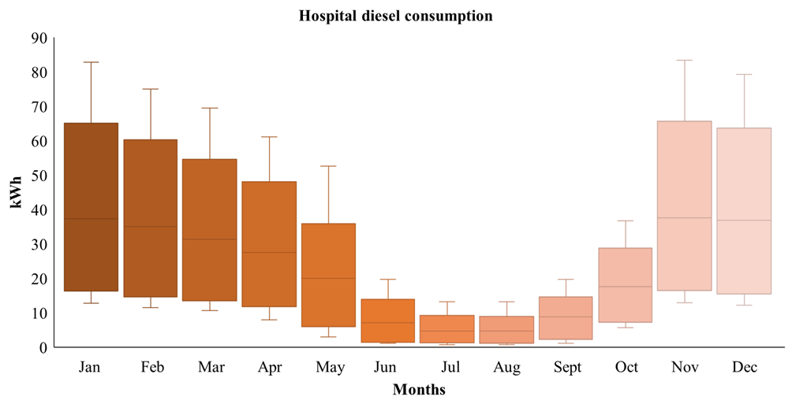

**Figure 5**. Hospital annual thermal energy consumption

2.3.3. Office

The Procida City hall has a total useful surface of 1,740 m2 and hosts 40 employees. The air conditioning system consists of a heat pump serving several single unit splits. As in the previous cases, thanks to the collaboration with the personnel, it was possible to get all the information of the year 2018. Then, using a known hourly consumption profile [58] for the same end use through the method reported in [52] and the required vector was built. Once again, the information about consumption subdivision is not given, thus a percentage division is assumed following the instruction in [59]. A 160 m2 PV plant (20 kWp) is already installed on the roof of the local City Hall with an additional power of 10 kWp that could be installed.

Although the new oversized PV can assure a certain RES surplus for ours purposes, it is worth noting that even with an installed capacity of 30 kWp, the excess power does not fit the optimum condition of the SEH as indicated in Table 1 and Table 2. For this reason, the building will not be analysed as a single user, but as part of a Smart District, explained in the next section.

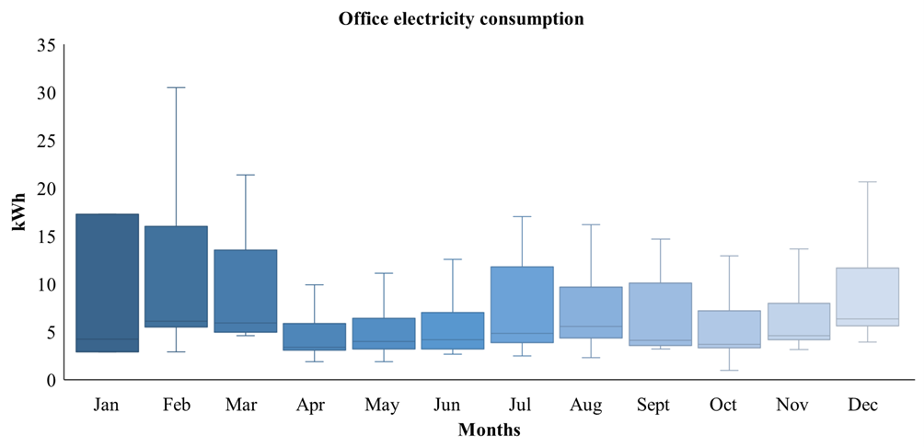

**Figure 6**. Office annual electricity consumption.

In Figure 6 are reported the building monthly consumption along one year, due to an error in the local switchboard meter, the consumptions for the month of January are average statistical consumption provided by the local distributor operator related to the investigated building.

2.3.4. Smart District

Rather than analyse the rSOC operation in the specific buildings only, an aggregate profile starting from the known data was built. As aforementioned, the office alone has low energy production and consumption potential compared to the minimum threshold to activate the rSOC reported in Tables 1 and 2. Nevertheless, this profile offers an interesting opportunity because its consumption shape is in counter-phase with the one recorded for the hotel. Since consumptions aggregation can be a valid future strategy to counteract RES overproduction and its managing problems [60], the aim of this test will be to study the rSOC operation in such aggregated context. The hotel, the hospital and the city hall will be analysed as a smart district where the three building consumptions can be fed by the PV plants already settled, for a total peak power of 200 kW made by roof PV systems only. The new district electric consumption is shown in Figure 7, while the thermal consumption by fossil fuels is equal to the consumption reported in Figure 5 since only the hospital heating system relies on fossil fuels**.**

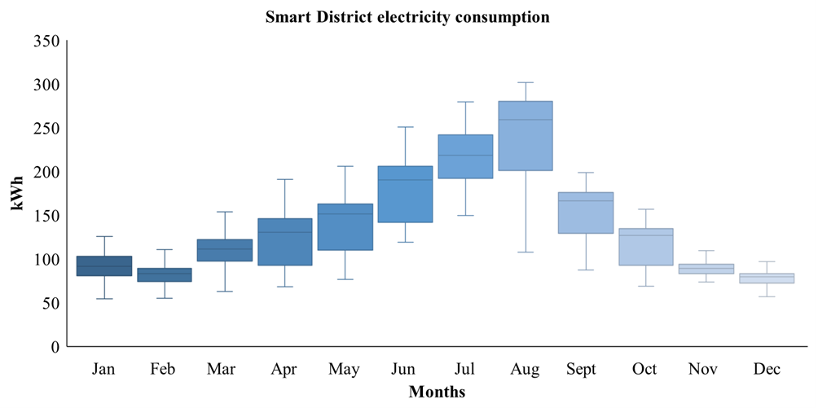

**Figure 7**. Smart District annual electricity consumption

*2.4. Key Performance Indicators*

The most relevant aspects analysed in those simulations are assessed by the selected Key Performance Indicators (KPI) divided in three areas:

2.4.1. Environmental

The first two KPIs refers to the CO2 saving (1) and Primary Energy Saving (PES) (2).

$CO_{2}sav=\frac{\left(CO_{2 in reference case}-CO_{2 in actual case}\right)}{CO_{2}reference case} [\%]$ (1)

$PES=\frac{{(PE}_{ in reference case}-{PE}_{ in simulated case})}{PE_{in reference case} }$ [%] (2)

Where the coefficient associated to primary energy and emissions are summarized in Table 3:

|  |  |  |
| --- | --- | --- |
| Generation | Primary Energy [kWh] | Emission[kgCO2/kWh] |
| Italian Power Grid | 2.42 | 0.447 |
| Diesel | 1.07 | 0.300 |
| Natural Gas | 1.04 | 0.234 |

Table 3.Primary Energy conversion factor [61],[62]

2.4.2. Grid

The chosen KPIs help to quantify the possible issue for the National Power Grid to absorb the surplus coming from local RES production and to understand how much of that produced energy is valorised in the building. To do so, the following quantities have been estimated:

(i) the consumption percentage supplied by renewable source (3), (ii) the production percentage sent to the Power Grid on the production from the PV (4), as signal of congestion for the grid, and (iii) finally, the renewable consumption percentage on PV total production (5), referred as integration of PV source in total consumptions:

${RES}_{cons}=\frac{FC_{el }+PV_{selfconsumption}+Batteries}{Electric Demand}$ [%] (3)

The term FCel is referring to the SEH rSOC electric contribution when it is working as SOFC.

$To Grid=\frac{Electricity to the gird}{PV total production} \left[\%\right]$ (4)

$Integration=\frac{FC_{el }+PV_{selfconsumption}+Batteries}{PV total production} \left[\%\right]$ (5)

Afterwards, a comparison is made to evaluate the amount of PV panels necessary only to attain the same outcomes scored by the SEH according to the selected KPIs. Thus, the size of the PV plant to be planned for obtaining the same CO2 reduction and REScons as with the SEH configuration is computed.

2.4.3. Economic

To conduct the economic analysis for the selected cases, capital expenditures (CAPEX) and operative expenditures (OPEX) of all systems must be determined. Table 4 presents CAPEX values used in the simulations. The value reported for the rSOC is a prototype price. The reported prices have to be intended comprehensive of installation and transport costs as well including the necessary permitting.

|  |  |
| --- | --- |
| Item | Price |
| PV panel [€/Wp] | 1.4 |
| Li-ion battery [€/kWh] | 450 |
| rSOC [k€/module] | 320 (prototype) |
| H2 tank [€/kg] | 500 |

Table 4. System components prices[63][65]

To evaluate the OPEX, different contributions are accounted:

1. Supply costs, coming from the utility bills for electricity, gas and diesel.
   1. electricity price: 0.20 €/kWh for the 2018 which corresponds to the yearly average cost from bills, for future bills a 4% annual increase is considered to evaluate the rising prices in the electric sector, considering the rise recorded between the year 2015-2019 [66];
   2. natural gas price: 0.75€ per standard meter cubic which corresponds to the yearly Italian average for 2018, in this case a 1% annual increase in prices is considered for future bills, both according to [67];
   3. Diesel price: 0.128 €/kWhth with annual increase price of 2% increase for future bills as recorded during 2015-2019 [68].
   4. No additional cost for water is assumed since the machine works in a closed loop both for SOEC and SOFC mode, furthermore the cost of water in Italy for a water total consumption between 300 and 1500 m3 varies from 10€ until 18€ [69].
2. Yearly maintenance and replacements:
   1. PV modules: 3% of CAPEX per year with 20 years lifetime;
   2. Battery modules: 30 €/kWh with 10 years lifetime and then substituted;
   3. For the rSOC the reference value used in the numerical evaluation is given by the constructor and can be attested in the 10% of prototype CAPEX per year along its 20 years of lifetime

The sum of the above-mentioned categories made the total OPEX. To assess the yearly net cash flow (Cf), the contribution coming from the Italian incentive mechanism called “scambio sul posto” evaluated following the instructions described in [70] must be added to the OPEX. The incentive can be considered as a refund for the renewable electricity sent to the Power Grid, which has an average value around 0.12 €/kWh. To estimate the economic savings, from the actual scenario OPEX it must be subtracted the Cf of the simulated scenarios to finally obtain the net cash inflow-outflow during the yearly period called Rt , this latter is then used to assess the economic analysis. The considered periods start from 2018 and last 20 years in accordance with the PV and SEH lifetime.

To carry out the economic analysis three KPIs are chosen. Firstly, the Net Present Value (NPV) which accounts for discounted value of money is evaluated in Eq. (6). It provides a method for evaluating and comparing capital projects or financial products with cash flows spread over time, as in loans, investments, pay-outs from insurance contracts plus many other applications.

$NPV=Σ_{t=1}^{n}\frac{R_{t}}{{\left(1+i\right)}^{t}}$ [ $€]$ (6)

Where Rt is net cash inflow-outflows during a single period t and *i* is the discount rate. From the Italian BTP, the average *i* value recorded for the 2018 can be assumed equal to 2.54% [71].

Secondly, the Internal Rate of Return (IRR) is calculated (7). The IRR on an investment or project is the "annualized effective compounded return rate" or rate of return that sets the net present value of all cash flows (both positive and negative) from the investment equal to zero.

$IRR=Σ_{t=1}^{n}\frac{R_{t}}{{\left(1+i\right)}^{t}}-CAPEX$ [%] (7)

Finally, the PayBack Period (PBP) which in capital budgeting refers to the period of time required to recoup the funds expended in an investment, or to reach the break-even point, is elaborated (8). PBP is popular due to its ease of use despite the recognized limitations [72].

$PBP=\frac{CAPEX}{R_{t}} \left[y\right]$ (8)

Since the rSOC technology is still at its early TRL stages, significant CAPEX and OPEX reductions are expected in the next years thanks to its industrialization. Using the trend produced by Sylfen, the economic analyses are repeated in 2025 and 2031 counting with major reduction in prices depending on production volume. To evaluate these longer-term scenarios, simulations have been conducted by changing only the rSOC purchase price while keeping the same values for the other parameters. For this reason, the economic analyses will be done in the three reference scenarios: prototype (2019), commercial (2025) and target (2031).

*2.5. Simulated scenarios*

Different design conditions are simulated for each case study to understand the impacts of the different involved technologies on the investigated KPIs as reported in Table 5**.** Scenario 1 corresponds to the reference scenario where only a PV plant is installed. The PV size is different from building to building as explained in the use cases description (hotel, hospital, and Smart District). Scenario 2 couples the installed PV panels and the battery pack storage system; this setting of components will be a comparative benchmark to Scenario 3 where the storage system is based on rSOC only.

|  |  |
| --- | --- |
| Scenarios | Components |
| Scenario 1 | PV panels |
| Scenario 2 | PV panels + battery pack |
| Scenario 3 | PV panels + rSOC |
| Scenario 4 | PV panels + SEH |
| Scenario 5 | PV panels (REScons 5 = REScons 4) |
| Scenario 6 | PV panels (CO2sav 6 = CO2sav 4) |

Table 5. Components installed for each case study

In Scenario 4 the characteristics of Scenarios 2 and 3 are merged to make the SEH configuration thus implying the coupled use of batteries and rSOC. Scenario 5 is the amount of PV needed to obtain the same renewable consumption, as described in Equation (3), recorded in Scenario 4 installing PV only. In Scenario 6 are installed enough PV panels to obtain the CO2 saving, as described in Equation (1), of Scenario 4 using PV only. These two latter comparison processes are performed by means of recursive simulations until the two KPIs match. In case it is not possible to reach a perfect matching, the simulation is stopped to the closest values. The various components characteristics are the same reported in Table 1 and Table 2.

**3. Results and Discussion**

It is shown for each study case a first figure summarizing the environmental and grid KPIs and then, the storage (battery and hydrogen tank) system state of charge. Similarly, the annual thermal production is showed as well as the time spent working in SOEC and SOFC modes. Finally the economic analysis results are organised in a table showing reporting conjointly the expected results for 2025 and 2031.

*3.1. Hotel*

Although PV size is adequately sized according to the total hotel consumptions, the mismatch between production and consumption leads to almost half of the production sent to the Grid, i.e. 47%, as shown in Figure 8, Scenario 1. It is possible to appreciate how Scenario 4, by coupling battery and rSOC, shows the most performing results. In this configuration just the 6% of PV production is sent to the grid, valorising along the year the 71% of the total production. Always in Scenario 4, thanks to a better management of the available energy, 60% and 70% reduction are expected respectively for CO2 emission and primary energy consumption, while the renewable consumption on total electric demand (REScons)is at 50%.

Besides, to obtain the same KPIs in the selected categories, it would be needed 70% more PV installed (300 kWp plant) to equal REScons as described in Scenario 5***.*** Whereas, obtaining the same CO2 reduction it is impossible because the maximum achievable results without any storage system is a 53% reduction as describe in Scenario 6 (500 kWp PV installed), supporting the importance of hydrogen and the rSOC in decarbonizing actions.

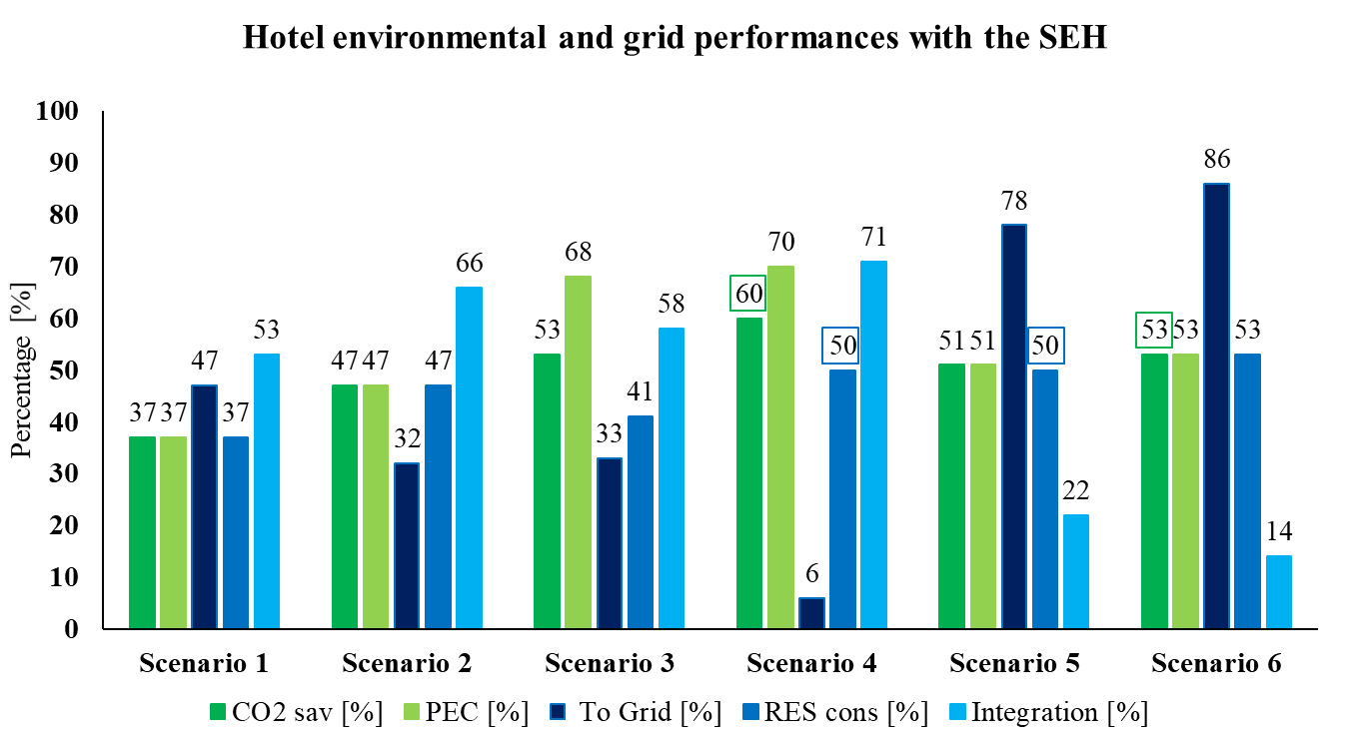

**Figure 8**. Hotel case study, environmental (1,2) and grid KPIs (3,4,5)

This phenomenon is largely due to the mismatch between the PV production and the consumption timing. This latter, reported in Figure9 , is concentrated during the morning and during evening in accordance with hotel attendances. Even if from an environmental and power grid point of view, the SEH can offers results which cannot be achievable considering RES production only, its economic performances are not yet comparable with an oversized PV plant.

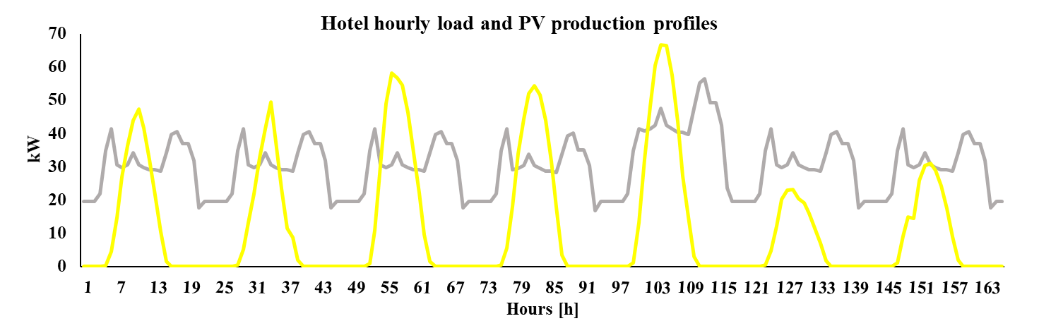

**Figure 9**. Hotel electric demand load shape (grey) and PV production (yellow) during the 3rd week of March

Considering Scenario 4 as the reference case due to the results scored, the storages behaviour of batterie and hydrogen tank is reported in Figure 10.

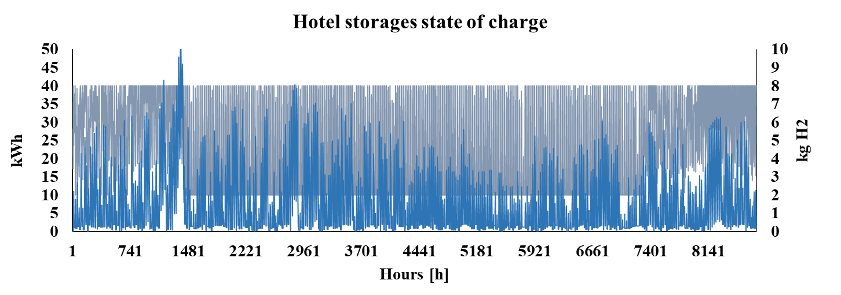

**Figure 10**. Annual state of charge of battery (grey) and hydrogen tank (blue) in the hotel Scenario 4

Figure 11 reports the time percentage breakdown of the operative mode spent along one year by the rSOC. As can be expected, the condition reported in Figure 9 is translated in full hydrogen tank during the month of March when the hotel activities are still low while the PV production start to be consistent in Southern Italy, and as an ulterior confirmation the time spent by the rSOC in SOEC is the higher between all the analysed scenarios.

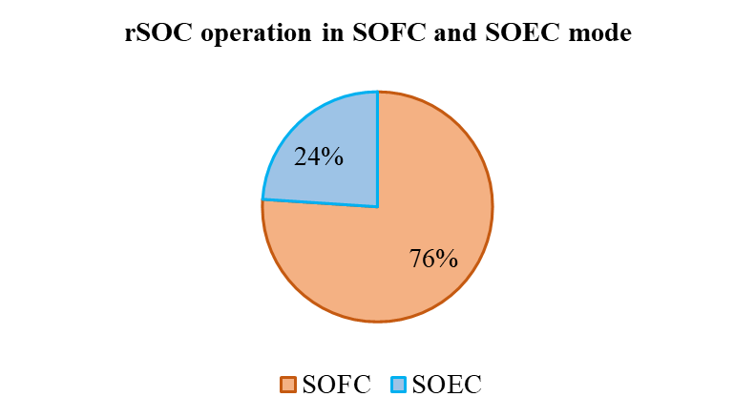

**Figure 11.** rSOC operative mode during one year of operation in the hotel Scenario 4

Considering the thermal energy production varying between 1kWh and 4 kWh according to the rSOC energy supply as reported in Table 1 and Table 2, it can be deduced that when the SOEC works at its minimum power the thermal exploitable energy is 1kWh, and how can be inferred from Figure 12, the rSOC works most of the time in this condition.

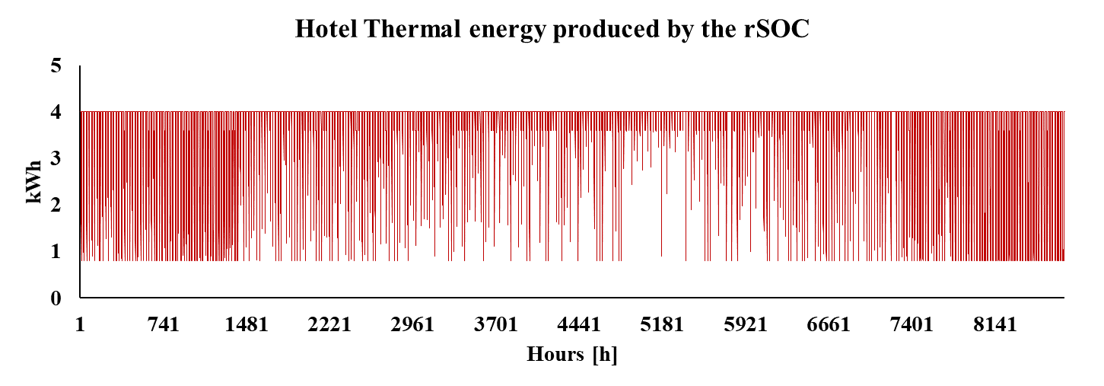Figure 12. rSOC thermal energy production considering hotel Scenario 4

In Table 6, in addition to the results for the rSOC prototype purchasing, the scenarios evaluated for the commercial and future target prices are reported too, revealing the favourable perspective for this technology. Thanks to the cost reduction in terms of initial purchase and relative cheaper components maintenance, a drastic reduction of its PBP is verified passing from the actual 45.7 years to 7 years from 2019 to 2031 projections, i.e. less than 12 years. Similarly, more than from an economic point of view, it must be deemed the land use when an oversized PV plant is installed.

|  |  |  |  |  |
| --- | --- | --- | --- | --- |
| Scenario | CAPEX (k€) | NPV  (k€) | IRR  (%) | PBP(y) |
| Scenario 4 (prototype) | 473 | -334.2 | -4.25 | 45.7 |
| Scenario 4 (commercial) | 343.5 | -49.6 | -1.22 | 16 |
| Scenario 4  (target) | 233.5 | 230.4 | 10.08 | 6.9 |
| Scenario 5 (2019) | 420 | 290.6 | 8.64 | 9 |
| Scenario 6 (2019) | 700 | -198.8 | -0.61 | 21.5 |

Table 6. Hotel economic KPIs (6,7,8)

Beside the problem related to managing its storage system, also the land value should be analysed carefully especially in a non-industrial environment where the space and land use might be an issue.

*3.2. Hospital*

The hospital is the building with the greater consumptions and PV power installed, those conditions are mirrored in the environment and grid performances shown in Figure 13. From Scenario 1 the amount of excess electricity sent to the power grid is 23% of the total production. This amount is valorised by the three tested storages. In this situation the solution proposed in Scenario 4, where the rSOC and batteries are coupled, shows the highest results. Referring to the emissions reduction, in this case a net difference between the scenarios where the rSOC is used (3 and 4) and where not (Scenario 2) is displayed. The performances scored by rSOC scenarios are linked also to the renovation of the heating system which currently relies on diesel boiler, thus the transition from this pollutant fuel to an efficient cogeneration system reduce the overall emission in the building.

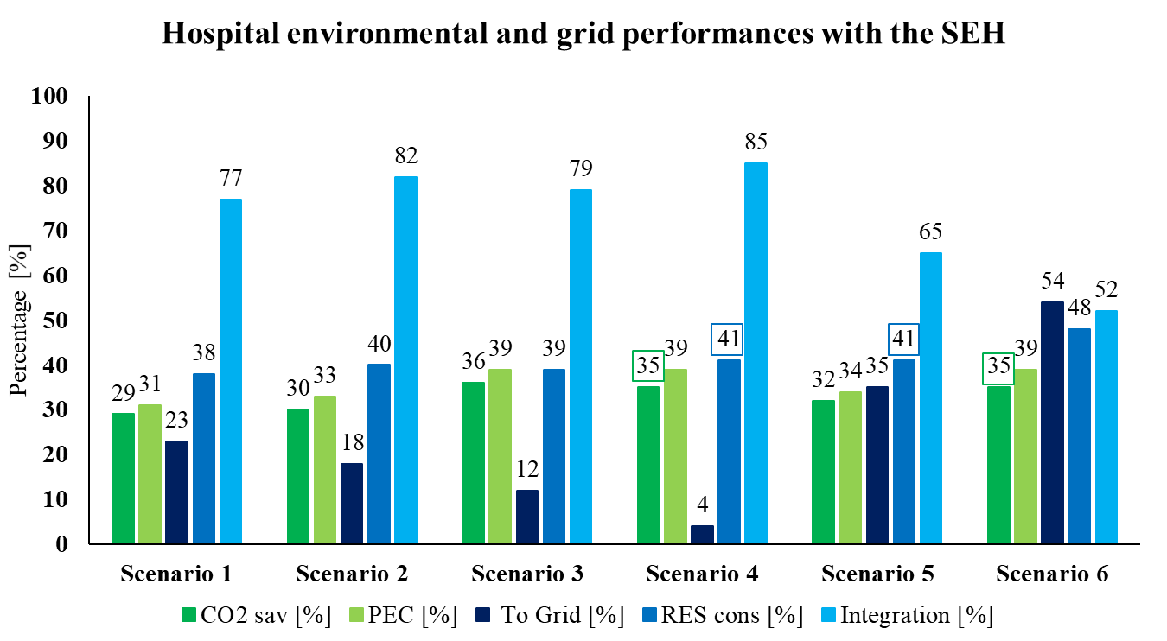

Figure 13. Hospital case study, environmental (1,2) and grid KPIs (3,4,5)

In comparison, as displayed in Figure 13, to achieve the same REScons and CO2 saving it would be needed a PV plant of 220 kWp and 320 kWp, respectively, with a relative increase in land use of 24% and 48%, if it is considered a PV footprint of 8m2/kWp. Taking a closer look at Scenario 4, analysing its storage system performances reported in Figure 14, it is possible to appreciate a lowering of hydrogen production along August due to the increase of electric demand and a corresponding limited RES availability.

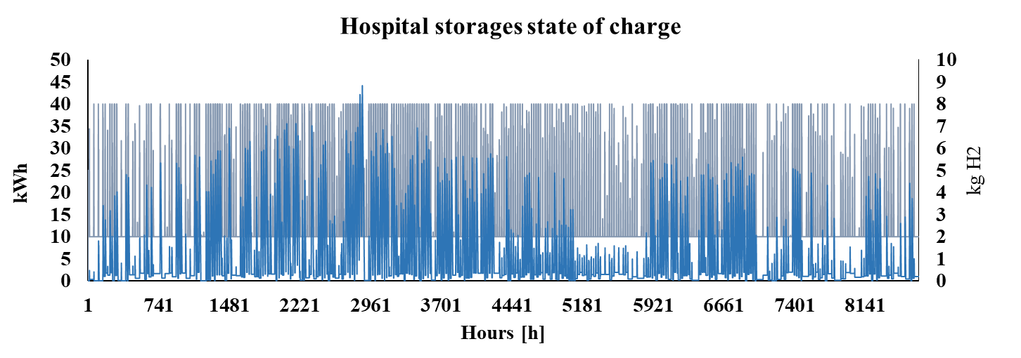

**Figure 14****.** Annual state of charge of battery (grey) and hydrogen tank (blue) in the Hospital Scenario 4

This latter condition is also reflected considering the values reported in Figure 15, where the SOEC function due to the RES scarcity, in relation to the high demand, is stated at 14%.

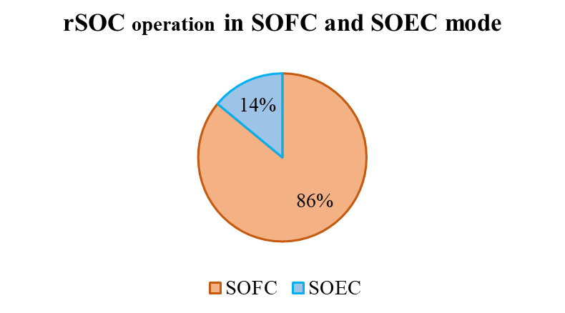

**Figure 15.** rSOC operative mode during one year of operation in the Hospital Scenario 4

Nevertheless, the rSOC fuel flexibility extends the SOFC operation beyond the merely stored hydrogen allowing to reach the 86% of the total rSOC operative time.

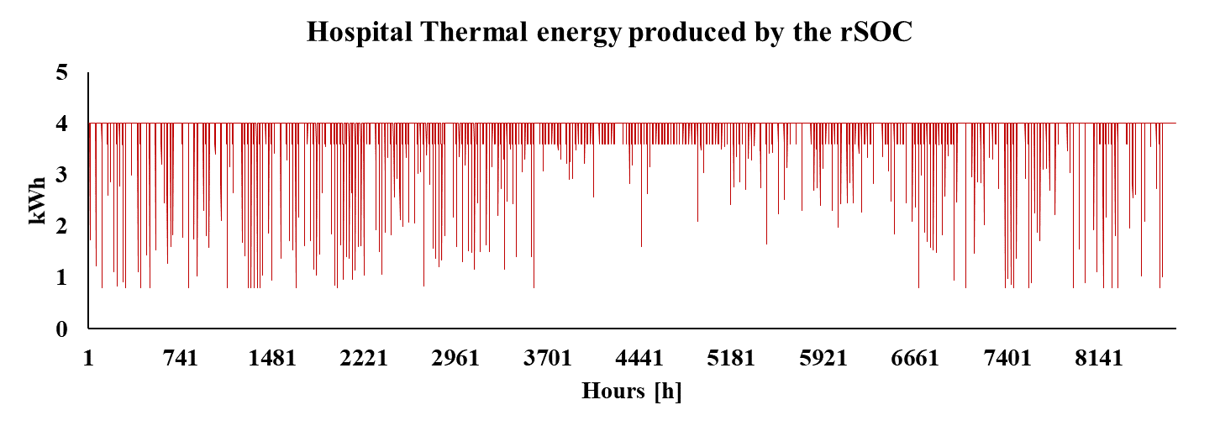

Figure 16. rSOC thermal energy production considering hospital Scenario 4

This situation is also manifested from the thermal production point of view reported in Figure 16, where it possible to see the rSOC working most of the time at its maximum thermal outputs while supplying electricity.

Since the SEH represents not only a storage system but also an improvement of the actual heating system, the economic KPIs are already consistent for the economic analysis, as shown in Table7, starting from the prototype price.

|  |  |  |  |  |
| --- | --- | --- | --- | --- |
| Scenario | CAPEX (k€) | NPV  (k€) | IRR  (%) | PBP(y) |
| Scenario 4  (prototype) | 582.7 | -153.72 | 0.3 | 19 |
| Scenario 4 (commercial) | 452.7 | 461.8 | 6 | 10 |
| Scenario 4  (target) | 342.7 | 934.8 | 7.7 | 5.3 |
| Scenario 5 (2019) | 308 | 406.7 | 12.3 | 6.4 |
| Scenario 6 (2019) | 448 | 481.8 | 11 | 7.2 |

Table 7. Hospital economic KPIs (6,7,8)

Those high scores are supported by the CHP mode guaranteed by the rSOC, and in line with what could be expected by revamping an obsolete heating system with one of the most efficient on the market [73]. Even if the PBP of the SEH is close to the entire system lifetime, it represents anyway the best solution for the environmental and the self-sufficiency KPIs, which allow to meet the objectives of a greater building sustainability.

*3.3. Smart District: hospital, hotel, and office building*

The rSOC operation is tested in the aggregated scenario composed by the above cited buildings virtually connected to each other by the SEH. As for the other analysed cases, the Scenario 4 shows the best results where it is possible to capitalize 90% of the total PV production, turning out to be the best option to be installed according to the KPIs. Moreover, a CO2 saving and PES over 30% is recorded and shown in Figure 17, with a 36% RES consumption in the total energy mix of the building .Scenario 4, with the SEH solution installed, represents also to the best case according to the minimum amount of electricity sent to the Power Grid while the Integration of PV power is at its maximum compared with the other scenarios***.*** To obtain comparable results with Scenario 4, a PV plant of 220 kWp is needed to assure equal REScons in Scenario 5, and 250 kWp plant is required to guarantee the same CO2 reduction in Scenario 6 with a consequent incumbrance in both cases non suitable with the available roof free surface.

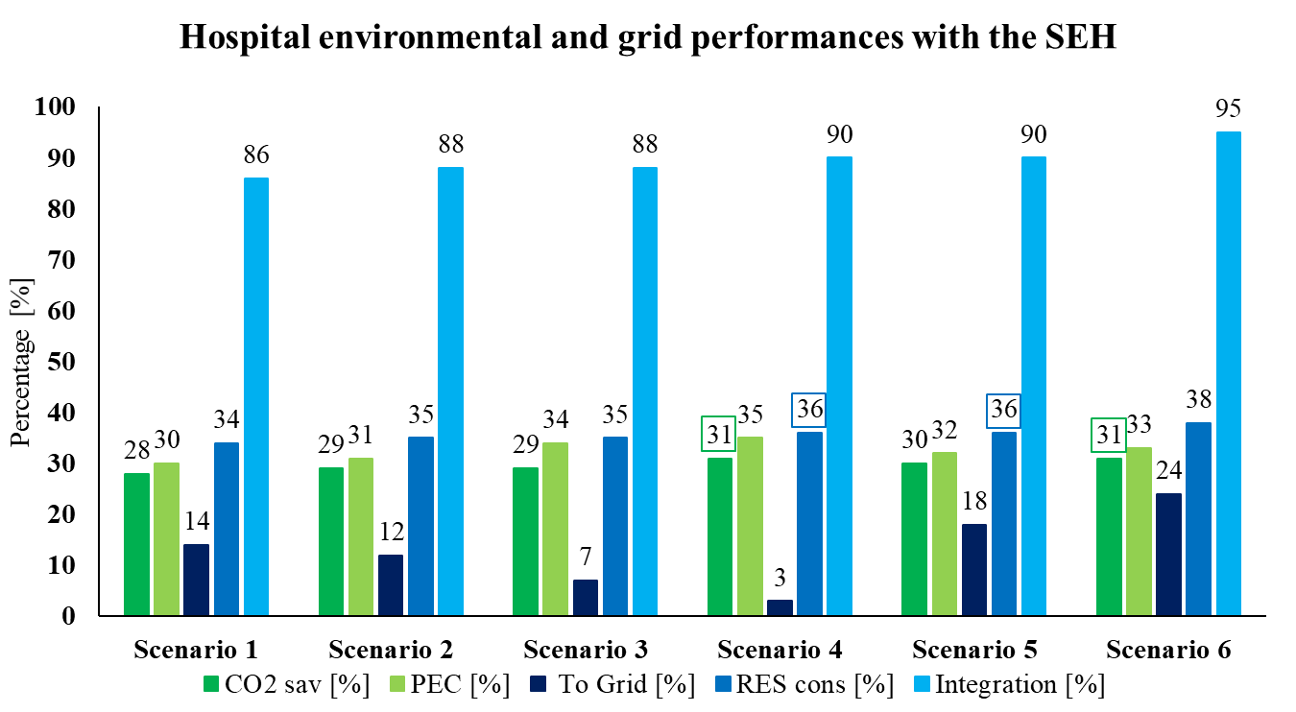

**Figure 17**. Smart District case study, environmental (1,2) and grid KPIs (3,4,5)

Examining the storages state of charge reported in Figure 18 it can be easily noted how the Optimization Engine works during the month of August when the RES production cannot cover the total District demand. It is possible to appreciate how the overproduction is stored in the battery while the SOFC mode is still maintained to supply energy to the District using the NG.

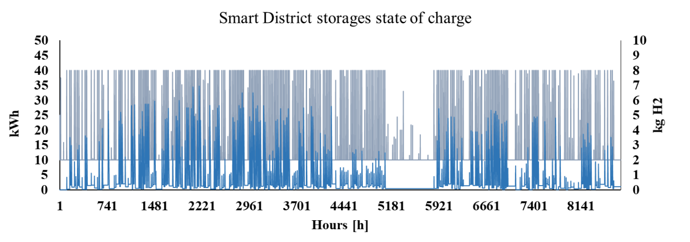

**Figure 18**. Annual state of charge of battery (grey) and hydrogen tank (blue) in the Smart District Scenario 4

Due to the RES direct consumption and the frequent energy request, the rSOC works in SOFC 91% of the time.

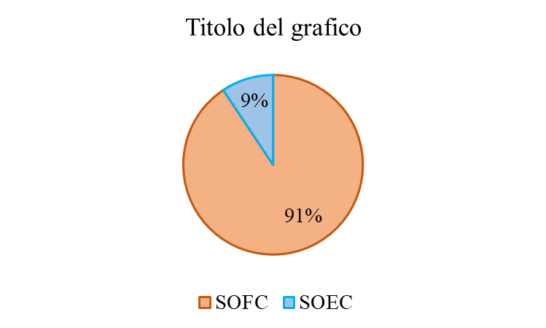

**Figure 19**. rSOC operative mode during one year of operation in the Smart District Scenario 4

Since the SOFC is functioning at maximum power most of the time to most of the time to cover the electric need of the district, also the thermal production is stable along the year with few lowering due to SOEC mode working at different power level depending on the different overproduction level.

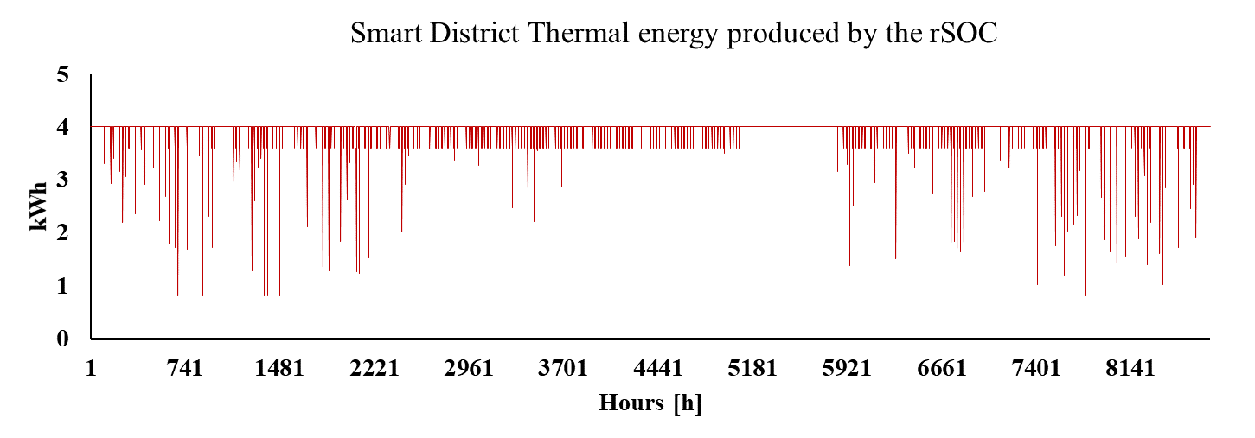

**Figure 20.** rSOC thermal energy production considering Smart District Scenario 4

Nevertheless, the Integration KPI recorded are the highest among all cases which denotes the high efficacy of the adopted strategies. This condition is detected also from an economic point of view, where the lowest current PBP of 14 years is recorded for Scenario 4 as shown in Table 8. Since the economic KPI are profitable for the 2019 purchase costs, they become more and more worthwhile for the projected case in 2025 and 2031 when 3 years PBP expected.

|  |  |  |  |  |
| --- | --- | --- | --- | --- |
| Scenario | CAPEX (k€) | NPV  (k€) | IRR  (%) | PBP(y) |
| Scenario 4 (prototype) | 627.5 | -1.8 | 2.5 | 15.3 |
| Scenario 4 (commercial) | 497.5 | 737.9 | 12.5 | 5.8 |
| Scenario 4 (target) | 387.5 | 1,508 | 25.3 | 3 |
| Scenario 5 (2019) | 308 | 485.1 | 13.6 | 5.7 |
| Scenario 6 (2019) | 350 | 524.1 | 13.2 | 5.9 |

Table 8. Smart District economic KPIs (6,7,8)

From all the different simulations, the mutual benefits to couple the rSOC with batteries can be demonstrated. Comparing Scenario 2, 3 and 4 the solution proposed in Scenario 4 has the highest building sustainability performance. Furthermore, analysing the economic indicators it is possible to appreciate an important cost reduction in the future. Not only the CAPEX affects the rSOC feasibility but also its thermal valorisation must be accounted carefully to harness its total potential to guarantee a favourable investment***.***

**4. Conclusion**

The operation of a real rSOC is simulated in different conditions and scenarios reflecting real operative settings. Moreover, the rSOC technology has been investigated coupled with Li-ion battery and the obtained results indicate how this technology can benefit from the proposed strategy. Thanks to the OE and the piloting strategy coded in the simulation software, the battery can be used also to supply energy to the rSOC when operating in SOEC and the mutual positive effects are proven in all the results reported in the different Scenarios 4 and can be a starting point for replication similar contexts. When operating, the rSOC thanks to a dedicated heat valorisation circuit is effective as well in decarbonizing the heating consumptions. Actually, the best scores in CO2 reduction are always achieved when the rSOC technology is used in the scenarios, showing its ability to increase the sustainability of all the buildings analysed during this work. Furthermore, also when green hydrogen coming from RES is not available, the rSOC still allow to switch from very polluting fossil fuel such a diesel, to a less polluting vector such as natural gas with high efficiency. Because of its fuel supply flexibility, the rSOC is therefore already prepared for next future scenario dominated by RES production and hydrogen as energy vector meanwhile supported during the transition by the NG.

Moreover, the consumptions aggregation returned the most relevant economic performances for the rSOC. The results coming from the Smart District case, show the best score attained in all the simulated scenarios, demonstrating how this machine can be already useful to enhance the sustainability of single building as well as for larger entities. Thus, the rSOC can represent a valid option for a building energy system notably when several buildings can communicate in a smart grid due to the diversification of the loads and the creation of a baseload along the year.

Considering the percentage breakdown of the time spent in SOEC and SOFC mode in the different cases, it is possible to notice how increasing the SOFC percentage the economic KPIs attain better results, this is inherent to a lowering in OPEX for the entire building, helping to reduce the investment breakeven. This condition is mainly due to the billing and green production incentives, i.e. “scambio sul posto” mechanism, oriented to economically sustain the overproduction sent to the Power Grid, at lower prices considering the market costs, rather than promoting the storages. Thus, this conclusion is strongly characterised by the context where the simulation is implemented, in this case the Italian billing and Energy supply scenario and can be susceptible of changing if an incentive system will be introduced also for the storage. During the economic analysis, the machine purchase and maintenance costs reduction are analysed for the cases taking place in 2025 and 2031, when the commercial and the final target models are expected to be deployed. The analysed starting prices will broaden the possible reference buildings where it will be feasible to install a rSOC, confirming the new trend to shift this technology from the industrial sector the civil one. Hence, the expected trends in costs reduction, the flexibility to work in different context and the ability to couple different consumptions, which means an overall reduction in costs and emissions, place this technology in a crucial position for next advanced energy management systems.

**Acknowledgement**

The research activities leading to this study have been carried out within the project "Progetti per Avvio alla Ricerca - Tipo 1" TrHYgeneration - n. AR120172B6D4EF18 financed by Sapienza University of Rome.

**References**

1. Sharaf OZ, Orhan MF. An overview of fuel cell technology: Fundamentals and applications. Renewable and Sustainable Energy Reviews 2014; 32:810-853, <https://doi.org/10.1016/j.rser.2014.01.012>
2. Nastasi B. Hydrogen policy, market, and R&D projects. Solar hydrogen production 2019; 31-44. <https://doi.org/10.1016/B978-0-12-814853-2.00002-3>
3. European Union, Important Project of Common European interest (IPCEI), <https://www.fch.europa.eu/event/hydrogen-important-projects-common-european-interest-ipcei> [Accessed: 20-February-2020].
4. Thellufsen JZ, Lund H, Sorknæs P, Østergaard PA, Chang M, Drysdale D, Sperling K. Smart energy cities in a 100% renewable energy context. Renewable and Sustainable Energy Reviews 2020; 129. <https://doi.org/10.1016/j.rser.2020.109922>
5. Østergaard PA, Duic N, Noorollahi Y, Mikulcic H, Kalogirou S. Sustainable development using renewable energy technology. Renewable Energy 2019; 146: 2430–2437. <https://doi.org/10.1016/j.renene.2019.08.094>
6. Reuß M, Grube T, Robinius M, Preuster P, Wasserscheid P, Stolten D. Seasonal storage and alternative carriers: A flexible hydrogen supply chain model. Applied Energy 2017; 200:290–302 <https://doi.org/10.1016/j.apenergy.2017.05.050>.
7. Ancona MA, Antonucci V, Branchini L, Catena F, De Pascale A, Di Blasi A, Vita A. Thermal integration of a high-temperature co-electrolyzer and experimental methanator for Power-to-Gas energy storage system. Energy Conversion and Management 2019; 186:140–155. <https://doi.org/10.1016/j.enconman.2019.02.057>.
8. Choudhury A, Chandra H, Arora A. Application of solid oxide fuel cell technology for power generation - A review. Renewable and Sustainable Energy Reviews 2013; 20:430–442. <https://doi.org/10.1016/j.rser.2012.11.031>
9. Buffo G, Ferrero D, Santarelli M, Lanzini A. Energy and environmental analysis of a flexible Power-to-X plant based on Reversible Solid Oxide Cells (rSOCs) for an urban district, Journal of Energy Storage 2020; 29:101314. <https://doi.org/10.1016/j.est.2020.101314>.
10. Afgan N, Veziroglu A. Sustainable resilience of hydrogen energy system. International Journal of Hydrogen Energy 2011; 37(7): 5461–5467. <https://doi.org/10.1016/j.ijhydene.2011.04.201>.
11. Paul B, Andrews J. PEM unitised reversible/regenerative hydrogen fuel cell systems: State of the art and technical challenges, Renewable and Sustainable Energy Reviews 2017; 79: 585-599. <https://doi.org/10.1016/j.rser.2017.05.112>.
12. Mottaghizadeh P, Santhanam S, Heddrich MP, Friedrich KA, Rinaldi F. Process modelling of a reversible solid oxide cell (r-SOC) energy storage system utilizing commercially available SOC reactor. Energy Conversion and Management 2017; 142:477–93. <https://doi.org/10.1016/j.enconman.2017.03.010>.
13. Peterson D. Reversible Fuel Cell Targets. DOE Hydrogen and Fuel Cells Program Record 2020. <https://www.hydrogen.energy.gov/pdfs/20001-reversible-fuel-cell-targets.pdf>
14. Wang Y, Leung DYC, Xuan J, Wang H. A review on unitized regenerative fuel cell technologies, part-A: Unitized regenerative proton exchange membrane fuel cells. Renewable and Sustainable Energy Reviews 2016; 65, 961–977. <https://doi.org/10.1016/j.rser.2016.07.046>.
15. Rokni M. Addressing fuel recycling in solid oxide fuel cell systems fed by alternative fuels. Energy 2017; 137, 1013–1025. <https://doi.org/10.1016/j.energy.2017.03.082>.
16. Bao C, Cai N, Croiset E. A multi-level simulation platform of natural gas internal reforming solid oxide fuel cell–gas turbine hybrid generation system – Part II. Balancing units model library and system simulation. Journal of Power Sources 2011; 196: 8424– 8434. <https://doi.org/10.1016/j.jpowsour.2011.05.032>.
17. Marchese M, Giglio E, Santarelli M, Lanzini A. Energy performance of Power-to-Liquid applications integrating biogas upgrading, reverse water gas shift, solid oxide electrolysis and Fischer-Tropsch technologies. Energy Conversion and Management: X 2020; 6:100041. <https://doi.org/10.1016/j.ecmx.2020.100041>.
18. Townsend AF. Natural Gas and the Clean Energy Transition. EM Compass International Finance Corporation, Washington, DC. © International Finance Corporation, 2019; 65.
19. Rokni M. Thermodynamic Analysis of an Integrated Solid Oxide Fuel Cell Cycle with a Rankine Cycle. Energy Conversion and Management 2010; 51(12): 2724-2732. <https://doi.org/10.1016/j.enconman.2010.06.008>.
20. Granovskii M, Dincer I, Rosen MA. Performance comparison of two combined SOFC – gas turbine systems. Journal of Power Sources 2007; 165 (1): 307–14. <https://doi.org/10.1016/j.jpowsour.2006.11.069>
21. Eveloy V, Karunkeyoon W, Rodgers P, Al Alili A. Energy, exergy and economic analysis of an integrated solid oxide fuel cell – gas turbine – organic Rankine power generation system. International Journal of Hydrogen Energy 2016; 41(31): 13843–13858. <https://doi.org/10.1016/j.ijhydene.2016.01.146>.
22. Baniasadi E, Alemrajabi AA. Fuel cell energy generation and recovery cycle analysis for residential application. International Journal of Hydrogen Energy 2010; 35:9460–7. <https://doi.org/10.1016/j.ijhydene.2010.03.015>.
23. Parra D, Gillott M, Walker GS. The role of hydrogen in achieving the decarbonization targets for the UK domestic sector. Int J Hydrogen Energy 2014; 39:4158–69. <https://doi.org/10.1016/j.ijhydene.2014.01.023>
24. Venkataraman V, Pérez-Fortes M, Wang L, Hajimolana YS, Boigues-Muñoz C, Agostini A, et al. Reversible solid oxide systems for energy and chemical applications – Review & perspectives. J Energy Storage 2019; 24:100782. <https://doi.org/10.1016/j.est.2019.100782>
25. International Energy Agency - IEA. 2015, Energy Climate and Change - World Energy Outlook Special Report. Special Report on Energy and Climate Change.
26. Gatt D, Yousif C, Cellura M, Camilleri L, Guarino, F. Assessment of building energy modelling studies to meet the requirements of the new Energy Performance of Buildings Directive. Renewable and Sustainable Energy Reviews 2020; 127:109886. <https://doi.org/10.1016/j.rser.2020.109886>.
27. Mogensen MB, Chen M, Frandsen HL, Graves C, Hansen JB, Hansen KV, Hauch A et al. Reversible solid-oxide cells for clean and sustainable energy, Clean Energy 2019; 3(3):175–201, <https://doi.org/10.1093/ce/zkz023>
28. Giap VT, Kang S, Ahn KY. HIGH-EFFICIENT reversible solid oxide fuel cell coupled with waste steam for distributed electrical energy storage system. Renew Energy 2019; 144:129–38. <https://doi.org/10.1016/j.renene.2018.10.112>.
29. Giap VT, Lee YD, Kim YS, Ahn KY. A novel electrical energy storage system based on a reversible solid oxide fuel cell coupled with metal hydrides and waste steam. Appl Energy 2020; 262:114522. <https://doi.org/10.1016/j.apenergy.2020.114522>.
30. Yang C, Shu C, Miao H, Wang Z, Wu Y, Wang J, et al. Dynamic modelling and performance analysis of reversible solid oxide fuel cell with syngas. Int J Hydrogen Energy 2019; 44:6192–211. <https://doi.org/10.1016/j.ijhydene.2019.01.068>.
31. Lindholm O, Weiss R, Hasan A, Pettersson F, Shemeikka J. A MILP Optimization Method for Building Seasonal Energy Storage: A Case Study for a Reversible Solid Oxide Cell and Hydrogen Storage System. Buildings 2020; 10(7):123. <https://doi.org/10.3390/buildings10070123>.
32. Sigurjonsson HÆ, Clausen LR. Solution for the future smart energy system: A polygeneration plant based on reversible solid oxide cells and biomass gasification producing either electrofuel or power. Applied Energy 2018; 216: 323-337. <https://doi.org/10.1016/j.apenergy.2018.02.124>.
33. Sunfire supplies Boeing with largest reversible solid oxide electrolyser/fuel cell system. Fuel Cells Bull 2016; 1. doi:10.1016/s1464-2859(16)70002-2.
34. Rispoli N, Vitale F, Califano F, Califano M, Polverino P, Rosen MA, et al. Constrained optimal design of a reversible solid oxide cell-based multiple load renewable microgrid. J Energy Storage 2020; 31:101570. <https://doi.org/10.1016/j.est.2020.101570>.
35. Scaltritti, M. (2016). Sistemi di accumulo di energia elettrica basati su celle a ossidi solidi reversibili (rSOC): dimensionamento e simulazioni preliminari (in Italian). Master thesis in Mechanical Engineering, Politecnico di Milano, Italy. https://www.politesi.polimi.it/bitstream/10589/125522/3/2016_09_Scaltritti.pdf.

[Accessed: 1-December-2020]

1. Mottaghizadeh P, Santhanam S, Heddrich MP, Friedrich KA, Rinaldi F. Process modeling of a reversible solid oxide cell (r-SOC) energy storage system utilizing commercially available SOC reactor. Energy Convers Manag 2017; 142:477–93. https://doi.org/10.1016/j.enconman.2017.03.010.
2. Xu HJ, Zhao CY. Thermodynamic analysis and optimization of cascaded latent heat storage system for energy efficient utilization 2015; 90: 1662–73. <https://doi.org/10.1016/j.energy.2015.06.131>.
3. Willich C, Westner C, Henke M, Leucht F, Kallo J, Friedrich Ka. Pressurized solid oxide fuel cells with reformate as fuel. J Electrochem Soc 2012;159(11): F711–6.
4. Reznicek E, Braun RJ. Techno-economic and off-design analysis of stand-alone, distributed-scale reversible solid oxide cell energy storage systems. Energy Convers Manag 2018; 175:263–77. <https://doi.org/10.1016/j.enconman.2018.08.087>.
5. Wendel CH, Gao Z, Barnett SA, Braun RJ. Modeling and experimental performance of an intermediate temperature reversible solid oxide cell for high-efficiency, distributed-scale electrical energy storage. J Power Sources 2015; 283: 329-342. <https://doi.org/10.1016/j.jpowsour.2015.02.113>.
6. Meschede H. Analysis on the demand response potential in hotels with varying probabilistic influencing time-series for the Canary Islands. Renewable Energy 2020: 160:1480–1491. <https://doi.org/10.1016/j.renene.2020.06.024>
7. Moreno B, Díaz G. The impact of virtual power plant technology composition on wholesale electricity prices: A comparative study of some European Union electricity markets. Renewable and Sustainable Energy Reviews 2019; 99:100–108. <https://doi.org/10.1016/j.rser.2018.09.028>
8. Calise F, Cappiello FL, Dentice d’Accadia M, Vicidomini M. Energy efficiency in small districts: Dynamic simulation and technoeconomic analysis. Energy Conversion and Management 2020; 220. <https://doi.org/10.1016/j.enconman.2020.113022>.
9. Sylfen, Grenoble, France 2020. https://sylfen.com/en/home/ [Accessed: 17-July-2019]
10. Nechache A, Hody S. Test and Evaluation of an Hybrid Storage Solution for Buildings, Based on a Reversible High-Temperature Electrolyzer. ECS Trans 2019; 91:2485–94. <https://doi.org/10.1149/09101.2485ecst>.
11. Nam W, Kim JY, Oh KY. The characterization of dynamic behavior of Li-ion battery packs for enhanced design and states identification. Energy Conversion and Management 2018; 162:264–275. <https://doi.org/10.1016/j.enconman.2018.02.022>.
12. Gómez SY, Hotza D. Current developments in reversible solid oxide fuel cells. Renewable and Sustainable Energy Reviews 2016; 61:155–174. <https://doi.org/10.1016/j.rser.2016.03.005>.
13. Pavičević M, Novosel T, Pukšec T, Duić N. Hourly optimization and sizing of district heating systems considering building refurbishment – Case study for the city of Zagreb. Energy 2017; 137:1264–1276. <https://doi.org/10.1016/j.energy.2017.06.105>.
14. [dataset] National Renewable Energy Laboratory (NREL). https://pvwatts.nrel.gov/pvwatts.php [Accessed: 17-July-2019]
15. Bertheau, P. Supplying not electrified islands with 100% renewable energy based micro grids: A geospatial and techno-economic analysis for the Philippines. Energy 2020; 202:117670. <https://doi.org/10.1016/j.energy.2020.117670>
16. Hainoun A. Construction of the hourly load curves and detecting the annual peak load of future Syrian electric power demand using bottom-up approach. Electrical Power and Energy Systems 2009; 31:1–12. <https://doi.org/10.1016/j.ijepes.2008.09.006>.
17. Lamagna M, Nastasi B, Groppi D, Nezhad MM, Garcia DA. Hourly energy profile determination technique from monthly energy bills. Building Simulation 2020. <https://doi.org/10.1007/s12273-020-0698-y>
18. Lombard LP, Ortiz J, Pout C. A review on buildings energy consumption information. Energy and Buildings 2008; 40:394–398. <https://doi.org/10.1016/j.enbuild.2007.03.007>.
19. Noussan M, Nastasi B. Data Analysis of Heating Systems for Buildings—A Tool for Energy Planning, Policies and Systems Simulation. Energies 2018; 11: 233. <https://doi.org/10.3390/en11010233>.
20. Crippa S (2013). Studio dei consumi energetici in ambito ospedaliero (in Italian). Master thesis in Mechanical Engineering, Politecnico di Milano, Italy. <https://docplayer.it/12899816-Politecnico-di-milano-studio-dei-consumi-energetici-in-ambito-ospedaliero.html>. [Accessed: 17-July-2019]
21. Chung M, Park HC. Comparison of building energy demand for hotels, hospitals, and offices in Korea. Energy 2015; 92:383-393. <https://doi.org/10.1016/j.energy.2015.04.016>
22. [dataset]U.S. General Services Administration, Technology Transformation Service. <https://catalog.data.gov/dataset/commercial-reference-building-hospital-f4636/resource/6587f1ec-a785-4dd5-b9aa-1f5f0f133723> [Accessed: 17-July-2019]
23. Luo X, Hong T, Chen Y, Piette MA. Electric load shape benchmarking for small- and medium-sized commercial buildings. Applied Energy 2017; 204:715–725. <https://doi.org/10.1016/j.apenergy.2017.07.108>.
24. [dataset]U.S. General Services Administration, Technology Transformation Service. <https://catalog.data.gov/dataset/commercial-reference-building-medium-office-de54b/resource/4fcdc5f4-9177-4e21-aba3-d64419d1efc8?inner_span=True> [Accessed: 17-July-2019]
25. Ribó-PérezD, Bastida-Molina P, Gómez-Navarro T, Hurtado-Pérez. Hybrid assessment for a hybrid microgrid: A novel methodology to critically analyse generation technologies for hybrid microgrids. Renewable Energy 2020; 157:874–887. <https://doi.org/10.1016/j.renene.2020.05.095>.
26. [dataset] L’Istituto Superiore per la Protezione e la Ricerca Ambientale, ISPRA, report Italian network emissions, 2017.
27. [dataset] L’Istituto Superiore per la Protezione e la Ricerca Ambientale, ISPRA, <http://www.isprambiente.gov.it/files2019/pubblicazioni/rapporti/R_303_19_gas_serra_settore_elettrico.pdf> [Accessed: 09-March-2020]
28. [dataset] Lazard’s Levelised Cost of Energy Analysis- Version 13.0 (2019) <https://www.lazard.com/media/451086/lazards-levelized-cost-of-energy-version-130-vf.pdf> [Accessed: 28-Dicember-2020]
29. [dataset] Lazard’s Levelised Cost of Storage Analysis- Version 4.0 (2018) <https://www.lazard.com/media/450774/lazards-levelized-cost-of-storage-version-40-vfinal.pdf> [Accessed: 20-March-2020]
30. James BD, Moton JM, Colella WG. Hydrogen Storage Cost Analysis. U.S. Department of Energy's (DOE's) 2013 Annual Merit Review and Peer Evaluation Meeting (AMR) for the Hydrogen and Fuel Cell Technologies (FCT) Program 2013.
31. [dataset] Autorità di Regolazione per Energia Reti e Ambiente, ARERA. <https://www.arera.it/it/dati/eep35.htm> [Accessed: 09-March-2020]
32. [dataset] Autorità di Regolazione per Energia Reti e Ambiente, ARERA <https://www.arera.it/it/dati/gp27new.htm> [Accessed: 09-March-2020]
33. [dataset] Ministero dello sviluppo economico, MISE. <https://dgsaie.mise.gov.it/prezzi_carburanti_mensili.php> [Accessed: 09-March-2020]
34. Minutillo M, Perna A, Forcina A, Di Micco S, Jannelli E. Analyzing the levelized cost of hydrogen in refueling stations with on-site hydrogen production via water electrolysis in the Italian scenario. International Journal of Hydrogen Energy 2020. <https://doi.org/10.1016/j.ijhydene.2020.11.110>.
35. Gestore Servizi Energetici, GSE. Determinazione del contributo in conto scambio sul posto ai sensi dell’articolo 12 dell’Allegato A alla deliberazione 570/2012/R/efr e s.m.i. Edizione n4; 2019.
36. [dataset] Brown editore, Triboo spa. <https://www.borse.it/spread/rendimento/BTP/720/giorni>, 2020. [Accessed: 09-March-2020]
37. Kaldellis JK, Zafirakis D, Kondili E. Energy pay-back period analysis of stand-alone photovoltaic systems. Renewable Energy 2010; 35 (7): 1444-1454, <https://doi.org/10.1016/j.renene.2009.12.016>.
38. Fichera A, Pluchino A, Volpe R. From self-consumption to decentralized distribution among prosumers: A model including technological, operational and spatial issues. Energy Conversion and Management 2020; 217:112932. <https://doi.org/10.1016/j.enconman.2020.112932>.