Gut microbial and metabolic profiling reveal lingering effects of infantile iron deficiency unless treated

Jordi Mayneris-Perxachs, Wellington Amaral, Gabriele R. Lubach, Mark Lyte, Gregory J Phillips, Joram M. Posma, Christopher L. Coe, Jonathan R. Swann

Supplementary Methods
Animal Model.
A naturalistic animal model of infantile ID was investigated in this work. This animal model manipulates the dietary supply of iron during pregnancy. Female monkeys were provided a level of iron that meets the recommended nutrient requirements for nonhuman primates (>180 mg/kg, NRC, 2003), but this is not sufficient to fulfill the higher needs of gravid females (Coe et al., 2013). As such, it simulates a gestation without the recommended dietary intake of iron (Lubach et al., 2006), which is common in low-income countries as well as in lower SES families in high-resource countries (Armitage et al., 2019). This prenatal diet results in 20-30% of infant monkeys developing a growth-related ID during the nursing phase, before they recover gradually after weaning by consuming iron in solid foods (Lubach et al., 2006). This model of infantile anemia has many effects on peripheral physiology, as well as reducing energy metabolism in the CNS (Rao et al., 2018, Sandri et al., 2020).

Animals.
Samples were analyzed from 38 young rhesus monkeys (Macaca mulatta) 7-15 months of age, including 23 that had remained iron sufficient (IS) and 15 that had been transiently iron deficient (ID) during the first year of life (see Supplemental Figure 4 for Participant Flow and Eligibility). The 15 otherwise healthy infants were identified as being ID at 6-months of age based on at least three of the four following indices: Hgb <110 g/L, MCV <60 fL, ZnPP/H >150 µM/M, and RDW percentage > 15. Prior validations of this model of ID determined that serum iron was decreased to 15 µM/L as compared with a normal level of 20 µM/L; transferrin saturation (TSAT) was significantly below normal at 18% as compared with 32%; and ferritin concentrations were only 10 pmol/L as compared with 25 pmol/L in an IS infant. At the time of assessment, the iron-related hematology of the iron-treated animals had returned to the normal range, including Hgb and MCV (see Suppl Table 2). All monkeys were from full-term singleton pregnancies; each reared by a different mother.

Diet. The experimental model of infantile ID is created by providing gravid females with a diet containing moderate levels of iron during pregnancy and then during the nursing period (225 mg Fe/kg) (see Suppl Table 2 for nutrient constituents of the biscuit). The mothers were maintained on this commercial biscuit diet (5LFD; LabDiet, St. Louis, MO) and supplemented 3-4 times per week with fruits and vegetables. At the time of the collection of urine and stool samples, the older juvenile monkeys were also fed the same biscuit diet.

Specimen collection.
For specimen collection, the juvenile monkeys were relocated to a quiet room for one week and acclimated to a small cage with a conical urine collection pan beneath it. Three serial filters in the collection pan were employed to limit particulate matter and the urine was centrifuged before aliquoted. Urine was collected for 12 hr period, combined to generate a daily 24 hr total, and stored frozen in an ultracold freezer. Blood was collected by femoral venipuncture on the first morning of urine collection between 0900-1100. For microbial analyses, rectal swabs (BBL CultureSwab™ Collection & Transport System) were acquired at the same time and stored at < -70 ºC until bacterial DNA was extracted for sequencing.

Metataxonomic analysis.
Total DNA was isolated from rectal swabs using the PowerSoil DNA Isolation Kit (MoBio, Carlsbad, CA) and bead-beating, according to manufacturer’s protocol. Purified genomic DNA extracts were quantified using a Qubit 2.0 Fluorometer (Life Technologies, Carlsbad, CA), and stored at -20 °C in 10 mM Tris buffer until sequenced. PCR amplification of the V4 variable region of the 16S rRNA gene using V4 region specific primers (515F-816R) and amplicon sequencing were performed by Institute for Genomics & Systems Biology at the Argonne National Laboratory (Argonne, IL) on the Illumina MiSeq platform per manufacturer’s guidelines. Microbial analyses were generated on 23 monkeys, representing each condition (IS, 14; pID, 7; pID+Fe, 4).

Metataxonomic Data Processing and Statistical Analyses.
UniFrac measures of beta-diversity and Faith’s Whole Tree Phylogenetic Diversity index of alpha-diversity were generated using QIIME. Weighted and unweighted UNIFRAC dissimilarity matrices were used to examine differences in microbial community structure while accounting for both microbial abundances and phylogenetic relatedness. Significance testing of the first two PCoA axes for each UniFrac analysis (which account for the largest portion of the beta diversity variance) and Faith’s Phylogenetic Diversity index were carried out in R-statistics by use of planned orthogonal contrasts. The beta-diversity matrices were graphed through the Principal coordinate Analyses (PCoAs) implementation in PAleontological Statistics (PAST). LEfSe (Linear discriminant analysis Effect Size) (Segata et al. 2011 Genome Biol) was used for phylogenetic enrichment analyses and significant testing was carried out at genus and species levels by the Wilcoxon implementation. The Kruskal-Wallis ANOVA implementation in QIIME was used to assess the differences in abundances for the taxa indicated by the LEfSe analyses. Further, significant PCoA axes were regressed on the bacteria indicated by the LEfSe analyses to inform how the significant measures of beta diversity were influenced by the taxa. These analyses were carried out by simultaneous general linear modeling and stepwise elimination in R using the lmSupport package. Phlyogenetic enrichment analyses were performed in Biobakery’s linear discriminant analyses effect (LefSE); PCoA graphin PAST and statistical testing in R using the ImSupport package. When multiple comparisons were performed on either diversity indices or taxonomic units, p-values were adjusted by Bonferroni or False Discovery Rate (FDR) adjustments.

¹H nuclear magnetic resonance spectroscopy-based metabolic profiling.
Urine samples were prepared by combining 400 µL urine with 200 µL phosphate buffer (pH 7.4; 100% D₂O) that contained 1 mM of the internal standard/L, 3-trimethylsilyl-1-[2,2,3,3-2H4] propionate (TSP). Plasma samples were prepared by combining 100 µL of plasma with 450 µL saline solution (100% D₂O). Samples were mixed with a vortex and centrifuged (10,000 x g) for 10 min at room temperature before transfer to a 5 mm NMR tube. Spectroscopic analysis of all samples was performed on a 700 MHz Bruker NMR spectrometer equipped with a cryoprobe. For urine samples, a standard one-dimensional (1D) NOESY presaturation pulse sequence (RD-90º-t1-90º-tm-90º-acquire) was used with water suppression. A recycle delay (RD) of 1.5 s, a mixing time (tm) of 100 ms, and an acquisition time of 3.8 s, and a 90º pulse of 14.70 µs, were used for all samples. For each sample, 8 dummy scans were followed by 128 scans and collected into 64K data points with a spectral width of 20 ppm. For all plasma samples, spectra were acquired using a water suppressed Carr-Purcell-Meiboom-Gill (CPMG) spin echo experiment (RD [90ºx-(τ-180ºy-τ)_{n}-collect FID). A recycle delay of 4 s, a mixing time of 100 ms, an acquisition time of 2.3 s, and a 90º pulse of 15.08 µs, were used. In addition, a number of loops n = 100 and a spin-echo delay τ = 400 µs was used to allow spectral editing through T₂ relaxation and therefore attenuation of broad signals. For each sample, 8 dummy scans were followed by 256 scans and collected in 64K data points with a spectral width of 20 ppm.

NMR data processing of urine and plasma.
NMR spectra were processed using TopSpin 3.0 (Bruker Biospin, UK). Prior to applying Fourier transformation, the free induction decays (FID) were multiplied by an exponential function corresponding to a line broadening of 0.3 Hz. Spectra were manually phased, baseline corrected and referenced to the chemical shift of TSP (0.0 ppm) for urine, and to the anomeric doublet of glucose at δ 5.233, for plasma samples. ¹H NMR spectra (δ = 0.2–10.0) were digitized into consecutive integrated spectral regions with a resolution of 0.00055 ppm. In all spectra, the regions between δ = 4.70 and 5.20 were removed to minimize the effect of baseline effects that were caused by imperfect water suppression. For urine samples, the urea region was also removed (δ = 5.50 and 6.15). All NMR spectra were normalized using a probabilistic quotient approach to compensate for differences in concentration between samples. All ¹H NMR spectra were manually aligned using a recursive segment-wise peak alignment method. Metabolite identification was carried out using standard methods and using information from the literature and public databases (Chenomx NMR Suite, Human Metabolite DataBase, Biological Mangetic Resonane Data Bank). Two-dimensional (2D) NMR experiments (COSY, TOCSY, HSQC) were acquired for a number of samples to assist or confirm metabolite identification.

Supplemental Table 1. Mineral and vitamin concentrations, as well as ingredient composition, for the standardized diet fed to the nursing mothers and then the older infant rhesus monkeys during the period of sample collection this study.¹
Fe concentration 225 mg/kg

Ingredients
Protein, % 15.6
Carbohydrate, % 69.1
Fat, % 6.3
Ash, % 5.3
Fiber (crude), % 4.2
Minerals
Iron² , mg/kg 225 .0
Zinc, mg/kg 110.0
Copper, mg/kg 21.0
Vitamins
A, IU/g 20.0
B12, mcg/kg 73.0
C, mg/kg 500.0
________________________________________________________________
¹PMI Lab Diet 5038 (Monkey Diet Jumbo, www.labdiet.com)
²Based on typical daily consumption (200g), the monkeys were provided approximately 45.0 mg of Fe from the biscuit diet each day.

Supplementary Table 2. Descriptive summary of the rhesus monkey subjects in the three study conditions, their iron status at the typical age for a growth-related depletion of iron, and subsequent age range for collection of urine, fecal, and blood specimens.
Condition | N | Sex | Iron status (6 mo)* |  |  | Assessment age (months)
 |  |  | Hgb** | MCV | H-ZnPP
Iron sufficient (IS) | 21 | 10M, 11F | 12.5 (.2) | 69.8 (.7) | 71.6 (5.9) | 7.2 – 19.2
Previously iron-deficient (pID) | 11 | 6M, 5F | 9.9 (.2) | 53.6 (.9) | 204.5 (27.8) | 7.4 – 15.3
Previously iron-deficient + iron dextran (pID+Fe) | 6 | 3M, 3F | 8.0 (.3) | 48.0 (1.3) | 331.3 (43.5) | 10.9 – 17.7
*Blood was collected at 5-7 months of age to determine which infants were iron deficient at the typical point when growth-related needs can exceed storage iron and bioavailable iron in breast milk. Urine, fecal and blood samples for the metabolomic and microbiome assessment were obtained after the monkeys were weaned from the mother into small juvenile peer groups and all consumed the same biscuit diet (see Supplemental Table 1 for nutrient composition). Specimens for pID+Fe condition were obtained after the administration of iron dextran and B vitamins had ended, and their hematological values had returned to the normal range.
**Criteria used for designating ID in infant monkeys: Hgb<10 mg/dL, MCV < 60 fL, and elevated H-ZnPP.

Supplementary Table 3. Serum and Urine Creatine concentrations

 |  | SCr (mg/dL) |  |  |  |  | UCr (mg/dL) |  |  |  |  | Ur Vol (mL)
 |  | Median |  | IQR |  |  | Median |  | IQR |  |  | Median |  | IQR
IS |  | 1.34 |  | 0.40 |  |  | 65.75 |  | 55.86 |  |  | 35.00 |  | 32.50
pID |  | 1.54 |  | 0.66 |  |  | 68.86 |  | 65.90 |  |  | 21.25 |  | 50.63
pID+Fe |  | 1.60 |  | 0.16 |  |  | 54.66 |  | 116.81 |  |  | 30.00 |  | 38.00

SCr, Serum Creatine; UCr, Urine Creatine; Ur Vol, Urine Volume; IQR, Interquartile Range; Urine was collected over a 12-hour period.

Supplementary Table 4. List of connected metabolites in the network that are involved in reactions which include a form of iron (network portrayed in Figure 3 and Supplementary Figure 4). For each pair of connected metabolites, the name of the metabolite listed in the network is given with the corresponding KEGG compound IDs. For each pair, all reactions in KEGG are listed along with all mediating enzymes The Macaca mulatta (MCC, rhesus monkey) genes associated with these enzymes are shown when the reaction is mediated by non-microbial enzymes; reactions that are mediated solely by microbial enzymes are indicated as ‘microbial reaction’. All enzymes entries for each metabolite pair were queried for containing iron in different forms (as part of the protein [iron-sulfur protein, ferredoxin], as a cation [Fe²⁺, Fe³⁺, Fe(II), Fe(III), FeII, FeIII] or listed otherwise [e.g., Fe, iron, ferro-, ferri-]).
KEGG metabolite names | KEGG compound ID(s) | KEGG reaction ID(s) | Enzyme code(s) | MCC gene(s) | Type of reaction with iron
ATP, ADP | C00002, C00008 | R00002, R00076, R00086, R00104, R00105, R00124, R00126, R00127, R00129, R00130, R00139, R00140, R00141, R00149, R00150, R00156, R00158, R00162, R00174, R00185, R00200, R00229, R00239, R00241, R00251, R00253, R00283, R00299, R00315, R00330, R00331, R00332, R00334, R00341, R00344, R00352, R00405, R00480, R00482, R00497, R00509, R00512, R00513, R00518, R00549, R00554, R00570, R00571, R00573, R00575, R00616, R00617, R00722, R00742, R00756, R00760, R00774, R00847, R00866, R00867, R00894, R00910, R00912, R00920, R00942, R00943, R00949, R00964, R01011, R01021, R01050, R01051, R01053, R01059, R01092, R01121, R01131, R01137, R01150, R01164, R01201, R01228, R01256, R01322, R01326, R01353, R01395, R01417, R01441, R01468, R01476, R01495, R01512, R01514, R01523, R01526, R01541, R01547, R01567, R01573, R01585, R01600, R01639, R01654, R01665, R01666, R01688, R01724, R01737, R01754, R01771, R01786, R01843, R01844, R01857, R01859, R01881, R01888, R01901, R01902, R01909, R01917, R01926, R01961, R01967, R01980, R01991, R02071, R02089, R02090, R02093, R02094, R02098, R02099, R02134, R02136, R02184, R02225, R02227, R02237, R02238, R02240, R02245, R02301, R02303, R02324, R02326, R02331, R02402, R02404, R02412, R02430, R02439, R02451, R02493, R02575, R02584, R02625, R02626, R02649, R02650, R02658, R02664, R02705, R02732, R02741, R02750, R02757, R02758, R02783, R02786, R02788, R02848, R02865, R02884, R02903, R02927, R02929, R02971, R02976, R02980, R03014, R03018, R03095, R03150, R03157, R03161, R03182, R03187, R03193, R03236, R03241, R03245, R03272, R03274, R03286, R03298, R03315, R03347, R03361, R03362, R03384, R03387, R03395, R03428, R03429, R03433, R03449, R03469, R03471, R03478, R03479, R03494, R03516, R03530, R03576, R03607, R03632, R03691, R03744, R03754, R03766, R03770, R03780, R03785, R03819, R03822, R03840, R03877, R03905, R03920, R03939, R03944, R04002, R04023, R04068, R04126, R04138, R04143, R04144, R04208, R04212, R04235, R04241, R04267, R04275, R04358, R04369, R04385, R04388, R04391, R04401, R04403, R04448, R04463, R04504, R04509, R04545, R04555, R04573, R04589, R04591, R04617, R04657, R04730, R04779, R04928, R05030, R05185, R05186, R05197, R05202, R05221, R05224, R05225, R05227, R05453, R05496, R05626, R05634, R05646, R05661, R05795, R05799, R05800, R05801, R05802, R05803, R05806, R05815, R06282, R06367, R06396, R06529, R06531, R06588, R06836, R06974, R06975, R06976, R07127, R07279, R07302, R07404, R07414, R07641, R07642, R07828, R08124, R08154, R08201, R08217, R08223, R08232, R08233, R08241, R08242, R08323, R08352, R08353, R08354, R08355, R08480, R08572, R08844, R08855, R08905, R08906, R08924, R08962, R08964, R08967, R08968, R09053, R09060, R09087, R09378, R09401, R09588, R09590, R09592, R09593, R09594, R09595, R09596, R09598, R09599, R09640, R09729, R09767, R09770, R09775, R09776, R09880, R09945, R09946, R09978, R10065, R10093, R10288, R10470, R10531, R10548, R10561, R10657, R10677, R10678, R10679, R10693, R10758, R10772, R10779, R10780, R10821, R10892, R10901, R10902, R10929, R10930, R10941, R10942, R10943, R10944, R10948, R10951, R10953, R10970, R10993, R10994, R11024, R11039, R11064, R11085, R11090, R11183, R11184, R11185, R11207, R11234, R11400, R11406, R11460, R11461, R11531, R11536, R11627, R11628, R11629, R11662, R11673, R11706, R11707, R11784, R11803, R11891, R11892, R11894, R11895, R11933, R12084, R12245, R12246, R12272, R12330, R12344, R12352 | 1.3.7.7, 1.3.7.8, 1.3.7.14, 1.3.7.15, 1.18.6.1, 1.18.6.2, 2.3.3.8, 2.7.1.1, 2.7.1.2, 2.7.1.3, 2.7.1.4, 2.7.1.5, 2.7.1.6, 2.7.1.8, 2.7.1.11, 2.7.1.12, 2.7.1.13, 2.7.1.14, 2.7.1.15, 2.7.1.16, 2.7.1.17, 2.7.1.19, 2.7.1.20, 2.7.1.21, 2.7.1.22, 2.7.1.23, 2.7.1.24, 2.7.1.25, 2.7.1.26, 2.7.1.28, 2.7.1.29, 2.7.1.30, 2.7.1.31, 2.7.1.32, 2.7.1.33, 2.7.1.35, 2.7.1.36, 2.7.1.39, 2.7.1.40, 2.7.1.43, 2.7.1.44, 2.7.1.45, 2.7.1.46, 2.7.1.47, 2.7.1.48, 2.7.1.49, 2.7.1.50, 2.7.1.51, 2.7.1.52, 2.7.1.53, 2.7.1.55, 2.7.1.56, 2.7.1.58, 2.7.1.59, 2.7.1.60, 2.7.1.64, 2.7.1.66, 2.7.1.67, 2.7.1.68, 2.7.1.71, 2.7.1.72, 2.7.1.73, 2.7.1.74, 2.7.1.76, 2.7.1.78, 2.7.1.82, 2.7.1.83, 2.7.1.85, 2.7.1.86, 2.7.1.87, 2.7.1.89, 2.7.1.91, 2.7.1.92, 2.7.1.94, 2.7.1.95, 2.7.1.100, 2.7.1.101, 2.7.1.105, 2.7.1.107, 2.7.1.113, 2.7.1.119, 2.7.1.127, 2.7.1.130, 2.7.1.134, 2.7.1.137, 2.7.1.138, 2.7.1.140, 2.7.1.144, 2.7.1.145, 2.7.1.148, 2.7.1.149, 2.7.1.150, 2.7.1.151, 2.7.1.153, 2.7.1.154, 2.7.1.156, 2.7.1.157, 2.7.1.158, 2.7.1.159, 2.7.1.162, 2.7.1.163, 2.7.1.164, 2.7.1.165, 2.7.1.166, 2.7.1.167, 2.7.1.168, 2.7.1.169, 2.7.1.170, 2.7.1.173, 2.7.1.175, 2.7.1.176, 2.7.1.177, 2.7.1.178, 2.7.1.181, 2.7.1.183, 2.7.1.184, 2.7.1.187, 2.7.1.188, 2.7.1.189, 2.7.1.209, 2.7.1.210, 2.7.1.213, 2.7.1.214, 2.7.1.215, 2.7.1.217, 2.7.1.218, 2.7.1.219, 2.7.1.220, 2.7.1.221, 2.7.1.223, 2.7.1.224, 2.7.1.225, 2.7.2.1, 2.7.2.2, 2.7.2.3, 2.7.2.4, 2.7.2.7, 2.7.2.8, 2.7.2.11, 2.7.2.15, 2.7.3.2, 2.7.3.3, 2.7.4.1, 2.7.4.2, 2.7.4.3, 2.7.4.6, 2.7.4.7, 2.7.4.8, 2.7.4.9, 2.7.4.14, 2.7.4.16, 2.7.4.21, 2.7.4.22, 2.7.4.23, 2.7.4.24, 2.7.4.25, 2.7.4.26, 2.7.4.31, 2.7.7.53, 2.7.10.1, 2.7.10.2, 2.7.11.1, 2.7.11.2, 2.7.11.4, 2.7.11.5, 2.7.11.8, 2.7.11.10, 2.7.11.11, 2.7.11.12, 2.7.11.13, 2.7.11.14, 2.7.11.15, 2.7.11.17, 2.7.11.18, 2.7.11.19, 2.7.11.21, 2.7.11.22, 2.7.11.23, 2.7.11.24, 2.7.11.25, 2.7.11.26, 2.7.11.30, 2.7.12.1, 2.7.12.2, 2.7.13.1, 2.7.14.1, 3.5.2.9, 3.5.2.14, 3.6.1.3, 3.6.1.5, 3.6.1.15, 3.6.1.61, 4.1.1.33, 4.1.1.49, 4.1.1.99, 4.2.1.93, 6.1.2.1, 6.2.1.5, 6.2.1.9, 6.2.1.13, 6.2.1.18, 6.3.1.2, 6.3.1.8, 6.3.1.10, 6.3.1.11, 6.3.1.12, 6.3.1.17, 6.3.1.19, 6.3.2.2, 6.3.2.3, 6.3.2.4, 6.3.2.6, 6.3.2.7, 6.3.2.8, 6.3.2.9, 6.3.2.10, 6.3.2.11, 6.3.2.12, 6.3.2.13, 6.3.2.17, 6.3.2.20, 6.3.2.25, 6.3.2.29, 6.3.2.30, 6.3.2.32, 6.3.2.33, 6.3.2.35, 6.3.2.41, 6.3.2.42, 6.3.2.43, 6.3.2.45, 6.3.2.47, 6.3.2.48, 6.3.2.49, 6.3.2.53, 6.3.3.1, 6.3.3.2, 6.3.3.3, 6.3.3.7, 6.3.4.2, 6.3.4.3, 6.3.4.6, 6.3.4.12, 6.3.4.13, 6.3.4.14, 6.3.4.16, 6.3.4.18, 6.3.4.20, 6.3.4.21, 6.3.4.23, 6.3.4.24, 6.3.5.3, 6.3.5.5, 6.3.5.6, 6.3.5.7, 6.3.5.9, 6.3.5.10, 6.3.5.11, 6.3.5.12, 6.3.5.13, 6.4.1.1, 6.4.1.2, 6.4.1.3, 6.4.1.4, 6.4.1.5, 6.4.1.8, 6.4.1.9, 6.6.1.1, 6.6.1.2, 7.3.2.6 | AK1, AK2, AK4, AK5, AK6, AK7, AK8, AK9, ENTPD2, ENTPD3, ENTPD8, NADK, NADK2, NME1, NME2, NME3, NME4, NME6, NME7, NTPCR, PHKG1, PHKG2 | Ferredoxin
NAD, Vitamin PP | C00003, C00153 | R00102, R00555, R03447, R04074, R04176, R10629, R10633, R10634, R10685, R12026 | 2.4.2.30, 2.4.2.31, 2.4.2.36, 2.4.2.37, 2.4.2.59, 2.4.2.60, 3.2.2.5, 3.2.2.6 | ART1, ART3, ART4, ART5, BST1, CD38, PARP1, PARP10, PARP11, PARP12, PARP14, PARP15, PARP16, PARP2, PARP3, PARP4, PARP6, PARP8, PARP9, TIPARP, TNKS, TNKS2, ZC3HAV1 | Ferredoxin
NAD, ADP-5-ethyl-4-methylthiazole-2-carboxylate | C00003, C20784 | R10685, R12026 | 2.4.2.59, 2.4.2.60 | microbial reaction | other
CoA, Succinyl-CoA | C00010, C00091 | R00265, R00405, R00407, R00432, R00727, R00829, R00830, R00832, R01197, R01777, R02570, R04365, R05587, R06908, R08549, R09280 | 1.2.1.76, 1.2.4.2, 1.2.7.3, 1.2.7.11, 1.8.1.4, 2.3.1.16, 2.3.1.37, 2.3.1.46, 2.3.1.61, 2.3.1.109, 2.3.1.117, 2.3.1.174, 6.2.1.4, 6.2.1.5 | ACAA1, ACAA2, ALAS1, ALAS2, HADHB, SUCLA2, SUCLG1, SUCLG2 | Ferredoxin
CoA, Benzoyl-CoA | C00010, C00512 | R00664, R01422, R02447, R02450, R02452, R02453, R05506, R05587, R06310, R08171, R08423, R08430, R09528, R09621 | 1.2.1.58, 2.3.1.16, 2.3.1.71, 2.3.1.177, 2.3.1.196, 6.2.1.25 | ACAA1, ACAA2, GLYAT, HADHB | Ferredoxin
CoA, Isobutyryl-CoA | C00010, C00630 | R01210, R02662, R06482, R06483, R07160, R09854, R11584 | 1.2.7.7, 2.3.1.168 | DBT | Ferredoxin
Pyruvate, Acetyl-CoA | C00022, C00024 | R00209, R00210, R00211, R00212, R00237, R00353, R01196, R07399, R10674, R10866 | 1.2.4.1, 1.2.7.1, 1.2.7.11, 1.8.1.4, 2.1.3.1, 2.3.1.12, 2.3.1.54, 2.3.1.182, 4.1.3.25 | DLAT, DLD, PDHA1, PDHA2, PDHB | Ferredoxin
Pyruvate, Serine | C00022, C00065 | R00220, R00585 | 2.6.1.51, 4.3.1.17, 4.3.1.19 | AGXT, SDS, SDSL | Ferredoxin
Pyruvate, L-Cysteine | C00022, C00097 | R00782 | 4.4.1.1, 4.4.1.13, 4.4.1.28 | CTH, KYAT1, KYAT3 | Ferredoxin
Pyruvate, L-Lactate | C00022, C00186 | R00196, R00703, R01447, R10691, R11996 | 1.1.1.27, 1.1.2.3, 1.1.3.2 | LDHA, LDHAL6A, LDHAL6B, LDHB, LDHC | other
Acetyl-CoA, 5-Methyltetrahydrofolate | C00024, C00440 | R10243 | 2.1.1.258, 2.3.1.169 | microbial reaction | Ferredoxin
Acetyl-CoA, Methylcorrinoid | C00024, C06020 | R08433, R09317 | 1.2.7.4, 2.3.1.169 | microbial reaction | Ferredoxin
Glutamate, 2-Oxoglutarate | C00025, C00026 | R00021, R00093, R00114, R00243, R00248, R00250, R00258, R00355, R00372, R00457, R00667, R00668, R00684, R00694, R00734, R00895, R00908, R01090, R01155, R01161, R01214, R01339, R01648, R01684, R01939, R01956, R02077, R02199, R02274, R02283, R02433, R02619, R02700, R02772, R02773, R03053, R03120, R03207, R03243, R03248, R03266, R03952, R04028, R04029, R04051, R04171, R04173, R04188, R04217, R04234, R04269, R04338, R04438, R04467, R04475, R04529, R05052, R05085, R05507, R06423, R06426, R06586, R06631, R06634, R06977, R07275, R07276, R07277, R07396, R07613, R07659, R08897, R08903, R08931, R09778, R09824, R09825, R10064, R10086, R10094, R10141, R10460, R10698, R10845, R10932, R10991, R11118, R11269, R11270, R11285, R11291, R11297, R11298, R11299, R11395, R11409, R11475, R11607, R11960, R11963, R12214 | 1.4.1.2, 1.4.1.3, 1.4.1.4, 1.4.1.13, 1.4.1.14, 1.4.7.1, 2.6.1.1, 2.6.1.2, 2.6.1.4, 2.6.1.5, 2.6.1.7, 2.6.1.9, 2.6.1.11, 2.6.1.13, 2.6.1.17, 2.6.1.19, 2.6.1.22, 2.6.1.27, 2.6.1.33, 2.6.1.34, 2.6.1.36, 2.6.1.39, 2.6.1.42, 2.6.1.44, 2.6.1.48, 2.6.1.52, 2.6.1.55, 2.6.1.57, 2.6.1.59, 2.6.1.76, 2.6.1.79, 2.6.1.81, 2.6.1.82, 2.6.1.83, 2.6.1.87, 2.6.1.89, 2.6.1.92, 2.6.1.98, 2.6.1.102, 2.6.1.103, 2.6.1.104, 2.6.1.106, 2.6.1.109, 2.6.1.110, 2.6.1.111, 4.2.1.168 | GLUD1, GPT, GPT2 | Ferredoxin
Glutamate, L-Glutamine | C00025, C00064 | R00021, R00093, R00114, R00253, R00256, R00257, R00573, R00575, R00578, R00768, R00986, R01072, R01231, R01716, R03905, R04212, R04463, R04558, R05224, R05225, R05815, R07456, R08244, R08855, R08956, R09195, R09598, R09599, R10089, R11515, R11627, R12352 | 1.4.1.13, 1.4.1.14, 1.4.7.1, 2.4.2.14, 2.6.1.16, 2.6.1.85, 2.6.1.86, 3.5.1.2, 3.5.1.38, 4.1.3.27, 4.3.2.10, 4.3.3.6, 6.3.1.2, 6.3.4.2, 6.3.5.1, 6.3.5.2, 6.3.5.3, 6.3.5.4, 6.3.5.5, 6.3.5.6, 6.3.5.7, 6.3.5.9, 6.3.5.10, 6.3.5.11, 6.3.5.12, 6.3.5.13 | GLS, GLS2, GLUL | Ferredoxin
Glutamate, gamma-Glutamyltyramine | C00025, C20926 | R10902 | 6.3.4.24 | microbial reaction | Fe2+
2-Oxoglutarate, Succinyl-CoA | C00026, C00091 | R00265, R01197, R08549 | 1.2.4.2, 1.2.7.3, 1.2.7.11, 1.8.1.4, 2.3.1.61 | DHTKD1, DLD, DLST, OGDH, OGDHL | Ferredoxin
Glucose, Robison ester | C00031, C00092 | R00299, R00303, R00725, R00837, R00838, R00839, R00850, R01139, R02185, R05804, R06112, R06113, R06115, R08404 | 2.7.1.1, 2.7.1.2, 2.7.1.63, 2.7.1.147, 3.1.3.9, 3.2.1.86, 3.2.1.93, 3.2.1.122 | G6PC, G6PC2, G6PC3, GCK, HK1, HK2, HK3, HKDC1 | Fe2+
Glucose, Maltose 6-phosphate | C00031, C02995 | R00838 | 3.2.1.122 | microbial reaction | Fe2+
Glycine, ADP-5-ethyl-4-methylthiazole-2-carboxylate | C00037, C20784 | R10685, R12026 | 2.4.2.59, 2.4.2.60 | microbial reaction | other
L-Alanine, L-Cysteine | C00041, C00097 | R07460, R11528, R11583 | 2.8.1.7, 2.8.1.9 | MOCOS, NFS1 | Ferredoxin
Succinate, Fumarate | C00042, C00122 | R00402, R00408, R00412, R01867, R02164, R10660 | 1.3.4.1, 1.3.5.1, 1.3.5.4, 1.3.98.1 | SDHA, SDHB | Ferredoxin
GTP, Formate | C00044, C00058 | R00424, R00425, R10348, R11633 | 1.1.98.6, 3.5.4.16, 3.5.4.25, 3.5.4.39 | GCH1 | Ferredoxin
L-Lysine, L-beta-Lysine | C00047, C01142 | R00461 | 5.4.3.2 | microbial reaction | Ferredoxin
Formate, DMF | C00058, C03134 | R02509 | 3.5.1.56 | microbial reaction | other
L-Arg, Citrulline | C00062, C00327 | R00552, R00557, R10106, R11711 | 1.14.13.39, 1.14.14.47, 3.5.3.6 | NOS1, NOS2, NOS3 | Ferredoxin
Serine, L-Cysteine | C00065, C00097 | R00891, R03923 | 2.8.1.4, 4.2.1.22 | CBS | Ferredoxin
Methanal, CH3OH | C00067, C00132 | R00602, R00605, R00608, R00614, R01146, R09553 | 1.1.1.244, 1.1.2.7, 1.1.3.13, 1.1.99.37, 1.2.98.1, 1.11.1.6, 1.11.1.7, 1.11.1.21 | CAT, EPX, LPO, PRDX6, PXDN, PXDNL | Fe3+
Methanal, Methylamine | C00067, C00218 | R00606, R01588, R06154, R11805 | 1.4.3.21, 1.4.9.1, 1.5.8.1, 1.14.13.238 | AOC2 | Ferredoxin
Methanal, Dimethylamine | C00067, C00543 | R01588, R02511, R02512, R11805 | 1.5.8.1, 1.5.8.2, 1.14.13.238 | microbial reaction | Ferredoxin
Methanal, (CH3)3N | C00067, C00565 | R02511 | 1.5.8.2 | microbial reaction | Ferredoxin
Methanal, 4-Anisic acid | C00067, C02519 | R01306 | 1.14.99.15 | microbial reaction | Ferredoxin
Methanal, 7-Methylxanthine | C00067, C16353 | R07957, R07958, R07961, R07962, R07965, R07966 | 1.14.13.128, 1.14.13.178, 1.14.13.179 | microbial reaction | other
Methanal, 3-Methylxanthine | C00067, C16357 | R07963, R07964, R07967, R07968, R07973, R07974 | 1.14.13.178, 1.14.13.179 | microbial reaction | other
Methanal, 1-Methylxanthine | C00067, C16358 | R07959, R07960, R07969, R07970, R07975, R07976 | 1.14.13.178, 1.14.13.179 | microbial reaction | other
Tryptophan, L-Formylkynurenine | C00078, C02700 | R00678 | 1.13.11.11, 1.13.11.52 | IDO1, IDO2, TDO2 | other
L-Phenylalanine, Tyrosine | C00079, C00082 | R01795, R07211 | 1.14.16.1 | PAH | Fe2+
Tyrosine, 4-Cresol | C00082, C01468 | R10246 | 4.1.99.19 | microbial reaction | Ferredoxin
Tyrosine, Iminoglycine | C00082, C15809 | R10246, R12161 | 2.5.1.147, 4.1.99.19 | microbial reaction | Ferredoxin
Robison ester, Maltose 6-phosphate | C00092, C02995 | R00838 | 3.2.1.122 | microbial reaction | Fe2+
Propanoyl-CoA, 2-Oxobutyrate | C00100, C00109 | R01199, R06987 | 1.2.7.1, 2.3.1.54 | microbial reaction | Ferredoxin
Uracil, Hydrouracil | C00106, C00429 | R00975, R00977, R00978 | 1.3.1.1, 1.3.1.2 | DPYD | Ferredoxin
2-Oxobutyrate, L-Threonine | C00109, C00188 | R00996 | 4.3.1.19 | SDS, SDSL | Ferredoxin
2-Ketovaline, Isobutyryl-CoA | C00141, C00630 | R01210, R07160 | 1.2.7.7 | microbial reaction | Ferredoxin
4-Hydroxybenzoate, 4-Anisic acid | C00156, C02519 | R01306 | 1.14.99.15 | microbial reaction | Ferredoxin
Citrate, Isocitrate | C00158, C00311 | R01324 | 4.2.1.3 | ACO1, ACO2 | Ferredoxin
Citrate, cis-Aconitate | C00158, C00417 | R01325 | 4.2.1.3 | ACO1, ACO2 | Ferredoxin
Citrate, N2-Citryl-N6-acetyl-N6-hydroxylysine | C00158, C20333 | R10090 | 6.3.2.38 | microbial reaction | other
Methylamine, Dimethylamine | C00218, C00543 | R01588, R09999, R10015, R11805 | 1.5.8.1, 1.14.13.238, 2.1.1.247, 2.1.1.249 | microbial reaction | Ferredoxin
Niacin, 6-Hydroxynicotinate | C00253, C01020 | R01720, R09473 | 1.17.1.5, 1.17.2.1 | microbial reaction | Ferredoxin
Hypoxanthine, Xanthine | C00262, C00385 | R01768, R01769 | 1.17.1.4, 1.17.3.2 | XDH | Ferredoxin
Isocitrate, cis-Aconitate | C00311, C00417 | R01900 | 4.2.1.3 | ACO1, ACO2 | Ferredoxin
Spermidine, 4-Aminobutanal | C00315, C00555 | R01914, R01915 | 1.5.3.14, 1.5.99.6 | microbial reaction | other
Urate, Xanthine | C00366, C00385 | R02103, R02107, R10920 | 1.17.1.4, 1.17.3.2 | XDH | Ferredoxin
Xanthine, 7-Methylxanthine | C00385, C16353 | R07965, R07966 | 1.14.13.128 | microbial reaction | other
Xanthine, 3-Methylxanthine | C00385, C16357 | R07967, R07968 | 1.14.13.179 | microbial reaction | other
Xanthine, 1-Methylxanthine | C00385, C16358 | R07969, R07970 | 1.14.13.178 | microbial reaction | other
5-Methyltetrahydrofolate, Methylcorrinoid | C00440, C06020 | R02289 | 2.1.1.258 | microbial reaction | Ferredoxin
Tyramine, gamma-Glutamyltyramine | C00483, C20926 | R10902 | 6.3.4.24 | microbial reaction | Fe2+
Benzoyl-CoA, 4-Hydroxybenzoyl-CoA | C00512, C02949 | R05316 | 1.3.7.9 | microbial reaction | Ferredoxin
Dimethylamine, (CH3)3N | C00543, C00565 | R02511, R09124, R10016 | 1.5.8.2, 2.1.1.247, 2.1.1.250 | microbial reaction | Ferredoxin
Dimethylamine, DMF | C00543, C03134 | R02509 | 3.5.1.56 | microbial reaction | other
L-Fucose, L-Fucose 1-phosphate | C01019, C02985 | R03161 | 2.7.1.52 | FCSK | Fe2+
2,5-Dihydroxypyridine, N-Formylmaleamic acid | C01059, C18232 | R09125 | 1.13.11.9 | microbial reaction | Fe2+
Methylmalonate, (S)-Methylmalonate semialdehyde | C02170, C06002 | R03869, R03871, R03872 | 1.2.1.3, 1.2.3.1 | ALDH1B1, ALDH2, ALDH3A2, ALDH7A1, ALDH9A1, AOX1, AOX2, AOX4 | Ferredoxin
1-Methylnicotinamide, N1-Methyl-2-pyridone-5-carboxamide | C02918, C05842 | R08408 | 1.2.3.1 | AOX1, AOX2, AOX4 | Ferredoxin
N6-Acetyl-N6-hydroxylysine, N2-Citryl-N6-acetyl-N6-hydroxylysine | C03955, C20333 | R10090, R10091 | 6.3.2.38, 6.3.2.39 | microbial reaction | other
4-Methylcatechol, 2-Hydroxy-5-methyl-cis,cis-muconic semialdehyde | C06730, C06760 | R05295 | 1.13.11.2 | microbial reaction | Fe2+

Supplementary Table 5
Number of microbial species included in the MetaboNetworks (Posma et al. 2014 Bioinformatics 30(6):893-895) database generation in addition to Macaca mulatta (rhesus monkey).
Type (number of organisms included)
Bacteria (3888)
-Bacteroidetes (299)
-Firmicutes (999)
-Bacilli (752)
-Clostridia (210)
-Other (37)
-Proteobacteria (2509)
-Alpha-proteobacteria (612)
-Beta-proteobacteria (401)
-Gamma-proteobacteria (1222)
-Enterobacteria (476)
-Other (746)
-Delta-proteobacteria (95)
-Epsilon-proteobacteria (170)
-Other (9)
-Spirochaetes (81)

Supplementary Figure 1. OPLS-DA models constructed from the urinary metabolic profiles of rhesus monkeys. OPLS-DA coefficients plots are shown that indicate the metabolic variation between (upper panel) IS and pID urinary profiles and (lower panel) pID and pID+Fe profiles. Positive peaks indicate metabolites that were excreted in greater amounts by pID monkeys, and negative peaks indicate metabolites that were excreted in lower amounts. The color scale represents the significance of the correlation for each metabolite to the class membership with red indicating strong significance and blue indicating weak significance. DMA, dimethylamine; DMSO2, dimethylsufone; HPHPA, 3-(3-hydroxyphenyl)-3-hydroxypropanoic acid; MG, methylguanidine; PAGn, N-phenylacetylglutamine; 2-HIB, 2-hydroxyisobutyrate; 2-PY, N-methyl-2-pyridone-5-carboxamide; 3-IS, 3-indoxylsulfate; 4-CS, 4-cresyl sulfate; 4-HPA, 4-hydroxyphenylacetate.
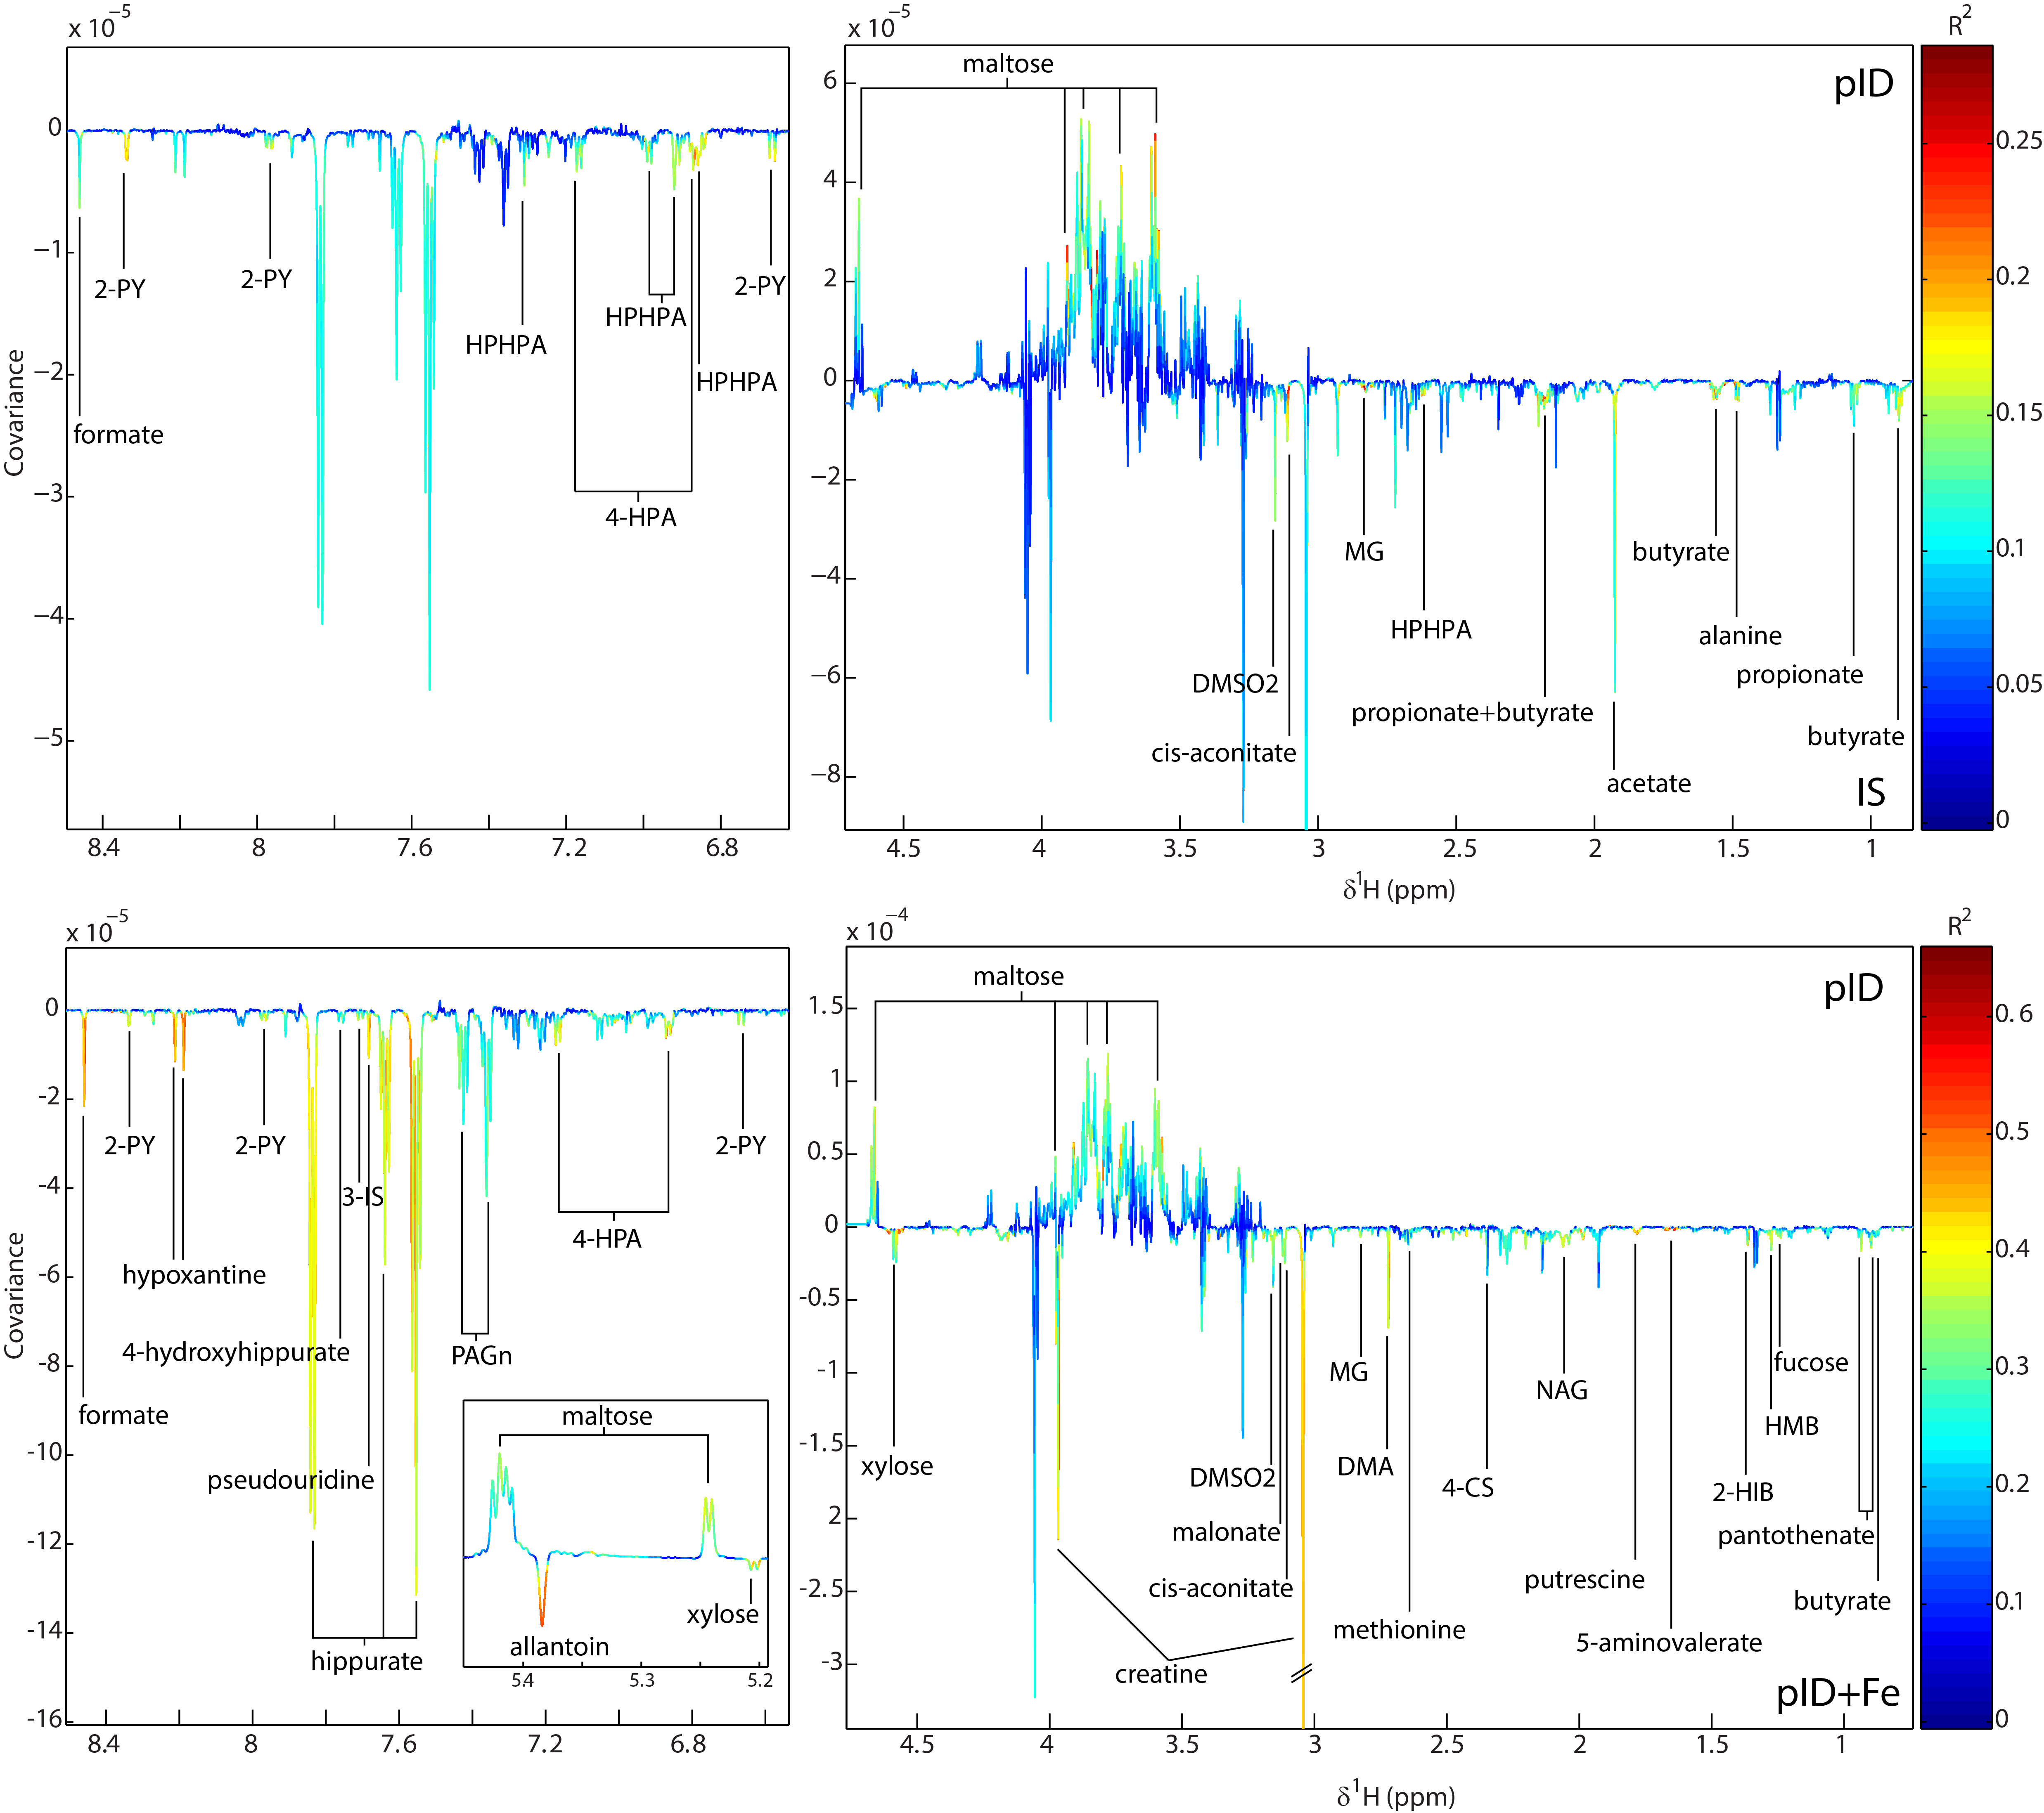

Supplementary Figure 2. OPLS-DA models constructed from the plasma metabolic profiles of rhesus monkeys. OPLS-DA coefficients plots are shown that indicate the metabolic variation between (upper panel) IS and pID plasma profiles and (lower panel) pID and pID+Fe profiles. Positive peaks indicate metabolites that were present in greater amounts in pID plasma, and negative peaks indicate metabolites that were present in lower amounts compared to the respective group. The color scale represents the significance of the correlation for each metabolite to the class membership with red indicating strong significance and blue indicating weak significance. GPC, glycerophosphocholine; OAG, O-acetyl-glycoprotein.
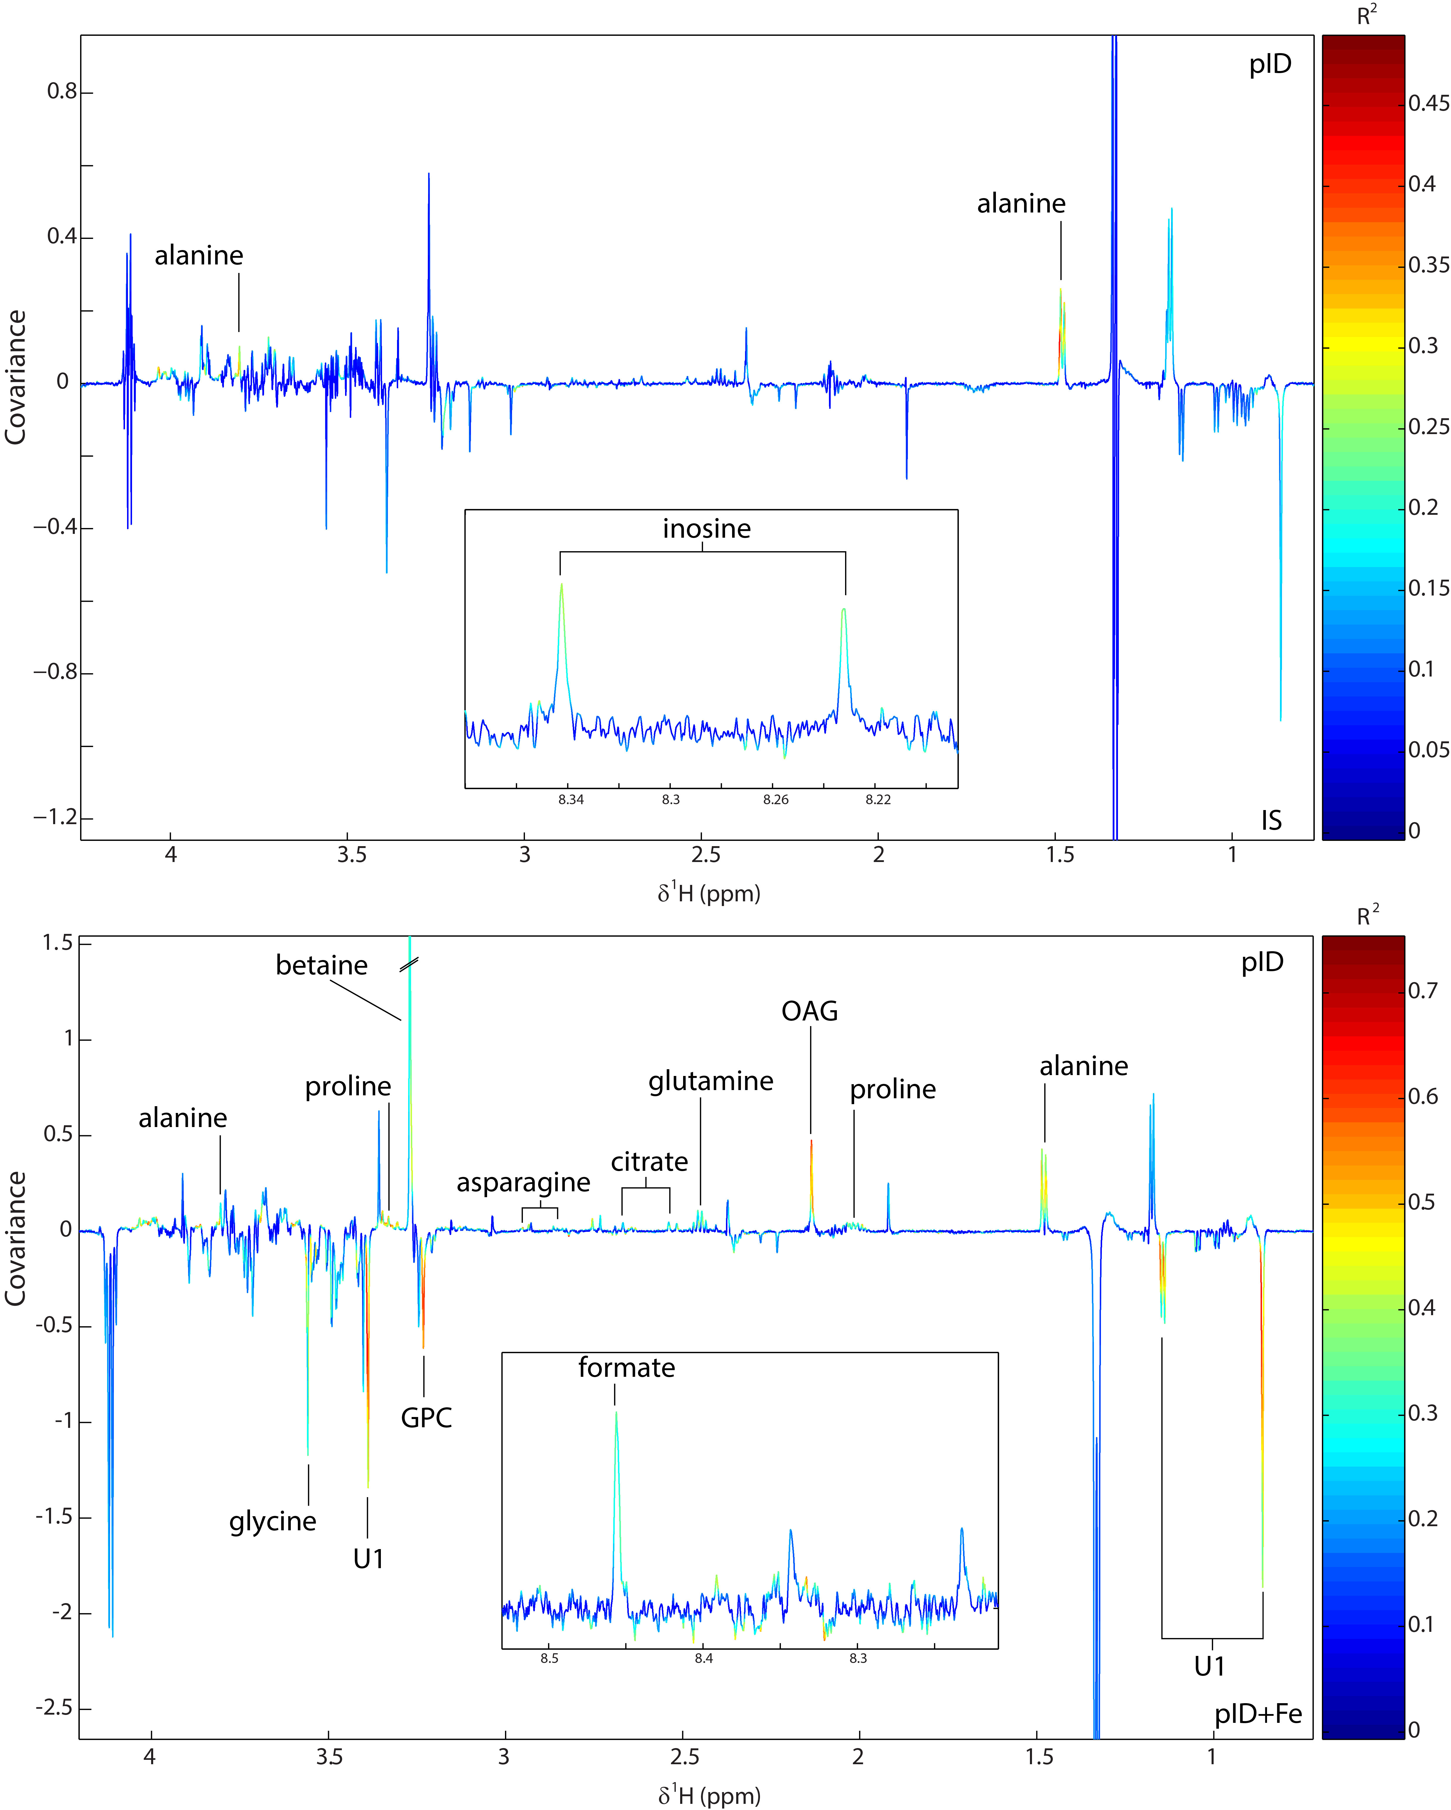

Supplementary Figure 3. Correlation and hierarchical clustering analysis showing the associations between the fecal microbiota and the urinary metabolites found to differ between IS and pID monkeys.

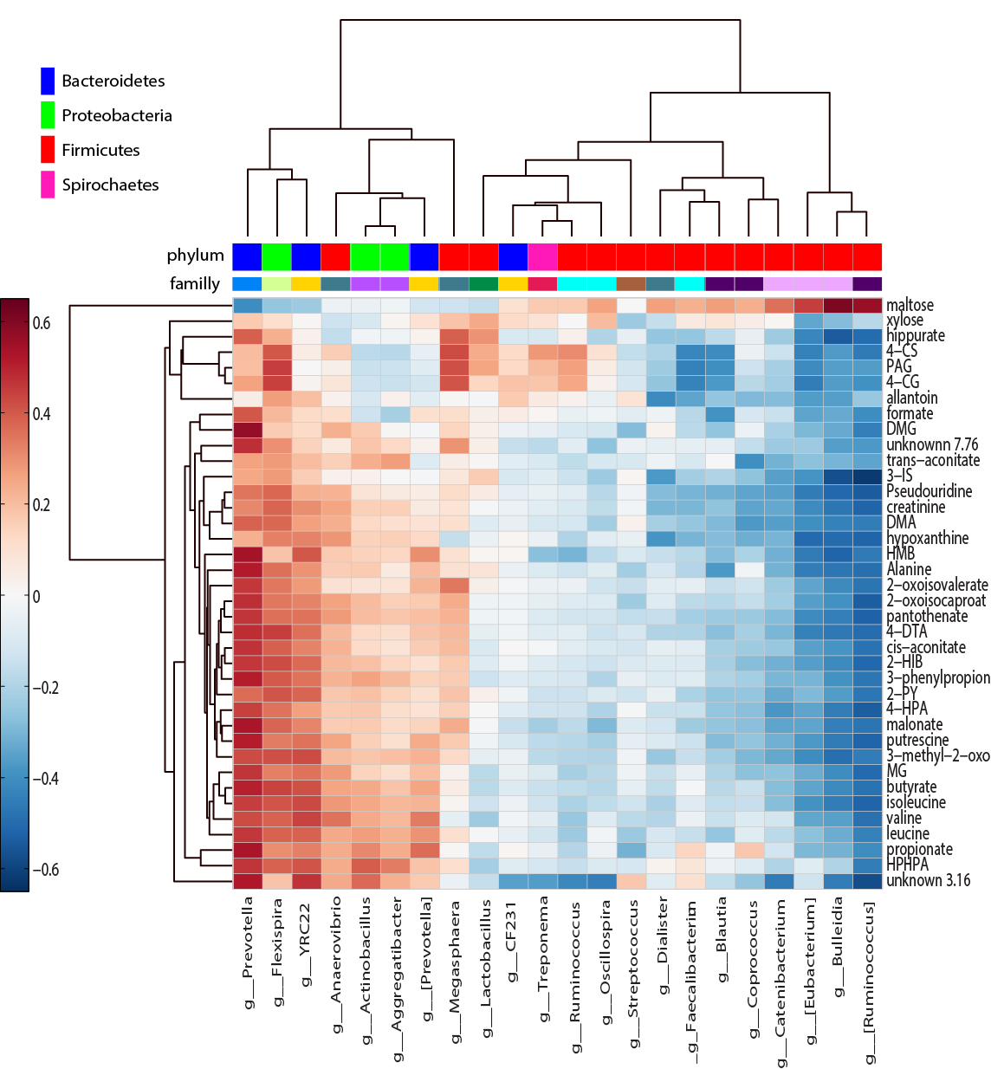

Supplementary Figure 4. Visualization of the multi-compartmental metabolic reaction network of metabolites identified to differ between monkeys that recovered gradually from ID (pID) when compared to always iron sufficient (IS) or ones supplemented with iron when determined to be ID (pID+Fe). The network includes reactions that can be performed by the monkey host (solid lines) or by bacteria present in the gut (dashed lines). The color of the line indicates reactions that require or involve iron. Grey boxes indicate urinary or plasma metabolites that differed between pID and IS or pID+Fe monkeys. White boxes indicate intermediate metabolites; boxes with an orange border indicate metabolites involved in reactions requiring or involving iron. Square nodes represent metabolites that are not involved in iron-dependent reactions or are more than two reactions away from a biomarker.

Supplementary Figure 5. Participant flow, sample aquistion and number of samples included in each step data analysis. Data from only 38 of the 43 potential animal were included in the final analyses after excluding 5 for poor quality spectra in the metabolomic profiling.

References
- Coe, C. L, Lubach, G. R., Busbridge, M., and Chapman, R. S. (2013). Optimal iron fortification of maternal diet during pregnancy and nursing for investigating and preventing iron deficiency in young rhesus monkeys. Res Vet Sci. 94, 549–554.
- Lubach, G. R., and Coe, C. L. (2006). Preconception maternal iron status is a risk factor for iron deficiency in infant rhesus monkeys (Macaca mulatta), J. Nutr. 136, 2345-2349.
- Armitage, A. E., and Moretti, D., (2019) Importance of iron status for young children in low- and middle-income countries: A narrative review. Pharmaceuticals, 12, 59. doi: 10.3390/ph120200059.
- National Research Council (2003). Nutrient requirements of nonhuman primates, Second Revised Edition, Washington DC, National Academies Press. https:/doi.org/10.17226/9826.
- Sandri, B. J., Lubach, G. R., Lock, E., F., Georgeiff, M. K., Kling, P. J., Coe, C. L., and Rao, R. B. (2020). Early life iron deficiency and its natural resolution are associated with altered serum metabolomic profiles in infant rhesus monkeys. J. Nutr. 150, 685-693.
- Rao, R., Ennis, K., Lubach, G. R., Lock, E. F., Georgieff, M. K., and Coe, C. L. (2018). Metabolomic analysis of CSF indicates brain metabolic impairment precedes hematological indices of anemia in the iron-deficient infant monkey. Nutr. Neurosci. 21, 40–48.

