Biaxial 3D-printed inclinometer based on Fiber Bragg Grating technology
Abstract
A Fiber Bragg Grating (FBG)-based inclinometer for field use has been developed using biaxial 3-dimensional, tilt sensors, into which four FBGs were incorporated and produced simply using 3D printing. The inclinometer was characterized by examining its response to tilts over the range from 0˚ to 90˚, towards the inclination axes. An excellent linear correlation between the wavelength shifts and inclination angle (up to the 90˚ used) was obtained, showing an average responsivity of 0.01 nm per degree of inclination angle, for each FBG. In addition to the four FBGs used for inclination measurement, a further FBG was included in the design to allow compensation for any temperature changes during the use of the instrument. It was calibrated over the range -25˚C to 80˚C (corresponding to the extremes of cold and hot weather conditions likely to be experienced), and a responsivity of 0.011nm/˚C was achieved. The data obtained from a full characterization the performance of the sensor system in a controlled environment indicate that this low cost inclinometer yields outstanding responsivity, making it highly applicable for use in monitoring rapid ground movements and deformations.

Keywords: Inclinometer, biaxial measurements, Fiber Bragg Grating-based technology,3D-printing, ground movements

- Introduction
Inclinometers have been widely used in various aspects of engineering and structural health monitoring, mainly to measure and characterize the inclination angles of slopes and building structures [1] as well as ground movements [2], especially caused by heavy rainfall and floods. As an example, in landslide detection, inclinometers are used in measuring the change of inclination of vertical boreholes and pipes installed in retaining structures, such as piles and diaphragms. This allows the more accurate determination of the rate of the ground sliding direction and depth. Inclinometers in use today are typically classified into two types – probe inclinometers and in-place inclinometers. In such probe inclinometers, the probe itself, (typically equipped with wheels) descends along a casing (into which grooves have been craeted), which is installed in a borehole. The probe is then stopped at specific displacement intervals, where measurements between 2 specific points are obtained and used to determine the inclination angle, while measurements are usually taken manually, on-site. By contrast, for in-place inclinometers, the sensors are typically permanently installed in boreholes at pre-determined depths, where the ground sliding is expected to take place. The aim for such technology is that measurements can be made remotely, either at a specific time, or continuously [3] if the need arises, for example during an extreme weather event.
In conventional electrical based inclinometers, the variation of the inclination angles is measured by monitoring the changes in the electrical signal caused by a magnetic effect in the sensor [4]. However, the presence of high voltages or high electromagnetic interference (such as for nearby power lines or broadcasting transmitters) can affect the accuracy and performance of these sensors [5], and thus limit their use in these types of environments, where often they are particularly needed. Recently, optical fiber based sensors have become an increasingly popular alternative to conventional mechanical and electrical sensors, and also for inclinometer applications. Various types of optical fiber based sensors have been utilized in a wide variety of civil and structural engineering, such as Fabry-Perot strain sensors [6], Michelson interferometer sensors [7], and Fiber Bragg Grating (FBG) sensors [8–15], usually applied to structural or infrastructure monitoring. Since the development of FBGs [16], their lightweight nature and potential for multiplexing, as well as their use over long distances [17] are seen to suit inclinometer applications very well.
A 2-dimensional (2-D) temperature-insensitive FBG tilt sensor was demonstrated by Bao et al in [18] where 4 FBGs were aligned in parallel on the outer part of a cylindrical surface, at an equal distance from each other. An accuracy of 0.013 nm per degree of inclination angle was obtained, within the limited range -40˚ to 40˚, towards the x-z and the y-z planes. In the work of He et al [10], a tilt sensor with three incorporated FBGs was used to minimize the friction, rotations, and instabilities induced by their design. The FBGs (at an equal distance from each other) were suspended from a circular top plate, with a 200g weight at the bottom, but tilted only over the -15˚ to 15˚ range with respect to the respective axes. A further tilt sensor design, incorporating 3 FBGs has also been reported by Dong et al [19], using a 2-D tilt sensor design with strain-chirped FBGs, based on a vertical pendulum structure that creates a variation of the observed optical power, over the tilt angles studied. In this design, each FBG was laid on top of a steel flake placed on to a base plate and then hung on a vertical pendulum. However, a weakness is that errors in the measurements will develop with time, as the optical power may fluctuate. A weakness with all the designs reported is that while they work well in the laboratory, under controlled conditions, most of them are large in size and have small operating degree of inclination angle and this are less well suited to the in-the-field monitoring that is essential for a device of this type, for ground movement monitoring.
Addressing the limitations in the previous work, this paper introduces a different design of inclinometer, based on compact tilt sensors and incorporating 4 FBGs for biaxial strain measurements, operating within the important -90˚ to 90˚ of tilt angle (towards the x and y axes). Care has been taken to create a design where the operating range has been extended from what has been reported above, so that it can detect tilts in any direction along the x and y axes. It was seen as critically important for effective in-the-field use to provide scope for temperature compensation inside the inclinometer, so in addition the 4 FBGs used for the tilt measurement itself, a further FBG characterized in a laboratory test chamber over the temperature range, -25˚C to 80˚C. Such an inclinometer has been created to be compact in its design, and having a wider operating range of inclination angle (-90˚ to 90˚) towards the respective axes, offers a practical solution for slope and structural monitoring.
- Design and operating principle of the FBG-based inclinometer
The key elements of the structure of this inclinometer, based on integrated tilt sensors, is shown in Fig. 1(a) where the bending towards the inclination angle, $θ$ causes strains which can be monitored by the FBGs integrated within the device.
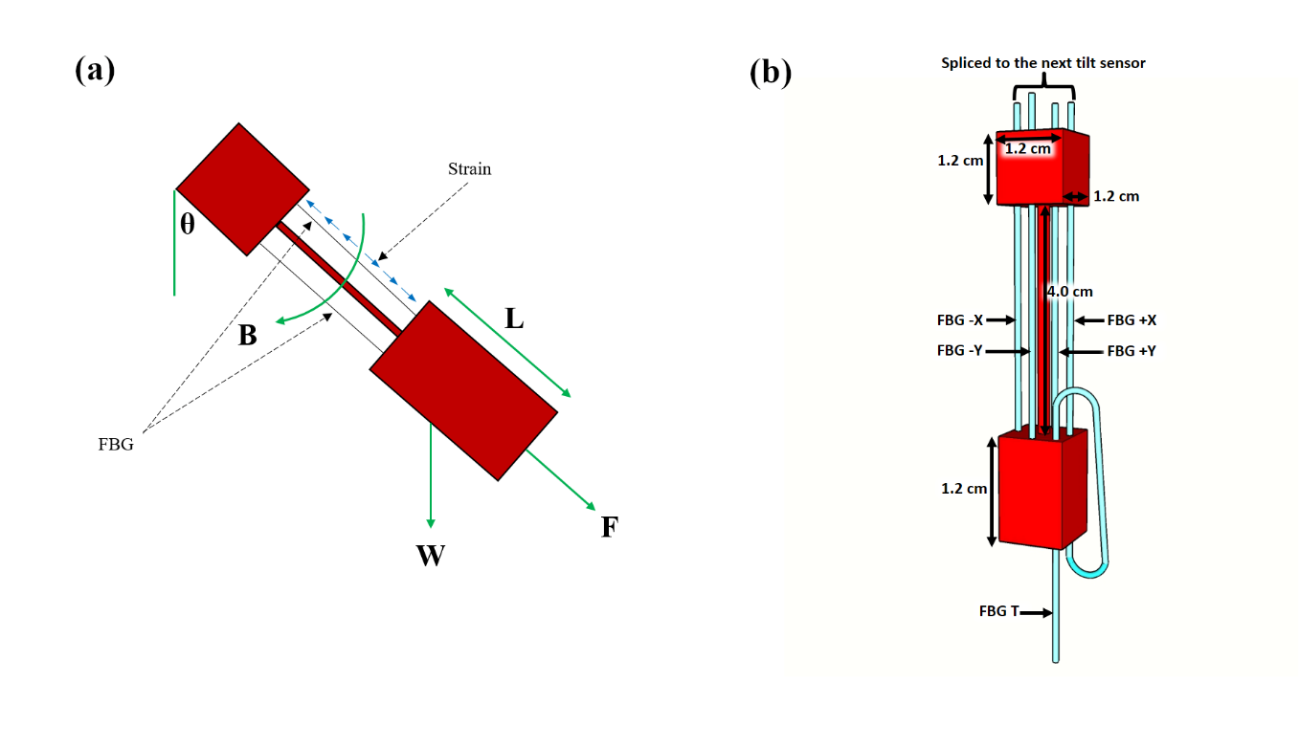
Fig. 1 Illustration of (a) the tilt sensor experiencing a tilt at an angle $θ$, and (b) the tilt sensor dimensions with the incorporated FBGs at 0˚ inclination angle.

The FBGs used both for tilt and temperature measurement were inscribed in the core of a hydrogenated single mode fiber by the phase mask technique, using a Krypton Fluoride (KrF*) excimer laser operating at a wavelength of 248 nm. Strain (and temperature) will affect the Bragg wavelength through contraction or expansion of the grating pitch where the Bragg wavelength λ_{B} of uniform FBG written in the SMF used is given by:
 | $$λ_{B}=2n_{eff}Λ$$ | (1)
where n_{eff} is the effective refractive index of the guided mode inside a single mode fiber, and Λ is the grating pitch. When the gratings are exposed to the external perturbations (such as the strain or temperature effects here), the Bragg wavelength will change accordingly, and Eq. (1) can be rewritten as follows:
 | $$\frac{{∆λ}_{B}}{λ_{B}}=K_{ε}∆ε+K_{T}∆T$$ | (2)
where ${∆λ}_{B}$ is the change of the Bragg wavelength, ∆ε is the strain change, ∆T is the temperature change of the FBG sensor while K_{ε} and K_{T} are the strain and temperature coefficients, respectively.
The design of the tilt sensor, illustrating its dimensions, is as illustrated in Fig 1(b). Four FBGs were used where each was attached to one of the four sides of the 3D-printed tilt sensor, representing the four inclination axes (+x, -x, +y, -y). To construct the device, the FBGs were inserted through the pre-printed holes on the tilt sensor and were glued at each end, using a strong adhesive glue.
The wavelength shifts of each FBG are then used as they can be calibrated to evaluate the magnitudes of tilt angles. With reference to Fig. 1(a), the tensile force, F_{T} and the bend moment, B of the tilt sensor can be expressed in terms of tilt angles $θ$ as follows:
 | $$F_{T}=W \cos{θ}$$ | (3)
 | $$B=W∙L\sin{θ}$$ | (4)
where W is the weight and L is the length that can be seen from the figure. Both the tensile force and bending moment cause the change of strain to the FBGs and this change can be expressed as:
 | $$∆ε=\frac{F_{T}}{EA_{s}}±\frac{B}{EI_{s}}$$ | (5)
where E is the elastic modulus, A_{s} is the cross sectional area, and I_{s} is the moment of inertia of the sensor shaft. Based on Equation (3) and (4), the change of the strain due to the inclination can be expressed as:
 | $$∆ε=\frac{F_{T}}{EA_{s}}±\frac{B}{EI_{s}}=\frac{W}{E}\left(\frac{\cos{θ}}{A_{s}}±\frac{L\sin{θ}}{I_{s}}\right).$$ | (6)

As shown in Fig. 1(b), another FBG (denoted as FBG T and with a Bragg wavelength of 1558.36 nm), was spliced to the FBG on the +x axis, glued to an adjacent pre-printed hole and was left hanging (to ensure strain insensitivity) and thus to provide a means for temperature compensation for the device.
The FBG-based in-place inclinometer for was designed to be installed in a standard inclinometer casing, having a diameter and thickness 70 mm and 5 mm respectively. This casing has 4 longitudinal wheel-grooves (labelled as 1, 2, 3, and 4) and spaced 90˚ apart, as shown in Fig. 2(a). The inclinometer consists of 3 built-in tilt sensors (T1, T2, and T3) set at 30 cm intervals, as illustrated in Fig. 2(b), where each tilt sensor (T1, T2, and T3) is installed with four FBGs, placed on four different axes (+x, -x, +y and -y) as depicted in Fig. 1(b). Each tilt sensor of this inclinometer was equipped with two units of spring-pressured wheels, positioned at points 1 and 3 of the casing to guide the inclinometer sensor along the longitudinal grooves of the casing, as depicted in 2(c). The FBGs at the +x axis (T1, T2 and T3) were spliced together in series. In this case, FBG T was also spliced to the end of the FBG at T3, in series, creating a single output from the +x axis with the four different wavelength peaks due to four different FBGs spliced being seen. The same method was applied to the other three axes (-x, +y and -y), providing in total the four different outputs which were then recorded. The inclinometer in this way is able to measure the internal movement of the slope being monitored, as the inclinometer device interacts closely with the surrounding soil mass and allows the inclination to be recorded.

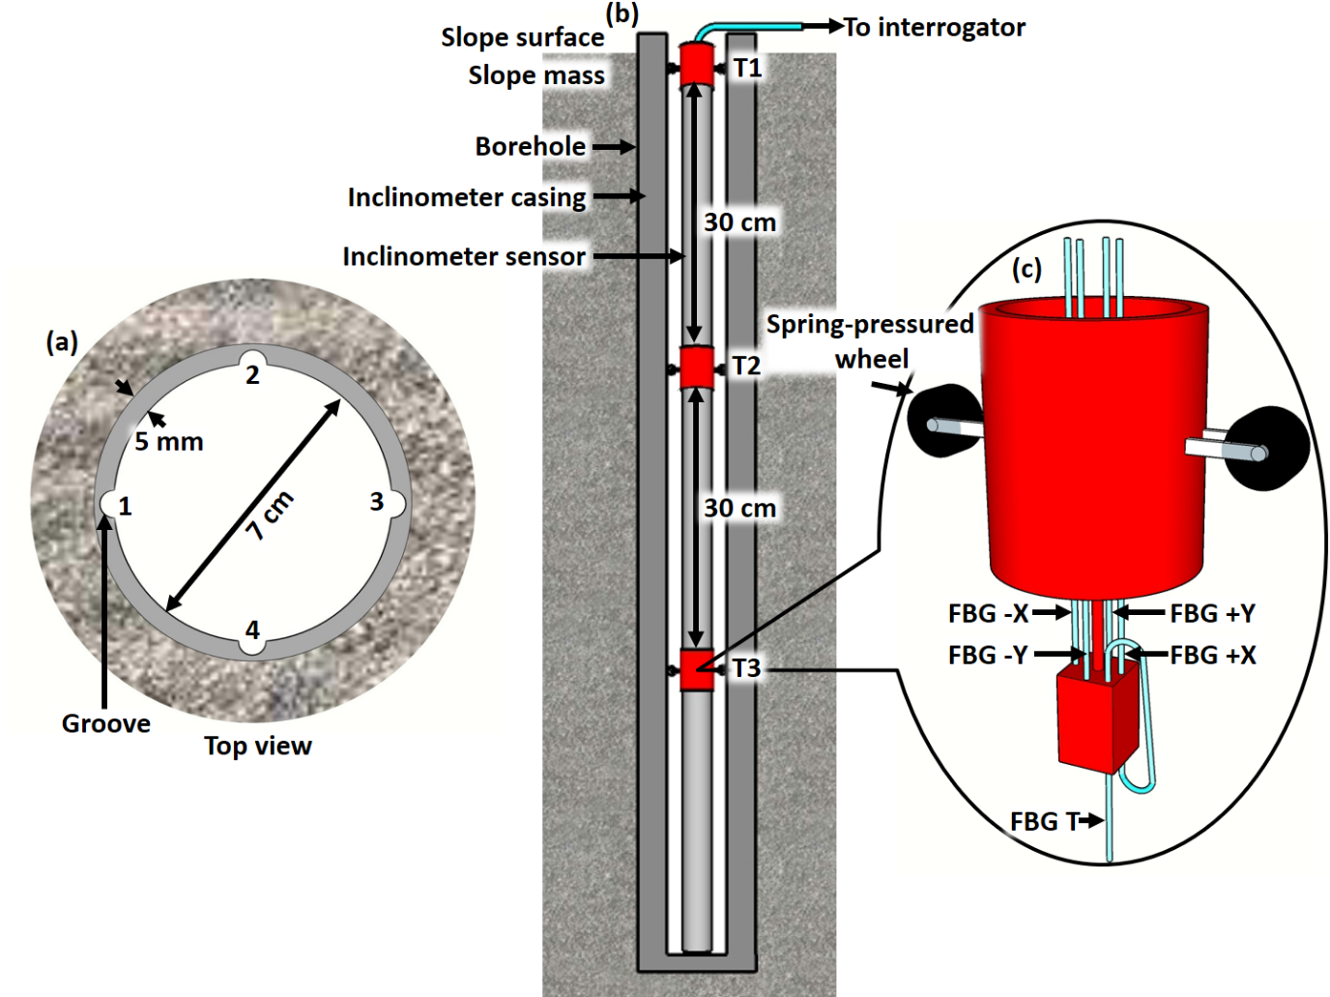
Fig. 2 Schematic design of the FBG-based inclinometer showing (a) top view of the inclinometer casing, (b) longitudinal section of the in-place inclinometer, and (c) built-in tilt sensor.

2.1 Laboratory calibration testing of FBG-based inclinometer
For this experiment, the Bragg wavelength shifts from the FBGs used in the device were observed and recorded using a Yokogawa AQ6370C Optical Spectrum Analyser. A schematic diagram of the experimental setup is shown in Fig. 3(a), where four outputs from the inclinometer were connected to the input channels of an optical switch, while the output channel was connected to Port 2 of an optical circulator. Port 1 and Port 3 of the circulator were coupled to an amplified spontaneous emission light source and the Optical Spectrum Analyzer respectively. In the calibration of the inclinometer, the bottom end of the inclinometer was pushed towards each of the inclination axes depicted in Fig. 3(c): starting from an initial 0˚, to 90˚ inclination angle, while the top end is anchored to a fixed position by a table vice with 360˚ rotations used for the inclination mechanism (as illustrated in Fig. 3(b)).

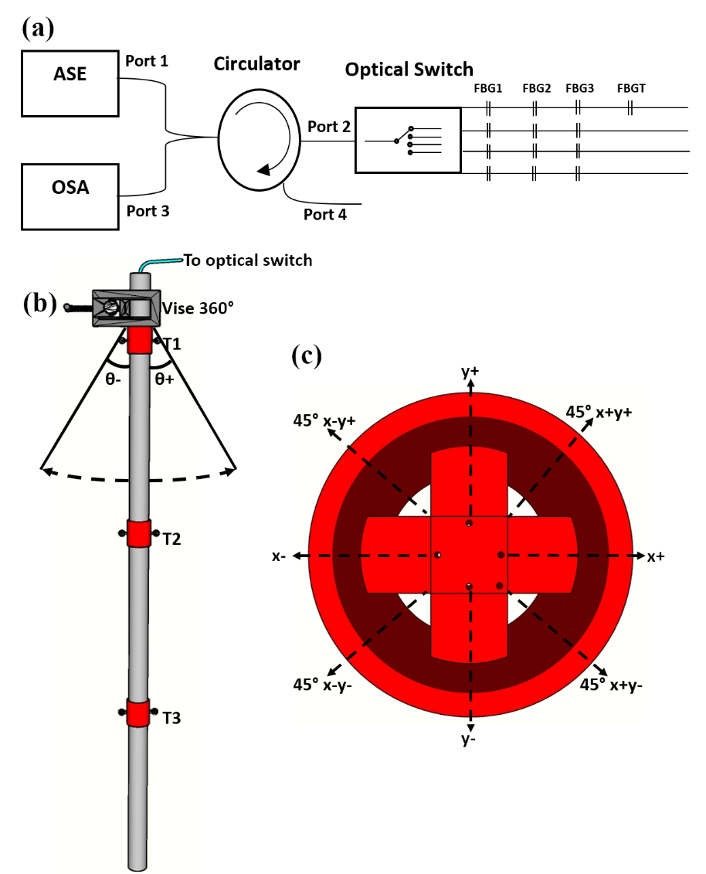
Fig. 3 Illustration of the (a) schematic diagram of the setup, (b) experimental setup, and (c) direction of the tilt (top view).

  - Calibration of the temperature compensation of the inclinometer
To evaluate the temperature compensation over the potentially very wide range that a device may experience when used in-the-field, the tilt sensor was initially placed inside a polystyrene box surrounded with dry ice (solid Carbon dioxide), as illustrated in Fig. 4(a), to create a stable, extreme cold environment at -25˚C. The dry ice was then removed and the temperature inside the polystyrene box was allowed to rise slowly to the room temperature (of 27˚C) measuring the response at 10˚C intervals through monitoring the peak wavelength shift of the FBG used (FBG T). To calibrate the device for temperatures above room temperature, the FBG was then placed in a water bath, as illustrated in Fig. 4(b) and the temperature of the water was increased from 27˚C to 80˚C, again with measurements of thw wavelength shift being taken at intervals of 10˚C, using the Optical Spectrum Analyser (OSA).

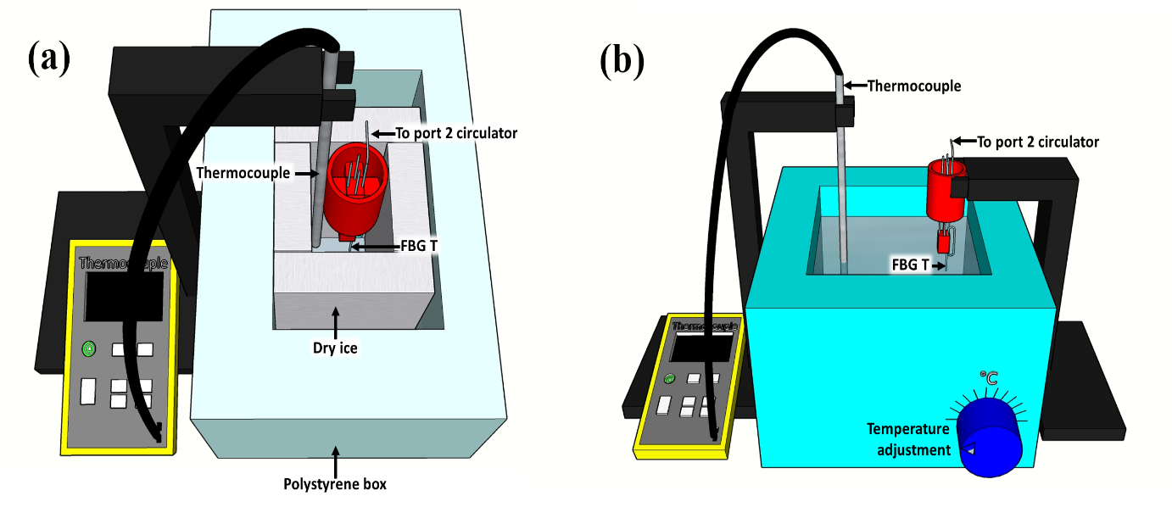Fig. 4 Illustrations of the calibration of the device at both sub-room temperature (a) and (b) beyond room temperature. The tilt sensor was placed (a) inside a polystyrene box surrounded with dry ice to create the low temperature environment and (b) in a water bath to create the high temperature environment.

- Results and Discussion
Data from the tilt sensors, T1, T2 and T3 were collected, as indicated in Table 1, which shows the wavelengths associated with these FBGs (with their respective sensors and axes), in the experimental setup illustrated in Fig. 3. Fig. 5 illustrates the reflected peak spectra of each grating in the tilt sensor, T1, T2, and T3, starting with an initial tilt angle of 0˚ (to their respective inclination axis (+x, -x, +y, –y)). In addition, the spectrum for the grating used for temperature compensation (FBG T which is strain insensitive) is shown in Fig. 5(a), in addition to the spectral features from the tilt sensors T1, T2 and T3 (for the +x direction). As the inclinometer is tilted in different ways, towards the +x, -x, +y, and –y directions, the spectra for all these directions are presented in Fig. 5(a), (b), (c), and (d) respectively. Fig. 6 illustrates the effect of the tilt of the device from 0 to 90˚ for sensors T1, T2, and T3 as the inclinometer is tilted towards (a) the +x direction (with the spectrum for FBG T for temperature compensation also included), (b) the -x direction, (c) the +y direction, and (d) the -y direction. Specifically, Fig. 6 shows the ‘redshifts’ in the wavelength spectra could be observed as the inclinometer is tilted from the initial 0˚ tilt (shown in red) to 90˚ (shown in green), with the spectrum from a number of intermediate tilt angles shown between these two, for the +x, -x, +y, and –y directions as Fig 6 (a), (b), (c) and (d) respectively. Further, Fig. 6 (a) shows the spectrum for FBG T, with the same tilts applied from 0˚ to 90˚, clearly indicating that it is insensitive to strain, and thus able to provide the temperature compensation needed. These results show the effectiveness of the mechanism proposed which then can be seen allows the mapping of the inclination angle – thus allowing the identification of the presence of ground movement or deformation on the tilt sensor when it is used as intended.
Table 1 : FBG wavelengths monitored for the different respective sensors and axes
Sensor | +x (nm) | -x (nm) | +y (nm) | -y (nm)
T1 | 1537.88 | 1540.90 | 1541.22 | 1539.02
T2 | 1546.86 | 1547.64 | 1546.94 | 1546.80
T3 | 1553.18 | 1553.30 | 1553.14 | 1553.54

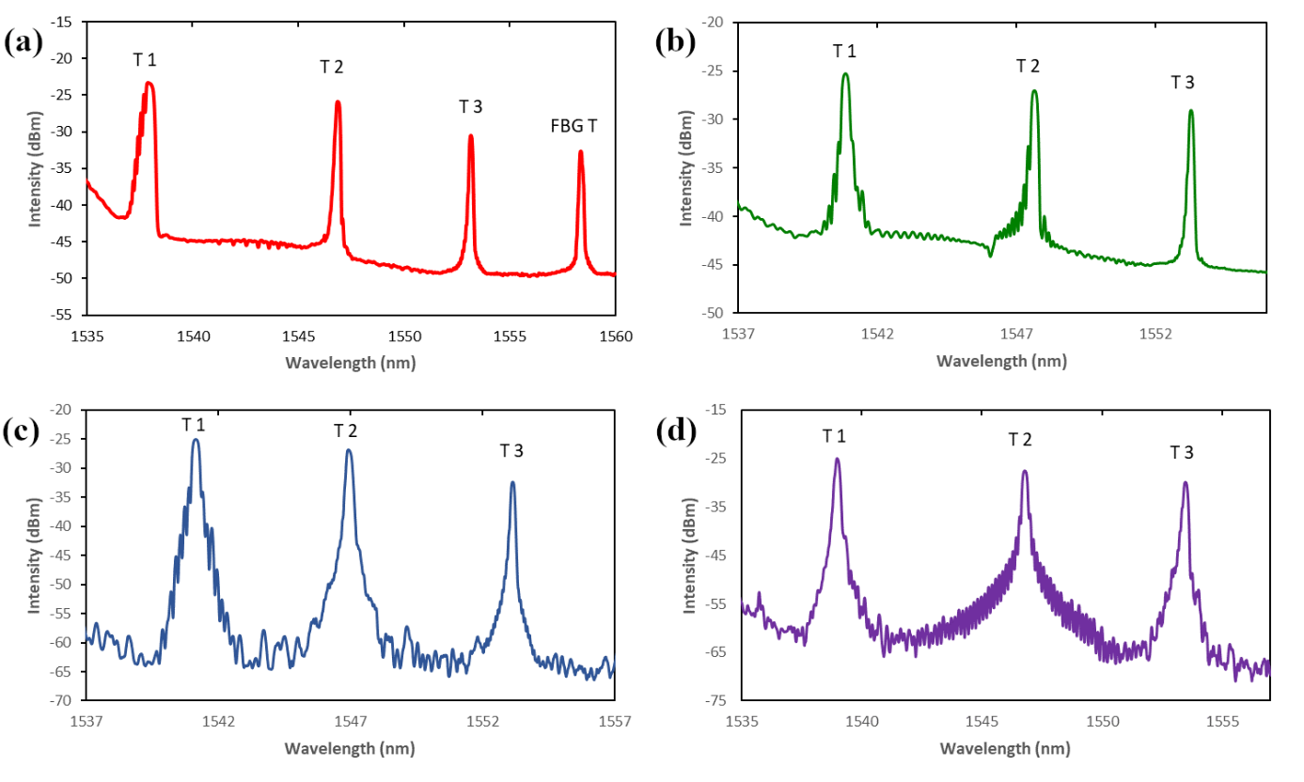
Fig. 5 Illustrations of the wavelength spectra for each tilt sensor T1, T2 and T3, at the initial position of 0˚ tilt angle at (a) +x direction with FBG T for temperature compensation included, (b) -x direction, (c) +y direction, and (d) -y direction.
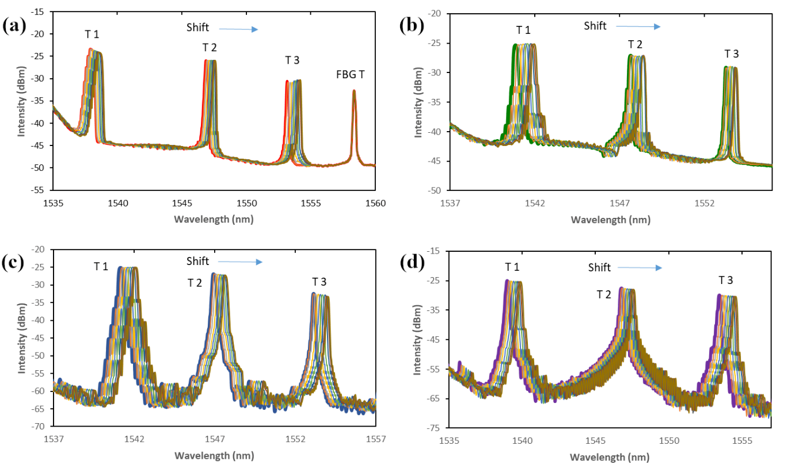
Fig. 6 Shifts of the wavelength spectra for each tilt sensor T1, T2, and T3 as the inclinometer is tilted from 0 to 90˚ towards (a) +x direction with FBG T for temperature compensation, (b) -x direction, (c) +y direction, and (d) -y direction.
Further experimentation has been carried out and Fig. 7 shows the shifts of the wavelength spectra for each tilt sensor grating, T1, T2 and T3, as the inclinometer is tilted from 0 to 90˚ towards 45˚ along the (a) +x and +y direction, (b) -x and -y direction. Thus in Fig. 7(a), when the inclinometer is tilted towards 45˚ from +x to +y axis (with reference to the scheme shown in Fig. 3(c)) from 0˚ - 90˚, a simultaneous biaxial response from the tilt sensor on the +x side and +y sides can be observed. Further, as the inclinometer is tilted towards 45˚ from the –x to –y axis (again with reference to Fig.3(c)), a similar pattern in the simultaneous biaxial response was observed, as shown in this case in Fig. 7(b).
These positive results have shown very clearly that the inclinometer could operate successfully over the tilt range from 0˚ to 90˚, and on any of the axes shown, as it is clear that a tilt in any direction will cause a shift in the spectrum of the FBG-based sensor, used to monitor that specific axis.
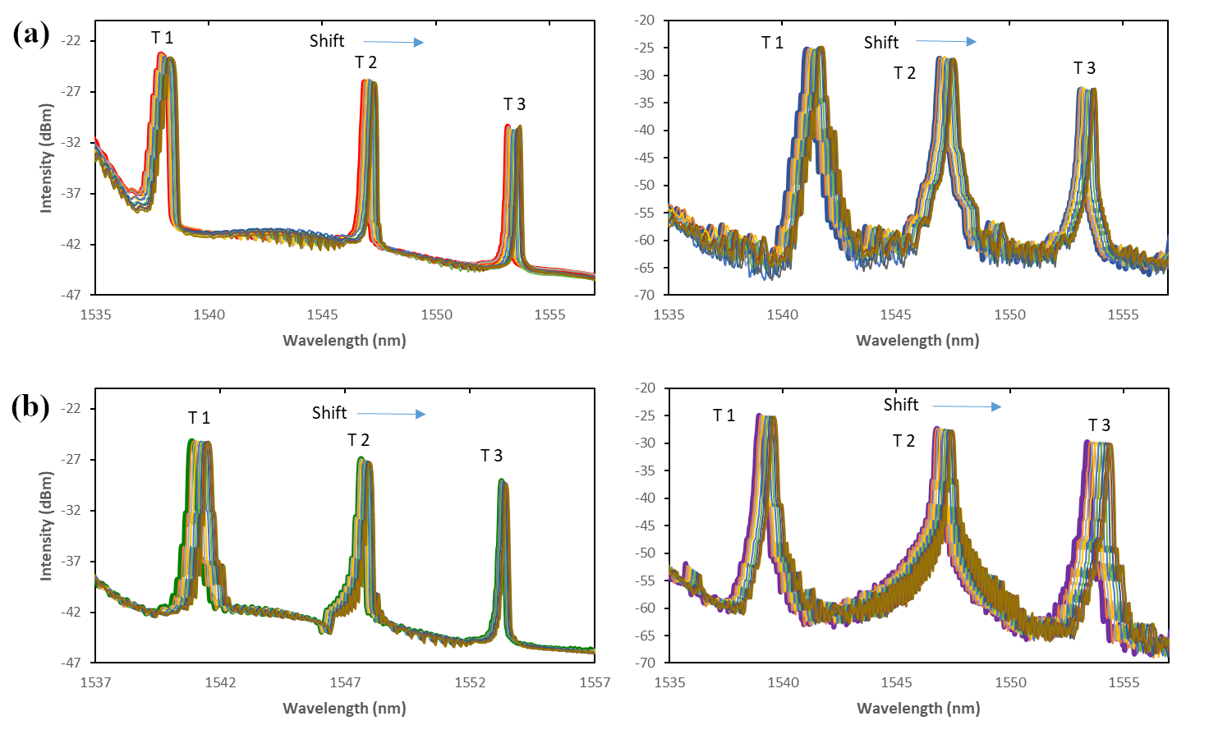
Fig. 7 Shifts of the wavelength spectrums for each tilt sensor T1, T2 and T3 as the inclinometer is tilted from 0 to 90˚ towards 45˚ along the (a) +x and +y direction, (b) -x and -y direction.
Fig. 8 shows the calibration of the device, in terms of tilt angle: for tilt sensor T1, as it is tilted from 0 to 90˚ towards (a) +x, (b) +y, (c) +x (all in red) and 45˚ towards +x (in green), (d) +y (in blue) and 45˚ towards +y (in green). A close linear relationship is seen, with a responsivity of 0.008 nm (+x) and 0.01 nm (+y) per degree of inclination observed over the range from 0˚ up to 90˚. For example, at 45˚ from the +x to +y axis, a similar linear relationship between the grating wavelength shift and the inclination angle, over the range 0˚ to 90˚ is also obtained. A comparison of the device sensitivity, indicated by the linearity of the graphs in Fig. 8 was made for tilt sensor T1, as the inclinometer was (i) tilted towards the +x and +y axis, and (ii) as it was tilted 45˚ from +X to +Y axis (as shown in Fig. 8(c) and Fig. 8(d) in particular). From these figures, it can be seen that the sensitivity of the tilt sensor (T1) during the single-axis tilt (along the axis) is greater than the 45˚ biaxial tilt. This arises simply because during the biaxial tilts, both gratings along the +x axis and +y axes share the total downward force experienced, resulting to small net force to each of them. Hence as a result, a lesser strain is applied to each grating in the tilt sensor, thus producing a smaller shift in the wavelength spectrum, as compared to the result from the single-axis tilt.

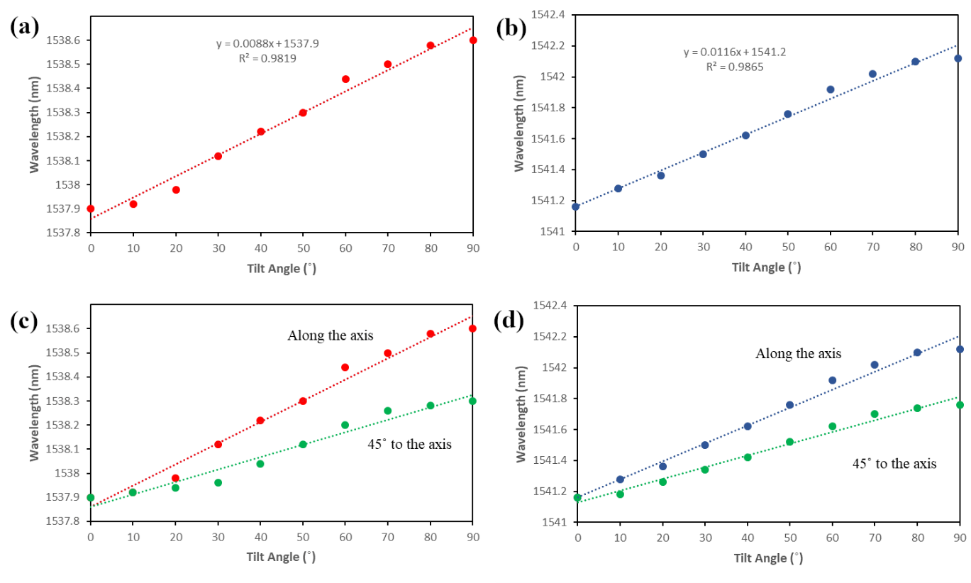
Fig. 8 Illustrations of wavelength over tilt angle for tilt sensor T1, as it is tilted from 0 to 90˚ towards (a) +x, (b) +y, (c) +x (in red) and 45˚ towards +x (in green), (d) +y (in blue) and 45˚ towards +y (in green).

Fig. 9 illustrates (a) the shift in the reflected peak spectrum of FBG T (which is insensitive to strain) due to the change in temperature, over the range from -25˚C → 80˚C and (b) the shift in the peak spectrum of this grating, FBG T, showing its linear response due to the change in temperature over the range from -25˚C → 80˚C. Fig. 9(a) and (b) thus show clearly that FBG T (with a Bragg wavelength of 1558.36 nm), is insensitive to strain. To ensure that it does provide the temperature compensation needed, the FBG was exposed to the extreme range of temperatures that would be expected in field use, thus calibrating over the range -25˚C to 80˚C. A linear response to temperature, with a responsivity of 0.011nm/˚C, indicates that a simple temperature compensation approach can be applied to the inclinometer to allow correction for any temperature changes that occur during the operation of the device in-the-field, for example from nigh to day temperatures.

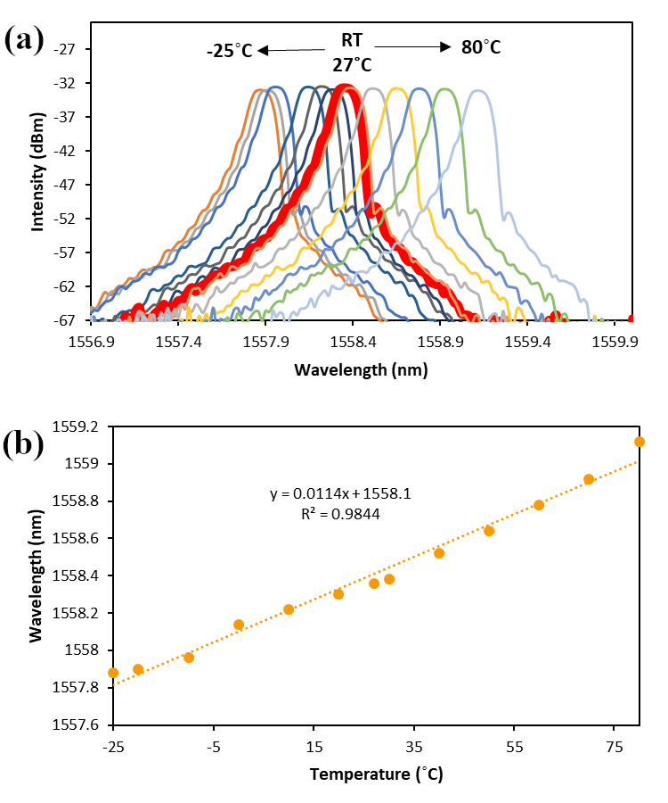
Fig. 9 Illustrations of (a) shift in the reflected peak spectrum of FBG T (insensitive to strain) due to the change in temperature over the range from -25˚C → 80˚C and (b) shift in the peak spectrum of FBG T showing a linear response due to the change in temperature over the range from -25˚C → 80˚C.
- Conclusion
A practical FBG-based compact and low cost inclinometer has been designed, fabricated and evaluated. This has been based on 3D-printed biaxial tilt sensors utilising 4 FBGs to ensure biaxial measurements. The experimental results showed an excellent degree of linearity in the response, not only of each FBG over a range of inclination angle of 0˚ to 90˚ (with an average responsivity of 0.01nm per inclination degree) but of the system as a whole. The inclinometer further has been designed to operate over a wide temperature range, such as would be experienced in-the-field by including a facility for temperature compensation (through a strain-insensitive FBG that provides a temperature compensation factor of 0.011nm/˚C). The inclinometer has the ability not only to measure biaxial response, but also at 45˚ between the inclination axis, showing a wider dimension to the inclination measurement possible.
The device is compact and inexpensive to produce, as well as being designed for use outside the laboratory. There, the ability of this inclinometer to operate in 2 axes, at extreme temperatures (-25˚C to 80˚C), opens up potential applications in civil engineering, especially in slope and structural monitoring and in the protection of vulnerable communities affected by landslips after major weather events.

- Acknowledgements
The authors are pleased to acknowledge support from the British Council-MIGHT NUOF (IF022-2020) and the University of Malaya (RK021-2019 and TOP100PRC). Grattan acknowledges support from the Royal Academy of Engineering.

References
[1] P. Ferdinand, S. Magne, V. Dewynter-marty, L. Maurin, P. Ferdinand, S. Magne, V. Dewynter-marty, S. Rougeault, L. Maurin, P. Ferdinand, S. Magne, V. Dewynter-marty, Applications of Fiber Bragg Grating sensors in the composite industry To cite this version : A pplications of Fiber Bragg Grating Sensors in the, (2018).
[2] Y.-T. Ho, A.-B. Huang, J. Ma, B. Zhang, Ground movement monitoring using an optic fiber Bragg grating sensored system, 17th Int. Conf. Opt. Fibre Sensors. 5855 (2005) 1020. https://doi.org/10.1117/12.623596.
[3] Z. Mihalinec, M. Bačić, M.S. Kovačević, Risk identification in landslide monitoring, Gradjevinar. 65 (2013) 523–536. https://doi.org/10.14256/jce.717.2012.
[4] R. Olaru, C. Cotae, Tilt sensor with magnetic liquid, Sensors Actuators, A Phys. 59 (1997) 133–135. https://doi.org/10.1016/S0924-4247(97)80162-8.
[5] L. Kerkeni, P. Ruano, L.L. Delgado, S. Picco, L. Villegas, F. Tonelli, M. Merlo, J. Rigau, D. Diaz, M. Masuelli, We are IntechOpen , the world ’ s leading publisher of Open Access books Built by scientists , for scientists TOP 1 %, Intech. (2016) 13. https://www.intechopen.com/books/advanced-biometric-technologies/liveness-detection-in-biometrics.
[6] Y. Yang, X. Ma, K. Chen, E. Wang, Z. Yu, Q. Yu, A high-resolution dynamic fiber-optic inclinometer, Sensors Actuators, A Phys. 283 (2018) 305–312. https://doi.org/10.1016/j.sna.2018.10.007.
[7] L.M.N. Amaral, O. Frazão, J.L. Santos, A.B. Lobo Ribeiro, Fiber-optic inclinometer based on taper Michelson interferometer, IEEE Sens. J. 11 (2011) 1811–1814. https://doi.org/10.1109/JSEN.2011.2105264.
[8] M. Maheshwari, Y. Yang, D. Upadrashta, T. Chaturvedi, A Rotation Independent In-Place Inclinometer/Tilt Sensor Based on Fiber Bragg Grating, IEEE Trans. Instrum. Meas. 68 (2019) 2943–2953. https://doi.org/10.1109/TIM.2018.2870246.
[9] C. Hong, Y. Zhang, Z. Lu, Z. Yin, A FBG Tilt Sensor Fabricated Using 3D Printing Technique for Monitoring Ground Movement, IEEE Sens. J. 19 (2019) 6392–6399. https://doi.org/10.1109/JSEN.2019.2908873.
[10] S. He, X. Dong, K. Ni, Y. Jin, C.C. Chan, P. Shum, Temperature-insensitive 2D tilt sensor with three fiber bragg gratings, Meas. Sci. Technol. 21 (2010). https://doi.org/10.1088/0957-0233/21/2/025203.
[11] R.W. Mok, P. Silveira, A. Dante, C. Carvalho, M. Keley, L. Garção, R. Allil, M. Werneck, Inclination sensor based on FBG with enhanced sensitivity, I2MTC 2018 - 2018 IEEE Int. Instrum. Meas. Technol. Conf. Discov. New Horizons Instrum. Meas. Proc. (2018) 1–5. https://doi.org/10.1109/I2MTC.2018.8409682.
[12] H.Y. Au, S.K. Khijwania, H.Y. Fu, W.H. Chung, H.Y. Tam, Temperature-insensitive fiber bragg grating based Tilt sensor with large dynamic range, J. Light. Technol. 29 (2011) 1714–1720. https://doi.org/10.1109/JLT.2011.2132695.
[13] H. Bao, X. Dong, L.Y. Shao, C.L. Zhao, S. Jin, Temperature-insensitive 2-D tilt sensor by incorporating fiber Bragg gratings with a hybrid pendulum, Opt. Commun. 283 (2010) 5021–5024. https://doi.org/10.1016/j.optcom.2010.07.050.
[14] X. Dong, L. Hu, L. Shao, Y. Wang, J. Zheng, Temperature-insensitive 2D fiber Bragg grating TILT sensor, Microw. Opt. Technol. Lett. 55 (2013) 344–346. https://doi.org/10.1002/mop.27281.
[15] Y.L. Wang, B. Shi, T.L. Zhang, H.H. Zhu, Q. Jie, Q. Sun, Introduction to an FBG-based inclinometer and its application to landslide monitoring, J. Civ. Struct. Heal. Monit. 5 (2015) 645–653. https://doi.org/10.1007/s13349-015-0129-4.
[16] K.O. Hill, G. Meltz, Fiber Bragg grating technology fundamentals and overview, J. Light. Technol. 15 (1997) 1263–1276. https://doi.org/10.1109/50.618320.
[17] A.D. Kersey, M.A. Davis, H.J. Patrick, M. LeBlanc, K.P. Koo, C.G. Askins, M.A. Putnam, E.J. Friebele, Fiber grating sensors, J. Light. Technol. 15 (1997) 1442–1462. https://doi.org/10.1109/50.618377.
[18] H. Bao, X. Dong, C. Zhao, L.Y. Shao, C.C. Chan, P. Shum, Temperature-insensitive FBG tilt sensor with a large measurement range, Opt. Commun. 283 (2010) 968–970. https://doi.org/10.1016/j.optcom.2009.11.014.
[19] X. Dong, C. Zhan, K. Hu, P. Shum, C.C. Chan, Temperature-insensitive tilt sensor with strain-chirped fiber Bragg gratings, IEEE Photonics Technol. Lett. 17 (2005) 2394–2396. https://doi.org/10.1109/LPT.2005.857978.

