Sustainable buyer-supplier relationship capability development: A relational framework and visualization methodology

Chunguang Bai
School of Management and Economics
University of Electronic Science and Technology of China
E-mail: Cbai@uestc.edu.cn

Simonov Kusi-Sarpong
Southampton Business School, University of Southampton
Southampton SO17 1BJ, UK
Email: simonov2002@yahoo.com

Sharfuddin Ahmed Khan
Industrial Engineering and Engineering Management Department,
University of Sharjah, Sharjah, UAE
E-mail: skhan@sharjah.ac.ae

Diego Vazquez-Brust
Portsmouth Business School, University of Portsmouth
United Kingdom
Email: diego.vazquez-brust@port.ac.uk

Acknowledgment：This work is supported by the National Natural Science Foundation of China Project (72072021, 71772032).

Sustainable buyer-supplier relationship capability development: A relational framework and visualization methodology

Abstract - Sustainable buyer-supplier relationship (SBSR) capability is a dynamic or relational capability that is considered as the key condition for achieving sustainable competitive advantage through both the buyer and its suppliers investing their heterogeneous resources. To accurately measure and develop the buyer-supplier relationship capability from the sustainability perspective, this study first proposes an effective evaluation framework based on the relational view and triple-bottom-line approach. This framework is characterized by the fact that the SBSR is a relational capability from economic, environmental and social perspectives. Then, this study develops a novel visualization method based on DEMATEL and an advanced radar chart to evaluate the level of current SBSR capability and to identify development strategies for future SBSR capability. An empirical case evaluation of the framework from both buyer and supplier perspectives is completed with the aid of the visualization method in the textile industry of Pakistan. The results can help managers of both buyers and suppliers to easily identify the advantages and disadvantages of, and the development strategies for, each SBSR.
Keywords: Buyer-supplier Relationship, Sustainability, Relational View, DEMATEL, Radar chart.
1.0 Introduction
With the increasing trends in environmental and social awareness and expectations, organizations have begun to pay significant attention to their sustainability concerns to achieve a more competitive advantage in the market (Bai et al., 2019a; Gupta et al., 2020; Shibin et al., 2020). Sustainability implementation requires organizations to extend their focus beyond the traditional economic objectives to a triple-bottom-line (TBL) approach that requires them to simultaneously meet or trade-off economic, environmental and social goals (Bai et al. 2020b; Chauhan et al., 2020; Kusi-Sarpong et al., 2019a). Yet, many organizations have acknowledged that it is quite difficult to achieve sustainability without the supplier’s support (Bai et al., 2019b; Kumar and Rahman, 2016; Kusi-Sarpong and Sarkis, 2019). For this reason, organizations have started to introduce sustainability initiatives along their supply chains to maximize opportunities to collaborate with sustainable suppliers to ensure that their supply chains give them competitive advantage (Ahmed et al., 2020; Brandenburg et al., 2014).
Unfortunately, not all organizations are equally successful in building a sustainable supply chain, due to their failure to build a strong buyer–supplier relationship (BSR) (de Sousa Jabbour et al., 2014; Kam and Lai 2018). There are many risks and financial disadvantages for traditional BSR, such as “free riding” and opportunism, which are no longer suitable for uncertain and complex situations such as sustainability (Bai et al., 2020a; Skowronski et al., 2020; Yan et al., 2020). Dyer and Singh (1998) pointed out that collaborative advantage (or relational capability) can be developed by combining heterogeneous resources held by buyers and suppliers within the supply chain. Collaborative advantage is an inter-organizational competitive advantage that cannot be realized by either side alone (Dyer et al., 2018). Thus, the new BSR needs to be built from a relational capability that can minimize the above risks.
Although some studies have begun to investigate the BSR as a relational capability (Obayi et al., 2017; Wang et al., 2013; Yang et al., 2019), few have extended this research to the sustainable buyer-supplier relationship (SBSR). Previous research has placed strong emphasis on the role that SBSR plays to facilitate sustainable supply chain management (SSCM) and initiatives (e.g., Kumar and Rahman 2015; Yoo et al., 2019). Some studies have also proved that ‘better’ SBSR has a positive influence on the sustainable performance of the entire supply chain (Adesanya et al., 2020; Gualandris and Kalchschmidt, 2016; Kumar and Rahman, 2016). To date, though, how to evaluate and develop this ‘better’ SBSR to form a relational capability, referred to as SBSR capability in this paper, remains unclear, particularly from the sustainability perspective.
To fill this gap, this study proposes an effective evaluation framework and a novel visualization method to measure the level of current SBSR capability and identify the development strategies for future SBSR capability. The key academic contributions of this paper are following three aspects. First, this study reveals the nature and conception of SBSR capability to achieve the goal of sustainability. The relational view (RV) provides a good theoretical lens for conceptualizing the SBSR capability studies, which is seen as the buyer and supplier trying to establish a relational capability to create collaborative sustainable performance that could not be generated by either collaborative partner independently (Chen et al., 2013). SBSR capability can help to effectively establish strategic alliances and avoid some risks because that is developed by the combination of resources existing in different organizations in the supply chain (Dyer et al., 2018). Then, faced with the uncertainty and complexity of sustainability, SBSR capability is a relational capability rather than an operational capability (Amoako-Gyampah et al., 2020).
Second, this paper proposes an evaluation framework to measure the extent of SBSR capability based on the RV and the triple-bottom-line approach. This can provide valuable guidance to sustainable supply chain managers involved in the planning, design, evaluation and operation of SBSR. The SBSR capability framework can also be used as a theoretical construct for further academic research on SSCM, including supplier sustainable development and supplier sustainable integration, among others (Bai et al., 2019b).
Third, this paper develops a novel visualization decision method based on the Decision-making Trial and Evaluation Laboratory (DEMATEL) and an advanced radar chart. DEMATEL is mainly used to confirm the weight (importance) of factors and their mutual influence relations. The radar chart is a useful visualization approach to display strengths and weaknesses among multivariate factors. However, it has many weaknesses which limit its application, such as fixed weight, factor-fixed order, inability to consider the influence relations between factors, and others. Hence, we develop an advanced radar chart to overcome the above limitations. First, this advanced radar chart not only provides insights into the level of current SBSR capability, but also makes room for the improvement of future SBSR capability. Second, it can effectively integrate the different evaluation opinions between the buyer and the supplier. Third, it also effectively considers the weight of factors and the influence relations between factors. An empirical study is conducted using a Pakistan textile manufacturing company (buyer) and five of its top suppliers to evaluate their SBSR capability to validate our framework and visualization method.
The remainder of this paper is organized as follows. The next section reviews the role of SBSR, SBSR capability as a relational capability, and identifies the factors that form SBSR capability. Section 3 presents the principles of DEMATEL and the radar chart, respectively. In Section 4, we present an empirical investigation aided by the proposed visualization method. Discussion of the empirical results, and managerial and methodology implications are presented in Section 5. Finally, we present the main study conclusions and directions for future work in this field in Section 6.
2. Theoretical Background
In this section, we discuss the roles of SBSR and SBSR capability, introduce the factors that form SBSR capability, and analyze the existing evaluation methods for SBSR capability.
2.1 The role of SBSR
With increasing global competition, the concept of the ‘buyer–supplier relationship’ has grown exponentially over the last decade (Liu et al., 2012). Organizations have realized that, to become competitive, they not only need to improve production technology, but also need to pay attention to the relationship with their suppliers (Kaufmann et al., 2018).
The positive economic or financial performance implications of close BSR have been studied and supported in various empirical research studies (e.g., Obayi et al., 2017; Wang et al., 2013; Yang et al., 2019). Researchers argued that close BSR will lead to significant improvements in terms of increasing delivery quality and flexibility and reducing inventory and cost. For example, Inemek and Matthyssens (2013) identified that BSR can promote the innovation of suppliers by expanding their knowledge resources and encouraging them to invest in innovation activities. Obayi et al. (2017) showed that the BSR partially mediated the positive effect of configuration flexibility and planning and control flexibility on operational performance. Yang et al. (2019) argued that starting from the external environment and developing a strong buyer-supplier relationship can help formulate strong buyer marketing capability.
With the growing concerns of sustainability and social responsibility, aspects of sustainable supplier management have been extensively studied, such as sustainable supplier selection, sustainable supplier development, sustainable supplier segmentation, and so on (Bai and Satir, 2020; Zimmer et al., 2016), yet only limited studies have focused on the SBSR. Dubey et al. (2019), Kumar and Rahman (2016) and Leppelt et al. (2013) sought to identify the factors affecting SBSR. Several studies have investigated the importance of SBSR in achieving sustainability in supply chains and the emphasis on SBSR to facilitate sustainability initiatives (Kumar and Rahman, 2015; Sharif, et al., 2014; Tidy et al., 2016). Other studies such as Adesanya et al. (2020), Yoo et al. (2019) and Pagell et al. (2007) also evinced that effective SBSR management can improve their sustainability performance. Cooperation with suppliers has become – and is increasingly seen as – a key component in building sustainable supply chains and has become even more critical for the success of sustainable supply chains.
However, some authors point out the financial disadvantages and potential risks of SBSR; for example, if the supplier shares the commonly developed technology or knowledge with the competitors of the buyer (Skowronski et al., 2020) or if a firm overinvests in supplier cooperation (Leppelt et al., 2013). We strongly believe that the research on how to achieve sustainability and avoid risks through SBSR is still in its infancy. In particular, it is not clear how the SBSR can effectively help to establish strategic alliances that can help the buyer to deal with the inherent risk of suppliers in the context of sustainability (Bai et al., 2020b; Cousins et al., 2004).
2.2. Defining SBSR capability as a relational capability
The establishment of the buyer–supplier relationship was first proposed as where the buyer should concentrate on what they are best at and outsource the other activities to its suppliers (Gottfredson et al., 2005). So, this puts more emphasis on buyer–supplier cooperation governed by contracts. However, this traditional supplier relationship and activity – e.g., supplier selection – has failed to adapt to the increasing risks and uncertainties brought by sustainable development. The main problem with sustainable practices is that suppliers lack the capacity required for sustainability management (Bai et al., 2020a). This limitation can be overcome if the buyer and supplier share their capabilities and cooperate closely with each other (Bai et al., 2019b).
The relational view is a theoretical framework to explain how idiosyncratic inter-firms achieve relational capability and collaborative advantages through investing valuable, rare, non-substitutable and irreplaceable heterogeneous resources (Dyer and Singh, 1998). According to the relational view, we see SBSR capability as a relational capability that promotes the creation, evolution and reorganization of other resources into new sources of competitive advantage (Chen et al., 2013). Unlike the operational capabilities that enable the firm to make a living in the short term and maintain the status quo (Helfat et al., 2007), relational capability helps the firm to update its operational capabilities (Obayi et al., 2017) and cope with long-term changes in its environment (Mubarik et al., 2021). Therefore, we define SBSR capability as the inter-organizational sustainable practices of using heterogeneous resources invested by both buyer and its suppliers to generate and own the collaborative sustainable performance (Chen et al., 2013; Obayi et al., 2017; Yang et al., 2019). The reason why SBSR capability is attractive is that, in addition to governance through contractual means, it emphasizes governance through relational means (Nyaga et al., 2010). By SBSR capability, buyers and suppliers can work as if they were a part of a single organization. They can access and utilize each other's resources and focus on co-creating value in dualistic relationships. In these situations, both parties will be willing to direct sustainability investment in supply operations, invest in specific machines, apparatus and instruments, share information, and dedicate human resources to other sustainability improvement efforts to satisfy them. These activities develop credible commitments to encourage sustainable cooperative behavior, increase the potential sustainability value, and prevent opportunism of the exchange relationship (Skowronski et al., 2020).
Existing literature has proposed two other theories of firms’ competitive advantage: the industry structure view (Porter, 1979) and the resource-based view (RBV) (Wernerfelt, 1984). The industry structure view argues that competitive advantage is mainly determined by the structural conditions of the industry, and the RBV argues that competitive advantage is mainly determined by the resources and capabilities of the individual firms. The relational view focuses on the collaborative advantage through an ongoing relationship based on inter-organizational behaviors and heterogeneous resources. Collaborative advantage focuses on the common benefits of partners while competitive advantage focuses on the organization’s own benefits. Thus, SBSR capability is centered on collaborative advantage among the buyer and the supplier rather than on the competitive advantage of the individual firm. Since there are many factors to consider for sustainability, it is important to consider the joint efforts of both parties, rather than the efforts of a single firm.
Despite the obvious benefits, many firms are still striving to achieve the expected level of SBSR capability and/or expected SBSR benefits. This is because key details, such as how to evaluate and develop this ‘better’ SBSR capability, are overlooked. In section 2.3, we use the relational view to develop a framework to characterize the extent of SBSR capability in the economic, environmental and social fields, and also take into account the decision-making processes of the SBSR.
2.3. Conceptual framework for SBSR capability
Dyer and Singh (1998) argued that relational capability is possible when alliance partners invest idiosyncratic assets, exchange substantial knowledge, complementary resources and capabilities, and employ effective governance mechanisms. To analyze the nature of the SBSR as a relational capability under sustainability, this study synthesizes the SBSR literature to define SBSR as four components based on the RV: (i) capital investments on sustainable issues (CIS), (ii) sustainable knowledge exchange (SKE), (iii) resources and capabilities sharing (RCS), and (iv) joint management effort (JME). We now overview these four components based on literature in the remaining paragraphs.
2.3.1 Capital investment on sustainable issues (CIS). CIS, which measures “invest idiosyncratic assets”, refers to direct capital investments made by a buyer and supplier that are used to implement sustainable practices, such as finance for some major capital expenditures on sustainable aspects, rewards and incentives for improving sustainable performance, and expenditures for solving sustainable technical problems (Harland et al., 2004). Capital investments offer tangible evidence that partners believe in each other, care about relationships, and are willing to make sacrifices (He et al., 2017). The SBSR literature often emphasizes that capital investments are associated with trust and strong commitment relationships (Bai et al., 2019a).
2.3.2 Resources and capabilities sharing (RCS). RCS, which measures “complementary resources and capabilities”, refers to shared heterogeneous resources and capabilities among buyer and supplier to implement sustainable practices, such as technology, facility, and equipment. Dyer and Singh (1998) argued that relationship partners can share key resources across firm boundaries and that may be embedded in day-to-day business and processes between firms. These resources form a more dependent relationship and more stable cooperation (Yang et al., 2019).
2.3.3 Sustainable knowledge sharing (SKE). SKE, which measures “exchange substantial knowledge”, refers to the extent to which a firm shares critical sustainable information and knowledge with its supply chain partners through communication, person exchange and other forms, such as involving others in the early stages of green product design, training on sustainable issues, providing sustainable technological advice, and giving eco-design product development-related advice (Kusi-Sarpong et al., 2015). Open, frequent, accurate, two-way, complete, multilevel and timely communication is generally a close inter-organizational relationship (Najam et al., 2018). Knowledge sharing and communication enable firms to understand each other's daily work and develop conflict resolution mechanisms, which signal that partners can trust each other. Past studies have shown that greater information sharing reduces uncertainty and encourages commitment to this relationship (Khan et al., 2016).
2.3.4 Joint management effort (JME). JME, which measures “effective governance mechanisms”, is characterized by informal management systems in contrast to the use of hierarchical authority, such as help to implement ISO 14000 or quality management, help in building top management commitment, and help to develop cross-functional teams for improving environmental practices. It also helps firms make operating decisions including order placement or delivery, inventory replenishment, and planning decisions. Additionally, researchers have documented the extent to which governance mechanisms are critical to managing inter-organizational exchange relationships (Paulraj et al., 2008). Joint effort – such as goal setting, performance measurement, planning, implementation and problem solving – is essential for successful collaborative relationships. Some studies have shown that joint effort enables partners to align their business and processes, thereby enhancing the relationship by building commitment and trust (Bai et al., 2019b; Chen and Chen, 2019; Ishizaka et al., 2020). Proper environmental operation management can develop capabilities that are rare, valuable, and irreplaceable and difficult for competitors to defeat (Hajmohammad et al., 2013).
In this paper, we propose a three-hierarchical framework of SBSR capability based on the triple-bottom-line approach and RV. First, we identify three dimensions based on the triple-bottom-line approach, and economic, environmental and social dimensions to determine sustainable performance goals. Second, we identify four aspects based on the RV – CIS, SKE, RCS and JME – for each dimension, to determine collaborative performance goals. Third, we refine and integrate the variety of inter-organizational practices among the buyer and their suppliers that have appeared in the sustainable supplier management literature. We arrive at three dimensions, four aspects and 36 practices as shown in Table 1. Given the large number of potential factors, the buyer and their suppliers can determine and adopt the sustainability investment for achieving SBSR capability. However, the formal analytical methods we use in this evaluation of the SBSR capability in supporting the buyer and supplier relationship are not extensively covered in the literature.

Table 1. SBSR evaluation attributes based on the relational view and triple-bottom-line
Dimensions | Aspects | Attributes
Economic | Sustainable knowledge exchange | Conducting training and education programs between the two partners in market expectations, cost control, capabilities (c₁₁₁)
Economic | Sustainable knowledge exchange | Giving related advice to each other in manufacturing, technology, and product development (c₁₁₂)
Economic | Sustainable knowledge exchange | Employees communicate between the two partners to increase their awareness of how their supplies (or products) are used (c₁₁₃)
Economic | Capital investments on sustainable issues | Investment in simplifying transaction processes, relationship building (c₁₂₁)
Economic | Capital investments on sustainable issues | Finance partner major capital expenditures (c₁₂₂)
Economic | Capital investments on sustainable issues | Rewards and incentives for economic performance (c₁₂₃)
Economic | Resources and capabilities sharing | Joint and team problem-solving on technical problems (c₁₃₁)
Economic | Resources and capabilities sharing | Transferring employees with operations expertise among two partners (c₁₃₂)
Economic | Resources and capabilities sharing | The participation level of suppliers in the product design, flexible improvement, and innovation (c₁₃₃)
Economic | Joint management effort | Developing assessment and feedback program about their economic performance (c₁₄₁)
Economic | Joint management effort | Setting economic improvement targets among two partners(c₁₄₂)
Economic | Joint management effort | Building top management commitment/support for economic improvement (c₁₄₃)
Environment | Sustainable knowledge exchange | Conducting training and education programs between the two partners in environmental issues, stakeholder green expectations, environmental capabilities, and environmental cost controls (c₂₁₁)
Environment | Sustainable knowledge exchange | Giving related advice between the two partners in green manufacturing, green technology, and eco-design product development (c₂₁₂)
Environment | Sustainable knowledge exchange | Employees communicate between the two partners to increase their awareness of what their partner's environmental goal is (c₂₁₃)
Environment | Capital investments on sustainable issues | Investment by both the partners in improvement of green transaction processes, partner environmental capability building, and solving environmental technical problems (c₂₂₁)
Environment | Capital investments on sustainable issues | Finance partner major capital environmental expenditures (c₂₂₂)
Environment | Capital investments on sustainable issues | Rewards and incentives for environmental performance (c₂₂₃)
Environment | Resources and capabilities sharing | Joint and team problem-solving on environmental issues (c₂₃₁)
Environment | Resources and capabilities sharing | Transferring employees with environmental expertise among two partners (c₂₃₂)
Environment | Resources and capabilities sharing | The participation level of suppliers in the eco-design stage, the process of green procurement, and green production (c₂₃₃)
Environment | Joint management effort | Developing environmental assessment and feedback programs among two partners (c₂₄₁)
Environment | Joint management effort | Setting environmental improvement targets among two partners (c₂₄₂)
Environment | Joint management effort | Building top management commitment/support for environmental practices (c₂₄₃)
Social | Sustainable knowledge exchange | Conducting training and education programs between the two partners in health and safety practices, career development, and use of dangerous and poisonous materials (c₃₁₁)
Social | Sustainable knowledge exchange | Giving related advice from each other's employees in career development, prevention of health and safety incidents, and unfair work/life balance policies (c₃₁₂)
Social | Sustainable knowledge exchange | Employees communicate between the two partners to increase their awareness of what their partner's social responsibility goal is (c₃₁₃)
Social | Capital investments on sustainable issues | Investment by both the partners in supporting community projects, supporting educational institutions, social welfare, and infrastructure (c₃₂₁)
Social | Capital investments on sustainable issues | Finance partner major capital social responsibility expenditures (c₃₂₂)
Social | Capital investments on sustainable issues | Grants and donations for local education, medical and old-age services, and infrastructure (c₃₂₃)
Social | Resources and capabilities sharing | Joint and team problem-solving on social issues (c₃₃₁)
Social | Resources and capabilities sharing | Transferring employees with environmental expertise among two partners (c₃₃₂)
Social | Resources and capabilities sharing | The participation level of suppliers in the social responsibility activities (c₃₃₃)
Social | Joint management effort | Developing social responsibility assessment and feedback programs among two partners (c₃₄₁)
Social | Joint management effort | Setting social responsibility targets among two partners (c₃₄₂)
Social | Joint management effort | Building top management commitment/support for social responsibility practices (c₃₄₃)
Sources: Adesanya et al. (2020); Bai and Sarkis (2010); Bai et al. (2019b); Chen et al. (2013); Dou et al. (2014); Inemek and Matthyssens (2013); Kam and Lai (2018); Kaufmann et al. (2018); Khan et al. (2016); Kumar and Rahman (2016); Obayi et al. (2017); Paulraj et al. (2008); Pagell et al. (2007); Dubey et al. (2019).
2.4 Multi-criteria decision methods for SBSR
Decision making is an important topic in the literature of SSCM (Bai et al., 2019b). Varieties of decision-making methods have been widely used in variant fields; for example, sustainable supplier selection (Bai et al., 2019a), supplier sustainable development (Awasthi and Kannan 2016), sustainable supply chain practices evaluation (Kusi-Sarpong et al., 2016a), green technology selection (Bai and Sarkis, 2020), and so on. Some journal articles have reviewed the literature regarding multi-criteria decision methods (MCDM) for the topic of SSCM (Fahimnia et al., 2017; Govindan et al., 2015; Seuring, 2013). In particular, extensive MCDM has been widely used for sustainable supply chain decision making, including analytic hierarchy process (AHP), analytic network process (ANP), fuzzy set theory, rough set theory (RST), data envelopment analysis (DEA), DEMATEL, grey system, mathematical programming, genetic algorithm (GA), and their related synergies.
SBSR capability evaluation is a key business task for developing sustainable supply chain partnerships. Organizations require some decision support tools to aid in developing a strong relational capability. Decisions can range from sustainable investment in technology, facility, and equipment, or selection of appropriate sustainable practices for buyer and supplier. One key managerial decision aspect for SBSR capability is to identify the level of current SBSR capability and provide room for future SBSR capability improvement. This knowledge forms a sound basis for continually improving existing SBSR capability and building and operating better SBSR capability in the future, which would qualify it as the paradigm of investigation for the SBSR capability research.
The visualization method, which is developed based on DEMATEL and a novel advanced radar chart, is used to evaluate the level of current SBSR and show room for SBSR improvement. The hybrid DEMATEL‐Radar Chart method has been used for the following reasons. First, DEMATEL can prioritize the factors to help the managers to understand the importance of each factor in developing a SBSR (Bai et al., 2020a). Second, DEMATEL can visualize the complicated structure among factors by quantitatively portraying them in the matrices or diagrams (Shao et al., 2016). SBSR evaluation is a dynamic process which considers the relationship among factors. DEMATEL can illustrate the interdependencies among the factors of SBSR, which cannot be achieved using other methods, such as AHP (Lin, 2013). Third, the radar chart can ease the comparison of different objects with multivariate data (Shaojie et al., 2017). The SBSR needs to consider the opinions of both buyers and suppliers at the same time, and then compare the opinions of both parties to give an objective evaluation. Fourth, the radar chart is a visualization method. The results from this approach are more intuitive to managers, which helps to improve the long‐term SBSR by initially targeting the investment gap among buyers and suppliers.
There are, however, many limitations to its application, such as fixed order of factors, no weights information, and no consideration of the impact between factors. Therefore, based on the traditional radar chart, we propose an advanced radar chart to effectively deal with the above limitations.
Also, there is a question concerning the buyer and its suppliers’ feelings about inequity in the relationship (Dou et al., 2014). In other words, the buyer and its suppliers may believe that they receive less than their partner’s expenditure of effort. Given the existence of perception inconsistency from buyer and supplier perspectives, this method evaluates SBSR capability from both perspectives. Solving this problem is very important for the future success of this relationship.
3.0 Methodology
In this section, we introduce some descriptive foundations of DEMATEL and the radar chart method before we develop a novel visualization decision method based on them.
3.1 DEMATEL and Radar Chart Background
DEMATEL and radar charts are both visualization decision methods that can give decision makers intuitive results. They all have powerful functions and are widely used. The DEMATEL technique has already been used in SSCM including the evaluation of drivers, barriers and practices, among others (Bai and Satir, 2020; Ortiz-Barrios et al., 2020). The radar chart is often used in business applications, and there are many related patents (Shaojie et al., 2017). Some of the main applications of radar charts are business performance evaluations, quality analysis, and improved display of the performance factors of any objects (Zhang et al., 2015). However, it has very few applications in the field of SSCM due to several limitations. In this paper, we develop an advanced radar chart to overcome these limitations. We first introduce their advantages, disadvantages, and specific procedure process below.
3.2 DEMATEL method
The Decision-Making Trial and Evaluation Laboratory (DEMATEL), which was first introduced in the 1970s (Fontela and Gabus 1976), is a decision-making method for analyzing and visualizing the structure of complex and intertwined problematic groups. DEMATEL first requires a group of decision makers to make pairwise judgments that estimate the influence relations among the systematic factors. Then, it obtains influence relations between those factors by means of matrices and digraphs through a set of mathematical techniques. Finally, the analysis of these matrices can classify factors into cause-and-effect groups, following which the importance and role of those factors in the system are evaluated. The procedure steps of DEMATEL are briefly summarized below:
Step 1: Determine the relevant factors of the system or problem.
Step 2: Establish the initial direct-relation matrix.
Step 3: Normalize the initial direct-relation matrix.
Step 4: Calculate the total-relation matrix.
Step 5: Construct the causal diagram.
The main results of DEMATEL are the importance of those factors and the influence relations among them. To date, how to use and mine the above results information to help organizations to make effective and visualize decisions has not been carefully studied in the literature. We develop and employ an advanced radar chart to consider the importance of those factors and their influence relations.
3.3 Radar chart method
A radar chart was first used by Georg von Mayr in 1877, as a visual method for comparing two or more different objects with multivariate data (Shaojie et al., 2017). It is also variously known as a spider chart, star chart, star plot, and web chart. The radar chart (shown in Figure 1) displays a sequence of axes starting from the center (same point), with each axis representing one of the factors. All axes are equal distances between each other and arranged radially, while they maintain the same scale. The value of each factor is the data point along this axis. A grid line is drawn connecting the data points from axis to axis and connecting all data points to form a polygon. Each polygon represents a single object. The radar chart is a useful way to display multivariate objects with small-to-moderate-sized factors. This makes them useful for identifying strengths and weaknesses among objects or factors.
However, there are some major limitations with the radar chart. (1) The order of factors will affect the area and perimeter of the polygon. (2) The relative position and angle of the axes is usually non-informative. (3) The weight of factors and the interaction of factors cannot be expressed.
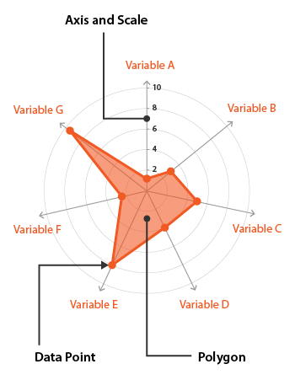
Figure 1. A sample of a radar chart
4. A CASE EXAMPLE
This study adopted a Pakistan textile manufacturing firm and its five top suppliers as an example case to provide decisions on and insights into SBSR capability development for sustainable supply chain practitioners.
4.1 The background of the case country and company
Pakistan, the case country of this study, is an emerging economy in the early stages of sustainable development implementation (Khan et al., 2018; 2020). The case country provides a socioeconomic background different from many other countries, which are widely considered in the existing literature (Agyemang et al., 2019; Khan et al., 2021). To contribute empirically to the SBSR literature, this study targets the Pakistan textile industry as the case study. We selected Pakistan’s textile industry because it is one of country’s the most established industries, while it continues to develop. This research is motivated by the fact that Pakistan is an emerging economy, and the textile industry is the largest manufacturing industry in Pakistan (Kusi-Sarpong et al., 2019b) and the eighth-largest exporter of textile commodities in Asia (Ravi Magazine, 2015). The textile industry provides over 14.5 million jobs in the country (Tahir, 2013) and contributes around 8.5% to Pakistan’s GDP (Faisal, 2017). In addition, it has the third-largest spinning capacity and is the fourth-largest producer of cotton in Asia after China and India, contributing 5% to global spinning capacity (Stotz, 2015). The case industry can boast of great potential in terms of infrastructure, low cost of available infrastructure, human capital, natural climatic conditions, cheap labor rates, and availability of deep-sea ports.
We chose the case company (hereafter referred to as Company XYZ) on the basis that it is one of the most established, and largest, textile companies in Pakistan, and is continuously working towards achieving sustainability. Company XYZ’s facility is spread across over 22 acres of land. It is well equipped with state-of-the-art machinery, and specializes in fabrics, garments, and laundry. Company XYZ produces 1.5 million garments and 3.2 million meters of denim fabric each month which reflects their commitment to the industry. It is proud to be recognized as one of the top and leading companies in the Apparel and Denim Textile industry in emerging economies, and exports goods to over 15 countries including Canada, Italy, Sweden, Denmark, and France, among others. Company XYZ has more than eight major certifications including Recycled Claim Standard (RCS), Quality Management System (ISO 9001:2015), and Environmental Management System (ISO 14001:2015).
Company XYZ is aiming to achieve an increasing sustainable performance and is therefore interested in embarking on SBSR capability evaluation as a starting point for identifying possible gaps in performance on both sides. The outcome will help them and their suppliers to construct strategic plans to improve their sustainable performance. For this decision-making initiative eight company managers, who work and are directly involved with supplier performance evaluation decision making and are familiar with various issues of this study were involved, comprising three industrial engineers, two assistant managers, a supply manager, a senior manager, and a general manager. Table 2 sets out some details about these managers from Company XYZ.

Table 2. Respondent managers from the case company involved in the decision-making process
No | Employee designation | Job Description | Years of Experience
1 | Industrial Engineer | Inventory management | 2
2 | Industrial Engineer | Production planning | 2
3 | Industrial Engineer | Data management | 2
4 | Asst. Manager | Supply chain coordination with other units | 3
5 | Asst. Manager | Procurement & purchasing | 4
6 | Supply Manager | Procurement & operations | 6
7 | Senior Manager | Production & operations management | 9
8 | General Manager | Head of supply chain | 15

The eight managers of Company XYZ decided to start this project with its five top suppliers shortlisted by management from their supply base. The criteria for selecting these five suppliers were mainly based on the volume of goods the company procured from them. These selected suppliers have been associated with Company XYZ for more than five years and they have won several ‘best supplier’ awards in different categories (quality, deliver, etc.) from them. In addition, the selected suppliers are ranked as class “A” according to Company XYZ’s supplier’s rating systems. Table 3 presents brief information about these five suppliers.

Table 3: Suppliers’ characteristics
Supplier | Location | Year of Establishment | Work Force Size | Turnover (PKR / Year)
Supplier 1 | Quaid-e-Azam Industrial Estate, Kot Lakhpat, Lahore, Pakistan | 1992 | 700 | 28500000
Supplier 2 | Mohlanwal, Lahore, Pakistan | 2010 | 900 | 34000000
Supplier 3 | Rafique Market Saddar, Karachi, Pakistan | 2005 | 2500 | 82500000
Supplier 4 | Ferozepur Road,  Near Sharf Din Kamahan,  Lahore, Pakistan | 1970 | 1800 | 73000000
Supplier 5 | Wazirabad Road, Sahowal, Sialkot, Pakistan | 1997 | 1500 | 58000000

4.2 Data analysis with the proposed visualization method
Stage 1: Define a hierarchical decision system for SBSR capability evaluation.
We first define a hierarchical decision system by DS = (R, , ) for SBSR capability evaluation. R = {, i=1, ... , n } is a set of n pair SBSRs to be evaluated. = {, j = 1, ... , J; k=1, ... , K; l=1, ... , L } is a hierarchical set of evaluation factors with three levels – J dimensions (based on the triple bottom line), K aspects (based on the relation view) for each dimension j, and L attributes (specific factors) for each aspect k. = {} are the values associated with SBSR on attribute .
Because there are many factors that need to be evaluated, we only collected five (n=5) SBSRs with complete data that are considered in this case; that is, R = {, i = 1, ... , 5}. SBSR 1 () represents the relationship capability between buyer and supplier 1. The overall factors of each SBSR pair are evaluated on three dimensions, four aspects in each dimension, and three attributes in each aspect: = {, j = 1, ... , 3; k=1, ... , 4; l=1, ... , 3 }. The three dimensions are economic, environmental and social dimensions from the triple-bottom-line of sustainability. The four aspects are capital investments on sustainable issues (CIS), sustainable knowledge exchange (SKE), resources and capabilities sharing (RCS), and joint management effort (JME) based on relational view. Table 1 presents all attributes for each aspect of each dimension.
Stage 2: Evaluate weights and influence relations of factors by DEMATEL
Step 1: Evaluate the direct relation among factors for both buyer and suppliers.
In our case, buyer and suppliers think that economic, environmental and social dimensions are equally important and independent among them. Therefore, we only evaluated the two-level factors of aspects and attributes by DEMATEL. We then constructed a two-level direct-relation matrix for aspect level and among attribute level. The matrix refers to the direct relation among aspects (k and o) for dimension j evaluated by organization u (buyer or suppliers). The matrix refers to the direct relation among attributes (l and p) for aspect k of dimension j evaluated by organization u (buyer or suppliers). The buyer and suppliers assign pairwise linguistic scales ranging from no influence (0) to very high influence (4). Hence, J matrices and J*K matrices for each organization u were obtained.
In our case, buyer (u = 1) considers that SKE (k = 1) has a low influence (L) on CIS (o = 2) in the environmental dimension (j = 1), so we set element = 2 for the aspect level. Hence, the pairwise influence relations () between the aspects (k and o) for environmental dimension (j = 1) form a 4x4 matrix, shown in Table 2. In all, there are 18 = (u = 6) * (j= 3) direct-relation matrices among aspects. In addition, the buyer (u = 1) considers that attribute has a high influence (H) on attribute for SKE (k = 1) in the environmental dimension (j = 1). Then we set direct-relation = 3 for attribute level. In all, there are 72 = (u = 6) * (j = 3) * (k = 4) direct-relation matrices among attributes. Because of space constraints, only pairwise direct-relation matrices in the environmental dimension for the buyer are shown in Table 4.

Table 4. The direct-relation matrix for SBSR in the environmental dimension by buyer

Panel A The direct-relation matrix for aspect level
 | CIS | SKE | RCS | IME
c₁₁ CIS | 0 | 2 | 3 | 2
c₁₂ SKE | 2 | 0 | 3 | 2
c₁₃ RCS | 4 | 3 | 0 | 3
c₁₄ IME | 3 | 2 | 2 | 0
Panel B The direct-relation matrix for attribute level
CIS | c₁₁₁ | c₁₁₂ | c₁₁₃ |  | SKE | c₁₁₁ | c₁₁₂ | c₁₁₃ |  | RCS | c₁₁₁ | c₁₁₂ | c₁₁₃ |  | IME | c₁₁₁ | c₁₁₂ | c₁₁₃
c₁₁₁ | 0 | 3 | 4 |  | c₁₁₁ | 0 | 3 | 2 |  | c₁₁₁ | 0 | 3 | 3 |  | c₁₁₁ | 0 | 2 | 2
c₁₁₂ | 3 | 0 | 3 |  | c₁₁₂ | 2 | 0 | 3 |  | c₁₁₂ | 3 | 0 | 3 |  | c₁₁₂ | 2 | 0 | 2
c₁₁₃ | 3 | 3 | 0 |  | c₁₁₃ | 3 | 2 | 0 |  | c₁₁₃ | 3 | 3 | 0 |  | c₁₁₃ | 3 | 2 | 0

Step 2: Aggregate direct relation of factors among buyer and suppliers.
In this step, the direct-relation matrices and for the buyer and suppliers are integrated into the aggregate matrices and by a simple average using expressions (1) and (2):
(1)
(2)
In our case, the aggregated direct-relation matrices among aspects and attributes for environmental dimension are shown in Table 5.

Table 5. The aggregate direct-relation matrix for SBSR in the environmental dimension

Panel A The aggregate direct-relation matrix for aspect level
 | CIS | SKE | RCS | IME
c₁₁ CIS | 0.000 | 2.833 | 2.833 | 2.833
c₁₂ SKE | 3.000 | 0.000 | 3.000 | 3.500
c₁₃ RCS | 2.500 | 2.667 | 0.000 | 0.500
c₁₄ IME | 2.833 | 2.333 | 2.667 | 0.000
Panel B The aggregate direct-relation matrix for attribute level
CIS | c₁₁₁ | c₁₁₂ | c₁₁₃ |  | SKE | c₁₁₁ | c₁₁₂ | c₁₁₃ |  | RCS | c₁₁₁ | c₁₁₂ | c₁₁₃ |  | IME | c₁₁₁ | c₁₁₂ | c₁₁₃
c₁₁₁ | 0.000 | 3.500 | 3.000 |  | c₁₂₁ | 0.000 | 2.500 | 2.833 |  | c₁₃₁ | 0.000 | 2.333 | 2.667 |  | c₁₄₁ | 0.000 | 2.333 | 2.667
c₁₁₂ | 2.500 | 0.000 | 2.500 |  | c₁₂₂ | 2.500 | 0.000 | 2.167 |  | c₁₃₂ | 2.167 | 0.000 | 2.000 |  | c₁₄₂ | 2.333 | 0.000 | 2.000
c₁₁₃ | 2.500 | 2.167 | 0.000 |  | c₁₂₃ | 2.500 | 2.333 | 0.000 |  | c₁₃₃ | 2.500 | 2.167 | 0.000 |  | c₁₄₃ | 2.500 | 2.000 | 0.000

Step 3: Normalize the aggregated direct relation of factors.
The aggregated direct-relation matrices and are transformed into the normalized matrices and using expressions (3) and (4).
, (3)
where .
, (4)
where .
Step 4: Determine the total relation of factors.
The total-relation matrices and are obtained from the normalized matrices and through expressions (5) and (6), respectively.
(5)
(6)
In our case, the total direct-relation matrices among aspects and attributes for environmental dimension are shown in Table 6.

Table 6. The total direct-relation matrix for SBSR in the environmental dimension
Panel A The total direct-relation matrix for aspect level
 | CIS | SKE | RCS | IME
c₁₁ CIS | 1.145 | 1.327 | 1.396 | 1.202
c₁₂ SKE | 1.488 | 1.195 | 1.511 | 1.332
c₁₃ RCS | 1.051 | 1.030 | 0.860 | 0.791
c₁₄ IME | 1.300 | 1.224 | 1.310 | 0.908
Panel B The total direct-relation matrix for attribute level
CIS | c₁₁₁ | c₁₁₂ | c₁₁₃ |  | SKE | c₁₁₁ | c₁₁₂ | c₁₁₃ |  | RCS | c₁₁₁ | c₁₁₂ | c₁₁₃ |  | IME | c₁₁₁ | c₁₁₂ | c₁₁₃
c₁₁₁ | 1.503 | 1.987 | 1.919 |  | c₁₂₁ | 4.295 | 4.515 | 4.647 |  | c₁₃₁ | 4.032 | 4.247 | 4.382 |  | c₁₄₁ | 4.164 | 4.180 | 4.426
c₁₁₂ | 1.529 | 1.361 | 1.614 |  | c₁₂₂ | 4.244 | 3.836 | 4.219 |  | c₁₃₂ | 3.855 | 3.463 | 3.841 |  | c₁₄₂ | 4.098 | 3.508 | 3.989
c₁₁₃ | 1.472 | 1.551 | 1.276 |  | c₁₂₃ | 4.339 | 4.232 | 4.024 |  | c₁₃₃ | 4.186 | 4.058 | 3.856 |  | c₁₄₃ | 4.221 | 3.893 | 3.809

Step 5: Identify the overall importance for each factor.
The values of the overall importance of each aspect k of dimension j and of each attribute l of aspect k of dimension j are calculated using expressions (7) and (8).
, (7)
where represents the sum of direct and indirect driving influence by aspect k on the other aspects in dimension j, and shows the sum of direct and indirect dependence influence that aspect o is receiving from the other aspects in dimension j.
, (8)
where and .
In our case, the overall importance and are shown in Table 7.

Table 7. The importance and angle of factors for SBSR in the environmental dimension
Panel A The importance and angle of aspects
c₁₁ CIS | 10.053 | 94.9º
c₁₂ SKE | 10.302 | 97.2º
c₁₃ RCS | 8.809 | 83.2º
c₁₄ IME | 8.974 | 84.7º
Panel B The importance and angle of attributes
CIS |  |  |  | SKE |  |  |  | RCS |  |  |  | IME
c₁₁₁ | 1.503 | 125.5º |  | c₁₂₁ | 4.295 | 123.6º |  | c₁₃₁ | 4.032 | 123.9º |  | c₁₄₁ | 4.164 | 125.3º
c₁₁₂ | 1.529 | 119.1º |  | c₁₂₂ | 4.244 | 116.8º |  | c₁₃₂ | 3.855 | 114.9º |  | c₁₄₂ | 4.098 | 115º
c₁₁₃ | 1.472 | 115.4º |  | c₁₂₃ | 4.339 | 119.6º |  | c₁₃₃ | 4.186 | 121.2º |  | c₁₄₃ | 4.221 | 119.7º

Stage 3: Evaluate performance of SBSR capability by advanced radar chart
Step 6: Draw a radar chart background according to the weights (importance) of factors. First, we can get the overall importance of aspects and attributes based on the overall importance or prominence and in Step 5. Then, we convert the overall importance of aspects or attributes into the angles and of each aspect’s or attribute’s region in an advanced radar chart. The more important the aspects or attributes, the larger area it occupies in the advanced radar chart.
， (9)
Second, we start to draw an auxiliary axis to divide each region of the aspect or attribute from the right horizontal axis. Then, we draw each scale axis for aspect or attribute in the middle of each region, to represent each aspect or attribute.
In our case, we first convert the overall importance ( = 9.913, = 9.403, and = 9.109) of attributes in the SKE aspect of the environmental dimension into the angles ( = 125.5º, = 119.1º, and = 115.4º) of each attribute. We then draw three arrow-free lines starting from the center representing auxiliary axes in Figure 2 according to the angles ( = 125.5º, = 119.1º, and = 115.4º) of each attribute. Each region between two auxiliary axes from the right horizontal axis represents each attribute, , or . Finally, we draw three arrow lines starting from the center in the middle of each region representing scale axes in Figure 2. Then, we plot the scale on the right horizontal axis.
auxiliary axis
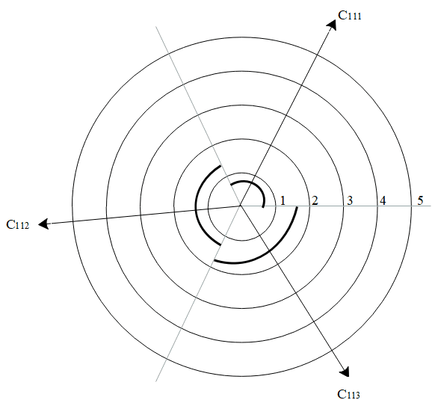
scale axis
right horizontal axis

Figure 2. Background of an advanced radar chart in the SKE aspect of the environmental dimension
Step 7: Draw performance level of factors for each SBSR i in the radar chart.
This step has three sub-steps.
Sub-step 1. Evaluate the performance level of each SBSR capability for both buyer and suppliers.
Both the buyer’s and suppliers’ decision makers u evaluate the attribute values for SBSR i of the attribute in k aspect of j dimension, respectively. The decision-makers’ opinions about attributes were scaled along a six-level linguistic perceptual score: “Very Good [5]”, “Good [4]”, “Medium [3]”, “Poor [2]”, “Very Poor [1]”, and “Not Applicable [0]”. The evaluated data for the full information decision system in the environmental dimension are shown in Table 8.

Table 8. Evaluation of each SBSR capability on sustainability attributes by both buyer and suppliers
Environment |  | c₁₁₁ | c₁₁₂ | c₁₁₃ | c₁₂₁ | c₁₂₂ | c₁₂₃ | c₁₃₁ | c₁₃₂ | c₁₃₃ | c₁₄₁ | c₁₄₂ | c₁₄₃
Buyer | SBSR1 | 3 | 1 | 2 | 1 | 1 | 0 | 1 | 0 | 1 | 0 | 1 | 1
Buyer | SBSR2 | 1 | 1 | 3 | 0 | 1 | 0 | 0 | 0 | 1 | 0 | 0 | 0
Buyer | SBSR3 | 1 | 1 | 1 | 0 | 0 | 0 | 0 | 0 | 0 | 0 | 0 | 0
Buyer | SBSR4 | 1 | 0 | 1 | 0 | 0 | 0 | 0 | 0 | 0 | 0 | 0 | 0
Buyer | SBSR5 | 1 | 0 | 1 | 0 | 0 | 0 | 1 | 0 | 0 | 0 | 0 | 0
Supplier | SBSR1 | 4 | 5 | 5 | 4 | 4 | 4 | 5 | 2 | 3 | 3 | 3 | 4
Supplier | SBSR2 | 3 | 3 | 3 | 3 | 3 | 3 | 5 | 1 | 3 | 3 | 3 | 4
Supplier | SBSR3 | 2 | 2 | 2 | 2 | 3 | 3 | 4 | 1 | 1 | 1 | 2 | 3
Supplier | SBSR4 | 2 | 2 | 3 | 2 | 2 | 3 | 3 | 0 | 1 | 0 | 2 | 3
Supplier | SBSR5 | 1 | 1 | 1 | 1 | 2 | 3 | 3 | 0 | 0 | 0 | 1 | 3
Social |  | c₂₁₁ | c₂₁₂ | c₂₁₃ | c₂₂₁ | c₂₂₂ | c₂₂₃ | c₂₃₁ | c₂₃₂ | c₂₃₃ | c₂₄₁ | c₂₄₂ | c₂₄₃
Buyer | SBSR1 | 5 | 4 | 1 | 1 | 2 | 2 | 1 | 0 | 1 | 1 | 1 | 1
Buyer | SBSR2 | 4 | 3 | 1 | 1 | 1 | 2 | 1 | 0 | 2 | 0 | 2 | 1
Buyer | SBSR3 | 4 | 2 | 0 | 0 | 0 | 1 | 0 | 0 | 0 | 0 | 0 | 1
Buyer | SBSR4 | 3 | 1 | 0 | 0 | 0 | 1 | 0 | 0 | 0 | 0 | 0 | 0
Buyer | SBSR5 | 2 | 1 | 0 | 0 | 0 | 0 | 0 | 0 | 0 | 0 | 0 | 0
Supplier | SBSR1 | 5 | 3 | 5 | 2 | 4 | 2 | 4 | 2 | 4 | 4 | 3 | 4
Supplier | SBSR2 | 4 | 4 | 5 | 2 | 3 | 2 | 4 | 2 | 4 | 3 | 3 | 4
Supplier | SBSR3 | 4 | 3 | 4 | 1 | 2 | 1 | 3 | 1 | 3 | 3 | 2 | 3
Supplier | SBSR4 | 1 | 2 | 3 | 0 | 2 | 1 | 3 | 0 | 3 | 2 | 1 | 3
Supplier | SBSR5 | 1 | 1 | 3 | 0 | 2 | 0 | 3 | 0 | 2 | 2 | 1 | 3
Economic |  | c₃₁₁ | c₃₁₂ | c₃₁₃ | c₃₂₁ | c₃₂₂ | c₃₂₃ | c₃₃₁ | c₃₃₂ | c₃₃₃ | c₃₄₁ | c₃₄₂ | c₃₄₃
Buyer | SBSR1 | 4 | 3 | 3 | 2 | 1 | 1 | 3 | 0 | 4 | 2 | 3 | 4
Buyer | SBSR2 | 1 | 4 | 2 | 1 | 0 | 0 | 2 | 0 | 3 | 1 | 2 | 3
Buyer | SBSR3 | 0 | 1 | 0 | 1 | 0 | 1 | 2 | 0 | 3 | 1 | 1 | 4
Buyer | SBSR4 | 0 | 1 | 0 | 1 | 0 | 0 | 2 | 0 | 2 | 0 | 0 | 2
Buyer | SBSR5 | 0 | 0 | 1 | 1 | 0 | 0 | 1 | 0 | 3 | 0 | 0 | 1
Supplier | SBSR1 | 4 | 4 | 4 | 5 | 4 | 4 | 4 | 3 | 4 | 3 | 2 | 4
Supplier | SBSR2 | 3 | 3 | 3 | 3 | 3 | 3 | 3 | 3 | 3 | 3 | 1 | 2
Supplier | SBSR3 | 3 | 4 | 3 | 2 | 2 | 3 | 3 | 2 | 2 | 1 | 1 | 2
Supplier | SBSR4 | 2 | 2 | 1 | 3 | 2 | 1 | 2 | 1 | 1 | 1 | 0 | 1
Supplier | SBSR5 | 2 | 2 | 1 | 2 | 1 | 1 | 2 | 1 | 1 | 1 | 0 | 1

Sub-step 2. Mark the performance values of factors for each SBSR capability on the scale axis.
We need to mark the performance value of each factor for each SBSR i on each scale axis according to the evaluation of the buyer or suppliers.
Sub-step 3. Mark the influenced values of factors on auxiliary axis.
We first need to calculate the influenced values of each SBSR i for attribute receiving other attributes ; that is, the sum of the values assigned to each performance value of the other attributes p and the interdependencies with other attributes by the following expression (10).
(10)
Then, we need to mark the influenced values of each SBSR i for each attribute on each auxiliary axis evaluated by buyer or supplier u.
In our case, we found that the performance levels , , or of attributes , , or for SBSR 1 evaluated by the buyer are ‘3’, ‘1’ and ‘2’. Then, we mark the performance value of each attribute on each scale axis of attributes , , or in Figure 3. Second, we calculate the influenced value, , or of attributes , , or which are ‘3.63’, ‘1.73’, and ‘2.70’. Then, we mark the influenced value of attribute on each auxiliary axis of attributes, , or in Figure 3.
Step 8: Draw radar chart by connecting points
We link performance points and influenced points to form a radar chart of each SBSR. Then, we can construct an advanced radar chart for five SBSRs in each aspect and each dimension for each buyer or supplier u.

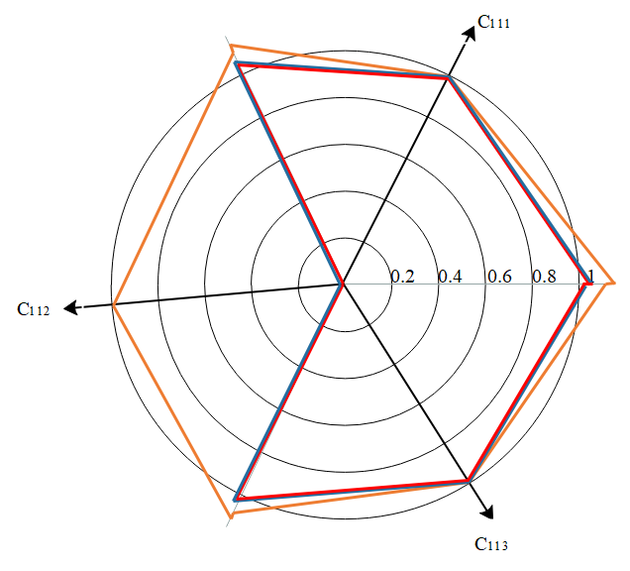
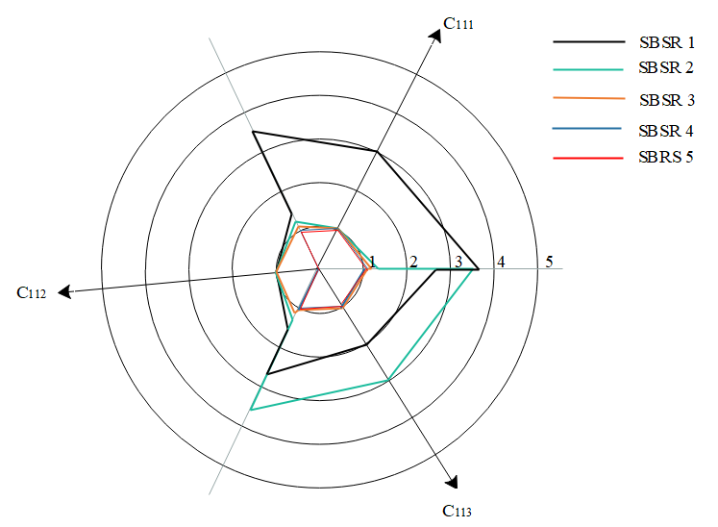
A larger image
Figure 3. An advanced radar chart in the SKE aspect of the environmental dimension
In our case, we found that SBSR 1 is the best SBSR in attribute, and the second best SBSR in attribute for buyer’s evaluation in Figure 3. We also found that SBSR 1, SBSR 2, and SBSR 3 have the same value 1 in attribute , but they have different influenced values : 1.73, 1.35, 1.16. Then, SBSR 1 is the best SBSR in due to its biggest influenced value 1.73. In all, there are 12 = (j = 3) * (k = 4) radar charts at the attribute level for buyer’s evaluation.
Now that we have completed the attribute-level radar charts, we proceed with the aspect-level radar charts. We can get the performance value of each aspect by calculating the average polygon of all attributes in this aspect by the following expression (11):
. (11)
Then we go back to step 7 and draw the radar chart of the aspect level and dimension level. In all, there are three radar charts of the aspect level and one radar chart of the dimension level for the buyer or each supplier.
Step 9: Integrating the radar chart of both sides by the two-matching principle
In the previous step, we arrived at two radar charts of a SBSR i for buyer and supplier evaluation. Therefore, in this step we integrate them into an overall radar chart by the two-matching principle. Then we get overlapping and shadowing radar charts for each SBRS capability. The overlapping part represents the actual level of SBSR capability. The shadowing part represents the extensible part of the SBSR capability and provides the direction of SBSR capability improvement that can be implemented through unilateral efforts.
In our case, we can get one overall radar chart for dimensions, three radar charts for aspects, and 12 radar charts for attributes through integrating the buyer’s and supplier’s radar charts. Because of space constraints, in Figure 4, we only show one overall radar chart for dimensions, and three radar charts for aspects for SBSR 1.
Step 10: Comparing the actual level of all SBSRs
Then, we can show the actual level of all five SBSRs in a radar chart for different levels. We also only show one overall radar chart for dimensions, and three radar charts for aspects for all five SBSRs in Figure 5. The values of the a part of Figure 5 are shown in Table 9.

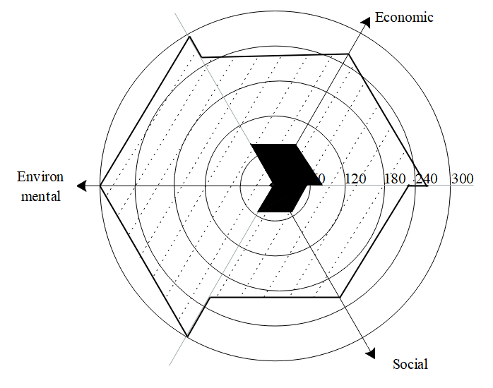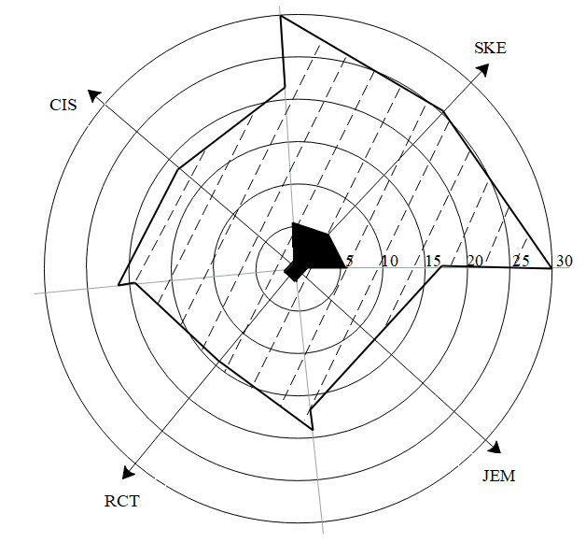
a radar chart of dimensions b radar chart of aspects for environmental dimension
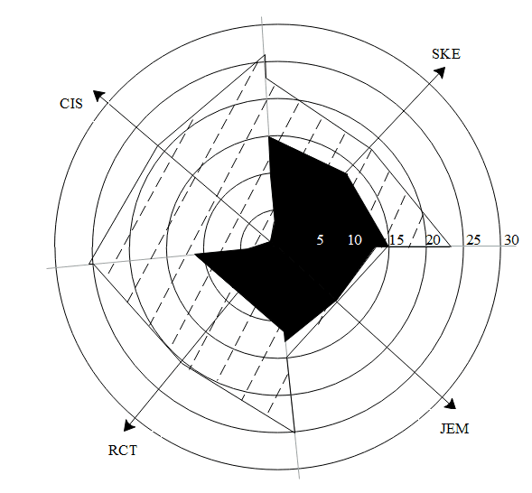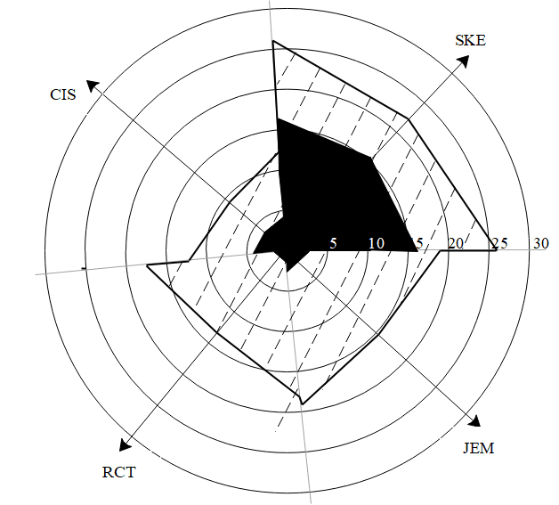

c radar chart of aspects for social dimension d radar chart of aspects for economic dimension

Figure 4. The overall radar chart in dimension and aspect levels for SBSR 1 for buyer and supplier evaluation

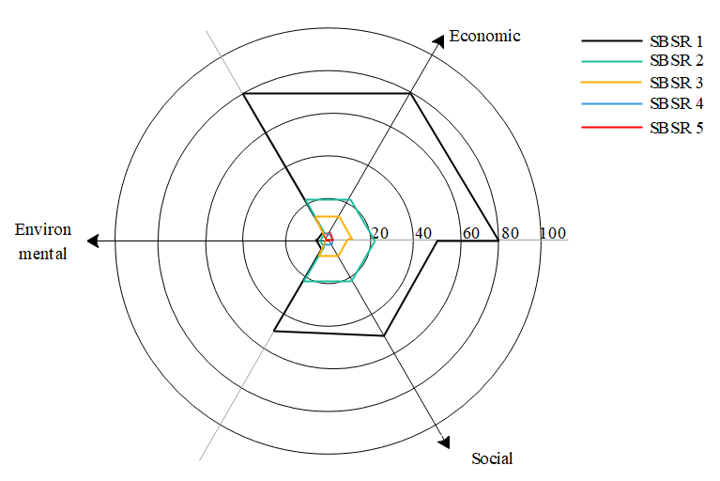

a actual radar chart of dimensions
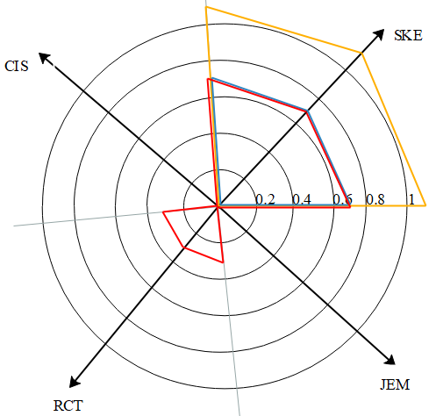
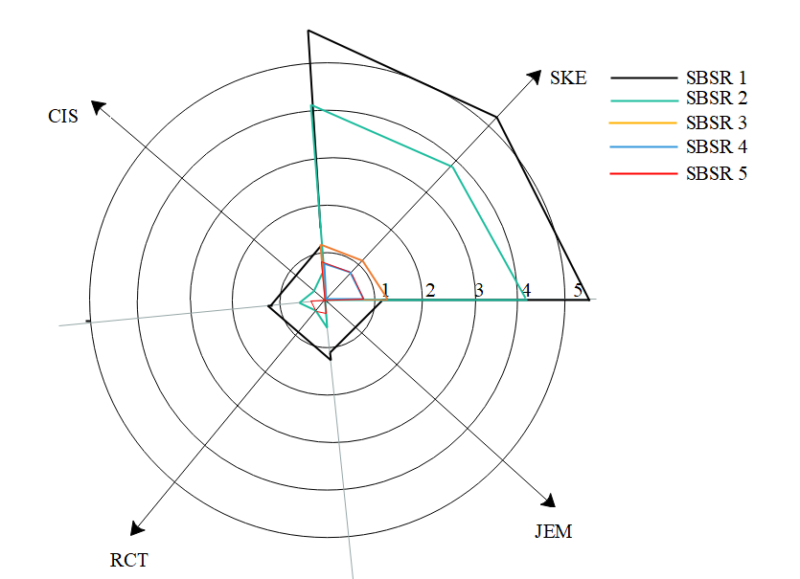
A larger image
b actual radar chart of aspects for environmental dimension

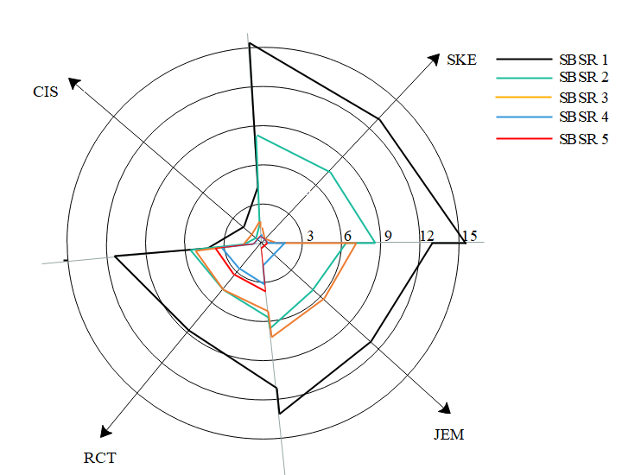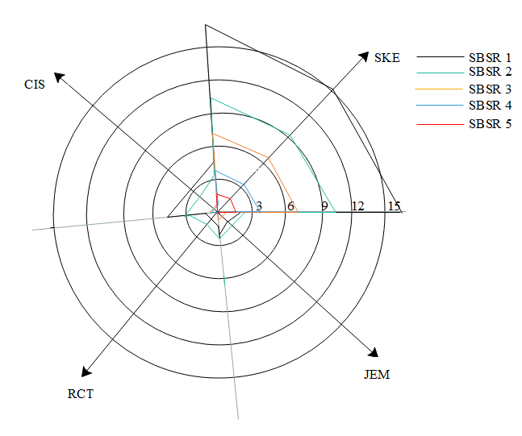
c actual radar chart of aspects for social dimension d actual radar chart of aspects for economic dimension
Figure 5. The actual radar chart in dimension and aspect levels for all SBSRs

Table 9. Evaluation result of each SBSR capability on the sustainability dimension
SBSRs | Environment |  |  | Social |  |  | Economic
SBSRs | Performance value | Influenced value | Angle | Performance value | Influenced value | Angle | Performance value | Influenced value | Angle
SBSR1 | 5.91 | 5.91 | 120 | 49.48 | 49.48 | 120 | 79.94 | 79.94 | 120
SBSR2 | 3.01 | 3.01 | 120 | 21.02 | 21.02 | 120 | 22.32 | 22.32 | 120
SBSR3 | 0.26 | 0.26 | 120 | 9.31 | 9.31 | 120 | 12.36 | 12.36 | 120
SBSR4 | 0.10 | 0.10 | 120 | 2.26 | 2.26 | 120 | 1.99 | 1.99 | 120
SBSR5 | 0.12 | 0.12 | 120 | 0.57 | 0.57 | 120 | 2.47 | 2.47 | 120
*Because there is no influence relationship among the three dimensions in the case study, the performance value and the influence value are the same, and the weight of attributes is all the same, which is 120 degrees.
4.3 Results analysis
The best SBSR. In the five evaluated SBSRs, SBSR 1 as the buyer’s (textile organization) relationship with supplier 1 is the best performing one in the overall radar chart in the a part of Figure 5. It reflects that SBSR 1 performs the best in all three dimensions: economic, environmental, and social. SBSR 1 also performs the best in almost all aspects of each dimension in the b, c, and d parts of Figure 5. This shows that the most critical supplier should be constructed from the economic, environmental and social dimensions. Bai et al. (2019a) pointed out that buyers can gain competitive advantage by developing different dimensions of resources (economic, environmental and social) that can help them to differentiate themselves from other competitors as these are valuable and difficult to replicate. The chart shows that supplier 1 is the critical supplier of the case firm, so both sides have invested significant activities and funds to build the relationship between them. Although SBSR 1 is the best, the buyer thinks that it is doing relatively well in terms of economic and social dimensions; however, the environmental performance is on the low side. Therefore, for the textile organization (buyer) to increase its overall sustainability performance which they aim to achieve whilst building a relationship with their topmost and critical supplier (supplier 1), there is a strong need for both parties to invest significant resources in the environmental dimension to catch up with the performance of the other dimensions (Kusi-Sarpong et al., 2016b).
The worst SBSR. In the five evaluated SBSRs, SBSRs 4 and 5 are considered the worst in a part of Figure 5. SBSR 5 performs the worst in the social dimension and SBSR 4 performs the worst in the economic and environmental dimensions. This shows that suppliers 4 and 5 may have received less attention from the buyer (case firm) than other suppliers, so both sides may have not invested much in terms of funds and activities for their relationship. Therefore, the strength of the bonding relationship between the buyer and suppliers 4 and 5 seems to be very weak among the top five suppliers, which may have hindered information sharing (Paulraj et al., 2008) and efforts in helping improve each other’s performance (Rehman et al., 2018; Yang et al., 2019). Since the case organization (buyer) is aiming to achieve an increasing sustainable performance, there is the need to improve the performance of suppliers 4 and 5, particularly in terms of economic and environmental dimensions for supplier 4 and the social dimension for supplier 5 (Badri Ahmadi et al., 2020). For these suppliers with poor SBSR capability, Bai et al. (2019b) pointed out that the buyer should focus on implementing supplier development practices for them to improve their SBSR capability. If the buyer does not have sufficient financial and operational resources to pursue this supplier development agenda, it can discard some or all of these suppliers.
The realistic level of performance. We can find the realistic performance of SBSR 1 through the overlapping part of the SBSR in Figure 4. The realistic SBSR capability requires both sides to invest matching resources to achieve a better level of performance (Bai and Sarkis, 2016). It also reflects the basic requirements of the relational view. Since buyers generally invest less than suppliers, in our case, we therefore use the performance evaluation of the buyer as the final realistic level of SBSR capability. This also reflects the unequal status of the relationship; suppliers are often at a disadvantage and, to attract orders, they will have to invest more resources. In addition, the buyer’s and suppliers’ expectation of SBSR capability is a critical consideration when selecting the improving attributes of SBSR capability (Dou et al., 2014). This is a challenge that buyers face when making an improving decision which requires the coordination of the different expectations and improvement practices of the buyer and suppliers.
Directions for future improvement. Although some literature has provided decision support for SBSR capability improvement (Bai et al., 2019b; Dou et al., 2014) we offer more instructive decisions. The radar charts can provide three improvement directions. First, we can intuitively see which attributes, aspects or dimensions of a SBSR that need to be improved through direct comparison of multiple SBSRs in Figure 5. For example, SBSR 1 should first improve their environmental dimension performance from the a part of Figure 5, and CIS, RCS, and JME aspects of environmental dimension from the b part of Figure 5. The supply chain can also confirm specific improvement attributes in a specific aspect. Second, when an attribute of a SBSR is already good, we can decide whether to improve this attribute’s performance by increasing other attributes’ performance through the influenced relations among them. Third, from the overall radar chart in Figure 4, we can intuitively decide whether the supplier or the buyer should invest more. For example, buyers invest relatively less than suppliers, and so buyers should invest more to improve their SBSR capability.
5. DISCUSSION
5.1 Managerial implications
The resulting evaluation for SBSR capability has some practical implications.
Maintenance and Termination of SBSR. The buyer should keep a SBSR with the supplier that has better value in the radar chart. The buyer can also take advantage of SBSR capability to improve their overall performance. The buyer should eliminate a SBSR with a supplier that has less value in the radar chart, if the buyer has alternatives. Maintaining the right supplier and terminating the bad supplier is the key factor for successful SBSR capability. Then, managers can use our multi-criteria evaluation framework and visualization method for selecting and discarding suppliers. Those decisions should be based on sustainability, relational capability and both parties’ mutual benefits, and include nonfinancial criteria, for example, eco-design, environmental practices, and social responsibility, among others.
Improve SBSR capability directions from attributes. Most SBSRs are not the best or the worst. In this case, it is likely that the buyer and its suppliers will need expertise and investment to achieve the sustainable goals. Therefore, to improve SBSR capability, we suggest that managers should not treat each SBSR with the same strategy. Radar charts can intuitively show which attribute weaknesses exist in each SBSR. This information can set the buyer and the supplier a target and find the weak areas to invest in to reach this target. Based on weakness of SBSR, managers should develop more appropriate and different SBSR improvement strategies and practices that are applied to deal efficiently with different SBSRs. This can help the buyer and supplier to save costs, and effectively improve their SBSR capability. The radar chart can also help the buyer and supplier to find some ways to make some new indirect improvements through the influence relations among attributes. For example, if SKE has a significant influence on RCS in the environmental dimension, then the buyer and its supplier can indirectly improve the level of RCS through the level of SKE, in addition to directly improving the performance of RCS.
Improve SBSR from objects. There are inequalities in investment level among the economic, environmental and social dimensions. Radar charts can effectively help identify where more investments can improve SBSR capability. Therefore, both sides need to improve the SBSR capability from the environmental, social and economic dimensions, but they first need to enhance the SBSR capability of specific dimensions from four aspects: (i) capital investments on sustainable issues (CIS), (ii) sustainable knowledge exchange (SKE), (iii) resources and capabilities sharing (RCS), and (iv) joint management effort (JME). This research found unequal impacts of these four aspects on the SBSR capability, and unequal impacts of various attributes on each aspect. Therefore, managers should identify and prioritize firms’ investment in dimensions, aspects, and attributes in accordance with their strategies and performance to efficiently develop SBSR capability to suitable levels.
Investment gap between both sides. We find a clear gap between both sides in the SBSR capability investment. First, all suppliers invest more than the buyer in our case. This is mainly because the buyer plays a dominant role in the cooperation process. The buyer always requires suppliers to meet certain standards and activities relating to economic, environmental and social sustainability. However, this long-term unequal investment and effort denote the risk point of their relationship. The effectiveness of SBSR practices and performance requires the joint efforts of both sides to maintain a longer-term relationship. Therefore, both sides need to plan, negotiate and invest sufficient resources and capital in order to build a stable SBSR. In addition, we find that when the buyer invests more in SBSR capability, suppliers will invest more accordingly. Therefore, the buyer should increase their investment in SBSR capability and guide the suppliers to invest more deeply, to strengthen their SBSR capability. Finally, both sides can implement the appropriate relationship investment strategies according to the advantages and disadvantages of them SBSR. For example, the two sides can work together to deal with a special risk point of the SBSR. For another example, both sides can formulate complementary investment strategies according to their own early investment level, in order to maximize the SBSR capability with the low cost.
In short, SBSR capability should be evaluated and developed based on the sustainability approach and relational view, which directly benefit SBSR. Buyer and supplier managers should also clearly communicate and understand the negative effects of unbalanced investment or effort among them. A visualization method should be used to evaluate and manage SBSR capability efficiently.
5.2 Methodology implications
In this research, a novel three-stage visualization method was proposed and applied to create and analyze a strategy plan chart. The novel way in which DEMATEL and the radar chart method are employed in this study has not been seen in previous literature.
Our advanced radar chart is a better tool that can successfully evaluate SBSR capability. It has three main advantages. First, it can give decision makers intuitive feelings about the rank of SBSRs through the graphic form. Second, it can identify the level of current SBSR capability, and provides an improvement strategy for future SBSR capability. Third, it effectively integrates the weight of factors and influence relations among them into the evaluation process.
Although the advanced radar chart is a suitable tool for investigating SBRS capability, it is not able to identify the weight of attributes and influence relations among them, where DEMATEL shows strong ability. Firstly, DEMATEL is used to analyze the important factors affecting SBSR capability. DEMATEL is also used to identify the influence relations among various factors of SBSR capability in complex decision-making models. Then, DEMATEL is selected to rank the main important adoption factors and reveal their influence relations.
Therefore, the combination of the DEMATEL method and the radar chart method can provide a useful tool for prioritizing factors and identifying the influence relations as well as evaluating and sequencing the SBSRs based on the adoption factors. This case has shown that this method is robust and convenient in the context of decision making.
6. CONCLUSIONS
Many buyers have recognized the importance of SBSR capability efforts for achieving sustainable performance. However, they hesitate to adopt SBSR capability improvement efforts since it is not always clear how to plan and invest in the relationship. Thus, it is necessary to evaluate SBSR capability for best investment. We believe that understanding how to measure and evaluate SBSR capability may help buyers’ and suppliers’ managers develop and implement better SBSR capability development strategies to create value for sustainable supply chain cooperation.
This paper extends prior studies and contributes in the following ways. From a conceptual perspective, we introduced a new conception of SBSR capability, which extends relational capability from traditional BSR to sustainable dimensions.
From a theoretical perspective, we developed a framework based on the RV and triple-bottom-line (TBL) to measure the extent of SBSR capability which in turn reflects the relational capability creation process. This framework is composed of 36 practices in three dimensions and four aspects. A review of the SSCM and BSR literature shows that those practices can improve a SBSR capability. It presents a comprehensive and complete system of criteria utilized in the domain of SBSR capability that can be considered as a proper reference for researchers and practitioners to select the most suitable criteria for their use.
From a methodology perspective, this study introduces a novel advanced radar chart as a visualization method to evaluate SBSR capability. This novel advanced radar chart can effectively evaluate the level of current SBSR capability and provide room for future SBSR capability improvement. It also overcomes many limitations of the traditional radar chart, and we hope that it will be used more widely in the future. DEMATEL can address complicated and intertwined problems and determines the causal relations among the SBSR factors. DEMATEL is an appropriate method to provide information about the importance of factors and relations among them for the radar chart.
From an empirical perspective, we carried out a detailed empirical investigation to evaluate the advantages and disadvantages of the framework and method in the domain of SBSR capability which are fully discussed in the literature. According to the case findings, this method effectively confirms SBSR 1 as the best and SBSR 5 as the worst. This method effectively identifies the strengths and weaknesses of each SBSR, and intuitively identifies how to improve these SBSRs from the dimensions, aspects and attributes perspectives. Through a case study, we identified that suppliers invest more than buyers in unequal relationships. Thus, buyers' increasing investment is the first decision to increase their SBSR capability.
The introduction of this framework and visualization method is a contribution to the literature on SBSR implementation. However, there is still room for improvement, which provides material for further research in this field.
First, we developed a generic framework of factors based on a literature review. These are a relatively smaller set of factors to help evaluate SBSR capability. The managing, developing, and evaluating of SBSR capability are not dependent on those factors alone; it is important that they consider information technology to enhance their SBSR capability (Bai and Sarkis, 2020). Different industries will use different factors to enhance their SBSR capability, so broader or industry-specific frameworks need to be developed.
Another limitation is that the novel advanced radar chart only considers the overall impact of other factors on a single factor but cannot express the influence relation between any two factors. Future research using the advanced radar chart should show the mutual influence relation among factors. This method should also be implemented in other industry contexts to obtain more general conclusions about the SBSR and how to improve it.
Although there are some limitations and shortcomings in this study, we feel the framework and the visualization method that we introduce will play an important role in developing SBSR capability. Given that this is one of the first papers to consider SBSR capability decisions, there is ample room for additional investigation.

References
Adesanya, A., Yang, B., Iqdara, F. W. B., & Yang, Y. (2020). Improving sustainability performance through supplier relationship management in the tobacco industry. Supply Chain Management: An International Journal, 25(4), 413-426.
Agyemang, M., Kusi-Sarpong, S., Khan, S. A., Mani, V., Rehman, S. T., & Kusi-Sarpong, H. (2019). Drivers and barriers to circular economy implementation: an explorative study in Pakistan’s automobile industry. Management Decision, 57(4), 971-994.
Ahmed, W., Ashraf, M. S., Khan, S. A., Kusi-Sarpong, S., Arhin, F. K., Kusi-Sarpong, H., & Najmi, A. (2020). Analyzing the impact of environmental collaboration among supply chain stakeholders on a firm’s sustainable performance. Operations Management Research, 1-18
Amoako-Gyampah, K., Boakye, K. G., Famiyeh, S., & Adaku, E. (2020). Supplier integration, operational capability and firm performance: an investigation in an emerging economy environment. Production Planning & Control, 31(13), 1128-1148.
Awasthi, A., & Kannan, G. (2016). Green supplier development program selection using NGT and VIKOR under fuzzy environment. Computers & Industrial Engineering, 91, 100-108.
Badri Ahmadi, H., Lo, H. W., Gupta, H., Kusi-Sarpong, S., & Liou, J. J. (2020). An integrated model for selecting suppliers on the basis of sustainability innovation. Journal of Cleaner Production, 277, 123261.
Bai, C., & Sarkis, J. (2016). Supplier development investment strategies: a game theoretic evaluation. Annals of Operations Research, 240(2), 583-615.
Bai, C., & Sarkis, J. (2020). A supply chain transparency and sustainability technology appraisal model for blockchain technology. International Journal of Production Research, 58(7), 2142-2162.
Bai, C., & Satir, A. (2020). Barriers for green supplier development programs in manufacturing industry. Resources, Conservation and Recycling, 158, 104756.
Bai, C., Gao, W., & Sarkis, J. (2020b). Operational Risks and Firm Market Performance: Evidence from China. Decision Sciences. https://doi.org/10.1111/deci.12467.
Bai, C., Govindan, K., Satir, A., & Yan, H. (2019b). A novel fuzzy reference-neighborhood rough set approach for green supplier development practices. Annals of Operations Research, https://doi.org/10.1007/s10479-019-03456-z.
Bai, C., Kusi-Sarpong, S., Badri Ahmadi, H., & Sarkis, J. (2019a). Social sustainable supplier evaluation and selection: a group decision-support approach. International Journal of Production Research, 57(22), 7046-7067.
Bai, C., Sarkis, J., Yin, F., & Dou, Y. (2020a). Sustainable supply chain flexibility and its relationship to circular economy-target performance. International Journal of Production Research, 58(19), 5893-5910.
Brandenburg, M., Govindan, K., Sarkis, J., & Seuring, S. (2014). Quantitative models for sustainable supply chain management: Developments and directions. European Journal of Operational Research, 233(2), 299-312.
Chauhan, A., Kaur, H., Yadav, S., & Jakhar, S. K. (2020). A hybrid model for investigating and selecting a sustainable supply chain for agri-produce in India. Annals of Operations Research, 290(1), 621-642.
Chen, D. Q., Preston, D. S., & Xia, W. (2013). Enhancing hospital supply chain performance: A relational view and empirical test. Journal of Operations Management, 31(6), 391-408.
Chen, Y., & Chen, I. J. (2019). Mixed sustainability motives, mixed results: the role of compliance and commitment in sustainable supply chain practices. Supply Chain Management: An International Journal, 24(5), 622-636.
Cousins, P. D., Lamming, R. C., & Bowen, F. (2004). The role of risk in environment-related supplier initiatives. International Journal of Operations & Production Management, 24(6), 554-565.
de Sousa Jabbour, A. B. L., Jabbour, C. J. C., Latan, H., Teixeira, A. A., & de Oliveira, J. H. C. (2014). Quality management, environmental management maturity, green supply chain practices and green performance of Brazilian companies with ISO 14001 certification: Direct and indirect effects. Transportation Research Part E: Logistics and Transportation Review, 67, 39-51.
Dou, Y., Zhu, Q., & Sarkis, J. (2014). Evaluating green supplier development programs with a grey-analytical network process-based methodology. European Journal of Operational Research, 233(2), 420-431.
Dubey, R., Gunasekaran, A., Childe, S. J., Papadopoulos, T., & Helo, P. (2019). Supplier relationship management for circular economy. Management Decision, 57(4), 767-790.
Dyer, J. H., & Singh, H. (1998). The relational view: Cooperative strategy and sources of interorganizational competitive advantage. Academy of Management Review, 23(4), 660-679.
Dyer, J. H., Singh, H., & Hesterly, W. S. (2018). The relational view revisited: A dynamic perspective on value creation and value capture. Strategic Management Journal, 39(12), 3140-3162.
Fahimnia, B., Sarkis, J., Gunasekaran, A., & Farahani, R. (2017). Decision models for sustainable supply chain design and management. Annals of Operations Research, 250(2), 277-278.
Faisal, M. (2017). An Empirical Study of Factors Influencing Performance of Textile Industry: Evidence from Pakistan. Master’s Thesis.
Fontela, E., & Gabus, A. (1976). The DEMATEL observer.
Gottfredson, M., Puryear, R., & Phillips, S. (2005). Strategic sourcing. Harvard Business Review, 83(2), 132-139.
Govindan, K., Rajendran, S., Sarkis, J., & Murugesan, P. (2015). Multi criteria decision making approaches for green supplier evaluation and selection: a literature review. Journal of Cleaner Production, 98, 66-83.
Gualandris, J., & Kalchschmidt, M. (2016). Developing environmental and social performance: the role of suppliers’ sustainability and buyer–supplier trust. International Journal of Production Research, 54(8), 2470-2486.
Gupta, H., Kusi-Sarpong, S., & Rezaei, J. (2020). Barriers and overcoming strategies to supply chain sustainability innovation. Resources, Conservation and Recycling, 161, 104819.
Hajmohammad, S., Vachon, S., Klassen, R. D., & Gavronski, I. (2013). Reprint of Lean management and supply management: their role in green practices and performance. Journal of Cleaner Production, 56, 86-93.
Harland, C., Zheng, J., Johnsen, T., & Lamming, R. (2004). A Conceptual Model for Researching the Creation and Operation of Supply Networks 1. British Journal of Management, 15(1), 1-21.
He, J., Ma, C., & Pan, K. (2017). Capacity investment in supply chain with risk averse supplier under risk diversification contract. Transportation Research Part E: Logistics and Transportation Review, 106, 255-275.
Helfat, C. E., Finkelstein, S., Mitchell, W., Peteraf, M. A., Singh, H., Teece, D. J., & Winter, S. G. (2007). Dynamic capabilities: foundations. Dynamic capabilities: Understanding strategic change in organizations, (pp.1-18). Wiley-Blackwell. https://cleanclothes.org/resources/publications/factsheets/pakistan-factsheet-2-2015.pdf (assessed: February 03, 2019).
Inemek, A., & Matthyssens, P. (2013). The impact of buyer–supplier relationships on supplier innovativeness: An empirical study in cross-border supply networks. Industrial Marketing Management, 42(4), 580-594.
Ishizaka, A., Khan, S. A., Kusi-Sarpong, S., & Naim, I. (2020). Sustainable warehouse evaluation with AHPSort traffic light visualisation and post-optimal analysis method. Journal of the Operational Research Society, 1-18.
Kam, B. H., & Lai, M. K. (2018). Buyer-supplier exchange relationship: How do exchange partners behave across the relationship life-cycle?. Transportation Research Part E: Logistics and Transportation Review, 113, 239-257.
Kaufmann, L., Esslinger, J., & Carter, C. R. (2018). Toward relationship resilience: managing buyer‐induced breaches of psychological contracts during joint buyer–supplier projects. Journal of Supply Chain Management, 54(4), 62-85.
Khan, M., Hussain, M., & Saber, H. M. (2016). Information sharing in a sustainable supply chain. International Journal of Production Economics, 181, 208-214.
Khan, S. A., Kusi-Sarpong, S., Arhin, F. K., & Kusi-Sarpong, H. (2018). Supplier sustainability performance evaluation and selection: A framework and methodology. Journal of Cleaner Production, 205, 964-979.
Khan, S. A., Kusi-Sarpong, S., Gupta, H., Arhin, F. K., Lawal, J. N., & Hassan, S. M. (2021). Critical Factors of Digital Supply Chains for Organizational Performance Improvement. IEEE Transactions on Engineering Management. https://doi.org/10.1109/TEM.2021.3052239
Khan, S. A., Mubarik, M. S., Kusi‐Sarpong, S., Zaman, S. I., & Kazmi, S. H. A. (2020). Social sustainable supply chains in the food industry: A perspective of an emerging economy. Corporate Social Responsibility and Environmental Management. 28(1), 404-418.
Kumar, D., & Rahman, Z. (2015). Sustainability adoption through buyer supplier relationship across supply chain: A literature review and conceptual framework. International Strategic Management Review, 3(1-2), 110-127.
Kumar, D., & Rahman, Z. (2016). Buyer supplier relationship and supply chain sustainability: empirical study of Indian automobile industry. Journal of Cleaner Production, 131, 836-848.
Kusi-Sarpong, S., & Sarkis, J. (2019). Sustainable supply chains and emerging economies. Resources, Conservation and Recycling,143, 238-243.
Kusi-Sarpong, S., Sarkis, J., & Wang, X. (2016a). Assessing green supply chain practices in the Ghanaian mining industry: A framework and evaluation. International Journal of Production Economics, 181, 325-341.
Kusi-Sarpong, S., Sarkis, J., & Wang, X. (2016b). Green supply chain practices and performance in Ghana's mining industry: a comparative evaluation based on DEMATEL and AHP. International Journal of Business Performance and Supply Chain Modelling, 8(4), 320-347.
Kusi-Sarpong, S., Gupta, H., & Sarkis, J. (2019a). A supply chain sustainability innovation framework and evaluation methodology. International Journal of Production Research, 57(7), 1990-2008.
Kusi-Sarpong, S., Bai, C., Sarkis, J., & Wang, X. (2015). Green supply chain practices evaluation in the mining industry using a joint rough sets and fuzzy TOPSIS methodology. Resources Policy, 46, 86-100.
Kusi-Sarpong, S., Gupta, H., Khan, S. A., Jabbour, C. J. C., Rehman, S. T., & Kusi-Sarpong, H. (2019b). Sustainable supplier selection based on industry 4.0 initiatives within the context of circular economy implementation in supply chain operations. Production Planning and Control. (In-press).
Leppelt, T., Foerstl, K., Reuter, C., & Hartmann, E. (2013). Sustainability management beyond organizational boundaries–sustainable supplier relationship management in the chemical industry. Journal of Cleaner Production, 56, 94-102.
Lin, R. J. (2013). Using fuzzy DEMATEL to evaluate the green supply chain management practices. Journal of Cleaner Production, 40, 32-39.
Liu, Y., Huang, Y., Luo, Y., & Zhao, Y. (2012). How does justice matter in achieving buyer–supplier relationship performance?. Journal of Operations Management, 30(5), 355-367.
Mubarik, M. S., Naghavi, N., Mubarik, M., Kusi-Sarpong, S., Khan, S. A., Zaman, S. I., & Kazmi, S. H. A. (2021). Resilience and cleaner production in industry 4.0: Role of supply chain mapping and visibility. Journal of Cleaner Production, 292, 126058.
Najam, U., Inam, A., Awan, H. M., & Abbas, M. (2018). The interactive role of temporal team leadership in the telecom sector of Pakistan: Utilizing temporal diversity for sustainable knowledge sharing. Sustainability, 10(5), 1309.
Nyaga, G. N., Whipple, J. M., & Lynch, D. F. (2010). Examining supply chain relationships: do buyer and supplier perspectives on collaborative relationships differ?. Journal of Operations Management, 28(2), 101-114.
Obayi, R., Koh, S. C., Oglethorpe, D., & Ebrahimi, S. M. (2017). Improving retail supply flexibility using buyer-supplier relational capabilities. International Journal of Operations & Production Management, 37(3), 343-362.
Ortiz-Barrios, M., Cabarcas-Reyes, J., Ishizaka, A., Barbati, M., Jaramillo-Rueda, N., & de Jesús Carrascal-Zambrano, G. (2020). A hybrid fuzzy multi-criteria decision making model for selecting a sustainable supplier of forklift filters: a case study from the mining industry. Annals of Operations Research, https://doi.org/10.1007/s10479-020-03737-y.
Pagell, M., Krumwiede, D. W., & Sheu, C. (2007). Efficacy of environmental and supplier relationship investments—moderating effects of external environment. International Journal of Production Research, 45(9), 2005-2028.
Paulraj, A., Lado, A. A., & Chen, I. J. (2008). Inter-organizational communication as a relational competency: Antecedents and performance outcomes in collaborative buyer–supplier relationships. Journal of Operations Management, 26(1), 45-64.
Ravi Magazine (2015), Textile Industry of Pakistan- An Analysis [online] Available: https://www.ravimagazine.com/textile-industry-of-pakistan-an-analysis/ (assessed: January 28, 2019).
Rehman, S. T., Khan, S. A., Kusi-Sarpong, S., & Hassan, S. M. (2018). Supply chain performance measurement and improvement system. Journal of Modelling in Management. 13(3), 522 – 549.
Seuring, S. (2013). A review of modeling approaches for sustainable supply chain management. Decision Support Systems, 54(4), 1513-1520.
Shao, J., Taisch, M., & Ortega-Mier, M. (2016). A grey-DEcision-MAking Trial and Evaluation Laboratory (DEMATEL) analysis on the barriers between environmentally friendly products and consumers: practitioners' viewpoints on the European automobile industry. Journal of Cleaner Production, 112, 3185-3194.
Shaojie, W. A. N. G., Liang, H. O. U., Lee, J., & Xiangjian, B. U. (2017). Evaluating wheel loader operating conditions based on radar chart. Automation in Construction, 84, 42-49.
Sharif, A. M., Alshawi, S., Kamal, M. M., Eldabi, T., & Mazhar, A. (2014). Exploring the role of supplier relationship management for sustainable operations: an OR perspective. Journal of the Operational Research Society, 65(6), 963-978.
Shibin, K. T., Dubey, R., Gunasekaran, A., Hazen, B., Roubaud, D., Gupta, S., & Foropon, C. (2020). Examining sustainable supply chain management of SMEs using resource based view and institutional theory. Annals of Operations Research, 290(1), 301-326.
Skowronski, K., Benton Jr, W. C., & Hill, J. A. (2020). Perceived supplier opportunism in outsourcing relationships in emerging economies. Journal of Operations Management, 66(7-8), 989-1023.
Stotz, L. (2015). Facts on Pakistan’s Garment Industry, Clean clothes campaign [online] Available:
Tahir, A. (2013). Textile industry of Pakistan [online] Available: https://www.slideshare.net/uuroosa/textile-industry-of-pakistan (assessed: February 03, 2019).
Tidy, M., Wang, X., & Hall, M. (2016). The role of Supplier Relationship Management in reducing Greenhouse Gas emissions from food supply chains: supplier engagement in the UK supermarket sector. Journal of Cleaner Production, 112, 3294-3305.
Wang, E. T., Tai, J. C., & Grover, V. (2013). Examining the relational benefits of improved interfirm information processing capability in buyer-supplier dyads. MIS quarterly, 149-173.
Yan, N., Zhang, Y., Xu, X., & Gao, Y. (2020). Online finance with dual channels and bidirectional free-riding effect. International Journal of Production Economics, 231, 107834.
Yang, J., Xie, H., Yu, G., Liu, M., & Yang, Y. (2020). Operational and relational governances of buyer–supplier exchanges. Asia Pacific Journal of Marketing and Logistics, 32(8), 1783-1798.
Yang, Z., Jiang, Y., & Xie, E. (2019). Buyer-supplier relational strength and buying firm's marketing capability: An outside-in perspective. Industrial Marketing Management, 82, 27-37.
Yoo, S. H., Rhim, H., & Park, M. S. (2019). Sustainable waste and cost reduction strategies in a strategic buyer-supplier relationship. Journal of Cleaner Production, 237, 117785.
Zhang, H., Hou, Y., Zhang, J., Qi, X., & Wang, F. (2015). A new method for nondestructive quality evaluation of the resistance spot welding based on the radar chart method and the decision tree classifier. The International Journal of Advanced Manufacturing Technology, 78(5-8), 841-851.
Zimmer, K., Fröhling, M., & Schultmann, F. (2016). Sustainable supplier management–a review of models supporting sustainable supplier selection, monitoring and development. International Journal of Production Research, 54(5), 1412-1442.

The figure comes from https://datavizcatalogue.com/methods/radar_chart.html at time 2019.04.23

