Reducing Revisions in House Price Indices by Use of Nowcasting Models
Doron Sayag^{a,b}, Dano Ben-hurª and Danny Pfeffermann^{a,c,d}
ª Central Bureau of Statistics, Israel ^{b} Bar Ilan University, Israel
^{c} Hebrew University of Jerusalem, Israel ^{d} University of Southampton, UK

ABSTRACT

National Statistical institutes (NSIs) must balance between timeliness and accuracy of the indicators they publish. Because some of the house sales transactions are reported several months after they occur, many countries, including Israel, publish provisional house price indices (HPIs), which are subject to large revisions as further transactions are reported. This happens because the late reported transactions behave differently from the transactions reported on time. In this paper we propose a novel methodology for minimizing the size of the revisions, with illustrations from Israel, but the method can be applied to other countries with appropriate modifications. The proposed methodology consists of nowcasting three types of variables at a sub-district level, and adding them as input data to an extended hedonic model used for the computation of the HPI. (1) the average characteristics of the late-reported transactions such as the average number of rooms and the area size of the sold apartments; (2) the average price of the late-reported transactions; (3) the number of late-reported transactions. The three variables are nowcasted based on models fitted to data from previous months. Evaluation of our methodology shows more than 50% reduction in the magnitude of the revisions.
JEL Classification: C43, C51, R31
Keywords: Hedonic model, Index revision, Provisional indicator, Real estate market.

1. Introduction
Since the 2008 Financial Crisis, many National Statistical Institutes (NSIs) are putting major efforts in constructing high-quality house price indices (HPI), which are both timely and accurate. However, due to data availability constraints, information on house transactions is often reported with large delays. As well-known and illustrated later, basing the computation of the HPI on only the transactions reported on-time often results in large revisions as further transactions become known. Indeed, van de Minne et al. (2020) argue that the size of the revisions should be considered as an important additional criterion when selecting an appropriate method for HPI computations.
Israel’s house prices have more than doubled in real value in less than a decade, which made them a key economic and social indicator. In particular, evidence-based policy requires high-frequency accurate statistics of current housing markets. Israel’s HPI (IHPI) is a bimonthly index with the following characteristics. It is published on a monthly basis, but each publication reflects a two-months price change. The first provisional HPI is released 45 days after the end of the reference month, at which time only about 60% of the transactions in that month are reported. For example, the first provisional HPI published in mid-December is an average of the price change between September and October, and the price change between August and September. This process is carried out in order to smooth the monthly price changes. See Figure A.1 in Appendix A for a timeline of all the publications in a given month.
Ignoring the late-reported transactions has previously resulted in large revisions of the HPI in the three months following the initial release, since the late-reported transactions behave differently from the reported transactions. Until the end of 2017, the ICBS published only a national HPI, based solely on the available reported transactions, which was often criticized for its large revisions at the ensuing two months. As of 2018, the ICBS publishes each month a national HPI as well as six district HPIs, based on nowcasting models which reduce significantly the magnitude of the revisions.
It is important to note that HPI revisions are not unique to Israel. Most of the OECD countries publish provisional indices, which are revised in the following months or quarters. The importance of accurate timely HPIs is discussed by Carless (2011), who argues that for UK stakeholders, one of the key requirements from the HPI is that it is timely, with minimal revisions. Some UK users specified that they prefer the publication of monthly house price indices within a couple of weeks after the end of the month to which they refer.
Fig. 1 shows the revisions in the national provisional HPIs in Israel (IHPI, first, second, and third), as more transactions are reported, when compared to the final HPI, published three months after the first provisional index is published. As can be seen, revisions occur in both directions- downward and upward- without any orderly pattern. Also, the revisions to the first provisional index are the largest, with the magnitude of the second and third revisions becoming smaller as additional transactions are reported.
- Revisions of 1st provisional HPI compared to final HPI
- Revisions of 2nd provisional HPI compared to final HPI
- Revisions of 3rd provisional HPI compared to final HPI
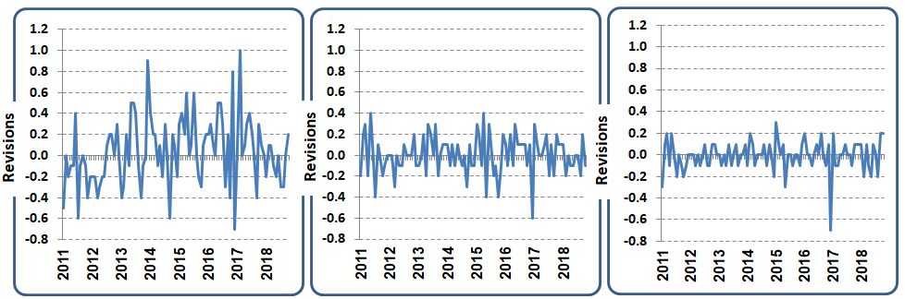

Note: The Revision is defined as the final price change minus the provisional price change.
Fig. 1. Revisions of first, second and third provisional IHPIs (2011-2018)
In order to reduce the revisions of the HPIs, without changing the frequency or timeliness of their production, we develop below nowcasting models that reduce the effect of the early reported transactions on the final HPIs. We nowcast three types of variables at the sub-district level: (1) the average characteristics of the late-reported transactions such as the average number of rooms and the area size of the sold apartments (see below); (2) the corresponding average price of the late-reported transactions; and (3) the number of late-reported transactions. Consequently, since the beginning of 2018, the ICBS uses an extended hedonic regression model with the nowcasted characteristics for the calculation of the provisional HPIs. As shown later, the use of our new methodology reduces the magnitude of the revisions by more than 50%. To our knowledge, this is the first use of nowcasting models by NSIs for the routine production of HPIs.
The rest of the paper is structured as follows. Section 2 presents background information on Israel’s HPI and describes the data bases and hedonic model underlying its computation. Section 3 introduces the nowcasting models and the corresponding extended hedonic model. In Section 4 we evaluate the performance of the new method with the nowcasts. We conclude with some summary remarks in Section 5.
2. Hedonic regression model for the HPI in Israel
Hedonic regression models are the most popular techniques for computing a quality adjusted residential property price index. It treats the price of a given property as representing the values of its characteristics. A price index should thus be unaffected by quality changes and only reflect pure price changes. Because of high heterogeneity in residential house characteristics, if sufficient data are available on salient housing characteristics, the hedonic regression method is generally considered to be the best technique for constructing quality adjusted HPIs (Eurostat, 2017. pp.87).
In order to construct hedonic price indices for Israel, the ICBS uses a rolling-time dummy (RTD) method, which allows the coefficients of the house characteristics to change over time by restricting the estimation period each time to two successive months. This method (also known as the “direct method”) is viewed favourably by international agencies and price index specialists as a reliable and robust way of computing the HPI even with relatively small number of reported transactions, (Eurostat, 2017; de Haan, 2010). The data used in Israel for implementation of the method consists of newly built houses and existing houses that had been sold during three successive months; t, (t-1), (t-2). Hereafter, these three months refer to the months with reported transactions used for computation of the most recent index (published 1.5 months later. See the timeline in Figure A.1 of Appendix A). The data contain sale prices and two subsets of quality variables, physical dwelling characteristics and location characteristics. The quality variables and a time dummy variable are used as explanatory variables in a multiplicative regression hedonic model fitted separately for the months (t, t-1) and (t-1, t-2). The final quality adjusted price change is computed as the simple average of the exponents of the coefficients of the time dummy variables in the two regressions. The model is re-estimated every month. See below for details.
2.1 Hedonic regression equation without nowcasting
The following hedonic model had been used for the provisional and final publications before incorporating the nowcasts into the model equation. For convenience, we omit the index t, defining the reference month, from the equation
;(1) where,
$P_{j}$ | is the sale price of transaction j,
$${SD}_{ji}$$ | is a dummy variable taking the value 1 if transaction j occurred in sub-district i, i=1,…,18, and 0 otherwise. See Table 1 for details of the sub-districts.
$M_{jm}$ | is a dummy variable taking the value 1 if transaction j occurred in district m, m=1,…,6, and 0 otherwise.
$$Z_{jk}$$ | are 7 quality measure variables of transaction j defined as:
 | $$Z_{1}$$ | number of rooms;
 | $$Z_{2}$$ | log of the net dwelling area in square meters;
 | $$Z_{3}$$ | a dummy variable indicating a non-standard dwelling (single-family home, detached house, semi-detached house, penthouse, etc.);
 | $$Z_{4}$$ | log of the age of the dwelling;
 | $$Z_{5}$$ | a dummy variable for new dwellings bought "on paper" (actual year of construction after the transaction is carried out);
 | $$Z_{6}$$ | socio-economic rank of the cluster of the statistical area in which the transaction occurred;
 | $$Z_{7}$$ | long-term level of dwelling prices of the statistical area where the transaction occurred.
 | is a dummy variable indicating the month of the transaction, taking the value 1 for the current month t, and 0 for the previous month.
$$ε_{j}$$ | is random error with mean 0 and constant variance.
The coefficients $\{β_{i}\}$,$\{η_{k}\}$,$\{δ_{ik}\}$,$\{γ_{m}\}$ are fixed parameters that are re-estimated in every month t by weighted least squares (WLS, see Section 2.2). Note that we allow for different coefficients of the quality measures in different sub-districts via the interaction coefficients $\left\{δ_{ik}\right\}.$ The interactions between the sub-districts and Z₇ were omitted after they were found to be insignificant.
Due to the logarithmic transformation of the price, the monthly price change at the district level is defined as. The national HPI is obtained as a weighted average of the district indices, with the weights defined by the relative stock in each district. The weights are shown in Table 1 below. As noted before, the model is fitted separately based on the transactions in months t and (t-1), and the transactions in months (t-1) and (t-2), with the final district and national HPIs for month t calculated by simple averaging of the corresponding two indexes. Note also that by re-estimating the model each month, we enable the inclusion of additional reported transactions in the estimation process.
2.2 Construction of weights for model estimation
The estimation of the unknown model coefficients in (1) is carried out by weighted least squares (WLS). The purpose of the weighting is to make the reported transactions representative of the stock of dwellings in each sub-district. The weights can take two forms, depending on the main purpose of the index: (i) volume weights, which represent the number of dwellings in each region and (ii) value weights which represent the total value of the dwellings in the region. It is generally accepted that the use of value-weights that reflect economic status are more appropriate for macro-economic goals; housing stock deflation and lenders' exposure. Notably, the use of weights that represent the value of dwellings is common with methods used for the computation of consumer price indices, which are based on the expenditure of the households.
The IHPI is a stock type index, intended to measure the changes in the value of the housing stock. In order to turn a price index based on transactions into an index of price changes based on the stock value of the dwellings, each transaction must be weighted according to its contribution to the total stock value of all the dwellings. Hence, the weights in the WLS regression model (1) are calculated as the ratio between the number of dwellings in the sub-district to which the transaction belongs, and the number of transactions reported in the sub-district, multiplied by the average price of dwellings in the sub-district during the base period (2017). Defining the weights this way also allows controlling situations in which the number of transactions in certain sub-districts varies greatly from one month to the next. The following weight is thus assigned to transaction j in sub-district i, i=1,…,18.

$w_{ij}=\frac{N_{stock,i}^{0}×{\overline{P}}_{i}^{0}}{N_{trans,i}}$, (2)
where $N_{stock,i}^{0}$ is the number of dwellings in sub-district i during the base period, $N_{trans,i}$ is the number of transactions reported in the sub-district at the same month and ${\overline{P}}_{i}^{0}$is the average price of dwellings in the sub-district during the base period. Table 1 lists the stock volume in the base period of 2017, the ratio of the stock volume to the average number of transactions in 2018, the average price during the base period and the resulting weights assigned to the transactions in each of the sub-districts.
Table 1
Stock volume, transactions and average price for districts and sub-districts
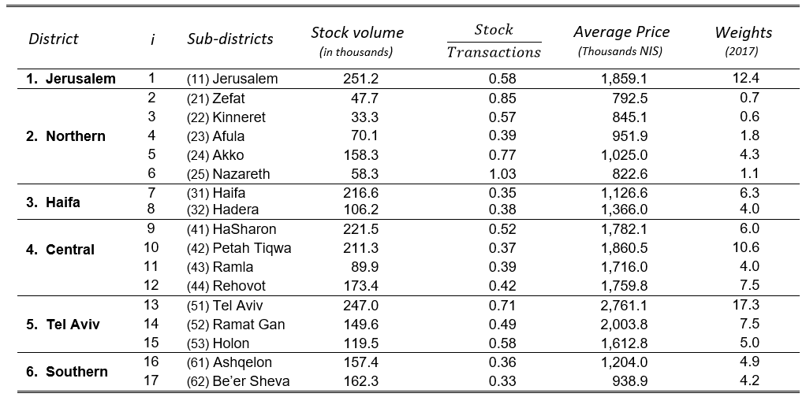
Note: we don't publish separate HPIs for the region of Judea and Samaria because of small number of transactions. However, the transactions occurring in this region are included in the computation of the national HPI as sub-district 18, accounting for the remaining 2.7 percent of the total weight (last column).
2.3 Data sources
The IHPI is computed based on administrative data sources. The main dataset named CARMAN is maintained by the Israel Tax Authority, with a total number of approximately 100,000 records per year at the national level. The data includes several characteristics of the sold dwellings: the date and price of the sale, the location of the dwelling, net and gross areas, number of rooms, number of floors in the building and year of construction.
As stated before, although the dataset is updated on a monthly basis with new transactions, some of the transactions are reported after long delays and thus cannot be used for calculating the first, and sometimes the second and even the third provisional HPIs. A possible explanation for the late reports is different prioritization, or more stringent examination by the Tax Authority in cases in which the reported sale prices seem lower than the market price, given the characteristics of a dwelling, possibly for lower tax payments. Israel's tax system includes two broad types of property taxes, which might incentivize underreporting of sale prices by both sellers and buyers: sellers, in order to pay less appreciation tax; buyers, in order to pay less purchase tax. These sellers-buyers joint interest encourages the Israel Tax Authority to examine more strictly transactions with reported prices that seem too low.
Fig. 2(a) shows that on average, only 60% of the transactions are reported within 30 days from the time that they occur. Fig. 2(b) shows the actual percentage of transactions used for computation of the first provisional HPI for each month.
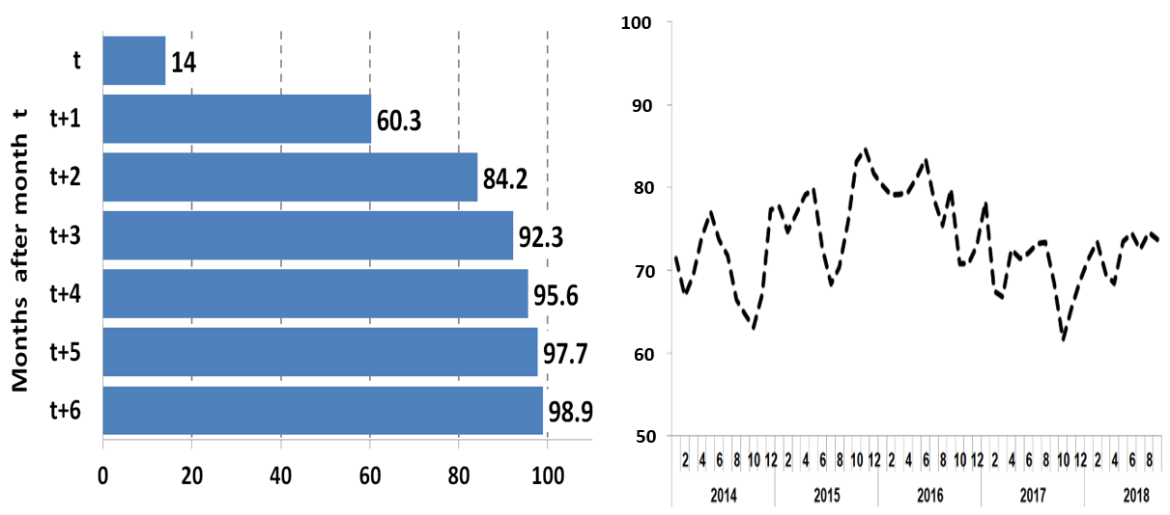
- Actual percentage of transactions used for computation of first provisional HPI by month.
- Average percentage of reports of transactions that occur in month t

Fig. 2. Timelines of on-time reported transactions. 2014-2018
Another data source for calculating the HPI includes the socio-economic clusters of the statistical areas, based on Geographic Information System (GIS) layers.
3. Use of nowcasting to reduce revisions
3.1 Relevant background literature on nowcasting
The term nowcasting is a contraction of “now” and “forecasting”. It can be defined in its basic form as predicting the present or the recent past (Castle, Fawcett, and Hendry, 2009). The field has interested economists for many decades, dating back to the pioneering work of Mitchell and Burns (1938). In that study, the authors developed hundreds of concurrent and past leading indicators of economic activity for detecting business cycles in the U.S. Nowadays, nowcasting methods in common use are often based on data of high-resolution, arriving at different frequencies, collected from a wide range of sources. The approach is often applied in economic time series, such as gross domestic product (GDP), unemployment rates and tourist arrivals, which are often published with significant delays. Giannone, Reichlin, and Small (2008) formalized the process of nowcasting by use of statistical models, which produce predictions based on rich information, without the need for additional subjective judgement. As becomes clear in subsequent sections, our proposed approach for HPI estimation follows this general approach of updating the estimates every month as new data become available, but to the best of our knowledge, the updates are obtained in a new, unique way, not proposed as yet in the literature and definitely not applied elsewhere.
Other nowcasting methods use models that exploit past revisions for deriving the best forecasts of the present. Authors like Garratt et al. (2008), Matheson, Mitchell and Silverstone (2010), Jacobs and van Norden (2011), Kishor and Koenig (2012) and Clements and Galvão (2017) argue that revisions contain useful information for prediction. For example, Matheson, Mitchell and Silverstone (2010) use qualitative responses from a panel business survey to predict revisions of GDP changes, based on nowcasts over 52 quarters (25 quarters for manufacturing output). Clements and Galvão (2017) show that past vintage data are good predictors of current quarterly output growth. In particular, the annual revisions, which take place in the third quarter of each year, can predict quarterly outputs.
Nowcasting methods have recently been applied in the framework of what is often referred to as "occurred but not yet reported" events, Lawless (1994). The problem originated in actuarial science, where it is known as “claims deserving modelling” (England and Verrall, 2002). The use of these methods intensified during the current COVID-19 pandemic, for providing near real-time epidemiological statistics of the true size and trajectory of newly-diagnosed cases and confirmed COVID-19 deaths. Typical models are based on the assumption that COVID-19 cases and deaths follow similar trajectories. Chitwood at el. (2020) found that States in the U.S report cases and deaths in different ways, which leads to inconsistencies and biases in the reported statistics.
Have nowcasting methods been used for the construction of HPIs? The answer is generally not. Few studies have investigated the magnitude and possible pattern of HPI revisions. Clapham et al. (2006) compared the HPI revisions when applying repeat-sale methods to the HPI revisions when applying hedonic-based indices for the city of Stockholm, Sweden, over the period of 1981–1999. The authors found that revisions of HPIs produced by repeat-sale methods are prone to be larger and biased downward compared to HPI revisions produced by hedonic methods. Deng and Quigley (2008) analysed the magnitude of HPI revisions in the U.S., and their effects on prices in housing options markets. The authors found that the average quarterly revision across 238 Metropolitan Statistical Areas (MSAs) was about -0.125%. However, large-scale revisions of about 1.5% in absolute size were found in about 25% of the MSAs. In about 15% of the housing markets, the average absolute revision exceeded 2%. In the context of nowcasting price indices, Knotek and Zaman (2017) developed a model for nowcasting the core inflation in the U.S. consumer price index in major "headlines", (core prices, food prices and energy prices). The authors found that their nowcasting model often outperforms the estimates of professional forecasters. ????????
The present article proposes for the first time the use of nowcasting models for the computation of timely HPIs in the common case where the on-time reported transactions are not representative of all the completed transactions. Our approach uses past disaggregated data to nowcast three different variables: the number of late-reported ("occurred but not yet reported") transactions, their average characteristics, and their average price at a sub-district level. As described below, the nowcasted statistics are then added to the hedonic model defined by Eq. (1) to produce the official HPI.
3.2 Nowcasting the HPI in Israel
The existence of late-reported transactions is not problematic per se, provided that the following two conditions are satisfied: (i) The late-reported transactions are missing at random given the covariates included in the hedonic model, so that they obey the same model, (ii) the number of transactions reported on-time is sufficiently large to guarantee the stability of the HPI computed from them.
As stated before, a thorough analysis over many years indicates very clearly is that the late-reported transactions behave differently from the transactions reported on time, and thus they are not missing at random. This is seen by comparing the average house characteristics and prices of the on-time reported transactions and the late- transactions, and of course by noting the large magnitude of the revisions once the late-reported transactions are added for fitting of the hedonic model. In other words, the on-time reported transactions are not representative of all the completed transactions, and thus ignoring the still missing (late-reported) transactions when computing the provisional HPIs, is statistically wrong.
Recognizing the importance of accurate provisional HPIs, motivated us to attempt nowcasting the average house characteristics (quality measures) of the late-reported transactions, their average sale price and their number. As it turns out and illustrated in Section 4, adding to our hedonic regression each month a single record (row) for each sub-district consisting of the nowcasted average sale price of the late-reported transactions in the left hand side of the equation and the averages of the housing characteristics in the right hand side, both weighted proportionally to the nowcasted number of the late-reported transactions, reduces the magnitude of the revisions very significantly. See Section 3.3 for the nowcasting models and Eq. (8) for the extended hedonic model used for the computation of the HPI.
Recall that we compute 3 provisional and a final HPI for every given month t, implying that in each month we actually publish 4 different HPIs, at both the district and the national level. The 1st provisional HPI is published for month t and is based on the transactions carried out in months (t-1), (t-2) and (t-3) (As explained before, in each month we average the two most recent successive HPIs, so as to smooth the price changes.) The 2nd provisional HPI is published for month (t-1), and is based on the transactions performed in months (t-2), (t-3) and (t-4), and so forth. The computation of the 3 provisional HPIs utilizes the nowcasts, as explained before.
Fig. 3 sketches a roadmap of the computation of the provisional and final HPIs.
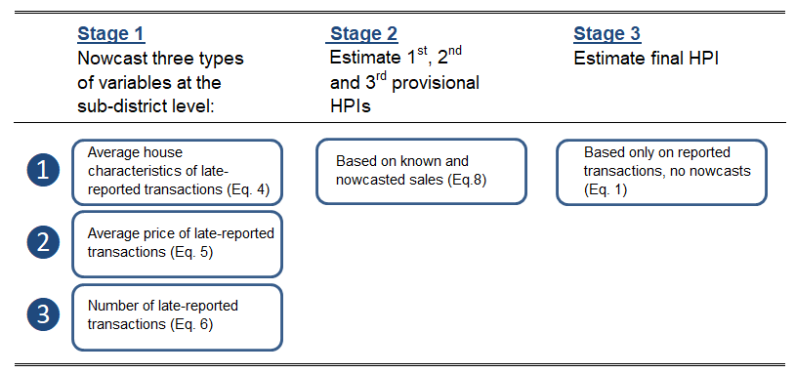
Fig. 3. Roadmap of three stages of computation of provisional and final HPIs
For developing our nowcasting models for the three types of variables, we employed past data as a learning period for exploring the relationships between the late-reported transactions and the on-time reported transactions. Since all the transactions are literary known after six months, and in order to guarantee sufficient number of observations, we set the learning period to cover the months (t-7) to (t-18).
3.3 Nowcasting average house characteristics of late-reported transactions
For nowcasting the average house characteristics, we use the following simple multiple regression models,
, (3)
where the subscript defines the sub-district and “g” the house characteristic (quality measure) under consideration. The added subscript "l" in the left hand side of the equation defines “late-reported transactions”. The means that define the explanatory variables in the regression are of the on-time transactions.
The models are fitted separately for every characteristic, using the data for all sub-districts over the months () to () for estimating the model coefficients by OLS. The following average characteristics are nowcasted and then included in the extended hedonic regression.
$${\overline{Z}}_{l1}$$ | – | average number of rooms
$${\overline{Z}}_{l2}$$ | – | average of logs of net area
$${\overline{Z}}_{l3}$$ | – | percentage of dwellings that are not in a residential building
$${\overline{Z}}_{l4}$$ | – | average of logs of age of dwellings
$${\overline{Z}}_{l5}$$ | – | percentage of new dwellings that are bought "on paper"
We do not nowcast the 2 quality measures and defined in Section 2.1, since no significant differences between the on-time and late-reported transactions have been found for these two variables. The two variables also do not contribute to the nowcasting of the other 5 variables.
The nowcasted means for any month with only provisional data are:
. (4)
Fig. 4 illustrates the performance of the nowcasts of two characteristics: (a) average net area of dwelling and (b) average number of rooms. Fig. 4(a) shows that the deviations between the average of the net dwelling area (in log scale) of the on-time reported transactions and the true dwelling area based on all the transactions (known 6 months later), are systematically larger than the corresponding deviations of the nowcasted dwelling area obtained from Eq. (4). Fig. 4(b) shows a similar pattern when considering the average number of rooms until towards the end of 2015, after which there is no clear pattern in either set of deviations (both being positive or negative), but the absolute deviations of the nowcasted averages are in most cases lower.
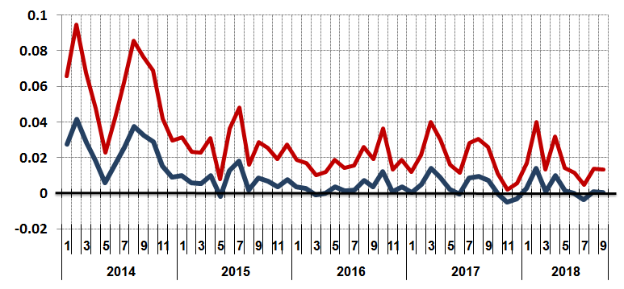
- Deviations from true averages: net dwelling area (in log scale)

Deviations
- Deviations from true averages: number of rooms
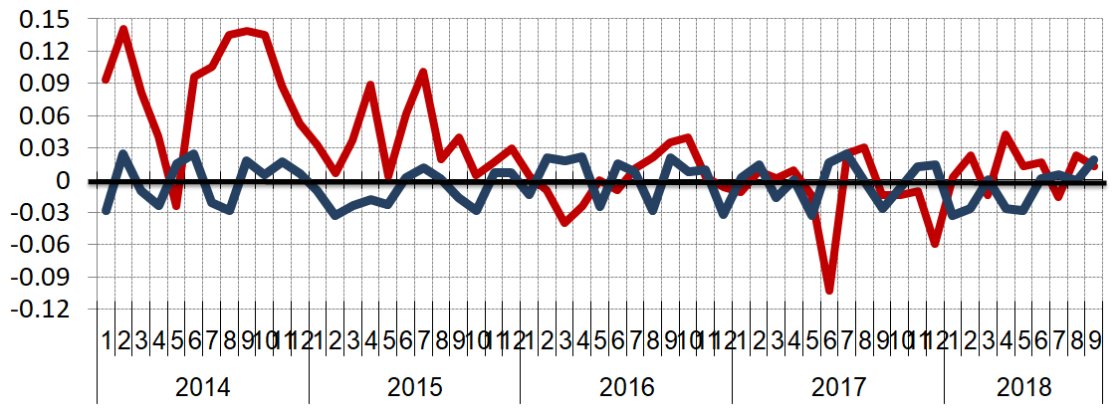
Deviations

Fig. 4. Deviations from true averages: provisional (known) versus nowcasted averages. Tel-Aviv district, 2014-2018
3.4 Nowcasting the monthly average price of late-reported transactions
For nowcasting the average of the log prices of the late-reported transactions at the sub-district level we use the model,
, (5)
where the dwelling characteristics $\left\{{\overline{Z}}_{k}\right\}$ are as defined in Section.3.4, is the average log price of the dwellings reported on-time, and is a random error with mean 0 and constant variance. Fig. 5 compares the deviations of the on-time and nowcasted averages of the log prices from the true prices (known 6 months later). As can be seen, the nowcasted deviations (in blue), are much smaller than the deviations of the on-time averages (red bars), suggesting good performance of the nowcasting model, even though the nowcasts are systematically below the true values from 2015 onwards, notably in 2017-2018, suggesting a change in the model intercept in more recent years. (We compare the average log prices because these are used in the extended hedonic model. See Eq. 8 below.)
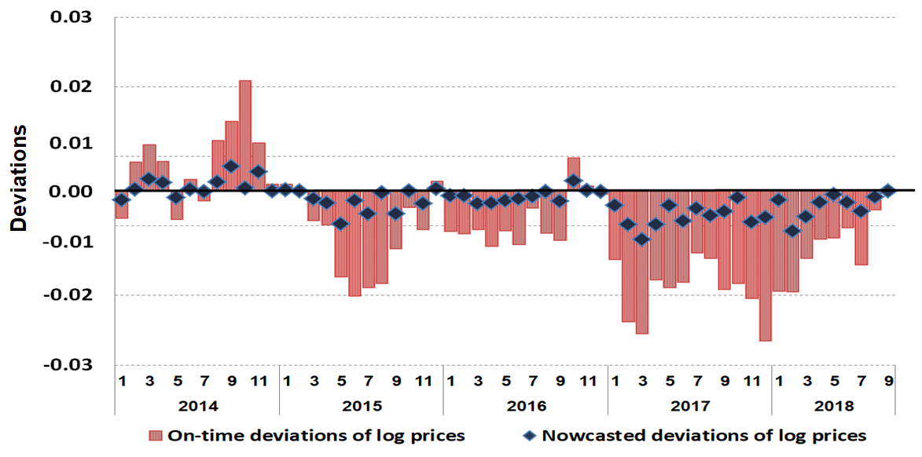
Fig. 5. Deviations from true average prices of late reported prices: on-time and nowcasted prices (in log scale). Tel-Aviv district, 2014-2018
3.5 Nowcasting the number of late-reported transactions
The third component that need to be nowcasted is the number of late-reported transactions, which provides inflation weights for the nowcasted averages in the hedonic model used for computing the HPI and also affects the weights of the on-time reported transactions in the estimation of the extended hedonic model in (8). See Section 3.6 for details. As depicted in Fig. 6, the proportion of transactions reported on-time out of all the reported transactions can vary greatly between sub-districts, depending on the Property Tax Office (PTO) operating in them. The PTOs are in charge of approving, and then recording the transactions. They are located within sub-districts, which explains the differences in the proportions of the on-time reported transactions between the sub-districts.
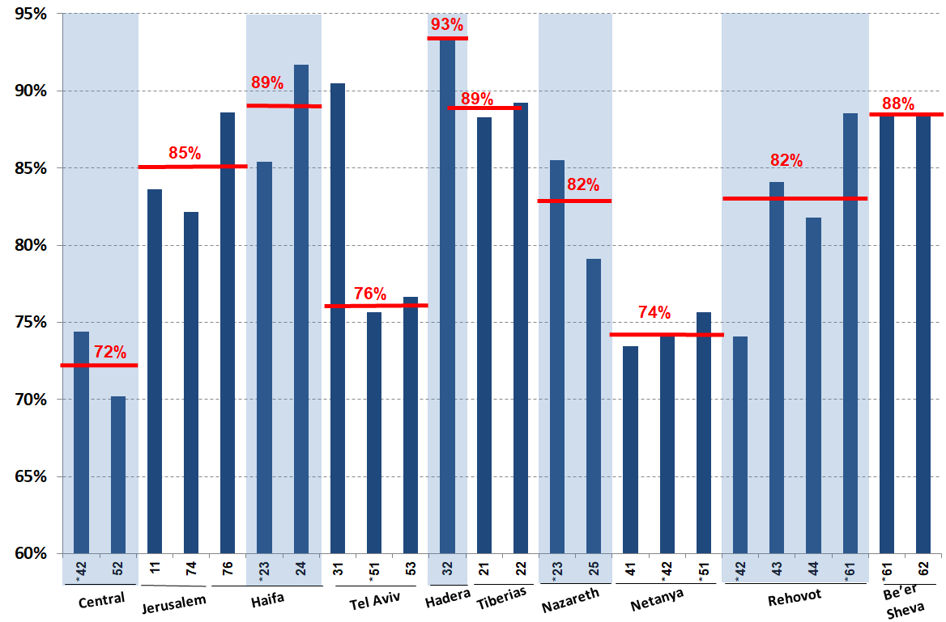
Notes: The x-axis shows the regional PTOs and the codes (42, 52,…,62) represent the sub-districts

Fig. 6. Percentage of transactions reported on-time out of total transactions at sub-district level, by regional PTOs, 2017
We use the following model for nowcasting the number of late-reported transactions in any given sub-district,
(6)
,
where $N_{t,t+6}$is the final (true) number of transactions carried out in month t (known 6 months later), and $N_{t-v,t-k}$ is the number of transactions carried out in month and known in month t - k, k,, with representing a random error with constant variance.
Note that in month t, the proportions which refer to previous months are already known. The final (true) number of transactions in the sub-district in month t, $N_{F,t},$ is nowcasted as:
, (7)
where is the predicted proportion of transactions reported on-time out of the true number of transactions, as obtained from Eq. (6).
Fig. 7 shows for two sub-districts the number of known transactions when computing the first provisional HPI, the final number of transactions (obtained after 6 more months), and the nowcasted final number of transactions as obtained by (6) and (7). The figure shows almost perfect nowcasts in both sub-districts. Similar results have been obtained for the other sub-districts.
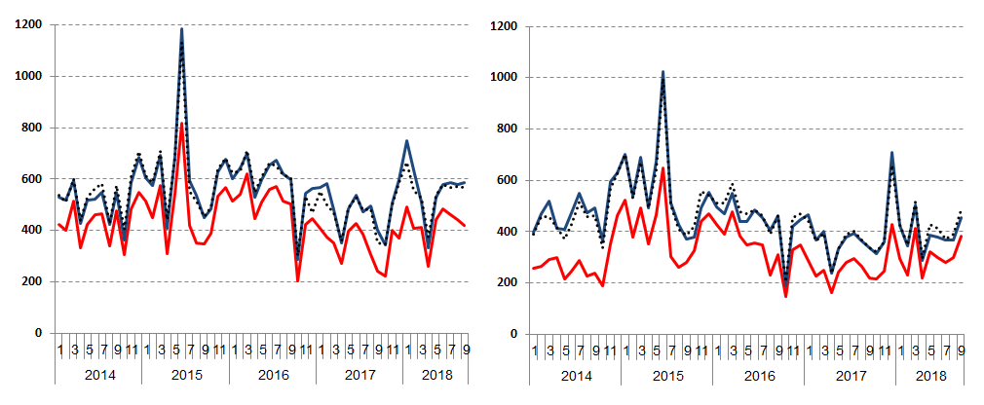
(a) Jerusalem (b) Tel Aviv

Fig. 7. Number of on-time reported transactions, final number of transactions, and nowcasted final number of transactions in two sub-districts. First provisional data.
3.6 Calculating the provisional HPIs with the addition of the nowcasts
Until the end of 2017, the hedonic regression model in Eq. (1) was used for the computation of both the provisional and the final HPIs, resulting with large revisions. Since 2018, the provisional HPIs are calculated by adding to the hedonic regression for each sub-district the nowcasted average of the log prices of the late-reported transactions in the left hand side of the regression, and the nowcasted averages of the corresponding housing characteristics (quality measures) to the right hand side, with both sets of averages weighted by the nowcasted numbers of the late-reported transactions (see below), based on the months (t-1) to (t–6). The extended model, fitted for months t and (t-1) is defined by Eq. (8). For convenience, we omit the index t (and t-1) from the notation.
, (8)
where for the transactions reported on-time, for the added row (Eq. 5); for the transactions reported on-time, for the added row.
When fitting the extended model (8), the added rows with the averages are assigned the following weights:
(9)
where $N_{stock,i}^{0}$ is the number of dwellings in sub-district i during the base period (same as in Eq. 1), ${\overline{P}}_{i}^{0}$is the average price of dwellings in the sub-district during the base period (same as in Eq. 1), t*=t or (t-1) depending on the month under consideration, and ${\hat{N}}_{i,F,t*}$ is the nowcasted total number of transactions for month t* in sub-district i, obtained from Eq. (7). The difference $({\hat{N}}_{i,F,t*}-N_{i,t*,t*})$ represents the nowcasted number of late reports. The weights for the other, individual records in the same sub-district are now (compare with Eq. 2),
(10)
4. Empirical results
4.1 Evaluation of the performance of the provisional HPIs with the nowcasts
In this section, we evaluate the performance of the hedonic model (8) with the nowcasts, in terms of the magnitude of the provisional HPI revisions, and compare it to the performance of the hedonic model (1) without the nowcasts. The revisions are the differences between the first provisional HPI and the final HPI, calculated 6 months later. As noted in footnote (17), the final HPI is computed by the traditional model (1), without the nowcasts. Fig. 8(a)-8(f) compare the revisions for each of the six districts.
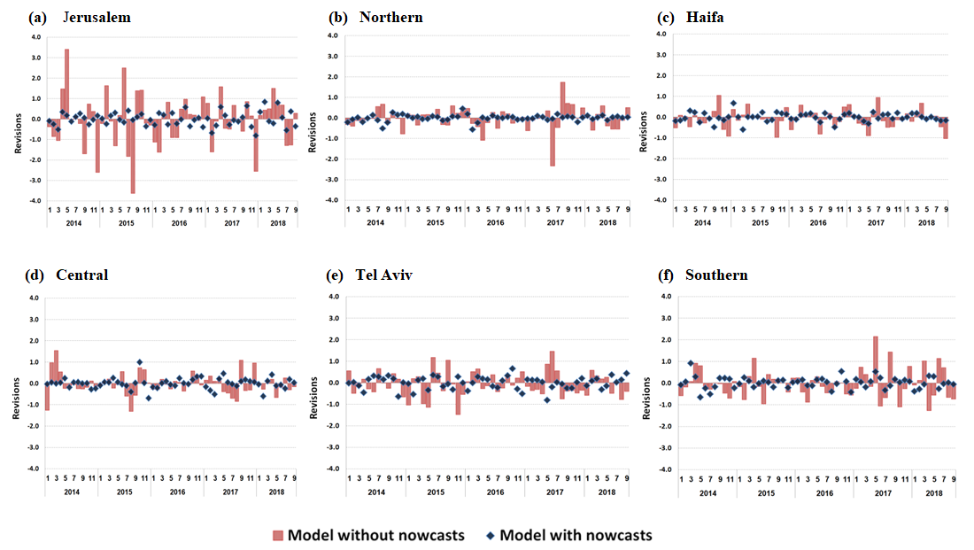
Fig. 8. Revisions of first provisional HPIs in six districts - model without nowcasts versus model with nowcasts. 2014-2018
Evidently, in all six districts, the provisional HPIs obtained by adding the nowcasts to the hedonic model are much closer to the corresponding final HPIs, than the HPIs computed without the nowcasts. Notice in particular, the big reductions in the revisions in the district of Jerusalem.
Table 2 displays the averages of revisions in absolute values of the three provisional HPIs in the six districts.

Table 2.
Average of absolute revisions of the three provisional HPIs in 6 districts, with and without the nowcasts. 2014 - 2018.
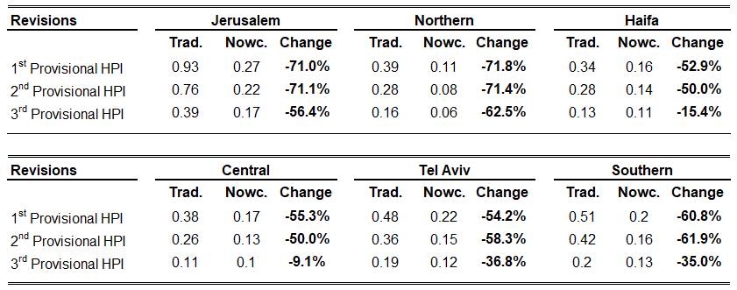
Trad. - “Traditional” model (Eq. 1) without nowcasts; Nowc. - model with nowcasts (Eq.8).

Except for the third provisional HPI in two districts, including the nowcasts reduces the revisions at the district level by 40% to 70%. As expected, the use of nowcasts is most effective for the first provisional HPI.
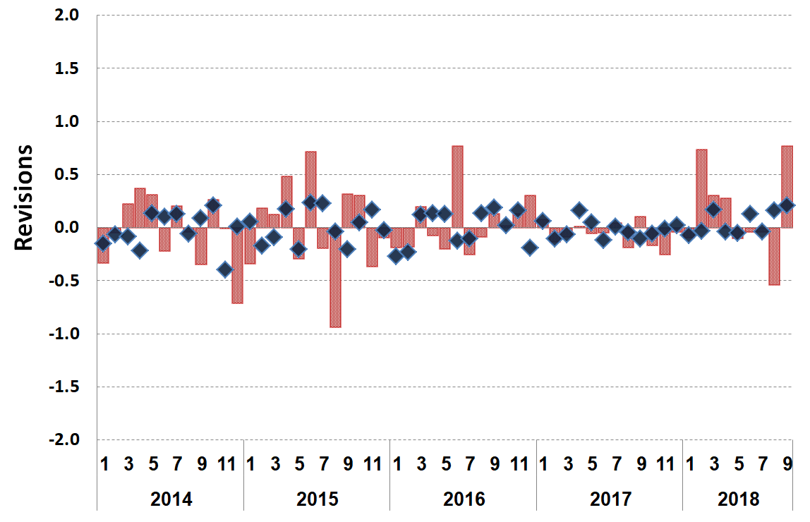
Fig. 9 presents the revisions of the national HPI resulting from the use of the two models over the recent 5-year period. The figures show clear improvements resulting from adding the nowcasts to the hedonic model.

Fig. 9. Revisions of first provisional HPI at the national level - with and without the nowcasts.

Table 3 displays the average of the absolute revisions of the three national provisional HPIs, over the years 2014-2018. As can be seen, the average revisions with the nowcasts are substantially lower than the average revisions without nowcasting.
Table 3.
Average of absolute revisions - with and without nowcasts. 2014-2018
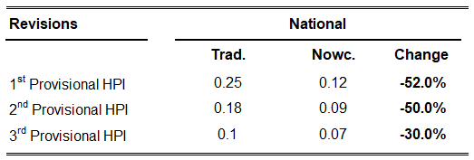
Trad. - “Traditional” model (Eq.1) without nowcasts; Nowc. - model with nowcasts (Eq.8).

4.2. Robustness check
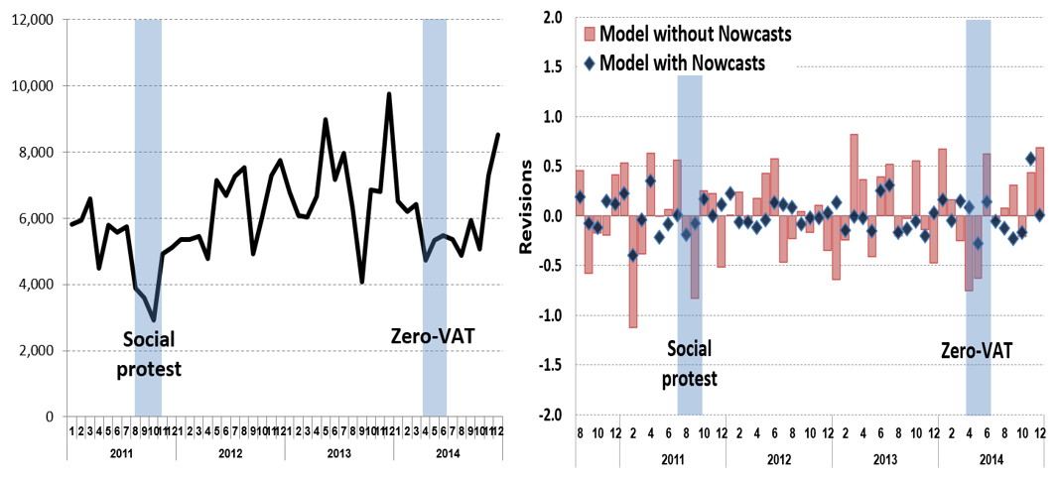
As a final evaluation of the performance of the nowcasting procedure, we examined as a robustness check, two "unique" periods characterized by a sharp decrease in the number of transactions (Fig. 10), and by lower house prices. The first is the period of social protests in Israel during the summer of 2011. The second is a period in 2014 when the government declared a zero-VAT tax for purchase of first new homes. As shown in Fig. 11, in both periods the model with the nowcasts reduces drastically the HPIs revisions.
Fig. 11. Revisions of first provisional HPIs during the years 2011-2014.
Fig. 10. Number of transactions during the years 2011-2014.

5. Concluding remarks
Timeliness and accuracy are the most important measures of the quality of official statistics. Although provisional HPIs with large revisions occur in many countries (Table C.1 in Appendix C), the international statistical community has not yet set out well-articulated guidelines for reducing their revisions. Notice in this regard that the literature suggests that the size of the revisions of HPIs should be an importance criterion for choosing their calculation. (van de Minne et al., 2020).
In this paper, we developed nowcasting models as a possible way of dealing with the effects of late-reported transactions that behave differently from the on-time reported transactions, when computing and publishing provisional HPIs. The provisional HPIs in Israel, calculated by use of the nowcasts since the beginning of 2018 proved to be very successful in drastically reducing the revisions. Evaluation of the method during the years 2014–2018 at both the district and national levels shows that the HPIs computed with the nowcasts are much more accurate than without them. The benefits from nowcasting are most noticeable at the district level, where the number of monthly transactions is considerably smaller than at the national level, leading to higher price volatility and larger revisions. Notably, we also observed much better performance of the provisional HPIs with the nowcasts during the unusual periods characterized by sharp decrease in the number of transactions and by lower home prices.
We hope that our proposed method and the background discussion in this article will raise awareness to the problem of "observed but not yet reported" events, and encourage NSIs in other countries, facing similar problems of late reports to try the method. In this paper we focused mostly on the computation of HPIs, but the general approach developed in this article can be applied in principle to reduce revisions of other time series subjected to nonignorable missing data, such as start and completion of new homes, number of sold homes, or series of National Accounts, which are known to undergo large revisions all over the world.
Acknowledgments
This paper has benefited from valuable comments and suggestions by members of Israel's Public Advisory Council for Statistics, and by participants in the 2019 Ottawa Group meeting in Rio de Janeiro. We are especially grateful to Yoel Finkel, Larisa Fleishman, Can Tongur and Jan de Haan for their detailed thoughtful comments. The opinions expressed in this paper are solely of the authors and do not necessarily reflect the views of institutions other than the ICBS, with which the authors are affiliated.
Appendix A. HPI publications on December 15th
In the following Figure A.1 we present as an example all the HPI publications released on December 15. The publications released in other months have similar time delays.
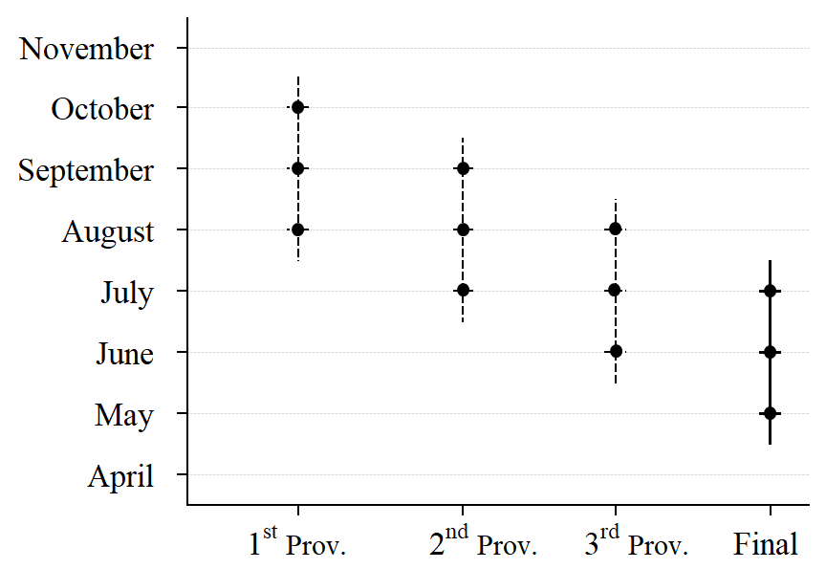
Fig. A.1. Timeline of HPI releases for the month of December and the months participating in
each release.
Appendix B. Construction of variable "Level of prices of dwellings in statistical area"
The explanatory variable "Level of prices of dwellings in a statistical area" was developed in 2018 by the ICBS for improving the quality adjustment in the IHPI. It is intended to capture the effects of unobserved variables in a statistical area such as the level of community services, transportation facilities, proximity to a beach or to a central business district, etc. The variable is calculated by use of out-of-sample transactions with a six-month delay, so as not to intervene with the current sales used for estimation of the price change, with a rolling 36-month window. The variable is revised relatively frequently in order to account for newly built neighbourhoods and other recent developments relating to the characteristics of the statistical area.
We use the following regression Eq. (estimated by Weighted Least Squares) for calculating this variable for Israel’s 2,936 statistical areas:
(A1)
where,
is a dummy variable taking the value 1 if transaction j occurred in statistical area a, a=1,….2936,
is a dummy variable indicating a non-standard dwelling (detached house, semi-detached house, penthouse, etc.),
is the net dwelling area,
is the age of the dwelling,
is the number of rooms,
is an indicator variable indicating the month of the transaction
is a random error.
The estimated coefficients provide the quality-adjusted estimators of the level of prices of dwellings in the 2936 statistical areas. (Defining the variable in Eqs. 1 and 8.) Eq. (1) is fitted twice a year (in December and June), and as mentioned above, the model is estimated based on all the transactions carried out in a three-year period, with a delay of 6 months. For example, the estimates used for the computation of the HPIs during January 2019 to June 2019 are based on all the transactions carried out between June 2015 and June 2018.
Appendix C. Average size of revisions for selected countries
To compare with the average size of revisions in other OECD countries, we present bellow the size of the revisions for countries which (1) publish data in a way which enable users to track the revisions or (2) provided revisions at our request. Table B.1 exhibits deceptive statistics on several characteristics of the revisions, along with their average absolute size. As can be seen, the use of our new method in Israel provides the smallest average of absolute revisions.

Table C.1
Average size of first revisions for selected OECD countries
Average of absolute revisions | Reference period | Method of calculation | Time of 1st publication | Frequency | Country
0.30 | 2018Q1 - 2018Q4 | HRM | t+85D | Quarterly | Denmark
0.31 | 2016Q1 - 2018Q4 | HRM | t+85D |  | Germany
0.19 | 2017Q1 - 2018Q4 | HRM | t+85D |  | Luxembourg
0.30 | 2016Q1 - 2018Q4 | HRM | t+85D |  | France
4.70 | 2016Q1 - 2018Q4 | HRM | t+85D |  | Hungary
0.20 | 16Q1 - 2018Q420 | HRM | t+26W |  | Finland
0.15 | 16Q1 - 2018Q420 | HRM | t+85D |  | Italy
0.21 | 16Q1 - 2018Q420 | HRM | t+80D |  | Czech Republic
0.15 | 2016M1 - 2017M12 | HRM without nowcasting model | t+45D | Monthly | Israel
0.08 | 2018M1 - 2018M9 | HRM with nowcasting model | t+45D
0.30 | 2016M2 - 2019M6 | HRM | t+(2-3)W |  | Ireland
0.13 | 16M1 - 2019M620 | GWRS | t+2M |  | USA
0.40 | 17M1 - 2019M420 | HRM | t+2M |  | United Kingdom

Notes: t defines the reference month, HRM stands for Hedonic Regression Models, GWRS stands for Geometric Weighted Repeated- Sales. D represents days, W weeks and M months.

References
Ben-Shahar, D. & Sayag, D. (2018). The Israeli Commission Report on Prices and Rent of Dwellings. The Public Advisory Council for Statistics Israel (Hebrew only).
Ben-Shahar, D., Golan, R., & Sulganik, E. (2017). Tax Evasion in the Housing Market: Identification and Exploration. Available at SSRN 3075073.‏
Bourassa, S. C., Hoesli, M., & Sun, J. (2006). A simple alternative house price index method. Journal of Housing Economics, 15(1), 80-97.‏
Calhoun, C. A. (1996). OFHEO house price indexes: HPI technical description (Working paper). Washington, DC: Office of Federal Housing Enterprise Oversight (OFHEO).
Carless, E. (2011). Reviewing House Price Indexes in the UK. Paper presented at the Workshop on House Price Indexes, Statistics Netherlands, The Hague, 10-11, 2011.
Castle, J. L., Fawcett, N. W., & Hendry, D. F. (2009). Nowcasting is not just contemporaneous forecasting. National Institute Economic Review, 210(1), 71-89.
Case, K. E., & Shiller, R. J. (1987). Prices of single family homes since 1970: New indexes for four cities.‏ New England Economic Review. (Sep), 45-56.
Clapham, E., Englund, P., Quigley, J. M., & Redfearn, C. L. (2006). Revisiting the past and settling the score: index revision for house price derivatives. Real Estate Economics, 34(2), 275-302.‏
Clapp, J. M., & Giaccotto, C. (1999). Revisions in repeat‐sales price indexes: here today, gone tomorrow?. Real Estate Economics, 27(1), 79-104.‏
de Haan, J. & Diewert, W. E. (2013). Handbook on residential property price indexes. Luxembourg: Eurostat.
de Haan, J. (2010). Hedonic Price Indexes: A Comparison of Imputation, Time Dummy and ’Re-Pricing’ Methods. Journal of Economics and Statistics, 230(6), 772–791.
Deng, Y., & Quigley, J. M. (2008). Index revision, house price risk, and the market for house price derivatives. The Journal of Real Estate Finance and Economics, 37(3), 191-209.‏
Eurostat (2017). Technical Manual on Owner-occupied Housing and House Price Indices. Available at: https://ec.europa.eu/eurostat/documents/7590317/0/Technical-Manual-OOH-HPI-2017/
Giannone, D., Reichlin, L. & Small, D. (2008). Nowcasting: The real-time informational content of macroeconomic data. Journal of Monetary Economics, 55(4), 665-676.‏
Hill, R. J., Scholz, M., Shimizu, C., & Steurer, M. (2020). Rolling-Time-Dummy House Price Indexes: Window Length, Linking and Options for Dealing with the Covid-19 Shutdown (No. 2020-14). University of Graz, Department of Economics.‏
Knotek, E. S., & Zaman, S. (2017). Nowcasting US Headline and Core Inflation. Journal of Money, Credit and Banking, 49(5), 931-968.‏
Lawless, J. F. (1994). Adjustments for reporting delays and the prediction of occurred but not reported events. Canadian Journal of Statistics, 22(1), 15-31.‏
Mitchell, W. C. & Burns, A. F. (1938). Statistical indicators of cyclical revivals. In Business cycle indicators, 1, 184-260. Princeton University Press.
Sayag, D. (2012). Measuring the local house price movements and estimating the price elasticity. Israel Economic Review, 10(1), 39–94.
Silver, M. (2002). The use of weights in hedonic regressions: the measurement of quality adjusted price changes. In 7th Meeting of the Ottawa Group, INSEE, Paris, May, 27-29.
Silver, M. (2012). Why house price indexes differ: measurement and analysis (No. 12-125). International Monetary Fund. ‏
van de Minne, A., Francke, M., Geltner, D., & White, R. (2020). Using revisions as a measure of price index quality in repeat-sales models. The Journal of Real Estate Finance and Economics. 60(4), 514-553.‏
Chitwood, M. H., Russi, M., Gunasekera, K., Havumaki, J., Pitzer, V. E., Warren, J. L., ... & Menzies, N. A. (2020). Bayesian nowcasting with adjustment for delayed and incomplete reporting to estimate COVID-19 infections in the United States. medRxiv.‏

We benefited from valuable comments and suggestions of members of the Israel Public Advisory Council for Statistics, and participants in the 2019 Ottawa Group meeting in Rio de Janeiro. We are especially grateful to Yoel Finkel, Larisa Fleishman, Can Tongur and Jan de Haan for detailed thoughtful comments. The opinions expressed in this paper are solely of the authors and do not necessarily reflect the views of institutions other than the ICBS, with which the authors are affiliated. The authors are solely responsible for any errors.
HPIs are often considered to be “early warning signals” in macroeconomic and financial stability risks.
At the third (final) revision, about 98% of the transactions are known.
The OECD countries are listed in Table C.1 in Appendix C, along with information of the method used for the computation of the HPI, the time until the first publication and the magnitude of the revisions.
The monthly UK HPI is final after a long delay of 12 months with revisions.
Following Eurostat's recommendation (2012), most of the NSIs in the European Union (EU) produce their HPI based on the hedonic method.
Among other countries that use the RTD method are France, Ireland, Japan, Portugal and Cyprus.
In terms of HPI revisions, the literature suggests that the RTD method, which does not include all the data in all the time periods in a single run (the classical time dummy method, TDM) adapts itself better to the inclusion of new data. Hill et al. (2020) argue that the RTD method has an advantage over the TDM when computing high frequency HPIs (e.g., monthly or weekly), and that the RTD method is more robust to the distorting effects of the covid-19 lockout or shutdown.
Sub-district 1 is omitted to avoid multicollinearity.
7 A Socio-economic Index was developed at the ICBS in the mid-1990s. The current index is based on the 2008 Population Census data. The index is calculated for more than 3,000 geographical areas, covering the entire country. It accounts for many aspects related to the socio-economic status of the population in the area, such as demographic characteristics, education, unemployment rate, income, etc. After computing the index for each area, the areas are ranked based on their index, and then clustered into 20 clusters, based on statistical cluster analysis. (20 is the highest level).
See Appendix B for the construction of this variable.
Interactions between the socio-economic rank and the sub-district are not significant.
For discussion of the advantages of weighted least squares (WLS) estimator over ordinary least squares regression (OLS) in the context of HPIs and the best type of weights, see Silver (2002), Section 3.
For more details, See Jan de Haan (2011)'s presentation "RPPI Handbook Chapter 13: Recommendations and Guidelines – weighting", pp.86-88 (retrieved from: http://m.stats.govt.nz/ottawa-group-2011/~/media/Statistics/ottawa-group-2011/Ottawa-2011-Presentations/RPPIHandbook.pdf)
Ben-Shahar et.al. (2017) found that about 8% of the transactions carried out in Israel during the years 1998-2015 were underreported, with an average underreport of 30%, resulting in an estimated loss of 2.5%-6.3% in the annual purchase tax.
The percentage of transactions used for the first provisional HPI is calculated based on the numbers of on-time and final transactions reported for months (t+1), (t+2) and (t+3).
Statistical areas are the smallest geo-statistical units for which official statistics is published. They are defined as continuous units of land, with 3,000 to 5,000 residents in most areas.
The HPI in the U.S. is computed by use of a "repeat-sales method" (e.g., Case-Shiller,1987). This method uses the houses sold at least twice to estimate the HPI. It is suitable for large, high-turnover property markets but it assumes no quality changes between successive sales of the same house, even if the sales are long time apart. For more detail on this method and other methods used for the computation of HPIs, see de Haan & Diewert (2013) and Eurostat (2017).
We refer to transactions as "on-time reported transactions" if they are reported in time to be included in the computations of the provisional HPI under consideration.
Although not reported here, using other methods such as Structural Time Series Modelling tends to perform relatively poorly, particularly when nowcasting the average house characteristics.
For computation of the final price change, we use the hedonic model in Eq. (1), without any nowcasts.
A possible explanation for the large revisions without the nowcasts is the rate of late-reported transactions, which is much higher in the Jerusalem district than in the other districts.
The social protests were against the continued rise in the cost of living and in particular, the rising prices of homes.

