Note: this is a draft of the journal article:

# Hemalatha Jayabal, Barbara M. Bates-Jensen, Nkemjika S. Abiakam, Peter R. Worsley, Dan L. Bader (2021) “Anatomical variability of subepidermal moisture and its clinical implications.”

# Journal of Tissue Viability, accepted

The final, fully proofed and peer-reviewed journal article is available from the publisher online,

Title: ***Anatomical variability of subepidermal moisture and its clinical implications***

Hemalatha Jayabala, Barbara M. Bates-Jensenb, Nkemjika S. Abiakama, Peter R. Worsleya, Dan L. Badera.

a School of Health Sciences, University of Southampton, Southampton, UK

b School of Nursing and David Geffen School of Medicine, University of California at Los Angeles (UCLA), USA

*Corresponding Author:* Hemalatha Jayabal, Clinical Academic Facility, School of Health Sciences, University of Southampton, Southampton, UK.

*Email:* [H.Jayabal@soton.ac.uk](mailto:H.Jayabal@soton.ac.uk) Phone: +44(0)2381 208287

***Abstract***

**Background:** Technologies have been developed to monitor changes in dermal oedema, indicative of the early signs of pressure ulcers. However, there is limited information on the effects of regional differences in tissue morphology on these sub-epidermal moisture (SEM) parameters. This study was designed to investigate the absolute SEM readings across different anatomical sites using a commercial device.

**Methods:** Twenty-four healthy participants were recruited to evaluate basal SEM values at different bony prominences, sampled by an experienced operator.

**Results:** Distinct differences were observed in unloaded SEM values across different anatomical sites, notably between the upper and lower extremities. A high degree of variability was observed in particular sites, such as the heels. Moreover, SEM values at certain locations revealed significant relationships with age, BMI and gender (p<0.05).

**Conclusion:** The study revealed a high level of variability between and within anatomical sites in a healthy cohort of participants. Determining the changes in local skin and sub-dermal tissue status using SEM may require consideration of both site specific and individual demographic factors, with further research needed in cohorts at risk of pressure ulcers.

***Keywords:*** Sub-epidermal moisture; Pressure Ulcers; chronic wounds; skin response variability; skin damage

# Introduction

Chronic wounds represent a major issue for vulnerable patients and healthcare providers, associated with reduced quality of life to those afflicted. The financial burden of managing chronic wounds have been estimated to account for 2-6% of the total health care expenditure in European countries (1, 2). Pressure Ulcers (PUs) and Diabetic Foot Ulcers (DFUs) represent common wounds, with annual UK costs ranging up to £2.1 billion and £962 million, respectively (3, 4). Although national and international guidelines for wound prevention are available and initiatives have been established to reduce their incidence, the number of individuals suffering from chronic wounds remains unacceptably high (5, 6).

Early detection of skin damage is critical in reducing the incidence of these chronic wounds. Current evaluation of skin status using risk assessment methods, which are based on clinical factors and visual skin assessment, are highly subjective and thereby offer limited predictive validity and poor reliability (7, 8). Commercial systems sensitive to tissue capacitance and permittivity have gained attention as a non-invasive biophysical measure of localized oedema in the sub-epidermal tissues (9, 10). Any early inflammatory changes coupled with impaired lymphatic drainage, associated with the early stage of tissue damage i.e. PUs and DFUs, will inevitably result in an accumulation of interstitial fluid underneath the skin tissues. This increase in sub-epidermal moisture levels creates a local change in tissue impedance and/or capacitance (10). This forms the basis of the sub-epidermal moisture (SEM) tool, which has been evaluated in both pre-clinical and clinical studies in detecting early signs of skin damage (11-14).

One of the market-leading devices uses a metric involving a differential reading in SEM values, termed the SEM delta value, between a site suspected to be damaged and local sites around its circumference. The threshold value to indicate likely skin damage is set at 0.6 arbitrary units, as recommended by the manufacturers. This has been shown to be highly sensitive and able to identify skin damage days prior to clinical inspection (15). However, it lacks specificity with, for example, a reported positive predictive value (PPV) estimated as 14% in a recent patient cohort study (14). In addition, a study using an *in-vitro* model revealed a number of factors which may influence readings e.g. depth of tissue adjacent to bone (16). Indeed, reliability studies demonstrate variability between anatomical sites, such as the sternum, sacrum and heels, with median values ranging between 2.6–3.1 AUs (17). Moreover, the SEM technology is currently only recommended in the UK to assess skin status at sacral and heel sites (18). Accordingly, there is a need to evaluate SEM readings at a number of different body sites to establish the basal values, while also assessing the effects of demographic factors. This motivated the present study, which examines the site-specific i.e. intra-individual and inter-individual variations associated with baseline SEM values in an able-bodied cohort.

# Materials and methods

## 2.1 Test cohort

A total of 24 healthy participants (10 males and 14 females) were recruited from the local community. They were aged between 23 and 82 years (mean age 48±17 years) with a mean height and weight of 1.7±0.1m and 72.7±13.8kg, and a corresponding mean BMI of 25±4 kg/m2. Exclusion criteria included a history of skin-related conditions or neurological or vascular pathologies that could affect the health of skin tissue. Institutional ethics was granted for the study (ERGO-FOHS-26040) and informed consent was obtained from each participant prior to testing.

## 2.2 Test equipment and protocol

Sub-epidermal moisture was measured using a handheld, portable device (SEM Scanner, Bruin Biometrics LLC, USA). The device measures the bio-capacitance of soft tissues which is converted into arbitrary units (AUs). All measurements were taken according to the manufacturer’s guidelines. To review briefly, light skin pressure was applied at an optimal level indicated by the device prior to each recording. The basal SEM measurements were collected from 27 anatomical sites involving bony prominences, which included the right (R) and left (L) sides of the shoulder, scapula, hip, trochanter, buttocks, ischial tuberosities, medial knee, lateral knee, medial ankle, lateral ankle, lateral heel, posterior heel, as well as the middle of the back, sacrum and coccyx (Figure 1). SEM readings were taken in triplicate by an experienced nurse (BBJ) and a mean of the three values was calculated for each body location. Participants either adopted a supine, prone or side-lying posture, ensuring that the sites were unloaded prior to taking the measurements. This was carried out by giving sufficient time for recovery after loading as informed by previous studies (19). All the measurements were performed in a controlled lab environment set at a temperature of 23 ± 2oC and relative humidity of 42 ± 6 %.



1. Shoulder (R/L)
2. Scapula (R/L)
3. Midback
4. Hip (R/L)
5. Trochanter (R/L)
6. Buttocks (R/L)
7. Ischial tuberosities (R/L)
8. Sacrum
9. Coccyx
10. Medial knee (R/L)
11. Lateral knee (R/L)
12. Medial ankle (R/L)
13. Lateral ankle (R/L)
14. Lateral heel (R/L)
15. Posterior heel (R/L)

Front Back Side

Figure 1: Location of 27 anatomical sites at which SEM measurements were performed

## 2.3 Data analysis

Data was imported into Excel 2019 (Microsoft, USA) and MATLAB (MathWorks, USA) was used for creating appropriate presentation of the results. Data was assessed for normality using a probability plot and Shapiro-Wilk test. Accordingly, data was presented using the mean and coefficient of variation (CV). The relationship between the intrinsic factors, such as BMI and age, and the baseline SEM values were examined using linear regression. A level of 5% (p≤0.05) was considered statistically significant. Subsequent analysis of the data was performed using a cluster analysis approach employed previously by the authors (19). To review briefly, the ranks were summed based on SEM values across all the locations for each of the participants and presented according to participant age and BMI.

# Results

The individual baseline SEM values at different anatomical sites, range considerably from 1.1 to 3.7 AUs. There was minimal variability observed between the replicate measurements taken by the experienced observer. The SEM values from each participant are presented with respect to the BMI in a heat map (Figure 2), revealing clear differences in both intra- and inter-individual baseline SEM values. Higher baseline SEM values were generally evident in participants presenting with a lower BMI (<20 kg/m2) i.e. subjects #1-4.

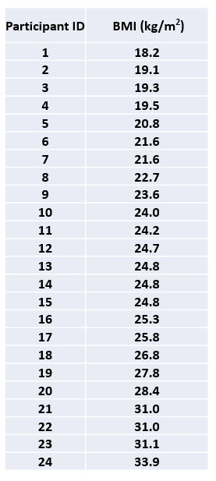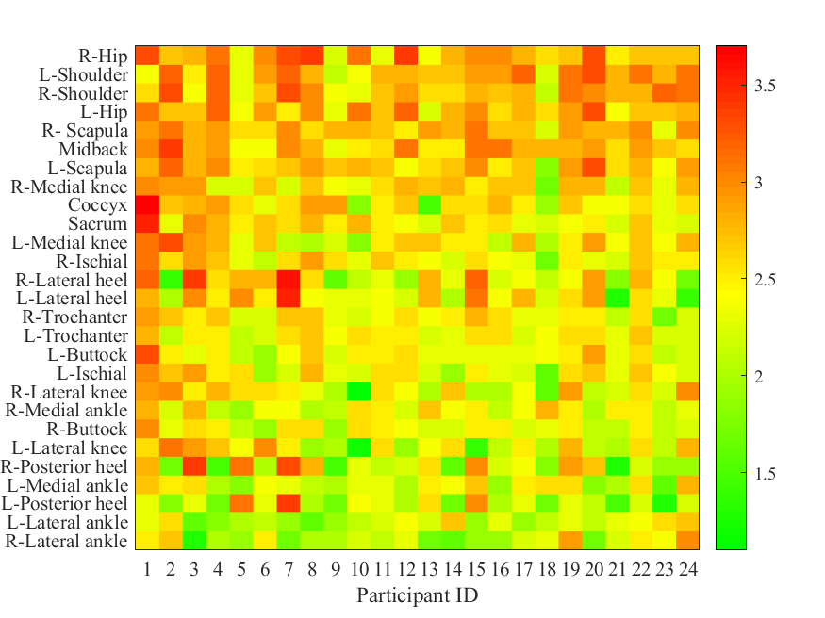

Figure 2: Heat map representation of baseline SEM values across 27 anatomical sites for individual participants (1-24) ordered from left to right based on increasing BMI

## 3.1 Intra-individual variations

With respect to the intra-individual variations, the mean and CV of the SEM values for different anatomical locations are presented in Table 1. Comparisons between right and left body sites revealed similar trends in each anatomical region. Indeed, in all cases where right and left SEM values were recorded, the corresponding mean values were within 0.1 AU. However, it is clear that certain anatomical locations, such as shoulder, scapula, and mid-back, corresponding to the cephalad (towards the head) locations presented with inherently higher basal values compared to those in caudad (towards the feet) locations. In addition, site-specific variability across the cohort, as determined by the CV, ranged from 8% to 27%, with the highest degree of variability associated with the sites adjacent to the heels.

Table 1: Mean and coefficient of variation (CV) of baseline SEM values measured rank ordered to different anatomical sites

|  |  |  |
| --- | --- | --- |
| Location | Mean | CV (%) |
| R - Hip | 2.8 | 12.6 |
| L - Shoulder | 2.8 | 12.2 |
| R - Shoulder | 2.8 | 12.0 |
| L - Hip | 2.8 | 10.6 |
| R - Scapula | 2.8 | 8.1 |
| Midback | 2.8 | 9.8 |
| L - Scapula | 2.7 | 10.9 |
| R - Medial knee | 2.6 | 12.4 |
| Coccyx | 2.6 | 16.7 |
| Sacrum | 2.6 | 11.9 |
| L - Medial knee | 2.5 | 14.7 |
| R - Ischial | 2.5 | 11.9 |
| R - Lateral heel | 2.5 | 23.2 |
| L - Lateral heel | 2.5 | 20.2 |
| R - Trochanter | 2.4 | 11.0 |
| L - Trochanter | 2.4 | 8.5 |
| L - Buttock | 2.4 | 11.8 |
| L - Ischial | 2.4 | 13.9 |
| R - Lateral knee | 2.4 | 19.2 |
| R - Medial ankle | 2.4 | 11.3 |
| R - Buttock | 2.4 | 11.1 |
| L - Lateral knee | 2.3 | 20.5 |
| R - Posterior heel | 2.3 | 26.2 |
| L - Medial ankle | 2.3 | 14.7 |
| L - Posterior heel | 2.2 | 22.9 |
| L - Lateral ankle | 2.2 | 14.4 |
| R - Lateral ankle | 2.2 | 19.3 |

In order to evaluate the potential intrinsic factors associated with the anatomical variation, a linear regression analysis was performed with respect to both BMI and age of the individuals. Table 2 indicates only the correlations which were found to be statistically significant. It is noted that the four heel locations consistently exhibited a significant negative relationship with age. In addition, there were significant relationships (p<0.05) between selected sites and BMI (Table 2). These corresponded to a range of sites including the sacrum, trochanter and the posterior heel (Table 2).

Table 2: The significant correlations between basal SEM values with respect to

(a) Age (b) BMI

|  |  |  |  |  |  |  |
| --- | --- | --- | --- | --- | --- | --- |
| Location | Age | | | BMI | | |
| **Slope** | **Intercept** | **‘r’ value** | **Slope** | **Intercept** | **‘r’ value** |
| R - Trochanter | ns | | | -0.033 | 3.26 | 0.52** |
| L - Lateral ankle | ns | | | 0.036 | 1.27 | 0.49* |
| R - Posterior heel | -0.021 | 3.31 | 0.61*** | ns | | |
| L - Posterior heel | -0.017 | 2.98 | 0.59** | ns | | |
| R - Lateral heel | -0.017 | 3.29 | 0.52** | ns | | |
| L - Lateral heel | -0.014 | 3.15 | 0.49* | -0.057 | 3.89 | 0.48* |
| Sacrum | ns | | | -0.043 | 3.61 | 0.59** |

(ns – Not significant; * - p≤0.05 ; ** - p≤0.01 ; *** - p≤0.001)

## 3.2 Inter-individual variations

An alternative analysis to examine the variability associated with the two intrinsic factors, namely age and BMI, involved ranking the SEM values for each location. The ranks were summed across all the locations for each of the genders as indicated in Figure 3. Based on the number of participants and anatomical sites, the maximum rank sum value was estimated to be 648. Close examination of rank-sum analysis with respect to BMI revealed considerable variability (Figure 3a). Adopting a cluster analysis approach with an arbitrary rank-sum threshold value of 325 i.e. half of the maximum rank-sum value and a BMI that could be classified into approximately three groups, a few tentative observations revealed:

1. Of the nine participants with BMI < 24 kg/m2, six of them demonstrated elevated SEM values as evidenced by high rank-sums,
2. Of the eight participants with BMI ranging from 24‐26 kg/m2, two of them demonstrated high SEM values,
3. Of the seven participants with BMI > 26 kg/m2, four of them revealed elevated SEM values.

Similar analysis with respect to age revealed no particular trends, for instance, with participants aged less than 50 years, 7 of the 13 i.e. 54%, demonstrated increased SEM values over baseline, compared with a corresponding value of 45% for those over 50 years (Figure 3b). There were no significant differences between genders at any of the locations, with the exception of the lateral knee, wherein males exhibited higher SEM values.

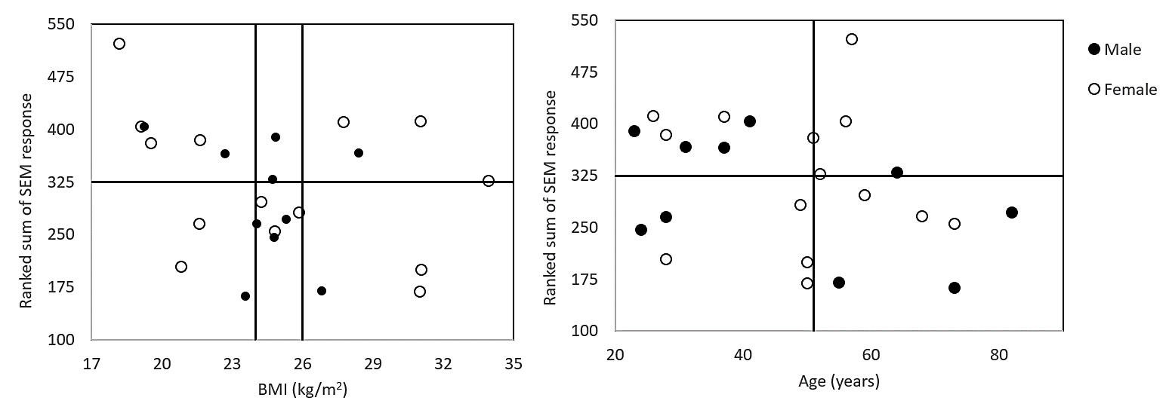

1. (b)

Figure 3: Rank sum analysis as a function of (a) BMI and (b) age

# Discussion

Evaluating the skin status using objective parameters represents an important clinical challenge in the prevention of chronic wounds. The use of sub-epidermal moisture measurement (SEM) as an adjunct to routine skin assessments has been recently recommended in the PU prevention and treatment guidelines (20). The findings of the study have revealed distinct differences in SEM values recorded at 27 different anatomical sites of the body, with a clear trend in decreasing values from the head to the feet. In addition, there appears to be some association between BMI and SEM values, with those individuals presenting with a low BMI (<20 kg/m2) generally exhibiting higher SEM readings.

Previous studies have highlighted the variability of skin biophysical parameters, such as, trans-epidermal water loss (TEWL) and skin hydration (21, 22). The findings from the present study revealed that basal SEM values varied considerably between anatomical sites, with a mean difference of 0.6 AUs between the hip and ankle (Table 1). Nonetheless, there was consistency in mean basal SEM values with respect to the sagittal plane, i.e. the right and the left sides of the body, which provides confidence of a reliable measurement at each specific body site. The present study reveals that the lower extremity locations, such as the heels exhibited lower SEM values. This is in accordance with previous studies employing different commercial devices measuring tissue oedema across a range of able-bodied and patient cohorts (17, 23-28). As an example, a previous study reported SEM values of 2.5-2.6 at the heels, which are in close agreement with the present study (lateral heel, mean = 2.5). The study also revealed similar trends of higher values at sternum (median 3.1), compared to sites at the sacrum (median 2.6) and the heels (median 2.6-2.7) (17). The inter-individual variability observed in the present study can be accommodated to some extent with the use of an individualised local delta values for predicting tissue status. However, anatomical variability may require further examination of the thresholds used to define tissue damage, currently set at 0.6. Indeed, the recommended threshold delta represents between 26-28% of the mean basal values at the posterior heel, a common site at which pressure ulcers can develop. The corresponding values at the shoulder and the sacrum were 21% and 23%, respectively.

Site-specific data, as detailed in Table 1, revealed high inter-individual variability in certain anatomical sites, for example the heels. In this anatomical region the coefficient of variation (26%) is representative of the cohort recording SEM values ranging from 1.3-3.4 AUs. Thus, a 0.6 delta value would represent a relative change of 46% for one individual and 18% for another. The range in values could, in some part, be explained by intrinsic factors, including BMI, age and gender (Table 2). It is worthy of note that the present findings contrast with those reporting a weak positive correlation between SEM values recorded at the heels and age (29), although that study was restricted to an elderly cohort of nursing home residents and used a different commercial SEM device. The present study also revealed that individuals with BMI < 20 kg/m2 were generally associated with elevated baseline SEM values (Figure 1). This is in contrast to a recent study reporting no significant differences between cohorts of different BMI (30). The difference in the observations could be attributed to the use of different commercial device and cohorts. It is probable that there are inter-individual differences in baseline SEM values as a function of their demographics (Figure 3). Indeed, further examination of a delta value which accommodates both intrinsic factors (age, sex, BMI) and anatomical site could provide a more robust means to predict individuals with changes in tissue status.

The study is limited by the use of a discrete cohort of mobile participants with minimal risk of skin damage, which precludes generalising the findings. Nonetheless, recent studies have highlighted the importance of cluster analysis to evaluate distinct skin responses even within an able-bodied cohort (19, 31). Further analysis is recommended to evaluate the variability of the SEM values in individuals deemed to be at high risk of developing pressure ulcers. With respect to the influence of other intrinsic factors such as ethnicity, due to the preponderance of Caucasian participants (20/24) within the cohort, the effect was not separately examined. Recent studies have highlighted the importance of the frequency of movement on the occurrence of pressure ulcers, with the use of SEM and visual skin assessment (32). Therefore, in addition to the influence of intrinsic factors on SEM values (demographics and comorbidities), the influence of extrinsic loading and movement, involving lying or sitting postures require further investigation. Furthermore, there could also be an influence of measurement sequence, temporal variations and the operator’s skill-levels on the SEM values that have to be considered in a clinical examination.

The use of objective techniques such as SEM has been reported to considerably reduce the time taken to detect early signs of skin damage and has also been advocated for use in clinical settings (15, 20, 32). Monitoring the temporal changes in the SEM parameter is recommended to robustly capture the early signs of skin damage. Further critical interrogation of the SEM delta thresholds at various skin sites, in the form of a sensitivity analysis, is recommended (33). A more detailed study incorporating measuring thickness at the different sites using medical imaging would enable its effects to be fully evaluated. In addition, clinical studies are required to evaluate the predictive capability of SEM across a range of anatomical regions and patient cohorts, to better understand the clinical implications of the findings from the present study.

# Conclusions

This study examined baseline SEM values measured across a large number of distinct bony landmarks on the body, using a well-reported commercial device. The study revealed distinct differences in mean baseline SEM values across the transverse plane of the body. Large variability was observed in site-specific SEM values, even in an unloaded state. Moreover, these sites with high variability i.e. heel locations revealed statistically significant relationship with age. Therefore, in a clinical context, more research is required to evaluate SEM readings in the light of anatomical, individual demographic and extrinsic factors such as posture and mobility.

**Acknowledgements**

The work was supported by the EPSRC-NIHR “Medical Device and Vulnerable Skin” Network and NetworkPLUS (Refs. EP/M000303/1 and EP/N02723X/1) and European Union’s Horizon 2020 research and innovation programme under the Marie Skłodowska-Curie grant agreement No. 811965 "STINTS - Skin Tissue Integrity under Shear”.

# References

1. Gottrup F, Holstein P, Jørgensen B, Lohmann M, Karlsmar T. A New Concept of a Multidisciplinary Wound Healing Center and a National Expert Function of Wound Healing. Archives of Surgery. 2001;136(7):765-72.

2. Phillips CJ, Humphreys I, Fletcher J, Harding K, Chamberlain G, Macey S. Estimating the costs associated with the management of patients with chronic wounds using linked routine data. International Wound Journal. 2016;13(6):1193-7.

3. Bennett G, Dealey C, Posnett J. The cost of pressure ulcers in the UK. Age Ageing. 2004;33(3):230-5.

4. Kerr M, Barron E, Chadwick P, Evans T, Kong WM, Rayman G, et al. The cost of diabetic foot ulcers and amputations to the National Health Service in England. Diabet Med. 2019;36(8):995-1002.

5. Armstrong DG, Boulton AJM, Bus SA. Diabetic Foot Ulcers and Their Recurrence. New England Journal of Medicine. 2017;376(24):2367-75.

6. Posnett J, Franks P. The costs of skin breakdown and ulceration in the UK. Skin Breakdown: The Silent Epidemic. 2007.

7. Anthony D, Papanikolaou P, Parboteeah S, Saleh M. Do risk assessment scales for pressure ulcers work? J Tissue Viability. 2010;19(4):132-6.

8. Papanikolaou P, Lyne P, Anthony D. Risk assessment scales for pressure ulcers: a methodological review. Int J Nurs Stud. 2007;44(2):285-96.

9. Mayrovitz HN, Davey S, Shapiro E. Suitability of single tissue dielectric constant measurements to assess local tissue water in normal and lymphedematous skin. Clin Physiol Funct Imaging. 2009;29(2):123-7.

10. Gefen A. The sub-epidermal moisture scanner - the principles of pressure-injury prevention using novel early detection technology. Wounds International. 2018;9(3):30-5.

11. Bates-Jensen BM, McCreath HE, Pongquan V. Subepidermal moisture is associated with early pressure ulcer damage in nursing home residents with dark skin tones: pilot findings. J Wound Ostomy Continence Nurs. 2009;36(3):277-84.

12. Bates-Jensen BM, McCreath HE, Pongquan V, Apeles NC. Subepidermal moisture differentiates erythema and stage I pressure ulcers in nursing home residents. Wound Repair Regen. 2008;16(2):189-97.

13. O'Brien G, Moore Z, Patton D, O'Connor T. The relationship between nurses assessment of early pressure ulcer damage and sub epidermal moisture measurement: A prospective explorative study. J Tissue Viability. 2018;27(4):232-7.

14. Okonkwo H, Bryant R, Milne J, Molyneaux D, Sanders J, Cunningham G, et al. A blinded clinical study using a subepidermal moisture biocapacitance measurement device for early detection of pressure injuries. Wound Repair and Regeneration. 2020;28:364-74.

15. Budri AMV, Moore Z, Patton D, O'Connor T, Nugent L, Avsar P. Sub-epidermal moisture measurement: an evidence-based approach to the assessment for early evidence of pressure ulcer presence. International Wound Journal. 2020:1-9.

16. Peko L, Gefen A. Sensitivity and laboratory performances of a second-generation sub-epidermal moisture measurement device. International Wound Journal. 2020;17(3):864-7.

17. Clendenin M, Jaradeh K, Shamirian A, Rhodes SL. Inter-operator and inter-device agreement and reliability of the SEM Scanner. Journal of Tissue Viability. 2015;24(1):17-23.

18. SEM Scanner 200 for preventing pressure ulcers.: National Institute for Health and Care Excellence [NICE]; 2020. Report No.: MTG51.

19. Bostan LE, Worsley PR, Abbas S, Bader DL. The influence of incontinence pads moisture at the loaded skin interface. J Tissue Viability. 2019;28(3):125-32.

20. National Pressure Ulcer Advisory Panel EPUAPaPPPIA. Prevention and Treatment of Pressure Ulcers: Clinical Practice Guideline. 2019.

21. Akdeniz M, Gabriel S, Lichterfeld-Kottner A, Blume-Peytavi U, Kottner J. TEWL reference values in healthy adults. British Journal of Dermatology. 2018;179(5):e204-e.

22. Firooz A, Sadr B, Babakoohi S, Sarraf-Yazdy M, Fanian F, Kazerouni-Timsar A, et al. Variation of biophysical parameters of the skin with age, gender, and body region. ScientificWorldJournal. 2012;2012:386936.

23. Gershon S. Using Subepidermal Moisture Level as an Indicator of Early Pressure Damage to Local Skin and Tissue. Adv Skin Wound Care. 2020;33(9):469-75.

24. Mayrovitz HN. Assessing Upper and Lower Extremities Via Tissue Dielectric Constant: Suitability of Single Versus Multiple Measurements Averaged. Lymphatic Research and Biology. 2019;17(3):316-21.

25. Mayrovitz HN, Mahtani SA, Pitts E, Michaelos L. Race-related differences in tissue dielectric constant measured noninvasively at 300 MHz in male and female skin at multiple sites and depths. Skin Research and Technology. 2017;23(4):471-8.

26. Bates-Jensen BM, McCreath HE, Patlan A. Subepidermal moisture detection of pressure induced tissue damage on the trunk: The pressure ulcer detection study outcomes. Wound Repair Regen. 2017;25(3):502-11.

27. Bates-Jensen BM, Reilly S, Hilliard C, Patton D, Moore Z. Subepidermal Moisture and Pressure Injury in a Pediatric Population: A Prospective Observational Study. Journal of Wound Ostomy & Continence Nursing. 2020;47(4):329-35.

28. Guihan M, Bates-Jenson BM, Chun S, Parachuri R, Chin AS, McCreath H. Assessing the feasibility of subepidermal moisture to predict erythema and stage 1 pressure ulcers in persons with spinal cord injury: a pilot study. J Spinal Cord Med. 2012;35(1):46-52.

29. Bates-Jensen BM, McCreath HE, Nakagami G, Patlan A. Subepidermal moisture detection of heel pressure injury: The pressure ulcer detection study outcomes. International Wound Journal. 2018;15(2):297-309.

30. Mayrovitz HN, Forbes J, Vemuri A, Krolick K, Rubin S. Skin tissue dielectric constant in women with high body fat content. Skin Research and Technology. 2020;26(2):226-33.

31. Soetens JFJ, Worsley PR, Bader DL, Oomens CWJ. Investigating the influence of intermittent and continuous mechanical loading on skin through non-invasive sampling of IL-1alpha. J Tissue Viability. 2019;28(1):1-6.

32. Moda Vitoriano Budri A, Moore Z, Patton D, O’Connor T, Nugent L, Mc Cann A, et al. Impaired mobility and pressure ulcer development in older adults: Excess movement and too little movement—Two sides of the one coin? Journal of Clinical Nursing. 2020;29(15-16):2927-44.

33. Jayabal H, Bates-Jensen BM, Abiakam NS, Worsley PR, Bader DL. Sensitivity analysis of biophysical parameters to evaluate skin status following mechanical and chemical insults. 2020.