Figures
Plan the process
Dynamic
Involve stakeholders

Bring together a team
Iterative
Involve stakeholders

Draw on existing theories
Creative
Articulate programme theory

Undertake primary data collection
Open to change
Understand context

Attend to future implementation
Looking towards evaluation
Design and refine

Principles
Actions to consider
Outputs
I
N
T
E
R
V
E
N
T
I
O
N

Manual or document describing intervention and training
Publication of development process
Figure 1 Principles and actions to consider in the development phase of a complex intervention- adapted from the logic model published by O'Cathain et al 2019 [12].
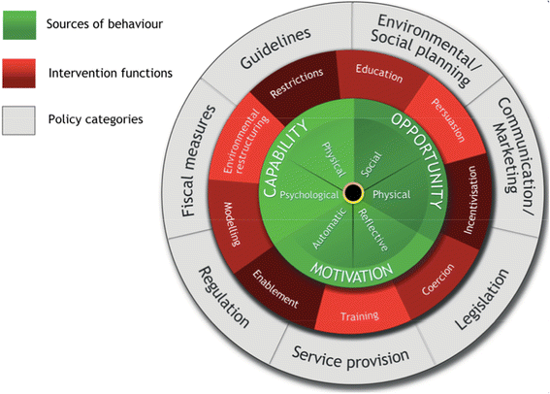
Figure 2- The Behaviour Change Wheel [14]

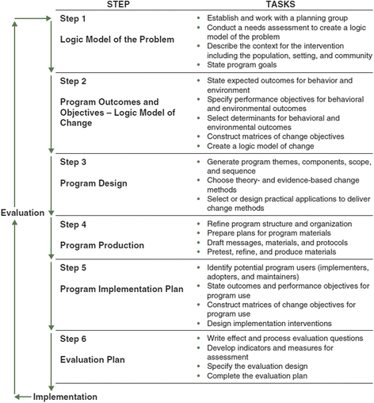
Figure 3- Intervention Mapping [15]

