**Examining the Effects of Passive and Active Strategy Use During Interactive Search for Lego Bricks**

Michael C. Hout1,2, Bryan White1, Jessica Madrid1, Hayward J. Godwin3, & Collin Scarince4

1 - New Mexico State University, USA

2 – National Science Foundation, USA

3 – University of Southampton, UK

4 – Texas A&M University, Corpus Christi, USA

*Author Note:* Correspondence regarding this article should be addressed to Michael C. Hout, New Mexico State University, Department of Psychology, Las Cruces, New Mexico, 88003, P.O. Box 30001 / MSC 3452. Telephone: 575-646-1730. Email: [mhout@nmsu.edu](mailto:mhout@nmsu.edu). Any opinions, findings, and conclusions expressed in this material are those of the authors and do not necessarily reflect the views of the National Science Foundation.

***Keywords****:* visual search, haptic search, search strategies, interactive search

**Figures: 6**

**Tables: 1**

**Abstract**

In many important search tasks, observers must find what they are looking for using only visual information (e.g., X-ray baggage screening/medical screening). However, numerous other search tasks can only be effectively completed when the searcher uses their hands to find what they are looking for (e.g., “rummage” search). Unfortunately, it is not currently well understood how observers conduct such “interactive” searches, nor what the best strategies might be for doing so. Here, we first review the limited literature on interactive search. We then present a novel methodology for the study of interactive search that involves having observers seek out Lego targets in a cluttered tray of assorted bricks. In our Validation Task, we confirm the validity of this approach by demonstrating that it produces sensible patterns of diminishing returns in response time as targets are removed from the set, as well as hastened search times for larger targets. In our Experiment, we modify the approach, refining its systematicity and experimental control. We also build on prior work exploring strategy use in visual search by investigating the extent to which active and passive strategy use impacts performance in interactive search. In contrast to our prior findings in hybrid visual search (Madrid & Hout, 2019), our current findings suggest that in interactive search, an active search strategy can be superior to a passive one. We close by offering a conceptual model (the Interactive Multiple Decision Model; i-MDM) that explicates the steps involved in a search task of this nature, and we then provide suggestions for how to further refine the task to achieve higher internal validity and to delve deeper into questions of theoretical importance in the field of interactive search.

**Translational Abstract**

Professional visual searchers – e.g., airport security screeners looking for weapons in travelers’ bags, radiologists looking for medical anomalies on chest x-rays – often perform crucial searches using only their eyes. However, many mundane real-world visual searches and other professional search scenarios also involve the use of one’s hands. For instance, a security guard may have to sift through a concert-goer’s backpack for contraband, or a parent may have to probe the depths of a toy box to find their child’s favorite item. To better understand these interactive searches that involve both eyes and hands, we developed a controlled laboratory task that involved searching for specific “target” Lego bricks in trays cluttered with lots of other “distractor” bricks. We also explored the extent to which strategy use impacts one’s ability to find what they are looking for. We compared active strategy use (wherein attention is tightly focused) to passive strategy use (wherein attention is more broadly diffused) and found that active search strategies are more useful for interactive searches like these, wherein the search environment is cluttered (i.e., there are lots of bricks) and potentially confusing (i.e., the bricks all look somewhat similar). This study is a first step towards better understanding interactive search and the effective use of attentional strategies.

**Public Significance Statement**

The present study advances experimental methodology for the study of interactive visual search; that is, search that involves use of both the eyes and the hands. It also suggests that during interactive search in cluttered and busy search environments, the use of an active attentional strategy is more effective than a passive strategy.

**Examining the Effects of Passive and Active Strategy Use During Interactive Search for Lego Bricks**

During many societally important tasks such as radiological and airport (X-ray) security screening, visual search is used as the primary route in the detection of targets. Accordingly, laboratory visual search investigations have generally focused on two-dimensional, “on screen” search, the likes of which are congruent with many medical and security screening settings. That said, mundane, everyday searches – for instance, looking for one’s keys in a cluttered drawer, or quarters in a pile of change – can often only be resolved by manipulating the search environment using the hands. Indeed, security screening tasks such as manually searching an airline passenger’s bag following initial flagging by an X-Ray screener (or performing a quick search for weapons in a concert-goer’s purse) frequently involve physically sorting through the search environment. Such visual and manual searches (which have elsewhere been called “haptic” or “rummage” searches, but which we will hereafter refer to more simply as “interactive,” following the convention of Sauter, Stefani, and Mack, 2020) are not limited to mundane everyday tasks or security settings. Several other professional scenarios involve the simultaneous scanning of the visual environment in orchestration with the manipulation of objects with the hands. For instance, archeologists and paleontologists must sort through layers of dirt and sediment in search of bone fragments or evidence of human settlement. Geologists may scour the landscape, turning over rocks while looking for specific minerals that provide evidence of natural resources. Forensic investigators may have to uncover objects at the scene of a crime while looking for evidence, wilderness search and rescue responders may brush aside plant matter while looking for clues to a missing hiker’s whereabouts, military personnel may rearrange items in a person’s vehicle while assessing it for threats, and so on. Unfortunately, there exist, at present, no models of search behavior (from a psychology perspective at least) that can understand, explain, or predict how people conduct these common and important forms of search. The consequence of this is that cognitive psychology researchers are unable to make recommendations for training, best practices, or improvements in tasks of this nature.

In addition to requiring use of the hands (and, therefore, sorting coupled with identification of targets using tactile senses), many real-world search tasks have visual characteristics that are often ignored in laboratory search investigations or are specifically controlled for in the interest of studying the mechanics of pure visual attention. For example, the most frequently adopted laboratory search task involves looking for a particular target on a display in which targets and distractors are placed on a blank white background and are individually isolated in space. Such displays thus remove the need to visually segment the object from the background environment in which it resides.[1] In real-world search, by contrast, search items are rarely isolated, and more often may overlap or be occluded by other objects (see Bravo & Farid, 2004a, 2004b, 2006; Hillstrom, Wakefield, & Scholey, 2013; Godwin et al., 2017). Other important differences include the preferred use of static displays in the lab – whereby objects retain the same spatial position over time, consequently making memory for prior attention allocations more useful than they would be in dynamic search environments (see Kristjansson, 2000; Kunar & Watson, 2011; Scarince & Hout, 2018) – or the fact that laboratory search items tend to appear in canonical orientations, making identification of the items easier (see Vickery, King, & Jiang, 2005). Outside of the lab, objects may appear in any number of orientations with respect to the observer. Moreover, object orientations and locations, as well as the observer’s perspective (see Jiang, Won, & Swallow, 2014) may change over time, depending on the nature of the items, the environment, and whether or not the observer is moving (e.g., search for security threats on CCTV, finding a spare key as you shuffle through your “junk drawer”, looking for your dog at the dog park).

Clearly, therefore, searches are not always purely visual tasks, so a more thorough understanding of the underlying mechanisms and performance in the real world will require laboratory tasks that more closely align with the constraints (or lack thereof) of interactive search. In this investigation, we were interested in removing the often-used laboratory constraint that the searcher must use only vision to locate their target and cannot use their hands to manipulate the environment. To that end, we moved search “off screen” and employed cluttered trays of Lego bricks that encouraged searchers to find their target “bricks” through the use of both their eyes and hands. Specifically, our goals were to 1) provide a proof-of-concept that search for Lego bricks is a viable tool for studying interactive search (see also Sauter et al., 2020), 2) to examine whether strategies that have been shown to be useful in purely visual tasks are also useful during search that includes use of the hands, and 3) put forth a simple, conceptual model of the steps involved in interactive search.

***Prior work in multi-modal and/or interactive visual search***

The current set of experiments are not the first or only work to examine visual and/or manual search. We will begin, therefore, with a brief review of prior work that has examined searches of this type. For instance, Ishibashi et al. (2012) examined well-documented prevalence effects – the finding that the ratio of present to absent search trials affects search accuracy and response time (Wolfe et al., 2005, 2007) – in what they called a ‘haptic’ search task. Their participants wore blinders and used their hands to search a tactile map (in some ways similar to reading Braille), under conditions of varying target prevalence; the task was to find a small circle of dots. The authors found that, much like in investigations of prevalence effects in visual search (Godwin, Menneer, Cave, & Donnelly, 2010; Godwin, Menneer, Cave, Thaibsyah, & Donnelly, 2015; Hout et al., 2015; Walenchok, Goldinger, & Hout, 2020), miss rates in haptic search increased and search termination times were slowed under conditions of low prevalence. This finding points to the notion that at least one well-established effect – that of target prevalence – does hold outside the confines of two-dimensional displays used in laboratory-based visual search tasks.

Using a different approach that blended manual and visual searches on a computer screen, Solman, Cheyne, and Smilek (2012; see also Solman et al., 2013) designed a task that did not involve physical touching of the search objects, but required participants to move the items around on a screen. In this task, targets and distractors were displayed on screen in a central, virtual “heap.” To locate the target, participants had to use the computer mouse to “unpack” the heap, moving items to adjacent locations on screen until they found what they were looking for. The most important findings from this work concerned the documentation of “unpacking errors” whereby participants directly manipulated (i.e., moved) the target and yet still failed to recognize it. Findings from this interactive task also neatly align with what has been found in the visual search literature. For instance, using eye-tracking, Hout et al. (2015) found that a substantial proportion of targets are directly examined and yet are still missed, and that such “recognition failures” are more common for low-prevalence targets than for high-prevalence targets (see also Godwin, Menneer, Riggs, et al., 2015; Godwin, Menneer, Riggs, Cave, & Donnelly, 2015). Madrid and Hout (2019) found that recognition failures also occur during “hybrid search” tasks (Wolfe, 2012), and are proportionately more common when using an active rather than a passive search strategy (which we address in more detail, below). Again, the pattern of recognition errors in the “unpacking” paradigm neatly align with patterns of recognition errors found in more standard (purely visual) search tasks.

Most recently, Sauter et al. (2020) developed a similar procedure to that of our own, with the aim of validating search for Lego bricks as a technique to study interactive search (which closely aligns with the first stated goal of our study)[2]. Their procedure was similar in several ways to our own (which is described in detail below). Sauter et al. (2020) were able to replicate with Lego brick search key findings from traditional computerized search tasks. For instance, target bricks were located more slowly when there were more distractors present in the tray (Beck, Lohrenz, & Gregory, 2010). Also, targets in conjunction searches (i.e., targets defined by a specific shape and color) were more slowly found than those defined by a single color (Treisman & Gelade, 1980).

Taken together, the studies described above suggest that there are notable parallels between purely vision-based search tasks and search that involves the use of the hands or manipulation of the items in the search environment. However, it should also be noted that some of what may be predicted (or expected) based on a careful reading of the purely visual search literature does not in fact align with what is found in multi-modal or interactive tasks, suggesting that more nuance is necessary to understand these phenomena in increasingly naturalistic settings. For instance, although visual set size and cognitive load are well-documented as having substantial effects on visual search performance (Hout & Goldinger, 2010; 2012; Palmer, 1995; Wolfe, 1998), Solman, Cheyne, and Smilek (2012) found that the effects of set size and cognitive load were quite minimal during their unpacking task (see also Gilchrist, North, & Hood, 2001). By contrast, Draschkow and Võ (2016) had participants perform visual search in the physical world, in one of two conditions: In the “Find” condition, participants merely looked for objects without physically handling them (much like standard computer-based search tasks) and in the “Handle” condition, participants collected the objects as they progressed through the task. The results showed that search times (i.e., time to first fixation of the target) were not different between conditions, but that the memories retained for objects in the rooms followed different patterns for the Find and Handle conditions (see also Draschkow & Võ, 2017; Helbing, Draschkow and Võ, 2020). Taken together, this work suggests that what we find in well-controlled laboratory settings may or may not translate to search behavior in settings wherein other senses and/or tasks are employed.

A central point relevant to the current investigation is that the manner in which search decisions are reached will depend greatly on the modalities involved and the extent to which the environment is being interacted with. As Riggs et al. (2018) point out, one of the key differences between purely visual search and interactive search (that involves use of the hands) is that the searcher in the latter case must perform some specific act in order to adequately perform an exhaustive search. In their study, participants performed a “rummage search” wherein they looked for an unspecified number of targets placed in various rooms and locations in a real house (akin to police or military searching a home for weapons, drugs, or improvised explosives). Importantly, some of the search targets were plainly visible (e.g., placed on a tabletop), some were partially hidden (i.e., were obscured by an occluder or could only be found by interacting with the environment, such as opening of a cupboard), and some could only be found through haptic examination (e.g., objects hidden in a cushion that could only be identified by feeling them with one’s hands). For these various categories of search target, performing an exhaustive search required a different set of behaviors: visual inspection of the space, manipulation of the space with the hands, or a combination of the two. Riggs and colleagues (2018) compared the performance of novices to that of novice dyads and expert dyads (i.e., military volunteers who had completed search training) and found that compared to experts, the novices were both less likely to visually inspect potential target locations and were less likely to perform the manual interactions necessary to conduct a thoroughly exhaustive search.

In a recent analogous study, van der Horst, Snell, and Theeuwes (2020) had experts and non-experts attempt to detect counterfeit bank notes using vision alone or using vision and touch. This was not a visual search task, but the results are nevertheless instructive. Van der Horst et al. (2020) found that only experts could detect counterfeits while using vision alone, but when both groups of participants were allowed to use both senses performance of non-experts improved, especially when non-expert participants were given more time in which to make their decisions. The findings suggest that visual and tactile information are used differently by experts and non-experts, and that their usefulness comes “online” at different time courses (i.e., vision impacts decision-making quickly and tactile information increasingly enhances performance over time). It seems clear, therefore, that effective search (and identification) behavior can be enhanced by training in more than one modality.

***Strategy use in visual and interactive search***

If expertise leads to differences in both the visual and manual components of interactive search, the natural follow-up question to ask is: Which strategies that arise from training and/or experience might be helpful to adopt to increase performance during interactive search? Questions of expertise in visual search have been explored in detail in previous research (Reingold & Sheridan, 2011; Sheridan & Reingold, 2017) but those studies have tended to compare groups of novices to groups of experts[3] who have already acquired skill in strategy use (e.g., radiologists who employ systematic scanpaths while conducting a radiographic examination: see Auffermann et al., 2015; 2018; see also van Geel, et al., 2017), perceptual identification (e.g., airport security screeners trained to identify improvised explosive devices: Kramer, Porfido, & Mitroff, 2019), or the use of search aids (e.g., control over volumetric scanning in three-dimensional radiography). Often in such studies, experts are either not queried about the strategies they adopt, or they are otherwise unable to articulate the details of the strategies they have learned to employ through experience in their profession (e.g., it may be difficult to explicitly define why one thinks that a certain area of tissue is abnormal or problematic during inspection of a chest X-ray; Waite et al., 2019).

That said, strategy use has been shown to be fairly consistent within individuals. For instance, Clark et al. (2020) examined the eye movement strategies (e.g., the extent to which attention was allocated to homogeneous or heterogeneous portions of the display)[4] of individuals conducting search in a variety of simple, computer-based tasks. The researchers compared the optimality of eye movement patterns within individuals (and across the various tasks) and found that individuals tended to adopt similar strategies over time. Similarly, Riggs et al. (2017) explored strategy use in the context of an open-terrain search task whereby participants were asked to find pseudo-randomly located coins on grassy terrain. Strategy use here was defined not by patterns of eye movements but rather by the route taken by the searcher as they walked through the search area. The researchers found that participants tended to adopt an ‘S’-shaped pattern, and that similar walking strategies were adopted under varying conditions of target prevalence and density.

Still, strategy use is hardly a “one-size-fits-all” phenomenon. In the Clark et al. (2020) study, it was also found that performance and strategy use in one task tended not to be predictive of an observer’s behavior in the other tasks. In their second experiment, Riggs et al. (2017) found that when participants teamed up during this task, dyads that adopted a strategy wherein both observers conducted independent searches of the entire space tended to outperform those who opted to split the search space into two discrete areas that were searched separately. Further, despite evidence that scan paths during visual search can include a systematic component (e.g., a tendency to search in a grid-like manner; Gilchrist & Harvey, 2006), when Sauter et al. (2020) overlaid a grid pattern to their Lego search task they found that it did not positively impact search performance. Together, these studies suggest that strategy use (and optimality) can be at times consistent, but that the effectiveness of strategy use is also highly context specific.

Additionally, it should be noted that certain crucial search tasks such as wilderness search and rescue may simultaneously employ teams of expert and novice searchers (e.g., local volunteers called out to the last known location of a missing person). In the case of wilderness search and rescue, the stakes are quite high (e.g., a missing person may fall ill or die before they are found), but novice searchers typically do not have the time to acquire expertise before heading out into the field to search for clues. As such, it is important to determine if simple strategy adoption (i.e., strategies that can be employed with little-to-no prior training) can improve search performance. It may also be of value to determine if simple strategy adoption can assist novice searchers as they acquire more complex skills during training (e.g., police/military personnel training to become expert rummage searchers), but that is a question beyond the scope of the current investigation.

Because the literature in this area is sparse, our starting point was to rely on what has already been established in the solely visual search literature. Our question was uncomplicated: Can simple strategy adoption (that has shown to be effective in modifying oculomotor behavior and search performance in visual search tasks) be used to improve performance in an interactive search task? To our knowledge, ours is the first investigation to explore this question.

The specific strategy techniques we explored here involved comparing a no strategy control condition to observers asked to adopt passive or active search strategies; we were motivated by findings that employed simplistic search tasks as well as recent findings that used more complicated stimuli and challenging task demands. For example, in prior work, Smilek et al. (2006, see also Smilek, Dixon, and Merikle, 2006) asked their participants to search for a circle that was broken on one side among distractors that were broken on both sides. Each participant was also asked to adopt either a passive or an active strategy. Passive and active strategy instructions were nearly identical, save several crucial phrases that asked observers to control their attention in different ways. Passive instructions emphasized an intuitive, “gut feeling” approach that employed phrases such as “be receptive” and “let the target item pop into mind.” Active instructions emphasized a more deliberate manner of control, employing phrases such as “direct your attention,” and “actively search.” The researchers’ findings indicated that passive strategy use led to more efficient search (indexed by inverse efficiency scores; Townsend & Ashby, 1983) when the task was difficult (i.e., when breaks in the circles were small rather than large), but not when it was easy.

More recently, Madrid and Hout (2019) explored passive and active strategy use during “hybrid” visual and memory search wherein participants must look for more items than can be held in visual working memory at any one time. Hybrid search is an important task to understand, as it connects both to mundane searches (such as looking for many items on one’s grocery list) and to societally important searches (such as airport security looking for many different prohibited items in a traveler’s bag). In this investigation, participants had to look for a search target that could belong to any one of 24 potential target categories (or be absent altogether); all stimuli were pictures of real-world objects. In keeping with prior work, we found that passive strategy use resulted in superior performance. That is, relative to active searchers, passive search participants were more efficient (as indicated by reaction time and accuracy, and by “balanced integration scores” that combine the two measures; Liesefeld & Janczyk, 2019). Eye-tracking revealed that passive searchers demonstrated more efficient attentional guidance (i.e., they fixated the targets more quickly) and more effective object recognition (i.e., they resolved search decisions more quickly once fixating the target and suffered proportionately fewer recognition failures). Moreover, the performance of active searchers quite closely aligned with that of the no strategy group, suggesting that hybrid searchers may as a default employ an active strategy, but that relaxing attentional control in a passive manner is a more beneficial strategy to adopt.

***The current investigation***

In this investigation, we first conducted a validation task (much like Sauter et al., 2020, but using different procedures and manipulations) in order to create and fine-tune a realistic search task for Lego bricks, and to validate that sensible results could be obtained when searching “off screen” and interacting with the search environment through the use of one’s hands. In the validation task, we performed both exploratory and confirmatory analyses in an attempt to validate the Lego search task by looking for sensible patterns in the data that would be predicted by prior visual search literature (e.g., that larger targets are found more quickly, that slower and more variable find times are observed as targets are removed from the set; see for instance, Wolfe, 2013). Additionally, we learned from limitations in the design of this validation task and used this information to modify the methodology in several ways for our substantive experiment. By making changes to our experimental methods, we were then able to carry out a more precise investigation of strategy use in our study. More specifically, the focus of our experiment was to compare passive and active search strategies in the context of Lego brick search to better understand the benefits of strategy adoption during interactive search.

**Validation Task**

Our first study was a validation task designed as a proof-of-concept that looking for Lego bricks can be used as a tool to understand interactive search in controlled, laboratory settings. As such, in the validation task, our primary goals were simply to: 1) design an interactive search task that employed novel but suitable experimental controls, 2) to validate the task by performing exploratory and confirmatory analyses that examined anticipated trends in behavior (based on prior search literature), and 3) to refine the methodology so that we could perform a more controlled and precise investigation in the next study.

Our basic task involved asking searchers to use their eyes and hands to search a tray of Lego bricks. Search targets were defined by a conjunction of features (Treisman & Gelade, 1980): A specific color and a specific shape. Each tray consisted of multiple pieces from two maximally opposing colors, and across trials, participants looked for small, medium, or large targets. Multiple exemplars could be present in each tray, but participants never knew how many there would be, so they were simply instructed to stop searching once they were satisfied that all targets had been located.

**Method**

**Participants**

Thirty-six students from New Mexico State University participated in the validation task in exchange for partial fulfillment of a course requirement. All participants signed an informed consent form prior to participation. All had normal (or corrected-to-normal) vision, were fluent in English, and had normal color vision (as determined by administration of the Ishihara color vision test; Clark, 1924).

**Design and Stimuli**

Three levels of target size (small, medium, large) were manipulated within-subjects, and were randomly presented across trials in equal proportions. All stimuli were bricks selected from the Lego “Creative Building Basket XL” set, which contained 1000 total pieces (item 10705; <https://www.lego.com/en-us/product/lego-creative-building-basket-10705>). Each trial consisted of between 173 and 271 total Lego bricks created by selecting from the sets of two opposing colors (e.g., red and green; see Table 1). Targets were defined by a conjunction of color and shape. For each level of target size, we identified one specific shape to be used as the target per color set. However, it was not possible to have the same shape designated as the small, medium, or large target across color sets, due to the availability of specific shapes provided in the sets. That said, the sizes of the target pieces were relatively consistent across colors; see Figure 1. Across trials, the number of targets varied from 2 to 12 items. There were 24 trials presented in total (in random order), representing a full crossing of eight possible target colors and three target sizes. Each search “set” – which comprised pieces from two distinct colors – could therefore be searched a total of six times (i.e., once per target size per target color). Two practice trials were administered, but these stimuli (brown and tan bricks) were not included in the rest of the task, nor was the data from the practice trials analyzed. In total, the experiment lasted between 50 and 90 minutes.

***Table 1.*** *Description of Lego brick sets denoting color combinations, the number of pieces per color, and the number of targets per condition.*



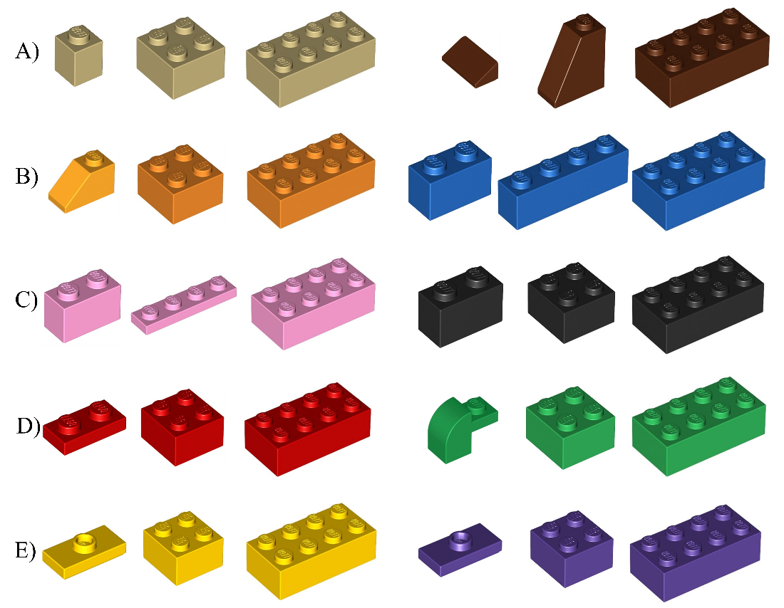

***Figure 1.*** *Target bricks grouped by search “set” (a combination of two colors, shown down rows A – E), and target size (ascending across columns). Set A was used for practice trials and sets B – E were used in experimental trials. Distractor bricks also included shapes not shown here.*

**Apparatus**

A Windows desktop computer running E-Prime vs3.0 (Schneider, Eschman, & Zuccolotto, 2013) was used to randomly determine the order of trials to be presented, as well as to collect response times as each brick was located. A custom frame was constructed to constrain the search area, and to hold a large piece of poster board between the participant and the search area until the start of each trial (so that pieces were not searched for prematurely); see Figure 2. A custom hopper – a bucket with the bottom cut out and multiple pieces of string laced throughout the body – was constructed to randomize brick placement (by pouring the Legos through it) at the start of each trial. All pieces were contained within a solid white tray that had raised edges on the side to prevent pieces from spilling out. Two portable boards were constructed on which were placed eight individual plastic containers used to hold the targets as each item was found (and to later verify that search targets were identified correctly once the trial had ended). A total of 16 bins were placed on the boards (which is more than the maximum 12 targets possible on any trial) so that participants could not use the filling up of search bins as a cue to indicate that they should stop searching.

**Procedure**

Figure 2 shows a sample timeline and visuals of the various apparatuses used to conduct the experiment. Over the course of the experiment, an E-Prime program randomly determined which trial should be administered to participants and communicated that information to a pair of researchers via the display of the search target on the computer monitor. The researchers then prepared the table for search by locating the trial condition that corresponded to the target. Each search set was contained in a pillowcase of a matching color. In order to create a randomized initial assortment of bricks – and to control against any idiosyncratic differences in how various researchers may scatter the pieces if asked to randomize by hand – a hopper was used to scatter the pieces. The search tray was placed at the center of the base of the frame, and the hopper was placed on top of it. Then, the Lego bricks were dumped en masse through the hopper, scattering them randomly on the search tray. During this time, the occluder remained on the frame to prevent the participant from seeing the search set before the timer began. A video of the overall procedure can be found on our Open Science Foundation page: <https://osf.io/5j6bs/?view_only=f770c06f7bfe42f2a9f0464384205ccb>; this video shows the specific procedure for a mock trial from the Experiment (wherein Lego bricks were all of the same color and searchers were sometimes instructed to use a strategy to control their attention), but the overall procedure is very much in line with this validation task.[5]

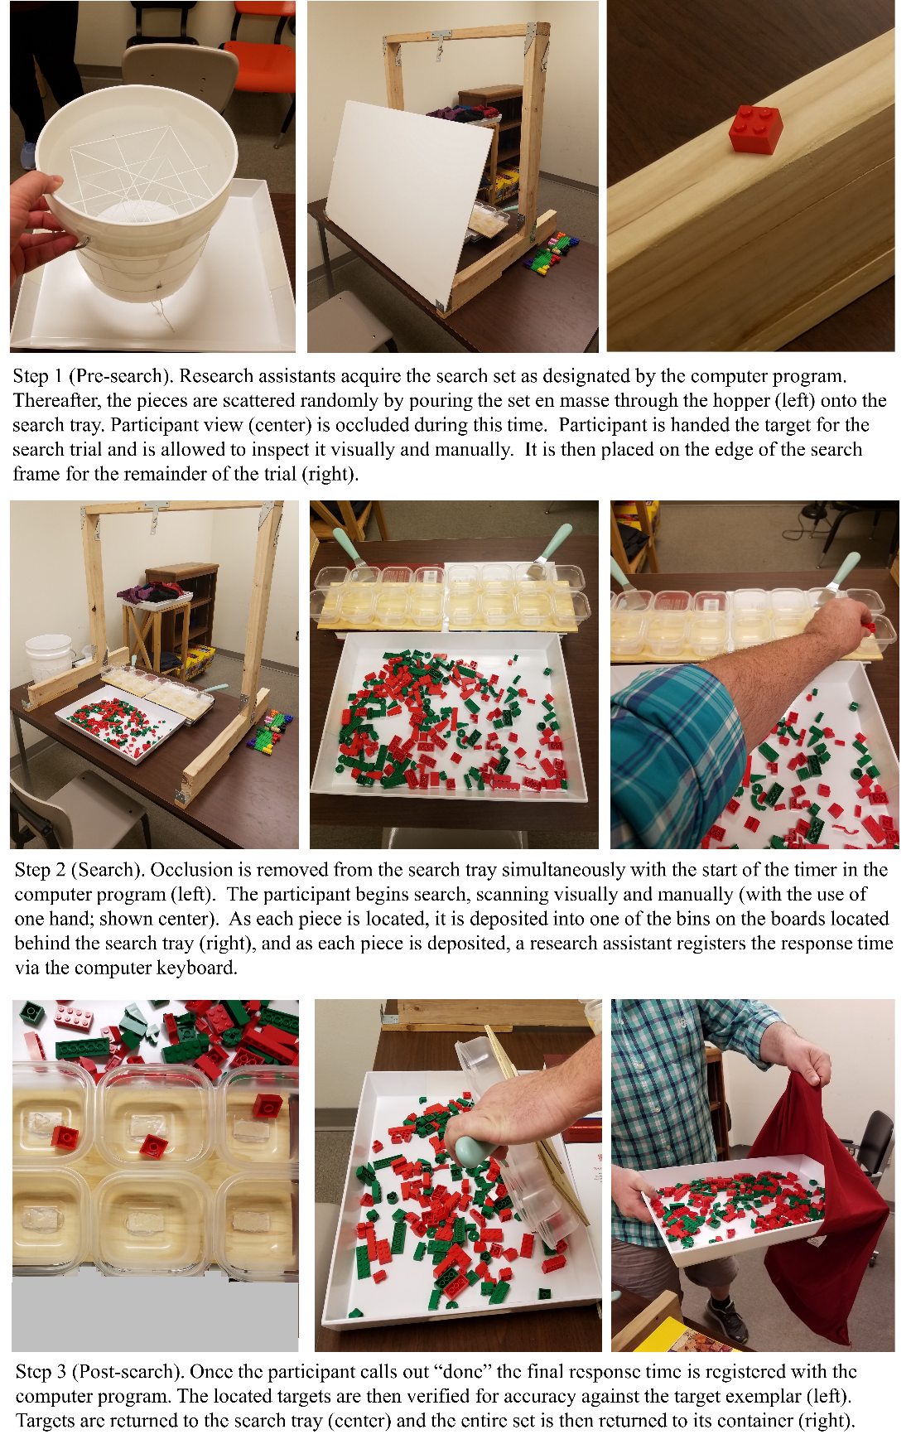

***Figure 2.*** *Timeline of events in a trial, including procedure setup/cleanup, participant behavior, and accuracy verification.*

In preparation for the start of the trial, the researcher handed the participant a physical exemplar of the target that they were to search for. The participant was allowed to visually and manually examine the target as long as they needed in order to memorize it, and then it was perched upon the side of the frame throughout the duration of the trial as a reminder of which specific pieces should be targeted. The instructions given to participants were to find as many target pieces as possible, as quickly and accurately as possible. Participants were not told how many targets would be included in each set, and they were informed to simply say “done” when they were satisfied that all targets had been located. They were instructed to use only one hand at a time to sort through the pieces, and to pick up and place each target in a bin upon locating it rather than “collecting” multiple pieces before depositing them (this helped ensure that each logged reaction time corresponded to the time taken to find a single piece).

Response times were recorded via the researcher interacting with the E-Prime program. At the start of the trial, one researcher simultaneously instructed the participant to begin while depressing a key on the keyboard that signaled to E-Prime to begin the response timer. At the same time, a second researcher removed the occluder so that the participant could begin searching. Response times were recorded from the start of the trial to the first target “find,” and from each new find to the next. As participants located each target, they placed the items in the separate plastic bins located on the boards in front of them (directly behind the search tray). When each new piece was dropped into the bins, one researcher simultaneously depressed the spacebar on the keyboard to register a response time with the E-Prime program. Once the participant had located as many targets as possible and said “done,” a researcher pressed a separate key on the keyboard to indicate that the final exhaustive search decision had been reached.

Once the trial was over, the researchers examined the plastic bins for accuracy. They then recorded in the E-Prime program any response errors they may have made in the recording of responses (e.g., failure to log a response) and any errors made by the participant (i.e., pieces incorrectly identified as targets). The selected pieces were then returned to the search tray, and then the search items were dumped back into the pillowcase from which they came, ending the trial. The entire process was then repeated anew until all trials were completed.

**Results**

Prior to analysis we removed any trials in which the participant incorrectly selected a non-target. We also removed any trials in which the researcher made a mistake in recording. Total data retention remained high: 96% of all conducted trials. Additionally, in order to reduce the skew of the data, all RTs were log-transformed (Whelan, 2008), and Greenhouse-Geisser corrected degrees of freedom were used to account for violations of Sphericity.

In the design of our task, we allowed several factors to vary freely (e.g., number of targets per color/shape combination) based on the pre-determined sets of bricks that were included in the Lego box sets that we purchased. As a result of this design choice, there were some cells of the design for which data was either missing for some participants or which had only a few (or a single) observation per participant (e.g., only one possible trial contained 7 targets, and if the participant made a mistake on that trial it was discarded, leaving an empty cell). As such, rather than perform traditional quantitative analyses on our full results, and more importantly because this task was planned to serve as a validation of our procedure, we opted to perform an exploratory analysis that looked qualitatively at the overall trends that were observed over the course of a trial (and we also used more traditional inferential statistics to look at average performance over the course of an entire trial).

Specifically, the first question we asked is, do we see a pattern of diminishing returns – a term borrowed from economics wherein proportionately smaller benefits are obtained as more effort is invested – as participants search through the sets and remove targets? If so, we should find that over the course of a trial, “find times” (i.e., the amount of time needed to locate each target) tend to increase (and likely become more variable) because as each target is found, there become fewer opportunities to find a new one in the set. For this exploratory analysis we simply plotted (in separate lines for small, medium, and large targets) the average find times over the course of a trial. As can be seen in Figure 3 (Panel A), participants began search a bit slowly, speeding up on their second or third find, and then slowed down consistently over time as more and more targets were removed from the set. Additionally, we plotted (in Figure 3, Panel B) standard deviation for each condition over time, and the pattern shown seems to clearly indicate an increase in the variability of response times towards the latter end of the trials[6].

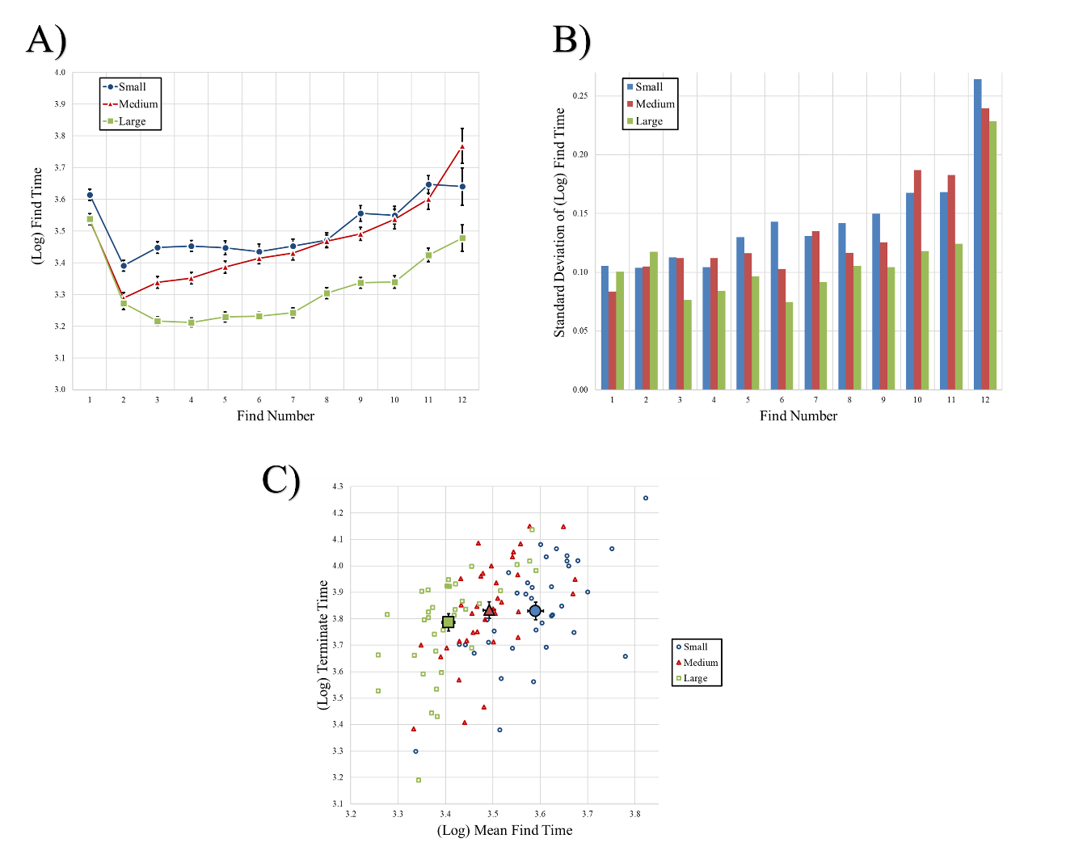

***Figure 3.*** *Panel A: Log find times plotted as a function of find number and target size (for small, medium, and large targets in blue, red, and green symbols, respectively). Error bars represent one standard error of the mean. Panel B: Standard deviation of log find times plotted as a function of find number and target size. Panel C: Scatterplot showing log mean find times (across all finds in a trial) and log terminate times presented separately for each target size and for each participant separately (in individual, unfilled symbols). Filled symbols present the means for each group (averaged across participants). Error bars again represent one standard error of the mean.*

The second question we asked was whether or not larger targets were responded to more quickly than smaller ones. If so, we should find hastened find times (i.e., larger targets should be easier to spot) and terminate times (i.e., the time needed to scan the tray and determine that no targets remain, which should be easier when those targets are larger) for larger targets. We conducted a one-way ANOVA on log mean find times (averaged across all finds in a trial) and found a significant effect of target size, [*F*(1.65, 57.81) = 246.59, *p* < .001, *ηp2* = .88], indicating that large targets were found most quickly (3.40), followed by medium (3.49) and small (3.59) ones. We also conducted a one-way ANOVA on log terminate times and found a significant effect of target size, [*F*(1.85, 64.73) = 3.57, *p* = .037, *ηp2* = .09], indicating that the decision to stop search was made more quickly for large (3.79) relative to medium (3.83) and small (3.83) targets. Results are plotted in Panel C of Figure 3, showing the means of the groups as well as participant- and condition-level means for both measures.

**Discussion**

In our validation task, we deployed a novel interactive search task wherein participants looked for multiple target bricks of varying colors and sizes. Our goal was to provide a proof-of-concept that search for Lego bricks could be an adequately controlled mechanism for studying interactive search, and to refine the methodology further so that it could be implemented to study questions of greater psychological importance. Our study bears a striking resemblance to that of Sauter et al. (2020) but there are also several key differences in methodology and design. For instance, in their first study, Sauter et al. (2020) also combined sets of colors from pre-determined Lego boxes but combined a pair of similar colors in their first experiment, and several different colors in their second experiment. Unlike our study, a hopper was not used to randomize starting placement of the bricks (i.e., research assistants randomly scattered the pieces), and a USB pointer was used by the participant to log their own find times (instead of relying on a researcher to do so). More importantly, there was no ambiguity about how many targets had been found or remained in the set (i.e., the number of targets was held constant and in their second experiment, a projector displayed the number of found targets to the participant at all times) and Sauter et al. (2020) manipulated overall set size and the number of features that defined the targets (rather than target size) in their work. There are certainly pros and cons to both approaches, and future work should combine the best pieces of each study (e.g., our randomization hopper, their method for participants recording their own response times) and manipulate the characteristics of the search sets (i.e., the manner in which color sets are combined and the features that define the targets) to suit new research questions in interactive search.

Regardless of these methodological differences, our two studies are entirely complementary insofar as they were both able to obtain evidence that a Lego brick search task is a viable tool for the study of interactive search because both studies show that these tasks can recreate patterns of data that would be expected based on prior visual search literature. Specifically, in our study we showed that as search targets are removed from the set, a pattern of diminishing returns appears whereby participant find times become longer (and perhaps more variable) over the course of a trial. And secondly, that the time needed to find each large target is shorter than for comparatively smaller ones.

More importantly, we identified various shortcomings in this initial experimental protocol and remedied/refined them in order to create a task with increased experimental control in our second study. Our intent in the design of the initial Lego task was to allow various factors to freely vary based on the specific pieces that were contained in the purchased Lego box sets. Doing this, we reasoned, would more easily allow other researchers to replicate our work and adopt our approach. In retrospect this was a poor design choice because it created an unbalanced approach, leaving some cells of the design with few or no observations across participants (something that is quite challenging to overcome without increasingly lengthy experimental sessions).

As such, in the Experiment we instituted the following changes: 1) We no longer employed multi-color trials. Instead, each trial contained only a single color of bricks, and sets were combined from multiple boxes to ensure that overall set size was comparable to that of our validation task. 2) We standardized each trial (across colors and target sizes) such that every search was conducted among the same number of bricks overall, with the same number of potential targets contained therein. And 3) we standardized the target items themselves, such that the small, medium, and large targets were the same precise shape across color sets.[7] By refining our design choices we were able to conduct a more controlled and statistically powerful second task aimed at exploring strategy use during interactive search.

**Experiment**

In our previous work (Madrid & Hout, 2019), we found that during hybrid visual and memory search, passive strategy use resulted in superior performance, relative to active strategies (and no explicit strategy instruction). We suggested that the superior performance of passive hybrid searchers may have resulted from a widening of their attentional focus, which would have allowed more items to be selected for further consideration upon each new fixation. A widened “attentional window” could also have allowed passive searchers to more effectively preview search objects prior to direct fixation, thus providing the searcher with a partial analysis that could be used to activate the most likely interpretation of the object before the searcher examined the item fully (cf. Bar, 2003; Bar et al., 2006; Kotowicz, Rutishauser, & Koch, 2010). This suggestion was supported by our findings that object recognition was facilitated for passive searchers, and that passive searchers suffered proportionately fewer recognition failures than active searchers.

That said, as previously discussed, optimal strategy use is likely context specific. Our current investigation differs from Madrid and Hout (2019) in many important ways: it is interactive in nature, requires observers to find multiple targets on each trial, involves a higher level of target/distractor similarity, has a greater degree of clutter within a search array, and the task asks observers to look for a specific exemplar rather than categorically-defined targets. Despite these distinctions, results from our prior work were useful in helping to guide our predictions for this new, interactive search scenario.

We predicted that passive search would be a *hindrance* during interactive search for Lego bricks. Because Lego brick search involves a crowded environment, and because the similarity of target and distractor bricks is high – and high target/distractor similarity is known to make search more difficult (Duncan & Humphreys, 1989; 1992; Hout et al., 2015; 2017) – we expected any hypothesized widening of an observer’s attentional window to be detrimental (or, at the very least, unhelpful) to search performance. Put simply, being able to process more items at once and/or to obtain an “educated guess” as to an object’s identity is likely only useful when object segmentation is relatively easy, and/or when targets and distractors have complex and varied identities (both of which were true in the previous work but not the current investigation). Therefore, contrary to our prior work, we expected that active search strategies – which, presumably narrow the attentional window – would be more beneficial during interactive Lego search, because an active strategy should allow for more precise identification of only the search object currently under direct investigation by the observer’s gaze.

**Method**

**Participants and power analysis**

We conducted an a priori power analysis in G*Power (Faul et al., 2007; 2009) to determine how many participants would be necessary to detect main effects of strategy use in the current investigation. To do this, we used the average strategy effect size found across all behavioral measurements in Madrid and Hout (2019): *ηp2* = .28. For a three-group design with power = .95, the analysis indicated that we required a total sample size of 45 participants. In order to approximate previous sample sizes and to err on the side of increased power, we opted to collect data in increments of one week, and to stop data collection once we acquired approximately 20 participants per condition. Our total sample size was 59 participants (with 19, 21, and 19 participants in the no strategy, active, and passive conditions, respectively). All participants were recruited from New Mexico State University and participated in exchange for partial fulfillment of a course requirement. All signed an informed consent form prior to participation, had normal (or corrected-to-normal) vision, were fluent in English, and demonstrated normal color vision during the Ishihara color vision test (Clark, 1924).

**Design, Stimuli, and Apparatus**

Three levels of target size (small, medium, and large) were manipulated within-subjects, randomly presented across trials in equal proportions. Additionally, strategy instructions (none, active, passive) were manipulated between-subjects, counterbalanced across participants.[8] Stimuli were Lego bricks selected from the same box sets as in the Validation Task. However, multiple sets were now combined to standardize overall set size across color conditions, and individual pieces were purchased á la carte to standardize target shape and number across color conditions. Each trial contained a total of 150 bricks from a single color, of which 20 were targets. Target shapes were now identical across color groups for the small, medium, and large trials. Small targets were raised 1x2 bricks, and medium and large targets were 2x2 and 2x4, respectively (for reference, see the small, medium, and large black targets in Figure 1). In the Validation Task, we created large sets of stimuli by combining two opposing colors. Because we now employed search sets selected from a single color at a time, we had more flexibility in color choice. As such, we added a second, lighter shade of green to the color set, as well as a set of gray bricks, bringing the total number of experimental trials from 24 to 30 (i.e., 10 colors by 3 target sizes), which were presented in random order. Three practice trials were administered (using brown and tan bricks, as in the Validation Task), but practice trials were not analyzed. In total, the experiment again lasted between 50 and 90 minutes. The apparatuses were identical to the Validation Task, with the exception that the boards were expanded such that there were 24 possible bins for target placement (which, again, was more than the maximum amount possible on any given trial).

**Procedure**

The procedure employed in this experiment was nearly identical to the Validation Task, save the details pertaining to the implementation of strategy use during search. Prior to conducting the experimental trials, participants were given instructions as to which strategy they should use to conduct their search (unless they were in the no strategy condition, in which case no specific strategy instructions were provided). Written instructions were printed out (in large font) and affixed to the occluder in front of the participant. The instructions were first read aloud to the participant by the researcher, and then the participant was asked to read them aloud for themselves. Thereafter, participants were reminded of the instructions every five trials by asking them to again read them aloud, but written instructions remained on the occluder throughout the duration of the experiment as well. The number of targets was held consistent across conditions, but participants were again not informed of how many were present in each search set. The specific strategy instructions were as follows (key differences between sets are highlighted with italics but italics were not presented to the participants):

Active search:

“The best strategy for this task, and the one that we want you to use from now on in this study, is to *be as active as possible and to ‘search’ for the target items* as you look at the tray. The idea is to *deliberately direct your attention* to determine your behavior. Sometimes people find it difficult or strange to *‘direct their attention’* but we would like you to try your best. Try to respond as quickly and accurately as you can while using this strategy. Remember, it is very critical for this experiment that you *actively search* for the target items.”

Passive search:

“The best strategy for this task, and the one that we want you to use from now on in this study, is to *be as receptive as possible and let the target items ‘pop’ into your mind* as you look at the tray. The idea is to *let the contents of the tray and your intuition* determine your behavior. Sometimes people find it difficult or strange to *tune into their ‘gut feelings’* but we would like you to try your best. Try to find your targets as quickly and accurately as you can while using this strategy. Remember, it is very critical for this experiment that *you let the target items just ‘pop’ into your mind*.”

**Results**

In this experiment we employed repeated measures ANOVAs to examine the effects of strategy use and target size on search speed and efficiency (indexed by “balanced integration scores”; Liesefeld & Janczyk, 2019) in a similar manner to the Validation Task. However, because each trial now contained the same number of targets (and therefore ambiguity about when to stop searching was ostensibly removed), we no longer examined termination times. Overall accuracy (i.e., proportion of total targets found) was high (97%) and did not vary across strategy conditions [*F*(2, 56) = 0.34, *p* = .713], so we do not report the effects further, but rather we included accuracy in the calculation of balanced integration scores (BIS) to compare performance across conditions while also controlling for potential speed/accuracy tradeoffs (and we also present participant level data in the interest of transparency). As in the Validation Task, when examining RTs, only results from error-free trials (i.e., trials in which the researchers made no errors and the bricks identified by the participants all matched the target exemplar) were analyzed (94% of all recorded trials). As before, all find times were log-transformed, results use Greenhouse-Geisser corrected degrees of freedom (when needed) to account for violations of the Sphericity assumption, and all post-hoc comparisons used the Bonferroni correction for multiple comparisons.

***Mean find times***

We first looked at the log mean find times using a 3 (Strategy: none, active, passive) x 3 (Target Size: small, medium, large) x 20 (Find Number: 1-20) repeated measures ANOVA. We found a significant main effect of Strategy, [*F*(2, 55) = 5.90, *p* < .01, *ηp2* = .18], indicating that the fastest find times were exhibited by the active searchers (3.37), followed by the no strategy group (3.45), and the passive searchers (3.45); see Figure 4. Post-hoc comparisons revealed a significant difference between the active and passive groups (*p* = .016) and between active and no strategy (*p* = .011), but not between no strategy and passive searchers (*p* = 1.0). There was also a main effect of Target Size, [*F*(1.97, 108.51) = 414.99, *p* < .001, *ηp2* = .88], indicating that find times were slower for smaller targets (3.50, 3.45, and 3.32 for small, medium, and large targets, respectively). Post-hoc comparisons revealed significant differences between all three target size comparisons (all *p*s < .001). The main effect of Find Number was also significant, [*F*(17.91, 223.64) = 201.04, *p* < .001, *ηp2* = .79], indicating that find times lengthened as more targets were removed from the set. None of the two- or three-way interactions were significant (all *p*s >= .08).

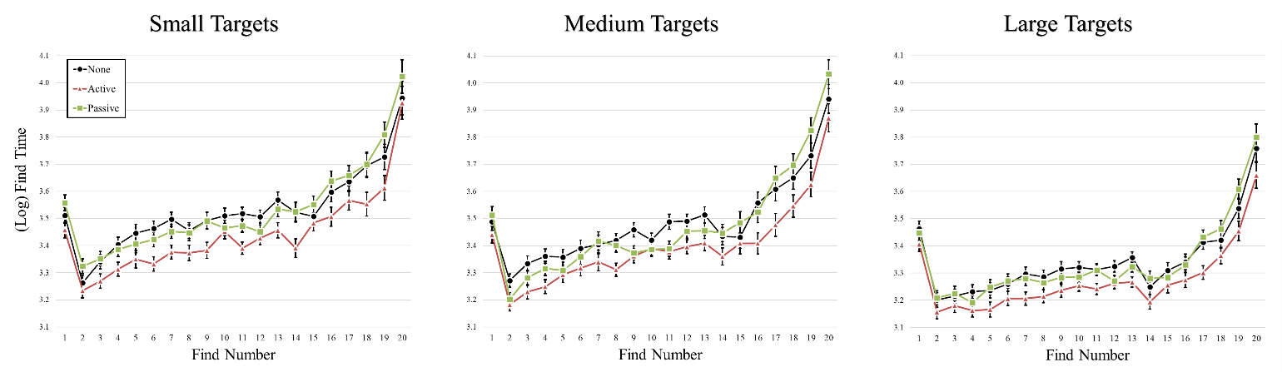

***Figure 4.*** *Log mean find times from the experiment. Results are plotted separately for each target size (small, medium, and large targets from left to right). In each plot, mean find times are plotted by find number (1-20) and separately for each search strategy condition (none, active, and passive in black, red, and green symbols, respectively). Error bars represent one standard error of the mean.*

***Balanced Integration Scores***

As previously mentioned, search accuracy overall was high: 97% of all targets were found. Nonetheless, it is important to make sure that the observed response time benefits exhibited by the active searchers were not a result of a speed/accuracy tradeoff, no matter how small. Accordingly, we calculated balanced integration scores (BIS; Liesefeld & Janczyk, 2019) by first standardizing mean find times[9] and percent correct (PC; that is, the percent of targets found on each trial). We then subtracted the z-transformed find times from the z-transformed PC. BIS can be interpreted, therefore, as a measure of relative performance used to index the relative difficulty of different conditions (e.g., target size) and across different participant groups (e.g., strategy use); negative BIS scores represent worse than average performance and positive BIS scores represent better than average performance. We examined BIS scores using a 3 (Strategy: none, active, passive) x 3 (Target Size: small, medium, large) repeated measures ANOVA.

BIS scores exhibited a main effect of Strategy, [*F*(2, 55) = 5.01, *p =* .01, *ηp2* = .15], with the worst performance exhibited by passive searchers (-.27) followed by no strategy (-.09) and active searchers (.27). Post-hoc comparisons revealed a significant difference between the active and passive searchers (*p* = .01), but not between the active and no strategy group (*p* = .119) or the no strategy and passive searchers (*p* = 1.0). There was also a main effect of Target Size, [*F*(1.96, 107.68) = 233.09, *p* < .001, *ηp2* = .81], with worse performance on smaller targets (-.64, -.32, and .88 for small, medium, and large targets, respectively). Post-hoc comparisons revealed that all three pairs of target size comparisons were significantly different from one another (all *p*s < .001). The interaction of Strategy and Target Size was not significant (*p*  = .65). Results are plotted in Figure 5.

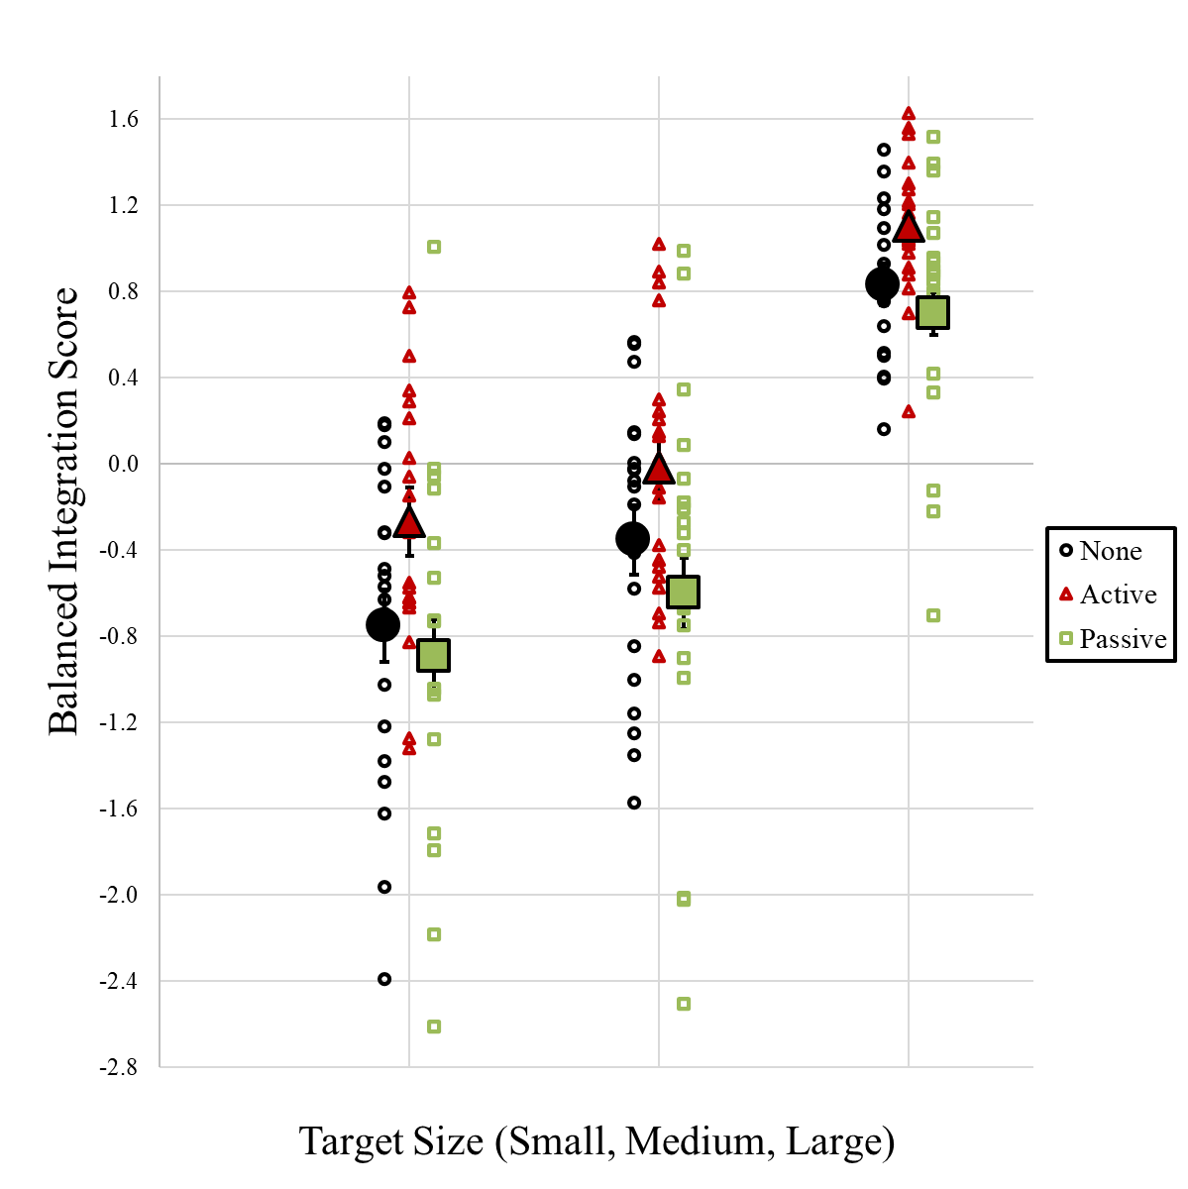

***Figure 5.*** *Balanced integration scores plotted as a function of strategy condition (none, active, and passive strategy conditions shown in black, red, and green symbols, respectively) and target size (small, medium, and large targets from left to right). Unfilled symbols represent data for individual participants and filled symbols present the means for each group and condition. Error bars represent one standard error of the mean.*

**Discussion**

In this experiment, we used our refined Lego search task to better understand strategy use in the context of interactive search. In keeping with the Validation Task, we replicated sensible trends in the data, finding a pattern of diminishing returns on find times as more targets were removed from the set, and hastened mean search times for larger targets. More importantly, we also found that – contrary to the effect of strategy use on hybrid visual memory search documented in Madrid and Hout (2019) – active searchers were faster to locate targets relative to passive and uninstructed searchers. Moreover, we ruled out that such efficiencies were the result of a speed/accuracy tradeoff by reporting balanced integration scores which indicate better than average performance by active searchers.

**General Discussion**

In this investigation, we make three important contributions to the study of interactive search. First, we document a set of protocols and apparatus than can be used to study interactive search by asking participants to recover target Lego bricks from a cluttered tray of shape and/or color distractors. We validated our procedures through exploratory and standard quantitative analyses that evinced expected patterns of diminishing returns as targets were removed from the set, and large effects of target size on the time required to locate targets. Furthermore, we document the potential shortcomings of using Lego sets “as is” – that is, using the brick quantities as they naturally occur in the purchased box sets – and suggest that purchasing bricks á la carte can allow for the standardization of search sets across trials and experimental conditions, affording greater flexibility in the manipulation of search conditions. Together, our study and the work of Sauter et al. (2020) strongly suggest that search for Lego bricks is a valid tool to study interactive search, and the combined methodological approaches offer other researchers a range of options to choose from, expand upon, and/or modify in future work.

***Strategy use in interactive search***

Our second contribution – and one of greater theoretical importance – was to explore the effects of strategy use on interactive search. In our previous work on hybrid visual memory search (Madrid & Hout, 2019), we found that passive strategy use leads to faster and more efficient search (indexed by behavioral performance and oculomotor behaviors) relative to active search. We hypothesized that one potential explanation for these effects is a widening of the “attentional window” whereby the increased visual processing that occurs upon each new fixation allows target-defining features to be identified at a greater distance (thus increasing the quality of attentional guidance), and/or allows objects to be “previewed” in parafoveal vision (thus giving the observer a “head start” on object recognition processing). In this prior work, however, search objects were isolated on a blank white background, and were visually complex (having been sampled from a wide variety of different real-world categories).

In the current investigation, by contrast, searchers were allowed to use their hands in addition to their eyes, and search objects were not isolated but were instead quite cluttered and prone to overlap, occlusion, and variety in orientation. As such, we hypothesized (and found) a reversal in the previously observed benefits of passive strategy adoption whereby passive strategies should be detrimental to search performance. It is possible that the benefits we observed for active searchers arose because of differences in the size of the attentional window among searchers of different strategy groups. For instance, the increased homogeneity and clutter among targets and distractors in our Lego task would likely have limited the utility of parafoveal/peripheral preview during search, and it is thus possible that a more focused attentional window allowed active searchers to more efficiently discriminate targets from distractors.

That said, it should not be concluded that passive search is universally beneficial in visual search, nor that active search is universally beneficial in interactive search. As discussed in our introduction, strategy use is not one-size-fits-all, and thus any observed benefits must be appreciated in light of the specific task constraints under which they were observed. Our task is the first investigation that we are aware of to explore strategy use in interactive search, and our results suggest that when observers use their hands to search through a set of similar looking items – e.g., looking for specific coins in a pile of change – an active strategy allows the observer to more swiftly find what they are looking for.

***Improving performance in real-world interactive search tasks***

In many real-world interactive searches that involve searching for threats or concealed items, the physical (i.e., through use of the hands) searching of objects is one of the last lines of defense against threats. In airport baggage screening, after an X-ray screener conducts a visual search that detects a potential threat, it is an interactive search of that bag that serves as the final decision on whether a passenger is safe to pass through security. At concerts, which have become an increasing target for terrorist attacks, it is the interactive search of backpacks and handbags that, if it fails, can allow terrorists to attack the public in a crowded and vulnerable space. At major public events, such as political party meetings, government meetings, and rallies, it is the interactive search that determines whether the venue is safe for people to enter without risk of concealed explosive devices.

Given all of this, it is unfortunate that decades of research into how human observers seek out targets has resulted in comparatively few (especially when compared to computer-based search experiments) studies that have asked participants to search physically as well as visually (see the Introduction for a nearly exhaustive list). We therefore know very little about how people conduct interactive searches, but the work presented here serves as an important further step in demonstrating that search strategies can be a key determinant in driving behavior and performance. We already know that expertise and training can influence performance in these tasks (Riggs et al., 2018) and so it stands to reason that future training regimes could be developed to involve detailed training in the strategies used here – or other, more refined ones – in order to increase the likelihood that those highly dangerous and damaging targets be found during interactive searches.

***A conceptual model for the steps involved in interactive search***

Our third contribution here is to provide a preliminary conceptual model for the steps involved in interactive search. Though not a formal computational model at present, we believe this is a useful first step toward understanding the stages involved in interactive search and the various decision-making components included in this process. We grounded our model in the work of Wolfe and Van Wert (2010), who introduced the multiple decision model (MDM) to capture the levels of decision making involved in simple visual search. The MDM breaks visual search down into steps of selection, recognition, and the decision to continue searching or to terminate the search (see Figure 6, Panel A). The general approach of the MDM can be applied to the search task used in our studies. There are recursive decisions about where to search and for how long, but a more complete model of the current procedures requires modifications to the MDM; for simplicity, we will refer to this expanded model as the Interactive Multiple Decision Model (i-MDM). Any model of interactive search will require adding another layer of decisions to the standard MDM. The three major differences between the current interactive search task and typical search tasks are: 1) the large number of objects in the search tray, 2) the potential of multiple targets to appear in the same trial, and 3) the ability of the observer to interact with the search environment. The i-MDM starts with the same recursive decision approach as the MDM (Wolfe & Van Wert, 2010) and expands upon it to accommodate these differences.

An overview of the i-MDM is presented in Figure 6, Panel B. Search starts with guidance to a selective subset of the stimuli. That is, the broader visual field is broken down into narrow areas (or clusters) that likely have targets. In terms of attentional selection, the activation of an area is based on the “central tendency” of activation for that area. An area with a higher density of target-relevant features is more likely to be selected for search than an area with fewer target-relevant features, much like stimulus selection procedures in models such as Guided Search (Wolfe & Gray, 2004, Wolfe, 2021; see also Solman, Cheyne, & Smilek, 2013). Search *within* the selected narrow area then proceeds similarly to the MDM. A stimulus is selected, and an internal two-alternative force choice (2AFC; “Is this a distractor or target?”) is made regarding the selected stimulus.

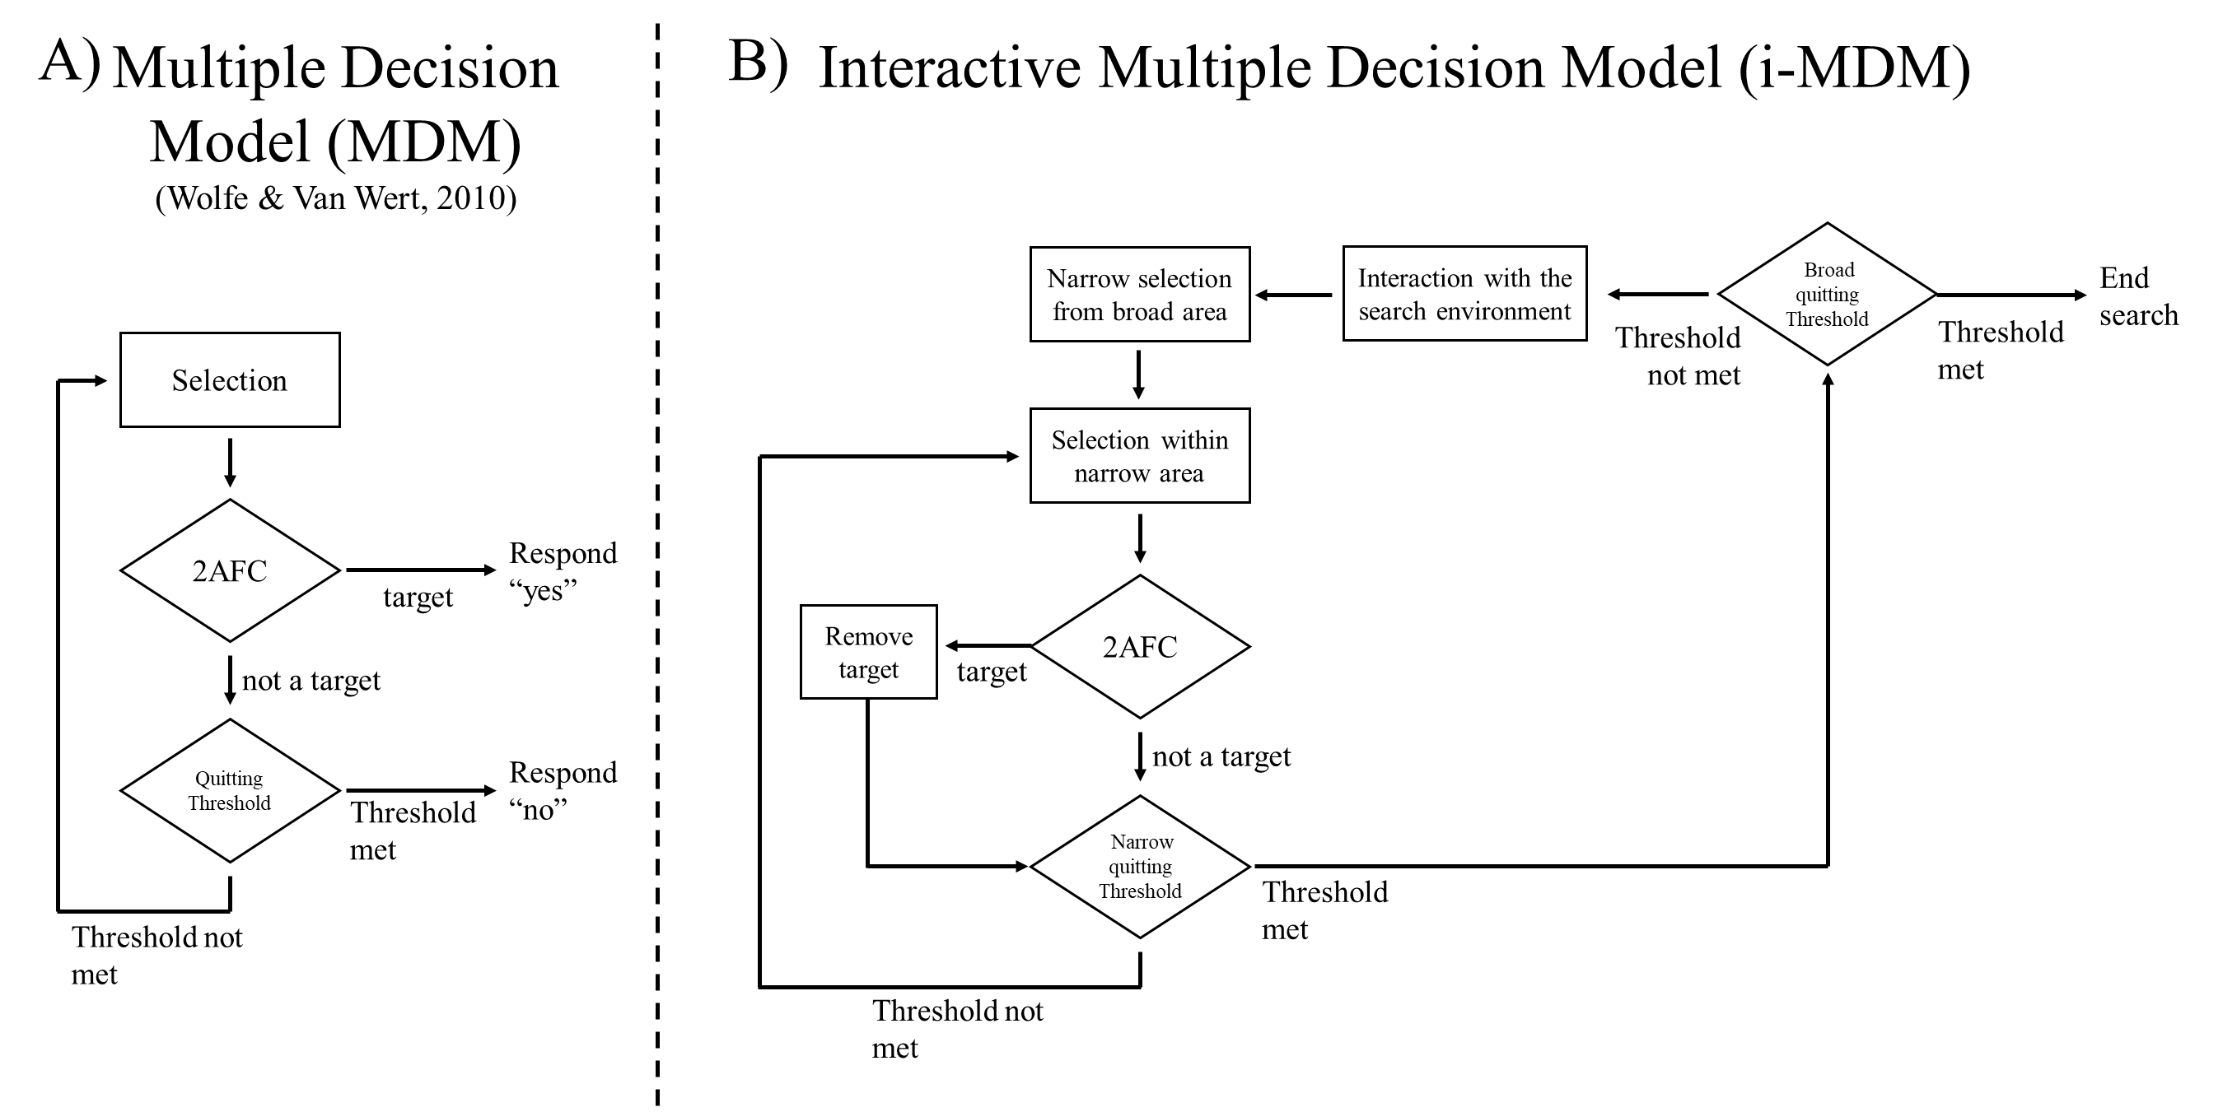

***Figure 6.*** *Panel A: An overview of the Multiple Decision Model by Wolfe and Van Wert (2010). Panel B: An overview of our expansion of the MDM, the Interactive Multiple Decision Model (i-MDM).*

The subsequent decisions in the model depend on the results of the 2AFC decision. If the stimulus is identified as a distractor, another internal decision must be made about continuing search within the narrow area. This could be formally modeled, for instance, with an accumulator that approaches an internal quitting threshold. As evidence of the narrow area not containing a target increases (by virtue of no target being found), the probability of ending search in the narrow area increases. If the threshold has not been met, search continues within the narrow area. If a stimulus is identified as a target, it is removed, and search continues within that narrow area. Search returns to the broad level once the quitting threshold for the narrow area is met. Once search within the narrow area is complete, a broad quitting decision is made for the trial as a whole, similar to the decision process for the narrow area. If the broad quitting threshold is not met, then the searcher may choose to (or not to) interact with the search environment (e.g., to move the pieces around or brush pieces aside), after which another narrow area is selected (or a new narrow area is functionally formed by virtue of the movement of pieces), and search continues. If the global quitting threshold is exceeded, then the search trial ends.

An important feature of this recursive decision procedure is identifying the scope of a decision. This is noted in this model as granularity – the degree to which the search area is broad or narrow. Most experimental visual search tasks involve relatively small set sizes (at least compared to the Lego search here), and search primarily occurs within narrow granularities, such as an individual stimulus or small group of items. In such tasks, searchers can easily redirect attention to individual items in the arrays and quickly examine or identify nearly all relevant stimuli. Searches across larger set sizes (as in the current study), by contrast, likely require broader, high-level decisions to manage an effective search because it is impractical to exhaustively identify every object in the set. The additional layers of stopping decisions within this model capture the process of traversing back and forth between different layers of granularity to effectively search areas most likely to contain a target without an exhaustive search.

This approach can also be applied to a wider variety of search tasks. For example, typical laboratory searches involve a few narrow levels of granularity and require few traversing decisions, as most of the objects in the set can be searched without much effort. Large set size searches, such as sifting through a pile of Lego bricks, involve navigating between broad and narrow levels. This approach can be scaled further to include search for objects in a physical space, such as finding a set of keys in a room. The very broad area (the room) can be broken down into narrower areas (e.g., bookcase, coffee table), which can then be searched similar to having a very narrow granularity. If the keys aren’t found on the coffee table, for instance, the searcher then needs to return to a broader granularity, consider interacting with the environment (e.g., moving things that might be obscuring the observer’s view), and then select another narrow area to search within.

Returning to the effects of strategy use during interactive search, it seems likely that passive and active strategies will have differential effects on the broad and narrow selection stages of the i-MDM depending on the nature of the task. For instance, in our prior work (Madrid & Hout, 2019) – which involved comparatively fewer search objects scattered on a blank white background – passive search strategies were likely beneficial because selection within a narrow area was less important as only one target could be found and no search items overlapped with one another. In that study, passive strategy use may have made search more efficient because it engendered a widened attentional window that made it easier for participants to locate target-relevant features in their parafoveal and peripheral vision. By contrast, our Lego search task requires greater selection at both broad and narrow granularities. Here, the potential benefit of passive strategy use at the broad level was likely obfuscated by the high target-distractor similarity of the pieces (i.e., it is hard to spot target-relevant features in non-foveal vision when all the objects look so much alike). Instead, active strategy use may have been beneficial at the stage of selection within the narrow area, allowing the observer to quickly home in on target-defining features in a smaller region of space near or at central vision. Future work will be needed to formalize this model and to test its predictions (likely using nuanced recordings of both hand and eye movements).

***Conclusion and future directions***

It should be acknowledged that ours is but one approach to the study of interactive search, and that future investigations could improve upon our design (and that of Sauter et al., 2020) in several ways that would further enhance the internal validity of the task or allow additional theoretical insights to be made. For example, there are drawbacks to the methods used by us and by Sauter et al. (2020) for recording target find times. Our approach required a research assistant to record find times by registering a response on the keyboard at the same time the participant dropped a target into one of the bins. This reduces the burden (and likely the mental workload) on the participant but introduces potential error variability between when the target is dropped and when the research assistant registers it on the keyboard. Sauter et al. (2020) had participants register their own find times using a USB pointer held in their non-dominant hand; this is arguably an improvement over our method but also likely includes some degree of error variability and also introduces a secondary cognitive burden (i.e., remembering to click the USB pointer precisely when a target was dropped) on the participant over and above the finding of target bricks. A more sophisticated approach might be to use pressure sensors in the bins to automatically register the RT with a computer program. Such a technological advance would serve to reduce unwanted noise in the response times altogether. Moreover, the use of mobile eye-tracking technology or the systematic recording and coding of hand movements could be used to supplement behavioral measurements (and to test our conceptual model). These additional measures may allow for a more nuanced understanding of the distribution of visual attention and may also provide insights into the various manual strategies that searchers use to sort and identify targets.

Another interesting avenue that should be explored in the study of interactive search is the use of virtual reality (VR). The obvious advantage of using VR is that if individual pieces are coded for movement, more sophisticated and nuanced analysis of interactivity during search would be made possible in a way that would be difficult and/or messy with real-world interactive search (e.g., video recordings of hand movements would need to be manually coded by independent raters and such a method would be unlikely to be able to code the movement of items down to individual pieces). Modern VR systems also allow for eye-tracking, enabling the dual coding of hand and eye movements, and thus allow insight into interactivity and visual attention simultaneously. Another advantage of using VR is that – in lieu of tactile gloves that provide limited feedback to the hands and fingers – the movement of pieces occurs without tactile stimulation to the observer. It thus stands to reason that VR would be an especially important avenue for dissociating tactile sensations used to identify the target based on touch from interactivity in its purest and most isolated form. Indeed, VR and even augmented reality (AR) are being used more and more in the study of search – including search through realistic home scenarios (Olk et al., 2018), simulated search and rescue (Bacim et al., 2012; Shi, et al., 2021), and drone-based search tasks (Del Angola et al., 2020 – opening up avenues for the study of search in more realistic situations that more accurately mimic the real world and allow for considerable interactivity in multiple forms.

Finally – to return to search for Lego bricks – it should be noted that the use of Lego bricks affords the experimenter a great deal of flexibility with respect to the manipulation and control of search scenarios. For example, future research should explore whether the observed benefits of active search extend to interactive search conditions in which the targets and distractors have a lower degree of featural similarity (e.g., when a security guard conducts a manual search of someone’s personal bag looking for prohibited items), and thus selection at the broader level of granularity is easier than it was in our tasks. Under such conditions, it is possible that a widened attentional window again becomes useful, thereby bringing performance among active and passive searchers more closely into alignment. This could be achieved experimentally (in the lab) by simply making targets and distractors more discriminable from one another – for instance, by manipulating the proportion of distractors in the tray that share a color or shape with the target, or through varying featural differences by systematically manipulating the similarity of the bricks’ colors.

In short, Lego bricks are an ideal medium for the study of interactive search due to their wide variety of colors and shapes, and the ease with which the experimental stimuli can be acquired. Lego bricks also offer unique utility in that they may be combined to create complex conjunctions of features that could be used to approximate categorical definitions (e.g., “look for Category A, which is a pair of conjoined 2x4 bricks that belong to the same general color category”) akin to searching for more complex, real-world objects that are defined by more than one or two features. In this way, search for Lego bricks (and the conceptual i-MDM) may indeed become a useful paradigm for better understanding how observers find things when not constrained to search using only their eyes.

**References**

Auffermann, W. F., Krupinski, E. A., & Tridandapani, S. (2018). Search pattern training for evaluation of central venous catheter positioning on chest radiographs. *Journal of Medical Imaging, 5(3),* 031407. doi: 10.1117/1.JMI.5.3.031407.

Auffermann, W. F., Little, B. P., & Tridandapani, S. (2015). Teaching search patterns to medical trainees in an educational laboratory to improve perception of pulmonary nodules. *Journal of Medical Imaging, 3(1),* 011006. doi:10.1117/1.jmi.3.1.011006.

Bacim, F., Ragan, E. D., Stinson, C., Scerbo, S., & Bowman, D. A. (2012). Collaborative navigation in virtual search and rescue. In *2012 IEEE Symposium on 3D User Interfaces (3DUI).* Pp.187-188.

Bar, M. (2003). A cortical mechanism for triggering top-down facilitation in visual object recognition. *Journal of Cognitive Neuroscience, 15,* 600-609.

Bar, M., Kassam, K. S., Ghuman, A. S., Boshyan, J., Schmid, A. M., Dale, A. M., Hamalainen, M. S., Marinkovic, K., Schacter, D. L., Rosen, B. R., & Halgren, E. (2006). Top-down facilitation of visual recognition. *Proceedings of the National Academy of Sciences, 103,* 449-454. doi: 10.1073pnas.0507062103.

Beck, M. R., Lohrenz, M. C., & Gregory, T. J. (2010). Measuring search efficiency in complex visual search tasks: Global and local clutter. *Journal of Experimental Psychology: Applied, 16,* 238-250. doi: 10.1037/a0019633.

Bravo, M. J., & Farid, H. (2004a). Recognizing and segmenting objects in clutter. *Vision Research*, *44*(4), 385–396. doi: 10.1016/j.visres.2003.09.031.

Bravo, M. J., & Farid, H. (2004b). Search for a category target in clutter. *Perception*, *33*(6), 643–652.

Bravo, M. J., & Farid, H. (2006). Object recognition in dense clutter. *Perception & Psychophysics*, *68*(6), 911–918. doi: 10.3758/BF03193354.

Clark, J. H. (1924). The Ishihara test for color blindness. *American Journal of Physiological Optics, 5,* 269-276.

Clark, A. D. F., Irons, J. L., James, W., Leber, A. B., & Hunt, A. R. (2020). Stable individual differences in strategies within, but not between, visual search tasks. *Quarterly Journal of Experimental Psychology.*

Dell-Agnola, F., Momeni, N., Arza, A., & Atienza, D. (2020). Cognitive workload monitoring in virtual reality based rescue missions with drones. In *International Conference on Human-Computer Interaction (pp.397-409).* Spring, Cham.

Draschkow, D., & Võ, M. L.-H. (2016). Of “what” and “where” in a natural search task: Active object handling supports object location memory beyond the object’s identity. *Attention, Perception, & Psychophysics, 78,* 1574-1584. doi: 10.3758/s13414-016-1111-x.

Duncan, J., & Humphrey, G. (1989). Visual search and stimulus similarity. *Psychological Review, 96,* 433-458.

Duncan, J., & Humphreys, G. (1992). Beyond the search surface: Visual search and attentional engagement. *Journal of Experimental Psychology: Human Perception and Performance, 18,* 578-588. doi: 10.1037/0096-1523.18.2.578.

Faul, F., Erdfelder, E., Buchner, A., & Lang, A.-G. (2009). Statistical power analyses using G*Power 3.1: Tests for correlation and regression analyses. *Behavior Research Methods, 41,* 1149-1160.

Faul, F., Erdfelder, E., Lang, A.-G., & Buchner, A. (2007). G*Power 3: A flexible statistical power analysis program for the social, behavioral, and biomedical sciences. *Behavior Research Methods, 39,* 175-191.

Gilchrist, I. D., & Harvey, M. (2006). Evidence for a systematic component within scan paths in visual search. *Visual Cognition, 14,* 704-715.

Gilchrist, I. D., North, A., & Hood, B. (2001). Is visual search really like foraging? *Perception, 30.* doi: 10.1068/p3249.

Godwin, H J, Menneer, T., Cave, K. R., & Donnelly, N. (2010). Dual-target search for high and low prevalence X-ray threat targets. *Visual Cognition, 18(10),* 1439–1493. doi: 10.1080/13506285.2010.500605.

Godwin, H J, Menneer, T., Cave, K. R., Thaibsyah, M., & Donnelly, N. (2015). The effects of increasing target prevalence on information processing during visual search. *Psychonomic Bulletin & Review, 22(2)*, 469–475. doi: 10.3758/s13423-014-0686-2.

Godwin, H J, Menneer, T., Liversedge, S. P., Cave, K. R., Holliman, N. S., & Donnelly, N. (2017). Adding Depth to Overlapping Displays can Improve Visual Search Performance. *Journal of Experimental Psychology: Human Perception and Performance*, *43*(8), 1532–1549. doi: 10.1037/xhp0000353.

Godwin, H J, Menneer, T., Riggs, C. A., Taunton, D., Cave, K. R., & Donnelly, N. (2015). Understanding the contribution of target repetition and target expectation to the emergence of the prevalence effect in visual search. *Psychonomic Bulletin & Review.* doi: 10.3758/s13423-015-0970-9.

Godwin, Hayward J, Menneer, T., Riggs, C. a, Cave, K. R., & Donnelly, N. (2015). Perceptual failures in the selection and identification of low-prevalence targets in relative prevalence visual search. *Attention, Perception & Psychophysics, 77(1),* 150–159. doi: 10.3758/s13414-014-0762-8.

Helbing, J., Draschkow, D., & Võ, M. L.-H. (2020). Search superiority: Goal-directed attentional allocation creates more reliable incidental identity and location memory than explicit encoding in naturalistic virtual environments. *Cognition, 196: 104147.* doi: 10.1016/j.cognition.2019.104147.

Hillstrom, A. P., Wakefield, H., & Scholey, H. (2013). The effect of transparency on recognition of overlapping objects. *Journal of Experimental Psychology. Applied*, *19*(2), 158–170. doi: 10.1037/a0033367.

Hout, M. C., Godwin, H. J., Fitzsimmons, G., Robbins, A., Menneer, T., & Goldinger, S. D. (2015). Using multidimensional scaling to quantify similarity in visual search and beyond. *Attention, Perception, & Psychophysics, 78,* 3-20. doi: 0.3758/s13414-015-1010-6.

Hout, M. C., & Goldinger, S. D. (2010). Learning in repeated visual search. *Attention, Perception & Psychophysics, 72,* 1267–1282. doi: 10.3758/APP.72.5.1267.

Hout, M. C., & Goldinger, S. D. (2012). Incidental learning speeds visual search by lowering response thresholds, not by improving efficiency: evidence from eye movements. *Journal of Experimental Psychology: Human Perception and Performance, 38*, 90–112. doi: 10.1037/a0023894.

Hout, M. C., Robbins, A., Godwin, H. J., Fitzsimmons, G., & Scarince, C. (2017). Categorical templates are more useful when features are consistent: Evidence from eye movements during search for societally important vehicles. *Attention, Perception, & Psychophysics, 79,* 1578-1592. doi: 10.3758/s13414-017-1354-1.

Hout, M. C, Walenchok, S. C., Goldinger, S. D., & Wolfe, J. M. (2015). Failures of perception in the low prevalence effect: Evidence from active and passive visual search. *Journal of Experimental Psychology: Human Perception and Performance, 41,* 977-944. doi: 10.1037/xhp0000053.

Ishibashi, K., Watanabe, K., Takaoka, Y., Watanabe, T., & Kita, S. (2012). Prevalence effect in haptic search. *i-Perception, 3,* 495-498. doi: 10.1068/i0509sas.

Jiang, Y. V., Won, B-Y., & Swallow, K. M. (2014). Spatial reference frame of attention in a large outdoor environment. *Journal of Experimental Psychology: Human Perception and Performance, 40,* 1346-1357. doi: 10.1037/a0036779.

Kotowicz, A., Rutishauser, U., & Koch, C. (2010). Time course of target recognition in visual search. *Frontiers in Human Neuroscience, 4:31.* doi: 10.3389/fnhum.2010.00031.

Kramer, M. R., Porfido, C. L., & Mitroff, S. R. (2019). Evaluation of strategies to train visual search performance in professional populations. *Current Opinion in Psychology*. doi: 10.1016/j.copsyc.2019.01.001.

Kristjansson, A. (2000). In search of remembrance: Evidence for memory in visual search. *Psychological Science*, 11, 328-332

Kunar, M. A., & Watson, D. G. (2011). Visual search in a multi-element asynchronous dynamic (MAD) world. *Journal of Experimental Psychology: Human Perception and Performance*, 37(4), 1017.

Liesefeld, H. R., & Janczyk, M. (2019). Combining speed and accuracy to control for speed-accuracy trade-offs (?). *Behavior Research Methods, 51(1),* 40–60.

Madrid, J., & Hout, M. C. (2019). Examining the effects of passive and active strategies on behavior during hybrid visual memory search: Evidence from eye tracking. *Cognitive Research: Principles and Implications, 4*:*39.* doi: 10.1186/s41235-019-0191-2.

Olk, B., Dinu, A., Zielinski, D. J., & Kopper, R. (2018). Measuring visual search and distraction in immersive virtual reality. *Royal Society Open Science, 5,* 172331.

Palmer, J. (1995). Attention in visual search: Distinguishing four causes of a set-size effect. *Current Directions in Psychological Science, 4,* 118-123. doi: 10.1111/1467-8721.ep10772534.

Papesh, M. H., Hout, M. C., Guevara Pinto, J. D., Robbins, A., Lopez, A. (*in press*). Eye movements reflect the development of expertise in hybrid search. *Cognitive Research: Principles and Implications.*

Reingold, E. M., & Sheridan, H. (2011). Eye movements and visual expertise in chess and medicine. In S. P. Liversedge, I. D. Gilchrist, & S. Everling, (Eds.) *Oxford Handbook on Eye Movements* (pp. 528-550). Oxford: Oxford University Press.

Riggs, C. A., Cornes, K., Godwin, H. J., Liversedge, S. P., Guest, R., & Donnelly, N. (2017). The importance of search strategy for finding targets in open terrain. *Cognitive Research: Principles and Implications, 2:14.* doi: 10.1186/s41235-017-0049-4.

Riggs, C. A., Godwin, H. J., Mann, C. M., Smith, S. J., Boardman, M., Liversedge, S. P., & Donnelly, N. (2018). Rummage search by expert dyads, novice dyads and novice individuals for objects hidden in houses. *Visual Cognition, 26,* 334-350. doi: 10.1080/13506285.2018.1445678.

Sauter, M., Stefani, M., & Mack, W. (2020). Towards interactive search: Investigating visual search in a novel real-world paradigm. *Brain Sciences, 10,* 927. doi: 10.3390/brainsci10120927.

Scarince, C., & Hout, M. C. (2018). Cutting through the MADness: Expectations about what a target is doing impact how likely it is to be found in dynamic visual displays. *Quarterly Journal of Experimental Psychology*, 71(11), 2342-2354.

Schneider, W., Eschman, A., & Zuccolotto, A. (2013). *E-Prime User’s Guide.* Pittsburgh, PA: Psychology Software Tools.

Sheridan, H., & Reingold, E. M. (2017). Chess players’ eye movements reveal rapid recognition of complex visual patterns: Evidence from a chess-related visual search task. *Journal of Vision, 17: 4.* doi: 10.1167/17.3.4.

Shi, Y., Kang, J., Xia, P., Tyagi, O., Mehta, R. K., & Du, J. (2021). Spatial knowledge and firefighters’ wayfinding performance: A virtual reality search and rescue experiment. *Safety Science,* 105231.

Smilek, D., Dixon, M. J., & Merikle, P. M. (2006). Revisiting the category effect: The influence of meaning and search strategy on the efficiency of visual search. *Brain Research, 1080,* 73-90. doi: 10.1016/j.brainres.2005.07.079.

Smilek, D., Enns, J. T., Eastwood, J. D., & Merikle, P. M. (2006). Relax! Cognitive strategy influences visual search. *Visual Cognition,* 14, 543-564. doi: 10.1080/13506280500193487.

Solman, G. J. F., Cheyne, J. A., & Smilek, D. (2012). Found and missed: Failing to recognize a search target despite moving it. *Cognition, 123,* 100-118. doi: 10.1016/j.cognition.2011.12.006.

Solman, G. J. F, Cheyne, J. A., & Smilek, D. (2013). Changing perspective: Zooming in and out during visual search. *Journal of Experimental Psychology: Human Perception and Performance, 39,* 348-364.

Solman, G. J. F., Wu, N., Cheyne, J. A., & Smilek, D. (2013). In manually-assisted search, perception supervises rather than directs action. *Experimental Psychology, 60,* 243-254. doi: 10.1027/1618-3169/a000193.

Torralba, A., Oliva, A., Castelhano, M. S., & Henderson, J. M. (2006). Contextual guidance of eye movements and attention in real-world scenes: The role of global features in object search. *Psychological Review, 113,* 766-786. doi: 10.1037/0033-295X.113.4.766.

Townsend, J. T., & Ashby, F. G. (1983). Stochastic modeling of elementary psychological processes. New York: Cambridge University Press.

Treisman, A. M., & Gelade, G. (1980). A feature-integration theory of attention. *Cognitive Psychology, 12,* 97-136. doi: 10.1016/0010-0285(80)90005-5.

van der Horst, F., Snell, J., & Theeuwes, J. (2020). Finding counterfeited banknotes: The roles of vision and touch. *Cognitive Research: Principles and Implications, 5:40.* doi: 10.1186/s41235-020-00236-3.

van Geel, K., Kok, E. M., Dijkstra, J., Robben, S. G. F., & van Merriënboer, J. J. G. (2017). Teaching Systematic Viewing to Final-Year Medical Students Improves Systematicity but Not Coverage or Detection of Radiologic Abnormalities. *Journal of the American College of Radiology, 14(2),* 235–241. doi:10.1016/j.jacr.2016.10.001.

Vickery, T. J., King, L-W., & Jiang, Y. (2005). Setting up the target template in visual search. *Journal of Vision, 5(8)*. doi: 10.1167/5.1.8.

Võ, M. L.-H., & Henderson, J. M. (2009). Does gravity matter? Effects of semantic and syntactic inconsistencies on the allocation of attention during scene perception. *Journal of Vision, 9(3)*, 24:1–15.

Waite, S., Grigorian, A., Alexander, R. G., Macknik, S. L , Carrasco, M., Heeger, D. J., & Martinez-Conde, S. (2019) Analysis of Perceptual Expertise in Radiology – Current Knowledge and a New Perspective. *Frontiers in Human Neuroscience, 13:213*. doi: 10.3389/fnhum.2019.00213.

Walenchok, S. C., Goldinger, S. D., & Hout, M. C. (2020). The confirmation and prevalence biases in visual search reflect separate underlying processes. *Journal of Experimental Psychology: Human Perception & Performance, 46,* 274-291. doi: 10.1037/xhp0000714.

Whelan, R. (2008). Effective analysis of reaction time data. *The Psychological Record, 58,* 475-482.

Wolfe, J. M. (1998). What can 1 million trials tell us about visual search? *Psychological Science, 9,* 33-39. doi: 10.1111/1467-9280.00006.

Wolfe, J. M. (2012). Saved by a log: how do humans perform hybrid visual and memory search? *Psychological Science, 23(7),* 698–703.

Wolfe, J. M. (2013). When is it time to move to the next raspberry bush? Foraging rules in human visual search. *Journal of Vision, 13.* doi: 10.1167/13.3.10.

Wolfe, J. M. (2021). Guided Search 6.0: An updated model of visual search. *Psychonomic Bulletin & Review.* doi: 10.3758/s13423-020-01859-9.

Wolfe, J. M., & Gray, W. (2004). Guided Search 4.0. *Integrated models of cognitive systems,* 99-119.

Wolfe, J. M., Horowitz, T. S., & Kenner, N. M. (2005). Rare items are often missed in visual searches. *Nature, 435*, 439–440. doi: 10.1038/435439a.

Wolfe, J. M., Horowitz, T. S., Van Wert, M. J., Kenner, N. M., Place, S. S., & Kibbi, N. (2007). Low target prevalence is a stubborn source of errors in visual search tasks. *Journal of Experimental Psychology: General*, 136(4), 623.

Wolfe, J. M., & Van Wert, M. J. (2010). Varying target prevalence reveals two dissociable decision criteria in visual search. *Current Biology, 26,* 121-124. doi: 10.1016/j.cub.2009.11.066.

1. Of course, exceptions to this are laboratory investigations that involve visual search through pictures of real-world scenes. These tasks reintroduce object segmentation, but also introduce potentially extraneous factors such as the top-down effects of scene semantics that may influence where one chooses to look (see Torralba, et al., 2006; Võ & Henderson, 2009).
2. It should be noted that our task was developed independently of the work by Sauter and colleagues (2020). Indeed, the initial draft of this manuscript was under review prior to publication of the Sauter et al. (2020) study.
3. But see Papesh et al. (2020) for an example of a study wherein the acquisition of search expertise was explored in a group of non-experts.
4. Note that “strategies” here refers not to explicit, *a priori* adoption of a search style, as we refer to below. Rather, it refers to the tendency of an individual to allocate his/her attention in a manner that is varying degrees of optimal given the task constraints.
5. It should also be noted that during actual data collection, a pair of researchers worked together to execute the task and log reaction times from the participant. However, the pandemic forced us to instead create a mock trial using only a pair of people (from the same household). No data collection actually occurred during the pandemic.
6. It is also possible, however, that the increased variability was derived simply by virtue of there being fewer observations toward the end of the scale, as not every set had a full 12 targets.
7. This was not possible in the validation task, wherein we did not supplement the bricks contained in the purchased sets. In our full experiment, when particular shapes were not available (or were not numerous enough) in a given color, we simply purchased them a la carte. Similarly, some pieces had to be discarded to ensure that overall set size remained constant across sets.
8. A sampling error caused by a participant number being incorrectly entered into the computer program resulted in the slightly unbalanced design across conditions.
9. This refers to raw find times, not log-transformed find times, as the normalization process would obfuscate any need to further transform the data.