Assessing the effect of global travel and contact reductions to mitigate the COVID-19 pandemic and resurgence
Shengjie Lai^{1*}, Nick W Ruktanonchai^{1,2*}, Alessandra Carioli¹, Corrine W Ruktanonchai¹, Jessica R Floyd¹, Olivia Prosper³, Chi Zhang⁴, Xiangjun Du⁴, Weizhong Yang⁵, and Andrew J Tatem^{1*}
¹WorldPop, School of Geography and Environmental Science, University of Southampton, UK
²Population Health Sciences, Virginia Tech, Blacksburg, VA, USA
³Department of Mathematics, University of Tennessee, Knoxville, TN, USA
⁴School of Public Health (Shenzhen), Sun Yat-sen University, Shenzhen, China
⁵School of Population Medicine and Public Health, Chinese Academy of Medical Sciences & Peking Union Medical College, Beijing, China
*Corresponding author. Email: Shengjie.Lai@soton.ac.uk (S.L.); nr1e14@soton.ac.uk (N.W.R); A.J.Tatem@soton.ac.uk (A.J.T.)

Abstract
Travel and physical distancing interventions have been implemented across the world to mitigate the COVID-19 pandemic, but studies are needed to understand the effectiveness of these measures across regions and time. Based on the population mobility metrics derived from mobile phone geolocation data across 135 countries or territories during the first wave of the pandemic in 2020, we built a metapopulation epidemiological model to measure the effect of travel and social distancing interventions on containing COVID-19 outbreaks across regions. We found that if these interventions had not been deployed, the cumulative number of cases might have shown a 97-fold (interquartile range 79 – 116) increase, as of May 31, 2020. However, the effectiveness differed by the timing, duration and intensity of interventions, with variations in case severity seen across populations, regions, and seasons. Additionally, before effective vaccines are widely available and the herd immunity is achieved, our results also emphasize that a certain degree of physical distancing at the stage of relaxing interventions is likely to be needed for avoiding a rapid resurgence and another lockdown.

Keywords: COVID-19; pandemic; non-pharmaceutical intervention; population mobility; travel restriction; physical distancing; resurgence; lockdown.

1. Introduction
The COVID-19 pandemic has caused an evolving global public health and economic crisis [1-3]. Before effective vaccines are widely available to achieve herd immunity, the medical and public health community are still relying on non-pharmaceutical interventions (NPIs) for mitigating COVID-19 pandemic [4-6]. Travel and physical distancing interventions have been implemented across countries by quarantining geographic “hot spots” and minimizing physical contacts between infectors and infectees [7-10], aiming to suppress the waves in this pandemic and delay the resurgence, protect healthcare capacity, and reduce the morbidity and mortality caused by COVID-19 [10-13].
The implementations of travel reduction and physical distancing measures, together with other interventions, e.g. improved testing, contact tracing and personal behavioral hygiene, are likely to have substantially reduced transmission and flattened epidemic curves across countries at the first half of 2020 [7-9, 14]. However, how intensive and effective these travel and social contact interventions across the world are remains unclear, due to the varying durations and intensities of interventions conducted across space and time [15, 16]. Additionally, to minimize the socioeconomic impacts of lockdowns or travel restrictions, strategies for relaxing interventions are also of importance to prevent resurgences and another lockdown. For example, China have moved past the first wave of the COVID-19 outbreak and lifted travel restrictions that were strictly implemented between late January and early March [17], while premature and sudden lifting of uncoordinated interventions could lead to a resurgence and earlier secondary peak [18-21], such as the rapid resurgences and second lockdown that have been seen in Europe for the time being. The uncontrolled outbreak in one country might introduce transmission in another country [12, 22]. However, few studies have been conducted using quantitative measures of global travel and contact reductions to inform how and when country-based social distancing measures should be implemented or lifted across the globe in the absence of a vaccine or effective treatment [18, 19]. To answer these questions, the effectiveness of interventions and potential relaxation strategies across countries should be measured and assessed to guide ongoing and future COVID-19 responses globally [23].
Anonymized and aggregated human mobility data derived from mobile devices have been increasingly used to provide an approximation of population-level travel patterns and physical contacts during the COVID-19 pandemic [24-26]. These data can help refine interventions by providing timely information about changes in patterns of human mobility across space and time to support epidemic control strategy design [27-30]. Here we use timely population movement data to measure the intensity and timing of actual travel across 135 countries or territories in the first wave of the COVID-19 pandemic in 2020. A metapopulation transmission model was built to (i) simulate COVID-19 spread across these countries, (ii) assess the relative effectiveness of travel and physical distancing interventions that have been in place, and (iii) examine various relaxation strategies. The potential numbers of age-specific severe and critical COVID-19 cases by populations, regions, and seasons were also estimated to help guide healthcare resource preparedness.

2. Methods

2.1 Mobile phone-derived travel and contact reductions
Two timely aggregated and anonymized population mobility datasets, obtained from Google and Baidu, respectively, were used in this study as an approximation to measure the intensity of travel and physical distancing interventions across space and time in the early stage of the COVID-19 pandemic.

2.1.1 Google data
The Google COVID-19 Aggregated Mobility Research Dataset contains anonymized mobility flows aggregated over users who have turned on the Location History setting, which is off by default [31]. This is similar to the data used to show how busy certain types of places are in Google Maps — helping identify when a local business tends to be the most crowded. The dataset aggregates flows of people between S2 cells from January 5 - May 30, 2020 which is here further aggregated by origin S2 cell and destination country level. Each S2 cell represents a quadrilateral on the surface of the planet and allows for efficient indexing of geographical data [32]. This dataset was analyzed by researchers at the University of Southampton as per the terms of the data sharing agreement. How to produce this anonymized and aggregated dataset has been detailed in previous studies [23, 31, 33, 34].
A total of 134 countries, territories, or areas outside of mainland China had domestic outflow data over the study period, and among them, 104 had international outflow data. The summed weekly outflows of each country were then divided by the number of origin S2 cells (each was calculated only once) that contained data from January 5, 2020 to May 30, 2020, accounting for the bias that might be introduced by the increasing number of S2 cells discarded in order to protecting privacy due to the decreasing number of travelers under travel restrictions.
To be comparable across countries and times, the population movement data during the physical distancing interventions for controlling the COVID-19 were further standardized by the ‘normal’ mobility before the COVID-19 outbreaks. Asian countries/regions neighboring mainland China received a relatively higher number of imported cases from China and might implement travel restrictions and physical distance interventions earlier than other countries across the world at the early stage of this outbreak. Therefore, the domestic and international weekly outflows in 7 Asian countries/regions (Hong Kong Special Administrative Region [SAR], India, Japan, South Korea, Singapore, Thailand, and Vietnam) during the period of January 26 – May 30, 2020 were standardized by the mean flows during the three weeks of January 5 – 25, 2020 (Fig. 1B). All other 127 countries/regions’ outflows since February 16, 2020 took the mean of movements on January 5 – February 15, 2020 as a baseline.
2.1.2 Baidu data
To capture the changing population movement patterns in China under the COVID-19 outbreak, the daily population mobility data at prefectural level (342 cities) in mainland China in 2020 were obtained from Baidu location-based services (LBS) [35, 36]. Baidu provides over 7 billion positioning requests per day for people who used relevant mobile phone applications. The aggregated and de-identified daily outbound and inbound flows (travel index) for each prefecture-level city are publicly-available online to understand mobility patterns during the outbreak [35] and have been used in previous studies [9, 27]. To derive the country-level mobility, we calculated the mean of daily outflows across the country from January 5 to May 2, 2020. As Wuhan’s lockdown and travel restrictions were applied on January 23, 2020, the daily flows since January 23 were standardized by the mean of outflows across mainland China on January 5 – 22, 2020 for comparing travel reductions over time.

2.2 Estimating effective reproduction numbers
To account for variations in the transmissibility of COVID-19 during the outbreak by country or territories, we calculated the reproduction number (the average number of new infections associated with 1 infected person) by countries/territories, for estimating the transmissibility of SARS-CoV-2 before implementing travel and physical distancing interventions, for simulating the COVID-19 transmission, and assessing the effectiveness of various intervention and relaxation scenarios across regions and time.

2.2.1 COVID-19 case data
We used country-specific daily counts of confirmed cases by date of report as of May 4, 2020, systematically collated by the European Centre for Disease Prevention and Control [37]. The number of cases by date of symptom onset reported in mainland China as of May 2, 2020, were obtained from the Chinese National Health Commission [38] and online resource of the Chinese Center for Disease Control and Prevention [39]. The epicurves in Hong Kong and Macau SAR were aggregated from individual case data, obtained from the Centre for Health Protection, Department of Health, Hong Kong SAR [40] and the Bureau of Health, Macau SAR, China [41].

2.2.2 Adjusting for reporting delays
To parameterize the COVID-19 transmission before travel and physical distancing interventions (see next section), we estimated the effective reproduction number ($R_{e}$) before these interventions were implemented by country or territory. If the estimates of $R_{e}$ were made at the date of report, any changes and interventions in the time-varying parameters during the simulation of COVID-19 transmission will be delayed by the incubation period and reporting. To account for potential biases in estimates of R_{e} due to these delays, we adjusted the case data by the distributions of incubation period (log-normal distribution with a mean of 5.2 days, 95% confidence interval [CI] 4.1 - 7.0) and the delay from symptom onset to first medical visit/report (Weibull distribution with a mean of 5.8 days, 95% CI 4.3 - 7.5), estimated from the epidemiological data at the early stage of outbreak in Wuhan before the lockdown of the city on January 23, 2020 [42]. For a given country, we drew a sample of delays from the posterior distribution of delay distribution parameters, to transform each observed reporting date into a sample infection date [43]. This resulted in 1000 samples of infection and onset date for each confirmed case. Then we calculated R_{e} using the epicurve of daily case counts generated from the potential infection dates before implementing travel and physical distancing interventions.

2.2.3 Timings of travel and physical distancing interventions
The timing of various NPIs by country were derived from the government measures dataset systematically collated by the Assessment Capacities Project of the United Nations Office for the Coordination of Humanitarian Affairs [44]. This dataset assembled the measures implemented by governments worldwide in response to the COVID-19 pandemic. The collection of this dataset included secondary data review from various data sources, and the information available fell into five categories: lockdowns, social distancing, (international) movement restrictions, public health measures, and social and economic measures. As our study focuses on the travel and physical distancing interventions, we extracted the earliest dates of implementing lockdowns, physical distancing, and (international) movement restrictions, respectively, in each country/territory.

2.2.4 Estimating effective reproduction numbers
We preliminarily used an exponential growth (EG) method described in a previous study [45] to estimate initial reproduction numbers of outbreaks before travel restrictions or lockdowns for each country/territory. We considered the period without travel and physical distancing interventions in the epidemic curve over which growth was exponential. An initial reproduction number links to the exponential growth rate, denoted by τ, at the early stage of an epidemic [46]. The exponential growth rate can be measured by the per capita change in number of new infections. Poisson regression is used to estimate this parameter as the numbers of cases reported are integer values [47, 48]. Therefore, we estimated the reproduction number, $R_{e}$, as
$$R_{e}=\frac{1}{M(-τ)}$$
where M represents the discrete moment generating function that generates the time distribution. The generation time distribution is usually obtained from the interval between the infection time of an infected person and the infection time of his or her infector. Since the generation time cannot be calculated directly in our research, it was replaced with the serial interval generated from the Weibull distribution (mean 7, SD 3.4 days; constant across periods), derived from case data at the early stage of the outbreak in Wuhan [42]. The R0 package [46] was used to perform the analysis based on the country-specific epidemic curves, adjusted for incubation period and reporting delays as described above, before implementing the lockdown. If the lockdown date was unavailable, the period from the first case to the date of maximum number of cases reported before May 2, 2020 was selected. For reducing the likelihood of spurious estimates for countries with limited transmission or case ascertainment, according to previous studies [49], we estimated the $R_{e}$ for countries/territories with at least 500 cases reported, as of April 28, 2020, to estimate the initial reproduction number in the first wave of the pandemic. For countries with less than 500 cases, we used the median of $R_{e}$ (2.4, IQR 2.0 – 2.8) estimated from other countries. In our COVID-19 simulations, for those countries/territories with a $R_{e}$ value higher than 3, we replaced the $R_{e}$ using 3 to avoid a potential overestimation of the transmission. The Supplementary data 1 shows $R_{e}$ values by country or territory originally estimated in this study, with 95%CI provided.

2.3 Simulating COVID-19 transmission
To assess the effectiveness of various travel and physical distancing interventions on COVID-19 pandemic mitigation and resurgence, we used a metapopulation epidemiological model (Code of the model is available at: https://github.com/wpgp/BEARmod) to simulate the COVID-19 spread across the 135 study countries and territories for 13 months from December 1, 2019 to December 31, 2020.

2.3.1 Model framework
We simulated the spread of COVID-19 using a previously published epidemiological susceptible-exposed-infectious-removed (SEIR) modeling framework for simulating the COVID-19 outbreak across mainland China [9]. In this model, each country/territory was represented in the model as a separate subpopulation, with its own susceptible (S), exposed (E), infected (I), and recovered/removed (R) populations. Based on a typical SEIR model, these stochastic infection processes within each country therefore approximate the following continuous-time deterministic model:
$$\frac{dS}{dt}=S-c\frac{SI}{N}$$
$$\frac{dE}{dt}=c\frac{SI}{N}-εE$$
$$\frac{dI}{dt}=εE-rI$$
$$\frac{dR}{dt}=rI$$
where $r$ denotes the rate of infected people becoming noninfectious per day due to recovery, death, or removal by isolation; $c$ is the travel and contact rate of each country; $ε$ is the inverse of the average time spent exposed to the virus but not infectious.

2.3.2 Model parameterization
For each day in our simulations, infected people recovered or were removed at an average rate $r$, where $r$ was equal to the inverse of the average infectious period, and removal represents recovery, death, (self-) isolation and effective removal from the population as a potential transmitter of disease. Explicitly, a Bernoulli trial was incorporated for each infected person with a probability of recovering $1-e^{-r}$. The time lags from illness onset to diagnosis/reporting were used as a proxy for the average infectious period, indicating the improved timeliness of case identification and isolation in the outbreak. Based on the information derived from confirmed cases in Wuhan and the first cases reported by county across mainland China before and since Wuhan’s lockdown on January 23, 2020 [9, 50], the time differences between disease onset and reporting/isolation/quarantine used in the model decreased from a 11-day lag before the lockdown (or physical distancing if the date of lockdown was unavailable) to a 3-day lag following day 15 of the lockdown, with the lag decreased every 2 days from the lockdown’s day 1 to day 14. Following day 15 of interventions, we also added an extra 0.5 day to the 3-day lag to account for potential transmission by asymptomatic infections before illness onset [51]. Additionally, the model converted exposed people to infectious by similarly incorporating a Bernoulli trial for each exposed individual, with the daily probability of becoming infectious $1-e^{-ε}$, where $ε$ was the inverse of the incubation period (5.2 days, 95% CI 4.1 - 7.0), estimated from case data at the early stage of the outbreak in Wuhan [42].
Newly exposed people were calculated for each country based on the number of infectious people in the country $I_{i}$, and the average number of daily contacts an infectious individual has and that lead to transmission of the infection. We simulated the number of exposed individuals in a country on a given day through a random draw from a Poisson distribution for each infectious person where the mean number of new infections per person was $c$, subsequently multiplied by the fraction of people in the country that were susceptible. The baseline daily contact rate $c$ was calculated using the country-specific $R_{e}$ divided by the average delay (5.8 days, 95%CI 4.3 - 7.5 days) from onset to first medical visit that was estimated at the early stage of outbreak in Wuhan [42]. To account for the impact of travel and contact reductions, the daily contact rate $c$ was weighted by the relative level of daily travel and contacts derived from Google and Baidu population mobility data within each country/territory. We assumed that no individual had existing immunity to COVID-19, and we did not include new susceptible individuals, or conversion of recovered people back to susceptible, as our simulation runs were not extended beyond 13 months. Corresponding country-level population data in 2020 for modelling were obtained from the United Nations (https://population.un.org/wpp/).

2.3.3 Simulation run, validation and sensitivity analysis
We initiated the outbreak in each country/territory at the earliest date (Supplementary data 1) with at least one case in the epicurves, adjusted by the reporting delays as detailed in the previous section. As the date of symptoms onset of the first confirmed case in Wuhan was December 8, 2019 [50], considering the underreporting of cases and the delay from infection to onset and report [52], we used December 1, 2019 as the initial date of simulation in China [27]. As in previous studies [9, 53], the outbreak in each country was simulated and initiated by 5 infectious people at day 0. We initially found that 5 is the small number that can prevent stochastic extinction of the epidemic during the initial days of the simulation, and found no significant difference at the end of 2020, over simulation runs that started with 5 and 7 initially infected people.
It should be noted that, as we need sufficient days to start the simulation for generating the outbreak in each country or territory, the start dates of simulations used in this study derived from reported case data are only for the purpose of initializing and propagating the transmission, which might not represent the actual timing of when the disease appeared in the country and caused the local transmission. In addition, the reported case data that we used do not have the information for classifying local and imported cases, and our model also did not consider the importation of pathogens via international population movements. Therefore, results from our study might underestimate the local transmission caused by imported cases.
Using this model, we simulated the transmission of COVID-19 in each country/territory using the parameters derived from the data before the lockdown as a baseline scenario. Then we compared the transmission of COVID-19 between scenarios with and without travel and physical distancing interventions, to assess the impact of these interventions. Our approach could also account for variance in recovery, exposure, and infection across many simulation runs (1000), and assess the effects and uncertainty of various intervention scenarios and timings, as well as the impact of relaxing these measures to guide future response. Additionally, the estimates of the outbreak before and under travel and physical distancing interventions, were compared with the reported number of COVID-19 cases across countries and time, as of June 1, 2020. The reported epicurves adjusted for reporting delays were further used to compare with the patterns and epicurves estimated in this study. We also conducted a series of sensitivity analyses to understand the relative impact of changing epidemiological parameters on the estimates and uncertainties of intervention efficacy.

2.4 Estimating number of severe and critical cases
Based on the outputs of COVID-19 spread simulation, we further estimated the potential number of severe and critical cases that might need intensive health care. First, we obtained the age-specific severity risk from a cohort of 32,583 laboratory-confirmed patients in Wuhan, spanning the outbreak from December 2019 through March 2020 [50]. A proportion of 22.1% (7139/32325) all confirmed cases with available data were severe and critical cases, with the risk increased with age: 4.10% in those aged <20 years, 12.1% in 20-39 years, 17.4% in 40-59 years, 29.6% in 60-79 years, and 41.3% in ≥80 years. We standardized the severity risk across these five age groups using population counts by age in Wuhan. Using the age-specific severity proportion ($S_{wuhan,g}$) above and the number of cases ($I_{wuhan,g}$, with 536, 5960, 12269, 11934, and 1884 cases, respectively) in each age group $g$ (0-19, 20-39, 40-59, 60-79, and ≥80 years) reported in Wuhan, combining with the country-specific number of cases ($I_{i}$) estimated by our simulations, we preliminarily estimated the amount of severe and critical cases ($C_{i}$) in a country/territory $i$ as below.
$$C_{i}=\sum{C_{i,g}}$$
$$C_{i,g}=I_{i}D_{i,g}S_{wuhan,g}$$
where
$$D_{i,g}=\frac{I_{i,g}^{'}}{\sum{I_{i,g}^{'}}}$$
and
$$I_{i,g}^{'}=P_{i,g}×\frac{I_{wuhan,g}}{P_{wuhan,g}}$$
The $C_{i,g}$ was the estimate of severe and critical cases in a given age group$g$ and country$i$. As we did not use age-structured transmission model to directly simulate the COVID-19 transmission by age group in each country, here we estimate the number of cases by age group using a country- and age-specific proportion ($D_{i,g}$), calculated from the age-specific incidence in Wuhan and standardized by the number of population counts by age group in Wuhan ($P_{wuhan,g}$) and study country ($P_{i,g}$). The population data by age in Wuhan were obtained from the Wuhan Statistical Yearbook 2018 [54], and the age structures of population in study countries or territories in 2020 were aggregated from the high-resolution gridded population count datasets (Supplementary data 2) projected by the WorldPop (www.worldpop.org/project/categories?id=8) [55]. R version 3.6.1 (R Foundation for Statistical Computing, Vienna, Austria) was used to perform data collation and analyses in this study.

3. Results

3.1 Intensity of travel and physical distancing interventions
Derived from two anonymized and aggregated mobility datasets obtained from Google and Baidu, respectively, population mobility across the 135 study countries and territories has rapidly declined since mid-March due to the implementation of travel and physical distancing measures. Low levels of movement continued through April (Fig. 1). During the 10 weeks of March 22 – May 30, 2020, domestic travel decreased to a median of 59% (interquartile range [IQR] 43% - 73%) of levels seen before the interventions, with international travel down to 26% (IQR 12% - 35%) of normal levels. However, the timing and intensity of these reductions in travel and physical contact differed. The reductions appeared earlier in countries that were initially strongly affected by COVID-19, e.g. China, Italy, and in Asian countries or regions that neighbor mainland China (Fig. 1), while the decline in African countries occurred later and was less steep with higher residual travel and social contact levels, compared with other countries around the world (Fig. 2). The population mobility have gradually resumed in May, with domestic travel back to a median of 69% (interquartile range [IQR] 56% - 80%) of normal levels and international travel recovered to 35% (IQR 15% - 47%) during the 4 weeks from May 3 – 30, 2020 (Fig. 1C-D).

3.2 Effects of global travel and contact reductions
As of May 31, 2020, we estimated that there were 15 million (IQR 11 – 20 million) COVID-19 cases under travel and physical distancing interventions deployed across the 135 study countries or territories. These interventions appear to effectively suppress the first wave of pandemic, with 448 million (IQR 365 – 539 million) infections likely prevented in these areas by May 31, 2020. Theoretically, without these interventions, the cumulative number of cases may have shown a 97-fold (IQR 79 – 116) increase as of May 31, 2020, and the peak of the pandemic might occur around July – August, with 51% (IQR 43% - 60%) of the population having been infected across the study regions by the end of 2020. If travel levels were to remain in place through June 30, we estimated that a total of 983 million (IQR: 808 – 1169 million) infections would be prevented by June 30, 2020, with only 20 million (IQR 15 – 27 million) cases developing (Fig. 3A).
The timing of interventions is critical. The COVID-19 outbreak was declared by the World Health Organization (WHO) on January 30, 2020 as a Public Health Emergency of International Concern [1]. We estimated that, if all travel and physical distancing interventions put in place since February 23, 2020, one month after the lockdown of Wuhan City, had been implemented one, two, or three weeks earlier across the study regions outside of mainland China, the number of COVID-19 cases by May 31, 2020, would have been dramatically reduced by 67% (IQR 55% – 76%), 87% (81% – 90%), or 95% (92% – 96%), respectively (Fig. 3E). If, on the other hand, these interventions had been implemented one, two, or three weeks later than they were, the case count by the end of May, 2020, would be 2.5-fold (IQR 1.9 – 3.3), 7.2-fold (5.3 – 9.3), or 16.4-fold (13.2 – 20.1) higher, respectively (Fig. 3F).

3.3 Impacts of various intervention and relaxation scenarios
Compared with the 4-week travel and physical distancing interventions, the 8-week and 12-week interventions were estimated to further reduce cases by 25% (IQR 20% - 30%) and 39% (IQR 32% - 45%), respectively, by December 31, 2020. However, if the travel and contact levels as of May 2, 2020, could be remained in place through the end of 2020, they would only further reduce the cases by 40% (IQR 33% - 46%) as of December 31, 2020, compared with the 8-week interventions and maintaining travel and contact rates at 70% of their normal levels after relaxing interventions (Fig. 3A and Supplementary data 3: Fig. S1). If a strict 8-week intervention could be in place across all regions in which there was only 25% of normal travel and contact rates, COVID-19 could be significantly suppressed at a relatively low level of daily new cases (median 4,155, IQR 2,555 – 7,364) from May through September 2020, without a resurgence before October (Fig. 3B).
We further assessed the potential effects of various travel and contact rates after easing interventions. We found that, relaxing the interventions would result in an increase in the number of cases, and a complete cancellation of travel and physical distancing interventions will lead to a rapid resurgence of COVID-19 (Fig. 3C). If the physical distancing intensity were maintained at 70% of normal levels or lower after relaxing interventions, countries might significantly delay the next wave and reduce its peak. However, due to the heterogeneity of intensities and extents in interventions among countries, a relatively high proportion of populations (median 14%, IQR 11% - 16%) might be infected by the end of 2020 in those countries with weak travel and physical distancing interventions, with only 0.9% (IQR 0.7% - 1.1%) population potentially infected in other countries with more intensive measures (Fig. 3D). These differences in interventions would result in temporal and spatial heterogeneity of COVID-19 across the world (Fig. 4).
Based on our simulations of COVID-19 spread under the 8-week travel and physical distancing interventions, the age structure of the population in each country/territory in 2020 (37), and the age-specific severity risk of confirmed COVID-19 cases reported from Wuhan (29), we estimated that a total of 0.9 million (IQR 0.6 – 1.2 million) cases as of March 31, 2020, might have progressed to severe and critical disease, with a potential cumulative number of 33 million (IQR 28 – 39 million) severe and critical cases by the end of 2020. Substantial variations in severe and critical infections might be seen across populations, continents, income groups, and seasons (Fig. 5 and Supplementary data 3: Figs. S2 to S4).
We validated our model and outputs using reported case numbers across regions and periods (Supplementary data 3: Fig. S5), with a series of sensitivity analyses conducted to help better understand the effectiveness of travel and physical distancing interventions under various settings (Supplementary data 3: Figs. S6 to S10). Generally, the overall correlation between the number of estimated cases and the reported number by country or territory was significant (p<0.001, $R^{2}$=0.73), with high correlations also found before (p<0.001, $R^{2}$=0.83) and since (p<0.001, $R^{2}$=0.72) the implementation of travel and physical distancing interventions, respectively. The estimated epicurves of the first wave in this pandemic were also consistent with reported data (p<0.001, $R^{2}$=0.91) (Supplementary data 3: Fig. S5D).

4. Discussion
The COVID-19 pandemic has led to the implementation of unprecedented travel restrictions and physical distancing interventions around the world. Using near real-time aggregated population mobility data, derived from time- and space-explicit mobile phone data, our study quantified the role of travel and contact changes in mitigating the first wave of the pandemic across multiple countries. We found that since mid-March, global population movements have dramatically declined and remained at low levels in April, but gradually recovered in May. These multi-nation, aggressive, and continuous measures have played a significant role in suppressing and containing the pandemic in the first half of 2020, and likely prevented a large number of cases, in turn alleviating the pressure on medical and public health services in areas where COVID-19 has spread in the community. Ultimately, these interventions have likely also helped delay subsequent waves of the pandemic, buying time for global preparation and response, and increasing the potential for the development of vaccines and therapeutics that could be used in later stages.
The effectiveness of travel and physical distancing interventions in slowing down COVID-19 transmission, however, hinges on the reduction in the number of contacts between infected individuals and healthy individuals, and between population groups with high rates of transmission and population groups with no or a low level of transmission [10]. The timing and intensity of physical distancing interventions in countries were not fully synchronized, and the ability to and strategies for containing or mitigating the COVID-19 outbreak also differed. Therefore, the effects of the interventions manifest differently across regions and seasons, especially in regions with uncoordinated interventions and low-income countries with weak prevention and control capability [56]. These travel restrictions and physical distancing measures have slowed, but not fully contained the outbreaks across the world [57], leading to the resurgence and the second or third lockdown in many countries, for the timing being.
At the end of April 2020, in hopes of reducing the human and economic impacts of social distancing measures, countries were gradually implementing exit strategies from these interventions and formulating their next pandemic responses. We found, however, that immediately lifting travel and physical distancing measures, have made a second wave of outbreaks inevitable, proved by our simulations and the reported data. Similar results have also been seen in previous modelling work [18, 19]. Moreover, the effectiveness of global travel and contact restrictions varied by the duration of interventions, the intensity of physical distancing, and the travel and contact rates after relaxation of the interventions. Before vaccines or highly effective treatments are available, a certain degree of physical distancing, in parallel with early case detection, diagnosis, reporting and (self-) isolation, should be maintained to avoid a rapid resurgence [9]. In addition, if immunity is not permanent, periodic transmission, e.g. annual cycle, will likely occur [19], and physical distancing interventions will again become necessary.
Several limitations in our study should be noted. First, the mobile phone data used in this study were limited to smartphone users who have opted into relevant product features. These data might not be representative of the population as a whole, and their representativeness might vary by location. Importantly, these limited data were subject to differential privacy algorithms, designed to protect user anonymity and obscure fine detail. Moreover, comparisons across rather than within locations could only be descriptive since regions differ in substantial ways. Second, the accuracy of our model relied on accurate estimates of $R_{e}$ and other epidemiological parameters derived from reported case data. The quality of reported data and epidemiologic features of COVID-19 likely differed across countries/regions [58-60], due to varying case definitions, diagnosis and surveillance capacity, population demographics, and other factors [61]. Third, we assumed the observed travel and contact reductions have similar effects in minimizing exposure risk of COVID-19 across space and time. The impact of physical distancing might, however, vary between urban and suburban or rural areas with different population densities. Fourth, many other factors might also contribute to COVID-19 spread, resurgence, containment, or mitigation. For example, our simulations did not specify the contributions of pre-symptomatic transmission, the presence of other NPIs such as using face masks, hand washing, and other preventive measures preventive measures at community, family and individual levels [62], or the potential continuous importations of the virus via international travel, and the seasonal impacts of climatic factors that might have a limited role in the early COVID-19 pandemic [63]. Future research is necessary to reveal the effects of travel and social distancing intervention as well as other measures at national and international levels and at community, family, and individual levels over time [15, 16]. Lastly, our preliminary estimates of the number of severe and critical cases by age assumed similarity in the severity of cases that were observed in Wuhan [64], and did not account for the individual characteristics, e.g. comorbidities, contact and mixing patterns [65], and country-specific healthcare capacity that vary widely across regions and may influence risk of serious disease. Additionally, the estimated infections and severe and critical cases varied across age groups, continents, income groups, and seasons, indicating that further studies are needed to assess the impact of socio-economic differences and demographic heterogeneities on COVID-19 for tailoring and adjusting response strategies in different populations and regions.
Viruses do not respect national borders, yet our societies are so deeply interconnected that the actions of one government can have rapid, profound global impacts. Our study serves to quantify important metrics of travel and physical distancing interventions, suggesting their potential effectiveness across the globe to improve international strategies and guiding national, regional and global future responses to prioritize limited resources and strengthen healthcare capacity. Countries vary widely in terms of their ability to prevent, detect, and respond to outbreaks [66], and many low and middle income might not be able to provide sufficient access to health care resources in the face of rapid spread of COVID-19 [67]. For the time being, therefore, travel and physical distancing measures remain still critical tools in mitigating the impacts of the COVID-19 pandemic, and some levels of interventions may be required for considerably longer to prevent a rapid resurgence and another lockdown. Given the improving access of timely anonymized population movement data for supporting COVID-19 mitigation across the globe [31], the potential exists to monitor and assess the effectiveness of travel and physical distancing interventions to inform strategies against future waves of the COVID-19 pandemic.

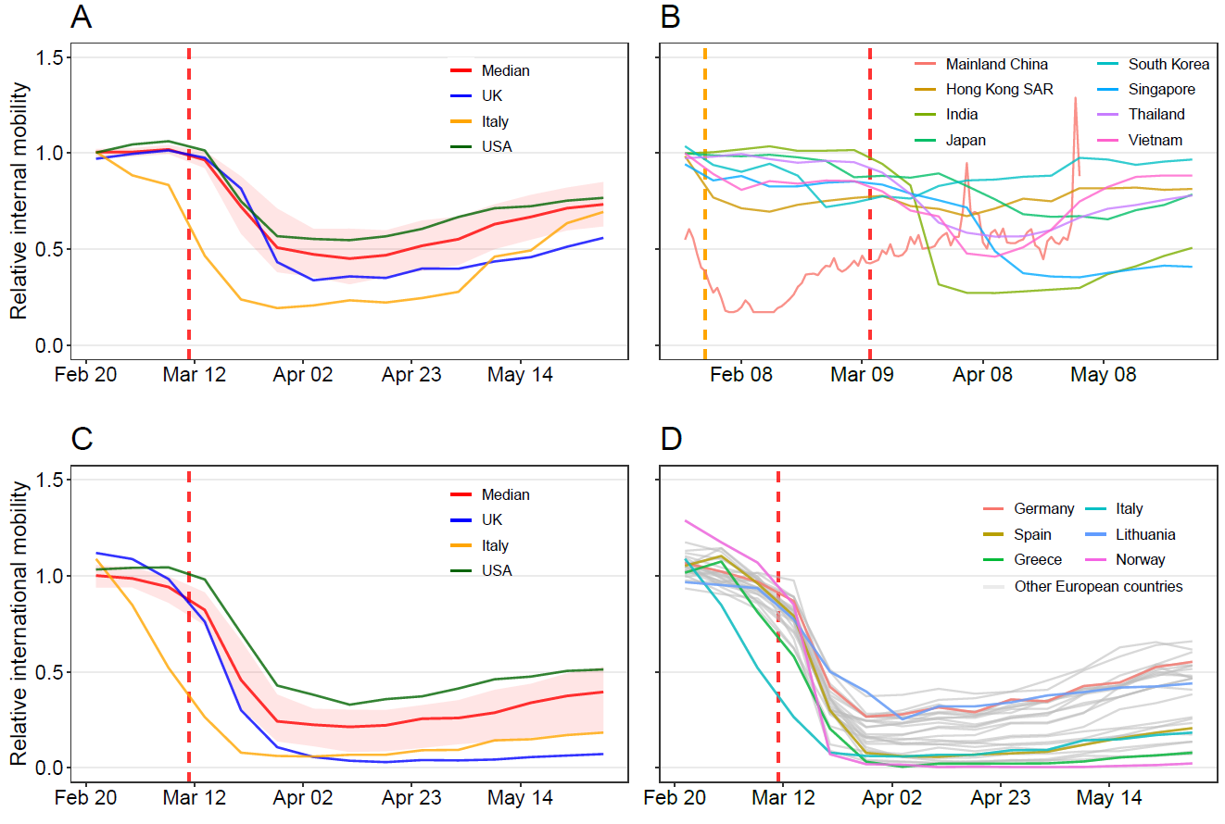
Fig. 1. Changing patterns of internal and international population movements across countries or territories, as of May 30, 2020. (A) Domestic weekly movements within 127 countries or territories, taking movements on January 5 – February 15, 2020 as a reference. (B) Domestic population movements within 8 Asian countries/regions. The daily mobility within mainland China from January 23 to May 2, 2020 was derived from Baidu location-based data, standardized by averaged travel flow on January 5 – 22 before Wuhan’s lockdown on January 23, 2020. All other country or region curves were derived from weekly Google location history data, taking movements on January 5 – 25 as a reference. (C) Relative international outflows from 104 countries with available international mobility data. The median and interquartile range are showed, with the UK, Italy, and the USA highlighted. (D) Relative international outflows from all European countries. The weekly international mobility measures, derived from Google data, took movements on January 5 – February 15 as a reference. The orange and red vertical dashed lines indicate the date of COVID-19 being declared a Public Health Emergency of International Concern and a pandemic by the WHO, respectively. The median (red line) and interquartile range (pink areas) are provided in (A) and (C), with the curves of Italy, the United Kingdom (UK), and the United States of America (USA) highlighted. Each curve in (B) and (D) represents the relative travel pattern of a country or territory. SAR: Special Administrative Region.

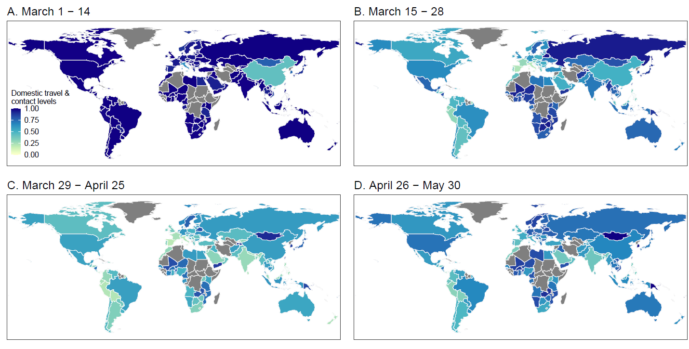
Fig. 2. Domestic travel and contact levels by country/territory across 135 countries or territories. (A) Population mobility for the two weeks from March 1 - 14, 2020, relative to reference periods. (B) Population mobility for the two week of March 15 - 28, 2020. (C) Population mobility during the four weeks from March 29 to April 25, 2020. (D) Population mobility for the five weeks from April 26 – May 30, 2020. The daily mobility data in mainland China derived from Baidu location-based data as of May 2, 2020 were standardized by the mobility levels on January 5 – 22, 2020. All other 134 countries or territories used Google location history data, with 127 countries or territories taking movements on January 5 – February 15, 2020 as a reference period (Fig. 1A), and 7 Asian countries/regions taking movements on January 5 – 25 as a reference (Fig. 1B). The administrative boundary maps at 1:110m scales were obtained from the Natural Earth (www.naturalearthdata.com). The regions without data are filled with a grey color.

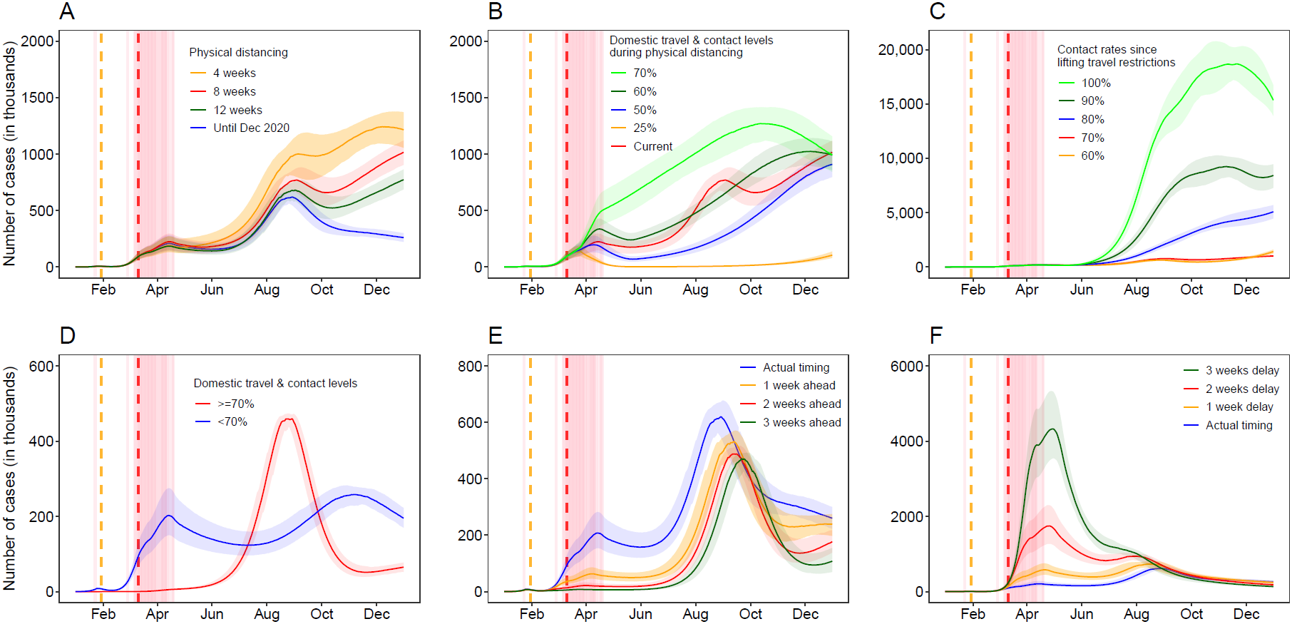
Fig. 3. Estimated epicurves of COVID-19 under different intervention scenarios across 135 countries or territories in 2020. (A) Implementing travel and physical distancing interventions during various periods. The median and interquartile range of estimates are provided. (B) 8-week interventions with various levels of travel and contact rates. In (A) and (B), the travel and contact levels after relaxing interventions were assumed to be 70% of normal level before outbreaks, if the travel and contact rates in a country or territory were lower than 70%. (C) Scenarios of various travel and contact rates after lifting 8-week interventions. (D) The estimated epicurves under interventions up until December 31, 2020 based on travel and contact levels by May 2, 2020: 14 countries/territories with travel and contact rates higher than or equal to 70%; 121 countries/territories with the rate less than 70% at any week. (E) Estimated epicurves under interventions implemented earlier than actual timing, under the scenario of interventions implemented by December 31, 2020. (F) Estimated epicurves under interventions implemented later than actual timing, under the scenario of interventions implemented up until December 31, 2020. The orange and red vertical dashed lines indicate the date of COVID-19 being declared a Public Health Emergency of International Concern and a pandemic by the WHO, respectively. The pink vertical lines indicate the dates of lockdown/physical distancing measures implemented by each country or territory.

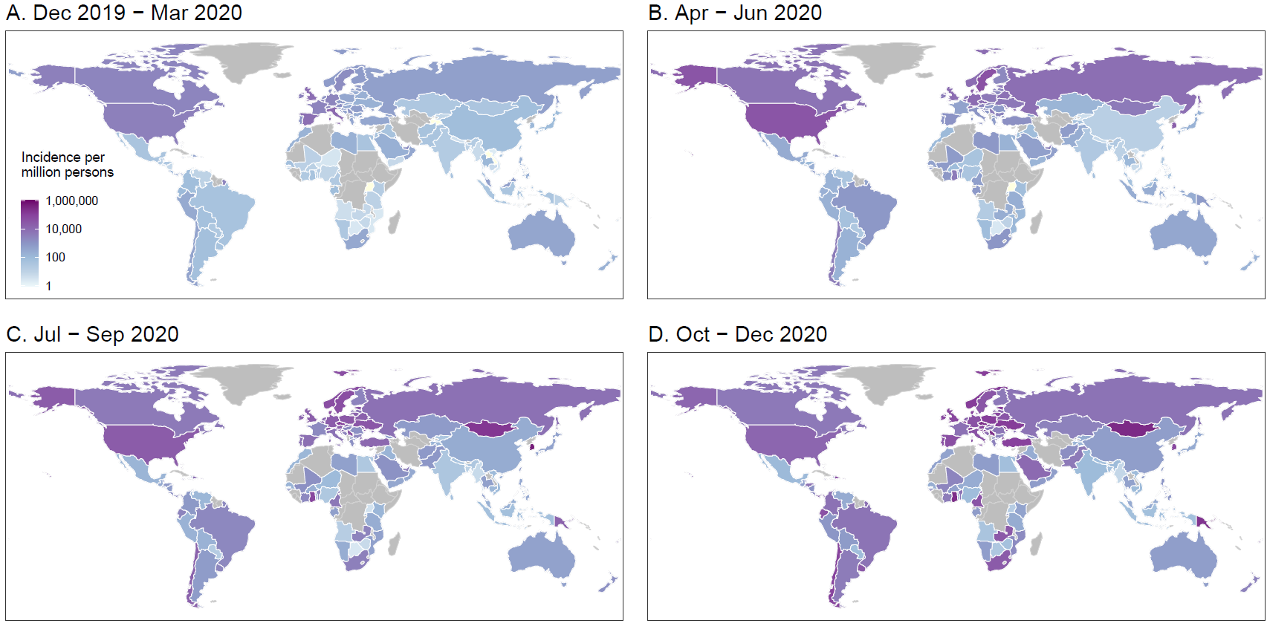
Fig. 4. Estimated incidence of COVID-19 cases by season and country/territory (n=135), under 8-week travel and physical distancing interventions in the first wave of the pandemic. (A) Estimated incidence in December 2019 – March 2020. (B) Estimated incidence in April – June 2020. (C) Estimated incidence in July– September 2020. (D) Estimated incidence in October– December 2020. The estimated incidence was standardized by the population counts of each country/territory in 2020. If the travel and contact rates in a country or territory were lower than 70% of normal levels before outbreaks, the rates were assumed to return to 70% after relaxing interventions. The administrative boundary maps at 1:110m scales were obtained from the Natural Earth (www.naturalearthdata.com). The areas without mobile phone data and estimates are filled with a grey color.

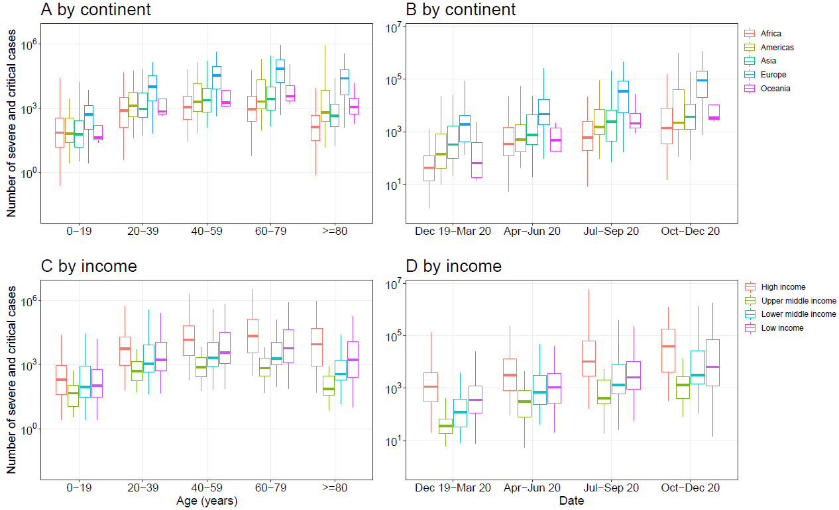
Fig. 5. Estimates of severe and critical COVID-19 cases in 135 countries or territories. (A) Estimates by age and continent. (B) Estimates by season and continent. (C) Estimates by age and income classification of each country or territory. (D) Estimates by season and income classification of each country or territory. The estimates were based on the scenario of 8-week travel and physical distancing interventions by May 30, 2020. If the travel and contact rates in a country or territory were lower than 70% of normal levels before outbreaks, the rates were assumed to return to 70% after relaxing interventions. The estimates of severe and critical infections were preliminarily based on the age structures of populations in each country/territory in 2020 [55] and the age-specific severity risk of confirmed COVID-19 cases reported from Wuhan over the outbreak [50].

Acknowledgments: The authors would like to acknowledge Google and Baidu for sharing population movement data. This study was supported by the grants from the Bill & Melinda Gates Foundation (OPP1134076, INV-024911). N.R. is supported by funding from the Bill & Melinda Gates Foundation (OPP1170969). O.P. is supported by the National Science Foundation (1816075). A.J.T. is supported by funding from the Bill & Melinda Gates Foundation (OPP1106427, OPP1032350, OPP1134076, OPP1094793), the Clinton Health Access Initiative, the UK Department for International Development (DFID) and the Wellcome Trust (106866/Z/15/Z, 204613/Z/16/Z).
Author contributions: S.L. designed the research. S.L., N.W.R., and O.P. built the model. S.L. ran simulations and carried out analyses. A.C., C.W.R., and J.R.F provided technical support. N.W.R, A.C., C.W.R., and J.R.F helped with data curation. A.C. collated the age-structure data of populations. C.Z. and X.D. collated Baidu mobility aggregated dataset. O.P., C.Z., X.D., and W.Y. did not access to the Google data used in this study. S.L. wrote the first draft of manuscript. S.L., N.W.R., A.C., C.W.R., J.R.F., O.P., C.Z., X.D., W.Y., and A.J.T. commented on and edited the manuscript.
Competing interests: All authors declare no competing interests.
Data and materials availability: Code for the model simulations is available at the following GitHub repository: https://github.com/wpgp/BEARmod. The data on COVID-19 cases and interventions reported by country are available from the data sources listed in Materials and Methods. The parameters and population data for running simulations and estimating the severity are listed in Supplementary data 1 and 2. The population movement data obtained from Baidu are publicly available online at: https://qianxi.baidu.com/. The Google COVID-19 Aggregated Mobility Research Dataset used for this study is available with permission from Google LLC.
Ethical approval: Ethical clearance for collecting and using secondary population mobility data in this study was granted by the institutional review board of the University of Southampton (No. 48002). All data were supplied and analyzed in an anonymous format, without access to personal identifying information.

Supplementary data:
Supplementary data 1. The parameters and intervention timings for simulations in each country or territory.
Supplementary data 2. The age structures of populations in each country or territory in 2020.
Supplementary data 3. Figure S1 to Figure S10.

References
1. World Health Organization. Coronavirus disease (COVID-19) pandemic. 2020 [https://www.who.int/emergencies/diseases/novel-coronavirus-2019]. Accessed 29 February 2020
2. Bonaccorsi G, Pierri F, Cinelli M, Flori A, Galeazzi A, Porcelli F, et al. Economic and social consequences of human mobility restrictions under COVID-19. Proc Natl Acad Sci U S A. 2020.
3. Yang J, Li J, Lai S, Ruktanonchai CW, Xing W, Carioli A, et al. Uncovering two phases of early intercontinental COVID-19 transmission dynamics. J Travel Med. 2020; 27.
4. Walker PGT, Whittaker C, Watson OJ, Baguelin M, Winskill P, Hamlet A, et al. The impact of COVID-19 and strategies for mitigation and suppression in low- and middle-income countries. Science. 2020:eabc0035.
5. Flaxman S, Mishra S, Gandy A, Unwin HJT, Mellan TA, Coupland H, et al. Estimating the effects of non-pharmaceutical interventions on COVID-19 in Europe. Nature. 2020.
6. Hu M, Lin H, Wang J, Xu C, Tatem AJ, Meng B, et al. The risk of COVID-19 transmission in train passengers: an epidemiological and modelling study. Clin Infect Dis. 2020.
7. Koo JR, Cook AR, Park M, Sun Y, Sun H, Lim JT, et al. Interventions to mitigate early spread of SARS-CoV-2 in Singapore: a modelling study. Lancet Infect Dis. 2020.
8. Cowling BJ, Ali ST, Ng TWY, Tsang TK, Li JCM, Fong MW, et al. Impact assessment of non-pharmaceutical interventions against coronavirus disease 2019 and influenza in Hong Kong: an observational study. Lancet Public Health. 2020.
9. Lai S, Ruktanonchai NW, Zhou L, Prosper O, Luo W, Floyd JR, et al. Effect of non-pharmaceutical interventions to contain COVID-19 in China. Nature. 2020.
10. European Centre for Disease Prevention and Control. Considerations relating to social distancing measures in response to COVID-19 - second update. 2020 [https://www.ecdc.europa.eu/sites/default/files/documents/covid-19-social-distancing-measuresg-guide-second-update.pdf]. Accessed 27 April 2020
11. Fong MW, Gao H, Wong JY, Xiao J, Shiu EYC, Ryu S, et al. Nonpharmaceutical Measures for Pandemic Influenza in Nonhealthcare Settings-Social Distancing Measures. Emerg Infect Dis. 2020; 26.
12. Chinazzi M, Davis JT, Ajelli M, Gioannini C, Litvinova M, Merler S, et al. The effect of travel restrictions on the spread of the 2019 novel coronavirus (COVID-19) outbreak. Science. 2020.
13. Tian H, Liu Y, Li Y, Wu CH, Chen B, Kraemer MUG, et al. An investigation of transmission control measures during the first 50 days of the COVID-19 epidemic in China. Science. 2020.
14. Zhang J, Litvinova M, Liang Y, Wang Y, Wang W, Zhao S, et al. Changes in contact patterns shape the dynamics of the COVID-19 outbreak in China. Science. 2020:eabb8001.
15. Haug N, Geyrhofer L, Londei A, Dervic E, Desvars-Larrive A, Loreto V, et al. Ranking the effectiveness of worldwide COVID-19 government interventions. Nat Hum Behav. 2020; 4:1303-1312.
16. Brauner JM, Mindermann S, Sharma M, Johnston D, Salvatier J, Gavenciak T, et al. Inferring the effectiveness of government interventions against COVID-19. Science. 2020.
17. Maier BF, Brockmann D. Effective containment explains subexponential growth in recent confirmed COVID-19 cases in China. Science. 2020.
18. Leung K, Wu JT, Liu D, Leung GM. First-wave COVID-19 transmissibility and severity in China outside Hubei after control measures, and second-wave scenario planning: a modelling impact assessment. Lancet. 2020.
19. Kissler SM, Tedijanto C, Goldstein E, Grad YH, Lipsitch M. Projecting the transmission dynamics of SARS-CoV-2 through the postpandemic period. Science. 2020.
20. Prem K, Liu Y, Russell TW, Kucharski AJ, Eggo RM, Davies N, et al. The effect of control strategies to reduce social mixing on outcomes of the COVID-19 epidemic in Wuhan, China: a modelling study. Lancet Public Health. 2020.
21. Lopez L, Rodo X. The end of social confinement and COVID-19 re-emergence risk. Nat Hum Behav. 2020.
22. Pang X, Ren L, Wu S, Ma W, Yang J, Di L, et al. Cold-chain food contamination as the possible origin of COVID-19 resurgence in Beijing. National Science Review. 2020; 7:1861-1864.
23. Ruktanonchai NW, Floyd JR, Lai S, Ruktanonchai CW, Sadilek A, Rente-Lourenco P, et al. Assessing the impact of coordinated COVID-19 exit strategies across Europe. Science. 2020; 369:1465-1470.
24. Buckee CO, Balsari S, Chan J, Crosas M, Dominici F, Gasser U, et al. Aggregated mobility data could help fight COVID-19. Science. 2020; 368:145.
25. Lai S, Farnham A, Ruktanonchai NW, Tatem AJ. Measuring mobility, disease connectivity and individual risk: a review of using mobile phone data and mHealth for travel medicine. J Travel Med. 2019; 26.
26. Ruktanonchai NW, Ruktanonchai CW, Floyd JR, Tatem AJ. Using Google Location History data to quantify fine-scale human mobility. Int J Health Geogr. 2018; 17:28.
27. Lai S, Bogoch I, Ruktanonchai N, Watts A, Lu X, Yang W, et al. Assessing spread risk of COVID-19 within and beyond China, January-April 2020: a travel network-based modelling study. medRxiv. 2020:2020.2002.2004.20020479.
28. Wu JT, Leung K, Leung GM. Nowcasting and forecasting the potential domestic and international spread of the 2019-nCoV outbreak originating in Wuhan, China: a modelling study. Lancet. 2020.
29. Google. COVID-19 Community Mobility Reports. 2020 [https://www.google.com/covid19/mobility/]. Accessed
30. Oliver N, Lepri B, Sterly H, Lambiotte R, Delataille S, De Nadai M, et al. Mobile phone data for informing public health actions across the COVID-19 pandemic life cycle. Science Advances. 2020:eabc0764.
31. Bassolas A, Barbosa-Filho H, Dickinson B, Dotiwalla X, Eastham P, Gallotti R, et al. Hierarchical organization of urban mobility and its connection with city livability. Nat Commun. 2019; 10:4817.
32. Ardalan MR, Shoja MM. Rapidly progressive glomerulonephritis in a patient with brucellosis. Nephrol Dial Transplant. 2006; 21:1743-1744.
33. Rader B, Scarpino SV, Nande A, Hill AL, Adlam B, Reiner RC, et al. Crowding and the shape of COVID-19 epidemics. Nat Med. 2020.
34. Wilson R, Zhang CY, Lam W, Desfontaines D, Simmons-Marengo D, Gipson B. Differentially Private SQL with Bounded User Contribution. Proceedings on Privacy Enhancing Technologies Symposium. 2020.
35. Baidu Migration. 2020 [https://qianxi.baidu.com/]. Accessed 8 February 2020
36. Lai S, Wangteeraprasert T, Sermkaew T, Nararak O, Binsard S, Phanawadee M, et al. Evaluation of Three Main Tuberculosis Case Reporting Systems in Satun Province, Thailand, 2011. Outbreak, Surveillance and Investigation Reports. 2014; 7:8.
37. European Centre for Disease Prevention and Control. Download today's data on the geographic distribution of COVID-19 cases worldwide. 2020 [https://www.ecdc.europa.eu/en/publications-data/download-todays-data-geographic-distribution-covid-19-cases-worldwide]. Accessed 2 May 2020
38. National Health Commission of China. COVID-19 outbreak notification in China. 2021 [http://www.nhc.gov.cn/xcs/yqtb/list_gzbd.shtml]. Accessed 10 January 2021
39. Chinese Center for Disease Control and Prevention. The Knowledge Center for China's Experiences in Response to COVID-19: Prevention and Control Measure of COVID-19 in China. 2020 [https://covid19.21wecan.com/covid19en/c100037/202004/abfdd96da7f340fe9e4ca8a063b0d2a6.shtml]. Accessed 25 April 2020
40. Centre for Health Protection HKS, . Data in Coronavirus Disease (COVID-19). 2020 [https://data.gov.hk/en-data/dataset/hk-dh-chpsebcddr-novel-infectious-agent]. Accessed 28 April 2020
41. Bureau of Health MS, . Information about confirmed diagnosed Patients with novel coronavirus (2019-nCoV) in Macau SAR. 2020 [https://www.ssm.gov.mo/apps1/PreventCOVID-19/en.aspx#clg17046]. Accessed 28 April 2020
42. Li Q, Guan X, Wu P, Wang X, Zhou L, Tong Y, et al. Early Transmission Dynamics in Wuhan, China, of Novel Coronavirus-Infected Pneumonia. N Engl J Med. 2020.
43. Yang WZ, Lan YJ, Lyu W, Leng ZW, Feng LZ, Lai SJ, et al. [Establishment of multi-point trigger mechanism and multi-channel surveillance mechanism for intelligent early warning of infectious diseases in China]. Zhonghua Liu Xing Bing Xue Za Zhi. 2020; 41:E079.
44. United Nations Office for the Coordination of Humanitarian Affairs. ACAPS COVID-19: Government Measures Dataset. 2020 [https://data.humdata.org/dataset/acaps-covid19-government-measures-dataset]. Accessed 28 April 2020
45. Wallinga J, Lipsitch M. How generation intervals shape the relationship between growth rates and reproductive numbers. Proc Biol Sci. 2007; 274:599-604.
46. Obadia T, Haneef R, Boelle PY. The R0 package: a toolbox to estimate reproduction numbers for epidemic outbreaks. BMC Med Inform Decis Mak. 2012; 12:147.
47. Boelle PY, Bernillon P, Desenclos JC. A preliminary estimation of the reproduction ratio for new influenza A(H1N1) from the outbreak in Mexico, March-April 2009. Euro Surveill. 2009; 14.
48. Hens N, Van Ranst M, Aerts M, Robesyn E, Van Damme P, Beutels P. Estimating the effective reproduction number for pandemic influenza from notification data made publicly available in real time: a multi-country analysis for influenza A/H1N1v 2009. Vaccine. 2011; 29:896-904.
49. Abbott S, Hellewell J, Thompson R, Sherratt K, Gibbs H, Bosse N, et al. Estimating the time-varying reproduction number of SARS-CoV-2 using national and subnational case counts [version 2; peer review: 1 approved with reservations]. Wellcome Open Research. 2020; 5.
50. Pan A, Liu L, Wang C, Guo H, Hao X, Wang Q, et al. Association of Public Health Interventions With the Epidemiology of the COVID-19 Outbreak in Wuhan, China. JAMA. 2020.
51. Huang L, Zhang X, Zhang X, Wei Z, Zhang L, Xu J, et al. Rapid asymptomatic transmission of COVID-19 during the incubation period demonstrating strong infectivity in a cluster of youngsters aged 16-23 years outside Wuhan and characteristics of young patients with COVID-19: A prospective contact-tracing study. J Infect. 2020; 80:e1-e13.
52. Li R, Pei S, Chen B, Song Y, Zhang T, Yang W, et al. Substantial undocumented infection facilitates the rapid dissemination of novel coronavirus (SARS-CoV2). Science. 2020.
53. Hellewell J, Abbott S, Gimma A, Bosse NI, Jarvis CI, Russell TW, et al. Feasibility of controlling COVID-19 outbreaks by isolation of cases and contacts. The Lancet Global Health.
54. Wuhan Bureau of Statistics. Wuhan Statistical Yearbook - 2018. 2020 [http://www.wuhandata.gov.cn/whData/directory-detail.html?id=d018c032-43b9-420a-8081-834e88f25a5f]. Accessed 10 April 2020
55. Pezzulo C, Hornby GM, Sorichetta A, Gaughan AE, Linard C, Bird TJ, et al. Sub-national mapping of population pyramids and dependency ratios in Africa and Asia. Sci Data. 2017; 4:170089.
56. 2019 Global Health Security Index. 2020 [https://www.ghsindex.org/]. Accessed 25 April 2020
57. Normile D. As normalcy returns, can China keep COVID-19 at bay? Science. 2020; 368:18.
58. Young BE, Ong SWX, Kalimuddin S, Low JG, Tan SY, Loh J, et al. Epidemiologic Features and Clinical Course of Patients Infected With SARS-CoV-2 in Singapore. JAMA. 2020.
59. Richardson S, Hirsch JS, Narasimhan M, Crawford JM, McGinn T, Davidson KW, et al. Presenting Characteristics, Comorbidities, and Outcomes Among 5700 Patients Hospitalized With COVID-19 in the New York City Area. JAMA. 2020.
60. Grasselli G, Zangrillo A, Zanella A, Antonelli M, Cabrini L, Castelli A, et al. Baseline Characteristics and Outcomes of 1591 Patients Infected With SARS-CoV-2 Admitted to ICUs of the Lombardy Region, Italy. JAMA. 2020.
61. Tsang TK, Wu P, Lin Y, Lau EHY, Leung GM, Cowling BJ. Effect of changing case definitions for COVID-19 on the epidemic curve and transmission parameters in mainland China: a modelling study. Lancet Public Health. 2020.
62. Chu DK, Akl EA, Duda S, Solo K, Yaacoub S, Schünemann HJ, et al. Physical distancing, face masks, and eye protection to prevent person-to-person transmission of SARS-CoV-2 and COVID-19: a systematic review and meta-analysis. Lancet.
63. Baker RE, Yang W, Vecchi GA, Metcalf CJE, Grenfell BT. Susceptible supply limits the role of climate in the early SARS-CoV-2 pandemic. Science. 2020.
64. Yang J, Chen X, Deng X, Chen Z, Gong H, Yan H, et al. Disease burden and clinical severity of the first pandemic wave of COVID-19 in Wuhan, China. Nat Commun. 2020; 11:5411.
65. Mistry D, Litvinova M, Pastore YPA, Chinazzi M, Fumanelli L, Gomes MFC, et al. Inferring high-resolution human mixing patterns for disease modeling. Nat Commun. 2021; 12:323.
66. Kandel N, Chungong S, Omaar A, Xing J. Health security capacities in the context of COVID-19 outbreak: an analysis of International Health Regulations annual report data from 182 countries. Lancet. 2020; 395:1047-1053.
67. Alegana VA, Maina J, Ouma PO, Macharia PM, Wright J, Atkinson PM, et al. National and sub-national variation in patterns of febrile case management in sub-Saharan Africa. Nat Commun. 2018; 9:4994.

