Collective behaviour of the European minnow (Phoxinus phoxinus) is influenced by signals of differing acoustic complexity
Helen A.L. Currie, ^{1*} Paul R. White, ² Timothy G. Leighton, ² and Paul S. Kemp. ¹

- International Centre for Ecohydraulics Research (ICER), University of Southampton, Boldrewood Innovation Campus, Southampton SO16 7QF UK

- Institute of Sound and Vibration Research, University of Southampton, Highfield, Southampton SO17 1BJ UK

* Corresponding author Helen.Currie@soton.ac.uk
ORCID iD for Helen A. L. Currie: orcid.org/0000-0001-5792-3488
ORCID iD for Paul R. White: orcid.org/0000-0002-4787-8713
ORCID iD for Timothy G. Leighton: orcid.org/0000-0002-1649-8750
ORCID iD for Paul S. Kemp: orcid.org/0000-0003-4470-0589
Abstract
Collective behaviour, such as shoaling in fish, benefits individuals through a variety of activities such as social information exchange and anti-predator defence. Human driven disturbance (e.g. anthropogenic noise) is known to affect the behaviour and physiology of individual animals, but the disruption of social aggregations of fish remains poorly understood. Anthropogenic noise originates from a variety of activities and differs in acoustic structure, dominant frequencies, and spectral complexity. The response of groups of fish may differ greatly, depending on the type of noise, and how it is perceived (e.g. threatening or attractive). In a controlled laboratory study, high resolution video tracking in combination with fine scale acoustic mapping was used to investigate the response of groups of European minnows (Phoxinus phoxinus) to signals of differing acoustic complexity (sinewave tones vs octave band noise) under low (150 Hz) and high (2200 Hz) frequencies. Fish startled and decreased their mean group swimming speed under all four treatments, with low frequency sinewave tones having the greatest influence on group behaviour. The shoals exhibited spatial avoidance during both low frequency treatments, with more time spent in areas of lower acoustic intensity than expected. This study illustrates how noise can influence the spatial distribution and social dynamics within groups of fish, and due to the high potential for freshwater aquatic environments to be influenced by anthropogenic activity, wider consequences for populations should be further investigated.
Key words
anthropogenic noise, fish, group behaviour, social dynamics, spatial avoidance
1. Introduction
The social aggregation of fish is common and has numerous benefits for the individual, including mating (pencil-streaked rabbitfish, Siganus doliatus: Fox et al., 2015), foraging (guppy, Poecilia reticulata: Day et al., 2001), and reduction of energy expenditure (mullet, Chelon labrosus: Hemelrijk et al., 2015). Functionally, collective behaviour is advantageous as an anti-predator strategy (artificial prey computer simulation: Ruxton et al., 2007), whereby schooling can confuse predators (largemouth bass, Micropterus salmoides: Landeau and Terborgh, 1986; Larsson, 2009) or accelerate the transmission of an alert signal among conspecifics within a group before a threat is detected first-hand by some individuals (Gulf menhaden, Brevoortia patronus: Handegard et al., 2012). However, anthropogenic disturbance can disrupt the collective behaviour of fish, resulting in the benefits bestowed being lost. For example, modification of group cohesion has been observed in response to exposure to artificial light (Atlantic mackerel, Scomber scombrus: Glass et al., 1986; estuarine round-herring, Gilchristella aestuaria, and Cape silverside, Atherina breviceps: Becker et al., 2013), chemical pollution (golden shiner, Notemigonus crysoleucas: Webber and Haines, 2003; Scott and Sloman, 2004), waterway obstruction (e.g. silver carp, Hypophthalmichthys molitrix, at dams or weirs: Mao, 2018), hypoxia (Atlantic herring, Clupea harengus: Domenici et al., 2000; 2017), and noise (sea bass, Dicentrarchus labrax: Herbert-Read et al., 2017a). Anthropogenic noise (unwanted, disruptive sound) is a highly pervasive pollutant of international concern (WHO, 2011), and is well known to have detrimental impacts on fish behaviour and ecology (Slabbekoorn et al., 2010; Kunc et al., 2016). The specific causal mechanisms by which acoustic signals influence group behaviour in fish, however, is not fully understood.
Anthropogenic noise may mask communicative calls (Lusitanian toadfish, Halobatrachus didactylus: Vasconcelos et al., 2007), impair anti-predator responses (European eel, Anguilla anguilla: Simpson et al., 2015), or modify the coordinated movements of fish within a group (e.g. sea bass: Herbert-Read et al., 2017a). Previously, the impact of anthropogenic broadband noise (e.g. continuous and intermittent Brownian noise: Neo et al., 2014; pile driving noise: Herbert-Read et al., 2017a) on the collective behaviour of fish has been investigated. A gap in understanding, however, exists in relation to the influence of “acoustic complexity” on fish aggregations. The acoustic complexity of a signal is not a well-defined concept. For example, complexity is frequently based on the entropy of a signal (Sueur et al., 2014), but also relates to its bandwidth, since this determines the amount of information which can be conveyed (Shannon, 1948). A sinewave represents an example of a simple signal since it has low entropy, and a narrow bandwidth. In this study, we define complex sound to be random-noise like signals which are more informatively complex, having higher entropy and wider bandwidths.
Group behaviour (e.g. cohesion and orientation) may be influenced by the structural complexity of the signal (Candolin, 2003), a commonly studied acoustic parameter in animal communication (e.g. avian vocalisations: Pieretti et al., 2011), although seldom considered in studies that quantify impacts of anthropogenic noise. Simple tonal (sinewave) signals also appear in the natural environment, albeit relatively infrequently compared to complex signals. For example, tonal bursts are used to maintain a territory (Bocon toadfish, Amphichthys cryptocentrus: Salas et al., 2018) or attract a mate (elephantfish, Pollimyrus adspersus: Crawford, 1997). Human generated low frequency noise tends to be complex, and is widely spatially distributed (e.g. shipping or boating: Sarà et al., 2007; Solan et al., 2016; Amoser et al., 2004; dredging, platform construction and pile driving: Greene Jr. and Moore, 1995; Solan et al., 2016). However, simple signals are also common, frequently deployed as acoustic deterrents (e.g. to limit spread of invasive fishes or direct native species away from anthropogenic hazards: Putland and Mensinger, 2019) and harassment devices (e.g. to keep marine mammals away from aquaculture facilities: Götz and Janik, 2013), or as sonar transmissions (Hildebrand, 2009; Kastelein and Hoek, 2010). Both complex and simple signals of anthropogenic origin can be received and processed by fish (Crawford, 1997; Hawkins and Popper, 2014; Stange et al., 2017; Vetter et al., 2017; e.g. Cypriniform auditory sensitivity: ~ 0.1 – 7 kHz: Putland and Mensinger, 2019).
While complex signals can be represented as the combination of tones, discerning fish behaviour in response to a simple tonal component will not enable the prediction of the response to more complex signals. Studies are beginning to address how vast differences in the signal characteristics of anthropogenic sound sources can differentially impact fish swimming behaviour (e.g. complexity of 2-stroke vs 4-stroke engine noise: McCormick et al., 2019: temporal structure: Neo et al., 2015a; Currie et al., 2020), however, a reductionist understanding of how fish groups respond to specific acoustic components of sound stimuli, such as complexity, is still lacking. This study investigated the effect of acoustic complexity on the group behaviour of a shoaling species of fish under experimental conditions by comparing their response to either simple (tonal) or complex (octave band noise) acoustic stimuli. Knowledge surrounding the collective behavioural responsiveness of fish to acoustic signals of differing complexity will aid in conservation efforts to reduce the impact of harmful components of anthropogenic noise, or may be applied to the development of more effective behavioural guidance systems. Using the European minnow (Phoxinus phoxinus: Linnæus, 1758) as the model species because of its strong facultative shoaling behaviour (Partridge, 1980; Pitcher et al., 1986; Ward and Krause, 2001) and local abundance, this study tested 250 fish over a total of 50 independent trials in response to four acoustic playback treatments, and one “silent” (ambient noise) control. Quantification of response to two different acoustic frequencies (low: 150 Hz, or high: 2200 Hz) were included as a secondary aim so that a greater understanding of the acoustic range over which minnows respond could be ascertained in light of the fact that no audiogram exists for this species. The study concentrated on five group behaviour metrics commonly used to assess the impacts of environmental stressors on fish behaviour. To quantify the response to the signal, we investigated: 1) presence of a startle response at the onset of the signal (e.g. Nedelec et al., 2015); 2) group swimming speed (e.g. Neo et al., 2015b); 3) cohesion (e.g. Herbert-Read et al., 2017a); 4) orientation (e.g. Herbert-Read et al., 2017a); and 5) shoal distribution (e.g. Neo et al., 2015b) relative to areas of different acoustic intensity. Given the added informative value of more complex acoustic signals, it was hypothesised that these would elicit a greater deviation in response from the control across the five behaviour metrics in comparison to simple signals. A controlled experimental approach was adopted in which fish response to acoustics was tested in a still-water tank. As opposed to marine species that experience very different acoustic conditions in the wild (Tonolla et al., 2010; Marley et al., 2016), this methodology is more appropriate when working with a species that inhabits riverine environments (e.g. shallow water, narrow width and often anthropogenically modified banks and beds) (Campbell et al., 2019; Leighton et al., 2019; Currie et al., 2020).

2. Materials and Methods
2.1 Study Species and Husbandry
In August 2016, 273 adult European minnows (♂ : ♀ unknown) were collected using a seine net from the River Itchen navigation channel, Hampshire, UK (51ᵒ02’58.9”N 1ᵒ18’42.2”W). The waterway holds environmental designations (e.g. Special Area of Conservation) and lacks boating activity. The average width of the slow flowing freshwater channel was 15 m, and depth ranged from 0.34 m in the shallows where fish were mainly acquired, to 0.94 m. Sediment was composed of silt, clay and gravel. Minnows typically inhabit river and lake habitats and are found across a wide geographical range within Europe and northern Asia, including the brackish coastal waters of the Baltic Sea (Svirgsden et al., 2018). They are subjected to a vast range of anthropogenic noise disturbance including boating, shipping, and road traffic noise, sonar, and pile driving (Amoser et al., 2004; Kozaczka and Grazyna, 2011).
Fish were transported to the University of Southampton’s International Centre for Ecohydraulics Research facility and gradually introduced over a period of three hours to one of two adjacent holding nets (0.78 m x 0.3 m x 0.62 m; water depth: 0.45 m; stocking density: 3.02 kg/ m⁻³) within a tank (1.5 m x 1.0 m x 0.78 m; water depth: 0.68 m; mean ± SE temperature 19.3 ± 0.2 ^{ᵒ}C). All minnows were in good physiological condition (no visible injuries). Fish were allowed to acclimate to captive conditions for five days prior to the start of the experiments. Water quality was maintained using a submersible aerated pump, and monitored to ensure optimum thresholds were not exceeded (NO³⁻: < 50 mg L⁻¹; NO²⁻: < 1 mg L⁻¹; NH₃: 0; and pH: < 8.4). Fish were kept on a 16:8 h light:dark photoperiod cycle, and fed to satiation with commercially available aquarium flaked food. Each fish was subjected to only one treatment. On completion of each trial fish were weighed (wet mass ±SE: 2.1 ± 0.1 g) and measured (standard length ± SE: 51.6 ± 0.4 mm). Wet mass (One-way ANOVAs: F_{1,4} = 0.35; p = 0.84) and standard length (F_{1,4} = 0.43; p = 0.79) of fish did not differ between the treatments. All experiments were approved by the University of Southampton’s Animal Welfare and Ethical Review Body (Ethics ID: 22982).

2.2 Experimental Arena
Experiments were performed within an acoustically isolated room, with in-air background SPLs monitored using a hand-held recorder (Mini Sound Level Meter N33GJ; measuring level range: 40 – 130 dB; accuracy: ± 3.5 dB @ 1 kHz, 94 dB under reference conditions; frequency weighting: dB(C); frequency response: 0.315 – 8 kHz; Maplin, Rotherham, UK). Readings were taken before the commencement of each trial to ensure ambient room conditions were standardised across treatments (averaged SPL of 40 dB re 20 μPa). Trials were conducted within a physically (but not acoustically) isolated experimental arena (86 cm x 30.8 cm x 30.2 cm) within a still water acrylic flume (300 cm x 30.8 cm x 30.2 cm), separated by two acoustically transparent dividers made of micro-mesh material (Figure 1).
The sound field was generated through two speakers (Electro-Voice UW-30; maximal output 153 dB re 1 μPa at 1 m for 150 Hz, Lubell Labs, Columbus, OH, USA), one behind each acoustic baffle, and fully immersed and suspended in place 7 cm from the floor of the flume. The opposing speakers were operating in phase. This set-up allowed for a more homogenous and non-directional acoustic field, ideally preventing left-right bias or orientation towards a source (Buwalda et al., 1983; Schuijf and Hawkins, 1983). Flume water was kept at a constant depth of 27 cm and replaced every ten trials, limiting debris build up within the experimental area. Experimental flume water changes were used as a precautionary measure to reduce the potential for cumulative effects of chemical alarm substance release (“Schreckstoff”, Pfeiffer et al., 1985; Hasan et al., 2018) by fish used in earlier experiments. Water was left to settle overnight, allowing for release of gas bubbles and a return to room temperature (mean ± SE 18.3 ± 0.1 ᵒC).
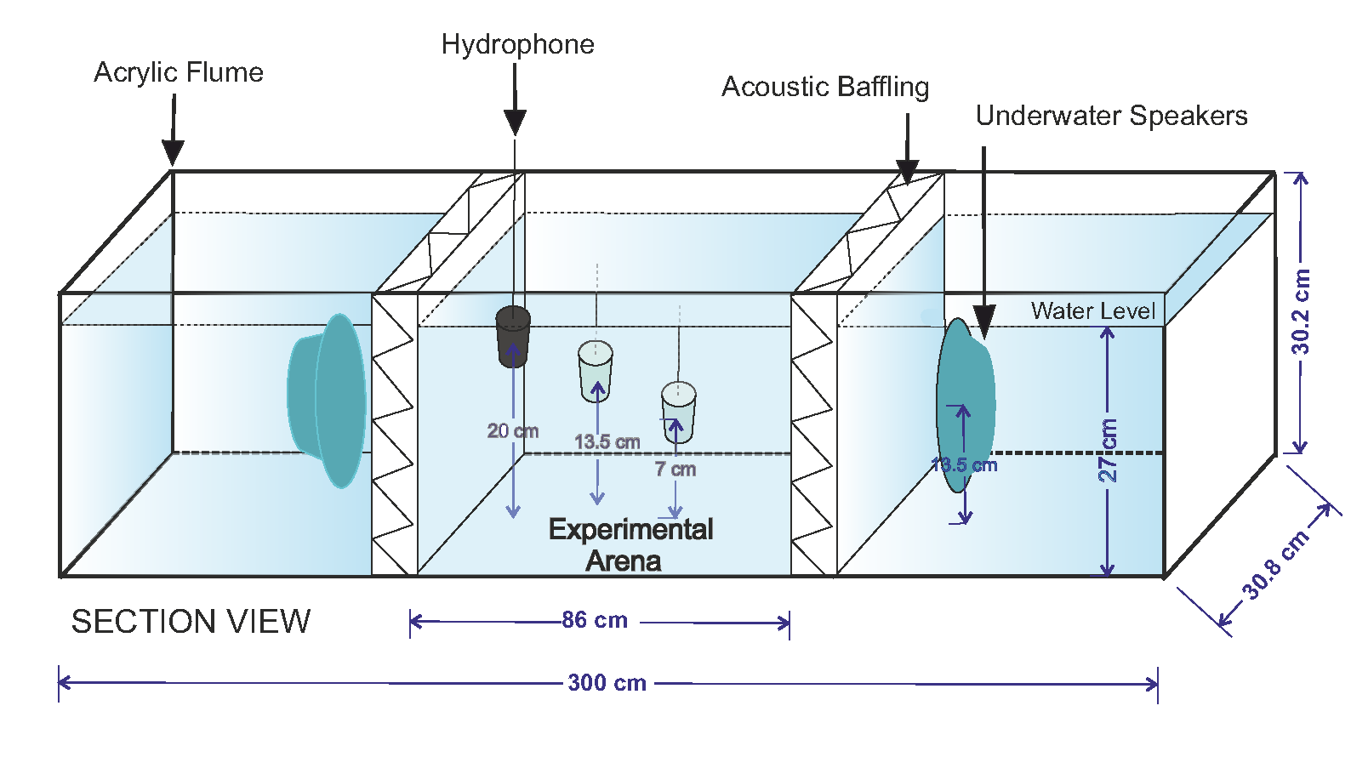
Figure 1: Section-view schematic of the experimental flume set-up with hydrophone positions shown for acoustic mapping at three water depths (7 cm; 13.5 cm; 20 cm).

Fish were visually isolated from the observer using black plastic sheeting attached to a large wooden frame, surrounding the experimental arena. To ensure light levels remained consistent between trials, two external spotlights were used to illuminate the room through two side-windows. Digital video recordings were obtained from a webcam (C920; HD 1080p; 30 frames per second; Logitech Pro, Switzerland) mounted above the tank. To increase contrast of the recordings, white-sheeting was attached outside the experimental area of the flume and lit from underneath by two PhotoSEL Photography bulbs (pure white full-spectrum flicker free; 85 W, 5000 lumen; SJT Commercial Ltd., UK).

2.3 Acoustic Stimuli and Mapping Protocol
While no audiograms currently exist for the European minnow, a number are available for closely related species (e.g. species with hearing specialisations: Pimephales promelas: 0.8 – 2 kHz: Scholik and Yan, 2001; and Pseudorasbora parva: 0.1 – 4 kHz: Scholz and Ladich, 2006). Combined with anecdotal evidence suggesting European minnows are capable of behaviourally responding to incremental tones up to 5 kHz (Dijkgraaf and Verheijen, 1950; Voellmy et al., 2014; Hanache et al., 2020), the upper and lower frequency limits of hearing were subsequently estimated. Low (150 Hz) and high (2200 Hz) frequencies deployed in the study were selected to be within the assumed hearing range for European minnow (Short et al., 2020). This range also covers frequency components commonly found in anthropogenically derived sound (e.g. boat traffic noise) in shallow water environments (Amoser et al., 2004; Kozaczka and Grazyna, 2011). All fish are sensitive to the displacement components of sound, particularly at lower frequencies, which is detected through the use of auditory and neuromast (lateral line) hair cells (Webb et al., 2008). In addition to particle motion, the hearing sensitivity of freshwater otophysine species is highly reliant on the sound pressure component of sound (Fay and Popper, 1974; Popper and Fay, 2011; Bretschneider et al., 2013). Cypriniforms possess accessory hearing structures (Weberian ossicles), which transmit oscillations from the gas-filled swimbladder (or other air bubble), to the inner ear. These specialisations allow for an enhanced auditory sensitivity to the sound pressure component, across a wider range of frequencies (Popper and Fay, 2011). This evolutionary adaptation is likely driven by the nature of sound propagation within extremely shallow water (e.g. riverine environments), allowing for an otherwise limited range of detection beyond the low frequency cut-off (Amoser and Ladich, 2005).

Sound samples were produced using custom written MATLAB script (Release 2015b, The Mathworks, Inc., Natick, Massachusetts, USA). A laptop computer connected via USB to a DAQ (NI USB-6341; National Instruments, UK) in turn transmitted the signal through a MOREL amplifier (MPS 4.400; 70 W, frequency response range approx. 0.01-30 kHz; MorelHifi, Israel), and on to the UW30 underwater speakers. Four acoustic treatments were used in the experiments (Figure 2): ‘SINE_150’ (150 Hz); ‘SINE_2200’ (2200 Hz); ‘NOISE_150’, octave band noise (centred at 150 Hz; frequency range: 106 -212 Hz); and ‘NOISE_2200’, octave band noise (centred at 2200 Hz; frequency range: 1556 – 3112 Hz). NOISE_150 and NOISE_2200 were produced by digitally filtering Gaussian white noise (sample rate: 25.6 kHz) using a 4th order elliptic filter with 0.5 dB passband ripple and 20 dB of stopband attenuation. For a signal with centre frequency, f_{c}, the cut-off frequencies of the filter were 0.7071 f_{c} and 1.414 f_{c}. Use of artificial stimuli allowed for tight control over the specific acoustic components being tested. It also ensured easy replicability, and reduced potential for pseudoreplication that may occur when pre-recorded sound samples contain artefacts (Kroodsma et al., 2001). Acoustic stimuli SPLs were standardised in the centre of the experimental arena so the intensities were ~150 dB (re 1 μPa), and background ambient noise in the experimental flume was recorded as less than 80 dB (re 1 μPa) (Figure 2). For SINE_150 and SINE_2200, the SPLs were calculated for the dominant stimulus frequency, whereas for NOISE_150 and NOISE_2200, they were calculated across the whole frequency band. The ‘seewave’ package in R was used to further characterise stimuli through calculation of the acoustic complexity index (ACI) for each treatment (Pieretti et al., 2011; McCormick et al., 2019) (sampling rate: 25.6 kHz; FFT 512; hamming window; frequency range: 50-5000 Hz; Figure 2). The metric is commonly used to characterise the natural variability of intensities in biotic sounds. Each acoustic stimulus involved playback of intermittent sound for one second ON: two seconds OFF, for a total of ten minutes. Stimuli were pulsed in an attempt to reduce the effects of acclimation and were more likely to evoke a stronger behavioural response (Rankin et al., 2009; Neo et al., 2014; 2018; Currie et al., 2020). A control group was tested under the same conditions in the absence of any additional acoustic playback stimuli, and post-experimental trials indicated there to be no confounding influence of an electromagnetic field (p > 0.5 for all parameters).
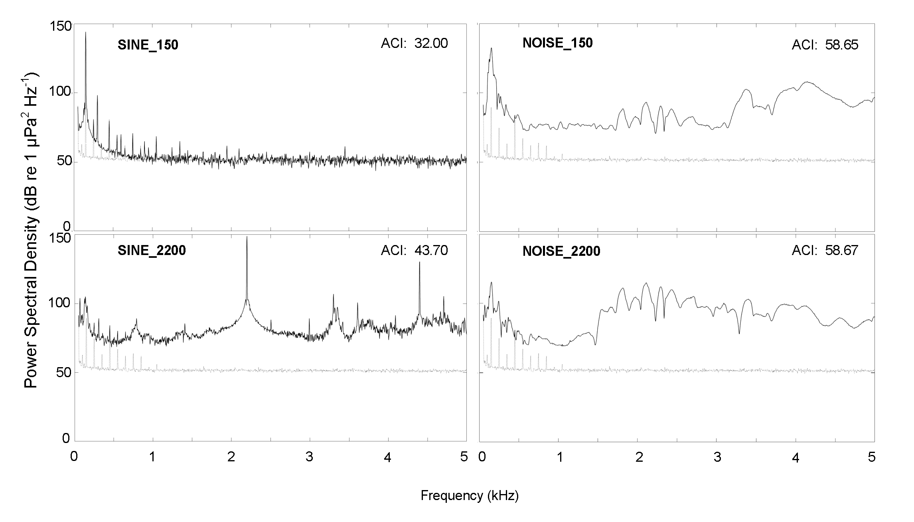
Figure 2. Power spectral densities (dB re 1 μPa² Hz⁻¹) and acoustic complexity index (ACI) of acoustic conditions (solid lines) plotted with baseline ambient noise conditions (dotted lines) in the experimental arena (sampling rate: 25.6 kHz; FFT 8192; overlap 91.5%; Hanning Window; frequency range 50 – 5000 Hz). Note: for ACIs, greater values indicate increasing complexity; a 5 ms ramp-up/ down Hanning taper was used to mitigate for the effects of speaker resonance at lower frequencies; a transient effect was observed for SINE_2200, also explaining the higher ACI for this tonal treatment; broadband levels for tonal stimuli may be slightly raised due to the pulsed nature of the signal; for ambient noise recordings, the peaks at lower frequencies more likely represent electric than acoustic noise.

Prior to exposing fish to signals, the acoustic environment in the arena was quantified for all treatments (Figure 2; Figure 3; Figure S1). In total, 306 positions within the experimental arena were measured (17 x 6 x 3 grid) using a hydrophone (Type: 8103: manufacturer-calibrated sensitivity -211 dB re: 1V μPa⁻¹, frequency response 0.1 Hz – 180 kHz; Brüel & Kjær, UK) mounted to a customised rig, and connected to a charge amplifier (Type: 2635; Brüel & Kjær, UK). This was connected to a DAQ where the signal was connected to the laptop computer. A pistonphone (Type: 4229; Brüel & Kjær, UK) was used to confirm hydrophone calibration. The resulting SPLs described the spatial distribution of the sound-field in the tank (Figure 3a). The particle acceleration component, a, was calculated as:

(1)
where P is the pressure, and is the ambient density.

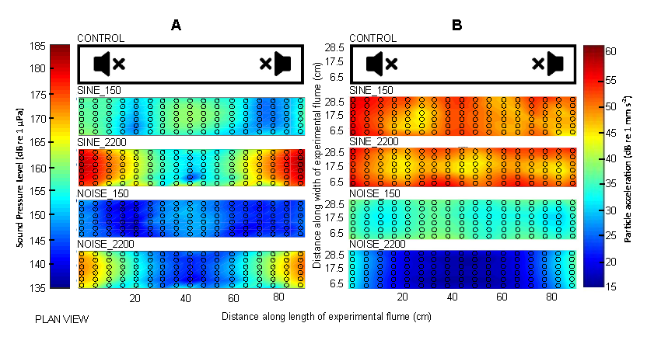
Figure 3. Acoustic conditions shown as (A) sound pressure level (SPL) (dB re 1 µPa) (average of three measured depths: 7 cm; 13.5 cm; 20 cm – each treatment was standardised at 150 dB re 1 µPa, in the centre of the tank: Figure S1); and (B) particle acceleration level (dB re 1 mm s⁻²), measured at 13.5 cm depth for control (no sound); SINE_150; SINE_2200; NOISE_150; and NOISE_2200 treatments. Note: open circles indicate hydrophone matrix positioning.

The pressure gradient was computed using a finite difference approach based on the grid measurements of the pressure signal. The root mean square (RMS) of the pressure difference was evaluated independently in each direction (x, y and z), from which the pressure gradient was obtained by dividing by the distance between measurements. Based on Equation (1), the RMS particle acceleration, in one direction, was calculated by dividing by the water density. Total RMS particle acceleration was finally determined through combining values in all three directions, with the results expressed in decibels (dB re 1 mm s⁻²) (Figure 3b).

A reductionist and carefully controlled approach using a small tank set-up was used to minimise the influence of confounding factors, and provide a stable, reproducible acoustic field. Owing to the nature of near-field conditions relative to wavelength, highly complex and directionally variable acoustic conditions were recorded (Gray et al., 2016). This was not considered to be problematic as the aim was to investigate how group behaviour varied with acoustic structural complexity, while keeping other acoustic parameters constant.

High levels of particle motion are produced on account of a tank’s small size, wall material properties, and the sound speed differences between water and the surrounding air (Akamatsu et al., 2002). In this experiment, with increasing distance from the two speakers, a reduction in particle acceleration was recorded. Although the relationship between the pressure and particle motion components of sound stimuli generated in small tanks is understood to differ from large-scale “natural” aquatic habitats (e.g. oceans or deep lakes), the acoustic nature of shallow streams (often < 1 m depth), rivers, or man-made flowing channels, tend to be more complex, and remain poorly understood (Campbell et al., 2019; Leighton et al., 2019; Currie et al., 2020). Of course, this is not to suggest that even for these freshwater species that results can be directly extrapolated from tanks to naturally occurring environments without further testing or validation.

2.4 Experimental Protocol
A total of 50 trials were conducted (ten replicates per treatment and control). Given the high variability of minnow behaviour, the designation of shoal size was important because the number of group members can influence overall structure and cohesion; an effect known as the “loose cruising association” (Nursall, 1973). For example, groups of four to six minnows integrate well and respond much faster than shoals of two to three fish (Partridge, 1980). This may be observed through lower response latencies and greater group cohesion (Partridge, 1980). Therefore, for each replicate, five fish of similar size were captured using a micro-mesh (< 1 mm diameter) hand net, and then transported as a group to the experimental arena using a small bucket (1 L capacity) of water (0.35 L). To avoid the confounding influence of order of introduction, fish were introduced as a group directly into the centre of the experimental arena, thus reducing the effects of any left-right or other spatial bias. On introduction the 40 minute video recording period commenced.
Each trial lasted a total of 40 minutes, allowing 20 minutes acclimation (established from pilot study data) prior to presentation of the stimuli that for the treatments involved playback projected simultaneously from the two underwater speakers for ten minutes. Assigning playback to a group was determined using an online random number generator to avoid order effects, and each group of five fish was used once only. Finally, a post-treatment period of ten minutes was included during which exposure to the stimuli ceased.

2.5 Behavioural Parameters and Video Tracking
For analyses of startle responses at the onset of the acoustic signal, videos were played-back in a randomly generated order, with the observer blind to treatment. A startle response at the onset of the acoustic stimuli (i.e. first sound presentation) was determined via visual inspection of the videos, and scored at group-level as a binary response based on presence or absence of specific behaviours (Table 1).
Fish were tracked using a custom written MATLAB script. Measurements of swimming speed, cohesion, orientation and shoal distribution were taken for each frame, providing an output of 72000 data points for each variable calculated per group (n=50) (Table 1). Individual tracks could become confused and lost when fish paths crossed. However, this did not affect analysis involving group means.
Shoal distribution (Table 1) based on the mean location of the centre of the group was calculated every ten seconds per trial exposure, providing 60 x, y shoal distribution reference positions. Coordinates were cross referenced with the harmonic averages of SPL measurements taken from the nearest hydrophone position, and frequency counts of time spent in areas of differing acoustic intensity (SPL) recorded. Histograms were produced with counts binned into 5 dB increments.

Table 1: Criteria and definitions of group behaviour quantified using video recordings of the response of groups of European minnows to differing acoustic stimuli.
Group behaviour | Definition | References
Startle response  (presence/absence) | Specifically, an ‘escape response’ at the onset of acoustic stimuli. One or more fish within a group were observed to exhibit a clear burst in swimming speed, at an altered angle in comparison to pre-startle swimming speed and direction | Blaxter et al., 1981 ; Kastelein et al., 2008 ; Purser and Radford, 2011 ; Neo et al., 2015b ; Nedelec et al., 2015
Swimming speed  (ms⁻¹) | Mean (± SE) speed of the mean shoal centre (see ‘shoal distribution’) (strength of response to neighbours decreases greatly as individual speed decreases) | Katz et al., 2011; Neo et al., 2015a; 2015b
Cohesion  (m) | Mean distance from the mean shoal centre  (measurements taken at centre point of each fish) | Partridge, 1980; Delcourt and Poncin, 2012; Neo et al., 2015a; Herbert-Read et al., 2017a
Orientation  (˚ ) | Imaginary horizontal line drawn through fish (head to tail) and the standard deviation of the angle of the fish compared to one another is calculated,  i.e. pointing the same direction, or randomly aligned  (lower orientation = more aligned) | Partridge, 1980 ; Couzin et al., 2002 ; Herbert-Read et al., 2017a
Shoal Distribution (x,y) | Mean shoal centre (X_{C}(n)) location of fish group in 2D calculated from:  Position of the ith fish in the nth video frame, vector X_{i}(n) = (x_{i}(n),y_{i}(n))^{t} ,  where x_{i}(n) corresponds to distance along length of tank, and y_{i}(n) to breadth.  Therefore: X_{C}(n) = (x_{c}(n),y_{c}(n))^{t}=(X₁(n) + X₂(n) + X₃(n) + X₄(n) + X₅(n))/5 | Hassan et al., 1992, Neo et al., 2015b

2.6 Statistical Analysis
Statistical analyses was performed using a combination of IBM SPSS Statistics v.22.0 (IBM Corp. IBM SPSS Statistics for Windows, Armonk, NY: IBM Corp, USA), freeware programme RStudio (v 3.2.2: https://rstudio.com/), and MATLAB.
To assess whether the number of startle responses at the onset of acoustic stimuli differed between treatments, logistic regression analysis was performed across all four treatments and the control. Post hoc multiple pairwise comparisons were performed using a Tukey adjustment among group least square means to allow for further investigation between treatments. To determine if group swimming behaviour changed during the trials, repeated measures Analysis of Variance (ANOVAs) were performed, with treatment as a between-subjects factor, and time period as a within-subjects factor for group swimming speed, cohesion and orientation. Time was divided into four blocks of five-minute bins (Neo et al., 2014): ‘pre-treatment’ (five minutes immediately pre-exposure), ‘start-treatment’ (first five minutes during onset of stimuli), ‘end-treatment’ (second five minutes to the end of the stimuli exposure) and ‘post-treatment’ (five minutes immediately post-exposure). Inclusion of a baseline control within the analyses increased the probability of interaction effects to outperform any main effects. Therefore, when these occurred, repeated measures ANOVAs were conducted for each treatment separately to test for differences over time.
The majority of data met assumptions of normality (Shapiro-Wilks test) and homoscedasticity (Levene’s test) (82% and 93% of data, respectively). In cases where it did not the violations were minor and insufficient to challenge assumptions of robustness for the use of ANOVA (Ito, 1980). Mauchly’s test of sphericity was used to assess the univariate approach of repeated measures ANOVAs (Huynh and Mandeville, 1979). When sphericity could not be assumed, Greenhouse-Geisser corrections were utilised for epsilon (ε) values less than 0.75; and Huynh-Feldt corrections for values greater than 0.75 (Greenhouse and Geisser, 1959; Huynh and Feldt, 1976). Post hoc Bonferroni tests were conducted when differences between factors were highlighted, thereby allowing for further investigation of between factor effects.
The distributions of shoals relative to areas of differing SPL (Figure S2) were measured as a proportion of total time spent in different areas. To evaluate shoal distribution (Table 1) in relation to acoustic intensity, the Kullback-Leibler Divergence (KLD) (Kullback and Leibler, 1951; Press et al., 2007) was used to calculate the divergence between two probability distributions for each acoustic treatment. These distributions are approximated by two histograms measured across N common bins. These histograms represent the control distribution (P), and the treatment distribution (Q), where:
P = {p₁, …, p_{N}} (2)
Q = {q₁, …, q_{N}} (3)
KLD is defined as:
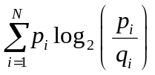 (4)

The constant back-off smoothing technique (absolute discounting) was used to address the infinite KLD value problem (Bigi, 2003; Shahriar et al., 2013), whereby all zero probability values in both P and Q were substituted with a small constant value, 1.67 x 10⁻⁴ was used here.
To better determine the normal spatial behaviour of groups of fish under control conditions while maintaining data variability, control data was bootstrapped (n = 10, r = 5) and 25 random samples taken and averaged in relation to the sound-field of each acoustic treatment (Efron, 1982). Control KLDs per treatment were computed by comparing the ten minute “exposure” period (P) to the ten minute “post-exposure” period (Q). These KLDs provided an expected divergence in probability distribution per treatment under which acoustic intensity had no influence on the mean location of the shoal centre.
Wilcoxon signed-rank tests were used to compare observed acoustic treatment condition KLDs with those expected for the controls. As bootstrapping incorporated the means of five control trials (out of ten), two Wilcoxon signed-rank tests per acoustic treatment were performed, i.e. KLDs of five treatment trials were compared to five random control KLDs for that condition. For the spatial distribution of shoals of minnows in response to acoustic intensity to be considered different from the control sample, both p-values were independently required to be less than an adjusted α level of 0.1 (thereby limiting the Type I error rate to 0.01).

3. Results
3.1 Startle response
With the onset of an acoustic stimulus, clear startle responses were observed; but remained absent during the control. Differences were observed between all treatments (χ² = 23.27; d.f. = 4; p < 0.001), accounting for approximately 36% of the model variance (Cox and Snell, Pseudo R² = 0.37; Figure 4). Startle responses were more frequent under SINE_150 (90%) than NOISE_150 (70%), followed by NOISE_2200 (50%) and SINE_2200 (40%) (Figure 4; Table 2; Table 3).

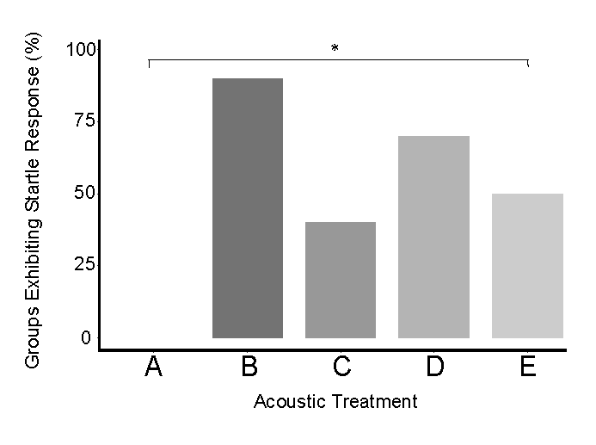
Figure 4. Percentage of at least one individual fish within groups (n=10 per condition) of five minnows observed to exhibit a startle response at initial onset of acoustic stimuli for (A) control; (B) SINE_150; (C) SINE_2200; (D) NOISE_150; and (E) NOISE_2200. Note: * indicates significance of p < 0.05.

Table 2: Differences in startle response between treatments from post hoc multiple pairwise comparisons. Note: a single asterisk indicates signficance of p < 0.05; double asterisk indicates significance of p < 0.01.
 | CONTROL | SINE_150 | SINE_2200 | NOISE_150 | NOISE_2200
SINE_150 | Z = -5.72; p < 0.01 **
SINE_2200 | Z = -4.41; p < 0.01 ** | Z = 3.10; p < 0.05 *
NOISE_150 | Z = -5.41; p < 0.01 ** | Z = 1.97; p = 0.28 | Z = -3.03; p < 0.05 *
NOISE_2200 | Z = -4.84; p <0.01 ** | Z = 3.00; p < 0.05 * | Z = -2.18; p = 0.18 | Z = 2.94; p < 0.05 *

3.2 Swimming speed
Mean group swimming speed (ms⁻¹) was lower at the start of the acoustic treatment phase (mean ± SE = 0.07 ± 0.01 ms⁻¹; Wilks’ Lambda = 0.56; F_{3,135} = 11.4; p < 0.001; η² = 0.44; Figure 5a; Table 3) when compared to the pre-treatment control (mean ± SE = 0.09 ± 0.02 ms⁻¹; p < 0.001) and post-treatment period (mean ± SE = 0.09 ± 0.02 ms⁻¹; p < 0.05). During the acoustic treatment phase, group swimming speed increased gradually for all treatments (mean ± SE = 0.12 ± 0.02 ms⁻¹) except for SINE_150, where a rapid increase occurred over the first minute (Figure 5a).
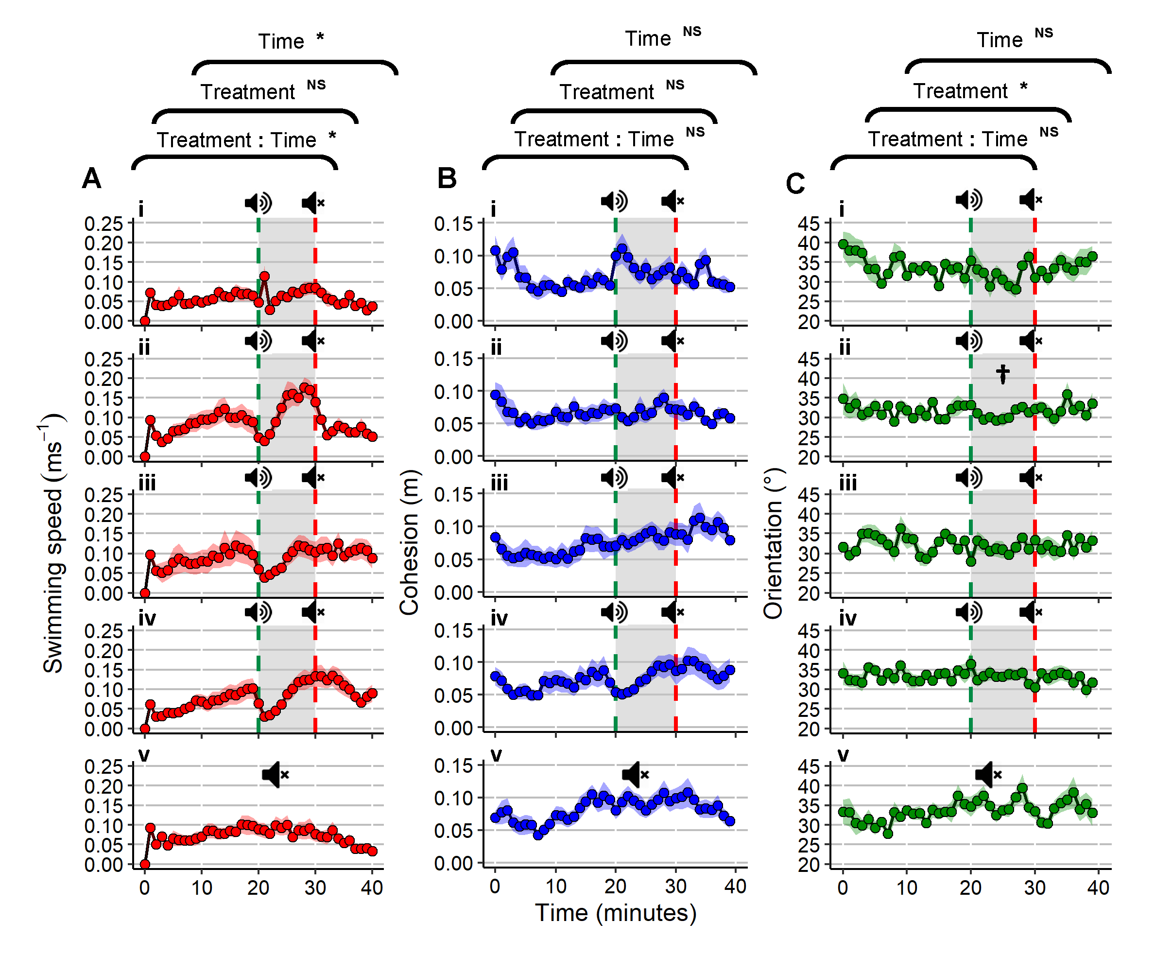
Figure 5. (A) Mean swimming speed (ms⁻¹) (red plots); (B) cohesion (m) (blue plots); and (C) orientation (˚) (green plots) of groups (n= 10 per condition) of five minnows over time (mean ± SE) exposed to SINE_150; SINE_2200; NOISE_150; NOISE_2200; and no playback (control) conditions. Note: * indicates significance of p < 0.05; and NS symbolises non-significance for repeated measures ANOVA; † indicates a significant difference (p < 0.05) of a single treatment from the control using post hoc Bonferroni tests. Dashed green lines portray sound on, and dashed red lines sound off; areas in grey represent the total acoustic treatment period. Data points are averaged per minute across 40 minute trial.
Effects of treatment were not significant, although there was an interaction between treatment and time (Wilks’ Lambda = 0.44; F_{12,135} = 3.52; p < 0.001; η² = 0.24). Mean group swimming speed differed over time for SINE_2200 (Wilks’ Lambda = 0.13; F_{3,27} = 15.5; p < 0.05; η² = 0.87), initially decreasing from the pre-treatment control (last minute mean ± SE = 0.09 ± 0.03 ms⁻¹) during the start-treatment phase (first minute mean ± SE = 0.04 ± 0.01 ms⁻¹), before rapidly increasing into the end-treatment phase (mean ± SE = 0.12 ± 0.03 ms⁻¹; p < 0.05) to almost double the baseline speed (maximum group speed ± SE = 0.18 ± 0.03 ms⁻¹; p < 0.001). Group swimming speed decreased for SINE_2200 after the stimuli was turned off during the post-treatment phase (mean ± SE = 0.07 ± 0.01 ms⁻¹; p < 0.05). There were similar differences in swimming speed over time for groups exposed to NOISE_2200 (Wilks’ Lambda = 0.21; F_{3,27} = 8.92; p <0.05; η² = 0.79), but, for this condition post-treatment speed (mean ± SE = 0.13 ± 0.02 ms⁻¹) remained higher than baseline levels (mean ± SE = 0.09 ± 0.02 ms⁻¹) after acoustic stimuli was switched off (p < 0.05).
3.3 Cohesion
There was no effect of treatment or time on group cohesion (m), and no interaction between treatment and time (Figure 5b; Table 3). When acclimated within the experimental arena, groups of five minnows typically swam in loose shoals (mean group cohesion ± SE: 0.09 ± 0.02 m), with some individuals swimming on their own, or in close proximity to one or more other fish, utilising the entirety of the tank.

3.4 Orientation
Group orientation differed between the control and SINE_2200 treatments (F_{4,45} = 3.27; p < 0.05; η² = 0.23; post hoc: p < 0.05; Figure 5c; Table 3), with an increase in alignment observed for fish groups exposed to SINE_2200. There was no difference over time or an interaction between treatment and time.

3.5 Shoal distribution
Shoal distribution of control fish differed from those of treated fish exposed to SINE_150 and NOISE_150, with the latter spending more time than expected in areas of lower acoustic intensity (SPL) (Z₁ = -1.753; p₁ = 0.08; Z₂ = -2.023; p₂ = 0.04: and Z₁ = -2.023; p₁ = 0.04; Z₂ = -2.023; p₂ = 0.04, respectively; Figure 6; Table 3). There was no difference between control fish and those exposed to SINE_2200 (Z₁ = -2.023; p₁ = 0.043; Z₂ = -0.405; p₂= 0.69) or NOISE_2200 (Z₁ = -1.214; p₁ = 0.225; Z₂ = -2.023; p₂ = 0.04).
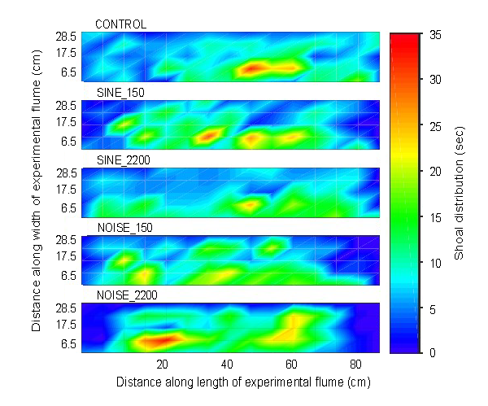
Figure 6. Average shoal distribution of groups (n = 10 per condition) of five common minnows over the 10 minute treatment exposure period in control (no sound); SINE_150; SINE_2200; NOISE_150; and NOISE_2200 conditions. Note: Total availability (Figure S2) and cumulative use of acoustic space should be considered when interpreting shoal distributions relative to the acoustic field; data points averaged (mean) per 10 seconds across 10 minute exposure period.
Table 3: Overview of behavioural tendencies in response to SINE_150; SINE_2200; NOISE_150; and NOISE_2200. Note: an asterisk indicates a statistically significant deviation in behaviour from control data; and a diamond indicates a significant deviation over time.
Treatment | Group behavioural response
 | Startle response  (presence/absence) | Swimming speed (ms⁻¹) | Cohesion  (m) | Orientation  (°) | Shoal distribution (x,y)
SINE_150 | Present: 90 % increase * | start-treatment: Rapid increase & decrease;  end-treatment:  Return to pre-exposure ◊ | No effect | No effect | Increase time in areas of lower acoustic intensity *
SINE_2200 | Present: 40 % increase * | start-treatment: Decrease;  end-treatment: Rapid increase ◊ | No effect | Increased alignment * | No effect
NOISE_150 | Present: 70 % increase * | start-treatment: Decrease;  end-treatment: Return to pre-exposure ◊ | No effect | No effect | Increase time in areas of lower acoustic intensity *
NOISE_2200 | Present: 50 % increase * | start-treatment: Decrease;  end-treatment: Rapid increase ◊ | No effect | No effect | No effect
4. Discussion
This study investigated the response of European minnow to acoustic stimuli that differed with respect to structural complexity and frequency. We hypothesised that the complex acoustic stimuli would elicit a stronger behavioural response, an effect observed in bighead carp (Hypophthalmichthys nobilis) exposed to either broadband (outboard motor Hp 4-stroke engine: 0.06 – 10 kHz) or pure tone stimuli (500, 1000, 1500, and 2000 Hz: Vetter et al., 2017). Contrary to our hypothesis, we found the simple sinewave tones to induce a detectable behavioural response more frequently. While it may be assumed that simple signals may not elicit a reaction by themselves if the specific tonal components have not been shaped by selection for communication purposes (Hebets and Papaj, 2005), they may still have informative value (Candolin, 2003). Our results indicate that despite, or perhaps, even owing to their lesser occurrence in nature (i.e. novelty) (Kastelein et al., 2008), simple sinewave tones are nevertheless capable of eliciting a measurable response. Minnows may have a high sensitivity to tonal stimuli, an effect observed in humans where tonal signals are perceived as louder than noise of the same intensity (Pinheiro and Ptacek, 1971). Alternatively, stronger reactions to novel disturbances could act as an adaptive survival mechanism (Crawford et al., 2012; Brown et al., 2013), akin to an antipredator response (“risk-disturbance hypothesis”) (Walther, 1969; Frid and Dill, 2002). Equally, the greater response to tonal stimuli may have been induced by the greater levels of particle motion generated by tonal stimuli within the tank set-up, however, such speculation requires further exploration that was not within the remit of this investigation. Perhaps, also owing to an assumed optimum hearing sensitivity within the lower frequency range, the lower frequency tonal treatment had the greatest influence on fish behaviour across all parameters tested in this study. This is an important result to note given the dominance of lower frequency (0.1 – 0.5 kHz) sources of anthropogenic noise (e.g. shipping and traffic noise) (Hildebrand, 2009; Holt and Johnston, 2015).
All acoustic treatments elicited a startle response in at least some of the subject fish, a behaviour in which the fish is observed to contract its body and burst swim in an altered direction from a stimulus to initiate escape (Nedelec et al., 2015). Startle behaviour among groups of fish has been studied under both field and laboratory conditions using a range of anthropogenic noise, including repeated underwater gun firings (field study: gadoid [bony fish] group behaviour: Wardle et al., 2001), pulsed white noise (laboratory studies: zebrafish, Danio rerio group behaviour: Neo et al., 2015b), and pure tone sinewaves (tested: 0.1 – 64 kHz; responses: 0.1 – 2 kHz) (laboratory study: sea bass, thicklip mullet, Chelon labrosus, pout, Trisopterus luscus, and horse mackerel, Trachurus trachurus group behaviour: Kastelein et al., 2008). As observed in this study, the swimming behaviour exhibited by individual fish tends to return to “baseline” after a few repeated exposures to stimuli in close conjunction with one another. In our study, more startle responses were observed at the onset of the lower frequency treatments, with SINE_150 observed to elicit the most. While the startle response is a useful behavioural parameter indicative of an anti-predator reaction (Domenici and Blake, 1997), more in-depth quantifiable analysis will assist understanding of shoal behaviour in response to acoustic stimuli. This information would benefit, for instance, the development of more successful behavioural guidance or deterrence systems used in fisheries management.
The high incidence of startle behaviour observed in responses to SINE_150 was associated with a rapid increase in group swimming speed within the first minute of the acoustic treatment. This was followed by a rapid decline in swimming speed to below that observed during the pre-exposure period. Increases in this behaviour likely indicated hyperactivity, or an anxiety-like behaviour associated with a perceived threat (Stewart et al., 2012; Neo et al., 2014). The initial spike observed when SINE_150 was switched on was not observed under the other treatments, where fish tended to exhibit a decline in swimming speed instead, a behaviour that could enhance information transfer among individuals (Ward et al., 2008; 2011; Miller et al., 2013). Indeed, it has been suggested that this behaviour may reflect an initial increased alertness (juvenile sea bass: Herbert-Read et al., 2017a), potentially enabling more accurate risk assessment and monitoring. Individuals within a group can obtain second-hand information about the surrounding environment through the speed changes of others (Harpaz et al., 2017). While for this experiment we cannot discern whether individual fish were gathering such sensory information directly or via behavioural cues exhibited by other fish, work by Short et al. (2020) suggests it to be the latter. Their study investigated responses of both solitary individuals and shoals of five European minnows to anthropogenic noise and found group responses to be universal in comparison to those of individuals which were more variable. Additionally, increased speeds have been noted as highly correlated with other behaviours (e.g. polarisation and near neighbour positioning) (Berdahl et al., 2013; Herbert-Read et al., 2017b; Kent et al., 2019).
Previous studies investigating response of marine fish to anthropogenic noise (e.g. tuna, Thunnus thynnus to boat noise: Sará et al., 2007; and sea bass to pile-driving noise: Herbert-Read et al., 2017) observed that shoals become less cohesive when exposed. Reduction in group cohesion can be costly if it reduces information sharing and increases predation risk (Magurran and Pitcher, 1987; Handegard et al., 2012; Ioannou et al., 2012). Further detrimental impacts may accrue if anthropogenic noise masks the detection of an additional modal stimulus (e.g. visual or chemical cues) (Caribbean hermit crab, Coenobita clypeatus: Chan et al., 2010; fathead minnow: Hasan et al., 2018). We did not observe an effect of treatment on group cohesion in this study, although fish exposed to SINE_150 tended to exhibit a strong startle response and scatter during the first minute, a behaviour referred to as “flash expansion” in which rapid startle and unpredictable movement by group members in multiple directions may be an anti-predator evasion tactic (Magurran and Pitcher, 1987). Of interest, however, is the contrasting observations in other recent studies in which group cohesion in shoaling minnows initially increased when exposed to an acoustic stimulus (e.g. 150 Hz tonal stimulus: Currie et al., 2020; and 60-2000 Hz random broadband noise: Short et al., 2020). Comparable observations to our study have however been reported in recent work involving another freshwater species, the three-spined stickleback (Gasterosteus aculeatus: Ginnaw et al., 2020). When exposed to multi-frequency square tones they observed no change in group cohesion, suggesting this behaviour to be relatively robust to playback of additional noise. The reasons for why results may differ between studies are not immediately obvious and warrant further investigation.
As was the case for group cohesion, the orientation displayed by minnows did not deviate from the baseline levels over time, but was influenced by treatment. When the SINE_2200 stimuli was turned on, fish became more aligned with one another. Increased polarisation within shoals is a common response to the detection of a predatory threat (Partridge, 1980; Couzin et al., 2002; Herbert-Read et al., 2017a, Ginnaw et al., 2020), enabling individuals to gain information and copy movement decisions of others (Harpaz et al., 2017). However, the exhibition of such a response may be context dependent (Herbert-Read et al., 2011), and how this varies with factors such as species, size of the group (Shelton et al., 2015) and setting requires further investigation.
Exposure to noise is assumed to result in the spatial displacement of fish, although empirically derived evidence remains lacking or anecdotal (Hawkins and Popper, 2017). Laboratory studies tend to be limited by the coarse scale measurement techniques employed to investigate acoustic spatial displacement. For instance, zebrafish showed no preference between an acoustically “quiet” and “noisy” double-chamber environment (Neo et al., 2015b), and time spent by ayu (Plecoglossus altivelis) within 300 cm² blocks, spaced at increments of 10 cm away from a sound source, suggested preference for some frequencies, and avoidance of others (Febrina et al., 2015). We found that shoals spent more time in areas of lower acoustic intensity during the SINE_150 and NOISE_150 treatments. We made use of high resolution fish tracking in combination with fine scale acoustic mapping (e.g. Murchy et al., 2017; Zielinski and Sorensen, 2017) to intricately understand and quantify the spatial distribution of fish in response to the highly complex and variable acoustic intensities (SPL) formed within small tanks (Akamatsu et al., 2002). We recommend that subsequent work should further refine this approach and consider larger areas of three-dimensional acoustic space, across both the sound pressure and particle motion domains, and attempt to more accurately quantify the positional depth of the model species used. Furthermore, as tank-based playback studies have previously been ecologically validated through the use of complimentary field experiments (e.g. Simpson et al., 2016; Ferrari et al., 2018), likewise it would be useful to confirm the results of our study among different populations of the same species in the wild, e.g. where fish are confined within large in situ outdoor pens or via long-term tracking studies of migratory fish encountering manipulated and well defined acoustic sound fields. This would allow investigation of group responses to acoustic stimuli which differs in complexity under a range of more “natural” settings, and where animals have the option to swim away (Popper and Hastings, 2009).
Although it is commonly argued that reductionist approaches, such as adopted in tank-based studies, does not fully replicate more “real-world” field conditions, it does allow for careful control of confounding factors, and provides valuable reference data for modelling or field studies (Rice et al., 2010; Slabbekoorn, 2016). Nevertheless, no approach is without its limitations. To better understand the impacts of anthropogenic noise on collective fish behaviour, the complimentary potential of differing methodologies must be drawn on. In this study, stimuli were pulsed at a regular rate to best control for any behavioural tolerance to a constant sound exposure (Neo et al., 2014; 2018; Currie et al., 2020). While tolerance was accounted for within the study design, without more intricately quantifying the magnitude of change for each behavioural metric over time, the effects of tolerance, or motor fatigue, cannot be ruled out. Any reduction in response to a repeated acoustic stimulus over time may alternatively be explained by other forms of sensory adaptation, such as a hearing threshold shift (Rankin et al., 2009). Even so, data regarding temporary threshold shifts (TTS) in closely related species (e.g. Carassius auratus: Smith et al., 2004) suggest that both louder and longer durations of acoustic exposure would be required to induce TTS in minnows exposed to the attributes of stimuli used in our study. Species-specific data is of course required to completely rule out this explanation. That said, a continued change in behaviour (e.g. increase in group swimming speed) was observed throughout the exposure period for all tested treatments, suggesting a continual response to the acoustic stimuli. Investigation of instantaneously demonstrable behavioural or physiological tolerance to acoustic stimuli is on the rise (e.g. Nedelec et al., 2016; Currie et al., 2020), however, the longer-term process of habituation remains somewhat elusive, and requires further attention (Neo et al., 2018; Putland and Mensinger, 2019).
Evidence that fish alter their spatial distributions in response to high acoustic intensities may have important ecological implications. For example, in other taxa, acoustic playback studies have shown that male European robins (Erithacus rubecula) move away from a noise source, and do so more frequently at higher intensities (McLaughlin and Kunc, 2013). Similarly, harbour seals (Phoca vitulina) avoid a tidal turbine noise source from a range of 500 m (Hastie et al., 2018). Such behavioural responses to anthropogenic noise may have direct fitness implications or wider impacts on population dynamics (McLaughlin and Kunc, 2013). Underwater, noise can originate from both ground (e.g. road traffic; Holt and Johnston, 2015) and water-borne sources, it attenuates less and consequently travels further than in air. Therefore, the spatial impact of noise on fish shoals, as demonstrated in this study, may have far reaching ecological impacts (e.g. habitat fragmentation; Barber et al., 2010).

5. Conclusion
Our study found low frequency sinewave tones to have the greatest influence on the behaviour of groups of European minnow. Shoals exhibited spatial avoidance in response to low frequency treatments. Knowledge of the spatial distribution and behaviour of fish in response to anthropogenic noise is useful for informing policy makers on the potential impacts of human activities in aquatic environments. It also has application in the development of behavioural guidance systems for use in fisheries management (Popper and Carlson, 1998; Murchy et al., 2017; Deleau et al., 2019; Piper et al., 2019), or as selective barriers to prevent spread of invasive species (Rahel and McLaughlin, 2018). Owing to the large diversity in characteristics of human induced noise (frequency, SPL, particle velocity or acceleration, and temporal waveform), further studies are needed to better understand the context dependent inter- and intra-specific variation in response to a greater range of acoustic stimuli.

Acknowledgements
We thank Matthew Short for assistance with experimental set-up and members of the International Centre for Ecohydraulics Research (ICER), who kindly assisted in the collection of fish.

Funding
This work was supported by a NERC Research Award (grant number NE/K007769/1); and Industrial Sponsors Fishtek Consulting Ltd.

Data availability
All data accompanying this paper can be downloaded from the University of Southampton repository at: https://doi.org/10.5258/SOTON/D1182
Competing interests
We have no competing interests.

References
Akamatsu, T., Okumura, T., Novarini, N. and Yan, H.Y. (2002). Empirical refinements applicable to the recording of fish sounds in small tanks. J. Acoust. Soc. Am. 112, 3073-3082.
Amoser, S. and Ladich, F. (2005). Are hearing sensitivities of freshwater fish adapted to the ambient noise in their habitats? J. Exp. Biol. 208(18), 3533-3542.
Amoser, S., Wysocki, L.E., and Ladich, F. (2004). Noise emission during the first powerboat race in an Alpine lake and potential impact on fish communities. J. Acoust. Soc. Am. 116, 3789-3797.
Barber, J.R., Crooks, K.R. and Fristrup, K.M. (2010). The costs of chronic noise exposure for terrestrial organisms. Trends Ecol. Evol. 25, 180-189.
Becker, A., Whitfield, A.K., Cowley, P.D., Järnegren, J. and Næsje, T.F. (2013). Potential effects of artificial light associated with anthropogenic infrastructure on the abundance and foraging behaviour of estuary-associated fishes. J. Appl. Ecol. 50, 43-50.
Berdahl, A., Torney, C.J., Ioannou, C.C., Faria J.J. and Couzin, I.D. (2013). Emergent sensing of complex environments by mobile animal groups. Science. 339, 574-576.
Bigi, B. (2003). Using Kullback-Leibler Divergence for Text Categorization. LNCS. 2633, 305-319.
Blaxter, J.H.S., Gray, J.A.B. and Denton, E.J. (1981). Sound and startle responses in herring shoals. J. Mar. Biol. Ass. U.K. 61, 851-869.
Bretschneider, F., van Veen, H., Teunis, P.F.M., Peters, R.C., and van den Berg, A.V. (2013). Zebrafish can hear sound pressure and particle motion in a synthesised sound field. Anim. Behav. 63, 199-215.
Brown, G.E., Ferrari, M.C.O., Elvidge, C.K., Ramnarine, I. and Chivers, D.P. (2013). Phenotypically plastic neophobia: a response to variable predation risk. Proc. R. Soc. Lond. B. 280, 20122712.
Buwalda, R.J.A., Schuijf, A. and Hawkins, A.D. (1983). Discrimination by the cod of sounds from opposing directions. J. Comp. Physiol. A. 150, 175-184.
Campbell, J., Shafiei Sabet, S. and Slabbekoorn, H. (2019). Particle motion and sound pressure in fish tanks: A behavioural exploration of acoustic sensitivity in the zebrafish. Behav. Process. 164, 38-47.
Candolin, U. (2003). The use of multiple cues in mate choice. Biol. Rev. 78, 575-595.
Chan, A.A.Y-H., Giraldo-Perez, P., Smith, S. and Blumstein, D.T. (2010). Anthropogenic noise affects risk assessment and attention: the distracted prey hypothesis. Biol. Lett. 6, 458-461.
Couzin, I.D., Krause, J., James, R., Ruxton, G.D. and Franks, N.R. (2002). Collective memory and spatial sorting in animal groups. J. Theor. Biol. 218, 1-11.
Crawford, B.A., Hickman, C.R. and Luhring, T.M. (2012) Testing the threat-sensitive hypothesis with predator familiarity and dietary specificity. Ethology. 118, 41-48.
Crawford, J.D. (1997). Hearing and acoustic communication in mormyrid electric fishes. Mar. Freshw. Behav. Phy. 29, 65-86.
Currie, H.A.L., White, P.R., Leighton, T.G. and Kemp, P.S. (2020). Group behavior and tolerance of Eurasian minnow (Phoxinus phoxinus) in response to tones of differing pulse repetition rate. J. Acoust. Soc. Am. 147, 1709-1718.
Day, R.L., MacDonald, T., Brown, C., Laland, K.N. and Reader, S.M. (2001). Interactions between shoal size and conformity in guppy social foraging. Anim. Behav. 62, 917-925.
Delcourt, J. and Poncin, P. (2012). Shoals and schools: back to the heuristic definitions and quantitative references. Rev. Fish. Biol. Fisher. 22, 595-619.
Deleau, M.J.C., White, P.R., Peirson, G., Leighton, T.G. and Kemp, P.S. (2019). Use of acoustics to enhance the efficiency of physical screens designed to protect downstream moving European eel (Anguilla Anguilla). Fish. Manag. Ecol. 00, 1-9.
Dijkgraaf, S. and Verheijen, F.J. (1950). Neue versuche über das tonunterscheidungsvermögen der elritze [in German]. Zeitschrift für vergleichende Physiologie. 32, 248-256.
Domenici, P. and Blake, R. (1997). The kinematics and performance of fish fast-start swimming. J. Exp. Biol. 200, 1165-1178.
Domenici, P., Steffensen, J.F. and Batty, R.S. (2000). The effect of progressive hypoxia on swimming activity and schooling in Atlantic herring. J. Fish. Biol. 57, 1526-1538.
Domenici, P., Steffensen, J.F. and Marras, S. (2017). The effect of hypoxia on fish schooling. Philos. Trans. Royal Soc. B. 372, 20160236.
Efron, B. (1982). The Jackknife, the Bootstrap and Other Resampling Plans. SIAM, Philadelphia.
Fay, R.R., and Popper, A.N. (1974). Acoustic stimulation of the ear of the goldfish (Carassius auratus). J. Exp. Biol. 61, 243-260.
Febrina, R., Sekine, M., Noguchi, H., Yamamoto, K., Kanno, A., Higuchi, T. and Imai, T. (2015). Modelling the preference of ayu (Plecoglossus altivelis) for underwater sounds to determine the migration path in a river. Ecol. Eng. 299, 102-112.
Ferrari, M.C.O., McCormick, M.I., Meekan, M.G., Simpson, S.D., Nedelec, S.L. and Chivers, D.P. (2018). School is out on noisy reefs: the effect of boat noise on predator learning and survival of juvenile coral reef fishes. Proc. R. Soc. Lond. B. 285, 20180033.
Fox, R.J., Bellwood, D.R. and Jennions, M.D. (2015). Why pair? Evidence of aggregative mating in a socially monogamous marine fish (Siganus doliatus, Siganidae). Royal Soc. Open Sci. 2, 150252.
Frid, A. and Dill, L. (2002). Human-caused disturbance stimuli as a form of predation risk. Conserv. Ecol. 6, 11.
Glass, C.W., Wardle, C.S. and Mojsiewicz, W.R. (1986). A light intensity threshold for schooling in the Atlantic mackerel, Scomber scombrus. J. Fish Biol. 29, 71-81.
Ginnaw, G.M., Davidson, I.K., Harding, H.R., Simpson, S.D., Roberts, N.W., Radford, A.N., and Ioannou, C.C. (2020). Effects of multiple stressors on fish shoal collective motion are independent and vary with shoaling metric. Anim. Behav. 168, 7-17.
Götz, T. and Janik, V.M. (2013). Acoustic deterrent devices to prevent pinniped depredation: efficiency, conservation concerns and possible solutions. Mar. Ecol. Prog. Ser. 492, 285-302.
Gray, M., Rogers, P.H. and Zeddies, D.G. (2016). Acoustic particle motion measurement for bioacousticians: principles and pitfalls. Proc. Mtgs. Acoust. 27, 010022.
Greene Jr., C.R.G. and Moore, S.E. (1995). Man-made noise. In Marine mammals and noise (ed. W.J. Richardson, C.R.G. Greene Jr., C.I. Malme and D.J.H. Thomson). San Diego, CA: Academic Press.
Greenhouse, S.W. and Geisser, S. (1959). On methods in the analysis of profile data. Psychometrika. 24, 95-112.
Hanache, P., Spataro, T., Firmat, C., Boyer, N., Firmat, C., Fonseca, P., and Médoc, V. (2020). Noise-induced reduction in the attack rate of a planktivorous freshwater fish revealed by functional response analysis. Freshw. Biol. 65(1), 75-85.
Handegard, N.O., Boswall, K.M., Ioannou, C.C., Leblanc, S.P., Tjøstheim, D.B. and Couzin, I.D. (2012). The dynamics of coordinated group hunting and collective information transfer among schooling prey. Curr. Biol. 22, 1213-1217.
Harpaz, R., Tkačik, G. and Schneidman, E. (2017). Discrete modes of social information processing predict individual behaviour of fish in a group. PNAS. 114, 10149-10154.
Hasan, M.R., Crane, A.L., Ferrari, M.C.O. and Chivers, D.P. (2018). A cross-modal effect of noise: the disappearance of the alarm reaction of a freshwater fish. Animal Cogn. 21, 419-424.
Hassan, El.-S., Abdel-Latif, H. and Biebricher, R. (1992). Studies on the effects of Ca⁺⁺ and Co⁺⁺ on the swimming behavior of the blind Mexican cave fish. J. Comp. Physiol. A. 171, 413-419.
Hastie, G.D., Russell, D.J.F., Lepper, P., Elliott, J., Wilson, B., Benjamins, S. and Thompson, D. (2018). Harbour seals avoid tidal turbine noise: Implications for collision risk. J. Appl. Ecol. 55, 684-693.
Hawkins, A.D. and Popper, A.N. (2014). Assessing the impact of underwater sounds on fishes and other forms of marine life. Acoustics Today. Spring 2014, 30-41.
Hawkins, A.D. and Popper, A.N. (2017).A sound approach to assessing the impact of underwater noise on marine fishes and invertebrates. ICES. 74, 635-651.
Hebets, E.A. and Papaj, D.R. (2005). Complex signal function: developing a framework of testable hypotheses. Behav. Ecol. Sociobiol. 57, 197-214.
Hemelrijk, C.K., Reid, D.A.P., Hildenbrandt, H. and Padding, J.T. (2015). The increased efficiency of fish swimming in a school. Fish. Fish. 16, 511-521.
Herbert-Read, J.E., Perna, A., Mann, R.P., Schaerf, T.M., Sumpter, D.J.T. and Ward, A.J.W. (2011). Inferring the rules of interaction of shoaling fish. PNAS. 108, 18726-18731.
Herbert-Read, H.E., Kremer, L., Bruintjes, R., Radford, A.N. and Ioannou, C.C. (2017a). Anthropogenic noise pollution from pile-driving disrupts the structure and dynamics of fish shoals. Proc. R. Soc. Lond. B. 284, 20171627.
Herbert-Read, H.E., Rosén, E., Szorkovszky, A., Ioannou, C.C., Rogell, B., Perna, A., Ramnarine, I.W., Kotrschal, A., Kolm, N., Krause, J., et al. (2017b). How predation shapes the social interaction rules of shoaling fish. Proc. R. Soc. Lond. B. 284, 20171126.
Hildebrand, J.A. (2009). Anthropogenic and natural sources of ambient noise in the ocean. Mar. Ecol. Prog. Ser. 395, 5-20.
Holt, D.E. and Johnston, C.E. (2015). Traffic noise masks acoustic signals of freshwater stream fish. Biol. Conserv. 187, 27-33.
Huynh, H. and Feldt, L.S. (1976). Estimation of the box correction for degrees of freedom from sample data in randomized block and split-plot designs. Journal of Educational Statistics. 1, 69-82.
Huynh, H. and Mandeville, G.K. (1979). Validity conditions in repeated measures designs. Psychol. Bull. 86, 964-973.
Ioannou, C.C., Guttal, V. and Couzin, I. (2012). Predatory fish select for coordinated collective motion in virtual prey. Science 337, 1212-1215.
Ito, P.K. (1980). 7 Robustness of ANOVA and MANOVA test procedures. Handbook of Statistics. 1, 199-236.
Kastelein, R.A. and Hoek, L. (2010). The effect of signal duration on the underwater detection thresholds of a harbor porpoise (Phocoena phocoena) for single frequency-modulated tonal signals between 0.25 and 160 kHz. J. Acoust. Soc. Am. 128, 3211-3222.
Kastelein, R.A., van der Heul, S., Verboom, W.C., Jennings, N., van der Veen, J. and de Haan, D. (2008). Startle response of captive North Sea fish species to underwater tones between 0.1 and 64 kHz. Mar. Environ. Res. 65, 369-377.
Katz, Y., Tunstrøm, K., Ioannou, C.C., Huepe, C. and Couzin, I.D. (2011). Inferring the structure and dynamics of interactions in schooling fish. PNAS. 108, 18726-18731.
Kent, M.I.A., Lukeman, R., Lizier, J.T. and Ward, A.J.W. (2019). Speed-mediated properties of schooling. Royal Soc. Open. Sci. 6, 181482.
Kozaczka, E., and Grelowska, G. (2011). Shipping low frequency noise and its propagation in shallow water. Acta Physica Polonica A. 119(6), 1009-1012.
Kroodsma, D.E., Byers, B.E., Goodale, E., Johnson, S. and Liu, W.-C. (2001). Pseudoreplication in playback experiments, revisited a decade later. Anim. Behav. 61, 1029-1033.
Kullback, S. and Leibler, R.A. (1951). On information and sufficiency. Ann. Math. Stat. 22, 79-86.
Kunc, H.P., McLaughlin, K.E. and Schmidt, R. (2016). Aquatic noise pollution: implications for individuals, populations, and ecosystems. Proc. R. Soc. B. 283, 20160839.
Landeau, L. and Terborgh, J. (1986). Oddity and the ‘confusion effect’ in predation. Anim. Behav. 34, 1372-1380.
Larsson, M. (2009). Possible functions of the octavolateralis system in fish schooling. Fish. Fish. 10, 344-353.
Leighton, T.G., Currie, H.A.L., Holgate, A., Dolder, C.N., Jones, S.L., White, P.R., and Kemp, P.S. (2019). Analogies in contextualizing human response to airborne ultrasound and fish response to acoustic noise and deterrents. Proc. Meet. Acoust. 37(1), 010014.
Linnæus, C. (1758). Systema naturæ. Stockholm: Laurentius Salvius.
Magurran, A.E. and Pitcher, T.J. (1987). Provenance, shoal size and the sociobiology of predator-evasion behaviour in minnow shoals. Proc. R. Soc. Lond. B. 229, 439-465.
Mao, X. (2018). Review of fishway research in China. Ecol. Eng. 115, 91-95.
Marley, S.A., Erbe, C. and Salgado-Kent, C.P. (2016). Underwater sound in an urban estuarine river: Sound sources, soundscape contribution, and temporal variability. Acoust. Aust. 44, 171-186.
McCormick, M.I., Fakan, E.P., Nedelec, S.L., and Allan, B.J.M. (2019). Effects of boat noise on fish fast-start escape response depend on engine types. Sci. Rep. 9, 6554.
McLaughlin, K.E. and Kunc, H.P. (2013). Experimentally increased noise levels change spatial and singing behaviour. Biol. Lett. 9, 20120771.
Miller, N., Garnier, S., Hartnett, A.T. and Couzin, I.D. (2013). Both information and social cohesion determine collective decisions in animal groups. PNAS. 110, 5263-5268.
Murchy, K.A., Cupp, A.R., Amberg, J.J., Vetter, B.J., Fredricks, K.T., Gaikowski, M.P. and Mensinger, A.F. (2017). Potential implications of acoustic stimuli as a non-physical barrier to silver carp and bighead carp. Fisheries Manag. Ecol. 24, 208-216.
Nedelec, S.L., Mills, S.C., Lecchini, D., Nedelec, B., Simpson, S.D. and Radford, A.N. (2016). Repeated exposure to noise increases tolerance in a coral reef fish. Environ. Pollut. 216, 428-436.
Nedelec, S.L., Simpson, S.D., Morley, E.L., Nedelec, B. and Radford, A.N. (2015). Impacts of regular and random noise on the behaviour, growth and development of larval Atlantic cod (Gadus morhua). Proc. R. Soc. Lond. B. 282, 20151943.
Neo, Y.Y., Hubert, J., Bolle, L.J., Winter, H.V. and Slabbekoorn, H. (2018). European seabass respond more strongly to noise exposure at night and habituate over repeated trials of sound exposure. Environ. Pollut. 239, 367-374.
Neo, Y.Y., Parie, L., Bakker, F., Snelderwaard, P., Tudorache, C., Schaff, M. and Slabbekoorn, H. (2015b). Behavioural changes in response to sound exposure and no spatial avoidance of noisy conditions in captive zebrafish. Front. Behav. Neurosci. 9, 1-11.
Neo, Y.Y., Ufkes, E., Kastelein, R.A., Winter, H.V., ten Cate, C. and Slabbekoorn, H. (2015a). Impulsive sounds change European seabass swimming patterns: Influence of pulse repetition interval. Mar. Pollut. Bull. 97, 111-117.
Neo, Y.Y., Seitz, J., Kastelein, R.A., Winter, H.V., ten Cate, C. and Slabbekoorn, H. (2014). Temporal structure of sound affects behavioural recovery from noise impact in European seabass. Biol. Cons. 178, 65-73.
Nursall, J.R. (1973). Some behavioral interactions of spottail shiners (Notropis hudsonius), yellow perch (Perca flavescens), and Northern pike (Esox lucius). Journal of the Fisheries Research Board of Canada. 30(8), 1161-1178.
Partridge, B.L. (1980). The effect of school size on the structure and dynamics of minnow schools. Anim. Behav. 28, 68.
Pfeiffer, W., Walz, U., Wolf, R. and Mongold-Wernado, U. (1985). Effects of steroid hormones and other substances on alarm substance cells and mucous cells in the epidermis of the European minnow, Phoxinus phoxinus (L.), and other Ostariophysi (Pisces). J. Fish Biol. 27, 553-570.
Pieretti, N., Farina, A. and Morri, D. (2011). A new methodology to infer the singing activity of an avian community: The Acoustic Complexity Index (ACI). Ecol. Indic. 11, 868-873.
Pinheiro, M.L. and Ptacek, P.H. (1971). Reversals in the perception of noise and tone patterns. J. Acoust. Soc. Am. 49, 1778-1782.
Piper, A.T., White, P.R., Wright, R.M., Leighton, T.G. and Kemp, P.S. (2019). Response of seaward-migrating European eel (Anguilla Anguilla) to an infrasound deterrent. Ecol. Eng. 127, 480-486.
Pitcher, T.J., Magurran, A.E. and Allan, J.R. (1986). Size-segregative behaviour in minnow shoals. J. Fish Biol. 29, 83-95.
Popper, A.N. and Carlson, T.J. (1998). Application of sound and other stimuli to control fish behaviour. Trans. Am. Fish. Soc. 127(5), 673-707.
Popper, A.N., and Fay. R.R. (2011). Rethinking sound detection by fishes. Hearing Research. 273, 25-36.
Popper, A.N. and Hastings, M.C. (2009). Effects of anthropogenic sources of sound on fishes. J. Fish. Biol. 75, 455.
Press, W.H., Teukolsky, S.A., Vetterling, W.T. and Flannery, B.P. (2007). 14.7.2 Kullback-Leibler Distance. In Numerical recipes: the art of scientific computing, pp. 756-758. Cambridge University Press.
Purser, J. and Radford, A.N. (2011). Acoustic noise induces attention shifts and reduces foraging performance in three-spined sticklebacks (Gasterosteus aculeatus). PLOS ONE. 6, e17478.
Putland, R.L. and Mensinger, A.F. (2019). Acoustic deterrents to manage fish populations. Rev. Fish. Biol. Fisheries. 29, 789-807.
Rahel, F.J. and McLaughlin, R.L. (2018). Selective fragmentation and the management of fish movement across anthropogenic barriers. Ecol. Appl. 28(8), 2066-2081.
Rankin, C.H., Abrams, T., Barry, R.J., Bhatnagar, S., Clayton, D.F., Colombo, J., Coppola, G., Geyer, M.A., Glanzman, D.L., Marsland, S., et al. (2009). Habituation revisited: An updated and revised description of the behavioural characteristics of habituation. Neurobiol. Learn. Mem. 92, 135-138.
Rice, S.P., Lancaster, J., and Kemp, P.S. (2010). Experimentation at the interface of fluvial geomorphology, stream ecology and hydraulic engineering and the development of an effective, interdisciplinary river science. Earth Surf. Process. 35(1), 64-77.
Ruxton, G.D., Jackson, A.L. and Tosh, C.R. (2007). Confusion of predators does not rely on specialist coordinated behavior. Behav. Ecol. 18, 590-596.
Salas, A.K., Wilson, P.S. and Ryan, M.J. (2018). Acoustic communication in the Bocon toadfish (Amphichthys cryptocentrus). Environ. Biol. Fish. 101, 1175-1193.
Sarà, G., Dean, J.M., Amato, D.D., Buscaino, G., Oliveri, A., Genovese, S., Ferro, S., Buffa, G., Martire, M.L. and Mazzola, S. (2007). Effect of boat noise on the behaviour of bluefin tuna Thunnus thynnus in the Mediterranean Sea. Mar. Ecol. Prog. Ser. 331, 243-253.
Scholik, A.R. and Yan, H.Y. (2001). Effects of underwater noise on auditory sensitivity of a cyprinid fish. Hear. Res. 152, 17-24.
Scholz, K. and Ladich, F. (2006). Sound production, hearing and possible interception under ambient noise conditions in the topmouth minnow Pseudorasbora parva. J. Fish Biol. 69, 892-906.
Schuijf, A. and Hawkins, A.D. (1983). Acoustic distance discrimination by the cod. Nature 302, 143-144.
Scott, G.R. and Sloman, K.A. (2004). The effects of environmental pollutants on complex fish behaviour: integrating behavioural and physiological indicator of anxiety. Aquat. Toxicol. 68, 369-392.
Shahriar, H., North, S., Chen, W.-C. and Mawangi, E. (2013). Design and development of anti-XSS proxy. The 8th International Conference for Internet Technology and Secured Transactions (ICITST-2013). 484-489.
Shannon, C.E. (1948). A mathematical theory of communication. Bell Syst. Tech. J. 27, 379-423.
Shelton, D.S., Price, B.C., Ocasio, K.M. and Martins, E.P. (2015). Density and group size influence shoal cohesion, but not coordination in zebrafish. J. Comp. Psych. 129, 72-77.
Short, M., White, P.R., Leighton, T.G., and Kemp, P.S. (2020). Influence of acoustics on the collective behaviour of a shoaling freshwater fish. Freshw. Biol. 65(12), 2186-2195.
Simpson, S.D., Purser, J. and Radford, A.N. (2015). Anthropogenic noise compromises antipredator behaviour in European eels. Glob. Chang. Biol. 21, 586-593.
Simpson, S.D., Radford, A.N., Nedelec, S.L., Ferrari, M.C., Chivers, D.P., McCormick, M.I. and Meekan, M.G. (2016). Anthropogenic noise increases fish mortality by predation. Nat. Commun. 7, 10544.
Slabbekoorn, H. (2016). Aiming for progress in understanding underwater noise impact on fish: complimentary need for indoor and outdoor studies. Adv. Exp. Med. Biol. 875 1057-1065.
Slabbekoorn, H., Bouton, N., van Opzeeland, I., Coers, A., ten Cate, C. and Popper, A.N. (2010). A noisy spring: the impact of globally rising underwater sound levels on fish. Trends Ecol. Evol. 25, 419-427.
Smith, M.E., Kane, A.S. and Popper, A.N. (2004). Noise-induced stress response and hearing loss in goldfish (Carassius auratus). J. Exp. Biol. 207, 427-435.
Solan, M., Hauton, C., Godbold, J.A., Wood, C.L., Leighton, T.G. and White P.R. (2016). Anthropogenic sources of underwater sound can modify how sediment-dwelling invertebrates mediate ecosystem properties. Sci. Rep. 6, 20540.
Stange, N., Page, R.A., Ryan, M.J. and Taylor, R.C. (2017). Interactions between complex multisensory signal components result in unexpected mate choice responses. Anim. Behav. 134, 239-247.
Stewart, A., Gaikwad, S., Kyzar, E., Green, J., Roth, A. and Kalueff, A.V. (2012). Modelling anxiety using adult zebrafish: a conceptual review. Neuropharmacology 62, 135-143.
Sueur, J., Farina, A., Gasc, A., Pieretti, N. and Pavoine, S. (2014). Acoustic indices for biodiversity assessment and landscape investigation. Acta Acust. united Ac. 100, 772-781.
Svirgsden, R., Rohtla, M., Albert, A., Taal, I., Saks, L., Verliin, A., and Vetemaa, M. (2016). Do Eurasian minnows (Phoxinus phoxinus L.) inhabiting brackish water enter fresh water to reproduce: Evidence from a study on otolith microchemistry. Ecol. Freshw. Fish. 27(1), 89-97.
Tonolla, D., Acuña, V., Lorang, M.S., Heutschi, K. and Tockner, K. (2010). A field-based investigation to examine underwater soundscapes of five common river habitats. Hydrol. Process. 24, 3146-3156.
Vasconcelos, R.O., Amorim, M.C.P. and Ladich, F. (2007). Effects of ship noise on the detectability of communication signals in the Lusitanian toadfish. J. Exp. Biol. 210, 2104-2112.
Vetter, B.J., Murchy, K., Cupp, A.R., Amberg, J.J., Gaikowski, M.P., and Mensinger, A.F. (2017). Acoustic deterrence of bighead carp (Hypophthalmichthys nobilis) to a broadband stimulus. J. Great Lakes Res. 43, 163-171.
Voellmy, I.K., Purser, J. Flynn, D., Kennedy, P., Simpson, S.D., and Radford, A.N. (2014). Acoustic noise reduces foraging success in two sympatric fish species via different mechanisms. Anim. Behav. 89, 191-198.
Walther, F.R. (1969). Flight behaviour and avoidance of predators in Thomson’s gazelle (Gazella thomsoni: Guenther 1884). Behaviour. 34, 184-221.
Ward, A.J.W., Herbert-Read, J.E., Sumpter, D.J.T., and Krause, J. (2011). Fast and accurate decisions through collective vigilance in fish shoals. PNAS. 108, 2312-2315.
Ward, A.J. and Krause, J. (2001). Body length assortative shoaling in the European minnow, Phoxinus phoxinus. Anim. Behav. 62, 617-621.
Ward, A.J.W., Sumpter, D.J.T., Couzin, I.D., Hart, P.J.B., and Krause, J. (2008). Quorum decision-making facilitates information transfer in fish shoals. PNAS. 105, 6948-6953.
Wardle, C.S., Carter, T.J., Urquhart, G.G., Johnstone, A.D.F., Ziolkowski, A.M., Hampson, G. and Mackie, D. (2001). Effects of seismic air guns on marine fish. Cont. Shelf Res. 21, 1005-1027.
Webb, J.F., Montgomery, J.C., and Mogdans, J. (2008). Bioacoustics and the lateral line system of fishes. In: Fish Bioacoustics (ed. Webb, J.F., Popper, A.N. and Fay, R.R.) pp. 145-182. New York, NY: Springer-Verlag.
Webber, H.M. and Haines, T.A. (2003). Mercury effects on predator avoidance behaviour of a forage fish, golden shiner (Notemigonus crysoleucas). Environ. Toxicol. Chem. 22, 1556-1561.
World Health Origanisation (WHO) (2011). Burden of disease from environmental noise – Quantification of healthy life years lost in Europe. WHO Regional Office for Europe.
Zielinski, D.P. and Sorensen, P.W. (2017). Silver, bighead, and common carp orient to acoustic particle motion when avoiding a complex sound. PLOS ONE. 12, e0180110.

Tables list
Table 1: Criteria and definitions of group behaviour quantified using video recordings of the response of groups of European minnows to differing acoustic stimuli.
Group behaviour | Definition | References
Startle response  (presence/absence) | Specifically, an ‘escape response’ at the onset of acoustic stimuli. One or more fish within a group were observed to exhibit a clear burst in swimming speed, at an altered angle in comparison to pre-startle swimming speed and direction | Blaxter et al., 1981 ; Kastelein et al., 2008 ; Purser and Radford, 2011 ; Neo et al., 2015b ; Nedelec et al., 2015
Swimming speed  (ms⁻¹) | Mean (± SE) speed of the mean shoal centre (see ‘shoal distribution’) (strength of response to neighbours decreases greatly as individual speed decreases) | Katz et al., 2011; Neo et al., 2015a; 2015b
Cohesion  (m) | Mean distance from the mean shoal center  (measurements taken at centre point of each fish) | Partridge, 1980; Delcourt and Poncin, 2012; Neo et al., 2015a; Herbert-Read et al., 2017a
Orientation  (˚ ) | Imaginary horizontal line drawn through fish (head to tail) and the standard deviation of the angle of the fish compared to one another is calculated,  i.e. pointing the same direction, or randomly aligned  (lower orientation = more aligned) | Partridge, 1980 ; Couzin et al., 2002 ; Herbert-Read et al., 2017a
Shoal Distribution (x,y) | Mean shoal centre (X_{C}(n)) location of fish group in 2D calculated from:  Position of the ith fish in the nth video frame, vector X_{i}(n) = (x_{i}(n),y_{i}(n))^{t} ,  where x_{i}(n) corresponds to distance along length of tank, and y_{i}(n) to breadth.  Therefore: X_{C}(n) = (x_{c}(n),y_{c}(n))^{t}=(X₁(n) + X₂(n) + X₃(n) + X₄(n) + X₅(n))/5 | Hassan et al., 1992, Neo et al., 2015b

Table 2: Differences in startle response between treatments from post hoc multiple pairwise comparisons. Note: a single asterisk indicates signficance of p < 0.05; double asterisk indicates significance of p < 0.01.
 | CONTROL | SINE_150 | SINE_2200 | NOISE_150 | NOISE_2200
SINE_150 | Z = -5.72; p < 0.01 **
SINE_2200 | Z = -4.41; p < 0.01 ** | Z = 3.10; p < 0.05 *
NOISE_150 | Z = -5.41; p < 0.01 ** | Z = 1.97; p = 0.28 | Z = -3.03; p < 0.05 *
NOISE_2200 | Z = -4.84; p <0.01 ** | Z = 3.00; p < 0.05 * | Z = -2.18; p = 0.18 | Z = 2.94; p < 0.05 *

Table 3: Overview of behavioural tendencies in response to SINE_150; SINE_2200; NOISE_150; and NOISE_2200. Note: an asterisk indicates a statistically significant deviation in behaviour from control data; and a diamond indicates a significant deviation over time.
Treatment | Group behavioural response
 | Startle response  (presence/absence) | Swimming speed (ms⁻¹) | Cohesion  (m) | Orientation  (°) | Shoal distribution (x,y)
SINE_150 | Present: 90 % increase * | start-treatment: Rapid increase & decrease;  end-treatment:  Return to pre-exposure ◊ | No effect | No effect | Increase time in areas of lower acoustic intensity *
SINE_2200 | Present: 40 % increase * | start-treatment: Decrease;  end-treatment: Rapid increase ◊ | No effect | Increased alignment * | No effect
NOISE_150 | Present: 70 % increase * | start-treatment: Decrease;  end-treatment: Return to pre-exposure ◊ | No effect | No effect | Increase time in areas of lower acoustic intensity *
NOISE_2200 | Present: 50 % increase * | start-treatment: Decrease;  end-treatment: Rapid increase ◊ | No effect | No effect | No effect

Figures list
Figure 1: Section-view schematic of the experimental flume set-up with hydrophone positions shown for acoustic mapping at three water depths (7 cm; 13.5 cm; 20 cm).
Figure 2. Power spectral densities (dB re 1 μPa² Hz⁻¹) and acoustic complexity index (ACI) of acoustic conditions (solid lines) plotted with baseline ambient noise conditions (dotted lines) in the experimental arena (sampling rate: 25.6 kHz; FFT 8192; overlap 91.5%; Hanning Window; frequency range 50 – 5000 Hz). Note: for ACIs, greater values indicate increasing complexity; a 5 ms ramp-up/ down Hanning taper was used to mitigate for the effects of speaker resonance at lower frequencies; a transient effect was observed for SINE_2200, also explaining the higher ACI for this tonal treatment; broadband levels for tonal stimuli may be slightly raised due to the pulsed nature of the signal; for ambient noise recordings, the peaks at lower frequencies more likely represent electric than acoustic noise.
Figure 3. Acoustic conditions shown as (A) sound pressure level (SPL) (dB re 1 µPa) (average of three measured depths: 7 cm; 13.5 cm; 20 cm – each treatment was standardised at 150 dB re 1 µPa, in the centre of the tank: Figure S1); and (B) particle acceleration level (dB re 1 mm s⁻²), measured at 13.5 cm depth for control (no sound); SINE_150; SINE_2200; NOISE_150; and NOISE_2200 treatments. Note: open circles indicate hydrophone matrix positioning.

Figure 4. Percentage of at least one individual fish within groups (n=10 per condition) of five minnows observed to exhibit a startle response at initial onset of acoustic stimuli for (A) control; (B) SINE_150; (C) SINE_2200; (D) NOISE_150; and (E) NOISE_2200. Note: * indicates significance of p < 0.05.

Figure 5. (A) Mean swimming speed (ms⁻¹) (red plots); (B) cohesion (m) (blue plots); and (C) orientation (˚) (green plots) of groups (n= 10 per condition) of five minnows over time (mean ± SE) exposed to SINE_150; SINE_2200; NOISE_150; NOISE_2200; and no playback (control) conditions. Note: * indicates significance of p < 0.05; and NS symbolises non-significance for repeated measures ANOVA; † indicates a significant difference (p < 0.05) of a single treatment from the control using post hoc Bonferroni tests. Dashed green lines portray sound on, and dashed red lines sound off; areas in grey represent the total acoustic treatment period. Data points are averaged per minute across 40 minute trial.
Figure 6. Average shoal distribution of groups (n = 10 per condition) of five common minnows over the 10 minute treatment exposure period in control (no sound); SINE_150; SINE_2200; NOISE_150; and NOISE_2200 conditions. Note: Total availability (Figure S2) and cumulative use of acoustic space should be considered when interpreting shoal distributions relative to the acoustic field; data points averaged (mean) per 10 seconds across 10 minute exposure period.

Supplementary figures list
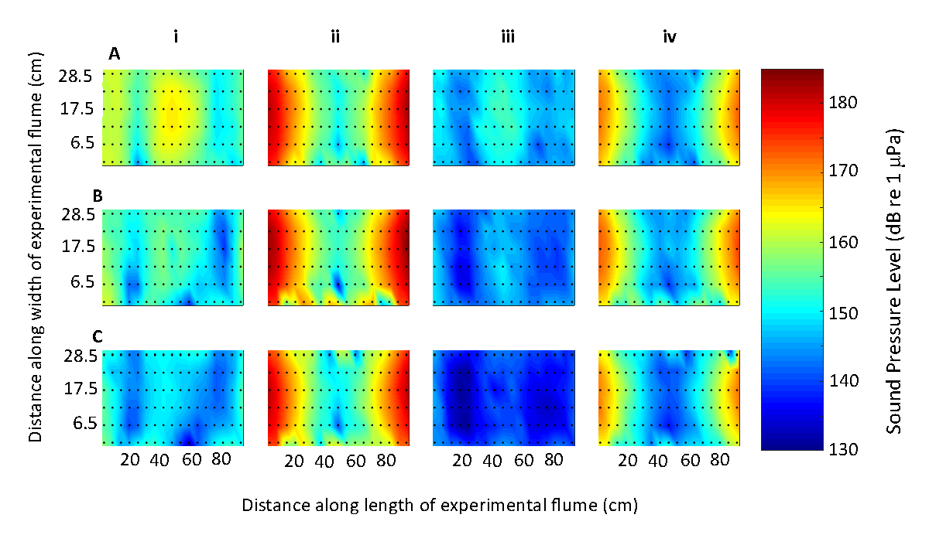
Figure S1. Acoustic treatment conditions for (i) SINE_150; (ii) SINE_2200; (iii) NOISE_150; and (iv) NOISE_2200, with recordings of SPL taken at three different water depths (A) 7 cm; (B) 13.5 cm; and (C) 20 cm. Note: Points indicate hydrophone positioning. Each treatment was standardised at 150 dB re 1 μPa in the centre (B) of the tank.
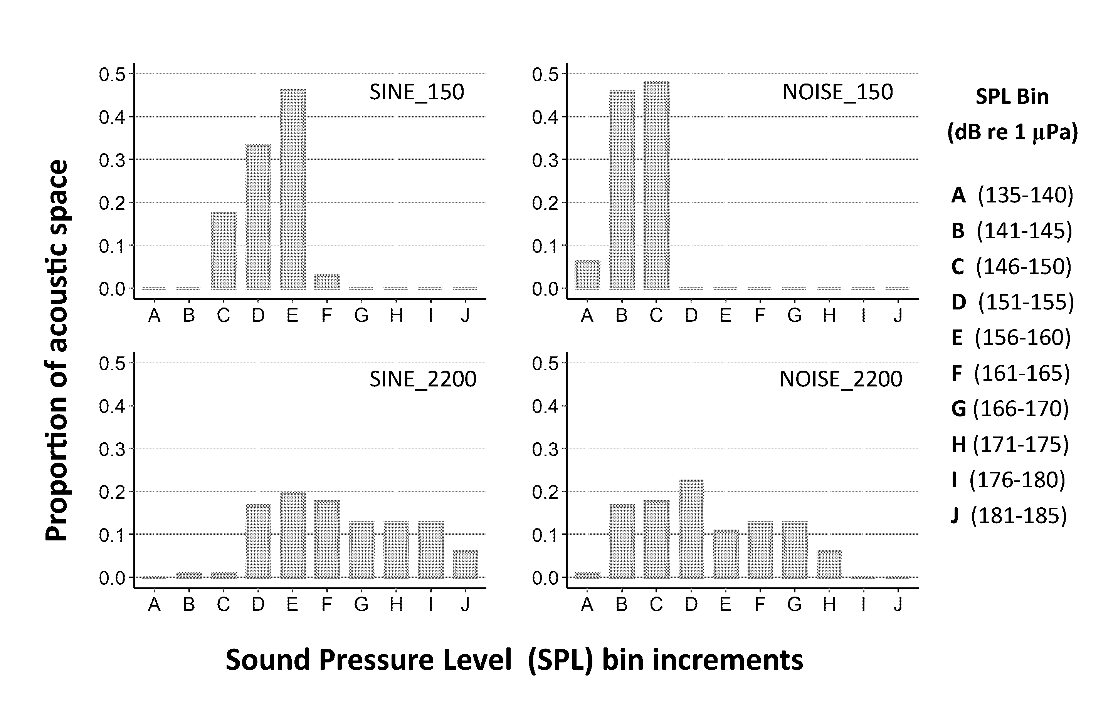
Figure S2. Total proportion of acoustic space available to groups of five minnows within the experimental arena, binned into 5 dB (re 1 μPa) increments for the four acoustic treatments: SINE_150; SINE_2200; NOISE_150; and NOISE_2200.

