Supplementary material for “Porosity and free gas estimates from controlled source electromagnetic data at the Scanner Pockmark in the North Sea” by Romina A.S. Gehrmann, Giuseppe Provenzano, Christoph Böttner, Héctor Marín-Moreno, Gaye Bayrakci, Yee Y. Tan, Naima K. Yilo, Axel T. Djanni, Karen A. Weitemeyer, Timothy A. Minshull, Jonathan M. Bull, Jens Karstens and Christian Berndt.

S.1 Additional data for synthetic study presented in Section 2.2
We ran simulations using the forward code in MARE2DEM for a simple model (Fig. 4a) with increasing resistivities with depth and with and without a resistive gas pocket at about 40 mbsf. Additional to the synthetic data shown in Fig. 4b, Fig. S.1.1 shows data for 1 to 11 Hz.
The amplitude response to the gas pocket does not change much between 7, 9, and 11 Hz. We conclude that including one of the frequencies above 5 Hz is sufficient, otherwise we possibly add a weighting for these higher frequencies in the inversion, which may bias the results.

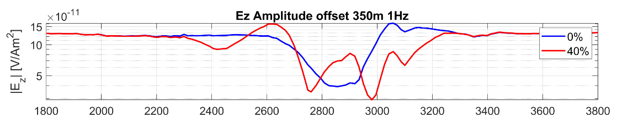
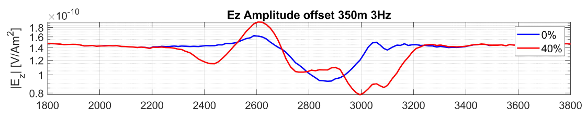
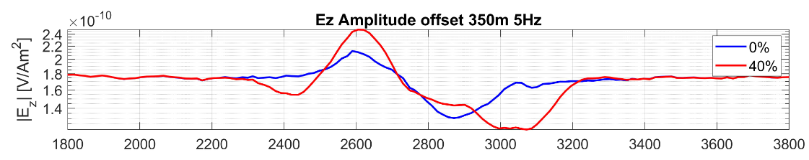
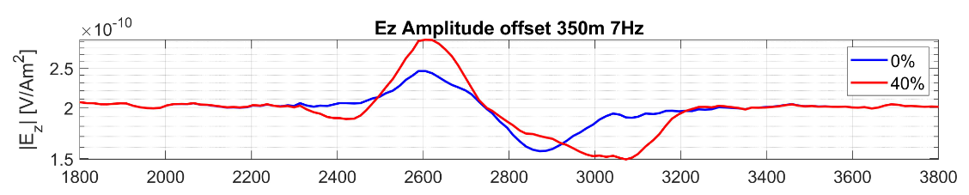
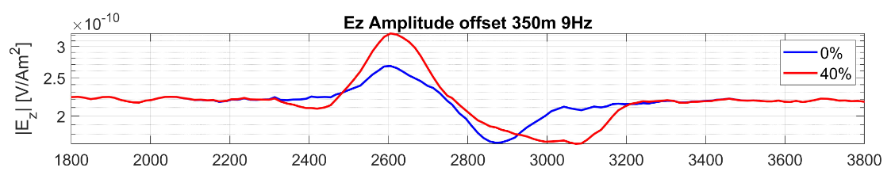
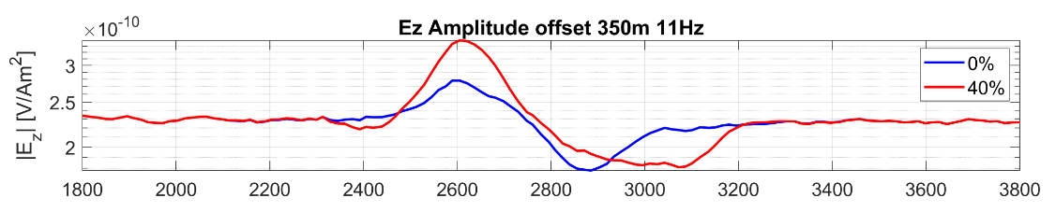
Fig. S.1.1: Example of synthetic vertical electric field (Ez) data at 1 to 11 Hz for zero and 40% free gas in a gas pocket (shown in Fig. 4a).

S.2 Inversion of CSEM data along profile P4 using different CSEM frequencies
Using vertical electric field data at frequencies of 1, 3, 5, and 7 Hz (Fig. S.2.1) in a 2D inversion along profile P4, we observe that the optimal model shows a steady increase in resistivity with depth (Fig. S.2.1a). E_{z} data from the Vulcan at 350 m offset vary more in magnitude for 1 and 3 Hz than for 5 and 7 Hz (Fig. S.2.1b). E_{z} is sensitive to the dip of the instrument, which explains the amplitude peaks and troughs when the array geometry is adjusted (e.g., the troughs in the 1 Hz data for the furthest Vulcan (b) at 1.1 km and 3.8 km relate to the receiver pitch in Fig. S.2.2; Note that the data in Fig. S.2.1b and c are shown at the transmitter-receiver midpoint instead of receiver position).
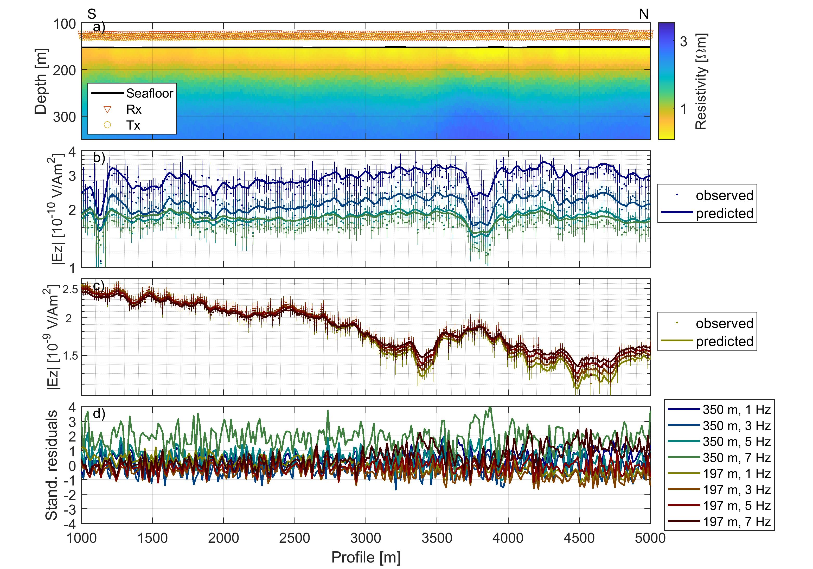
Fig. S.2.1: Resistivity model (a) and vertical electric field amplitudes (b-c) for CSEM profile P4 for frequencies 1, 3, 5, and 7 Hz. The amplitudes for the vertical electric field E_{z} are shown on panel b for the furthest Vulcan and c for the closest Vulcan, for observed (dots with error bars) and predicted data (solid lines). Standardised residuals for both receivers are shown on panel d.
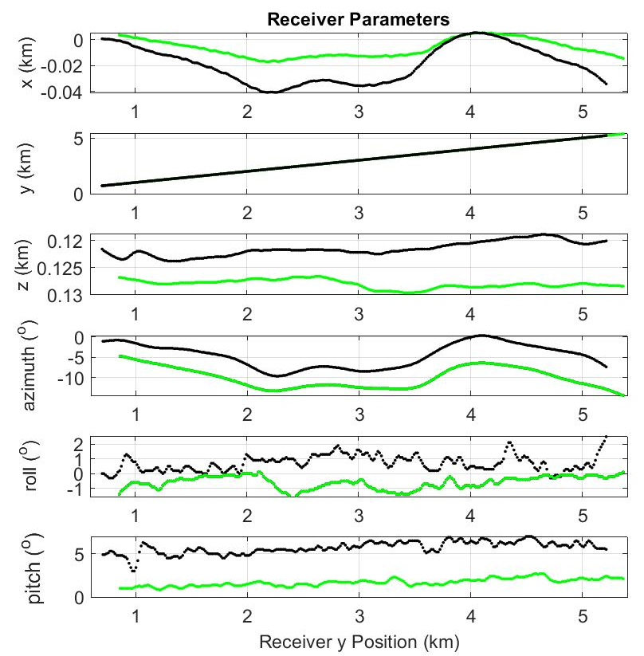 | 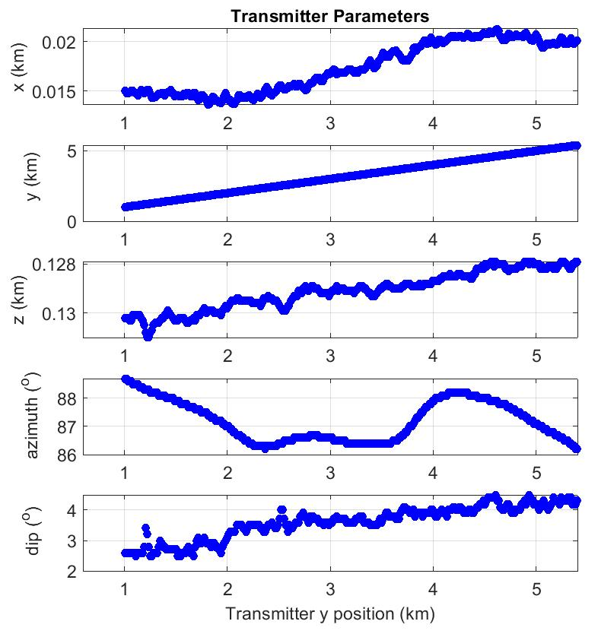
Fig. S.2.2: Transmitter antenna and receiver parameters (197-m offset, green, 350-m offset, black) versus the y position along the profile: Cross-line distance along the profile x, in-line distance along the profile y, depth along the profile z, azimuth in respect to cross-line direction for the transmitter, azimuth in respect to the in-line direction for the receiver, roll for the receivers, dip for the transmitter, and the pitch for the receivers.

Now by using electric field data at frequencies 1, 5, 9, and 13 Hz (Fig. S.2.3), the optimal model shows conductive areas (~0.8 Ωm, at ~100 mbsf, past the 3000 m mark along the profile) that are difficult to be explained geologically. The residuals for E_{z} data are larger past the 3000 m mark along the profile (Fig. S.2.3c compared to Fig. S.2.1c) suggesting that a better data fit can be achieved using 1, 3, 5 and 7 Hz without including the conductive areas. We also observe that the E_{z} data from the Vulcan at 350 m offset for frequencies 9 and 13 Hz are close together in magnitude. Our interpretation is that the inversion tries to fit the high-frequency data by including more structure, and is putting less weight on the low frequencies although these penetrate deeper into the subsurface. Using 1, 3, 5 and 7 enables us to invert all profiles yielding very similar results and data fits without contradictions or erroneous resistivity structure.

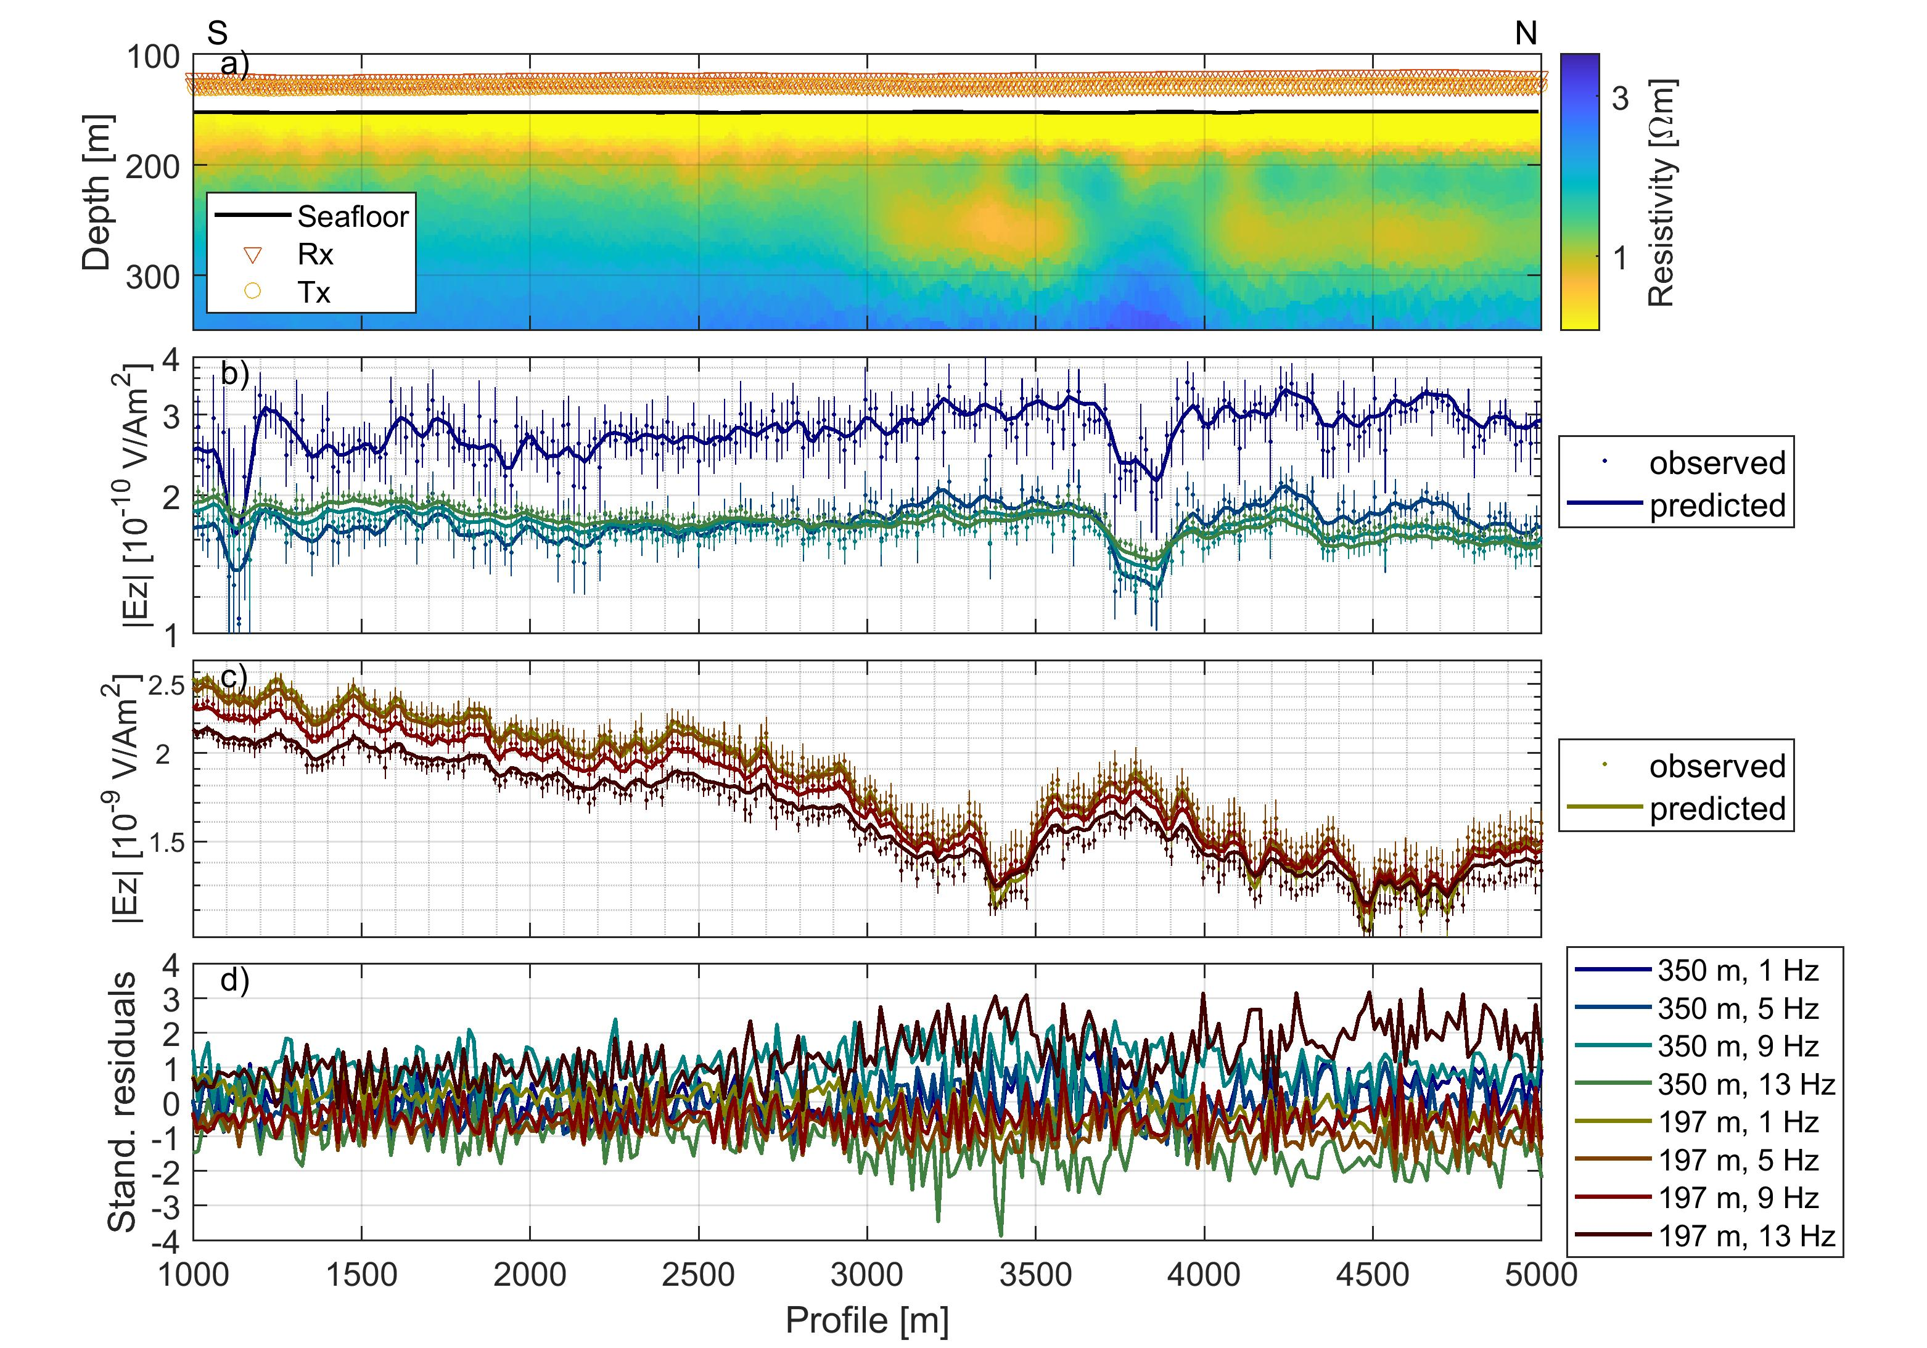
Fig. S.2.3: Resistivity model (a) and vertical electric field amplitudes (b-c) for CSEM profile P4 for frequencies 1, 5, 9 and 13 Hz. The amplitudes for the vertical electric field E_{z} are shown on panel b for the furthest Vulcan and c for the closest Vulcan, for observed (dots with error bars) and predicted data (solid lines). Standardised residuals for both receivers are shown on panel d.

