The reactions of MoOCl₄ with neutral Group 15 and 16 ligands and a re-investigation of some N-donor ligand complexes of MoOCl₃.

Victoria K. Greenacre, William Levason, James Powell, Gillian Reid* and Danielle E. Smith

School of Chemistry, University of Southampton, Southampton SO17 1BJ, U.K. (G.Reid@soton.ac.uk)

Abstract
The reaction of molybdenum(VI) oxide tetrachloride, MoOCl₄, with neutral ligands including MeCN, Ph₃PO, SMe₂, MeS(CH₂)₃SMe, SeMe₂, PMe₃, 2,2’-bipyridyl and 1,10-phenanthroline, results in reduction to form oxomolybdenum(V) complexes, identified by microanalysis, IR and UV/visible spectroscopy and via X-ray crystal structure analyses of several examples. Unexpectedly, the product formed with SeMe₂ was [SeMe₃]₂[Mo₂O₂Cl₆(μ-Cl)₂] and with SMe₂, [SMe₂Cl]₂[Mo₂O₂Cl₆(μ-Cl)₂]. X-ray crystal structures are reported for mer-[MoOCl₃(MeCN)₂], [{MoOCl₂(MeCN)}₂(µ-Cl)₂], [MoOCl₃{MeS(CH₂)₃SMe}], [SeMe₃][MoOCl₄(H₂O)], [SMe₂Cl]₂[Mo₂O₂Cl₆(μ-Cl)₂] and [PMe₃H][MoOCl₄(PMe₃)]. The reaction of MoOCl₄ with [Et₄N]Cl forms the dinuclear Mo(V) species, [Et₄N]₂[Mo₂O₂Cl₆(μ-Cl)₂].
The red mer-[MoOCl₃(diimine)] (diimine = 2,2’-bipyridyl, 1,10-phenathroline) complexes were prepared from [MoOCl₃(thf)₂] and the diimine and fully characterised by spectroscopy and by X-ray crystallography. The long-known ‘green isomers’ of [MoOCl₃(diimine)] obtained from MoOCl₄ and the diimines (and in other ways), are suggested to be the red isomers co-crystallised with another lower oxidation state molybdenum complex.
Keywords:
Molybdenum oxide tetrachloride; molybdenum oxide trichloride; 2,2’-bipyridyl; 1,10-phenanthroline, X-ray structures.

1. Introduction
The chemistries of molybdenum and tungsten are in general very similar [1,2], but significant differences are seen in their highest oxidation state (+6), where the tungsten compounds are often much more stable. For example, WBr₆, WOBr₄ and WSCl₄ have been known since the mid-twentieth century [3], but the corresponding MoBr₆, MoOBr₄ and MoSCl₄ have never been obtained. Also, while WCl₆ is commercially available as a precursor for other tungsten compounds, MoCl₆ was only characterised in 2013 and decomposes below room temperature [4]. The lower stability of the analogous molybdenum complexes also extends to their coordination complexes. The coordination chemistry of the molybdenum oxide chlorides, Mo^{VI}O₂Cl₂ and Mo^{V}OCl₃ received significant effort in the period 1960-1990, much of it driven by catalytic applications and attempts to model the active sites of molybdenum enzymes [1,2]. The third oxide chloride, Mo^{VI}OCl₄ was very little studied and it was usually reported to be reduced by neutral organic ligands [5,6,7], although detailed descriptions were rare. It is commercially available and can be made readily from reaction of MoO₃⋅nH₂O with SOCl₂ followed by vacuum sublimation [6].
We have recently examined various series of coordination complexes with WOCl₄ and WSCl₄, including with nitrogen and oxygen donor ligands [8], phosphines and arsines [9], and thio-, seleno- and telluro-ethers [10] (of which some had been described in early literature) and we demonstrated that some thioether complexes of WSCl₄ can function as single source precursors for low pressure CVD (chemical vapour deposition) growth of semi-conducting WS₂ thin films [10]. We have also established three series of complexes of MoOCl₃ with thio-, seleno- and telluro-ethers, [MoOCl₃(L-L)] (L-L = RS(CH₂)₂SR, R = ^{i}Pr, Ph; MeS(CH₂)₃SMe; MeSe(CH₂)_{n}SeMe, n = 2, 3), [{MoOCl₂(EMe₂)}₂(µ-Cl)₂] (E= S, Se, Te) and [(MoOCl₃)₂(L’-L’)] (L’-L’ = o-C₆H₄(SeMe)₂, o-C₆H₄(TeMe)₂, MeTe(CH₂)₃TeMe) [11].
In terms of Mo(VI) complexes, the first neutral organic ligand complexes of molybdenum(VI) oxide tetrafluoride, MoOF₄, [MoOF₄(L)] (L = MeCN, thf, OPPh₃, OPMe₃, dmso, dmf, bipy) have been obtained very recently [12], but in contrast to WOF₄, which formed [WOF₄(L-L)] (L-L = Me₂P(CH₂)₂PMe₂, o-C₆H₄(PMe₂)₂) and [WOF₄(PMe₃)] [13], MoOF₄ is reduced by phosphines, arsines or thioethers [12].
Here we describe the reactions of MoOCl₄ with a variety of donor ligands from Groups 15 and 16, including re-investigation of some examples described previously, and the characterisation of MoOCl₃ complexes with some neutral nitrogen donor ligands. The molybdenum (III, IV and V) complexes of the nitrogen ligands 2,2’-bipyridyl and 1,10-phenanthroline (L-L) were much studied in 1960–1980’s, but the literature is complicated, confused and often contradictory. For example, describing green, pink-purple and sometimes khaki “isomers” of [MoOCl₃(L-L)], in addition to dimers and protonated imine salts of oxochloromolybdate(V) anions [1,7]. The reports are mostly based upon wet analyses and limited spectroscopy and no structures were reported. In this paper we have also attempted to clarify some of this work.
2. Experimental
Syntheses were performed using standard Schlenk and glovebox techniques under a dry N₂ atmosphere. MoOCl₄ was obtained from Climax Molybdenum and MoOCl₃ made by the literature route from MoCl₅ and O(SiMe₃)₂ [14]. Solvents were dried by distillation from CaH₂ (MeCN and CH₂Cl₂) or Na/benzophenone ketyl (toluene, n-hexane). Ligands were dried by heating in vacuo (bipy, phen, Ph₃PO) or over molecular sieves (liquid ligands). Infrared spectra were recorded on a PerkinElmer Spectrum 100 spectrometer in the range 4000–200 cm⁻¹, with samples prepared as Nujol mulls between CsI plates. UV/ visible spectra were recorded as powdered solids, using the diffuse reflectance attachment of a Perkin Elmer 750S spectrometer. Where appropriate, ¹H NMR spectra were obtained on a Bruker DPX400. Magnetic measurements were made using a Johnson-Matthey magnetic balance. Microanalyses on new compounds were undertaken by London Metropolitan University or Medac.
2.1 Reaction of MoOCl₄ with [Et₄N]Cl → [Et₄N]₂[Mo₂O₂Cl₆(μ-Cl)₂]
MoOCl₄ (0.150 g, 0.59 mmol) was suspended in CH₂Cl₂ (3 mL) and a solution of [Et₄N]Cl (0.097 g, 0.59 mmol) in CH₂Cl₂ (3 mL) was slowly added and the solution left to stir for 1h. The brown solution was concentrated to 3 mL in vacuo and filtered, and the solid then dried in vacuo yielding a brown powder. Yield: 0.095 g, 47%. IR spectrum (Nujol, v /cm⁻¹): 998s Mo=O, 352s Mo-Cl. Orange-yellow crystals were grown from CH₂Cl₂ solution and shown to have the formulation above.
2.2 Reaction of MoOCl₄ with MeCN → mer-[MoOCl₃(MeCN)₂] and [{MoOCl₂(MeCN)}₂(µ-Cl)₂])
MeCN (1 mL) was added dropwise to MoOCl₄ (0.150 g, 0.59 mmol) dissolved in CH₂Cl₂ (5 mL). After stirring the red solution for 1 h. at room temperature, the then dark brown solution was concentrated in vacuo. A pale green solid was isolated through filtration, washed with hexane (2 x 1 mL) and dried in vacuo. On careful examination it was seen to contain both green and yellow material. Crystals of both were grown by evaporation from CH₂Cl₂ solution. Combined yield: 0.128 g. Microanalyses gave values intermediate between those required for the two complexes, the ratios of which varied between samples, hence these are not reported. IR spectrum (Nujol, ν/cm⁻¹): 2313, 2304 C≡N, 2284, 2277 ν(C−C) + δ(CH₃), 1022, 986 Mo=O, 371, 346, 320 Mo-Cl.

2.3 Reaction of MoOCl₄ with OPPh₃ → mer-[MoOCl₃(OPPh₃)₂]
A solution of OPPh₃ (0.328 g, 1.18 mmol) in CH₂Cl₂ (5 mL) was added dropwise to a solution of MoOCl₄ (0.150 g, 0.59 mmol) in CH₂Cl₂ (5 mL). After stirring the initially red solution for 1 h at ambient temperature, the purple solution produced was concentrated in vacuo. The light blue-green solid deposited was isolated through filtration, washed with hexane (2 x 1 mL) and dried in vacuo. Yield: 0.247 g, 54%. Required for C₃₆H₃₀Cl₃MoO₃P_{2:} (774.87) C, 55.80; H, 3.90. Found: C, 55.78; H, 3.23%. IR spectrum (Nujol, υ/cm⁻¹): 1159 s, 1145 m, P=O, 972 Mo=O s, 320 s Mo-Cl. UV/Vis spectrum (diffuse reflectance) ν / cm⁻¹: 33,000, 28,200, 22,300, 13,400. μ_{eff}: 1.71 B.M. Blue-green crystals were grown from CH₂Cl₂ layered with n-hexane.
2.4 Reaction of MoOCl₄ with SMe₂ → [SMe₂Cl]₂[Mo₂O₂Cl₆(μ-Cl)₂]
MoOCl₄ (0.150 g, 0.59 mmol) was suspended in CH₂Cl₂ (6 mL) and a SMe₂ (0.09 mL, 1.1 mmol) solution in CH₂Cl₂ (3 mL) was added slowly and left to stir for 1 h. The green solution was filtered away from a pale green solid and layered with hexane (10mL). Green crystals formed, shortly after isolation the green solid began to decompose into a green oil, hence microanalytical data could not be obtained. IR spectrum (Nujol, v/cm⁻¹): 1000s Mo=O, 342s Mo-Cl. ¹H NMR (CD₂Cl₂): 3.10 (br, s).
2.5 Reaction of MoOCl₄ and MeS(CH₂)₃SMe → [MoOCl₃{MeS(CH₂)₃SMe}]
The reaction was conducted in toluene as described elsewhere [11]. IR spectrum (Nujol, v/cm⁻¹): 951s Mo=O, 351s, 326s, 305m Mo-Cl. μeff: 1.71 B.M. Green crystals suitable for single crystal X-ray analysis were grown from CH₂Cl₂.
2.6 Reaction of MoOCl₄ with SeMe₂ → [SeMe₃]₂[Mo₂O₂Cl₆(μ-Cl)₂]
MoOCl₄ (0.150 g, 0.59 mmol) was suspended in CH₂Cl₂ (6 mL) before a solution of SeMe₂ (0.1 mL, 1.1 mmol) in CH₂Cl₂ (3 mL) was added slowly and left to stir for 1 h. The yellow-green suspension was dried in vacuo and washed with hexane (2 x 2 mL) to give a yellow-brown solid. Yield: 0.138 g, 62%. Required for C₆H₁₈Cl₈Mo₂O₂Se₂ (755.6): C, 9.54; H, 2.40. Found: C, 9.22; H, 2.75 %. IR spectrum (Nujol, v/cm⁻¹): 969s Mo=O, 341s Mo-Cl. ¹H NMR (CD₂Cl₂) 3.09(s). Pale green crystals grown from CH₂Cl₂ solution were found to be [SeMe₃][MoOCl₄(H₂O)].
2.7 Reaction of MoOCl₄ with PMe₃ → fac-[MoOCl₃(PMe₃)₂]
MoOCl₄ (0.150 g, 0.59 mmol) was suspended in CH₂Cl₂ (5 mL) and cooled to -85 °C before a solution of PMe₃ (0.12 mL, 1.2 mmol) in CH₂Cl₂ (4 mL) was added slowly and left to stir for 1 h. The deep red solution was concentrated in vacuo and the resulting pink solid was isolated. Yield: 0.181 g, 83%. Required for C₆H₁₈Cl₃MoOP₂ (370.45): C, 19.45; H, 4.90. Found: C, 20.00; H, 5.90 %. IR spectrum (Nujol, v/cm⁻¹): 950s Mo=O, 330s, 303m Mo-Cl. A few yellow-green crystals grown from the mother liquor were identified by their crystal structure as [PMe₃H][MoOCl₄(PMe₃)].

2.8 Mer-[MoOCl₃(bipy)]
A solution of bipy (0.065 g, 0.41 mmol) in CH₂Cl₂ (5 mL) was added dropwise to a solution of [MoOCl₃(thf)₂] (0.150 g, 0.41 mmol) dissolved in CH₂Cl₂ (5 mL). After stirring the dark green solution for 1 h at room temperature, the then dark red suspension was concentrated to half its volume in vacuo. The red solid was isolated through filtration, washing with hexane (2 x 1 mL) and drying in vacuo. Yield: 0.087 g, 56%. Required for C₁₀H₈Cl₃MoN₂O (374.48): C, 32.07; H, 2.15; N, 7.48. Found: C, 32.07; H, 2.28; N, 7.28%. IR spectrum (Nujol, v/cm⁻¹): 970s Mo=O, 365sh, 348s, 316m Mo-Cl. μeff: 1.71 B.M. UV/Vis spectrum (diffuse reflectance) ν/cm⁻¹: 13,800, ~21,000(sh), 22,200, 25,000, 30,000.
2.9 Reaction of MoOCl₄ with bipy
MoOCl₄ (0.150 g, 0.59 mmol) was suspended in CH₂Cl₂ (3 mL) and a solution of 2,2’-bipy (0.092 g, 0.59 mmol) in CH₂Cl₂ (5 mL) was added slowly and the solution left to stir for 1 h. The resulting green suspension was then concentrated to 3 mL in vacuo, filtered and the solid was washed with hexane (2 x 1 mL) before it was dried in vacuo. Yield: 0.145 g. Required for ‘green isomer’ C₁₀H₈N₂Cl₃MoO (374.48): C, 32.07; H,2.15; N, 7.48, Cl, 28.4%. Found (typical analyses from different batches): C, 31.4; H, 2.1; N, 7.2; Cl, 28.2%; C, 31.05; H, 2.09; N, 7.24%; C, 30.98; H, 2.83 N, 5.68% - see discussion. IR spectrum (Nujol, v/cm⁻¹): 970s Mo=O, 385sh, 340s, 317m Mo-Cl. UV/Vis spectrum (diffuse reflectance) ν/cm⁻¹: 13,800, 18,800, 21,000(sh), 25,000, 31,000.

2.10 Mer-[MoOCl₃(phen)]
A solution of phen (0.074 g, 0.41 mmol) in CH₂Cl₂ (5 mL) was added dropwise to a solution of [MoOCl₃(thf)₂] (0.150 g, 0.41 mmol) dissolved in CH₂Cl₂ (5 mL). After stirring the dark green solution for 1 h at room temperature, the then dark red suspension was concentrated to 5 mL in vacuo. The red solid was isolated through filtration, washing with hexane (2 x 1 mL) and drying in vacuo. Yield: 0.110 g, 66%. Required for C₁₂H₈N₂Cl₃MoO (398.5): C, 36.17, H, 2.02; N, 7.03. Found: C, 36.04; H, 1.85; N, 6.90%. IR spectrum (Nujol, v/cm⁻¹): 971s Mo=O, 360m, 342s, 309w. Mo-Cl. μeff: 1.69 B.M. UV/Vis spectrum (diffuse reflectance) ν/cm⁻¹: 13,400, ~ 21,000(sh), 22,800, 27,500, 30,500.
2.11 Reaction of MoOCl₄ with phen
A solution of 1,10-phen (0.106 g, 0.59 mmol) in CH₂Cl₂ (5 mL) was added dropwise to a cold solution of MoOCl₄ (0.150 g, 0.59 mmol) dissolved in CH₂Cl₂ (5 mL). After stirring the red solution for 1 h at room temperature, the then green suspension was concentrated to ~ 5 mL in vacuo. The green solid was isolated through filtration, washing with hexane (2 x 1 mL) and drying in vacuo. Required for ‘green isomer’ C₁₂H₈N₂Cl₃MoO (398.5): C, 36.17, H, 2.02; N, 7.03, Cl 26.65%. Found (examples from different batches): C, 36.04; H, 1.85; N, 6.90, Cl, 26.69%; C, 31.46; H, 2.24; N, 5.99; Cl, 30.50 %; C, 33.95, H, 1.77, N, 6.31%. IR spectrum (Nujol, v/cm⁻¹): 977 Mo=O, 331 br, m Mo-Cl. UV/Vis spectrum (diffuse reflectance) ν/cm⁻¹: 13,400, 18,700, 19,800, 26,300, 27,800, 30,700.
2.12 X-ray experimental
Crystals were grown by slow evaporation from saturated solutions in CH₂Cl₂ or by liquid-liquid diffusion using CH₂Cl₂ and hexane. Data collections used either a Rigaku AFC12 goniometer equipped with an enhanced sensitivity (HG) hybrid pixel (HyPix-600HE) detector mounted at the window of an FR-E+ SuperBright molybdenum (λ = 0.71073 Å) rotating anode generator with VHF Varimax optics (70 micron focus) with the crystal held at 100 K (N₂ cryostream), or a Rigaku AFC11 goniometer equipped with a hybrid pixel (HyPix-600HE) detector mounted at the window of a Rigaku 007 HF (high flux) copper (λ = 1.54178 Å) rotating anode generator with HF optics with the crystal held at 100 K (N₂ cryostream). Crystallographic parameters are presented in Table 1. Structure solution and refinement were performed using SHELX(T)-2018/2, SHELX-2018/3 through Olex2 [15,16,17] and were mostly straightforward. H atoms were added and refined with a riding model. Where additional restraints were required, details are provided in the cif file for each structure found on CCDC.
3. Results and discussion
3.1 Reaction of MoOCl₄ with neutral ligands:
Scheme 1: summary of MoOCl₄ reactions described in this work.
The reactions of MoOCl₄ with the neutral ligands were carried out in either anhydrous CH₂Cl₂ or toluene at ambient temperatures, unless indicated otherwise (Scheme 1).
Reaction of MoOCl₄ with dry MeCN in CH₂Cl₂ solution at ambient temperature gave a paramagnetic pale green solid, which on closer examination was seen to contain both green and yellow powder. Repeating this reaction varying the MoOCl₄ : MeCN ratio, in an ice bath, under reflux, in toluene solution, or using neat MeCN, also gave mixtures of the same two species, with the relative amounts varying depending upon the reaction conditions, but both were always present in the isolated solids (from their IR spectra). Crystals were grown by slow evaporation from CH₂Cl₂ solution, and under the microscope were seen to contain both yellow and green crystals with different morphologies, which were identified by their X-ray structures as the Mo(V) complexes, mer-[MoOCl₃(MeCN)₂] (yellow) and [{MoOCl₂(MeCN)}₂(µ-Cl)₂]) (green) (Fig.1). The structure of [(MoOCl₂(MeCN))₂(µ-Cl)₂] shows a centrosymmetric dimer with the MeCN ligands arranged anti, and very asymmetric chloride bridges, the Mo-Cl_{transO} being some 0.35 Å longer than the Mo-Cl_{transCl}; otherwise the bond lengths in both structures are as expected.. Similar structures with L perpendicular to the Mo₂O₂Cl₆ plane and arranged anti have been reported for [(MoOCl₂(L))₂(µ-Cl)₂] (L = O=C(H)OMe, thf, O=CEt₂, SMe₂, SeMe₂) [11,18,19,20].

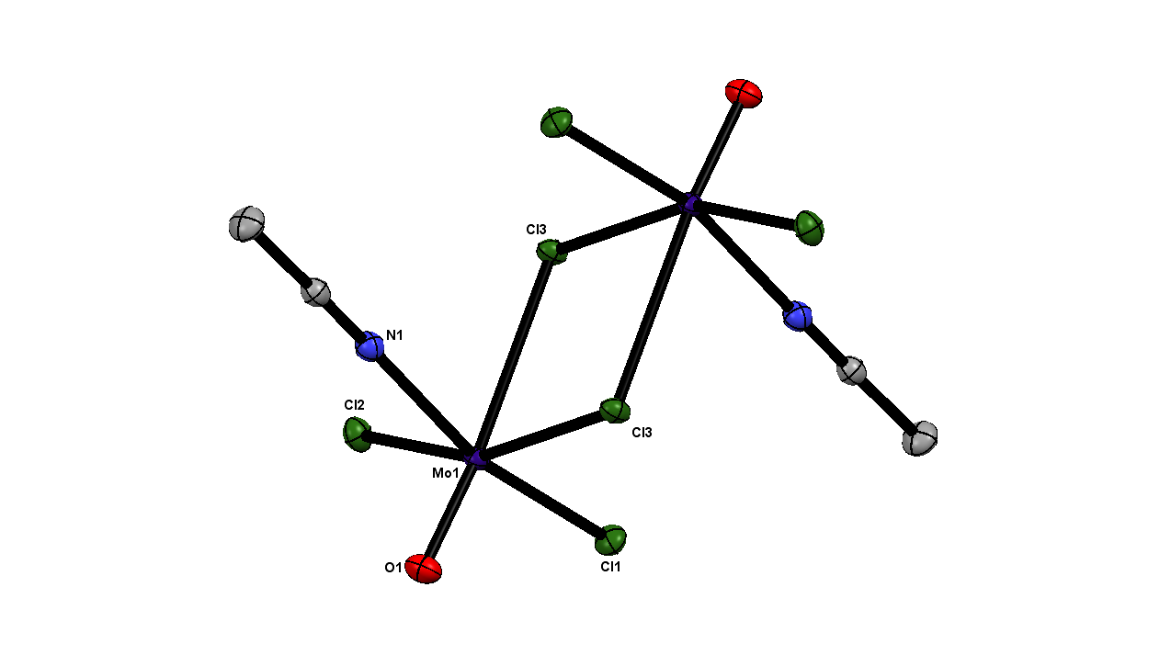

(a) (b)
Fig. 1. Crystal structures of (a) [{MoOCl₂(MeCN)}₂(µ-Cl)₂] and (b) mer-[MoOCl₃(MeCN)₂] showing the atom numbering scheme. Ellipsoids shown at 50% probability and hydrogen atoms are omitted for clarity. Note that [MoOCl₃(MeCN)₂] exhibits O/Cl disorder, which was modelled with split atom sites and refined to occupancies of 0.30:0.70; only the major form is shown. Selected bond lengths (Å) and angles (°) : (a) Mo1-Cl1 = 2.3082(4), Mo1-Cl2 = 2.3199(3), Mo1-Cl3 = 2.4142(3), Mo1-Cl3’ = 2.7788(3), Mo1-O1 = 1.6502(9), Mo1-N1 = 2.151(1), O1-Mo1-Cl1 = 100.82(4), O1-Mo1-Cl2 = 102.70(3), O1-Mo1-Cl3 = 98.32(3), Cl1-Mo1-Cl3 = 88.38(1), Cl2-Mo1-Cl3 = 81.19(1), Cl3-Mo1-Cl3’ = 77.01(1), N1-Mo1-Cl3’ = 85.23(3), N1-Mo1-Cl3 = 78.15(3), N1-Mo1-Cl2 = 87.30(3) O1-Mo1-N1 = 92.53(4); (b) Mo1-Cl1 = 2.311(1), Mo1-Cl2 = 2.3633(7), Mo1-Cl3 = 2.3453(7), Mo1-O1 = 1.653(4), Mo1-N1 = 2.136(2), Mo1-N2 = 2.140(2), Cl1-Mo1-Cl2 = 1.91(4), Cl1-Mo1-O1 = 103.5(1), Cl1-Mo1-Cl3 = 87.73(4), Cl3-Mo1-O1 = 100.1(1), O1-Mo1-Cl2 = 97.19(15), N2-Mo1-N1 = 77.87(5).
The ¹H NMR spectrum of the original mixture showed no resonances, ruling out the presence of any diamagnetic Mo(VI) species. The IR spectrum of the mixture showed two ν(C≡N) 2313, 2304 and two ν(C−C) + δ(CH₃) at 2284, 2277 cm⁻¹, with ν(Mo=O) at 1023, 986 and overlapping ν(Mo-Cl) at 371, 348 and 321 cm⁻¹. Comparison with other oxomolybdenum(V) complexes [11,19,20] allows assignment of the Mo=O at 986 cm⁻¹ to mer-[MoOCl₃(MeCN)₂] and the band at 1023 cm⁻¹ to [{MoOCl₂(MeCN)}₂(µ-Cl)₂]), but the overlapping Mo-Cl modes precludes their assignment to a specific species. The spectroscopic data on mer-[MoOCl₃(MeCN)₂] are in fair agreement with that reported for the same complex made from MoOCl₃ [21], although in that study the presence of the second complex was overlooked.
The reaction of MoOCl₄ with bipy or phen in CH₂Cl₂ or toluene solution produced green paramagnetic powders, which seemed to correspond to the reported ‘green isomers’ of [MoOCl₃(diimine)], variously made by heating [diimineH₂][MoOCl₅] either as a solid or in MeCN or dmf solution, by chlorination of [Mo(CO)₄(diimine)] or from MoCl₅ and the diimine in wet solvents [22,23,24,25,26]. The complexes are described as “trans” in the older literature, which corresponds to a mer arrangement of the chlorines. Our samples exhibited rather poor and varying microanalyses from batch to batch, but typically with the % C, H, N, lower and % Cl higher than expected for this formula. These species are discussed further in Section 3.2.
The reaction of MoOCl₄ with Ph₃PO in CH₂Cl₂ gave pale blue-green crystals identified by an X-ray structure and spectroscopically as the Mo(V) complex, [MoOCl₃(Ph₃PO)₂]. The structural (Table 1) and spectroscopic data (Section 2.3) are in excellent agreement with literature data [27,28] and therefore are not discussed further here.
Since MoOCl₄ was reduced to Mo(V) by MeCN, diimines and Ph₃PO, it was expected that reduction would occur with heavier Group 15 and 16 donor ligands, and therefore only representative examples of P, S and Se donors were examined.
The major molybdenum product isolated from reaction of MoOCl₄ and PMe₃ was red fac-[MoOCl₃(PMe₃)₂], previously made from PMe₃ and [MoOCl₃(thf)₂] [11] or [Cl₂OMo(µ-OEt)₂(µ-EtOH)MoOCl₂] [29], and identified by microanalysis and through comparison of the spectroscopic data. A few yellow-green crystals grown from the mother liquor were identified by their crystal structure as [PMe₃H][MoOCl₄(PMe₃)]. This complex was previously isolated as a product of the slow reaction of fac-[MoOCl₃(PMe₃)₂] with HCl in CH₂Cl₂ [29]. The structure shows (Fig. 2) a distorted six-coordinate anion with PMe₃ trans to Cl. The bond lengths are unexceptional, and little different to the corresponding bonds in the neutral fac-[MoOCl₃(PMe₃)₂] [11,29].
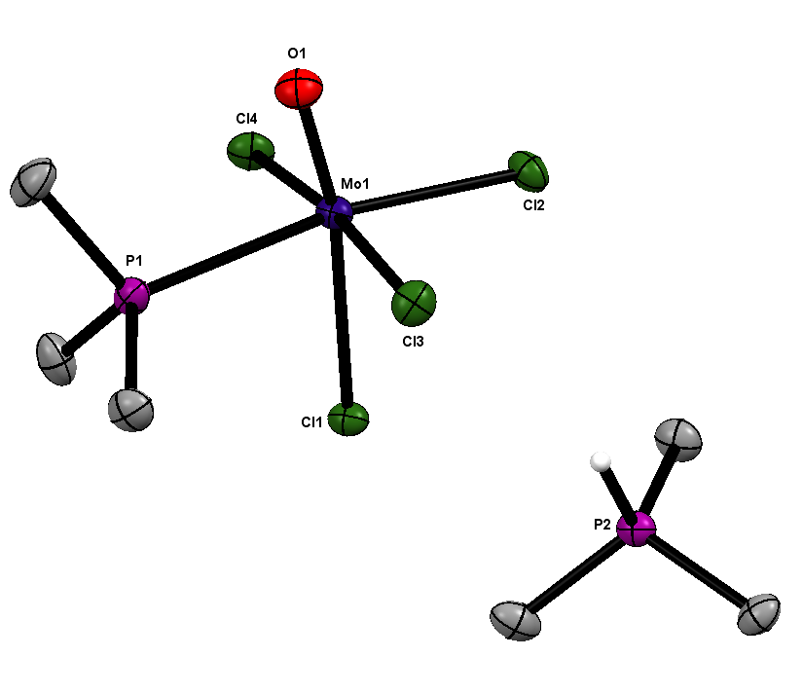
Fig. 2 Structure of [PMe₃H][MoOCl₄(PMe₃)] showing the atom numbering scheme and a hydrogen atom on the cation for clarity (other H atoms are omitted). Ellipsoids are shown at 50% probability. Selected bond lengths (Å) and angles (°): Mo1-Cl1 = 2.5344(6), Mo1-Cl2 = 2.4028(6), Mo1-Cl3 = 2.3922(6), Mo1-Cl4 = 2.3857(6), Mo1-P1 = 2.5393(7), Mo1-O1 = 1.6719(18), Cl1-Mo1-P1 = 77.74(2), Cl2-Mo1-Cl1 = 89.23(2), Cl3-Mo1-Cl1 = 83.86(2), Cl3-Mo1-Cl2 = 91.97(2), Cl3-Mo1-P1 = 90.74(2), Cl4-Mo1-Cl1 = 87.84(2), Cl4-Mo1-Cl2 = 89.79(2), Cl4-Mo1-P1 = 85.64(2), O1-Mo1-Cl2 = 103.60(7), O1-Mo1-Cl3 = 92.79(7), O1-Mo1-Cl4 = 94.89(7), O1-Mo1-P1 = 89.65(7).

The reaction of MoOCl₄ with SMe₂ in CH₂Cl₂ led to the growth of some green crystals of [SMe₂Cl]₂[Mo₂O₂Cl₈] from a CH₂Cl₂/hexane mixture (Fig. 3). The crystal was twinned, and the SMe₂Cl cation exhibited disorder. NMR spectroscopy of the crude reaction mixture showed the major proton resonance at 3.10 ppm, which is consistent with the [SMe₂Cl]⁺ cation [30]. Both the crude mixture, and the crystals decomposed within 12 h of being isolated from solution, forming a brown-green oil, and precluding microanalysis. The cation is known to be unstable [31] forming MeSCH₂Cl and other products, and this would account for the instability of the crystals. Further discussion of the anion is given later in this section along with the [Et₄N]₂[Mo₂O₂Cl₈] salt.
Fig 3: Structure of [SMe₂Cl]₂[Mo₂O₂Cl₈] showing the atom numbering scheme. Ellipsoids are shown at 50% probability and hydrogen atoms are removed for clarity. Note: [SMe₂Cl]₂ [Mo₂O₂Cl₆(μ-Cl)₂] was a twinned structure and was solved accordingly. The cation exhibits some C/Cl disorder, which was modelled with split atom sites and fixed occupancies of 0.75:0.25; only the major form is shown. Selected bond lengths (Å) and angles (°) : Mo1-Cl1 = 2.3758(8), Mo1-Cl2 =2.3898(7), Mo1-Cl3 = 2.3624(7), Mo1-Cl4 =2.3488(8), Mo1-O1 = 1.653(2), Mo1-Cl2a = 2.904 (symmetry generated), Cl2-Mo1-Cl2a = 76.00, Cl1-Mo1-Cl2 = 88.94(3), Cl4-Mo1-Cl1 = 88.27(3), Cl3-Mo1-Cl2 = 89.02(3), Cl3-Mo1-Cl1 = 165.42(3), Cl4-Mo1-Cl2 = 155.91(3), Cl4-Mo1-Cl3 = 87.71(3), O1-Mo1-Cl2 = 100.53(8), O1-Mo1-Cl3 = 97.66(8), O1-Mo1-Cl4 = 103.56(8), O1-Mo1-Cl1 = 96.90(8).
Reaction of MoOCl₄ with MeS(CH₂)₃SMe in toluene gave a deep green solution from which green [MoOCl₃{MeS(CH₂)₃SMe)] was isolated. It was spectroscopically identical with the product obtained from MoOCl₃ and MeS(CH₂)₃SMe in CH₂Cl₂ [11]. Final confirmation of the identity was obtained from the X-ray crystal structure (Table 1), which showed the fac-[MoOCl₃{MeS(CH₂)₃SMe}] isomer with the dithioether in the meso-form (see SI).
Unexpectedly, the major product from reaction of MoOCl₄ and SeMe₂ the was the anion [MoOCl₄]⁻ with an associated selenonium, [SeMe₃]⁺, cation. Although the IR spectrum showed no water present in the original sample, pale green crystals grown from this product were [SeMe₃][MoOCl₄(H₂O)] (Fig. 4), no doubt the result of ingress of adventitious water during crystallisation. The water O(2) is trans to Mo=O (O1). The structure of this anion has been reported previously [32] and the data are in very good agreement with that in the present work.
Fig. 4 Structure of [SeMe₃][MoOCl₄(H₂O)] showing the atom numbering scheme. Ellipsoids are shown at 50% probability and hydrogen atoms (except on the water) are omitted for clarity. Selected bond lengths (Å) and angles (°): Mo1-Cl1 = 2.3615(8), Mo1-Cl2 = 2.3949(8), Mo1-Cl3 = 2.3676(8), Mo1-Cl4 = 2.4074(8), Mo1-O1 = 1.665(2), Mo1-O2 = 2.256(2), Cl1-Mo1-Cl2 = 89.64(3), Cl1-Mo1-Cl4 = 89.02(3), Cl3-Mo1-Cl2 = 89.16(3), Cl3-Mo1-Cl4 = 88.29(3), O1-Mo1-Cl1 = 98.08(8), O1-Mo1-Cl2 = 96.98(8), O1-Mo1-Cl3 = 98.75(8), O1-Mo1-Cl4 = 96.34(8), O2-Mo1-Cl1 = 81.23(6), O2-Mo1-Cl2 = 83.83(6), O2-Mo1-Cl3 = 81.93(6), O2-Mo1-Cl4 = 82.86(6).

The reaction of MoOCl₄ with [Et₄N]Cl in anhydrous CH₂Cl₂ formed a red solution, which turned brown after 1 h. The solution was concentrated in vacuo, causing precipitation of a brown solid. Orange-yellow crystals were grown from CH₂Cl₂ solution, and their X-ray structure revealed the compound to contain the Mo(V) anion [Mo^{V}₂O₂Cl₆(μ-Cl)₂]^{2–} (Fig. 5). The structure of the present anion reveals the chloride bridges to be very asymmetric (Mo1-Cl4 = 2.4159(3) and Mo1-Cl4^{i} = 2.8350(4) Å), an effect also observed in other examples [33,34,35,36], including [SMe₂Cl]₂[Mo₂O₂Cl₈] (above), which sometimes also show significant interaction with the cations. Whether the best description in individual cases is of two very weakly associated square pyramidal anions or chloride-bridged dimer anions has been discussed by Marchetti et. al. [37]. No cation-anion interaction is observed in the present case and we have formulated it as a dimer. Since high oxidation states are often stabilised in anions, the formation of [Mo^{VI}OCl₅]– in this reaction might have been expected, but this Mo(VI) anion remains unknown.
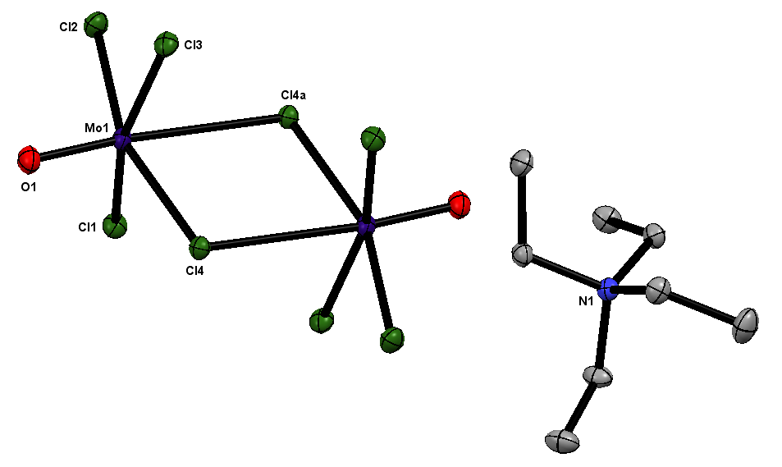
Fig. 5. Crystal structure of the anion in [Et₄N]₂[Mo₂O₂Cl₆(μ-Cl)₂] showing the atom numbering scheme. Ellipsoids are shown at 50% probability. Selected bond lengths (Å) and angles (°): Mo1-Cl1 = 2.3710(4), Mo1-Cl2 = 2.3454(4), Mo1-Cl3 = 2.3605(4), Mo1-Cl4 = 2.4159(3), Mo1-Cl4a = 2.8350(4), Mo1-O1 = 1.6563(8), Cl1-Mo1-Cl2 = 88.12(1), O1-Mo1-Cl4i = 173.89(3), O1-Mo1-Cl4 = 98.29(3), Cl4-Mo1-Cl4a = 75.63(1), Cl2-Mo1-O1 = 102.96(3), Cl1-Mo1-O1 = 98.39(3).

3.2 [MoOCl₃(diimine)] (diimine = 2,2’-bipyridyl or 1,10-phenanthroline)
Scheme 2
Red complexes mer-[MoOCl₃(diimine)] were made by reaction of [MoOCl₃(thf)₂] and the diimine in anhydrous CH₂Cl_{2.} The solids appear stable in air and they are poorly soluble in common organic solvents, which hindered crystal growth. Crystals of both were finally obtained by slow evaporation from diethyl ether solutions and the structures are shown in Fig. 6. Both structures show the expected distorted octahedral geometry with mer-chlorines. [MoOCl₃(phen)] is isomorphous with [TaOCl₃(phen)] [38] and showed O/Cl disorder trans to the diimine, which was modelled with split atom sites and refined to occupancies of 0.1 : 0.9; only the major form is shown. The crystal of [MoOCl₃(bipy)] was found to have the rare space group Ia with Z = 12; there are three molecules in the asymmetric unit, two molecules exhibited whole molecule disorder, which was modelled with split atom sites and refined to occupancies of 0.60 : 0.40 and 0.86 : 0.14, respectively. The third (ordered) molecule is shown in Fig. 6. Careful examination of the disordered molecules showed them to be mer-[MoOCl₃(bipy)], and no evidence for co-crystallisation of a second species (see below). Note that the red isomers have a mer-geometry, not the “cis” (i.e. fac) arrangement assumed in much of the earlier literature [24,25,26].
(a) (b)
Fig. 6: Crystal structures of [MoOCl₃(bipy)] (a) and [MoOCl₃(phen)] (b) showing the atom numbering scheme.Ellipsoids are shown at 50% probability and hydrogen atoms are omitted for clarity. Selected bond lengths (Å) and angles (°): (a) Mo1-Cl1 = 2.346(2), Mo1-Cl2 = 2.347(2), Mo1-Cl3 = 2.358(1), Mo1-O1 = 1.665(5), Mo1-N1 = 2.325(5), Mo1-N2 = 2.191(6), Cl1-Mo1-Cl2 = 90.61(6), Cl1-Mo1-O1= 99.4(2), Cl2-Mo1-Cl3 = 89.17(6), Cl3-Mo1-O1 = 98.2(2), N1-Mo1-N2 = 71.70(16); (b) Mo1-Cl1 = 2.3655(7), Mo1-Cl2 = 2.3839(7), Mo1-Cl3 = 2.3348(6), Mo1-O1 = 1.629(3), Mo1-N1 = 2.201(2), Mo1-N2 = 2.350(2), Cl1-Mo1-Cl3 = 89.66(2), Cl1-Mo1-O1 = 98.4(1), Cl2-Mo1-Cl3 = 92.11(2), Cl2-Mo1-O1 = 97.30(6), N1-Mo1-N2 = 71.44(7).
The complexes are paramagnetic with µ ~ 1.7 B.M., as expected, and exhibit strong bands in the IR spectra at ~ 970s Mo=O, ~ 365m, 348s, 316m Mo-Cl, generally in fair agreement with the literature [24,25,26,39]. The UV/visible spectrum of solid mer-[MoOCl₃(bipy)] (Fig. 7) shows a d-d band at 13,800 cm⁻¹, assigned as ²B₂ → ²E (in C_{4v} symmetry) [40], an ill-defined shoulder at ~21,000 (probably ²B₂ → ²B₁), and poorly resolved overlapping charge transfer and π→π* transitions at higher energy. The spectrum of mer-[MoOCl₃(phen)] is very similar (Section 2.9 and S6).
With the X-ray structures and IR and UV/visible spectra of the red mer-[MoOCl₃(diimine)] isomers in hand, we now return to consider the ‘green isomers’ mentioned above. Our samples of green “[MoOCl₃(bipy)]” were prepared from MoOCl₄ and bipy under different conditions (solvent, temperature etc) and as noted typically these had poor and variable microanalyses for the target molecule. They appear to be the same species as made from MoCl₅ and bipy in wet solvents and by heating [bipyH₂][MoOCl₅] [24,25,26]. In passing we note that the chromium(V) analogue, [CrOCl₃(bipy)] can be made by heating [BipyH₂][CrOCl₅], but the product is impure, and its instability and poor solubility prevents purification [41]. The main bands in the IR spectra (ν(Mo=O), ν(Mo-Cl) and the strong bands of the diimine) were essentially identical to those in the red isomer, and in addition, some of the spectra (but not all) showed other weaker bands, absent in the spectra of the red isomer (S3, S13). Very similar spectra for the two ‘isomers’ are also reported in the literature, although data quality are variable with doubts about the purity of some samples raised by other authors, and often data below 500 cm⁻¹ were not reported [22,23,24,25,26,39]. As would be expected from the different colours, the greatest differences are in the UV/visible spectra. Fig. 7 shows the solid state UV/visible spectra of red mer-[MoOCl₃(bipy)] (a) and of a green sample (b). It can be seen that (b) contains a broad feature ~ 18,800 cm⁻¹ that is absent in the spectrum (a). From other green samples, this band varied in resolution and relative intensity from well defined as in (b) to a weak shoulder on the rising absorption. This clearly implies that the green samples contain varying amounts of a second complex, probably a Mo^{IV} species [40, 42]. We prepared fewer samples of ‘green isomer’ of [MoOCl₃(phen)], but these too were generally spectroscopically similar in the IR to the red form [S5, S14]. Many attempts to grow good quality crystals of the green substances failed. We note an X-ray structure of a green compound [2MoOCl₃(bipy). Mo(OH)₂Cl₂(bipy)], made solvothermally from MoCl₃, bipy, S and PPh₃ in H₂O/toluene [43], and on one occasion we obtained a green crystal with the same unit cell. Unfortunately, the crystal quality was poor and we could not refine the data below R₁ ~ 12%, although it appeared to be the same compound as reported [42]. A structure of a green form was cited [26,39] as unpublished work without any details some 40 years ago, but never published subsequently. Our results strongly suggest that the ‘green isomers’ are in fact co-crystallised mixtures of the red mer-[MoOCl₃(diimine)], with varying amounts of a second species, probably a Mo^{IV} complex such as [Mo(OH)₂Cl₂(diimine)] or [MoCl₄(diimine)]. In which case this system presents a further example of the type of behaviour found in other molybdenum systems such as [MoOCl₂(PR₃)₃]/[MoCl₃(PR₃)₃] [29,44], although the poor solubility and the difficulties in obtaining good quality crystals, has meant the evidence is based on spectroscopic rather than crystallographic data in the molybdenum-diimine systems.
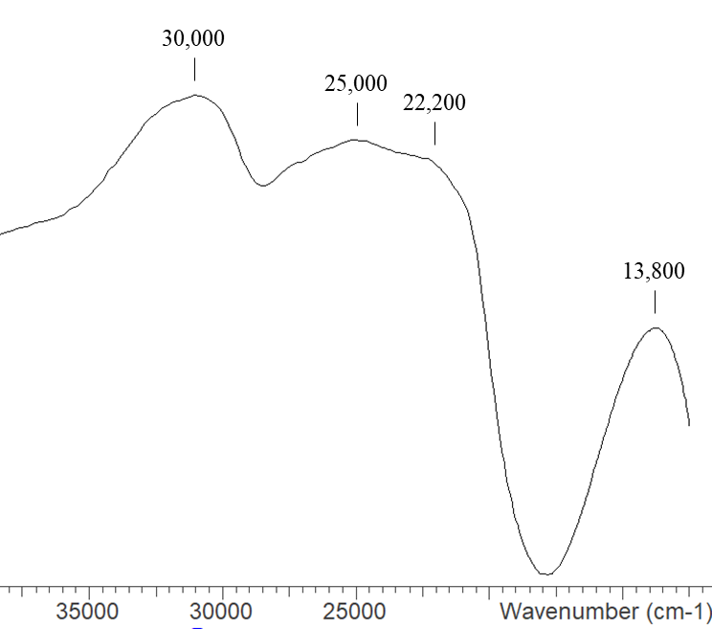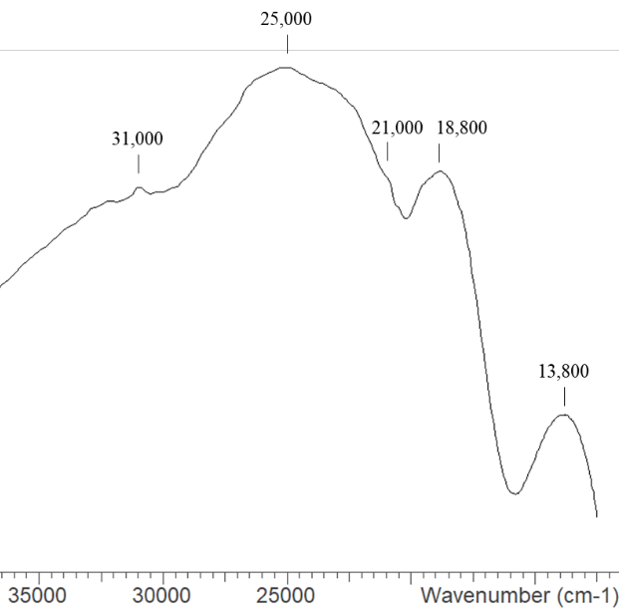
(a) (b)
Fig. 7 The diffuse reflectance UV/visible spectra of (a) red mer-[MoOCl₃(bipy)] and (b) a sample of the ‘green isomer’.

4. Conclusions
The reactions of MoOCl₄ with representative neutral donor ligands from Groups 15 and 16, even under mild conditions (CH₂Cl₂ solution at room temperature or below), result in reduction to molybdenum(V), mostly producing complexes of MoOCl₃. Even with [NEt₄]Cl the product is the Mo(V) anion [Mo₂O₂Cl₆]²⁻, the X-ray structure of which shows it to be a weakly associated dimer, and in contrast to some other examples, there are no cation-anion interactions. However, the salts, [SeMe₃][MoOCl₄(H₂O)], [SMe₂Cl]₂[Mo₂O₂Cl₆(μ-Cl)₂], and (as a more minor product) [PMe₃H][MoOCl₄(PMe₃)], are only found from reactions starting from MoOCl₄ and not MoOCl₃. In contrast, MoOF₄ does form a small range of complexes with N- and O-donor ligands, although these are hydrolytically very sensitive [12], and mono- and poly-nuclear Mo(VI) oxofluoride anions are known [3,42], reflecting the fluorides stabilising the highest oxidation state more readily.
The X-ray structures of the long known red form of [MoOCl₃(diimine)] have been obtained (directly from the Mo(V) precursor [MoOCl₃(thf)₂]) and confirm them to contain the mer-isomer, but evidence is presented that strongly suggests the ‘green isomers’ are in fact co-crystallised mixtures of red [MoOCl₃(diimine)] and another (oxide-free) molybdenum(V) or (IV) chloro species with the diamine coordinated.

Conflicts of interest
None to declare.
Acknowledgement
We thank EPSRC for support via EP/P025137/1 and EP/N509747/1.

Appendix A. Supplementary data.
Contains the supplementary crystallographic data for this paper. CCDC numbers are: 2050674 [MoOCl₃(MeS(CH₂)₃SMe)], 2068670 [Et₄N]₂[Mo₂O₂Cl₈], 2068671 [MoOCl₃(phen)], 2068672 [MoOCl₃(bipy), 20686672 [MoOCl₃(MeCN)₂], 2068674 [Mo₂O₂Cl₆(MeCN)₂], 2068684 [PMe₃H][MoOCl₄(PMe₃)], 2068685 [SeMe₃][MoOCl₄(H₂O)], 2070885 [SMe₂Cl]₂[Mo₂O₂Cl₈].
These data can be obtained free of charge via http://www.ccdc.cam.ac. uk/conts/retrieving.html, or from the Cambridge Crystallographic Data Centre, 12 Union Road, Cambridge CB2 1EZ UK. Other supplementary materials include IR, UV/vis and NMR spectra for the complexes described herein. Supplementary data to this article can be found online at https://doi.xxxxx

Table 1 Crystallographic parameters^{a,b}
Compound | [MoOCl₃(MeCN)₂] | [{MoOCl₂(MeCN)}₂(μ-Cl)₂] | [MoOCl₃{MeS(CH₂)₃SMe}]
Formula | C₄H₆Cl₃MoN₂O | C₄H₆Cl₆Mo₂N₂O₂ | C₅H₁₂Cl₃MoOS₂
M | 300.40 | 518.69 | 354.56
Crystal system | Monoclinic | Monoclinic | Orthorhombic
Space group (no) | P2₁/c (14) | P2₁/c (14) | Pnma (62)
a /Å | 5.79300(10) | 6.7943(1) | 12.2795(2)
b /Å | 13.3033(3) | 8.9915(1) | 12.7576(3)
c /Å | 12.7461(3) | 11.7775(1) | 7.6118(2)
α /° | 90 | 90 | 90
β /° | 90.889(2) | 95.4310(1) | 90
γ/° | 90 | 90 | 90
U /Å³ | 975.20(4) | 716.269(2) | 1192.44(5)
Z | 4 | 2 | 4
μ(Mo-K_{α}) /mm^{–1} | 2.115 | 2.405 | 2.078
F(000) | 580 | 492 | 700
Total number reflns | 31937 | 22409 | 6824
R_{int} | 0.022 | 0.018 | 0.029
Unique reflns | 3207 | 2372 | 1807
No. of params, restraints | 130/10 | 74/0 | 62/0
GOF | 1.056 | 1.287 | 1.074
R₁, wR₂ [I > 2σ(I)]^{b} | 0.020, 0.045 | 0.013, 0.032 | 0.029, 0.058
R₁, wR₂ (all data)^{b} | 0.024, 0.047 | 0.014, 0.032 | 0.036, 0.061
ª common data: wavelength (Mo-K_{α}) = 0.71073 Å; θ(max) = 27.5°; ^{b} R₁ = Σ||Fo|-|Fc||/Σ|Fo|; wR₂=[Σw(Fo²-Fc²)²/ΣwFo⁴]^{1/2}

Table 1 cont.
Compound | [Et₄N]₂[(MoOCl₃)₂(μ-Cl)₂] | [MoOCl₃(bipy)] | [MoOCl₃(phen)]
Formula | C₁₆H₄₀Cl₈Mo₂N₂O₂ | C₁₀H₈Cl₃MoN₂O | C₁₂H₈Cl₃MoN₂O
M | 767.98 | 374.47 | 398.49
Crystal system | Monoclinic | Monoclinic | Monoclinic
Space group (no) | P2₁/c (14) | Ia (9) | P2₁/c (14)
a /Å | 9.8073(2) | 17.9139(5) | 7.8218(2)
b /Å | 11.2086(2) | 12.4890(3) | 17.8021(3)
c /Å | 14.2779(3) | 18.1127(5) | 10.0811(2)
α /° | 90 | 90 | 90
β /° | 109.989(2) | 107.314(3) | 106.197(2)
γ/° | 90 | 90 | 90
U /Å³ | 1474.96(5) | 3868.68(19) | 1348.02(5)
Z | 2 | 12 | 4
μ(Mo-K_{α}) /mm^{–1} | 1.592 | 1.621 | 1.557
F(000) | 772 | 2196 | 780
Total number reflns | 47926 | 40829 | 48679
R_{int} | 0.026 | 0.049 | 0.052
Unique reflns | 4960 | 11788 | 4578
No. of params, restraints | 140/0 | 558/110 | 182/15
GOF | 1.045 | 1.044 | 1.068
R₁, wR₂ [I > 2σ(I)]^{b} | 0.016, 0.038 | 0.043, 0.094 | 0.034, 0.082
R₁, wR₂ (all data)^{b} | 0.019, 0.038 | 0.052, 0.097 | 0.042, 0.086

Table 1 cont.
Compound | [SeMe₃][MoOCl₄(H₂O)] | [PMe₃H][MoOCl₄(PMe₃)] | [SMe₂Cl]₂[(MoOCl₃)₂(μ-Cl)₂]
Formula | C₃H₁₁Cl₄MoO₂Se | C₆H₁₉Cl₄MoOP₂ | C₂H₆Cl₅MoOS
M | 395.82 | 406.89 | 351.32
Crystal system | Monoclinic | Monoclinic | Monoclinic
Space group (no) | P2₁/n (14) | P2₁/c (14) | P2₁/c (14)
a /Å | 7.2849(4) | 10.19810(10) | 6.5387(2)
b /Å | 18.1039(9) | 12.34520(10) | 9.4798(3)
c /Å | 9.2743(4) | 12.81160(10) | 16.7486(4)
α /° | 90 | 90 | 90
β /° | 97.603(5) | 89.7940(10) | 94.412(2)
γ/° | 90 | 90 | 90
U /Å³ | 1212.39(10) | 1612.94(2) | 1035.09(5)
Z | 4 | 4 | 4
μ(Mo-K_{α}) /mm^{–1} | 4.925 | 14.427 | 2.698
F(000) | 756 | 812 | 676
Total number reflns | 16745 | 22821 | 13510
R_{int} | 0.052 | 0.055 | 0.028
Unique reflns | 3682 | 2883 | 2646
No. of params, restraints | 104/0 | 137/0 | 106/3
GOF | 1.036 | 1.050 | 1.078
R₁, wR₂ [I > 2σ(I)]^{b} | 0.036, 0.072 | 0.027, 0.067 | 0.028, 0.075
R₁, wR₂ (all data)^{b} | 0.055, 0.076 | 0.027, 0.067 | 0.030, 0.076

References
[1] Comprehensive Coordination Chemistry; G. Wilkinson, R. D. Gillard and J. A. McCleverty (Eds), Pergamon, Oxford, 1987, vol. 3.
[2] Comprehensive Coordination Chemistry II, J. A. McCleverty and T. J. Meyer (Eds), Elsevier, Oxford, 2004, vol. 4.
[3] J. H. Canterford, R. Colton, Halides of the Second and Third Row Transition Metals, Wiley NY. 1968.
[4] F. Tamadon, K. Seppelt, Angew. Chem. Int. Ed. 52 (2013) 767.
[5] M. L. Larson, F. W. Moore, Inorg. Chem. 5 (1966) 801.
[6] R. Colton, I. B. Tomkins, Aust. J. Chem. 18 (1965) 447.
[7] E. I. Stiefel, Prog. Inorg. Chem. 22 (1977) 1.
[8] V. K. Greenacre, A. L. Hector, W. Levason, G. Reid, D. E. Smith, L. Sutcliffe, Polyhedron 162 (2019) 14.
[9] W. Levason, G. Reid, D. E. Smith, W. Zhang, Polyhedron 179 (2020) 114372.
[10] D. E. Smith, V. K. Greenacre, A. L. Hector, R. Huang, W. Levason, G. Reid, F. Robinson, S. Thomas, Dalton Trans. 49 (2020) 2496.
[11] D. E. Smith, W. Levason, J. Powell, G. Reid, Dalton Trans. 50 (2021) 4380.
[12] W. Levason, F.M. Monzittu, G. Reid, W. Zhang, E.G. Hope, J. Fluorine Chem. 200 (2017) 190.
[13] J. W. Emsley, W. Levason, G. Reid, W. Zhang, G. De Luca, J. Fluorine Chem. 197 (2017) 74.
[14] V. C. Gibson, T. P. Kee, A. Shaw, Polyhedron 9 (1990) 2293.
[15] G. M. Sheldrick, Acta Crystallogr., Sect. C: Struct. Chem. 71 (2015) 3.
[16] G. M. Sheldrick, Acta Crystallogr., Sect. A: Found. Crystallogr. 64 (2008) 112.
[17] O. V. Dolomanov, L. J. Bourhis, R. J. Gildea, J. A. K. Howard, H. Puschmann, J. Appl. Crystallogr. 42 (2009) 339.
[18] S. Dolci, F. Marchetti, G. Pampaloni, S. Zacchini, Eur. J. Inorg. Chem. (2013) 1371.
[19] L. Favero, F. Marchetti, G. Pampaloni, S. Zacchini, S. Dalton Trans., 43 (2014) 495.
[20] F. Marchetti, G. Pampaloni, S. Zacchini, Dalton Trans., 42 (2013) 2477.
[21] D. A. Edwards, J. Inorg. Nucl. Chem. 27 (1965) 303.
[22] P. C. H. Mitchell, J. Inorg. Nucl. Chem. 25 (1963) 963.
[23] C. G. Hull, M. H. B. Stiddard, J. Chem. Soc. (A) (1966) 1633.
[24] H. K. Saha, M. C. Halder, J. Inorg. Nucl. Chem. 33 (1971) 3719.
[25] H. K. Saha, M. C. Halder, J. Inorg. Nucl. Chem. 34 (1972) 3097.
[26] R. D. Taylor, P. G. Todd, N. D. Chasteen, J. T. Spence, Inorg. Chem. 18 (1979) 44.
[27] C. D. Garner, N. C. Howlader, F. E. Mabbs, A. T. McPhail, K. D. J. Onan, J. Chem. Soc., Dalton Trans. (1978) 1848.
[28] S. Y. Tyree, S. M. Horner, Inorg. Chem. 1 (1962) 122.
[29] C. Limberg, M. Buechner, K. Heinze, O. Walter, Inorg. Chem. 36 (1997) 872.
[30] J. R. Gauvreau, S. Poignant, G. J. Martin, Tet. Letts. 21 (1980) 1319.
[31] M. E. Peach, Can. J. Chem. 47 (1967) 1675.
[32] A. Bino and F.A. Cotton, J. Amer. Chem. Soc., 101 (1979) 4150.
[33] P. Klinzing, A. El-Kholi, U. Müller, K. Dehnicke, Z. Anorg. Allg. Chem. 569 (1989) 83.
[34] J. Beck, M. Hengstmann, Z. Naturforsch. B 51 (1996) 1415.
[35] J. Beck, M. Kellner, M. Kreuzinger, Z. Anorg. Allg. Chem. 628 (2002) 2656
[36] A. Baumann, J. Beck, Z. Anorg. Allg. Chem. 624 (1998) 1725.
[37] F. Marchetti, G. Pampaloni, S. Zacchini, Polyhedron 85 (2015) 369.
[38] R. D. Bannister, W. Levason, M. E. Light, G. Reid, W. Zhang, Polyhedron 167 (2019) 1.
[39] M. I. Scullane, R. D. Taylor, M. Minelli, J. T. Spence, K. Yamanouchi, J. H. Enemark, N. D. Chasteen, Inorg. Chem. 18 (1979) 3213.
[40] A. B. P. Lever, Inorganic Electronic Spectroscopy, Elsevier, Amsterdam 1984.
[41] W. Levason, G. Reid, W. Zhang, Z. Anorg. Allgem. Chem. 640 (2014) 35.
[42] W. M. Carmichael, D. A. Edwards, R. A. Walton, J. Chem. Soc. (A) (1966) 97.
[43] L-J. Song, H-Y. Zeng, L-Z. Cai, Z-C. Dong, G-C, Guo, J. S. Huang, Chinese. J. Struct. Chem. 22 (2003) 395.
[44] G. Parkin, Chem. Rev. 93 (1993) 887.
[45] M. Gerken, H. P. A. Mercier, G. J. Shrobilgen, in Advanced Inorganic Fluorides, T. Nakajima, B. Zemva, A. Tressaud (eds). Elsevier, Amsterdam, 2000.

