Prevalence and early-life risk factors of school age allergic multimorbidity – the EuroPrevall-iFAAM birth cohort
Short title: Prevalence and risk factors of allergic multimorbidity
Sigurveig T Sigurdardottir*, Kristjan Jonasson*, Michael Clausen, Kristin Lilja Bjornsdottir, Sigridur Erla Sigurdardottir, Graham Roberts, Kate Grimshaw, Nikolaos G. Papadopoulos, Paraskevi Xepapadaki, Ana Fiandor, Santiago Quirce, Aline B. Sprikkelman, Lies Hulshof, Marek L Kowalski, Marcin Kurowiski, Ruta Dubakiene, Odilija Rudzeviciene, Johanna Bellach, Songül Yürek, Andreas Reich, Sina Maria Erhard, Philip Couch, Montserrat Fernandez Rivas, Ronald van Ree, Clare Mills, Linus Grabenhenrich, Kirsten Beyer, Thomas Keil
* The first two authors contributed equally to the article.

Affiliations
Sigurveig T Sigurdardottir: a) Landspitali University Hospital, Reykjavik. Iceland; b) University of Iceland, Faculty of Medicine, Reykjavik, Iceland
Kristjan Jonasson: Department of Computer Science, University of Iceland, Reykjavík, Iceland
Michael Clausen: a) Children's Hospital Reykjavik, Reykjavik, Iceland; b) Department of Allergy, Landspitali University Hospital, Reykjavik, Iceland
Kristin Lilja Bjornsdottir: Children’s Hospital, Landspitali University Hospital, Reykjavik, Iceland
Sigridur Erla Sigurdardottir: Department of Allergy, Landspitali University Hospital, Reykjavik, Iceland
Graham Roberts: a) Human Development and Health & Clinical and Experimental Sciences, Faculty of Medicine, University of Southampton, UK; b) NIHR Southampton Biomedical Research Centre, University Hospital Southampton NHS Foundation Trust, Southampton, UK; c) The David Hide Asthma and Allergy Research Centre, St Mary’s Hospital, Isle of Wight, UK
Kate Grimshaw: a) Dietetic Department, Salford Royal NHS Foundation Trust, UK; b) Clinical and Experimental Sciences, Faculty of Medicine, University of Southampton, UK; c) School of Biological Sciences, Division of Infection, Immunity and Respiratory Medicine, Manchester Institute of Biotechnology, University of Manchester, Manchester, UK
Nikolaos G. Papadopoulos: a) Allergy Department, 2nd Pediatric Clinic, National and Kapodistrian University of Athens, Athens, Greece; b) Division of Infection, Immunity & Respiratory Medicine, University of Manchester, Manchester, UK
Paraskevi Xepapadaki: Allergy Department, 2nd Pediatric Clinic, National and Kapodistrian University of Athens, Athens, Greece
Ana Fiandor: Department of Allergy, La Paz University Hospital, IdiPAZ, Madrid, Spain
Santiago Quirce: Department of Allergy, La Paz University Hospital, IdiPAZ, Madrid, Spain
Aline B. Sprikkelman: Department of Pediatric Pulmonology and Pediatric Allergology, University Medical Center Groningen, University of Groningen, The Netherlands
Lies Hulshof: Department of Pediatric Pulmonology and Pediatric Allergology, Emma Children's Hospital, Amsterdam UMC, University of Amsterdam, Amsterdam, The Netherlands
Marek L Kowalski: Department of Immunology, Allergy and Rheumatology, Medical University of Lodz, Lodz, Poland
Marcin Kurowiski: Department of Immunology, Allergy and Rheumatology, Medical University of Lodz, Lodz, Poland
Ruta Dubakiene: Vilnius University Medical Faculty Clinic of Chest diseases, allergology and immunology, Vilnius, Lithuania
Odilija Rudzeviciene: Vilnius University, Faculty of Medicine Clinic of Children's diseases, Vilnius, Lithuania.Johanna Bellach: Department of Paediatric Pneumology and Immunology, Charité – Universitätsmedizin Berlin, Berlin Germany
Songül Yürek: Department of Paediatric Pneumology and Immunology, Charité – Universitätsmedizin Berlin, Berlin Germany
Andreas Reich: Epidemiology Unit, German Rheumatism Research Centre, Berlin, Germany
Sina Maria Erhard: Institute of Social Medicine, Epidemiology and Health Economics, Charité – Universitätsmedizin Berlin, Berlin, Germany
Philip Couch: Centre for Health Informatics, School of Health Sciences, The University of Manchester, Manchester, UK
Montserrat Fernandez Rivas: Allergy Department, Hospital Clinico San Carlos, Universidad Complutense, IdISSC, ARADyAl, Madrid, Spain
Ronald van Ree: Departments of Experimental Immunology and of Otorhinolaryngology, Amsterdam University Medical Centers, location AMC, Amsterdam, The Netherlands
Clare Mills: Institute of Inflammation and Repair, University of Manchester, Manchester, UK
Linus Grabenhenrich: Department for Infectious Disease Epidemiology, Robert Koch-Institut, Berlin, Germany
Kirsten Beyer: Department of Paediatric Pneumology and Immunology, Charité - Universitätsmedizin Berlin, Berlin, Germany
Thomas Kiel: a) Institute of Social Medicine, Epidemiology and Health Economics, Charité – Universitätsmedizin Berlin, Berlin, Germany; b) Institute of Clinical Epidemiology and Biometry, University of Würzburg, Würzburg, Germany; c) State Institute of Health, Bavarian Health and Food Safety Authority, Bad Kissingen, Germany

Acknowledgements
We thank all families who participated in the birth cohort study and the medical and nursing staff of the participating hospitals, especially G. Christopoulou, I. Roumpedaki, R. Stergiou (Greece); H. Ragnarsdottir (Iceland); S. Paschke-Goossens, G. Schulz, A. Rohrbach, S. Tschirner, T. Schrezenmaier, A. Scholz, D. McBride, M. Kulig (Germany); A. Stanczyk-Przyłuska, K. Zeman, J. Wilczynski, L. Podciechowski (Poland); S. Quirce, M. Reche, M. Martin Esteban, R. Gabriel, J. I. Larco, I. Bobolea, T. Cuevas (Spain); K. Foote, E. Oliver, A. Selby, L. Fairhead, Z. Dobson, S. Bhatt, S. Roberts, J. Martin, NIHR Wellcome Trust Clinical Research Facility (UK); Midwives Zorggroep Almere, N. v. d. Berg, W. M. C. van Aalderen, B. Dontje, N. C. M. Petrus, H. C. Vriesendorp, A. Schoemaker (The Netherlands); I. Butiene, D. Vaicekauskaite (Lithuania).

Funding sources
The birth cohort study was funded by the European Commission: (a) under the 6th Framework Programme (FOOD-CT-2005-514000) within the collaborative research initiative “EuroPrevall,” and (b) under the 7th Framework Programme (FP7-KBBE-2012-6; grant agreement no. 312 147) within the collaborative project “iFAAM.” Additional funds were received by the Icelandic birth cohort centre from Landspitali University Hospital Iceland Science Fund, and from GlaxoSmithKline Iceland; by the UK birth cohort centre from the UK Food Standards Agency; by the Polish birth cohort centre from the Ministry of Science and Higher education; by the Lithuanian birth cohort centre as unrestricted grants from Grida and MSD; and by the Dutch birth cohort centre as unrestricted grants from Nutricia Advanced Medical Nutrition Netherlands, AstraZeneca Netherlands, TEVA Netherlands, and GlaxoSmithKline Netherlands. None of the funding bodies had any influence on the study design the collection and analysis of data, interpretation of results, manuscript preparation or decision to submit the paper for publication.

Correspondence
Sigurveig T Sigurdardottir Kristjan Jonasson
Landspitali University Hospital School of Engineering and Natural Sciences, University of Iceland
Reykjavik. Iceland Reykjavík, Iceland
Email: veiga@landspitali.is Email: jonasson@hi.is

Abstract
Background: Coexistence of childhood asthma, eczema and allergic rhinitis is higher than can be expected by chance, suggesting a common mechanism. Data on allergic multimorbidity from a pan-European, population-based birth cohort study has been lacking. This study compares the prevalence and early-life risk factors of these diseases in European primary school children.
Methods: In the prospective multicentre observational EuroPrevall/iFAAM birth cohort study we used standardized questionnaires on socio-demographics, medical history, parental allergies and lifestyle, and environmental exposures at birth, 12 and 24 months. At primary school age, parents answered ISAAC-based questions on current asthma, rhinitis and eczema. Allergic multimorbidity was defined as the coexistence of at least two of these.
Results: From 10,563 children recruited at birth in 8 study centres, we included data from 5,572 children (mean age 8.2 years; 51.8% boys). Prevalence estimates were: asthma 8.1%, allergic rhinitis 13.3%, eczema 12.0%. Allergic multimorbidity was seen in 7.0% of the whole cohort, ranging from 1.2% (Athens, Greece) to 10.9% (Madrid, Spain). Risk factors for allergic multimorbidity, identified with AICc, included family-allergy-score, odds ratio (OR) 1.50 (95% CI 1.32–1.70) per standard deviation; early-life allergy symptoms, OR 2.72 (2.34–3.16) for each symptom; and caesarean birth, OR 1.35 (1.04–1.76). Female gender, OR 0.72 (0.58–0.90); older siblings, OR 0.79 (0.63–0.99); and day-care, OR 0.81 (0.63–1.06) were protective factors.
Conclusion: Allergic multimorbidity should be regarded as an important chronic childhood disease in Europe. Some of the associated early-life factors are modifiable and may be considered for prevention strategies.

Key words: allergic multimorbidity, asthma, eczema, allergic rhinitis, children
1. Introduction
Interest in multiple coexisting allergic diseases (allergic multimorbidity) has been increasing, and several recent studies address prevalence and risk factors focusing on childhood and adolescence. Allergic multimorbidity is often defined as two or more allergic diseases: asthma, allergic rhinitis and eczema. The German birth cohort Multicentre Allergy Study (MAS) found an allergic multimorbidity prevalence of 2% at age 9 in those with no family history, compared to 11% of those with at least one allergic parent.(1) The Mechanisms of the Development of ALLergy (MeDALL) meta-analysis showed a relatively high occurrence of coexisting asthma, allergic rhinitis and eczema in 4 and 8 year old children in many European cohorts suggesting a common mechanism.(2) In their combined data analysis, as well as in the Swedish BAMSE birth cohort,(3) allergic multimorbidity prevalence increased with age up to adolescence.
The iFAAM study is a continuation of the EuroPrevall birth cohort study that recruited new-borns in 2005–2010(4, 5) and completed its last follow-up assessment at 6–10 years in eight European cities.(6) It gives a unique opportunity to estimate the influence of prenatal and postnatal environmental, lifestyle, and sociodemographic early-life factors on the prevalence of asthma (allergic and non-allergic), allergic rhinitis, eczema and allergic multimorbidity at primary school age in Europe, which is indeed the aim of current analysis.

2. METHODS

2.1 Study design, setting and population
The study design and baseline characteristic of the study population have been described in detail previously.(4-7) In summary, the prospective multicentre birth cohort study (funded by the European Commission) recruited 12,049 new-borns in 2005–2010 in 9 European centres (Figure 1). After a perinatal baseline interview, regular standardized parental telephone interviews were conducted at 12 and 24 months of age. Socio-demographics, medical history, parental allergies, parental lifestyle, dietary habits, environmental exposures, and other potentially influential factors for developing allergies were assessed. Excluded were children born before 34 weeks, with a 5-minute APGAR score <7, and parents with insufficient skills of the local language.(4)
During the years 2014–2017, at primary school age, all the study centres except Milan participated in a follow-up assessment, iFAAM (also funded by the European Commission). Parents answered questions online, including questions on symptoms of current allergic diseases. A few parents that were unable or unwilling to access/complete the questionnaire by themselves were invited to the study centre or questioned via telephone interviews.
Ethical approval was obtained individually for both study periods from the local ethics committee in each participating country. Informed parental consent was also obtained for each assessment, in written form for the early childhood period, and online at school age.

2.2 Key outcomes
The iFAAM questionnaire was based on stringent epidemiological definitions as well as validated and widely used questions in population-based cross-sectional childhood and teenage studies like the International Study of Asthma and Allergies in Childhood (ISAAC project).(8-11)
Current asthma at school age was defined as present if at least three of the following five parent-reported criteria were fulfilled: (a1) wheezing or whistling, (a2) breathing difficulties, (a3) dry cough at night, (a4) asthma medication, all in the past 12 months, and (a5) doctor diagnosed asthma ever. Asthma was also considered to be present if criteria (a4) and (a5) were both fulfilled without any of the three symptoms (a1–a3), indicating a well-managed disease.
Current allergic rhinitis at school age was defined as present if at least two of the following three criteria were fulfilled: (r1) sneezing, or a runny or blocked nose, without having a cold, (r2) nasal allergy/hay fever medication, both in the past 12 months, and (r3) doctor diagnosed allergic rhinitis or hay fever ever.
Current eczema at school age was defined as present if both of the following criteria were fulfilled: (e1) an itchy rash which was intermittently coming and going, and (e2) doctor diagnosed eczema/atopic dermatitis ever.
Current allergic multimorbidity at school age was defined as present if at least two of current asthma, allergic rhinitis, and eczema were coexisting.

2.3 Definition of covariates
Many of the early-age covariates were simple yes-no questions: sex, caesarean-birth, child’s and mother's antibiotics-at-birth, cows-milk-in-first-week, pets-at-home (cats/dogs), live-on-a-farm and mould in the house. Other early-age covariates require more explanation. Mothers-age is a simple continuous variable, Parent-education is also continuous, sum of mother’s and father's education codes, each of these in the range 1–4 according to education level. Family-allergy-score at baseline is also a continuous variable and computed as previously described (Appendix S1).(12) Breastfeeding is true if the child was breastfed for ≥6 months (possibly along with other feeding). Breastfeeding for ≥4 months was also evaluated. Vitamin-D was true if the child received daily vitamin D supplementation starting within the first 2 months. Older-siblings (dichotomous), is true if other children, ≤10 years older, were living in the household. Day-care is true if the child attended day-care before the age of 18 months for ≥8 hours/week with ≥2 other children. Pregnancy-smoking is true if the mother reported smoking ≥5 cigarettes/day during pregnancy. Smoking-at-home (dichotomous variable), is true if ≥10 cigarettes/day were smoked at home.
The continuous variable Early-age-symptoms was defined as the sum of three dichotomous variables: symptoms associated with asthma, allergic rhinitis and eczema. The first of these is 1 if the child had wheezing or whistling in the chest between 12 and 24 months of age, otherwise it is 0. The second is 1 if the child had at least 2 of the following 3 criteria before age 2: (1) sneezing, or a runny or blocked nose, without having a cold, (2) itchy, watery eyes, and (3) doctor diagnosed hay fever. The third is 1 if the child had an itchy rash or eczema that lasted for at least 7 days, in the fold of the elbows, behind the knees, in front of the ankles, on the cheeks or around the neck, ears or eyes, before age 2.
A crucial variable considered was the study centre. This variable was treated as giving a multiplicative centre effect, as described in more detail in the statistics section below.
Finally, the iFAAM study included a question on current heavy traffic, which was the only school-age covariate considered.

2.4 Data processing and statistical analysis
Data were processed with Unix and Matlab (version 9.3; Mathworks Inc.). To assess the significance of covariates, a logistic regression model was constructed, where centre effect was included as a multiplicative factor:
Odds = centre-effect × effect-of-covariate-1 × effect-of-covariate-2 × ...
The covariates entering the model were selected using the AICc criterion (Akaike information criterion with correction). One advantage of using AICc is that it is independent of (arbitrary) statistical significance levels: it selects the model with the smallest expected mean-squared-error.(13) Forest plots were used to show 95% confidence intervals.
Note that in the model all individuals weight equally, and therefore the centers are effectively weighted by the participant count in each one, as in inverse probability weighting.(14)

3. RESULTS
Of 10,563 recruited children in the eight participating centres, 5,572 (52.8%) fulfilled the eligibility criteria listed in Section 2.1 (Figure 1). Table S1 shows a breakdown of the drop-out by study centre. The participation in individual centres is shown in Figure 2. The children were aged between 6 and 10 years when the last parental questionnaire was answered. The allergic outcomes at school age were as follows: asthma 8.1%, allergic rhinitis 13.3%, eczema 12.0%, allergic multimorbidity 7.0%, and 1.3% had all three diseases (Table 1).
The difference between the centres was considerable, with only 1.2% allergic multimorbidity in Athens and 4.0% in Vilnius, reaching 9.4-10.9% in Amsterdam, Southampton, Lodz and Madrid, with Reykjavik and Berlin falling in-between. Asthma had the largest prevalence in Southampton, allergic rhinitis in Lodz, and eczema in Madrid (Table 1).

3.2 Differences between non-participating and participating school age children
Tables 2 and S3 show a summary of the covariates for the two groups: the 3,212 children dropping out in the last step in Figure 1 and the final study population for the current analysis. There were fewer day-care children in the drop-out group (two-tailed p < 0.01), and that group also had fewer children with early age symptoms of allergic diseases (p = 0.04). There was more smoking at home, more pregnancy smoking, less breastfeeding, more dogs, more children but fewer mothers receiving antibiotics at birth, parent education level was lower (p < 0.01 for all), and there was less vitamin-D supplementation in the non-participating group (p = 0.03).

3.3 Risk factors
The logistic regression model included six covariates for allergic multimorbidity, selected according to AICc: family-allergy-score, early-age-symptoms, sex, caesarean-birth, older-siblings, and day-care before 18 months of age (Table 2, Figure 3). Female sex, older-siblings, and day-care were independently protective for multimorbidity, whereas the family-allergy-score, caesarean-birth, and early-age-symptoms posed a risk. The low occurrence of caesarean birth in Madrid is explained by the recruitment in the maternity ward where scheduled c-sections were absent (Table 2). Note that this deviation does not change the modelling result: In a model without Madrid, AICc selects the same six covariates as the full data model, with very similar estimated odds ratios (S5).
The AICc-procedure selects many of the same covariates for individual diseases (Figure 4). Day-care provides a protective effect against asthma and allergic rhinitis and the same applies to having older siblings. Female sex lowers the risk for both asthma and allergic rhinitis but interestingly it increased the risk for eczema. Caesarean birth increased the risk only for asthma, but not for the other two allergic diseases. Smoking during pregnancy was included in the asthma model according to the AICc value as a risk factor. Finally, both high family-allergy-score and many early-age-symptoms are positively related to all three individual diseases.
All the other covariates listed in Section 2.3, mothers-age, parent-education, antibiotics-at-birth, cows-milk-in-first-week, breastfeeding, vitamin-D supplementation, pets-at-home, smoking-at-home, live-on-a-farm, and mould in the house, were not selected into the models, neither for multimorbidity nor for any of the individual diseases. Of these variables, live-on-a-farm had the largest estimated effect, but the statistical power is low as indicated by a wide confidence interval (OR=0.67, 95% CI 0.26–1.71).
Models including only specific early age symptoms were also considered. AICc selected early symptoms of both allergic rhinitis and eczema as predictors of school-age allergic multimorbidity by themselves, but not wheezing. However, when combined with one or both of the other two symptoms, wheezing increased the estimated risk, and it was also selected as a predictor of school age asthma (Table S7).
Current heavy traffic exposure was identified as a risk factor for asthma, but not for the other two diseases (Table S8).

3.4 Consistency of the statistical model
To check the consistency of the modelling, multimorbidity models with each covariate as the only variable apart from centre effect were constructed. Table S2 shows the odds ratios and AICc values for these models and some additional models, including the final 6-variable model of Figure 3. The results were consistent. To further check the stability of the results the final model was fitted 8 times, each time leaving out one centre, and again the results were consistent (Tables S4 and S5).
To further check the sanity of the models, and to demonstrate that the multiplicative effect of the number of predictive early-age symptoms was realistic, we analysed two examples: There were 176 children with two early-age symptoms. According to the model the odds for these children was increased by a factor of 2.72² = 7.4. The model can be used to predict the rate of allergic multimorbidity at school age among these children (adjusting for all the other variables). Such computation predicts 46.7 children, while the actual count is 47. A similar investigation for all three early-age symptoms gives 38 children, 17 of which are multimorbid, while the model predicts 19.3.

4. DISCUSSION

4.1 Current study prevalence and comparison with other studies
In our study with children aged 6–10 years, allergic rhinitis and eczema were more common than asthma. There was considerable difference between the study centres with allergic multimorbidity ranging from 1.2% in Athens to 10.9% in Madrid. One to 11% of the parents reported symptoms of current allergic multimorbidity, i.e. 2 or more allergic diseases. We did not see any clear geographical prevalence gradient across the participating European centres, such as from north to south or west to east, as found in a previous population-based cross-sectional evaluation.(15) While other studies that we considered defined multimorbidity also as having at least two of asthma, allergic rhinitis, and eczema, they sometimes used different definitions of the individual diseases, however often based on original ISAAC questions.(8)
In the Swedish BAMSE birth cohort study in Stockholm, about 12 years before our study, the prevalences at 8 years were similar with 7.1%, 14.7%, 17.0% and 5.5% for asthma, allergic rhinitis, eczema and allergic multimorbidity respectively,(3, 16) however the Scandinavian mainland was not part of our study. In the rural Isle of Wight study (UK), multimorbidity in 4 and 10 year old children was 7.8% and 10.5%, respectively, in 1993–1999(17) as compared to 9.7% in 7.9 year old children in Southampton in the current study. In that study the prevalence of allergic multimorbidity increased further to 15.8% in 18-year-olds. A recent Polish cross-sectional multicentre study found 10.7% of 6–7 year old children having allergic multimorbidity,(18) compared with the current study prevalence in Lodz, 9.8%. In the Dutch PIAMA birth cohort, including many rural areas, the published asthma prevalence for 8 year old children in 2003–2004 was 7.2%,(19) thus lower than the 11.4% for the city of Amsterdam in the current study. Study prevalence of allergic multimorbidity in Berlin was similar to the risk-enriched population-based German MAS study, about 20 years earlier, when compared separately for high-risk and low-risk children (Table S6).(1)
In 116,863 children at 6–7 years from 22 affluent and non-affluent countries that participated in phase III of the global cross-sectional International Study of Asthma and Allergies in Childhood (ISAAC), performed 2000–2003, the prevalence for asthma was 9.7%, for allergic rhinitis 8.9%, for eczema 7.3% and for allergic multimorbidity 5.0%,(20) somewhat lower than our findings across Europe.
The differences in definitions of the allergic diseases between studies and study settings make it hard to draw conclusions on whether allergic multimorbidity is a waxing problem in Europe. However, our prevalence estimates ranging up to 11% in Madrid considering only the three most common allergic diseases, shows that allergic multimorbidity is a common problem for many primary school aged children in Europe.
In our assessments in children up to 2.5-year-olds, Athens (Greece) had the second lowest wheezing prevalence and lowest prevalence of confirmed food allergy,(21-23) and now has the lowest study prevalence of all three single diseases, as well as allergic multimorbidity. It also has, by far, the lowest estimate for school age food allergy.(6) However, Madrid, also in Mediterranean Europe, has the highest observed prevalence of both allergic multimorbidity and eczema, and high percentage for the other two diseases.
The considerable differences between cities (Section 3.1) evidently cannot be explained by the geographical locations. Genetic susceptibility and/or environmental factors such as diet may play a role. The relatively low prevalence in Reykjavik could be partly due to the widespread supplementation of fish oil to infants,(12) or possibly less pollution.

4.2 Risk factors
As expected, family-allergy-score had a large effect not only on single allergic diseases but also on allergic multimorbidity. Interestingly, allergic family history appeared to influence the occurrence of eczema less than respiratory allergy.
Also, as expected, the best predictor for allergic multimorbidity at school age were early-age-symptoms of allergic diseases. Early age symptoms are of course not a risk factor, strictly speaking. Multimorbidity models without early-age-symptoms, give odds ratios for the other factors that are comparable to those of the full model (Figure 3, Table S2). The same holds for individual diseases (data not shown). If the aim is to predict school age allergic diseases one would use all available data, including the early-age-symptoms, but if the aim is to study the causal pathway this variable should be excluded.
Being a girl is protective against allergic multimorbidity, asthma and allergic rhinitis at school age, but carries a risk for eczema. These findings confirm results from MAS, PARIS and BAMSE.(1, 10, 16, 24) In MAS, boys with eczema had more allergic multimorbidity than girls with eczema. This was confirmed by our study, 40% and 30% for boys and girls, respectively (p = 0.07; data not shown). The PARIS study also showed boys to be at higher risk of allergic sensitization to aero and food allergens, and at much higher risk of being multisensitised.
Pregnancy-smoking was not found to affect allergic multimorbidity; however, according to the AICc criterion, it is a risk factor for primary school age asthma (OR = 1.54, 95% CI = 0.99–2.38). This is in agreement with multiple other studies, where smoking during pregnancy increased the risk for early life wheezing and school age asthma, even more than other tobacco smoke exposure.(25-30)
Figure 4 indicates that pregnancy smoking primarily affects non-atopic asthma,(28, 31) and the same applies to caesarean-birth which is a risk factor for multimorbidity and asthma, but not for allergic rhinitis or eczema. The result for asthma confirms findings of a recent meta-analysis, albeit with considerable statistical heterogeneity, with mainly retrospective and cross-sectional studies, showing an increased asthma risk by caesarean birth.(32) Not included in this meta-analysis were two separate evaluations of long-term prospective population-based birth cohorts, focusing on asthma and allergy, which did not find association between caesarean birth and asthma at age 15(33) and 20 years.(30)
In previous studies, having older siblings and day-care attendance were both protective for respiratory allergic diseases at school age.(20, 34, 35) The protective effects of natural birth, older siblings, and day-care attendance have been explained by the increased exposure to protective bacteria in infancy,(36, 37) whereas the protection by older siblings was also hypothesized of being an in utero immune priming effect.(35)
The negative effect of current traffic on asthma is consistent with earlier findings (Table S7).(19). We did not have accessible information on traffic at early-age.

4.3 Allergic multimorbidity is a disease in its own right
Several studies show that allergic multimorbidity can be considered as a special disease.(2, 16) This is supported by a genetic study.(38)
In our study, asthma concurrent with allergic rhinitis and/or eczema counted for about half of the asthma cases, 3.9% (2.9% + 1.0%; Table 1) out of 8.1%, approximately twice as often as would be expected if the diseases were independent. If they were independent, the prevalence of all three being concurrent would be 0.13% (0.081×0.133×0.120 = 0.0013) whereas the actual cohort prevalence of the triple multimorbidity is ten times higher, 1.3% (Table 1).
We concentrated on allergic diseases at the age around 8 years, however the coexistence of the diseases may have developed in different patterns from infancy. A study using machine learning identified 8 such patterns, leading to different combinations of the diseases at school age.(39) A study on atopic endotypes in childhood identified four patterns of disease development.(40)

4.4 Strengths and weaknesses of the study
The current study involves multiple countries from all climatic regions in Europe, it uses prospectively collected data from birth to school age by the same standardized methods, and it is to date the largest such single study. It had sufficient statistical power to examine potential risk factors in a single model. To a certain extent, some of these risk and protective factors are modifiable (pregnancy smoking, caesarean birth, day-care and traffic exposure). Being a prospective study, early life risk factors can be determined without relying on long term memory of the parents.
However, the generalizability of the cohort to the whole populations has not been formally assessed and may be limited. Furthermore, a considerable number of children were lost to follow-up after 6–10 years since birth, possibly exaggerating the estimated multimorbidity percentage. It is also possible that the differences in loss between centres introduces bias in the estimates from the regression, however it is not easy to analyse the nature of this bias. Also, several interesting and probably important potential early life factors are not considered, for example paracetamol and antibiotics use, diet, and IgE sensitization. The BAMSE birth cohort, the Isle of Wight study and PARIS birth cohort showed food and airborne sensitization in infancy to be risk factors for later allergic multimorbidity.(3, 17, 24)

5. Conclusions
Allergic multimorbidity should be considered as a relevant chronic childhood condition in Europe, and probably around the globe. Importantly, some of the associated early-life factors which this study identified are modifiable, and thus can be considered for prevention strategies. Future research on allergic diseases, should focus on individuals with multimorbidity, for better understanding of the underlying mechanisms, with the ultimate aim for improved disease management. Knowledge gaps include the age bracket from childhood to adulthood, associations with other allergic and non-allergic comorbidities, and effects of the diseases on quality of life in families with allergic multimorbidity. The currently ongoing COVID-19 pandemic will further direct the focus on the link between viral infections and chronic respiratory diseases and allergies.

Conflict of interest
Dr. Roberts reports grants from EU, grants from Food Standards Agency, during the conduct of the study; Dr. Grimshaw reports grants from Food Standards Agency UK, during the conduct of the study; Dr. Papadopoulos reports personal fees from Novartis, personal fees from Nutricia, personal fees from HAL, personal fees from MENARINI/FAES FARMA, personal fees from SANOFI, personal fees from MYLAN/MEDA, personal fees from BIOMAY, personal fees from AstraZeneca, personal fees from GSK, personal fees from MSD, personal fees from ASIT BIOTECH, personal fees from Boehringer Ingelheim, grants from Gerolymatos International SA, grants from Capricare, outside the submitted work; Dr. Xepapadaki reports personal fees from Uriach, personal fees from Novartis, personal fees from Nestle, personal fees from Nutricia, outside the submitted work; Dr. Fiandor reports personal fees and non-financial support from AstraZeneca, outside the submitted work; Dr. Quirce reports personal fees and non-financial support from GSK, personal fees and non-financial support from AstraZeneca, personal fees and non-financial support from Sanofi, personal fees and non-financial support from Novartis, personal fees and non-financial support from Mundipharma, personal fees and non-financial support from Teva, personal fees and non-financial support from Allergy Therapeutics, outside the submitted work; Dr. Sprikkelman reports grants from Nutricia Advanced Medical Nutrition Netherlands, grants from AstraZeneca, Netherlands, grants from TEVA Netherlands, grants from GlaxoSmithKline Netherlands, during the conduct of the study; grants from Aimmune, outside the submitted work; Dr. Couch reports grants from EU FP7-KBBE, during the conduct of the study; Dr. Fernandez-Rivas reports grants from European Commission, during the conduct of the study; personal fees from Aimmune, DBV, Novartis, SPRIM, grants from Aimmune, Diater, ALK, DIATER, GSK, HAL Allergy, outside the submitted work; Dr. van Ree reports personal fees from HAL Allergy BV, personal fees from Citeq BV, personal fees from Angany Inc, personal fees from ThermoFisher Scientific, grants from European Commission, grants from Dutch Science Foundation, outside the submitted work; ENC Mills reports grants from Reacta Biotech Ltd, outside the submitted work; and Chief Scientific Adviser and shareholder of Reacta Biotech Ltd, a start-up developed to commercialise foods for use in oral food challenges; Dr. Beyer reports grants from European Commission, during the conduct of the study; grants and personal fees from Aimmune, personal fees from Bencard, grants and personal fees from Danone/Nutricia/Milupa, grants and personal fees from DBV, grants and personal fees from Hipp, grants and personal fees from Hycor, grants and personal fees from Infectopharm, personal fees from Jenapharma, personal fees from Mylan/Meda, personal fees from Nestle, personal fees from Novartis, personal fees from ThermoFisher, outside the submitted work; All other authors have nothing to disclose.

Author contributions
ENCM was overall coordinator of the collaborative research initiatives EuroPrevall and iFAAM; KB was initiator, principal investigator and iFAAM theme leader of the birth cohort study, and participated in planning of the present analysis, interpretation of results and writing of the manuscript; TK was co-PI of the birth cohort (both in EuroPrevall and iFAAM), initiated, planned and supervised the present analysis, and participated in the writing of the manuscript; STS was PI in Iceland, initiated, planned and supervised the present analysis, and wrote the first draft of the manuscript; KJ planned and carried out statistical analysis and wrote the first draft of the manuscript; MC participated in the planning and interpretation of the results of the present study, and the manuscript writing, LG coordinated the iFAAM school age follow-up of the birth cohort, carried out data cleaning, participated in planning the present analysis, interpretation of results and writing of the manuscript; RvR was responsible for laboratory analyses for the whole project, participated in the planning of the birth cohort, was PI in The Netherlands; MFR was responsible for laboratory analyses including skin prick tests and participated in the planning of the study design and was PI for the SERMAS-iFAAM team; PC was responsible for all central IT aspects including the central database, and participated in the planning of the school age follow-up; AR was responsible for the central data management, participated in the cohort management and planning of the study; all authors participated in the planning and/or local implementation of the various assessments including study management, parental interviews, and clinical visits of the birth cohorts; all authors reviewed and commented the draft of the manuscript and approved the final version.

References
1. Gough H, Grabenhenrich L, Reich A, Eckers N, Nitsche O, Schramm D, et al. Allergic multimorbidity of asthma, rhinitis and eczema over 20 years in the German birth cohort MAS. Pediatric Allergy and Immunology. 2015;26(5):431-7.
2. Pinart M, Benet M, Annesi-Maesano I, von Berg A, Berdel D, Carlsen KCL, et al. Comorbidity of eczema, rhinitis, and asthma in IgE-sensitised and non-IgE-sensitised children in MeDALL: A population-based cohort study. The Lancet Respiratory Medicine. 2014;2(2):131-40.
3. Ballardini N, Bergström A, Wahlgren CF, Van Hage M, Hallner E, Kull I, et al. IgE antibodies in relation to prevalence and multimorbidity of eczema, asthma, and rhinitis from birth to adolescence. Allergy: European Journal of Allergy and Clinical Immunology. 2016;71(3):342-9.
4. Keil T, McBride D, Grimshaw K, Niggemann B, Xepapadaki P, Zannikos K, et al. The multinational birth cohort of EuroPrevall: Background, aims and methods. Allergy: European Journal of Allergy and Clinical Immunology. 2010;65(4):482-90.
5. McBride D, Keil T, Grabenhenrich L, Dubakiene R, Drasutiene G, Fiocchi A, et al. The EuroPrevall birth cohort study on food allergy: Baseline characteristics of 12,000 newborns and their families from nine European countries. Pediatric Allergy and Immunology. 2012;23(3):230-9.
6. Grabenhenrich L, Trendelenburg V, Bellach J, Yürek S, Reich A, Fiandor A, et al. Frequency of food allergy in school-aged children in eight European countries—The EuroPrevall-iFAAM birth cohort. Allergy: European Journal of Allergy and Clinical Immunology. 2020;75(9):2294-308.
7. Grabenhenrich LB, Reich A, Bellach J, Trendelenburg V, Sprikkelman AB, Roberts G, et al. A new framework for the documentation and interpretation of oral food challenges in population-based and clinical research. Allergy: European Journal of Allergy and Clinical Immunology. 2017;72(3):453-61.
8. Asher MI, Barry D, Clayton T, Crane J, D'Souza W, Ellwood P, et al. The burden of symptoms of asthma, allergic rhinoconjunctivitis and atopic eczema in children and adolescents in six New Zealand centres: ISAAC Phase One. New Zealand Medical Journal. 2001;114(1128):114-20.
9. Bousquet J, Gern JE, Martinez FD, Anto JM, Johnson CC, Holt PG, et al. Birth cohorts in asthma and allergic diseases: Report of a NIAID/NHLBI/MeDALL joint workshop. Journal of Allergy and Clinical Immunology. 2014;133(6):1535-46.
10. Gabet S, Just J, Couderc R, Seta N, Momas I. Allergic sensitisation in early childhood: Patterns and related factors in PARIS birth cohort. International Journal of Hygiene and Environmental Health. 2016;219(8):792-800.
11. Lazic N, Roberts G, Custovic A, Belgrave D, Bishop CM, Winn J, et al. Multiple atopy phenotypes and their associations with asthma: Similar findings from two birth cohorts. Allergy: European Journal of Allergy and Clinical Immunology. 2013;68(6):764-70.
12. Clausen M, Jonasson K, Keil T, Beyer K, Sigurdardottir ST. Fish oil in infancy protects against food allergy in Iceland—Results from a birth cohort study. Allergy: European Journal of Allergy and Clinical Immunology. 2018;73(6):1305-12.
13. Burnham KP, Anderson DR. Multimodel inference: Understanding AIC and BIC in model selection. Sociological Methods and Research. 2004;33(2):261-304.
14. Mansournia MA, Altman DG. Inverse probability weighting. Bmj. 2016;352:i189.
15. Asher MI, Montefort S, Björkstén B, Lai CK, Strachan DP, Weiland SK, et al. Worldwide time trends in the prevalence of symptoms of asthma, allergic rhinoconjunctivitis, and eczema in childhood: ISAAC Phases One and Three repeat multicountry cross-sectional surveys. Lancet. 2006;368(9537):733-43.
16. Ballardini N, Kull I, Lind T, Hallner E, Almqvist C, Östblom E, et al. Development and comorbidity of eczema, asthma and rhinitis to age 12 - Data from the BAMSE birth cohort. Allergy: European Journal of Allergy and Clinical Immunology. 2012;67(4):537-44.
17. Ziyab AH, Karmaus W, Zhang H, Holloway JW, Steck SE, Ewart S, et al. Allergic sensitization and filaggrin variants predispose to the comorbidity of eczema, asthma, and rhinitis: results from the Isle of Wight birth cohort. Clinical & Experimental Allergy. 2014;44(9):1170-8.
18. Raciborski F, Bousqet J, Namysłowski A, Krzych-Fałta E, Tomaszewska A, Piekarska B, et al. Dissociating polysensitization and multimorbidity in children and adults from a Polish general population cohort. Clinical and Translational Allergy. 2019;9(1).
19. Gehring U, Wijga AH, Koppelman GH, Vonk JM, Smit HA, Brunekreef B. Air pollution and the development of asthma from birth until young adulthood. European Respiratory Journal. 2020;56(1).
20. Rutter CE, Silverwood RJ, Asher MI, Ellwood P, Pearce N, Garcia-Marcos L, et al. Comparison of individual-level and population-level risk factors for rhinoconjunctivitis, asthma, and eczema in the International Study of Asthma and Allergies in Childhood (ISAAC) Phase Three. World Allergy Organization Journal. 2020;13(6).
21. Schoemaker AA, Sprikkelman AB, Grimshaw KE, Roberts G, Grabenhenrich L, Rosenfeld L, et al. Incidence and natural history of challenge-proven cow's milk allergy in European children - EuroPrevall birth cohort. Allergy: European Journal of Allergy and Clinical Immunology. 2015;70(8):963-72.
22. Selby A, Munro A, Grimshaw KE, Cornelius V, Keil T, Grabenhenrich L, et al. Prevalence estimates and risk factors for early childhood wheeze across Europe: The EuroPrevall birth cohort. Thorax. 2018.
23. Xepapadaki P, Fiocchi A, Grabenhenrich L, Roberts G, Grimshaw KEC, Fiandor A, et al. Incidence and natural history of hen's egg allergy in the first 2 years of life - The EuroPrevall birth cohort study. Allergy: European Journal of Allergy and Clinical Immunology. 2016;71(3):350-7.
24. Gabet S, Just J, Couderc R, Bousquet J, Seta N, Momas I. Early polysensitization is associated with allergic multimorbidity in PARIS birth cohort infants. Pediatric Allergy and Immunology. 2016;27(8):831-7.
25. Keil T, Lau S, Roll S, Grüber C, Nickel R, Niggemann B, et al. Maternal smoking increases risk of allergic sensitization and wheezing only in children with allergic predisposition: Longitudinal analysis from birth to 10 years. Allergy: European Journal of Allergy and Clinical Immunology. 2009;64(3):445-51.
26. Lannerö E, Wickman M, Van Hage M, Bergström A, Pershagen G, Nordvall L. Exposure to environmental tobacco smoke and sensitisation in children. Thorax. 2008;63(2):172-6.
27. Pietinalho A, Pelkonen A, Rytilä P. Linkage between smoking and asthma. Allergy: European Journal of Allergy and Clinical Immunology. 2009;64(12):1722-7.
28. Neuman Å, Hohmann C, Orsini N, Pershagen G, Eller E, Kjaer HF, et al. Maternal smoking in pregnancy and asthma in preschool children: A pooled analysis of eight birth cohorts. American Journal of Respiratory and Critical Care Medicine. 2012;186(10):1037-43.
29. O'Connor GT, Lynch SV, Bloomberg GR, Kattan M, Wood RA, Gergen PJ, et al. Early-life home environment and risk of asthma among inner-city children. Journal of Allergy and Clinical Immunology. 2018;141(4):1468-75.
30. Grabenhenrich LB, Gough H, Reich A, Eckers N, Zepp F, Nitsche O, et al. Early-life determinants of asthma from birth to age 20 years: A German birth cohort study. Journal of Allergy and Clinical Immunology. 2014;133(4):979-88.e3.
31. Strachan DP, Cook DG. Health effects of passive smoking. 6. Parental smoking and childhood asthma: longitudinal and case-control studies. Thorax. 1998;53(3):204-12.
32. Darabi B, Rahmati S, Hafeziahmadi MR, Badfar G, Azami M. The association between caesarean section and childhood asthma: An updated systematic review and meta-analysis. Allergy, Asthma and Clinical Immunology. 2019;15(1).
33. Brüske I, Pei Z, Thiering E, Flexeder C, Berdel D, Von Berg A, et al. Caesarean Section has no impact on lung function at the age of 15 years. Pediatric Pulmonology. 2015;50(12):1262-9.
34. Ball TM, Castro-Rodriguez JA, Griffith KA, Holberg CJ, Martinez FD, Wright AL. Siblings, day-care attendance, and the risk of asthma and wheezing during childhood. New England Journal of Medicine. 2000;343(8):538-43.
35. Wolsk HM, Chawes BL, Følsgaard NV, Rasmussen MA, Brix S, Bisgaard H. Siblings Promote a Type 1/Type 17-oriented immune response in the airways of asymptomatic neonates. Allergy: European Journal of Allergy and Clinical Immunology. 2016;71(6):820-8.
36. Bisgaard H, Bønnelykke K, Stokholm J. Immune-mediated diseases and microbial exposure in early life. Clinical and Experimental Allergy. 2014;44(4):475-81.
37. Wu P, Feldman AS, Rosas-Salazar C, James K, Escobar G, Gebretsadik T, et al. Relative importance and additive effects of maternal and infant risk factors on childhood asthma. PLoS ONE. 2016;11(3).
38. Lemonnier N, Melén E, Jiang Y, Joly S, Ménard C, Aguilar D, et al. A novel whole blood gene expression signature for asthma, dermatitis, and rhinitis multimorbidity in children and adolescents. Allergy: European Journal of Allergy and Clinical Immunology. 2020.
39. Belgrave DCM, Granell R, Simpson A, Guiver J, Bishop C, Buchan I, et al. Developmental Profiles of Eczema, Wheeze, and Rhinitis: Two Population-Based Birth Cohort Studies. PLOS Medicine. 2014;11(10):e1001748.
40. Schoos AMM, Chawes BL, Rasmussen MA, Bloch J, Bønnelykke K, Bisgaard H. Atopic endotype in childhood. Journal of Allergy and Clinical Immunology. 2016;137(3):844-51.e4.

TABLE 1. Prevalence of individual allergic diseases at primary school age according to study centre (%), and breakdown according to the number and type of coexisting diseases. The bolded column, headed “2 or 3”, shows the prevalence of allergic multimorbidity, i.e. two or more of asthma, allergic rhinitis and eczema. The section headed “Single diseases” shows the percentage of children having one specific disease and the section headed “Double diseases” shows the percentage having exactly two specific diseases.
 |  |  |  | Age, yr, |  | Prevalence, % |  |  |  | Number of allergic diseases, % |  |  |  |  |  | Single diseases, % |  |  |  | Double diseases, %
Centre |  | n |  | mean (sd) |  | Asthma | Rhinitis | Eczema |  | 2 or 3 | 3 | 2 | 1 | 0 |  | Asthma | Rhinitis | Eczema |  | A & R | A & E | R & E
Reykjavik |  | 848 |  | 8.0 (0.6) |  | 7.1 | 12.4 | 12.0 |  | 5.8 | 0.6 | 5.2 | 19.3 | 74.9 |  | 3.5 | 7.3 | 8.5 |  | 2.2 | 0.7 | 2.2
Southampton |  | 350 |  | 7.9 (0.7) |  | 12.3 | 12.3 | 15.1 |  | 9.7 | 2.3 | 7.4 | 18.0 | 72.3 |  | 4.6 | 4.9 | 8.6 |  | 3.1 | 2.3 | 2.0
Amsterdam |  | 628 |  | 6.7 (0.8) |  | 11.3 | 11.3 | 17.5 |  | 9.4 | 1.6 | 7.8 | 19.7 | 70.9 |  | 4.3 | 4.0 | 11.5 |  | 3.3 | 2.1 | 2.4
Berlin |  | 970 |  | 8.3 (0.9) |  | 7.8 | 10.9 | 12.5 |  | 6.7 | 1.4 | 5.3 | 16.4 | 76.9 |  | 3.0 | 5.1 | 8.4 |  | 2.6 | 0.8 | 1.9
Lodz |  | 837 |  | 8.7 (0.6) |  | 10.0 | 23.3 | 9.9 |  | 9.8 | 1.4 | 8.4 | 22.2 | 68.0 |  | 2.5 | 13.9 | 5.9 |  | 5.7 | 0.4 | 2.3
Vilnius |  | 833 |  | 8.6 (0.5) |  | 4.2 | 11.4 | 5.4 |  | 4.0 | 1.3 | 2.6 | 11.8 | 84.3 |  | 1.7 | 7.4 | 2.6 |  | 1.2 | 0.0 | 1.4
Madrid |  | 589 |  | 8.7 (0.6) |  | 11.0 | 16.5 | 20.5 |  | 10.9 | 1.5 | 9.3 | 24.8 | 64.3 |  | 2.7 | 8.1 | 13.9 |  | 4.2 | 2.5 | 2.5
Athens |  | 517 |  | 8.9 (0.6) |  | 3.7 | 5.8 | 6.2 |  | 1.2 | 0.2 | 1.0 | 13.2 | 85.7 |  | 2.9 | 4.8 | 5.4 |  | 0.4 | 0.2 | 0.4
All children |  | 5572 |  | 8.2 (0.9) |  | 8.1 | 13.3 | 12.0 |  | 7.0 | 1.3 | 5.8 | 18.1 | 74.9 |  | 3.0 | 7.3 | 7.8 |  | 2.9 | 1.0 | 1.9

TABLE 2. Early-life covariates according to study centre. The table shows only covariates that AICc selected into the model for allergic multimorbidity, or into a model for one of the individual diseases. Family-allergy-score is standardized to have SD = 1. The table also shows a summary for the EuroPrevall children which did not participate in primary school age follow-up assessment (iFAAM project). See section 2.3 for detailed definitions and Table S3 for other covariates. There is a significant difference (according to a two-tailed test at the 5% level), for day care, pregnancy smoking and all the early age allergy-like symptoms (shown in bold red italics).
 |  |  |  |  |  |  |  |  |  | Allergy-like symptoms before age two (%)
 |  |  | Avg. family | Girls | Caesarian | Older | Day | Pregnancy
 | Centre | n | allergy score | (%) | birth (%) | siblings (%) | care (%) | smoking (%) |  | Wheezing | Rhinitis | Eczema
Participants in current study | Reykjavik | 848 | 1.5 | 47.9 | 12.6 | 54.4 | 77.6 | 4.7 |  | 15.7 | 9.4 | 15.0
 | Southampton | 350 | 1.7 | 44.3 | 31.7 | 43.7 | 45.4 | 1.1 |  | 10.3 | 10.6 | 16.3
 | Amsterdam | 628 | 1.5 | 48.7 | 11.6 | 52.7 | 69.9 | 5.4 |  | 9.6 | 9.1 | 21.3
 | Berlin | 970 | 1.4 | 47.9 | 32.1 | 36.3 | 66.0 | 3.3 |  | 10.1 | 6.0 | 12.7
 | Lodz | 837 | 0.7 | 49.0 | 38.2 | 27.5 | 4.9 | 0.0 |  | 0.7 | 9.6 | 10.0
 | Vilnius | 833 | 0.3 | 48.0 | 18.8 | 34.7 | 10.8 | 2.5 |  | 2.0 | 0.4 | 4.0
 | Madrid | 589 | 1.0 | 48.9 | 3.2 | 42.1 | 61.6 | 10.4 |  | 2.4 | 2.5 | 12.1
 | Athens | 517 | 0.7 | 46.8 | 44.7 | 40.6 | 10.4 | 8.5 |  | 2.7 | 6.8 | 5.8
 | Total | 5572 | 1.1 | 48.0 | 23.9 | 40.8 | 43.9 | 4.2 |  | 6.8 | 6.6 | 11.8
Not participating |  | 3212 | 1.0 | 48.2 | 22.9 | 43.1 | 35.9 | 6.0 |  | 6.2 | 5.6 | 10.2

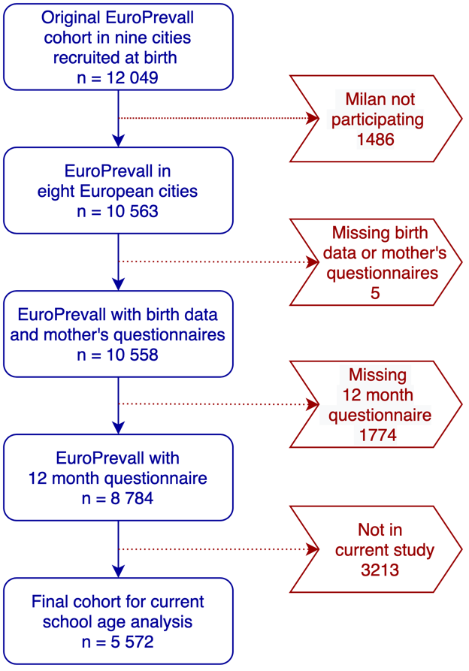
FIGURE 1. Flow chart of the population-based pan-European birth cohort study showing the EuroPrevall and iFAAM participants up to inclusion in the current analysis. The EuroPrevall study centre Milan did not participate in the iFAAM project. The eight participating cities were: Reykjavík, Iceland; Southampton, UK; Amsterdam, the Netherlands; Berlin, Germany; Lodz, Poland; Vilnius, Lithuania; Madrid, Spain; and Athens, Greece. “Not in current study” are children whose parents were not reachable, or were not interested in participation at school age.
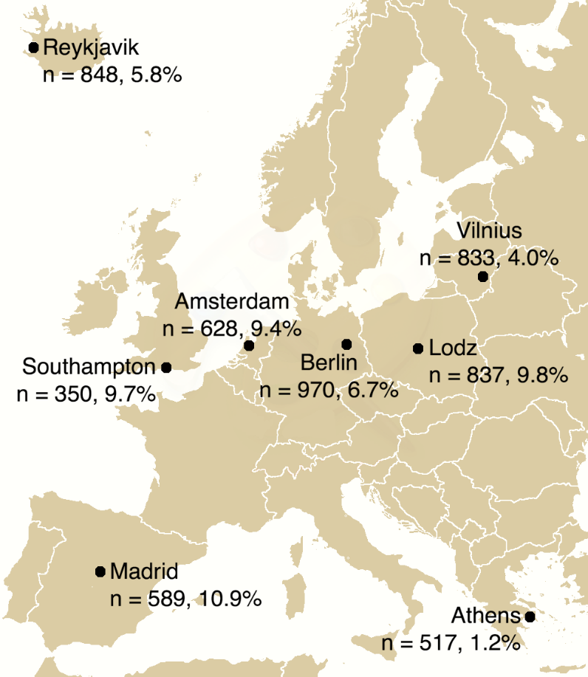
FIGURE 2. The eight centres of the population-based EuroPrevall/IFAAM birth cohort study, the number of children who participated in each one at the school age follow-up assessment (in total 5 572 children), and the proportion of these with allergic multimorbidity (overall proportion 7.0%).
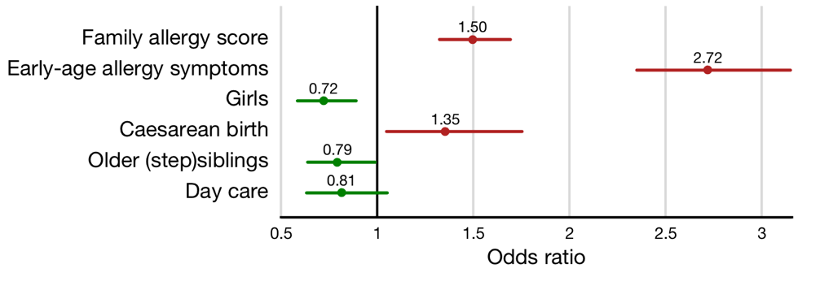
FIGURE 3. Odds ratios and 95% confidence intervals for protective factors (green) and risk factors (red) of allergic multimorbidity at school age [of a model selected according to AICc]. Family-allergy-score is standardized to have SD = 1. Early-age-symptoms is in the range 1–3, and counts the number of allergic symptoms (of allergic rhinitis, eczema, asthma) observed before age 2. All the remaining variables are dichotomous. The OR for family-allergy-score shows the multiplicative effect for each standard deviation, and somewhat similarly, the OR for early-age symptoms shows the multiplicative effect of each such symptom which is present. The factors shown are the ones present in a multivariate logistic model which maximizes the AICc model selection criterion.
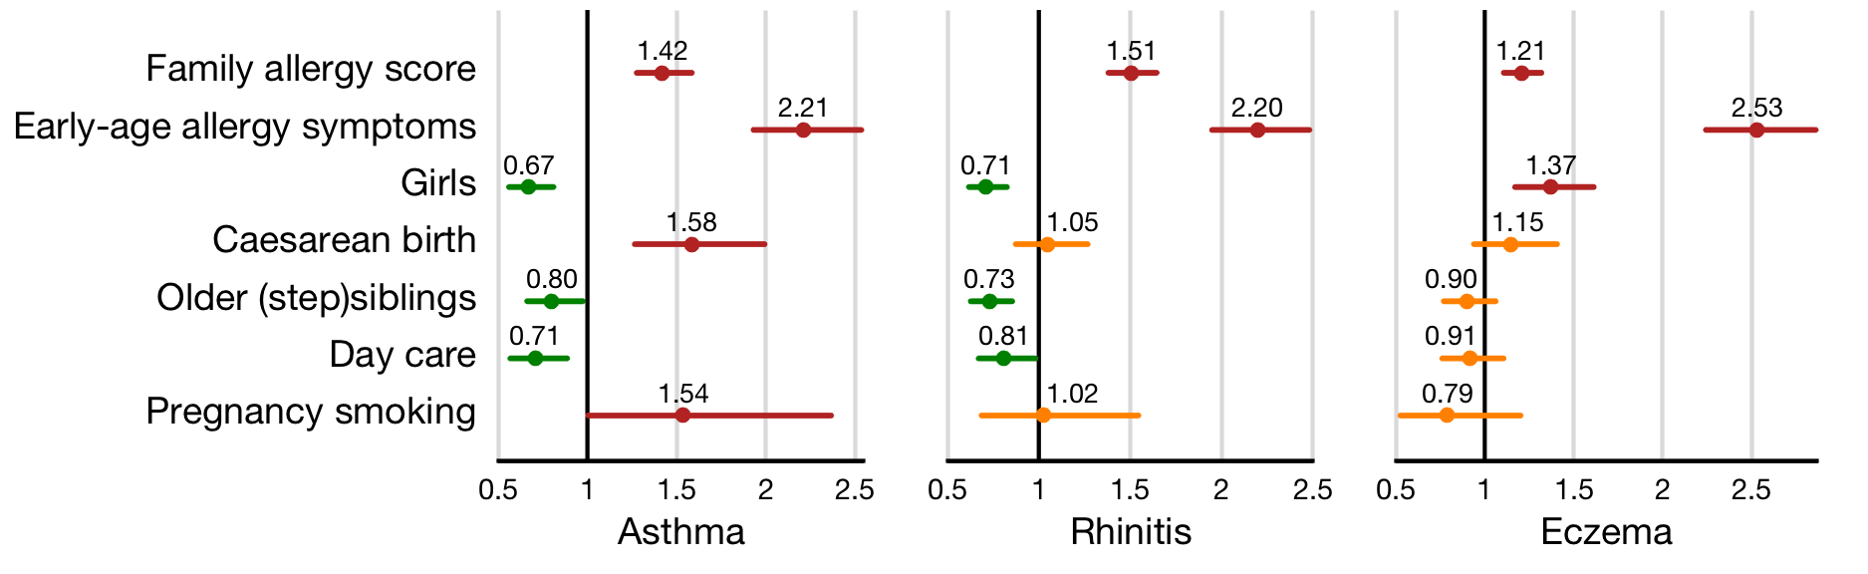
FIGURE 4. Odds ratios and 95% confidence intervals for covariates that are predictors for one or more of the individual diseases considered in the study (secondary outcomes). Covariates for which the confidence intervals do not contain 1 are colored green if the factor is protective and red if it poses a risk. Confidence intervals of variables which are not selected into a corresponding model are shown in orange. See also explanations in the caption of Figure 3

Graphical abstract
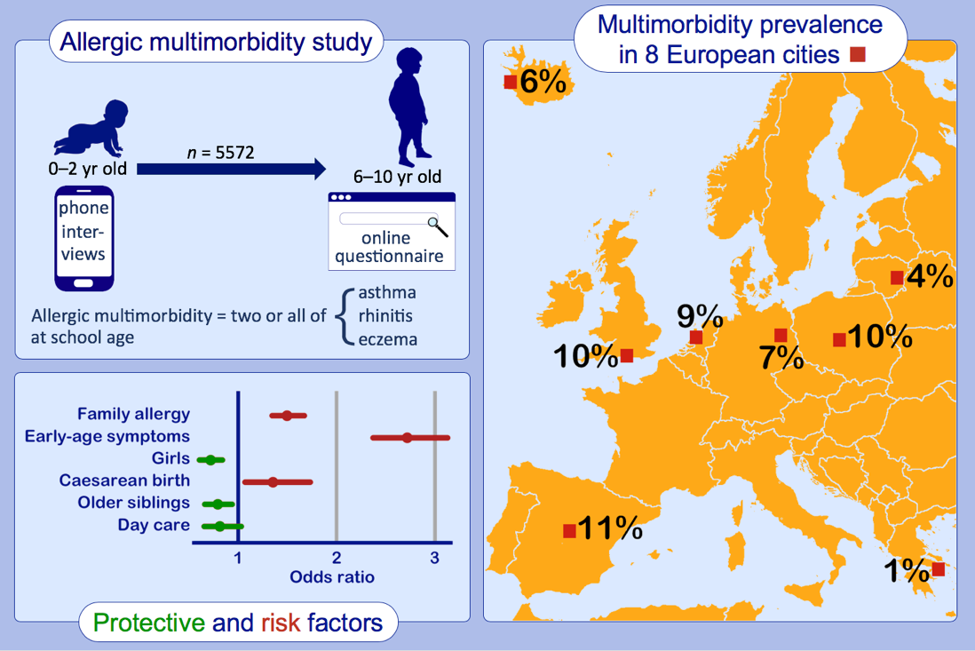

SUPPLEMENT – TABLES S1–S8 and appendix s1
TABLE S1. EuroPrevall/iFAAM participants included in final cohort of the current study according to centre.
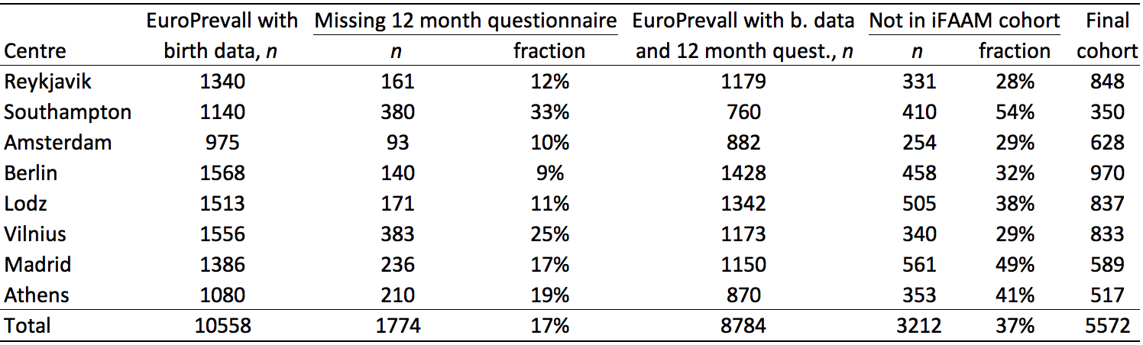

TABLE S2. Details of some of the models for multimorbidity that were considered. The centre effect is present in all models. The column headed Δ-AICc shows the difference in AICc (Akaike information criterion with correction) between the empty model and the actual one. The final selected model maximizes this difference with Δ-AICc = 247.2. The odds ratios shown for the 6 variable models are those of the final selected model of Section 3.3.
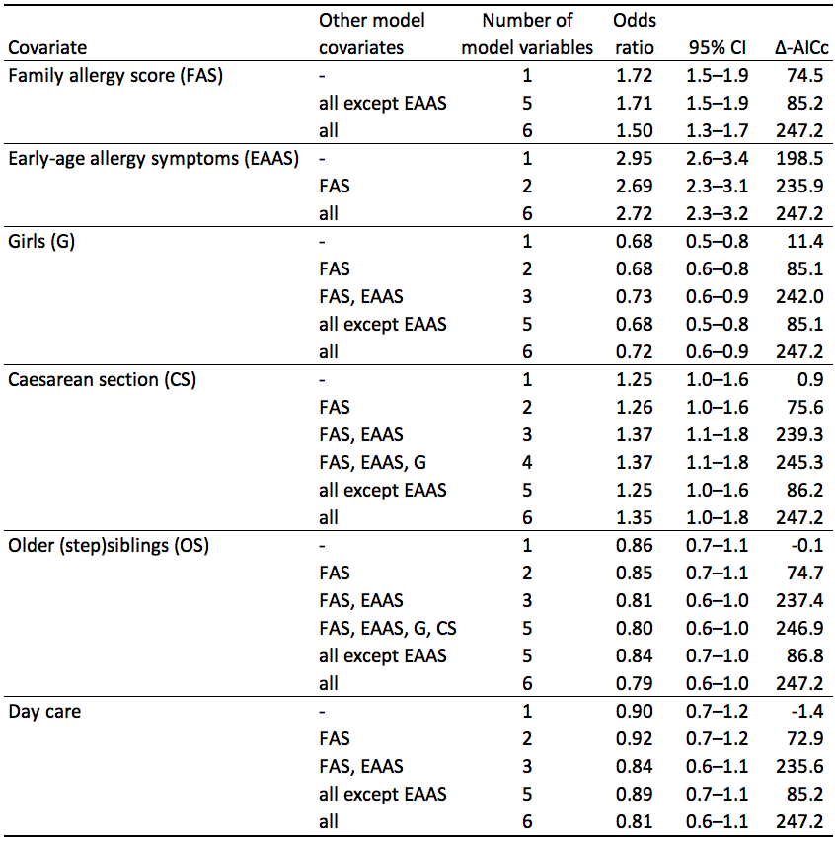
TABLE S3. Early-life covariates according to centre. The table shows covariates that the statistical modelling did not identify as affecting multimorbidity or one of the individual diseases. Breakdown of the other covariates is given in Table 2 in the main text. The table also shows a summary for the EuroPrevall children which did not participate in iFAAM. There is a significant difference (according to a two-tailed test at the 5% level), for breastfeeding, child and mother antibiotics, dogs, parent education, smoking at home, and vitamin D supplementation (shown in bold red italics).
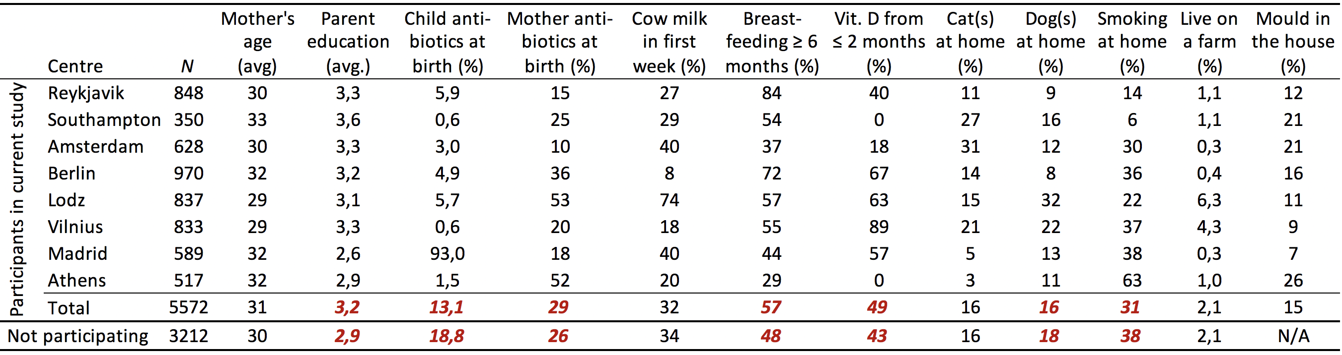

TABLE S4. Multimorbidity model consistency check: Odds ratios for models based on data from all centres except one, and comparison with the full data model. Variables that are not selected according to the AICc criterion are shown in red italics. The most notable discrepancy is that when Lodz is left out, the odds ratio for caesarean birth is considerably reduced.
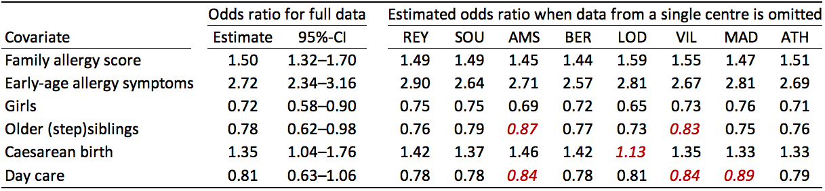

TABLE S5: Asthma model consistency check: Odds ratios for models based on data from all centres except one, and comparison with the full data model. Variables that are not selected according to the AICc criterion are shown in red italics.
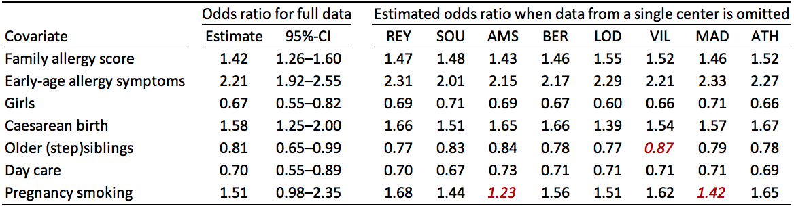
TABLE S6. The German MAS study was enriched with about 19% high-risk children and also uses a wider definition of multimorbidity than the current study.(1) To attempt a comparison for the Berlin part of our cohort we compare those with a minimal family history (family-allergy-score ≤ 1; 29% of the Berlin children) and the remaining „high-risk“ children separately, and use a modified definition of multimorbidity which is approximately equivalent to the MAS definition. About 64% of the MAS children had „negative family history“ (after correcting for the enrichment) in 6 cities across Germany, and among these multimorbidity occurred in 1.9% at 9 years of age, and in 11.2% of those with positive history. In the current study 1.8% of the Berlin children with minimal family history were multimorbid using the modified definition, and 8.8% of those with non-minimal history. The table shows details of the different definitions of allergic multimorbidity. The “modified” definition is intended to agree approximately with the definition of allergic multimorbidity in the MAS study. The table also shows the definition used in the current study (unmodified) and the actual definition used in the MAS study.
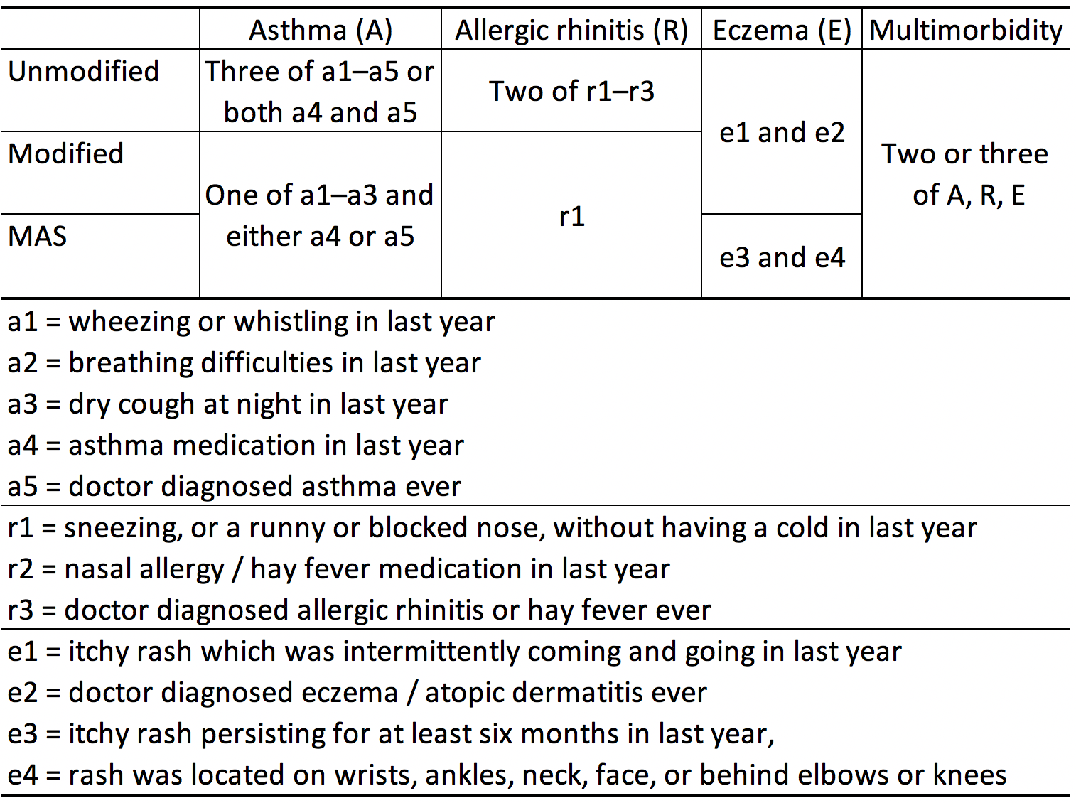
TABLE S7. Odds ratio for allergic multimorbidity for single and multiple early age allergic symptoms, modelled without correcting for other factors.
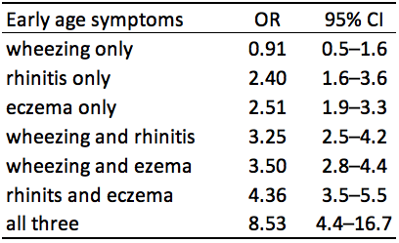
TABLE S8. Results of adding heavy traffic to the logistic regression model discussed in section 3.3. The identified risk of heavy traffic on asthma is consistent with results from the Dutch PIAMA study which comprehensively investigated the association between air pollution and asthma in children up to 20 years. That study found significant association between the concentration of five different traffic related air pollutants and asthma development.¹⁷
iFAAM question | do you live on a main road where heavy vehicles (trucks, buses) pass by?
number of yes answers | 1708 (30.6%)
estimated odds ratio for asthma | 1.26 (95% CI 1.01–1.56)
increase in AICc | 2.28

Appendix S1: Family allergy score
The family allergy score was computed as follows(12). The birth data questionnaire contained questions on history of allergies in first degree relatives. We split the questions into four groups according to the type of allergy: (1) food allergy, (2) animal allergy, (3) hay fever/asthma, and (4) other allergies. The possible animals listed were dogs, cats, birds, rodents, horses and other animals. Among "other allergies" were latex, metals, penicillin, adhesive bandage and soap. Eczema was also placed in group (4).
For food, the question was "Do you experience or have you experienced allergic reaction to food" and then 14 common allergenic foods were listed, and space given for three "others". For each food, the questionnaire asked for specific reactions that had been experienced, and 21 possible reactions were allowed for. A food score was computed by giving, for each food, 0.5 points for 0 or 1 reaction, 1 point for 2, 1.5 points for 3, and 2 points for ≥ 4 reactions, and then adding all the points for the different foods.
For groups (2), (3) and (4) the following two questions were asked for each type of allergy causing agent: "Do you suffer from or have you suffered from hay fever?" (or "cat allergy", "latex allergy", etc.), and: "Was it medically confirmed?". Each yes scored one point and the points for each group were added.
The score for each group was now standardized to make the mean score for the group = 1.0, and the sum of all four group scores gave the score of the relative. Since the sibs are younger than the parents and have had less time to develop allergy, their score was multiplied by 1.5. This gave the following mean scores: mothers 2.56, sibs 2.10, fathers 1.72. Next the average of all available scores for mother, father and sibs was computed for each child in the study, and finally the scores were standardized to have SD = 1. For example, if the mother had a score of 1.0, two sibs had scores of 1.0 and 4.0, and no data for the father was available, the family allergy score before standardization was calculated to be (1 + 1 + 4)/3 = 2.0.

