Does Green Financing help to improve Environmental & Social Responsibility? Designing SDG framework through Advanced Quantile modelling.

Abstract

Striving to achieve the Sustainable Development Goals (SDGs), countries are increasingly embracing a sustainable financing mechanism via green bond financing. Green bonds have attracted the attention of the industrial sector and policymakers, however, the impact of green bond financing on environmental and social sustainability has not been yet been confirmed. There is no empirical evidence on how this financial product can contribute to achieving the goals set out in Agenda 2030. In this study, we empirically analyze the impact of green bond financing on environmental and social sustainability by considering the S&P 500 Global Green Bond Index and S&P 500 Environmental and Social Responsibility Index, from 1st October 2010 to 31st July 2020 using a combination of Quantile-on-Quantile Regression and Wavelet Multiscale Decomposition approaches. Our results reveal that green financing mechanisms might have gradual negative transformational impacts on environmental and social responsibility. Furthermore, we attempt to design a policy framework to address the relevant SDG objectives.

Keywords: green financing; green bonds; Agenda 2030; environmental and social responsibility; wavelet; quantile
- Introduction
Growing environmental degradation forces policymakers to focus on imbibing sustainability in the economic growth agendas. The recent Sustainable Development Goals (SDG) report, i.e., Agenda 2030, has attributed the global economic growth pattern to be responsible for the issue of rising climatic disasters across the globe (United Nations, 2019). The economic growth prevailing across the nations is majorly dependent on the fossil fuel consumption bringing forth the ecological predicament in the form of climatic shift. In recent years, the world experienced a rise in the renewable energy solutions, however, these are yet to reach their full potential.
As an economic growth is catalyzed largely through an industrial growth, it can be argued that the trajectory of the industrial growth pattern is shaping the trajectory of climatic shift. Driven by the profit motive, the industrial sector is largely interested in reducing the operational costs, however an implementation of renewable energy solutions can cause a short run decline in their profit due to the high implementation costs (Sinha et al., 2020b). This incessant rise in industrialization is complemented by the financial mobilization within the nations, thus the prevailing financial mechanism is also adding to the issue of rising environmental degradation. This might create a predicament on the way of attaining the objectives of SDG 13, i.e., climate action. Persistence of this mechanism is not only adding to environmental issues, but also to social issues, such as rising health issues among the population. Social issues can cause negative impact on economic growth pattern itself, which might in turn create a predicament on the way of attaining the objectives of SDG 8, i.e., decent work and economic growth.
In the recent report on SDG financing by Garroway and Carpentier (2019), the authors have stressed the deficiency of the nations in making progressions towards SDG financing. This report is based on the Addis Ababa Action Agenda, which focused on how financing mechanism can be used as a vehicle for ascertaining sustainable economic growth (United Nations, 2015). However, the recent progress on this front shows that the developmental agenda has not yet been prioritized, and many nations might not be able fulfill the 2030 agenda. One of the major obstacles is mainstreaming or realigning the capital market with the Addis Ababa Action Agenda. The recent report by United Nations Global Compact (2019) has discussed this fact and has stressed the importance of reorienting the global capital markets for ascertaining the attainment of the objectives of SDGs by 2030.
In this pursuit, capital market products and corporate financing mechanisms have been identified as the major instruments for this realignment. The need for realignment with SDG objectives called for a product, which can primarily address the issues of climatic shift. Thus, Green Bond or Climatic Bond started gaining prominence in the global capital market, while nations started recognizing its potential. In 2009, the World Bank introduced this product in the global capital market, with an objective of restoring the environmental and social balance in the global sustainability ecosystem, driven by the growing concern of the stakeholders in environmental, social, and governance (ESG) disputes (World Bank, 2009). Following the Addis Ababa Action Agenda, green bonds started attracting attention of the individual and institutional investors, and in 2016 debtors from China, European Union, and the United States of America started capturing the green bonds market. Once the report of United Nations Global Compact (2019) was published, green bonds started gaining prominence again among the global investors, after experiencing a slump in 2018.
From the perspective of Limits to Growth (Meadows, 1974), introduction of green bonds carries a significant place in the global sustainability fora. As an unconstrained economic growth is catalyzed by natural resource consumption continues, then the existing pool of natural resources will not only start diminishing fast, but also rising demand of natural resources might create a disbalance in the social strata. Therefore, in order to address both the environmental and social issues, green bonds might be considered as a viable solution. This solution might be traced back to the aspects of decarbonization, which is a major policy-level concern across the globe. However, the ecological and social implications of green bonds have not been fully understood yet. Although green bonds are identified as a vehicle for ascertaining sustainable development, there is not enough evidence demonstrating how exactly this financial product can fulfill these two crucial simultaneous roles at a global scale. Criticality of the solution might bring forth a policy trade-off in the decarbonization context, where the stabilization of the policy implications might be stemmed from the social background of the context. Bringing this trade-off aspect in the decarbonization scenario might prove to be crucial from the perspective of sustainable development. There lies the focus of this study.
Following the ongoing sustainable development agenda across the globe, this study aims to devise a sustainable development framework through analyzing the impact of the green bonds returns on Environmental and Social Responsibility at a global scale. For promoting environmentally sustainable projects, it is necessary that the financing mechanism should be transparent and well understood by the different groups of stakeholders. This can be achieved by sharing a project’s progress and outcomes with the public via various online platforms and the media. This might help to generate a positive environmental externality of the financing mechanism. Moreover, the tax benefits received from this mechanism might help in tacking the social issues associated with environmental degradation, while assisting in the growth in implementation of renewable energy solutions.
This study aims to assess this impact at a global scale, by considering the S&P 500 Environmental and Socially Responsible Index, as the indicator of socio-ecological performance of firms. Considering the role of industrialization in shaping economic growth trajectory, we focus on the impact of S&P 500 Global Green Bond Index on S&P 500 Environmental and Social Responsibility Index, and vice versa. Therefore, our empirical findings inform our approach for designing a comprehensive policy framework to help the nations in attaining the objectives of certain SDGs. The proposed policy framework mainly focused on addressing the issues of climatic shift (SDG 13) and ascertaining sustained economic growth (SDG 8). However, the proposed policy framework also covers SDG 7 (making energy solutions clean and affordable), SDG 9 (promoting innovation), and SDG 16 (institutionalizing the solutions while maintaining social order). This comprehensive policy approach for attaining SDG objectives by means of green bond is the main policy contribution of our paper.
Apart from important policy implications, this paper also contributes to the growing body of Green Finance literature, and specially to the green bond financing literature (e.g., Huynh et al., 2020), providing a novel empirical evidence from the advanced quantile modelling approach. The existing studies are often based on the using the median of the data and ignoring potentially meaningful information contained towards the tails of the data distribution. Thus, we select our methodological approach based on the need of analysis of socio-ecological impacts of green bond financing using the entire data spectrum and employ an advanced Quantile-on-Quantile (QQR) method devised by Sim and Zhou (2015). This method can capture the impact of the explanatory variable on the target policy variable across the spectrum of the data, which is derived through quantile-decomposition. This methodological approach complements the policy-level contribution of the study and adds to the existing empirical evidence in Green Finance literature.
The remainder of the paper is organised as follows. Section 2 provides overview of the relevant literature, Section 3 explains the applied methodology, Section 4 discusses the findings, and Section 5 concludes the study with relevant policy implications.

- Literature Review

One of the earliest studies on the socio-ecological impact assessment of green bonds was carried out by Zerbib (2019), where the author considered the demand side of the green bond markets though the analysis of the impact of environmental preferences on the premium of green bonds. The author placed emphasis on the rising demand of superior environmental quality as a main driving factor of the green bonds’ demand. These findings are relevant to the results obtained by Agliardi and Agliardi (2019), who analyzed the supply side aspect instead. The authors found that the environmental awareness of the shareholders and the pro-environmental tax benefits by the government can have a positive impact on the green bonds’ prices. However, the existing trend in this literature strand is largely inclined towards the supply side aspect, and this falls in line with the theme of the present study. Considering of the performance of Chinese listed firms, Zhou and Cui (2019) analyzed the impact of green bonds issuing announcements on the corporate social responsibility (CSR) activities, which was further reciprocated to the social and environmental activities carried out by the firms. Reboredo (2018) further reported that the positive environmental externality exerted by the green bonds trade eases the implementation and diffusion of renewable energy solutions across a nation.
Although Wang and Zhi (2016), among others, have reviewed the market mechanisms, through which green bond financing can partake in environmental protection, they did not suggest any policy directions, which might deem to be suitable for assuring the developmental sustainability. A notable exception is the study by Clapp et al. (2015) that conducted a thorough review of the available arguments on the role of green bonds in building a low-carbon economy. The authors provided a set of suggestions, which are seemingly significant, given they have been developed in a pre-SDG epoch. More recently, a shadowy reflection of these policies can be seen in the study carried out by Flammer (2020), who discussed the importance of green bonds in shaping environmentally responsible firms, while giving an indication to utilize them as a public policy tool to address the SDG objectives. While Flammer (2020) focused on the environmental aspects, Braouezec and Joliet (2019) analyzed the role of green bonds in shaping socially responsible firms, and how firms’ actions can be delivered through their CSR activities.
The abovementioned studies demonstrate on the operational and strategic transitions of the firms towards socio-ecological evolution, and the instrumentalization of green bonds as a public policy tool that can be utilized by corporations and enforced by policy makers. In Chinese context, Ng (2018) presented different scenarios for enforcing institutional legitimacy and policy-level reorganization to assure the sustenance of green bonds. During the institutionalizing of the green bond’s operationalization, it is necessary to protect the interest of the investors, while addressing the issue of climate change. This aspect is critically important to ascertain the demand of green bonds among the investors. The study by Gianfrate and Peri (2019) has analyzed this in the European green bonds market bringing together the demand and supply side of green bonds discussing their ecological impacts. Huynh et al. (2020) further analyzed green bonds from portfolio diversification perspective, indicating potential safe haven properties of these assets, and explaining why these new financial instruments are attractive for investors.
Preference towards achieving a high economic growth can create hindrance in way of implementing green finance solutions, as it was shown by Nguyen et al. (2018) in the case of Vietnam. Prevailing political instability within the nation has been attributed as the second major cause behind this hindrance. In the similar context, Urban et al. (2018) have shown the inclination towards sustainable development drives the growth of green bonds adding to the findings of Nguyen et al. (2018). However, the role of the policymakers to recognize the potential of green bonds remains essential in creating the positive socio-ecological spillovers. Banga (2019) has considered this research problem for the developing nations, as the issuance of green bonds might be crucial for these nations, keeping their pro-growth objective in mind.
While the reviewed studies considered the socio-ecological impact of green bonds in different contexts, there is a lack of comprehensive policy framework for sustainable development. This is evident that green bonds can be used as a policy instrument for assuring social and environmental responsibility among the industrial sector, however, this has not been yet confirmed empirically. Though the green bonds came into existence during the Millennium Development Goals (MDG) regime, there role is coming out to be more crucial in the era of SDGs, and therefore, the void of a comprehensive policy framework needs to be addressed. There comes the role of the present study.
In this paper, by analyzing the socio-ecological impact of green bonds, we aim to devise a comprehensive policy framework for attaining the objectives of SDGs, providing an original contribution to the literature. In methodological terms, the analytical approach adopted in this study complements the policy-level contribution of the study by considering the entire data spectrum of the target and explanatory policy variables, and this particular approach is necessary for understanding the wholesome depiction of the impact. In this view, the present study addresses the gap in the literature not only through devising a comprehensive policy framework for attaining SDGs, but also by applying the QQR methodological approach, which is necessary for designing the policy framework.

- Data and Methodology

  - Data
The present paper utilizes the time series dataset constituting the daily observations of S&P 500 Global Green Bond Index as a proxy for green financing and S&P 500 Environmental and Social Responsibility Index. These daily observations for the given variables cover the period from 1st October 2010 to 30th September 2020. The descriptive statistical features of the variables and the correlation between is reported in Table 1. The non-normal distribution nature of the data taken under study gets well evident from the results of Jarque-Bera Test presented in Table 1. This leads to possibility of non- linear linkage between the variables and the same may be examined by employing Quantile approaches (e.g. Bekiros et al., 2016; Balcilar et al., 2016; Troster et al., 2018; Sharif et al., 2019) which can very well deal with the issue of heavy tails. The correlation coefficient between the Global Green Bond Index and Environmental Social Responsibility Index is observed to be positive and statistically significant.

<Insert Table 1 here>

The innovative approach in the present paper lies in its endeavor to explore the effect of different frequencies of the time series of Global Green Bond Index on Environmental and Social Responsibility Index. The paper adopts the wavelet framework to examine the linkage between the variables taken under study. In this regard we utilize wavelets to decompose the daily time series of Global Green Bond Index into six different frequency components. Figure 1 presents the time series plot raw data of both dependent and independent variables and different frequency components of Global Green Bond Index. The high frequency in the short period accompanied by stability in longer periods may be very well demonstrated in Figure 1.

<Insert Figure 1 here>

As the empirical model is based on a bivariate framework, it is quite obvious that the model will suffer from the endogeneity issue, and this issue might be arising out of omitted variable bias. In absence of other control variables in the model, it might be possible that the stochastic error term is correlated with the explanatory variable, which might cause the endogeneity issue (Ullah et al., 2018, 2020). In keeping with our research objective and to proceed with the bivariate framework, we have carried out the analysis in the frequency domain rather than the temporal domain. Drifting away from the temporal domain will nullify the possibility of the occurrence of any stochastic error, and therefore, the quantile estimation has been carried out on the data decomposed in the frequency domain by wavelet multiscale decomposition method.

  - Quantile Autoregressive Unit Root Test

We analyze the stationary properties of the time series by employing Quantile Auto-Regressive (QAR) unit root test proposed by Koenker and Xiao (2004). The QAR model of unit root test is instrumental in examining the stationarity of a time series data at both conditional mean and all the quantiles of the conditional distribution. Galvao (2009) further incorporated covariates and linear trend in the QAR model and consequently generalized it.
Suppose $X_{t}$ indicates the presence of strict stationarity with the prior information set $I_{T }^{X}={(X_{T-1},……,X_{T-S})}^{' }ϵR^{S}$. Further $F_{X }\left(. | I_{t}^{X}\right)$ is assumed to be the conditional distribution function of $X_{T}$ with $I_{t}^{X}$ . The linear Quantile Regression Model (QRM) forms the basis of QAR unit root test which may be indicated as follows:

$Q_{τ}^{X}\left(X_{T} | I_{T}^{X}\right)=μ_{1}\left(τ\right)+μ_{2}\left(τ\right)T+α\left(τ\right)X_{t-1}+\sum_{j=1}^{p}{α_{j}(τ)}∆X_{t-j}+F_{u}^{-1}(τ)$ (1)

The $ϑ$ quantile of $F_{X }\left(. | I_{t}^{X}\right)$ is indicated by $Q_{τ}^{X}\left(. | I_{T}^{X}\right)$ and $φ_{1}\left(ϑ\right)$ indicate the drift term. The linear trend and the persistence parameter in the QAR model for unit root test is represented by $t$ and $ω\left(ϑ\right)$ respectively. The errors’ inverse conditional distribution for $τϵT⊂\left[0,1\right]$ quantiles is indicated by $z_{u}^{-1}$. In this manner we estimate the tenacity parameters ($\hat{α })$ for all the quantiles of the X_{t} conditional distribution. The QAR model as suggested by Koenker and Xiao (2004) and Galvao (2009) estimate and analyse the t- statistic for different quantiles $τϵT$ to test the null hypothesis $H_{0}: α\left(τ\right)=1$
  - Quantile Cointegration Test

The present paper further employs Quantile Cointegration Test to explore the systematic effect of varied frequencies of Green Bond Index on the shape, scale and locational aspect of Environmental and Social Responsibility Index. The Quantile Cointegration Test was introduced by Xiao (2009) to deal with the endogeneity issue in a standard cointegration model. Xiao (2009) followed Saikkonen (1991) to disintegrate the cointegration equation errors into the lead-lag terms along with the pure innovation component. The Quantile Cointegration Model terms β(τ) as a vector of constants and thus extends the cointegration model of Engle and Granger (1987). The special case of Quantile Cointegration Model comprises of:

$X_{t}= α+β^{'}Z_{t}+\sum_{j= -k}^{k}{∆Z_{t-j}^{'}}П_{j}+u_{t}$ (2)

and

$Q_{τ}^{X}\left(X_{t} | I_{t}^{X}.I_{t}^{z}\right)= α\left(τ\right)+β{\left(τ\right)}^{'}Z_{t}+\sum_{j=-k}^{k}{∆Z_{t-j}^{'}П_{j}+F_{u}^{-1}(τ)}$ (3)

We further add regressor’s quadratic term in the model and can be represented as follows:

$Q_{τ}^{X}\left(X_{t} | I_{t}^{X}.I_{t}^{z}\right)= α\left(τ\right)+β{\left(τ\right)}^{'}Z_{t}+γ{\left(τ\right)}^{'}Z_{t}^{2}+\sum_{j=-k}^{k}{∆Z_{t-j}^{'}П_{j}+\sum_{j=-k}^{k}{∆Z_{t-j}^{2'}Г_{j} F_{u}^{-1}(τ)} }$ (4)

Form the abovementioned equation (4) Xiao (2009) estimated the stability test for cointegrating coefficients. Over all the quantiles, the null hypothesis, $H_{0}: β\left(τ\right)= β$ was examined by Xiao (2009). Further, the researcher introduced a supermum norm of the absolute value of difference $\hat{V_{n}}\left(τ\right)=(\hat{β}\left(τ\right)-\hat{β})$ as a test statistic. This test statistic forms the basis for applying test statistic $\sup_{τ}\left|\hat{V_{n}}\left(τ\right)\right|$ across the distribution of quantiles. The present research follows the idea of Xiao (2009) to estimate $\sup_{τ}\left|\hat{V_{n}}\left(τ\right)\right|$ test statistic’s critical values by performing 1000 Monte Carlo simulations.

  - Wavelet Multiscale Decomposition

The wavelet analysis of any time series combines it’s both time and frequency domain. In contrast to other conventional econometric methods, the wavelet analysis disintegrates a time series data to be analyzed into a number of wavelet scales. Wavelets perform the orthogonal decomposition of a time series data to present it in a non-parametric way (Ramsey, 1999). The wavelets perform frequency decomposition of the time series data and at the same preserve its time series properties. According to Gencay et al. (2002) the Wavelet Transform presents the holistic information pertaining to individual time horizons and locational aspects of a time series data. This unique property of the wavelets makes it suitable to analyze a time series data irrespective of it being stationary or non-stationary.

According to Ramsey (2002) the functions of any time series data are represented by father (ϕ) and mother (ψ) wavelets. The father wavelets represent a signal’s incredibly large-scale smooth components while integrating to one. The mother wavelets indicate the deviations occurring in these smooth components and integrate to zero. Father wavelets generate scaling coefficients whereas the mother wavelets produce differencing coefficients.
We represent the father wavelets as:

$ϕ_{j,k}= {-2}^{-j/2}ϕ\left(\frac{t-2^{j}k}{2^{j}}\right) with \int{ϕ \left(t\right)dt=1}$ (5)

The mother wavelet can be indicated as follows:

$ψ_{j,k}= {-2}^{-j/2}ψ\left(\frac{t-2^{j}k}{2^{j}}\right) with \int{ψ \left(t\right)dt=0}$ (6)

These parent wavelets form the basic functions defining the coefficients’ sequence. The derived smooth coefficients from the father wavelets are indicated as follows:

$S_{j,k}= \int{f(t)}ϕ_{J,k}$ (7)

We define the detailed coefficients obtained from the mother wavelets as follows:

$d_{j,k}= \int{f(t)}ψ_{J,k}$ With j = 1………. $J$ (8)

The $2^{j}$ form the maximal scale of the former, whereas the detailed coefficients deduced from the mother wavelets are at the scales from 1 to $J$ We define the function f (.) from the above-mentioned coefficients in the following manner:

$f\left(t\right)= \sum_{k}{S_{J,k}}ϕ_{J,k}\left(t\right)+\sum_{k}{d_{J,k}}ψ_{J,k}\left(t\right)….+\sum_{k}{d_{J,k}}ψ_{j,k}\left(t\right)…+\sum_{k}{d_{1,k}}ψ_{1,k}\left(t\right)$ (9)

When we simplify Equation (5) we get

$f\left(t\right)= S_{J}+D_{J}+D_{J-1}+…+D_{j}+…+D_{1}$ (10)
The orthogonal components of the above-mentioned equation are represented as follows:

$S_{I}= \sum_{k}{S_{J,k}}ϕ_{J,k}\left(t\right)$, (11)
$D_{J}= \sum_{k}{d_{J,k}}ψ_{J,k}\left(t\right).$ j = 1,…. $J$ (12)

The multi horizon or multi resolution decomposition of f($t$) is represented as {$S$_{J,} $D_{J-1}$,… ,D₁}.

The $J$ th level wavelet detail related with series’ variations at scale λ_{j} is estimated by $D_{J}$. At each level, the cumulative sum of alterations is defined by $S_{J}$. With the increase in $J$, $S_{J}$ becomes smoother (Gencay et.al., 2002). We further estimate the scaling and wavelet coefficients by incorporating the Maximal Overlap Discrete Wavelet Transform (MODWT). Unlike Discrete Wavelet Transform (DWT), MODWT does not suffer from any limitation like linked with the sample size to an integer multiple of $2^{J_{0}}$ (Percival and Walden, 2000). Moreover, the detailed and smooth coefficients of MODWT are linked with zero phase filters which are instrumental in aligning the original time series features with the features of Multiple Resolution Analysis (MRA). According to Percival (1995) and Percival and Mofjeld (1997), the variance estimators derived from MODWT are also asymptomatically more efficient than of DWT derived estimators. Further unlike DWT, MODWT works with average operator and moving difference which conserves the actual number of observations at each wavelet decomposition scale.
In the present paper, we incorporate Daubechies Least Asymmetric (LA) filter of length 8 (LA8) wavelet, which according to Gencay et.al. (2002) are considered smoother than HAAR wavelet filters. Moreover, as compared to HAAR wavelet filters, the LA8 filters provide better non-correlations across the scales (Cornish et.al. 2006). We decompose the series into wavelet coefficients D₁ to D₆. The detail coefficient D_{j} gives the resolution of data at scale 2^{j} to 2^{j+1}. The oscillations of periods 0-4, 4-8, 8-16, 16-32, 32-64, 64-128, days are represented by λ₁, λ₂, λ₃, λ₄, λ₅, λ₆, respectively. The long-term movements are represented by wavelet smooth S_{6.}

  - Quantile on Quantile Regression Approach

The present study intends to characterize the novel features of Quantile-on-Quantile Regression approach introduced by Sim and Zhou (2015). The paper demonstrates bivariate linkage between Global Green Bond Index and Global Environmental and Social Responsibility Index. The Quantile-on-Quantile Regression approach which is inclusive of Quantile Regression Approach primarily examines the effect quantiles of independent variables on the quantiles of dependent variables. The Quantile-on-Quantile Regression approach integrates the features of quantile regression as well as non-parametric estimation. The conventional quantile regression approach primarily examines the influence of independent variable on the varied quantiles of dependent variable. The normal Ordinary Least Squares model estimates the conventional effect of a single quantile of an independent variable on the criterion variable. The novel Quantile on Quantile Regression approach combines both these conventional Quantile Regression and normal Ordinary Least Squares to model the inter-linkage between quantiles of both dependent and independent variables. The Quantile-on-Quantile Regression approach which is non parametric in nature can be modelled as follows:

${ESRI}_{t}= β^{ε}{(GRBI}_{t})+ϑ_{t}^{ε}$ (13)

The Green Bond Index and Environmental and Social Responsibility Index at a particular time t are represented by ${GRBI}_{t}$ and ${ESRI}_{t}$ respectively. $ε$ indicate $ε$th quantile of the conditional distribution growth of Environmental and Social Responsibility Index. The $ε$th quantile of the conditional distribution growth of Environmental and Social Responsibility Index is indicated by$ε$. We indicate quantile residual term having $ε$th quantile with zero value with $ϑ_{t}^{ε}$. $β^{ε}(.)$ represent the unidentified function with no prior information on inter-relationship between the variables taken under study. The Quantile-on-Quantile Regression model is flexible enough to explore and examine the extent of dependency between the variables in their functional form.
Since the bandwidth controls the smoothness of the estimated results its optimal choice is highly imperative for any non-parametric analysis. In specific terms, larger the bandwidth, stronger the bias and smaller the bandwidth, more prevalence of variance in the estimations. Thus, an optimal balance between the bias and the variance in the estimations can be ensured through effective and efficient choice of bandwidth. The present study follows Sim and Zhou (2015) while selecting the bandwidth parameter of h = 0.05.

  - Granger Causality in Mean and Quantiles Approach

We further extend the present research by examining the Granger Causality in the quantiles of Green Bond Index and Environmental and Social Responsibility Index. In terms of Granger (1969), a particular time series $X_{i}$ does not Granger Cause another time series${ Z}_{i}$, else earlier $X_{i}$ has not been instrumental in forecasting${ Z}_{i}$. Let us suppose there is a describing vector ${\left(M_{i}=M_{i}^{Z}, M_{i}^{X}\right)}^{'}∈ R^{e}, e=o+q,$ with $M_{i}^{X}$ is the former evidence set of${X_{i}M}_{i}^{X}≔{\left(X_{i-1}, … , X_{i-q}\right)}^{'}∈R^{q}$. Further the null hypothesis of Granger non-causality from $X_{i}$ to $Z_{i}$ is explained as follows:

$H_{0}^{X↛Z}: F_{Z}\left(Z | M_{i}^{Z},M_{i}^{X}\right)=F_{Z}\left(Z | M_{i}^{Z}\right)$ for all $XϵR$, (14)

The $F_{Z}\left(. | M_{i}^{Z},M_{i}^{X}\right)$ is termed as the conditional scattering function of $Z_{i}$ provided ${(M}_{i}^{X}, M_{i}^{Z})$ in the ambit of null hypothesis represented in equation 14. We further follow the work of Troster (2018) in performing the D_{t} test which identifies the Quantile Auto Regressive (QAR) framework $m(∙)$ for entire$π∈Γ⊂[0,1]$, upon the null hypothesis of non-Granger causal relationship. The same may be indicated as follows:

$QAR\left(1\right):m^{1}\left(M_{i}^{Z} | ∂\left(π\right)\right)=λ_{1}\left(π\right)+λ_{2}\left(π\right)Z_{i-1}+μ_{t}ψ_{X}^{-1}(π)$ (15)

where the values $∂\left(π\right)= λ_{1}\left(π\right), λ_{2}\left(π\right)$ and $μ_{t}$ are calculated by supreme probability in an identical space of grid of quantiles, and $ψ_{X}^{-1}\left(.\right)$ is the converse of a traditional ordinary scattering function. We further rectify the causality sign between the variables, by calculating the Quantile Auto regressive framework in equation 15 with the lagged variable to another variable. The equation of QAR (1) model developed from equation 16 may be represented as follows:

$Q_{π}^{Z}=\left(Z_{i} | M_{i}^{Z},M_{i}^{X}\right)= λ_{1}\left(π\right)+λ_{2}\left(π\right)Z_{i-1}+η\left(π\right)X_{i-1}+μ_{t}ψ_{X}^{-1}(π)$ (16)

4. Empirical Results
4.1. Quantile Auto Regressive Unit Root Test (QAR) Test

The estimates from the Quantile Unit Root Test examining the stationarity of data are reported in Table 2. The Quantile Unit Root Test presents the presence of persistence and t-statistics estimates for the null hypothesis postulating that H₀ = a(τ) = 1 for the grid of 19 quantiles T = {0.05-0.95}. The study avoids the issue pertaining to possible presence of serial correlation by employing 10 lags of endogenous variables. The estimates from the QAR test indicate the presence of unit root at a level for the conditional distribution quantiles thus leading to inference of existence of non-stationarity in the variables’ data. However, at the first order difference, the data is observed to be stationary as confirmed by the QAR estimates.

<Insert Table 2 here>

4.2. The Quantile Cointegration Test

The Quantile Cointegration test introduced by Xiao (2009) investigates the possible presence of cointegration among the variables taken under study. The present study examines the existence of cointegration between Global Green Bond Index and Global Environmental and Social Responsibility Index within the grid of 19 quantiles’ (0.05-0.95) which are equally spaced. Further the given Quantile Cointegration Model employed in the study uses two leads and lags of (${∆Z}_{t, }{∆Z}_{t}^{2}$) as presented in Equation 3. The Table 3 reports the estimates from the Quantile Cointegration model performed between Global Green Bond and Environmental and Social Responsibility Index. The estimates from the indicate the presence of asymmetric long run linkage between the quantiles of the given variables which are also statistically significant.

<Insert Table 3 here>

4.3. The Quantile-on-Quantile Estimates

The empirical estimates derived from the Quantile-on-Quantile Regression of Global Green Bond Index and its various decomposed series on Global Environmental and Social Responsibility Index are presented in Figure 2. The given Quantile on Quantile Regression analysis illustrated in Figure 2 presents the slope coefficient $β_{1},(θ,τ)$ estimates. These slope coefficient estimates predict the influence of τ^{th} quantile of Global Green Bond Index and its decomposed series on the θ^{th} quantile of Global Environment and Social Responsibility Index at divergent values of θ and τ.
<Insert Figure 2 here>
In the composite series, we observe a strong positive effect of Global Green Bond Index (GRBI) on Environmental and Social Responsibility Index (ESRI) in the area adjoining the lower (0.1-0.4) quantiles of both the indices taken under study. However, as we move further, this positive linkage between the variables starts weakening and eventually becomes negative. The weakening of positive effect of Global Green Bond Index on Environmental and Social Responsibility Index can be observed in the middle quantiles of both variables. In the area adjoining the higher (0.7-0.9) quantiles of Environmental and Social Responsibility Index and lower (0.1-0.3) quantiles of Green Bond Index, we observe a weak negative linkage between the variables. In the rest of the area adjoining the quantiles of the given variables the effect of Green Bond index is observed to be almost negligible.
These results indicate that in the initial level, the Green Bond Index (GRBI) might have a positive impact on the Environmental and Social Responsibility Index (ESRI). However, with the rise in both the indices, it can be seen that GRBI is gradually losing its impact on ESRI. This phenomenon might be possible because of focus of the firms on the economic output rather than socio-ecological outcome, which traces back to the classic tradeoff between growth and development. In absence of the policy level directives for ascertaining sustainable development through the business operations, it might be possible that firms might use GRBI as a tax saving mechanism, rather than envisaging it as an instrument for generating socio-ecological outcome.
Moreover, in absence of the properly defined guidelines for monitoring socio-environmental impact of projects, it is quite likely that firms will try to maximize profit, notwithstanding the intended outcome of the financing mechanism. In the context of the tradeoff between output and outcome, the intended impact of GRBI on ESRI will gradually start to diminish, as the marginal utility of the firms to create a positive socio-ecological externality will start to diminish, as focusing on the developmental aspects might increase the marginal monitoring cost of the firms. Furthermore, in order to save higher taxes through the GRBI mechanism, firms will rely more on automation in order to demonstrate a perceivable improvement in the environmental quality, and this initiative might have a detrimental impact on the employment scenario across industries. Therefore, it can be assumed that high level of GRBI might have a negative impact on ESRI, as higher proneness towards the betterment of environmental quality by virtue of automation might lead to a disturbance in the social order, in the form of rising unemployment and consequential income inequality. Reflection of this argument can be visible in the latter half of the results.
This segment of the results can be compared with case of the Next 11 economies, where the energy innovation was found to have a detrimental impact on the social order through rising income inequality (Sinha et al., 2020). In this way, achievement of the objectives of SDG 9 might enable the nations to achieve the objectives of SDG 13, but will also make them depart from the objectives of SDG 16. This tradeoff needs to be internalized through suitable policy interventions.
In order to understand the phenomenon in a more comprehensive manner, we further decompose the series and analyze the effects of frequency-level decomposed series (D1-D6 and S6) of Global Green Bond Index on Environmental and Social Responsibility Index. When we examine the influence of decomposed series of Green Bond Index (GRBI.D1) on Environmental and Social Responsibility Index we find a similar scenario as observed in the Quantile-on-Quantile estimates performed on the composite indices. Here also the decomposed series GRBI.D1 is observed to have strong positive effect on ESRI at the area adjoining lower to middle (0.2-0.5) quantiles of both the dependent and independent variables. However, at the rest of the combining quantiles of both the variables the linkage between the decomposed series of Green Bond Index and Environmental and Social Responsibility Index are negligible. Identical scenario is also observed in the influence of decomposed series GRBI.D2 on ESRI, where the strong positive effect of the GRBI.D2 is observed on the ESRI on the lower to middle (0.2-0.6) quantiles of both GRBI.D2 and ESRI. When we move further, we observe this positive linkage starts weakening in the middle to higher (0.6-0.9) quantiles of ESRI combined with lower to middle (0.2-0.6) quantiles of GRBI.D2. In rest of the area adjoining the quantiles of the variables the effect of GRBI.D2 on ESRI is observed to be extremely insignificant.
We further examine the influence of GRBI.D3 on ESRI under Quantile-on-Quantile Regression framework. We find the prevalence of strong positive linkages between the variables across the quantiles of ESRI combined with lower (0.1-0.3) quantiles of GRBI.D3. Furthermore, the positive effect of GRBI.D3 on ESRI becoming almost non-existent. In the area adjoining the higher (0.7-0.9) quantiles of GRBI.D3 and lower to middle (0.1-0.5) quantiles of ESRI we find weak to strong negative effect of decomposed series (GRBI.D3) on ESRI. Similarly, the decomposed series GRBI.D4 is observed to have positive effect on ESRI in the area adjoining lower to higher (0.1-0.9) quantiles of ESRI and lower (0.3-0.4) quantiles of GRBI.D4. Further at middle to higher (0.5-0.9) quantiles of GRBI.D4 we observe its negative effect of varying strength (weak to strong) on ESRI across its quantiles.
When we further decompose the series and analyze the effect of GRBI.D5 and GRBI.D6 on ESRI, we find complete absence of its positive effect on ESRI across the quantiles of both dependent and independent variables. We observe a strong negative effect of the decomposed series of Green Bond Index (GRBI.D5 and GRBI.D6) on ESRI at the area encompassing lower to higher (0.1-0.9) quantiles of ESRI and lower (0.1-0.4) quantiles of GRBI.D5 and GRBI.D6. As we move further, from middle to higher (0.5-0.9) quantiles of the independent variable we find this negative effect starts weakening. However, across the quantiles of ESRI and GRBI.D5 and GRBI.D6, we find a complete prevalence of negative linkage between the variables. We find a similar result, when we examine the effect of the most stable component of the decomposed time series of Green Bond Index GRBI.S6 on ESRI. We find negative influence of decomposed GRBI.S6 of varying strength on ESRI across the quantiles of dependent and independent variables.

4.4. Robustness tests

At the next stage of our analysis, we investigate all the segments of the results using the frequency-level wavelet-based QQR analysis. As we move along from the short-run to medium-run and long-run frequency domains, it can be seen that the positive impact of GRBI on ESRI is not only gradually diminishing but is gradually turning out to be negative. These results show that during the initial level of implementation, GRBI is having a short run positive impact on ESRI. This particular result has been found both across the time and the frequency domains, and this demonstrates the validity of the findings. Our results demonstrate that inadequately defined policy directives and profit motive of the firms might bring the objectives of sustainable development at the crossroads, i.e., policy instrument for assuring sustainable development might turn out to be a double-edged sword. An indication of such a scenario from rent-seeking perspective of public sector firms has been provided by Sinha et al. (2019).
The paper further compares the quantile regression parameter estimates with τ- averaged QQ parameter estimates and thus ascertains the validity of the adopted Quantile on Quantile approach. The plots presented in Figure 3 illustrate the estimates of the slope coefficients derived from the Quantile Regression and average of the slope coefficients from Quantile-on-Quantile Regression. The plots in Figure 3 reveal the trend in slope coefficients of Quantile-on-Quantile Regression being similar to that of Quantile Regression. However, while examining the impact of original time series of Global Green Bond Index and its decomposed time series, i.e., GRBI.D1, GRBI.D2, GRBI.D3 and GRBI.D4 we may observe the value estimate from Quantile-on-Quantile Regression being nearly similar to that of the results of Quantile Regression. On the contrary, the trend line for value estimates of QQ and QR coincide for the effect of GRBI.D5, GRBI.D6 and GRBI.S6 on ESRI. This segment of the findings shows the robustness of the findings of QQR estimates.

<Insert Figure 3 here>

Finally, we employ the Granger Causality Test in quantiles for Green Bond Index and its various decomposed series and Environmental and Social Responsibility Index. The estimates from Granger Causality Test in Quantiles of dependent and independent variables are reported in Table 4. From Table 4 we can very well witness the existence of unidirectional Granger Causality from GRBI and it is decomposed to ESRI across all the quantiles. The outcome from the Granger Causality Test in Quantiles remains similar for all the lags considered in the present study. The results confirm the significant effect of changes in Green Bond Index and its decomposed series on Global Environmental and Social Responsibility Index. However, at certain instances of extreme lower (0.1) or extreme higher (0.7or 0.9) quantiles we may somewhat observe the presence of bidirectional Granger Causality in Quantiles between both the variables. The latter section of the findings indicates that the initiation and higher levels of ESRI call for equivalent levels of penetration of green bonds, which can be reflected in terms of the low and high returns on GRBI. This direction of causality might prove to be significant from the policymaking perspective in a context, where the higher GRBI might have a negative influence on ESRI.

<Insert Table 4 here>

5. Policy Implications

5.1 Central policy framework
While a high penetration of green bonds with low attainment of SDG objectives might have gradual negative transformational impact on environmental and social responsibility, it can be assumed that the socio-ecological benefits of green bonds have not been communicated to the industrial players effectively. This issue can be considered as a classic outcome-output trade off, and one of the major reasons behind prevalence of this trade-off might be the strategic myopia of the industrial players regarding their potential role in ascertaining the sustainable development of nations. To address this problem, an appropriate complementary policy mechanism for the green financing channel should be implemented. While firms are using green bonds as a mere tax saving mechanism, policymakers need to ensure that the social outcome of financing mechanism is also fulfilled.
One of the possible solutions, is to create the demand for a positive social outcome, however the implementation of this particular policy can be difficult given the profit motive of the firms. Therefore, policymakers need to implement a rigorous monitoring mechanism for measuring the social outcomes of the projects, so that firms can create sufficient social externality. In this way operational costs of the firms might be increased and might have a negative impact on their revenue streams. To protect interests of the firms, the policymakers also need to create certain incentivization scheme, so that the firms can be motivated for achieving the intended social outcome of the green financing mechanism. Moreover, presence of an incentivization scheme might also bring forth the effectiveness of promotional activities carried out by policymakers for elucidating the socio-ecological benefits of green bonds among the industrial players. The expectation of supernormal profit in the form of economic incentives, penetration of green bonds might rise while in keeping with the assurance of social benefits communicated and monitored by the policymakers. Issuance of green bonds will eventually support the rise in the green projects, which might exert positive environmental externality. In this way, the financing mechanism of the firms can create environmental benefits, and the nation might make a progression towards achieving the objective of SDG 13.
Effective communication and continuous monitoring by the government might discourage the firms to go beyond a certain limit in terms of implementing automation, and thereby, putting a cap on the possibilities of jobless economic growth. If the firms can maintain a certain capital-labor ratio, following the mandated maximum permissible limit of job loss, then firms can add to the prevailing level of per capita income of the citizens by enhancing the scope and scale of job market. In this way, the possible financial innovations being carried out by the firms will lead to not only the betterment of environmental quality but also able to sustainable vocational opportunities, which might lead to rise in the per capita level of income at the industrial level. This policy initiative in terms of creating an incentivized monitoring framework might help the nation to make progression towards achievement of the objectives of SDG 8.

5.2. Policy caveats
When the policy frameworks are being laid out, it is also necessary about to mention about the required caveats and assumptions, in absence of which the policy frameworks might not produce the intended results. First, the policy makers should enforce strict environmental regulations for protecting the pool of natural resources, so that the fossil fuel consumption can be reduced. Second, the policymakers need to ensure an environment of trust for making the diffusion of technologies across the industry effective. Third, while moving away from the traditional fossil fuel-based solutions, it is possible that the labors employed with the traditional fossil fuel-based energy generation sector might losing their jobs, because of the gradual decline in demand for this form of energy. Therefore, the policymakers need to take proactive measures for the capacity building of these labors so that they can be employed in the other industrial sectors. This policy move is extremely necessary to retain the balance in the social order. Maintenance of these caveats will also help the nation to tread along the developmental trajectory in the long run.

6. Conclusion

Carried out at a global context, the present study explores the possible impact of green bonds returns (GBRI) on environmental and social responsibility (ESRI) during the period from October 1, 2010 to September 30, 2020. Using a combination of advance quantile modelling methods this paper empirically investigates the patterns of connectedness between the GBRI on ESRI providing useful insights for policy development in this area. The robustness of our empirical results confirmed by using the wavelet-based quantile modeling and Granger Causality in quantiles approaches.
We observe not only the transformational impact of green bonds returns on the environmental and social responsibility, but also uncover in the role of environmental and social responsibility in initiating and sustaining the green bonds market. The outcome of this study might be employed to devise a policy framework for accomplishing the SDG objectives, and this framework can be considered as an example for the countries, which are characterized by high penetration of green bonds with low attainment to SDG objectives.
Finally, we acknowledge the limitations of this research and understand that this study can be extended in the future. Our paper has embarked upon a bivariate analytical approach, which might be restrictive considering the scale of the problem that we targeted. Consideration of additional contextual aspects, e.g. entrepreneurship development, level of human development, and geopolitical aspects could help to provide additional policy-level insights. Our study employs a baseline approach to understand the impact of green financing mechanism on socio-ecological sustainability, while future studies can be conducted based on the volatility of returns, and co-movement among the indices.

References
Agliardi, E., Agliardi, R., 2019. Financing environmentally-sustainable projects with green bonds. Environment and Development Economics, 24(6), 608-623.
Balcilar, M., Gupta, R., & Pierdzioch, C. (2016). Does uncertainty move the gold price? New evidence from a nonparametric causality-in-quantiles test. Resources Policy, 49, 74-80.
Banga, J., 2019. The green bond market: a potential source of climate finance for developing countries. Journal of Sustainable Finance & Investment, 9(1), 17-32.
Bekiros, S., Gupta, R., & Majumdar, A. (2016). Incorporating economic policy uncertainty in US equity premium models: a nonlinear predictability analysis. Finance Research Letters, 18, 291-296.
Braouezec, Y., Joliet, R., 2019. Time to invest in corporate social responsibility and the value of CSR operations: The case of environmental externalities. Managerial and Decision Economics, 40(5), 539-549.
Buhari, D.Ğ.A., Lorente, D.B., Nasir, M.A., 2020. European commitment to COP21 and the role of energy consumption, FDI, trade and economic complexity in sustaining economic growth. Journal of Environmental Management, 273, 111146.
Clapp, C., Alfsen, K.H., Lund, H.F., Pillay, K., 2015. Green bonds and environmental integrity: Insights from cicero second opinions. Nature Climate Change, 5.
Cornish, S. L., Thompson, S. T., & Wieman, C. E. (2006). Formation of bright matter-wave solitons during the collapse of attractive Bose-Einstein condensates. Physical review letters, 96(17), 170401.
Engle, R. F., & Granger, C. W. (1987). Co-integration and error correction: representation, estimation, and testing. Econometrica: journal of the Econometric Society, 251-276.
Flammer, C., 2020. Green bonds: effectiveness and implications for public policy. Environmental and Energy Policy and the Economy, 1(1), 95-128.
Galvao Jr, A. F. (2009). Unit root quantile autoregression testing using covariates. Journal of econometrics, 152(2), 165-178.
Garroway, C., Carpentier, C.L., 2019. Why are we behind on SDG finance and what can we do about it?. United Nations Conference on Trade and Development.
Gençay, R., Selçuk, F., & Whitcher, B. J. (2002). An introduction to wavelets and other filtering methods in finance and economics. Elsevier.
Gianfrate, G., Peri, M., 2019. The green advantage: Exploring the convenience of issuing green bonds. Journal of Cleaner Production, 219, 127-135.
Granger, C. W. (1969). Investigating causal relations by econometric models and cross-spectral methods. Econometrica: journal of the Econometric Society, 37(3), 424-438.
Huynh, T.L.D., Hille, E., Nasir, M.A., 2020. Diversification in the age of the 4th industrial revolution: The role of artificial intelligence, green bonds and cryptocurrencies. Technological Forecasting and Social Change, 159, 120188.
Karyawati, G., Subroto, B., Sutrisno, T., Saraswati, E., 2020. Explaining the complexity relationship of CSR and financial performance using neo-institutional theory. Journal of Asian Business and Economic Studies, 27(3), 227-244.
Koenker, R., & Xiao, Z. (2004). Unit root quantile autoregression inference. Journal of the American Statistical Association, 99(467), 775-787.
Kovilage, M.P., 2020. Influence of lean-green practices on organizational sustainable performance, Journal of Asian Business and Economic Studies, Vol. ahead-of-print No. ahead-of-print. https://doi.org/10.1108/JABES-11-2019-0115.
Meadows, D.L., 1974. Limits to Growth a Finite World. Cambridge University Press.
Nasir, M.A., Huynh, T.L.D., Tram, H.T.X., 2019. Role of financial development, economic growth & foreign direct investment in driving climate change: A case of emerging ASEAN. Journal of Environmental Management, 242, 131-141.
Nasir, M.A., Canh, N.P., Le, T.N.L., 2021. Environmental degradation & role of financialisation, economic development, industrialisation and trade liberalisation. Journal of Environmental Management, 277, 111471.
Ng, A.W., 2018. From sustainability accounting to a green financing system: Institutional legitimacy and market heterogeneity in a global financial centre. Journal of Cleaner Production, 195, 585-592.
Nguyen, D.K., Huynh, T.L.D., Nasir, M.A., 2021. Carbon emissions determinants and forecasting: Evidence from G6 countries. Journal of Environmental Management, 285, 111988.
Nguyen, T.C., Chuc, A.T., Dang, L., 2018. Green finance in Vietnam: barriers and solutions. ADBI Working paper No. 886, Asian Development Bank Institute.
Percival, D. B., & Mofjeld, H. O. (1997). Analysis of subtidal coastal sea level fluctuations using wavelets. Journal of the American Statistical Association, 92(439), 868-880.
Percival, D. B., & Walden, A. T. (2000). Wavelet methods for time series analysis (Vol. 4). Cambridge university press.
Percival, D. P. (1995). On estimation of the wavelet variance. Biometrika, 82(3), 619-631.
Pham, L., Huynh, T.L.D., 2020. How does investor attention influence the green bond market?. Finance Research Letters, 35, 101533.
Pham, N.M., Huynh, T.L.D., Nasir, M.A., 2020. Environmental consequences of population, affluence and technological progress for European countries: A Malthusian view. Journal of Environmental Management, 260, 110143.
Ramsey, J. B. (1999). The contribution of wavelets to the analysis of economic and financial data. Philosophical Transactions of the Royal Society of London. Series A: Mathematical, Physical and Engineering Sciences, 357(1760), 2593-2606.
Ramsey, J. B. (2002). Wavelets in economics and finance: Past and future. Studies in Nonlinear Dynamics & Econometrics, 6(3), 1-23.
Reboredo, J.C., 2018. Green bond and financial markets: Co-movement, diversification and price spillover effects. Energy Economics, 74, 38-50.
Saikkonen, P. (1991). Asymptotically efficient estimation of cointegration regressions. Econometric theory, 1-21.
Shahbaz, M., Nasir, M.A., Roubaud, D., 2018. Environmental degradation in France: the effects of FDI, financial development, and energy innovations. Energy Economics, 74, 843-857.
Shahbaz, M., Nasir, M.A., Hille, E., Mahalik, M.K., 2020a. UK's net-zero carbon emissions target: Investigating the potential role of economic growth, financial development, and R&D expenditures based on historical data (1870–2017). Technological Forecasting and Social Change, 161, 120255.
Shahbaz, M., Kablan, S., Hammoudeh, S., Nasir, M.A., Kontoleon, A., 2020b. Environmental implications of increased US oil production and liberal growth agenda in post-Paris Agreement era. Journal of Environmental Management, 271, 110785.
Sharif, A., Afshan, S., & Qureshi, M. A. (2019). Idolization and ramification between globalization and ecological footprints: evidence from quantile-on-quantile approach. Environmental Science and Pollution Research, 26(11), 11191-11211.
Sim, N., Zhou, H., 2015. Oil prices, US stock return, and the dependence between their quantiles. Journal of Banking & Finance, 55, 1-8.
Sinha, A., Gupta, M., Shahbaz, M., & Sengupta, T. (2019). Impact of corruption in public sector on environmental quality: Implications for sustainability in BRICS and next 11 countries. Journal of Cleaner Production, 232, 1379-1393.
Sinha, A., Gupta, M., Shahbaz, M., Sengupta, T., 2019. Impact of corruption in public sector on environmental quality: Implications for sustainability in BRICS and next 11 countries. Journal of Cleaner Production, 232, 1379-1393.
Sinha, A., Sengupta, T., & Saha, T. (2020). Technology policy and environmental quality at crossroads: Designing SDG policies for select Asia Pacific countries. Technological Forecasting and Social Change, 161, 120317.
Sinha, A., Sengupta, T., Kalugina, O., Gulzar, M.A., 2020a. Does distribution of energy innovation impact distribution of income: A quantile-based SDG modeling approach. Technological Forecasting and Social Change, 160, 120224.
Sinha, A., Shah, M.I., Sengupta, T., Jiao, Z., 2020b. Analyzing technology-emissions association in Top-10 polluted MENA countries: How to ascertain sustainable development by quantile modeling approach. Journal of Environmental Management, 267, 110602.
Troster, V., Shahbaz, M., & Uddin, G. S. (2018). Renewable energy, oil prices, and economic activity: A Granger-causality in quantiles analysis. Energy Economics, 70, 440-452.
Ullah, S., Akhtar, P., Zaefarian, G., 2018. Dealing with endogeneity bias: The generalized method of moments (GMM) for panel data. Industrial Marketing Management, 71, 69-78.
Ullah, S., Zaefarian, G., Ullah, F., 2020. How to use instrumental variables in addressing endogeneity? A step-by-step procedure for non-specialists. Industrial Marketing Management.
United Nations Global Compact, 2019. Scaling Finance for the Sustainable Development Goals.
United Nations, 2015. Addid Ababa Action Agenda of the Third International Conference on Financial for Development.
United Nations, 2019. The Sustainable Development Goals Report 2019.
Urban, F., Siciliano, G., Wallbott, L., Lederer, M., Dang Nguyen, A., 2018. Green transformations in Vietnam's energy sector. Asia & the Pacific Policy Studies, 5(3), 558-582.
Wang, Y., Zhi, Q., 2016. The role of green finance in environmental protection: Two aspects of market mechanism and policies. Energy Procedia, 104, 311-316.
World Bank, 2009. Green Bond. Available at: http://pubdocs.worldbank.org/en/570371507751951589/investor-update-green-bond-2009.pdf
Xiao, Z. (2009). Quantile cointegrating regression. Journal of Econometrics, 150(2), 248-260.
Zerbib, O.D., 2019. The effect of pro-environmental preferences on bond prices: Evidence from green bonds. Journal of Banking & Finance, 98, 39-60.
Zhou, X., Cui, Y., 2019. Green bonds, corporate performance, and corporate social responsibility. Sustainability, 11(23), 6881.

Figures & Tables
Figure 1. Trend plot of Environmental & Social Responsibility Index and Green Bond Index
Table 1. Descriptive Statistics

Variables | ESRI | GRBI
Mean | 0.000045 | 0.000347
Minimum | -0.030789 | -0.125476
Maximum | 0.025727 | 0.092403
Std. Dev. | 0.003918 | 0.010516
Skewness | -0.350107 | -0.984011
Kurtosis | 9.789043 | 23.874770
Jarque-Bera | 4632.909*** | 43724.763***
Correlation Matrix
ESRI | 1.000000 | -
GRBI | 0.8478*** | 1.000000
Note: *** represents that variables are significant at 1% level of significance. ESRI represents Environmental & Social Responsibility Index and GRBI denotes Green Bond Index. Source: Authors Estimation

Table 2: Quantile Unit Root test
Quantile | ESRI |  |  | GRBI
 | α(τ) | t-stats | C.V | α(τ) | t-stats | C.V
0.05 | 0.907 | -2.282 | -2.332 | 0.893 | -1.577 | -2.292
0.10 | 0.908 | -2.111 | -2.490 | 0.894 | -2.057 | -2.562
0.20 | 0.915 | -0.653 | -2.694 | 0.912 | -1.228 | -2.683
0.30 | 0.917 | -0.436 | -2.699 | 0.916 | -0.884 | -2.520
0.40 | 0.917 | -1.144 | -2.769 | 0.917 | -0.573 | -2.507
0.50 | 0.917 | -1.943 | -2.795 | 0.917 | -0.297 | -2.528
0.60 | 0.917 | -0.629 | -2.765 | 0.917 | 0.201 | -2.532
0.70 | 0.917 | -0.370 | -2.645 | 0.917 | 0.181 | -2.565
0.80 | 0.916 | -0.453 | -2.665 | 0.920 | 0.900 | -2.625
0.90 | 0.917 | -0.361 | -2.348 | 0.921 | 0.313 | -2.364
0.95 | 0.920 | 1.069 | -2.124 | 0.935 | 1.073 | -2.562
Notes: The table shows point estimates and t-statistics values for the 5% significance level.
Source: Author Estimation.

Table 3: Quantile Cointegration Test Results
Model | Coeff. | Sup_{τ} | V_{n}(τ) | | CV1 | CV5 | CV10
ESRI_{t} vs. GRBI_{t} | β | 87436.312 | 59431.477 | 50382.416 | 47215.765
 | γ | 16477.049 | 9475.991 | 6114.003 | 4441.374
Note: This table presents the results of the quantile cointegration test of Xiao (2009) for the logarithm of the Environmental & Social Responsibility Index (ESRI) and Green Bond Index (GRBI). We test the stability of the coefficients β and γ in the quantile cointegration model and CV1, CV5, and CV10 are the critical values of statistical significance at 1%, 5%, and 10%, respectively. We use 1000 Monte Carlo simulations to generate the critical values. We use an equally spaced grid of 19 quantiles, [0.05-0.95], to calculate the test statistic of the quantile cointegration model between ESRI & GRBI.

Figure 2: Quantile on Quantile estimates of slope coefficient
Impact of Green Bond Index on Environmental & Social Responsibility Index
GRBI  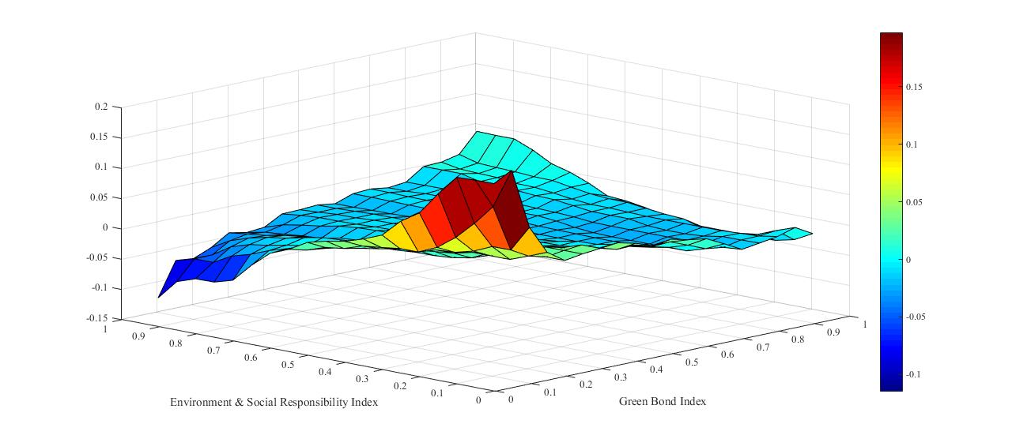 | GRBI (D1)  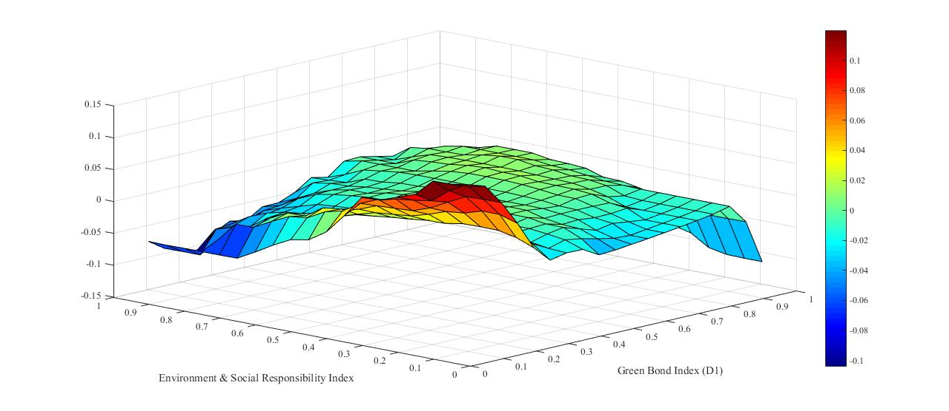
GRBI (D2)  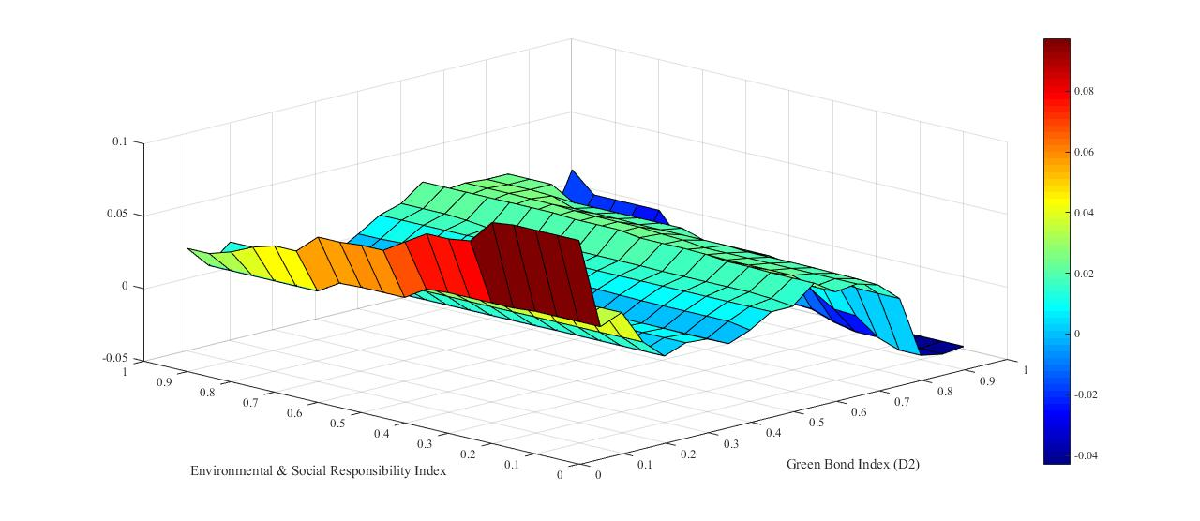 | GRBI (D3)  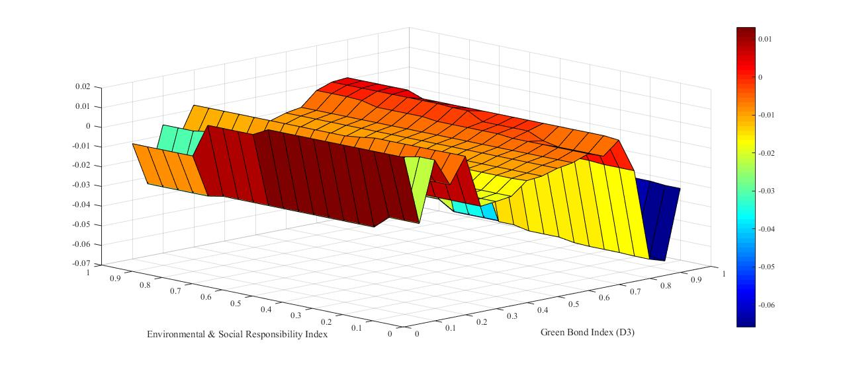
GRBI (D4)  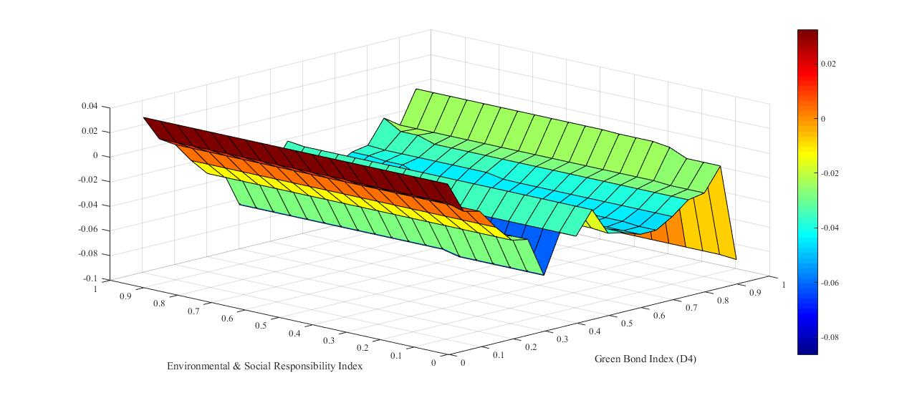 | GRBI (D5)  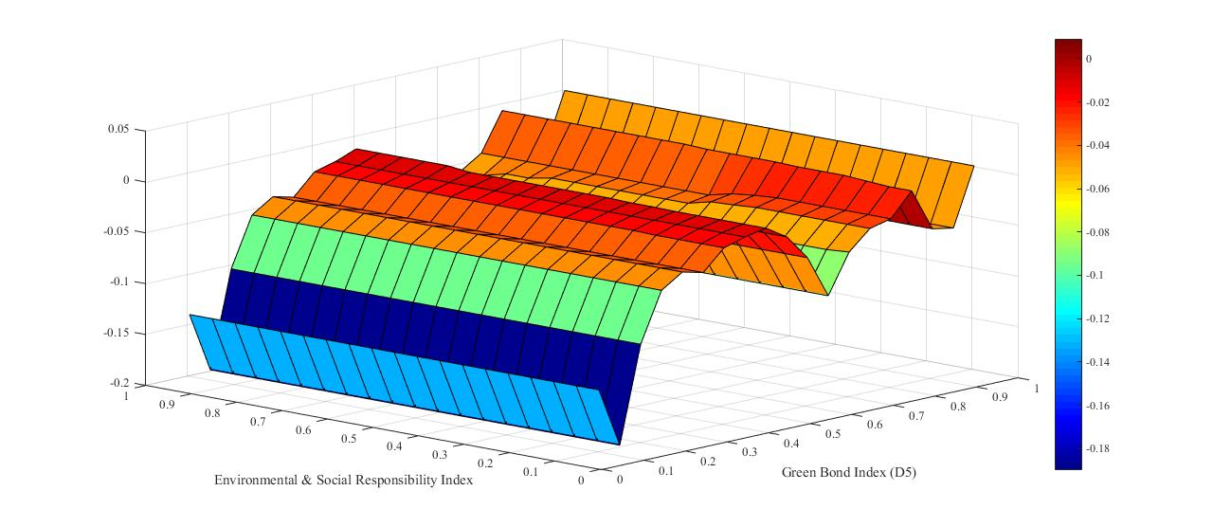
GRBI (D6)  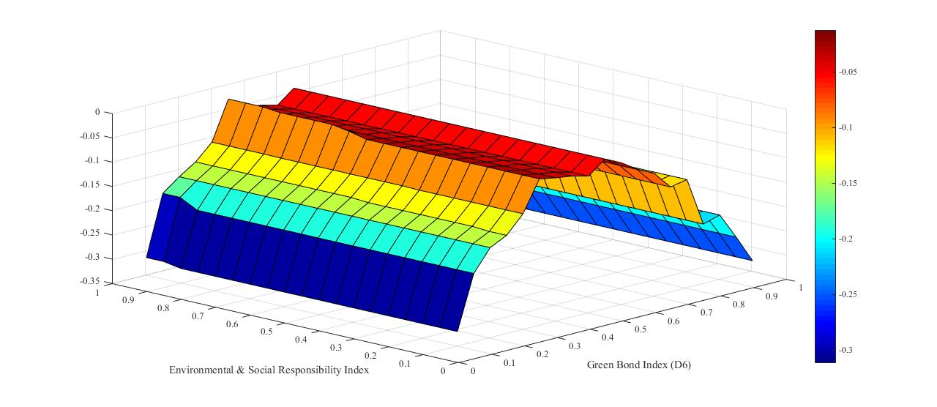 | GRBI (S6)  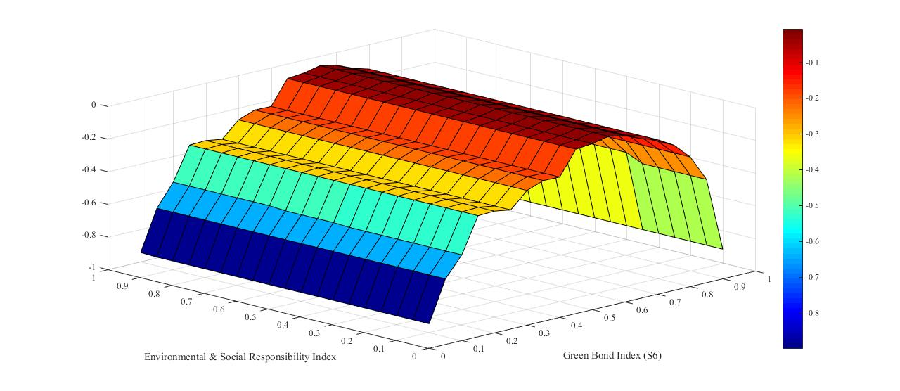
Note: GRBI represents Green bond index, GRBI-Di: 0–4, 4–8, 8–16, 16–32, 32–64, 64–128days; i : 1,2,..6; GRBI.s6: long- term movement.

Figure 3. Comparison between QQR and QR estimates
Impact of Green Bond Index on Environmental & Social Responsibility Index
GRBI | GRBI (D1)
GRBI (D2) | GRBI (D3)
GRBI (D4) | GRBI (D5)
GRBI (D6) | GRBI (S6)
Note: The graph shows the estimates of the slope coefficients against the quantiles of Environmental & Social Responsibility Index in the y-axis and the quantiles of decomposing green bond index (d1, d2, . . . d6 and s6) in the x-axis.

Table 4. Results of Wavelet Based Granger Causality in Quantile approach.
Panel A: ΔGRBI shocks to ΔESRI |  |  |  |  | Panel B: ΔESRI shocks to ΔGRBI
Time Scale | quantiles | Number of lags |  |  | Time Scale | quantiles | Number of lags
 |  | 1 | 2 | 3 |  |  | 1 | 2 | 3
Raw Data | [0.10-0.90] | 0.000*** | 0.000*** | 0.000*** | Raw Data | [0.10-0.90] | 0.568 | 0.340 | 0.249
 | 0.10 | 0.000*** | 0.000*** | 0.000*** |  | 0.10 | 0.947 | 0.469 | 0.597
 | 0.20 | 0.000*** | 0.000*** | 0.000*** |  | 0.20 | 0.381 | 0.587 | 0.536
 | 0.30 | 0.000*** | 0.000*** | 0.000*** |  | 0.30 | 0.667 | 0.637 | 0.263
 | 0.40 | 0.000*** | 0.000*** | 0.000*** |  | 0.40 | 0.669 | 0.169 | 0.520
 | 0.50 | 0.000*** | 0.000*** | 0.000*** |  | 0.50 | 0.234 | 0.235 | 0.535
 | 0.60 | 0.000*** | 0.000*** | 0.000*** |  | 0.60 | 0.746 | 0.855 | 0.731
 | 0.70 | 0.000*** | 0.000*** | 0.000*** |  | 0.70 | 0.359 | 0.648 | 0.757
 | 0.80 | 0.000*** | 0.000*** | 0.000*** |  | 0.80 | 0.193 | 0.841 | 0.336
 | 0.90 | 0.000*** | 0.000*** | 0.000*** |  | 0.90 | 0.026** | 0.036** | 0.004**
D1 | [0.10-0.90] | 0.000*** | 0.000*** | 0.000*** | D1 | [0.10-0.90] | 0.280 | 0.381 | 0.974
 | 0.10 | 0.000*** | 0.000*** | 0.000*** |  | 0.10 | 0.262 | 0.148 | 0.422
 | 0.20 | 0.000*** | 0.000*** | 0.000*** |  | 0.20 | 0.244 | 0.300 | 0.362
 | 0.30 | 0.000*** | 0.000*** | 0.000*** |  | 0.30 | 0.176 | 0.135 | 0.801
 | 0.40 | 0.000*** | 0.000*** | 0.000*** |  | 0.40 | 0.703 | 0.264 | 0.884
 | 0.50 | 0.000*** | 0.000*** | 0.000*** |  | 0.50 | 0.337 | 0.957 | 0.505
 | 0.60 | 0.000*** | 0.000*** | 0.000*** |  | 0.60 | 0.048** | 0.047** | 0.842
 | 0.70 | 0.000*** | 0.000*** | 0.000*** |  | 0.70 | 0.534 | 0.048** | 0.797
 | 0.80 | 0.000*** | 0.000*** | 0.000*** |  | 0.80 | 0.517 | 0.575 | 0.201
 | 0.90 | 0.000*** | 0.000*** | 0.000*** |  | 0.90 | 0.036** | 0.805 | 0.247
D2 | [0.10-0.90] | 0.000*** | 0.000*** | 0.000*** | D2 | [0.10-0.90] | 0.185 | 0.823 | 0.613
 | 0.10 | 0.000*** | 0.000*** | 0.000*** |  | 0.10 | 0.105 | 0.945 | 0.276
 | 0.20 | 0.000*** | 0.000*** | 0.000*** |  | 0.20 | 0.704 | 0.464 | 0.746
 | 0.30 | 0.000*** | 0.000*** | 0.000*** |  | 0.30 | 0.792 | 0.355 | 0.825
 | 0.40 | 0.000*** | 0.000*** | 0.000*** |  | 0.40 | 0.441 | 0.403 | 0.551
 | 0.50 | 0.000*** | 0.000*** | 0.000*** |  | 0.50 | 0.333 | 0.692 | 0.345
 | 0.60 | 0.000*** | 0.000*** | 0.000*** |  | 0.60 | 0.696 | 0.956 | 0.549
 | 0.70 | 0.000*** | 0.000*** | 0.000*** |  | 0.70 | 0.952 | 0.012 | 0.198
 | 0.80 | 0.000*** | 0.000*** | 0.000*** |  | 0.80 | 0.750 | 0.800 | 0.488
 | 0.90 | 0.000*** | 0.000*** | 0.000*** |  | 0.90 | 0.003*** | 0.008*** | 0.009***
D3 | [0.10-0.90] | 0.000*** | 0.000*** | 0.000*** | D3 | [0.10-0.90] | 0.364 | 0.283 | 0.903
 | 0.10 | 0.000*** | 0.000*** | 0.000*** |  | 0.10 | 0.983 | 0.838 | 0.469
 | 0.20 | 0.000*** | 0.000*** | 0.000*** |  | 0.20 | 0.995 | 0.405 | 0.911
 | 0.30 | 0.000*** | 0.000*** | 0.000*** |  | 0.30 | 0.483 | 0.857 | 0.311
 | 0.40 | 0.000*** | 0.000*** | 0.000*** |  | 0.40 | 0.397 | 0.404 | 0.230
 | 0.50 | 0.000*** | 0.000*** | 0.000*** |  | 0.50 | 0.914 | 0.659 | 0.523
 | 0.60 | 0.000*** | 0.000*** | 0.000*** |  | 0.60 | 0.369 | 0.482 | 0.034**
 | 0.70 | 0.000*** | 0.000*** | 0.000*** |  | 0.70 | 0.562 | 0.780 | 0.612
 | 0.80 | 0.000*** | 0.000*** | 0.000*** |  | 0.80 | 0.926 | 0.143 | 0.752
 | 0.90 | 0.000*** | 0.000*** | 0.000*** |  | 0.90 | 0.140 | 0.701 | 0.980
D4 | [0.10-0.90] | 0.000*** | 0.000*** | 0.000*** | D4 | [0.10-0.90] | 0.124 | 0.359 | 0.446
 | 0.10 | 0.000*** | 0.000*** | 0.000*** |  | 0.10 | 0.063* | 0.074* | 0.675
 | 0.20 | 0.000*** | 0.000*** | 0.000*** |  | 0.20 | 0.465 | 0.924 | 0.581
 | 0.30 | 0.000*** | 0.000*** | 0.000*** |  | 0.30 | 0.106 | 0.979 | 0.899
 | 0.40 | 0.000*** | 0.000*** | 0.000*** |  | 0.40 | 0.855 | 0.702 | 0.694
 | 0.50 | 0.000*** | 0.000*** | 0.000*** |  | 0.50 | 0.440 | 0.676 | 0.610
 | 0.60 | 0.000*** | 0.000*** | 0.000*** |  | 0.60 | 0.648 | 0.310 | 0.699
 | 0.70 | 0.000*** | 0.000*** | 0.000*** |  | 0.70 | 0.650 | 0.952 | 0.138
 | 0.80 | 0.000*** | 0.000*** | 0.000*** |  | 0.80 | 0.923 | 0.456 | 0.545
 | 0.90 | 0.000*** | 0.000*** | 0.000*** |  | 0.90 | 0.007*** | 0.004*** | 0.001***
D5 | [0.10-0.90] | 0.000*** | 0.000*** | 0.000*** | D5 | [0.10-0.90] | 0.658 | 0.730 | 0.599
 | 0.10 | 0.000*** | 0.000*** | 0.000*** |  | 0.10 | 0.561 | 0.807 | 0.561
 | 0.20 | 0.000*** | 0.000*** | 0.000*** |  | 0.20 | 0.969 | 0.331 | 0.984
 | 0.30 | 0.000*** | 0.000*** | 0.000*** |  | 0.30 | 0.842 | 0.490 | 0.214
 | 0.40 | 0.000*** | 0.000*** | 0.000*** |  | 0.40 | 0.701 | 0.033** | 0.582
 | 0.50 | 0.000*** | 0.000*** | 0.000*** |  | 0.50 | 0.751 | 0.512 | 0.148
 | 0.60 | 0.000*** | 0.000*** | 0.000*** |  | 0.60 | 0.565 | 0.821 | 0.067*
 | 0.70 | 0.000*** | 0.000*** | 0.000*** |  | 0.70 | 0.009*** | 0.576 | 0.279
 | 0.80 | 0.000*** | 0.000*** | 0.000*** |  | 0.80 | 0.354 | 0.544 | 0.971
 | 0.90 | 0.000*** | 0.000*** | 0.000*** |  | 0.90 | 0.134 | 0.100 | 0.146
D6 | [0.10-0.90] | 0.000*** | 0.000*** | 0.000*** | D6 | [0.10-0.90] | 0.168 | 0.469 | 0.266
 | 0.10 | 0.000*** | 0.000*** | 0.000*** |  | 0.10 | 0.152 | 0.055 | 0.569
 | 0.20 | 0.000*** | 0.000*** | 0.000*** |  | 0.20 | 0.760 | 0.659 | 0.686
 | 0.30 | 0.000*** | 0.000*** | 0.000*** |  | 0.30 | 0.665 | 0.579 | 0.213
 | 0.40 | 0.000*** | 0.000*** | 0.000*** |  | 0.40 | 0.165 | 0.610 | 0.985
 | 0.50 | 0.000*** | 0.000*** | 0.000*** |  | 0.50 | 0.279 | 0.472 | 0.661
 | 0.60 | 0.000*** | 0.000*** | 0.000*** |  | 0.60 | 0.814 | 0.028** | 0.231
 | 0.70 | 0.000*** | 0.000*** | 0.000*** |  | 0.70 | 0.208 | 0.116 | 0.274
 | 0.80 | 0.000*** | 0.000*** | 0.000*** |  | 0.80 | 0.857 | 0.327 | 0.211
 | 0.90 | 0.000*** | 0.000*** | 0.000*** |  | 0.90 | 0.372 | 0.412 | 0.745
S6 | [0.10-0.90] | 0.000*** | 0.000*** | 0.000*** | S6 | [0.10-0.90] | 0.952 | 0.030** | 0.356
 | 0.10 | 0.000*** | 0.000*** | 0.000*** |  | 0.10 | 0.068* | 0.877 | 0.534
 | 0.20 | 0.000*** | 0.000*** | 0.000*** |  | 0.20 | 0.725 | 0.371 | 0.961
 | 0.30 | 0.000*** | 0.000*** | 0.000*** |  | 0.30 | 0.799 | 0.576 | 0.386
 | 0.40 | 0.000*** | 0.000*** | 0.000*** |  | 0.40 | 0.818 | 0.031 | 0.239
 | 0.50 | 0.000*** | 0.000*** | 0.000*** |  | 0.50 | 0.438 | 0.365 | 0.182
 | 0.60 | 0.000*** | 0.000*** | 0.000*** |  | 0.60 | 0.755 | 0.543 | 0.057*
 | 0.70 | 0.000*** | 0.000*** | 0.000*** |  | 0.70 | 0.443 | 0.649 | 0.641
 | 0.80 | 0.000*** | 0.000*** | 0.000*** |  | 0.80 | 0.080* | 0.266 | 0.398
 | 0.90 | 0.000*** | 0.000*** | 0.000*** |  | 0.90 | 0.001*** | 0.004*** | 0.007***
Notes: **, *** represents the significant level of null hypothesis rejected at 5% or 1%. D1-D6 represents the time horizons with timescales of 0-4, 4-8, 8-16, 16-32, 32-64 and 64-128 days, respectively.

Appendix 1: Summary of the literature
Author | Geography | Period | Method | Outcome
Clapp et.al. (2015) | Global Market |  | Opinion based survey | Management aligning their policies with the climate risk attribute to greater confidence in green bond.
Wang and Zhi (2016) | NA | NA | Review study | Green finance can restore ecological balance
Ng (2018) | Hong Kong | NA | Multiple-case study | Institutional legitimacy for sustainability influenced by a national policy and enhanced through a market-based finance approach
Nguyen et al. (2018) | Vietnam | NA | Review study | Green bond reduces the dependence on imported coal for energy needs
Reboredo (2018) | Global data | 2014-2017 | Copula | Substantial spill over effect from corporate and treasury fixed-income market on green bond prices. Negligible effect of equity and energy markets on green bond prices.
Shahbaz et al. (2018) | France | 1955-2016 | Bootstrapping Bounds Testing Approach | Positive impact of FDI and negative impact of energy research innovations on carbon emissions.
Urban et al. (2018) | Vietnam | NA | Review study | Green financing is an enabler of green transformation
Agliardi and Agliardi (2019) | NA | NA | Review study | Shareholders’ awareness and pro-environment tax benefit enhance the price of green bond.
Banga (2019) | NA | NA | Review study | Green bond is a potential source of climate finance for developing countries
Braouezec and Joliet (2019) | Germany | NA | Real Option Framework | Addition of CSR dimension to projects with negative environment externalities induces immediate firm investment in CSR activities.
Gianfret and Peri (2019) | Europe | 2013-2017 | Propensity Score Matching Approach | Green Bonds are more financially convenient than their non-green contemporaries.
Nasir et.al. (2019) | ASEAN Countries | 1982-2014 | FMOLS and DOLS approach | Economic growth, FDI and financial development leads to environmental degradation.
Zerbib (2019) | Global data | 2013-2017 | Matching Method and two step regression procedure | Low impact of investor’s pro-environmental preference on green bond prices.
Zhou and Cui (2019) | China | 2016-2019 | Event Study Approach | Issuance of green bonds positively influence companies’ financial performance and CSR activities.
Buhari et al. (2020) | Europe | 1995-2014 | Panel Quantile Regression | Renewable energy consumption is more effective on economic growth as compared to the non-renewable energies.
Flammer (2020) | The USA | 2007-2018 | Event Based Study | Observed strong linkage between companies’ financial and environmental performance and the issuance of green bond.
Huynh et al. (2020) | The USA | 2017-2020 | Copulas and Generalised Forecast Error Variance Decomposition | Observed potential safe haven properties of green bond assets.
Karyawati et al. (2020) | Indonesia | 1998-2017 | Meta-analysis integrating 55 different contexts with correlation coefficients as the effect size | Various dimensions like country characteristics, forms of CSR, CSR and financial performance measurements define complex nature of relationship between CSR practices and financial performance.
Kovilage (2020) | Sri Lanka | NA | Interpretive Structural Modelling Technique | Observed strong effect of lean practices on green practices which in turn significantly influence sustainable performance measures.
Pham et al. (2020) | Europe | 1990-2014 | Panel VAR and FMOLS | Observed role of economic factors in enhancing environmental degradation. The sociological factors like population growth and urbanisation have negative effect in short run and positive effect in the long run. The renewable energy factors are instrumental in reducing carbon emission levels.
Pham L and Huynh T.L.D (2020) | Global Data | 2014-2019 | Diebold-Yilmaz Connectedness framework and Generalised Forecasting Error Variance Decomposition | Time varying feedback between green bond performance and investor attention.
Shahbaz et.al. (2020a) | United Kingdom | 1870-2017 | Bootstrapping ARDL Approach | Financial development and energy consumption enhance but R&D expenditures helps in reducing carbon emissions.
Shahbaz et.al. (2020b) | USA | 1976-2016 | ARDL Bounds Testing Approach | Negative linkage between oil price and energy consumption as well as carbon emission. Further abundance of energy resources and economic growth leads to rise in energy consumption and carbon emission.
Nasir et.al. (2021) | Australia | 1980-2014 | Cointegration and Causality Tests. | Observed long run positive impact of financial development, energy consumption and trade openness on carbon emissions. Further observed short run bidirectional causality between economic growth, energy consumption, industrialization and stock market development with carbon emissions.
Nguyen et.al. (2021) | G-6 Countries | 1978-2014 |  | Carbon emissions are mainly driven by economic growth, expansion of capital market and trade openness. Stock market capitalisation and FDI has weak yet negative effect on carbon emissions.

