Advantages of a curved image plate for rapid laboratory-based X-ray total scattering measurements: application to pair distribution function analysis.

Daniel J. M. Irving,¹ David A. Keen² & Mark E. Light^{1*}
AFFILIATIONS
¹ School of Chemistry, University of Southampton, Southampton, SO17 1BJ, UK
²ISIS Neutron and Muon Source, Science and Technology Facilities Council, Rutherford Appleton Laboratory, Harwell Campus, Didcot, Oxon, OX11 0QX, UK

* Author to whom correspondence should be addressed: M.E.Light@soton.ac.uk

ABSTRACT
The analysis and interpretation of the pair distribution function (PDF), as derived from total scattering measurements is still seen by many as a technique confined to central synchrotron and neutron facilities. This situation has begun to change with a rising visibility of total scattering experiments reported in mainstream scientific journals, and the modification of an increasing number of laboratory diffractometers. However, the rigour required during data reduction and the complexities of data interpretation mean the technique is still very far from being routine. Herein we report the first application of a large area curved image plate system based on a Rigaku SPIDER (R-AXIS RAPID II) equipped with an Ag tube for collecting data amenable to high quality PDF refinement/modelling of crystalline, amorphous and liquid samples. The advantages of such a system are the large Q range available without scanning (routinely in excess of 20 Å⁻¹) and the inherent properties of an image plate detector (single photon sensitivity, large dynamic range [1.05 x 10⁶] and effectively zero noise). Data are collected and structural models refined for a number of standard materials including NIST 640f silicon for which a R_{wp} ≤ 0.12 value was obtained with data collected in 60 minutes (excluding background measurements). These and other data are discussed and compared to similar examples in the literature.

I. INTRODUCTION
Interpretation of the pair distribution function or PDF is an approach for interrogating the structure of crystalline and amorphous materials including, but not limited to, Li-ion battery electrodes,¹ hydrogen storage materials² and catalysts.³ It utilises the Fourier transform of the total scattering structure factor, S(Q) that is accessible through a simple scattering experiment and, in its most powerful form, compares this to the same function calculated from a refined model. Unlike traditional crystallography, there is no requirement for long-range order and this opens up myriad applications, introductions to which can be found in the very readable review articles of Billinge & Kanatzidis⁴ and Mancini & Malavasi.⁵
Over the last 10-15 years renewed interest⁶ has been given to collecting total scattering data for PDF analysis using laboratory-based instruments, and most manufactures now openly market instrumentation configured for such measurements. In-fact, it is reasonably simple to adapt any diffractometer for collecting PDF quality data as long as the requirements for accessing high Q data can be achieved through a combination of wavelength, instrument geometry and appropriate counting times. Instruments originally designed for either powder or single crystal diffraction can be adapted in this way and examples in the literature include a PANalytical X’Pert Pro^{7,8} & PANalytical Empyrean⁹, Bruker D8 Advance¹⁰ and most recently a STOE STADI P diffractometer.¹¹ The quality of the data is most noticeable in the signal/noise ratio (counting statistics) and this is most strongly affected by the type of detector and required scans times. Most laboratory-based equipment based on a powder diffractometer will have some form of 1D detector that speeds up the collection time compared to point counters but collecting high quality data is still a time-consuming business. A recent paper by Thomae et al. describes an instrument which combines 4 such 1D detectors and a novel scanning mode that reduces the time to around 6 hours.¹¹
Herein we describe the first use of a single, large area, curved image plate system based on a Rigaku Spider (currently marketed as RAPID II) single crystal diffractometer fitted with an Ag tube and graphite monochromator. Eliminating the need to scan the detector reduces the typical counting time to about 1-2 hours. This gain in efficiency throughout the data collection process (sample, empty holder, empty instrument) enables routine data collection of several samples per day, while giving data quality congruent with full model fitting and refinement.

II. THEORY
Although extended treatments of total scattering and PDF theory are available in the literature, for example Underneath the Bragg Peaks by Egami & Billinge¹², it is pertinent here to include a brief overview so the reader can understand the importance of rigorous data collection and processing strategies. The X-ray PDF is obtained by the Fourier transform of the total scattering X-ray structure factor, S(Q), where Q is as large as possible. The exact value is dependent on the instrument geometry and most significantly the wavelength, but typically ranges from Q_{min} = 0.2 Å⁻¹ to Q_{max} = 20-40 Å⁻¹ (including laboratory and synchrotron sources). For a high-quality PDF, the maximum range should be used, and one form of the function is given below:
$$D\left(r\right)= \left(\frac{2}{π}\right)\int_{Q_{min}}^{Q_{max}}{Q[S\left(Q\right)-1]\sin\left(Qr\right)dQ} (1)$$
where S(Q) is the total scattering structure factor obtained from the total scattering I(Q) after normalization for the scattering cross section of each of the contributing atoms and corrections including background scattering, Compton and multiple scattering, absorption and geometrical considerations. It should be noted that the literature contains various definitions and symbols to describe alternative correlation functions and these are well explained by Keen.⁹
To obtain the most accurate PDF, careful correction of data must be implemented. This requires collection of the sample itself, the empty container (capillary) and the empty diffractometer to enable subtraction of all scattering not coming from the sample. This subtraction and corrections for other factors, such as Compton scattering mentioned above, above can be implemented in a number of freely available software packages such as GudrunX.¹⁴
III. INSTRUMENTAL REQUIREMENTS
As previously discussed, PDF experiments are subject to specific data requirements which are rarely met by laboratory-based diffractometers in standard configurations. The main limitation is the restricted Q_{max} value that can be accessed which needs to be as large as possible to enable a usable Fourier transform of the total scattering. An instrument fitted with a molybdenum tube will have a theoretical Q_{max} of 17.68 Å⁻¹ (for sinθ = 1), which enables generation of qualitative PDFs for some systems, but is still sub optimal. The most suitable tube commonly available is silver which gives a potential Q_{max} of 22.4 Å⁻¹ (for sinθ = 1). The actual value obtainable depends on physical limitations of the diffractometer geometry and scattering power of the sample.
Another major consideration is the detector; the accessible 2θ range will, in combination with the wavelength, dictate the Q_{max} and considerations regarding the intrinsic noise and sensitivity will impact the acquisition time. The reduced flux of the shorter wavelength (silver radiation typically being approximately a third of the intensity of copper) is also a major factor to contend with. Therefore, a detector that is sensitive to lower intensity, has a high efficiency at higher energy and exhibits a low noise level during measurements is crucial to a laboratory-based total scattering instrument.
IV. IN-HOUSE INSTRUMENTATION
The laboratory-based diffractometer described herein is a modified Rigaku Spider/Rapid II utilising a point focus sealed silver tube (40 kV, 35 mA) in transmission geometry (Debye-Scherrer geometry). The beam is monochromated using a flat graphite (200) crystal allowing Kα radiation to pass, but suppressing K_{β} giving a wavelength of λ = 0.560886 Å. The sample position is fixed at 127.4 mm from the detector, with the beam stop placed 13 mm behind the sample.
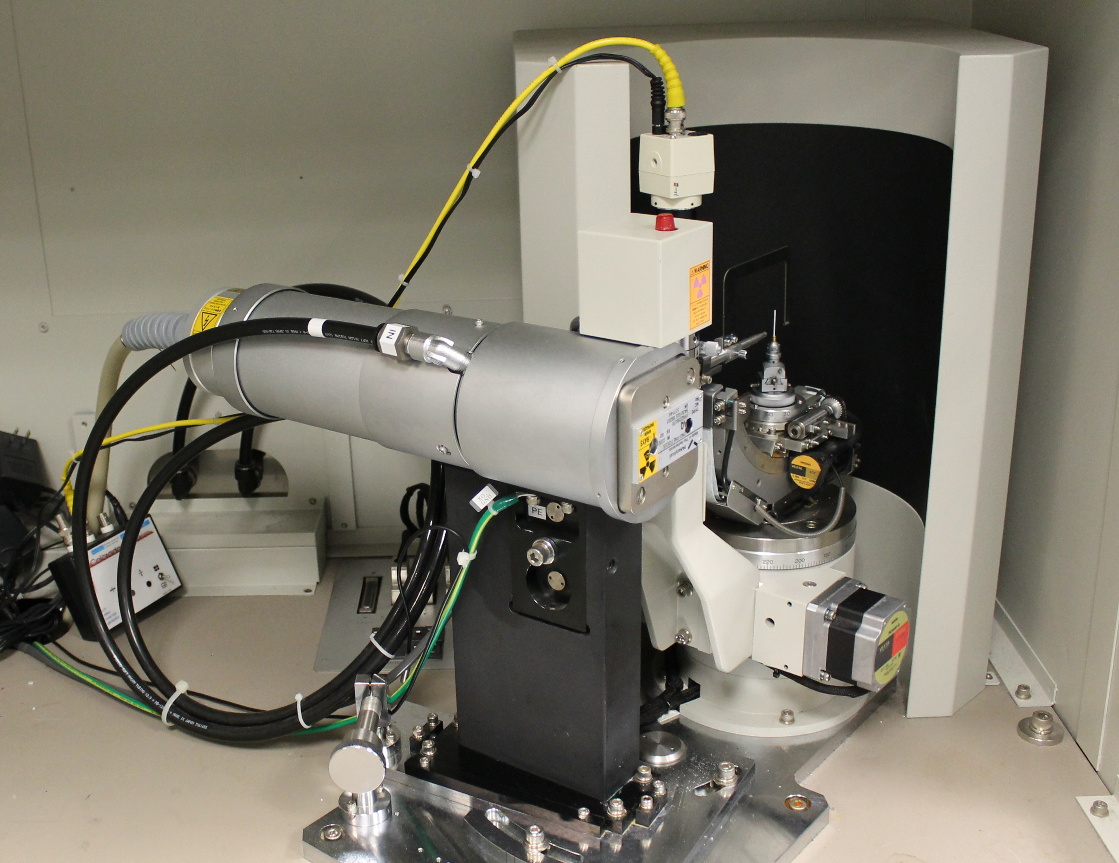
Figure 1. Rigaku SPIDER (RAPID II) with sealed Ag tube, graphite monochromator, pin-hole collimator ¼ χ goniometer and curved image plate.
The beam width is set by the double pin-hole collimator and, where possible, matched to the inner capillary diameter; the distance from the end of the collimator to the sample is kept short (10 mm) to reduce air scatter between collimator and sample. The detector is a unique Fujifilm image plate with a 2θ range -60° to 144°, totalling in a full usable area of 2θ = 204° (asymmetrically spanning 2θ = 0°). The sample is mounted on a Eulerian 3-axis goniometer, with the sample set to oscillate in φ 0-85° (continuous rotation is not supported by the control software). Exposure times are sample specific but range from 30 minutes to 6 hours. Samples are mounted in borosilicate glass capillaries ranging from 0.5-2.0 mm in diameter depending on the scattering power of the sample.
V. DATA REDUCTION
The 2D images are integrated to a 1D profile using Rigaku’s 2DP software.¹⁵ The maximum available Q_{max} for sinθ = 1 is 22.4 Å⁻¹ but a value of 20.68 Å⁻¹ is routinely used to allow full capture of the available range in χ (also denoted β) and provides a compromise between absolute Q and counting statistics. Thus, the area integrated typically spans 3.0 – 134.8° in 2θ and 135.0 – 225.0° in χ as shown in figure 2. Note, the size of the detector allows for capture of higher 2θ angles (204.0°) but the direct beam is centred to allow ca. 75° 2θ to be captured on the negative side - as required by the original single crystal use. For this application it is unfortunate that the detector is fixed and cannot be moved to make more efficient use of its large area. The integration of the 2D area described above into a 1D profile is somewhat simplified by the curved nature (in one direction) of the image plate, and the removal of the need to stitch overlapping images together. To avoid any scaling issues only the positive 2θ side of the detector is used in conjunction with a constant χ range, this has the disadvantage of wasting a significant amount of detector real estate. Standard Lorentz and polarisation corrections are applied, the latter required due to use of a monochromator.

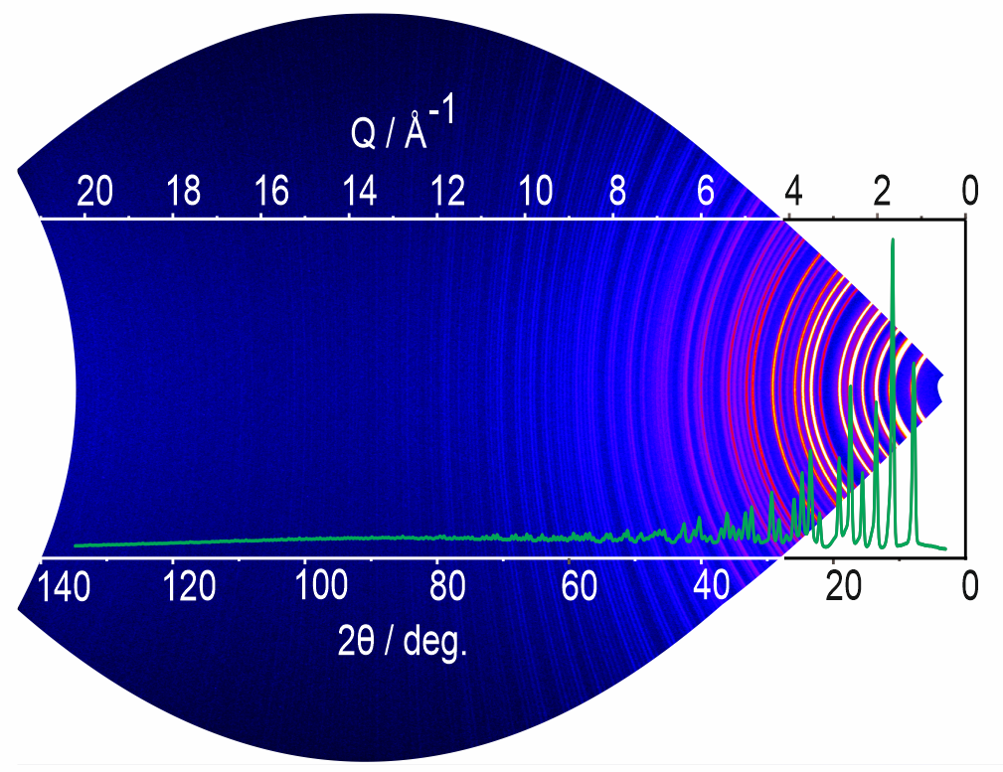
Figure 2. Integrated area of the image plate for a sample of LaB₆, showing the constant χ range and extent in 2θ. overlaid is the 1D profile corrected for Lorentz and polarisation effects. Q scale is approximate and both scales refer to χ = 0°.
Further data reduction and Fourier transform of the 1D profile are performed using GudrunX¹⁴ with appropriate instrument specific parameters such as beam profile and goniometer geometry (see table S1 in supporting data). The use of a monochromator greatly reduces, and thus simplifies, the corrections for Bremsstrahlung and K_{β} contamination. The instrument beam profile is such that K_{α1} and K_{α2} splitting can be observed only for cases of highly crystalline materials. GudrunX takes the intensity weighted average K_{α} wavelength which results in an accurate Fourier transform to the PDF and subsequent model refinement. During this step the data are corrected for absorption, multiple scattering and non-sample scattering using measurements of the empty instrument (background) and empty capillary (container), see figure S3 for the individual contributions. The calculated Compton scattering is also subtracted, and the data are scaled to optimally follow the total scattering cross-section of the sample. During the Fourier transform the Lorch function (which helps smooth termination ripples¹⁶) is set at 0.1 for crystalline materials and between 0.15 and 0.2 for amorphous and liquid samples. The data are output in a number of forms including the normalised total scattering structure factor S(Q), the reduced total scattering factor F(Q) and the pair distribution function D(r).
The experimental pair distribution functions for all standard samples are refined against a model using a small-box approach in TOPAS v6 academic¹⁷. The instrument specific parameters used in TOPAS refinements are dQ (peak width), Lor (the Lorentzian contribution to the pseudo Voigt Peak shape) and α (the convolution term). Ideal values for these were obtained by a TOPAS Rietveld refinement of the silicon diffraction data with these parameters being extracted from the fitted peak shapes. For the PDF fits presented here the following values were used dQ = 0.07219, Lor = 0.40958 and α = 0.01175. The full Rietveld fit for silicon can be found in the figure S1 of the supporting data.

VI. EXPERIMENTAL RESULTS
A. Standard Materials
To test the ability of the modified instrument setup and evaluate the implementation of data processing procedures a number of standard materials were chosen for measurement. These were lanthanum hexaboride (Sigma-Aldrich), silicon 604f (NIST), 5nm anatase from Get-Nano-Materials and amorphous silica (Alfa Aesar). In addition, water was chosen as a more challenging sample with direct relevance to ongoing studies of aqueous metal salts.
First we discuss LaB₆ which has an extremely strong X-ray scattering profile and is often used as an X-ray line profile standard. In the context of total scattering it was desirable to have a material that scattered strongly to high angles to test the full angular range of the image plate and to evaluate the integration parameters used for extracting the required line profile from the 2D image to high Q values. The resulting PDF refinement is presented in figure 3 and clearly shows a well fitting model providing confidence in the parameters used to extract the PDF from the total scattering data.
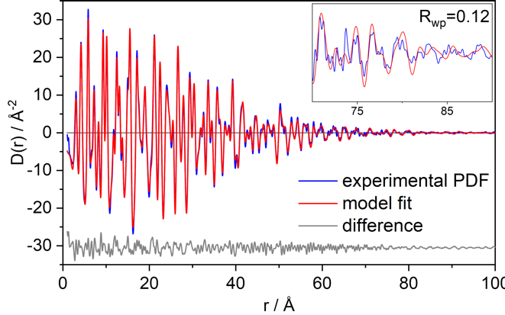
Figure 3. PDF refinement data for LaB₆ showing the experimental (blue), fit (red) and difference (grey - offset). Sample collection time of 120 minutes plus identical exposures for empty capillary and empty diffractometer.
Whilst a strong scatterer highlights the performance of the instrument it is not suitable for rigorously evaluating the data reduction strategy as the coherent scattering dominates the incoherent scattering and the quality of the extracted PDF is less sensitive to the adequacy of the various corrections. To address this silicon was chosen as a sample with a lower scattering power and being more representative of real materials. It is also the most commonly supplied standard with new diffractometers and has potential as a useful comparison between different labs. The data and refinement results are presented in Figure 4 and show excellent data quality and goodness of fit (Rwp = 0.12) out to values of r = 80 Å, where, as seen in the inset, there is no longer information observable in the experimental PDF.
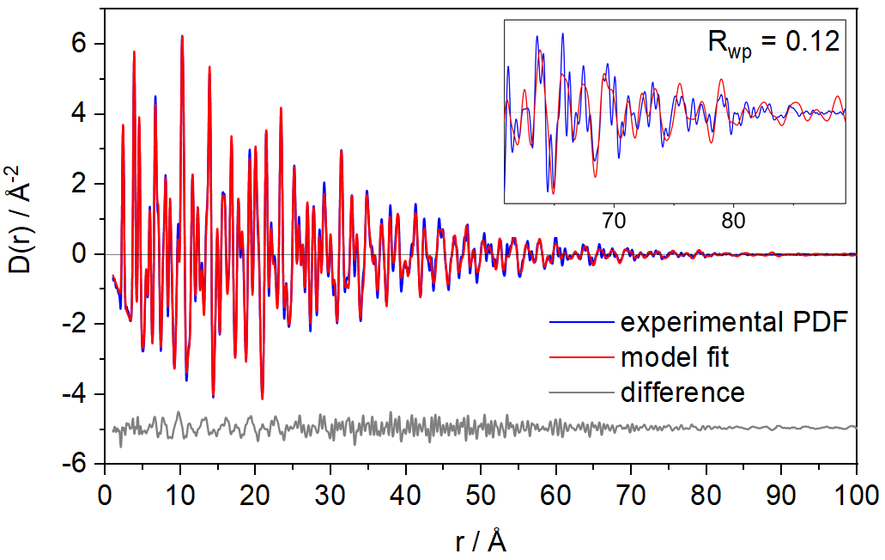
Figure 4. PDF refinement data for Si NIST standard 640f showing the experimental (blue), fit (red) and difference (grey - offset). The inset shows that the fit is still reasonable out to about 80 Å. Sample collection time of 120 minutes plus identical exposures for empty capillary and empty diffractometer.
This drop off of signal above 80 Å is indicative of some fundamental characteristics of the instrument as it is the Q-resolution (broadness of the Bragg peaks) and not the r-space resolution (size of Q_{max}) that causes this broadening. This is because broad Bragg peaks are linked to a drop off in intensity at higher-r as can be seen in the data for LaB₆ (figure 3) and contrasted with that of Thomae et al. (their figure 2) where the higher resolution instrument (curved Ge(111) monochromator focusing the beam on the detector) produces less of a Q dependent intensity drop off. ¹¹ To aid comparison of the Q resolution of our instrument to others in the literature a PDFgui refinement of LaB₆ was performed providing values for q_{damp} of 0.036 and q_{broad} of 0.011 (see figure S2 in the supporting data for full refinement details) compared to 0.011 and 0.010 reported by Thomae et al.¹¹ These numbers are as expected and reflect the differences in Q resolution of these 2 instruments.
Nanomaterials are currently of great interest in numerous fields^{18–20} and are ideally suited to analysis via the PDF approach^{21,22}. As a further standard material TiO₂ (anatase) nanoparticles were chosen as this would allow data quality comparison with other lab-based systems¹¹. The measurement and refined fit are presented in Figure 5 and show excellent data quality (Rwp = 0.11). The loss of long-range order is clearly visible in the experimental PDF (inset figure 5) and can be interpreted with some assumptions, such as a monodispersive sample, as the size of the nanoparticles. Refined in TOPAS as the spherical damp value, this gives a size of ca. 46 Å (4.6 nm) which is in good agreement with that quoted by the supplier (5.0 nm) and also with that obtained from interpretation of the Bragg peak width using the Scherrer equation of 56(3) Å (LaB₆ and Si gave near identical values of 72.1(5) and 72.6(16) Å respectively and were used to correct the TiO₂ value for instrument broadening).²³ Although the TiO₂ nanoparticle data presented by Thomae et al. are not comparable, they are different samples and the refinement and data reduction strategies are different, it nonetheless provides a significantly lower Rwp.¹¹ It should be noted that the resolution of the instrument needs to be ruled out as the cause of the observed signal drop-off.
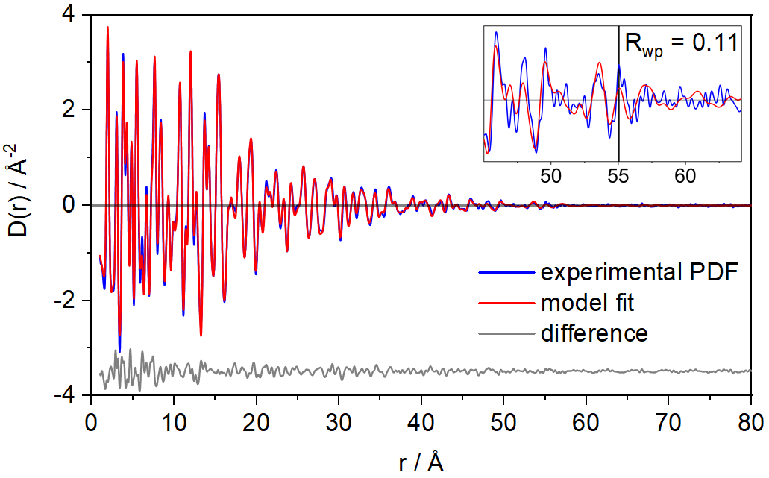
Figure 5. PDF refinement data for TiO₂ nanoparticles showing the experimental (blue), fit (red) and difference (grey - offset). The inset shows the region where the experimental PDF contains no structural information – which corresponds to a nanoparticle size of roughly 5.0 nm. Sample collection time of 120 minutes plus identical exposures for empty capillary and empty diffractometer.
The application of total scattering to the study of dissolved species in liquid media is of particular interest to us, and herein we present the data for water – a common solvent and a useful standard material for these more challenging systems. There is much written on the structure of water and much associated debate²⁴ - we do not intend to add to this, but merely show that data of refinable quality can be collected in the laboratory. Figure 6 shows the reduced total scattering factor for water collected for 180 minutes and the corresponding EPSR refinement.²⁵ Considering the short exposure time this data compares favourably with other studies in the literature, for example those contained in the review by Soper (figure 10b).²⁶
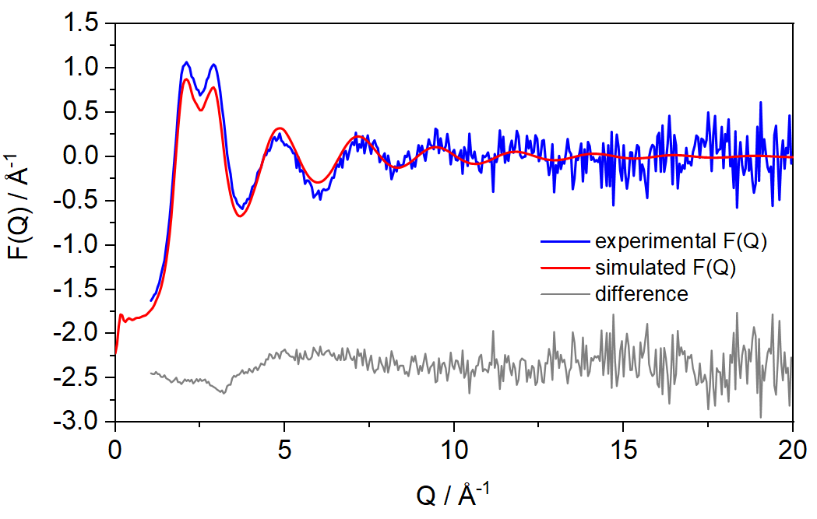
Figure 6. Total scattering structure factor F(Q) for water (blue), the corresponding EPSR fit (red) and difference (grey - offset). This can be favourably compared with data compiled in figure 10b of Soper’s paper.²⁶ Sample collection time of 180 minutes plus identical exposures for empty capillary and empty diffractometer.
B. Counting statistics
While we do not intend to provide a rigorous statistical analysis, the following basic observations can be made. Once capillary size has been chosen, the main data collection variable is the scan or image exposure time. To evaluate the effect this has on the processed data, amorphous silica was chosen as a weakly scattering material in which noise was likely to dominate the scattering at high Q. This is most clearly seen in the total scattering structure factor S(Q) plots and a series of measurements with increasing exposure times are shown in figure 7. The propagation of noise into the final PDF can be seen in figure 8 as high frequency ripples at longer r, for the shorter data collection times. A perceptible improvement in the form of the very low r region can also be seen, although this is somewhat dependent on various parameters adjusted during the data reduction as well as the value of Q_{max} chosen.
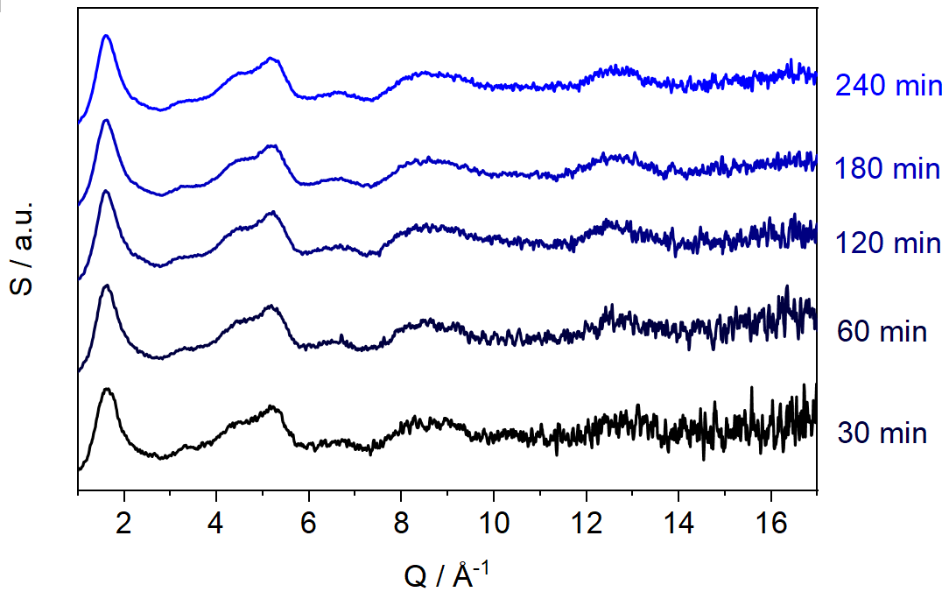
Figure 7. Stacked total structure factor, S(Q), plots for amorphous silica collected with increasing image exposure times. There is a clear advantage in this case for collecting for 180 minutes, but longer exposure times do not show significant further improvement.

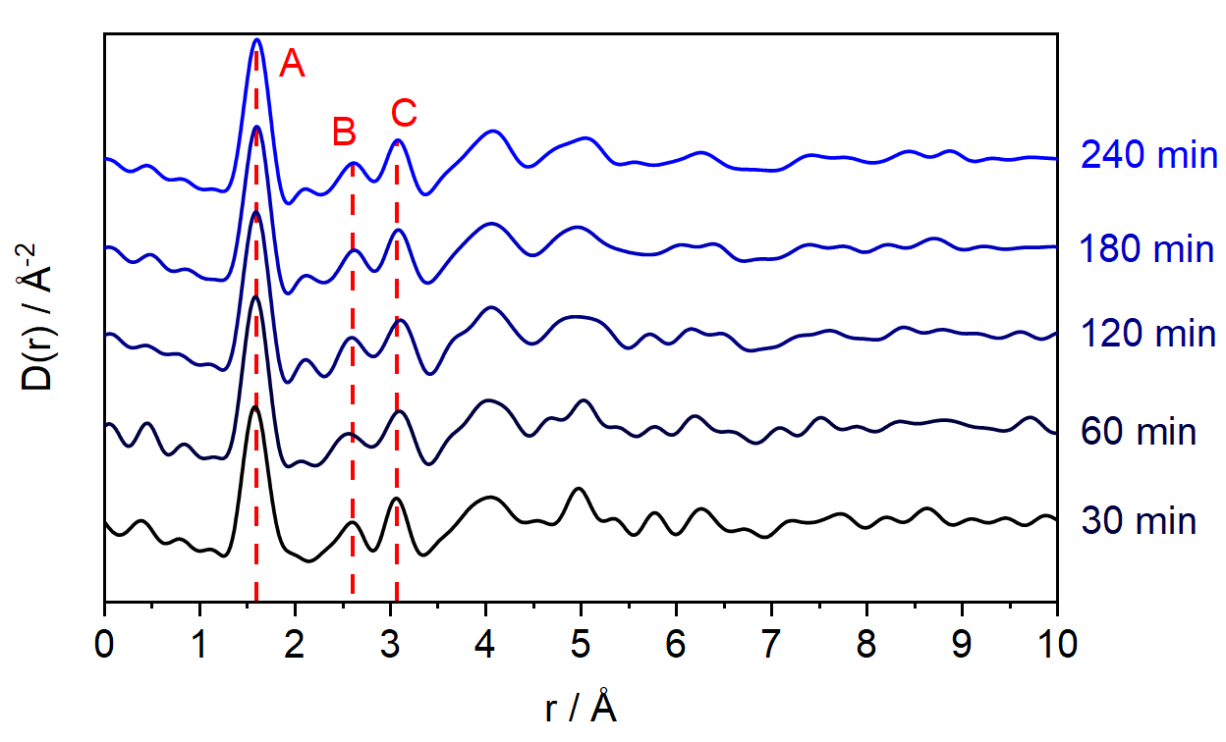
Figure 8. Stacked D(r) plots of amorphous silica generated from the data in Figure 7. These clearly show the noise propagation through to the PDF from the short exposure images and cleaner PDFs at longer exposure times. Due to the amorphous nature of the sample, peaks in the PDF are not apparent beyond 10 Å. Selected peak assignments: A [1.6 Å] Si-O bonds, B [2.6 Å] first shell O…O distances (edges of SiO₄ tetrahedra) and C [3.1 Å] first shell Si…Si distances (centre-to-centre of corner sharing tetrahedra).
VII. CONCLUSIONS
In this work we have reported the successful modification of an image plate based single crystal diffractometer to collect high quality total scattering data. Through the full PDF refinement of a number of standard materials we have demonstrated the high quality of this data and the suitability of the data reduction protocols.
Although the required switch to shorter wavelength radiation reduces the intensity of the incident beam significantly (scales approximately as λ³) the large image plate detector (high quantum efficiency at hard X-ray energies²⁷) is the ideal solution for providing an excellent signal/noise ratio in comparatively short exposure times.
While the instrument and procedures described in this article produce excellent quality total scattering data, an enhancement can be imagined employing an Ag rotating anode generator and a narrow band monochromator such as Ge(111) with the same image-plate detector and shifted beam centre, which would give a high Q resolution instrument with excellent counting statistics, and large Q_{max}.
In conclusion we have demonstrated that a large curved image-plate, with virtually zero background response, is ideal for collecting total scattering data from samples including all but the most crystalline powders, amorphous materials and liquids and whose scattering is dominated by the weak diffuse component.

SUPPLEMENTARY MATERIAL
See supporting data for additional material including ﬁgures and tables.
ACKNOWLEDGMENTS
DJMI acknowledges the EPSRC for DTP funding (EP/R513325/1).
DATA AVAILABILITY
Data supporting this study are openly available from the University of Southampton repository at https://doi.org/10.5258/SOTON/D1676.
REFERENCES
1 Y. Idemoto, M. Inoue and N. Kitamura, Journal of Power Sources, 2014, 259, 195–202.
2 H. Kim, K. Sakaki, H. Ogawa, Y. Nakamura, J. Nakamura, E. Akiba, A. Machida, T. Watanuki and T. Proffen, J. Phys. Chem. C, 2013, 117, 26543–26550.
3 B. N. Wanjala, B. Fang, S. Shan, V. Petkov, P. Zhu, R. Loukrakpam, Y. Chen, J. Luo, J. Yin, L. Yang, M. Shao and C.-J. Zhong, Chem. Mater., 2012, 24, 4283–4293.
4 S. J. L. Billinge and M. G. Kanatzidis, Chem. Commun., 2004, 749–760.
5 A. Mancini and L. Malavasi, Chem. Commun., 2015, 51, 16592–16604.
6 D. A. Keen, Crystallography Reviews, 2020, 26, 141–199.
7 J. te Nijenhuis, M. Gateshki and M. J. Fransen, Z. Kristallogr. Suppl., 2009, 30, 163–169.
8 T. D. Bennett, A. L. Goodwin, M. T. Dove, D. A. Keen, M. G. Tucker, E. R. Barney, A. K. Soper, E. G. Bithell, J.-C. Tan and A. K. Cheetham, Phys. Rev. Lett., 2010, 104, 115503.
9 G. Confalonieri, M. Dapiaggi, M. Sommariva, M. Gateshki, A. N. Fitch and A. Bernasconi, Powder Diffraction, 2015, 30, S65–S69.
10 2006.
11 S. L. J. Thomae, N. Prinz, T. Hartmann, M. Teck, S. Correll and M. Zobel, Review of Scientific Instruments, 2019, 90, 043905.
12 Takeshi Egami and Simon Billinge, Underneath the Bragg Peaks, Structural Analysis of Complex Materials, Pergamon, 2nd edn., 2012, vol. 16.
13 D. A. Keen, J Appl Cryst, 2001, 34, 172–177.
14 A. K. Soper and E. R. Barney, J Appl Cryst, 2011, 44, 714–726.
15 2DP, Rigaku Corperation, 2012.
16 A. K. Soper and E. R. Barney, J Appl Cryst, 2012, 45, 1314–1317.
17 A. A. Coelho, J Appl Cryst, 2018, 51, 210–218.
18 J. Jeevanandam, A. Barhoum, Y. S. Chan, A. Dufresne and M. K. Danquah, Beilstein J. Nanotechnol., 2018, 9, 1050–1074.
19 L. A. Kolahalam, I. V. Kasi Viswanath, B. S. Diwakar, B. Govindh, V. Reddy and Y. L. N. Murthy, Materials Today: Proceedings, 2019, 18, 2182–2190.
20 M. Shafiq, S. Anjum, C. Hano, I. Anjum and B. H. Abbasi, Foods, , DOI:10.3390/foods9020148.
21 A. S. Masadeh, Journal of Experimental Nanoscience, 2016, 11, 951–974.
22 M. Sommariva, M. Gateshki, J.-A. Gertenbach, J. Bolze, U. König, B. Ş. Vasile and V.-A. Surdu, Powder Diffraction, 2014, 29, S47–S53.
23 A. L. Patterson, Phys. Rev., 1939, 56, 978–982.
24 A. K. Soper, J. Phys. Chem. B, 2011, 115, 14014–14022.
25 A. K. Soper, Molecular Simulation, 2012, 38, 1171–1185.
26 A. K. Soper, ISRN Physical Chemistry, 2013, 2013, 67.
27 D. J. Cookson, J Synchrotron Rad, 1998, 5, 1375–1382.

We use the historical definition of structure factors for S(Q) and F(Q) for consistency with historical work in the field of amorphous scattering¹³.

