Hydrogen-rich syngas production from biomass in a steam microwave-induced plasma gasification reactor
Simon Vectenª, Michael Wilkinson^{b}, Nuno Bimbo^{a,1}, Richard Dawson^{a, 2}, Ben M.J. Herbert^{b,}*
ªEngineering Department, Lancaster University, LA1 4YW, United-Kingdom
^{b}Stopford Projects Ltd, The Gordon Manley Building, Lancaster University, LA1 4YQ, United-Kingdom
¹Present address: School of Chemistry, University of Southampton, SO17 1BJ, United Kingdom
²Present address: LiNa Energy, White Cross Industrial Estate, Unit 1 Sharpes Mill, South Rd, Lancaster, LA1 4XQ, United-Kingdom
* Corresponding author, Email address: ben.herbert@stopford.co.uk (B.M.J Herbert)

List of Authors and email address:
- Simon Vecten, s.vecten@lancaster.ac.uk
- Michael Wilkinson, michael.wilkinson@stopford.co.uk
- Nuno Bimbo, n.bimbo@soton.ac.uk
- Richard Dawson, rdawson@lina.energy
- Ben Herbert, ben.herbert@stopford.co.uk

Abstract
Substitution of fossil fuels by sustainable practices must be rapidly implemented to mitigate the impacts of climate change. The conversion of biomass into combustible gas is investigated in a microwave-induced plasma reactor using pure steam as the plasma working gas for the first time. The optimum results are achieved at the highest forward microwave power of 6 kW with biomass carbon conversion efficiency over 98% and complete biomass energy recovery in syngas. Unreacted steam is simply condensed out, leading to the production of a syngas with low inert dilution and high calorific value in the range 10.5-12 MJ/Nm³. The syngas produced is rich in hydrogen, exceeding 60% by volume. The proposed process could aid in the transition to a carbon neutral economy as it has the potential to efficiently convert biomass to syngas that can be used for the sustainable generation of fuels, chemicals and energy.

Keywords: Biomass – Gasification – Microwaves – Plasma - Hydrogen

Introduction
The Intergovernmental Panel on Climate Change (IPCC) demonstrated in its 5th assessment report that “continued emission of greenhouse gases will cause further warming and long-lasting changes in all components of the climate system, increasing the likelihood of severe, pervasive and irreversible impacts for people and ecosystems” (IPCC, 2014). It is therefore recognised that there is an urgent need to reduce greenhouse gas emissions. The IPCC estimated that a reduction of 25% of CO₂ emissions from 2010 levels by 2030 and reaching net zero by 2070 is required to meet the Paris Agreement target in order to limit global temperature rise to <2°C above pre-industrial levels (IPCC, 2018). Achieving this target will require major modifications in society, especially in the energy sector, as more than 80% of the total primary energy consumption in 2018 was provided by fossil fuels, being the main source of greenhouse gas emissions (BP, 2019). The development of sustainable energy sources, such as the use of biomass, is thus needed to substitute fossil fuel utilisation. Whereas the sustainability of first-generation biomass (biomass production from traditional agriculture crops) is often criticized (Gasparatos et al., 2013), second-generation biomass (including agricultural and forestry residues, and organic fractions of municipal and industrial wastes) are generally available by-products suitable for energy generation (Shukla et al., 2015). Moreover, the energy potential of second-generation biomass is estimated at over 100 EJ/year (Eisentraut, 2010) and could supply an important fraction of the global primary energy consumption that was estimated at 580 EJ for the year 2017 (UN, 2020).

One method for biomass conversion is through advanced conversion technologies such as gasification. Gasification is defined as the thermal conversion of a carbonaceous feedstock into a combustible synthetic gas (syngas) rich in H₂ and CO, with partial oxidation whereby the oxidant may be oxygen and/or steam (Higman, 2008). Gasification of coal in large scale plant has been developed in the last decades for the production of chemicals (such as ammonia and methanol) or electricity. In fact, integrated gasification power plants with electrical capacity >200 MW enable the increase of the efficiency of coal conversion to electricity, and enhance coal environmental acceptability (Higman, 2008). Nevertheless, the exploitation of fossil fuel reserves releases sequestrated carbon, which contributes to climate change. On the other hand, gasification is attracting more and more interest because it provides a path for the sustainable conversion of biomass into fuels, chemicals and energy (Higman, 2008). However, the exploitation of biomass as a fuel brings new challenges. Indeed, bioresources must be used efficiently and with care to avoid overexploitation and further damage to the environment. An alternative is therefore the deployment of sustainable small-scale integrated gasification plant implemented directly where the resource is available (Ahrenfeldt et al., 2013).

One of the main barriers of biomass gasification deployment is the presence of contaminants in syngas such as tars (condensable hydrocarbons with molecular weight greater than benzene C₆H₆) causing fouling, clogging, corrosion or poisoning of downstream equipment (Abdoulmoumine et al., 2015). One possible solution is to crack the tars by integrating a plasma torch within the gasifier, with the aim of reducing the cost and complications of downstream cleaning prior to syngas utilisation (Fabry et al., 2013). Plasma is often referred as the “fourth state of the matter” and is the result of gas ionisation, which is the separation of at least one electron from an atom or molecule. Plasma has exceptional properties such as extremely high temperatures (can be more than 5,000°C) and the presence of highly chemically reactive species including ions, electrons, excited species and photons (Fridman, 2008). These properties enhance chemical reactions in gasification in a similar manner to catalysts and this phenomena is often referred as “plasma catalysis” (Fridman, 2008).

Plasma gasification, to date, has been developed commercially typically utilising direct-current (DC) plasma discharge technology. Nevertheless, DC torches suffer from a short electrode lifespan in the presence of oxidative gases, resulting in high operational costs related to their replacement (Tang et al., 2013). An alternative is the utilisation of microwave-induced plasma (MIP) torches that are electrodeless and can be stably operated with pure steam (Vecten et al., 2020). The development of MIP gasification at laboratory scale has been investigated using air and steam MIP for the conversion of coal through the injection of powdered feedstock within the plasma plume in entrained-flow reactor configurations (Ho et al., 2017). Ho et al. (2017) highlighted that in that reactor configuration the short retention time was the key parameter to be addressed. Recent studies investigated the conversion of biomass in laboratory-scale MIP reactors using air as the plasma working gas. Sturm et al. (2016) and Delikonstantis et al. (2019) treated biomass in an entrained-flow reactor demonstrating the limited conversion rate achieved related to the short residence time in the air plasma plume. Whereas Sanlisoy and Carpinlioglu (2019) achieved the complete conversion of several solid fuels under air plasma in a spouted fixed-bed reactor. Our manuscript presents for the first time the treatment of biomass in a laboratory moving-bed MIP reactor using pure steam as the plasma working gas. The study empirically determines the performance of biomass conversion in a MIP reactor under a pure steam atmosphere, and measures the composition of the syngas generated, the biomass conversion rate and the process efficiency.

Material and Methods
Fig. 1 presents a diagram of the MIP gasification system. The main components of the laboratory set - up are described in sections 2.1 to 2.3 and section 2.4 describes the calculation of the performance parameters.

Fig. 1. Diagram of the microwave-induced plasma gasification system set-up.

  - Downstream plasma source
The MIP torch used in this study is a Downstream plasma source connected to a microwave generator operating at a frequency of 2.45 GHz and with power than can go up to 6 kW (Sairem, Décines-Charpieu, France). The microwaves propagate through a standard WR340 waveguide and are directed to a quartz tube in which the plasma is generated. The waveguides are equipped with a 3-stub tuner and a sliding short-circuit to maximise impedance matching and minimise the reflected microwave power to less than 1% of the forward microwave power whilst maintaining a stable plasma.

Pure steam plasma is generated in the MIP torch in this study. The steam is provided by an E-3000 precision steam generator (Cellkraft, Stockholm, Sweden) capable of providing up to 50 g/min of steam at a temperature of 200°C. The plasma is initially ignited by inserting a tungsten rod in the quartz tube, after which stable plasma operation is achieved. More details on the MIP torch system and its operation with steam plasma are available in Vecten et al. (2020).

  - Reactor and biomass injection
The plasma plume is discharged within a moving-bed reactor that is directly connected to the MIP torch. Details of the reactor design and dimensions are available in Vecten et al. (2021), where the temperature distribution is investigated varying the MIP torch operating conditions. Briefly, the reactor has a cylindrical shape with an internal diameter of 15 cm and internal height of 35 cm. It is internally and externally insulated with a 3 cm fire cement layer and thermal webbing tape, respectively. A thermocouple protruding 3 cm into the reactor, measured from the inside of the fire cement layer, and located 4 cm above the bottom of the reactor measures the temperature close to where the wood pellets sit in the reactor and is defined as the gasification temperature. The syngas temperature is estimated by calculating the average temperature provided by two thermocouples located 3 cm from the internal reactor wall and 1 cm above and under the syngas outlet pipe.

The reactor is equipped with a syngas outlet located near the top. On the opposite side is the feedstock inlet composed of a 2-inch inclined pipe. The inclined pipe is connected to the feeding system made of a ball valve and a removable tube fitted with a plunger. For feedstock injection, the wood pellets are inserted in the removable tube, the ball valve is opened, the wood pellets are pushed into the reactor using the plunger and the ball valve is closed to prevent air ingress in the reactor. The wood pellets are dropped in the inclined tube and sit at the bottom of the reactor. The tube with the plunger can be removed and recharged with wood pellets for additional feedstock injection. For the results presented here, three wood pellets injections of 50 g, with 20 minutes intervals, are undertaken for each set of MIP torch operating conditions studied.

Table 1 provides the ultimate analysis, proximate analysis and calorific value of the wood pellets used as feedstock in this study, as well as the ultimate analysis of the remaining char at the end of the MIP gasification experiments. The analysis of the wood pellets was carried out by a UKAS accredited laboratory. The char remaining after each set of MIP gasification experiments was weighted and their ultimate analysis determined using a VARIO Micro-Cube elemental analyser.

Table 1
Element analysis of wood pellets and chars remaining after gasification experiment for different forward microwave power.

  - Syngas analysis
The reactor outlet is connected to a condenser to cool down the syngas to below 100°C and condense the steam out of the syngas. Between the reactor and condenser, a constant flow of 10 SLPM (standard litre per minute) N₂ is injected through a mass flow controller to dilute the syngas to ensure the concentration of the different gas species remains within the recommended ranges of the syngas analyser. The syngas composition is determined using a Gasboard 3100P syngas analyser (Hubei Cubic-Ruiyi Instrument Co. Ltd., Wuhan, China) that simultaneously and continuously provides the concentration of H₂, CO, CO₂, CH₄, O₂ and N₂. The concentration of H₂ is determined within the range 0-30% by volume using a thermal conductivity detector (TCD) with a precision <3% full scale (FS). The CO, CO₂ and CH₄ concentrations are determined using a nondispersive infrared (NDIR) sensor with a precision <2% FS. The O₂ concentration is provided by an electron capture detector (ECD) with a precision <3% FS. The syngas is sub-sampled from the condenser outlet before passing through a gas conditioning scheme composed of two water bubblers, a carbon filter and a precision filter before entering the syngas analyser. The N₂ concentration is calculated by difference assuming the presence of higher hydrocarbons than CH₄ is negligible because of their low quantity and removal in the syngas conditioning train.

  - Calculation of performance parameters
Several parameters are calculated to describe the performance of the MIP gasification process. Because a constant and known flow of N₂ is injected in the syngas, and assuming the N₂ released from biomass devolatilisation is negligible, the volume flow of each gas species can be estimated using equation (1). Q_{x} and Q_{N2} are the volume flow of species x and N₂ in SLPM (Q_{N2}=10 SLPM), respectively, and X_{x} and X_{N2} are the volume fraction of species x and N₂ provided by the syngas analyser, respectively. The total volume of a gas species x (V_{x} expressed in L) generated during an experiment is the sum of the flow rates calculated over a specific period (Δt_{i} expressed in s) and calculated according to equation (2). Two different gasification stages are defined. The fast gasification (FG) period corresponds to the period after biomass injection for which X_{CO} >1.5% and the slow gasification (SG) period corresponds to the period for which X_{CO} <1.5%. The volume of gas generated can be calculated for the fast gasification and the slow gasification whereas the volume of gas generated during the total gasification (TG) experiment is the sum of the volume of gas for the fast and slow gasification.
$$Q_{x}=\frac{Q_{N_{2}}×X_{x}}{X_{N_{2}}}$$ | (1)
$$V_{x}=\sum_{i=1}^{n}{\frac{Q_{x,i}×{∆t}_{i}}{60}}$$ | (2)
The N₂ can be subtracted to estimate the composition of the syngas generated (V_{syngas} expressed in L), which is the sum of the volume of H₂, CO, CO₂ and CH₄. The volume fraction of species x in syngas Y_{x} can then be determined by dividing the volume of species x by the volume of syngas. The syngas lower heating value (LHV_{syngas} expressed in MJ/Nm³) is calculated based on syngas composition using equation (3), where 10.79, 12.62 and 35.81 are the LHV of H₂, CO and CH₄, respectively, and are expressed in MJ/Nm³ (Kaewluan and Pipatmanomai, 2011). Two performance parameters, the cold gas efficiency (CGE) and the process efficiency (PE), are calculated and used to report on the energy efficiency of the process. The CGE compares the energy recovered in syngas with the initial biomass energy, whereas the process efficiency takes into account the energy of the microwaves in the energy balance. The CGE and PE are calculated according to equations (4) and (5), respectively, where m_{WP} and LHV_{WP} are the mass and lower heating value of wood pellets injected, respectively. P_{torch} is the forward microwave power in kW and Δt the gasification duration. The CGE and PE can be calculated over the fast gasification (FG) or total gasification (TG) periods.
$${LHV}_{syngas}=10.78×Y_{H_{2}}+12.62×Y_{CO}+35.82×Y_{{CH}_{4}}$$ | (3)
$$CGE=\frac{V_{syngas}× {LHV}_{syngas}}{m_{WP}×{LHV}_{WP}}$$ | (4)
$$PE=\frac{V_{syngas}× {LHV}_{syngas}}{m_{WP}×{LHV}_{WP}+P_{torch}×Δt}$$ | (5)
$$CCE=\frac{m_{WP}×C_{WP}-m_{char}×C_{char}}{m_{WP}×C_{WP}}$$ | (6)
The carbon conversion efficiency (CCE) represents the fraction of solid carbon from wood pellets converted to syngas and is calculated according to equation (6), where C_{WP} and C_{char} are the fraction of carbon in wood pellets and char, respectively. m_{WP} is the mass of wood pellets injected and m_{char} the mass of char recovered at the end of a plasma gasification experiment.

Results and Discussion
  - Syngas generation
Fig. 2 presents the evolution of the temperatures and gas generation for the gasification of three 50 g batches of wood pellets when operating the MIP torch with 50 g/min steam and a forward microwave power of 4 kW. First, it is empirically determined that oxygen and hydrogen are present in the reactor prior to wood pellets injection with low flow rate estimated to be 0.15 SLPM and 0.06 SLPM, respectively. In fact, most of the steam dissociates within the plasma plume following the reaction ${2H}_{2}O↔{2H}_{2}+O_{2}$; but recombines with decreasing temperatures (Uhm et al., 2007). It is estimated that only 0.2- 0.3% of the H₂O molecules passing through the plasma torch are converted to H₂ and O₂, measured at the condenser outlet. Once wood pellets are injected in the reactor, the level of measured O₂ drops to zero as it is consumed through oxidation reactions that enhance the overall gasification, whilst the H₂ from H₂O dissociation enriches the generated syngas.

Fig. 2. Evolution syngas generation and temperatures for three injection of 50 g wood pellets with steam flow rate of 50 g/min and forward microwave power of 4 kW.

For each injection of 50 g wood pellets in the reactor, two gasification regimes are defined: the fast gasification (FG) and the slow gasification (SG). The fast gasification corresponds to the rapid conversion of wood pellets to syngas when entering the reactor and is defined as the gasification with CO generation (CO concentration >1.5% at condenser exhaust). The fast gasification is driven by the pyrolysis of wood pellets into char and volatile hydrocarbons, which then reacts with H₂O through the water-gas reaction $C+H_{2}O→CO+H_{2}$ and steam reforming reactions $C_{n}H_{m}+ n { H}_{2}O↔ n CO + \left(n + m/2\right) H_{2}$, respectively (Arena, 2012). Because these reactions are endothermic, the temperature at the bottom of the reactor (defined as the gasification temperature) drops by approximately 30-50°C after the injection of the wood pellets.

After wood pellets devolatilisation, the gasification regime evolves to slow gasification corresponding to the conversion of the remaining char to syngas. The slow gasification regime mainly produces H₂ and CO₂. In fact, the slow gasification is driven by the conversion of char to gas through the water-gas reaction, but because of the abundance of H₂O in the reactor, all the CO is then converted to CO₂ through the water-gas-shift reaction: $CO+H_{2}O↔{CO}_{2}+H_{2}$. The slow gasification regime is thus driven by the overall reaction: $C+2H_{2}O→{CO}_{2}+{2H}_{2}$. The slow gasification process takes place during long periods, with two solutions potentially improving the conversion rate. First, the biomass could be injected in the form of powder maximising the surface contact between carbon and steam. Secondly, it was found that some wood pellets were remaining near the wall in the reactor and the conversion rate could be improved if the biomass was maintained in the centre of the reactor in the axis of the plasma plume where it would be exposed to higher temperatures and higher levels of chemically reactive species.

  - Effect of microwave power
The gasification experiment is repeated for forward microwave power of 3, 4, 5 and 6 kW. The temperature in the reactor is directly proportional to the forward microwave power and follows a near linear increase over time explained by the slow reactor warm-up described in detail in Vecten et al. (2021). Therefore, the gasification of the second and third batch of 50 g wood pellets occurs at higher temperatures than the first injection. As depicted in Fig. 3, the average gasification temperatures increase from the range 500-560°C to the range 770-900°C when increasing the forward microwave power from 3 to 6 kW.

Fig. 3. Volume of gas generated and duration of fast gasification for each 50 g wood pellets injection as a function of the average gasification temperature with a steam flow rate of 50 g/min and varying the forward microwave power.

Temperature is one of the main drivers of gasification chemical reactions, enhancing the rates of these reactions at elevated temperature. This is highlighted in Fig. 3.a) as the total volume of syngas generated per batch of 50 g biomass injected increases when increasing the gasification temperature. Thus, the volume of syngas produced during fast pyrolysis increases from 24 L at an average gasification temperature of 510°C to almost 60 L at an average gasification temperature approaching 900°C. The increase in volume of syngas generated is mainly driven by enhanced H₂ production at elevated temperature, but also an increase in CO₂ and CO production at a lower level. By comparing the H₂ production at forward microwave power of 4 and 5 kW, one can see that higher H₂ production is achieved at 5 kW than at 4 kW, despite the relatively similar gasification temperature. This phenomenon suggests that the presence of higher rates of chemically reactive species (ions, electrons, excited species, photons) serves to enhance the chemical reactions and therefore H₂ production, i.e. syngas generation is not only influenced by the gasification temperature but also by the plasma characteristics through the plasma catalysis effect. On the other hand, the CH₄ production remains relatively constant explained by a balance between CH₄ release from biomass devolatilisation and conversion through steam reforming, both enhanced at elevated temperatures.

Fig. 3.b) also highlights the relation between fast gasification duration and the gasification temperature. Actually, higher temperatures reduce the fast gasification period from nearly 500 seconds at gasification temperatures below 600°C to less than 300 seconds at gasification temperatures exceeding 800°C. Ultimately, the use of higher forward microwave power increases the gasification temperature leading to the faster generation of higher volumes of syngas.

  - Syngas composition
The average volume composition and the LHV of the syngas generated at different values of forward microwave power are represented in Fig. 4. The syngas is mainly composed of H₂ with volume concentration ranging between 45 and 65% and is positively correlated with forward microwave power. In contrast, the volume of CO that was generated ranged between 15 and 30% across the same microwave power range but decreased with increases in forward microwave power. Similar results were observed for CH₄, which represented between 5 and 10% by volume of the gas mix. The volume of CO₂ generated remained relatively constant at around 15%. The results indicate that the elevated gasification temperature that occurs by increasing the forward microwave power enhances CH₄ and other hydrocarbons conversion to H₂ because of steam reforming reactions. For example, the steam reforming of one mole of CH₄ generates three moles of H₂ and one mole of CO. Consequently, the syngas LHV is in the range 10.5-12 MJ/Nm³, which is close to the LHV of CO (12.62 MJ/Nm³) and H₂ (10.79 MJ/Nm³). The syngas LHV is slightly reduced at higher forward microwave power because of the lower fraction of CO and CH₄ that have higher LHV than H₂.

Fig. 4. Average syngas composition and LHV during fast gasification with 50 g/min steam and varying the forward microwave power.

The use of pure steam as plasma working gas and gasifying agent enables the generation of a hydrogen- rich syngas with low inert gas dilution. In fact, the only syngas diluent is the CO₂ that is released from biomass conversion, whilst the remaining steam can be condensed out of the syngas. Yoon and Lee (2012) demonstrated that syngas with high H₂ concentration exceeding 60% can be achieved by applying pure steam plasma to powdered coal in a MIP entrained-flow reactor. This study presents for the first time the conversion of biomass in a MIP reactor with pure steam. Recent studies investigated the potential of MIP torches for the treatment of biomass using air plasma, showing the generation of a syngas composed of around 50% of N₂ and thus with a LHV half that of the results described in this manuscript (Delikonstantis et al., 2019; Sanlisoy and Carpinlioglu, 2019; Sturm et al., 2016). On the other hand, this study does not investigate the presence of contaminants in the syngas leaving the reactor, such as the quantity and composition of tars. The control and management of syngas contaminants is one of the main barriers to commercial deployment of gasification (Abdoulmoumine et al., 2015) and further studies on syngas contaminants are necessary to better understand the quality of the syngas generated in the developed process. This is especially true for the use of syngas in solid oxide fuel cells (SOFCs) that have high electrical efficiency in the range 40-60%, but also stringent contaminants requirements (Bocci et al., 2014).

  - Efficiencies
The system efficiency is determined calculating three performance parameters: the cold gas efficiency (CGE), the process efficiency (PE) and the carbon conversion efficiency (CCE). The CGE and PE are calculated for both the fast gasification (FG) and the total gasification (TG, fast + slow gasification) periods, whereas the CCE could only be estimated for the total gasification period. As depicted in Fig. 5, all efficiencies are improved when increasing the forward microwave power. The CCE increases from 58.5% to 98.4% when increasing the forward microwave power from 3 to 6 kW. The highest forward microwave power tested enables a near complete conversion of the introduced biomass and the remaining char is mainly unconverted carbon (83 to 90% carbon by mass as per Table 1). This result highlights the advantage of the moving-bed reactor compared to entrained-flow MIP reactor. In fact, Delikonstantis et al. (2019) and Sturm et al. (2016) achieved a maximum biomass CCE of 89% and 45% respectively using air MIP, mainly explained by the short residence time of solid feedstock within the plasma in entrained-flow bed reactor configurations.

Fig. 5. Efficiencies with 50 g/min steam flow rate and varying the forward microwave power. Error bars are related to syngas analyser precision for CGE and PE, and precision of weighing remaining char for CCE.

The CGE varies between 34.8% and 65.2% for the fast gasification period and 40.5% to more than 100% for the total gasification process. This is achievable because a fraction of the syngas energy is H₂ that was initially in the steam, in addition to the energy conversion of the solid biomass to syngas. It should be noted that approximatively two thirds of the biomass energy is recovered during the fast gasification period and one third during the slow gasification period. Nevertheless, for a continuous solid feedstock supply, the fast and slow gasification are expected to occur simultaneously. The CGE is directly proportional to the CCE but also related to the nature of the gasifying agent. This study demonstrates that complete energy recovery is achievable when using steam. In comparison, Sanlisoy and Carpinlioglu (2019) obtained a maximum CGE of approximately 62% when applying air plasma to biomass in a MIP spouted fixed bed reactor whilst achieving complete carbon conversion. Actually, the use of air lowers the CGE because of the conversion of combustible gases into non-combustible gases through oxidation reactions.

The process efficiency (PE) is calculated through a global energy balance of the system taking into account the energy of the microwaves. The PE of fast gasification increases from 13.1% at 3 kW to 22.7% at 6 kW, whereas the PE of the total gasification experiment increases from 8.3% at 3 kW to 10.2% at 6 kW. The PE improves when increasing the forward microwave power as it improves the energy recovered from biomass into syngas in a greater proportion than the additional energy applied through the MIP torch. Nevertheless, the PE estimated is relatively low compared to other biomass gasification studies in laboratory MIP reactor that achieved a PE approaching 40% when using air as gasifying agent (Delikonstantis et al., 2019; Sanlisoy and Carpinlioglu, 2019).

The PE calculated is low because of the low quantity of biomass injected, especially over the total experiment as the flow rate of syngas generated during the slow gasification period is very low in comparison with the forward microwave power. In fact, according to equation (5), the PE can be increased if more syngas is generated, which can be achieved if more feedstock is injected in the reactor assuming a constant CGE, and for a similar forward microwave power. The PE is therefore expected to be optimised for the higher quantity of feedstock injected that enables to maintain a high CGE for a given forward microwave power. However the impact of additional feedstock injection in the reactor on endothermic reactions decreasing the temperature in the reactor must be considered. Whilst this study provides a first empirical study of biomass gasification in a steam MIP reactor, further experimental work using a continuous biomass feeding is necessary to estimate the potential PE of the presented process.

It is estimated that the PE must be of approximately 80% for the process to be competitive with incineration. Assuming a CGE of 90%, the forward microwave power must be no more than 12.5% of the feedstock energy to achieve a PE of 80%. For the laboratory system operating at a forward microwave power of 6 kW, the energy of the treated feedstock must be at least 48 kW, corresponding to a wood pellets flow of 9.9 kg/hr or 165 g/min. This feedstock flow seems high in comparison with the experimental results presented in this manuscript but there are several options to improve the performance of the system. For example, Yoon and Lee (2012) showed that the addition of oxygen to steam plasma can be used to improve the solid conversion rate, but would nevertheless negatively impact the calorific value of the syngas generated.

Assuming the system can achieve a PE of 80%, assuming syngas is converted to electricity in SOFCs with an efficiency of 50% (Bocci et al., 2014), and assuming that microwaves are generated with an electrical efficiency of 90% (De La Fuente et al., 2017), a power plant integrating a MIP gasifier and SOFC technology could potentially convert biomass to electricity with an efficiency of 31%. Simulation studies also estimated that integrated plasma gasification and SOFCs power plant could convert waste to electricity with efficiency exceeding 30% (Galeno et al., 2011; Perna et al., 2018). This efficiency may be achieved in a wide scale-range from 0.1 MW to several MW, and is higher than conventional combustion systems equipped with steam turbines that generally require large scale >50 MW systems (Wiese, 2013).

Uhm et al. (2014) presented a demonstration MIP reactor equipped with two plasma torches operating at frequency of 915 MHz and power up to 75 kW. Their reactor achieved almost complete conversion of coal when applying steam MIP and additional air and oxygen, generating a syngas rich in H₂ and CO (approximatively 40 and 32%, respectively) with a high PE of 84%. Whilst the MIP gasification process can be scaled-up for industrial application, the presented study suggests that it can be developed for biomass energy conversion. The process can be deployed for the production of fuels, chemicals or electricity from renewable sources substituting fossil fuel utilisation and could therefore find a place in the future low carbon and circular economy.

Biomass gasification has been intensively studied using several gasifier designs and gasifying agents. The proposed steam MIP reactor shows excellent feedstock conversion with near complete carbon conversion and a CGE reaching 100%, whilst conventional gasifiers generally achieve CGEs in the range 80-95% (Ud Din and Zainal, 2016). The syngas generated is typical of steam plasma gasification with high H₂ content and medium lower heating value in the range 10-16 MJ/Nm³, which is considerably higher than 4-6 MJ/Nm³ generally obtained when using air as gasifying agent (Ud Din and Zainal, 2016). These results are achieved thanks to the high temperature and chemical reactivity of the pure steam plasma generated by the MIP torch (Vecten et al., 2020). MIP torch utilisation also enables operation at atmospheric pressure and the design of compact reactor leading to lower set up costs (Ho et al., 2017). In addition, the processing environment can be directly managed through variation of the MIP torch operational parameters, enabling real-time control and optimisation of the gasification process (Vecten et al., 2021). Nevertheless, further optimisation of the system is required to improve the overall process efficiency and demonstrate its competitiveness with existing technologies.

Conclusions
The conversion of biomass in a laboratory MIP reactor under pure steam atmosphere is investigated for the first time. The described process achieves complete biomass energy conversion into syngas when applying the maximum microwave power of 6 kW. The benefits of using pure steam plasma are highlighted with the generation of a hydrogen-rich syngas with high calorific value in the range 10.5-12 MJ/Nm³. The proposed process has the potential to provide an efficient path for the sustainable production of fuels, chemicals and energy from biomass, and could find a place in the transition to a sustainable society.

Acknowledgements
This work was supported by the European Regional Development Fund (ERDF) through the Centre for Global Eco-Innovation in partnership between Lancaster University and Stopford Projects Ltd (grant number 19R16P01012); and Innovate UK (grant number 133710).

References
References numbered alphabetically:
- Abdoulmoumine, N., Adhikari, S., Kulkarni, A., Chattanathan, S., 2015. A review on biomass gasification syngas cleanup. Applied Energy 155, 294-307.
- Ahrenfeldt, J., Thomsen, T.P., Henriksen, U., Clausen, L.R., 2013. Biomass gasification cogeneration – A review of state of the art technology and near future perspectives. Applied thermal engineering 50, 1407-1417.
- Arena, U., 2012. Process and technological aspects of municipal solid waste gasification. A review. Waste Management 32, 625-639.
- Bocci, E., Di Carlo, A., McPhail, S.J., Gallucci, K., Foscolo, P.U., Moneti, M., Villarini, M., Carlini, M., 2014. Biomass to fuel cells state of the art: A review of the most innovative technology solutions. International Journal of Hydrogen Energy 39, 21876.
- BP, 2019. BP Statistical Review of World Energy 2019.
- De La Fuente, J.F., Kiss, A.A., Radoiu, M.T., Stefanidis, G.D., 2017. Microwave plasma emerging technologies for chemical processes. Journal of Chemical Technology & Biotechnology 92, 2495-2505.
- Delikonstantis, E., Sturm, G., Stankiewicz, A.I., Bosmans, A., Scapinello, M., Dreiser, C., Lade, O., Brand, S., Stefanidis, G.D., 2019. Biomass gasification in microwave plasma: An experimental feasibility study with a side stream from a fermentation reactor. Chemical Engineering and Processing - Process Intensification 141.
- Eisentraut, A., 2010. Sustainable Production of Second-Generation Biofuels.
- Fabry, F., Rehmet, C., Rohani, V., Fulcheri, L., 2013. Waste Gasification by Thermal Plasma: A Review. Waste and Biomass Valorization 4, 421-439.
- Fridman, A., 2008. Plasma chemistry. Cambridge University Press, Cambridge.
- Galeno, G., Minutillo, M., Perna, A., 2011. From waste to electricity through integrated plasma gasification/fuel cell (IPGFC) system. International journal of hydrogen energy 36, 1692-1701.
- Gasparatos, A., Stromberg, P., Takeuchi, K., 2013. Sustainability impacts of first-generation biofuels. Animal Frontiers 3, 12-26
- Higman, C., 2008. Gasification, 2nd ed. Gulf Professional Pub.
- Ho, G.S., Faizal, H.M., Ani, F.N., 2017. Microwave induced plasma for solid fuels and waste processing: A review on affecting factors and performance criteria. Waste Management 69, 423-430.
- IPCC, 2018. Global Warming of 1.5°C. IPCC, Geneva.
- IPCC, 2014. Climate Change 2014: Synthesis Report. IPCC, Geneva.
- Kaewluan, S., Pipatmanomai, S., 2011. Potential of synthesis gas production from rubber wood chip gasification in a bubbling fluidised bed gasifier. Energy conversion and management 52, 75-84.
- Perna, A., Minutillo, M., Lubrano Lavadera, A., Jannelli, E., 2018. Combining plasma gasification and solid oxide cell technologies in advanced power plants for waste to energy and electric energy storage applications. Waste Manag 73, 424-438.
- Sanlisoy, A., Carpinlioglu, M.O., 2019. Microwave Plasma Gasification of a Variety of Fuel for Syngas Production. Plasma Chemistry and Plasma Processing 39, 1211-1225.
- Shukla, M., Singh, S., Siddiqui, S.A., Shukla, A., 2015. Energy Sustainability by Biomass, in: Sharma, A., Kar, S.K. (Eds.), Energy Sustainability Through Green Energy. Springer India, New Delhi, pp. 267-285.
- Sturm, G.S.J., Munoz, A.N., Aravind, P.V., Stefanidis, G.D., 2016. Microwave-Driven Plasma Gasification for Biomass Waste Treatment at Miniature Scale. IEEE Transactions on Plasma Science 44, 670-678.
- Tang, L., Huang, H., Hao, H., Zhao, K., 2013. Development of plasma pyrolysis/gasification systems for energy efficient and environmentally sound waste disposal. Journal of Electrostatics 71, 839-847.
- Ud Din, Z., Zainal, Z.A., 2016. Biomass integrated gasification–SOFC systems: Technology overview. Renewable and Sustainable Energy Reviews 53, 1356-1376.
- Uhm, H., Na, Y., Hong, Y., Shin, D., Cho, C., Park, Y., 2014. High-Efficiency Gasification of Low-Grade Coal by Microwave Steam Plasma. Energy Fuels 28, 4402-4408.
- Uhm, H.S., Kim, J.H., Hong, Y.C., 2007. Disintegration of water molecules in a steam-plasma torch powered by microwaves. Physics of Plasmas 14.
- United Nations (UN), 2020. 2020 Energy Statistics Pocketbook.
- Vecten, S., Wilkinson, M., Bimbo, N., Dawson, R., Herbert, B.M.J., 2021. Experimental investigation of the temperature distribution in a microwave-induced plasma reactor. Fuel processing technology 212.
- Vecten, S., Wilkinson, M., Martin, A., Dexter, A., Bimbo, N., Dawson, R., Herbert, B., 2020. Experimental study of steam and carbon dioxide microwave plasma for advanced thermal treatment application. Energy (Oxford) 207, 118086.
- Wiese, A., 2013. Biomass Combustion for Electricity Generation, in: Kaltschmitt, M., Themelis, N.J., Bronicki, L.Y., Söder, L., Vega, L.A. (Eds.), Renewable Energy Systems. Springer New York, New York, pp. 290-327.
- Yoon, S.J., Lee, J.-G., 2012. Hydrogen-rich syngas production through coal and charcoal gasification using microwave steam and air plasma torch. International Journal of Hydrogen Energy 37, 17093-17100.

References numbered chronologically by order of appearance in the text:

1. IPCC, 2014. Climate Change 2014: Synthesis Report. IPCC, Geneva.
2. IPCC, 2018. Global Warming of 1.5°C. IPCC, Geneva.
3. BP, 2019. BP Statistical Review of World Energy 2019.
4. Gasparatos, A., Stromberg, P., Takeuchi, K., 2013. Sustainability impacts of first-generation biofuels. Animal Frontiers 3, 12-26.
5. Shukla, M., et al., Energy Sustainability by Biomass, in Energy Sustainability Through Green Energy, A. Sharma and S.K. Kar, Editors. 2015, Springer India: New Delhi. p. 267-285.
6. Eisentraut, A., Sustainable Production of Second-Generation Biofuels. 2010.
7. United Nations (UN). 2020 Energy Statistics Pocketbook. 2020.
8. Higman, C., Gasification. 2nd ed., M.v.d. Burgt. 2008: Gulf Professional Pub.
9. Ahrenfeldt, J., Thomsen, T.P., Henriksen, U., Clausen, L.R., 2013. Biomass gasification cogeneration – A review of state of the art technology and near future perspectives. Applied thermal engineering 50, 1407-1417.
10. Abdoulmoumine, N., et al., A review on biomass gasification syngas cleanup. Applied Energy, 2015. 155: p. 294-307.
11. Fabry, F., et al., Waste Gasification by Thermal Plasma: A Review. Waste and Biomass Valorization, 2013. 4(3): p. 421-439.
12. Fridman, A., Plasma chemistry. 2008.
13. Tang, L., et al., Development of plasma pyrolysis/gasification systems for energy efficient and environmentally sound waste disposal. Journal of Electrostatics, 2013. 71(5): p. 839-847.
14. Vecten, S., et al., Experimental study of steam and carbon dioxide microwave plasma for advanced thermal treatment application. Energy (Oxford), 2020. 207: p. 118086.
15. Ho, G.S., H.M. Faizal, and F.N. Ani, Microwave induced plasma for solid fuels and waste processing: A review on affecting factors and performance criteria. Waste Management, 2017. 69: p. 423-430.
16. Sturm, G.S.J., et al., Microwave-Driven Plasma Gasification for Biomass Waste Treatment at Miniature Scale. IEEE Transactions on Plasma Science, 2016. 44(4): p. 670-678.
17. Delikonstantis, E., et al., Biomass gasification in microwave plasma: An experimental feasibility study with a side stream from a fermentation reactor. Chemical Engineering and Processing - Process Intensification, 2019. 141.
18. Sanlisoy, A. and M.O. Carpinlioglu, Microwave Plasma Gasification of a Variety of Fuel for Syngas Production. Plasma Chemistry and Plasma Processing, 2019. 39(5): p. 1211-1225.
19. Vecten, S., et al., Experimental investigation of the temperature distribution in a microwave-induced plasma reactor. Fuel processing technology, 2021. 212.
20. Kaewluan, S., Pipatmanomai, S., 2011. Potential of synthesis gas production from rubber wood chip gasification in a bubbling fluidised bed gasifier. Energy conversion and management 52, 75-84.
21. Uhm, H.S., J.H. Kim, and Y.C. Hong, Disintegration of water molecules in a steam-plasma torch powered by microwaves. Physics of Plasmas, 2007. 14(7).
22. Arena, U., Process and technological aspects of municipal solid waste gasification. A review. Waste Management, 2012. 32(4): p. 625-639.
23. Yoon, S.J. and J.-G. Lee, Hydrogen-rich syngas production through coal and charcoal gasification using microwave steam and air plasma torch. International Journal of Hydrogen Energy, 2012. 37(22): p. 17093-17100.
24. Bocci, E., et al., Biomass to fuel cells state of the art: A review of the most innovative technology solutions.(Report). International Journal of Hydrogen Energy, 2014. 39(36): p. 21876.
25. De La Fuente, J.F., et al., Microwave plasma emerging technologies for chemical processes. Journal of Chemical Technology & Biotechnology, 2017. 92(10): p. 2495-2505.
26. Galeno, G., M. Minutillo, and A. Perna, From waste to electricity through integrated plasma gasification/fuel cell (IPGFC) system. International journal of hydrogen energy, 2011. 36(2): p. 1692-1701.
27. Perna, A., et al., Combining plasma gasification and solid oxide cell technologies in advanced power plants for waste to energy and electric energy storage applications. Waste Manag, 2018. 73: p. 424-438.
28.Wiese, A., Biomass Combustion for Electricity Generation, in Renewable Energy Systems, M. Kaltschmitt, et al., Editors. 2013, Springer New York: New York, NY. p. 290-327.
29. Uhm, H., et al., High-Efficiency Gasification of Low-Grade Coal by Microwave Steam Plasma. Energy Fuels, 2014. 28(7): p. 4402-4408.
30. Ud Din, Z., Zainal, Z.A., 2016. Biomass integrated gasification–SOFC systems: Technology overview. Renewable and Sustainable Energy Reviews 53, 1356-1376.

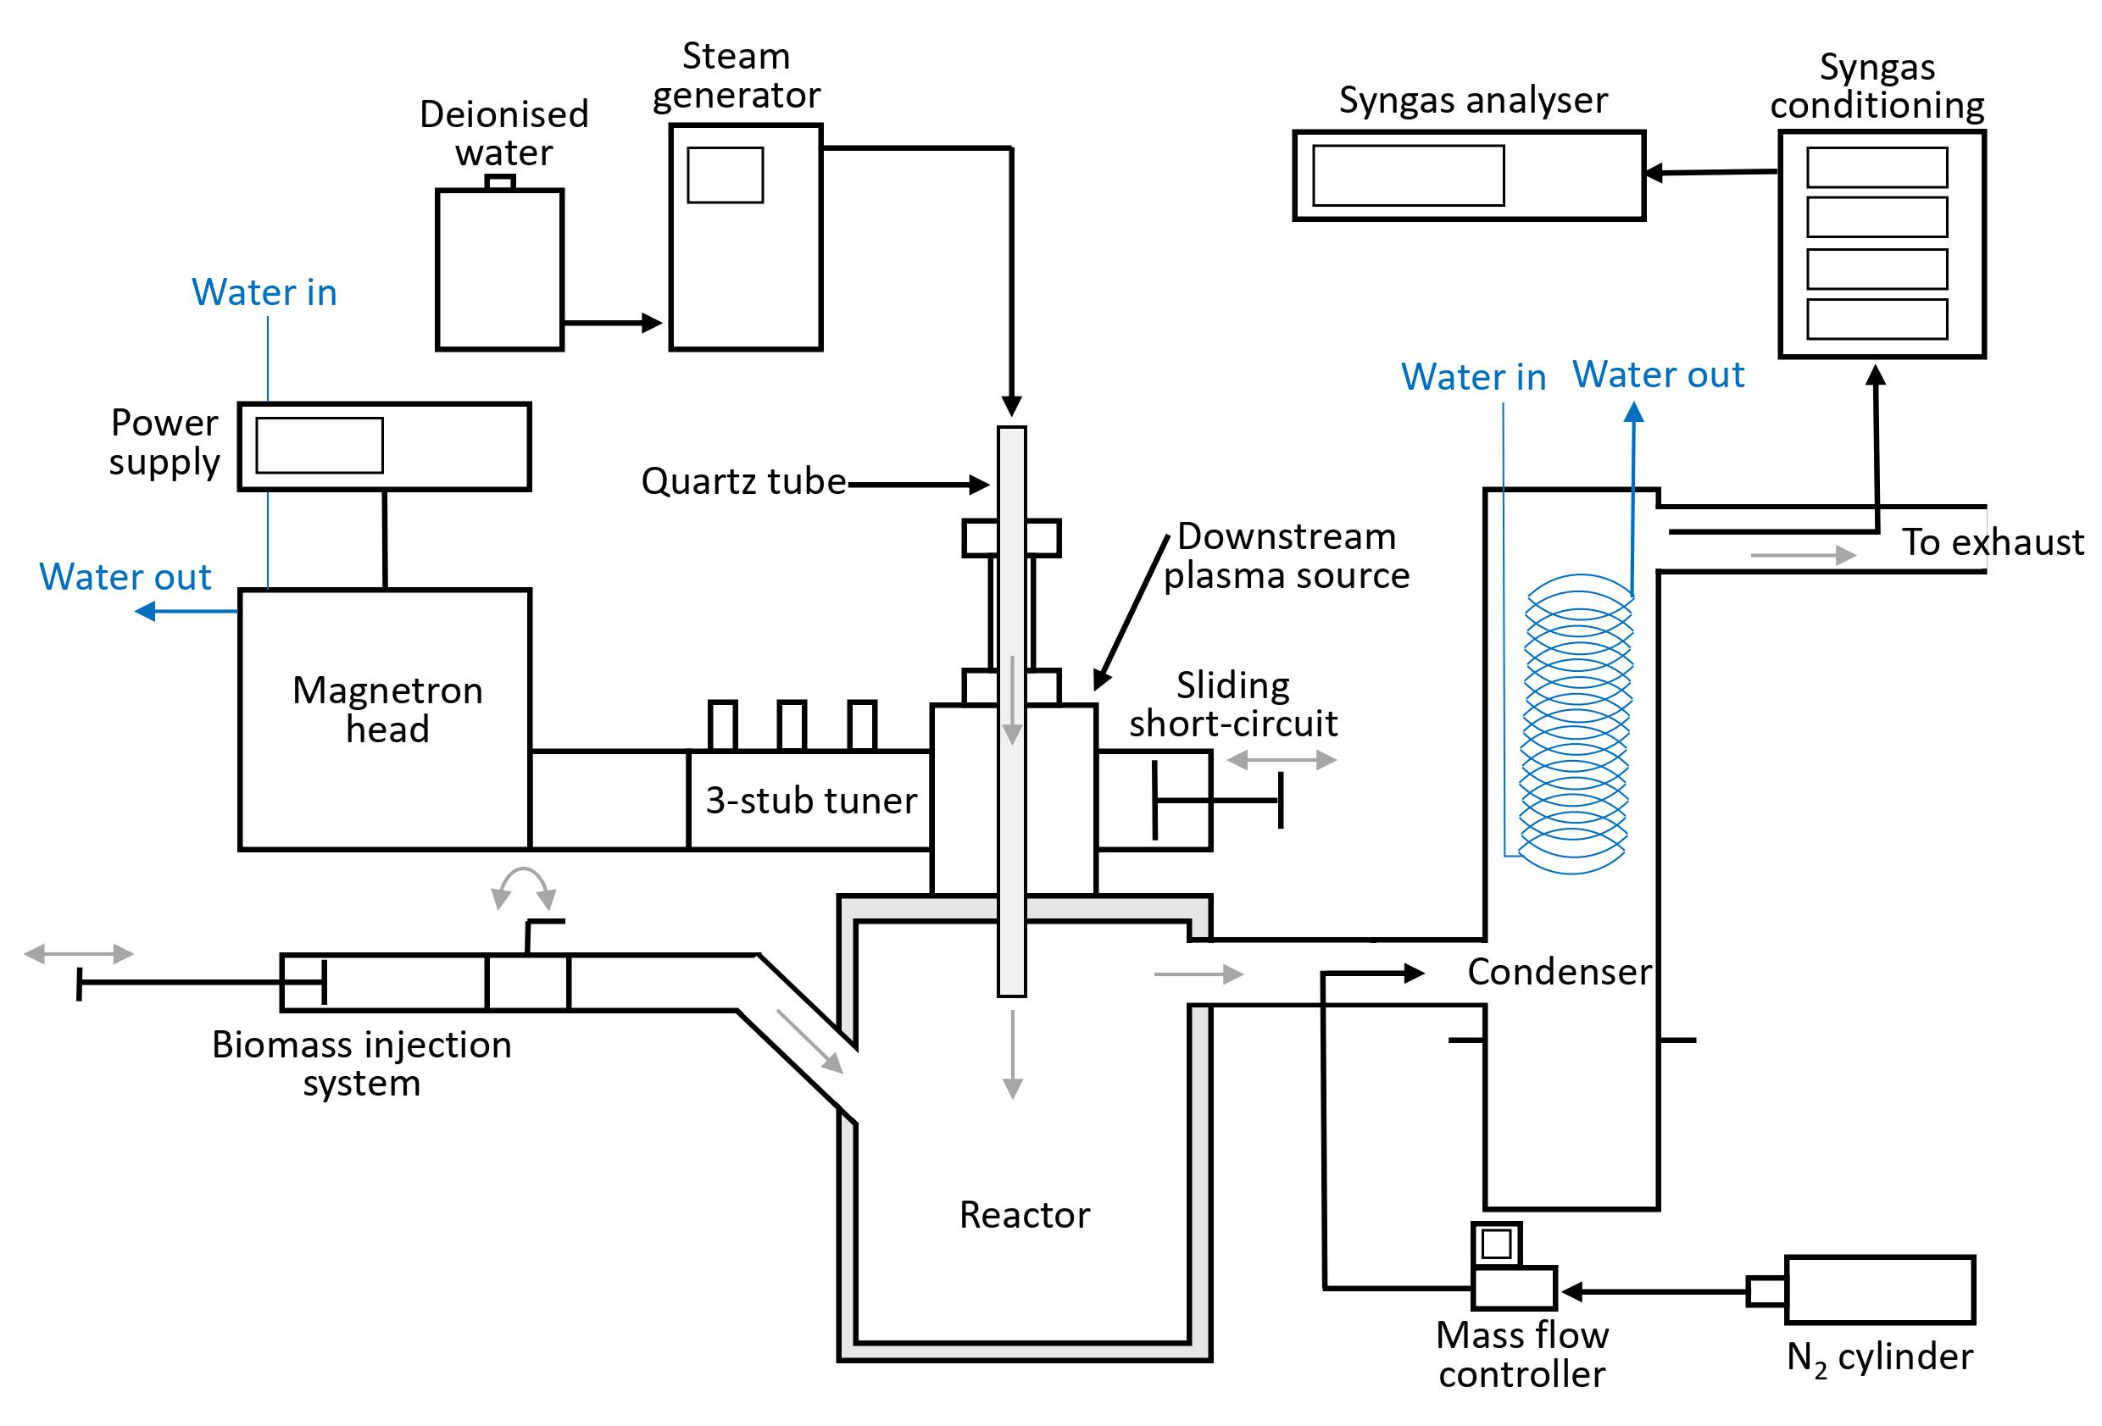
Fig. 1. Diagram of the microwave-induced plasma gasification system set-up.

Table 1
Element analysis of wood pellets and chars remaining after gasification experiment for different forward microwave power.
 | Wood pellets |  | Char (3 kW) |  | Char (4 kW) |  | Char (5 kW) |  | Char (6 kW)
Ultimate Analysis
C (%, dry) |  | 50.52 |  | 83.8 |  | 87.9 |  | 89.4 |  | 86.8
H (%, dry) |  | 6.12 |  | 3.67 |  | 2.74 |  | 1.71 |  | 1.63
O* (%, dry) |  | 42.68 |  | 11.58 |  | 8.47 |  | 7.44 |  | 10.39
N (%, dry) |  | <0.08 |  | 0.85 |  | 0.73 |  | 1.20 |  | 0.90
S (%, dry) |  | 0.30 |  | 0.12 |  | 0.18 |  | 0.20 |  | 0.24
Proximate Analysis
Moisture |  | 6.8
Ash |  | 0.3
Volatile matter |  | 79.6
Fixed carbon |  | 13.3
Calorific Value
LHV (MJ/kg) |  | 17.47
* O calculated by difference

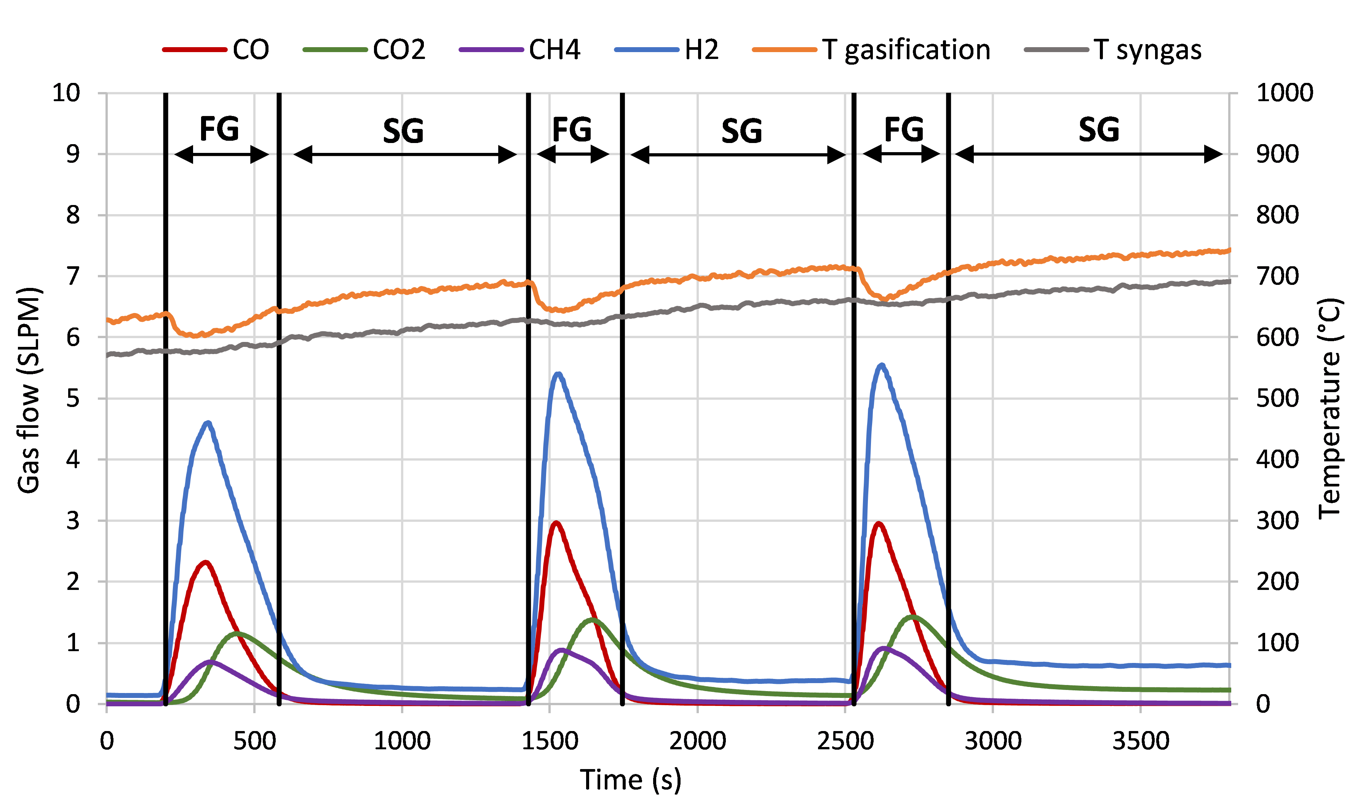
Fig. 2. Evolution syngas generation and temperatures for three injection of 50 g wood pellets with steam flow rate of 50 g/min and forward microwave power of 4 kW.

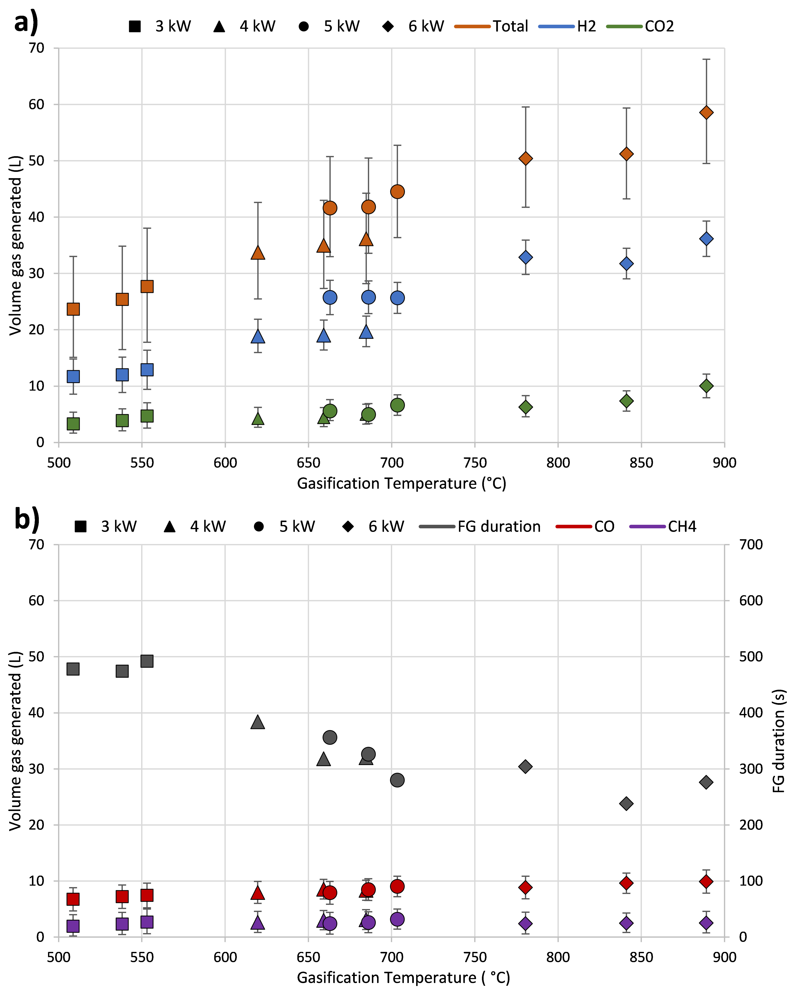
Fig. 3. Volume of gas generated and duration of fast gasification for each 50 g wood pellets injection as a function of the average gasification temperature with a steam flow rate of 50 g/min and varying the forward microwave power.

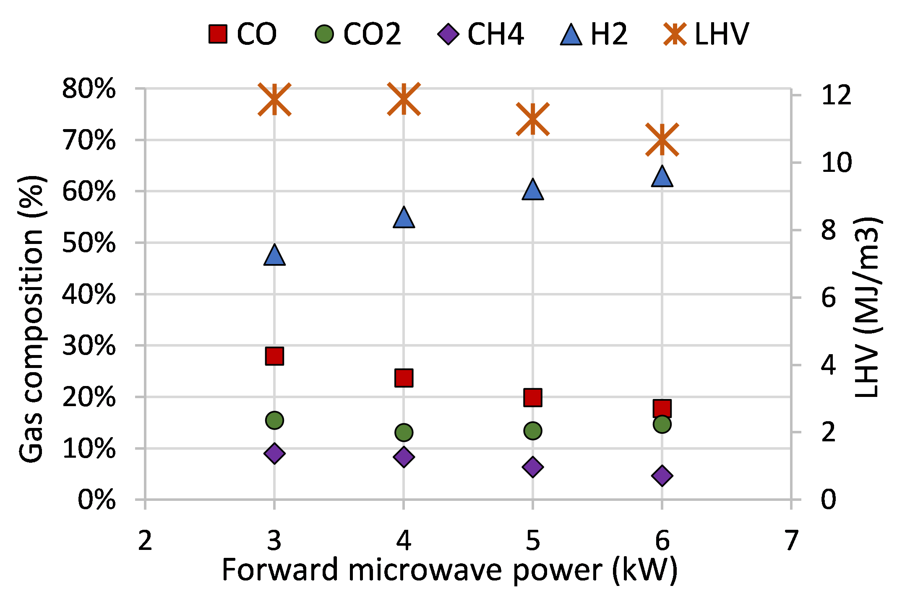
Fig. 4. Average syngas composition and LHV during fast gasification with 50 g/min steam and varying the forward microwave power.

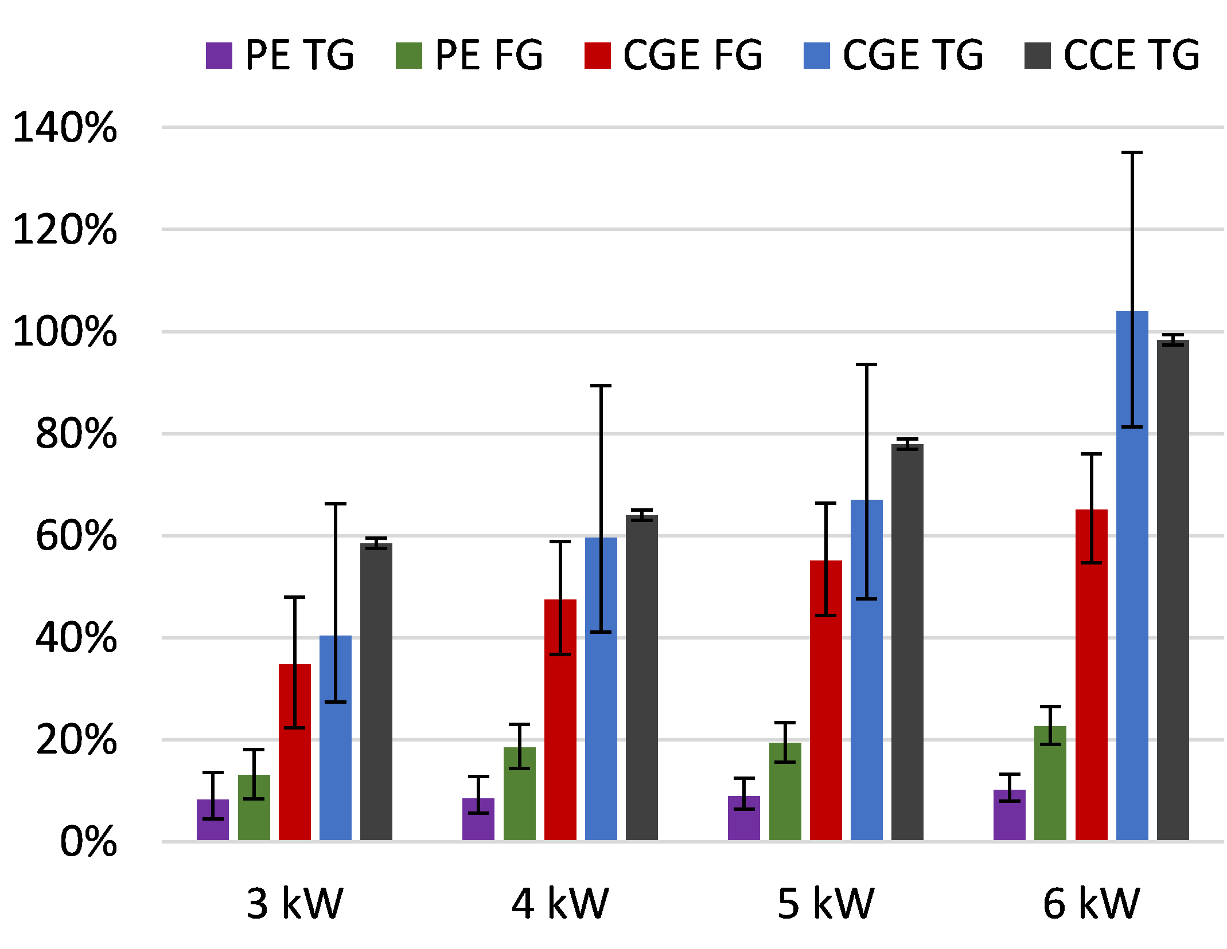
Fig. 5. Efficiencies with 50 g/min steam flow rate and varying the forward microwave power. Error bars are related to syngas analyser precision for CGE and PE, and precision of weighing remaining char for CCE.

