High maternal folic acid intake around conception alters mouse blastocyst lineage allocation and expression of key developmental regulatory genes.

R.S Penailillo¹, J.J Eckert², M.A.Burton¹, G.C Burdge², T.P Fleming¹ and K.A Lillycrop¹.
¹Centre for Biological Sciences, University of Southampton, UK
²School of Human Health and Development, Faculty of Medicine, University of Southampton, UK.

Corresponding author: K.A Lillycrop. Email: K.A.Lillycrop@soton.ac.uk

Abstract
Folate, a cofactor for the supply of one-carbon groups, is required by epigenetic processes to regulate cell lineage determination during development. The intake of folic acid (FA), the synthetic form of folate, has increased significantly over the past decade, but the effects of high periconceptional FA intake on cell lineage determination in the early embryo remains unknown. Here, we investigated the effect of maternal high FA (HFA) intake on blastocyst development, and expression of key regulatory genes. C57BL/6 adult female mice were fed either Control diet (1 mg FA) for 4 weeks before conception and during the preimplantation period (Con-Con); Control diet for 4 weeks preconception, followed by HFA (5 mg FA) diet during preimplantation (Con-HFA); or HFA diet for 4 weeks preconception and during preimplantation (HFA-HFA). At E3.5, blastocyst cell number, protein and mRNA expression were measured. In HFA-HFA blastocysts, trophectoderm cell numbers and expression of CDX2, Oct-4 and Nanog were reduced compared with Con-Con blastocysts; Con-HFA blastocysts showed lower CDX2 and Oct-4 expression than Con-Con blastocysts. These findings suggest periconceptional HFA intake induces changes in key regulators of embryo morphogenesis with potential implications for subsequent development.

Keywords: folic acid, blastocyst, trophectoderm, Cdx2, epigenetics.

Introduction

Folate (vitamin B9) is an essential cofactor which supplies one-carbon moieties for DNA synthesis and epigenetic mechanisms (L. B. Bailey et al., 2015; Ducker & Rabinowitz, 2017). Methyl groups are used in both histone and DNA methylation reactions, two epigenetic processes which regulate gene expression by controlling the accessibility of DNA to the transcriptional machinery. Methylation level thereby determines when and where genes are expressed and their level of expression. DNA and histone methylation play essential roles in development, working in concert to ensure the coordinated expression of gene networks that govern pluripotency and the subsequent differentiation of cells into specific lineages through the regulation of tissue-specific gene expression (Burdge & Lillycrop, 2012). As a result, DNA and histone methylation patterns are highly dynamic during development. For example, DNA methylation marks are largely erased upon fertilisation followed by a global increase in de novo DNA methylation as cells become committed to specific cell lineages. This transition coincides with concomitant changes in the location of the polycomb repressive complexes which mediate histone H3K27 trimethylation from differentiation-specific genes to pluripotency factors (Messerschmidt, Knowles, & Solter, 2014; Surani, Hayashi, & Hajkova, 2007).

The intake of folic acid (FA), the synthetic form of folate, has increased significantly over the past decade due to recommendations worldwide for the use of periconceptional FA supplements of 400 μg/d to prevent neural tube defects (NTD) (Pitkin, 2007; Smithells et al., 1980; Wilson et al., 2007), the widespread use of vitamin supplements that contain FA together with FA fortification of staple foods in many countries (R. L. Bailey et al., 2010; Colapinto, O’Connor, & Tremblay, 2011; Pfeiffer et al., 2007). However, despite the beneficial effects of FA in preventing NTD (Blom, 2009; De Wals et al., 2007; Pitkin, 2007), there remains uncertainty whether high levels of FA intake during the periconceptional period, a period where there is extensive epigenetic remodelling, may have unforeseen effects on the development of the embryo. Indeed, provision of metabolites to coordinate one-carbon metabolism is viewed as a critical biochemical conduit between mother and embryo to protect epigenetic remodelling during development (Clare, Brassington, Kwong, & Sinclair, 2019). Consistent with this concept, Pickell et al., reported that high maternal FA intake was associated with embryonic delay and growth retardation at E10.5 (Pickell et al., 2011). Further studies have reported long-term phenotypic changes in offspring born to dams fed a high FA diet, including impaired insulin secretion (Y. Huang et al., 2014; Kintaka et al., 2020), reduced femoral area (Huot et al., 2013) and increased mammary tumour risk (Ly et al., 2011). However, moderate but not excess levels of mouse maternal FA intake may improve success in assisted reproduction treatment (Rahimi et al., 2019).

Despite these findings that high maternal FA intake may adversely affect embryo development and offspring phenotype, there have been none studies investigating how pre and/or periconceptional high FA intake may affect lineage determination or the expression of epigenetic regulators that modulate this process during blastocyst development. The purpose of this study was to investigate whether differences in maternal periconceptional FA intake may modify gene expression and early morphogenesis. We used a mouse model to examine the effect of high (five-fold recommended daily level) maternal FA intake 4 weeks prior to conception and/or during the preimplantation period on blastocyst number, lineage allocation and the expression of key epigenetic regulators.

Methods

Animals and diet
All experimental procedures were conducted using protocols approved by and in accordance with the United Kingdom Home Office Animals (Scientific Procedures) Act 1986 and local Ethics Committee at the University of Southampton under the United Kingdom Home Office Project License PPL30/2968 and PPL30/3001. Virgin female C57BL/6 mice were fed a maintenance diet (RM1; Special Diet Services, Ltd.) prior to the experimental period. On a postnatal day (PND) 74, mice were fed either a Control (Con) FA diet containing rodent recommended daily intake (1 mg of FA/kg of feed AIN 93M) (Test Diet, US.) (Reeves, Nielsen, & Fahey, 1993) or a higher FA (HFA) diet (5 mg/kg of feed AIN 93M) (test Diet, US) for 4 weeks (Table S1). On PND 102, eight animals from each group were culled by cervical dislocation, and a blood sample was collected by cardiac puncture for plasma analyses. The remaining animals were mated overnight with C57BL/6 male mice, and the presence of a positive plug defined as E0.5. The mice were then fed either the Control or HFA diet during the preimplantation period, before culling on E3.5 by cervical dislocation and isolation of embryos (Figure 1). Three dietary groups were studied: (1) A control group fed the Control diet 4 weeks prior to conception and during the preimplantation period (Con-Con group), (2) a group fed the HFA diet for 4 weeks prior to conception and during the preimplantation period (HFA-HFA group), and (3) a group fed the Control diet for 4 weeks preconception and then switched to the HFA diet during the preimplantation period (Con-HFA). Individual body weight (g) and total food intake per cage (g) over 24 hours were measured weekly throughout the 4 week preconception period. Energy intake (kJ per 10g of mouse) was estimated for individual mice based on total food consumption over 24 hours per cage. Average daily FA intake was estimated using whole cage intakes and the FA content of the diets.

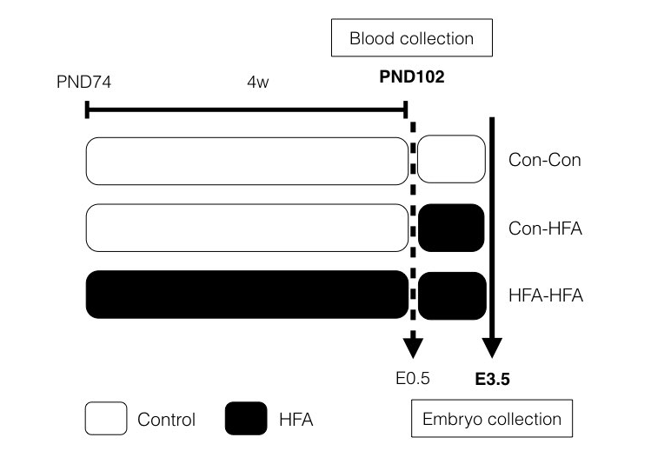
Figure 1 | Experimental model describing the three diet groups: Con-Con fed with Control diet (1 mg/kg food) for 4 weeks prior to mating and during the preimplantation period; Con-HFA fed with Control diet for 4 weeks preconception, followed by high FA (HFA, 5 mg FA/kg food) diet during the preimplantation period; HFA-HFA fed with high FA diet for 4 weeks prior to mating and during the preimplantation period.

Measurement of Plasma 5-methyltetrahydrofolate and Folate Metabolites
The concentration of plasma FA and folate metabolites (5-methyltetrahydrofolate (5-meTHF), 4-α-hydroxy 5-methyltetrahydrofolate (hmTHF), 5-formyltetrahydrofolate (5fTHF), and two folate degradation products, namely p-aminobenzoylglutamate (pABG) and p-acetamidobenzoylglutamate (apABG), were measured at the end of the 4 week preconception period using liquid chromatography-tandem mass spectrometry by Bevital Laboratories (Bergen, Norway).

Embryo collection
Pregnant mice were culled at the same hour of the day on E3.5. Embryos were collected by flushing the uterus with H6 medium containing bovine serum albumin (BSA) (4 mg/ml, H6BSA; Sigma). Freshly harvested embryos were washed once in H6BSA, followed by three washes with H6 medium containing polyvinyl pyrrolidone (PVP) (6 mg/ml, H6PVP Sigma), and three washes in PBS. Embryos were classified as follows: early blastocyst, when the blastocoel cavity occupied less than half the blastocyst; mid blastocyst, when the blastocoel cavity filled half the blastocyst; late blastocyst, when the blastocoel cavity filled the majority of the blastocyst, and the zona pellucida was substantially reduced; and morula, when there was no sign of a cavity (Schrode et al., 2013). E-Mouse Atlas Project (http://www.emouseatlas.org) was used as a visual reference for embryo classification. Embryos and oocytes with signs of disintegration were classified as degenerated embryo or oocyte. The total number of embryos was also calculated. Single staged embryos to be used for qPCR were transferred to a siliconised tube with a minimal volume (1 - 2 µl) of PBS, snap-frozen in liquid nitrogen, and stored at -80 ºC. For blastocyst differential labelling of cell lineages and immuno-detection, embryos were washed and used immediately.

Quantitative RT-PCR
RNA was isolated from a single blastocyst using the Dynabeads mRNA DIRECT kit (Invitrogen), as described by Kwong et al., 2006. In total one blastocyst per dam, with a total number of 10 dams per group were used for RNA expression studies. Complementary DNA was transcribed using Moloney-murine leukemia virus reverse transcriptase (M-MLV) (Promega) according to the manufacturer’s protocol and stored at -20 °C. Quantitative RT-PCR was then performed using SYBR Green (Qiagen) and samples analysed in duplicate using a Light Cycler 480 II (Roche). mRNA levels were determined by the standard curve method (Čikoš, Bukovská, & Koppel, 2007) and normalised to H2afz, Ppib, and Tuba as reference genes selected from geNorm analysis using Biogazelle qbase plus 3.0 (Biogazelle, Belgium) (Vandesompele et al., 2002). Six housekeeping genes were tested and the three housekeeping genes which showed the greatest stability (M value < 0.575) and the lowest variability among samples (V < 0.15) were used. Primer sequences and QuantiTect primers (Qiagen) are listed in Table 1. Mid blastocysts were the most abundant stage at E3.5 (> 50%). Total RNA was extracted from 80 mid blastocysts and their sex determined as described below (61% male, 9% female, 30% were undetermined due to insufficient DNA product). One male mid blastocyst was analysed for qPCR per dam (n = 10 dam per group); only male blastocysts were analysed as the number of female mid blastocysts was limited.

Table 1 | Primer sequences for blastocyst Real-time RTPCR

Gene | Primer | Primer Sequence
Ppib† | Forward | TTCTTCATAACCACAGTCAAGACC
 | Reverse | ACCTTCCGTACCACATCCAT
Tuba‡ | Forward | CTGGAACCCACGGTCATC
 | Reverse | GTGGCCACGAGCATAGTTATT
Oct4A§ | Forward | CACGAGTGGAAAGCAACTCA
 | Reverse | TTGGTTCCACCTTCTCCAAC
Nanog¶ | Forward | TGCTTACAAGGGTCTGCTACT
 | Reverse | GAGGCAGGTCTTCAGAGGAA
Cdx2¶ | Forward | CTGCCACACTTGGGCTCT
 | Reverse | CTGCTGCTGCTTCTTCTTGA
Dnmt1† | Forward | GCTACCAGTGCACCTTTGGT
 | Reverse | ATGATGGCCCTCCTTCGT
 |  | Quantitect Primer Assay
H2afz |  | QT00137319
Ezh2 |  | QT01063671
Gata6 |  | QT00171297
Eed |  | QT00172424
† Watkins et al., 2017, ‡ Lucas et al., 2011, § Kashani et al., 2014, and ¶ from J. Eckert, University of Southampton.

Embryo sex determination
To identify the sex of the embryo, DNA was collected from the supernatant from the RNA extraction of a single embryo (Kwong et al., 2006) using glycogen and ethanol precipitation. The DNA was then used in a nested PCR reaction with specific primers for DXNd-3, SRY, and ZFY (Kunieda et al., 1992). The PCR product was separated by electrophoresis using a 1.5% (w/v) agarose gel to identify bands associated with female embryos (DXNd single band) or male (DXNd, SRY and ZFY, three bands).

Differential labelling of embryos
Differential labelling of the blastocyst inner cell mass (ICM) and trophectoderm (TE) was carried out as described by Hardy et al. in 1989 (Hardy, Handyside, & Winston, 1989) with modifications by Velazquez et al. in 2011 (Velazquez, Hermann, Kues, & Niemann, 2011). After embryo collection, blastocysts were washed three times in H6BSA medium and zona pellucida removed using acidified Tyrodes solution (Sigma), pH 2.3 at 37 °C for 30-60 seconds followed by extensive washing in H6BSA. The outer cells of the blastocysts were labelled using 10% (w/v) trinitrobenzene sulfonic acid (Sigma) at room temperature for 10 minutes. Blastocysts were then washed three times in H6PVP and then incubated with anti-dinitrophenol (1 mg/ml in H6PVP, Sigma) and washed three times in H6PVP. Blastocysts were subsequently incubated with guinea pig complement (diluted 1:10 in H6BSA, Sigma) supplemented with 4 µl propidium iodide (1 mg/ml, Sigma) and incubated at 37 °C for 10 minutes. Blastocysts were then washed three times in H6BSA and then fixed using absolute ethanol with 1% Bisbenzimide (Hoechst 33258, 2.5 mg/ml in distilled water, Sigma) at 4 °C for 30 minutes or until the image was taken. A Z-series of images was taken using a Nikon Elipse Ti fluorescence microscope with NIS elements software (version 4.30). This method has been used previously in a number of published studies (Igosheva et al., 2010; M. A. Velazquez, Smith, Smyth, Osmond, & Fleming, 2016; P. J. Williams, Bulmer, Innes, & Broughton Pipkin, 2011).

Immunohistochemistry
Blastocysts collected from the uterus of the female at E3.5 after their zona pellucida was removed, were fixed with 4% paraformaldehyde in PBS at room temperature for 10 minutes and washed in PBS-PVP drops. Permeabilization of the embryos was achieved with 0.25% (v/v) Triton X-100 in PBS for 15 minutes, followed by neutralisation with ammonium chloride (2.6 mg/ml in PBS) solution for 10 minutes. The embryos were washed with PBS containing 0.1% (v/v) Tween 20 (PBST), incubated with blocking solution (PBST and 3% (w/v) BSA) for 30 minutes, then incubated with primary antibody (monoclonal CDX2 1:100 dilution; or product no. Ab157524, Abcam; monoclonal NANOG 1:100 dilution; product no. Ab80892, Abcam) overnight at 4 °C in the dark. The next day, embryos were washed and incubated with secondary antibody (Donkey Anti-mouse Alexa fluor 488 1:500 dilution, product no. Ab150105, Abcam; or Donkey Anti-rabbit Alexa fluor 568 1:500 dilution, product no. Ab175470, Abcam) in blocking solution for 1 hour at room temperature in the dark. Embryos were then washed and incubated with 4’,6-diamidino-2-phenylindole (DAPI, Sigma) for 20 minutes at room temperature in the dark. Citifluor anti-fading mounting solution (Agar Scientific) was added to the embryo and then mounted with a coverslip. Imaging was performed using a Leica SP8 Confocal microscope equipped with a 63x glycerol objective and LAS-X software (Leica). Images were acquired by an accumulation of Z-series 2 μm sections of each whole embryo. CDX2 and NANOG expression was defined as the number of cells expressing the protein of interest divided by the total of cells per blastocyst.

Statistical analysis
Statistical analysis of data was performed using STATA statistical software version 12 for Mac (StataCorp). The distribution of the data was tested using the Shapiro-Wilk test. In cases where the data did not approximate to a normal distribution, data was log-transformed and re-checked for normality prior to analysis by ANOVA test with Bonferroni correction for multiple comparisons. For FA plasma measurements, animal food intake and body weight Student’s unpaired T-test was used. All data analyses from the embryo studies were analysed in parallel by a multilevel random effect regression model (supplementary Table S2) which takes into account the hierarchical nature of the data considering between-dams and between-litter variations and the different parameters measured from individual embryos including number of cells, gene expression and immunofluorescence. This regression model accounting for embryo number has been widely used previously (Kwong, Osmond, & Fleming, 2004; Miguel A. Velazquez et al., 2018; Watkins et al., 2010; Watkins, Lucas, Wilkins, Cagampang, & Fleming, 2011; Watkins et al., 2007; Watkins, Ursell, et al., 2008; Watkins, Wilkins, et al., 2008; C. L. Williams, Teeling, Perry, & Fleming, 2011). Both ANOVA (reported in tables and figures in main manuscript) and the multi-level regression model (Supplementary Table 2) gave similar results.

Results

Analysis of plasma folate and folic acid concentrations
Plasma folate and FA concentrations were measured at the end of the 4 week experimental period prior to conception. FA (p = 0.01), mTHF (p < 0.0001) and pABG (p = 0.04) concentrations were all higher in plasma from animals fed the HFA diet compared to the Control group (Figure 2A,C,E). However, no significant change in the concentrations of fTHF (p = 0.59), hmTHF (p = 0.85) and apABG (p = 0.07) were found between groups (Figure 2B,D,F).
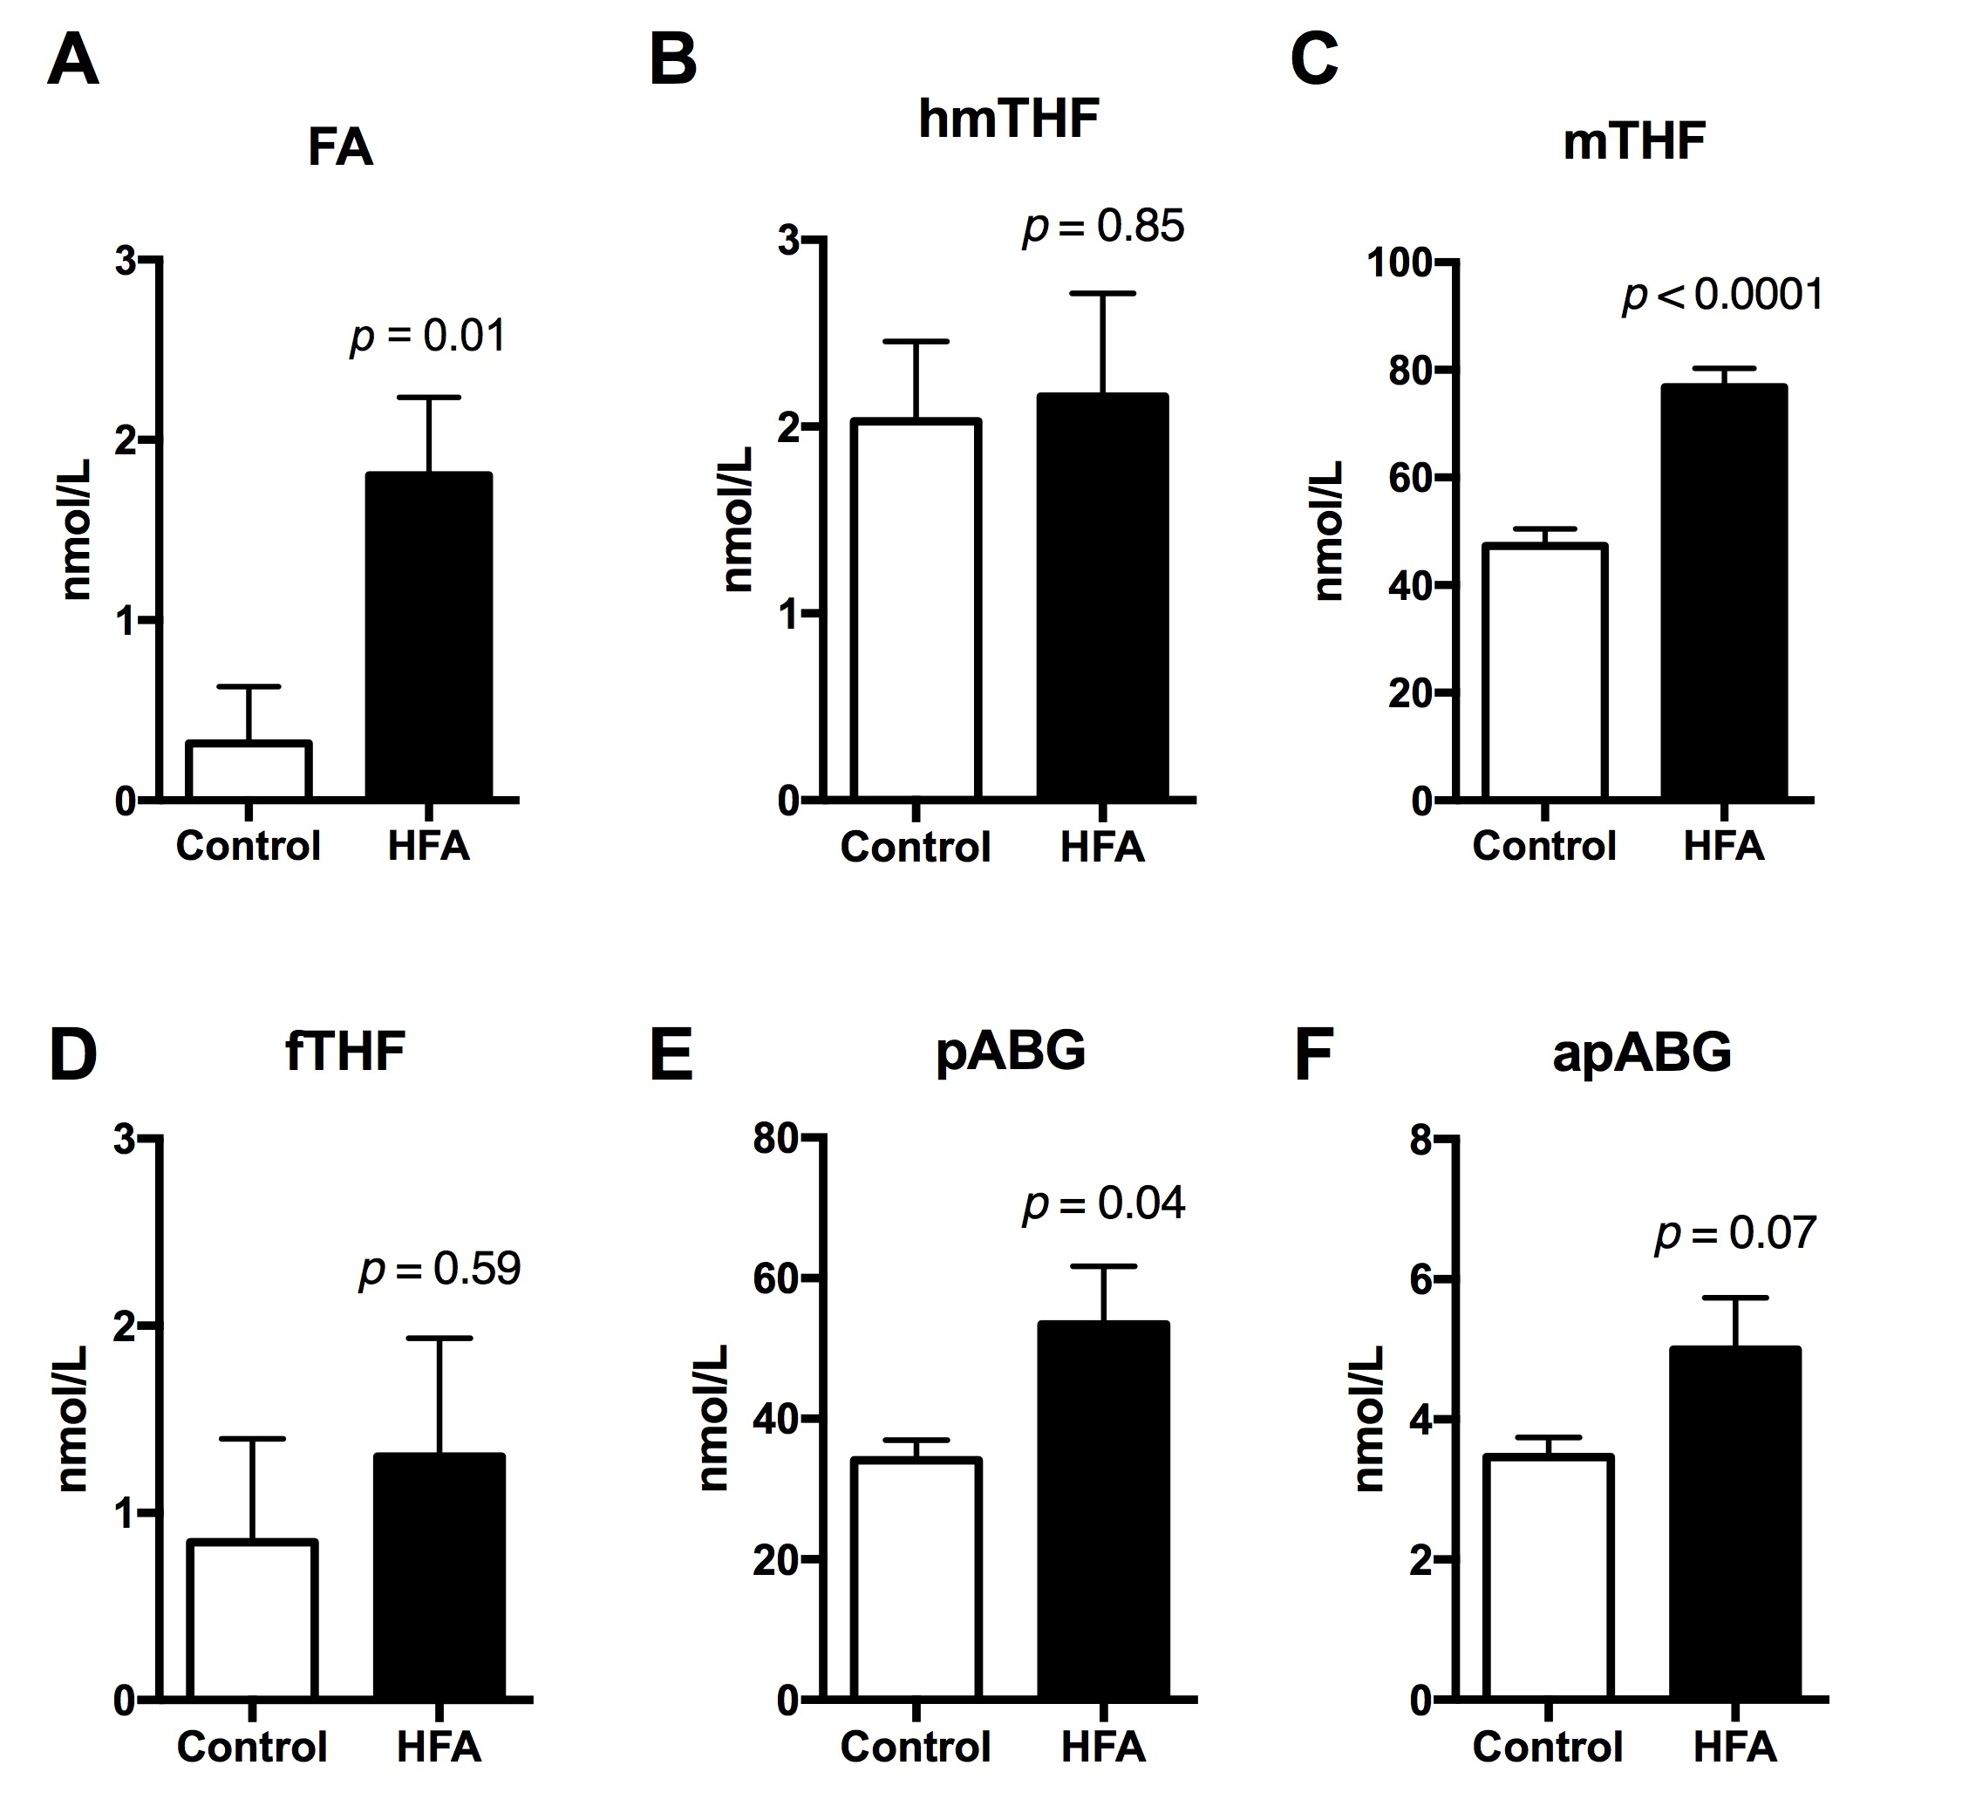
Figure 2 Concentrations of FA and metabolites of folate cycle in plasma after 4 weeks feeding in non-pregnant mice. (A) FA (Folic acid); (B) hmTHF (4-alpha-hydroxy-5-methyl-tetrahydrofolate); (C) mTHF (5-methyl-tetrahydrofolate); (D) fTHF (5-formyl-tetrahydrofolate); (E) pABG (para-aminobenzoylglutamic acid) and (F) apABG (acetyl-para- aminobenzoylglutamic acid). Data expressed as mean ± SEM. n = 8 females per diet group. Statistical analysis was by Student’s unpaired T-test.

Effect of increased FA intake on body weight and energy intake
Body weight and energy intake were assessed weekly over the 4 week preconception period. There was no difference in body weight or energy intake between the mice fed the HFA or Control diet (Figure S1). Based on whole cage intake, the estimated intake of FA was 3.4 ± 0.03 µg/day for mice fed the Control diet and 16.2 ± 0.21 µg/day for mice fed the HFA diet. Preconceptional HFA intake was associated with an increase in mating time, which was delayed by one day compared to the control group (p = 0.002, Table 2).

Table 2 | Influence of maternal dietary FA intake on early embryo development
 | Con-Con | Con-HFA | HFA-HFA | p value
Days mating | 2.0 ± 0.2 | 2.4 ± 0.3 | 2.9 ± 0.2†,‡ | 0.002
Embryos per mouse | 7.9 ﻿± 0.4 | 7.3 ﻿± 0.5 | 8.7 ﻿± 0.2‡ | 0.02
Blastocysts per mouse | 7.2 ﻿± 0.4 | 6.3 ﻿± 0.6 | 7.9 ﻿± 0.3‡ | 0.03
Late blastocyst (%) | 12.7 ± 3.5 | 11.6 ± 3.2 | 14.0 ± 3.4 | 0.88
Mid blastocyst (%) | 53.2 ± 4.1 | 52.7 ± 5.0 | 50.7 ± 4.5 | 0.91
Early blastocyst (%) | 21.9 ± 3.9 | 16.4 ± 3.2 | 22.0 ± 3.4 | 0.44
Morula (%) | 2.7 ± 1.6 | 2.5 ± 2.1 | 1.2 ± 0.7 | 0.74
Degenerated embryo (%) | 9.5 ± 2.2 | 16.6 ± 4.8 | 12.1 ± 3.1 | 0.35
† different to the Con-Con group, ‡ different to the Con-HFA group. One-way ANOVA, Bonferroni posthoc. Data expressed as mean ± SEM. Embryos were collected at E3.5 n =24-26 pregnant mice per group.

Effect of high FA intake on the number of embryos and stage of embryo development per pregnancy.
To determine whether a higher FA intake affected the stage of blastocyst development or the number of embryos per pregnancy, embryos were collected at E3.5 and divided into late, mid or early blastocyst morula, or degenerated oocytes/embryos from dams from the three dietary groups. There was no difference in the total number of embryos, blastocysts or stage of development between the HFA-HFA or Con-HFA groups compared to Con-Con group (Table 2), but a reduction in the total number of embryos and blastocysts occurred in the Con-HFA group compared to the HFA-HFA group (Table 2).

Number of TE and ICM cells in the blastocyst
To determine whether increased maternal FA intake affected the number of cells in the blastocyst, differential cell staining was used to identify the total number of cells together with the number of TE and ICM cells per blastocyst. There was no significant difference in the total number of cells per blastocyst in either the HFA-HFA or Con-HFA groups compared to the control group, although there was a significant decrease in the total number of cells per blastocyst between the HFA-HFA group and Con-HFA group (p = 0.009) (Figure 3A). The number of TE cells was 1.1-fold lower in the HFA-HFA group compared to the Con-Con (p = 0.04) group and the ICM/TE ratio 1.4 fold higher (p = 0.002) in the HFA-HFA group compared to the Con-Con (Figure 3B). There was no significant difference in the number of TE cells or the ICM/TE ratio in the Con-HFA group compared to the Con-Con group. However, Con-HFA blastocysts showed a higher number of ICM cells compared to the Con-Con group (p = 0.02). A multilevel random effect regression model taking in consideration the potential maternal-embryo hierarchical association was also run parallel to the ANOVA and gave similar results (Supplementary table 2).
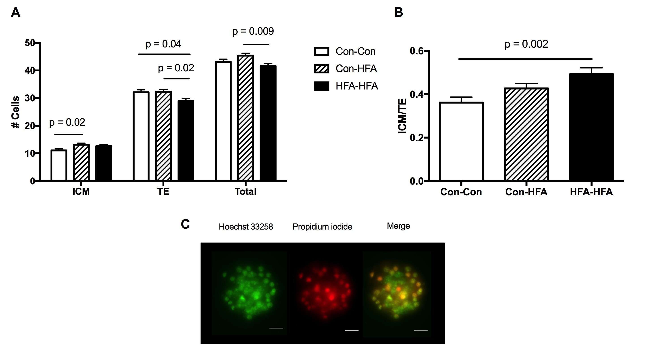
Figure 3 | Differential labelling of inner cell mass (ICM) and trophectoderm (TE) cells (A) in blastocysts. (B) ICM/TE ratio. (C) Representative image of blastocyst stained with Hoechst and propidium iodide. Data was analysed by ANOVA with Bonferroni correction for multiple comparisons, adjusted p values are showed in the graph. Data expressed as mean ± SEM. n = 7-8 pregnant mice per group (38-44 blastocyst per group). Scale bar = 20 µm

3.5 Expression of developmental control genes
The expression of the TE lineage marker Cdx2 was lower in both the HFA-Con and HFA-HFA groups (p = 0.019 and p = 0.0008, respectively) compared to the Con-Con group (Figure 4A). The expression of pluripotency genes, Oct4 and Nanog, were also down-regulated in blastocysts from the HFA-HFA group compared to the Con-Con group (p = 0.04 and p = 0.008, respectively, Figure 4B and 4C). Oct4 was downregulated in the Con-HFA group compared to the Con-Con group (p = 0.009, Figure 4B). The primitive endoderm marker Gata6 did not show differences at the mRNA level among the groups (p = 0.20).

Immunohistochemistry was used to assess the proportion of cells per blastocyst expressing CDX2 and NANOG. The number of cells expressing CDX2 was lower in both Con-HFA (p < 0.0001) and HFA-HFA (p = 0.003) groups compared to the Con-Con group (Figure 5A). In contrast, the number of cells expressing NANOG was higher in the Con-HFA and HFA-HFA than in the Con-Con group (p < 0.001 and p = 0.004, respectively, Figure 5B).
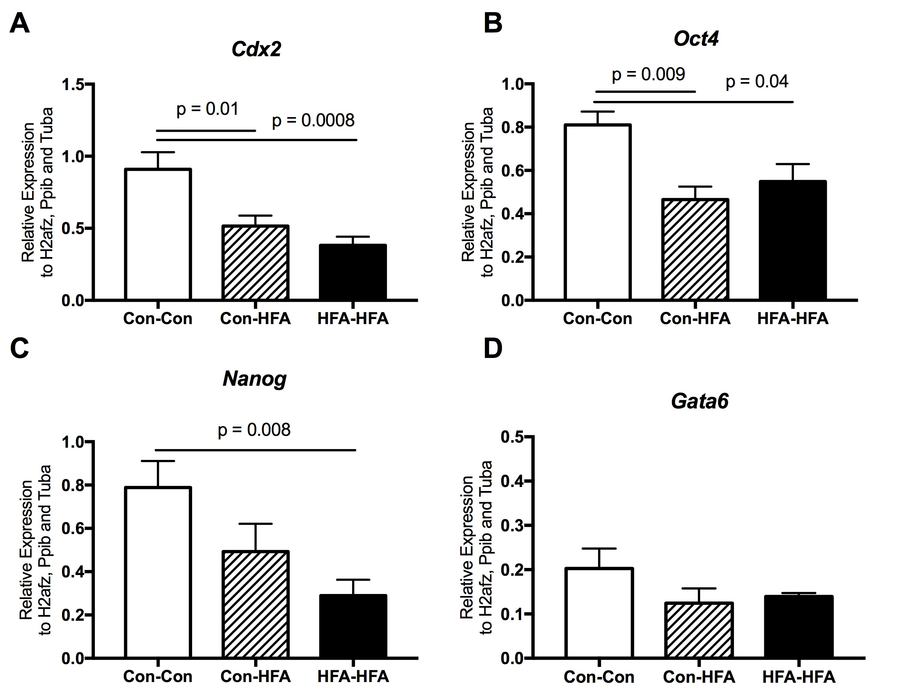
Figure 4 | mRNA expression of lineage markers (A) Cdx2, (B) Oct4, (C) Nanog and (D) Gata6 in male mid-expanded blastocysts. Data was analysed by ANOVA with Bonferroni correction for multiple comparisons, adjusted p values are showed in the graph. Data expressed as mean ± SEM. n = 10 blastocyst per group, one male blastocyst per mouse.

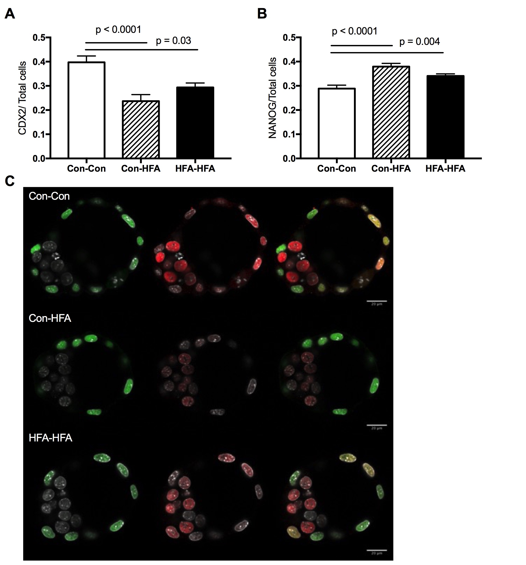
Figure 5 | Immunohistochemistry CDX2 and NANOG in blastocyst at E3.5. (A) CDX2 and (B) NANOG positive cells in relation to the total cells. (C) Representative image of blastocyst stained with CDX2 (green) and NANOG (red) and DAPI (grey). Data was analysed by ANOVA with Bonferroni correction for multiple comparisons, adjusted p values are showed in the graph. Data expressed as mean ± SEM. n = 4-8 pregnant mice per group (21-38 blastocysts per group). Scale bar = 20 µm

3.6 Expression of epigenetic regulatory genes
As epigenetic processes play a central role in lineage determination and are reliant on the supply of methyl groups from one-carbon metabolism, the expression of components of the Polycomb repressive complex (Ezh2 and Eed) which maintains pluripotency by repressing lineage-specific genes through H3K27 trimethylation, together with DNA methyltransferase 1 (DNMT1), responsible for maintaining DNA methylation patterns (Bird, 2002), were also analysed in the blastocysts from the Con-Con, HFA-HFA, and Con-HFA groups. The expression of Ezh2 (p = 0.04) and Eed (p = 0.01) decreased by 1.4-fold in the blastocysts from the Con-HFA group compared to the Con-Con group (Figure 6A). Eed expression decreased by 1.7-fold in the HFA-HFA group compared to the Con-Con group (p < 0.0001, Figure 6B), but there was no significant difference in Dnmt1 expression between groups (p = 0.17, Figure 6C).

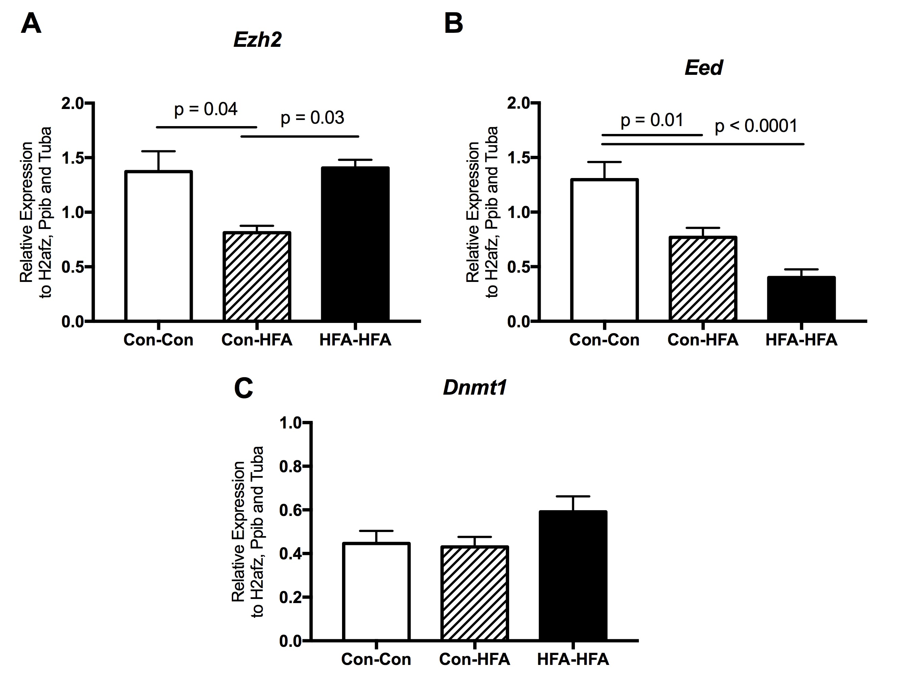
Figure 6 | mRNA expression of (A) Ezh2, (B) Eed, and (C) Dnmt1 in male mid-expanded blastocysts. Data was analysed by ANOVA with Bonferroni correction for multiple comparisons, adjusted p values are showed in the graph. Data expressed as mean ± SEM. n =10 blastocyst per group, one male blastocyst per dam.

Discussion

Here we have shown that increased maternal FA intake during mouse preconception and preimplantation period alters early embryo development by reducing the number and proportion of TE cells within the blastocyst and reducing the expression level of regulatory genes coordinating lineage diversification and epigenetic reorganisation of the genome.

Increasing FA intake for 4 weeks preconception increased the concentrations of unmetabolised FA, mTHF, and the level of a major catabolite; pABG. In humans, FA supplementation has been associated with the presence of unmetabolised FA in plasma (Pfeiffer et al., 2015; Tam, O’Connor, & Koren, 2012), which has been suggested to occur as a result of saturating the capacity for reduction of FA to mTHF in the gut (Patanwala et al., 2014) and liver (S. W. Bailey & Ayling, 2009). The presence of unmetabolised FA in this study suggests that the intake of 5 mg FA/kg diet may be sufficient to saturate capacity for the reduction of FA to THF in mice. There was also an increase in pABG in mice fed the high FA diet; an increase in pABG levels has been suggested to be a mechanism to limit the increase in intracellular folate (Suh, Herbig, & Stover, 2001). Although there was also an increase in apABG levels in mice fed the high FA diet, a metabolite of pAGB, and the major excreted form in urine (Geoghegan, McPartlin, Weir, & Scott, 1995), this did not reach significance. The mechanism underlying differential effect of higher FA on apABG and pABG is not known. One possible explanation is that at high FA intakes, capacity for acetylation of pABG by arylamine N-acetyltransferase activity (Stanley et al., 1998) is limited compared to synthesis of the pABG substrate. Increased FA intake did not affect levels of fTHF or hmTHF. However fTHF is regulated and contributes to multiple metabolic pathways which will also influence fTHF levels (Ducker & Rabinowitz, 2017), while hmTHF is generally observed after long term storage of samples and here levels of hmTHF were low consistent with little or no oxidation of the samples.

Mice fed the high FA diet for 4 weeks showed a delay in mating time. In humans, higher intake of FA has been associated with changes in the hormonal control of the menstrual cycle; with higher intake of synthetic folate significantly associated with higher luteal progesterone levels (Gaskins et al., 2012), while women taking FA supplementation have a shorter menstrual cycle length (Cueto et al., 2015). The delay in mating time observed in this study may result from higher FA intake disrupting the estrus cycle, but further analysis of the effect of FA intake on the estrus cycle and hormonal regulation is required to determine the mechanism by which FA intake influence time to conception.

There was no significant difference in the total number of blastocysts or stage of blastocyst development between the HFA-HFA or Con-HFA groups compared to the Con-Con group. However, feeding a HFA diet before mating and during the preimplantation period, did reduce the number of TE cells and consequently led to an increased ICM/TE ratio. Altered proportions of TE and ICM cells have been described after maternal protein restriction during the preimplantation period (Eckert et al., 2012; Kwong, Wild, Roberts, Willis, & Fleming, 2000; Mitchell, Schulz, Armstrong, & Lane, 2009), with the changes in the number of TE and ICM cells in the blastocyst being accompanied by the development of hypertension in the adult offspring. As the protein-restricted diet results in a reduced intake of essential amino acids such as glycine, which plays a key role in one-carbon metabolism (Bagley & Stipanuk, 1995), it has been suggested that the effects of maternal protein restriction on the embryo and offspring may result from the impaired supply of methyl groups and changes to the epigenetic processes that govern lineage determination, consistent with findings from this study. Indeed, direct changes in epigenetic regulation during development have been identified in response to periconception maternal protein restriction (Denisenko et al., 2016; Sun et al., 2015).

The mRNA and protein expression of the TE lineage marker CDX2 was also lower in the HFA-HFA group compared to the Con-Con group, consistent with the reduction in the number of TE cells. CDX2 is a transcription factor that is required for TE cell fate specification in the early mouse embryo (Strumpf et al., 2005). At the blastocyst stage, CDX2 is expressed specifically in TE cells (Ralston & Rossant, 2008). Activation of CDX2 in the outer cells, leads to the repression of OCT4/NANOG expression and the differentiation of the totipotent cells into TE cells (D. Huang et al., 2017; Nishioka et al., 2008). The decrease in CDX2 expression observed in this study may reflect the lower number of TE cells but it is also possible that lower CDX2 expression may result in a reduction in the number of TE cells. Loss of CDX2 in mouse embryos has been reported to lead to a failure to repress OCT4 and NANOG expression in the TE lineage, and impaired implantation (Strumpf et al., 2005; Wu et al., 2010). In this study however, we found while the expression of both Oct4 and Nanog mRNA was reduced in whole blastocysts from the HFA-HFA group, the number of cells expressing Nanog protein was increased. Further studies will be required to assess how a high FA intake affects the transcription and translation of Oct4/Nanog within each cell compartment within the blastocyst to delineate the long terms effects on embryo development.

There was no significant change in TE cell number in the Con-HFA group compared to the Con-Con group, despite lower CDX2 mRNA and protein expression. This may reflect the shorter duration of the HFA diet in the Con-HFA group compared to the HFA-HFA group. The Con-HFA blastocysts did exhibit reduced levels of Oct-4 and nanog mRNA but an increase in the number of cells expressing Nanog protein, as observed in HFA-HFA blastocysts, suggesting a common effect of an increased FA intake fed during the preimplantation period. There were however differences between the HFA-HFA and Con-HFA groups, with the Con-HFA group having have a higher number of total cells and ICM cells per blastocysts then the HFA-HFA group. Such differences between the groups fed the HFA diet pre-conception and throughout the preimplantation period compared to those fed the HFA diet only during the preimplantation period, suggests that shorter exposure and/or switch in diet is responsible for these differential effects. Understanding how increased FA intake over these different time periods impact on folate metabolism in the embryo will be crucial to elucidate the differential effects on cell specification.

During development, the interplay between pluripotency and lineage commitment is coordinated by specific transcription factors that regulate gene expression programs by the recruitment of a series of epigenetic writers that alter chromatin structure. This epigenetic regulation of gene expression is essential for the initiation and maintenance of lineage cell fate; EZH2/EED are subunits of the polycomb repressive complex 2 (PRC2), which play a central role in mediating lineage commitment in the embryo (Aloia, Di Stefano, & Di Croce, 2013; Illingworth, Hölzenspies, Roske, Bickmore, & Brickman, 2016). In this study, HFA intake during the preimplantation period only led to a decrease in Ezh2 and Eed expression, while periconceptional HFA intake resulted in decreased Eed expression. Loss of Ezh2 in mouse embryos is associated with arrested development at the blastocyst stage, increased apoptosis, together with a decrease of Oct4, Nanog, and Sox2 expression (X. J. Huang et al., 2014), consistent with the PRC2 playing a role in regulating the expression of Oct4, Nanog and Sox2 (Walker et al., 2010). Here, a decrease in Eed expression in the HFA-HFA and a decrease in Eed and Ezh2 in the Con-HFA blastocysts was accompanied by changes in the expression of both Oct4 and Nanog, suggesting that a higher FA intake may disrupt the balance between pluripotency and differentiation in the embryo through altered expression of components of the PRC, and interestingly this was observed with both exposure to an increased FA intake pre pregnancy and during the implantation period as well as when fed just during the implantation period.

There are, however, some limitations to this study. Measurements of blood folate and metabolites were performed after 4 weeks of FA supplementation prior to conception in the Con-Con and HFA-HFA mice rather than at E3.5, so whether blood folate levels were also increased in the Con-HFA mice is not known. In addition, it will be important to assess how altered levels of folate metabolites in the maternal circulation may affect 1-C metabolism in the embryo, and how this contributes to the altered expression of epigenetic regulators observed in this study. Secondly, although we observed no difference in embryo development between the different dietary groups, subtle differences in development may not have been detected through visual classification of the embryo stages. Thirdly, we only examined gene expression in male blastocysts due to the low number of female blastocysts obtained. Given a number of studies have reported sexual dimorphism in the phenotypic response to variations in the maternal diet (Tarrade et al., 2013), it will be important to investigate whether similar changes occur in female embryos. Finally, although we found differences in the number of TE cells and altered expression of a number of lineage determination markers, the consequences for embryo implantation or development were not tested. Elucidation of the long-term consequences of high maternal FA intake will be important to guide FA intake recommendations.

This study does show, however, that increased FA intake during the preconception and preimplantation period can potentially affect cell number within the blastocyst, the ratio of ICM/TE, and the expression of key lineage markers such as CDX2. High intake of FA during both preconception and preimplantation had the most pronounced effects on these parameters. Nevertheless, HFA intake during the preimplantation period alone also affected the expression of the key lineage markers. A change in lineage allocation and reduction in cell number in early development has been reported to result in compensatory accelerated cell proliferation in the embryo (Kojima, Tam, & Tam, 2014; Power & Tam, 1993) and although the long-term implications of such changes are unknown, there may be potential consequences for long-term health (Fleming et al., 2018). Consistent with this, high FA diets have previously been implicated in the dysregulation of the embryo and placenta development (Bahous et al., 2017; Penailillo, Guajardo, Llanos, Hirsch, & Ronco, 2015; Pickell et al., 2011), thus, the consequences of increased maternal FA intake during the preimplantation period needs to be addressed more rigorously in human and animal reproduction.

Acknowledgments

Conflict of interest

The authors declare that there are no conflict of interests.

References
Aloia, L., Di Stefano, B., & Di Croce, L. (2013). Polycomb complexes in stem cells and embryonic development. Development, 140(12), 2525–2534. https://doi.org/10.1242/dev.091553
Bagley, P. J., & Stipanuk, M. H. (1995). Rats Fed a Low Protein Diet Supplemented with Sulfur Amino Acids Have Increased Cysteine Dioxygenase Activity and Increased Taurine Production in Hepatocytes. The Journal of Nutrition, 125(4), 933–940. https://doi.org/10.1093/jn/125.4.933
Bahous, R. H., Jadavji, N. M., Deng, L., Cosín-Tomás, M., Lu, J., Malysheva, O., … Rozen, R. (2017). High dietary folate in pregnant mice leads to pseudo-MTHFR deficiency and altered methyl metabolism, with embryonic growth delay and short-term memory impairment in offspring. Human Molecular Genetics, 26(5), ddx004. https://doi.org/10.1093/hmg/ddx004
Bailey, L. B., Stover, P. J., McNulty, H., Fenech, M. F., Gregory, J. F., Mills, J. L., … Raiten, D. J. (2015). Biomarkers of Nutrition for Development--Folate Review. Journal of Nutrition, 145(7), 1636S-1680S. https://doi.org/10.3945/jn.114.206599
Bailey, R. L., Mills, J. L., Yetley, E. A., Gahche, J. J., Pfeiffer, C. M., Dwyer, J. T., … Picciano, M. F. (2010). Unmetabolized serum folic acid and its relation to folic acid intake from diet and supplements in a nationally representative sample of adults aged ≥60 y in the United States. The American Journal of Clinical Nutrition, 92(2), 383–389. https://doi.org/10.3945/ajcn.2010.29499
Bailey, S. W., & Ayling, J. E. (2009). The extremely slow and variable activity of dihydrofolate reductase in human liver and its implications for high folic acid intake. Proceedings of the National Academy of Sciences of the United States of America, 106(36), 15424–15429. https://doi.org/10.1073/pnas.0902072106
Bird, A. (2002). DNA methylation patterns and epigenetic memory. Genes & Development, 16(1), 6–21. https://doi.org/10.1101/gad.947102
Blom, H. J. (2009). Folic acid, methylation and neural tube closure in humans. Birth Defects Research Part A: Clinical and Molecular Teratology, 85(4), 295–302. https://doi.org/10.1002/bdra.20581
Burdge, G. C., & Lillycrop, K. a. (2012). Folic acid supplementation in pregnancy: are there devils in the detail? Br J Nutr, 108(11), 1924–1930. https://doi.org/10.1017/S0007114512003765
Čikoš, Š., Bukovská, A., & Koppel, J. (2007). Relative quantification of mRNA: comparison of methods currently used for real-time PCR data analysis. BMC Molecular Biology, 8(1), 113. https://doi.org/10.1186/1471-2199-8-113
Clare, C. E., Brassington, A. H., Kwong, W. Y., & Sinclair, K. D. (2019). One-Carbon Metabolism: Linking Nutritional Biochemistry to Epigenetic Programming of Long-Term Development. Annual Review of Animal Biosciences, 7(1), 263–287. https://doi.org/10.1146/annurev-animal-020518-115206
Colapinto, C. K., O’Connor, D. L., & Tremblay, M. S. (2011). Folate status of the population in the Canadian Health Measures Survey. Canadian Medical Association Journal, 183(2), E100–E106. https://doi.org/10.1503/cmaj.100568
Cueto, H. T., Riis, A. H., Hatch, E. E., Wise, L. A., Rothman, K. J., Sørensen, H. T., & Mikkelsen, E. M. (2015). Folic acid supplement use and menstrual cycle characteristics: a cross-sectional study of Danish pregnancy planners. Annals of Epidemiology, 25(10), 723-729.e1. https://doi.org/10.1016/j.annepidem.2015.05.008
De Wals, P., Tairou, F., Van Allen, M. I., Uh, S.-H., Lowry, R. B., Sibbald, B., … Niyonsenga, T. (2007). Reduction in Neural-Tube Defects after Folic Acid Fortification in Canada. New England Journal of Medicine, 357(2), 135–142. https://doi.org/10.1056/NEJMoa067103
Denisenko, O., Lucas, E. S., Sun, C., Watkins, A. J., Mar, D., Bomsztyk, K., & Fleming, T. P. (2016). Regulation of ribosomal RNA expression across the lifespan is fine-tuned by maternal diet before implantation. Biochimica et Biophysica Acta (BBA) - Gene Regulatory Mechanisms, 1859(7), 906–913. https://doi.org/10.1016/j.bbagrm.2016.04.001
Ducker, G. S., & Rabinowitz, J. D. (2017). One-Carbon Metabolism in Health and Disease. Cell Metabolism, 25(1), 27–42. https://doi.org/10.1016/j.cmet.2016.08.009
Eckert, J. J., Porter, R., Watkins, A. J., Burt, E., Brooks, S., Leese, H. J., … Fleming, T. P. (2012). Metabolic Induction and Early Responses of Mouse Blastocyst Developmental Programming following Maternal Low Protein Diet Affecting Life-Long Health. PLoS ONE, 7(12), e52791. https://doi.org/10.1371/journal.pone.0052791
Fleming, T. P., Watkins, A. J., Velazquez, M. A., Mathers, J. C., Prentice, A. M., Stephenson, J., … Godfrey, K. M. (2018). Origins of lifetime health around the time of conception: causes and consequences. The Lancet, 391(10132), 1842–1852. https://doi.org/10.1016/S0140-6736(18)30312-X
Gaskins, A. J., Mumford, S. L., Chavarro, J. E., Zhang, C., Pollack, A. Z., Wactawski-Wende, J., … Schisterman, E. F. (2012). The Impact of Dietary Folate Intake on Reproductive Function in Premenopausal Women: A Prospective Cohort Study. PLoS ONE, 7(9), e46276. https://doi.org/10.1371/journal.pone.0046276
Geoghegan, F. L., McPartlin, J. M., Weir, D. G., & Scott, J. M. (1995). para-acetamidobenzoylglutamate is a suitable indicator of folate catabolism in rats. The Journal of Nutrition, 125(10), 2563–2570. https://doi.org/10.1093/jn/125.10.2563
Hardy, K., Handyside, A., & Winston, R. (1989). The human blastocyst: cell number, death and allocation during late preimplantation development in vitro. Development, 107(3), 597–604.
Huang, D., Guo, G., Yuan, P., Ralston, A., Sun, L., Huss, M., … Han, X. (2017). The role of Cdx2 as a lineage specific transcriptional repressor for pluripotent network during the first developmental cell lineage segregation. Scientific Reports, 7(1), 1–10. https://doi.org/10.1038/s41598-017-16009-w
Huang, X. J., Wang, X., Ma, X., Sun, S.-C., Zhou, X., Zhu, C., & Liu, H. (2014). EZH2 is essential for development of mouse preimplantation embryos. Reproduction, Fertility and Development, 26(8), 1166. https://doi.org/10.1071/RD13169
Huang, Y., He, Y., Sun, X., He, Y., Li, Y., & Sun, C. (2014). Maternal High Folic Acid Supplement Promotes Glucose Intolerance and Insulin Resistance in Male Mouse Offspring Fed a High-Fat Diet. International Journal of Molecular Sciences, 15(4), 6298–6313. https://doi.org/10.3390/ijms15046298
Huot, P. S. P., Dodington, D. W., Mollard, R. C., Reza-López, S. A., Sánchez-Hernández, D., Cho, C. E., … Anderson, G. H. (2013). High Folic Acid Intake during Pregnancy Lowers Body Weight and Reduces Femoral Area and Strength in Female Rat Offspring. Journal of Osteoporosis, 2013, 1–9. https://doi.org/10.1155/2013/154109
Igosheva, N., Abramov, A. Y., Poston, L., Eckert, J. J., Fleming, T. P., Duchen, M. R., & McConnell, J. (2010). Maternal Diet-Induced Obesity Alters Mitochondrial Activity and Redox Status in Mouse Oocytes and Zygotes. PLoS ONE, 5(4), e10074. https://doi.org/10.1371/journal.pone.0010074
Illingworth, R. S., Hölzenspies, J. J., Roske, F. V., Bickmore, W. A., & Brickman, J. M. (2016). Polycomb enables primitive endoderm lineage priming in embryonic stem cells. ELife, 5, 1–28. https://doi.org/10.7554/eLife.14926
Kashani, I. R., Zarnani, A. H., Soleimani, M., Abdolvahabi, M. A., Nayernia, K., & Shirazi, R. (2014). Retinoic acid induces mouse bone marrow-derived CD15 ⁺ , Oct4 ⁺ and CXCR4 ⁺ stem cells into male germ-like cells in a two-dimensional cell culture system. Cell Biology International, 38(6), 782–789. https://doi.org/10.1002/cbin.10260
Kintaka, Y., Wada, N., Shioda, S., Nakamura, S., Yamazaki, Y., & Mochizuki, K. (2020). Excessive folic acid supplementation in pregnant mice impairs insulin secretion and induces the expression of genes associated with fatty liver in their offspring. Heliyon, 6(4), e03597. https://doi.org/10.1016/j.heliyon.2020.e03597
Kojima, Y., Tam, O. H., & Tam, P. P. L. (2014). Timing of developmental events in the early mouse embryo. Seminars in Cell & Developmental Biology, 34, 65–75. https://doi.org/10.1016/j.semcdb.2014.06.010
Kunieda, T., Xian, M., Kobayashi, E., Imamichi, T., Moriwaki, K., & Toyoda, Y. (1992). Sexing of Mouse Preimplantation Embryos by Detection of Y Chromosome-Specific Sequences Using Polymerase Chain Reaction1. Biology of Reproduction, 46(4), 692–697. https://doi.org/10.1095/biolreprod46.4.692
Kwong, W. Y., Miller, D. J., Ursell, E., Wild, A. E., Wilkins, A. P., Osmond, C., … Fleming, T. P. (2006). Imprinted gene expression in the rat embryo–fetal axis is altered in response to periconceptional maternal low protein diet. Reproduction, 132(2), 265–277. https://doi.org/10.1530/rep.1.01038
Kwong, W. Y., Osmond, C., & Fleming, T. P. (2004). Support for Barker hypothesis upheld in rat model of maternal undernutrition during the preimplantation period: Application of integrated “random effects” statistical model. Reproductive BioMedicine Online, 8(5), 574–576. https://doi.org/10.1016/S1472-6483(10)61105-4
Kwong, W. Y., Wild, A. E., Roberts, P., Willis, A. C., & Fleming, T. P. (2000). Maternal undernutrition during the preimplantation period of rat development causes blastocyst abnormalities and programming of postnatal hypertension. Development (Cambridge, England), 127(19), 4195–4202. Retrieved from http://www.ncbi.nlm.nih.gov/pubmed/10976051
Lucas, E. S., Watkins, A. J., Cox, A. L., Marfy-Smith, S. J., Smyth, N., & Fleming, T. P. (2011). Tissue-specific selection of reference genes is required for expression studies in the mouse model of maternal protein undernutrition. Theriogenology, 76(3), 558–569. https://doi.org/10.1016/j.theriogenology.2011.03.008
Ly, A., Lee, H., Chen, J., Sie, K. K. Y., Renlund, R., Medline, A., … Kim, Y.-I. (2011). Effect of maternal and postweaning folic acid supplementation on mammary tumor risk in the offspring. Cancer Res, 71(3), 988–997. https://doi.org/10.1158/0008-5472.CAN-10-2379
Messerschmidt, D. M., Knowles, B. B., & Solter, D. (2014). DNA methylation dynamics during epigenetic reprogramming in the germline and preimplantation embryos. Genes & Development, 28(8), 812–828. https://doi.org/10.1101/gad.234294.113
Mitchell, M., Schulz, S. L., Armstrong, D. T., & Lane, M. (2009). Metabolic and Mitochondrial Dysfunction in Early Mouse Embryos Following Maternal Dietary Protein Intervention1. Biology of Reproduction, 80(4), 622–630. https://doi.org/10.1095/biolreprod.108.072595
Nishioka, N., Yamamoto, S., Kiyonari, H., Sato, H., Sawada, A., Ota, M., … Sasaki, H. (2008). Tead4 is required for specification of trophectoderm in pre-implantation mouse embryos. Mechanisms of Development, 125(3–4), 270–283. https://doi.org/10.1016/j.mod.2007.11.002
Patanwala, I., King, M. J., Barrett, D. a, Rose, J., Jackson, R., Hudson, M., … Jones, D. E. (2014). Folic acid handling by the human gut: implications for food fortification and supplementation. The American Journal of Clinical Nutrition, 100(2), 593–599. https://doi.org/10.3945/ajcn.113.080507
Penailillo, R., Guajardo, A., Llanos, M., Hirsch, S., & Ronco, A. M. (2015). Folic Acid Supplementation during Pregnancy Induces Sex-Specific Changes in Methylation and Expression of Placental 11β-Hydroxysteroid Dehydrogenase 2 in Rats. Plos One, 10(3), e0121098. https://doi.org/10.1371/journal.pone.0121098
Pfeiffer, C. M., Johnson, C. L., Jain, R. B., Yetley, E. A., Picciano, M. F., Rader, J. I., … Osterloh, J. D. (2007). Trends in blood folate and vitamin B-12 concentrations in the United States, 1988–2004. The American Journal of Clinical Nutrition, 86(3), 718–727. https://doi.org/10.1093/ajcn/86.3.718
Pfeiffer, C. M., Sternberg, M. R., Fazili, Z., Yetley, E. A., Lacher, D. A., Bailey, R. L., & Johnson, C. L. (2015). Unmetabolized folic acid is detected in nearly all serum samples from US children, adolescents, and adults. The Journal of Nutrition, 145(3), 520–531. https://doi.org/10.3945/jn.114.201210
Pickell, L., Brown, K., Li, D., Wang, X.-L., Deng, L., Wu, Q., … Rozen, R. (2011). High intake of folic acid disrupts embryonic development in mice. Birth Defects Research, 91(1), 8–19. https://doi.org/10.1002/bdra.20754
Pitkin, R. M. (2007). Folate and neural tube defects. The American Journal of Clinical Nutrition, 85(1), 285S-288S. https://doi.org/10.1093/ajcn/85.1.285S
Power, M. A., & Tam, P. P. L. (1993). Onset of gastrulation, morphogenesis and somitogenesis in mouse embryos displaying compensatory growth. Anatomy and Embryology, 187(5), 493–504. https://doi.org/10.1007/BF00174425
Rahimi, S., Martel, J., Karahan, G., Angle, C., Behan, N. A., Chan, D., … Trasler, J. M. (2019). Moderate maternal folic acid supplementation ameliorates adverse embryonic and epigenetic outcomes associated with assisted reproduction in a mouse model. Human Reproduction, 34(5), 851–862. https://doi.org/10.1093/humrep/dez036
Ralston, A., & Rossant, J. (2008). Cdx2 acts downstream of cell polarization to cell-autonomously promote trophectoderm fate in the early mouse embryo. Developmental Biology, 313(2), 614–629. https://doi.org/10.1016/j.ydbio.2007.10.054
Reeves, P. G., Nielsen, F. H., & Fahey, G. C. (1993). AIN-93 Purified Diets for Laboratory Rodents: Final Report of the American Institute of Nutrition Ad Hoc Writing Committee on the Reformulation of the AIN-76A Rodent Diet. The Journal of Nutrition, 123(11), 1939–1951. https://doi.org/10.1093/jn/123.11.1939
Schrode, N., Xenopoulos, P., Piliszek, A., Frankenberg, S., Plusa, B., & Hadjantonakis, A.-K. (2013). Anatomy of a blastocyst: Cell behaviors driving cell fate choice and morphogenesis in the early mouse embryo. Genesis, 51(4), 219–233. https://doi.org/10.1002/dvg.22368
Smithells, R. W., Sheppard, S., Schorah, C. J., Seller, M. J., Nevin, N. C., Harris, R., … Fielding, D. W. (1980). Possible prevention of neural-tube defects by periconceptional vitamin supplementation. The Lancet, 315(8164), 339–340. https://doi.org/10.1016/S0140-6736(80)90886-7
Stanley, L. A., Copp, A. J., Pope, J., Rolls, S., Smelt, V., Perry, V. H., & Sim, E. (1998). Immunochemical detection of arylamine N-acetyltransferase during mouse embryonic development and in adult mouse brain. Teratology, 58(5), 174–182. https://doi.org/10.1002/(SICI)1096-9926(199811)58:5<174::AID-TERA3>3.0.CO;2-Q
Strumpf, D., Mao, C.-A., Yamanaka, Y., Ralston, A., Chawengsaksophak, K., Beck, F., & Rossant, J. (2005). Cdx2 is required for correct cell fate specification and differentiation of trophectoderm in the mouse blastocyst. Development, 132(9), 2093–2102. https://doi.org/10.1242/dev.01801
Suh, J. R., Herbig, A. K., & Stover, P. J. (2001). New Perspectives on Folate Catabolism. Annual Review of Nutrition, 21(1), 255–282. https://doi.org/10.1146/annurev.nutr.21.1.255
Sun, C., Denisenko, O., Sheth, B., Cox, A., Lucas, E. S., Smyth, N. R., & Fleming, T. P. (2015). Epigenetic regulation of histone modifications and Gata6 gene expression induced by maternal diet in mouse embryoid bodies in a model of developmental programming. BMC Developmental Biology, 15(1), 3. https://doi.org/10.1186/s12861-015-0053-1
Surani, M. A., Hayashi, K., & Hajkova, P. (2007). Genetic and Epigenetic Regulators of Pluripotency. Cell, 128, 747–762. https://doi.org/10.1016/j.cell.2007.02.010
Tam, C., O’Connor, D., & Koren, G. (2012). Circulating Unmetabolized Folic Acid: Relationship to Folate Status and Effect of Supplementation. Obstetrics and Gynecology International, 2012, 1–17. https://doi.org/10.1155/2012/485179
Tarrade, A., Rousseau-Ralliard, D., Aubrière, M.-C., Peynot, N., Dahirel, M., Bertrand-Michel, J., … Chavatte-Palmer, P. (2013). Sexual Dimorphism of the Feto-Placental Phenotype in Response to a High Fat and Control Maternal Diets in a Rabbit Model. PLoS ONE, 8(12), e83458. https://doi.org/10.1371/journal.pone.0083458
Vandesompele, J., De Preter, K., Pattyn, ilip, Poppe, B., Van Roy, N., De Paepe, A., & Speleman, rank. (2002). Accurate normalization of real-time quantitative RT-PCR data by geometric averaging of multiple internal control genes. Genome Biology, 3(711), 34–1. https://doi.org/10.1186/gb-2002-3-7-research0034
Velazquez, M. A., Hermann, D., Kues, W. A., & Niemann, H. (2011). Increased apoptosis in bovine blastocysts exposed to high levels of IGF1 is not associated with downregulation of the IGF1 receptor. REPRODUCTION, 141(1), 91–103. https://doi.org/10.1530/REP-10-0336
Velazquez, M. A., Smith, C. G. C., Smyth, N. R., Osmond, C., & Fleming, T. P. (2016). Advanced maternal age causes adverse programming of mouse blastocysts leading to altered growth and impaired cardiometabolic health in post-natal life. Human Reproduction, 31(9), 1970–1980. https://doi.org/10.1093/humrep/dew177
Velazquez, Miguel A., Sheth, B., Smith, S. J., Eckert, J. J., Osmond, C., & Fleming, T. P. (2018). Insulin and branched-chain amino acid depletion during mouse preimplantation embryo culture programmes body weight gain and raised blood pressure during early postnatal life. Biochimica et Biophysica Acta - Molecular Basis of Disease, 1864(2), 590–600. https://doi.org/10.1016/j.bbadis.2017.11.020
Walker, E., Chang, W. Y., Hunkapiller, J., Cagney, G., Garcha, K., Torchia, J., … Stanford, W. L. (2010). Polycomb-like 2 Associates with PRC2 and Regulates Transcriptional Networks during Mouse Embryonic Stem Cell Self-Renewal and Differentiation. Cell Stem Cell, 6(2), 153–166. https://doi.org/10.1016/j.stem.2009.12.014
Watkins, A. J., Lucas, E. S., Torrens, C., Cleal, J. K., Green, L., Osmond, C., … Fleming, T. P. (2010). Maternal low-protein diet during mouse pre-implantation development induces vascular dysfunction and altered renin–angiotensin-system homeostasis in the offspring. British Journal of Nutrition, 103(12), 1762–1770. https://doi.org/10.1017/S0007114509993783
Watkins, A. J., Lucas, E. S., Wilkins, A., Cagampang, F. R. a, & Fleming, T. P. (2011). Maternal Periconceptional and Gestational Low Protein Diet Affects Mouse Offspring Growth, Cardiovascular and Adipose Phenotype at 1 Year of Age. PLoS ONE, 6(12), e28745. https://doi.org/10.1371/journal.pone.0028745
Watkins, A. J., Platt, D., Papenbrock, T., Wilkins, A., Eckert, J. J., Kwong, W. Y., … Fleming, T. P. (2007). Mouse embryo culture induces changes in postnatal phenotype including raised systolic blood pressure. Proceedings of the National Academy of Sciences, 104(13), 5449–5454. https://doi.org/10.1073/pnas.0610317104
Watkins, A. J., Sirovica, S., Stokes, B., Isaacs, M., Addison, O., & Martin, R. A. (2017). Paternal low protein diet programs preimplantation embryo gene expression, fetal growth and skeletal development in mice. Biochimica et Biophysica Acta - Molecular Basis of Disease, 1863(6), 1371–1381. https://doi.org/10.1016/j.bbadis.2017.02.009
Watkins, A. J., Ursell, E., Panton, R., Papenbrock, T., Hollis, L., Cunningham, C., … Fleming, T. P. (2008). Adaptive Responses by Mouse Early Embryos to Maternal Diet Protect Fetal Growth but Predispose to Adult Onset Disease1. Biology of Reproduction, 78(2), 299–306. https://doi.org/10.1095/biolreprod.107.064220
Watkins, A. J., Wilkins, A., Cunningham, C., Perry, V. H., Seet, M. J., Osmond, C., … Fleming, T. P. (2008). Low protein diet fed exclusively during mouse oocyte maturation leads to behavioural and cardiovascular abnormalities in offspring. The Journal of Physiology, 586(8), 2231–2244. https://doi.org/10.1113/jphysiol.2007.149229
Williams, C. L., Teeling, J. L., Perry, V. H., & Fleming, T. P. (2011). Mouse maternal systemic inflammation at the zygote stage causes blunted cytokine responsiveness in lipopolysaccharide-challenged adult offspring. BMC Biology, 9(1), 49. https://doi.org/10.1186/1741-7007-9-49
Williams, P. J., Bulmer, J. N., Innes, B. a, & Broughton Pipkin, F. (2011). Possible roles for folic acid in the regulation of trophoblast invasion and placental development in normal early human pregnancy. Biology of Reproduction, 84(6), 1148–1153. https://doi.org/10.1095/biolreprod.110.088351
Wilson, R. D., Wilson, R. D., Désilets, V., Wyatt, P., Langlois, S., Gagnon, A., … Kapur, B. (2007). Pre-conceptional Vitamin/Folic Acid Supplementation 2007: The Use of Folic Acid in Combination With a Multivitamin Supplement for the Prevention of Neural Tube Defects and Other Congenital Anomalies. Journal of Obstetrics and Gynaecology Canada, 29(12), 1003–1013. https://doi.org/10.1016/S1701-2163(16)32685-8
Wu, G., Gentile, L., Fuchikami, T., Sutter, J., Psathaki, K., Esteves, T. C., … Scholer, H. R. (2010). Initiation of trophectoderm lineage specification in mouse embryos is independent of Cdx2. Development, 137(24), 4159–4169. https://doi.org/10.1242/dev.056630

