How does Attachment Imagery for Paranoia work? Cognitive Fusion and Beliefs about Self and Others Mediate the Impact on Paranoia and Anxiety
Psychosis describes diagnoses (e.g., schizophrenia) and psychotic-type experiences (e.g., paranoia) that can be observed in clinical and non-clinical populations (Berry et al., 2020). Cognitive behavioral therapy (CBT) is a recommended psychological treatment for schizophrenia; however, systematic reviews have found only small symptom reductions (Jauhar et al., 2014), modest improvement in clinical and recovery outcomes (Jones et al., 2018), and equivocal long-term benefits (Laws et al., 2018).
Targeting individual symptoms (e.g., paranoia) may improve outcomes. Paranoia describes unfounded interpersonal threat beliefs (Freeman et al., 2005). Clinical paranoia typically describes enduring persecutory delusions, whereas non-clinical paranoia describes transient suspicious thoughts. Researchers agree that clinical and non-clinical paranoia exist on a continuum, and both are associated with distress (Freeman et al., 2005). Researchers have proposed that clinical paranoia develops from mechanisms associated with non-clinical paranoia, such as worry (van Os et al., 2000). Isolating these mechanisms will inform targeted psychological interventions for paranoia.
Paranoia and anxiety are closely associated. Threat appraisals are likely to elicit anxiety, and anxiety can lead to unfounded and implausible ideas that increase the likelihood of threatening interpretations and safety behaviors which then maintain paranoia (Freeman et al., 2002).
Attachment theory proposes that the availability and responsiveness of early attachment figures shape individuals’ internal working models (Bowlby, 1969) that influence perceptions of interactions and operate as templates for future relationships (Collins & Read, 1994). Working models underlie attachment styles which influence interpersonal cognitions, affect, and behavior and lie on two orthogonal dimensions: anxiety about abandonment and avoidance of intimacy (Brennan et al., 1998).
Attachment-anxious individuals fear abandonment, exaggerate distress to gain attention from inconsistent caregivers, and believe themselves incapable of autonomously managing distress (Mikulincer & Shaver, 2016). They typically become over-dependent on others and persistently seek reassurance. Attachment-avoidant individuals suppress distress, are compulsively self-reliant in times of need due to undependable or rejecting caregivers, and are uncomfortable with proximity (Mikulincer & Shaver, 2016). They withdraw from relationships to avoid intimacy. Individuals low on anxiety and avoidance (secure attachment) feel safe and secure in relationships, trust that others will be available and responsive when needed, and are confident in their ability to manage distress (Mikulincer & Shaver, 2016).
Attachment anxiety and avoidance are associated with clinical and non-clinical paranoia (Murphy et al., 2020). Attachment imagery (Baldwin et al., 1996; Carnelley & Rowe, 2007) has been used to investigate whether it is possible to effect change in state paranoia. When people with high non-clinical paranoia are primed to feel secure and trusting of others, their paranoia and anxiety decrease, whereas when primed to feel suspicious and untrusting of others, paranoia and anxiety increase (Bullock et al., 2016; Newman-Taylor et al., 2017; Sood & Newman-Taylor, 2020). Similarly, case studies of people with schizophrenia demonstrate that secure priming decreases paranoia and negative affect (Pitfield et al., 2020). Attachment styles may therefore inform our understanding of the development and maintenance of paranoia, and attachment priming may augment psychological therapies.
Attachment style also has implications for help-seeking. Secure individuals typically seek help because they have learned that others will respond when needed, and that they are worthy of love (Simpson et al., 1992). Avoidant individuals do not typically seek help because they view others as unavailable and unresponsive (Dewitte et al., 2008; Vogel & Wei, 2005). Findings for attachment-anxious individuals are inconsistent. Some evidence suggests that they are more likely to seek help than their attachment-avoidant counterparts due to their intense desire for security and protection (Dewitte et al., 2008; Vogel & Wei, 2005). Other evidence suggests that they perceive others as unsupportive and thus do not seek help (Rholes et al., 2001). Attachment-anxious individuals’ fear of rejection may make them hesitant to seek help directly and instead use indirect methods, such as exaggerating sad facial expressions (Mikulincer & Shaver, 2016). Conflicting beliefs regarding the need for protection and fear of rejection may explain these contradictory findings.
People with paranoia tend not to seek help when distressed (Bird et al., 2017; Harper & Timmons, 2019), use more avoidant coping strategies, and have negative attitudes toward expressing emotions (Melo & Bentall, 2010). Poor help-seeking partly accounts for longer duration of untreated psychosis (Birchwood et al., 2013), which is associated with poorer clinical outcomes and reduced remission (Crumlish et al., 2009).
Help-seeking in psychosis is typically examined by measuring service engagement (a person’s availability for appointments, collaborative responsibility for managing difficulties, help-seeking, and treatment adherence [Tait et al., 2002]). Secure individuals with psychosis are more engaged than avoidant individuals (Tait et al., 2004), but findings for attachment-anxious individuals are inconsistent. Dozier (1990) found that attachment-anxious individuals sought more help than attachment-avoidant individuals. MacBeth et al. (2011) found no differences in engagement between anxious and avoidant individuals, but secure individuals were more engaged than avoidant individuals. Other studies have failed to replicate these effects (Kvrgic et al., 2011; Macinnes et al., 2016). Overall, the research suggests that attachment styles influence the likelihood of help-seeking in those with psychosis.
No studies have examined the implications of attachment for help-seeking in paranoia. This is important so that services can adapt engagement efforts to increase the likelihood that individuals will accept and collaborate with treatment. Based on the evidence in psychosis samples, people with paranoia would be less likely to seek help if avoidantly attached, more likely to seek help if securely attached, and possibly more likely to seek help if anxiously attached.
Given that CBT for psychosis yields modest outcomes, and with the move to symptom-specific interventions, isolating the psychological mechanisms involved in the development and maintenance of paranoia would inform targeted paranoia interventions. Candidate mechanisms include negative self- and other-beliefs and cognitive fusion.
Evidence suggests that negative self-beliefs mediate the relationship between anxious and avoidant attachment and paranoia in non-clinical (Pickering et al., 2008) and clinical (Wickham et al., 2014) groups. However, this research relies on measured (rather than manipulated) variables which precludes causal inferences. Methods involving the manipulation of attachment (priming) would demonstrate that attachment styles cause changes in paranoia. Although attachment anxiety is reliably associated with negative self-beliefs and attachment avoidance with negative other-beliefs (Bartholomew & Horowitz, 1991), studies have not examined the mediatory role of negative other-beliefs in the attachment–paranoia relationship.
Cognitive fusion describes the ability to distance oneself from one’s thoughts, letting these transient internal events come and go, rather than becoming entangled in them (Gillanders et al., 2014). People with paranoia struggle to defuse from negative thoughts, which exacerbates distress (Newman-Taylor et al., 2020). Similarly, attachment-anxious individuals experience difficulty stepping back from negative cognitions which increases negative affect (Fraley & Shaver, 1997). This suggests that cognitive fusion may mediate the relationship between attachment and paranoia. One study has examined this; Sood and Newman-Taylor (2020) found that cognitive fusion mediated the impact of attachment imagery (threat/insecure vs. secure) on paranoia and anxiety in individuals with high non-clinical paranoia. Relative to the threat/insecure group, the secure group was less fused with their thoughts and, therefore, less paranoid and anxious. This study requires replication.
In summary, people with psychosis, and/or paranoia specifically, experience heightened distress and paranoia due to negative self-beliefs and an inability to defuse from unhelpful cognitions. These problems are overrepresented in insecure individuals, suggesting that attachment could cause these problems. If we can confirm that attachment problems lead to paranoia, and identify the mechanisms which exacerbate and mitigate paranoia, we can target these in psychological interventions.
Current Study
We examined whether priming secure, anxious, and avoidant attachment imagery influences paranoia, and identify underlying cognitive mechanisms. We did this by randomly allocating participants to secure, anxious, or avoidant imagery. Given the associations between anxiety and paranoia, and help-seeking and paranoia, we included anxiety and help-seeking intentions as secondary outcomes.
Hypotheses:
- Relative to anxious and avoidant attachment imagery, secure attachment imagery will reduce negative self- and other-beliefs, cognitive fusion, paranoia, and anxiety, and increase positive self- and other-beliefs and help-seeking intentions from pre-imagery (Time 1) to post-imagery (Time 2).
- At Time 2, relative to the anxious and avoidant imagery groups, the secure imagery group will have fewer negative self- and other-beliefs, less cognitive fusion, paranoia, and anxiety, and more positive self- and other-beliefs and help-seeking intentions.
- At Time 2, relative to the anxious imagery group, the avoidant group will be less likely to seek help.
- Negative self- and other-beliefs and cognitive fusion will mediate the relationship between imagery (avoidant vs. secure; anxious vs. secure) and (a) paranoia, (b) anxiety, and (c) help-seeking. Specifically, relative to anxious and avoidant imagery, secure imagery will (a) decrease paranoia, (b) decrease anxiety, and (c) increase help-seeking intentions, via decreased negative self- and other-beliefs and cognitive fusion.
Method
The study was pre-registered (https://osf.io/86u5j/?view_only=425aedb98068479d8a82e381c3d5fe48).
Participants
We recruited a general population sample of adults with high non-clinical paranoia. Participants scoring at or above 53 (1SD above the original sample mean) on the Paranoia Scale (Fenigstein & Vanable, 1992) were eligible; we used this cut-off following key research (e.g., Bullock et al., 2016) to allow cross-study comparisons. A total of 902 participants completed the screening, 390 were eligible, and 321 completed the study. Participants with more than 5% missing data were excluded (n=9); mean replacement was used when less than 5% of data were missing (Tabachnick & Fidell, 2013). Three participants completed the study twice, two reported distractions, and four did not finish in the requested time-frame. The final sample comprised 303 participants (182 males, 2 non-binary, and 2 did not report), aged 18–65 years (M=26.24, SD=8.30). Most identified as White (80.2%).
The sample size was justified by an a priori G*Power analysis and path model guidelines. For ANOVA, to obtain .95 power and detect a medium effect of .25 at p=0.05 with three groups, 252 participants are required. For mediation, Kline (2005) recommends 20 participants per parameter (we have 27).
Self-Report Measures
The Paranoia Scale (PS) measures trait sub-clinical paranoia (Fenigstein & Vanable, 1992). Twenty items (α=0.70) were rated on a 5-point scale from 1 (not at all applicable to me) to 5 (extremely applicable to me).
The Experiences in Close Relationships Short-Form (ECR-12) comprises two subscales (6 items each) assessing attachment anxiety (α=0.81) and avoidance (α=0.79) in close relationships (Lafontaine et al., 2016). Participants rated items on a 7-point scale from 1 (disagree strongly) to 7 (agree strongly).
The State and Trait Anxiety Inventory (STAI) measures trait and state anxiety (Spielberger et al., 1983). The trait subscale comprises 20 items (α=0.90); participants rated the frequency of items on a 4-point scale from 1 (almost never) to 4 (almost always). We used a 6-item version of the state subscale (Marteau & Bekker, 1992): Time 1 (α=0.80) and Time 2 (α=0.89). Participants rated the frequency of state items on a slider from 1 (not at all) to 4 (very much).
The trait (Gillanders et al., 2014) and state (Bolderston et al., 2019) Cognitive Fusion Questionnaires (CFQs) each comprise seven items and measure the extent to which people are fused with their thoughts. Participants rated trait items (α=0.91) on a 7-point scale from 1 (never true) to 7 (always true), and state items (Time 1: α=0.93, Time 2: α=0.94) on a slider from 1 (completely untrue) to 7 (completely true).
The Adapted Paranoia Checklist (APC) is a 5-item measure of state paranoia (Schlier et al. 2016): Time 1 (α=0.75); Time 2 (α=0.82). Participants rated items on a slider from 0 (not at all) to 10 (very much).
The Brief Core Schema Scales (BCSS) are four 6-item subscales assessing positive and negative self- and other-beliefs (Fowler et al., 2006). Instructions were adapted to reduce burden; participants rated items on a scale from 0 (no, I do not hold this belief) to 4 (yes, I believe it totally). Internal consistencies: trait negative-self (α=0.89), positive-self (α=0.87), negative-other (α=0.90), positive-other (α=0.90); state negative-self (Time 1: α=0.86, Time 2: α=0.91), positive-self (Time 1: α=0.87, Time 2: α=0.89), negative-other (Time 1: α=0.90, Time 2: α=0.93), and positive-other (Time 1: α=0.89, Time 2: α=0.93).
We developed a 3-item measure of help-seeking intentions. Participants rated how likely they were to contact, talk to, or ask for help from someone if feeling upset right now, using a slider from 1 (not at all) to 5 (extremely): Time 1 (α=0.89), Time 2 (α=0.93).
Experimental Manipulations
Attachment Imagery
Imagery scripts (Bullock et al., 2016) were adapted to manipulate secure, anxious, and avoidant attachment (see supplementary section). Participants were asked to recall a time when they were with another person and felt safe, secure, and trusting (secure), worried and uncomfortable that the other person did not like them and wanted to pull away (anxious), or nervous and uncomfortable when the other person tried to get too close (avoidant). Participants were prompted to recreate the situation as vividly as possible, focussing on all their senses.
Manipulation Checks
Participants rated vividness of the image on a 10-point scale from 1 (not at all) to 10 (very much) and provided a percentage of time that the image was held in mind. They reported felt security (Luke et al., 2012), rating the first 6 items (α=0.97) on a 6-point scale from 1 (not at all) to 6 (very much).
Fillers
An optical illusion and map reading task were used to hide the study objectives.
Procedure
General population participants accessed the study on social media and most (N=296) completed the study through Prolific, a platform in which people participate for money. Students received credit for participation. Upon providing informed consent, participants reported demographics, trait paranoia, attachment, cognitive fusion, anxiety, and positive and negative self- and other-beliefs.
Eligible participants were invited to complete Part 2 via email 4–7 days later. Participants were asked to switch off phones and verify they were alone without distractions, otherwise they were told to exit the study. Those who proceeded to Part 2 provided their email address or Prolific ID and completed a filler item. They then completed state measures of cognitive fusion, self- and other-beliefs, paranoia, anxiety, and help-seeking, after which the research platform automatically randomly assigned participants to listen to a 3-minute audio recording which primed secure, anxious, or avoidant attachment imagery. Subsequently, participants repeated the state measures, this time holding the attachment image in mind. Finally, participants completed the imagery manipulation checks, second filler, mood-repair, and were debriefed.
Results
Pre-Manipulation Between-Group Differences
Table 1 shows descriptive statistics. Differences between the secure, anxious, and avoidant groups were tested using one-way Analyses of Variance (ANOVA) and chi-square for gender. There were no differences in age, gender, trait attachment style, fusion, beliefs about self and others, paranoia, and anxiety, indicating that the groups were comparable on all demographic and trait measures (see supplementary material).
ANOVA
We conducted mixed-model ANOVAs, with one between-subjects factor (3 levels, attachment imagery: secure, anxious, and avoidant) and one within-subjects factor (2 levels, pre- vs. post-imagery: Time 1 vs. Time 2), to test whether secure imagery (relative to anxious and avoidant imagery) reduces state paranoia, anxiety, negative self- and other-beliefs, and cognitive fusion, and increases help-seeking intentions and positive self- and other-beliefs. Simple effects with multiple comparisons and paired t-tests were conducted to explore between- and within-group differences. A Bonferroni-corrected p-value (α=0.006 [0.05/8]) was used for ANOVA and post-hoc tests. There were no univariate outliers (z>±3.29). All variables were normally distributed except for state negative self-beliefs which was positively skewed at Time 1 (0.86) and 2 (1.01); square-root transformations were performed (new skewness statistics: -0.26 [Time 1] and -0.08 [Time 2]) and mixed-model ANOVAs and simple effects tests were conducted on the transformed variables.
Main effects are reported in Table 2. There were significant condition by time interactions for all DVs (Figure 1). Simple effects revealed that the three imagery conditions did not differ on any of the state measures at Time 1, though differed in paranoia, anxiety, help-seeking, cognitive fusion, negative other-beliefs, and positive self- and other-beliefs at Time 2 (Table 2). At Time 2, relative to the secure condition, the anxious and avoidant conditions reported higher levels of paranoia, anxiety, cognitive fusion, negative other-beliefs, and fewer positive self- and other-beliefs (Table 1); between-group differences on negative self-beliefs at Time 2 did not reach significance. Relative to the secure condition, the avoidant condition was less likely to seek help at Time 2; however, there was no difference in help-seeking between the secure and anxious conditions, and the anxious and avoidant conditions, at Time 2.
Paranoia, anxiety, and cognitive fusion decreased from pre- to post-imagery in the secure condition and increased over time in the anxious and avoidant conditions. Negative self- and other-beliefs decreased over time in the secure condition and there was a trend toward these increasing in the anxious and avoidant conditions (though not statistically significant). Positive self- and other-beliefs increased from pre- to post-imagery in the secure imagery condition and decreased in the anxious and avoidant conditions. Help-seeking increased from pre- to post-imagery in the secure condition, did not change in the anxious condition, and decreased in the avoidant condition.
Mediation
We conducted parallel mediation using PROCESS version 3.0 (Hayes, 2018) to test whether cognitive fusion and negative self- and other-beliefs mediate the association between attachment imagery and paranoia, anxiety, and help-seeking. Post-imagery minus pre-imagery scores were computed for the DVs and mediators.
Attachment imagery was dummy coded into two conditions: anxious relative to secure imagery (D₁), and avoidant relative to secure imagery (D₂) (Hayes & Preacher, 2014). We report the relative specific indirect effects and infer these using percentile bootstrap confidence intervals (CI) with 5000 bootstrapped samples. Mediation is inferred when the CIs do not straddle zero (Hayes, 2018). To reduce the risk of Type 1 error, we used a p-value of 0.01 (0.05/4) and based inferences about the indirect effects on 99% CIs (Hayes & Preacher, 2014). We report the partially standardized indirect effects (ab_{ps}; Hayes, 2018), and infer the magnitudes of these following Kenny’s (2018) designation of small (.01), medium (.09), and large (.25).
Paranoia
There was no relative direct effect of D₁, but there was a direct effect of D₂, on state paranoia (Figure 2). Holding imagery condition constant, higher levels of paranoia were observed among those who had higher cognitive fusion and more negative self- and other-beliefs.
There were relative indirect effects for D₁ and D₂ on paranoia through cognitive fusion and negative self- and other-beliefs (Table 3). The partially standardized relative indirect effect of D₁ on paranoia was large for cognitive fusion (a₁₁b_{1ps}=0.40, SE=0.07, 99% CI=[0.23, 0.59]), and medium for negative self- (a₁₂b_{2ps}=0.16, SE=0.05, 99% CI=[0.04, 0.32]) and other-beliefs (a₁₃b_{3ps}=0.17, SE=0.06, 99% CI=[0.03, 0.32]). The partially standardized relative indirect effect of D₂ on paranoia was large for cognitive fusion (a₂₁b_{1ps}=0.39, SE=0.07, 99% CI=[0.23, 0.56]) and medium for negative self- (a₂₂b_{2ps}=0.13, SE=0.05, 99% CI=[0.03, 0.26]) and other-beliefs (a₃₂b_{3ps}=0.14, SE=0.06, 99% CI=[0.02, 0.31]).
Anxiety
There were relative direct effects of D₁ and D₂ on state anxiety (Figure 3). Holding imagery condition constant, higher levels of anxiety were observed among those who had higher cognitive fusion and more negative self- and other-beliefs.
There were relative indirect effects for D₁ and D₂ on anxiety through cognitive fusion and negative self- and other-beliefs (Table 3). The partially standardized relative indirect effect of D₁ on anxiety was large for cognitive fusion (a₁₁b_{1ps}=0.41, SE=0.07, 99% CI=[0.24, 0.59]), and medium for negative self- (a₁₂b_{2ps}=0.17, SE=0.05, 99% CI=[0.06, 0.33]) and other-beliefs (a₁₃b_{3ps}=0.15, SE=0.05, 99% CI=[0.02, 0.29]). The partially standardized relative indirect effect of D₂ on anxiety was large for cognitive fusion (a₂₁b_{1ps}=0.39, SE=0.07, 99% CI=[0.23, 0.56]) and medium for negative self- (a₂₂b_{2ps}=0.14, SE=0.05, 99% CI=[0.06, 0.33]) and other-beliefs (a₃₂b_{3ps}=0.13, SE=0.05, 99% CI=[0.02, 0.27]).
Help-seeking
There was a relative direct effect of D₂, but not D₁, on help-seeking (Figure 4). Holding imagery condition constant, lower levels of help-seeking were observed among those with higher cognitive fusion and more negative self- and other-beliefs – these results approached significance (significant at the 0.05 level) and are reported given the novelty of the findings. There were no relative indirect effects of D₁ and D₂ on help-seeking through cognitive fusion or negative self- and other-beliefs (Table 3).
Discussion
This study shows that secure, anxious, and avoidant attachment imagery are associated with paranoia, anxiety, and help-seeking, and the associations between imagery and paranoia and anxiety are mediated by cognitive fusion and negative self- and other-beliefs. When participants recalled a time when they felt safe, secure, and trusting of another person, their paranoia, anxiety, cognitive fusion, and negative self- and other-beliefs decreased, whereas help-seeking intentions and positive self- and other-beliefs increased. By contrast, when participants recalled a time when they felt worried that the other person did not like them and wanted to pull away (anxious imagery), or nervous and uncomfortable when the other person tried to get too close (avoidant imagery), their paranoia, anxiety, cognitive fusion, and negative self- and other-beliefs typically increased, and help-seeking and positive self- and other-beliefs decreased.
The change in state paranoia from pre- to post-imagery was largely accounted for by the effect of secure imagery, which decreased paranoia with a moderate effect. State anxiety and cognitive fusion decreased from pre- to post-imagery in the secure imagery group and increased in the anxious and avoidant groups with moderate effects. These results align with research demonstrating that secure imagery reduces paranoia in individuals with non-clinical paranoia (Newman-Taylor et al., 2017) and a diagnosis of schizophrenia (Pitfield et al., 2020). The results are consistent with research showing that, relative to insecure/threat imagery, secure attachment imagery reduces state paranoia and anxiety via reduced cognitive fusion (Sood & Newman-Taylor, 2020). The results extend previous research by distinguishing anxious and avoidant imagery and demonstrating that both increase paranoia and anxiety via reduced cognitive fusion and negative self- and other-beliefs.
This is the first study to examine the effects of attachment imagery on help-seeking intentions, which decreased in the avoidant group and increased in the secure group. The change in help-seeking from pre- to post- imagery was largely accounted for by secure imagery. These results align with evidence demonstrating that securely attached individuals with psychosis are more engaged with services (Tait et al., 2004). We are the first to demonstrate these relationships in analog paranoia and show that secure working models can be activated using secure attachment imagery, which increases help-seeking intentions.
Help-seeking intentions did not change over time in the anxious imagery group. This may be because the anxious prime activated individuals’ attachment systems resulting in both fear of rejection and desire for support.
Figure 1 shows that help-seeking intentions diverge for participants in the secure and avoidant imagery conditions, with the anxious condition falling between these. The trend for post-imagery differences between the secure and anxious groups did not reach significance and is consistent with research showing no significant differences in help-seeking between secure and anxious individuals (Dozier, 1990; MacBeth et al., 2011). This pattern of findings (attachment-anxious people exhibiting help-seeking behaviors between those typical of secure and avoidant groups) could explain the contradictory results in the literature – with consistent differences between secure and avoidant individuals, and variable differences between secure and anxious, and anxious and avoidant individuals.
Similarly, although some evidence suggests that, in psychosis, attachment-anxious individuals seek more help than attachment-avoidant individuals (Dozier, 1990), this is inconsistent. Our results align with MacBeth et al.’s (2011) findings showing no differences in service engagement among anxious and avoidant individuals, though secure individuals were more engaged than avoidant individuals.
Compared with the insecure imagery groups, the secure group experienced fewer negative self- and other-beliefs, and more positive self- and other-beliefs. This suggests that secure imagery successfully facilitated endorsement of positive working models of self and others, and insecure imagery facilitated endorsement of negative working models of self and others. These results are consistent with Carnelley and Rowe (2007) and demonstrated here for the first time in a high non-clinical paranoia sample.
The changes in negative self- and other-beliefs from pre- to post- imagery were accounted for by secure imagery which decreased negative self- and other-beliefs with moderate effects. The increase in negative self-beliefs over time did not reach significance in the anxious and avoidant imagery conditions; this is surprising given that negative self-beliefs (e.g. ‘I am unworthy’) are a defining feature of attachment anxiety. Negative other-beliefs increased over time in the anxious imagery condition but showed only a trend toward significance in the avoidant condition. This is surprising given that negative other-beliefs (e.g., ‘others are rejecting’) are a defining feature of attachment avoidance. People with paranoia are more likely to have negative self- and other-beliefs (Fowler et al., 2006) which might explain the small or lack of significant change in negative beliefs following insecure imagery.
At Time 2, relative to the anxious and avoidant conditions, the secure imagery condition reported fewer negative self- and other-beliefs, less cognitive fusion, paranoia, and anxiety, and more positive self- and other- beliefs and help-seeking intentions. This demonstrates that secure attachment imagery successfully produced the hypothesized effects with medium to large effect sizes.
Since the imagery groups did not differ on demographic and trait variables, we are confident that the effects are due to the imagery tasks and cannot be explained by characteristics of individuals in each group. Previous studies have largely relied on correlations between trait attachment style and paranoia (e.g., Pickering et al., 2008). The imagery manipulation in the present study adds to the literature by enabling us to infer causation between secure, anxious, and avoidant attachment imagery and paranoia. We have shown that activating mental representations of secure, anxious, or avoidant attachment figures influences fluctuations in paranoia.
As hypothesized, cognitive fusion and negative self- and other-beliefs mediated the association between attachment imagery (anxious/avoidant vs. secure) and paranoia and anxiety, but not help-seeking. Relative to the secure group, the anxious and avoidant imagery groups were more fused with their negative cognitions, held more negative self- and other-beliefs and, therefore, felt more paranoid and anxious. These results align with evidence showing that negative self-beliefs mediate the attachment–paranoia association (Wickham et al., 2014), and that cognitive fusion mediates the impact of attachment imagery on paranoia and anxiety (Sood & Newman-Taylor, 2020).
We have demonstrated that, as predicted by cognitive theory, both cognitive content (negative self- and other-beliefs) and process (cognitive fusion) are key mechanisms in the maintenance of paranoia and linked distress. Importantly, the mediation effects were larger for cognitive fusion than negative self- and other-beliefs, suggesting that cognitive fusion explained more variance.
Unexpectedly, cognitive fusion and negative self- and other-beliefs did not mediate the relationship between imagery and help-seeking. It is possible that help-seeking intentions are predicted by other factors (e.g., the availability of help-offering others). Another possibility is related to the fact that secure and anxious individuals differ in their support-seeking motives and behaviors. Secure individuals seek support when necessary (e.g., when self-soothing is insufficient), whereas attachment-anxious individuals seek reassurance excessively. Measures that differentiate between these help-seeking motives and behaviors (e.g., direct and indirect help-seeking), might elucidate different results for secure- and anxious-primed individuals.
A key concern regarding the replicability of social priming experiments (Cesario, 2014) is that researchers are often unable to control all confounding variables (e.g., mood and environment). However, the effects of attachment security priming on numerous outcomes hold even when mood is accounted for or when compared to a positive affect prime, and security priming consistently improves positive affect and attenuates negative affect with medium to large effect sizes, across various priming methods, designs, and outcomes (Rowe et al., 2020). Criticisms regarding social priming generally therefore do not apply to attachment priming research.
Limitations
This study was cross-sectional and the mediators and DVs were measured which precludes causal inferences between these variables. There is reason to assume causality since evidence suggests that cognitive fusion exacerbates distress (Bach & Hayes, 2002; Bardeen & Fergus, 2016), and negative self-beliefs precede the onset of state paranoia (Thewissen et al., 2008). Since we manipulated and randomized participants to attachment imagery, we can be confident that changes in the proposed mediators and DVs are attributable to the imagery tasks. A longitudinal design with repeated primes is needed to determine if these effects can be sustained and whether changes in fusion and negative beliefs precede changes in paranoia. Replication with clinical populations is also needed. Given the high rates of early adversity in people with psychosis (Varese et al., 2012), it may be necessary to include a hypothetical attachment figure for participants who have difficulty identifying a secure figure from their network.
Implications
The present study shows that attachment imagery effects change in paranoia, anxiety, and help-seeking intentions, and operates by influencing working models of self and others and the degree to which people are fused with negative cognitions. Secure attachment imagery can be used to manage state paranoia and anxiety, either as a standalone intervention or incorporated into CBT to target key interpersonal threat beliefs, and facilitate optimal emotional expression (cf. Blackburn et al., 2000). The role of cognitive fusion suggests that therapists should pay attention to facilitating people’s ability to defuse from compelling paranoid thoughts when using this imagery. As a brief, ‘low-intensity’ intervention for people with early signs of psychosis, repeated secure attachment imagery might promote continued service engagement. Examination of the feasibility and impact of sustained use of secure attachment imagery in a clinical sample is now required.
References
Bach, P., & Hayes, S. C. (2002). The use of acceptance and commitment therapy to prevent rehospitalization of psychotic patients: a randomized controlled trial. Journal of Consulting and Clinical Psychology, 70(5), 1129–1139. https://doi.org/10.1037//0022-006x.70.5.1129
Baldwin, M. W., Keelan, J. P., Fehr, B., Enns, V., & Koh-Rangarajoo, E. (1996). Social-cognitive conceptualization of attachment working models: Availability and accessibility effects. Journal of Personality and Social Psychology, 71, 94–109. https://doi.org/10.1037/0022-3514.71.1.94
Bardeen, J. R., & Fergus, T. A. (2016). The interactive effect of cognitive fusion and experiential avoidance on anxiety, depression, stress, and posttraumatic stress symptoms. Journal of Contextual Behavioral Science, 5, 1–6. https://doi.org/10.1016/j.jcbs.2016.02.002
Bartholomew, K., & Horowitz, L. M. (1991). Attachment styles among young adults: a test of a four-category model. Journal of Personality and Social Psychology, 61(2), 226–244. https://doi.org/10.1037//0022-3514.61.2.226
Berry, K., Barrowclough, C., & Wearden, A. (2008). Attachment theory: A framework for understanding symptoms and interpersonal relationships in psychosis. Behaviour Research and Therapy, 46(12), 1275–1282. https://doi.org/10.1016/j.brat.2008.08.009
Berry, K., Bucci, S., & Danquah, A. N. (2020). Attachment theory and psychosis: Current perspectives and future directions. London: Routledge.
Berry, K., Wearden, A., Barrowclough, C., Liversedge, T. (2006). Attachment styles, interpersonal relationships and psychotic phenomena in a non-clinical student sample. Personality and Individual Differences, 41(4), 707–718. https://doi.org/10.1016/j.paid.2006.03.009
Birchwood, M., Connor, C., Lester, H., Patterson, P., Freemantle, N., Marshall, M., Fowler, D., Shôn, L., Jones, P., Amos, T., Everard, L., & Singh, S. P. (2013). Reducing duration of untreated psychosis: care pathways to early intervention in psychosis services. British Journal of Psychiatry, 203(1), 58–64. https://doi.org/10.1192/bjp.bp.112.125500
Bird, J. C., Waite, F., Rowsell, E., Fergusson, E. C., & Freeman, D. (2017). Cognitive, affective, and social factors maintaining paranoia in adolescents with mental health problems: A longitudinal study. Psychiatry Research, 257, 34–39. https://doi.org/10.1016/j.psychres.2017.07.023
Blackburn, I.-M., James, I. A., Milne, D. L., Baker, C., Standart, S., Garland, A., & Reichelt, F. K. (2001). The revised cognitive therapy scale (CTS-R): Psychometric properties. Behavioural and Cognitive Psychotherapy, 29(4), 431–446. https://doi.org/10.1017/s1352465801004040
Bolderston, H., Gillanders, D. T., Turner, G., Taylor, H. C., Mhaoileoin, D. N., & Coleman, A. (2019). The initial validation of a state version of the Cognitive Fusion Questionnaire. Journal of Contextual Behavioral Science, 12, 207–215. https://doi.org/10.1016/j.jcbs.2018.04.002
Bowlby, J. (1969). Attachment and loss: Attachment (Vol. 1). Basic Books.
Brennan, K. A., Clark, C. L., & Shaver, P. R. (1998). Self-report measurement of adult romantic attachment: An integrative overview. In J. A. Simpson & W. S. Rholes (Eds.), Attachment theory and close relationships (pp. 46-76). New York: Guilford Press.
Bullock, G., Newman-Taylor, K., & Stopa, L. (2016). The role of mental imagery in non-clinical paranoia. Journal of Behavior Therapy and Experimental Psychiatry, 50, 264–268. https://doi.org/10.1016/j.jbtep.2015.10.002
Carnelley, K. B., & Rowe, A. C. (2007). Repeated priming of attachment security influences later views of self and relationships. Personal Relationships, 14(2), 307–320. https://doi.org/10.1111/j.1475-6811.2007.00156.x
Cesario, J. (2014). Priming, replication, and the hardest science. Perspectives on Psychological Science, 9(1), 40–48. https://doi.org/10.1177/1745691613513470
Collins, N. L., & Read, S. J. (1994). Cognitive representations of attachment: The structure and function of working models. In K. Bartholomew & D. Perlman (Eds.), Attachment processes in adulthood. Advances in personal relationships (pp. 53-90). Kingsley.
Crumlish, N., Whitty, P., Clarke, M., Browne, S., Kamali, M., Gervin, M., Mctigue, O., Kinsella, A., Waddington, J. L., Larkin, C., & O’Callaghan, E. (2009). Beyond the critical period: longitudinal study of 8-year outcome in first-episode non-affective psychosis. British Journal of Psychiatry, 194(1), 18–24. https://doi.org/10.1192/bjp.bp.107.048942
Dewitte, M., Houwer, J., Buysse, A., & Koster, E. H. W. (2008). Proximity seeking in adult attachment: Examining the role of automatic approach-avoidance tendencies. British Journal of Social Psychology, 47(4), 557–573. https://doi.org/10.1348/014466607x265148
Dozier, M. (1990). Attachment organization and treatment use for adults with serious psychopathological disorders. Development and Psychopathology, 2(1), 47–60. https://doi.org/10.1017/S0954579400000584
Fenigstein, A., & Vanable, P. A. (1992). Paranoia and self-consciousness. Journal of Personality and Social Psychology, 62(1), 129–138. https://doi.org/10.1037//0022-3514.62.1.129
Fowler, D., Freeman, D., Smith, B., Kuipers, E., Bebbington, P., Bashforth, H., Coker, S., Hodgekins, J., Gracie, A., Dunn, G., & Garety, P. (2006). The Brief Core Schema Scales (BCSS): psychometric properties and associations with paranoia and grandiosity in non-clinical and psychosis samples. Psychological Medicine, 36(6), 749–759. https://doi.org/10.1017/S0033291706007355
Fraley, R. C., & Shaver, P. R. (1997). Adult attachment and the suppression of unwanted thoughts. Journal of Personality and Social Psychology, 73(5), 1080–1091. https://doi.org/10.1037/0022-3514.73.5.1080
Freeman, D., Garety, P. A., Bebbington, P. E., Smith, B., Rollinson, R., Fowler, D., Kuipers, E., Ray, K., & Dunn, G. (2005). Psychological investigation of the structure of paranoia in a non-clinical population. British Journal of Psychiatry, 186(5), 427–435. https://doi.org/10.1192/bjp.186.5.427
Freeman, D., Garety, P. A., Kuipers, E., Fowler, D., & Bebbington, P. E. (2002). A cognitive model of persecutory delusions. British Journal of Clinical Psychology, 41, 331–347. https://doi.org/10.1348/014466502760387461
Gillanders, D. T., Bolderston, H., Bond, F. W., Dempster, M., Flaxman, P. E., Campbell, L., Kerr, S., Tansey, L., Noel, P., Ferenbach, C., Masley, S., Roach, L., Lloyd, J., May, L., Clarke, S., & Remington, B. (2014). The development and initial validation of the cognitive fusion questionnaire. Behavior Therapy, 45(1), 83–101. https://doi.org/10.1016/j.beth.2013.09.001
Harper, D. J., & Timmons, C. (2019). How is paranoia experienced in a student population? A qualitative study of students scoring highly on a paranoia measure. Psychology and Psychotherapy: Theory, Research and Practice. https://doi.org/10.1111/papt.12250
Hayes, A. F. (2018). Introduction to mediation, moderation, and conditional process analysis (2nd ed.). Guilford Press.
Hayes, A. F., & Preacher, K. J. (2014). Statistical mediation analysis with a multicategorical independent variable. British Journal of Mathematical and Statistical Psychology, 67, 451–470. https://doi.org/10.1111/bmsp.12028
Jauhar, S., McKenna, P. J., Radua, J., Fung, E., Salvador, R., & Laws, K. R. (2014). Cognitive-behavioural therapy for the symptoms of schizophrenia: systematic review and meta-analysis with examination of potential bias. British Journal of Psychiatry, 204(1), 20–29. https://doi.org/10.1192/bjp.bp.112.116285
Jones, C., Hacker, D., Meaden, A., Cormac, I., Irving, C. B., Xia, J, Zhao, S., Shi, C., & Chen, J. (2018). Is cognitive behavioural therapy as effective as other psychosocial treatments for people with schizophrenia. Cochrane Database of Systematic Reviews. https://doi.org/10.1002/14651858.CD008712.pub3
Kenny, D. A. (September, 2018). Mediation. http://davidakenny.net/cm/mediate.htm
Kline, R. B. (2005). Methodology in the social sciences: Principles and practice of structural equation modeling (2nd ed.). Guilford Press.
Kvrgic, S., Beck, E. M., Cavelti, M., Kossowsky, J., Stieglitz, R. D., & Vauth, R. (2011). Focusing on the adult attachment style in schizophrenia in community mental health centres: validation of the Psychosis Attachment Measure (PAM) in a German-speaking sample. International Journal of Social Psychiatry, 58(4), 362–373. https://doi.org/10.1177/0020764011399004
Lafontaine, M.-F., Brassard, A., Lussier, Y., Valois, P., Shaver, P. R., & Johnson, S. M. (2016). Selecting the best items for a short-form of the Experiences in Close Relationships questionnaire. European Journal of Psychological Assessment, 32(2), 140–154. https://doi.org/10.1027/1015-5759/a000243
Laws, K. R., Darlington, N., Kondel, T. K., McKenna, P. J., & Jauhar, S. (2018). Cognitive Behavioural Therapy for schizophrenia - outcomes for functioning, distress and quality of life: a meta-analysis. BMC Psychology, 6(1), 32. https://doi.org/10.1186/s40359-018-0243-2
Luke, M. A., Sedikides, C., & Carnelley, K. B. (2012). Your love lifts me higher! The energizing quality of secure relationships. Personality and Social Psychology Bulletin, 38(6), 721–733. https://doi.org/10.1177/0146167211436117
MacBeth, A., Gumley, A., Schwannauer, M., & Fisher, R. (2011). Attachment states of mind, mentalization, and their correlates in a first-episode psychosis sample. Psychology and Psychotherapy: Theory, Research and Practice, 84, 42–57. https://doi.org/10.1348/147608310X530246
Macinnes, M., Macpherson, G., Austin, J., & Schwannauer, M. (2016). Examining the effect of childhood trauma on psychological distress, risk of violence and engagement, in forensic mental health. Psychiatry Research, 246, 314–320. https://doi.org/10.1016/j.psychres.2016.09.054
Marteau, T. M., & Bekker, H. (1992). The development of a six-item short-form of the state scale of the Spielberger State-Trait Anxiety Inventory (STAI). British Journal of Clinical Psychology, 31(3), 301–306. https://doi.org/10.1111/j.2044-8260.1992.tb00997.x
Melo, S. S., & Bentall, R. P. (2010). Coping in subclinical paranoia: A two nations study. Psychology and Psychotherapy, 83(4), 407–420. https://doi.org/10.1348/147608310X487542
Mikulincer, M., & Shaver, P. R. (2016). Attachment in adulthood: Structure, dynamics, and change (2nd ed.). Guilford Press.
Murphy, R., Goodall, K., & Woodrow, A. (2020). The relationship between attachment insecurity and experiences on the paranoia continuum: A meta-analysis. British Journal of Clinical Psychology, 59(3), 290–318. https://doi.org/10.1111/bjc.12247
Newman-Taylor, K., Richardson, T., Sood, M., Sopp, M., Perry, E., & Bolderston, H. (2020). Cognitive mechanisms in cannabis-related paranoia. Part 1: Initial testing in a general population sample. Psychosis, 1–14. https://doi.org/10.1080/17522439.2020.1757742
Newman-Taylor, K., Kemp, A., Potter, H., & Au-Yeung, S. K. (2017). An online investigation of imagery to attenuate paranoia in college students. Journal of Child and Family Studies, 1–7. https://doi.org/10.1007/s10826-017-0934-y
Pickering, L., Simpson, J., & Bentall, R. P. (2008). Insecure attachment predicts proneness to paranoia but not hallucinations. Personality and Individual Differences, 44, 1212–1224. https://doi.org/10.1016/j.paid.2007.11.016
Pitfield, C., Maguire, T. & Newman-Taylor, K. (2020). Impact of attachment imagery on paranoia and mood: Evidence from two single case studies. Behavioural and Cognitive Psychotherapy, 48(5), 572–583. https://doi.org/10.1017/S1352465820000351
Rholes, W. S., Simpson, J. A., Campbell, L., & Grich, J. (2001). Adult attachment and the transition to parenthood. Journal of Personality and Social Psychology, 81(3), 421–435. https://doi.org/10.1037/0022-3514.81.3.421
Rowe, A. C., Gold, E. R., & Carnelley, K. B. (2020). The effectiveness of attachment security priming in improving positive affect and reducing negative affect: a systematic review. International Journal of Environmental Research and Public Health, 17(3), 968. https://doi.org/10.3390/ijerph17030968
Schlier, B., Moritz, S., & Lincoln, T. M. (2016). Measuring fluctuations in paranoia: Validity and psychometric properties of brief state versions of the Paranoia Checklist. Psychiatry Research, 241, 323–332. https://doi.org/10.1016/j.psychres.2016.05.002
Simpson, J. A., Rholes, W. S., & Nelligan, J. S. (1992). Support seeking and support giving within couples in an anxiety-provoking situation: The role of attachment styles. Journal of Personality and Social Psychology, 62(3), 434– 446. https://doi.org/10.1037/0022-3514.62.3.434
Sood, M., & Newman-Taylor, K. (2020). Cognitive fusion mediates the impact of attachment imagery on paranoia and anxiety. Cognitive Therapy and Research. https://doi.org/10.1007%2Fs10608-020-10127-y
Spielberger, C. D., Gorsuch, R. L., Lushene, R. E., Vagg, P. R., & Jacobs, G. A. (1983). Manual for the state-trait anxiety inventory. Consulting Psychologists Press.
Tabachnick, B. G., & Fidell, L. S. (2013). Using multivariate statistics (6th ed.). Pearson Education.
Tait, L., Birchwood, M., & Trower, P. (2004). Adapting to the challenge of psychosis: Personal resilience and the use of sealing-over (avoidant) coping strategies. British Journal of Psychiatry, 185(5), 410–415. https://doi.org/10.1192/bjp.185.5.410
Tait, L., Birchwood, M., & Trower, P. (2002). A new scale (SES) to measure engagement with community mental health services. Journal of Mental Health, 11(2), 191–198. https://doi.org/10.1080/09638230020023570-2
Thewissen, V., Bentall, R. P., Lecomte, T., van Os, J., & Myin-Germeys, I. (2008). Fluctuations in self-esteem and paranoia in the context of daily life. Journal of Abnormal Psychology, 117(1), 143–153. https://doi.org/10.1037/0021-843x.117.1.143
van Os, J., Hanssen, M., Bijl, R. V., & Ravelli, A. (2000). Strauss (1969) revisited: a psychosis continuum in the general population? Schizophrenia Research, 45(1–2), 11–20. https://doi.org/10.1016/s0920-9964(99)00224-8
Varese, F., Smeets, F., Drukker, M., Lierverse,, R., Lataster, T., Viechtbauer, W., Read, J., van Os, J., & Bentall, R. P. (2012). Childhood adversities increase the risk of psychosis: a meta-analysis of patient-control, prospective- and cross-sectional cohort studies. Schizophrenia Bulletin, 38, 661-671. https://doi.org/10.1093/schbul/sbs050
Vogel, D. L., & Wei, M. (2005). Adult attachment and help-seeking intent: The mediating roles of psychological distress and perceived social support. Journal of Counseling Psychology, 52(3), 347–357. https://doi.org/10.1037/0022-0167.52.3.347
Wickham, S., Sitko, K., Bentall., R. P. (2014). Insecure attachment is associated with paranoia but not hallucinations in psychotic patients: the mediating role of negative self-esteem. Psychological Medicine, 45(7), 1495–1507. https://doi.org/10.1017/s0033291714002633

Table 1
Descriptive Statistics for Demographic, Trait, and State Measures in the Secure, Anxious, and Avoidant Imagery Conditions
 | Secure Imagery (n = 106) |  |  | Anxious Imagery (n = 98) |  |  | Avoidant Imagery (n = 99)
 | M (SD) |  |  | M (SD) |  |  | M (SD)
Age | 26.25 (8.35) |  |  | 26.18 (7.70) |  |  | 26.16 (8.00)
Trait paranoia (PS) | 64.94 (8.20) |  |  | 64.17 (8.47) |  |  | 64.44 (7.86)
Trait anxiety (STAI) | 54.25 (9.36) |  |  | 51.58 (10.14) |  |  | 54.31 (9.55)
Trait cognitive fusion (CFQ) | 33.32 (8.35) |  |  | 32.12 (8.30) |  |  | 33.47 (8.86)
Negative self-beliefs (BCSS) | 7.70 (5.40) |  |  | 8.06 (6.63) |  |  | 7.04 (6.01)
Positive self-beliefs (BCSS) | 10.19 (5.46) |  |  | 10.90 (5.35) |  |  | 10.02 (5.70)
Negative other-beliefs (BCSS) | 9.42 (5.18) |  |  | 9.92 (5.79) |  |  | 8.90 (5.05)
Positive other-beliefs (BCSS) | 9.11 (3.96) |  |  | 9.21 (4.87) |  |  | 9.29 (4.90)
Attachment anxiety (ECR) | 4.85 (1.22) |  |  | 4.60 (1.09) |  |  | 4.66 (1.17)
Attachment avoidance (ECR) | 4.16 (1.29) |  |  | 4.19 (1.19) |  |  | 4.23 (1.27)
 | Time 1  M (SD) | Time 2  M (SD) |  | Time 1  M (SD) | Time 2  M (SD) |  | Time 1  M (SD) |  | Time 2  M (SD)
Paranoia (APC) | 24.04 (8.29) | 19.58 (10.28) |  | 22.23 (9.70) | 24.17 (10.82) |  | 23.14 (10.31) |  | 26.14 (11.15)
Anxiety (STAI) | 14.26 (3.64) | 11.98 (4.13) |  | 13.80 (3.64) | 15.59 (4.55) |  | 14.46 (3.81) |  | 16.62 (4.72)
Help-seeking | 2.40 (1.16) | 2.89 (1.22) |  | 2.47 (1.20) | 2.37 (1.28) |  | 2.55 (1.20) |  | 2.26 (1.23)
Cognitive Fusion (CFQ) | 28.78 (10.35) | 23.12 (10.49) |  | 26.20 (10.19) | 31.30 (9.67) |  | 28.72 (12.15) |  | 33.40 (10.33)
Negative self-beliefs (BCSS) | 7.25 (5.31) | 5.49 (5.16) |  | 6.12 (5.53) | 7.42 (6.37) |  | 6.63 (5.51) |  | 7.38 (6.43)
T-Negative self-beliefs (BCSS) | 2.44 (1.14) | 2.01 (1.21) |  | 2.13 (1.26) | 2.38 (1.33) |  | 2.26 (1.23) |  | 2.37 (1.33)
Positive self-beliefs (BCSS) | 10.01 (5.19) | 11.54 (5.44) |  | 10.69 (5.03) | 9.01 (5.35) |  | 10.14 (5.50) |  | 8.65 (5.74)
Negative other-beliefs (BCSS) | 8.75 (5.38) | 6.75 (5.37) |  | 8.48 (5.30) | 9.46 (5.82) |  | 9.15 (5.18) |  | 9.76 (5.66)
Positive other-beliefs (BCSS) | 8.88 (4.14) | 9.92 (4.92) |  | 8.76 (4.34) | 7.32 (5.00) |  | 8.85 (4.48) |  | 7.25 (4.79)

Note. Time 1 = pre-imagery; Time 2 = post-imagery. PS = Paranoia Scale; STAI = State-Trait Anxiety Inventory; CFQ = Cognitive Fusion Questionnaire; BCSS = Brief Core Schema Scales; ECR = Experiences in Close Relationships Inventory; APC = Adapted Paranoia Checklist. Original and transformed (T-) scores are reported for negative self-beliefs.
Table 2
Analyses of Variance and Simple Effects Statistics
Measure | F | p | Effect Size
Paranoia
Condition (2, 300) | 2.31 | 0.101 | -
Time (1, 300) | 0.14 | 0.705 | -
Condition × Time | 31.66 | <0.001 | 0.17
Simple effects T1 | 0.93 | 0.369 | -
Simple effects T2 | 10.14 | <0.001 | 0.06
Anxiety
Condition | 11.49 | <0.001 | 0.07
Time | 6.99 | 0.009 | -
Condition × Time | 47.10 | <0.001 | 0.24
Simple effects T1 | 0.85 | 0.429 | -
Simple effects T2 | 30.68 | <0.001 | 0.17
Help-seeking
Condition | 1.41 | 0.246 | -
Time | 0.49 | 0.486 | -
Condition × Time | 26.82 | <0.001 | 0.15
Simple effects T1 | 0.41 | 0.666 | -
Simple effects T2 | 7.55 | 0.001 | 0.05
Cognitive fusion
Condition | 7.50 | 0.001 | 0.05
Time | 6.54 | 0.01 | -
Condition × Time | 44.17 | <0.001 | 0.23
Simple effects T1 | 1.81 | 0.165 | -
Simple effects T2 | 29.41 | <0.001 | 0.16
Negative self-beliefs
Condition | 0.16 | 0.854 | -
Time | 0.40 | 0.526 | -
Condition × Time | 22.88 | <0.001 | 0.13
Simple effects T1 | 1.71 | 0.183 | -
Simple effects T2 | 2.78 | 0.064 | -
Positive self-beliefs
Condition | 1.95 | 0.144 | -
Time | 8.03 | 0.005 | 0.03
Condition × Time | 29.43 | <0.001 | -
Simple effects T1 | 0.48 | 0.619 | -
Simple effects T2 | 8.44 | <0.001 | 0.05
Negative other-beliefs
Condition | 3.00 | 0.051 | -
Time | 0.48 | 0.491 | -
Condition × Time | 22.44 | <0.001 | 0.13
Simple effects T1 | 0.40 | 0.668 | -
Simple effects T2 | 9.04 | <0.001 | 0.06
Positive other-beliefs
Condition | 3.48 | 0.032 | -
Time | 10.75 | 0.001 | 0.04
Condition × Time | 18.40 | <0.001 | 0.04
Simple effects T1 | 0.02 | 0.987 | -
Simple effects T2 | 9.99 | <0.001 | 0.06
T1 = Time 1 (pre-imagery); T2 = Time 2 (post-imagery). Partial eta squared (η_{p}²) is reported for main effects and interactions and eta squared (η²) reported for simple effects tests.
Table 3
Relative Indirect Effects of Attachment Imagery on Paranoia, Anxiety, and Help-Seeking Through Cognitive Fusion and Negative Self- and Other-Beliefs
 | Path coefficient | Standard error | Lower 99% CI | Upper  99% CI
Paranoia
Indirect effects of D₁:
Cognitive fusion | 3.21 | 0.65 | 1.72 | 5.03
Negative self-beliefs | 1.25 | 0.42 | 0.30 | 2.47
Negative other-beliefs | 1.32 | 0.46 | 0.26 | 2.64
Indirect effects of D₂:
Cognitive fusion | 3.08 | 0.62 | 1.65 | 4.78
Negative self-beliefs | 1.03 | 0.36 | 0.23 | 2.10
Negative other-beliefs | 1.16 | 0.47 | 0.19 | 2.61
Anxiety
Indirect effects of D₁:
Cognitive fusion | 1.69 | 0.31 | 0.96 | 2.56
Negative self-beliefs | 0.72 | 0.23 | 0.23 | 1.35
Negative other-beliefs | 0.64 | 0.22 | 0.09 | 1.24
Indirect effects of D₂:
Cognitive fusion | 1.63 | 0.30 | 0.90 | 2.44
Negative self-beliefs | 0.59 | 0.19 | 0.19 | 1.15
Negative other-beliefs | 0.56 | 0.21 | 0.07 | 1.17
Help-seeking
Indirect effects of D₁:
Cognitive fusion | -0.11 | 0.06 | -0.27 | 0.03
Negative self-beliefs | -0.10 | 0.05 | -0.25 | 0.04
Negative other-beliefs | -0.08 | 0.06 | -0.25 | 0.04
Indirect effects of D₂:
Cognitive fusion | -0.10 | 0.05 | -0.26 | 0.03
Negative self-beliefs | -0.08 | 0.05 | -0.22 | 0.03
Negative other-beliefs | -0.07 | 0.05 | -0.22 | 0.04
Note. D₁ = anxious relative to secure attachment imagery. D₂ = avoidant relative to secure attachment imagery. Estimated path coefficients are unstandardized.

Figure 1
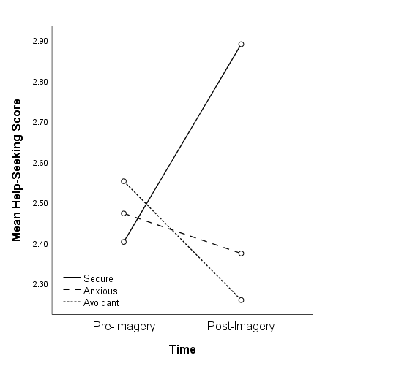
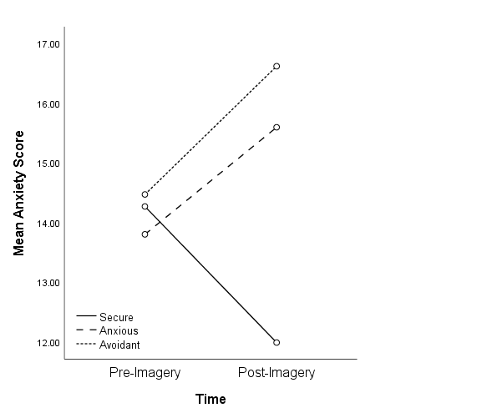
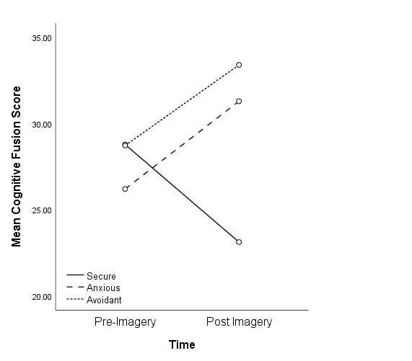
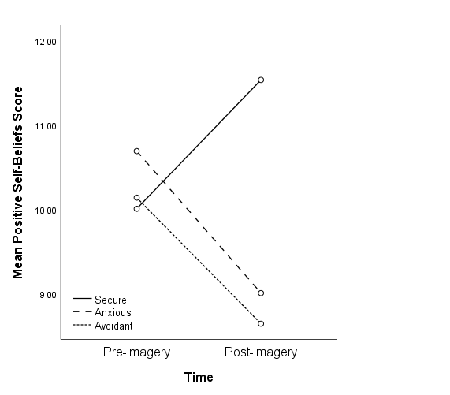
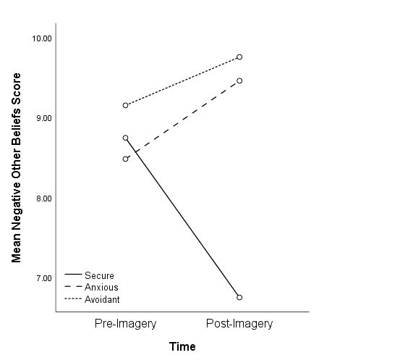
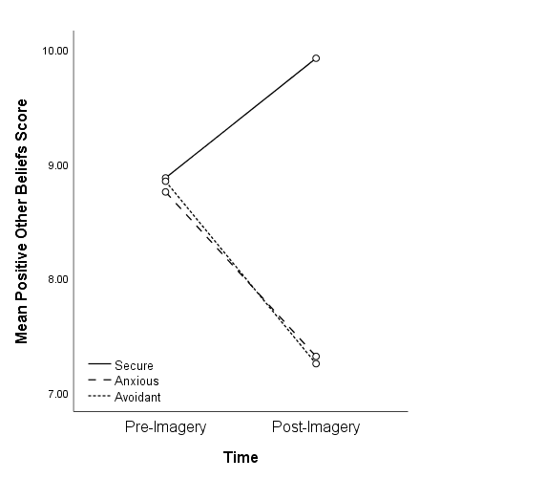
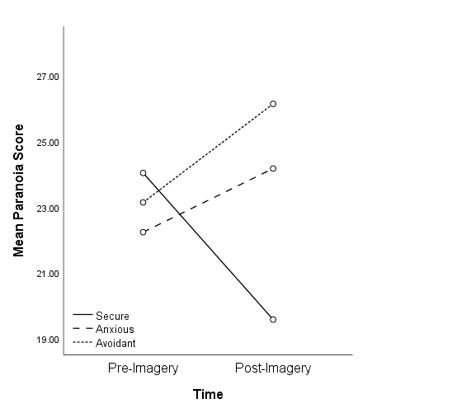
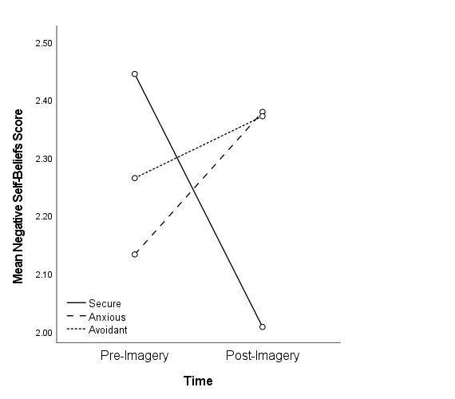
Change in State Variables Pre- and Post-Imagery in the Secure, Anxious, and Avoidant Attachment Imagery Conditions

Figure 2
Mediation Model of the Effect of Attachment Imagery on State Paranoia through Cognitive Fusion and Negative Self- and Other-Beliefs
Negative self-beliefs
Paranoia
Negative other-beliefs
D₁: Anxious vs.
Secure (ref)
D₂: Avoidant vs. Secure (ref)

Cognitive fusion
a₃₂= 2.61***
a₂₂= 2.52***
a₁₂= 10.33***
a₃₁= 2.98***
a₂₁= 3.06***
a₁₁= 10.75***
b₂= 0.41***
b₃= 0.44***
b₁= 0.30***
c’₂ = 2.19*
(c₂ = 7.46***)

c’₁ = 0.62
(c₁= 6.40***)

ref = reference category; c’ = relative direct effect, c = relative total effect. Estimated path coefficients are unstandardized.
* p < .05. *** p < .001
Figure 3
Mediation Model of the Effect of Attachment Imagery on State Anxiety through Cognitive Fusion and Negative Self- and Other-Beliefs
Negative self-beliefs
Anxiety
Negative other-beliefs
D₁: Anxious vs.
Secure (ref)
D₂: Avoidant vs. Secure (ref)

Cognitive fusion
a₃₂= 2.61***
a₂₂= 2.52***
a₁₂= 10.33***
a₃₁= 2.98***
a₂₁= 3.06***
a₁₁= 10.75***
b₂= 0.24***
b₃= 0.22***
b₁= 0.16***
c’₂ = 1.65***
(c₂ = 4.43***)

c’₁= 1.02*
(c₁= 4.08***)

ref = reference category; c’ = relative direct effect, c = relative total effect. Estimated path coefficients are unstandardized.
* p < .05. *** p < 001.
Figure 4
Mediation Model of the Effect of Attachment Imagery on State Help-Seeking Intentions through Cognitive Fusion and Negative Self- and Other-Beliefs
Negative self-beliefs
Help-Seeking Intention
Negative other-beliefs
D₁: Anxious vs.
Secure (ref)
D₂: Avoidant vs. Secure (ref)

Cognitive fusion
a₃₂=2.61***
a₂₂=2.52***
a₁₂=10.33***
a₃₁=2.98***
a₂₁=3.06***
a₁₁=10.75***
b₂= -0.03*
b₃= -0.03*
b₁= -0.01*
c’₂= -0.52***
(c₂= -0.78***)

c’₁= -0.30*
(c₁= -0.59***)

ref = reference category; c’ = relative direct effect, c = relative total effect. Estimated path coefficients are unstandardized.
* p < .05. *** p < 001.

Cronbach’s alphas reported in this section are for the current sample.
Attachment anxiety and avoidance were also measured using the Psychosis Attachment Measure (Berry et al., 2006, 2008) to assess concurrent validity of this measure with the ECR, which will be reported separately.
Post-hoc paired t-test statistics are reported in the supplementary material.
Correlations between all variables are reported in the supplementary material.
Relative specific indirect effects quantify the effect of anxious relative to secure imagery (D₁), and avoidant relative to secure imagery (D₂), on the outcome through each specific mediator.
Exploratory analyses testing whether trait attachment anxiety and avoidance moderated the effect of attachment imagery on state paranoia, anxiety, and help-seeking are reported in the supplementary material.
See supplementary material for statistical interpretations of partially standardized indirect effects.

