Title: The human dimension of biodiversity changes on islands
Authors: Sandra Nogué^{1*†,} Ana M. C. Santos^{2,3,4,5}, H. John B. Birks^{6,7}, Svante Björck⁸, Alvaro Castilla-Beltrán¹, Simon Connor^{9,10}, Erik J. de Boer¹¹, Lea de Nascimento^{12,13}, Vivian A. Felde⁶, José María Fernández-Palacios¹², Cynthia A. Froyd¹⁴, Simon G. Haberle^{9,10}, Henry Hooghiemstra¹⁵, Karl Ljung⁸, Sietze J. Norder¹⁶, Josep Peñuelas^{17,18}, Matthew Prebble^{9,19} Janelle Stevenson^{9,10}, Robert J. Whittaker^{20,21}, Kathy J. Willis²², Janet M. Wilmshurst^{13,23}, Manuel J. Steinbauer^{24,25*†}
Affiliations:
¹School of Geography and Environmental Science, University of Southampton, Highfield, SO17 1BJ Southampton, United Kingdom.
²cE3c – Centre for Ecology, Evolution and Environmental Changes, Faculdade de Ciências, Universidade de Lisboa, Lisboa, Portugal/Azores Biodiversity Group and Universidade dos Açores, Angra do Heroísmo, Azores, Portugal.
³GloCEE - Global Change Ecology and Evolution Group, Department of Life Sciences, Universidad de Alcalá, 28805 Alcalá de Henares, Madrid, Spain.
⁴Terrestrial Ecology Group (TEG), Departamento de Ecología, Universidad Autónoma de Madrid, Madrid, Spain.
⁵Centro de Investigación en Biodiversidad y Cambio Global (CIBC-UAM), Universidad Autónoma de Madrid, Madrid, Spain.
⁶Department of Biological Sciences and Bjerknes Centre for Climate Research, University of Bergen, PO Box 7803, N-5020 Bergen, Norway.
⁷Environmental Change Research Centre, University College London, Gower Street, WC1E 6BT London, United Kingdom.
⁸Department of Geology, Lund University, SE-223 62 Lund, Sweden.
⁹School of Culture, History & Language, College of Asia and the Pacific, Australian National University, ACT 2601, Australia.
¹⁰ARC Centre of Excellence for Australian Biodiversity and Heritage, Australian National University, ACT 2601, Australia.
¹¹Departament d'Estratigrafia, Paleontologia i Geociències Marines, Facultat de Ciències de la Terra, Universitat de Barcelona, Martí i Franquès s/n, 08028 Barcelona, Catalonia, Spain
¹²Island Ecology and Biogeography Group, Instituto Universitario de Enfermedades Tropicales y Salud Pública de Canarias (IUETSPC), Universidad de La Laguna (ULL), 38200 La Laguna, Canary Islands, Spain.
¹³Long-term Ecology Laboratory, Manaaki Whenua – Landcare Research, 7640 Lincoln, New Zealand.
¹⁴Department of Biosciences, Swansea University, Singleton Park, SA2 8PP Swansea, United Kingdom.
¹⁵Department of Ecosystem and Landscape Dynamics, Institute of Biodiversity and Ecosystem Dynamics (IBED), University of Amsterdam, Science Park 904, 1098XH Amsterdam, Netherlands.
¹⁶Leiden University Centre for Linguistics. PO Box 9515, 2300 RA Leiden, Netherlands.
¹⁷CSIC, Global Ecology Unit, CREAF-CSIC-UAB, Bellaterra, 08193 Barcelona, Catalonia, Spain.
¹⁸CREAF, Cerdanyola del Vallès, 08193 Barcelona, Catalonia, Spain
¹⁹School of Earth & Environment, College of Science, University of Canterbury, Christchurch 8140, New Zealand.
²⁰School of Geography and the Environment, University of Oxford, OX1 3QY Oxford, United Kingdom.
²¹Center for Macroecology, Evolution and Climate, GLOBE Institute, University of Copenhagen, University of Copenhagen, Universitetsparken 15, Copenhagen 2100, Denmark.
²²Oxford Long-Term Ecology Laboratory, Department of Zoology, University of Oxford, OX1 3PS Oxford, United Kingdom.
²³School of Environment, University of Auckland, 1142 Auckland, New Zealand.
²⁴Bayreuth Center of Ecology and Environmental Research (BayCEER) & Department of Sport Science, University of Bayreuth, 95447 Bayreuth, Germany.
²⁵Department of Biological Sciences, University of Bergen, PO Box 7803, N-5020 Bergen, Norway

*Correspondence to: s.nogue-bosch@soton.ac.uk, steinbauer@uni-bayreuth.de
† Equal contribution.

Abstract: Islands are among the last regions on Earth settled and transformed by human activities and provide replicated model systems for analysis of how people affect ecological functions. By analyzing 27 representative fossil pollen sequences encompassing the past 5000 years from islands globally, we quantify rates of vegetation compositional change before and after human arrival. Following human arrival, rates of turnover accelerate by a median factor of eleven, with faster rates on islands colonized in the past 1500 years than for those colonized earlier. This global anthropogenic acceleration in turnover suggests that islands are on trajectories of continuing change. Strategies for biodiversity conservation and ecosystem restoration must acknowledge the long duration of human impacts and the degree to which ecological changes today differ from pre-human dynamics.

One Sentence Summary: Accelerated rates of vegetation turnover in island ecosystems follow initial human settlement around the world

Main Text:

Globally, human activities dominate ecological systems (1, 2) and are considered the main drivers for accelerating contemporary ecosystem transformation (3-6). The pressing need to evaluate the extent and dimensions of human impacts as well as the desire to restore ‘wild’ systems have sparked controversy concerning the value of establishing pre-human baselines (7-9) and on the nature and timing of the onset of the Anthropocene (10-12). Archaeological and other paleodata on human impacts in continental systems reveal an increasingly human-transformed planet intensifying around the end of the Pleistocene (2,13,14). The lengthy time frame of human modification of ecosystem dynamics in continental contexts, spanning periods of substantial post-glacial climate change, complicates the definition of pre-human baselines and hinders the investigation of natural ecosystem processes (15,16).

In contrast to continents, most remote oceanic islands were colonized by people relatively recently, within the past three thousand years, when climates were similar to present conditions (17). The recent nature of human settlement means that the archaeological, paleoecological, and climate records are often more precisely resolved on well-studied islands compared with continents, and potentially more relevant for understanding remnant ecosystems and informing conservation and ecosystem restoration agendas. Hence, island ecosystems provide opportunities to quantify the critical ecological transition from pre-human to human-dominated ecosystems (4, 15), and allow anthropogenic impacts on ecosystems to be placed within the context of long-term pre-human ecological dynamics (16-20). While numerous studies have documented the timing, waves, and processes of species extinctions that accompanied human arrival on islands (18-24), paleoecological data networks now allow systematic quantification of ecosystem transformations on islands globally. Here, we analyze fossil pollen time-series for multiple independent islands from all the major archipelagos and oceans and across latitudes, using a breakpoint regression approach to test for altered rates and directionality of pollen and hence vegetation compositional turnover connected with human colonization (25) within an overall timeframe of the past 5000 years. These time-series of millennial-scale dynamics allow the assessment of whether the rates of vegetation compositional change consistently accelerated across multiple islands following initial human arrival. Our method employs ordination analyses to characterize the major gradient of compositional variation in the pollen data for each island, quantifying the mean rate of change through time pre- and post-human arrival (Fig. 1), thereby allowing us to assess how human populations impacted islands differently from natural perturbations (23).

Our results show that human arrival systematically accelerated directional compositional change in island ecosystems (Figs. 1 and 2). Rates of pollen compositional turnover increase following human arrival by up to a factor of eleven, with large differences amongst islands (i.e. a median of 10.7 times higher turnover after human arrival, with a mean of 20.8 ±26.5 times higher turnover). This acceleration is a globally consistent pattern observed on 24 out of 27 islands, independent of current and past island area, latitude, isolation, and elevation of the sampling site (Fig. 3B-3G; Tables S3, S4; 25). Islands that were settled more recently, such as Poor Knights (13th century)(19) and the Galápagos Islands (16th century)(26), show a steeper increase in the rate of turnover change (p=0.008, R²: 0.22; linear regression with log-transformed (arrival time), Fig. 3A) than on islands where humans arrived >1500 years ago (e.g. New Caledonia (27) and Fiji (28)). This indicates either that the islands settled earlier were more resilient to human arrival or more likely that the recent major compositional turnover observed is explained by introduced species, land-use practices, and technology deployed by later settlers being more transformative than those of earlier settlers. In addition, those islands colonized >3000 years ago appear to show some declines in rates of compositional turnover towards the end of the sequence, although there are too few cases (n=5) to draw firm conclusions.

For many islands, the model implementing a prescribed breakpoint at the time of human arrival closely fits the observed patterns in compositional turnover (Fig. 1). Human arrival estimates fall within the 95% confidence intervals of the optimal breakpoints (representing the greatest change in turnover in each record) for 41% of islands. Human arrival times are within 500 years of the optimal breakpoint for 70% of islands and within 1000 years for 81% of islands (median 329 years compared to 953 for randomized data simulations, Table S5 and Fig. 2). There is no tendency for optimized breakpoints to be systematically earlier or later than estimated human arrival time (t-test with null model of mean difference being 0, p=0.27). A systematic difference would have either indicated earlier human arrival or delayed human impact. On some islands, initial human arrival is not associated with a major shift in turnover (see 25 and Figs. 1 and S1). These results might reflect the specific local characteristics of the study site. For example, on La Gomera (Canary Islands), the sedimentary sequence was collected at an elevation of 1250 m above sea level (asl) in one of the largest remnant areas of laurel forest, where paleoecological analyses showed no evidence of human impacts (29). On other islands, e.g. Hispaniola, shifts in vegetation turnover differ from the time of human arrival that we estimated based on archaeological or historical sources, but the rate of directional change increases (Fig. 1).

Our analysis also shows that ecological change is an integral part of island systems, with changes observed both before recorded human arrivals (median turnover 1.7 x 10⁻² [SD_{ptt}/100 years] and mean 4.0 ± 6.8 x 10⁻² [SD_{ptt}/100 years]; directional change in composition measured in standard deviations of pollen taxon turnover (SD_{ptt}) per 100 years) and after human arrival (median turnover 14.7 x 10⁻² [SD_{ptt}/100 years] and mean 23.3 ± 29.8 x 10⁻² [SD_{ptt}/100 years]) (Fig. 2). Results show that the rate of directional turnover prior to human arrival was slower, in contrast to human agencies of change. Natural drivers of ecosystem change on islands, operating before and alongside humans include: volcanic activities, fire, climate change (episodes such as the ‘Little Ice Age’), earthquakes, extreme weather events (e.g. droughts and cyclones), and sea-level fluctuations (20, 30, 31). While not measurable with the precision to include formally within our analysis, volcanic activities and natural climate fluctuations have likely not increased over the analyzed timeframe across the islands studied and thus cannot explain the systematic increase and varied timing of directional turnover observable across islands (25). Climate warming in the last 50 years, in contrast, is too recent to be detectable within our dataset. Over the timeframe of the last five thousand years, direct human impacts greatly outweigh other processes that have shaped island biodiversity and species interactions (32, 33).

Moreover, ecological legacies of human arrival on islands may persist for centuries and are often irreversible. An example is Tawhiti Rahi in the Poor Knights archipelago, New Zealand, which is currently uninhabited (19). Immediately following initial arrival by Polynesians in the 13th century, the island’s forest cover was cleared by fire for human habitation and gardens. After a massacre of local Ngatiwai inhabitants on Tawhiti Rahi in 1820, local kaitiaki (guardians) declared the islands wahi tapu (protected by a sacred covenant), after which time there was no subsequent settlement. Despite the island becoming totally reforested within 150 years, the current forest composition is completely different to that of the pre-human period. In contrast to the Poor Knights archipelago, most currently inhabited islands have experienced at least two distinct waves of settlement, each with distinctive signatures of change and leaving increasingly complex legacies (24,30).

Preparing and managing for ecosystem change is one of the major challenges that island societies currently face as islands experience continued or accelerated threats from detrimental land-use practices (12), novel species invasions (24, 34), sea-level rise (35), and climate change (11, 17) in addition to naturally occurring disturbances. The challenges are made more difficult as these processes are affecting native ecosystems where vegetation communities have already been severely degraded or lost, species have gone extinct (15, 21), and important mutualistic plant–animal interactions have been disrupted (36). Our results show little indication that these human-impacted ecosystems are either similar to, or returning to, the dynamic baselines observed prior to human arrival. Hence, anthropogenic impacts on islands are lasting components of these systems, typically involving initial clearance (e.g. using fire), and then compounded by the introduction of a range of introduced species and extinctions of endemic species and ongoing disturbances. This contrasts with turnover following natural disturbances in the pre-human period, when island ecosystems often recovered rapidly to pre-disturbance states (e.g, 20, 31). While for many islands, widescale return to pre-colonization ecosystems is an unrealistic goal, paleoecological data, such as analyzed here, may serve to inform targeted ecosystem restoration efforts within islands, providing insights into previous system states and their responsiveness to global change processes (9, 37).

Reference and Notes:

- P. M. Vitousek, H. A. Mooney, J. Lubchenco, J. M. Melillo, Human domination of Earth’s ecosystems. Science 277, 7 (1997).
- L. Stephens, D. Fuller, N. Boivin, T. Rick, N. Gauthier, A. Kay, et al., Archaeological assessment reveals Earth’s early transformation through land use. Science 365, 897–902 (2019).
- S. E. Connor, J. F. N. van Leeuwen, T. M. Rittenour, W. O. van der Knaap, B. Ammann, S. Björck, The ecological impact of oceanic island colonization – a palaeoecological perspective from the Azores. J. Biogeogr. 39, 1007–1023 (2012).
- S. Nogué, L. de Nascimento, C. A. Froyd, J. M. Wilmshurst, E. J. de Boer, E. E. D. Coffey, et al. Island biodiversity conservation needs palaeoecology. Nat. Ecol. Evol. 1, 0181 (2017).
- W. Steffen, W. Broadgate, L. Deutsch, O. Gaffney, C. Ludwig, The trajectory of the Anthropocene: The great acceleration. Anthropocene Rev. 2, 81–98 (2015).
- M. J. Steinbauer, J.-A. Grytnes, G. Jurasinski, A. Kulonen, J. Lenoir, H. Pauli, et al., Accelerated increase in plant species richness on mountain summits is linked to warming. Nature 556, 231–234 (2018).
- K. J. Willis, R. M. Bailey, S. A. Bhagwat, H. J. B. Birks, Biodiversity baselines, thresholds and resilience: testing predictions and assumptions using palaeoecological data. Trends Ecol. Evol. 25, 583–591 (2010).
- R. J. Hobbs, S. Arico, J. Aronson, J. S. Baron, P. Bridgewater, V. A. Cramer, et al., Novel ecosystems: theoretical and management aspects of the new ecological world order. Global Ecol. Biogeogr. 15, 1–7 (2006).
- A.D. Barnosky, E. A. Hadly, P. Gonzalez, J. Head, P. D. Polly, P. D., A. M Lawing, et al., Merging paleobiology with conservation biology to guide the future of terrestrial ecosystems. Science 355, 6325 (2017).
- W. F. Ruddiman, Three flaws in defining a formal ‘Anthropocene’. Prog. Phys. Geog. 42, 451–461 (2018).
- J. Zalasiewicz, C. N. Waters, M. J. Head, C. Poirier, C. P. Summerhayes, R. Leinfelder, J. et al., A formal Anthropocene is compatible with but distinct from its diachronous anthropogenic counterparts: a response to W.F. Ruddiman’s ‘three flaws in defining a formal Anthropocene’. Prog. Phys. Geog. 43, 319–333 (2019).
- C. S. M. Turney, J. Palmer, M. A. Maslin, A. Hogg, C. J. Fogwill, J. Southon, et al., Global peak in atmospheric radiocarbon provides a potential definition for the onset of the Anthropocene Epoch in 1965. Sci. Rep. 8, 3293 (2018).
- E. C. Ellis, D. Q. Fuller, J. O. Kaplan, W. G. Lutters, Dating the Anthropocene: Towards an empirical global history of human transformation of the terrestrial biosphere. Elementa: Science of the Anthropocene. 1 (2013), doi:10.12952/journal.elementa.000018.

- Y. Malhi, C. E. Doughty, M. Galetti, F. A. Smith, J.-C. Svenning, J. W. Terborgh, Megafauna and ecosystem function from the Pleistocene to the Anthropocene. Proc Natl Acad Sci USA. 113, 838 (2016).

- H. J. B. Birks, Contributions of Quaternary botany to modern ecology and biogeography. Plant. Ecol. Divers. 12, 189–385 (2019).
- J. R. Wood, G. L. W. Perry, J. M. Wilmshurst, Using palaeoecology to determine baseline ecological requirements and interaction networks for de-extinction candidate species. Funct. Ecol. 31, 1012–1020 (2017).
- C. Nolan, J. T. Overpeck, J. R. M. Allen, P. M. Anderson, J. L. Betancourt, H. A. Binney, S. et al.. Past and future global transformation of terrestrial ecosystems under climate change. Science 361, 920–923 (2018).
- W. D. Gosling, D. A. Sear, J. D. Hassall, P. G. Langdon, M. N. T. Bönnen, T. D. Driessen, et al. Human occupation and ecosystem change on Upolu (Samoa) during the Holocene. J. Biogeogr. 47, 600–614 (2020).
- J. M. Wilmshurst, N. T. Moar, J. R. Wood, P. J. Bellingham, A. M. Findlater, J. J. Robinson, C. Stone, Use of pollen and ancient DNA as conservation baselines for offshore islands in New Zealand. Conserv. Biol. 28, 202–212 (2014).
- J. M. Wilmshurst, M. S. McGlone, T. R. Partridge, A late Holocene history of natural disturbance in lowland podocarp/hardwood forest, Hawke’s Bay, New Zealand. N. Z. J. Bot. 35, 79–96 (1997).
- D.W. Steadman, Prehistoric extinctions of Pacific Islands birds: Biodiversity meets Zooarchaeology. Science 267, 1123–1131 (1995).
- D. A. Burney, T. F. Flannery, Fifty millennia of catastrophic extinctions after human contact. Trends Ecol. Evol. 20, 395–401 (2005).
- R. J. Whittaker, J. M. Fernández-Palacios, Island Biogeography: Ecology, Evolution, and Conservation (Oxford Univ. Press, 2007).
- J. R. Wood, J. A. Alcover, T. M. Blackburn, P. Bover, R. P. Duncan, J. P. Hume, et al., Island extinctions: processes, patterns, and potential for ecosystem restoration. Environ. Conserv. 44, 348–358 (2017).
- Materials and methods are available as supplementary materials at the Science website.
- A. Restrepo, P. Colinvaux, M. Bush, A. Correa-Metrio, J. Conroy, M. R. Gardener, P. Jaramillo, M. Steinitz-Kannan, J. Overpeck, Impacts of climate variability and human colonization on the vegetation of the Galápagos Islands. Ecology 93,1853–1866 (2012).
- J. Stevenson, R. Dodson, I. P. Prosser, A late Quaternary record of environmental change and human impact from Plum Swamp, New Caledonia. Palaeogeogr. Palaeoclimatol. Palaeoecol. 168, 97–123 (2001).
- G. Hope, J. Stevenson, W. Southern, Vegetation histories from the Fijian Islands: Alternative records of human impact, in G. Clark, Ed. The early prehistory of Fiji. Terra Australis 31 (ANU ePress, Canberra, ACT, Australia, 2009), pp. 63–86.
- S. Nogué, L. de Nascimento, J. M. Fernández-Palacios, R. J. Whittaker, K. J. Willis, The ancient forests of La Gomera, Canary Islands, and their sensitivity to environmental change. J. Ecol. 101, 368–377 (2013).
- B. Rolett, J. Diamond, Environmental predictors of pre-European deforestation on Pacific islands. Nature 431, 443–446 (2004).
- J. M. Wilmshurst, M. S. McGlone, Forest disturbance in the central North Island, New Zealand, following the. 1850 BP Taupo eruption. The Holocene 6, 399-411 (1996).
- M. R. Helmus, D. L. Mahler, J. B. Losos, Island biogeography of the Anthropocene. Nature 513, 543–546 (2014).
- H. Kreft, W. Jetz, J. Mutke, G. Kier, W. Barthlott, Global diversity of island floras from a macroecological perspective. Ecol. Lett. 11, 116–127 (2008).
- D. Moser, B. Lenzner, P. Weigelt, W. Dawson, H. Kreft, J. Pergl, et al., Remoteness promotes biological invasions on islands worldwide. Proc. Natl. Acad. Sci. U.S.A. 115, 9270 (2018).
- S. J. Norder, J. B. Baumgartner, P. A. V. Borges, et al., A global spatially explicit database of changes in island palaeo‐area and archipelago configuration during the late Quaternary. Global Ecol. Biogeogr. 27, 500– 505 (2018).
- C. N. Kaiser-Bunbury, A. Traveset, D. M. Hansen, Conservation and restoration of plant–animal mutualisms on oceanic islands. Perspect. Plant Ecol. Evol. Syst. 12, 131–143 (2010).
- J.-C. Svenning, Proactive conservation and restoration of botanical diversity in the Anthropocene’s “rambunctious garden”. Am. J. Bot. 105(6), 963–966 (2018).
- S. Goring, A. Dawson, G. L. Simpson, K. Ram, R. W. Graham, E. C. Grimm, J. W. Williams, Neotoma: a programmatic interface to the Neotoma palaeoecological database. Open Quat. 1, art.2 (2015).
- J. Haslett, A.C. Parnell, A simple monotone process with application to radiocarbon-dated depth chronologies. J. R. Stat. Soc. Ser. C Appl. Stat. 57, 399-41 (2008).
- A. C. Parnell, J. Haslett, J. R. M. Allen, C.E. Buck, B. Huntley, A flexible approach to assessing synchroneity of past events using Bayesian reconstructions of sedimentation history. Quat. Sci. Rev. 271872–1885 (2008).
- J. Van der Plicht, C. Bronk Ramsey, T. Heaton, E. Scott, S. Talamo, Recent developments in calibration for archaeological and environmental samples. Radiocarbon 1–23. (2020).
- M. Blaauw, clam: Classical Age-Depth Modelling of Cores from Deposits. R package version 2.3.5. (2020). (available at CRAN.R-project.org/package=clam).
- R Core Team, R: A language and environment for statistical computing. R Foundation for Statistical Computing, Vienna, Austria (2019) (available at www.R-project.org).
- J. Oksanen, F. G. Blanchet, M. Friendly, R. Kindt, P. Legendre, D. McGlinn, P. R. Minchin, R. B. O’Hara, G. L. Simpson, P. Solymos, M. H. H. Stevens, E. Szoecs, H. Wagner, vegan: Community Ecology Package (2019) (available at CRAN.R-project.org/package=vegan).
- M. O. Hill, H. G. Gauch, Detrended correspondence analysis: an improved ordination technique, In E. van der Maarel, Ed. Classification and Ordination. Advances in Vegetation Science, vol. 2. (Springer, Dordrecht, 1980).
- P. Breheny, W. Burchett, Visualization of regression models using visreg. The R Journal 9, 56 (2017).
- V.M.R. Muggeo. Interval estimation for the breakpoint in segmented regression: a smoothed score‐based approach. Aust N Z J Stat 59, 311-322 (2017).
- L. Anderson, D.B Wahl, T. Bhattacharya, Understanding rates of change: a case study using fossil pollen records from California to assess the potential for and challenges to a regional data synthesis. Quat. Int. https://doi.org,/10.1016/jquaint.2020.04.044/(2020).

- E.C. Grimm, G.L, Jacobson, 1992. Fossil-pollen evidence for abrupt climate changes during the past 18000 years in eastern North America. Clim. Dyn. 6, 179–184 (1992).

- C.J.F. Ter Braak, P. Šmilauer, Canoco reference manual and user’s guide: software for ordination (version 5). Microcomputer Power, Ithaca, New York, (2012).

- J. Braje, J. M. Erlandson, Human acceleration of animal and plant extinctions: A Late Pleistocene, Holocene, and Anthropocene continuum. The Anthropocene 4, 14-23 (2013).
- D. W. Steadman, Extinction & biogeography of tropical Pacific birds. (University of Chicago Press, 2007).
- H. Kreft, W. Jetz, Global patterns and determinants of vascular plant diversity. Proc. Natl. Acad. Sci. U.S.A. 104, 5925–5930 (2007).
- A. H. Harcourt, Human Biogeography (1st ed.). (University of California Press, JSTOR, 2012).
- S. J. Norder, R. F. de Lima, L. de Nascimento, J. Y. Lim, J. M. Fernández-Palacios, M.M. Romeiras, R. B. Elias, et al., Global change in microcosms: Environmental and societal predictors of land cover change on the Atlantic Ocean Islands, Anthropocene 30, 2213–3054 (2020).
- A. Chiarucci, S. Fattorini, B. Foggi, L. Sara, L. Lazzaro, J. Podani et al, Plant recording across two centuries reveals dramatic changes in species diversity of a Mediterranean archipelago. Sci. Rep. 7, 5415 (2017).
- R. H. MacArthur, E.O. Wilson, The theory of island biogeography (1st ed.). (Princeton University Press 1967).
- S. J. Norder, K. Proios, R. J. Whittaker, M. R. Alonso, P. A. V. Borges, M. K. Borregaard, et al., Beyond the Last Glacial Maximum: Island endemism is best explained by long‐lasting archipelago configurations. Global Ecol. Biogeogr. 28, 184–197. (2019).
- P. Weigelt, H. Kreft, Quantifying island isolation – Insights from global patterns of insular plant species richness. Ecography 36, 417–429 (2013).
- S. J. Wright, How isolation affects rates of turnover of species on islands. Oikos 44(2), 331-340 (1985).
- H. Shaefer, Flora of the Azores (2nd edition). (Margraf Publishers, Weikersheim, 2005).

- V. Rull, A. Lara, M. J. Rubio-Inglés, S. Giralt, V. Gonçalves, P. Raposeiro, et al., Vegetation and landscape dynamics under natural and anthropogenic forcing on the Azores Islands: A 700-year pollen record from the São Miguel Island. Quat. Sci. Rev. 159, 155–168 (2017).

- K. D. Patterson, Epidemics, famines, and population in the Cape Verde Islands, 1580-1900. Int. J. Afr. Hist. Stud. 21, 291–313 (1988).

- J.Velasco, V, Alberto, T. Delgado, M. Moreno, C. Lecuyer, P. Richardin, P, Poblamiento, colonización y primera historia de Canarias: el C14 como paradigma. Anu. Estud. Atl. 66, 1e24 (2019).

- L. de Nascimento, S.Nogué, A.Naranjo-Cigala, C. Criado, M. McGlone, E. Fernández-Palacios, et al., Human impact and ecological changes during prehistoric settlement on the Canary Islands, Quat. Sci. Rev. 239, 106332 (2020).

- M. Arnay-de-la-Rosa, A. Gámez-Mendoza, J. F. Navarro-Mederos, J. C. Hernández-Marrero, R. Fregel, Y. Yanes, L. Galindo-Martín, C.S. Romanek, E. González-Reimers, Dietary patterns during the early prehispanic settlement in La Gomera (Canary Islands). J. Arch. Sci. 36, 1972–1981 (2009).

- J. C. Rando, J. A. Alcover, B. Galván, J. F. Navarro, Reappraisal of the extinction of Canariomys bravoi, the giant rat from Tenerife (Canary Islands). Quat. Sci. Rev. 94, 22–27 (2014).

- S. B. Cooke, L. M. Dávalos, A. M. Mychajliw, S. T. Turvey, N. S. Upham, Anthropogenic extinction dominates Holocene declines of West Indian mammals. Annu. Rev. Ecol. Evol. Syst. 48, 301–327 (2017).

- J. K. Headland, Chronological list of Antarctic expeditions and related historical events. (Cambridge University Press, Cambridge, 1989).

- M. Halsdóttir, Pollen analytical studies of human influence on vegetation in relation to the Landnám tephra layer in southwest Iceland. Lundqua Thesis, 18, 45 pp (1987).

- A. Cheke, J. P. Hume, Lost land of the dodo. An ecological history of the Mascarene Islands. (Bloomsbury, 2008).

- T. M. Reith, E. E. Cochrane, The chronology of colonization in remote Oceania, in The Oxford Handbook of Prehistoric Oceania, T. L. Hunt, E. E. Cochrane, Eds. (Oxford University Press, Oxford, 2017).

- F. Petchey, M. Spriggs, F. Leach, M. Seed, C. Sand, M. Pietrusewsky, K. Anderson, Testing the human factor: radiocarbon dating the first peoples of the South Pacific. J. Arch. Sci. 38, 29–44 (2011).

- P. A. Colinvaux, E. K. Schofield, Historical ecology in the Galápagos Islands, Holocene pollen record from El Junco Lake, Isla San Cristobal. J. Ecol. 64, 989–1012 (1976).

- C. A. Froyd, J. A. Lee, A. J. Anderson, S. G. Haberle, P. E. Gasson, K. J. Willis, Historic fuel wood use in the Galápagos Islands: identification of charred remains. Veget. Hist. Archaeobot. 19, 207–217 (2010).

- T. M. Rieth, T. L. Hunt, C. Lipo, J. M. Wilmshurst, The 13th century Polynesian colonization of Hawai’i Island. J. Arch. Sci. 38, 2740–2749 (2011).

- A. Anderson, S. Haberle, G. Rojas, A. Seelenfreund, I. Smith, T. Worthy, An archaeological exploration of Robinson Crusoe Island, Juan Fernandez Archipelago, Chile, in Fifty years in the field. Essays in honour and celebration of Richard Shutler Jr’s archaeological career, S. Bedford, C. Sand, D. Burley, Eds. (Auckland: New Zealand Archaeological Association Publications, 2002).

- J. M. Wilmshurst, A.J. Anderson, T.F.G. Higham, T.H. Worthy, Dating the late prehistoric dispersal of Polynesians to New Zealand using the commensal Pacific rat. Proc. Natl. Acad. Sci. U.S.A. 105 (22), 7676–7680 (2008).

- R. Green, A retrospective view of settlement pattern studies in Samoa. In: Pacific landscapes. Archaeological approaches, T. N. Ladefoged, M. W. Graves, Eds. (Los Osos: Easter Island Foundation, Bearsville Press 2002).

- J. G. Kahn, Y. Sinoto, Refining the Society Islands cultural sequence: Colonization phase and developmental phase coastal occupation on Mo’orea Island. J. Polynesian Soc. 126, 33–60 (2017).

- J. M. Wilmshurst, T. L. Hunt, C. P. Lipo, A. J. Anderson, High-precision radiocarbon dating shows recent and rapid initial human colonization of East Polynesia. Proc. Natl. Acad. Sci. U.S.A. 108, 1815–1820 (2011).

- S. Björck, T. Rittenour, P. Rosén, Z. França, P. Möller, I. Snowball, S. Wastegård, O. Bennike, B. Kromer, A Holocene lacustrine record in the central North Atlantic: proxies for volcanic activity, short-term NAO mode variability and long-term precipitation changes. Quat. Sci. Rev. 25, 9–32 (2006).
- A. Castilla-Beltrán, I. Duarte, L. de Nascimento, J. M. Fernández-Palacios, M. Romeiras, R. J. Whittaker, M. Jambrina-Enríquez, C. Mallol, A. B. Cundy, M. E. Edwards, S. Nogué, Using multiple palaeoecological indicators to guide biodiversity conservation in tropical dry islands: the case of São Nicolau, Cabo Verde. Biol. Cons. 242, 108397 (2020).
- A. Castilla-Beltrán, L. de Nascimento, J. M. Fernández-Palacios, T. Fonville, R. J. Whittaker, M. E. Edwards, S. Nogué, Late Holocene environmental change and the anthropization of the highlands of Santo Antão Island, Cabo Verde. Palaeogeogr. Palaeoclimatol. Palaeoecol. 524, 101–117 (2019).
- L. de Nascimento, S. Nogué, C. Criado, C. Ravazzi, R. J. Whittaker, K. J. Willis, J. M. Fernández-Palacios, Reconstructing Holocene vegetation on the island of Gran Canaria before and after human colonization. The Holocene 26, 113–125 (2016).
- L. de Nascimento, K. J. Willis, J. M. Fernández-Palacios, C. Criado, R. J. Whittaker, The long-term ecology of the lost forests of La Laguna, Tenerife (Canary Islands). J. Biogeogr. 36, 499–514 (2009).
- S. D. Crausbay, P. H. Martin, E. F. Kelly, Tropical montane vegetation dynamics near the upper cloud belt strongly associated with a shifting ITCZ and fire. J. Ecol. 103, 891–903 (2015).
- K. Ljung, S. Björck, Holocene climate and vegetation dynamics on Nightingale Island, South Atlantic – an apparent interglacial bipolar seesaw in action? Quat. Sci. Rev. 26, 3150–3166 (2007).
- K. Ljung, S. Björck, D. Hammarlund, L. Barnekow, Late Holocene multi-proxy records of environmental change on the South Atlantic island Tristan da Cunha. Palaeogeogr. Palaeoclimatol. Palaeoecol. 241, 539–560 (2006).
- M. Halsdóttir, Pollen analytical studies of human influence on vegetation in relation to the Landnám tephra layer in southwest Iceland. Lundqua Thesis, 18, 45 pp (1987).
- E. J. de Boer, H. Hooghiemstra, F. B. Vincent Florens, C. Baider, S. Engels, V. Dakos, M. Blaauw, K. D. Bennett, Rapid succession of plant associations on the small ocean island of Mauritius at the onset of the Holocene. Quat. Sci. Rev. 68, 114–125 (2013).
- W. Southern, The Late Quaternary environmental history of Fiji, PhD Thesis. (Australian National University, Canberra, 1986).
- G. Hope, J. Stevenson, W. Southern, Vegetation histories from the Fijian Islands: Alternative records of human impact, In: The early prehistory of Fiji, G. Clark, Ed. (ANU ePress, Canberra, ACT, Australia, 2009).
- S. Pau, G. M. MacDonald, T. W. Gillespie, A dynamic history of climate change and human impact on the environment from Keālia Pond, Maui, Hawaiian Islands. Ann. Am. Assoc. Geogr. 102, 748–762 (2012).
- S. G. Haberle, Late Quaternary vegetation dynamics and human impact on Alexander Selkirk Island, Chile. J. Biogeogr. 30, 239–255 (2003).
- A. J. Anderson, S. G. Haberle, G. Rojas, A. G. Seelenfreund, I. W. Smith, I. W. T. Worthy, An archaeological exploration of Robinson Crusoe Island, Juan Fernandez Archipelago, Chile, In: Fifty years in the field: essays in honour and celebration of Richard Shutler Jr’s archaeological career, S. Bedford, C. Sand, D. Burley, Eds. (New Zealand Archaeological Association Monograph 25, 2002).
- S. G. Haberle, Juan Fernandez Islands, In: Encyclopedia of Islands, R. Gillespie, D. A. Clague, Eds. (University of California Press, Berkeley, CA, 2009).
- S. J. Holdaway, J. Emmitt, L. Furey, A. Jorgensen, G. O’Regan, R. Phillipps, M. Prebble, R. Wallace, T. N. Ladefoged, Māori settlement of New Zealand: The Anthropocene as a process. Arch. Oceania 54, 17–34 (2019).
- M. Prebble, A. J. Anderson, P. Augustinus, J. Emmitt, S. J. Fallon, L. L. Furey, S. J. Holdaway, A. Jorgensen, T. N. Ladefoged, P. J. Matthews, J. Y. Meyer, R. Phillipps, R. Wallace, N. Porch, Early tropical crop production in marginal subtropical and temperate Polynesia. Proc. Natl. Acad. Sci. U.S.A., 201821732 (2019).
- J. Stevenson, A. Benson, J. S. Athens, J. Kahn, P. V. Kirch, Polynesian colonization and landscape changes on Mo’orea, French Polynesia: The Lake Temae pollen record. The Holocene 27, 1963–1975 (2017).
- M. Prebble, J. M. Wilmshurst, Detecting the initial impact of humans and introduced species on island environments in remote Oceania using palaeoecology. Biol. Inv. 11, 1529–1556 (2009).
- D. Kennett, A. Anderson, M. Prebble, E. Conte, J. Southon, Prehistoric human impacts on Rapa, French Polynesia. Antiquity 80, 340–354 (2006).
- M. Prebble, A. Anderson, D. J. Kennett, Forest clearance and agricultural expansion on Rapa, Austral Archipelago, French Polynesia. The Holocene 23, 179–196 (2013).
- D.A. Sear, M.S. Allen, J.D. Hassall, A.E. Maloney, P.G. Langdon, A.E. Morrison. Human settlement of East Polynesia earlier, incremental, and coincident with prolonged South Pacific drought. Proc. Natl. Acad. Sci. U.S.A., 117, 8813-8819 (2020).
- J. W. Williams, E.G. Grimm, J. Blois, D.F. Charles, E. Davis, S.J. Goring, et al., The Neotoma Paleoecology Database: A multi-proxy, international community-curated data resource. Quat. Res. 89, 156–177 (2018).
- R. M. Fyfe, J. L. de Beaulieu, H. Binney, R. H. W. Bradshaw, S. Brewer, A. Le Flao, W. Finsinger, et al, The European Pollen Database: past efforts and current activities. Veg. Hist. Archaeobot. 18, 417-424 (2009).
- P. de Menocal, J. Ortiz, T. Guilderson, J. Adkins, M. Sarnthein, L. Baker, et al. Abrupt onset and termination of the African Humid Period: rapid climate responses to gradual insolation forcing. Quat. Sci. Rev. 19, 347–361 (2000).
- H. Li, A. Sinha, A. Anquetil André, C. Spötl, H. B. Vonhof, A. Meunier, et al, A multimillennial climatic context for the megafaunal extinctions in Madagascar and Mascarene Islands. Sci. Adv. 6, eabb2459 (2020).
- E. J. de Boer, M. I. Vélez, K. F. Rijsdijk, P. G. B. de Louw, T. J. J. Vernimmen, P.M. Visser, R. Tjallangii, H. Hooghiemstra, A deadly cocktail: How a drought around 4200 cal. yr BP caused mass mortality events at the infamous ‘dodo swamp’ in Mauritius. The Holocene 25, 758-771 (2013)
- A. G. Hogg, T. F. G. Higham, D. J. Lowe, J. G. Palmer, P. J. Reimer, R. M. Newnham, A wiggle-match date for Polynesian settlement in New Zealand. Antiquity 77, 116-125 (2003).
- G. F. Camoin, L. Montaggioni, C. Braithwaite, Late glacial to post glacial sea-levels in the Western Indian Ocean. Mar. Geol. 206, 119–146 (2004).

Acknowledgements: Funding: A.M.C.S was supported by a “Juan de la Cierva” Fellowship (IJCI-2014-19502) funded by the Spanish ‘Ministerio de Ciencia, Innovación y Universidades’, and by the Portuguese “Fundação para a Ciência e a Tecnología” (contract CEEIND/03425/2017). H.J.B.B., V.A.F., and M.J.S. acknowledge support from the European Research Council under the EU H2020 research and innovation programme (grant 741413 HOPE) Humans on Planet Earth – Long-term impacts on biosphere dynamics. J.P. was supported by the European Research Council grant ERC-SyG-2013-610028 IMBALANCE-P. L.dN. was supported by the European Union’s Horizon 2020 research and innovation programme under the Marie Skłodowska-Curie grant agreement No 700952. M.J.S was supported by the Deutsche Forschungsgemeinschaft (STE 2360/2-1 embedded in the Research Unit TERSANE FOR 2332). S.B and K.L were supported by several grants from the Swedish Research Council (VR). S.N acknowledges support from the Worldwide Universities Network (WUN) Research Mobility Programme and a generous sabbatical granted by the School of Geography and Environmental Science (University of Southampton). S.J.N gratefully acknowledges support from the European Research Council under the EU H2020 and Research and Innovation programme (grant 818854 SAPPHIRE). Author contributions: S.N. and M.J.S. led, analyzed the datasets, and wrote the paper together with all authors: A.M.C.S., H.J.B.B., S.B., A.C.B., J.M.W., S.C., E.J.d.B., L.dN., V.A.F., J.M.F.P., C.A.F., S.G.H., H.H., K.L., S.J.N., J.P., M.P., J.S., R.J.W., K.J.W. All authors contributed in the discussion. Competing interests: The authors declare no competing interests. Data and materials availability: Data and code are available at github.com/ManuelSteinbauer/biodiversity-changes-on-islands.

Supplementary Materials:
Materials and Methods
Figure S1
Figure S2
Figure S3
Figure S4

Table S1
Table S2
Table S3 and Box 1
Table S4 and Background information
Table S5
Citations to References (38-111)
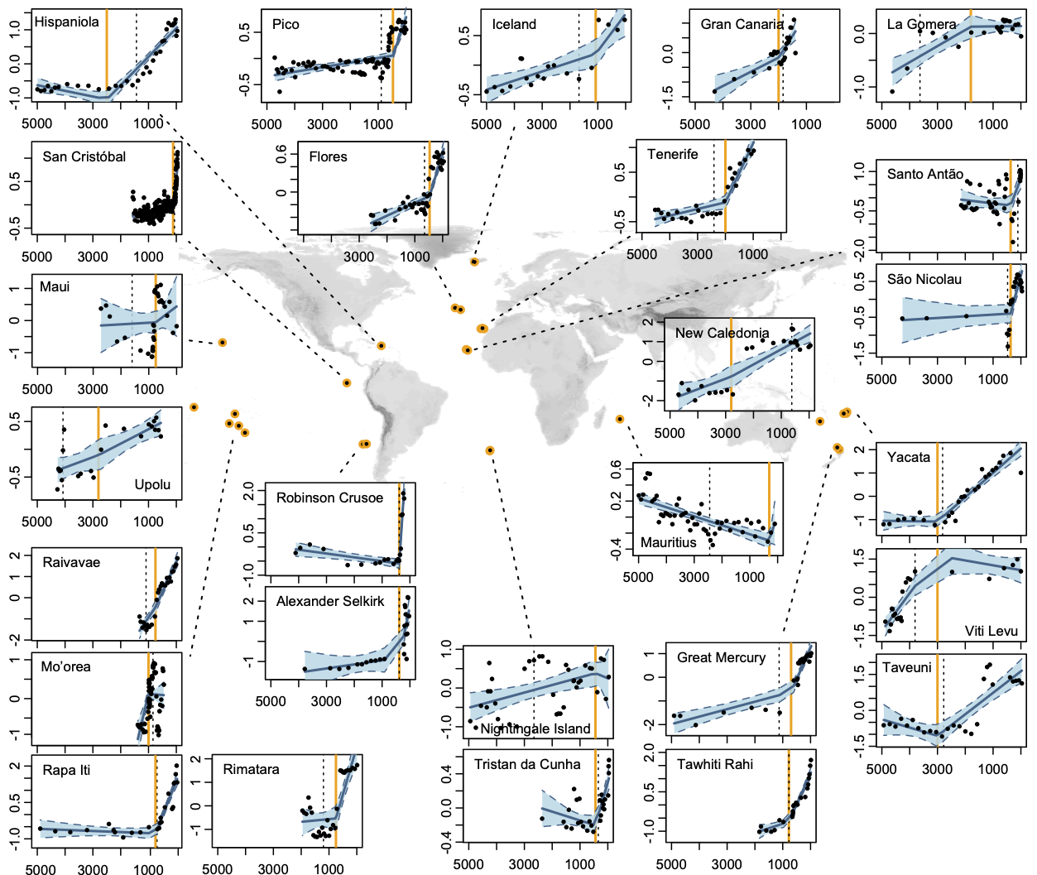

Fig. 1. Human arrival accelerated compositional turnover on islands. Global analysis of rate of palynological and hence vegetation compositional turnover (slope of the line) for 27 representative fossil pollen records from sedimentary sequences on islands. The x-axis represents calibrated years BP (cal yr BP=years before 1950) calculated using Bayesian age-depth models for each island (25). The y-axes represent the major gradient in pollen composition quantified by the ordination axis 1 scores of separate Detrended Correspondence Analyses (DCA) of each sequence. The units are measured in DCA axis scores, which approximate the standard deviation of pollen taxon compositional turnover (SD_{ptt}), with a SD of 4 corresponding roughly to 100% compositional turnover. These plots show results of breakpoint analyses of the rate of compositional turnover with the date of recorded human arrival as the prescribed breakpoint. The recorded date of human arrival is indicated by the vertical orange line (see Table S3 for details). Scaling varies among panels. Shaded areas (blue) depict 95% confidence intervals of the models. A second continuous breakpoint analysis was implemented which detects the major statistical change point in turnover rate intrinsic to the data. This ‘optimized breakpoint’ is indicated by the vertical dashed black line.

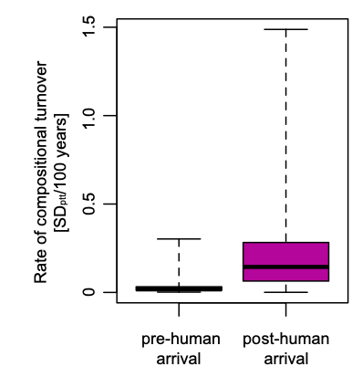

Fig. 2: Rates of turnover before and after human arrival. Change in the rate of pollen compositional turnover before (on the left) and after recorded date of human settlement (purple) for the time-series of fossil pollen records for each of 27 islands, globally, where each island’s sequence has been subject to a separate ordination analysis using DCA. Rate of pollen taxon turnover is quantified as the absolute slope in the relationship between ordination scores of the first axis of each DCA with time. The units approximate standard deviation of compositional turnover per 100 years (SD_{ptt}/100 years). The pre-settlement rate of compositional turnover is represented on the left (median: 1.7 x 10⁻⁴; mean: 4.0 x 10⁻⁴) and the rate post-human arrival is represented on the right (median: 14.7 x 10⁻⁴; mean: 23.3 x 10⁻⁴). The difference is highly significant (p<0.004; paired t-test). See (21) for details.

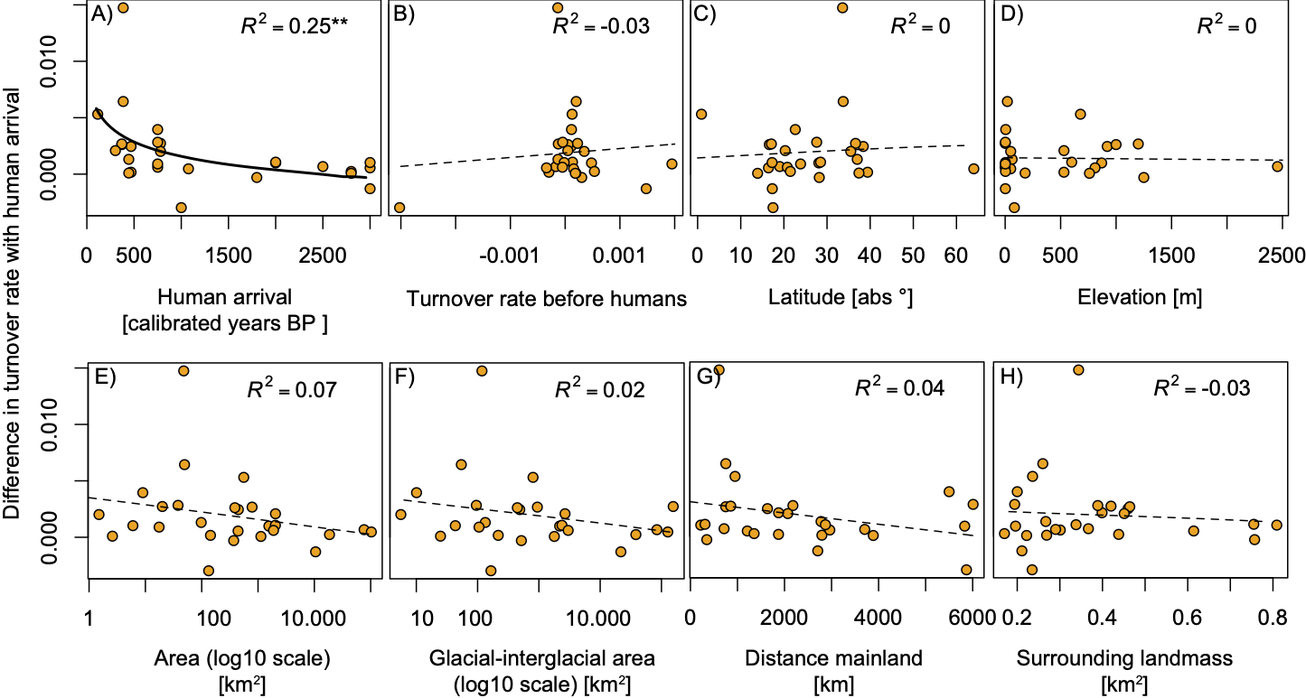
Fig. 3: Differences between the pre-human and human-dominated turnover scale with human-arrival times. Relationships between the change in the rate of pollen compositional turnover pre- and post-human arrival and several island features, showing: a curvilinear decrease in observed turnover as the time elapsed since the first colonization increases (A), but no relationship with Turnover rate before human arrival (B), latitude (C), elevation of the coring site (D), island area (E) glacial-interglacial area (F), and isolation (represented by distance to mainland (G) or surrounding landmass (H)). Asterisks (**) correspond to p<0.01 (panel A).

