Measurements and modelling of dynamic stiffness of a railway vehicle primary suspension element and its use in a structure-borne noise transmission model
Xiaowan Liu¹, David Thompson¹, Giacomo Squicciarini¹, Martin Rissmann², Pascal Bouvet², Gang Xie³, José Martínez-Casas⁴, Javier Carballeira⁴, Ines Lopez Arteaga⁵, Miguel A. Garralaga⁶, José A. Chover⁶

¹Institute of Sound and Vibration Research, University of Southampton,
Southampton SO17 1BJ, United Kingdom
²Vibratec, Chemin du Petit Bois BP 36, F-69131 Ecully Cedex, France
³CDH-AG, Competence Center Vibration & Acoustics, 70565 Stuttgart, Germany
⁴Centro de Investigación en Ingeniería Mecánica, Universitat Politècnica de València,
Camino de Vera s/n, 46022 Valencia, Spain
⁵KTH Royal Institute of Technology, The Marcus Wallenberg Laboratory for Sound and Vibration Research, Teknikringen 8, SE-100 44 Stockholm, Sweden
⁶Servicio de Ingeniería de Material Móvil, Área de Ingeniería, Metro de Madrid S.A., Calle del Néctar 44, 28022 Madrid, Spain

Abstract
The noise inside railway vehicles is transmitted by both structure-borne and airborne paths and, although there are many sources, the rolling noise is often the most important. This paper focuses on the structure-borne transmission of rolling noise in a metro vehicle. Measurements are presented first of the vertical and lateral dynamic stiffness of a primary suspension element consisting of conical rubber/metal elements. Results are presented for various constant preloads over the frequency range 60-600 Hz. An analytical model of the suspension element is also developed, based on a mass-spring system and including wave motion within the rubber elements. The dynamic stiffness results are used in a finite element model of the running gear, consisting of the bogie frame, wheelsets and suspension elements. The excitation is provided by the combined wheel/rail roughness at the contact point. This model is used to calculate the blocked forces at the connection points between the secondary suspension elements and the car body. The blocked forces are combined with measured vibro-acoustic transfer functions from these mounting points to the vehicle interior to determine the structure-borne noise inside the vehicle. The proposed methodology is validated against measurements during operation in terms of acceleration levels, blocked forces and structure-borne noise levels inside the vehicle, showing reasonably good agreement. Including the dynamic stiffness for the primary suspension leads to improved agreement between 100 and 500 Hz compared with using a constant stiffness.
Keywords: Primary suspension, dynamic stiffness, structure-borne noise transmission, FE method

Introduction
Due to increasing demands for acoustic comfort within trains, interior noise and vibration have become important concerns for railway operators. In order to model vehicle interior noise, understanding is needed both of the various noise sources and of their propagation paths. There are a number of potential sources contributing to the interior noise [1], including wheel/rail interaction and rolling noise, noise and vibration from auxiliary equipment or motive power plants and, at high speeds, aerodynamic noise. In many situations, the major source is the rolling noise caused by wheel and rail vibration induced at the wheel/rail contact. The rolling noise can be transmitted to the interior of the vehicle by both airborne and structure-borne paths. Structure-borne transmission is often dominant at low frequencies and airborne transmission at higher frequencies [1]. A typical railway vehicle has four wheelsets mounted in two bogies and is supported by two levels of suspension: the primary suspension between the wheelsets and the bogie and the secondary suspension between the bogie and the car body. The focus of this paper is on the structure-borne noise path from the wheels, through the primary suspension, the bogie frame and secondary suspension to the car body.
Depending on the frequency range of interest, different approaches can be applied to predict vehicle interior noise. At low frequencies the conventional Finite Element (FE) approach can be used to model the train structure [2, 3] but, as frequency increases, the model size increases dramatically and it becomes impractical. Statistical Energy Analysis (SEA) is usually preferred at higher frequencies because of its low computation costs. In this method, the vehicle is subdivided into a number of subsystems for which the input powers can be determined from measurements [4] or source strength models [5]. An important limitation of SEA is the requirement that acoustic (and vibration) fields are diffuse. Another limitation is that it provides only an average result within each subsystem and cannot account easily for the spatial variations. In order to apply SEA to model the interior noise of a train car with spatially varying energy density, Forssén et al. [6] made a correction to the solution using a spatial decay rate obtained from literature on sound decay in corridors.
A hybrid approach combining the FE method and SEA in a single model based on the coupling method has been developed by Shorter and Langley [7]. This approach extends the applicability of SEA to include the low frequency range where the modal density is low by using FE to provide a deterministic analysis and has been given increasing attention in recent years for studying railway vehicles [8]. Sapena et al. [9] applied this approach to the driver’s cab of a Duplex TGV to investigate the structure-borne transmission both of sources induced by structural excitation and of aeroacoustic sources. Good agreement was obtained with experiments between 100 and 300 Hz although discrepancies increased above 500 Hz. They also indicated that reliable estimates of the power input to the structure were difficult to obtain and a large effort is needed for medium and high frequencies. Results of full rail vehicle models using hybrid FE-SEA can be found in Zheng et al. [10].
Experimental studies have also been carried out to analyse railway vehicle interior noise. Noh [11] applied operational transfer path analysis (OTPA) on a high speed train at 300 km/h and identified wheel noise and centre pivot vibration to be the main contributions to interior noise and floor vibration respectively. Through OTPA, Li et al. [12] compared the contributions of structure-borne and airborne paths at different speeds in a high-speed train and indicated that the structure-borne path is always more significant whereas the difference between the two paths becomes smaller with increasing speed. Han et al. [13] experimentally investigated the effects of rail corrugation on interior noise of a metro vehicle. Li et al. [14] conducted field measurements to examine the influence of rail fastener stiffnesses on railway vehicle interior noise. Li et al. [15] studied the airborne sound transmission into a metro vehicle using a combination of numerical methods.
The excitation of structure-borne rolling noise occurs at the wheel/rail contact. The mechanism of wheel/rail interaction is well understood and a validated modelling tool, TWINS [16], is widely used for the calculation of wheel/rail noise; this can also be used to determine the contact forces. It is based on a ‘moving roughness’ model [17] in which the roughness excitation of the wheel/rail system is included without directly accounting for the motion of the vehicle. The track system can be modelled as either a continuously or discretely supported beam with the sleepers represented as a mass or a flexible beam. The discrete nature is found to be particularly important for track with a stiff rail pad, which is the case for the example considered in the present study.
The contact forces excite vibration of the wheel and axle and this is transmitted through the primary suspension, the bogie, the secondary suspension and other connections, resulting in forces which excite vibration of the car body, producing interior noise. The stiffness and damping properties of the suspension elements play a key role in structure-borne transmission. Railway vehicle suspension components may include coil springs, leaf springs, rubber springs, air springs and hydraulic dampers. The modelling of suspension components has been the subject of extensive research in the context of railway vehicle dynamics multibody simulations [18, 19] and different mathematical models have been proposed depending on the required level of detail. In vehicle dynamics simulations, the main frequency range of interest is below 20 Hz, which is sufficient to deal with issues such as car body sway, gauging, wear or ride comfort. However, for application to structure-borne noise, the frequency range of interest extends from 20 Hz to several hundred Hz and more detailed dynamic models are needed to cover this higher frequency range. Internal resonances in suspension springs can cause significant vibration transmission at the corresponding natural frequencies, which may fall within this range.
Lee and Thompson [20] determined the high frequency dynamic stiffness matrix of a helical spring by deriving the equation of free wave motion based on Timoshenko beam theory. Although such a helical spring leads to significant dynamic amplification, it was found in a recent study by Sun et al. [21], for a metro rail vehicle with coil springs, that the force transmitted to the bogie frame can be minimised by including a pivot arm with appropriate moment of inertia and pivot bushing stiffness.
For rubber springs, Berg [22] proposed a non-linear frequency-dependent model by using a superposition of elastic, friction and viscous forces. An improved model accounting for the frequency dependence by using fractional derivatives was developed by Sjöberg and Kari [23]. Kari [24] modelled a primary suspension isolator with sandwich elements by adopting a frequency-dependent waveguide approach and included the non-linear static load dependence through a shape factor associated with changes in the surface area of the rubber layer during compression. Measurements of the dynamic stiffness were also presented.
A set of international standards for measuring the dynamic stiffness of resilient elements is available [25, 26, 27]. In this context the dynamic stiffness is the frequency-dependent complex transfer function between applied force and resulting deflection, explained further in Section 2.1 below. As such it includes damping as well as stiffness information through its imaginary component. Although resilient elements are often nonlinear, as a good approximation linear behaviour can be assumed for small amplitudes under a steady preload. The direct method [26] is more appropriate for low frequency measurements whereas the indirect method [27, 28] can be used for higher frequencies and for different directions. In [29] improvements to the indirect method were proposed to allow it to be extended to lower frequencies. This improved indirect method has been used in the current measurements and will be introduced later in Section 2.2.
The damping properties of visco-elastic materials such as rubber are generally represented by a constant damping loss factor [30]. In practice, the magnitude of the dynamic stiffness of such materials is mildly frequency dependent (and also temperature dependent) [31], but they are often represented in a frequency domain model within a limited frequency range by a constant stiffness and loss factor.
The aim of this paper is to present a complete prediction method for the structure-borne noise transmission into a railway vehicle due to wheel/rail forces caused by random surface roughness, taking account of the frequency-dependent stiffness of the primary suspension elements. The main novelty of the work therefore lies in (i) the detailed modelling and measurement of the dynamic stiffness of the primary suspension element (ii) the assembly of a complete modelling approach for structure-borne noise transmission in railway vehicles, and (iii) its validation using field measurements. Although the method is applied to random roughness excitation, it could readily be extended to the case of impact excitation due to discontinuities.
For this purpose, measurements of the static stiffness and the vertical and lateral dynamic stiffness of a primary suspension element at various preloads are described in Section 2 and analytical modelling methods for the suspension element are also introduced. Section 3 presents a structure-borne noise transmission model that combines an FE model of the running gear with the dynamic stiffnesses of the suspension spring. This is used to predict the blocked forces at connection points with the car body. Transmission into the vehicle interior is obtained by combining these forces with vibro-acoustic transfer functions measured on the car body. Validation of the model against measurements obtained during operation is described in Section 4 in terms of acceleration levels, blocked forces and structure-borne noise levels inside the vehicle.
The methodology is applied to a metro vehicle with a primary suspension consisting of conical metal-rubber suspension elements. Two such suspension elements are used between each wheel and the bogie frame, located on either side of the axlebox, as shown in Figure 1. This type of suspension element, using rubber elements in shear to obtain a low vertical stiffness, is widely used in passenger rolling stock, particularly in primary suspensions. There are no separate damper elements in the primary suspension of this vehicle, with damping being provided by the material damping of the rubber. The secondary suspension consists of air springs and there are additional connections between each bogie and the car body through two lateral dampers and two traction rods.
(a) |  | (b) | 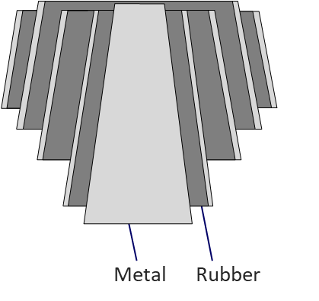
Figure 1. (a) An example of conical rubber/metal element used in the primary suspension of a Metro de Madrid train; (b) Cross-section of the suspension element (not to scale).

Suspension element measurements and modelling

Dynamic stiffness
The dynamic stiffness of a resilient element is a frequency-dependent quantity that encompasses both stiffness and damping behaviour [25, 26, 27]. If one termination of a resilient element is blocked and a harmonic displacement of amplitude $u_{1}(ω)$ at circular frequency $ω$ is applied at the free termination, the dynamic transfer stiffness is given by the ratio of the force amplitude $F_{2}\left(ω\right)$ at the blocked termination to the deflection amplitude $u_{1}(ω)$:
 | $$K_{t}\left(ω\right)=\frac{F_{2}\left(ω\right)}{u_{1}(ω)}$$ | (1)
This is a complex frequency response function, and is the reciprocal of a transfer receptance. Similarly, the driving point dynamic stiffness can be written as
 | $$K_{p}\left(ω\right)=\frac{F_{1}\left(ω\right)}{u_{1}(ω)}$$ | (2)
For a lossless spring, $K\left(ω\right)$ is a purely real stiffness whereas for a viscous damper with damping coefficient $C$, $K\left(ω\right)=iωC$ is purely imaginary. For a more general massless isolator, the tangent of the phase angle of the dynamic stiffness can be written as a loss factor
 | $$η\left(ω\right)=tan⁡(∠K\left(ω\right))=\frac{Im(K\left(ω\right))}{Re(K\left(ω\right))}$$ | (3)
and the dynamic stiffness can be written as $K\left(ω\right)=K_{r}(ω)(1+iη(ω))$ where $K_{r}(ω)$ is the real part of $K(ω)$. Where internal mass cannot be neglected, $K_{p}\left(ω\right)≠K_{t}\left(ω\right)$.

Laboratory measurements

Introduction
The measurement method used for determining the dynamic stiffness of the primary suspension element has been used previously, for example for rail pads [29]. The international standards [25, 26, 27] describe two basic measurement methods, referred to as the direct method and the indirect method. In the direct method the resilient element is mounted on a blocked termination and excited at the other side. The transfer stiffness is determined by measuring the force amplitude F₂ at the blocked termination using a load cell or force transducer and the deflection amplitude u₁ input at the free termination using either a displacement transducer or an accelerometer. Their frequency-dependent dynamic transfer stiffness is obtained from Eq. (1). A second force transducer can also be used to measure the applied force amplitude at the input location F₁ allowing the dynamic point stiffness to be obtained, Eq. (2). This method is often limited to frequencies below typically 300 Hz and is also limited to the axial direction.
The indirect method [27, 28] allows measurements at higher frequencies and for other degrees of freedom. Here the blocked force amplitude F₂ is not measured directly. The element under test is installed between two blocks which are resiliently mounted in a frame, as shown in Figure 2(a). The transfer stiffness is determined based on the transfer function between the accelerations of the upper and lower block (${\ddot{u}}_{1}$ and ${\ddot{u}}_{2}$) together with the mass of the lower block m₂. This method was revised in [29] to extend the lower limit of the frequency range. In the revised method, the relative acceleration across the resilient element $({\ddot{u}}_{1}-{\ddot{u}}_{2})$ is used and the stiffness is derived from $m_{2}{\ddot{u}}_{2}/({\ddot{u}}_{1}-{\ddot{u}}_{2})$. However, the indirect method has a strict lower bound for the valid frequency range that is related to the resonance of the lower block on its mounts.

Measurement apparatus
A schematic diagram of the measurement apparatus is shown in Figure 2(a). The suspension element is located between a length of steel box section (the ‘upper block’) and a large steel block and the whole rig is isolated above and below using soft rubber mounts. The purpose of the box section is to allow both a static preload and dynamic excitation to be applied to the top of the suspension element. The lower block has dimensions 104×74×35 cm and a mass of 2000 kg; its large mass ensures that its resonance on the supporting mounts is as low as possible. A preload is applied by a hydraulic loading cylinder attached centrally to a thick steel plate, and is transmitted to the upper block through the soft isolators. For convenience the suspension element was mounted upside down, opposite to the orientation when mounted in the vehicle (see Figure 1). The shaft of the suspension element was recessed into a hole in the box section and attached using a large nut to the inside of the upper face of the box section. A hollow metal spacer was inserted between the suspension element and the lower block to allow full vertical movement under preload. The tests were carried out at a temperature of approximately 20˚C.
(a) | 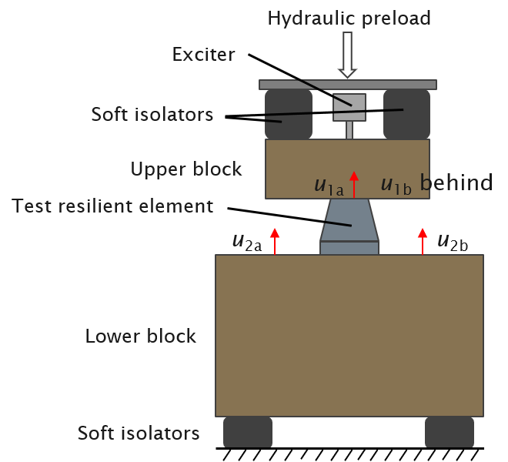 | (b) | 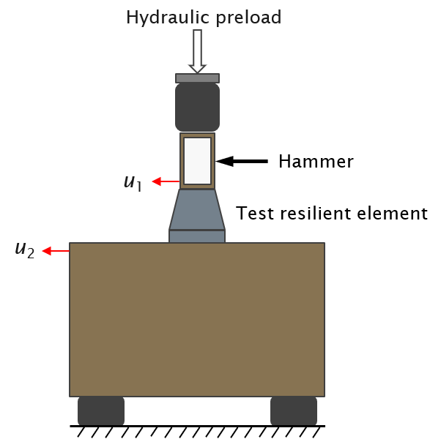
Figure 2. Schematic diagram of the measurement rig including measured accelerations for (a) the vertical dynamic stiffness and (b) the lateral dynamic stiffness.

Measurements of vertical dynamic stiffness
The excitation was provided by a single electrodynamic inertial shaker which was located centrally on the upper block. It was excited with a pseudo-random noise signal covering a frequency range 10 – 1000 Hz. Different values of applied hydraulic preload were used, from 10 kN to 42.5 kN.
Figure 2(a) shows the measurement locations used for determining the vertical dynamic stiffness. The vertical vibration of the upper block was obtained by taking the average of the accelerations ${\ddot{u}}_{1a}$ and ${\ddot{u}}_{1b}$, which were measured using accelerometers 1a and 1b located on the top plate of the suspension element. The vibration of the lower block was recorded using two accelerometers, 2a and 2b, placed on the diagonally opposite sides of the suspension element. The average of these two signals was used to eliminate rotation of the block. Their position was chosen to ensure a flat apparent mass spectrum up to at least 600 Hz. Although the first bending and twisting modes of the block occur well above 1 kHz, the point accelerance at the centre of the block contains a strong anti-resonance at around 500 Hz due to these modes. Therefore, to minimise the influence of these modes, the accelerometers were placed on the nodal lines of these two modes of the block.
After obtaining the vibration of the upper and lower block, the vertical dynamic transfer stiffness can be calculated according to [29],
 | $K_{t}(ω)= -m_{2}ω^{2}\left(\frac{1}{\frac{{\ddot{u}}_{1}}{{\ddot{u}}_{2}}-1}\right)$ for ω > 3ω₁ | (4)
where m₂ is the mass of the lower block and ω₁ is the natural frequency of the rigid-body mode of the lower block on the isolators, which occurs at about 19 Hz for this set-up.

Measurements of lateral dynamic stiffness
A similar method was also used for measuring the lateral dynamic transfer stiffness. However, in this case the excitation was provided by an impact hammer at the vertical centre of the upper block, as shown in Figure 2(b).
In order to measure the translational component of vibration, accelerometer 1 was attached on one side of the upper block, as near as possible to the top of the suspension element. To measure the lateral vibration of the lower block, accelerometer 2 was placed near its top. For this location, the effective mass of the lower block (ratio between a force applied at the top and the acceleration at this location) is m_{eq} = 1312 kg. The lateral complex dynamic stiffness is given as [29],
 | $K_{t}(ω)= -m_{eq}ω^{2}\left(\frac{1}{\frac{{\ddot{u}}_{1}}{{\ddot{u}}_{2}}-1}\right)$ | (5)

Measurement results of static and dynamic stiffness
The vertical static stiffness was measured using the same rig setup as shown in Figure 2(a) by applying the hydraulic preload, F, in steps of 2.5 kN from 2.5 kN to 45 kN. Dial gauges were attached to the two ends of the upper block, from which the relative displacement u on each side could be read. The load-deflection curves are shown in Figure 3(a), and indicate that the suspension element was located symmetrically. The static stiffness as a function of preload is shown in Figure 3(b). This is derived as k = ΔF/Δu, where Δ indicates the increment in values between the adjacent points in the load-deflection curve. It can be seen that the static stiffness remains roughly constant at about 0.5 MN/m for preloads up to about 20 kN, above which it increases to about 1.4 MN/m at 39 kN. The nominal operating point for the suspension element is at around 23 kN without passengers and 34 kN when the vehicle is full.
(a) |  | (b)
Figure 3. Static load-deflection curve (a) and static stiffness derived from it (b).
To show the response to the pseudo-random noise signal, Figure 4 shows the power spectral densities (PSD) of the accelerations of the upper and lower blocks at different preloads, 20 and 30 kN, obtained during the measurements of the vertical dynamic stiffness. The available frequency range is limited by the coherence between the vibration of the upper and lower blocks. Here all the results in the frequency range between 60 and 600 Hz have coherence above 0.9. A peak between 70 and 80 Hz is found in the response of both blocks, which corresponds to the resonance of the system with the two masses moving in anti-phase on the suspension element. For the response of the lower block, there are two further peaks, at around 200 and 450 Hz, which are caused by internal resonances of the suspension element, as discussed below. The frequencies of these two peaks increase slightly when the preload is increased from 20 to 30 kN.
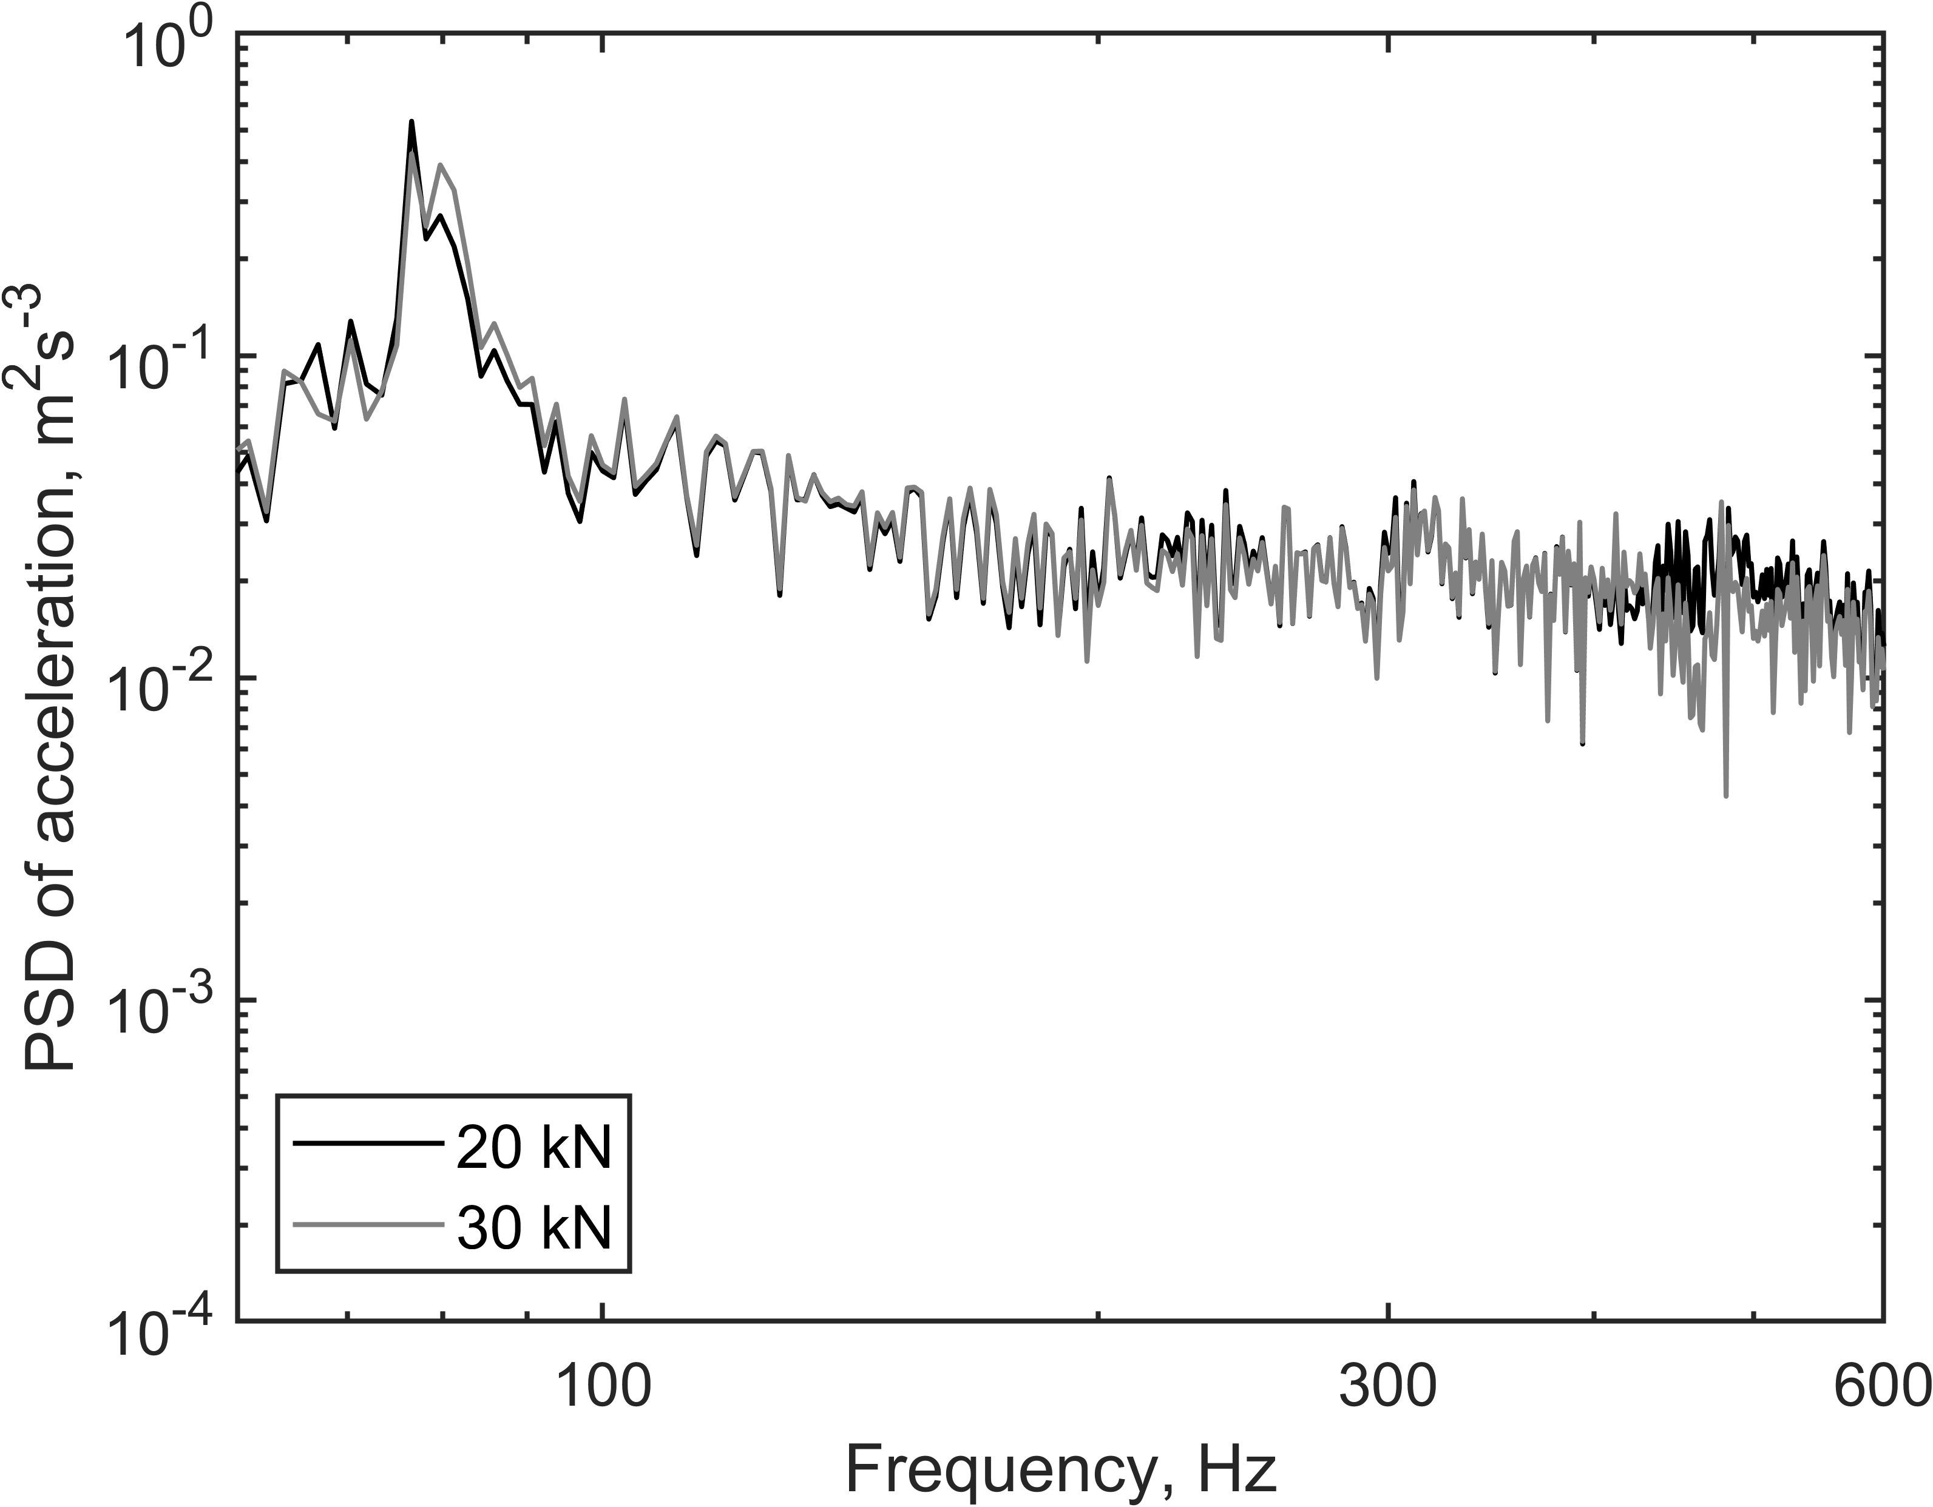  (a) | 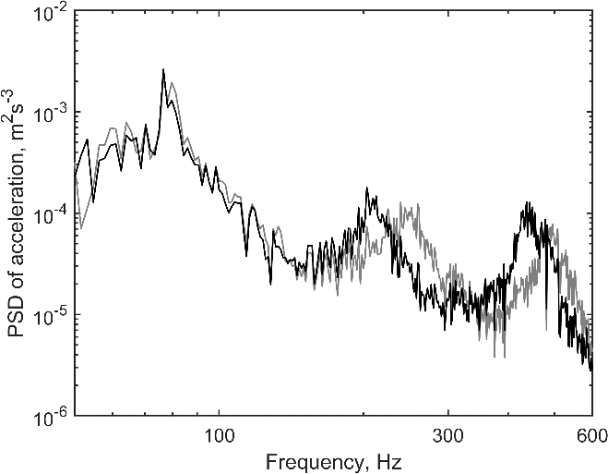  (b)
Figure 4. Power spectral densities of acceleration of upper (a) and lower (b) block at different preloads.
Figure 5 shows the magnitude and phase of the vertical dynamic stiffness obtained for different preloads. At low frequencies the dynamic stiffness is at around 1 MN/m, increasing slightly with the preload. This is about twice the value of the static stiffness shown in Figure 3(b). At higher frequencies, the stiffness increases by more than a factor of 10 and the result for each preload contains three peaks, which are due to internal resonances of the suspension element.
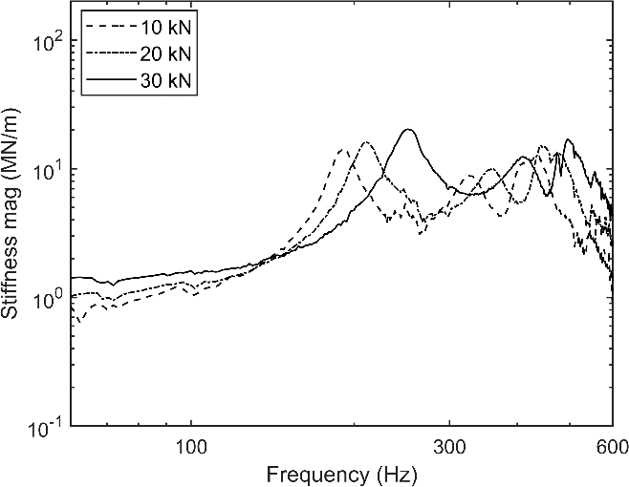  (a) | 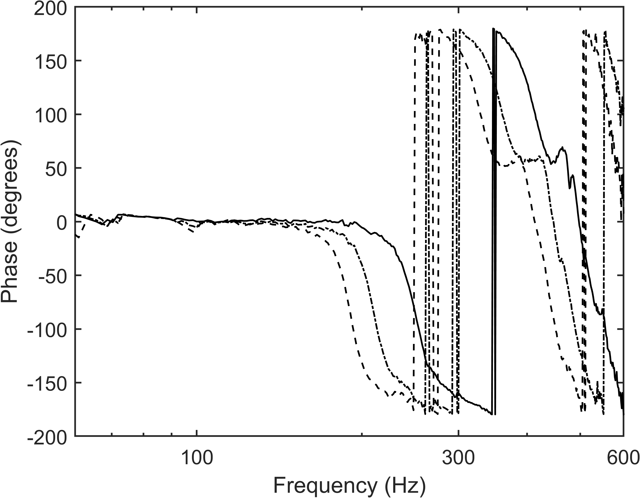  (b)
Figure 5. Magnitude and phase of vertical dynamic transfer stiffness for various preloads.
For the lateral direction, as the excitation was given by a hammer, the coherence at low frequency is adversely affected, and the lower limit of the usable frequency range is increased to 80 Hz. The results below about 150 Hz have been omitted as they are affected by the dynamics of the test rig. The upper limit is still around 600 Hz.
The lateral dynamic stiffness results obtained at the preloads of 20 and 30 kN are presented in Figure 6. Unlike the vertical stiffness, the lateral one has only a single peak in this frequency range, occurring between 400 and 500 Hz. With the increase of the preload, a higher dynamic stiffness amplitude is found for frequencies between 150 and 250 Hz, while the peak frequency increases slightly.
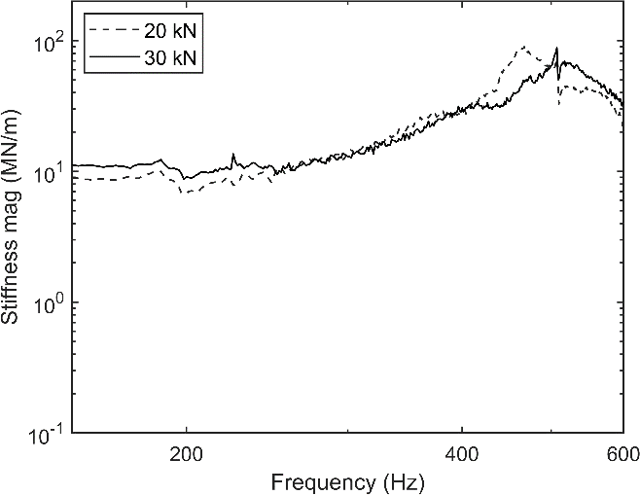  (a) | 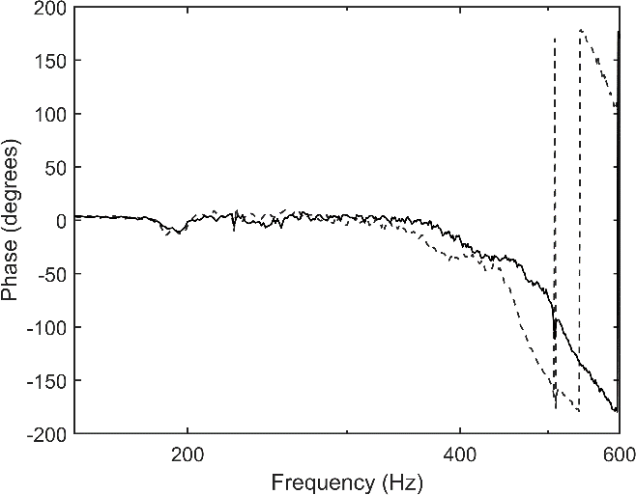  (b)
Figure 6. Magnitude and phase of lateral dynamic transfer stiffness at different preloads.

Suspension element modelling method
The suspension element consists of several conical layers of rubber and steel, as shown in Figure 1(b). An estimate of the area, S, of each layer of the suspension element in contact with the metal parts, averaged between the internal and external surfaces, is listed in Table 1. The estimated thickness of each rubber layer, l, between adjacent metal parts and the masses of the internal metal parts, m, are also given, where m₁ refers to the inner mass, l₁ and S₁ to the thickness and area of the conical rubber suspension element between this and the next mass, etc. These parameters will be used for the modelling.
Table 1. Parameters of internal metal and rubber components used for modelling primary suspension element.
Metal |  |  | Rubber
m₁ (kg) | 2.84 |  | l₁ (m) | 0.0183 | S₁ (m²) | 0.0263
m₂ (kg) | 0.82 |  | l₂ (m) | 0.0258 | S₂ (m²) | 0.0336
m₃ (kg) | 0.99 |  | l₃ (m) | 0.0176 | S₃ (m²) | 0.0380
m₄ (kg) | 1.00 |  | l₄ (m) | 0.0124 | S₄ (m²) | 0.0372

The suspension element can be represented as a system of masses connected by four damped springs, as shown schematically in Figure 7. The outer masses will be connected rigidly to the bogie frame and the axlebox and are excluded from the definition of the dynamic stiffness. As a first step, each of these springs is considered to have a constant stiffness, which will satisfy the following relationship,
 | $$\frac{1}{K_{T}}=\frac{1}{K_{1}}+\frac{1}{K_{2}}+\frac{1}{K_{3}}+\frac{1}{K_{4}}$$ | (6)
where $K_{T}$ is the overall measured stiffness at low frequencies and $K_{i}, i=1, 2, 3, 4$ represent the stiffness of each spring. Damping is introduced by making use of a damping loss factor η, replacing $K_{i}$ by $K_{i}(1+iη)$. The rubber springs are acting in shear but they can be represented by a corresponding system of springs in extension with an equivalent Young’s modulus. By assuming that each rubber element has the same equivalent Young’s modulus, the various values of the constant stiffnesses can be determined from the above equation together with the expressions $K_{i}=E_{0}S_{i}/l_{i}$, where $E_{0}$ is the equivalent Young’s modulus for the rubber, $S_{i}$ is the surface area of the $i^{th}$conical rubber part, and $l_{i}$ is its thickness.
(a) | 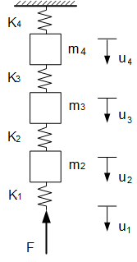 | (b) | 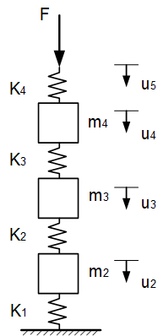
Figure 7. Equivalent mass-spring system (a) for excitation at the base (axlebox side), (b) excitation at the top (bogie frame side). Note that each ‘spring’ shown in the diagram represents a damped dynamic stiffness which may be frequency dependent.
For this mass-spring system with a harmonic force with amplitude F applied to the degree of freedom u₁, and with u₅ blocked, as shown in Figure 7(a), the equations of motion can be written in terms of matrices as given below. Writing the displacement vector as $u=[u_{1} u_{2} u_{3} {u_{4}]}^{T}$, the dynamic stiffness matrix (implicitly including the loss factor in each component) is given by
 | $$K=\left[\begin{matrix}K_{1} & -K_{1} & 0 & 0 \\ -K_{1} & K_{1}+K_{2} & -K_{2} & 0 \\ 0 & -K_{2} & K_{2}+K_{3} & -K_{3} \\ 0 & 0 & -K_{3} & K_{3}+K_{4}\end{matrix}\right]$$ | (7)
and the mass matrix by
 | $$M=\left[\begin{matrix}0 & 0 & 0 & 0 \\ 0 & m_{2} & 0 & 0 \\ 0 & 0 & m_{3} & 0 \\ 0 & 0 & 0 & m_{4}\end{matrix}\right]$$ | (8)
while the displacement can be obtained from
 | $$u=(K-ω^{2}M)^{-1}[F 0 0 0]^{T}$$ | (9)
The dynamic point and transfer stiffnesses for the whole system can then be derived as
 | $K_{p}(ω)=\frac{F}{u_{1}}$; $K_{t}(ω)=\frac{u_{4}K_{4}}{u_{1}}$ | (10)
When the suspension element is excited at the top, the lower degree of freedom u₁ is constrained whereas u₅ is free, as shown in Figure 7(b). The displacement vector is $u=[u_{2} u_{3} u_{4} {u_{5}]}^{T}$, and the stiffness and mass matrices are
 | $$K=\left[\begin{matrix}K_{1}+K_{2} & -K_{2} & 0 & 0 \\ -K_{2} & K_{2}+K_{3} & -K_{3} & 0 \\ 0 & -K_{3} & K_{3}+K_{4} & -K_{4} \\ 0 & 0 & -K_{4} & K_{4}\end{matrix}\right]$$ | (11)
and
 | $$M=\left[\begin{matrix}m_{2} & 0 & 0 & 0 \\ 0 & m_{3} & 0 & 0 \\ 0 & 0 & m_{4} & 0 \\ 0 & 0 & 0 & 0\end{matrix}\right]$$ | (12)
The displacement can be obtained from
 | $$u=(K-ω^{2}M)^{-1}[0 0 0 F]^{T}$$ | (13)
and the dynamic point and transfer stiffnesses for the whole system are
 | $K_{p}(ω)=\frac{F}{u_{5}}$; $K_{t}(ω)=\frac{u_{2}K_{1}}{u_{5}}$ | (14)

Model extension to include wave motion
Instead of using constant values for each stiffness, frequency-dependent point and transfer stiffnesses are introduced to include wave motion in each rubber element. The point stiffness for rubber element i, which can be represented by a finite rod, can be expressed as [32],
 | $K_{ip}(ω)=ωS_{i}\sqrt{Eρ} cot⁡(kl_{i}$) |  | (15)
and the corresponding transfer stiffness as
 | $K_{it}(ω)=ωS_{i}\sqrt{Eρ}/sin(kl_{i}$) |  | (16)
where ρ is the density, $k=\frac{2πf}{c}$ is the wavenumber, and c ($=\sqrt{\frac{E}{ρ}}$ ) is the wave speed. The stiffness matrix is then modified to (e.g. for excitation at the base),
 | $$K=\left[\begin{matrix}K_{1p} & -K_{1t} & 0 & 0 \\ -K_{1t} & K_{1p}+K_{2p} & -K_{2t} & 0 \\ 0 & 0 & K_{2p}+K_{3p} & -K_{3t} \\ 0 & 0 & 0 & K_{3p}+K_{4p}\end{matrix}\right]$$ | (17)
and the point and transfer dynamic stiffnesses for the whole system excited at the base are,
 | $$K_{p}(ω)=\frac{F}{u_{1}}; K_{t}(ω)=\frac{u_{4}K_{4t}}{u_{1}}$$ | (18)
and similarly, for excitation at the top:
 | $$K_{p}(ω)=\frac{F}{u_{5}}; K_{t}(ω)=\frac{u_{2}K_{1t}}{u_{5}}$$ | (19)

Comparisons of measured and modelled dynamic stiffness
The computed transfer stiffness results obtained using the two different models, for constant and frequency-dependent stiffness elements, are presented in Figure 8(a) and (b) for the vertical stiffness and Figure 8(c) and (d) for the lateral stiffness; these are also compared with the measured data. Here ρ is set to 900 kg/m³ and η to 0.12 for the rubber elements. The calculation procedure is similar for the two directions; a value of 1.0 MN/m is used for K_{T} for the vertical direction, and 5.0 MN/m for the lateral direction, corresponding to the low frequency limit. For both the vertical and lateral directions, the mass-spring model based on constant stiffness values gives peaks at higher frequencies than the measurement, whereas the extended model gives very good agreement with the measurement.
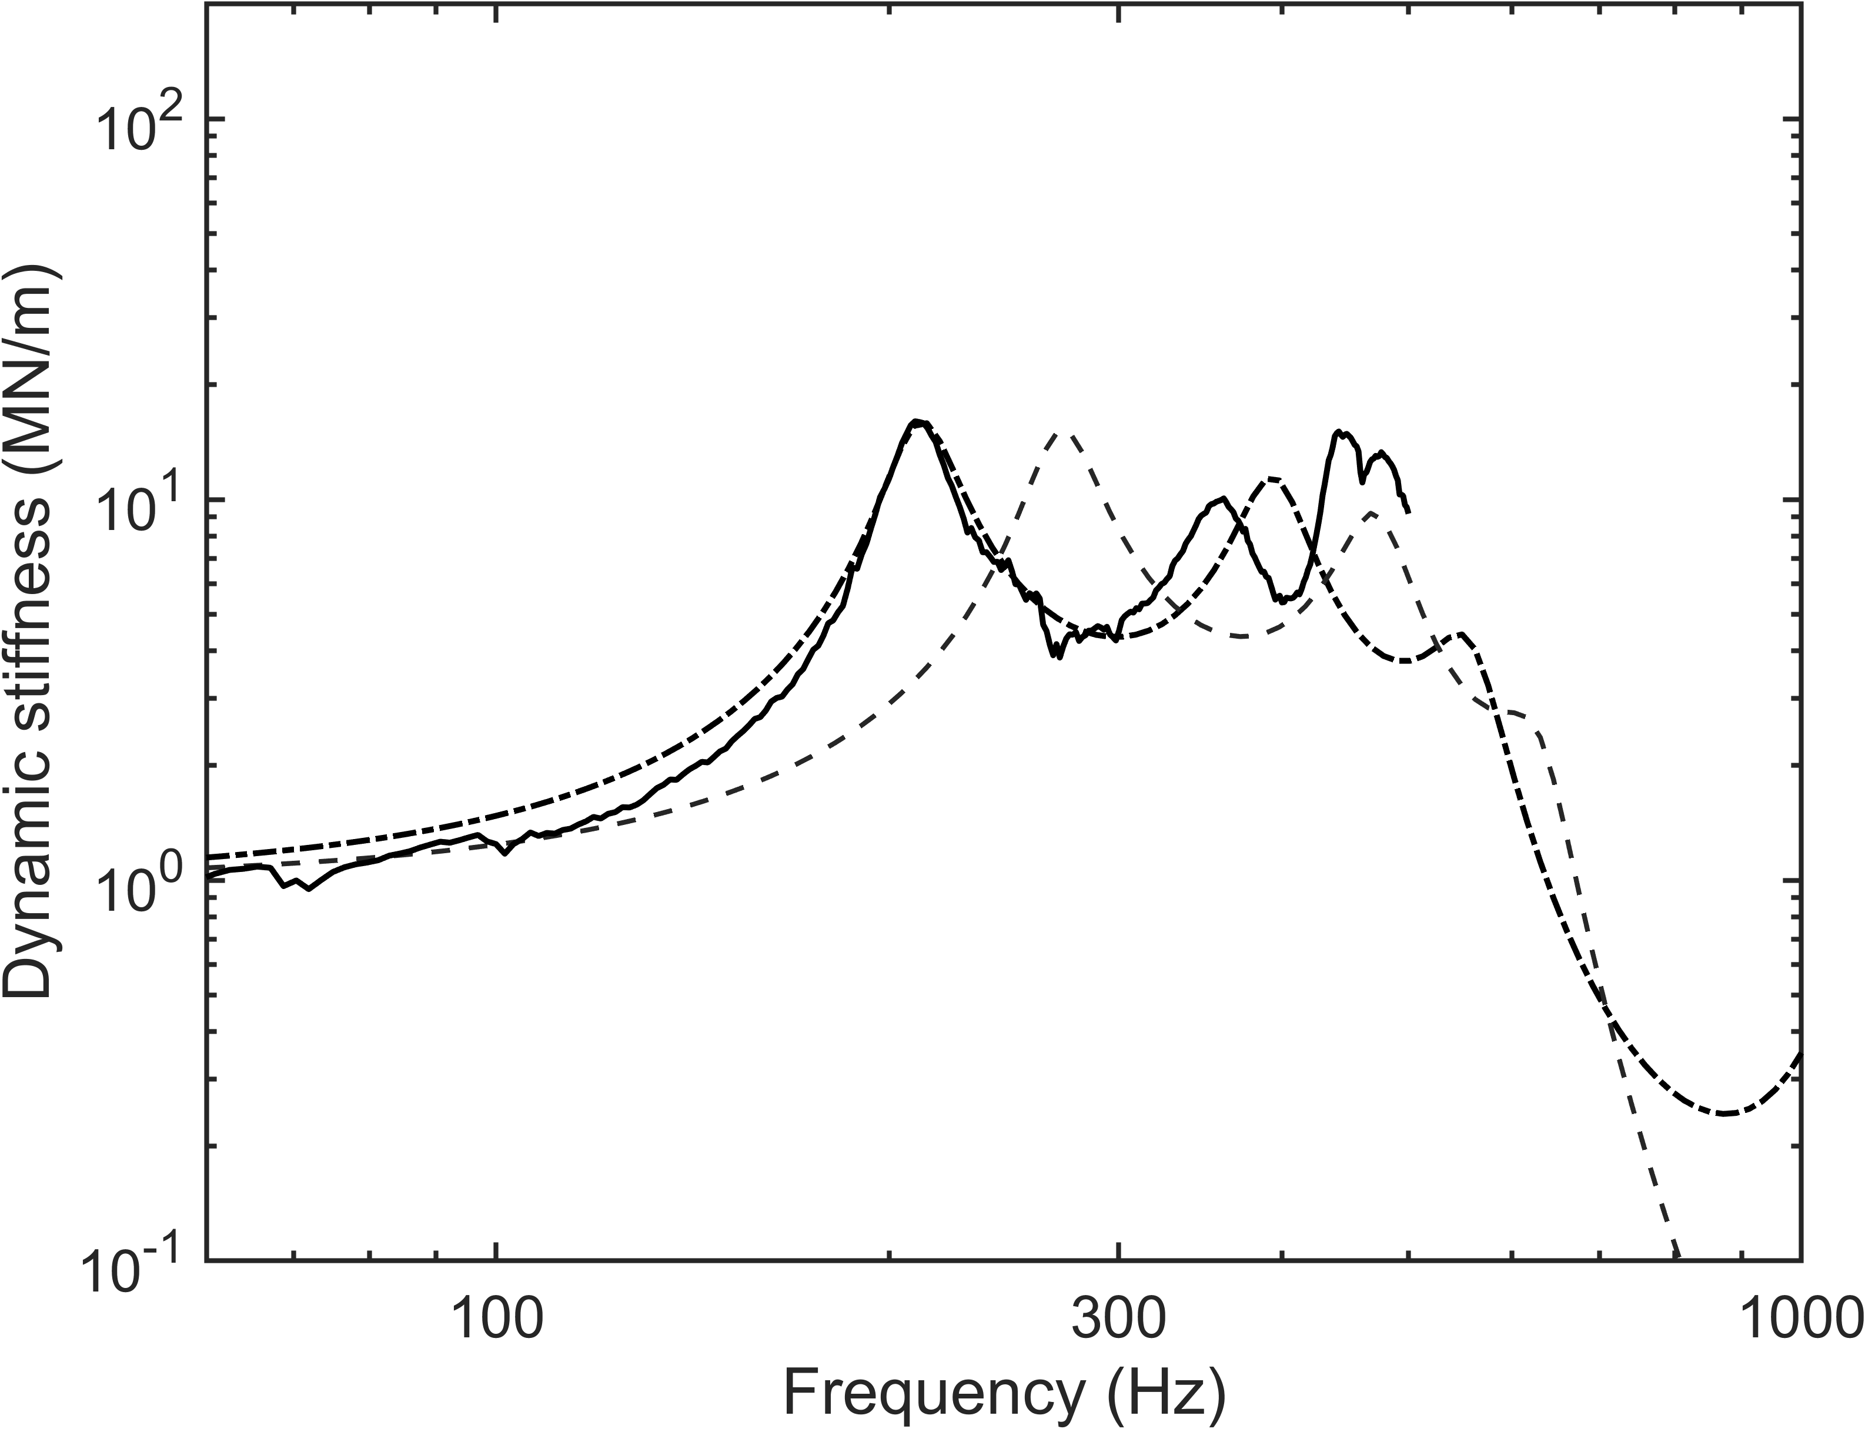  (a) | 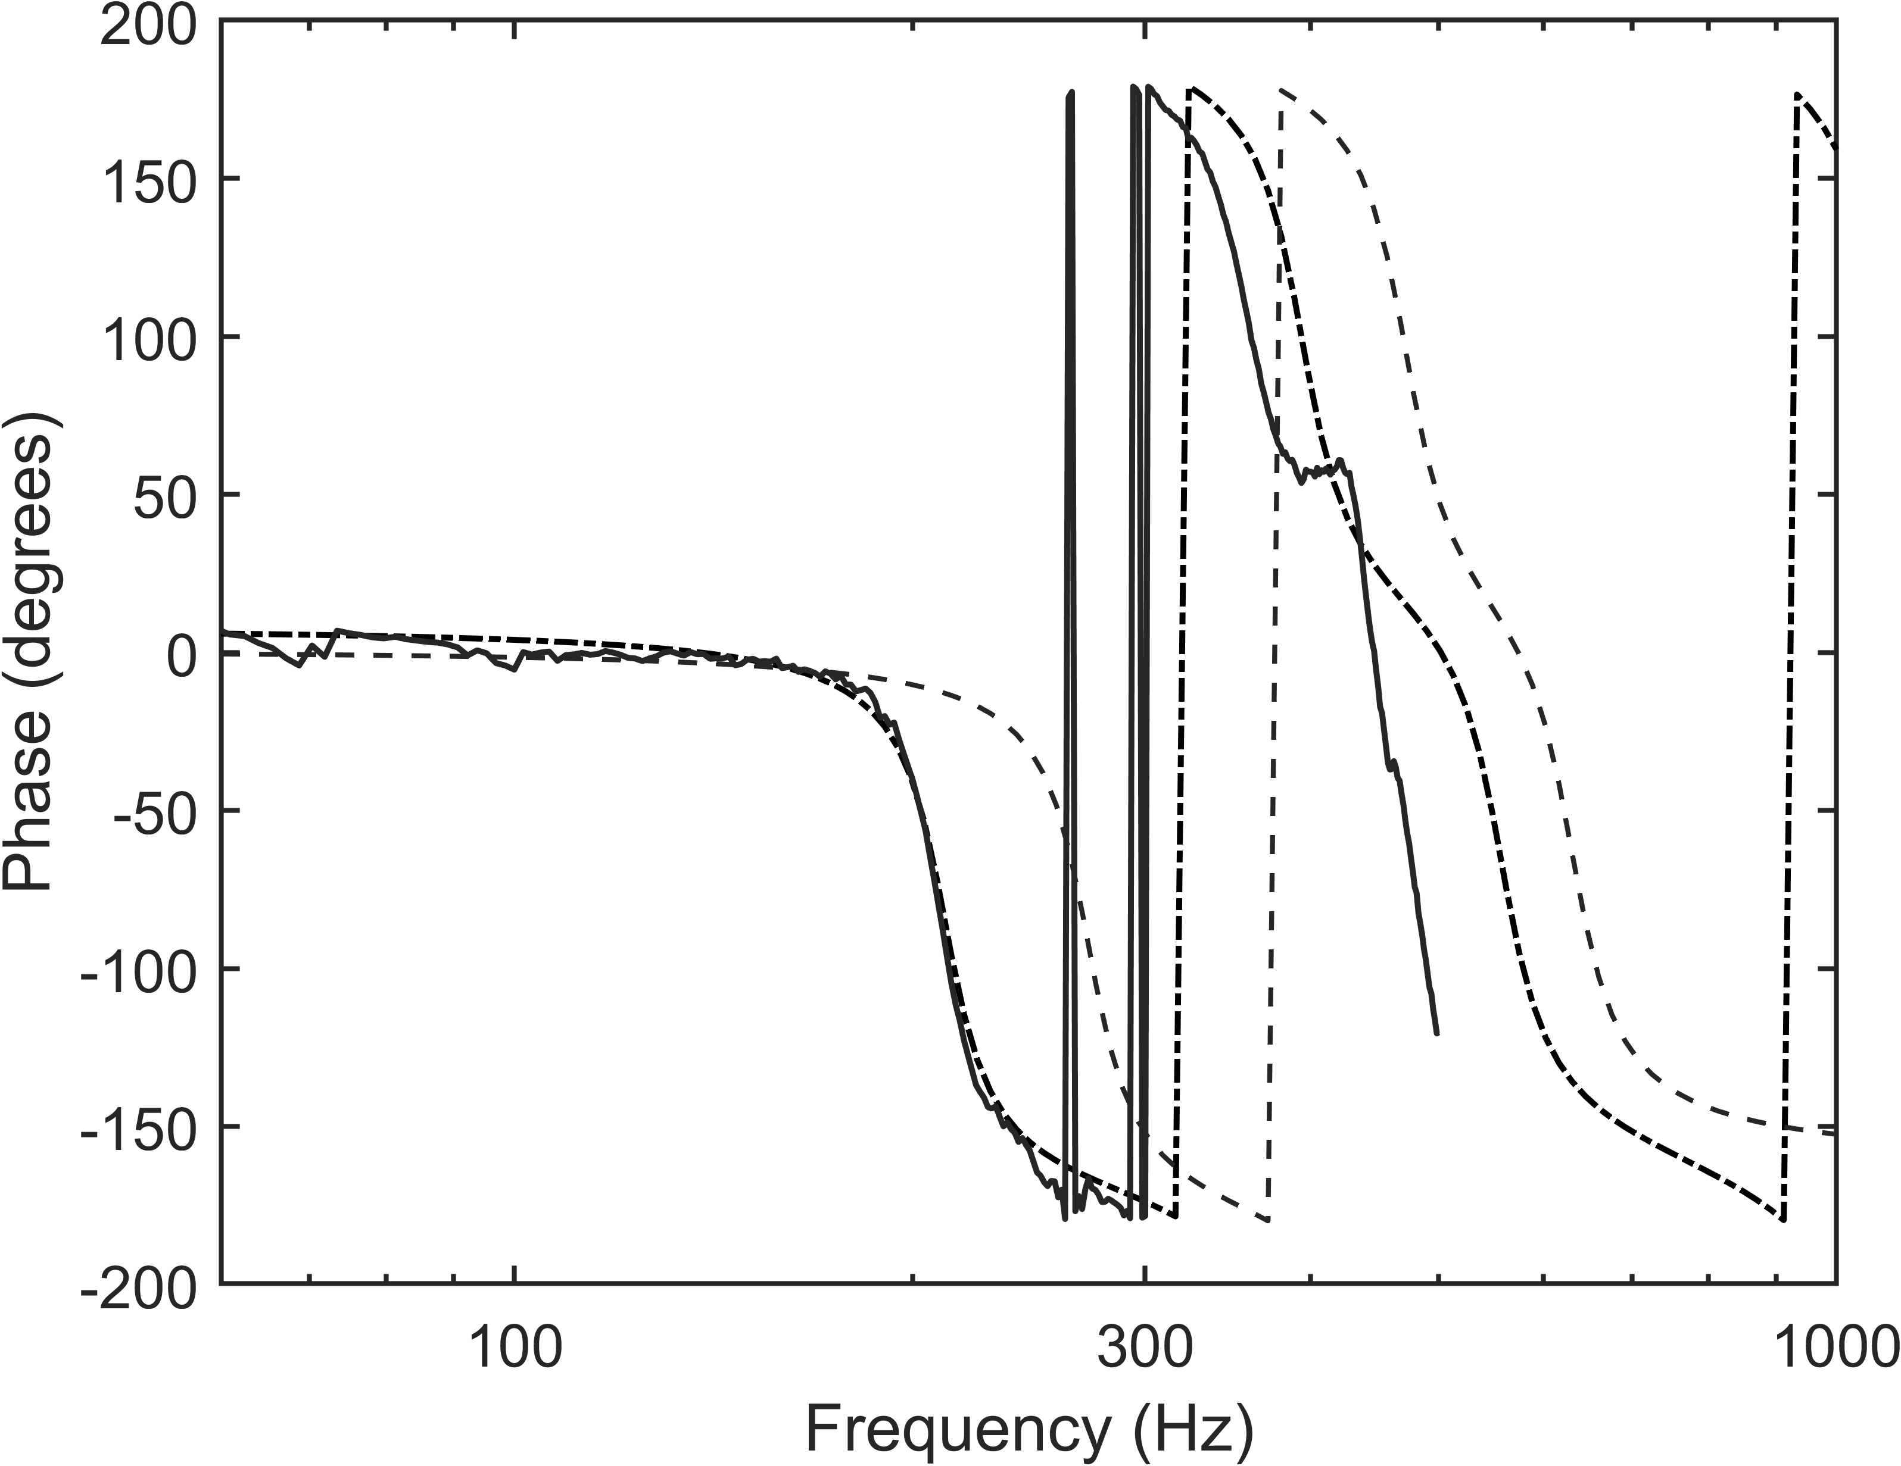  (b)
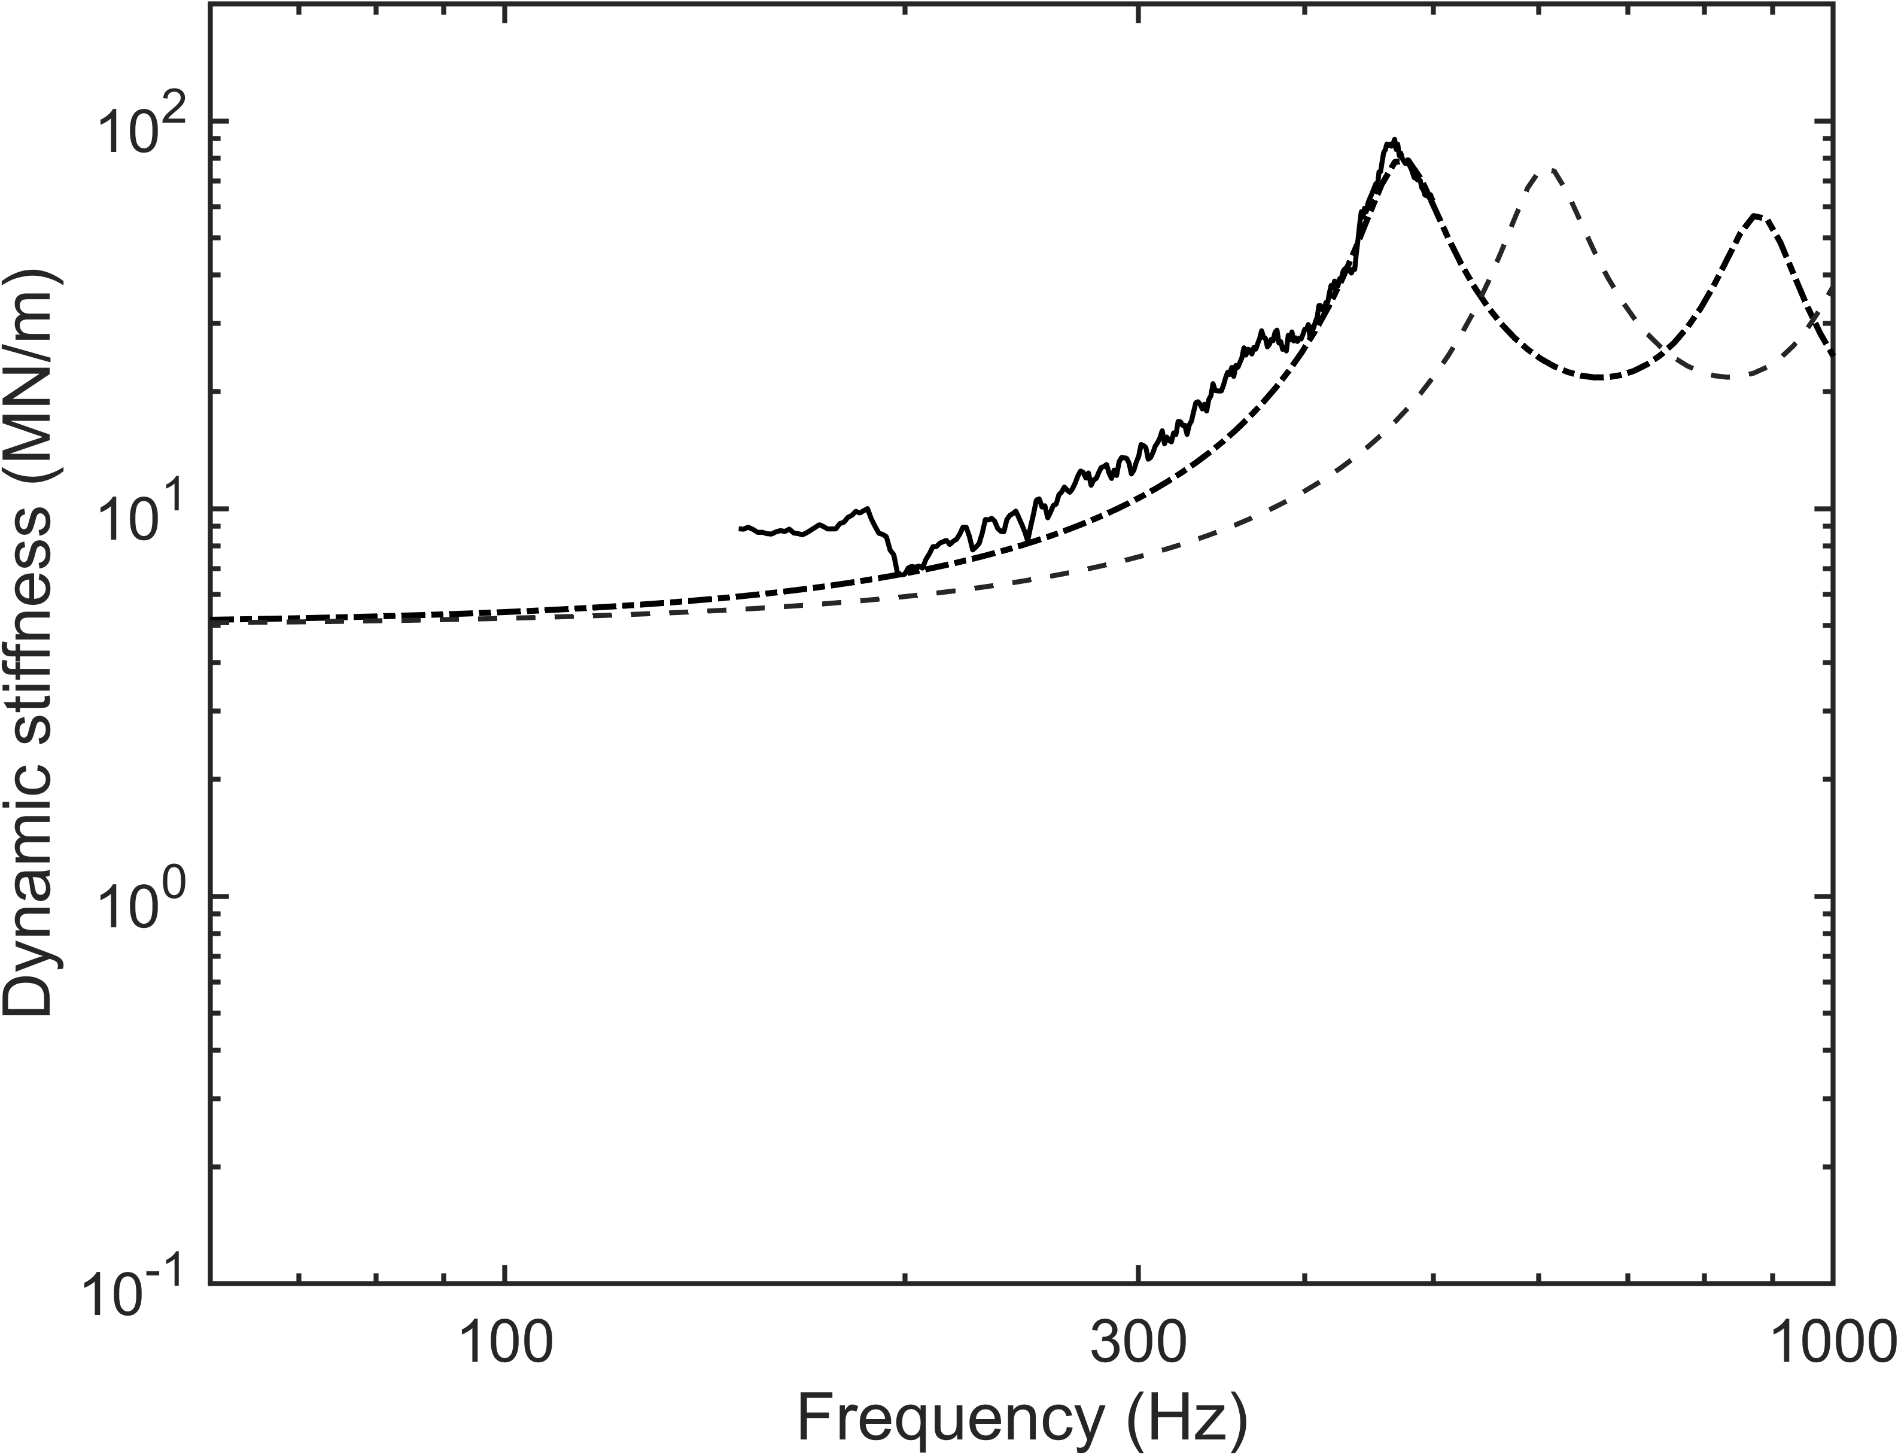  (c) | 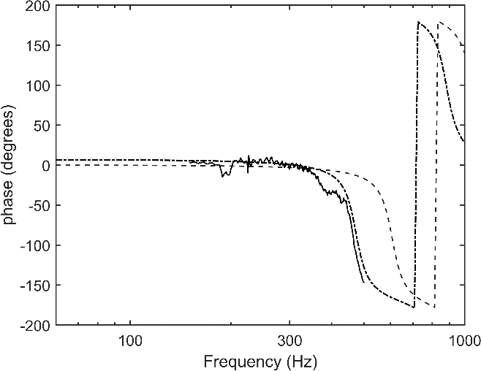  (d)
Figure 8. Comparisons between the measured and modelled magnitude and phase of vertical ((a) and (b)) and lateral ((c) and (d)) dynamic transfer stiffnesses. The measured data is from the preload of 20 kN. ―, Measurement; − − −, mass-spring model; − ⋅ − ⋅, model including wave motion.
The model can also be used to obtain the point stiffnesses at both ends of the suspension element. These are shown in Figure 9 together with the transfer stiffness.
It would also be possible to extend the model to use frequency-dependent material properties, as in [23, 24]. However, for a loss factor of 0.12 it is expected that the modulus of the rubber will only increase by about 20% for a ten-fold increase in frequency [33], which is negligible compared with the effects considered here.
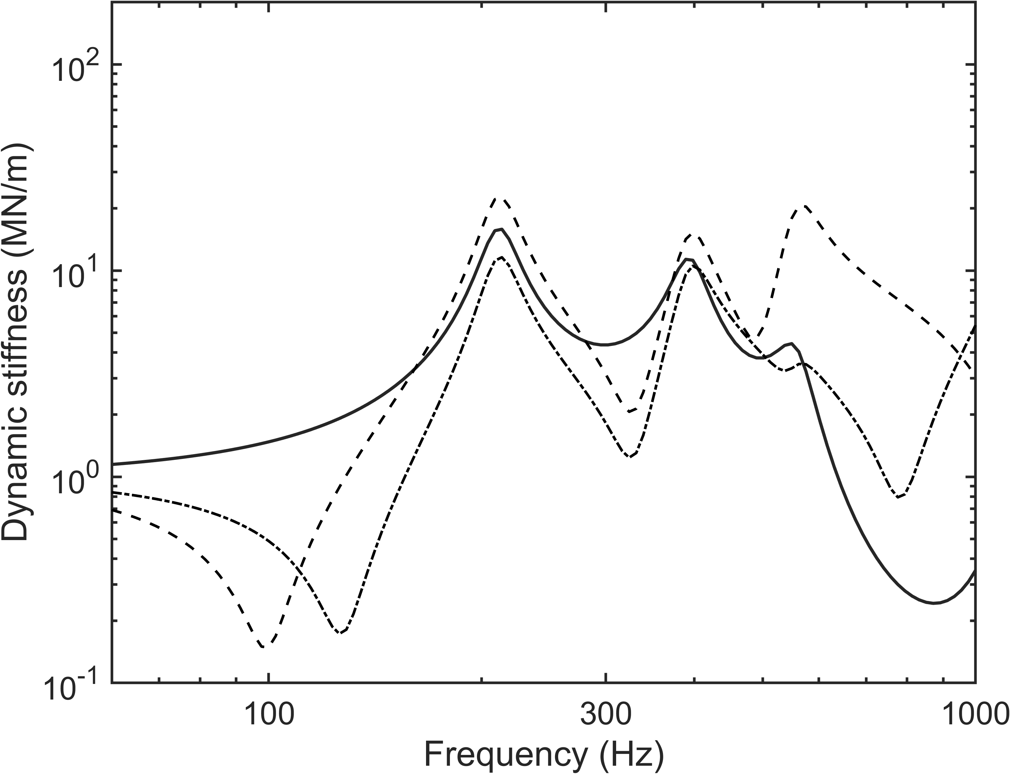  (a) | 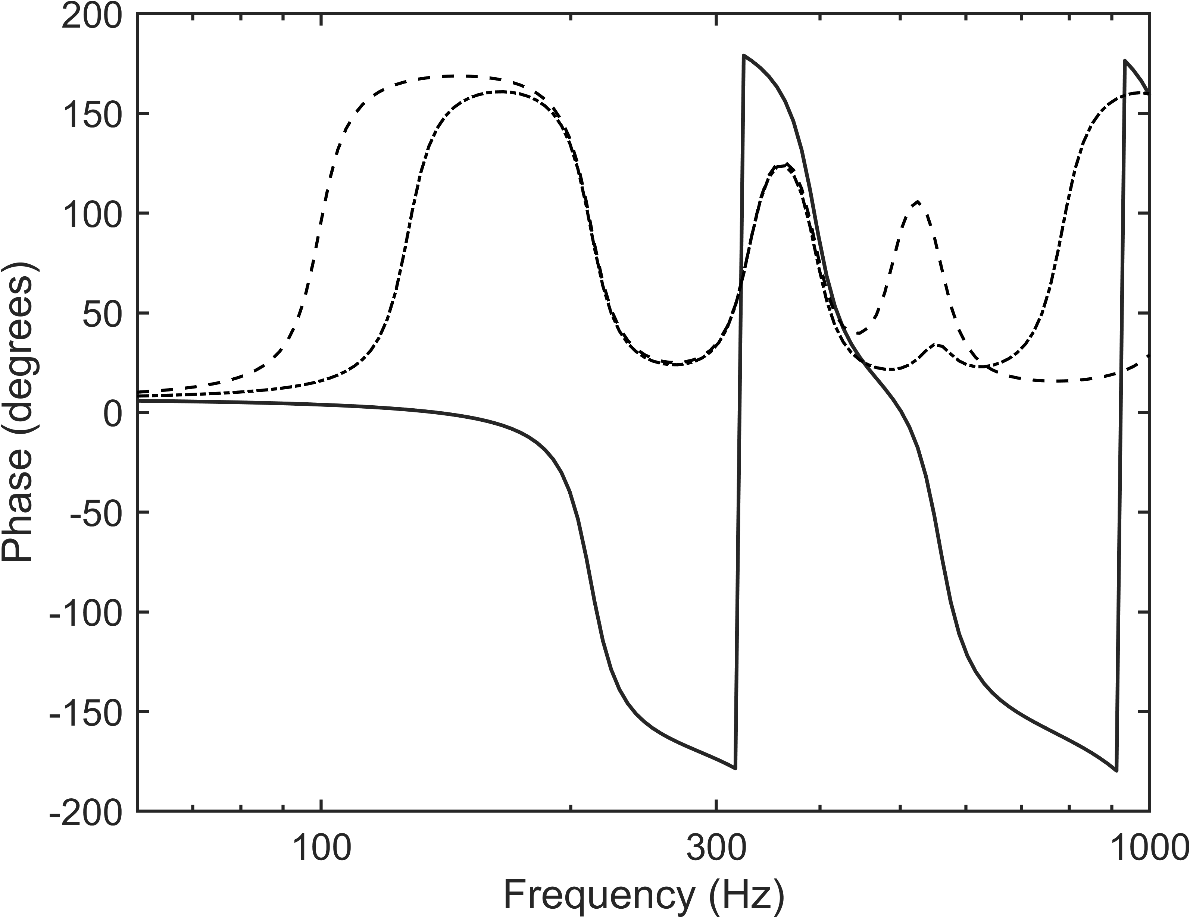  (b)
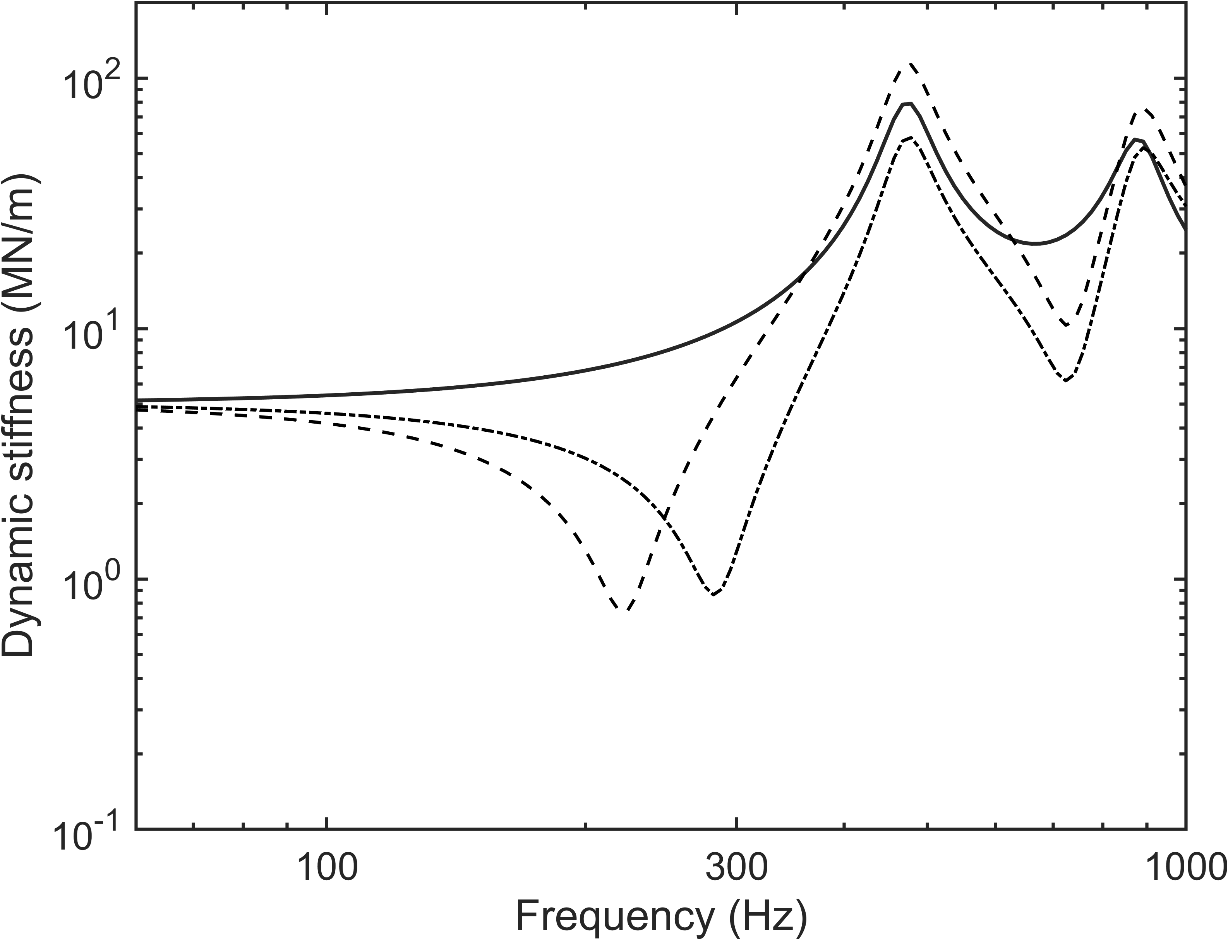  (c) | 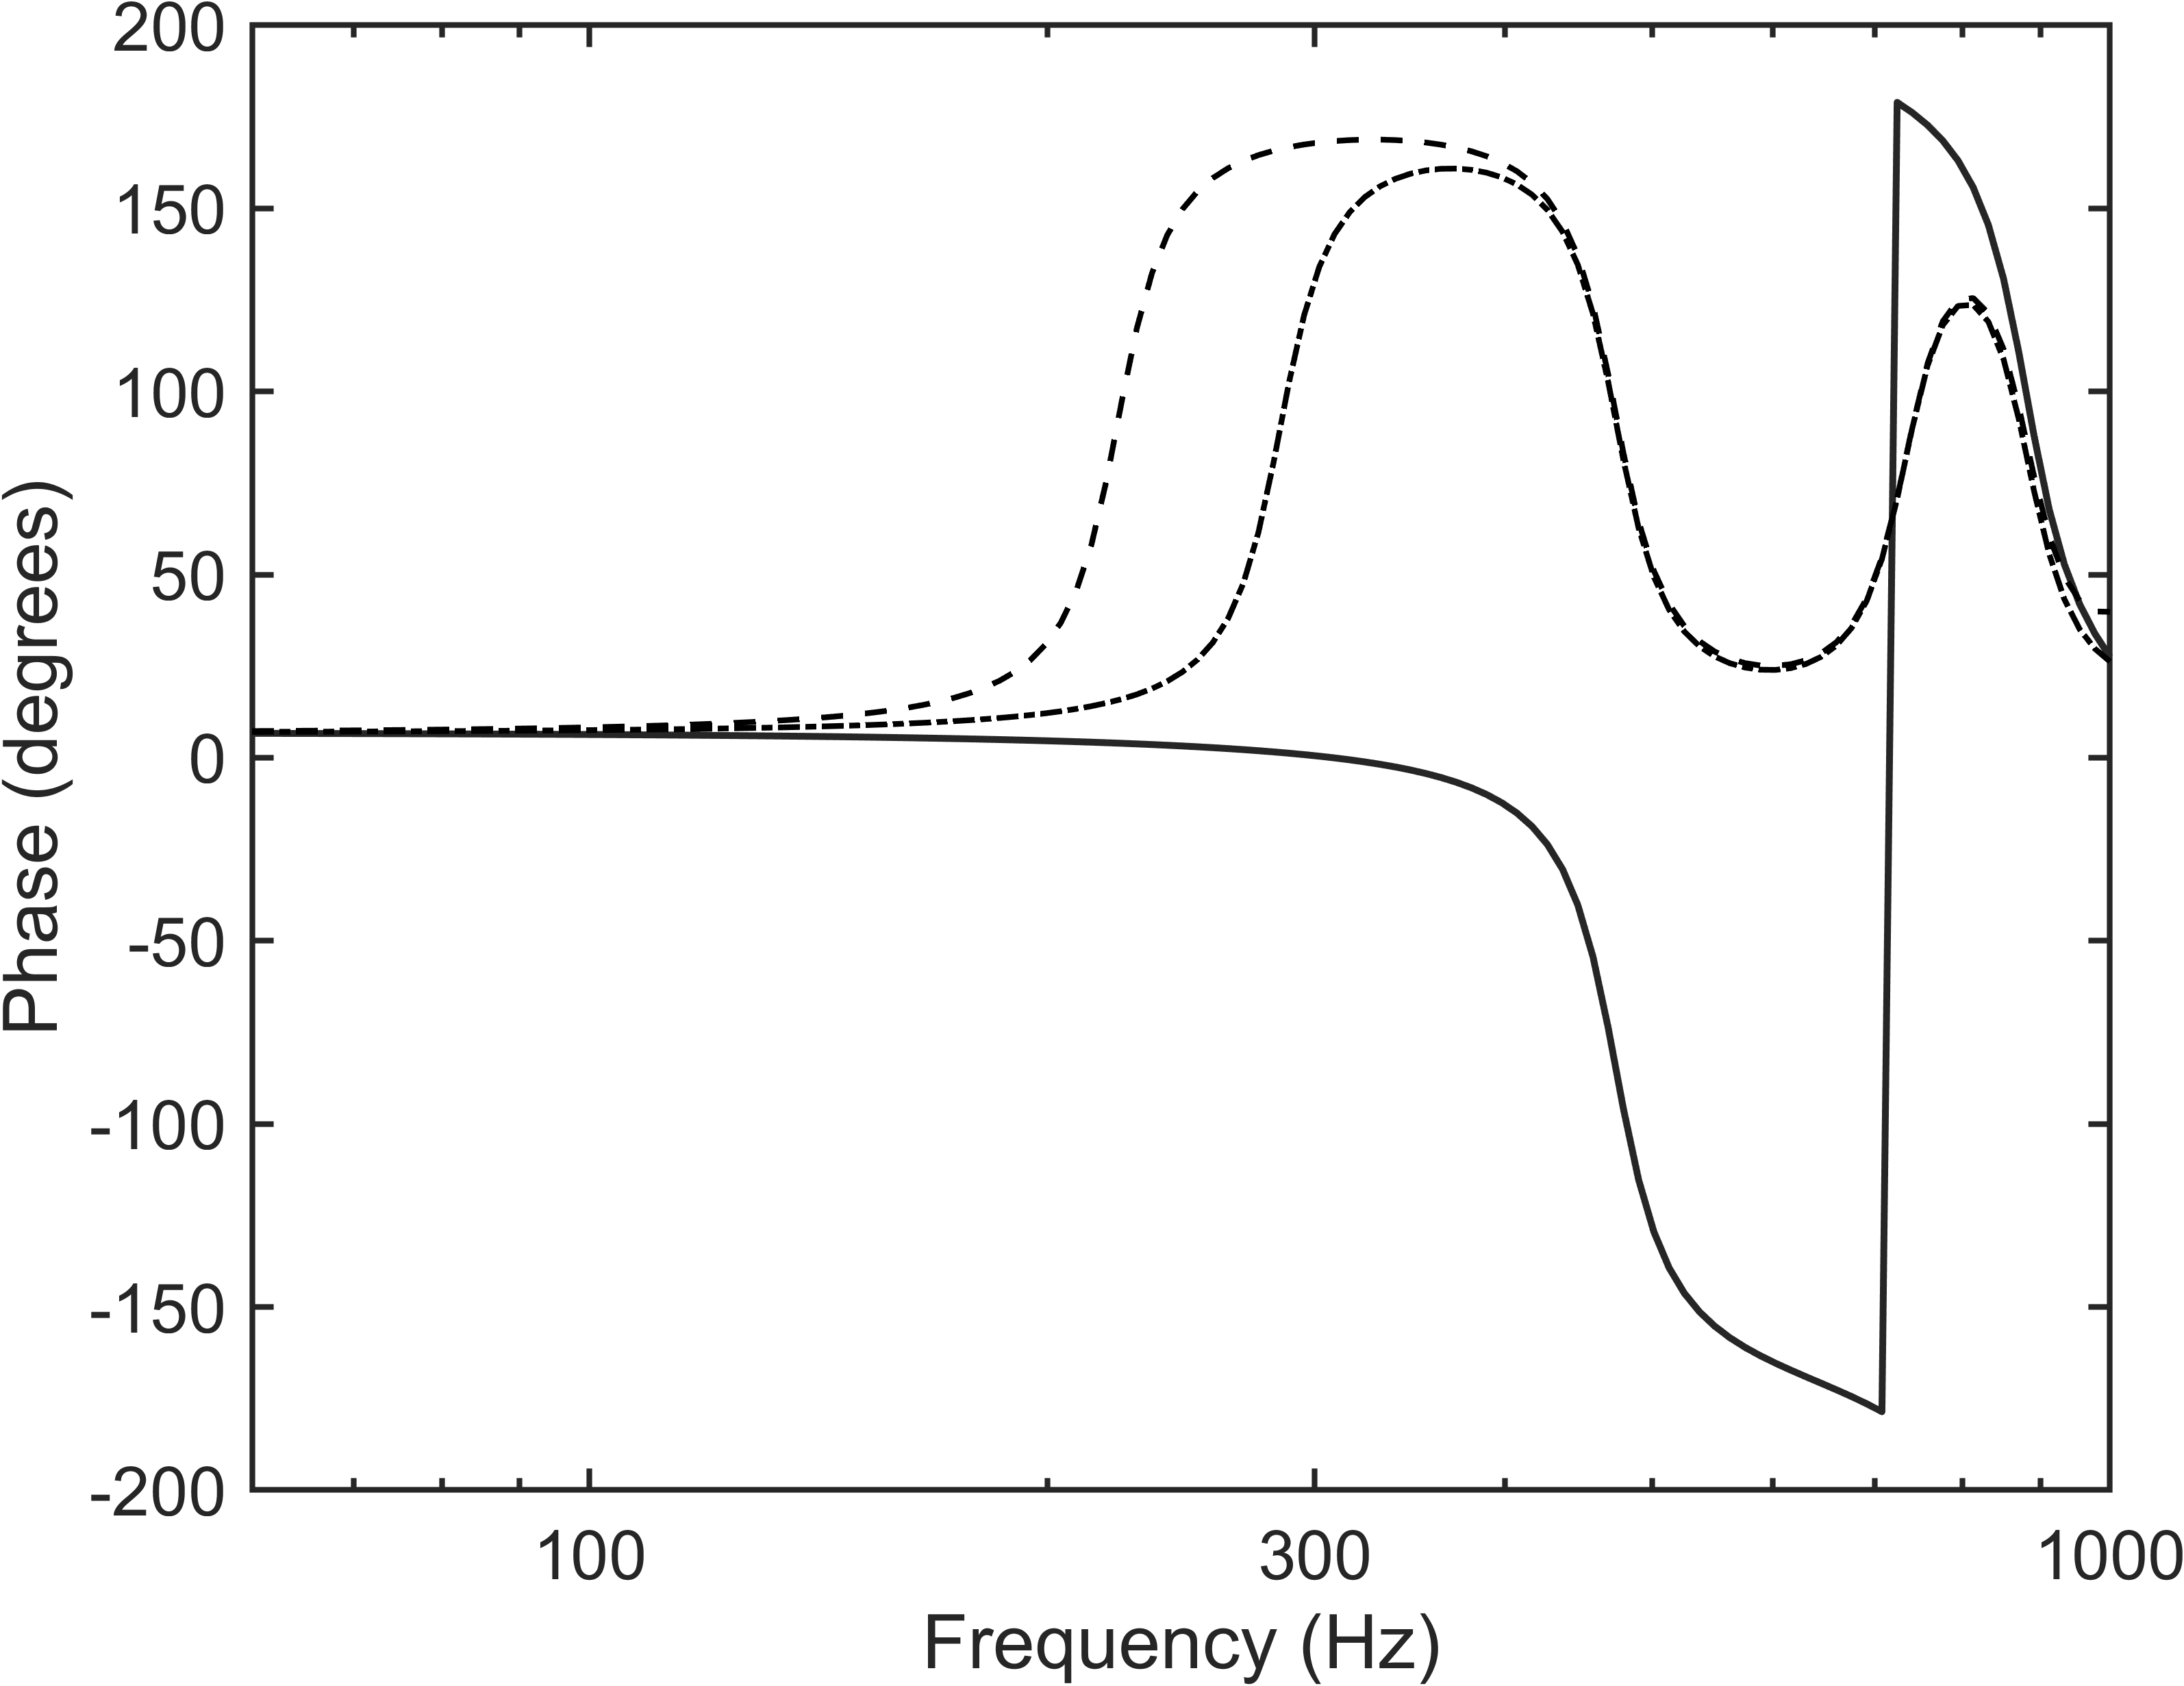  (d)
Figure 9. Vertical ((a) and (b)) and lateral ((c) and (d)) point and transfer stiffnesses (magnitude and phase) obtained from the model for preload 20 kN. ―, transfer stiffness; − − −, point stiffness with excitation at the top; − ⋅ − ⋅, point stiffness with excitation at the bottom.

Structure-borne noise transmission model
An FE model of the running gear has been established in the frequency domain to obtain the point and transfer receptances at the wheel-rail contact points and sets of transfer functions between the wheel-rail contact point and various response points on the bogie as well as the connection points with the car body. The receptances are used to calculate the wheel/rail contact forces using a linearised frequency domain approach based on a ‘moving roughness’ model excited by the measured roughness spectrum [17]. This approach is similar to that used for example in the TWINS model of rolling noise which has been previously validated [16]. The wheel/rail contact forces are then combined with the bogie transfer functions to obtain estimates of the vibration levels on the bogie as well as the blocked forces acting on the car body under operational conditions. The computed blocked forces are finally combined with measured vibro-acoustic transfer functions to determine the structure-borne noise contribution to interior noise.

The FE model
The work focuses on a trailer vehicle of a Metro de Madrid train. A complete FE model has been produced including the bogie frame, front and rear wheelsets, axleboxes, primary suspension elements, lateral dampers and traction rods. An overview of the FE model is shown in Figure 10. The wheelsets, bogie frame and axleboxes are modelled using solid elements. There are about 1.36 million nodes in the whole model and 0.7 million elements. The damping loss factor in the FE model is set to 0.08 for the metal parts of the bogie to correspond to static measurements.
Special attention is given to modelling the primary suspension elements, for which the point and transfer dynamic stiffnesses obtained from the previous sections are applied using the user-defined generalised spring-damper elements (CBUSH element in Nastran). This is a general spring and damper element with the capability of including frequency-dependent stiffness and damping. The element is defined between two points in the model and its stiffness and damping include translational and rotational directions. In practice, it is common to define two coincident points to model a suspension component, with a dynamic stiffness only given for the three translational degrees of freedom. The rotational stiffness is set to an arbitrary large value.
To represent a simple spring connecting points 1 and 2 in a single direction, the stiffness matrix of such an element is given by,
 | $$K= \left[\begin{matrix}K_{11} & -K_{12} \\ {-K}_{21} & K_{22}\end{matrix}\right]$$ | (20)
where K₁₁ = K₁₂ = K₂₁ = K₂₂ is the stiffness defined in the CBUSH element. However, for the primary suspension elements, as seen above, the point stiffnesses K₁₁ and K₂₂ are different from each other and from the transfer stiffnesses K₁₂ = K₂₁ and each contain damping. To represent a primary suspension element in the FE model, three generalised spring elements are needed for each coordinate direction. The first element is defined between points 1 and 2 including only the transfer dynamic stiffnesses. The other two elements are defined by introducing grounded generalised springs at points 1 and 2 respectively with the dynamic stiffness defined by the difference between the point and transfer dynamic stiffness. Thereby, the dynamic stiffnesses of the primary suspension elements can be readily modelled by using the combination of these three generalised spring elements,
 | $$K= \left[\begin{matrix}K_{12} & -K_{12} \\ {-K}_{21} & K_{21}\end{matrix}\right]+\left[\begin{matrix}{K_{11}-K}_{12} & 0 \\ 0 & 0\end{matrix}\right]+\left[\begin{matrix}0 & 0 \\ 0 & K_{22}-K_{21}\end{matrix}\right]$$ | (21)
where each element $K_{ij}$ is frequency dependent and complex.
A close-up view of the FE mesh in the vicinity of the primary suspension element is shown in Figure 11. The locations of the primary suspension elements are indicated by vertical yellow lines on either side of the wheel centre. They are attached to multiple nodes on the underside of the bogie frame and the upper side of the axlebox frame by a series of rigid connectors.
The dampers and traction rods in the secondary suspension are modelled approximately using one-dimensional beam elements. There are rubber bushings at each end which are represented by damped springs of constant stiffness, with the values listed in Table 2, in which the convention used for the global coordinates x, y and z is also indicated (see also Figure 10). These damped springs are assigned a damping loss factor of 0.1. The secondary suspension consists of air springs with a very low stiffness and so are neglected in the model.
Table 2. Constant stiffnesses used for bushing elements
Global coordinate  direction |  | Lateral damper (MN/m) | Traction rod (MN/m)
x (longitudinal) |  | 5 | 10
y (lateral) |  | 20 | 2
z (vertical) |  | 20 | 10

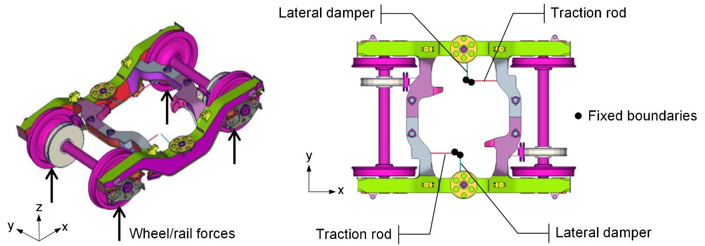
Figure 10. Overview of the finite element model of a complete trailer bogie.
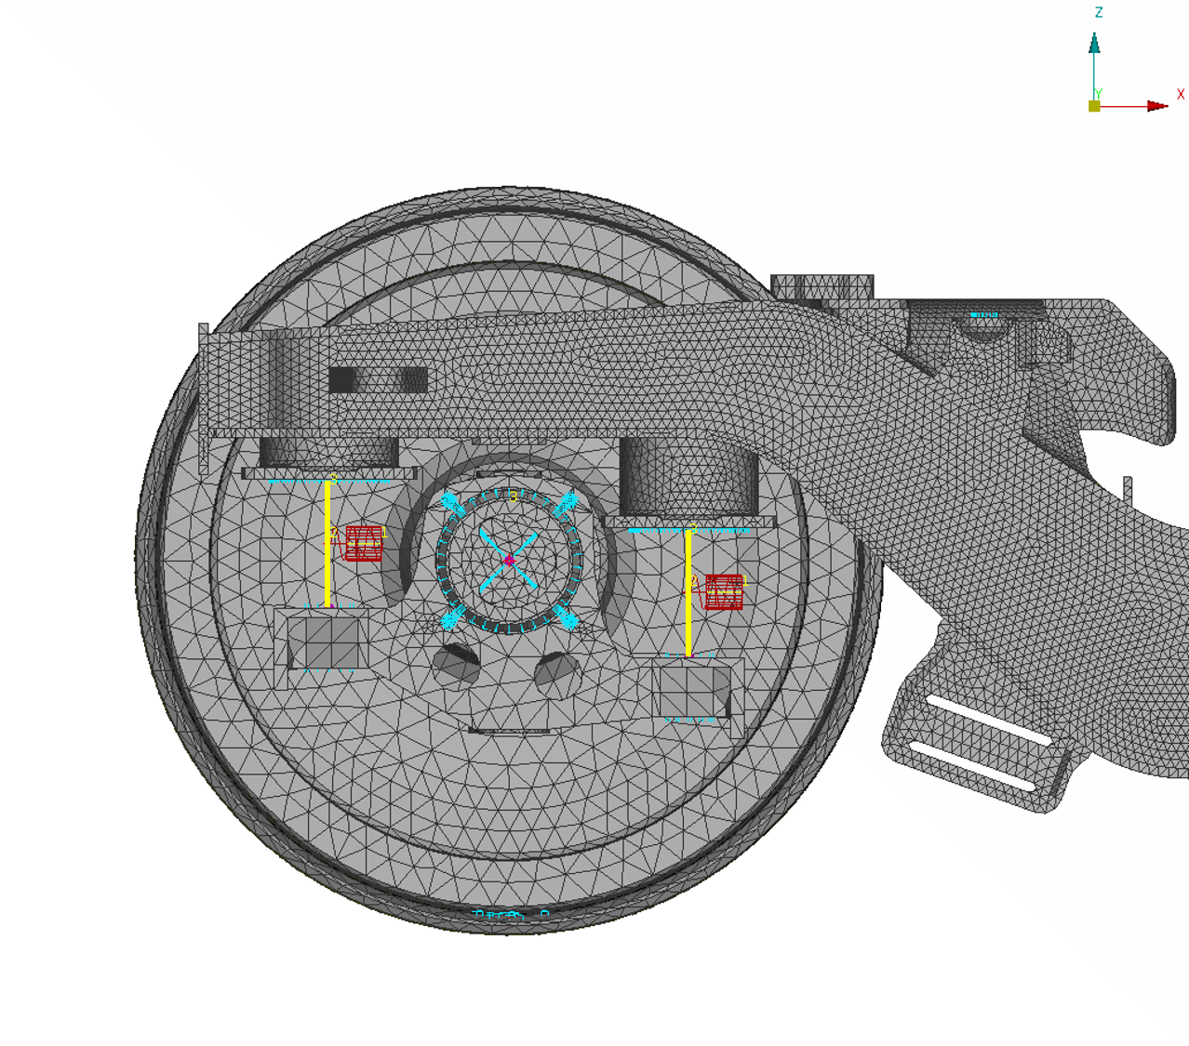
Figure 11. Detail of the part of the finite element model of the trailer bogie showing the location of the primary suspension elements (yellow lines).

Contact forces
The FE model is excited by four wheel/rail contact points, see Figure 10. The interaction forces $F_{contact}$ at a given wheel-rail contact point, in vertical and lateral directions, are calculated from the wheel/rail roughness $R$ and the receptances of the wheel $A_{w}$, rail $A_{r}$ and contact $A_{c}$ using a linearised frequency domain approach based on a ‘moving roughness’ model [17]. This approach is similar to that used in the TWINS model of rolling noise [16] but here includes all four wheels in the bogie simultaneously. This can be expressed as
 | $$F_{contact}={(A_{w}+A_{r}+A_{c})}^{-1}R$$ | (22)
Here, coupling between the vertical and lateral directions is considered, as well as between wheels 1 and 2 of a wheelset. Coupling through the axle takes account of the fact that both wheels of a wheelset can vibrate when one wheel is excited. Therefore, the contact force vector is given as $F_{contact}=[F_{z1} F_{y1} F_{z2} F_{y2}]^{T}$. The roughness excitation at each contact point is considered to be the incoherent sum of the wheel and rail roughness which are obtained from measurements. For excitation on wheel 1, $R= {[R_{z1} 0 0 0]}^{T}$ and for excitation on wheel 2, $R= {[0 0 R_{z2} 0]}^{T}$. The input roughness spectrum is filtered by the contact patch using an analytical formula that depends on speed and wheel load [1].
The wheel receptance matrix is given by
 | $$A_{w}=\left[\begin{matrix}A_{z1} & ⋯ & A_{zy12} \\ ⋮ & ⋱ & ⋮ \\ A_{yz12} & ⋯ & A_{y2}\end{matrix}\right]$$ | (23)
The off-diagonal terms represent coupling between vertical and lateral directions as well as between the two wheels of a wheelset. The wheel receptances are obtained from the FE model.
Similarly, in principle the rail receptance matrix includes the cross terms with subscripts 1 and 2 indicating coupling between the two rails:
 | $$A_{r}=\left[\begin{matrix}A_{z1} & ⋯ & A_{zy12} \\ ⋮ & ⋱ & ⋮ \\ A_{yz12} & ⋯ & A_{y2}\end{matrix}\right]$$ | (24)
In the present case, however, the rail receptances are calculated using a a Timoshenko beam model with discrete supports [1] and the coupling between the two rails is not included. Alternatively, an FE model of the track could be used to include this coupling.
The contact receptance matrix is diagonal and is given by
 | $$A_{c}=\left[\begin{matrix}A_{z1} & ⋯ & 0 \\ ⋮ & ⋱ & ⋮ \\ 0 & ⋯ & A_{y2}\end{matrix}\right]$$ | (25)
The vertical contact receptance is given by 1/K_{H}, where K_{H} is the linearised contact stiffness. The lateral receptance also includes a term representing the creep force as used in the TWINS model [1, 16]. The linearised model has been shown in [34] to be acceptable for all practical levels of roughness provided that loss of contact does not occur.

Response on the bogie and at the car body connection points
From the FE model, the vibration transfer functions $H_{γ/F}$ between forces at the contact point and a response point on the bogie can be obtained. Together with the contact forces $F_{contact}$ obtained in Section 3.2, the vibration response at a certain point on the bogie is calculated according to
 | $$γ=H_{γ/F}F_{contact}$$ | (26)
The above calculation is repeated for roughness excitation at each of the four wheels in turn and these vibration responses are combined by incoherent addition to estimate the total response spectrum.
In the present study, the car body is not included in the FE model and instead the blocked-force method is used. The four connection points on the bolster, to which the traction rods and lateral dampers are attached, are constrained as fixed. The force transmissibility functions $H_{F/F}$ between the wheel/rail contact points and the blocked force at each connection point are obtained from the FE model. Similar calculations to those used for the vibration response are applied to determine the blocked force spectrum at each connection point,
 | $$F_{bl}=H_{F/F}F_{contact}$$ | (27)
The total blocked force spectra are then obtained by taking the incoherent sum over the results for excitation at the four wheels.

Transmission to interior noise
The sound pressure amplitude p at a position inside the vehicle due to structure-borne transmission can be determined using
 | $$p=H_{connected}F_{bl}$$ | (28)
Here $H_{connected}$ contains the measured vibro-acoustic transfer functions between forces at the bogie-car body connection points and the pressure at the interior microphones. The subscript ‘connected’ indicates that the measurements were carried out without disconnecting the traction rods and lateral dampers from the car body. The pressure is determined as the incoherent sum of the contributions from each connection point.

Validation using field measurements
The vibration levels on the bogie and the blocked forces at the connecting elements as well as the structure-borne component of the interior noise predicted from the model have been compared with field measurements [35] which are briefly described below.

Field measurements
An extensive set of field measurements was carried out on a trailer vehicle of a Metro de Madrid Series 8000 train. This consisted of static measurements to characterise the structure-borne transmission path and running measurements on a test track at about 50 km/h. The track was a 1 km long, straight test track that was level with the adjacent ground. It was fitted with continuously welded rail and concrete sleepers with a sleeper spacing of 1 m.
In the static tests, a large number of transfer functions were measured on the bogie frame using an impact hammer to identify modes of vibration and verify the FE model. Updating of the FE model was not carried out but, despite some discrepancies, the agreement was generally reasonable. A matrix of frequency response functions was measured at the connection points between the bogie and the car body which was used to identify the blocked forces through a transfer path analysis (TPA) approach. These connection points consist of the lateral dampers, traction rods and secondary suspension springs, at each of which forces in three directions were taken into account. The vibro-acoustic transfer functions $H_{connected}$ from each of these force positions to the interior sound pressures were also measured.
Measurements were made of the track dynamic properties, including track decay rates and mobilities, from which the rail pad stiffness was identified as 800 MN/m in the vertical direction and 156 MN/m in the lateral direction, in each case with a damping loss factor of 0.2. The rail receptances are estimated using a model of a Timoshenko beam on a two-layer foundation, with damped springs representing the rail pads and the ballast and flexible beams used to represent the sleepers [1]. Figure 12 compares the point receptances of the rail, the wheel (obtained from the FE model) and the contact zone used in the model. These are the most important elements in Eq. (22), with the cross terms having a much smaller influence.
The wheel and rail roughness were also measured. The combined roughness of the wheel and rail is shown in Figure 13. The wheels were very smooth but the rail roughness levels can be seen to be considerably higher than the reference curve from ISO 3095:2013 [36]. A simple modal analysis of the wheelset was also carried out and used to verify the FE model of the wheelset.
In the running tests, vibration was measured at various locations on the bogie and at all the connection points to the car body. In particular, the traction rod, lateral damper and secondary suspension connection points were instrumented with accelerometers in all three coordinate directions to obtain the acceleration levels in operational conditions. These were used together with the accelerance matrix at the car body connection points to estimate the blocked forces using an experimental TPA technique [37]. The interior sound pressure was also measured during operation. A typical interior microphone position labelled 2004, for which results will be presented, is shown in Figure 14.
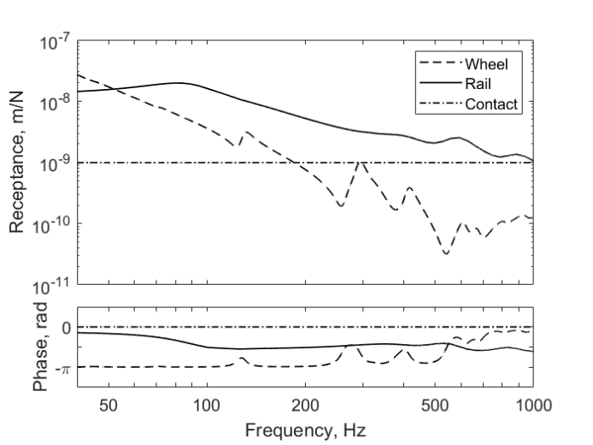 | 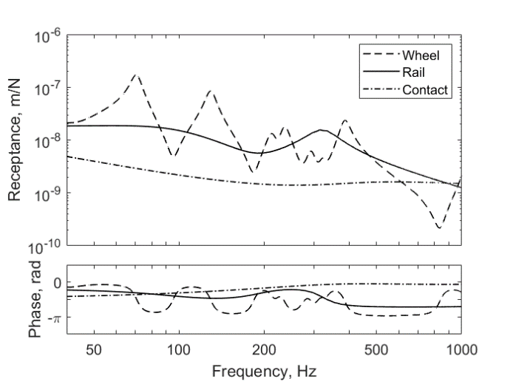
Figure 12. Predicted point receptances of wheel, rail and contact zone: (a) vertical, (b) lateral.
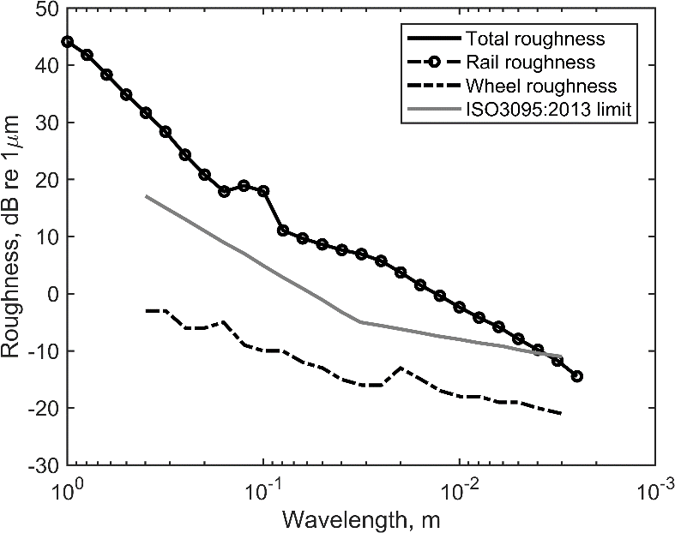
Figure 13. Wheel and rail roughness spectra.
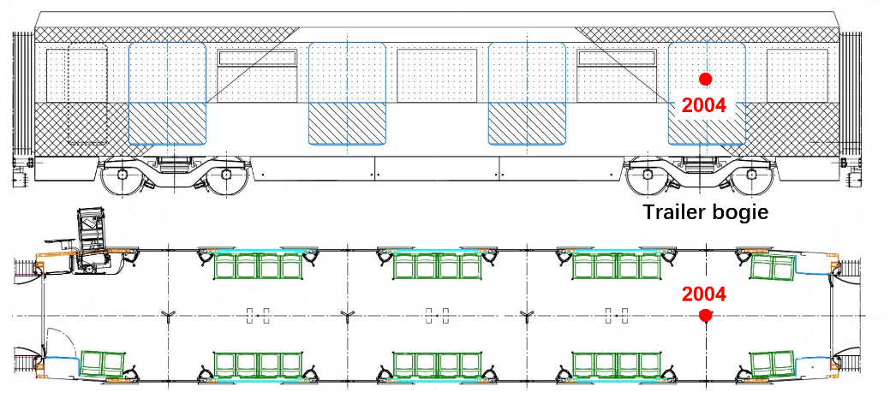
Figure 14. A typical interior microphone position used for comparison with predictions.

Results
Figure 15 shows comparisons for different locations between the predicted acceleration levels and the results measured during operation. This shows the vertical direction (z) for the axlebox and on either side of the primary suspension element, the lateral direction (y) for the lateral damper and the longitudinal direction (x) for the traction rod. Figure 15(a) and (b) also include the results predicted using the constant stiffness of the primary suspension for comparison with those obtained using the dynamic stiffness. Results are calculated with a frequency resolution of 0.25 Hz and are presented in one-third octave bands between 50 and 1000 Hz.
For the axlebox vibration, Figure 15(a), the spectral shape is well predicted between 100 and 400 Hz although the levels are found to be around 5 dB higher than the measurement. These discrepancies are transmitted to the positions below and above the primary suspension element, Figure 15(b), leading to slightly higher levels in the prediction between 100 and 400 Hz. The effect of using the dynamic stiffness is clearly seen at the position above the suspension element in Figure 15(b), at which the levels predicted by using the constant stiffness are generally lower than those obtained using the dynamic stiffness above 100 Hz, with differences of up to 20 dB. The predicted results based on the dynamic stiffness show better agreement with the measurements.
Good agreement with the measurements is obtained for the position on the bogie side of the lateral damper (Figure 15(c)) and the traction rod (Figure 15(d)). At the vehicle side of these components, reasonable agreement is also obtained at frequencies up to 500 Hz for the lateral damper and up to 200 Hz for the traction rod. At higher frequency, however, the levels are considerably under-predicted, indicating that the vibration filtering by the rubber bushings at the extremities of the lateral dampers and traction rods is overestimated in the model. This suggests that the dynamic stiffness values used for the bushings in the model are too low at these frequencies.
Below 80 Hz the levels are over-predicted for all the locations shown in Figure 15. A possible reason is that the rail roughness used to calculate the excitation forces (Figure 13) may be too high. Rail vibration predicted using this roughness (not shown here) was also found to be over-predicted at low frequency in comparison with measurements [35].
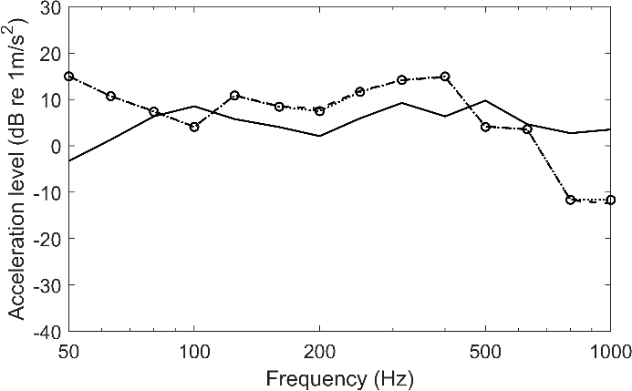
(a)
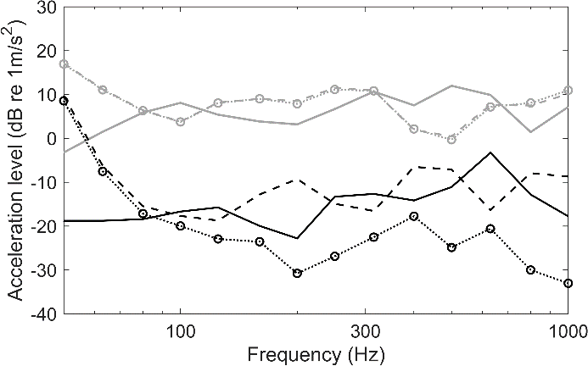
(b)
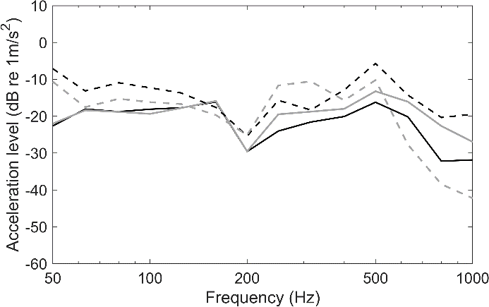
(c)
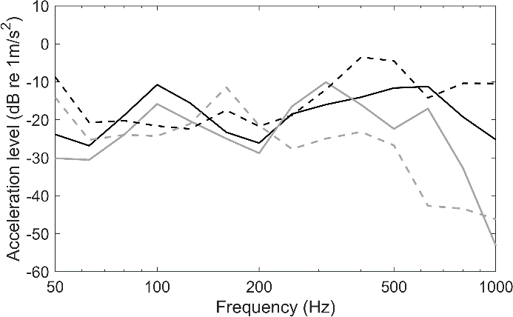
(d)
Figure 15. Comparisons between measured and predicted acceleration levels in one-third octave bands (a) on the axlebox in the vertical direction, (b) below (grey) and above (black) the primary suspension in the vertical direction, (c) bogie (black) and vehicle (grey) side of the lateral damper in the lateral direction and (d) bogie (black) and vehicle (grey) side of the traction rod in the longitudinal direction. ―, measured; − −, predicted using dynamic stiffness; ⋅ ⋅ ⋅, predicted using constant stiffness (a and b only).
The blocked forces from the connections at the lateral damper and the traction rod with the largest contributions to the interior noise are shown in Figure 16. The results obtained from the model are compared with those estimated from the TPA measurements (see Section 4.1). It is evident that, compared with using the constant stiffness, the consideration of the dynamic stiffness for the primary suspension can give better predictions of the spectral shape. Similar to the results in Figure 16(c) and (d), the predictions are mostly satisfactory at low frequencies, but large discrepancies are observed above 500 Hz for the lateral damper and above 200 Hz for the traction rod.
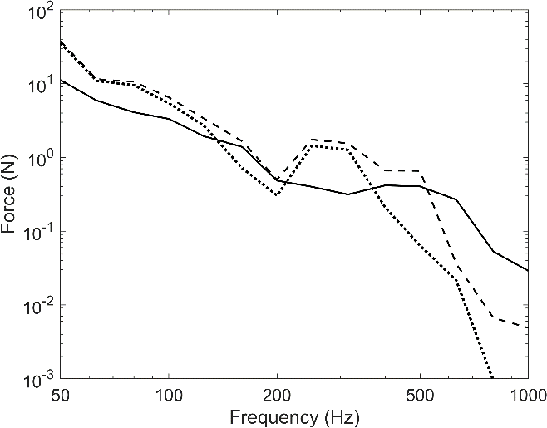 | 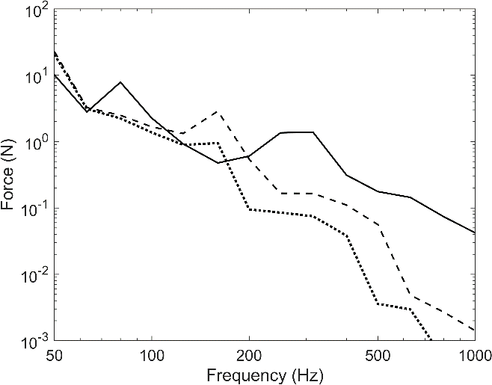
Figure 16. Main contributing blocked forces in one-third octave bands from (a) the lateral damper in the lateral (y) direction and (b) the traction rod in the longitudinal (x) direction. ―, measured (from TPA); − −, predicted using dynamic stiffness; ⋅ ⋅ ⋅, predicted using constant stiffness.
Figure 17 shows the structure-borne component of noise at a typical location inside the vehicle (indicated in Figure 14). From the model the individual contributions from the lateral damper and traction rod are also identified. As discussed in relation to Figure 15, the difference with the measurements below 80 Hz may be associated with the uncertainties in the measured rail roughness. In addition, the overestimation of the vibration levels on the axlebox is propagated through the whole chain to the interior noise. The prediction using the dynamic stiffness for the primary suspension shows satisfactory agreement with the measurements between 80 and 500 Hz although the levels are higher than the measured ones. Above 500 Hz, the predicted levels are much lower than the measurements due to the over-estimation of the filtering effect of the rubber bushings, as demonstrated in Figure 15.
To eliminate the differences caused by the calculation of wheel/rail forces seen in Figure 15, these results have been recalculated to correspond to the measured axlebox vibration and are shown in Figure 18. Apart from the 500 Hz band, the agreement with the measured spectrum obtained from TPA is much improved, especially when the dynamic stiffness of the primary suspension is taken into account. The overpredictions found in Figures 15-17 may therefore be due to discrepancies in the transfer function from the contact point to the axlebox; for example, the bearings may introduce some isolation whereas these are considered as rigid in the FE model.
From Figures 17 and 18, it can be found that both the lateral damper and the traction rod are important paths at frequencies up to 200 Hz although the contributions from the traction rod are smaller. Above 200 Hz, the levels estimated for the traction rod drop significantly due to over-estimated filtering effect and the lateral damper is predicted to be the dominant path (also when using forces obtained from TPA the lateral damper is predicted to be the dominant path). From Figure 17, the overall A-weighted sound pressure level over the frequency range between 80 and 1000 Hz predicted using the dynamic and constant stiffness for the primary suspension are 47.7 and 43.7 dBA respectively, and the corresponding measured result is 43.8 dBA. The predicted contributions from the lateral damper and the traction rod are 47.2 and 38.4 dBA respectively.
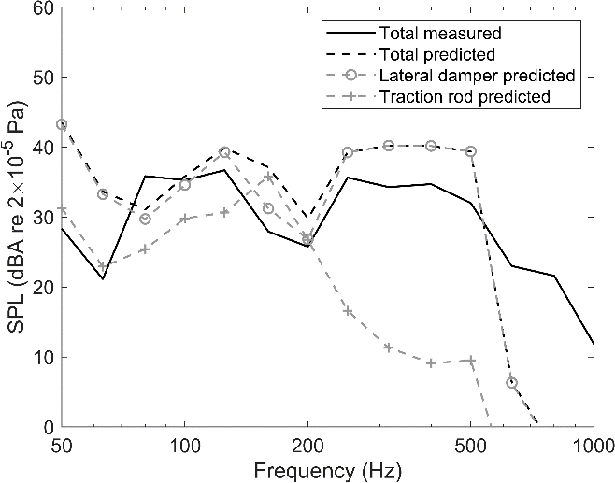 | 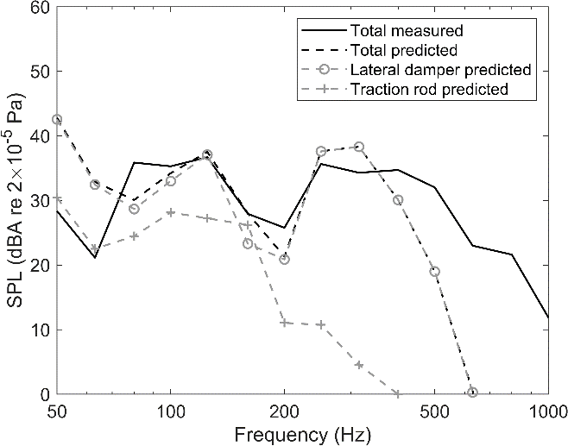
Figure 17. Comparison of predicted A-weighted structure-borne noise levels in one-third octave bands with measured estimates from TPA for position inside the vehicle at microphone 2004. (a) Prediction based on dynamic stiffness; (b) prediction based on constant stiffness.
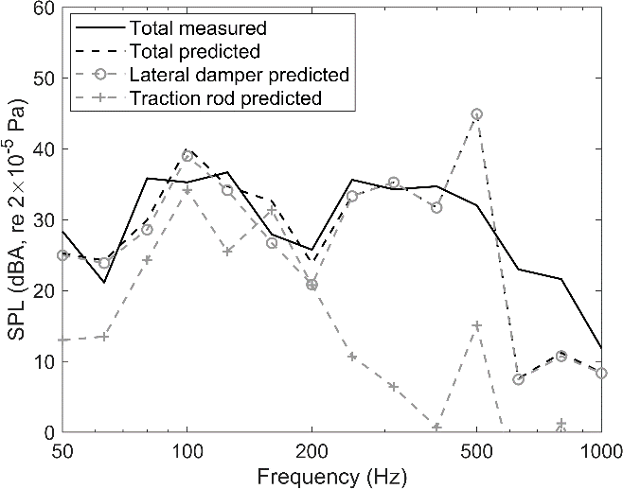  (a) | 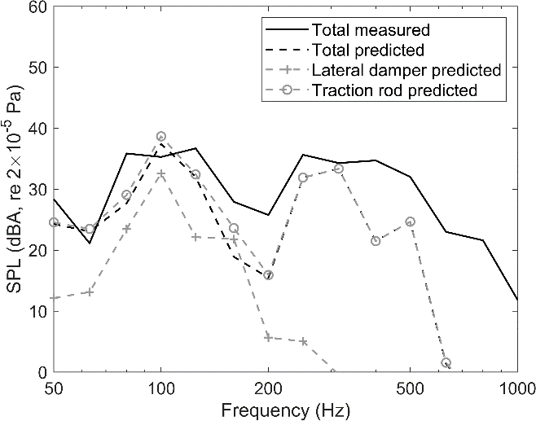  (b)
Figure 18. Predicted A-weighted structure-borne noise levels in one-third octave bands based on measured axlebox vibration for position inside the vehicle at microphone 2004. (a) Prediction based on dynamic stiffness; (b) prediction based on constant stiffness.

Conclusions
A method to investigate the structure-borne noise transmission from the wheel/rail contact to the interior of a train has been presented. A model of wheel/rail interaction is used to determine the contact forces and a detailed finite element model of the bogie is used to determine the blocked forces at the connection points with the car body. The frequency-dependent dynamic stiffnesses of a conical metal/rubber suspension element have been determined through both measurements and analytical models and are used in the FE model of the bogie. The blocked forces are then combined with vibro-acoustic transfer functions of the car body, in this case obtained by measurement, to predict the structure-borne interior noise.
The vertical dynamic stiffness magnitude of the primary suspension element at low frequencies is found to be about twice the value of the static stiffness. Furthermore, there are peaks caused by internal resonances at around 200 and 450 Hz with amplitudes that are more than 10 times greater than the low frequency stiffness. Both the frequency and magnitude of these peaks increase with increasing preload. A model based on a mass-spring system including wave motion in the rubber elements gives good agreement with the measured dynamic stiffness. Both the internal resonance frequency and the magnitude of the peak can be well predicted by including wave motion in the rubber.
The approach for predicting the structure-borne transmission has been validated against field measurements. Apart from discrepancies below 80 Hz, believed to be due to uncertainties in the measured rail roughness, good agreement has been obtained for acceleration levels on different components. The vibration of the axlebox is overpredicted and this is propagated through the whole model. The effect of the frequency dependence of the primary suspension element dynamic stiffness is clearly seen, indicating that it is necessary to include this in the FE model. The computed blocked forces at the car body connection points show satisfactory agreement with those obtained from measurements up to 500 Hz.
The structure-borne component of noise inside the vehicle, predicted from the computed blocked forces and measured vibro-acoustic transfer functions of the car body, agrees well with estimates from experimental TPA. In addition, by assessing the contributions from different elements, it is found that both the lateral dampers and the traction rods are important structure-borne paths. To reduce the structure-borne noise transmission, attention should be given to reducing the stiffness of the bushings at either end of the lateral dampers and the traction rods, provided that they can still sustain the static loads required of them.

Acknowledgements
The work presented in this paper has received funding from the Shift2Rail Joint Undertaking under the European Union’s Horizon 2020 research and innovation programme (grant agreement no. 777564). The contents of this publication only reflect the authors’ views and the Joint Undertaking is not responsible for any use that may be made of the information contained in the paper.
The authors are grateful to CAF (Construcciones y Auxiliar de Ferrocarriles), and especially to Ainara Guiral, for assistance with information on the vehicles. The authors are also grateful to Francisco D. Denia and Juan Giner-Navarro from UPV, Bruno Delescluse from Vibratec, Julián Martín Jarillo and Juan Moreno García-Loygorri from Metro de Madrid for their assistance with the measurements.

References

[1] | D. Thompson, Railway noise and vibration: mechanisms, modelling and means of control, Elsevier, 2008.
[2] | W. Sun, J. Zhou, D. Gong and T. You, Analysis of modal frequency optimization of railway vehicle car body, Advances in Mechanical Engineering 8 (4) (2016) 1-12.
[3] | L. Ling, Q. Zhang, X. Xiao, Z. Wen and X. Jin, Integration of car-body flexibility into train–track coupling system dynamics analysis, Vehicle System Dynamics 56 (4) (2018) 485-505.
[4] | J. Zhang, X. Xiao, X. Sheng, C. Zhang, R. Wang and X. Jin, SEA and contribution analysis for interior noise of a high speed train, Applied Acoustics 112 (2016) 158-170.
[5] | A. Frid, U. Orrenius, T. Kohrs and S. Leth, BRAINS - the concepts behind a quick and efficient tool for prediction of exterior and interior railway vehicle noise, in Acoustics 2012, Nantes, 2012.
[6] | J. Forssén, S. Tober, A. C. Corakci, A. Frid and W. Kropp, Modelling the interior sound field of a railway vehicle using statistical energy analysis, Applied Acoustics, 73(4) (2012) 307-311.
[7] | P. J. Shorter and R. S. Langley, Vibro-acoustic analysis of complex systems, Journal of Sound and Vibration 288 (3) (2005) 669-699.
[8] | L. Ji, X. Sheng, X. Xiao, Z. Wen and X. Jin, A review of mid-frequency vibro-acoustic modelling for high-speed train extruded aluminium panels as well as the most recent developments in hybrid modelling techniques, Journal of Modern Transportation 23 (2015) 159-168.
[9] | J. Sapena, A. Tabbal, J. Jové and F. Guerville, Interior Noise Prediction in High-Speed Rolling Stock Driver’s Cab: Focus on Structure-Borne Paths (Mechanical and Aero Sources), in Proceedings of the 10th International Workshop on Railway Noise, Nagahama, Japan, 2010.
[10] | X. Zheng, Z. Hao, X. Wang and J. Mao, A full-spectrum analysis of high-speed train interior noise under multi-physical-field coupling excitations, Mechanical Systems and Signal Processing 75 (2016) 525-543.
[11] | H. M. Noh, Contribution analysis of interior noise and floor vibration in high-speed trains by operational transfer path analysis, Advances in Mechanical Engineering, 9(8) (2017) 1-14.
[12] | M. Li, Z. Zhu, T. Deng and X. Sheng, An investigation into high-speed train interior noise with operational transfer path analysis method, Railway Engineering Science, 29(1) (2021) 1-14.
[13] | J. Han, X. Xiao, Y. Wu, Z. Wen and G. Zhao, Effect of rail corrugation on metro interior noise and its control, Applied Acoustics, 130 (2018) 63-70.
[14] | L. Li, D. Thompson, Y. Xie, Q. Zhu, Y. Luo and Z. Lei, Influence of rail fastener stiffness on railway vehicle interior noise, Applied Acoustics 145 (2019) 69-81.
[15] | H. Li, D. Thompson, G. Squicciarini, X. Liu, M. Rissmann, P. Bouvet, F. D. Denia, L. Baeza, J. Martín Jarillo and J. Moreno García-Loygorri, A framework to predict the airborne noise inside railway vehicles with application to rolling noise, Applied Acoustics 179 (2021) 108064.
[16] | D. J. Thompson, B. Hemsworth and N. Vincent, Experimental validation of the TWINS prediction program for rolling noise, part 1: description of the model and method, Journal of Sound and Vibration 193 (1) (1996) 123-135.
[17] | K. Knothe and S. Grassie, Modelling of railway track and vehicle/track interaction at high frequencies, Vehicle System Dynamics 22 (3-4) (1993) 209-262.
[18] | S. Bruni, J. Vinolas, M. Berg, O. Polach and S. Stichel, Modelling of suspension components in a rail vehicle dynamics context, Vehicle System Dynamics 49 (7) (2011) 1021-1072.
[19] | B. M. Eickhoff, J. R. Evans and A. J. Minnis, A review of modelling methods for railway vehicle suspension components, Vehicle System Dynamics 24 (6) (1995) 469-498.
[20] | J. Lee and D. J. Thompson, Dynamic stiffness formulation, free vibration and wave motion of helical springs, Journal of Sound and Vibration 239 (2) (2001) 297-320.
[21] | W. Sun, D. Thompson and J. Zhou, A mechanism for overcoming the effects of the internal resonances of coil springs on vibration transmissibility, Journal of Sound and Vibration 471 (2020) 115-145.
[22] | M. Berg, A model for rubber springs in the dynamic analysis of rail vehicles, Proceedings of the Institution of Mechanical Engineers, Part F: Journal of Rail and Rapid Transit 211 (2) (1997) 95-108.
[23] | M. M. Sjöberg and L. Kari, Non-Linear Behavior of a Rubber Isolator System Using Fractional Derivatives, Vehicle System Dynamics 37 (3) (2002) 217-236.
[24] | L. Kari, Audible-frequency stiffness of a primary suspension isolator on a high-speed tilting bogie, Proceedings of the Institution of Mechanical Engineers, Part F: Journal of Rail and Rapid Transit 217 (1) (2003) 47-62.
[25] | ISO 10846-1, Acoustics and vibration - Laboratory measurement of vibro-acoustic transfer properties of resilient elements - Part 1: principles and guidelines, 2008.
[26] | ISO 10846-2, Acoustics and vibration—Laboratory measurement of vibro-acoustic transfer properties of resilient elements—Part 2: dynamic stiffness of elastic supports for translatory motion—direct method, 2008.
[27] | ISO 10846-3, Acoustics and vibration—Laboratory measurement of vibro-acoustic transfer properties of resilient elements—Part 3: dynamic stiffness of elastic supports for translatory motion—indirect method, 2002.
[28] | J. W. Verheij, Measuring sound transfer through resilient mountings for separate excitation with orthogonal translations and rotations., in Proceedings of Inter Noise, Miami, 1980.
[29] | D. J. Thompson, W. J. V. Vliet and J. W. Verheij, Developments of the indirect method for measuring the high frequency dynamic stiffness of resilient elements, Journal of Sound and Vibration 213 (1) (1998) 169-188.
[30] | D. J. Mead, Passive Vibration Control, John Wiley & Sons, Chichester, 1998.
[31] | A. D. Nashif, D. I. G. Jones and J. P. Henderson, Vibration Damping, John Wiley & Sons, New York, 1985.
[32] | F. Fahy and J. Walker, Advanced applications in acoustics, noise and vibration, CRC Press, 2018.
[33] | N. Ahmad, D. J. Thompson, C. J. C. Jones and A. H. Muhr, Predicting the effect of temperature on the performance of elastomer-based rail damping devices, Jound of Sound and Vibration 322 (2009) 674-689.
[34] | T. X. Wu and D. J. Thompson, Theoretical investigation of wheel/rail non-linear interaction due to roughness excitation, Vehicle System Dynamics 34 (2000) 261-282.
[35] | P. Bouvet, M. Rissmann, D. Thompson, X. W. Liu, H. Li, G. Squicciarini and G. Xie, Validation of complete virtual test method for structure-borne and airborne noise transmission, RUN2Rail Deliverable D4.3, 2019.
[36] | ISO 3095, Railway applications – Acoustics – Measurements of noise emitted by railbound vehicles, International Standards Organization, Geneva, 2013.
[37] | A. Moorhouse, A. Elliott and T. Evans, In situ measurement of the blocked force of structure-borne sound sources, Journal of Sound and Vibration 325 (4) (2009) 679-685.

