Revised Manuscript ID CLT-2021-04-0054 [email ref: DL-SW-2-a]

Circulating miRNAs – a potential tool to identify severe asthma risk?
M Aref Kyyaly^{1,2,3}, Tilman Sanchez-Elsner^{2,3}, Peijun He⁴, Collin L Sones4, S Hasan Arshad^{1,2,3}, and *Ramesh J Kurukulaaratchy^{1,2,3}
¹David Hide Asthma and Allergy Research Centre, Isle of Wight, UK. ²Clinical and Experimental Sciences, Faculty of Medicine, University of Southampton, Southampton, UK. ³Respiratory Biomedical Research Centre, University Hospitals Southampton NHS Foundation Trust, Southampton, ⁴Optoelectronics Research Centre, University of Southampton
*corresponding author
Corresponding author: Ramesh J Kurukulaaratchy, David Hide Asthma and Allergy Research Centre, Isle of Wight, School of Clinical and Experimental Sciences, Faculty of Medicine, University of Southampton, NIHR Southampton Biomedical Research Centre, University Hospital Southampton, NHS Foundation Trust, UK, Level F, South Academic Block, Southampton General
Hospital, Southampton SO16 6YD, UK. Email: R.J.Kurukulaaratchy@soton.ac.uk
Abstract
Background: Identifying patients at risk of severe asthma is vitally important given the disproportionate burden of disease imposed by that state. However, biomarkers to support such needs remain elusive.

Methods: In this letter, we show that assessed whether specific panels of circulating miRNAs (microRNAs) can differentiate between mild and severe asthma patients as well as between healthy subjects and severe asthma patients.

Results: To our knowledge, the miRNAs identified in our work such as miR‐28‐3p, miR‐16‐2‐3p, and miR‐210‐3p have not been previously reported as differentially expressed in the serum of severe asthma patients.

Conclusion: Our findings suggest that miRNA expression profiles may have the capability as potential biomarkers that signal the risk of having severe asthma. As such, these findings have significant novelty and merit wider dissemination to facilitate further work in this field.
Keywords
Asthma, MicroRNA, Biomarkers

To the Editor:
Although one of the commonest chronic diseases, asthma lacks a gold standard diagnostic test. Reliance on a clinical diagnosis alongside the heterogeneous nature of asthma means that asthma diagnosis is often delayed to the detriment of the patient. Therefore, new asthma diagnostic biomarkers are an important research focus. MicroRNAs (miRNAs) might hold promise in that regard. These small noncoding RNAs act through RNA-induced silencing complexes to post-transcriptionally regulate mRNA (messenger RNA). A previous study demonstrated differential miRNA expression in blood eosinophils from asthmatics compared with healthy individuals. They clustered asthmatics and healthy subjects showing that miRNA profiles in eosinophils (especially miR-185-5p and miR-1246) are potential serum biomarkers for ranking asthma severity.(1) Another study from our lab demonstrated that miR-150, miR-152, and miR-375 are up-regulated in severe asthma.(2)
We determined the differential miRNA expression in sera of severe asthmatic patients and compared it to mild asthma and no asthma to assess their potential as biomarkers for the diagnosis of asthma and its discriminative capability for asthma severity.
We investigated the presence of 175 miRNAs in serum samples collected from 12 adult subjects (4 healthy, 4 mild asthma, and 4 severe asthma) of our cohort studies (summary features and definitions, Table 1). Healthy subjects and mild asthma patients were from the Isle of Wight Birth Cohort (IOWBC) (4), while severe asthma patients were from the Wessex AsThma CoHort of difficult asthma (WATCH) study (5). We hypothesized that asthma-specific miRNAs may differentiate asthmatic from healthy subjects, while other miRNAs may differentiate mild from severe asthma.
We extracted miRNAs from stored serum using miRNeasy Serum/Plasma Kit (QIAGEN). After extraction, RNA was reverse-transcribed to cDNA. We then evaluated miRNA expression by quantitative PCR using Human Serum/Plasma Focus, miRCURY LNA miRNA Focus PCR Panel kit (QIAGEN) which is designed for profiling 175 human miRNAs commonly found in serum and plasma. Results were analysed using QIAGEN web portal GeneGlobe. At least two-fold change in expression and P ≥0.05 were required to consider the miRNA of diagnostic value.
Figure 1 shows volcano plots for comparisons of the studied miRNAs in severe asthmatic, mild asthmatic, and healthy groups. We found that, miR-193a-5p was significantly increased while miR-181a-5p, miR-146a-5p, and miR-16-2-3p were significantly decreased in serum from severe asthmatics compared to healthy subjects. Furthermore, miR-197-3p, miR-223-3p, miR-151a-3p, miR-191-5p, and miR-28-3p were significantly increased and miR-451a, miR-16-2-3p, miR-210-3p, miR-133a-3p, miR-660-5p and miR-144-3p significantly decreased in serum from severe asthmatics compared to mild asthmatics. There were no significant differences in expression of the studied miRNAs in serum between healthy subjects and mild asthma patients.
Our preliminary study demonstrated differential sera miRNA expression in severe asthma compared to both mild asthma and healthy subjects. We also found that different miRNAs respectively distinguished severe asthma from mild asthma than from healthy controls. Such findings emphasise the distinctive nature of severe asthma and may aid understanding of mechanistic differences between mild and severe asthma. To our knowledge, miR-28-3p, miR-16-2-3p, and miR-210-3p have not been previously reported as differentially expressed miRNAs in asthma while miR-151a-3p has been inversely correlated with Bronchoalveolar lavage (BAL) eosinophil percentage in asthma patients.(6) We tested 175 miRNAs within a standard panel but other miRNAs previously reported in the literature may differentiate asthmatic patients from healthy subjects.(1, 2) Furthermore, asthma is a heterogeneous condition so different miRNAs may be relevant to different phenotypes and endotypes. Differential miRNA expression may be seen in different tissues too. Our pilot study shows that miRNA expression may help to distinguish severe asthma status. However, the numbers studied were small. Furthermore, there were factors other than severity that differed between the groups in our study including age, body mass index and current smoking status which might also have plausibly impacted on differential miRNA expression. It is worth noting though that more difficult-to-treat asthma in our WATCH cohort is typically a multimorbid state associated with older age, obesity and absence of current smoking (7) as seen in the severe asthma subgroup analysed in this study. Larger scale work studying miRNA expression in different asthma subgroups, different tissue compartments and using a wider array of miRNAs is therefore warranted as we seek to build on these initial findings.

Table1: Clinical characteristics for subjects from different groups.
 | Severe asthma  N=4 | Mild asthma  N=4 | Healthy  N=4
Definition of Asthma Status | Enrolled in WATCH study and taking BTS steps “additional controller therapies/specialist therapies” (3) | Enrolled in IOWBC. Physician diagnosis of asthma at age 18-years plus either wheeze within the last 12 months or currently taking asthma medication at BTS steps “regular preventer/ initial add on therapy” (3) | Enrolled in IOWBC. No documented history of asthma ever at age 18-years
Age  (Years) | 35.7  (18-52) | 18  (NA) | 18  (NA)
Gender (F)  % (N) | 75  (3) | 75  (3) | 100  (4)
Current Smoker  % (N) | 0  (0) | 50  (2) | 25  (1)
Never smoked  % (N) | 50  (2) | 25  (1) | 75  (3)
ICS dose  (BDP equivalent μg/day)* | 2500  (1000-3000) | 400  (0-800) | NA
BMI  (Kg/m²)* | 31.8  (22.1-39.6) | 23.9  (20.2-26.4) | 21.7  (19.0-24.6)
Rescue OCS (in last 12 months)  (N)* | 3.7  (1-7) | 0 | 0
On Maintenance OCS | No | No | No
On Asthma Biologics  % (N) | 0  (0) | 0  (0) | 0  (0)
FEV1 (%)* | 80.84  (68.73-96.76) | 82.90  (77.15-88.92) | 88.91  (90.56-92.43)
FEV1/FVC  (%)* | 71.67  (65-76) | 84.25  (77-91) | 89  (81-94)
Total IgE (KU/L)* | 1463.7  (19.6-2907.9) | 119.4  (5.6-346.0) | 210  (36-384)
Atopy  % (N) | 50  (2) | 75  (3) | 50  (2)
Note: Atopy was defined as positive Skin Prick Test (≥3 mm wheal diameter) to any aeroallergen.Abbreviations: BDP, beclometasone dipropionate; BMI, body mass index; BTS, British Thoracic Society; FEV1, forced expiratory volume in 1 s; FVC, forced vital capacity; ICS, inhaled corticosteroids; IOWBC, Isle of Wight Birth Cohort; NA, not applicable; OCS, oral corticosteroids; WATCH, Wessex AsThma CoHort.*Mean (range).

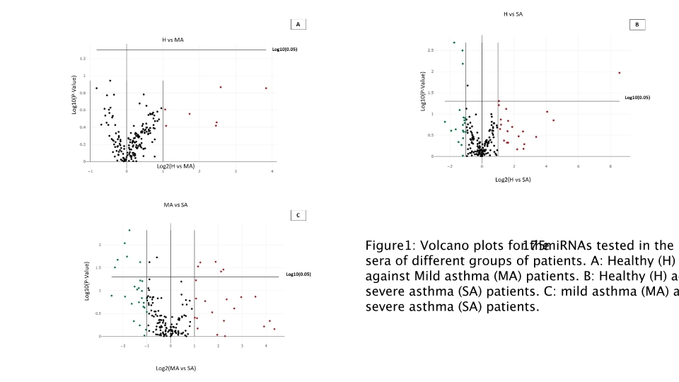

List of abbreviations
miRNA: MicroRNA
mRNA: messenger RNA
BAL: Bronchoalveolar lavage
Declarations
Conflicts of interest: The authors have no conflicts of interest related to this article to disclose.
Funding: This work was funded by Asthma, Allergy & Inflammation Research (AAIR) Charity and Asthma UK (Grant: AUK-PG-2019-419).
Authors’ contribution: M.A.K. contributed to study design, undertook laboratory experiments, data analysis and wrote the 1st draft of the manuscript. T.S.E. supervised the experiments, guided data interpretation and revised the manuscript. S.H.A. helped supervise the work and revised the manuscript. R.J.K. supervised the work, helped with patient selection, manuscript writing and acts as Guarantor for the manuscript. P.H and C.L.S. critically reviewed and revised the manuscript
References:
- Rodrigo-Muñoz JM, Cañas JA, Sastre B, Rego N, Greif G, Rial M, Mínguez P, Mahíllo-Fernández I, Fernández-Nieto M, Mora I, Barranco P, Quirce S, Sastre J, Del Pozo V. Asthma diagnosis using integrated analysis of eosinophil microRNAs. Allergy. 2019 Mar;74(3):507-517. doi: 10.1111/all.13570. Epub 2018 Oct 11. PMID: 30040124.
- Rupani H, Martinez-Nunez RT, Dennison P, Lau LC, Jayasekera N, Havelock T, Francisco-Garcia AS, Grainge C, Howarth PH, Sanchez-Elsner T. Toll-like Receptor 7 Is Reduced in Severe Asthma and Linked to an Altered MicroRNA Profile. Am J Respir Crit Care Med. 2016 Jul 1;194(1):26-37. doi: 10.1164/rccm.201502-0280OC. PMID: 26815632; PMCID: PMC4960627.
- British guideline for the management of asthma. A national clinical guideline. British Thoracic Society/NHS Scotland. 2019.
- Arshad SH, Holloway JW, Karmaus W, Zhang H, Ewart S, Mansfield L, Matthews S, Hodgekiss C, Roberts G, Kurukulaaratchy R. Cohort Profile: The Isle Of Wight Whole Population Birth Cohort (IOWBC). Int J Epidemiol. 2018 Aug 1;47(4):1043-1044i. doi: 10.1093/ije/dyy023. PMID: 29547889; PMCID: PMC6124620.
- Azim A, Mistry H, Freeman A, Barber C, Newell C, Gove K, Thirlwall Y, Harvey M, Bentley K, Knight D, Long K, Mitchell F, Cheng Y, Varkonyi-Sepp J, Grabau W, Dennison P, Haitchi HM, Arshad SH, Djukanovic R, Wilkinson T, Howarth P, Kurukulaaratchy RJ. Protocol for the Wessex AsThma CoHort of difficult asthma (WATCH): a pragmatic real-life longitudinal study of difficult asthma in the clinic. BMC Pulm Med. 2019 May 24;19(1):99. doi: 10.1186/s12890-019-0862-2. PMID: 31126281; PMCID: PMC6534885.
- Francisco-Garcia AS, Garrido-Martín EM, Rupani H, Lau LCK, Martinez-Nunez RT, Howarth PH, Sanchez-Elsner T. Small RNA Species and microRNA Profiles are Altered in Severe Asthma Nanovesicles from Broncho Alveolar Lavage and Associate with Impaired Lung Function and Inflammation. Noncoding RNA. 2019 Nov 2;5(4):51. doi: 10.3390/ncrna5040051. PMID: 31684064; PMCID: PMC6958500.
- Azim A, Freeman A, Lavenu A, Mistry H, Haitchi HM, Newell C, Cheng Y, Thirlwall Y, Harvey M, Barber C, Pontoppidan K, Dennison P, Arshad SH, Djukanovic R, Howarth P, Kurukulaaratchy RJ. New Perspectives on Difficult Asthma; Sex and Age of Asthma-Onset Based Phenotypes. J Allergy Clin Immunol Pract. 2020 Jun 13:S2213-2198(20)30594-8. doi: 10.1016/j.jaip.2020.05.053.

