Accepted for publication as:
Synes NW, Ponchon A, Palmer SCF, Osborne PE, Bocedi G, Travis JMJ & Watts K (2020) Prioritising conservation actions for biodiversity: Lessening the impact from habitat fragmentation and climate change. Biological Conservation, 252, Art. No.: 108819. https://doi.org/10.1016/j.biocon.2020.108819

Abstract
The interacting impacts of habitat fragmentation and climate change present a substantial threat for biodiversity, constituting a ‘deadly anthropogenic cocktail’. A range of conservation actions has been proposed to allow biodiversity to respond to those environmental changes. However, determining the relative effectiveness of these actions has been hampered by incomplete evidence. Empirical studies have provided important insights to inform conservation, but the challenge of considering multiple actions at large spatial and temporal scales is considerable. We adopt an individual-based modelling approach to qualitatively assess the effectiveness of alternative conservation actions in facilitating range expansion and patch occupancy for eight virtual species. We test actions to: (i) improve the quality of existing habitat patches, (ii) increase the permeability of the surrounding matrix, (iii) restore degraded habitat, (iv) create new habitat patches to form stepping-stones or (v) create new habitat to enlarge existing habitat patches. These actions are systematically applied to six real landscapes of the UK, which differ in their degree of habitat fragmentation and availability. Creating new habitat close to existing patches typically provides the strongest benefits for both range expansion and patch occupancy across species and landscapes. However, some landscapes may be so degraded that even under unrealistically high levels of management action, species’ performances cannot be rescued. We identify that it is possible to develop a triage of conservation actions at the landscape, species and investment level, thereby providing timely evidence to inform action on the ground to lessen the hangover from the deadly anthropogenic cocktail.
Keywords: habitat loss, dispersal, range expansion, patch occupancy, habitat restoration, individual-based modelling

Introduction
Habitat loss, fragmentation and climate change are driving local, regional and global extinction and decline of many species; despite de- cades of conservation actions and a notable increase in the areas of protected land, the Convention on Biological Diversity (CBD) Aichi Target 12 shows little progress in halting species extinctions or reversing declines (Secretariat of the Convention on Biological Diversity, 2014; Tittensor et al., 2014). On the contrary, many studies have demonstrated that habitat fragmentation, driven by land-use change, not only reduces biodiversity, especially when remaining fragments are small and isolated (Gibson et al., 2013; Morcatty et al., 2013), but also dramatically impairs key ecosystem functions (Haddad et al., 2015; Valiente-Banuet et al., 2015). Notably, the ecological threats posed by habitat loss and climate change can be synergistic, posing a ‘deadly anthropogenic cocktail’ for biodiversity (Travis, 2003). This occurs because it is increasingly challenging for species to shift their ranges to track changing climatic conditions when there is less suitable habitat (Travis, 2003; Bellard et al., 2012; Hodgson et al., 2012) and when that habitat is more fragmented within increasingly hostile landscapes (McInerny et al., 2007; Krosby et al., 2010; Haddad et al., 2015).
To address the combined threats of fragmentation and climate change, specific conservation actions have been proposed in the hope of forming ‘ecological networks’ to i) maintain the persistence of species in fragmented landscape and ii) offer the opportunity for species to adjust their range in response to climate change (Jongman and Pungetti, 2004; Bennett and Mulongoy, 2006; Oliver et al., 2016; Isaac et al., 2018). Until recently, actions were mostly implemented at the site-scale, and consisted of improving local habitat quality or expanding habitat patches through habitat creation. However, many studies soon stressed the importance of connectivity between habitat patches embedded in an inhospitable matrix, and recommended the development of conservation plans at the landscape scale (Krauss et al., 2003; Opdam and Wascher, 2004; Tscharntke et al., 2005; Krosby et al., 2010; Scheper et al., 2013). Thereby, conservation actions were extended (stepping stones, corridors between existing habitat fragments) to create more permeable landscapes to aid species movement within the landscape (Lawton et al., 2010; Isaac et al., 2018). These combined actions are carried out with the expectation that they will deliver ecological networks that are effective now but will also confer ecological resilience in the face of climate change (Bixler et al., 2016; Samways and Pryke, 2016; Albert et al., 2017; Isaac et al., 2018).
This shift in conservation focus towards creating ecological networks has been widely embraced and adopted by conservation communities worldwide (e.g. Boitani et al., 2007; Lawton et al., 2010; Worboys et al., 2010; Fitzsimons et al., 2013). Nevertheless, although they are inherently appealing and based upon sound scientific principles, the under- pinning evidence base is limited (Boitani et al., 2007). In the absence of strong evidence, there exists an ongoing debate within the scientific and conservation communities on ideal actions including the relative merit of, and balance between, site- and landscape-scale actions (Prugh et al., 2008; Hodgson et al., 2009; Doerr et al., 2011; Fahrig, 2013; Tingley et al., 2014; Hanski, 2015). It has even been suggested that ecological networks are based on oversimplifications of complex ecological concepts and offer little for biodiversity conservation beyond a simple conceptual framework that may even be misdirecting limited resources (Boitani et al., 2007; Quinlan et al., 2016). Developing the robust evidence base that is required to achieve greater clarity and consensus on the appropriate balance between site and landscape scale actions is therefore a key applied ecological challenge.
The spatial and temporal scales required are prohibitive for the collection of empirical data to assess the relative importance of different site- and landscape-scale conservation actions. Therefore, theoretical models have a vital role to play in this context. Various modelling approaches have already informed much of our thinking on ecological networks. Classic metapopulation models consider the proportion of patches occupied in the landscape as the state variable and colonization and extinction as the key ecological processes (Cadotte et al., 2017). Theory developed from them leads to the prediction that, for a given number of habitat patches, higher patch occupancy is achieved when those patches are spatially aggregated. This implies that species can persist under greater rates of habitat loss when the remaining habitat is more clumped (Jacquemyn et al., 2003). However, under climate change, when a species’ ability to spread across a landscape becomes crucial, avoiding large gaps between aggregation of patches becomes critical (McInerny et al., 2007; Hodgson et al., 2012). There may thus exist a tension between the optimal landscape for persistence in a static climate and the optimal one for facilitating range shifts (Carroll et al., 2010).
The majority of modelling studies investigating the climate-change resilience of ecological networks at larger scales (e.g. regional or national) have typically not included demography and dispersal explicitly. Instead, they have relied on methods including environmental niche modelling, least-cost path, graph theory and circuit theory approaches (Tingley et al., 2014). Rather than explicitly incorporating species- specific biology, these methods have sought general insights into likely broad-scale resilience by making simplifying assumptions. They have the major benefits of requiring fewer data for parameterisation and being much less computationally demanding. However, with these ‘coarse filter’ approaches, there is no nuance in the assessment of conservation action across a range of species’ life-history traits (Tingley et al., 2014).
Here, we used a ‘fine-filter’ individual-based modelling approach (sensu Tingley et al., 2014) that explicitly incorporates demography and dispersal, to test the relative effectiveness of six alternative site- and landscape-scale conservation actions on six real landscapes. Instead of gaining quantitative predictions on how individual species may perform in a particular landscape (e.g. Tingley et al., 2014), we sought here qualitative insights into which potential management actions were likely to work effectively across a range of species and landscapes and for different conservation objectives. Thus, in each of our six landscapes, we assessed the response of eight virtual species to each action based on their range expansion and patch occupancy potential, thus assessing both how well the action may facilitate a distributional shift in response to climate change and how well it enables persistence within an existing range suffering from fragmentation.

Methods
We implemented our simulations using RangeShifter, a spatially-explicit individual-based modelling platform (Bocedi et al. 2014a). RangeShifter incorporates demography and the three phases of dispersal (emigration, transfer and settlement) of single species, thereby providing a process-based modelling approach. We used a new version which enabled simulations to be run on dynamic landscapes.

2.1 Landscapes
Six study sites were selected from across the UK to represent a broad range of landscapes in terms of their habitat availability, configuration and land-use (Fig. 1). Each landscape was a 20 km x 50 km region extracted from the UK Landcover Map 2007 (Morton et al. 2011) and discretised at 20 m resolution. Broadleaved woodland was defined as the suitable habitat for all the study species, as this is severely fragmented across the UK and is the focus of much conservation action (Defra 2018). Five other composite land-use classes formed the inter-patch matrix, each with associated permeability or perceived movement costs (Fig. 1). Costs were assigned so that habitat permeability was ranked from natural, through semi natural to highly managed landcover types. In this study, in line with previous experience of using RangeShifter, we were interested in relative rather than absolute costs. Moreover, the permeability of each habitat type was held constant across all species and landscapes to allow for direct comparison of the relative effects of the conservation actions.
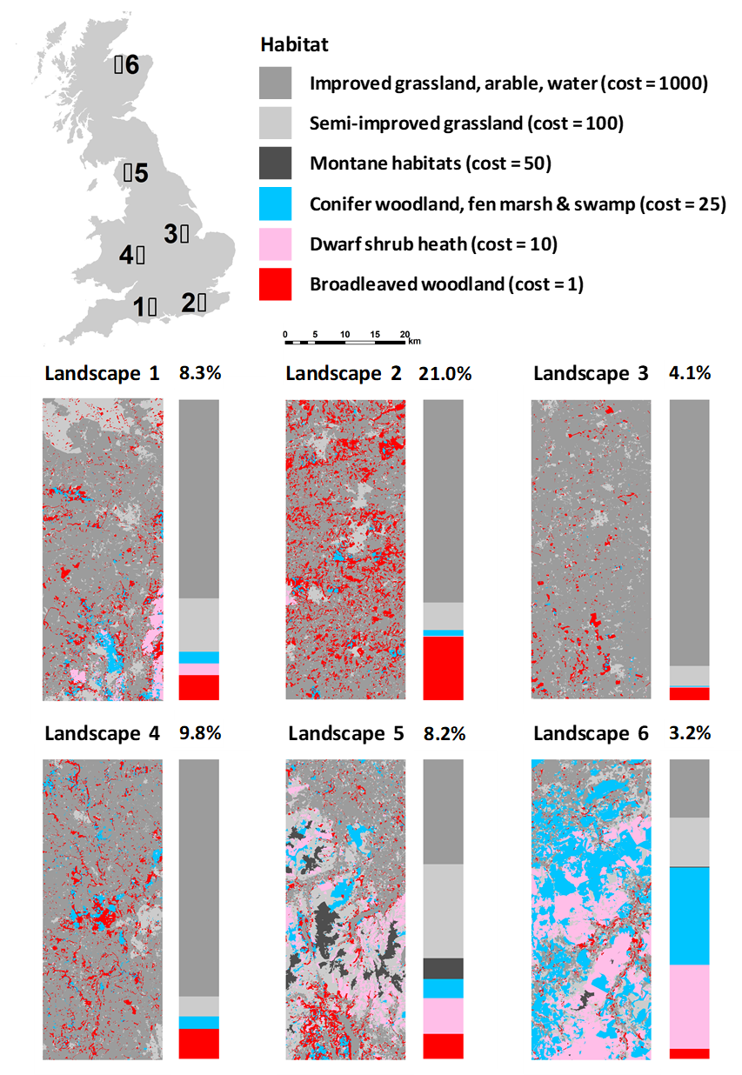
Figure 1 Location in the UK and land-use composition in the six study landscapes (20km x 50km). Vertical bars represent the proportion of each land-use class, above which the percentage of broadleaved woodland is shown. A perceived movement cost is associated with each class, ranging from 1 (most permeable) to 1000 (least permeable).

2.2 Conservation actions assessed
Six conservation actions detailed in Table 1 were applied systematically to each of the six landscapes at four levels, defined as the pro- portion of the landscape that was changed, namely 500 ha (0.5% of the landscape), 1000 ha (1%), 2000 ha (2%) and 4000 ha (4%), which were considered plausible as they spanned the policy aspiration to increase woodland cover in England from 10% to 12% by 2060 (Defra, 2018). A number of actions at a level of change >1% could not be implemented owing to limited availability of habitat that could be restored or created. As each conservation action was applied using a stochastic spatial algorithm (see Supplementary material), ten replicates were created for each action and change level in each landscape (see Synes et al., 2015).

2.3 Species
We choose to use virtual species. There are two main reasons for taking this approach. Most importantly, we seek to determine how potential landscape modifications will impact a broad range of species across different taxa that possess different life-history traits. Currently, it would be very challenging, if not impossible, to robustly parameterise our model for more than a handful of real species as all the necessary data have rarely been gathered for individual species (for one species, excellent data may exist on fecundity and reproduction but not on dispersal behaviour, while for another species we might have strong dispersal data but lack information on survival). Furthermore, even if we could find the necessary data on a reasonable number of U.K. forest species from a range of taxa, it is unlikely that those species would have current (or future potential) distributions across all the six landscapes that we focus on here, which would understandably result in people questioning the appropriateness of the chosen species rather than focussing on the generality. Thus, here we follow previous approaches (e.g. Watts et al., 2010) in adopting a virtual species approach. Eight virtual species were modelled, representing taxa having a wide range of dispersal abilities, population densities, lifespans, stage structuring and method of reproduction (Table 2). Two species were assumed to have relatively passive dispersal that is little influenced by the matrix (e.g. aerially dispersed insects) and these were modelled using dispersal kernels. For these two species, distinct suitable habitat patches were defined as contiguous areas of habitat only. We assumed the other six species to be active dispersers which respond to land-use in the matrix (representing invertebrate, mammal and bird species with varied dispersal abilities). For these species we simulated dispersal using the stochastic movement simulator (SMS), which accounts for beneficial and inhibitory features of a heterogeneous environment (Palmer et al., 2011). Species parameters are taken from Synes et al. (2015) (Supplementary material Tables S1, S2).

2.4 Simulations
First, for each species on each of the six original landscapes, ten replicate simulations were run to generate a scenario of no conservation action to provide a baseline. Second, ten replicate simulations were run for each species on each landscape for each of the six conservation actions at each level of change. Every simulation started with the species initialised at half carrying capacity in all patches within the southern 20% of the original landscape. The species were restricted to this region for the first 50 years to allow equilibrium total population and patch occupancy to be attained. At year 50, the conservation action was implemented, the restriction was removed, and the population was allowed to expand its range northwards for the next 100 years. We extracted two summary variables from each simulation to determine how well the conservation action worked: patch occupancy, i.e. the mean proportion of patches occupied from years 100 to 150 in the southern 20% of each landscape, and the range expansion rate, i.e. the mean speed from year 50 to 150 at which the population expanded northwards. The relative efficiency of each conservation action was assessed by subtracting the mean baseline results from the conservation action results. A positive difference meant that the conservation action was beneficial for the species while a negative difference meant that the action was less successful than leaving the landscape unaltered. We then partitioned the variance in each relative efficiency metric by fitting the data to ANOVA models having landscape, species, action, change level (within action), landscape replicate (within change level) and interactions as fixed effects, in order to identify which factors had the greatest influence on the overall success of the conservation actions.

Table 1 Site- and landscape-scale conservation actions applied in each of the six study landscapes
Conservation action | Details
(i) Improve-InSitu | Improve habitat quality through site-scale management. Existing broadleaved woodland patches (0.5 to 20 ha) were selected randomly and their carrying capacity increased by 10%.
(ii) Improve-Matrix | Increase the permeability of the surrounding landscape matrix. The permeability of agricultural land was increased by changing it to conifer woodland. Each patch of improved matrix (0.5 to 10 ha) was positioned randomly.
(iii) Restore-Adjacent | Restore unsuitable woodland habitat adjacent to existing woodland. Conifer woodland patches (0.5 to 20 ha) adjacent to existing suitable habitat were selected randomly and restored to provide additional suitable habitat.
(iv) Create-Random | Create random woodland patches. New patches of broadleaved woodland were created (0.5 to 10 ha) on improved grassland and arable land in random locations at least 200 m from existing broadleaved woodland to create stepping-stones.
(v) Create-Adjacent | Create woodland adjacent to existing woodlands. Broadleaved woodland patches (0.5 to 10 ha) were created on improved grassland and arable land adjacent to randomly selected existing broadleaved woodland to increase their size and carrying capacity.
(vi) Create-AdjacentSmall | Create woodland to increase the size of small woodlands. As Create-Adjacent, but restricted to existing patches less than 3 ha.

Table 2 Species characteristics. SMS – stochastic movement simulator; Kernel – negative exponential dispersal kernel.
Group | Dispersal ability (D) | Population density (P) | Reproduction (S) | Dispersal method | Name
Invertebrates | Low | Very high | Asexualª | SMS | Invert 1
 | Medium | High | Asexualª | SMS | Invert 2
 | Medium | Very high | Asexualª | Kernel | Invert 3
 | Medium | Very high | Sexual | Kernel | Invert 4
Mammals | Medium | Medium | Sexual | SMS | Mammal 1
 | High | Low | Sexual | SMS | Mammal 2
Birds | High | Medium | Sexual | SMS | Bird 1
 | Very high | Low | Sexual | SMS | Bird 2
ª In this context, ‘asexual’ does not necessarily imply asexual reproduction. Rather, it may represent invertebrate species that mate upon emergence into the adult stage within the natal patch, and then fertilised females disperse and are able to found a new colony alone; hence dispersal of males does not need to be modelled.

Results
Partitioning the variance in the summary variables (Supplementary material Table S1) indicated that landscape, species and their interaction could account for little of the range expansion rate (5.6%) and somewhat more of patch occupancy (23.3%). Similarly, the conservation action and the level of change could account for only a negligible proportion of range expansion rate (2.4%) and a moderate proportion of occupancy (29.1%). Only when all four factors were considered together could we account for a substantial proportion of the variance in the responses (73.4% and 92.2% respectively). We therefore present the results in terms of how each action and level of change influenced the response of each species on each landscape, rather than present marginal mean effects having low levels of confidence.

Species dynamics in a “no conservation action scenario”
Under no conservation action, the mean proportion of occupied suitable patches in the southern 20% of the landscape was high for all invertebrates (>86%), intermediate for birds (54 - 93%) and lower for mammals (24 - 70%; Fig. 2a). This was not strongly influenced by the type of landscape but rather by the life history traits of species. Contrastingly, species’ rates of range expansion strongly depended on the configuration and composition of the landscape (Fig. 2b). In the case of Landscape 3, which had the lowest proportion of suitable habitat (<5%) and the highest proportion of the most costly, least permeable land-use class (88%), most species were unable to expand their range as fast as in other landscapes. Likewise, species’ life history traits strongly influenced range expansion rate: Invert 4 and Mammal 2 had a lower range expansion ability compared to Invert 1 and Invert 2 at higher population densities and the two bird species (Fig. 2b).
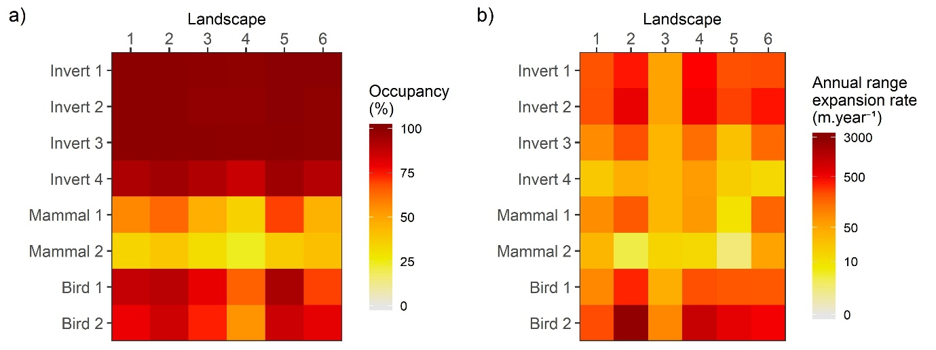
Figure 2 (a) The mean proportion of suitable habitat occupied in the southern 20% of the landscape and (b) the mean annual range expansion rate for each species in each landscape (columns) and for each species (rows) when no conservation action is applied.

How conservation actions impact patch occupancy and range expansion potential of a single species across different landscapes
We first illustrate the results for the example species Bird 1, characterized by medium dispersal ability and medium population density. Regardless of the landscape, conservation actions implementing improvement or restoration of adjacent habitat, or improvement of the matrix had a negligible effect on patch occupancy (<5%; Fig. 3a). On the contrary, actions based on the creation of new habitat always had a positive effect and the extent of this benefit increased with the level of change, improving species occupancy by up to 27%.
Regarding potential range expansion, modest to negligible gains were made in all landscapes by improving in situ or by improving the matrix (difference <50 m.year⁻¹; Fig. 3b). All conservation actions that created new habitat were consistently effective across the landscapes except Landscape 6. The magnitude of benefits depended upon both the landscape and the level of change (Fig. 3b). The rate of range expansion was strongly enhanced by creating new habitat adjacent to existing patches when it was carried out in Landscapes 2 and 4 while it had less benefit in Landscapes 1, 3 and 5, especially for levels of change <2%. In Landscape 6, only creating new random habitat patches or creating adjacent patches at 4% change improved species spread compared to the baseline (Fig. 3b). Results for other species can be found in Supplemental material.
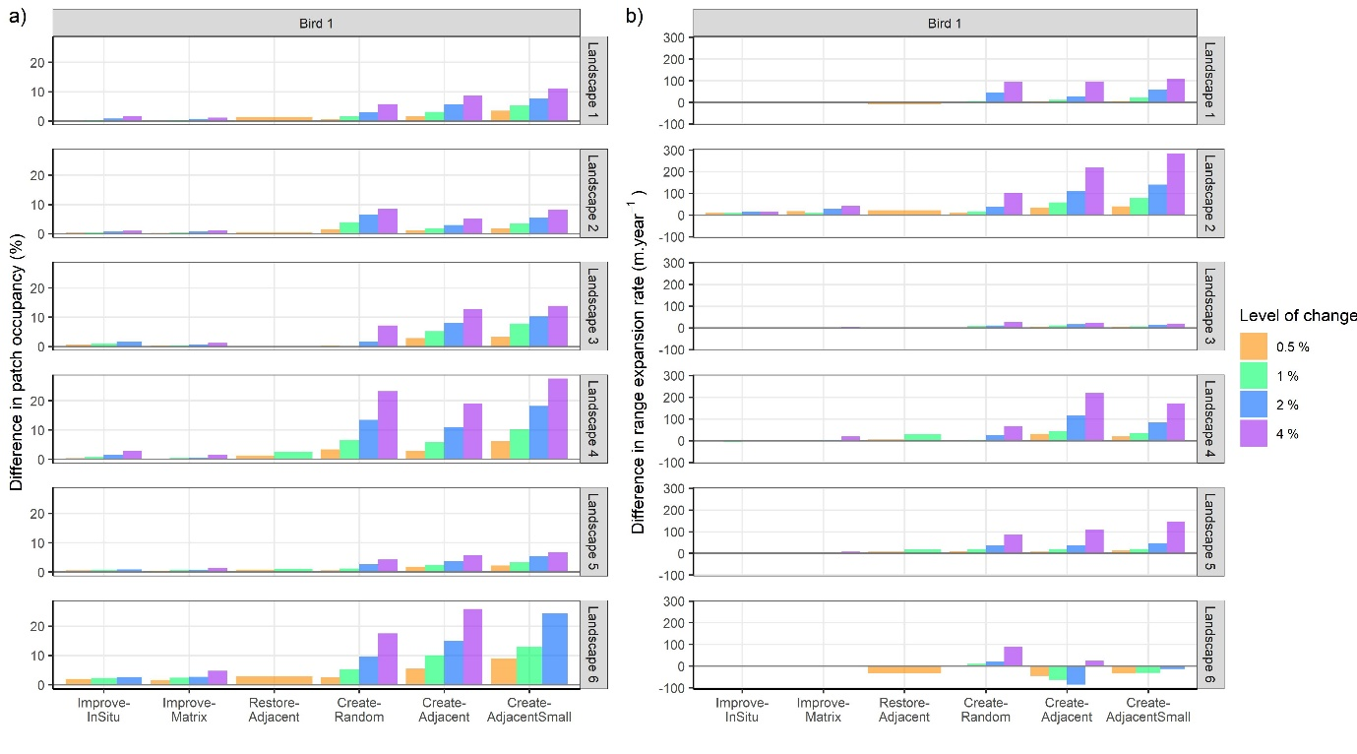
Figure 3 Difference in (a) patch occupancy during the final 50 years and (b) range expansion rate compared to a no conservation action scenario for a species with medium dispersal ability and medium population density (Bird 1) by landscape, conservation action and level of change. A positive difference reflects a positive effect of the conservation action. Note: some conservation actions could not be implemented owing to the lack of suitable land for conversion, e.g. Restore-Adjacent in Landscape 6 was possible only at 0.5% change.

How do conservation actions improve patch occupancy and range expansion of eight virtual species?
When looking at patch occupancy within the existing range (Fig. 4), regardless of the landscape or level of change, none of the conservation actions had any major benefits for Invert 1, 2 and 3, which were ‘asexual’ species. Even for the highest level of change, the increase in patch occupancy was never more than 1.4%. Indeed, those three species all had high initial patch occupancies (Fig. 2a) and thus, there was no great scope for improving their patch occupancy within the existing range (Fig. 4). On the contrary, Invert 4, the two mammals and the two birds had patch occupancies enhanced by most conservation actions, especially when creating new habitat adjacent to existing large or small patches. While creating random patches could have negative impacts on occupancy, especially for Invert 4, Mammal 2 and, to a lesser extent, Mammal 1, the Restore-Adjacent strategy tended to have positive effects, but never more than +3.3%. Finally, the benefit was consistently increased as the level of change increased (Fig. 4). For example, by applying a Create-Adjacent action for Mammal 1, the mean increase in occupancy averaged across the six landscapes was 3.4% when 0.5% of the landscape was converted, rising to 20% when 4% was converted.
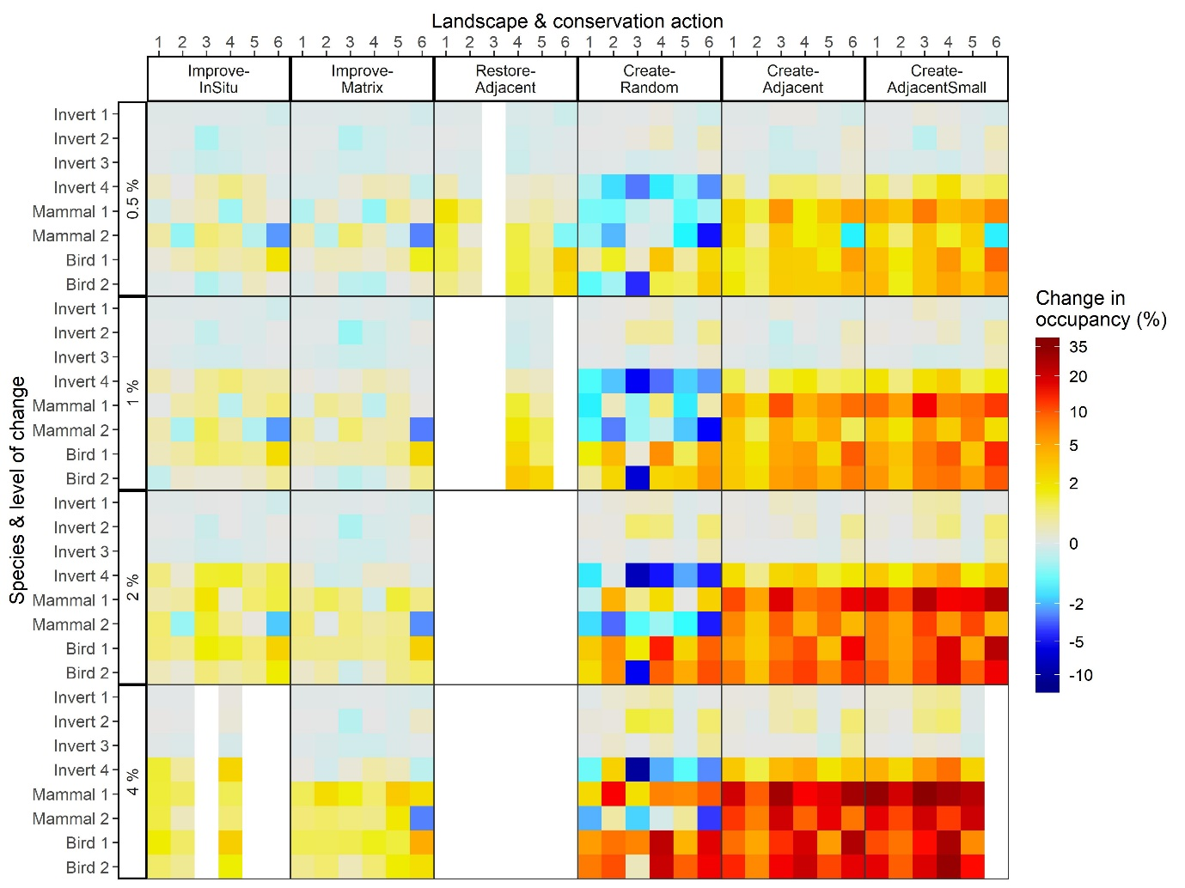
Figure 4 Difference in patch occupancy in the southern 20% of the landscape compared to the baseline scenario for the final 50 years of the simulations according to the landscape, conservation action, species and level of change. White cells indicate that the action could not be implemented due to the lack of suitable land.
When comparing the range expansion rate between each conservation action and the baseline scenario in each landscape, results depended on the species, landscape and level of change considered (Fig. 5). Improving the quality of existing suitable habitat or enhancing the matrix was much less effective in increasing the spread of any of the virtual species than creating new habitat. Indeed, in many cases these two first actions actually resulted in reduced rates of spread compared to no action. When the Improve-InSitu or Improve-Matrix conservation actions were applied, respectively 45% and 35% of range expansion rates were negative, meaning that these conservation actions could slow species range shifts in the landscape compared to a no action scenario (presumably due to increased carrying capacity leading to longer time-lags before newly-colonised patches produce dispersers by density-dependent emigration under the Improve-InSitu action and under the Improve-Matrix action randomly located matrix improvements being as likely to direct dispersers away from suitable patches as towards them). On the contrary, Create-Random, Create-Adjacent and Create-AdjacentSmall conservation actions were beneficial in most cases, only 13%, 9% and 11% respectively of responses being negative compared to the baseline scenario. The Restore-Adjacent action was intermediate at 30% of the species range expansion rates being negative, but this action could not be applied for high levels of change. Although species range expansion seemed specific to the landscape and conservation action applied, Bird 2 had a particularly noticeable and consistent high response in its range expansion rate in Landscape 2, regardless of the conservation action (Fig. 5). This was because Bird 2 had a very high range expansion rate through Landscape 2, and reached the northern edge of the landscape rapidly in all scenarios. However, while it reached there in 7 years in the baseline scenario, the time it took under conservation actions varied from 4 to 10 years, leading to extreme but somewhat artificial negative as well as positive differences in range expansion rates (Supplementary Material Fig. S1).
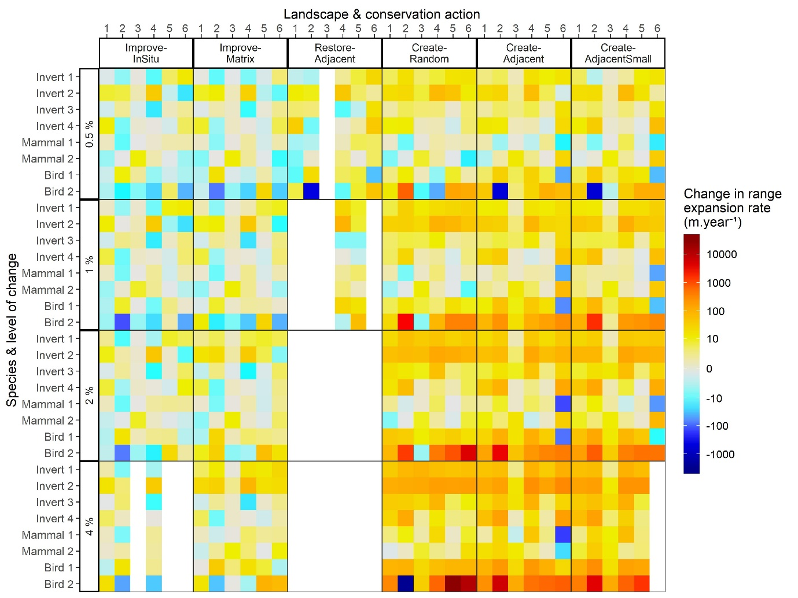
Figure 5 Difference in the range expansion rate (m.year⁻¹) compared to the baseline scenario according to the study species, the landscape, the conservation action and the level of action. White cells indicate that the action could not be implemented due to the lack of suitable land for conversion e.g. Restore-Adjacent at > 1% level of change.

3.4. Do conservation actions provide benefits for both patch occupancy and range expansion?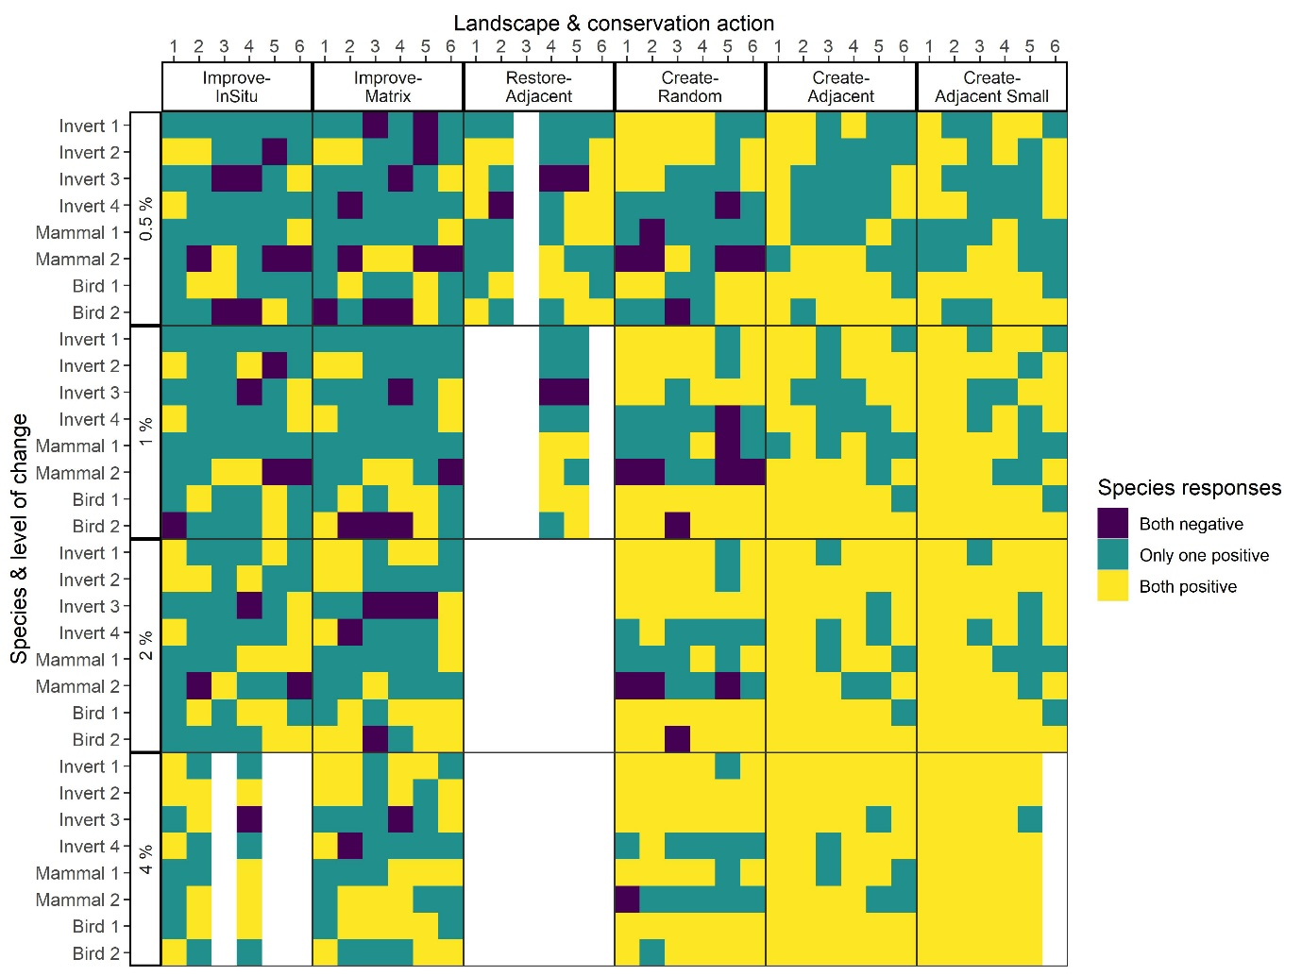
Figure 6 Comparison of the effects of each conservation action on the combined responses (patch occupancy and range expansion rates) for each species, each landscape and each level of change. White cells indicate that the action could not be implemented due to the lack of suitable land, e.g. Restore-Adjacent at >1% level of change.

When comparing the effect of each of the conservation actions in each landscape and for each species on both patch occupancy and range expansion rates, Improve-InSitu and Improve-Matrix rarely led to both responses being positive. At 0.5% change, those two conservation actions resulted in 19% of responses being both positive, 20% of responses being both negative and the rest having contradictory effects (Fig. 6). Contrastingly, Create-Adjacent and Create-AdjacentSmall did not lead to both negative responses in any of the landscapes. At 0.5% change, both positive responses were achieved in 50% of cases. This was increased to 92% when the level of change was 4%. The Restore-Adjacent action was intermediate, 42% of both responses being positive, 8% being negative and 50% having contradictory effects. However, this action could only be applied for levels of change <2 %.

Discussion
We have demonstrated here how a process-based modelling approach may be applied to fill a major recently-identified gap in addressing the combined impacts of fragmentation and range expansion as an adaptation strategy for climate change, as recommended by Costanza and Terando (2019). Our method assesses, at large spatial and temporal scales, the relative effectiveness of alternative conservation actions aiming at (i) improving a species’ occupancy within its existing range and (ii) improving its range expansion ability in response to climate change. Importantly, the method yields significant new insights into how landscapes should be managed effectively at appropriate spatial and temporal scales, for different aims and for multiple species with different demographies and behaviours. Previous work has suggested that the optimal landscape management for facilitating range shifts may be different from the one aiming at protecting species within established ranges (e.g. Carroll et al., 2010; Prober et al., 2019). If this were true, it would pose a major challenge for landscape management.
Our results show that across the range of simulated virtual species, the conservation actions based on creating new habitat adjacent to existing ones consistently and substantially outperform those of improving existing habitat or the landscape matrix. This is the case in all six landscapes and regardless of the response variable (patch occupancy or range expansion rates). If we compare the highest level of change (4%) for improving matrix or improving habitat against creating habitat at the lowest level (0.5%), the habitat creation actions still substantially outperform the alternatives. This suggests that any difference in cost per unit area between the strategies would need to be at least eight-fold in order to make the improvement of habitat or matrix as effective. How- ever, we acknowledge that we only investigated modest change from these conservation actions, consisting of a 10% increase in carrying capacity from in situ habitat management and only a small increase in permeability and decrease in mortality from matrix management.
For most of the examined species and landscapes, greater benefits in occupancy and range expansion were achieved when habitat is added adjacent to existing patches, and not at random. On one hand, this is entirely in line with expectations gained from classical metapopulation theory (Rybicki and Hanski, 2013; Peterman et al., 2018). Local occupancy is enhanced through higher metapopulation connectivity and potential rescue effects occurring in small patches (Heard et al., 2015). However, it contrasts with some studies which have suggested that the ideal management strategy to enhance species spread in fragmented landscape is to create new habitat patches as stepping stones (McInerny et al., 2007; Hodgson et al., 2012).
The differences obtained in species’ responses to conservations actions can be explained by their different demographic and dispersal traits, or at least by modelling choices to represent them. We modelled our virtual invertebrates in a relatively similar way to the species used in the theoretical studies that highlighted a potential tension between managing landscapes for persistence versus range expansion (McInerny et al., 2007; Hodgson et al., 2012). Species from those theoretical studies had relatively simple demography and life cycle: only a female sex, no stage-structure, and simple dispersal (passive dispersal kernel). At initially high local densities, populations are readily established in new habitat patches, even when they are quite distant from existing patches as long as occasionally an individual moves far enough. There are thus no Allee effects and stochastic extinction of establishing populations is unlikely, as the intrinsic population growth rate is moderately high. In contrast, our virtual vertebrate species have more complex demographic and dispersal traits. They are stage-structured, both sexes are modelled and dispersal is implemented in a mechanistic way, accounting for the permeability of the surrounding matrix, so that an empty suitable patch can only be colonized successfully when both a male and female arrive there. Consequently, Allee effects and demographic stochasticity are more pronounced in newly colonized patches, and particularly in the most distant ones, which are less likely to experience sustained immigration.
The substantial differences that we observe between our virtual species reinforces other recent results (Bocedi et al., 2014b) which already highlight the need to model with more detail the ecology and behaviour of species to understand better how those characteristics influence species’ range expansions across fragmented landscapes. Our results emphasise that this is not only important for improving our ability to make quantitative predictions on the speed of range shifts, but also, critically, for ranking alternative management interventions. This work also provides valuable new evidence to the ongoing debate on how we should best target our conservation actions to improve the resilience of landscapes under environmental change (Shoo et al., 2013; Prober et al., 2019).
The benefits derived for patch occupancy and range expansion due to level of change vary substantially depending upon the landscape, and this has important implications in terms of prioritising actions. In particular, in Landscape 3, even a level of change as high as 4% (unlikely given real-world constraints) has only modest benefits, especially when aiming at improving range expansion potential. Indeed, it is smaller than the gains to be derived elsewhere with much more limited addition of new habitat. This leads to an important issue. If funding for management is to be prioritised, where should it be best used? There is a case for targeting those regions and landscapes where the greatest improvement in the management objectives is to be derived. To illustrate this point, if our objective at the UK scale is improving species’ range expansion potential, it might be much better to create an additional 1% of wood- land in each of four landscapes with characteristics similar to those found in our Landscapes 2 and 6 than investing in creating 4% in Landscape 3. Essentially, our results highlight that conservation actions applied in landscapes with an existing low proportion of suitable habitat are unlikely to be cost effective. On the other hand, some species in certain landscapes (e.g. 2 and 4) already show good occupancy and range expansion abilities and may not require additional conservation actions. Therefore, we seek to implement modest actions in the right landscape to provide the best overall outcome.
As suggested by several studies (Bottrill et al., 2008; Wiens et al., 2012; Wilson and Law, 2016), we must begin to prioritise conservation efforts and target the most effective areas to get the greatest ‘bang for our buck’ (Rappaport et al., 2015). Conservation triage (Bottrill et al., 2008) may sometimes be necessary and, in the current environmental crisis, is likely to need to resemble the medical triage applied in disaster or war conditions under which some patients’ chances of survival are deemed too low to be allocated scare medical assets (Wilson and Law, 2016). From our analysis, it would appear that Landscapes 1 and 2 are already providing opportunities for our species to maintain patch occupancy and expand their range and respond to small conservation interventions. In contrast, Landscape 3 appears to offer limited potential for our species and would require very substantial actions to provide conservation benefits. In between these extremes, Landscapes 4, 5 and 6 may be the best targets for future actions, as within them the eight species appear to respond well to moderate levels of change.
There is a need for future work and further developments applying such fine-filter modelling approaches. We highlight four important aspects here. First, our analysis implicitly assumes that all conservation actions have an instantaneous impact on the species. We are, in effect, testing the resilience of the networks at the point when the management actions have resulted in the desired habitat change. In reality, the creation of new woodland may take many decades to provide ideal habitat for species depending on their composition and ecological complexity (e.g. Peterson and Soberon, 2018), whereas some actions, such as habitat management and restoration, could produce far quicker results. Extending the approach to understand and account for the time lags between management actions and species’ response will be vital, in order to assess how the most effective management options depends upon the time horizon considered (Watts et al., 2020). Second, we can begin to assess the degree to which the rankings of alternative conservation options gained from a fine-filter approach such as ours are concordant with the rankings gained with coarse-filter approaches that have been used to date. Ideally, we would find close agreement between the rankings from the different approaches, as that would provide a degree of reassurance that the results from coarse-filter approaches are robust. However, were there to be differences, it would be important to determine the conditions under which they are more substantial, such that caution is taken before implementing management based on the outcome of a single model type. Third, in-situ management, restoration and matrix management might be cheaper, and faster, than creating new habitat patches. For instance, 1 ha of newly created habitat could equate to 10 ha of in-situ management or 50 ha of matrix permeability management. Therefore, the economics of conservation will be very important to consider and will require the development of suitable indices to be able to make an effective triage of alternative conservation actions. Finally, to enable increasingly effective parameterisation of these parameter-rich models, it is critically important that high quality empirical work is conducted to obtain life-history data across broad numbers of species from different taxa. While the virtual species approach enables general conclusions to be made about the likely relative effectiveness of alternative conservation actions for different landscapes, high quality data for real species is required before similar approaches can be used to gain robust quantitative estimates of the impacts of alternative management actions on local species assemblages.

Data availability statement
All the simulation outputs are uploaded on a public repository (https://doi.org/10.5281/zenodo.3985126). These are freely accessible.

authorship contribution statement
All authors contributed to discussions that generated the ideas embedded in the paper. NS and SP conducted the simulation analyses. AP and NS analysed the simulation outputs. AP led the writing of the paper supported by NS. All authors contributed to revising the paper.

References
Albert, C.H., Rayfield, B., Dumitru, M. & Gonzalez, A. (2017) Applying network theory to prioritize multispecies habitat networks that are robust to climate and land-use change. Conservation Biology, 31, 1383-1396.
Bellard, C., Bertelsmeier, C., Leadley, P., Thuiller, W. & Courchamp, F. (2012) Impacts of climate change on the future of biodiversity. Ecology letters, 15, 365-377.
Bennett, G. & Mulongoy, K.J. (2006) Review of experience with ecological networks, corridors and buffer zones. Technical Series No. 23, pp. 100. Secretariat of the Convention on Biological Diversity, Montreal.
Bixler, R.P., Johnson, S., Emerson, K., Nabatchi, T., Reuling, M., Curtin, C., Romolini, M. & Grove, J.M. (2016) Networks and landscapes: a framework for setting goals and evaluating performance at the large landscape scale. Frontiers in Ecology and the Environment, 14, 145-153.
Bocedi, G., Palmer, S.C.F., Pe'er, G., Heikkinen, R.K., Matsinos, Y.G., Watts, K. & Travis, J.M.J. (2014a) RangeShifter: a platform for modelling spatial eco-evolutionary dynamics and species' responses to environmental changes. Methods in Ecology and Evolution, 5, 388-396.
Bocedi, G., Zurell, D., Reineking, B. & Travis, J.M.J. (2014b) Mechanistic modelling of animal dispersal offers new insights into range expansion dynamics across fragmented landscapes. Ecography, 37, 1240-1253.
Boitani, L., Falcucci, A., Maiorano, L. & Rondinini, C. (2007) Ecological Networks as Conceptual Frameworks or Operational Tools in Conservation. Conservation Biology, 21, 1414-1422.
Bottrill, M.C., Joseph, L.N., Carwardine, J., Bode, M., Cook, C., Game, E.T., Grantham, H., Kark, S., Linke, S., McDonald-Madden, E., Pressey, R.L., Walker, S., Wilson, K.A. & Possingham, H.P. (2008) Is conservation triage just smart decision making? Trends in Ecology & Evolution, 23, 649-654.
Cadotte, M.W., Barlow, J., Nuñez, M.A., Pettorelli, N. & Stephens, P.A. (2017) Solving environmental problems in the Anthropocene: the need to bring novel theoretical advances into the applied ecology fold. Journal of Applied Ecology, 54, 1-6.
Carroll, C., Dunk, J.R. & Moilanen, A. (2010) Optimizing resiliency of reserve networks to climate change: multispecies conservation planning in the Pacific Northwest, USA. Global Change Biology, 16, 891-904.
Costanza, J.K. & Terando, A.J. (2019) Landscape Connectivity Planning for Adaptation to Future Climate and Land-Use Change. Current Landscape Ecology Reports, 4, 1-13.
Defra (2018) A Green Future: Our 25 Year Plan to Improve the Environment. DEFRA, London, UK.
Doerr, V.A.J., Barrett, T. & Doerr, E.D. (2011) Connectivity, dispersal behaviour and conservation under climate change: a response to Hodgson et al. Journal of Applied Ecology, 48, 143-147.
Fahrig, L. (2013) Rethinking patch size and isolation effects: the habitat amount hypothesis. Journal of Biogeography, 40, 1649-1663.
Fitzsimons, J., Pulsford, I. & Westcott, G. (2013) Linking Australia’s Landscapes: Lessons and Opportunities from Large-Scale Conservation Networks. pp. 306. CSIRO, Melbourne, Australia.
Gibson, L., Lynam, A.J., Bradshaw, C.J.A., He, F., Bickford, D.P., Woodruff, D.S., Bumrungsri, S. & Laurance, W.F. (2013) Near-Complete Extinction of Native Small Mammal Fauna 25 Years After Forest Fragmentation. Science, 341, 1508-1510.
Haddad, N.M. et al. (2015) Habitat fragmentation and its lasting impact on Earth’s ecosystems. Science Advances, 1, e1500052.
Hanski, I. (2015) Habitat fragmentation and species richness. Journal of Biogeography, 42, 989-993.
Heard, G.W., Thomas, C.D., Hodgson, J.A., Scroggie, M.P., Ramsey, D.S.L. & Clemann, N. (2015) Refugia and connectivity sustain amphibian metapopulations afflicted by disease. Ecology letters, 18, 853-863.
Hodgson, J.A., Thomas, C.D., Dytham, C., Travis, J.M.J. & Cornell, S.J. (2012) The Speed of Range Shifts in Fragmented Landscapes. PLOS ONE, 7, e47141.
Hodgson, J.A., Thomas, C.D., Wintle, B.A. & Moilanen, A. (2009) Climate change, connectivity and conservation decision making: back to basics. Journal of Applied Ecology, 46, 964-969.
Isaac, N.J.B. et al. (2018) Defining and delivering resilient ecological networks: Nature conservation in England. Journal of Applied Ecology, 55, 2537-2543.
Jacquemyn, H., Butaye, J. & Hermy, M. (2003) Impacts of Restored Patch Density and Distance from Natural Forests on Colonization Success. Restoration Ecology, 11, 417-423.
Jongman, R.H.G. & Pungetti, G. (2004) Ecological Networks and Greenways: Concepts, Design, Implementation. pp. 345. Cambridge University Press, Cambridge, UK.
Krauss, J., Steffan-Dewenter, I. & Tscharntke, T. (2003) How does landscape context contribute to effects of habitat fragmentation on diversity and population density of butterflies? Journal of Biogeography, 30, 889-900.
Krosby, M., Tewksbury, J., Haddad, N.M. & Hoekstra, J. (2010) Ecological Connectivity for a Changing Climate. Conservation Biology, 24, 1686-1689.
Lawton, J.H. et al. (2010) Making Space for Nature: A Review of England’s Wildlife Sites and Ecological Network. Department for Food, Agriculture and Rural Affairs, London, UK.
McInerny, G., Travis, J.M.J. & Dytham, C. (2007) Range shifting on a fragmented landscape. Ecological Informatics, 2, 1-8.
Morcatty, T.Q., El Bizri, H.R., Carneiro, H.C.S., Biasizzo, R.L., Alméri, C.R.d.O., da Silva, E.S., Rodrigues, F.H.G. & Figueira, J.E.C. (2013) Habitat loss and mammalian extinction patterns: are the reserves in the Quadrilátero Ferrífero, southeastern Brazil, effective in conserving mammals? Ecological Research, 28, 935-947.
Oliver, T.H., Smithers, R.J., Beale, C.M. & Watts, K. (2016) Are existing biodiversity conservation strategies appropriate in a changing climate? Biological Conservation, 193, 17-26.
Opdam, P. & Wascher, D. (2004) Climate change meets habitat fragmentation: linking landscape and biogeographical scale levels in research and conservation. Biological Conservation, 117, 285-297.
Palmer, S.C.F., Coulon, A. & Travis, J.M.J. (2011) Introducing a ‘stochastic movement simulator’ for estimating habitat connectivity. Methods in Ecology and Evolution, 2, 258-268.
Peterman, W.E., Anderson, T.L., Ousterhout, B.H., Drake, D.L., Burkhart, J.J., Rowland, F. & Semlitsch, R.D. (2018) Using Spatial Demographic Network Models to Optimize Habitat Management Decisions. The Journal of Wildlife Management, 82, 649-659.
Peterson, A.T. & Soberón, J. (2018) Essential biodiversity variables are not global. Biodiversity and Conservation, 27, 1277-1288.
Prober, S.M., Doerr, V.A.J., Broadhurst, L.M., Williams, K.J. & Dickson, F. (2019) Shifting the conservation paradigm: a synthesis of options for renovating nature under climate change. Ecological Monographs, 89, e01333.
Prugh, L.R., Hodges, K.E., Sinclair, A.R.E. & Brashares, J.S. (2008) Effect of habitat area and isolation on fragmented animal populations. Proceedings of the National Academy of Sciences, 105, 20770.
Quinlan, A.E., Berbés-Blázquez, M., Haider, L.J. & Peterson, G.D. (2016) Measuring and assessing resilience: broadening understanding through multiple disciplinary perspectives. Journal of Applied Ecology, 53, 677-687.
Rappaport, D.I., Tambosi, L.R., Metzger, J.P. & Cadotte, M. (2015) A landscape triage approach: combining spatial and temporal dynamics to prioritize restoration and conservation Journal of Applied Ecology, 52, 590-601.
Rybicki, J. & Hanski, I. (2013) Species–area relationships and extinctions caused by habitat loss and fragmentation. Ecology letters, 16, 27–38.
Samways, M.J. & Pryke, J.S. (2016) Large-scale ecological networks do work in an ecologically complex biodiversity hotspot. Ambio, 45, 161-172.
Scheper, J., Holzschuh, A., Kuussaari, M., Potts, S.G., Rundlöf, M., Smith, H.G. & Kleijn, D. (2013) Environmental factors driving the effectiveness of European agri-environmental measures in mitigating pollinator loss – a meta-analysis. Ecology letters, 16, 912-920.
Secretariat of the Convention on Biological Diversity (2014) Global Biodiversity Outlook 4. pp. 155. Montreal.
Shoo, L.P., Hoffmann, A.A., Garnett, S., Pressey, R.L., Williams, Y.M., Taylor, M., Falconi, L., Yates, C.J., Scott, J.K., Alagador, D. & Williams, S.E. (2013) Making decisions to conserve species under climate change. Climatic Change, 119, 239-246.
Synes, N.W., Watts, K., Palmer, S.C.F., Bocedi, G., Bartoń, K.A., Osborne, P.E. & Travis, J.M.J. (2015) A multi-species modelling approach to examine the impact of alternative climate change adaptation strategies on range shifting ability in a fragmented landscape. Ecological Informatics, 30, 222-229.
Tingley, M.W., Darling, E.S. & Wilcove, D.S. (2014) Fine- and coarse-filter conservation strategies in a time of climate change. Annals of the New York Academy of Sciences, 1322, 92-109.
Tittensor, D.P. et al. (2014) A mid-term analysis of progress toward international biodiversity targets. Science, 346, 241.
Travis, J.M.J. (2003) Climate change and habitat destruction: a deadly anthropogenic cocktail. Proceedings of the Royal Society B: Biological Sciences, 270, 467-473.
Tscharntke, T., Klein, A.M., Kruess, A., Steffan-Dewenter, I. & Thies, C. (2005) Landscape perspectives on agricultural intensification and biodiversity – ecosystem service management. Ecology letters, 8, 857-874.
Valiente-Banuet, A. et al. (2015) Beyond species loss: the extinction of ecological interactions in a changing world. Functional Ecology, 29, 299-307.
Watts, K., Whytock, R.C., Park, K.J., Fuentes-Montemayor, E., Macgregor, N.A., Duffield, S. & McGowan, P.J.K. (2020) Ecological time lags and the journey towards conservation success. Nature Ecology & Evolution.
Wiens, J.A., Goble, D.D. & Scott, J.M. (2012) Time to accept conservation triage. Nature, 488, 281-281.
Wilson, K.A. & Law, E.A. (2016) Ethics of Conservation Triage. Frontiers in Ecology and Evolution, 4.
Worboys, G.L., Francis, W.L. & Lockwook, M. (2010) Connectivity conservation management: a global guide. Earthscan, London, UK.

