Advanced materials for mechanical engineering: ultrafine-grained alloys with multilayer coatings

Irina P. Semenova*, Ruslan Z. Valiev, Anatoly M. Smyslov, Mihail V. Pesin, Terence G. Langdon

Prof. I. P. Semenova, Prof. R. Z. Valiev, Prof. A. M. Smyslov
Ufa State Aviation Technical University, 12 K. Marx St., Ufa, 450008, RF
e-mail: semenova-ip@mail.ru

Prof. M. V. Pesin
Perm National Research Polytechnic University, 29 Komsomolsky pr., Perm, 614990, RF

Prof. T. G. Langdon
Materials Research Group, Department of Mechanical Engineering, University of Southampton, Southampton SO17 1BJ, UK

Keywords: titanium alloys; ultrafine-grained structure; ion implantation; vacuum-plasma multilayer coatings; adhesion; fatigue; creep properties; engineering application.

Research performed has demonstrated that the formation of a bulk ultrafine-grained (UFG) structure in metals and alloys through severe plastic deformation (SPD) enables increasing their strength properties, decreasing the temperature range of superplasticity, etc. Designers and process engineers show a great interest in such materials, since the development of the mechanical engineering industries places ever increasing demands on the performance properties of commercial alloys, especially for parts operating under extreme conditions. One of the approaches for a comprehensive enhancement of the performance characteristics of structural materials is the combination of a UFG structure in the bulk of a material, providing an increase in the strength, and an additional surface modification for the resistance to erosion and corrosion damages. As a result, a set of materials service properties can be enhanced, which is difficult to achieve by means of only metal nanostructuring or only surface modification. This approach was demonstrated through the example of UFG titanium alloys produced by SPD, including those with nanostructured multilayer TiVN coatings of different “architectures”. We examine the promising tendencies in the area of surface modification for the innovative application of structural UFG titanium alloys in mechanical engineering.

1. Introduction
Research performed in the past two decades shows that the most efficient way to increase the physical and mechanical properties of commercial metals and alloys is to form in them ultrafine-grained (UFG) structures by severe plastic deformation (SPD) methods that enable producing very high plastic strains at relatively low temperatures (normally Т_{melt} = 0.3-0.4 K) under high imposed pressures.^{[1,2]} UFG metals and alloys produced by SPD, as a rule, have a grain size in a range of 100-500 nm, but usually contain in the grain interiors different nanostructural elements: nanotwins, nanoparticles, segregations, etc., which also have a significant effect on their properties; therefore, such materials are referred to as bulk nanostructured materials.^{[3]}
In particular, such a “breakthrough” in attaining high physical and mechanical properties has been demonstrated for light structural UFG Ti- and Al-based alloys, as indicated by lots of publications.^{[4-11]} Designers and process engineers show a great interest in such materials, since the development of the present-day mechanical engineering industries places ever increasing demands on the performance properties of commercial alloys, especially for parts operating under extreme conditions. Therefore, for a successful structural application of UFG metallic materials it is necessary to find new approaches to ensure their service properties required in specific operation conditions. For example, gas-turbine engine (GTE) parts made of Ti alloys need to have, together with a low specific weight, a high fatigue strength and thermal stability at the operating temperatures. Depending on the GTE operation location (in an aircraft or on the ground), parts may operate under extreme atmospheric conditions (humidity, dustiness, etc.) and increased cyclic loads. In this case, the role of a material’s surface, where defects and mirocracks generate, leading to its subsequent failure, dramatically increases.
One of the approaches for a comprehensive enhancement of the performance characteristics of structural materials is the combination of a UFG structure in the bulk of a material, providing an increase in the strength properties, and an additional surface modification for the resistance to external action, i.e. erosion and corrosion damages. In relation to Ti alloys, these are the surface treatments by concentrated energy flows, among which are ion implantation and the deposition of vacuum-plasma coatings based on the nitrides and carbides of refractory elements.^{[12-15]} The formation of a UFG structure in the material of a part may have a significant effect on the physico-chemical and mechanical properties of a modified layer or coating.^{[16-19]} Thus, as a result of such a combined treatment of a material, a set of its service properties can be enhanced, which is difficult to achieve by means of only metal nanostructuring or only surface modification. Such a synergetic approach to the enhancement of performance properties opens prospects of designing structural materials for parts operating in extremely severe environments.
This paper presents the results of recent research on UFG Ti alloys produced by SPD. A special attention is given to the experimental studies of Ti alloys having a UFG structure in combination with the surface modification by nitrogen ion implantation and TiVN coatings with different “architectures”. We examine the promising tendencies in the area of surface modification for the innovative application of structural UFG titanium alloys in mechanical engineering and aircraft-engine building.

2. Producing ultrafine-grained structural states in metallic materials by severe plastic deformation (SPD)
In the past two decades, a special interest among researchers has been aroused by the formation in metals and alloys of ultrafine-grained (UFG) structures with a grain size in the submicro- and nanocrystalline ranges by severe plastic deformation (SPD) processing.^{[1-3]} A transition from laboratory samples to the commercial adoption of UFG materials calls for systematic investigations in three main areas. The first one is increasing the efficiency and adaptability to manufacture, and reducing the production cost, as well as the upscaling in terms of an increase in the geometrical dimensions of the produced billets. The second area is related to combining SPD methods with the conventional methods of plastic deformation by rolling, drawing, extrusion, etc., for the production of semi-products and products of different shapes from UFG materials. The third one is the study of the service properties of UFG structural materials, requirements to them depending strongly on the operating conditions of a product.
To date, several SPD processes have been successfully used for producing a UFG structure in Ti alloys: high-pressure torsion (HPT), equal-channel angular pressing (ECAP), all-round multi-stage forging. For Ti alloys, SPD is implemented at relatively high temperatures, therefore the character of structure refinement is greatly influenced by the ratio between the alpha and beta phases, the alloying composition, the initial morphology of structure and the processing conditions (temperature, rate, strain, etc.).^{[4-7,20-24]}
The first studies of the Ti-6Al-4V titanium alloy subjected to high-pressure torsion at room temperature demonstrated the possibility in principle to produce a nanostructured state with a grain size of about 80 nm.^{[25]} Also, multiaxial forging was used to produce a submicrocrystalline (SMC) structure with a grain size of 400 nm in this alloy.^{[5,6]} However, due to a low deformability of Ti alloys, this processing was possible only at elevated temperatures. One of the conditions for producing a submicron grain size was the use of an initial martensitic or fine-globular structure.
The ECAP processing of two-phase Ti alloys involves certain difficulties associated with the features of the stress-strain state under the deformation by simple shear. The structure and properties of an alloy are greatly influenced by the processing temperature, the angle of channels intersection in the die, the morphological features of the initial structure.^{[4,22]} For example, an increase in accumulated strain during ECAP processing was achieved due to the use of a die-set with increased angles of channels intersection, ϕ = 120° (е_{i} ∼ 0.7) and 135° (е_{i} ∼ 0.5), in contrast to the previously used angle ϕ = 90° (е_{i} ∼ 1), which enabled reducing the strain intensity in one pass.^{[4]} On the basis of experimental studies, the processing temperatures were selected below the recrystallization temperature in a range of 600-700 °С, providing a satisfactory technological ductility. Besides, a previous publication on the Ti-6Al-4V alloy already reported considerable differences in the mechanisms of structure refinement for an initial globular or Widmanstatten microstructure in the process of ECAP.^{[22]} Using as an example the Ti-6Al-4V ELI alloy that had a mixed globular-lamellar structure in the initial hot-rolled condition, it was demonstrated that the most efficient structure refinement occurs in regions with the alpha-phase of a thin-plate morphology. Thin plates transform easier in the process of deformation due to the formation of transverse subgrains which increase their misorientation to a high-angle one, interacting with lattice dislocations.
Combining SPD processing with conventional deformation methods, such as rolling, broaching, drawing, etc., is one of the ways to produce semi-products and products of required dimensions. This approach was successfully used in producing large-sized billets from the Ti-6Al-4V alloy with an SMC structure, UFG semi-products by ECAP processing followed by rolling.^{[26-28]} The conducted research showed that the features of the distribution of the α- and β-phases, their shape and sizes determine to a large extent the character of structural transformations during ECAP processing and subsequent deformational treatments. The evolution of the UFG structure during a subsequent shape-forming deformational treatment is associated with various processes, including an additional fragmentation by slip and twinning, recovery and polygonization, β-phase decomposition.
In particular, Demakov et al. demonstrated the effect of ECAP processing on the character of microstructure refinement in the Ti-6Al-4V alloy during subsequent warm rolling via the “oval – square” arrangement at temperatures in a range of 450-650 °С.^{[28]} It was established that in the structure of the alloy in the as-received condition, after rolling at 450 °С the globular α-phase changes its shape primarily via multiple slip without a considerable contribution from twinning, which conditions a slight structure refinement. The fragmentation of the α-phase grains is mainly accompanied by the formation of subgrain dislocation boundaries with low-angle misorientations. The β-phase preserved its predominant morphology in the form of interlayers, but as a result of deformation, their thickness decreased (Figure 1а). In this case, the strength of the Ti-6Al-4V alloy did not exceed 1300 MPa.
A different picture was observed when ECAP processing was performed prior to the rolling at 450 °С. In the process of rolling at 450 °С, stress accommodation in the α-phase during deformation is impeded, and it is realized via twinning and slip. There is an intensive dislocation redistribution with the formation of a typical cellular structure. The β-phase remains localized in separate volumes where it decomposes with the formation of dispersed particles of the secondary α-phase. An increase in the rolling temperature to 550 °С promoted the processes of recovery and polygonization in the deformed structure (after ECAP processing) due to the redistribution of dislocations and the formation of a more perfect subgrain and grain structure with thin boundaries having primarily high-angle misorientations (Figure 1b), which led to an increase in tensile strength to σ_{max} = 1430 MPa.
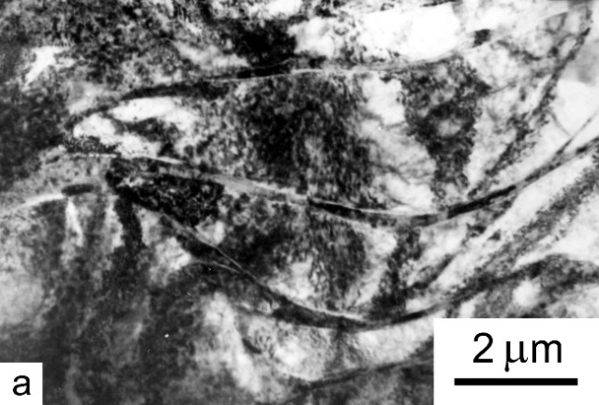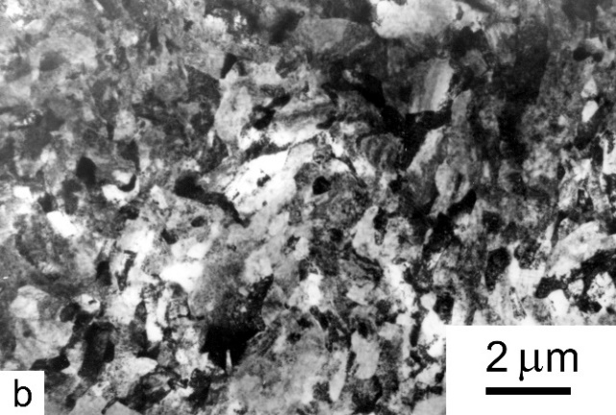
Figure 1. Microstructure of the Ti-6Al-4V alloy: a) after rolling at a temperature of 450 °С; b) after ECAP at 700 °С and rolling at 550 °С. TEM.
Reproduced with permission.^{[28]} 2008, Springer Nature.

The extrusion of ECAP-processed Ti-6Al-4V alloy billets at relatively low temperatures (300 °С) noticeably increases strength up to 1510 MPa, while the elongation is not less than 10%.^{[22]} The strength characteristics attained in this alloy are visibly higher that the level of mechanical properties after a strengthening heat treatment where the ultimate tensile strength (UTS) reaches 1200 MPa with an elongation of 9%.^{[29]}
Among structural Ti-based materials, alloys of other compositions attract an ever-growing attention. For example, the VT8M-1 (Ti-5.7Al-3.8Mo-1.2Zr-1.3Sn) alloy is applied more and more widely in the production of highly-loaded items in aircraft-engine building. It has several advantages in comparison to the Ti-6Al-4V alloy, in particular, a high hot strength and a lower sensitivity to stress raisers.^{[30]} The formation of a UFG structure in such alloys and hence high mechanical properties creates prospects for their successful industrial application. At the same time, the features of the solid-solution alloying and phase transformations may influence the character of microstructure evolution in the process of SPD, as described in.^{[31]} Notably, the structure refinement mechanisms in two-phase Ti alloys have a common character.
To produce larger semi-products with a UFG structure, swaging was employed; its principle lies in the high-frequency deformation of a metal by dies via the quasi-hydrostatic compression scheme.^{[32]} Increasing the geometrical dimensions (diameter and length) of the produced billets is an important condition for producing parts in industrial manufacture. Modina et al. demonstrated the possibility in principle of attaining high strength properties in the VT8M-1 alloy semi-products subjected to rotary swaging.^{[33]} No significant differences were revealed between the UFG structures produced by the traditional ECAP method and by rotary swaging. Also, the precipitation was found of nano-sized particles of (TiZr)₆Si₃ silicides with a mean grain size of ~ 80 nm, which were absent in the coarse-grained (CG) VT8M-1 alloy; they apparently make an additional contribution via the precipitation mechanism of strengthening into the total strength after SPD processing (Figure 2).^{[34]}
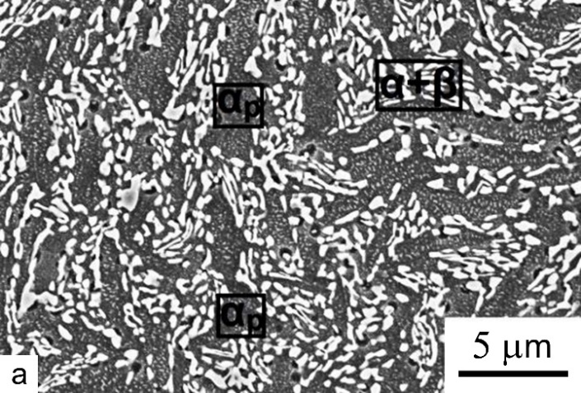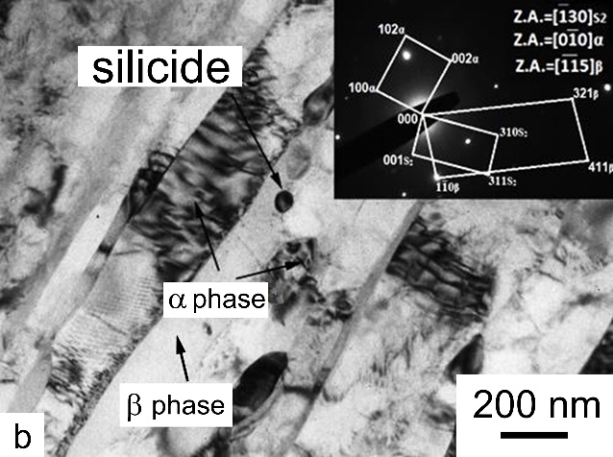
Figure 2. Microstructure of the VT8M-1 alloy after rotary swaging: а) scanning electron microscopy; b) transmission electron microscopy. Cross section.
Reproduced with permission.^{[34]} 2021, Trans Tech Publications, Ltd.

One of the essential characteristics of a structural material is resistance to cyclic loads. The research performed in the past few years shows the enhancement of the fatigue properties of metals and alloys through the formation of an ultrafine-grained state in them by means of SPD processing. In most cases it is associated primarily with an increase in static strength as a result of grain refinement (Figure 3). Therefore, the dependence of endurance limit (σ_{R}) on grain size is often described by a relation similar to the Hall-Petch relation for yield strength (Equation 1), where σ_{iR} and K_{R} are constants for a given material.
σ_{R} = σ_{iR} + K_{R}·d ^{-1/2} (1)
Previously, Saitova et al. demonstrated the possibility of enhancing the fatigue strength of the Ti-6Al-4V ELI alloy by means of the UFG structure formation – the alloy’s endurance limit increased by 70 МPa.^{[35]} The UFG alloy’s fatigue strength in the low-cycle region is higher by almost 30%, which is an advantage for several important engineering applications. Semenova et al. conducted the fatigue tests of the Ti-6Al-4V alloy samples in the conditions of bending with rotation under a controlled stress, a frequency of 50 Hz and a symmetrical loading cycle.^{[36]} It was found that the alloy’s high strength and ductility (1550 MPa and 12%, respectively), attained by ECAP processing in combination with extrusion and annealing at 500 °С, increased the endurance limit from 600 to 740 MPa.
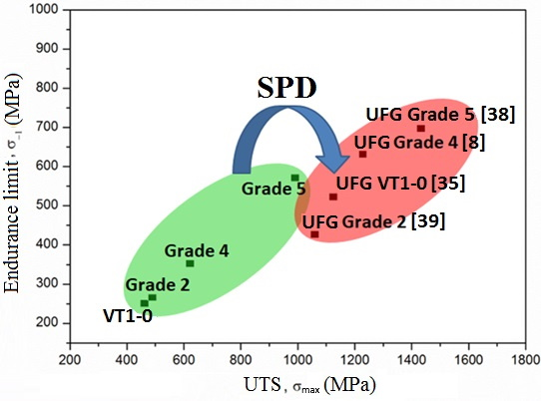
Figure 3. Relationship between the endurance limit and UTS in Ti alloys.

The recent publications reported in the review demonstrated the results of the fatigue tests performed in the high-cycle and low-cycle regions.^{[8]} It is known that UFG metals often exhibit a lower resistance to low-cycle loads as compared to the coarse-grained counterparts. This occurs due to a certain loss of ductility taking place in UFG materials after SPD processing. As demonstrated by Mughrabi and Höppel for Cu, Al and other metals, the fatigue curves for the CG and UFG states intersect at a certain number of cycles, and then the curve for the UFG state in the low-cycle fatigue (LCF) range becomes lower than that for the CG state.^{[37]} Polyakov et al. conducted the fatigue tests of the UFG Ti-6Al-4V alloy samples under push-pull symmetrical loading at stress amplitudes in a range of 700–1050 MPa and a frequency of 5 Hz.^{[38]} The UFG samples exhibited an enhanced fatigue strength at high stress amplitudes as compared to the CG state.
Therefore, the formation of a bulk UFG structure in billets of two-phase Ti alloys creates conditions for a high deformability of the billets during subsequent deformational treatments and the production of commercial semi-products and products. For example, Semenova et al. demonstrated a possibility for the shape-forming of GTE parts by isothermal stamping at relatively low temperatures (780 °С), while the current technology involves heating and deformation at temperatures of 910-940 °С.^{[39]} It was shown that under such conditions of item’s shape forming, the UFG structure is preserved in the bulk of the forged piece and, consequently, a level of the strength and fatigue properties increased by 30% in comparison to the current technological processes is attained. It is evident that this fact opens wide prospects for the development and introduction of new technologies for the manufacture of products with high performance properties for such high-priority industries as transport and power engineering.

2. Мultilayer PVD coatings for increasing the erosion resistance of GTE parts
The gas-turbine engines of airplanes and helicopters are often operated in a sea or desert environment, where the rotor blades of a gas turbine compressor are exposed to salt corrosion, the action of erosive media, such as sand and dust. Therefore, for parts operating in such extreme environments the surface condition plays an important role in the resistance to external loads. To protect the surface of GTE parts, different methods of treatment by concentrated energy flows are used, including ion implantation, as well as erosion-resistant coatings applied by cathode-arc physical vapor deposition (PVD) using arc deposition, magnetron sputtering and the electron-beam method. ^{[12-15,40-52]} For steels and Ti alloys, vacuum-plasma coatings based on the nitrides and carbides of refractory elements are widely used. As a rule, the nitrides and carbides of transition metals are much harder than the majority of steels or specialized alloys, and have much lower erosion or corrosion rates.^{[43,44]}
Nanolayer (Ti,Cr)N coatings were applied on Ti-6Al-4V, 17-4PH and Inconel 718 substrates by physical vapor deposition in order to increase the erosion and corrosion resistance.^{[45]} It was shown that a coating’s corrosion performance depended strongly on the coating thickness and packing factors, and correlated with the increased content of Cr in nanolayer (Ti,Cr)N coatings. The erosion-resistant coatings of different compositions, such as Ti-N, Ti-C-N, Ti-Zr-N, Ti-Zr-C-N, Ti-Al-N and Ti-Al-C-N, applied by PVD, can be used to extend the service life of a compressor’s airfoil surfaces in the conditions of sand erosion.^{[48]}
A detailed study of PVD coatings with a high erosion resistance (based on VN, VC, Cr₃C₂, ZrN and TiN) revealed that a zirconium nitride coating is the most suitable for the protection of compressor blades made of two-phase Ti alloys, and a chromium carbide PVD-coating is the best for compressor blades made of steel.^{[47]}
A (Ti,Al)N coating exhibited the best properties during both erosion and corrosion tests. It was shown in publications that titanium diboride and Ti-Al nitrides could be the most promising coatings for compressor blades.^{[48-52]}
Single-layer coatings are the most thoroughly studied. Their main disadvantage is that they wear easily under multiple impact loads caused by erosive particles. An obvious solution here is to design a multilayer coating combining a hardness withstanding brittle fracture and a satisfactory impact toughness. Besides, alternating layers with different properties enables designing the optimum coating structure though varying the values of internal stresses.
The architecture of erosion-resistant coatings is normally established empirically, while their characteristics are evaluated experimentally by measuring the minimum losses due to erosion. This impedes the optimization of the coating structure without a detailed knowledge of the failure mechanisms and the principal parameters of erosion. Hassani et al. investigated single and multilayer TiN and nanocomposite nc-TiN/a-SiN_{1.3} and nc-TiCN/a-SiCN systems on titanium alloy and stainless steel substrates.^{[45]} The authors demonstrated that the FE design of the coating architecture, combined with the tailored mechanical properties of individual components of the coating systems, opens new opportunities as a predictive tool for high-performance erosion coatings. An example of such model architectures is shown in Figure 4.^{[45]}
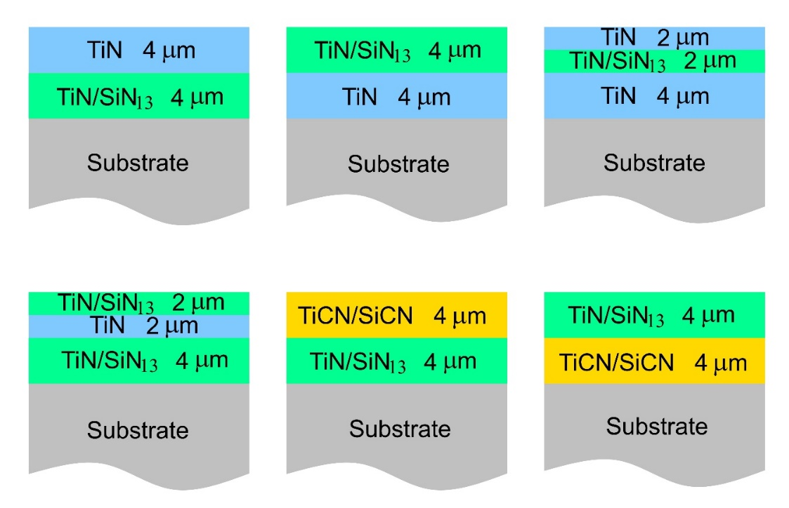
Figure 4. Architecture of model multilayer PVD coatings
Reproduced with permission.^{[45]} 2008, Elsevier.

Selivanov et al. demonstrated the possibility in principle to apply multi-layered coatings with different compositions and quantities of the deposited coatings on a Ti-6Al-4V alloy substrate. The TiZrN, TiVN and TiAlN systems were used in the investigation.^{[53]} It was shown that the microhardness of the coatings depends little on the chemical composition of the layers. The decisive factor for the high hardness of a coating is the number of layers, i.e. the total thickness of a coating. At the same time, the enhanced hardness of multi-layered coatings is attributed to the periodic structure of the interface which can block dislocation motion between layers.^{[53]} In particular, Cheng et al. demonstrate that with increasing Ti/TiN thickness ratio the hardness value gradually decreases for multilayer coatings.^{[55,56]} According to the mixing rule, an increase in the volume fraction of the softer Ti sublayers reduces the hardness values of the coatings.^{[56]}

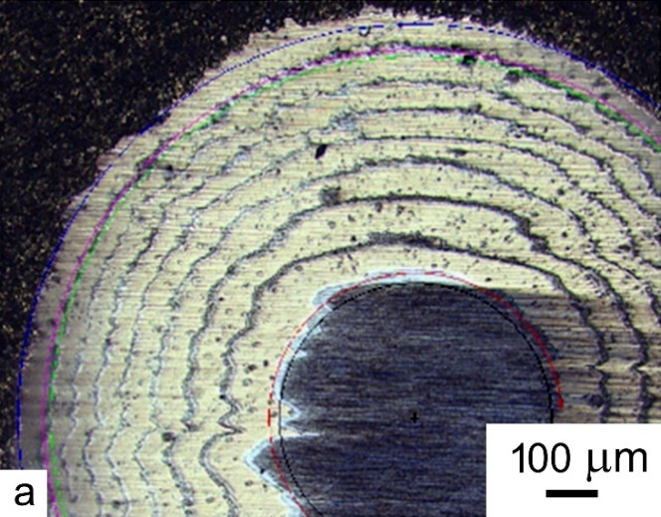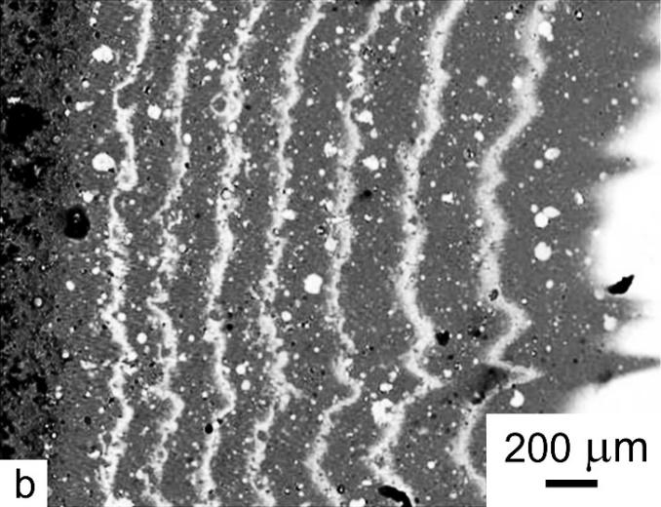
Figure 5. SEM images of multilayer coating (Ti –TiN) x7: (a) spherical section, optical microscope, (b) view of the fracture in the sample section.
Reproduced with permission.^{[53]} 2019, Elsevier.

In the same publication, the effect of the architecture (Figure 5) and composition of coatings on their erosion resistance (Figure 6) was reported. All the multilayer ion-plasma coatings based on the investigated compositions Ti-TiN, Ti + TiVN, Ti + TiZrN produced an at least five-fold increase in the resistance to erosive wear (Figure 5). The best characteristics of erosion resistance were exhibited by the Ti-TiVN coating where the erosion rate decreased by a factor of 10 for the Ti-6Al-4V samples.^{[53]}
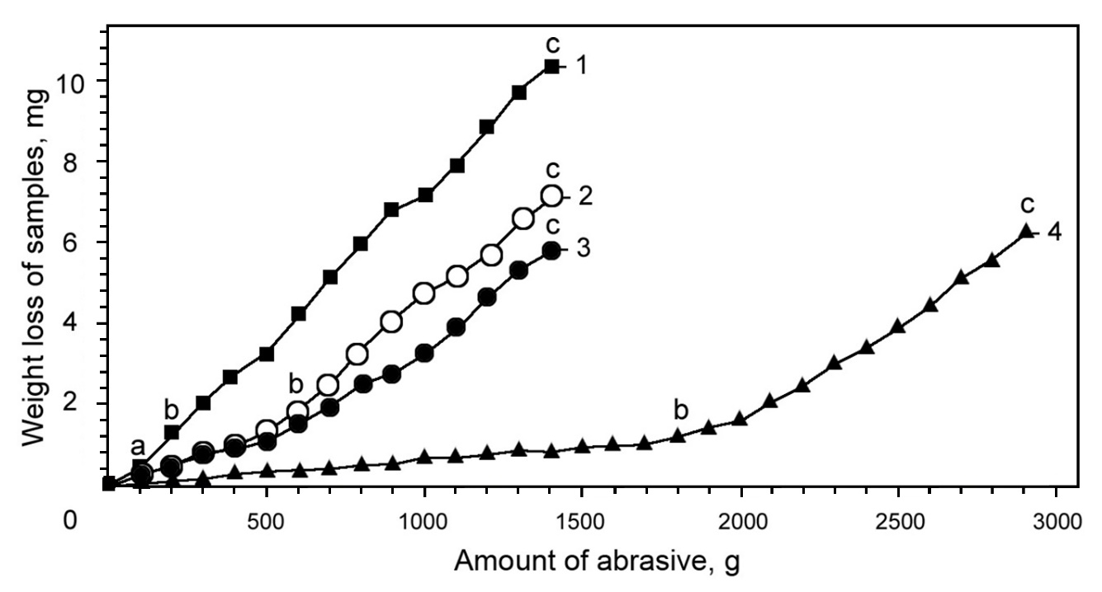

Figure 6. Erosive wear of coatings: 1 – wear of samples from Ti-6Al-4V without coating; 2 – wear of coating (Ti + TiN)х2; 3 – wear of coating Ti + (TiN + Ti)х7 + TiN 2; 4 – wear of coating (Ti + TiVN)х2.
Reproduced with permission.^{[53]} 2019, Elsevier.

Thus, an important conclusion was made from the previous studies that selecting the composition and architecture of a coating for specific operating conditions calls for a specialized approach. When developing the structure of a multilayer coating (the combination of materials, the quantity and thickness of individual layers), one should take into account the internal stresses initiating the separation of the coating from the substrate in areas where surface defects emerge.^{[53]} Also, depending on the substrate material, it is necessary to ensure the maximum adhesion by selecting the material of the first (adhesive) layer of a coating. The adhesive strength will be greatly influenced by the chemical composition of thin sublayers and the method of application of a multilayer coating.

3. Ultrafine-grained Ti alloys combined with ion modification and multilayer PVD coatings
A new approach to the enhancement of the performance properties of Ti alloys lies in the development of the scientific principles for a combined strengthening of two-phase Ti alloys based on the modification of the structural-phase composition and the nanostructuring of a material in its bulk and in the surface layer. First, the formation of a UFG nanostructure by SPD processing in the bulk of a material produces the highest strength and fatigue properties, as well as the low-temperature and/or high-strain-rate superplasticity required for the subsequent shape-forming of a product. Second, surface modification due to the formation of nanocrystalline layers in a protective coating by ion-plasma treatment methods will enable providing the resistance to corrosive and erosive actions. The present section reports the results of the recent studies performed on UFG Ti alloys.
3.1 Ion modification of the surface
Among the successful and promising methods for the surface treatment of structural materials are the methods associated with the action of concentrated energy flows, one of them being ion implantation. The physical essence of ion-implantation doping consists in the introduction (implantation) of an alloying element into the surface layer of a part through its bombardment with ions having a high kinetic energy (Figure 7).^{[58]} In particular, surface modification of the conventional coarse-grained (CG) Ti-6Al-4V alloy by nitrogen ion implantation enables considerably improving its tribological and corrosion properties, as well as long-term strength at 600 °С.^{[12,13,59]}
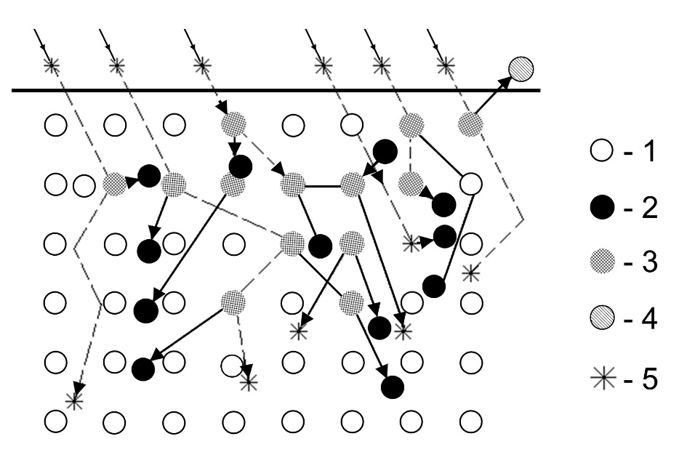
Figure 7. Ion implantation scheme. 1 – Substrate material atoms; 2 – Substrate material interstitial atoms; 3 – vacancies generated; 4 – Substrate atom removed from surface by sputtering; 5 – atoms being implanted.

Ion implantation is considered a rather well studied process for a number of Ti alloys.^{[59-61]} It is known that the surface hardening of Ti alloys is achieved by the interaction of implanted nitrogen atoms and the emerged radiation defects of the crystalline structure, as well as the significant solid-solution strengthening mechanism due to the formation of dispersed nitride phases. Ti₃N with a tetragonal lattice and TiN titanium nitride with a face-centered cubic lattice may form at a relatively high nitrogen concentration in titanium (over 10%). Ti₃N is situated in octahedral voids of the lattice where the quantity of the tetranitride atoms is approximately equal to the quantity of Ti atoms.^{[60]} It is known that the ionized atoms of molecules of a doping material in the surface layer form a complex dislocation substructure, while the ions introduced into the crystalline lattice of a metallic substrate form solid solutions or new chemical compounds.^{[60]} Unlike in conventional CG materials, in ultrafine grains with a high dislocation density the nucleation and accumulation of new dislocations is difficult.^{[2]} This may have a significant effect on the formation mechanisms and parameters of the modified layer in the surface of a UFG Ti alloy, and correspondingly, on the level of its performance characteristics. In particular, Semenova et al. demonstrated the effect of nitrogen ion modification of the surface of a UFG Ti alloy on fatigue strength, using special samples imitating the shape of a GTE blade.^{[62]} The main increase in fatigue strength (from 500 to 570 MPa, i.e. approximately by 15%) is observed as a result of a bulk UFG structure formation. The subsequent nitrogen ion implantation makes an additional contribution into strengthening, and the endurance limit reaches 600 MPa.
Ion implantation of the surface can be used as an independent treatment producing an ion-modified hardened layer. At the same time, the nitrogen ion implantation of the surface can be used to sputter oxide films and thereby to increase the reactive capacity of the surface for the implantation of ions into the crystalline lattice and the formation of new chemical compounds. As a result, such a surface treatment promotes an increase in the adhesive strength of a coating when it is subsequently applied.

3.2 Ultrafine-grained alloys with multilayer PVD coatings
A new approach for enhancing the performance properties of metals both at room temperature and at elevated temperatures is combining a UFG structure in the bulk of a material and a protective coating applied on the surface of a product by the vacuum-plasma method.^{[16-18]} It is evident that the UFG structure will influence the performance properties of the coatings, which will depend on the surface condition and quality (grain size, thermal and physical properties, microgeometry). Wang et al. demonstrated that the use of a substrate from nanostructured Ti and the Ti-6Al-4V titanium alloy, processed by high-pressure torsion, for the subsequent application of the DLC-7Zr, DLC:H-7Zr and DLC-9Z diamond-like coatings considerably increases the hardness and adhesive strength of a coating as compared to a CG substrate.^{[17]} For the coating thickness 1.4 μm, the coating’s microhardness grows from 1.8 on a CG substrate to 3.0 GPa on a UFG substrate. Normally, a scratch test using a spherical indenter is employed to find the adhesive properties of a coating.^{[18]} Figure 8 shows the scratch test results demonstrating that the coating applied on a CG substrate fails at lower stresses as compared to that applied on a UFG substrate.
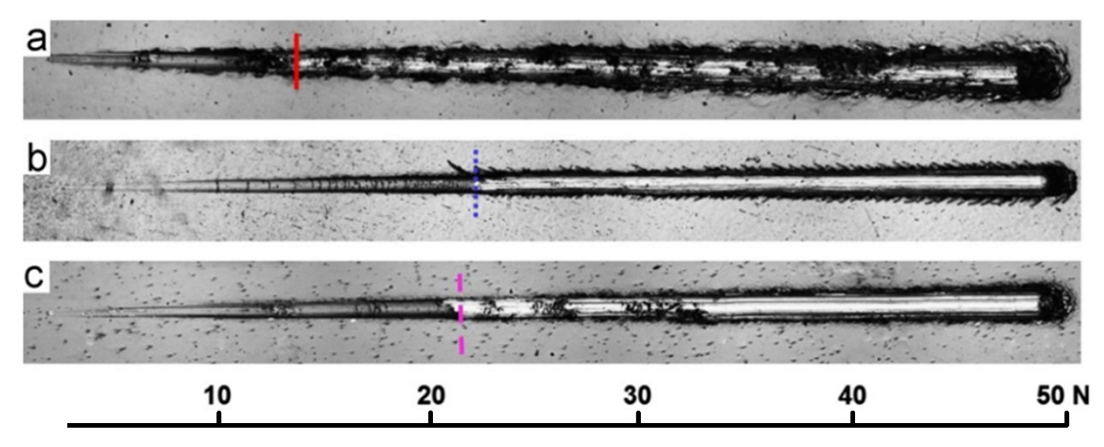
Figure 8. Scratch tracks of DLC-7Zr coatings on (a) coarse-grained Ti, (b) ultrafine-grained Ti, and (c) Ti-6Al-4V substrates.
Reproduced with permission.^{[17]} 2013, Elsevier.

Similar results showing the improvement of tribological properties and wear resistance in the samples of nanostructured Grade 2 Ti with a TiN coating were demonstrated in other publications.^{[16,18]}
Semenova et al. used such a combined approach to the strengthening of the Ti-6Al-4V alloy, consisting in the ECAP processing combined with extrusion for a bulk UFG structure formation, followed by the deposition of a protective multi-layered (Ti+V)N coating onto the surface by the vacuum-plasma method.^{[63]} The structure of the coating was formed by a successive deposition of each layer and the quantity of the deposited material from each cathode. The architecture of the (Ti+V)N coating consisted of two principal (Ti+V)N layers and the intermediate very thin Ti interlayers (Figure 9).
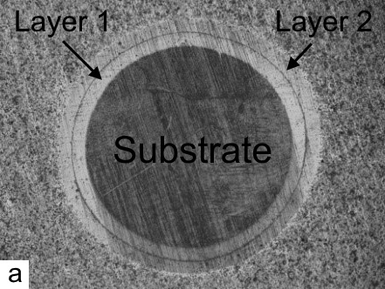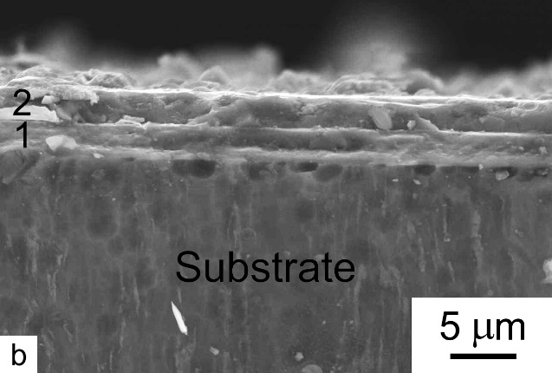
Figure 9. Optical image of a UFG alloy sample (disk) with a (Ti+V)N coating (а) and the SEM image in the EBSD regime (b).
Reproduced with permission.^{[63]} 2017, Advanced Study Center Co. Ltd.

It was found that the ultrafine grains in the substrate’s microstructure promote a considerable increase in the coating’s hardness, in comparison to the CG substrate from the Ti-6Al-4V alloy (35.53 and 26.54 GPa, respectively), and an increase in the critical load to the coating’s failure, Lс, by 10-20% during a scratch test, which indicates an increase in the adhesive strength of the coating on the UFG alloy, as compared to that on the coarse-grained alloy.
Another publication was focused on studying the adhesive strength of the TiVN protective coating on the commercial titanium alloy VT8M-1 (Ti-5.7Al-3.8Mo-1.2Zr-1.3Sn-0.16Fe) produced by an SPD technique of rotary swaging (RS).^{[8,64]} Unlike the “architecture” of the above-described coating, a V underlayer with a thickness of 0.2 μm was deposited on the substrate between the TiVN layers. The architecture of the TiVN coating with a total thickness of about 6 μm represented two layers visible in SEM (Figure 10), but the thin V interlayers were practically undetectable due to their small thickness.
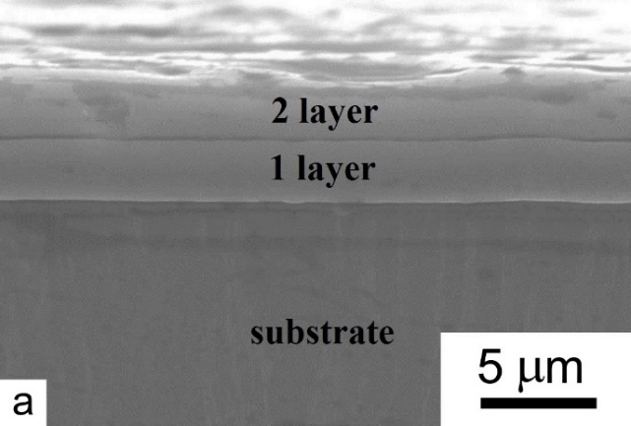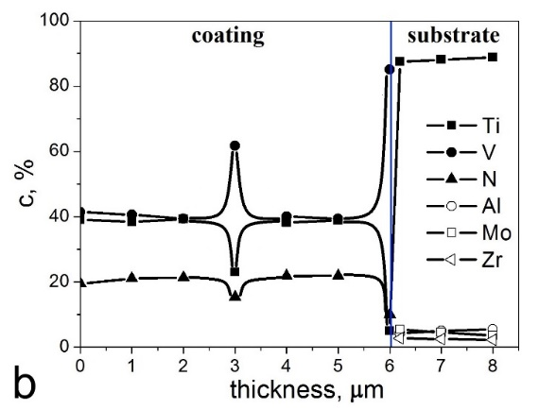
Figure 10. SEM image of the UFG substrate from the VT8M-1 alloy with a deposited coating (а), the optical image of the spherical polished specimen (b), the chemical element distribution throughout the thickness of the coating and substrate (с)
Reproduced with permission.^{[64]} 2020, John Wiley and Sons.

A local chemical analysis of the coating confirmed that in this “substrate-coating” system, at a thickness of about 3 μm there is a TiV underlayer containing V with a concentration of about 60%, and also containing N with a concentration lower than that in the basic layers. The experimental data obtained by a scratch test show that, as a result of the grain structure refinement in the alloy, there is an increase in the сritical load of the coating’s adhesive fracture, Lc2, determined from the acoustic emission data during the experiment.
Thus, the experimental data obtained in these investigations confirm the general regularity that the hardness and adhesive strength of a coating are higher when applied on a UFG substrate. The physical nature of this effect may be related to an increase in the number of generation and growth points during the coating substance crystallization during vacuum-plasma deposition, which results in a decreasing grain/crystal size in the coating itself. However, this issue calls for further special studies.
It is known that GTE parts are operated at elevated temperatures, in particular, from 250 to 450 °С for two-phase Ti alloys. Therefore, to evaluate the innovative potential of UFG Ti alloys in combination with ion-plasma surface modification, their mechanical behavior is studied at the operating temperatures.
Semenova et al. demonstrated a positive effect of a (Ti+V)N PVD-coating on the strength of a UFG alloy during testing at 300-400 °С. In particular, at 400 °С the UTS of the coated UFG sample was 1000 MPa, which is much higher than the UTS of the uncoated UFG and CG samples (900 and 600 MPa, respectively).^{[65]} The authors attribute this to the so-called phenomenon of a coating’s “barrier effect”. The researchers examine several mechanisms responsible for the manifestation of the barrier effect which account for the influence of the surface coatings on the mechanical properties of metals: elastic repulsion between the dislocations in the substrate with a coating having a higher elasticity modulus; the suppression of the surface dislocation sources by a coating; the blocking mechanism where a coating hinders the release of dislocations onto the surface, etc.^{[65]} This leads to the emergence of a dislocation density gradient and the formation of a strengthened near-surface layer which represents a “barrier” for the release of dislocations from the interior volume of the material onto the surface and, as a consequence, to the load redistribution between the surface and interior volumes of the metal and a change in the mechanical properties of the substrate.
The emergence of the “barrier effect” of the coating applied on the UFG VT6 alloy samples promoted an increase in the 100-hour creep rupture strength at the operating temperatures up to 400 °С.^{[55]} Figure 11 summarizes the data from the 100-hour strength tests of the UFG VT6 alloy without any coating and with a (Ti+V)N coating.
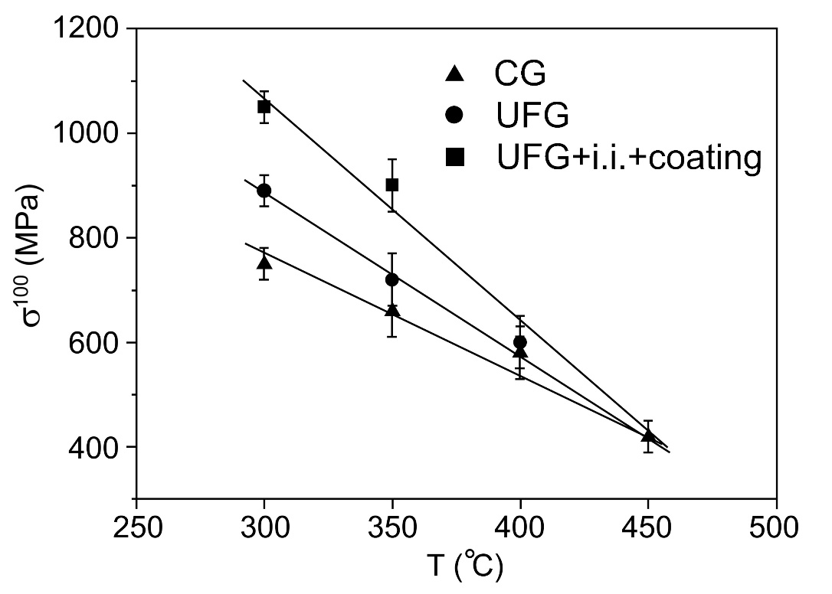
Figure 11. Dependence of the 100-hour creep rupture strength of the Ti-6Al-4V alloy in CG and UFG states, and in the UFG state with a coating.
Reproduced with permission.[65] 2020, John Wiley and Sons.

Semenova et al. also found that the presence of a coating on the UFG alloy substrate changes the mechanism of surface fracture under a long-term exposure to temperature and tensile stresses, as indicated by the different deformation reliefs of the sample surfaces (Figure 12).^{[65]}

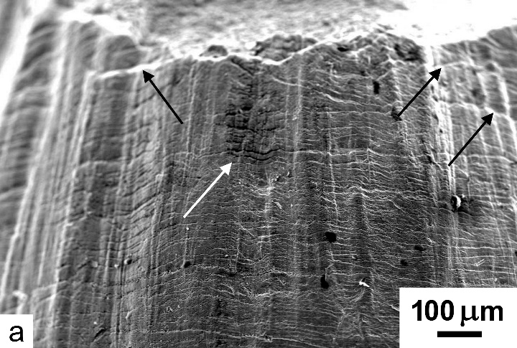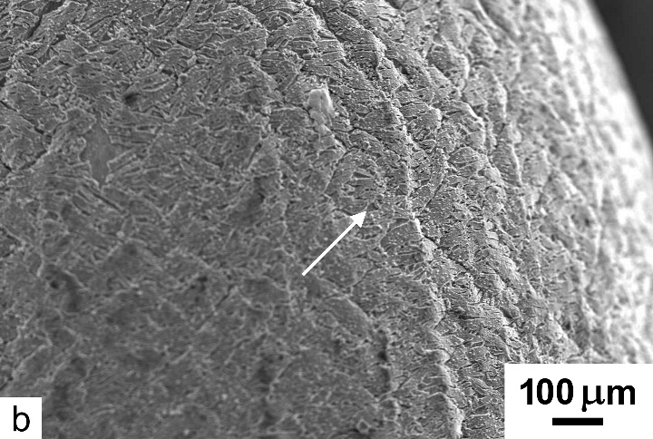
Figure 12. SEM images showing the deformation relief of the surface of the UFG samples without any coating (a) and with a (Ti+V)N coating (b) after testing.
Reproduced with permission.^{[65]} 2020, John Wiley and Sons.

As a result of the work of plastic deformation, a characteristic relief is formed on the surface (Figure 12а) in the form of Chernov-Lüders bands and ring-shaped microcracks. The coated sample under a load apparently has a more complex stress-strain state. It can be seen in Figure 12b that the surface of the coated sample has a network of microcracks developing at an angle of about 45º with respect to the sample axis, which may indicate the emergence of shear strains with subsequent coating failure.
Thus, the above presented experimental data for the Ti-6Al-4V alloy as an example demonstrate a possibility in principle to increase the strength properties of structural Ti alloys with an ultrafine-grained structure at operating temperatures (up to 400 °С) by means of applying a high-hardness and high-strength (Ti+V)N coating by the vacuum-plasma method. Such a comprehensive approach to the strengthening of the Ti-6Al-4V alloy is promising for the production of the heavy-duty parts of gas-turbine engines, e.g., compressor blades, which should meet high requirements in terms of fatigue resistance and oxidation in the conditions of operation at elevated temperatures. However, this approach requires a more detailed study of the alloy’s fatigue behavior, especially at elevated temperatures, and the resistance to surface wear, which will be the focus of our efforts in future.

4. Promising trends in the development of new technologies for the surface modification of parts operating under extreme conditions
To date, a whole range of new approaches have emerged in the area of the surface modification of materials and parts, in particular, those related to the action of concentrated energy fluxes of different origins which lead to processes that cannot be described by the classic laws of physics and fracture mechanics.^{[66]} For example, in structural steels in the near-surface regions the structure of adiabatic shear bands (ASBs) or localized plastic strain bands is produced. The mechanism of ASB formation consists in decreasing yield stress in local surface layers as a result of a considerable heat emission under high-rate dynamic loading and the intensification of plastic flow in these zones.^{[67,68]} According to a number of authors, the emergence of such structures of localized and/or adiabatic shear may promote efficient structure dispersion in local surface regions.^{[69-71]} Owing to such a structure, most materials acquire a high set of mechanical characteristics, including strength and crack resistance, and in some cases, cold resistance, primarily due to an increased resistance to the propagation of initial cracks, especially under impact loading. Simonov demonstrated that the formation the ASB structure in the surface layer of sheet steel and subsequent annealing lead to the formation of a nanodispersed and extremely homogeneous grain-subgrain structure with a higher level of strength and an exceptionally high resistance to crack growth, primarily under dynamic (impact) loading.^{[70]} Besides, due to an extremely high density of grains and subgrains, the bands in such a structure can serve as peculiar tunnels for a fast and rather deep penetration of interstitial impurity atoms, as well as nanoparticles, and consequently, for an accelerated formation of layers of different origins on the surface of metallic workpieces and parts.
To create such near-surface structures in structural materials, such commercial technologies can be used as cold radial forging, transverse screw rolling, forming by rolling, etc. On the whole, the characteristics of the mechanical properties of conventional structural steels can be increased to a level corresponding to highly alloyed and consequently very expensive steels, such as maraging steels. Meanwhile, the problem of increasing the crack resistance of structural materials operating under extreme loads is of great current importance. It is worth noting that in combination with a bulk UFG structure providing a high strength, surface layer modification with the formation of ASBs may have a positive effect on the resistance to brittle fracture, i.e. crack resistance.
One of the ways to increase fatigue resistance, corrosion resistance and wear resistance in materials used in highly-loaded products is the method of laser-shock peening (LSP).^{[72-75]} At present, the laser shock peeing process is investigated by the research groups from Russia, Germany, USA, China. This technology has prospects as a finishing operation in the manufacture of highly-loaded parts. LSP enables treating the surface of complex-shaped parts, hardly accessible for other strengthening methods, and forming a deeper hardened layer. Furthermore, the formation of compressive residual stresses in the surface layer after LSP inhibits crack generation under subsequent cyclic loads. The principle of the process is shown in Figure 13.

Figure 13. Schematic presentation of the laser shock peening process.
Reproduced with permission.^{[76]} 2006, Elsevier.

The principle of LSP is that a laser with a high pulse energy generates plasma on a material surface that is usually covered by a waterproof layer. High-pressure plasma partially transforms into mechanical shock waves, propagating deep into the material. These high-pressure shock waves result in deep compressive residual stresses underneath a treated zone and, as a rule, to tensile stresses in neighboring regions.^{[76,77]} Using АА2024-Т3 aluminum alloy as an example, Chupakhin et al. demonstrated the possibility of increasing the fatigue life of samples by a factor of 3 to 8, as compared to the untreated condition, due to the optimization of the LSP regimes.^{[73]}
At the same time, different functional characteristics of the surface of bulk materials can influence their performance in electrical power plants, electronics and biomedicine. For example, superhydrophobic surfaces have many desirable properties, such as protection against fouling and abrasion, therefore they are often used in such applications as surgical instruments and biomedical devices.^{[78]} To date, many studies have shown the possibility of producing hydrophilic or hydrophobic characteristics in coarse-grained metals by laser surface treatment.^{[79,80]} In combination with a bulk UFG structure, it is possible to achieve a synergetic effect and produce the desired functional properties of a material. For example, as reported by Lin et al., nanostructured Ti samples processed by high-pressure torsion were laser surface-treated with different laser powers.^{[19]} The surface roughness of the laser-textured samples increased with increasing laser power and led to a lower contact angle which signifies an increased hydrophilicity. The authors conclude that laser surface texture processes are capable of controlling the hydrophilic/hydrophobic properties of ultrafine-grained Ti.

5. Conclusion
Thus, the formation of an ultrafine-grained structure by SPD processing in commercial alloys enables a considerable enhancement of their mechanical properties, including strength and endurance limit, which creates prospects for their successful application in industry for the production of highly-loaded parts. To date, a number of studies have demonstrated the possibility in principle of attaining high fatigue characteristics in two-phase Ti alloys widely used in GTE structures, located both in aircrafts and on the ground.
For parts operating under extreme conditions, an important role is played by the condition of the surface which is exposed to different atmospheric environments, dust, foreign particles, etc. Therefore, in many cases GTE parts are operated only with a protective layer and/or coating. The development of multilayer and multi-component protective coatings is an actively progressing research area. There is a great variety of coating application technologies and processing equipment, which makes this way attractive for developing new technologies for the strengthening of parts operating in erosive environments. In particular, widely used for parts from Ti alloys are vacuum-plasma coatings based on nitrides and carbides of refractory elements with a view to increase the resistance to corrosive and erosive action.
At the same time, for parts operating under the extreme conditions of cyclic and tensile loads, in different atmospheric environments, exposed to high temperatures, dustiness, etc., a combination is required of high strength and the resistance of the surface to erosion damage. Therefore, a new approach is proposed for the enhancement of the performance properties of structural materials. This approach consists in producing a UFG structure in the bulk of a material and a protective coating on the surface of a part. Using Ti alloys as an example, it is demonstrated that the UFG structure in the substrate has a considerable effect on the physical and mechanical properties of the coating, such as adhesive strength and hardness. In its turn, this greatly influences the performance characteristics of the material on the whole. For example, the combination of a UFG structure in the Ti-6Al-4V titanium alloy and a subsequent application of the (Ti+V)N coating deposited on the part surface by the vacuum-plasma method increases the creep rupture strength at elevated operating temperatures.
Using Ti alloys as an example, the research results presented in this overview paper demonstrate the prospects of developing a comprehensive approach to the development of structural materials capable of operating under extreme conditions. It consists in the formation of a UFG structure in the bulk of materials, with the subsequent creation of a surface layer with special functional properties by different methods related to the action of concentrated energy flows of different origins on the surface. Depending on the operating conditions and desired functional properties of the surface of a material and/or part, different methods of surface modification are proposed, e.g., the creation of a structure with adiabatic shear bands in the surface layer, ion implantation, erosion-resistant vacuum-plasma coatings, laser shock peening, etc.
The authors of this overview paper are a group of experts from different scientific schools, which allows setting ambitious tasks. The solutions of these tasks can be implemented in such hi-tech industries as the aircraft industry, ship-building industry, chemical engineering industry, power-plant industry and automotive industry.

Acknowledgements
This work was carried out with the financial support of the Ministry of Science and Higher Education of the Russian Federation in the framework of the project №FSNM-2020-0027. Mihail V. Pesin thanks for the support of activities of the Perm Scientific and Educational Center "Rational Subsoil Use".

References
[1] R. Z. Valiev, R. K. Islamgaliev, I. V. Alexandrov, Prog. Mater. Sci. 2000, 45, 103.
[2] R. Z. Valiev, A. P. Zhilyaev, T. G. Langdon, Bulk Nanostructured Materials: Fundamentals and Applications, Wiley/TMS, Hoboken, NJ, USA 2014.
[3] R. Z. Valiev, Y. Estrin, Z. Horita, T. G. Langdon, M. J. Zehetbauer, Y. T. Zhu, JOM 2016, 68, 1216.
[4] I. P. Semenova, L. R. Saitova, G. I. Raab, R. Z. Valiev, Mater. Sci. Eng., A 2004, 387-389, 805.
[5] S. V. Zherebtsov, G. A. Salishchev, R. M. Galeyev, Defect Diffus. Forum 2002, 208-209, 237.
[6] S. Zherebtsov, E. Kudryavtsev, S. Kostjuchenko, S. Malysheva, G. Salishchev, Mater. Sci. Eng., A 2012, 536, 190.
[7] Y. Estrin, A. Vinogradov, Acta Mater. 2013, 61, 782.
[8] I. P. Semenova, V. V. Polyakova, G. S. Dyakonov, A. V. Polyakov, Adv. Eng. Mater., DOI: 10.1002/adem.201900651.
[9] Y. D. Zhang, S. B. Jin, P. W. Trimby, X. Z. Liao, M. Yu. Murashkin, R. Z. Valiev, J. Z. Liu, J. M. Cairney, S. P. Ringer, G. Sha, Acta Mater. 2019, 162, 19.
[10] R. Z. Valiev, V. U. Kazykhanov, A. M. Mavlyutov, A. A. Yudakhina, N. Q. Chinh, M. Yu. Murashkin, Adv. Eng. Mater. 2019, 22, 1900555.
[11] A. E. Medvedev, M. Y. Murashkin, N. A. Enikeev, I. Bikmukhametov, R. Z. Valiev, P. D. Hodgson, R. Lapovok, J. Alloys Compd. 2019, 796, 321.
[12] P. Budzynski, A. A. Youssef, J. Sielanko, Wear 2006, 261, 1271.
[13] A. Zhecheva, W. Sha, S. Malinov, A. Long., Surf. Coat. Technol. 2005, 200, 2192.
[14] S. A. Muboyadzhyan, A. N. Lutsenko, D. A. Aleksandrov, D. S. Gorlov, P. L. Zhuravleva, Russian Metallurgy (Metally) 2011, 2011, 680. (in Russian).
[15] V. M. C. A Oliveira, C. Aguiar, A. M. Vazquez, A. Robin, M. J. R. Barboza, Corros. Sci. 2014, 88, 317.
[16] C. T. Wang, N. Gao, M. G. Gee, R. J. K. Wood, T. G. Langdon, J. Mech. Behav. Biomed. Mater. 2013, 17, 166.
[17] C. T. Wang, A. Escudeiro, T. Polcar, A. Cavaleiro, R. J. K. Wood, N. Gao, T. G. Langdon, Wear 2013, 306, 304.
[18] C. T. Wang, N. Gao, M. G. Gee, R. J. K. Wood, T. G. Langdon, J. Mater. Sci. 2013, 48, 4742.
[19] H. K. Lin, G. Y. Li, S. Mortier, P. Bazarnik, Y. Huang, M. Lewandowska, T. G. Langdon, J. Alloys Compd. 2019, 784, 653.
[20] D. P. DeLo, S. L. Semiatin. Metall. Mater. Trans., A, 1999, 30, 2473.
[21] Y. G. Ko, W. S. Jung, D. H. Shin, C. S. Lee, Scr. Mater. 2003, 48, 197.
[22] I. P. Semenova, L. R. Saitova, G. I. Raab, A. I. Korshunov, Y. T. Zhu, T. C. Lowe, R. Z. Valiev, Mater. Sci. Forum. 2006. 503-504, 757.
[23] S. V. Zherebtsov, G. A. Salishchev, R. M. Galeyev, O. R. Valiakhmetov, S. Yu. Mironov, S. L. Semiatin, Scr. Mater. 2004, 51, 1147.
[24] S. Zherebtsov, M. Murzinova, G. Salishchev, S. L. Semiatin, Acta Mater. 2011, 59, 4138.
[25] A. A. Popov, I. Yu. Pyshmintsev, S. L Demakov, A. G. Illarionov, T. C. Lowe, R. Z. Valiev, Scr. Mater. 1997, 37, 1089.
[26] G. A. Salishchev, R. M. Galeyev, O. R. Valiakhmetov, R. V. Safiulin, R. Y. Lutfullin, O. N. Senkov, F. H. Froes, O. A. Kaibyshev, J. Mater. Process. Technol. 2001, 16, 265.
[27] T. Zhu, Y. R. Kolobov, G. P. Grabovetskaya, V. V. Stolyarov, N. V. Girsova, R. Z. Valiev, Int. J. Mater. Res. 2003, 18, 1011.
[28] S. L. Demakov, O. A. Elkina, A. G. Illarionov, M. S. Karabanalov, A. A. Popov, I. P. Semenova, L. R. Saitova, N. V. Shchetnikov, Phys. Met. Metallogr. 2008, 105, 602.
[29] C. Veiga, J. P. Davim, A. J. R. Loureiro, Rev. Adv. Mater. Sci. 2012, 32, 133.
[30] G. Antashev, N. A. Nochovnaya, T. V. Pavlova, V. I. Ivanov, High-temperature titanium alloys, VIAM, Moscow, 2007, http://viam.ru/public/files/2006/2006-204686.pdf (in Russian).
[31] I. P. Semenova, G. S. Dyakonov, G. I. Raab, Y. F. Grishina, Y. Huang, T. G Langdon, Adv. Eng. Mater. 2018, 20, 1700813.
[32] M. Klimova, M. Boeva, S. Zherebtsov, G. Salishchev, IOP Conf. Ser.: Mater. Sci. Eng. 2014, 63, 012070.
[33] Iu. M. Modina, A. V. Polyakov, G. S. Dyakonov, T. V. Yakovleva, A. G. Raab, I. P. Semenova, IOP Conf. Ser.: Mater. Sci. Eng. 2018, 461, 012056.
[34] T. Yakovleva, G. Dyakonov, A. Stotskiy, Iu. Modina, I. Semenova, Mater. Sci. Forum 2021, 1016, 1659.
[35] L. R. Saitova, H. W. Hoeppel, M. Goeken, I. P. Semenova, R. Z. Valiev, Int. J. Fatigue 2009, 31, 322.
[36] I. P. Semenova, E. B. Yakushina, V. V. Nurgaleeva, R. Z. Valiev, Int. J. Mater.Res. 2009, 100, 1691.
[37] H. W. Höppel, M. Kautz, C. Xu, M. Murashkin, T. G. Langdon, R. Z. Valiev, H. Mughrabi, Int. J. Fatigue 2005, 28, 1.
[38] A. V. Polyakov, I. P. Semenova, Y. Huang, R. Z. Valiev, T. G. Langdon, Adv. Eng. Mater. 2014, 16(8), 1038.
[39] I. P. Semenova, G. I. Raab, V. V. Polyakova, N. F. Izmailova, S. P. Pavlinich, R. Z. Valiev,
Rev. Adv. Mater. Sci. 2012, 31(2), 179.
[40] M. I. Guseva, Yu. V. Martynenko, A. M. Smyslov, in: Proc. 3-rd Inter. Workshop on Plasma-Based Ion Implantation, Rossendorf, Germany 1996.
[41] P. J. Wilbur, B. W. Buchholtz, Surf. Coat. Tech. 1996, 79, 1.
[42] R. Rajendran, Eng. Fail. Anal. 2012, 26, 355.
[43] M. Reedy, T. Eden, J. Potter, D. Wolfe, Surf. Coat. Technol. 2011, 206, 464.
[44] B. Borawski, J. Todd, J. Singh, D. Wolfe, Wear 2011, 271, 2890.
[45] S. Hassani, J.E. Klemberg-Sapieha, M. Bielawski, W. Beres, L. Martinu, M. Balazinski, Wear 2008, 265(5–6), 879.
[46] S. Lin, K. Zhou, M. Dai, E. Lan, Q. Shi, F. Hu, T. Kuang, C. Zhuang, Vacuum 2015, 122, 179.
[47] L. Swadzba, B. Formanek, H. M. Gabriel, P. Liberski and P. Podolski, Surf. Coat. Technol. 1993, 62 486.
[48] S. A. Muboyadzhyan, Russian Metallurgy (Metally) 2009, 2009(3), 183.
[49] V. R. Parameswaran, J. P. Immarigeon, D. Nagy, Surf. Coat. Technol. 1992, 52, 251.
[50] A. Feuerstein, A. Kleyman, Surf. Coat. Technol. 2009, 204, 1092.
[51] P. Wieciński, J. Smolik, H. Garbacz, K. J. Kurzydłowski, Vacuum 2014, 107, 277.
[52] J. Deng, F. Wu, Y. Lian, Y. Xing, S. Li, Int. J. Refract. Hard. Met. 2012, 35, 10.
[53] K. S. Selivanov, A. M. Smyslov, Y. M. Dyblenko, I. P. Semenova, Wear 2019, 418–419, 160.
[54] P. C. Yashar, W. D. Sproul, Vacuum 1999, 55, 179.
[55] Y. H. Cheng, T. Browne, B. Heckerman, C. Bowman, V. Gorokhovsky, E. I. Meletis, Surf. Coat. Technol. 2010, 205(1), 146.
[56] D. Zhou, H. Peng, L. Zhu, H. Guo, S. Gong, Surf. Coat. Technol. 2014, 258, 102.
[57] A. Santana, A. Karimi, V. Derflinger, A. Schütze, Surf. Coat. Technol. 2004, 177, 334.
[58] G. Carter, I. V. Katardjiev, M. J. Nobes, in Materials modification by high-fluence ion beams (Eds: R. Kelly, M. Fernanda da Silva) Springer, Dordrecht, Nederland 1989, P. 3.
[59] M. Castagnet, L. M. Yogi, M. M. Silva, M. Ueda, A. A. Couto, D. A. P. Reis, C. M. Neto, Mater. Sci. Forum 2012, 727–728, 50.
[60] V. A. Belous, G. I. Nosov, I. O. Klimenko, Voprosy Atomnoj Nauki i Tekhniki (Probl. of Atom. Sci. and Tech.) 2017, 5, 73. (in Russian)
[61] E. V. Safin, S. P. Malysheva, A. M. Smyslov, G. F. Minnigaleeva, F. G. Ishmuratov Adv. Mater. 2013, 15, 110. (in Russian)
[62] I. P. Semenova, M. K. Smyslova, K. S. Selivanov, R. R. Valiev, Yu. M. Modina, IOP Conf. Ser.: Mater. Sci. Eng. 2017, 194, 012035.
[63] I. P. Semenova, R. R. Valiev, K. S. Selivanov, Yu. M. Modina, A. V. Polyakov, M. K. Smyslova, R. Z. Valiev, Rev. Adv. Mater. Sci. 2017, 48, 62.
[64] R. R. Valiev, K. S. Selivanov, Iu. M. Modina, Yu. M. Dyblenko, I. P. Semenova, R. Z. Valiev. Adv. Eng. Mater. 2020, 2000121.
[65] I. P. Semenova, K. S. Selivanov, R. R. Valiev, Iu. M. Modina, M. K. Smyslova, A. V. Polyakov, T. G. Langdon, Adv. Eng. Mater. 2020, 1901219. DOI:10.1002/adem.201901219.
[66] V. E. Panin, A. V. Panin, D. D. Moiseenko, A. D. Shlyapin, Yu. S. Avraamov, V. I. Koshkin, Phys. Mesomech. 2007, 10(1-2), 25.
[67] C. Zener, J. H. Hollomon, J. Applied. Physics. 1944, 15(1), 22.
[68] C. Froustey, O. B. Naimark, I. A. Panteleev, Phys. Mesomech. 2017, 20(1), 31.
[69] M. Yu. Simonov, O. B. Naimark, Yu. N. Simonov, M. N. Georgiev, G. S. Shaimanov, D. D. Karpova, D. A. Bilalov, Met. Sci. Heat Treat., 2020, 61(10), 628.
[70] M. Yu. Simonov. Met. Sci. Heat Treat., 2020, 61(10), 639.
[71] M. Yu. Simonov, O. B. Naimark, Yu. N. Simonov, G. S. Shaimanov, D. D. Karpova, A. N. Yurchenko, Met. Sci. Heat Treat., 2020, 61(10), 648.
[72] F. Fomin, B. Klusemann, N. Kashaev, Procedia Structural Integrity 2018, 13, 273.
[73] S. Chupakhin, B. Klusemann, N. Huber, N. Kashaev, Int. J. Adv. Manuf. Technol. 2019, DOI: 10.1007/s00170-018-3034-2.
[74] N. Kashaev, S. Chupakhin, V. Ventzke, MATEC Web of Conferences 2018, 165(8), 18001.
[75] V. N. Trofimov, A. A. Shiryaev, V. V. Karmanov, AIP Conference Proceedings 2018, 2053, 040097. DOI: https://doi.org/10.1063/1.5084535.
[76] K. Ding, L. Ye, Laser shock peening. Performance and process simulation. Woodhead Publishing, Cambridge, UK, 2006.
[77] P. Peyre, R. Fabbro, P. Merrien, H. Lieurade, Mater. Sci. Eng., A 1996, 210(1–2), 102.
[78] F. Niekiel, P. Schweizer, S. M. Kraschewski, B. Butz, E. Spiecker, Acta Mater. 2015, 90, 118.
[79] J. Fu, Y. Zhu, C. Zheng, R. Liu, Z. Ji, Optic Laser. Technol. 2015, 73, 94.
[80] B. S. Yilbas, H. Ali, Optic Laser. Technol. 2016, 78, 140.

