# Capturing the healthfulness of the in-store environments of UK supermarket stores over 5 months (January – May 2019)

Georgina Harmer, MSc1, Professor Susan Jebb, PhD1,Dr Georgia Ntani, PhD2, Dr Christina Vogel, PhD2, Dr Carmen Piernas, PhD1.

1 Nuffield Department of Primary Care Health Sciences, University of Oxford

2 MRC Lifecourse Epidemiology Unit, University of Southampton

Correspondence to:

Dr Carmen Piernas

T: +44 (0)1865 289284

E: carmen.piernas-sanchez@phc.ox.ac.uk

Nuffield Department of Primary Care Health Sciences, University of Oxford

Radcliffe Primary Care Building, Radcliffe Observatory Quarter, Woodstock Road, Oxford, OX2 6GG

**Word count:**

Text only: 3009, Number of pages: 14, Number of tables: 2, Number of figures: 2.

## **Conflict of interest:**

**CV has a non-financial research relationship with a UK food retail company and maintains independence in all evaluation activities. This article, however, is not related to this relationship.** All other authors declare that they have no competing interests.

## **Funding sources**

This study received funding from Guy’s and St Thomas’ Charity (grant EIC181003). The study sponsor had no role in the study design; collection, analysis, and interpretation of data; writing the report; or the decision to submit the report for publication. GH, CP and SJ are funded by the National Institute of Health Research (NIHR) Applied Research Collaborations Oxford. CV and GN are supported by funding from the UK Medical Research Council (MC_UU_12011/4) and (NIHR Public Health Research Programme (grant funding, 17/44/46). The views expressed in this publication are those of the author(s) and not necessarily those of the National Health Service, the National Institute for Health Research, the UK Department of Health and Social Care. No financial disclosures were reported by the authors of this paper.

# Abstract

**Background:** Numerous environmental factors within supermarkets can influence the healthfulness of food purchases. This research aimed to identify changes in store healthfulness scores and to assess variations by store type and neighbourhood deprivation, using an adapted Consumer Nutrition Environment (CNE) tool.

**Methods:** 104 supermarkets in London were surveyed on 1-3 occasions between January and May 2019. The adapted CNE tool included data on nine variables (variety, price, quality, promotions, shelf placement, store placement, nutrition information, healthier alternatives and single fruit sale) for 11 healthy and 5 less healthy food items. An algorithm was used to create a composite score of in-store healthfulness and assessed inter-rater reliability. Longitudinal changes in overall store healthfulness and individual variables were investigated using multivariable hierarchical mixed models. Descriptive statistics were used to describe differences by store type and neighbourhood deprivation in each month. All analyses were conducted between January-July 2020.

**Results:** The adapted CNE tool showed acceptable inter-rater reliability. Large stores exhibited healthier environments than small stores (*P*<0.001), with a similar pattern for each of the nine individual variables. Within large stores, the overall healthfulness score did not change over the study period. Promotions on more healthful items increased in February (*P*=0.04), and availability of healthier alternatives for less healthy foods decreased in March (*P*=0.01). Within small stores, there was a trend towards increasing healthfulness (*P*<0.001), primarily due to more promotions on healthy items (*P*<0.001). There was no difference in overall healthfulness by neighbourhood deprivation.

**Conclusions:** The adapted CNE tool is sensitive to longitudinal changes in environmental variables that contribute to store healthfulness. Wider application of this tool could be used to map in-store environments to identify targets for interventions to encourage healthier food purchasing.

# Keywords

Supermarkets, food environment, consumer nutrition environment, diet quality, dietary inequalities

# Introduction

Supermarkets are a major source of food purchased for home consumption, accounting for approximately 87% of all UK retail grocery sales.1 The supermarket food environment, including variables that influence purchasing such as availability, price, promotions, placement, variety, quality, and nutrition information, has been found to influence dietary behaviours by encouraging both excessive food purchasing and sales of less healthy items.2-4 Understanding how key variables and the overall healthfulness of supermarket environments change over time is needed to identify and monitor interventions most likely to be effective in encouraging healthier food purchasing.

Tools have been developed to assess supermarket environments, but they differ in their content and complexity, and their use is mostly limited to cross-sectional studies.5,6 The Consumer Nutrition Environment (CNE) tool was originally developed to capture information on products used to characterise healthy or less healthy dietary patterns of women of child-bearing age7. Adapting this tool to be suitable for the broader UK population will increase its applicability and use in evaluating supermarket interventions or policies. To our knowledge, there are currently no studies investigating changes in the overall in-store environment of supermarkets over time. Yet, the supermarket environment is prone to rapid changes in promotional strategies that influence short-term purchasing behaviour.8

This study aimed to describe the development and application of an adapted CNE tool and investigate changes in the healthfulness scores and the nine contributing variables over the first five months of the year, and to assess variations by store type and neighbourhood deprivation. This period of the year is marked by numerous occasions typically celebrated with confectionery including Valentine’s Day, Mother’s Day and Easter, and enabled assessment of seasonal fluctuations in supermarket environments.

# Methods

***Consumer Nutrition Environment Tool Development***

The CNE tool was originally developed to measure nine variables (variety, price, quality, promotions, shelf placement, store placement, nutrition information, healthier alternatives and single fruit sale) each assessed for seven healthy and five less healthy foods.7,9-12 The food items were expanded here to better reflect the diet for the whole population. A greater range of fruits and vegetables frequently consumed in the UK, and frequently consumed less healthy foods that represent target products in the UK government’s calorie reduction and sugar reduction programmes were included.13,14 The adapted tool included 11 healthy (peppers, tomatoes, apples, bananas, carrots, broccoli, cauliflower, tinned tomatoes, tinned sweetcorn, frozen mixed vegetables and frozen peas) and seven less healthy (sausages, crisps, carbonated soft drinks, biscuits, sweets, chocolate bars and pizza) items. Only fruit and vegetables were included as healthy items as consumption of these products remains well below recommended levels in the UK and selections can vary across store types and area deprivation.15 The adapted CNE tool and protocol are available in Supplementary Files 2 and 3.

The variables measured and methods used were the same as the original CNE tool.9 Briefly, for each product, the number of varieties, price, promotion, shelf placement and store placement were collected. Price was recorded for the cheapest item for each product and converted to pounds per portion. The type of nutrition information present and availability of a healthier alternative were collected only for less healthy products. The quality and option for single sale of two fruits, and the quality of five vegetables were also assessed. Supplementary Table 1 provides full definitions and measurement scales of the variables assessed. Supplementary Appendix 1 provides information on the healthfulness score development.

**Study Sample**

Stores were sampled across London from two major UK food retail chains, which jointly have over 40% of the UK market share.16 Large and small stores were selected to cover a range of socio-economic deprivation strata based on the 2019 English Index of Multiple Deprivation (IMD) income domain, the official measure of relative deprivation in small areas in England (Table 1). 9,17-20 The sample covered neighbourhoods from deciles 1-8; re-grouped into IMD 1-3 (high), 4-5 (mid) and 6-8 (low) (Table 2). The sample included 88% of the two target retailers within two highly deprived London areas, plus an additional 22 stores to increase representation across area deprivation levels.

Between January-May 2019, trained fieldworkers visited stores on one to three occasions in different months and completed the adapted CNE survey in paper format. For each time point, fieldworkers had a two-week window in which to visit stores. Unexpected store manager refusal on seven occasions and fieldworker unreliability meant the final dataset does not include three visits for all stores. Eight stores were additionally surveyed by the primary researcher (GH) to assess inter-rater reliability. All data was cleaned by GH and transferred to an electronic database before analysis.

**Statistical Analysis**

***Inter-rater reliability analysis***

The kappa statistic was calculated to assess level of agreement for each variable, except price. The relative consistency of price responses was assessed using the coefficient of variation: the standard deviation of difference divided by the mean, expressed as a percentage (%).

***Longitudinal differences in healthfulness score***

Stores measured at least twice were included in this analysis. Hierarchical mixed models with random intercepts for store, with an interaction term for store type by time and adjusted for deprivation level and retailer were used. Post-estimation marginal mean scores were calculated for each month and store type. A test for trend was performed using the same models described above, except the coefficient for month was now modelled as a continuous variable.

***Cross-sectional differences by store type and neighbourhood deprivation***

Differences by store type and neighbourhood deprivation for each month were illustrated using box plots, Student’s *t*-tests for normally distributed variables, Mann-Whitney tests for non-parametric variables, and Chi-squared tests for categorical variables.

***Exploratory and sensitivity analyses***

Exploratory analyses investigated if changes observed in individual variable scores were driven by changes in healthy or less healthy items. Hierarchical mixed models were used as described above, where the outcomes were the average scores from the healthy and less healthy items for *price, variety, shelf placement, store placement* and *promotions*.

A sensitivity analysis was performed to recalculate overall in-store healthfulness scores after subtracting two variables (*quality* and *single fruit sale*) that showed poor inter-rater reliability or little variation across time or store type, respectively. Overall healthfulness scores were also recalculated after reducing the number of healthy items to seven, to match the number of less healthy items included. Fresh tomatoes, cauliflower, tinned sweetcorn and frozen peas were removed to leave the two original fruits (apples and bananas) and the other most commonly consumed vegetables in the UK (peppers, broccoli, carrots, tinned tomatoes and frozen mixed vegetables).21

Descriptive statistics and regressions were conducted using Stata (version 14; StataCorp LP), with a two-sided p-value of <0.05 to define statistical significance.

# Results

***Store characteristics***

Data was collected from a total of 104 stores (Table 2), mostly small supermarkets (85%, n=88), and from the most deprived areas IMD 1-3 (n=47, 46%).

***Inter-rater reliability***

Overall inter-rater reliability of the tool was good for most components except shelf and store placement, and quality of fruit and vegetables (Supplementary Appendix 2).

***Longitudinal changes in healthfulness score by store type***

At all time-points, large stores had a higher overall healthfulness score (more healthful environments), and higher scores for variety, promotions, shelf placement, store placement, quality, healthier alternative and nutrition information compared to small stores (Figure 1). Only price had a higher score in small stores compared to large stores, reflecting prices more supportive of affordable healthy food purchasing relative to less healthy foods.

For large stores, there was no overall trend and no significant changes in the overall healthfulness score in any month compared to January. Among individual variables, the score for promotions significantly increased in February (P=0.04) reflecting a healthier promotional environment, decreased in March before increasing again in May, with no significant trend across the study period. Availability of healthier alternatives of less healthy foods declined in March (P=0.01).

For small stores, there was a significant decrease in the overall healthfulness score in February compared to January (P=0.03), but an overall significant upward trend from January to May (P<0.001) (Supplementary Table 3, Figure 1). In March, price scores decreased (P=0.03) and less-healthful items became cheaper, however there was no overall trend. There was a trend towards increasing healthfulness of promotions between January and May (P<0.001), and by May this was significantly different from January (P<0.01) reflecting a healthier promotional environment with time.

Changes in healthy and less healthy items separately (Figure 2, Supplementary Table 4) showed that in January to May, in both large and small stores, less healthy items were cheaper and more frequently promoted than healthier items. The price difference between less healthy and healthy items was greater in small stores than large stores (Figure 2). In large stores, the price of the cheapest healthy (P=0.01) and less healthy (P=0.02) items increased over time. This was also observed in small stores for healthy (P<0.001), but not less healthy items. In large stores, there was greater variety of healthy items than less healthy items across the whole study period, whereas in small stores, there was similar variety of less healthy items to that in large stores, but far fewer varieties of healthy items. Shelf and store placement scores highlighted that healthy items tend to be more easily identifiable than less healthy items in both store types at every month (Figure 2).

In large stores between January and February, promotions of healthier items increased more than promotions of less healthy items (P<0.001, and P=0.01, respectively). Furthermore, there was an increasing trend of promotions on healthy items across January-May (Ptrend<0.01). In February, prominence in shelf placement of healthy items (P=0.02) was reduced compared to January, with little change in the prominence of less healthy items.

In small stores, there was a significant fall in the price of the cheapest less healthy items (P=0.01) in March compared to January. In February and May, there were significant increases in promotions on healthy items (P<0.01 and P<0.001, respectively) compared to January, and an overall trend of increasing promotions on healthy items across January to May (Ptrend<0.01). Store prominence of less healthy items increased significantly in February (P=0.01) from January, whilst store prominence of healthy items deteriorated.

***Cross-sectional differences in healthfulness score by store type and neighbourhood deprivation***

Healthfulness scores for small stores were lower than in large stores at all time-points (*P*<0.001, Supplementary Figure 1A). The individual variables followed similar patterns with significantly higher estimates at all time-points in large stores except for price scores which were significantly higher in small stores (Supplementary Table 5).

There was no clear pattern between the composite healthfulness score or the individual variables and neighbourhood deprivation across all time points (Supplementary Table 3), nor at any given time-point (Supplementary Table 6, Supplementary Figure 1B).

***Sensitivity analyses***

Sensitivity analyses revealed no significant effect of removing quality and single fruit sale variables, or reducing the number of healthy items included, on any findings. A full description can be found in Supplementary Appendix 3.

# Discussion

This study developed an adapted CNE tool to be more appropriate for general population health research by including foods representative of national dietary trends and that are targeted in public policies aimed at reducing energy and sugar intakes in England.13,14 The adapted CNE tool showed acceptable inter-rater reliability. Large stores consistently offered more healthful environments than small stores. The tool was sensitive to longitudinal changes in environmental variables that contribute to store healthfulness.

This study provides novel insights into the healthfulness of supermarket in-store environments. The findings are consistent with the monthly fluctuations in food marketing practices expected throughout January-May that accompany seasonal events. From January to February, there was a greater increase in promotions on healthy items compared to less healthy items, likely reflecting the end of promotions on Christmas items and a new focus on supporting New Year health resolutions. In March, promotions on less healthy items increased and promotions on healthy items decreased, likely capturing the introduction of highly promoted Mother’s Day and Easter products. Simultaneously, availability of healthier alternatives of less healthy items decreased, perhaps because healthier alternatives were removed to increase capacity for Easter products. After Easter, variety and promotion of healthy items increased in May, as new British spring/summer fruits and vegetables became available and were promoted.

Results consistently showed that large stores offered more healthful environments than small stores; a feature also reflected in the majority of the individual variables, and suggests that the variety, quality, promotions, shelf placement, store placement, nutrition information, healthier alternatives and single fruit sale is better for healthy products in larger stores. This is consistent with previous research conducted in Hampshire, UK, which assessed the healthfulness of 601 retail food stores using the original CNE tool,9 as well as other research from high income countries.5,22,23 A potential explanation for the more healthful environment in large stores is the greater space to stock a wider variety of healthy products and the ability to promote these. Small stores by comparison have limited scope to increase their range beyond core products or to alter where products are placed and promoted. These discrepancies by store type may be contributing to dietary inequalities, 17,24 although there was no evidence of an association between store healthfulness and neighbourhood deprivation after adjustment for store type. Similarly, research in Scotland, England and Australia has shown little variation in price and availability by level of neighbourhood deprivation.15,25,26, whilst others have reported poorer fruit and vegetable quality27,28 and greater promotion of less healthy foods29 in stores in less affluent areas. Unexpectedly, in small stores, the difference in food prices between healthy and less healthy food products was minimal, showing they were more supportive of affordable healthy foods, while in large stores cheaper prices favoured less healthy items. Collectively, these findings suggest targets for future intervention for researchers and policy makers may differ according to store format, whereby strategies in large stores need to correct the price differential between healthy and less healthy products and small stores could focus on increasing their varieties of fruits and vegetables in an effort to address inequalities.

Numerous tools have been developed to assess supermarket in-store environments5,30, however few have undergone reliability or validity testing, and most tools focus on measuring two specific factors: availability and price.5,30,31 The adapted CNE tool is a comprehensive tool with moderate to excellent kappa for almost all variables, except for in-store placement and quality. The former could be improved with more precise definitions of in-store locations, such as those used in the GroPromo tool.32 Fruit and vegetable quality showed lowest agreement, consistent with previous research9. However, removing quality and single fruit sale variables (which showed minimal variation between stores) from the tool had no effect on composite healthfulness scores. Future assessment using photographs or a two-point scale of acceptable/unacceptable may provide a more robust measure of quality.33,34

**Strengths and Limitations**

This study expanded on research by Black et al9 by adapting their existing tool to include greater emphasis on products which are the focus of current policies to improve the healthfulness of the food supply, and by assessing changes in in-store variables over time.

Both large and small supermarkets were included, but discount supermarkets, convenience or speciality stores which have previously been shown to have a different health profile9,35 were not sampled. The study sample included areas covering a wide range of socioeconomic status. Not all stores, however, had data collected every month, and the longitudinal analyses only included stores with two or more observations within the study period, considerably reducing the sample size and ability to detect differences in store healthfulness which may exist across deprivation levels. Considering known regional differences in food environments,36 and that London has on average a younger, more educated population with greater earnings than the rest of the UK37 which may influence supermarket design and strategy and possibly impact store healthfulness, the generalisability of the results are limited.

The complexity of supermarket environments makes it difficult to measure all aspects of the environment which may influence purchasing decisions, but changes in the tool variables may be offset by other in-store changes. The tool is intended to give an overall store healthfulness rating, however there is risk of retailers focusing on specific components of the score while continuing less healthful practices in areas missed by the tool. Future research could link changes in healthfulness scores to changes in the nutritional quality of food purchases to assess the extent to which this occurs.

Lastly, given the natural seasonal variations of price and availability on fresh produce, only including fruit and vegetables as healthy items may have limited the ability to detect useful information on pricing and promotions of other nutrient-dense ambient products. Further research could examine including a wider range of healthy items. Despite these limitations, this study provides proof of concept that the adapted CNE tool can be used to assess store healthfulness.

**Implications for Further Research**

The tool detected changes in the healthfulness of certain in-store variables over time and differentiated between different store types in meaningful ways. Ways to further simplify the tool without materially changing the findings were also identified. For example, removing four healthy items to match the number of healthy and less healthy items included in the tool did not materially alter findings and will reduce the burden of future assessments. By assessing products targeted by the government sugar and calorie reduction programmes, the tool could be useful in providing information at a store level on the healthfulness of marketing strategies or the change over time. This adapted tool could be used to conduct a wider investigation of the specific differences in healthfulness between stores and over time. Furthermore, it could be used to monitor effectiveness of policies intended to improve the healthfulness of in-store environments.

This study provides proof-of-concept that the adapted CNE tool is able to detect changes over time in specific in-store environmental features which can influence food purchasing decisions. It shows large stores to be more healthful than small stores particularly due to the wider variety of healthy items available and the greater ability to promote these. This knowledge could be useful in identifying areas for change to enhance the healthfulness of smaller store environments.

## Acknowledgements

We would like to acknowledge the funding received from Guy’s and St Thomas’ Charity (grant EIC181003). We all also like to acknowledge the support from Public Health England and The Food Foundation in recruiting data collectors. We would like to thank the data collectors themselves for conducting the store surveys, and the participating supermarkets and store managers for allowing the data collectors to take the necessary measurements for this research.

CP, CV and SJ participated in the design of the study. GH and CP adapted the audit tool with input from GN, CV and SJ. GH and CP coordinated the data collection, healthfulness score development and analyses, and wrote the first draft of the manuscript. GN and CV contributed to the development of the healthfulness score and performed some of the statistical analyses. SJ, GN and CV provided critical revisions to the manuscript. All authors read and approved the manuscript. No financial disclosures were reported by the authors of this paper.

### List of abbreviations

CNE - Consumer Nutrition Environment

IMD - Index of Multiple Deprivation

LSOA - Lower Super Output Area

NHS - National Health Service

# References

1. Department for Environment Food and Rural Affairs. *Food Statistics Pocketbook 2014.* London 2015 2015.

2. Shaw SC, Ntani G, Baird J, Vogel CA. A systematic review of the influences of food store product placement on dietary-related outcomes. *Nutr Rev.* 2020.

3. Adam A, Jensen JD. What is the effectiveness of obesity related interventions at retail grocery stores and supermarkets? -a systematic review. *BMC Public Health.* 2016;16(1):1247-1247.

4. Cameron AJ, Charlton E, Ngan WW, Sacks G. A Systematic Review of the Effectiveness of Supermarket-Based Interventions Involving Product, Promotion, or Place on the Healthiness of Consumer Purchases. *Curr Nutr Rep.* 2016;5(3):129-138.

5. Gustafson A, Hankins S, Jilcott S. Measures of the consumer food store environment: a systematic review of the evidence 2000-2011. *J Community Health.* 2012;37(4):897-911.

6. Glanz K, Johnson L, Yaroch AL, Phillips M, Ayala GX, Davis EL. Measures of Retail Food Store Environments and Sales: Review and Implications for Healthy Eating Initiatives. *J Nutr Educ Behav.* 2016;48(4):280-288 e281.

7. Crozier SR, Inskip HM, Barker ME, Lawrence WT, Cooper C, Robinson SM. Development of a 20-item food frequency questionnaire to assess a 'prudent' dietary pattern among young women in Southampton. *Eur J Clin Nutr.* 2010;64(1):99-104.

8. Hawkes C. Dietary Implications of Supermarket Development: A Global Perspective. *Dev Policy Rev.* 2008;26(6):657-692.

9. Black C, Ntani G, Inskip H, et al. Measuring the healthfulness of food retail stores: variations by store type and neighbourhood deprivation. *Int J Behav Nutr Phys Act.* 2014;11:69.

10. Crozier SR, Inskip HM, Godfrey KM, Robinson SM. Dietary patterns in pregnant women: a comparison of food-frequency questionnaires and 4 d prospective diaries. *Br J Nutr.* 2008;99(4):869-875.

11. Fisk CM, Crozier SR, Inskip HM, Godfrey KM, Cooper C, Robinson SM. Influences on the quality of young children's diets: the importance of maternal food choices. *Br J Nutr.* 2011;105(2):287-296.

12. Robinson S, Syddall H, Jameson K, et al. Current patterns of diet in community-dwelling older men and women: results from the Hertfordshire Cohort Study. *Age Ageing.* 2009;38(5):594-599.

13. Public Health England. *Calorie reduction: The scope and ambition for action.* London. 2018.

14. Public Health England. *Sugar reduction: the evidence for action.* 2015.

15. Black C, Ntani G, Kenny R, et al. Variety and quality of healthy foods differ according to neighbourhood deprivation. *Health Place.* 2012;18(6):1292-1299.

16. Kantar Worldpanel. Grocery Market Share 2020; <https://www.kantarworldpanel.com/en/grocery-market-share/great-britain/snapshot/26.01.20/>. Accessed 25/02/20.

17. Vogel C, Ntani G, Inskip H, et al. Education and the Relationship Between Supermarket Environment and Diet. *Am J Prev Med.* 2016;51(2):e27-e34.

18. Department for Communities and Local Government. *The English Indices of Deprivation 2015.* London, UK 2015.

19. Noble M, McLennan D, Wilkinson K, Whitworth A, Barnes H, Dibben C. English Indices of Deprivation 2007. London: Communities and Local Government. 2008.

20. McLennan D, Noble S, Noble M, Plunkett E, Wright G, Gutacker N. *The English Indices of Deprivation 2019.* Ministry of Housing, Communities and Local Government. ;2019.

21. Sandercock H. *Fresh Fruit & Veg: Top Products 2019.* The Grocer 9 December 2019.

22. Dawson J, Marshall D, Taylor M, Cummins S, Sparks L, Anderson A. Accessing healthy food: Availability and price of a healthy food basket in Scotland. *J Mark Manag.* 2008;24:893-913.

23. Larson NI, Story MT, Nelson MC. Neighborhood environments: disparities in access to healthy foods in the U.S. *Am J Prev Med.* 2009;36(1):74-81.

24. Pechey R, Monsivais P. Supermarket Choice, Shopping Behavior, Socioeconomic Status, and Food Purchases. *Am J Prev Med.* 2015;49(6):868-877.

25. Cummins S, Smith DM, Aitken Z, et al. Neighbourhood deprivation and the price and availability of fruit and vegetables in Scotland. *J Hum Nutr Diet.* 2010;23(5):494-501.

26. Giskes K, Van Lenthe FJ, Brug J, Mackenbach JP, Turrell G. Socioeconomic inequalities in food purchasing: the contribution of respondent-perceived and actual (objectively measured) price and availability of foods. J *Prev Med.* 2007;45(1):41-48.

27. Cummins S, Smith DM, Taylor M, et al. Variations in fresh fruit and vegetable quality by store type, urban-rural setting and neighbourhood deprivation in Scotland. *Public Health Nutr.* 2009;12(11):2044-2050.

28. Millichamp A, Gallegos D. Comparing the availability, price, variety and quality of fruits and vegetables across retail outlets and by area-level socio-economic position. *Public Health Nutr.* 2013;16(1):171-178.

29. Dibb S. *Healthy competition: how supermarkets can affect your chances of a healthy diet.* London: National Consumer Council;2005.

30. Ohri-Vachaspati P, Leviton LC. Measuring food environments: a guide to available instruments. *Am J Health Promot.* 2010;24(6):410-426.

31. Anderson A, Dewar J, Marshall D, et al. The development of a healthy eating indicator shopping basket tool (HEISB) for use in food access studies-identification of key food items. *Public Health Nutr.* 2007;10(12):1440-1447.

32. Kerr J, Sallis JF, Bromby E, Glanz K. Assessing reliability and validity of the GroPromo audit tool for evaluation of grocery store marketing and promotional environments. *J Nutr Educ Behav.* 2012;44(6):597-603.

33. Glanz K, Sallis JF, Saelens BE, Frank LD. Nutrition Environment Measures Survey in stores (NEMS-S): development and evaluation. *Am J Prev Med.* 2007;32(4):282-289.

34. Minaker LM, Raine KD, Wild TC, Nykiforuk CI, Thompson ME, Frank LD. Objective food environments and health outcomes. *Am J Prev Med.* 2013;45(3):289-296.

35. Cummins S, Macintyre S. A Systematic Study of an Urban Foodscape: The Price and Availability of Food in Greater Glasgow. *Urban Stud.* 2002;39(11):2115-2130.

36. Black C, Moon G, Baird J. Dietary inequalities: what is the evidence for the effect of the neighbourhood food environment? *Health Place.* 2014;27:229-242.

37. Trust For London; London's Poverty Profile. 2020. Accessed 10th February 2021.

# Tables

**Table 1.** Retail food outlet categorisation system.9,17

|  |  |  |  |
| --- | --- | --- | --- |
| **Code** | **Store type** | **Description** | **Examples** |
| 1 | Large supermarket | 5+ manned cash registers  All foods and many varieties  Majority of supermarket share | Tesco Superstore, Sainsbury’s |
| 2 | Small supermarket | 1-4 manned cash registers  Smaller store of known brand name | Tesco Express, Sainsbury’s Local |

**Table 2.** Store sample by store type and level of neighbourhood deprivation.

|  |  |  |  |  |  |  |  |  |
| --- | --- | --- | --- | --- | --- | --- | --- | --- |
| Store type | IMD 1-3  (most deprived) | | IMD 4-5 | | IMD 6-8  (least deprived) | | Total n | (%) |
|  | Retailer 1 | Retailer 2 | Retailer 1 | Retailer 2 | Retailer 1 | Retailer 2 |  |  |
| Large stores | 3 | 4 | 4 | 2 | 2 | 1 | 16 | (15) |
| Small stores | 32 | 8 | 20 | 13 | 9 | 6 | 88 | (85) |
| Total n | 35 | 12 | 24 | 15 | 11 | 7 | 104 |  |
| (%) | (34) | (12) | (23) | (14) | (11) | (7) |  | 100 |

# Figure legends

**Figure 1.** Changes in store healthfulness score and individual variables across January - May 2019 by store type.

Footnote

Estimates from hierarchical mixed models with random intercepts for store and retailer, interaction of store type x time; and adjusted for IMD score; *P*-values for the trend between January - May (Ptrend) are shown next to the line plots for each store type separately. *Small stores: January n=28, February n = 49, March n=37, May n=56. Large stores: January n=12, February n=10, March n=7, May n=15.* *Note: Boldface indicates statistical significance (p<0.05). *p<0.05, **p<0.01, ***p<0.001.*

**Figure 1.**









**Figure 2.** Changes in individual variables of the store healthfulness score for healthy and less healthy products compared to January in A) large stores and B) small stores.

Footnote

Estimates from hierarchical mixed models with random intercepts for store and retailer, interaction of store type x time; and adjusted for IMD score; *P*-values for the trend between January - May (Ptrend) are shown next to the line plots for each store type separately. *Small stores: January n=28, February n = 49, March n=37, May n=56. Large stores: January n=12, February n=10, March n=7, May n=15.* *Boldface indicates statistical significance (p<0.05). *p<0.05, **p<0.01, ***p<0.001.*

**Figure 2.**

1. Large stores B) Small stores

**SUPPLEMENTARY MATERIALS**

**Index**

**Supplementary Appendix**

**Supplementary Appendix 1.** Healthfulness Score Development

**Supplementary Appendix 2.** Inter-rater reliability

**Supplementary Appendix 3.** Sensitivity analyses

**Supplementary Figures**

**Supplementary Figure 1.** Measures ofstore healthfulness score across January - May 2019 by A) store type and B) neighbourhood deprivation.

**Supplementary Tables**

**Supplementary Table 1.** Variables measured in the Consumer Nutrition Environment tool.

**Supplementary Table 2.** Inter-rater reliability estimates for the individual variables of the CNE tool and the derived composite healthfulness score.

**Supplementary Table 3.**  Regression coefficients from hierarchical mixed models to investigate longitudinal changes in the overall healthfulness score and individual variables over time by store type.

**Supplementary Table 4.** Regression coefficients from hierarchical mixed models to investigate longitudinal changes in the individual variables of the store healthfulness score for healthy and less healthy items over time by store type.

**Supplementary Table 5.** CNE tool individual variable and composite scores by store type across January - May 2019.

**Supplementary Table 6.** CNE tool individual variable and composite scores by IMD across January - May 2019.

**Supplementary Table 7.**  Regression coefficients from hierarchical mixed models to investigate longitudinal changes in the overall healthfulness score over time by store type, with quality and single fruit sale variables removed.

**Supplementary Table 8.**  Regression coefficients from hierarchical mixed models to investigate longitudinal changes in the overall healthfulness score over time by store type, with matching number of healthy and less healthy items.

**Supplementary Files**

**Supplementary File 2.** Consumer Nutrition Environment Audit Tool

**Supplementary File 3.** Consumer Nutrition Environment Audit Tool Protocol

***Supplementary Appendix 1. Healthfulness Score Development***

A composite score was calculated to give a rating of the overall healthfulness of the store environment for each store using the published algorithm that combines data from the nine in-store variables, equally weighted.1

The composite score of healthfulness was created for each store surveyed at each time point, where each of the nine in-store variables were weighted equally. Initially, individual scores for each of the nine variables were developed. All scores were calculated such that higher scores reflected a more healthful environment. Black *et al.* 1 detail in full the process of creating the scores. Briefly, this involved: i) converting *price* measures to pound per portion using standard portion sizes 2 and for each store, deducting the mean price of healthy items from the mean price of less healthy items, ii), imputing missing values due to fieldwork error, with the mean value for the variable of that store type, iii) generating summed scores for each store for *quality* of fruit and vegetables*, single fruit sale*, *nutrition information* on and *healthier alternative* of less healthy products, iv) developing a score for *variety, shelf placement, store placement* and *promotions* for each store by calculating the difference between the sum of less healthy scores and the sum of the healthy scores, v) standardising all of the nine in-store derived variables vi) producing a composite score for each store by adding the nine standardised variable scores and dividing by nine, vii) standardising the final healthfulness score by calculating a z-score.

***Supplementary Appendix 2. Inter-rater reliability***

We examined data from 8 unique stores (large supermarkets; n=2, small supermarkets; n=6), yielding 16 independent observations. There was good inter-rater reliability for variety, healthier alternative, nutrition information, and promotion (all kappa ≥ 0.70; Supplementary Table 2). Moderate agreement was found for shelf placement (kappa=0.51), and fair agreement for store placement (kappa=0.24). There was poor agreement for quality (kappa=0.11). Single fruit sale was recorded as available by both observers in all but one entry (99.6% agreement), meaning the kappa statistic could not be calculated. There was low variation in prices across all products, with a mean coefficient of variation of 26%.

***Supplementary Appendix 3. Sensitivity analyses***

Sensitivity analyses were carried out to investigate the effect of removing the individual variables quality, which exhibited low inter-rater reliability (kappa=0.11), and single fruit sale, which demonstrated lack of variation in the data, from the adapted CNE tool. Removing these variables did not significantly change any of our findings (Supplementary Table 7). Sensitivity analyses were also carried out to investigate the effect of removing four healthy items, leaving seven healthy and seven less healthy items included, which did also not significantly alter any of our findings (Supplementary Table 8).

**Supplementary Figure 1.**

1. Store type

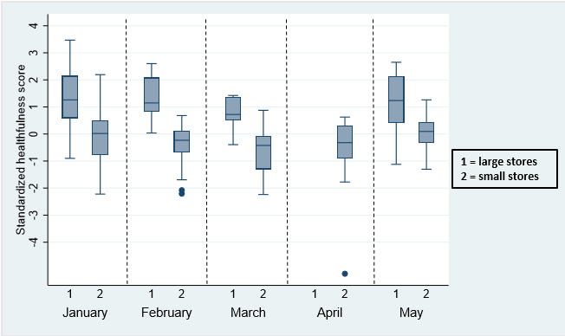

1. Neighbourhood deprivation

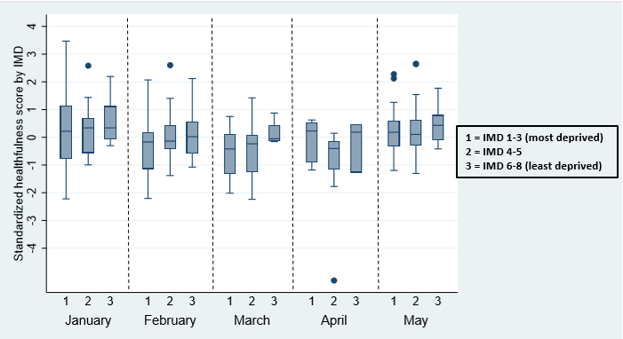

**Supplementary Table 1.** Variables measured in the Consumer Nutrition Environment tool.

|  |  |  |  |
| --- | --- | --- | --- |
|  |  |  |  |
| I | Variety | The number of different choices within a product range based on: product flavour, product size, fair trade/organic range or no-name/low-cost range | Not available, 1, 2, 3, 4, 5+ |
| II | Price | Price of the cheapest item, £ per portion, for each product | Pound sterling per portion |
| III | Promotions | Whether or not the product was on price promotion | Yes (1) / No (0) |
| IV | Shelf placement | Where on the shelf the cheapest item for each product was placed | Bottom shelf (1), other (2), prominent (eye-level; 3) |
| V | Store placement | Which part of the store the cheapest item for each product was placed | Inconspicuous (1), noticeable (2), prominent (3) |
| VI | Quality | Level of quality of the two fruit and five vegetables | Poor (0), medium (1), good (3) 3 |
| VII | Healthier alternative | Whether or not a healthier option was available for less healthy products | Yes (1) / No (0) |
| VIII | Nutrition information | The type of nutrition information available on the cheapest item for each product | None (0), other a (1), back-of-pack (2), front and back of pack (3) |
| IX | Single fruit sale | Whether or not single sale of the two fruit measured was possible | Yes (1) / No (0) |

a For example recipe card

**Supplementary Table 2.** Inter-rater reliability estimates for the individual variables of the CNE tool.

|  |  |
| --- | --- |
| **Variable** | **Inter-rater reliability estimate**  kappa (95% CI) |
| Variety | 0.70 (0.67, 0.80) |
| Price (coefficient of variation) | 26.01% |
| Promotion | 0.80 (0.72, 0.88) |
| Shelf placement | 0.51 (0.47, 0.58) |
| Store placement | 0.24 (0.15, 0.34) |
| Quality | 0.11 (-0.08, 0.33) |
| Healthier alternative | 0.76 (0.61, 0.91) |
| Nutrition information | 0.74 (0.67, 0.78) |

**Supplementary Table 3.**  Regression coefficients from hierarchical mixed models to investigate longitudinal changes in the overall healthfulness score and individual variables over time by store type.

|  |  |  |  |  |  |  |  |  |  |  |  |  |  |
| --- | --- | --- | --- | --- | --- | --- | --- | --- | --- | --- | --- | --- | --- |
|  |  | **Composite score** | | | | **Variety** | | | | **Price** | | | |
|  |  | **β** | **[95% CI]** | | **P value** | **β** | **[95% CI]** | | **P value** | **β** | **[95% CI]** | | **P value** |
| **Changes within store type by month a** | February | -0.10 | -0.30 | 0.10 | 0.31 | -0.21 | -2.33 | 1.92 | 0.85 | 0.02 | -0.04 | 0.07 | 0.52 |
| March | -0.16 | -0.40 | 0.07 | 0.17 | -1.12 | -3.64 | 1.39 | 0.38 | -0.04 | -0.11 | 0.03 | 0.26 |
| May | -0.07 | -0.24 | 0.11 | 0.45 | 1.60 | -0.22 | 3.43 | 0.09 | -0.02 | -0.07 | 0.02 | 0.31 |
| **Changes between store type by month** (Interaction month x store type) | February*Small stores | -0.02 | -0.25 | 0.20 | 0.85 | 0.11 | -2.32 | 2.54 | 0.93 | -0.05 | -0.11 | 0.02 | 0.16 |
| March*Small stores | 0.09 | -0.17 | 0.36 | 0.49 | 1.48 | -1.36 | 4.32 | 0.31 | 0.00 | -0.07 | 0.07 | 0.99 |
| May*Small stores | 0.17 | -0.03 | 0.38 | 0.09 | -1.86 | -4.00 | 0.29 | 0.09 | -0.01 | -0.06 | 0.05 | 0.86 |
| **Store type b** | Small stores | -0.62 | -0.81 | -0.43 | <0.001 | -14.86 | -17.45 | -12.28 | <0.001 | 0.14 | 0.09 | 0.19 | <0.001 |
| **IMD group c** | IMD 4-5 | 0.02 | -0.10 | 0.14 | 0.43 | -0.37 | -2.39 | 1.64 | 0.72 | -0.01 | -0.03 | 0.02 | 0.59 |
| IMD 6-8 | 0.14 | 0.00 | 0.29 | 0.06 | 0.58 | -1.87 | 3.03 | 0.64 | 0.00 | -0.03 | 0.04 | 0.84 |
| **Retailer d** | Retailer 2 | 0.21 | 0.10 | 0.32 | <0.001 | 3.54 | 1.91 | 5.18 | <0.001 | -0.04 | -0.06 | -0.01 | 0.01 |
|  | Constant | 0.42 | 0.24 | 0.60 | <0.001 | 4.99 | 2.46 | 7.53 | <0.001 | 0.16 | 0.12 | 0.21 | <0.001 |

*\*Reference groups: aJanuary, blarge stores, cIMD 1-3, dRetailer 1*

**Supplementary Table 3 continuation.**  Regression coefficients from hierarchical mixed models to investigate longitudinal changes in the overall healthfulness score and individual variables over time by store type.

|  |  |  |  |  |  |  |  |  |  |  |  |  |  |
| --- | --- | --- | --- | --- | --- | --- | --- | --- | --- | --- | --- | --- | --- |
|  |  | **Promotions** | | | | **Shelf placement** | | | | **Store placement** | | | |
|  |  | **β** | **[95% CI]** | | **P value** | **β** | **[95% CI]** | | **P value** | **β** | **[95% CI]** | | **P value** |
| **Changes within store type by month a** | February | 1.08 | 0.08 | 2.09 | 0.04 | -2.52 | -4.63 | -0.41 | 0.02 | 0.12 | -1.91 | 2.15 | 0.91 |
| March | -0.09 | -1.28 | 1.10 | 0.89 | 0.94 | -1.57 | 3.44 | 0.46 | -0.28 | -2.68 | 2.11 | 0.82 |
| May | 0.83 | -0.07 | 1.74 | 0.07 | -1.38 | -3.22 | 0.46 | 0.14 | -0.80 | -2.57 | 0.96 | 0.37 |
| **Changes between store type by month** (Interaction month x store type) | February*Small stores | -0.93 | -2.08 | 0.22 | 0.11 | 1.80 | -0.62 | 4.22 | 0.14 | -1.26 | -3.58 | 1.06 | 0.29 |
| March*Small stores | -0.28 | -1.60 | 1.04 | 0.68 | -1.92 | -4.72 | 0.89 | 0.18 | 0.40 | -2.29 | 3.09 | 0.77 |
| May*Small stores | 0.07 | -0.98 | 1.13 | 0.90 | 0.91 | -1.25 | 3.07 | 0.41 | 1.52 | -0.55 | 3.59 | 0.15 |
| **Store type b** | Small stores | -1.49 | -2.32 | -0.66 | <0.001 | -4.45 | -6.48 | -2.42 | <0.001 | -2.05 | -3.98 | -0.13 | 0.04 |
| **IMD group c** | IMD 4-5 | -0.16 | -0.55 | 0.23 | 0.41 | 0.01 | -1.26 | 1.29 | 0.98 | -0.43 | -1.62 | 0.76 | 0.48 |
| IMD 6-8 | 0.67 | 0.18 | 1.16 | 0.01 | 0.29 | -1.28 | 1.86 | 0.72 | 0.43 | -1.03 | 1.89 | 0.56 |
| **Retailer d** | Retailer 2 | -0.68 | -1.07 | -0.28 | <0.001 | 2.95 | 1.78 | 4.12 | <0.001 | 2.23 | 1.14 | 3.33 | <0.001 |
|  | Constant | -3.65 | -4.39 | -2.90 | <0.001 | 7.95 | 6.06 | 9.85 | <0.001 | 10.01 | 8.22 | 11.80 | <0.001 |

*\*Reference groups: aJanuary, blarge stores, cIMD 1-3,d Retailer 1*

**Supplementary Table 3 continuation.** Regression coefficients from hierarchical mixed models to investigate longitudinal changes in the overall healthfulness score and individual variables over time by store type.

|  |  |  |  |  |  |  |  |  |  |  |  |  |  |  |  |  |  |
| --- | --- | --- | --- | --- | --- | --- | --- | --- | --- | --- | --- | --- | --- | --- | --- | --- | --- |
|  |  | **Quality** | | | | **Healthier alternative** | | | | **Nutrition Information** | | | | **Single sale fruit** | | | |
|  |  | **β** | **[95% CI]** | | **P value** | **β** | **[95% CI]** | | **P value** | **β** | **[95% CI]** | | **P value** | **β** | **[95% CI]** | | **P value** |
| **Changes within store type by month a** | February | -1.05 | -2.27 | 0.16 | 0.09 | -0.29 | -0.89 | 0.32 | 0.35 | -0.27 | -1.07 | 0.52 | 0.50 | -0.04 | -0.18 | 0.09 | 0.52 |
| March | -0.75 | -2.19 | 0.69 | 0.31 | -0.93 | -1.65 | -0.22 | 0.01 | -0.02 | -0.96 | 0.91 | 0.96 | -0.02 | -0.18 | 0.13 | 0.79 |
| May | -1.14 | -2.22 | -0.07 | 0.04 | 0.07 | -0.46 | 0.60 | 0.78 | 0.44 | -0.27 | 1.14 | 0.22 | -0.08 | -0.19 | 0.03 | 0.17 |
| **Changes between store type by month** (Interaction month x store type) | February*Small stores | 1.62 | 0.23 | 3.01 | 0.02 | 0.22 | -0.47 | 0.91 | 0.53 | -0.09 | -0.99 | 0.82 | 0.85 | -0.02 | -0.17 | 0.13 | 0.84 |
| March* Small stores | 1.07 | -0.53 | 2.67 | 0.19 | 1.12 | 0.32 | 1.92 | 0.01 | 0.16 | -0.88 | 1.21 | 0.76 | 0.00 | -0.17 | 0.18 | 0.97 |
| May* Small stores | 1.58 | 0.32 | 2.84 | 0.01 | -0.15 | -0.77 | 0.47 | 0.63 | 0.16 | -0.66 | 0.98 | 0.71 | 0.10 | -0.03 | 0.24 | 0.13 |
| **Store typeb** | Small stores | -1.72 | -2.76 | -0.67 | <0.01 | -1.61 | -2.16 | -1.06 | <0.001 | -0.31 | -0.99 | 0.36 | 0.36 | -0.06 | -0.20 | 0.08 | 0.40 |
| **IMD groupc** | IMD 4-5 | 0.19 | -0.35 | 0.73 | 0.49 | -0.01 | -0.33 | 0.31 | 0.97 | 0.39 | 0.05 | 0.74 | 0.03 | 0.03 | -0.07 | 0.13 | 0.58 |
| IMD 6-8 | 0.65 | -0.03 | 1.33 | 0.06 | -0.14 | -0.54 | 0.26 | 0.49 | -0.05 | -0.48 | 0.38 | 0.81 | 0.08 | -0.04 | 0.21 | 0.18 |
| **Retailer d** | Retailer 2 | -0.24 | -0.78 | 0.29 | 0.37 | 1.10 | 0.80 | 1.40 | <0.001 | -0.10 | -0.44 | 0.24 | 0.57 | 0.07 | -0.02 | 0.16 | 0.12 |
|  | Constant | 18.88 | 17.94 | 19.83 | <0.001 | 2.68 | 2.17 | 3.19 | <0.001 | 20.12 | 19.51 | 20.72 | <0.001 | 1.95 | 1.82 | 2.09 | <0.001 |

*\*Reference groups: aJanuary, blarge stores, cIMD 1-3, dRetailer 1*

**Supplementary Table 4.** Regression coefficients from hierarchical mixed models to investigate longitudinal changes in the individual variables of the store healthfulness score for healthy and less healthy items over time by store type.

|  |  |  |  |  |  |  |  |  |  |  |  |  |  |  |  |  |  |  |  |  |  |
| --- | --- | --- | --- | --- | --- | --- | --- | --- | --- | --- | --- | --- | --- | --- | --- | --- | --- | --- | --- | --- | --- |
|  |  | **Variety** | | | | | | | | | | **Price** | | | | | | | | | |
|  |  | **Healthy items** | | | | | **Less healthy items** | | | | | **Healthy items** | | | | | **Less healthy items** | | | | |
|  |  | **β** | **[95% CI]** | | **P value** | **β** | | **[95% CI]** | | **P value** | **β** | | **[95% CI]** | | **P value** | **β** | | **[95% CI]** | | **P value** |
| **Changes within store type by month a** | February | -0.26 | -2.31 | 1.78 | 0.80 | -0.02 | | -0.84 | 0.81 | 0.97 | 0.00 | | 0.00 | 0.01 | 0.52 | 0.02 | | -0.04 | 0.08 | 0.47 |
| March | -1.19 | -3.61 | 1.23 | 0.34 | -0.18 | | -1.16 | 0.80 | 0.71 | -0.01 | | -0.02 | 0.00 | 0.03 | -0.05 | | -0.11 | 0.02 | 0.18 |
| May | 1.58 | -0.18 | 3.33 | 0.08 | -0.05 | | -0.78 | 0.68 | 0.89 | 0.00 | | -0.01 | 0.00 | 0.12 | -0.03 | | -0.08 | 0.02 | 0.26 |
| **Changes between store type by month** (Interaction month x store type) | February*Small stores | 0.19 | -2.15 | 2.53 | 0.87 | 0.07 | | -0.88 | 1.02 | 0.89 | 0.00 | | -0.01 | 0.00 | 0.43 | -0.05 | | -0.12 | 0.01 | 0.13 |
| March* Small stores | 1.84 | -0.89 | 4.57 | 0.19 | 0.51 | | -0.58 | 1.60 | 0.36 | 0.00 | | -0.01 | 0.01 | 0.67 | 0.00 | | -0.08 | 0.07 | 0.97 |
| May* Small stores | -1.56 | -3.63 | 0.50 | 0.14 | 0.33 | | -0.53 | 1.19 | 0.45 | -0.01 | | -0.01 | 0.00 | 0.13 | -0.01 | | -0.07 | 0.05 | 0.67 |
| **Store typeb** | Small stores | -15.39 | -17.94 | -12.84 | <0.001 | -0.79 | | -1.50 | -0.08 | 0.03 | 0.05 | | 0.04 | 0.05 | <0.001 | 0.19 | | 0.14 | 0.24 | <0.001 |
| **IMD groupc** | IMD 4-5 | -0.22 | -2.24 | 1.80 | 0.83 | 0.17 | | -0.20 | 0.54 | 0.37 | 0.00 | | -0.01 | 0.00 | 0.63 | -0.01 | | -0.04 | 0.02 | 0.54 |
| IMD 6-8 | 0.75 | -1.70 | 3.21 | 0.55 | 0.21 | | -0.25 | 0.67 | 0.37 | 0.00 | | 0.00 | 0.01 | 0.42 | 0.01 | | -0.03 | 0.04 | 0.75 |
| **Retailer d** | Retailer 2 | 3.29 | 1.68 | 4.91 | <0.001 | -0.49 | | -0.85 | -0.12 | 0.01 | 0.00 | | -0.01 | 0.00 | 0.34 | -0.04 | | -0.07 | -0.01 | 0.01 |
|  | Constant | 39.88 | 37.38 | 42.39 | <0.001 | 35.16 | | 34.52 | 35.81 | <0.001 | 0.13 | | 0.12 | 0.14 | <0.001 | 0.29 | | 0.24 | 0.34 | <0.001 |

*\*Reference groups: aJanuary, blarge stores, cIMD 1-3, dRetailer 1*

**Supplementary Table 4 continuation.** Regression coefficients from hierarchical mixed models to investigate longitudinal changes in the individual variables of the store healthfulness score for healthy and less healthy items over time by store type.

|  |  |  |  |  |  |  |  |  |  |  |  |  |  |  |  |  |  |
| --- | --- | --- | --- | --- | --- | --- | --- | --- | --- | --- | --- | --- | --- | --- | --- | --- | --- |
|  |  | **Promotions** | | | | | | | | **Shelf placement** | | | | | | | |
|  |  | **Healthy items** | | | | **Less healthy items** | | | | **Healthy items** | | | | **Less healthy items** | | | |
|  |  | **β** | **[95% CI]** | | **P value** | **β** | **[95% CI]** | | **P value** | **β** | **[95% CI]** | | **P value** | **β** | **[95% CI]** | | **P value** |
| **Changes within store type by month a** | February | 2.22 | 1.36 | 3.08 | <0.001 | 1.11 | 0.23 | 2.00 | 0.01 | -2.34 | -4.28 | -0.40 | 0.02 | 0.05 | -1.29 | 1.38 | 0.95 |
| March | 1.11 | 0.09 | 2.13 | 0.03 | 1.26 | 0.22 | 2.31 | 0.02 | -0.61 | -2.91 | 1.69 | 0.61 | -1.59 | -3.18 | -0.01 | 0.05 |
| May | 2.05 | 1.28 | 2.82 | <0.001 | 1.22 | 0.42 | 2.01 | <0.01 | -0.82 | -2.52 | 0.87 | 0.34 | 0.44 | -0.73 | 1.62 | 0.46 |
| **Changes between store type by month** (Interaction month x store type) | February*Small stores | -1.46 | -2.45 | -0.47 | <0.01 | -0.56 | -1.58 | 0.45 | 0.27 | 2.26 | 0.03 | 4.48 | 0.05 | 0.61 | -0.92 | 2.14 | 0.44 |
| March* Small stores | -1.12 | -2.25 | 0.02 | 0.05 | -0.96 | -2.10 | 0.19 | 0.10 | 0.11 | -2.47 | 2.69 | 0.94 | 2.09 | 0.32 | 3.85 | 0.02 |
| May* Small stores | -1.12 | -2.02 | -0.22 | 0.02 | -1.23 | -2.16 | -0.30 | 0.01 | 0.80 | -1.19 | 2.79 | 0.43 | 0.01 | -1.37 | 1.39 | 0.99 |
| **Store typeb** | Small stores | -1.33 | -2.05 | -0.61 | <0.001 | 0.21 | -0.51 | 0.92 | 0.57 | -1.95 | -3.80 | -0.11 | 0.04 | 2.46 | 1.29 | 3.64 | <0.001 |
| **IMD groupc** | IMD 4-5 | -0.18 | -0.53 | 0.17 | 0.31 | -0.01 | -0.33 | 0.30 | 0.93 | -0.08 | -1.22 | 1.05 | 0.88 | -0.12 | -0.76 | 0.52 | 0.72 |
| IMD 6-8 | 0.51 | 0.07 | 0.95 | 0.02 | -0.15 | -0.55 | 0.25 | 0.47 | 0.55 | -0.86 | 1.95 | 0.45 | 0.22 | -0.58 | 1.01 | 0.59 |
| **Retailer d** | Retailer 2 | -0.48 | -0.83 | -0.12 | 0.01 | 0.17 | -0.16 | 0.50 | 0.30 | 2.96 | 1.90 | 4.01 | <0.001 | 0.12 | -0.50 | 0.74 | 0.71 |
|  | Constant | 2.09 | 1.44 | 2.74 | <0.001 | 5.74 | 5.10 | 6.38 | <0.001 | 21.71 | 19.99 | 23.42 | <0.001 | 13.76 | 12.69 | 14.82 | <0.001 |

*\*Reference groups: aJanuary, blarge stores, cIMD 1-3, dRetailer 1*

**Supplementary Table 4 continuation.** Regression coefficients from hierarchical mixed models to investigate longitudinal changes in the individual variables of the store healthfulness score for healthy and less healthy items over time by store type.

|  |  |  |  |  |  |  |  |  |  |
| --- | --- | --- | --- | --- | --- | --- | --- | --- | --- |
|  |  | **Store placement** | | | | | | | |
|  |  | **Healthy items** | | | | **Less healthy items** | | | |
|  |  | **β** | **[95% CI]** | | **P value** | **β** | **[95% CI]** | | **P value** |
| **Changes within store type by month a** | February | -0.39 | -2.65 | 1.87 | 0.74 | -0.46 | -1.59 | 0.67 | 0.42 |
| March | -1.31 | -3.99 | 1.37 | 0.34 | -1.16 | -2.49 | 0.18 | 0.09 |
| May | -1.54 | -3.52 | 0.44 | 0.13 | -0.73 | -1.72 | 0.27 | 0.15 |
| **Changes between store type by month** (Interaction month x store type) | February*Small stores | -0.02 | -2.61 | 2.56 | 0.99 | 1.25 | -0.04 | 2.54 | 0.06 |
| March* Small stores | 2.49 | -0.50 | 5.49 | 0.10 | 2.30 | 0.82 | 3.79 | <0.01 |
| May* Small stores | 2.37 | 0.05 | 4.69 | 0.05 | 0.91 | -0.26 | 2.08 | 0.13 |
| **Store typeb** | Small stores | -2.32 | -4.38 | -0.25 | 0.03 | -0.31 | -1.28 | 0.66 | 0.53 |
| **IMD groupc** | IMD 4-5 | -0.55 | -1.76 | 0.66 | 0.37 | -0.11 | -0.62 | 0.40 | 0.66 |
| IMD 6-8 | 0.78 | -0.72 | 2.28 | 0.31 | 0.35 | -0.29 | 0.98 | 0.28 |
| **Retailer d** | Retailer 2 | 2.19 | 1.05 | 3.34 | <0.001 | -0.06 | -0.56 | 0.44 | 0.81 |
|  | Constant | 24.81 | 22.90 | 26.72 | <0.001 | 14.79 | 13.91 | 15.67 | <0.001 |

*\*Reference groups: aJanuary, blarge stores, cIMD 1-3, dRetailer 1*

**Supplementary Table 5.** CNE tool individual variable and composite scores by store type across January - May 2019.

|  |  |  |  |  |  |  |  |  |  |  |  |  |  |  |  |  |  |
| --- | --- | --- | --- | --- | --- | --- | --- | --- | --- | --- | --- | --- | --- | --- | --- | --- | --- |
|  | **January** | | | | **February** | | | | **March** | | | **April** | | | **May** | | |
|  | **Large**  **store** | **Small**  **store** | **P**  **value** | **Large store** | | **Small store** | **P**  **value** | **Large store** | | **Small store** | **P**  **value** | **Large store** | **Small store** | **P**  **value** | **Large store** | **Small store** | **P**  **value** |
| **Composite**  **score** | 0.5  (0.3 to 0.9) | 0.0  (0.3 to 0.2) | <0.001a | 0.5  (0.4 to 0.9) | | 0.1  (0.3 to 0.0) | <0.001a | 0.3  (0.2 to 0.6) | | 0.2  (0.6 to 0.0) | <0.001a | n/a | 0.1  (0.4 to 0.1) | n/a | 0.5  (0.2 to 0.9) | 0.0  (0.1 to 0.2) | <0.001a |
| **Variety** | 7  (2 to 13) | -6  (-10 to -3) | <0.001a | 12  (8 to 13) | | -9  (-10 to -5) | <0.001a | 10  (3 to 10) | | -10  (-12 to -9) | <0.001a | n/a | -10  (-12 to -8) | n/a | 11  (3 to 16) | -9  (-11 to -6) | <0.001a |
| **Price** | 0.13  (0.11 to 0.17) | 0.23  (0.20 to 0.26) | 0.01 a | 0.14  (0.12 to 0.18) | | 0.26  (0.22 to 0.29) | <0.001a | 0.08  (0.07 to 0.10) | | 0.27  (0.25 to 0.28) | <0.001a | n/a | 0.28  (0.22 to 0.29) | n/a | 0.09  (0.06 to 0.15) | 0.27  (0.20 to 0.30) | <0.001a |
| **Promotion** | -5  (-5 to -4) | -6  (-6 to -5) | <0.01 a | -3  (-4 to -2) | | -5  (-6 to -4) | <0.001a | -4  (-5 to -3) | | -6  (-6 to -5) | <0.01 a | n/a | -4  (-5 to -3) | n/a | -3  (-4 to -2) | -5  (-6 to -4) | <0.001a |
| **Shelf**  **placement** | 11  (6 to 14) | 6  (3 to 9) | 0.01 a | 8  (6 to 10) | | 4  (3 to 6) | <0.001a | 11  (3 to 13) | | 2  (0 to 4) | <0.001a | n/a | 3  (2 to 5) | n/a | 9 (5 to 14) | 5  (2 to 7) | <0.001a |
| **Store**  **placement** | 11  (10 to 13) | 9  (8 to 13) | 0.12 a | 10  (9 to 14) | | 8  (7 to 9) | 0.01 a | 11  (9 to 11) | | 8  (7 to 10) | 0.18 a | n/a | 11  (7 to 14) | n/a | 10  (9 to 12) | 9  (7 to 13) | 0.65 a |
| **Quality** | 19  (18 to 21) | 18  (16 to 18) | <0.01 b | 18  (17 to 19) | | 18  (17 to 18) | 0.76 b | 18  (18 to 20) | | 18  (17 to 19) | 0.49 b | n/a | 17  (16 to 18) | n/a | 19  (15 to 20) | 18  (17 to 19) | 0.25 b |
| **Healthier**  **alternative** | 4  (1 to 5) | 2  (1 to 3) | 0.05 b | 4  (2 to 4) | | 1  (1 to 2) | <0.001b | 2  (1 to 2) | | 1  (1 to 1) | 0.04 b | n/a | 1  (1 to 1) | n/a | 3  (2 to 5) | 1  (1 to 2) | <0.001b |
| **Nutrition**  **information** | 21  (20 to 21) | 20  (20 to 21) | 0.53 b | 20  (20 to 20) | | 20  (19 to 20) | 0.34 b | 20  (20 to 21) | | 20  (20 to 21) | 0.69 b | n/a | 20  (19 to 21) | n/a | 21  (21 to 21) | 21  (20 to 21) | 0.01 b |
| **Single sale of**  **two fruitse** | 100 | 96 | 0.51 c | 100 | | 90 | 0.29 c | 100 | | 89 | 0.41 c | n/a | 86 | n/a | 93 | 95 | 0.74 c |

aStudent’s t test, bMann-Whitney test, cChi square test, dMedian and inter-quartile range (IQR) were provided for both parametric and non-parametric variables for ease of reading, ePercentage of two fruits available for single sale was provided because this variable was categorical

**Supplementary Table 6.** CNE tool individual variable and composite scores by IMD across January - May 2019.

|  |  |  |  |  |  |  |  |  |  |  |  |  |  |  |  |  |  |  |  |  |
| --- | --- | --- | --- | --- | --- | --- | --- | --- | --- | --- | --- | --- | --- | --- | --- | --- | --- | --- | --- | --- |
|  | **January** | | | | **February** | | | | **March** | | | | **April** | | | | **May** | | | |
|  | **IMD 1-3** | **IMD 4-5** | **IMD 6-8** | **P value** | **IMD 1-3** | **IMD 4-5** | **IMD 6-8** | **P value** | **IMD 1-3** | **IMD 4-5** | **IMD 6-8** | **P value** | **IMD 1-3** | **IMD 4-5** | **IMD 6-8** | **P value** | **IMD 1-3** | **IMD 4-5** | **IMD 6-8** | **P value** |
| **Composite**  **score** | 0.1 (0.3 to 0.5) | 0.1 (0.2 to 0.3) | 0.1 (0.0 to 0.5) | 0.67a | 0.1 (0.5 to 0.1) | 0.1 (0.2 to 0.2) | 0.0 (0.3 to 0.2) | 0.16 a | 0.2 (0.6 to 0.0) | 0.1 (0.5 to 0.0) | 0.0 (0.1 to 0.2) | 0.23 a | 0.1 (0.4 to 0.2) | 0.2 (0.5 to 0.1) | 0.1 (0.5 to 0.2) | 0.31 a | 0.1 (0.1 to 0.3) | 0.0 (0.1 to 0.3) | 0.2 (0.0 to 0.3) | 0.30 a |
| **Variety** | -5 (-10 to 7) | -3 (-7 to -1) | -5 (-8 to 0) | 0.77 a | -8 (-9 to -3) | -9 (-10 to -4) | -7 (-9 to -3) | 0.74 a | -10 (-12 to -8) | -9 (-13 to -8) | -8 (-11 to 1) | 0.42 a | -9 (-12 to -7) | -10 (-12 to -10) | -10 (-18 to -8) | 0.22 a | -9 (-11 to -5) | -5 (-11 to -3) | -6 (-9 to -4) | 0.16 a |
| **Price** | 0.19 (0.14 to 0.25) | 0.20 (0.20 to 0.23) | 0.24 (0.21 to 0.47) | 0.31 a | 0.27 (0.22 to 0.31) | 0.25 (0.18 to 0.28) | 0.23 (0.18 to 0.27) | 0.11 a | 0.27 (0.24 to 0.28) | 0.27 (0.25 to 0.28) | 0.22 (0.15 to 0.25) | 0.34 a | 0.28 (0.21 to 0.30) | 0.28 (0.25 to 0.29) | 0.25 (0.20 to 0.28) | 0.62 a | 0.28 (0.20 to 0.30) | 0.21 (0.19 to 0.29) | 0.21 (0.19 to 0.26) | 0.04 a |
| **Promotion** | -5 (-6 to -5) | -6 (-6 to -5) | -5 (-6 to -5) | 0.98 a | -5 (-6 to -4) | -5 (-6 to -4) | -5 (-6 to -3) | 0.28 a | -5 (-6 to -4) | -6 (-6 to -5) | -5 (-5 to -4) | 0.85 a | -4 (-5 to -3) | -4 (-5 to -3) | -4 (-4 to -3) | 0.96 a | -4 (-5 to -3) | -5 (-6 to -4) | -4 (-4 to -3) | 0.39 a |
| **Shelf placement** | 8 (3 to 10) | 6 (3 to 11) | 7 95 to 9) | 0.94 a | 5 (4 to 7) | 5 (3 to 8) | 6 (3 to 8) | 0.46 a | 2 (0 to 4) | 2 (1 to 5) | 4 (1 to 9) | 0.47 a | 4 (3 to 5) | 3 (0 to 4) | 3 (0 to 8) | 0.48 a | 5 (2 to 8) | 5 (3 to 8) | 5 (3 to 7) | 0.77 a |
| **Store placement** | 10 (8 to 13) | 11 (8 to 12) | 11 (9 to 13) | 0.37 a | 8 (7 to 11) | 9 (8 to 10) | 9 (7 to 9) | 0.95 a | 9 (7 to 10) | 8 (7 to 10) | 10 (9 to 11) | 0.74 a | 10 (7 to 14) | 12 (7 to 14) | 10 (0 to 16) | 0.98 a | 9 (7 to 12) | 9 (7 to 15) | 9 (9 to 12) | 0.41 a |
| **Quality** | 18 (16 to 19) | 17 (17 to 18) | 18 (17 to 18) | 0.90b | 18 (17 to 18) | 18 (17 to 19) | 18 (18 to 19) | 0.77 b | 18 (17 to 19) | 18 (17 to 19) | 18 (17 to 19) | 0.85 b | 17 (17 to 18) | 16 (15 to 17) | 17 (16 to 18) | 0.36 b | 18 (16 to 19) | 18 (17 to 19) | 19 (18 to 19) | 0.01 b |
| **Healthier alternative** | 2 (1 to 4) | 2 (1 to 3) | 2 (1 to 3) | 0.89 b | 1 (1 to 2) | 2(1 to 2) | 2 (1 to 2) | 0.40 b | 1 (1 to 1) | 1 (1 to 2) | 2 (1 to 3) | 0.01 b | 1 (1 to 1) | 1 (1 to 1) | 1 (1 to 1) | 0.97 b | 1 (1 to 2) | 1 (1 to 3) | 1 (1 to 2) | 0.75 b |
| **Nutrition information** | 20 (20 to 21) | 20 (20 to 21) | 20 (18 to 21) | 0.48 b | 19 (18 to 20) | 20 (19 to 21) | 20 (19 to 20) | 0.32 b | 20 (20 to 21) | 20 (20 to 21) | 20 (20 to 20) | 0.36 b | 20 (20 to 21) | 20 (18 to 21) | 21 (19 to 21) | 0.09 b | 21 (20 to 21) | 21 (20 to 21) | 21 (20 to 21) | 0.66 b |
| **Single sale of two fruitse** | 94% | 100% | 100% | 0.46c | 88% | 89% | 100% | 0.42c | 87% | 94% | 100% | 0.59c | 91% | 75% | 100% | 0.46c | 94% | 93% | 100% | 0.65c |

aStudent’s t test, bMann-Whitney test, cChi square test, dMedian and inter-quartile range (IQR) were provided for both parametric and non-parametric variables for ease of reading, ePercentage of two fruits available for single sale was provided because this variable was categorical.

**Supplementary Table 7.**  Regression coefficients from hierarchical mixed models to investigate longitudinal changes in the overall healthfulness score over time by store type, with quality and single fruit sale variables removed.

|  |  |  |  |  |  |
| --- | --- | --- | --- | --- | --- |
|  |  | **Composite score** | | | |
|  |  | **β** | **[95% CI]** | | **P value** |
| **Changes within store type by month a** | February | -0.01 | -0.23 | 0.21 | 0.94 |
| March | -0.14 | -0.40 | 0.12 | 0.31 |
| May | 0.06 | -0.14 | 0.25 | 0.56 |
| **Changes between store type by month** (Interaction month x store type) | February*Small stores | -0.16 | -0.41 | 0.10 | 0.23 |
| March*Small stores | 0.04 | -0.25 | 0.33 | 0.80 |
| May*Small stores | 0.03 | -0.19 | 0.26 | 0.76 |
| **Store type b** | Small stores | -0.64 | -0.84 | -0.44 | <0.001 |
| **IMD group c** | IMD 4-5 | -0.01 | -0.12 | 0.11 | 0.91 |
| IMD 6-8 | 0.08 | -0.06 | 0.22 | 0.28 |
| **Retailer d** | Retailer 2 | 0.27 | 0.16 | 0.38 | <0.001 |
|  | Constant | 0.42 | 0.24 | 0.61 | <0.001 |

*\*Reference groups: aJanuary, blarge stores, cIMD 1-3, dRetailer 1*

**Supplementary Table 8.**  Regression coefficients from hierarchical mixed models to investigate longitudinal changes in the overall healthfulness score over time by store type, with matching number of healthy and less healthy items.

|  |  |  |  |  |  |
| --- | --- | --- | --- | --- | --- |
|  |  | **Composite score** | | | |
|  |  | **β** | **[95% CI]** | | **P value** |
| **Changes within store type by month a** | February | -0.12 | -0.33 | 0.08 | 0.23 |
| March | -0.20 | -0.45 | 0.04 | 0.10 |
| May | -0.05 | -0.23 | 0.13 | 0.56 |
| **Changes between store type by month** (Interaction month x store type) | February*Small stores | -0.51 | -0.70 | -0.33 | <0.001 |
| March*Small stores | -0.01 | -0.25 | 0.22 | 0.91 |
| May*Small stores | 0.13 | -0.14 | 0.40 | 0.36 |
| **Store type b** | Small stores | 0.16 | -0.05 | 0.37 | 0.14 |
| **IMD group c** | IMD 4-5 | 0.03 | -0.08 | 0.14 | 0.57 |
| IMD 6-8 | 0.15 | 0.01 | 0.28 | 0.03 |
| **Retailer d** | Retailer 2 | 0.25 | 0.15 | 0.36 | <0.001 |
|  | Constant | 0.31 | 0.14 | 0.49 | <0.001 |

*\*Reference groups: aJanuary, blarge stores, cIMD 1-3, dRetailer 1*

**Supplementary File 1. Consumer Nutrition Environment Audit Tool**

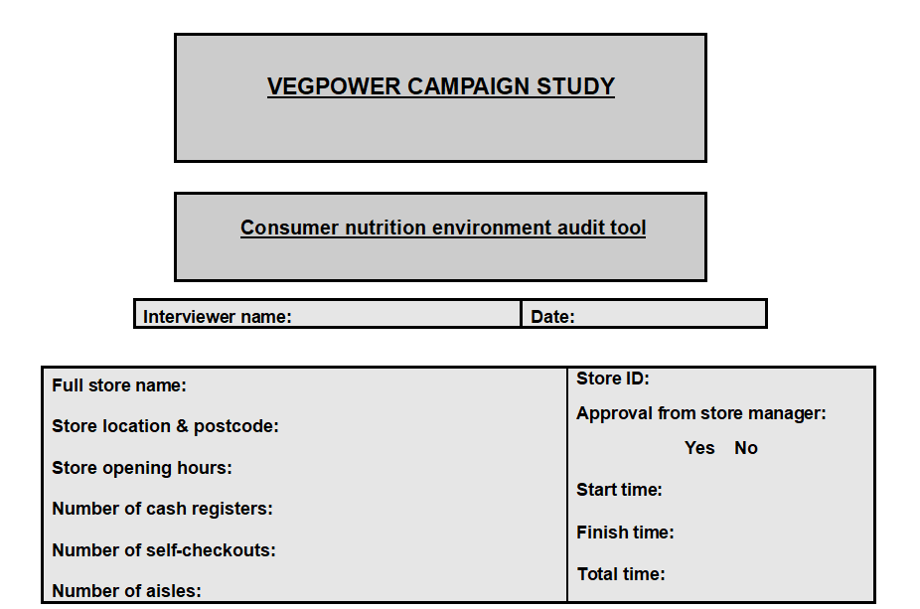

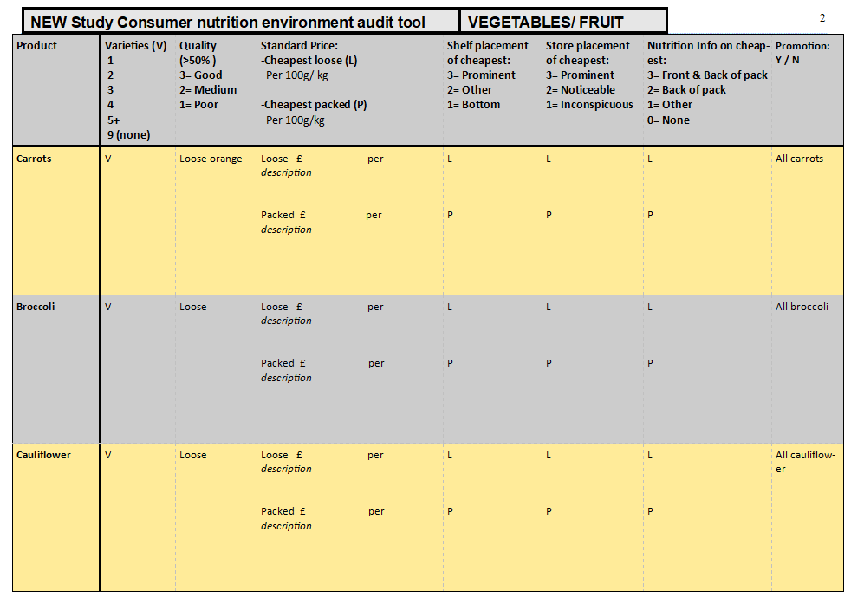

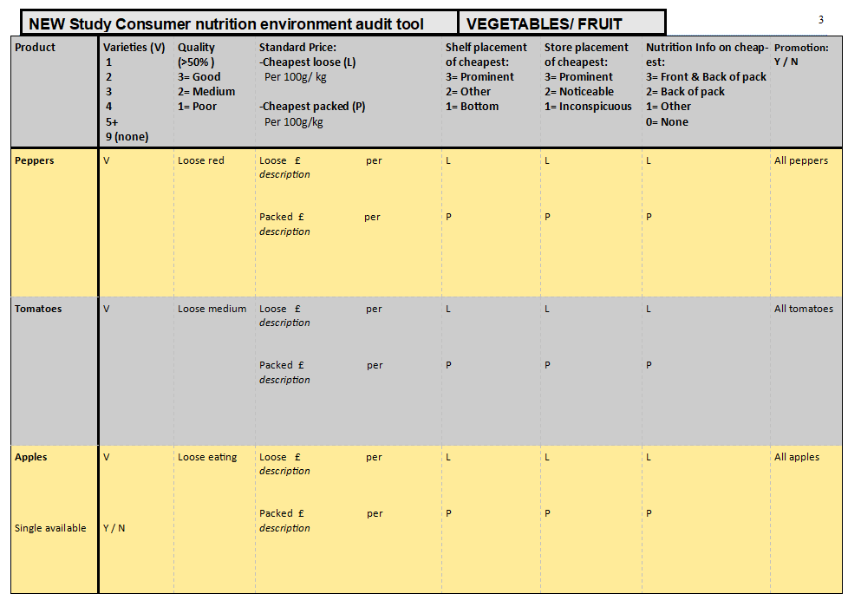

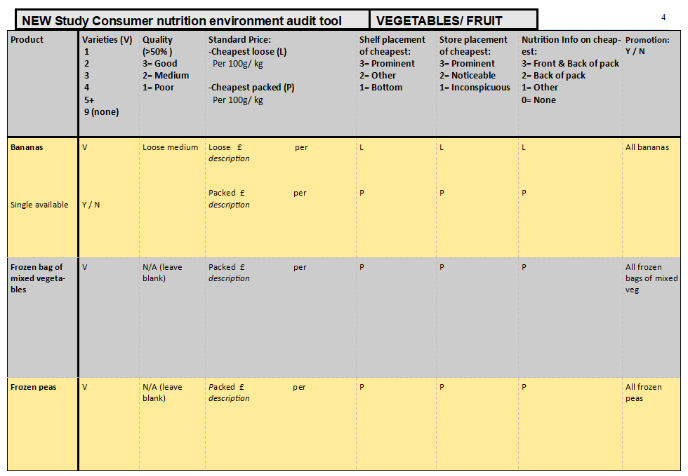

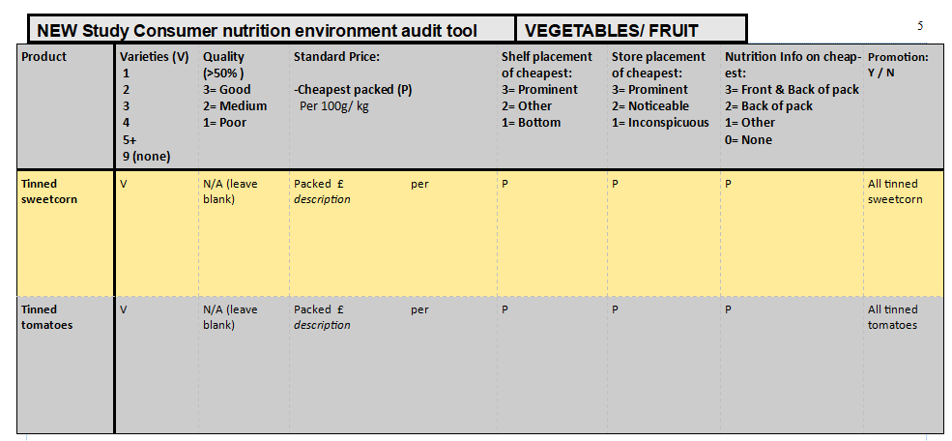

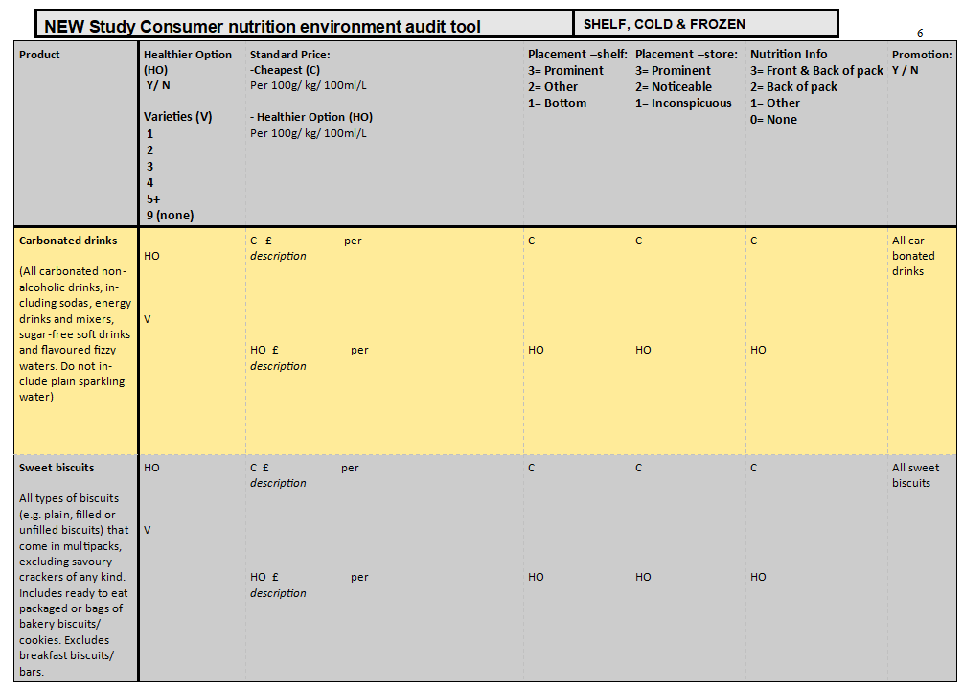

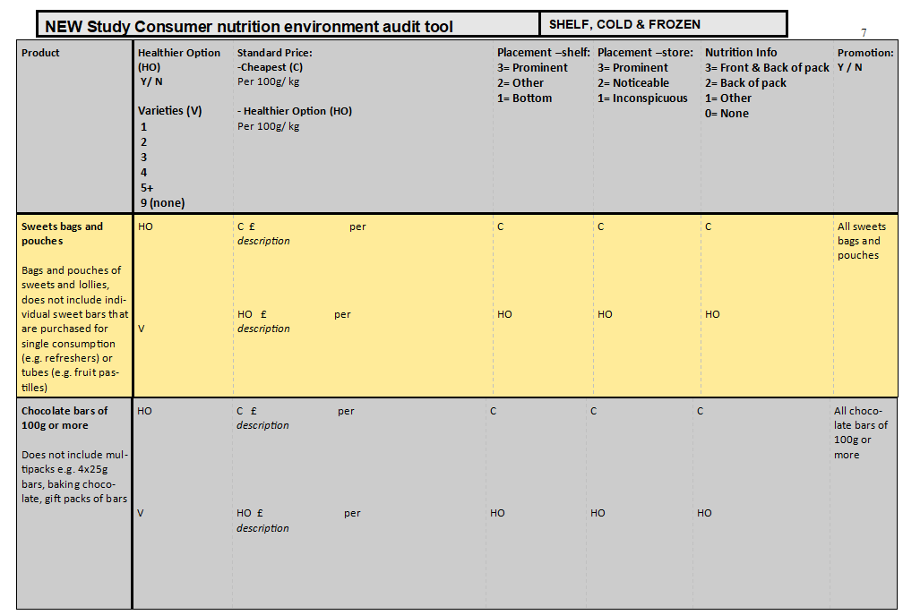

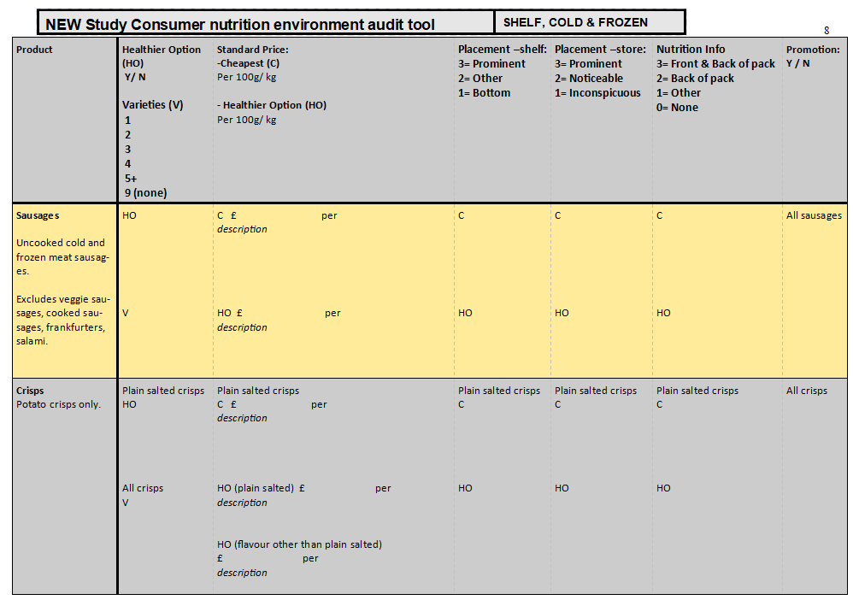

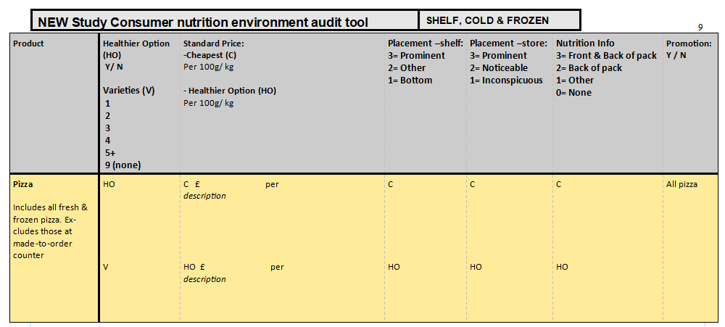

**Supplementary File 3. Consumer Nutrition Environment Audit Tool Protocol**

Consumer Nutrition Environment Audit Tool

**Survey Instructions**

This tool has been developed to assess the availability, quality, cost, placement, nutrition information and promotion of selected food products. The tool includes 19 products; 12 fruit and vegetable products and 7 other products. To ensure consistency of data collection across data collectors and at different times, **it is essential you follow this protocol closely**.

**Before you start**

**Time:** all surveys are to be completed between 8am-8pm.

**Ask the store manager:** Ask at the customer service desk for the store manager or supervisor in charge and present the information sheet. Briefly explain: *we are conducting research on behalf of the Universities of Oxford and Southampton, and the Food Foundation investigating the level of activation of the Vegpower campaign in stores in the area, which involves assessing how food stores are marketing certain products. We are looking at over 100 stores in the Lambeth & Southwark area, and we hope it will be possible to complete a 30-45 minute survey in the store – no photos will be taken. The store will not be individually identified and the only information taken is that already available to customers.*

**Front Page**

Complete the front page with:

* Your name (interviewer)
* Date DD/MM/YY
* Start Time & Finish time – Record the time you start and finish the survey to calculate the total time in minutes it takes you to complete the surveys in each store
* Full store name *(e.g. Sainsbury’s Local, Tesco Metro)*
* Store opening hours – Note times the store is open on each day of the week in 24h time (24/7 = 08:00 – 08:00)
* Location & postcode
* Store ID (*provided with store list*)
* Whether the store manager allowed data collection (*yes or no*)
* Number of cash registers that could be manned with a sales assistant (*exclude self-service cash registers, service desk, tobacco desk and post office registers here*)
* Number of self-checkouts
* Number of aisles – referring to the main aisles within a store. *Please note, each side of a walkway is counted as a separate aisle (the side to your left is one aisle, the side to your right is a separate aisle. Do not count the edges as an aisle.)*

**Survey Variables** **– only include products that are available for purchase**

1. **Number of varieties**

The variety variable relates to product flavour, product size, ‘fair-trade/organic’ products and budget products. The number of varieties however is **specific to each product** (details below). The number of varieties is categorised using: **1, 2, 3, 4, 5+ or 9** (9= none available).

When looking at apples and bananas, note down whether there is the opportunity to buy a single item loose Y (yes) or N (no)

1. **Quality – for Fruit and Vegetable Products ONLY**

The quality score is based on the condition of the vast majority of the proxy product given (details below). If the proxy product is not available, please assess the quality of the cheapest variety of the product. The quality is categories using:

* 3 = high/good
* 2 = medium
* 1 = low/poor

1. **Healthy Option Available – Shelf, Cold and Frozen Products ONLY**

A healthier option is a product that has a nutrient claim on the front of the pack indicating it is lower in total fat, sugar or salt AND/OR higher in a nutrient intrinsically part of the product (details below). Note mark Y if healthier option is available or N if healthier option is not available.

1. **Product Price**

Note down the price (£0.00) of the **cheapest product**. For fruit and vegetables, write down the price of the cheapest loose product and cheapest packed product per g or 100g or kg. Write down the sale price if the product is on special offer, but exclude ‘Buy One Get One Free’ where 2 items must be purchased. If there are two products of the same cheapest price, make a note of both and complete the rest of the columns for both.

Although some of the categories seem very large and overwhelming when you look for the cheapest product, you will soon learn which product is cheapest. Often the supermarket own brand biscuits/ confectionery/ crisps are cheapest, so you will know where to focus your attention.

1. **Product Weight**

Note the product weight in grams clearly in the space provided. If the weight of a vegetable product is not identified, apply standardised weights in Table 3.

|  |  |  |
| --- | --- | --- |
| **Product** | **Description** | **Weight** |
| Peppers | 1 medium red/green | 160g |
| Tomatoes | 1 small tomato  1 medium tomato  1 large/beefsteak tomato  1 cherry tomato | 65g  85g  150g  15g |
| Apples | 1 small  1 medium  1 large | 75g  112g  170g |
| Bananas | 1 small without skin  1 medium without skin  1 large without skin | 80g  100g  120g |
| Cauliflower | 1 small-head cauliflower  1 medium-head cauliflower  1 large-head cauliflower | 800g  1000g (1kg)  1200g |
| Broccoli | 1 small-head broccoli  1 medium-head broccoli  1 large-head broccoli | 500g  700g  900g |

1. **Product Description**

Write down the brand and name of the product. Also write down how the product is packed (e.g. 3 mixed peppers, 6 x 25g multipack of crisps)

1. **Placement – shelf**

Write down the number representing the shelf placement of the cheapest item and cheapest healthier option of the product category. For fruit and veg, it refers to the shelf placement of the cheapest loose product and cheapest packed product.

Shelf placement is categorised using the 3 scales below:

* **3 = Prominent (eye level/ obvious placement)**
* **2 = Other**
* **1= Bottom (low)**

The diagram below gives guidance on using the descriptors. If the product is placed on more than one shelf (i.e. 2 and 3), score the product as the highest possibility (3). Record chest freezers as bottom (1).

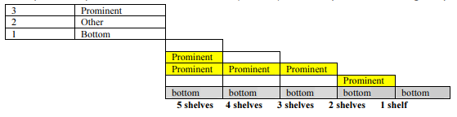

1. **Placement – store**

Write down the number representing the store placement of the cheapest item and cheapest healthier option of the product. Product placement in the store is categories using: 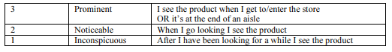

1. **Nutrition Information**

Write down the number representing the nutrition information on the cheapest item and cheapest healthier option. Nutrition information must be easily visible before purchase. 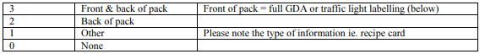

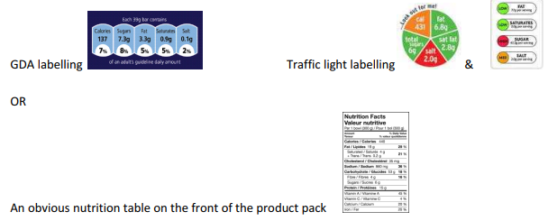

1. **Promotion**

Note down Yes (Y) or No (N) if there is promotion on any product within the product category. Exclude reduced price items that may have poorer quality or shorter shelf life. Also, do not ‘included in meal deal’ as on promotion.

**Descriptions for Individual Products**

**Carrots**

**Variety**

|  |  |  |
| --- | --- | --- |
| **Definition of Variety** | **Coding Tips** | **Exclusions** |
| * Different colours (e.g. orange, purple) * Different size * Organic/fair-trade * Economy Range | Each colour counts as a different variety – except multipacks = 1 variety  Size only counts if the carrot is of a different species (different name e.g. chantenay/baby carrots)  Organic and fair-trade products= 1 variety even if both are available  One or more economy products = 1 variety | Loose and bagged will not count as different varieties, only if they are of different colours or species  Only count organic/fair-trade when an additional choice  Only count economy when an additional choice |

**Quality**

|  |  |  |  |
| --- | --- | --- | --- |
| **Product** | **High/Good (3)** | **Medium (2)** | **Low/Poor (1)** |
| Loose medium orange carrot | Good strong intense bright orange colour, uniform shape and size, free from cracks, decay, mould and fungi, relatively clean, firm product, tight skin | Good orange colour, mixed sizes, occasional blemish, no bruises or soft marks, firm product | Soft bendy product, cracks, blemishes, moulds, wrinkled/wilted skin, product drying out |

**Standard price** – write down price per kilogram (kg) or 100g or g or per piece for cheapest loose and cheapest packed items, AND the name and how the items are packed

Example of where to look for price for kg:

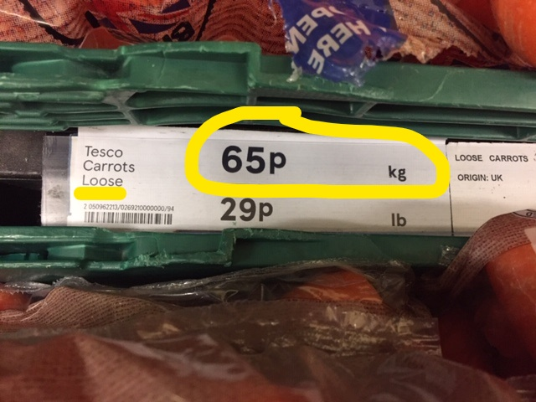

**Broccoli**

**Variety**

|  |  |  |
| --- | --- | --- |
| **Definition of Variety** | **Coding Tips** | **Exclusions** |
| * Different species * Organic/fair-trade * Economy Range | Each species e.g. (purple sprouting, tenderstem) counts as a different variety  Organic & fair-trade products = 1 variety even if both are available  One or more economy products = 1 variety | Pre-packed and loose do not count as different varieties  Only count organic/fair-trade when an additional choice  Only count economy when an additional choice |

**Quality**

|  |  |  |  |
| --- | --- | --- | --- |
| **Product** | **High/Good (3)** | **Medium (2)** | **Low/Poor (1)** |
| Loose broccoli | Good strong green colour, uniform shape and size, free from yellowing florets, mould and fungi, firm crisp product | Good green colour, mixed sizes, occasional yellowing floret, no bruises or soft marks, relatively firm product | Faded greeny-yellow colour, blemishes, mould, soft & bendy product |

**Standard price** – write down price per kilogram (kg) or 100g or g or per piece for cheapest loose and cheapest packed items, AND the name and how the items are packed

**Cauliflower**

**Variety**

|  |  |  |
| --- | --- | --- |
| **Definition of Variety** | **Coding Tips** | **Exclusions** |
| * Different size * Organic/fair-trade * Economy Range | Regular and extra-large (if labelled as this) cauliflower counted as different variety  Organic & fair-trade products = 1 variety even if both are available  One or more economy products = 1 variety | Pre-packed and loose do not count as different varieties  Only count organic/fair-trade when an additional choice  Only count economy when an additional choice |

**Quality**

|  |  |  |  |
| --- | --- | --- | --- |
| **Product** | **High/Good (3)** | **Medium (2)** | **Low/Poor (1)** |
| Loose cauliflower | Good strong white colour, uniform shape and size, free from greying florets, mould and fungi, firm crisp product | Good white colour, mixed sizes, occasional grey/dark floret, no bruises or soft marks, relatively firm product | Greyish colour, blemishes, mould, soft & wilted product |

**Standard price** – write down price per kilogram (kg) or 100g or g or per piece for cheapest loose and cheapest packed items, AND the name and how the items are packed

**Peppers**

**Variety**

|  |  |  |
| --- | --- | --- |
| **Definition of Variety** | **Coding Tips** | **Exclusions** |
| * Different colours * Different size/ pointed shape * Organic/fair-trade * Economy/budget range | Each colour counts as a different variety – except multipacks = 1 variety  Size and shape only count if the pepper is of a different species (different name)  Organic and fair-trade products= 1 variety even if both are available  One or more economy products = 1 variety | Exclude multipacks as a variety when colour is repeated  Only count organic/fair-trade when an additional choice  Only count economy when an additional choice |

**Quality**

|  |  |  |  |
| --- | --- | --- | --- |
| **Product** | **High/Good (3)** | **Medium (2)** | **Low/Poor (1)** |
| Loose red peppers | Good strong intense bright red colour, uniform shape and size, free from cracks, decay, mould and fungi, clean with no blemishes, bruises or marks, firm crisp product, tight skin | Good red colour, mixed sizes, occasional blemish, no bruises or soft marks, firm product | Soft product, brown marks, blemishes, moulds, wrinkled/wilted skin, product drying out |

**Standard price** – write down price per kilogram (kg) or 100g or g or per piece for cheapest loose and cheapest packed items, AND the name and how the items are packed

**Tomatoes**

**Variety**

|  |  |  |
| --- | --- | --- |
| **Definition of Variety** | **Coding Tips** | **Exclusions** |
| * Different species * Different size/shape * Organic/fair-trade * Economy/budget range | Each species (cherry, beef, plum etc.) counts as a different variety  Size & shape only count if tomatoes are a completely new species  Organic & fair-trade products = 1 variety even if both are available  One or more economy products = 1 variety | Vine-ripened tomatoes are not considered a new variety  Apply the first name of a product where it is a cross-species i.e. cherry plum is classed as in cherry variety  Only count organic/fair-trade when an additional choice  Only count economy when an additional choice |

**Quality**

|  |  |  |  |
| --- | --- | --- | --- |
| **Product** | **High/Good (3)** | **Medium (2)** | **Low/Poor (1)** |
| Loose medium (cheapest) | Bright green/red colour, consistently sized products, no blemishes, bruises or abrasions, firm turgid product, shiny skin | Shiny red colour (90%) for variety, no bruising, slight size variation, firm product, occasional blemish, perhaps a few marks, no bruises | Dull red colour, marks, blemishes, bruised, product feels soft, skin not turgid but wrinkled/wilted |

**Standard price** – write down price per kilogram (kg) or 100g or g or per piece for cheapest loose and cheapest packed items, AND the name and how the items are packed

**Apples**

**Variety**

|  |  |  |
| --- | --- | --- |
| **Definition of Variety** | **Coding Tips** | **Exclusions** |
| * Different species/ colours * Bagged sliced apples * Organic/fair-trade * Economy/budget range | Species identified in name = 1 different variety Bagged sliced apples = 1 variety (no matter how many different types)  Organic & fair-trade products = 1 variety even if both are available  One or more economy products = 1 variety | Only count organic/fair-trade when an additional choice  Only count economy when an additional choice |

**Quality**

|  |  |  |  |
| --- | --- | --- | --- |
| **Product** | **High/Good (3)** | **Medium (2)** | **Low/Poor (1)** |
| Cheapest loose eating apples  (cheapest packed apples if loose apples are not available) | Good strong intense bright red/green colour, no blemishes, bruises or marks, firm product, tight skin | Good red/green colour for variety, occasional blemish, perhaps a few marks, no bruises, firm product, looks good | Weak red/green colour, marks, blemishes, bruised, blackened, soft, wrinkled/wilted skin, looks like it should be eaten immediately |

**Standard price** – write down price per kilogram (kg) or 100g or g or per piece for cheapest loose and cheapest packed items, AND the name and how the items are packed

**Bananas**

**Variety**

|  |  |  |
| --- | --- | --- |
| **Definition of Variety** | **Coding Tips** | **Exclusions** |
| * Different species/ colours * Different size * Organic/fair-trade * Economy/budget range | Species identified in name = a different variety  If size is specified in the name = 1 variety (i.e. kids/ lunchbox bananas)  Organic & fair-trade products = 1 variety even if both are available  One or more economy products = 1 variety | Ripen at home is not an additional variety  Only count organic/fair-trade when an additional choice  Only count economy when an additional choice |

**Quality**

|  |  |  |  |
| --- | --- | --- | --- |
| **Product** | **High/Good (3)** | **Medium (2)** | **Low/Poor (1)** |
| Loose medium (cheapest) | Strong green/yellow colour, no black marks, blemishes or bruises, firm product firm | Predominately yellow/green stalk, occasional blemish, perhaps a few marks, no bruises, firm product, looks good | Brown marks on skin, blackening, wizened stalk, other blemishes, product feels soft, looks like it should be eaten immediately or use for cooking |

**Standard price** – write down price per kilogram (kg) or 100g or g or per piece for cheapest loose and cheapest packed items, AND the name and how the items are packed

**Frozen Bag of Mixed Vegetables**

**Variety**

|  |  |  |
| --- | --- | --- |
| **Definition of Variety** | **Coding Tips** | **Exclusions** |
| * Different types of vegetable mixes | E.g. General mixed vegetables, Farmhouse mixed veg and summer vegetable medley will all count as different varieties | Exclude those with added butter, pulses, grains |

**Standard price** – write down price per kilogram (kg) or 100g for cheapest product, AND the name, brand, and how the item is packed

**Frozen Peas**

**Variety**

|  |  |  |
| --- | --- | --- |
| **Definition of Variety** | **Coding Tips** | **Exclusions** |
| * Different species * Different types * Organic/fair trade * Economy/budget range | Garden peas and petit pois will count as different varieties  One or more different type (e.g. supermarket own brand and Birds eye) = 1 variety  Organic & fair-trade products = 1 variety even if both are available  One or more economy products = 1 variety | Exclude bags of peas with other additions (e.g. other mixed veg) |

**Standard price** – write down price per kilogram (kg) or 100g for cheapest product, AND the name, brand, and how the item is packed

**Tinned Sweetcorn**

**Variety**

|  |  |  |
| --- | --- | --- |
| **Definition of Variety** | **Coding Tips** | **Exclusions** |
| * Different brands * Different names | Supermarket own brand and Green Giant will count as different varieties  Original, salad crisp and salt free will count as different varieties | Multipacks of tins will not count as a different variety  Exclude tins of mixed corn and peas |

**Standard price** – write down price per kilogram (kg) or 100g for cheapest product, AND the name, brand, and how the item is packed

Example of where to look for price for kg:

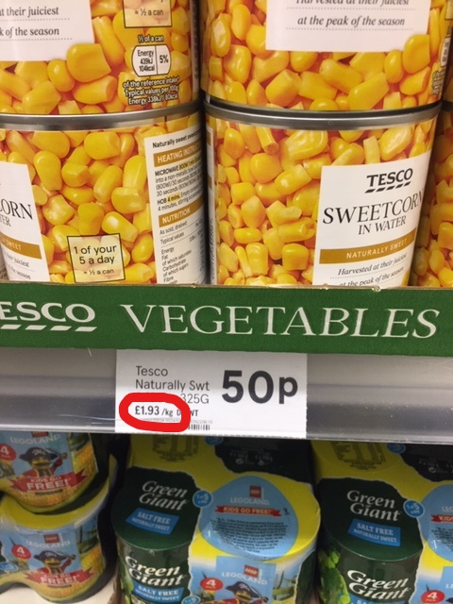

**Tinned Tomatoes**

**Variety**

|  |  |  |
| --- | --- | --- |
| **Definition of Variety** | **Coding Tips** | **Exclusions** |
| * Different brands * Different style of tomatoes in tin | Supermarket own brand and Growers Harvest will count as different varieties  Chopped tomatoes, peeled plum tomatoes or those with basil will count as different varieties | Multipacks of tins will not count as a different variety  Exclude tomato paste/puree and passata |

**Standard price** – write down price per kilogram (kg) or 100g for cheapest product, AND the name, brand, and how the item is packed

**Carbonated Drinks**

All carbonated non-alcoholic drinks, including sodas, energy drinks and mixers, sugar-free soft drinks and flavoured fizzy waters. Do not include plain sparkling water.

**Variety**

|  |  |  |
| --- | --- | --- |
| **Definition of Variety** | **Coding Tips** | **Exclusions** |
| * Different types of drink * Different sizes * Healthier options * Economy Range | Lemonade, cola, ginger ale etc. will all count as different varieties  One or more different size from the standard 2L bottle = 1 variety  One or more healthier option (diet, zero sugar, caffeine free) = 1 variety  One or more economy products = 1 variety | Multipacks of tins will not count as a different variety  Only count economy when an additional choice |

**Healthier Option**

|  |  |
| --- | --- |
| **Nutrient claims included** | **Example** |
| * Diet * Zero sugar * Caffeine Free |  |

**Standard price** – write down price per litre (1000ml) or 100ml for cheapest regular and cheapest healthier item (if available), AND note down item name, brand and how the item is packed (bottle or can)

**Sweet Biscuits**

All types of biscuits (e.g. plain, filled or unfilled biscuits) that come in a single pack (see below) excluding any savoury cracker of any kind. Includes ready to eat packaged or bags of bakery biscuits/cookies. Excludes breakfast biscuits/bars (e.g. Go Ahead, Nutrigrain, Belvita).

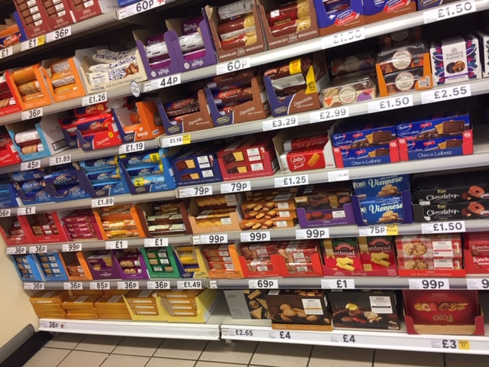 

**Variety**

|  |  |  |
| --- | --- | --- |
| **Definition of Variety** | **Coding Tips** | **Exclusions** |
| * Different types of biscuit * Healthier options * Economy Range | E.g. Custard creams, Bourbons & Jammie Dodgers will all count as different varieties  One or more healthier option (low sugar, ‘light’) = 1 variety  One or more economy products = 1 variety | Only count economy when an additional choice |

**Healthier Option**

|  |  |
| --- | --- |
| **Nutrient claims included** | **Example** |
| * Low sugar * ‘Light’ * Reduced fat | *5g of total sugars or less per 100g (look at nutrition label if labelled as ‘low sugar’ to check)*  *30% reduced fat compared to regular type* |

**Standard price** – write down price per 100g for cheapest regular and cheapest healthier item (if available), AND note down item name, brand and how the item is packed

**Sweets Bags & Pouches**

Bags and pouches of sweets and lollies, does not include individual sweet bars (e.g. refreshers) or tubes (e.g. fruit pastilles). You are looking out for the kinds of bags and pouches in the photos below (and not the individual sweet bars that are purchased for single consumption):

11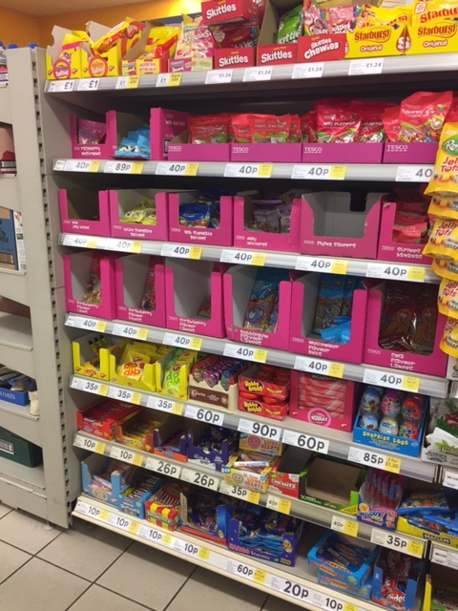1. 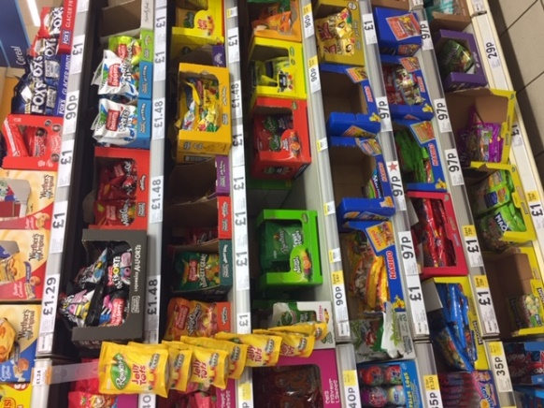

**Variety**

|  |  |  |
| --- | --- | --- |
| **Definition of Variety** | **Coding Tips** | **Exclusions** |
| * Different types * Healthier Options | E.g. Fizzy cola bottles, jelly beans, bubblegum bottles will all count as different varieties  One or more healthier option = 1 variety | Ignore packet size, will not count as different variety  Ignore ‘no artificial colours or preservatives’ as healthier option |

**Healthier Option**

|  |  |
| --- | --- |
| **Nutrient claims included** | **Example** |
| * Low sugar / sugar-free | *30% less sugar than regular sweets* |

**Standard price** – write down price per 100g for cheapest regular and cheapest healthier item (if available), AND note down item name, brand and how the item is packed

**Chocolate Bars of 100g or More**

Bars of chocolate of 100g or more, does not include multipacks (e.g. 4 x 25g bars, or baking chocolate). Examples:

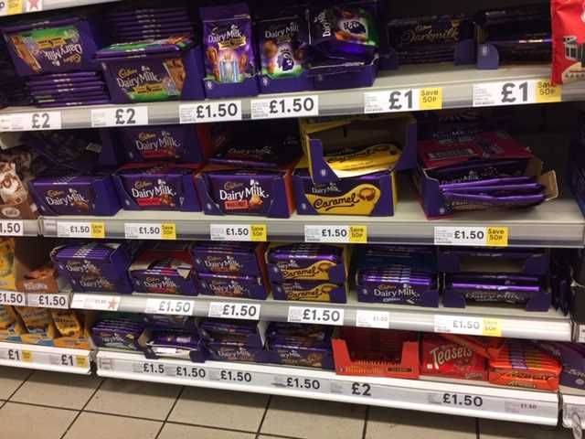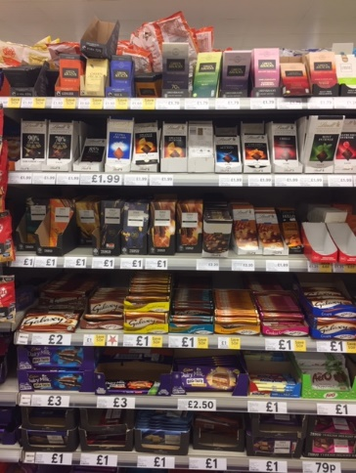

**Variety**

|  |  |  |
| --- | --- | --- |
| **Definition of Variety** | **Coding Tips** | **Exclusions** |
| * Different flavours * Healthier options * Organic/fair-trade * Economy range | E.g. fruit and nut and caramel bars will count as different varieties  One or more healthier options = 1 variety Organic & fair-trade products = 1 variety even if both are available  One or more economy products = 1 variety | Multipacks  Baking chocolate  Chocolate covered biscuit bars |

**Healthier Option**

|  |  |
| --- | --- |
| **Nutrient claims included** | **Example** |
| * Low sugar | *30% less sugar than regular milk chocolate / no added sugar* |

**Standard price** – write down price per 100g for cheapest regular and cheapest healthier item (if available), AND note down item name, brand and how the item is packed

**Sausages**

Uncooked cold and frozen meat sausages. Excludes veggie sausages, cooked sausages, salami, deli-counter sausages.

**Variety**

|  |  |  |
| --- | --- | --- |
| **Definition of Variety** | **Coding Tips** | **Exclusions** |
| * Different flavours * Different sizes * Microwavable * Healthier options * Organic/fair-trade * Economy Range | Count different flavours all fresh & frozen sausages first  One or more chipolatas/ smaller sausages = 1 variety  One or more microwavable sausage = 1 variety  One or more healthier options = 1 variety Organic & fair-trade products = 1 variety even if both are available  One or more economy products = 1 variety | Exclude cooked sausages (e.g. frankfurters), sausage rolls, party sausages, salami etc., veggie sausages  Only count organic/fair-trade when an additional choice  Only count economy when an additional choice |

**Healthier Option**

|  |  |
| --- | --- |
| **Nutrient claims included** | **Example** |
| * Lower total fat * Lower salt | *30% less fat than regular sausages*  *20% less salt than regular sausages* |

**Standard Price** – write down price per kilogram (kg) or 100g for cheapest regular and cheapest healthier item AND note item name, brand & how the item is packed. Note down if the cheapest sausages (regular and healthy option) are cold or frozen.

**Crisps**

Potato crisps only.

**Variety**

|  |  |  |
| --- | --- | --- |
| **Definition of Variety** | **Coding Tips** | **Exclusions** |
| * Different flavours * Different sizes * Healthier options * Organic/fair-trade * Economy Range | Count different flavours (cheese & onion, ready salted etc.) first  Each different size other than the main size available = 1 variety  One or more healthier options = 1 variety  Organic & fair-trade products = 1 variety even if both are available  One or more economy products = 1 variety | Rice, vegetable, wheat, corn and prawn/oriental crackers are not included  Only count organic/fair-trade when an additional choice  Only count economy when an additional choice |

**Healthier Option**

|  |  |
| --- | --- |
| **Nutrient claims included** | **Example** |
| * Lower total fat * Lower salt | *30% less fat than regular salted crisps*  *20% less salt than regular salted crisps* |

Fill in the columns for plain salted crisps first. Then for the cheapest healthier option.

If a healthier option of crisps is available in a flavour other than plain salted, note down the price, availability and flavour.

**Standard Price** - Note price per Kg or 100g for cheapest regular and cheapest healthier item AND note item name, brand & how the item is packed

**Pizza**

Includes all fresh and frozen pizza, exclude those at the made-to-order counter

**Variety**

|  |  |  |
| --- | --- | --- |
| **Definition of Variety** | **Coding Tips** | **Exclusions** |
| * Different flavours * Different sizes * Healthier options * Economy Range | Count different flavours all fresh & frozen pizzas first  One or more pizza different from the main size = 1 variety  One or more healthier options = 1 variety One or more economy products = 1 variety | Pizzas at the made-to-order counter |

**Healthier Option**

|  |  |
| --- | --- |
| **Nutrient claims included** | **Example** |
| * Wholewheat pizza base |  |

**Standard Price** - Note price per Kg or 100g for cheapest regular and cheapest healthier item AND note item name, brand & how the item is packed