**Field scale trial of fibre-reinforced ballast**

Geoff Watson1[0000-0003-3074-5196], Edgar Ferro2[0000-0002-4511-7187], Louis Le Pen1[0000-0002-4362-3895], David Milne1[0000-0001-6702-3918], Tristan Rees White1[0000-0001-9009-8432], and William Powrie1[0000-0002-2271-0826]

1 Infrastructure Research Group, School of Engineering, University of Southampton, Building 178, Burgess Road, Southampton, SO16 7QF, UK

2 University of Trento, Department of Civil Environmental and Mechanical Engineering, via Mesiano 77, 38123, Trento, Italy.  
[g.watson@soton.ac.uk](mailto:g.watson@soton.ac.uk)

**Abstract.** Rail infrastructure companies spend a substantial proportion of their operating budget on track maintenance and renewal. This could be reduced by extending the life and/or the maintenance interval of ballasted track and minimizing service disruption. A possible means to achieve this is with a fibre-reinforced ballast. Fibre-reinforced ballast is created by randomly introducing fibres to the granular matrix. If appropriately sized, these fibres may be held between grains and develop tensions that increase the effective confining pressure on the assembly. Previous laboratory research has shown that the addition of specific types, quantities and dimensions of fibres can increase the peak strength and reduce settlements of railway ballast. Based on laboratory test results, a field trial has been carried out at a site on a UK mass transit railway. The site was due for trackbed renewal which offered the opportunity to reinforce the replacement ballast with fibres consisting of polyethylene strips 300 mm x 25 mm x 0.5 mm at a concentration of 670 fibres per tonne of a standard ballast gradation. At the trial site, fibre-reinforced ballast was placed along a 48 m length. A further length was renewed with unreinforced ballast as a control. Following the installation, measurements of dynamic track movements as trains pass using a high-speed camera and digital image correlation were carried out on two visits. This paper presents an evaluation of the post-installation monitoring data. Results confirm that the fibre-reinforced ballast performs at least as well as the control section of track.

**Keywords:** Ballast, fibres, maintenance.

1. Introduction/Background

Rail infrastructure companies spend a substantial proportion of their operating budget (e.g. £4.1 billion or 37% in 2016/17 in the case of Network Rail, UK; €1.9 billion in 2016 in the case of Rete Ferroviaria Italiana (RFI), Italy [1] and $27.1 billion in the US in 2015 [2]) on track maintenance and renewal. Conventionally ballasted railway tracks settle differentially along their length leading to a loss of alignment and level that needs to be corrected, usually by mechanical tamping. Tamping is a process whereby a specialized plant vehicle measures and lifts the track to its intended geometry and then, using vibrating tines, tamps/squeezes ballast into position beneath sleepers (**Fig. 1**), to support them at their corrected level [3]. However, the accumulation of damage to the trackbed through trafficking and tamping leads to a diminishing return. For example, from placement a new track could deteriorate geometrically to a point requiring maintenance after 4 years initially. However, the next maintenance interval may be 3.5 years with the return diminishing at each maintenance cycle so that at some point the trackbed requires more comprehensive treatment such as by ballast cleaning or eventually, complete renewal. If it were possible to increase the intervals between maintenance tamps by even a small amount, this could result in substantial savings and prolong the life of the trackbed.

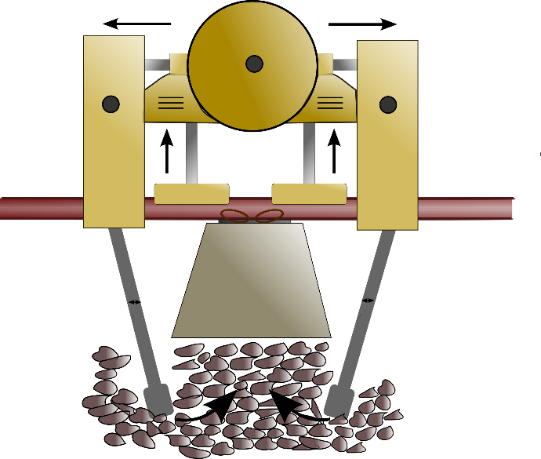

**Fig. 1.** Schematic showing the tamping mechanism (modified after [2]).

Previous work used triaxial tests to identify scaling relationships for the optimal selection of fibres [3,4]. Full-size laboratory testing of the most promising fibre dimensions was then carried out using the Southampton Railway Testing Facility (SRTF), shown in **Fig. 2**. This is represents a single sleeper bay on a ballast bed deforming in plane strain, with the sleeper subjected to cyclic loading representative of a 20 tonne train axle [5, 6, 7].

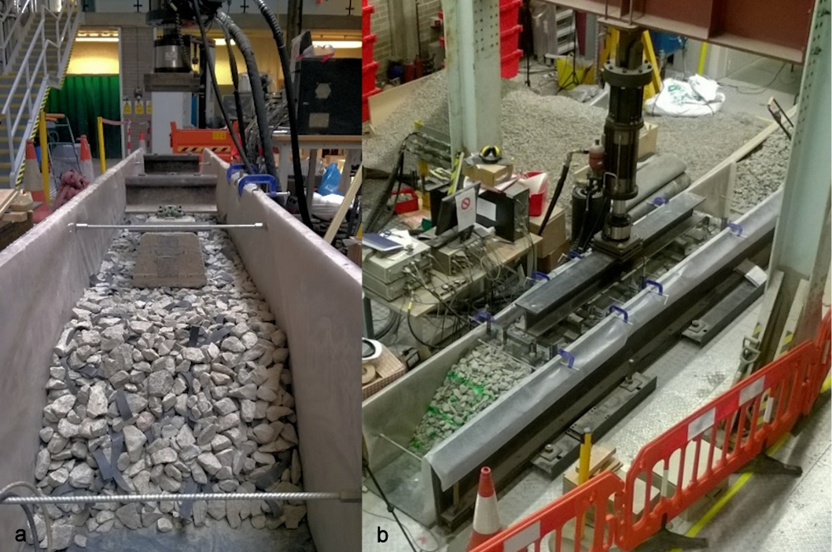

**Fig. 2.** Photographs of the SRTF during preparation (a) and ready for testing (b)

The fibres used were formed from strips of polyethylene, 0.5 mm thick, pre-cut to the desired dimensions. These were mixed into the ballast prior to placement into the testing rig.

**Fig. 3** shows settlement results from the SRTF for the optimal fibre mix and a baseline test for comparison. In these tests, 3 million cycles of a 20 tonne equivalent axle load were applied at 3 Hz. The x-axis shows the number of load cycles on a logarithmic scale and the y-axis shows the permanent settlement of the ballast layer. The baseline test was carried out on standard ballast with a G44[1] sleeper. The optimal fibre dimensions were 300 × 25 × 0.5 mm. at a volume fraction (defined as the ratio of the volume of fibres to the volume of ballast grains) of 0.65%. In practice this meant 670 fibres per tonne of ballast assuming a ballast bulk density of 1600 kg/m3. The addition of fibres to a granular material tends to increase the void ratio and may reduce the stiffness [8, 9, 10]. However, owing to the narrow geometry and very small thickness, these fibres do not inhibit the packing of the ballast grains and hence are not expected to reduce ballast stiffness, while they have the potential to reduce the permanent settlement [11, 12].

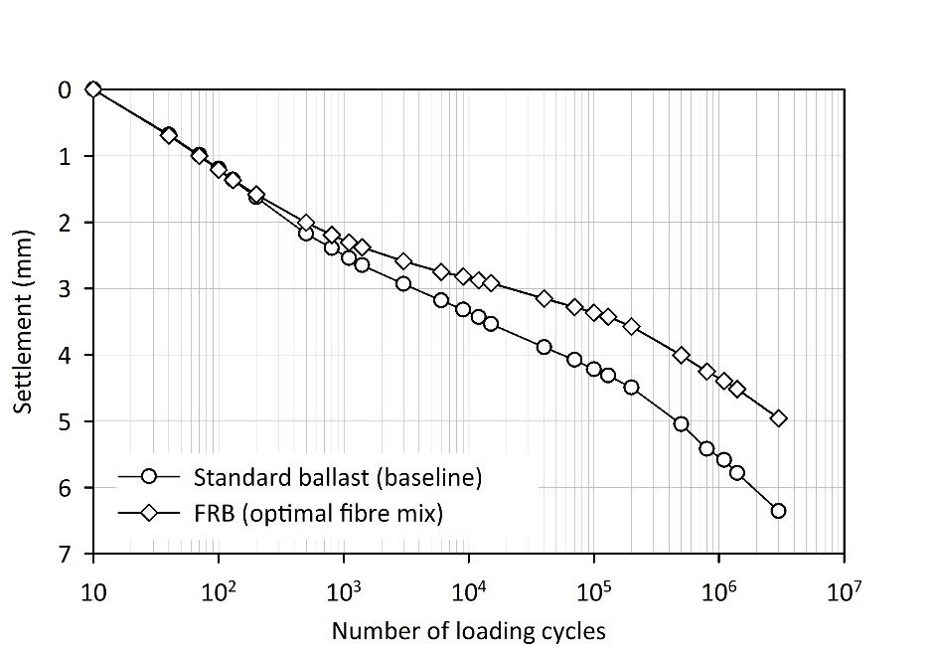

**Fig. 3.** Full-size laboratory test results for ballast reinforced with optimal fibre mix (polyethylene plastic strips 300 × 25 × 0.5 mm at 0.6% volume fraction)

**Fig. 3** shows that the FRB reduced the settlement from 6.3 to 5.0 mm at 3 million cycles. This is a reduction of ~25%. The relationship between individual settlement tests and along the track differential settlement is unclear and likely to be complex. However, in principle, if the ballast layer is less susceptible to settlement at each sleeper location then the potential for differential settlement originating from the ballast layer should also reduce. It is in part this lack of a direct link between single sleeper/ballast settlement and differential settlement that necessitates field trials to quantify any potential benefit over the life cycle of a trackbed.

Based on the laboratory testing a field trial was planned using the fibre dimensions and proportions identified as optimal. This paper presents results from two site monitoring visits carried out within the first 14 months after installation.

1. The site

A section of a mass transit urban line in North London was selected for the trial, mainly because it was about to be renewed and offered a suitable site with reasonable access. New rails, sleepers and ballast were placed on a 500 m length of one line on the twin track route in May 2017. A section of the renewal formed a 48 m long FRB trial. This trial length was on an embankment between two underbridges as shown in **Fig. 4**.

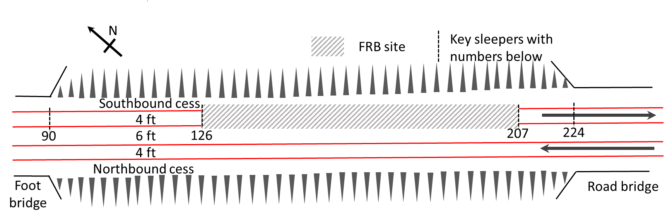

**Fig. 4.** Site plan including UK rail nomenclature[2]. The south eastern end is on the right.

* 1. Ground conditions

The 48 m trial site is situated on an embankment, between two underbridges. At the south-eastern end of the site, a masonry bridge crosses a road. At the north-western end of the site, there is a bridge that enables pedestrians to cross under the railway. This section of track was originally built in the 1920s. The British Geological Survey (BGS) maps and nearby borehole logs show the embankment to be underlain by stiff brown and grey clays of the London Clay formation. Site investigation records, not in the public domain, show that the embankment is constructed of firm clay.

* 1. Method for mixing fibres with ballast

For the trial, 120 tonnes of ballast were mixed with 80520 fibres, to give approximately 670 fibres per tonne. The mixing was carried out at a depot (**Fig. 5**) in stages: (1) suitable proportions of ballast and fibres were placed. (2) The materials were mixed using a crane-mounted grab until the fibres appeared to be well mixed. (3) The mixed batch was moved to the back of the loading bay and the process repeated until complete. The ballast mixture was stored at the depot and trains were loaded some time later. A thin layer of ballast was placed on top of the FRB after loading into the wagons so that fibres near the surface would not be blown away in transit.

If the use of FRB were to become commonplace, fibres could be introduced at the quarry to ensure a uniform mix quality and density.

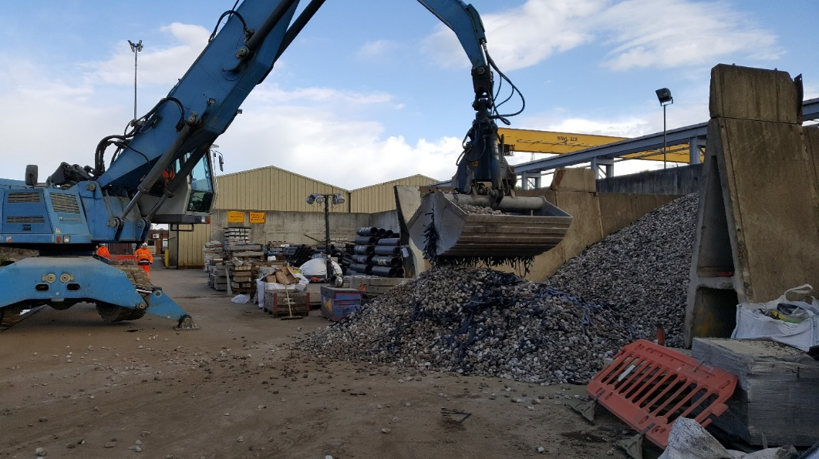

**Fig. 5.** Fibres being mixed with ballast at a depot.

1. Performance monitoring – methods

Owing to the low train speeds at the site, (48 km/h or 30 mph) track movement was measured by high-speed filming with digital image correlation (DIC) [13, 14, 15, 16].

The equipment used comprised a USB 3 camera (IDS uEye 337) (**Fig. 6a**) with a data transfer rate of up to 320 MB/s connected to a laptop PC. The camera sensor has a resolution of 2048 × 2048 pixels and a frame rate of 75 fps (frames per second) at full resolution. By only capturing data from part of the sensor, known as the area of interest (AOI), the frame rate can be increased dramatically (e.g. 300 fps for 640 × 480 and 1000 fps or more for smaller areas). Typically, data for a single target can be captured at up to 500 fps provided there is sufficient light. To aid the analysis and provide a reference for scaling it is usual (though not necessary) to attach square, textured targets to the sleeper ends (**Fig. 6b**).

The PC captures the data as an AVI format video file, which is then converted to a series of jpeg images for analysis. Analysis was carried out using a digital image correlation technique [13], in which patterns are matched across frames using normalized cross-correlation. This assumes that the pattern is approximately constant between successive images and that the local textural information is unique.

There are four main causes of noise in the calculated deflections:

• Deflections being too small compared with the size of each pixel

• Ground borne vibration

• Wind caused by weather and/or the passing of a train

• Heat haze generated by the rails during hot and sunny weather

Controlling these potential sources of error is essential if acceptable data are to be obtained, the difficulty in achieving this tends to increase with train speed. For digital image correlation, the camera position or lens used should be chosen such that the target movement during train passage is sufficient (10 – 20 pixels).

At this site, the camera was set up in the northbound cess (**Fig. 6a**) with targets installed on the southbound sleeper ends in the 6 ft (**Fig. 6b**) as there was insufficient room in the southbound cess owing to the proximity of the cable carriers to the track. The distance between the camera and the track reduced both ground-borne vibration and wind buffeting due to the passage of trains [13,14] but meant that the line of sight crossed multiple rails. High frequency noise in the data is reduced by low pass Butterworth filtering to give a cleaner signal. The DIC targets used were 50 mm squares on sleeper brackets and 70 mm squares attached to the rail using double-sided tape or glue.

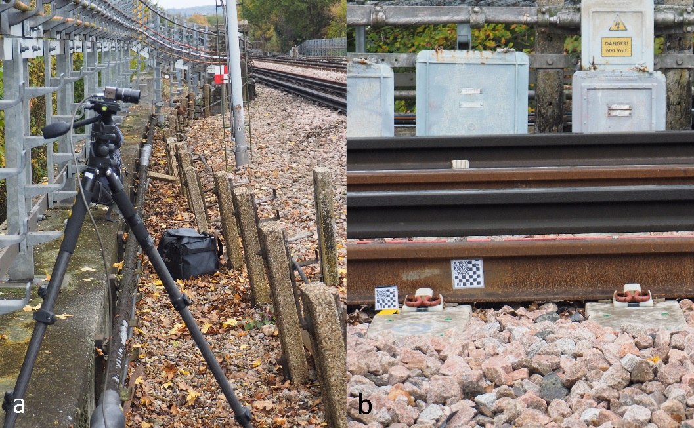

**Fig. 6.** Photographs of the camera setup (a) and targets on sleeper end and rail web (b).

1. Monitoring Visits and data gathered

The site was monitored twice, 6 months and 14 months after renewal.

All trains were 6 cars, made up of two three-car units each consisting of a driving motor car (DMC - 29.4 t), a trailer car (TC - 21.5 t) and an uncoupling non-driving motor car (UNMC - 27.9 t).

A typical time deflection trace from the high-speed filming with DIC is shown in **Fig. 7**.

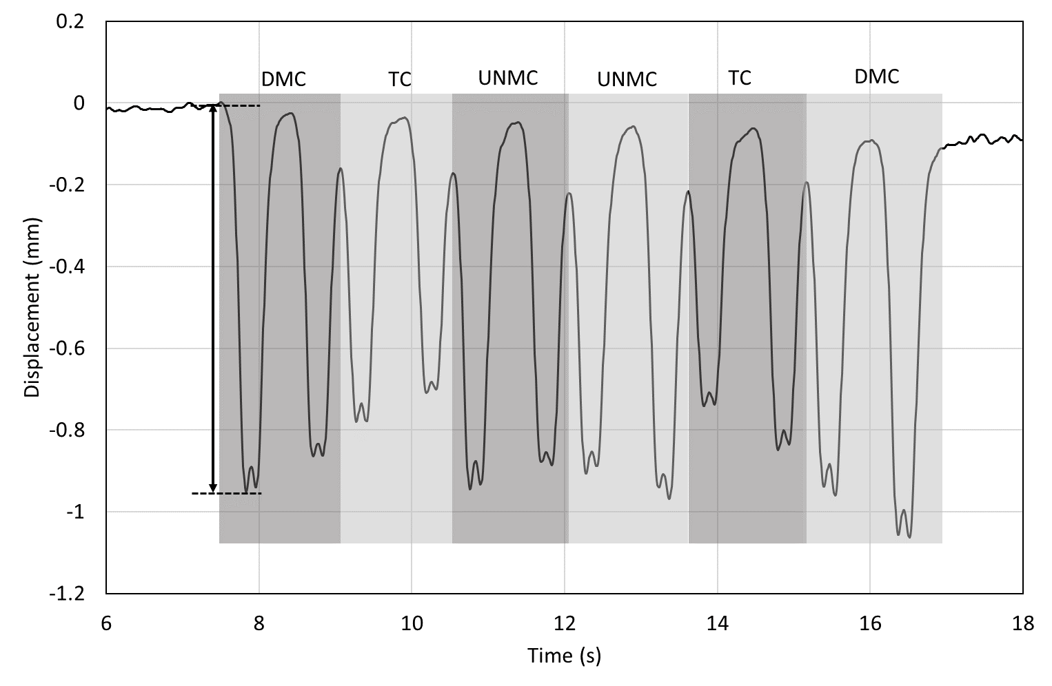

**Fig. 7.** Typical DIC trace for a 6 car train. This plot is from sleeper 144 and is low pass filtered at 8 Hz with a fourth order Butterworth filter. A characteristic deflection used in later comparisons is indicated by the arrowed vertical line. Each car is shown by a grey rectangle.

1. Results

At each visit (6 months and 14 months) a number of trains were monitored (47 and 79 respectively) with the camera moved along the track to capture multiple locations. As each train was of the same type, these data can be combined to create a plot of characteristic sleeper deflection by sleeper location. The characteristic deflection has been taken as the difference between the maximum deflection in the first bogie pass and the lowest point in the trough before initial uplift (as shown in **Fig. 7**). In each case, data were taken from a plot which had been low pass filtered at 8 Hz using a fourth order Butterworth filter to remove high frequency noise not relevant to the major trackbed motions. Results from the two visits are shown in **Fig. 8** and **Table 1** shows the statistical data for the FRB and non-FRB sections for each visit. **Table 1** shows that the two sections of track produce similar results in terms of the mean, maximum, minimum, standard deviation and first and third quartiles. This suggests that the performance across the sections is similar and that the performance has remained unchanged between the two visits.

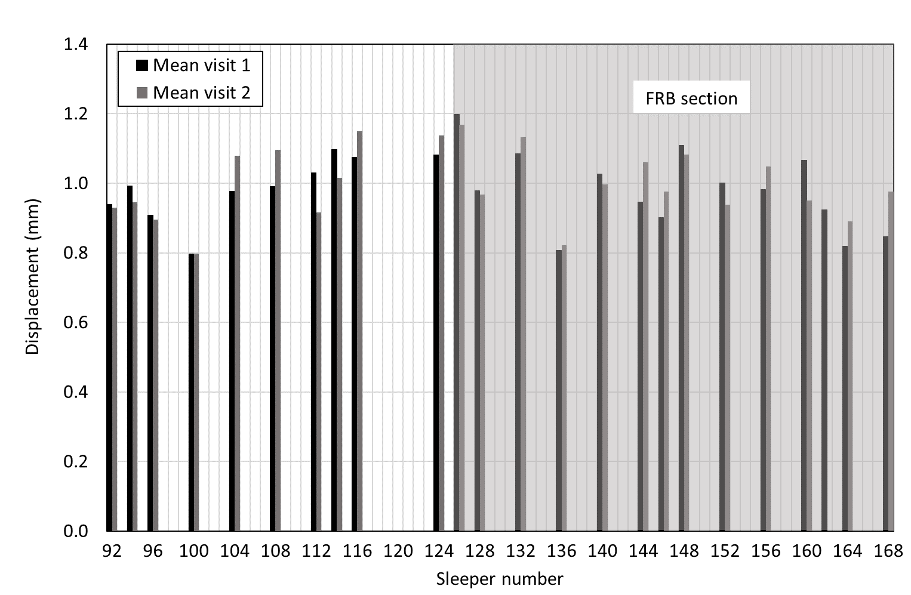

|  |  |  |  |  |
| --- | --- | --- | --- | --- |
|  | Non-FRB | | FRB | |
| Visit | 1 | 2 | 1 | 2 |
| Mean | 1.00 | 0.99 | 0.98 | 0.99 |
| Max. | 1.13 | 1.15 | 1.24 | 1.17 |
| Min. | 0.80 | 0.80 | 0.81 | 0.82 |
| SD | 0.10 | 0.11 | 0.12 | 0.10 |
| 1st quartile | 0.95 | 0.92 | 0.91 | 0.94 |
| 3rd quartile | 1.06 | 1.09 | 1.06 | 1.06 |

**Fig. 8.** Displacement data from the DIC measurements in visits 1 & 2. All sleepers in the shaded area are in the FRB test section

**Table 1.** Analysis of data from both visits by section.

1. Discussion

The movements of the sleepers have not changed significantly between the two visits and the dynamic responses of the sections with and without FRB were very similar on both occasions (**Fig. 8**). As was expected on the basis of the laboratory tests, the addition of narrow fibres has not affected the stiffness of the ballast bed and is therefore compatible with railway track requirements in terms of its dynamic performance. However, the ability of FRB to reduce the long-term settlement cannot yet be assessed. The small difference in track response between the two visits indicates that, thus far, the sleepers have maintained relatively uniform contact with the trackbed along the length of the trial site, with negligible adverse effect from differential settlement. Given the recentness of the renewal and the relatively low axle loads (7.35 t maximum unladen weight), this is to be expected. However, as further monitoring visits occur and more data become available, it should be possible to evaluate the longer-term performance of the FRB compared with the classically ballasted track.

It is planned to visit the site again in the near future to repeat the dynamic monitoring and compare the results with other conventional measures of track condition.

1. Acknowledgements

The authors are grateful for the financial support of the Engineering and Physical Sciences Research Council (EPSRC) through the programme grant Track to the Future (EP/M025276/1) and Network Rail through the University Research Partnership in Future Infrastructure Systems. The authors are also grateful for the support of the infrastructure owner, Transport for London (TfL), particularly Stephen Barber, for, enabling the trials to take place.

1. References
2. Camera dei Deputati: Schema di contratto di programma 2016-2021 - parte servizi tra il Ministero delle infrastrutture e dei trasporti e la società Rete ferroviaria italiana Spa (374), <url:http://documenti.camera.it/apps/nuovosito/attigoverno/Schedalavori/getTesto.ashx?file=0374.pdf&leg=XVII#pagemode=none> (2017).
3. American Society of Civil Engineers: 2017 Infrastructure report card, url: <https://www.infrastructurereportcard.org/wp-content/uploads/2017/01/Rail-Final.pdf> (2017).
4. Aingaran, S., Le Pen, L., Zervos, A., Powrie, W.: Modelling the effects of trafficking and tamping on scaled railway ballast in triaxial tests. Transportation Geotechnics, 15, 84-90. DOI: 10.1016/j.trgeo.2018.04.004. (2018)
5. Ajayi, O., Le Pen, L., Zervos, A., Powrie, W.: A behavioural framework for fibre reinforced gravel. Géotechnique, 67(1), 56-68. DOI: 10.1680/jgeot.16.P.023 (2016).
6. Ajayi, O., Le Pen, L., Zervos, A., Powrie, W.: Scaling relationships for strip fibre reinforced aggregates. Canadian Geotechnical Journal, 54(5), 710-719 (2017).
7. Abadi, T., Le Pen, L., Zervos, A., Powrie, W.: Improving the performance of railway track through ballast interventions. Proceedings of the Institution of Mechanical Engineers Part F Journal of Rail and Rapid Transit, 1-17. doi:10.1177/0954409716671545 (2016)
8. Abadi, T., Le Pen, L., Zervos, A., Powrie, W.: The effect of sleeper interventions on railway track performance. Journal of Geotechnical and Geoenvironmental Engineering, 145(4), 1-14. [04019009]. DOI: 10.1061/(ASCE)GT.1943-5606.0002022 (2019).
9. Santos S. Dos, Consoli N.C., Baudet B.A.: The mechanics of fibre-reinforced sand. Geotechnique, 60(10), 791–799. (2010).
10. Lirer S., Flora A., Consoli N.C.: Experimental Evidences of the Effect of Fibres in Reinforcing a Sandy Gravel. *Geotechnical and Geological Engineering*, 30, 75–83. (2012).
11. Ajayi O., Le Pen L., Zervos A., Powrie W.: Effects of Random Fibre Reinforcement on the Density of Granular Materials. In International Symposium on Geomechanics from Micro and Macro. Cambridge, UK, 1363–1367. (2014).
12. Ferro, E., Ajayi, O., Le Pen, L., Zervos, A., Powrie, W.: Settlement response of fibre reinforced railway ballast. 11th World Congress on Railway Research. (WCRR2016). (2016).
13. Ferro, E.: The mechanical behaviour of fibre reinforced railway ballast. University of Southampton, Doctoral Thesis, 230pp (2018).
14. Bowness, D., Lock, A. C., Powrie, W., Priest, J. A., Richards, D. J.: Monitoring the dynamic displacements of railway track. Proceedings of the Institution of Mechanical Engineers, Part F (Journal of Rail and Rapid Transit), 221, 13-22 (2007).
15. Le Pen, L., Watson, G. V. R., Powrie, W., Yeo, G., Weston, P., Roberts, C.: The Behaviour of Railway Level Crossings: Insights Through Field Monitoring. Transportation Geotechnics, Special issue: Rail Geomechanics (2014).
16. Murray, C. A., Take, W. A., Hoult, N. A.: Measurement of vertical and longitudinal rail displacements using digital image correlation. Canadian Geotechnical Journal, 52, 141-155 (2014).
17. Bhandari, A., Powrie, W., Harkness, R.: A Digital Image-Based Deformation Measurement System for Triaxial Tests. ASTM geotechnical testing journal, 35, 209-226 (2012).

1. G44 sleepers are pretensioned, steel reinforced, concrete sleepers (ties). The major dimensions are 2500 mm long and 285 mm wide, with a height of 200 mm at the rail seat. They are a common sleeper used in UK track renewals and are comparable with national counterparts globally.
2. When there are two tracks the term ‘6 ft’ (‘6 foot’) refers to the space between the two lines, 6 ft is not an actual measurement although 6 feet or approximately 1.8 m is the approximate distance between the two adjacent inner rails of the two lines. The term ‘cess’ refers to the area outside of either line. The term ‘4 ft’ (‘4 foot’) refers to the space between the running rails (gauge). The actual gauge is 1,435 mm (4 ft 8½ in).