Modelling habitat suitability for the breeding Egyptian Vulture (Neophron percnopterus) in the Kurdistan Region of Iraq

Nabaz R. Khwarahm^{1*}, Korsh Ararat², Sarchil Qader^{3, 4}, Ayad M. Fadhil Al-Quraishi⁵

¹Department of Biology, College of Education, University of Sulaimani, Sulaimani 334, Kurdistan Region, Iraq
²Department of Biology, College of Science, University of Sulaimani, Sulaimani 334, Kurdistan Region, Iraq
³WorldPop, Geography and Environmental Science, University of Southampton, Southampton SO17 1BJ, UK
⁴Natural Resources Department, College of Agricultural Engineering Sciences, University of Sulaimani, Sulaimani 334, Kurdistan Region, Iraq
⁵Surveying and Geomatics Engineering Department, Faculty of Engineering, Tishk International University, Erbil 44001, Kurdistan Region, Iraq.

*khwarahm21302@alumni.itc.nl

Abstract

The Egyptian Vulture (Neophron percnopterus) is an endangered species with a globally declining population. Information on the current habitat distribution and potential suitable habitat for this ecologically important species will provide invaluable insight into conservation planning and the species’ future status as climate changes. This is specifically important for areas where there is little or no reported data on the status of the Egyptian Vulture. We used 13 years nest-site records (n = 69) together with relevant environmental variables to understand the known distribution and predict potential habitat distribution of the Egyptian Vulture in the Kurdistan Region of Iraq. A machine-learning model, maximum entropy, was used to generate various model options, from which the best model was selected based on the Akaike information criterion (AICc) statistical indicators. The model showed reasonably good discriminative ability using both True Skill Statistics TSS = 0.722 and Area under the Curve (AUC) = 0.825 metrics.
The Egyptian Vultures in Iraq mainly breed in territories at elevations between 1000 meters and 3300 meters above sea level. This suggests that the species shows preference to areas distant from human settlements likely due to decreased disturbance and that the species may rely on alternative/complementary food sources (e.g., wild goat and boar). The total area of the study site is approximately 51069 km², out of which around 25% (12767 km²) is predicted as suitable breeding habitat for the Egyptian Vulture. The output of this study provides useful baseline information for local and international conservation biologists and researchers.

Keywords: Egyptian Vulture, MaxEnt model, predictive modelling, habitat suitability, Iraq

1. Introduction

Understanding the habitat and ecology of a species is an essential step in implementing effective conservation management plans and actions. This can also fill gaps in our knowledge on the population biology of birds, in particular threatened species (Sutherland et al., 2004). The Egyptian Vulture (Neophron percnopterus) is a medium-sized Old World vulture, considered globally endangered by the International Union for Conservation of Nature (IUCN) since 2007 (IUCN 2020). In recent years, conservation biologists have traced threats to vulture populations to human-wildlife conflict (Ogada et al., 2012). For example, the majority of vulture deaths are the result of farmers poisoning foxes/rabbits, the bodies of which are then eaten by vultures. These conflicts indirectly affect vulture populations across a wide geographic range, with cases of poisoning by diclofenac in Asia (Oaks et al., 2004; Loveridge et al., 2019; Green et al., 2004) and by other poisons in Africa (Safford et al., 2019) and Europe (Pantović and Andevski, 2018; Margalida, 2012). Moreover, habitat degradation, scarcity of food, persecution, trade, electrocution, and collision pose additional threats to the species (Safford et al., 2019; Venette, 2015).

The Egyptian Vulture has a wide range and is distributed throughout the Palaearctic, Afrotropical, and western Indohimalayan geographic regions (Ferguson-Lees et al., 2001). The nominate subspecies, Neophron percnopterus, occurs in southern Europe (Carrete et al., 2007; Mateo-Tomás and Olea, 2009; García‐Ripollés et al., 2010; López-López et al., 2014; Oppel et al., 2015), the Middle East (Şen et al., 2017; Farashi and Alizadeh-Noughani, 2019; Angelov et al., 2020), Africa (Angelov et al., 2013; Ogada et al., 2016), and south-west and central Asia, east to the Tien Shan and Pakistan (Ferguson-Lees et al. 2001).

Previous works have covered various aspects of the ecology of the Egyptian Vulture,for instance, its relationship with environmental variables at various spatial scales. In Spain, the Balkans, and the Iberian Peninsula, Egyptian Vulture population density has been linked to areas rich in food availability (e.g., settlements with sheep and goats, supplementary feeding stations, landfills) and to cave entrances with vegetation on the cliff base (Oppel et al., 2017; Katzenberger et al., 2019; Mateo-Tomás and Olea, 2009; Margalida et al., 2007; Tauler et al., 2015). In Turkey, Şen et al. (2017) reported that the species avoids breeding near roads and settlements. In contrast, in Nepal and Ethiopia, the vulture populations are undisturbed by settlements and pathways (KC et al., 2019; Arkumarev et al., 2014). In Sicily, Sarà and Di Vittorio (2003) suggest that Egyptian vulture prefers upland habitat away from human disturbance.

Other studies have employed species distributing models (SDMs) to quantify patterns and predict links between species records and environmental variables (Elith et al., 2011; Jiménez-Valverde, 2014; Fourcade et al., 2014). In recent years, machine learning algorithms such as maximum entropy (MaxEnt)(Phillips et al., 2004) have been very popular, especially among the conservation and management-oriented scientific communities due to their predictive power of a species’ geographical range (i.e., the probability of a species’ presence in an area).

In Iraq, studies on Egyptian Vultures are extremely limited and mostly descriptive, likely due to the long history of political and social instability in the country. Over the past few years, there have been continuous seasonal survey efforts by local researchers and enthusiastic members of NGOs such as Nature Iraq (NI) and the Kurdistan Botanical Foundation (KBF), supported by international counterparts. These surveys demonstrate that in Iraq, the Egyptian Vulture breeds during summer in the mountains and rocky hills in the northern and western regions (Salim et al., 2012). Apart from that, little is known on the ecology of this species in Iraq, leaving many questions yet unanswered, for example, quantitative information on nest-sites and foraging sites, breeding success, food sources, possible overlap with rival species, historic trends, and current and potential habitat distribution. Therefore, this study is a starting point in answering the simplest yet probably the most relevant of the above-mentioned questions. Knowledge on the current habitat distribution and potential suitable habitat can provide invaluable benchmark information for further research on the ecology of the Egyptian Vulture in Iraq.

Through the use of MaxEnt modelling, this study aims at predicting potential habitat suitability distribution of breeding Egyptian Vultures in the Kurdistan Region of Iraq (KRI) and determining the relative importance of environmental variables contributing to its presence. Information on the species’ current habitat distribution and potential suitable habitat can provide invaluable insight for management and conservation efforts, as well as spurring further research on the ecology of the Egyptian Vulture in the KRI.

2. Materials and Methods

2.1 Study site

The physical geography of Iraq is composed of four distinctive regions from northeast to southwest: highlands, uplands (hilly and undulating areas), deserts, and alluvial plains (Malinowski, 2002). This study focuses on Iraq’s highlands, mountainous areas located in the north of the country in the Kurdistan Region, which encompasses three provinces: Sulaimani, Erbil (the capital of the KRI) and Duhok (Fig.1). The KRI has an area of approximately 40,633 km² with an annual precipitation of 375-724 mm. The climate is semi-arid, with very hot, dry summers (maximum temperature approximately 50 °C, average 39-43 °C) and cold wet winters (minimum temperature approximately -1 °C, average temperature 7-13 °C) (https://gov.krd/english/). The elevation of the region’s highlands, which are mostly remote and inaccessible, ranges from c.1000 to 3544 meters above sea level. The topography includes elevated peaks, rocky cliffs, valleys, and steep gorges, and the mountains and hillsides are vegetated with shrubs, grasses, and oak forests (Malinowski, 2002).

2.2 Egyptian Vulture Presence Records/Data sources/Survey Methods

Data for this study was obtained from bird and fauna surveys conducted over a 13-year period. Between 2007 and 2020, Iraq’s Key Biodiversity Areas (KBAs) were comprehensively surveyed in a joint effort between Nature Iraq (NI) and the Kurdistan Botanical Foundation (KBF).
One of the main goals of the KBA surveys was looking for globally threatened or endangered species, such as the Egyptian Vulture. Since the surveys were done during breeding season (April to the end of May), only confirmed breeding birds were used in this study. We followed the British Trust for Ornithology (BTO) breeding evidence guidelines for confirming nest-sites, which requires sighting “adults entering or leaving nest-site in circumstances indicating Occupied Nest” (Sharrock, 2010). Systematic sampling design was adopted during the KBA survey efforts that combined straight line transects and stand point inspections. Survey members walked straight 500-meter line transects through the demarcated area, with a minimum distance of 100 m between two transects (Hoel, 1943). Point count surveys of at least 15 minutes (Bibby et al., 1998) were performed on mountains and other areas of limited accessibility. Geographical coordinates and altitude at transect start and end points were obtained using a Garmin 60 handheld GPS receiver. Additionally, binoculars and a digital camera were used to record and observe species observed. Local knowledge from village heads, and shepherds before and during the surveys were of significant assistance in locating nest-sites.

2.3 Environmental predictors

Environmental variables (Table 1) were acquired from multiple sources (e.g., remotely sensed dataset and climate model output datasets) and pre-processed in the ArcGIS 10.2 platform. The Normalized Difference Vegetation Index (NDVI) data calculated from Landsat 8 OLI/TIRS sensors Surface Reflectance (SR) bands 4 and 5 for the ‘leaf on season’ (March)(i.e., 15/03/2019 to 30/9/2019). The Landsat 8 imagery scenes (ground resolution 30 m) with the least cloud cover percentage were downloaded from the United States Geological Survey (USGS) via the Earth Explorer portal (https://earthexplorer.usgs.gov). The DEM (Digital Elevation Model) derived from Shuttle Radar Topography Mission (SRTM) from the Consultative Group for International Agricultural Research (CGIAR) Consortium for Spatial Information. The SRTM dataset with 90 m ground resolution Version 4, was downloaded from (http://srtm.csi.cgiar.org/srtmdata/). Slope and aspect in degree units were calculated from the DEM. The land cover/land use data was acquired from the European Commission database (Global Land Cover 2000 (GLC 2000)) (https://www.eea.europa.eu). Nineteen standards bioclimatic variables, with ~1 km ground resolution, were downloaded from (https://www.worldclim.org). The bioclimatic data is composed of average monthly climate data for minimum, mean, and maximum temperature and for precipitation for 1970-2000.
The number of the original environmental variables was 25, and most of them were removed due to interdependency (i.e., multicollinearity) during the model building process. Highly correlated predictors can inflate model output, in particular with regression analysis (Dormann et al., 2013). However, selecting important predictors depends on the modeler’s knowledge of the ecology of the target species in the study area. In other words, selecting and/or removing important predictors requires careful attention regardless of having relatively high correlation coefficients (Elith and Leathwick, 2009). Following the recommendation of Dormann et al. (2013), a pre-selected approach was applied to the predictors to minimize collinearity. This approach has the benefit of reducing model over-fitting and allowing comparability between different models (Phillips et al., 2004). Predictors with a correlation coefficient (Pearson’s pairwise correlation absolute value of R) above 7 (Pearson’s < 0.7) were eliminated. Generally, there is not consensus on a specific threshold range of correlation coefficient for collinearity purposes (Dormann et al., 2013). The correlation analysis for the environmental predictors was performed with SDMtoolbox (Fourcade et al., 2014).

2.4 Model building

Model selection and building is partly dependent on the nature of the input data. In particular, in case of SDMs, the species occurrence data (presence-only or presence/absence data) determines which model to use (Mateo-Tomás and Olea, 2015). Sampling strategies of the occurrence data that ensure representation of the landscape and/or randomization can play a role in model selection and thus the reliability of the model outputs. Here, we used data of the nest-site locations of 69 Egyptian Vulture pairs collected over a period of 13 years. Based on the presence-only data, and the predictive power, MaxEnt was the model choice for this study. MaxEnt is one of the most robust, popular, and straightforward presence-only dependent models (Cuthbert et al., 2006), which researchers have used in various ecological disciplines (Radosavljevic and Anderson, 2014; Sarà and Di Vittorio, 2003; Tauler et al., 2015; KC et al., 2019).

For this study, we trained the model with 70% of the presence-data points, with the remainder (30%) used for testing/validating the models. Model-replicate was assigned as 10 (i.e., a total of 10 models were produced randomly with different scenarios of test data 30% allocated to each run with 500 iterations for model training optimization). This method is useful as the average of the 10 models can be considered for producing probability maps of the species’ distribution (Venette, 2015). The Jackknife test of the regularizing training gain for the importance of the variables was selected. To minimize the ratio of the presence-points to background points, the model was based on only 400 background points. This value is significantly smaller than the default value (i.e., 10,000 background points). Elith et al. (2011) reports that the number of background samples within the extent of the species distribution or landscape can significantly influence model output reliability. To further minimize the extent of the random background sample points (i.e., 400 points), a bias file generated in ArcGIS 10.2 was used in the modelling process. The bias file was created based on the presence records of the vultures overlaid with a shape file depicting all the provinces of the study area. Using the spatial selection method, the presence records and the overlaid districts were spatially intersected. The intersected layer was then converted to a raster with value of 1 across the intersected districts and ‘Nodata’ elsewhere using Map Algebra.

Complex models are more likely to have optimistic outputs as they usually fit numerous predictor variables quite well. This comes at the cost of the model to be more local and would not perform well under new environmental conditions (areas). The complexity of the model can be adjusted via the regularization multiplier (β) (Phillips et al., 2006) within the MaxEnt environment (Merow et al., 2013), where the default value is 1. Reducing this number increases model complexity; in contrast, increasing it reduces model complexity. In this study, six subsequent regularization multipliers (from β = 0.5 to β = 5) were used, and the best model was selected based on the smallest value of the Akaike information criterion (AICc) (Burnham and Anderson, 2002; Warren and Seifert, 2011).

The MaxEnt output provides a continuous probability of the species’ habitat distribution together with various threshold choices for delineating suitable habitats from unsuitable areas. The threshold chosen for this study was ‘maximum test sensitivity plus specificity Logistic threshold’ (i.e., output format choice of model building was also logistic distribution). This threshold has the benefit of enhancing the discrimination ability of the presence-based distribution from the background points (Jiménez-Valverde and Lobo, 2007; Liu et al., 2013). The average of the 10 models’ ‘maximum test sensitivity plus specificity Logistic threshold’ value was 0.3569.This value was used to delineate the probability of habitat suitability for the Egyptian Vulture.

2.5 Model evaluation

MaxEnt evaluates the overall model performance by Area Under the Receiver Operator Characteristic (ROC) Curve (AUC) metric (Hanley and McNeil, 1982). For presence-background data, AUC alone may indicate inflation (Boyce et al., 2002). To adjust for this uncertainty, True Skill Statistics (TSS) (Allouche et al., 2006) was used for the evaluation. The AUC values range from 0 to 1; AUC ≥0.9 is excellent, 0.7- 0.8 is moderately good, and <0.5 is poor (i.e., the prediction is not better than random guess) (Elith et al., 2006). The TSS value range is between -1 and 1, with 1 indicating best model performance and values <0 indicating no better than random guess (Allouche et al., 2006).

3. Results

3.1 Model selection and performance

From the six models with a subsequent regularization multiplier (β), model number 4 with β = 3 was chosen based on the AICc for the best and the most transferable model (Table 2). The average of this model (i.e., 10 replicates) was used to delineate the probability of the habitat suitability distribution for the Egyptian Vulture in the KRI (Fig. 2). The discriminative power of this model was fairly good with TSS = 0.722 ± 0.156 and AUC = 0.825 ± 0.059 respectively.

3.2 Egyptian Vulture habitat suitability prediction

Of the 51069 km² total area of the study site (Table 3), around 75% was predicted to be unsuitable habitat for the Egyptian Vulture, since these areas are composed of low lands, residential areas, and other land use/land cover types where the species has not been observed. The remaining ~25% (12739 km²) was predicted by the model as suitable breeding habitatfor the Egyptian Vulture in the KRI. Out of the ~25% suitable habitat, approximately11.4% , 7.4%, 4.8%, and 1.4% of it was respectively categorized as ‘Low’, ‘Moderate’, ‘High’, ‘Very High’ in terms of habitat suitability (Table 3). The prediction was based on the maximum test sensitivity plus specificity logistic threshold value of 0.356 (i.e., the value used to delineate the probability of habitat suitability/unsuitability for the Egyptian Vulture) (Table 3, Fig.2).

3.3 Variable importance to the probability of habitat distribution of the Egyptian Vulture

From the jackknife test the regularizing training gain (relative importance %) without DEM, Temperature Annual Range, Landcover and Precipitation Seasonality, demonstrated lower than the other variable values. This suggests that during model training, these variables held more information than the other variables, such as bio1 (Annual Mean Temperature), slope, bio2 (Mean Diurnal Range (Mean of monthly (max temp - min temp))), bio12 (Annual Precipitation), NDVI) (Fig.4). The Egyptian Vulture population in the KRI are found in areas of relatively high elevation (optimal elevation ~1000-3300 m.a.s.l.), likely suggesting their preference for undisturbed distances from human settlements. Land cover was another important environmental predictor that demonstrated relative importance from the regularizing training gain. The relevant land cover categories related to the probability of distribution/presence of the species were herbaceous with patches of sparse trees/shrubs, shrub land, cropland, wetland, and bare land (soil and rock). Similarly, annual temperature range between 30 and 32°C and Precipitation Seasonality of 92-103 mm were related to high probability of the presence of Egyptian Vultures.

Furthermore, the included environmental variables demonstrated DEM, Slope, Temperature Annual Range (bio7) (i.e., the difference between Max Temperature of Warmest Month - Min Temperature of Coldest Month), Land cover, and Precipitation Seasonality (Coefficient of Variation) significantly contributed to overall model performance. In other words, these variables relatively influenced the probability of the presence of the Egyptian Vulture in the Kurdistan Regional of Iraq (Table 4). DEM alone contributed around 54% of the total model performance. Similarly, Slope and bio7 together contributed 34% of the total model performance.

4. Discussion

The original KBA field surveys found breeding Egyptian Vultures limited to the highlands in the northeast of Iraq, generally corresponding to the Kurdistan region (Fig.2). This modelling preformed in this study revealed three main factors that determine ideal habitat suitability within the species’ distribution range. Modelling demonstrated that the most important variable in habitat suitability for breeding Egyptian Vultures is elevation. Optimal elevation for the breeding population of the species is within 1000 and 3300 m.a.s.l. The mountain valleys, cliffs and rocky areas with patchy and/or sparse vegetation structure offer suitable breeding habitat for the Egyptian Vulture in the KRI. In general, residential areas (i.e. settlements, villages) tend to be near the foothills and foot of the mountains. Thus, easier accessibility to the main roads from where the farming products can reach the local markets quicker. The livelihood of these settlements is mostly dependent on livestock farming and animal husbandry. The livestock carcasses near these settlements are one possible food source for the Egyptian Vulture (Dobrev et al., 2016; Hidalgo et al., 2005). Human settlements usually used as a proxy for the food source availability for the scavenging bird (Oppel et al., 2017). However, the dynamics of these settlements and mortality rate of the livestock animals may also influence the distribution of the species. Moreover, the health management of livestock animals in Iraq and likely in the whole of the Middle East, where meat is quite expensive relative to per capita income, has been improving significantly. However, livestock health management and treatment may also increase the risk of informal veterinary practices where illegal and harmful human formula medications (e.g. diclofenac (anti-inflammatory drug (NSAID)) could be administered. This in turn can pose risks to vultures when carcasses contaminated with these drugs are consumed. The detrimental effect of diclofenac (Oaks et al., 2004; Loveridge et al., 2019; Green et al., 2004) and the similar drugs on the population of the Egyptian Vulture remain a threat. In Iraq and the KRI, the improvement of livestock health management and sanitary care will likely increasingly impactthe populations breeding and passage migrant Egyptian Vultures.

Complementary food sources (e.g., wild animals) will likely provide a more of a sustainable future for the Egyptian Vulture across its global distribution swath. Local conservation plans and management in the KRI should be more realistic by establishing national and conservation parks to keep the natural functioning of the ecosystems. While distance to settlements is likely an important predictor of habitat suitability, due to lack of reliable data, this was not considered in the current work. In the last few years wild goat and wild boar populations, a likely alternative and/or complementary food source for the Egyptian Vulture, in the KRG have been reviving despite illegal persecutions (Abdulhasan et al., 2016). Şen et al. (2017) showed Egyptian Vulture population tend to ‘keep a distance’ from human settlements and roads in Turkey. In contrast, in the mid-hills of Nepal the Egyptian Vulture population sites are closer to the human settlements (KC et al., 2019). Similar to neighboring Turkey, the Egyptian Vulture population sites in the KRI tend to be within an un-disturbing distance to villages and roads. This contrast in the behavior of the Egyptian Vulture may have developed over a long time of ecological interactions. Habitat selection by the Egyptian Vulture is driven by local landscape factors, for example, food availability and avoidance of human disturbance or direct persecution (Oppel et al., 2017; Zuberogoitia et al., 2014). Therefore, it did not surprise the modelling demonstrated elevation in the KRI as the most important predictor for the distribution of the species. This prediction does not necessarily imply individual Egyptian Vulture nest-sites are not found below the optimal elevation range in the KRI, and immature and non-breeding (passage migrant) individuals may forage and even congregate in other types of habitats and other areas where abundant food exists. Rather, the modelling findings are predictive of the breeding range of the species’ population.

Topographic features of the mountains (elevations) in the KRI are composed of elevated peaks, valleys, and other features (e.g., cliffs, rocky slopes, boulders and gorges). There are various types of gorges in the northeast of Iraq (Sissakian et al., 2015), which form important vulture nest-site habitat. The gorges, often with canyon characteristics, are mostly associated with waterways in their depths, and vegetation on the slopes (e.g., shrub and sparse oak trees with grass matrix).

In general, the natural vegetation structure of the mountains and hills are shrub lands, grasslands, sparse, and relatively dense oak forests (Farashi and Alizadeh-Noughani, 2019). These cover types often occur in mosaics with different proportions. The model demonstrated the Landcover types found in the vicinity of the nest-sites across the study area were herbaceous forests with patches of sparse trees/shrubs, shrub land, cropland, wetland and bare land (soil and rock). To adjust for the possible intrinsic possible inaccuracy of the global land cover types (GLC2000) (Mayaux et al., 2006) and taking into account the factor of change from 2000 onwards the GLC2000 product was overlaid with Google earth Imagery for cross-valuation. In all the cases the classification scheme was accurate except for (bare land (soil and rock)) which was classified as (urban area). The result from the modelling coincides with our local observation despite some discrepancies in the accuracy of the classification of the GLC2000 product. Moreover, modelling demonstrated the optimal slope of the Egyptian Vulture territory in the KRI ranges between 87°and 90°. Egyptian Vultures tend to establish nest sites on cliff side caves with some sparse vegetation in the vicinity (Safford et al., 2019).

Apart from elevation and associated features, temperature (Temperature Annual Range) and precipitation (Precipitation Seasonality) are two important distal predictors partly influencing the habitat distribution of the Egyptian Vulture. These relative predictors influence varies over space and time, in particular for plant distribution. Primary producers (plants) directly affect food availability at upper trophic levels in the pyramid of the food chain. In the arid and semi-arid eco-regions of Iraq, precipitation probably plays a prominent role in the determination of the amount of the biomass during and prior to growing-season. The KRI, like the rest of the Middle East, is prone to drought. For example, the 1997–2001 and the 2006–2010 droughts caused detrimental water scarcity and hence vegetation failure (Awchi and Kalyana, 2017; Gaznayee and Al-Quraishi, 2019; Al-Quraishi et al., 2020). Water scarcity directly influences primary producers (e.g., grassland) and the length of the growing season; this in turn negatively influences the livestock population. Drought episodes likely impact livestock mortality directly or indirectly through drought-related disease outbreaks.

Modelling the habitat distribution of the endangered Egyptian Vulture in the Kurdistan Region of Iraq is a necessary precursor for launching conservation plans and further investigation. Habitat suitability maps provide a timely and effective means for communication and further surveying efforts. Here, the suitable habitats were categorized area-wise into various levels of significance (Table 3). This level of detail is important for conservation planning and aids in easier decision making. This is specifically more relevant for Iraq where establishing conservation efforts require convincing various parties and stakeholders. The widely used binary maps which only depict suitable and unsuitable habitat categories, in general, provide inadequate information for conservation and management actions.

5. Conclusion

This paper examined one species of bird in an understudied area of the world, used modelling to determine ideal breeding habitat, and made conclusions for its conservation. Approximately 25% of the northeast area of Iraq is predicted to be suitable for Egyptian Vulture habitat; out of this total area of 12767 km², at least 6.15% (3143 km²) should be considered for conservation planning. This area is a specific breeding site of Egyptian Vulture (i.e., high and very high categories). Other categories (low and moderate) are also crucial likely foraging and nesting sites for both local breeders and passage migrants. Conservation actions for the breeding Egytian Vulture habitat in the KRI should at minimum include sustainable plans, for example, by establishing local national and conservation parks to ensure the natural functioning of the landscape ecosystem. This would collaterally protect wild ungulates such as wild goat and boar and increase their numbers as a food base for the vultures in the KRI. Besides, the creation of vulture feeding stations where the local livestock breeders can dispose of their carcasses for the benefit of both vultures and people. Feeding stations could be established with the cooperation with local village heads and herders. Finally, we encourage more efforts to investigate the breeding population of the Egyptian Vulture and other vultures in the Kurdistan Region of Iraq.

Acknowledgement

We would like to express our gratitude to Dr. Volen Arkumarev from the Bulgarian Society for the Protection of Birds/BirdsLife Bulgaria for reviewing and providing invaluable comments and feedback on the manuscript. Richard Porter’s advice and teachings on designing fieldwork and bird surveys has been invaluable. We also would like to thank NI and the KBF for supporting the survey efforts, without which this paper could not have been written.

References

Abdulhasan, N., Abdulrahman, S., Al-Sheikhly, O., Ararat, K., Bachmann, A., Obeidi, L., Raza, H. & Salim, M. 2016. Key Biodiversity Areas of Iraq, Iraq: Tablet House Publishing.

Al-Quraishi, A. M. F., Qader, S. H. & Wu, W. 2020. Drought monitoring using spectral and meteorological based indices combination: a case study in Sulaimaniyah, Kurdistan region of Iraq. Environmental Remote Sensing and GIS in Iraq. Springer.

Allouche, O., Tsoar, A. & Kadmon, R. 2006. Assessing the accuracy of species distribution models: prevalence, kappa and the true skill statistic (TSS). Journal of applied ecology, 43(6), pp 1223-1232.

Angelov, I., Bougain, C., Schulze, M., Al Sariri, T., McGrady, M. & Meyburg, B.-U. 2020. A Globally-Important Stronghold in Oman for a Resident Population of the Endangered Egyptian Vulture Neophron percnopterus. Ardea, 108(1), pp 1-10.

Angelov, I., Hashim, I. & Oppel, S. 2013. Persistent electrocution mortality of Egyptian Vultures Neophron percnopterus over 28 years in East Africa. Bird Conservation International, 23(1), pp 1-6.

Arkumarev, V., Dobrev, V., Abebe, Y. D., Popgeorgiev, G. & Nikolov, S. C. 2014. Congregations of wintering Egyptian Vultures Neophron percnopterus in Afar, Ethiopia: present status and implications for conservation. Ostrich, 85(2), pp 139-145.

Awchi, T. A. & Kalyana, M. M. 2017. Meteorological drought analysis in northern Iraq using SPI and GIS. Sustainable Water Resources Management, 3(4), pp 451-463.

Bibby, C., Jones, M. & Marsden, S. 1998. Expedition Field Techniques Bird Survey Royal Geographical Society 1 Kensington Gore. London SW72AR.

Boyce, M. S., Vernier, P. R., Nielsen, S. E. & Schmiegelow, F. K. 2002. Evaluating resource selection functions. Ecological modelling, 157(2-3), pp 281-300.

Burnham, K. P. & Anderson, D. R. 2002. A practical information-theoretic approach. Model selection and multimodel inference, 2nd ed. Springer, New York.

Carrete, M., Grande, J. M., Tella, J. L., Sánchez-Zapata, J. A., Donázar, J. A., Díaz-Delgado, R. & Romo, A. 2007. Habitat, human pressure, and social behavior: Partialling out factors affecting large-scale territory extinction in an endangered vulture. Biological Conservation, 136(1), pp 143-154.

Cuthbert, R., Green, R., Ranade, S., Saravanan, S., Pain, D., Prakash, V. & Cunningham, A. 2006. Rapid population declines of Egyptian vulture (Neophron percnopterus) and red‐headed vulture (Sarcogyps calvus) in India. Animal Conservation, 9(3), pp 349-354.

Dobrev, V., Boev, Z., Arkumarev, V., Dobrev, D., Kret, E., Saravia, V., Bounas, A., Vavylis, D., Nikolov, S. C. & Oppel, S. 2016. Diet is not related to productivity but to territory occupancy in a declining population of Egyptian Vultures Neophron percnopterus. Bird Conservation International, 26(3), pp 273-285.

Dormann, C. F., Elith, J., Bacher, S., Buchmann, C., Carl, G., Carré, G., Marquéz, J. R. G., Gruber, B., Lafourcade, B. & Leitão, P. J. 2013. Collinearity: a review of methods to deal with it and a simulation study evaluating their performance. Ecography, 36(1), pp 27-46.

Elith, J., H. Graham*, C., P. Anderson, R., Dudík, M., Ferrier, S., Guisan, A., J. Hijmans, R., Huettmann, F., R. Leathwick, J. & Lehmann, A. 2006. Novel methods improve prediction of species’ distributions from occurrence data. Ecography, 29(2), pp 129-151.

Elith, J. & Leathwick, J. R. 2009. Species distribution models: ecological explanation and prediction across space and time. Annual review of ecology, evolution, and systematics, 40(677-697.

Elith, J., Phillips, S. J., Hastie, T., Dudík, M., Chee, Y. E. & Yates, C. J. 2011. A statistical explanation of MaxEnt for ecologists. Diversity and distributions, 17(1), pp 43-57.

Farashi, A. & Alizadeh-Noughani, M. 2019. Niche modelling of the potential distribution of the Egyptian Vulture Neophron percnopterus during summer and winter in Iran, to identify gaps in protected area coverage. Bird Conservation International, 29(3), pp 423-436.

Ferguson-Lees, J., Christie, D. A. & Franklin, K. 2001. Raptors of the World: Christopher Helm.

Fourcade, Y., Engler, J. O., Rödder, D. & Secondi, J. 2014. Mapping species distributions with MAXENT using a geographically biased sample of presence data: a performance assessment of methods for correcting sampling bias. PloS one, 9(5), pp.

García‐Ripollés, C., López‐López, P. & Urios, V. 2010. First description of migration and wintering of adult Egyptian vultures Neophron percnopterus tracked by GPS satellite telemetry. Bird Study, 57(2), pp 261-265.

Gaznayee, H. A. & Al-Quraishi, A. M. F. 2019. Analysis of Agricultural Drought’s Severity and Impacts in Erbil Province, the Iraqi Kurdistan Region based on Time Series NDVI and TCI Indices for 1998 through 2017. Jour of Adv Research in Dynamical & Control Systems, 11(11), pp.

Green, R. E., Newton, I., Shultz, S., Cunningham, A. A., Gilbert, M., Pain, D. J. & Prakash, V. 2004. Diclofenac poisoning as a cause of vulture population declines across the Indian subcontinent. Journal of Applied ecology, 41(5), pp 793-800.

Hanley, J. A. & McNeil, B. J. 1982. The meaning and use of the area under a receiver operating characteristic (ROC) curve. Radiology, 143(1), pp 29-36.

Hidalgo, S., Zabala, J., Zuberogoitia, I., Azkona, A. & Castillo, I. 2005. Food of the Egyptian vulture (Neophron percnopterus) in Biscay. Buteo, 14(23-29.

Hoel, P. G. 1943. The accuracy of sampling methods in ecology. The annals of mathematical statistics, 14(3), pp 289-300.

Jiménez-Valverde, A. 2014. Threshold-dependence as a desirable attribute for discrimination assessment: implications for the evaluation of species distribution models. Biodiversity and Conservation, 23(2), pp 369-385.

Jiménez-Valverde, A. & Lobo, J. M. 2007. Threshold criteria for conversion of probability of species presence to either–or presence–absence. Acta oecologica, 31(3), pp 361-369.

Katzenberger, J., Tabur, E., şen, b., İsfendİyaroğlu, s., erkol, i. l. & Oppel, S. 2019. No short-term effect of closing a rubbish dump on reproductive parameters of an Egyptian Vulture population in Turkey. Bird Conservation International, 29(1), pp 71-82.

KC, K. B., Koju, N. P., Bhusal, K. P., Low, M., Ghimire, S. K., Ranabhat, R. & Panthi, S. 2019. Factors influencing the presence of the endangered Egyptian vulture Neophron percnopterus in Rukum, Nepal. Global Ecology and Conservation, 20(e00727.

Liu, C., White, M. & Newell, G. 2013. Selecting thresholds for the prediction of species occurrence with presence‐only data. Journal of biogeography, 40(4), pp 778-789.

López-López, P., García-Ripollés, C. & Urios, V. 2014. Food predictability determines space use of endangered vultures: implications for management of supplementary feeding. Ecological Applications, 24(5), pp 938-949.

Loveridge, R., Ryan, G. E., Sum, P., Grey-Read, O., Mahood, S. P., Mould, A., Harrison, S., Crouthers, R., Ko, S. & Clements, T. 2019. Poisoning causing the decline in South-East Asia’s largest vulture population. Bird Conservation International, 29(1), pp 41-54.

Malinowski, J. C. 2002. Iraq: A Geography.

Margalida, A. 2012. Baits, budget cuts: a deadly mix. Science, 338(6104), pp 192-192.

Margalida, A., García, D. & Cortés-Avizanda, A. 2007. Factors influencing the breeding density of Bearded vultures, Egyptian vultures and Eurasian griffon vultures in Catalonia (NE Spain): management implications. Animal biodiversity and conservation, 30(2), pp 189-200.

Mateo-Tomás, P. & Olea, P. P. 2009. Combining scales in habitat models to improve conservation planning in an endangered vulture. Acta Oecologica, 35(4), pp 489-498.

Mateo-Tomás, P. & Olea, P. P. 2015. Livestock-driven land use change to model species distributions: Egyptian vulture as a case study. Ecological Indicators, 57(331-340.

Mayaux, P., Eva, H., Gallego, J., Strahler, A. H., Herold, M., Agrawal, S., Naumov, S., De Miranda, E. E., Di Bella, C. M. & Ordoyne, C. 2006. Validation of the global land cover 2000 map. IEEE Transactions on Geoscience and Remote Sensing, 44(7), pp 1728-1739.

Merow, C., Smith, M. J. & Silander Jr, J. A. 2013. A practical guide to MaxEnt for modeling species’ distributions: what it does, and why inputs and settings matter. Ecography, 36(10), pp 1058-1069.

Oaks, J. L., Gilbert, M., Virani, M. Z., Watson, R. T., Meteyer, C. U., Rideout, B. A., Shivaprasad, H., Ahmed, S., Chaudhry, M. J. I. & Arshad, M. 2004. Diclofenac residues as the cause of vulture population decline in Pakistan. Nature, 427(6975), pp 630-633.

Ogada, D., Shaw, P., Beyers, R. L., Buij, R., Murn, C., Thiollay, J. M., Beale, C. M., Holdo, R. M., Pomeroy, D. & Baker, N. 2016. Another continental vulture crisis: Africa's vultures collapsing toward extinction. Conservation Letters, 9(2), pp 89-97.

Ogada, D. L., Keesing, F. & Virani, M. Z. 2012. Dropping dead: causes and consequences of vulture population declines worldwide. Annals of the New York Academy of Sciences, 1249(1), pp 57-71.

Oppel, S., Dobrev, V., Arkumarev, V., Saravia, V., Bounas, A., Kret, E., Velevski, M., Stoychev, S. & Nikolov, S. C. 2015. High juvenile mortality during migration in a declining population of a long‐distance migratory raptor. Ibis, 157(3), pp 545-557.

Oppel, S., Dobrev, V., Arkumarev, V., Saravia, V., Bounas, A., Manolopoulos, A., Kret, E., Velevski, M., Popgeorgiev, G. S. & Nikolov, S. C. 2017. Landscape factors affecting territory occupancy and breeding success of Egyptian Vultures on the Balkan Peninsula. Journal of Ornithology, 158(2), pp 443-457.

Pantović, U. & Andevski, J. 2018. Review of the problem of poison use and vulture poisoning in the Balkan Peninsula. Vulture Conservation Foundation, Netherlands.

Phillips, S. J., Anderson, R. P. & Schapire, R. E. 2006. Maximum entropy modeling of species geographic distributions. Ecological modelling, 190(3-4), pp 231-259.

Phillips, S. J., Dudík, M. & Schapire, R. E. A maximum entropy approach to species distribution modeling. Proceedings of the twenty-first international conference on Machine learning, 2004. 83.

Radosavljevic, A. & Anderson, R. P. 2014. Making better Maxent models of species distributions: complexity, overfitting and evaluation. Journal of biogeography, 41(4), pp 629-643.

Safford, R., Andevski, J., Botha, A., Bowden, C. G., Crockford, N., Garbett, R., Margalida, A., Ramirez, I., Shobrak, M. & Tavares, J. 2019. Vulture conservation: the case for urgent action. Bird Conservation International, 29(1), pp 1-9.

Salim, M. A., Al-Sheikhly, O. F., Majeed, K. & Porter, R. 2012. An annotated checklist of the birds of Iraq. Sandgrouse, 34(1), pp 3-44.

Sarà, M. & Di Vittorio, M. Factors influencing the distribution, abundance and nest-site selection of an endangered Egyptian vulture (Neophron percnopterus) population in Sicily. Animal Conservation Forum, 2003. Cambridge University Press, 317-328.

Şen, B., Tavares, J. P. & Bİlgİn, C. C. 2017. Nest site selection patterns of a local Egyptian Vulture Neophron percnopterus population in Turkey. Bird Conservation International, 27(4), pp 568-581.

Sharrock, J. T. R. 2010. The atlas of breeding birds in Britain and Ireland: A&C Black.

Sissakian, V., Jabbar, M. A., Al-Ansari, N. & Knutsson, S. 2015. Development of Gulley Ali Beg Gorge in Rawandooz Area, Northern Iraq. Engineering, 7(1), pp 16-30.

Sutherland, W. J., Pullin, A. S., Dolman, P. M. & Knight, T. M. 2004. The need for evidence-based conservation. Trends in ecology & evolution, 19(6), pp 305-308.

Tauler, H., Real, J., Hernandez-Matias, A., Aymerich, P., Baucells, J., Martorell, C. & Santandreu, J. 2015. Identifying key demographic parameters for the viability of a growing population of the endangered Egyptian Vulture Neophron percnopterus. Bird Conservation International, 25(4), pp 426-439.

Venette, R. C. 2015. Pest risk modelling and mapping for invasive alien species: CABI.

Warren, D. L. & Seifert, S. N. 2011. Ecological niche modeling in Maxent: the importance of model complexity and the performance of model selection criteria. Ecological applications, 21(2), pp 335-342.

Zuberogoitia, I., Zabala, J., Martínez, J., González‐Oreja, J. & López‐López, P. 2014. Effective conservation measures to mitigate the impact of human disturbances on the endangered E gyptian vulture. Animal conservation, 17(5), pp 410-418.

Table 1 Environmental variables with their units used in model building (left column) and not used (right column) in model building due to high correlation
Variables used in Modelling | Variables Not used in Modelling
Landcover/landuse (categorical) | Aspect (degree)
NDVI | Distance to water line (m)
DEM (m) | Isothermality (BIO2/BIO7) (*100) (%)
Slope (degree) | Temperature Seasonality (standard deviation *100) (%)
bio1 (Annual Mean Temperature) (°C) | Max Temperature of Warmest Month (°C)
bio2 (Mean Diurnal Range (Mean of monthly (max temp - min temp))) (°C) | Min Temperature of Coldest Month (°C)
bio7 (Temperature Annual Range (BIO5-BIO6)) (°C) | Mean Temperature of Wettest Quarter (°C)
bio12 (Annual Precipitation (mm)) | Mean Temperature of Driest Quarter (°C )
Bio15 (Precipitation Seasonality (Coefficient of Variation)) (%) | Mean Temperature of Warmest Quarter (°C)
 | Mean Temperature of Coldest Quarter (°C)
 | Precipitation of Wettest Month (mm)
 | Precipitation of Driest Month (mm)

Table 2 Best model selection based on AICc
Model No. | No. of (β) | Log Likelihood | Parameters | Sample Size | AIC score | AICc score | Model replicates
1 | 0.5 | -680.504 | 49 | 69 | 1459.007 | 1716.902 | 10
2 | 1 | -688.585 | 24 | 69 | 1425.170 | 1452.443 | 10
3 | 2 | -696.194 | 18 | 69 | 1428.389 | 1442.069 | 10
4 | 3 | -702.039 | 14 | 69 | 1432.077 | 1439.855 | 10
5 | 4 | -706.705 | 11 | 69 | 1435.410 | 1440.042 | 10
6 | 5 | -710.523 | 9 | 69 | 1439.046 | 1442.097 | 10

Table 3 Habitat suitability and unsuitability areas for the Egyptian Vulture in the Kurdistan Region of Iraq.
Habitat Suitability | Area km² | Area% km² | Description
Very low | 38329.782 | 75.055 | Unsuitable
Low | 5830.090 | 11.416 | Suitable
Moderate | 3765.936 | 7.374 | Suitable
High | 2427.953 | 4.754 | Suitable
Very high | 715.449 | 1.401 | Suitable
Total | 51069.211 | 100%

Table 4 Relative contribution (%) of the environmental variables from the MaxEnt model that influence the probability of distribution of Egyptian Vulture in the KRI
Variable | Contribution importance (%) | Permutation importance (%)
DEM | 54.342 | 58.371
Slope | 17.747 | 3.432
bio7 | 16.058 | 22.714
Landcover | 5.233 | 4.527
bio15 | 4.659 | 9.313
bio 2 | 0.912 | 0.145
bio12 | 0.773 | 0.126
NDVI | 0.162 | 0.063
bio1 | 0.114 | 1.310

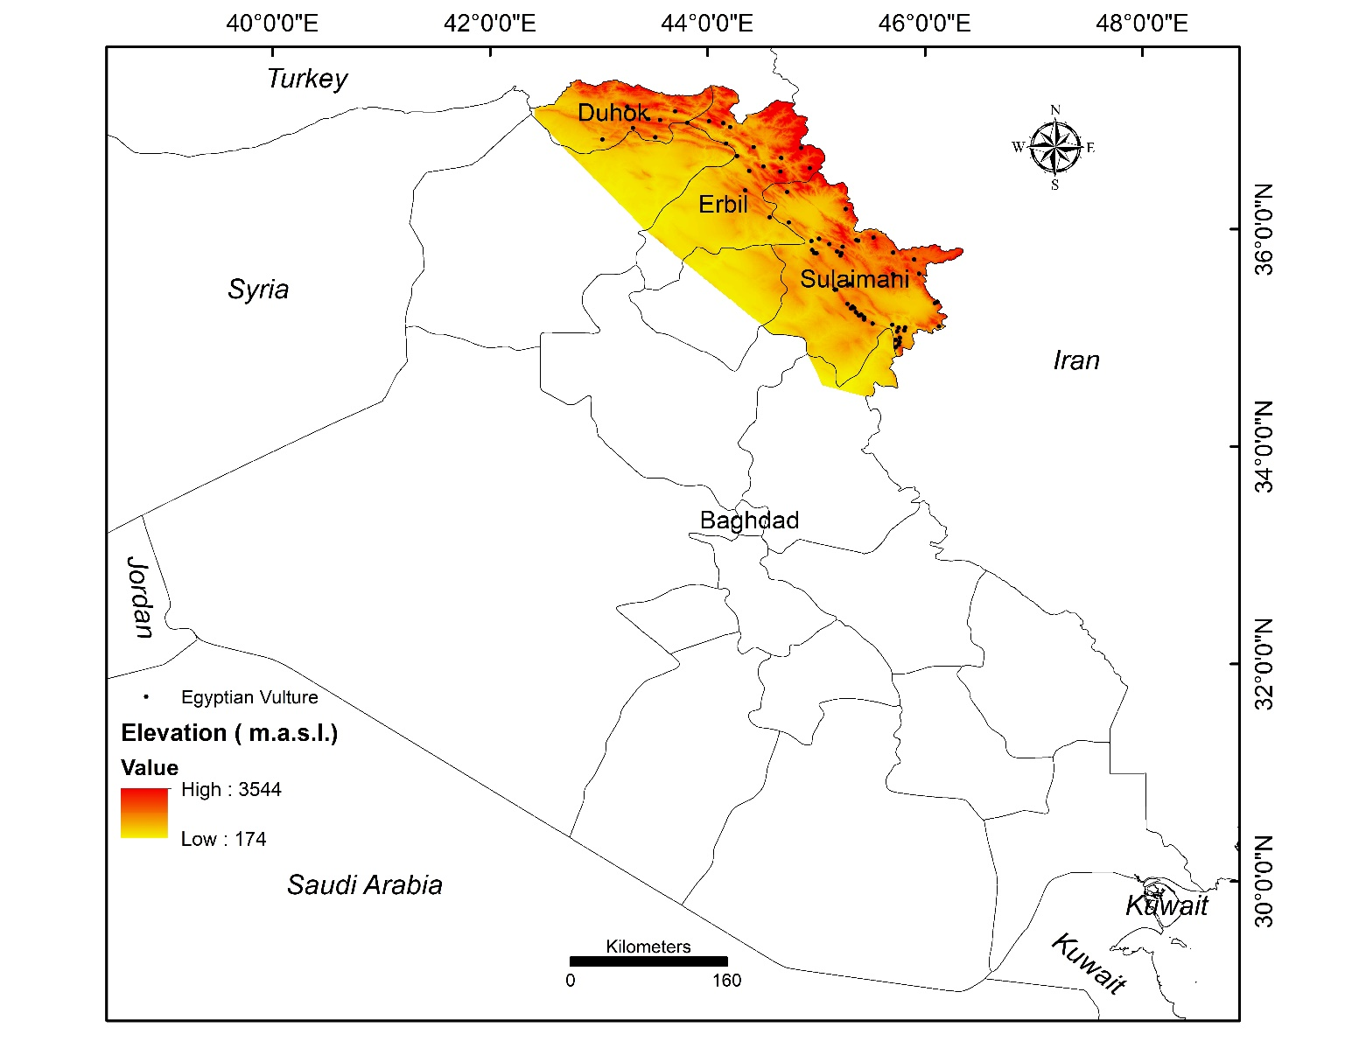
Figure 1 Extent of the study site and administrative boundaries

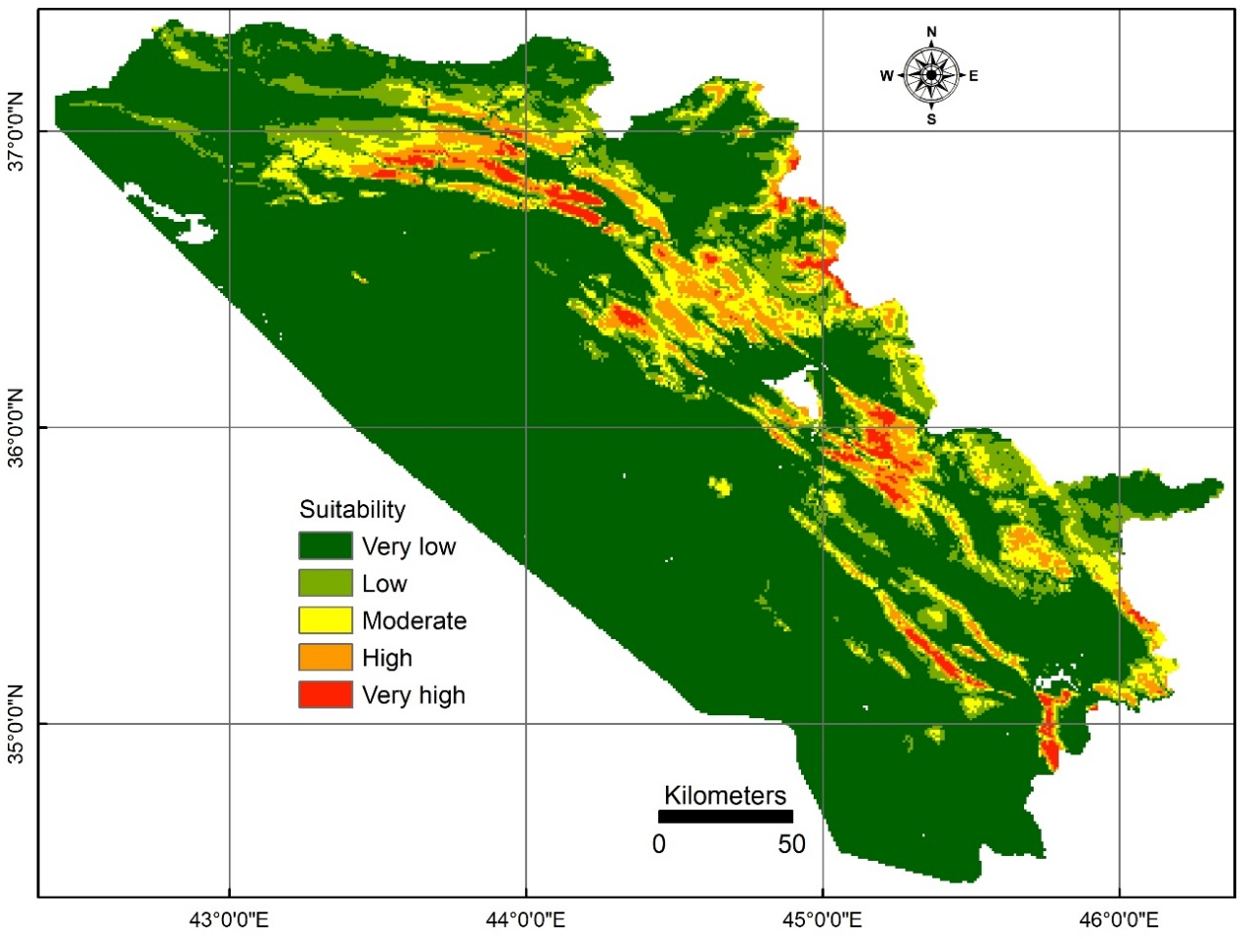
Figure 2 Categorical habitat suitability for the Egyptian Vulture in the KRI

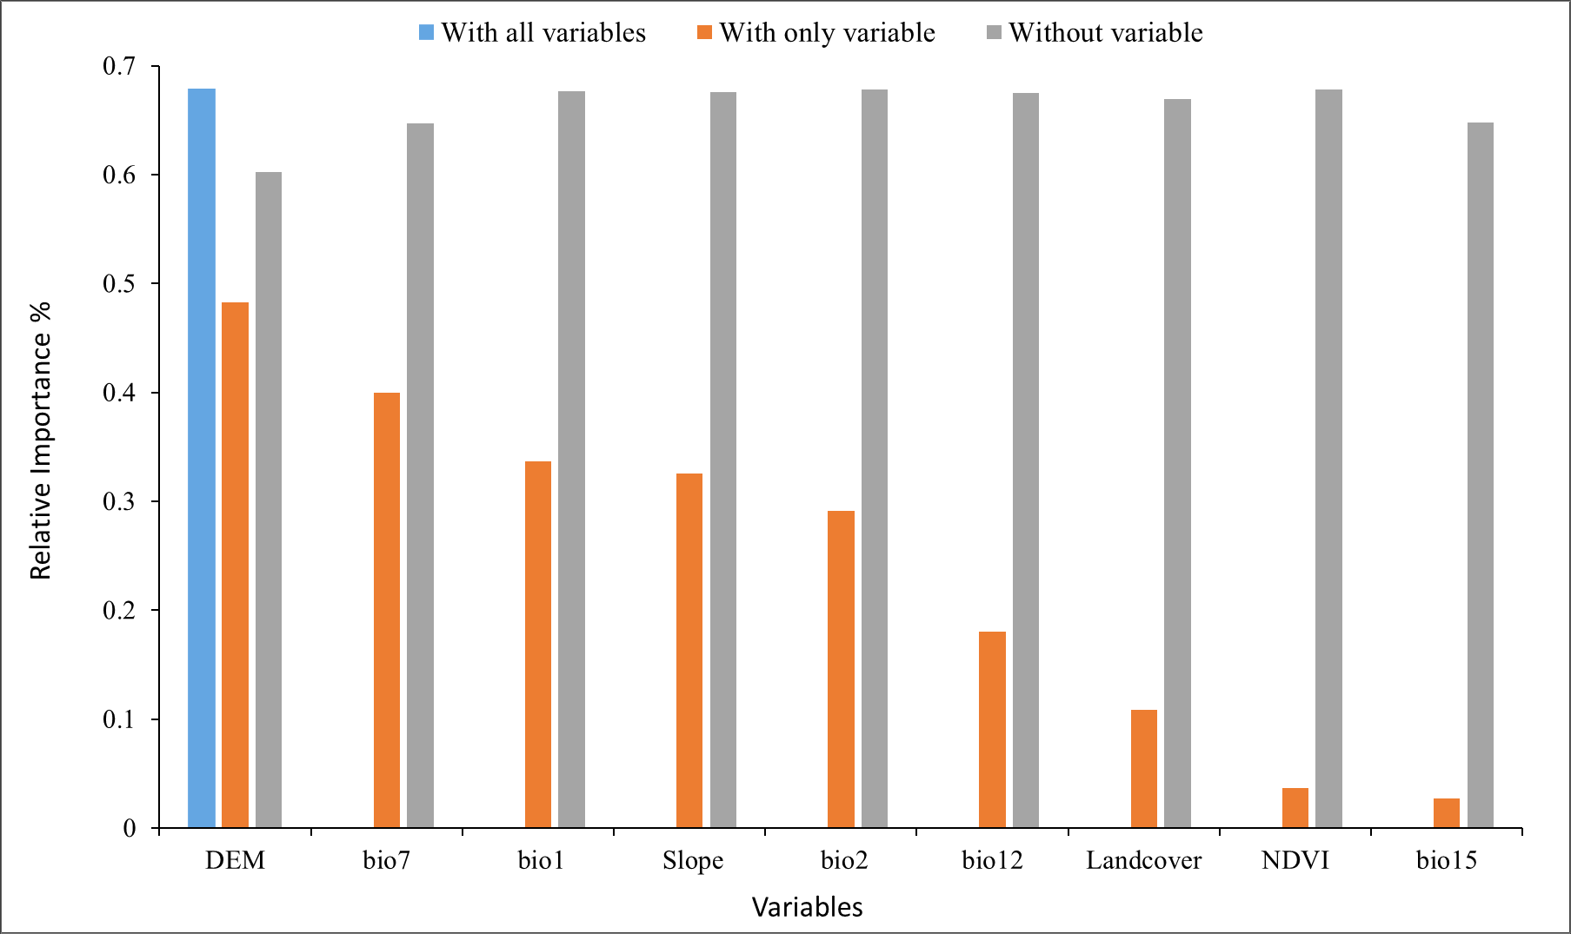
Figure 3 Jackknife test of the regularizing training gain for the variables relative importance % (training gain) for the habitat distribution of the Egyptian Vulture in the KRI. The orange bars indicate the relative importance of each variable descending from left to right. The blue bar indicates the overall training gain of the model (i.e., all the variables included). The grey bars indicates the training gain value of all variables minus one variable at a time.

Appendices
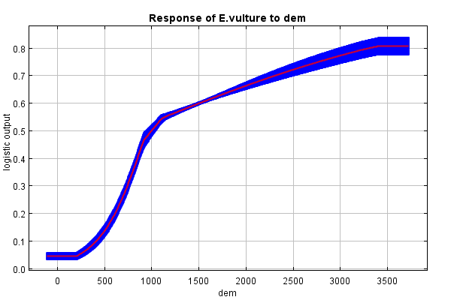
Fig. A.1 Response curve of Egyptian vulture habitat suitability to elevation

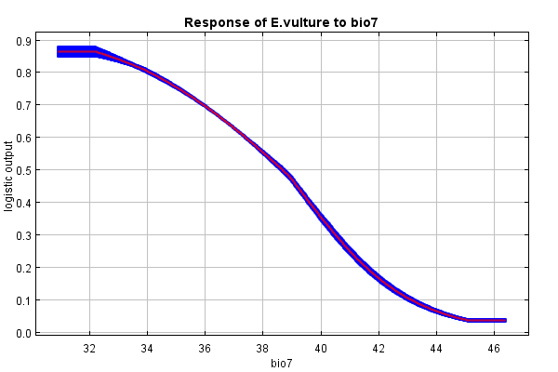 Fig. A.2 Response curve of Egyptian vulture habitat suitability to Temperature Annual Range (bio7)

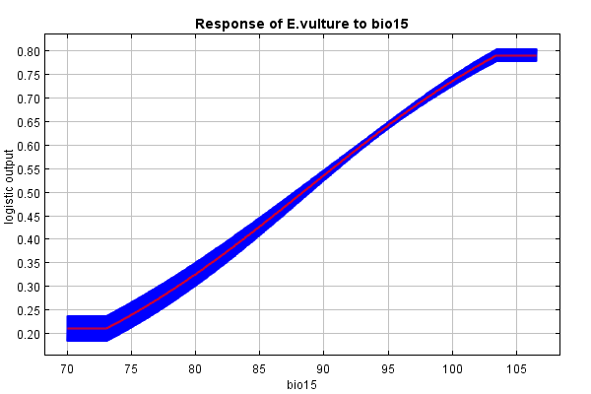
Fig. A.3 Response curve of Egyptian vulture habitat suitability to (Precipitation Seasonality (Coefficient of Variation) (bio15)

