Title Page
Type of manuscript: Original Article
Title: Intergenerational Change in Anthropometry of Children and Adolescents in the New Delhi Birth Cohort
Authors and affiliations:
Sikha Sinha,¹ Dheeraj Shah,² Clive Osmond,³ Caroline H.D. Fall,³ Santosh K Bhargava,⁴ and Harshpal Singh Sachdev¹*
¹Division of Clinical Epidemiology and Pediatrics, Sitaram Bhartia Institute of Science and Research, New Delhi, India, ²Department of Pediatrics, University College of Medical Sciences and GTB Hospital, New Delhi, India, ³MRC Lifecourse Epidemiology Unit, University of Southampton, Southampton, UK and ⁴Founder, New Delhi Birth Cohort, D-7 Gulmohar Park, New Delhi, India
*Corresponding author: Prof. Harshpal Singh Sachdev, Senior Consultant Pediatrics and Clinical Epidemiology, Sitaram Bhartia Institute of Science and Research, B-16 Qutab Institutional Area, New Delhi 110016, India. Email: hpssachdev@gmail.com

Word count: (main text): 3686; (abstract) 267
Abstract
Background: A comparison of the anthropometry of children and adolescents with that of their parents at the same age, may provide a more precise measure of intergenerational changes in linear growth and Body-Mass-Index (BMI).
Methods: New Delhi Birth Cohort participants (F1), born between 1969 and 1972, were followed-up for anthropometry at birth and 6-monthly intervals until 21 years. 1447 children aged 0-19 years (F2) born to 818 F1 participants were measured (weight and height) at variable intervals providing 2236 sets of anthropometries. Intergenerational changes (F2-F1) in height and BMI (absolute and SD units) were computed by comparing children with their parents at corresponding ages.
Results: F2 children were taller (P<0.001) than their parents at corresponding ages; the increase (mean (95% CI) World Health Organization SD units) was 0.97 (0.83, 1.11), 1.21 (1.10, 1.32), 1.09 (0.98, 1.19), 1.10 (1.00, 1.21) and 0.75 (0.65, 0.85) for age categories of 0-5, 5-7.5, 7.5-10, 10-12.5, and >12.5 years, respectively. In absolute terms, this increase ranged from 3.5 cm (0-5-year-olds) to 7.5 cm (10-12.5-year-olds). The corresponding increases in BMI SD scores were 0.32 (0.18, 0.47), 0.60 (0.45, 0.75), 1.13 (0.99, 1.27), 1.30 (1.15, 1.45), and 1.00 (0.85, 1.15), respectively. The absolute BMI increase ranged from 1-3 kg/m² >5-years age (~3 kg/m² >10-years). The intergenerational increases were comparable in both sexes, but were greater in children born and measured later. A positive change in socio-economic status was associated with an increase in height across the generations.
Conclusions: Children and adolescents, throughout the ages 0-19 years, have become considerably taller, and have a higher BMI than their parents at corresponding ages in an urban middle-class Indian population undergoing socio-economic improvements.
Keywords: Anthropometry, Body mass index, Growth, Height, Intergenerational changes, Obesity, Secular trend

Key Messages:
- Children and adolescents, throughout the ages 0-19 years, have become considerably taller, and have a higher body mass index (BMI) than their parents at corresponding ages in an Indian urban middle-class population undergoing socio-economic improvements.
- Children and adolescents were ~1 standard deviation (SD) (World Health Organisation Reference) taller, translating into absolute height increases of 3.5 cm in 0-5-year-olds to 7.5 cm in 10-12.5-year-olds, while BMI gains ranged from 0.3 SD below 5 years of age (0.4 kg/m²) to 1.3 SD (3 kg/m²) at 10-12.5 years.
- A sustained improvement in overall living conditions may be all that is required to increase anthropometry in children and adolescents in a transitioning population.

Intergenerational Change in Anthropometry of Children and Adolescents in the New Delhi Birth Cohort

INTRODUCTION
India has achieved substantial economic growth in the past few decades, but the level of childhood undernutrition and stunting still remains high. In the nationally representative Comprehensive National Nutrition Survey (CNNS) carried out between 2016 and 2018 in 30 states of India, 35% of children aged 0-59 months, and 22% of school-age (5-9 years) children were stunted (height-for-age < −2 SD of World Health Organisation (WHO) reference).¹ The corresponding figures for underweight (weight-for-age < −2 SD of WHO reference) were 33% and 10%, respectively. A low weight-for-height is often used to estimate the burden of acute undernutrition in populations, for example, severe acute malnutrition (weight-for-height below −3 SD of WHO reference), which necessitates therapeutic feeding and monitoring. As per CNNS data, 17% of Indian children 0-59 months of age were wasted (weight-for-height below −2 SD of WHO reference) while 23% of school-age children had low (below −2 SD of WHO reference) Body-Mass-Index (BMI) for age.¹ Linear growth faltering is not only associated with higher under-5 mortality,² but also has long-term associations with poorer learning and earning potential, particularly in first two years of life.^{3,4}
Periodic national surveys, over the last two decades, suggest a relatively slow decline in stunting among under-five children in India.^{1,5,6} Cross-sectional surveys from Europe and North America had documented a secular increase in height and weight of children and adolescents in the 1900s but these trends had flattened in the past few decades.⁷⁻⁹ On the other hand, some African countries as well as deprived populations in upper-income countries showed no or only a marginal positive secular trend in growth of children and adolescents.¹⁰⁻¹³ Experience suggests that several generations may be needed to mitigate the effects of undernutrition on populations, particularly during early childhood.¹⁴ Also, large-scale rural-urban migration has the propensity to initially dilute the improvements, especially among the middle-income population of urban locales since rural-born populations are likely to be benefited less by the socio-economic transition.^{15,16} Thus, repeated cross-sectional surveys may not generally provide the most robust evidence of secular change in anthropometry and its magnitude due to change in the underlying source population.
A better indication of anthropometric secular trends can emerge from intergenerational changes within the same family. Such data are relevant for formulating realistic anthropometric goals when designing nutritional interventions, and also to recognize any unwanted trends such as overweight and obesity among those undergoing rapid nutritional transition. Both birth weight and adult height are consistently increasing as seen from a few intergenerational studies in European and American populations.¹⁷ Data from a British cohort showed an increase of about 1 cm in height among offspring at 7 years of age in comparison to their parents’ height at broadly comparable ages.¹⁸ BMI also showed an increasing trend in two generations (increase of 0.16 SD for boys and 0.25 SD for girls),¹⁹ with families living in social housing and in households with more crowding having a higher risk of overweight and obesity in the next generation.²⁰ From low- and middle-income (LMIC) settings, we earlier reported preliminary findings from the New Delhi Birth Cohort (NDBC), which suggested that children throughout 0-10 years of age were considerably taller and heavier than their parents at similar ages, while only those aged 5-10 years had a higher BMI than their parents.²¹ However, there is scant data, which can be used to evaluate patterns of such intergenerational change in anthropometry for the entire age span from birth to adolescence. This communication attempts to fill this void, and also evaluate the association of intergenerational changes in height and BMI with transition in socio-economic status (SES).

Methods
Study sample and data collection
The New Delhi Birth Cohort (NDBC) comprised 8181 (8030 singletons and 151 twins) live births (F1 generation) from 9169 pregnancies in 20,755 married women recruited over a 3-year period between 1969 and 1972 from a population of 119,799 living in a defined area of 12 km² in South Delhi, India.^{22,23} The cohort was followed-up through home visits by trained personnel, from the antenatal period by collecting data on the parental (F0 generation) and family factors, including schooling, occupation and socio-economic characteristics. The weight and length of the infants were recorded within 72 hours of birth, at the ages of 3, 6, 9 and 12 months (± 7 days) and every 6 months (± 15 days) until 14-21 years using standardized techniques. At the time of recruitment, 59.9 percent of families had an income above 50 rupees per month (national average, 28.4). Only 14.9 percent of parents were illiterate (national average, 66.3). Nevertheless, 43.0 percent of families lived in only one room.²³
Between 1998 to 2002 (age 26-30 years), 2584 (31.6%) participants (F1 generation) of this cohort were traced again, out of which 1583 (19.3%) consented to participate. Finally, 1526 (18.7%) were followed-up for anthropometry and cardio-metabolic risk factors after excluding 57 (24 were pregnant, 2 withdrew, and 31 were unreliably linked to earlier data).²³ In comparison with the original cohort, this cohort had more males (7% higher), higher maternal literacy (6% higher), higher (by 32 g) mean birth weight and more mean length at birth (by 2 mm). The height, weight and BMI in childhood and adolescence were about 0.1 SD lower than in the original cohort.²³
Subsequently, subsets of these 1526 participants could be traced and consented for follow-up at ages 33-39, 36-42 and 42-46 years. During these assessments, their (F1 generation) socio-economic profile (education and occupation, occupation of spouse, type of housing, material possessions, family size, water and sanitation practices) was recorded. Simultaneously, their children (F2 generation) of ages 0-19 years were invited to attend the clinics for anthropometry. Informed consent from parents (F1) and assent from children >6 years of age were obtained at the time of these assessments. The height (length below 2 years of age) and weight of the F2 generation were recorded using standard techniques.²⁴ Recumbent length in children below 2 years of age was measured using an infantometer, and height in children ≥2 years of age using a portable stadiometer to the nearest 0.1 cm. Weight was measured using calibrated digital weighing scales with a sensitivity of 0.1 Kg.

Statistical methods
BMI was calculated as weight in kilograms divided by height in meters squared. Anthropometric parameters for both F1 and F2 generations were converted to WHO length/height-for-age and BMI-for-age Z-scores at the date of measurement, using an SPSS macro for age-groups 0-5 years and 5-19 years.^{25,26} Simultaneously, internal cohort Z-scores of the population were calculated by modelling the longitudinal height, weight and BMI measurements of the F1 generation into the growth charts using the Lambda-Mu-Sigma (LMS) method.^{27,28} These were then used to compute age- and sex-specific Z-scores for F2 children at the date of measurement. The intergenerational change in anthropometry (F2-F1) was computed using both these types of Z-scores. To compare intergenerational anthropometry at similar ages, the F1 Z-score was interpolated at the exact age of the F2 measurement, using neighbouring F1 measurements. The interpolation was acceptable if the F1 observation was within (+/-) 6 months for ages up to 1 year; within 1 year for ages 1 to 2 years; within 1.5 years for ages 2 to 3 years; and within 2 years thereafter. To estimate the comparison in absolute units, the interpolated F1 Z-score at the exact date of F2 measurement was back-transformed using the L, M and S values for the internal cohort Z-scores.²⁹
This intergenerational model had a 4-level data structure comprising the F0 generation having one or more F1 children (F1-F1 siblings), the F1 generation having one or more F2 children (F2-F2 siblings) and repeated measurement of same F2 children over different time periods. Thus, a mixed model approach was used to allow for this structure.³⁰ These multilevel models allowed for variation among the F2-F2 siblings and F2 repeated measurement, but there were few F1 (46 pairs) sibships to disturb the intergenerational effect size estimates and their standard errors; so subsequently we ignored this variance component. The statistical test for intergenerational change in anthropometry uses the multilevel regression model estimate of the intercept and its 95% confidence interval. This corresponds to the fact that the 1-sample t-test is equivalent to regression analysis of the intercept in the model y = a + error. Other variables included in the model were centred.
The change was quantified in five age groups: 0-5, 5-7.5, 7.5-10, 10-12.5 and >12.5 years, adjusting for all combinations of the sex of the child and parent. We chose these age groups to have roughly similar, yet substantial numbers, and to have similar, interpretable widths. This intergenerational change was further evaluated for APC (Age, Period and Cohort) effects and socio-economic characteristics recorded both at F1 birth and at F2 measurement. Characteristics used at F1 birth were small pox and BCG vaccination, delivery at a healthcare facility, maternal (F0) schooling, paternal (F0) occupation, family income, crowding, type of family, type of housing, type of toilet, water supply, and facilities for sanitation and water supply. At F2 measurement, these were education of the F1 parent, material possessions, crowding, paternal and maternal occupation, type of toilet, general and drinking water supply facilities, and general and drinking water source. To maintain sample size, we imputed missing socio-economic variables. Multiple imputation was run using the fully conditional version of MICE (multiple imputation by chained equations).^{31,32} Imputation was required for 1-18 participants (0.1%-2.2%) at F2 measurement, and for 11-261 (1.3%-31.9%) subjects for 11 variables and for 311 (38%) and 409 (50%) participants for small pox and BCG vaccinations, respectively at F1 birth. We derived the first principal component score at both timepoints.³³ These had a correlation of 0.52. In the mixed model, we included both the mean and difference of these scores (correlation 0.00) to represent the typical family socio-economic level and its change over the study. Data were analyzed using SPSS 20.0.

Results
We analysed 2236 anthropometric measurements of F2 child-F1 parent pairs between 0 and 19 years for 1447 unique F2 children (Figure 1). These 1447 F2 children were born to 818 F1 parents and among these 818 F1 participants, there were 46 pairs of F1-F1 siblings. We compared socio-economic variables and anthropometry of the F1 parents included in the intergenerational analysis (n=818) with those who were lost to follow-up (n=708). In comparison to those who were lost to follow-up, participants included in the intergenerational analyses resided more often (73.6% vs. 65.7%) in owned houses and maternal literacy was higher (73% vs. 65%), whereas there were no differences in healthcare facilities, sources of water supply. toilet facilities, household income, and anthropometry (height or BMI) at birth, 2 years, 8 years and 15 years, both for males and females (data not shown).
Among 1447 unique F2 children, 259 children (17.9%) were single, and 1188 (82.1%) were F2-F2 siblings; 624 (43.1%) children were measured more than once at different ages. The unique 1447 F2-F1 pairs included 492 (34.0%) father-son, 383 (26.5%) father-daughter, 318 (22.0%) mother-son and 254 (17.5%) mother-daughter comparisons. The distribution of these parent-child pairs in the total sample of 2236 F2-F1 pairs was 811 (36.3%) father-son, 622 (27.8%) father-daughter, 438 (19.6%) mother-son and 365 (16.3%) mother-daughter comparisons.
The socio-economic characteristics at the time of the parents’ (F1 generation) birth and at the time of the child’s (F2 generation) measurement are summarized in Supplementary Table S1 and showed large changes. When the F1 generation was born, one-fourth of the families were residing in rented accommodation, nearly two-thirds (62%) had a common/communal general water supply, and a large majority (81%) used common/communal toilet facilities. At the F2 time of measurement, more than 80% had separate general and drinking water sources, and 96% had separate toilet facilities. The educational status of the mothers of the F2 generation was higher than that of the mothers of the F1 generation (0% vs 27% illiterate; 82% vs 13.4% beyond high school), and overcrowding was lower (1.8 vs 3.6 members/room) for the F2 generation.
Table 1 compares the length/height-for-age and BMI z-scores between F1 and F2 generation whereas Table 2 presents the intergenerational changes. F2 children in all age groups were taller (P<0.001) than their parents at corresponding ages; the increase was broadly similar (~1 SD) for height in all age groups except beyond 12.5 years when the increase narrowed down to about 0.75 SD of WHO reference (Table 2 and Supplementary Figure S1). In absolute terms, this ranged from an increase of about 3.5 cm in 0-5-year-olds to 7.5 cm in 10-12.5-year-olds. For BMI also, there was an increase in all age groups; this was greater beyond 5 years of age with the maximum increase in 7.5-12.5-year-olds (0.3 SD <5 years and 0.6 to 1.3 SD later). The average change in absolute BMI ranged from 1 to ~3 kg/m² in the >5-year age group (~3 kg/m² in >10 years). The average change in height SD score for F2 males and F2 females were comparable in all age groups except for the >12.5-year age group where the change in males was almost double that in females (Figure 2 and Supplementary Table S2). For BMI, males and females had broadly comparable intergenerational increase in SD scores. The quantum of anthropometric change was comparable (overlapping confidence intervals) for WHO and internal cohort Z-scores.
We used a principal component analysis of SES measurements obtained at the time of birth of F1 subjects to represent their early SES. Similarly, we used SES measurements obtained at the time of measurement of F2 subjects to represent this later SES. We entered these into the mixed model as the two uncorrelated variables “change in SES” and “mean SES”. Supplementary Table S3 shows the mix of measurements that leads to the principal components we have used. Table 3 shows that positive change in SES, but not mean SES, was associated with an increase in height across the generation. Change in SES was not clearly associated with change in BMI across the generations, but mean SES was positively associated with change in BMI in the three older age groups. Adjustment for SES made only small changes to the precision of the estimation of the overall intergenerational effects.
Children born and measured later had a clear and repeated tendency (overlapping 95% confidence intervals) for greater intergenerational change for both height and BMI (Table 4).

Discussion
This study documented a consistent and substantial intergenerational increase in height and BMI throughout infancy, childhood and adolescence in an urban middle-income cohort from a LMIC undergoing socio-economic and nutrition transition. Children and adolescents were ~1SD taller than their parents at corresponding ages, translating into absolute height increases of 3.5 cm in 0-5-year-olds to 7.5 cm in 10-12.5-year-olds. BMI increases ranged from 0.3 SD below 5 years of age (0.4 kg/m²) to 1.3 SD (3 kg/m²) at 10-12.5 years. The changes were similar for boys and girls, except for almost double height gain for boys beyond 12.5 years. A positive change in SES status was associated with an increase in height across the generations. Prospectively collected data from a large sample encompassing 0-19 years of age, comparison with parents at corresponding ages during their childhood, and use of appropriate statistical techniques inspire confidence in these findings.
Our findings are in agreement with height increase trends of about 1 cm/decade derived from cross-sectional data from Europe in the early 1900s,^{8,34-36} and from many Asian countries in the late 1900s.^{8,37-39} These results are also in conformity with the steady decline in stunting observed in periodic nutritional surveys in India.^{1,4-6} However, the intergenerational model demonstrated a greater secular trend in height in a middle-income urban locale. There is a scarcity of similar intergenerational comparisons of childhood anthropometry, especially from LMIC settings. In a follow-up analysis of the height of offspring (measured once between 4-18 y) of 1958 British birth cohort (measured at 7 y), the average childhood height had increased by only 1 cm.¹⁸ The lower intergenerational change in height in comparison to NDBC may reflect slowing of the secular trend in the British cohort due to general improvement in living conditions. In the British cohort too, the intergenerational changes in height were greater for lower social classes (based on occupation, education and housing).²⁰ In a series of follow-up studies from a nutritional supplementation program in Guatemala, researchers demonstrated a secular trend in early childhood growth and reduced rates of stunting across two generations, which was further enhanced by provision of improved nutrition to the mothers.⁴⁰⁻⁴² However, in these studies only mothers were evaluated and the intergenerational effects comprise a mixture of nutrient supplementation and other components including socio-economic transition. In contrast, in the NDBC there was no ongoing formal food supplementation programme. A positive secular trend in BMI is reported from several cross-sectional comparisons in transitioning societies.⁴³ Intergenerational data are available from British¹⁹ and Danish⁴⁴ cohorts, in which a higher BMI was recorded in children at approximately 7 years of age in comparison to their parents at broadly comparable age (increase in median by 0.23 units for boys and 0.46 units for girls in the British cohort; and -0.1 to 0.2 units for children born between 1952-1970 and 0.3-0.5 units for children born between 1971-1989 in the Danish cohort). Our preliminary findings in a much smaller sample (432 children) restricted up to the age of 10 years had shown an intergenerational increase in BMI by 0.2 units in 0-5-year-olds, and by 1.9 units in 5-10 year-olds.²¹ The present analysis confirms the trends in a much larger sample extending up to the end of adolescence, wherein substantial increases in both height and BMI were observed.
The height increase was almost constant at ~1SD throughout 0-19 years while the BMI gain increased after 7.5 years to ~1SD. This lends support to the hypothesis that children “grow up” before “growing out”.²¹ The greater magnitude of intergenerational change in children born and measured later suggests an accelerating nutrition transition with time. Interestingly, the SD was greater for all groups and indicators in the F2 generation compared to F1, which further suggests that the upward transition was not uniform in the whole population. The lower intergenerational change in height in girls than boys beyond 12.5 years age may be related to a trend towards early puberty and menarche in girls in a setting of increasing BMI^{45,46} leading to earlier growth cessation. Prenatal and early postnatal growth restriction combined with greater subsequent natal weight gain are associated with earlier puberty, well demonstrated in girls.⁴⁷ There is some evidence that female puberty is more sensitive to anthropometric transitions.^{48,49} This may be related to ‘life history trade offs’ to support reproductive fitness⁵⁰ that could plausibly dilute some of the intergenerational benefit in linear growth, especially in girls.
Intergenerational changes observed in our study are likely to be a result of improved socio-economic conditions, nutrition and health. Better availability of water and sanitation facilities were apparent in the second generation of our cohort. Further, a positive change in SES status was associated with an increase in height across the generations. In the case of the mother-to-child comparison, the effect could also be mediated by larger overall and pelvic size of mothers and a better intrauterine environment for the next generation. The paternal effect could be mediated directly through genetic and epigenetic effects, and indirectly through assortative mating, often prevalent in society.
The findings of our study may be generalizable to urban LMIC settings undergoing rapid socio-economic changes, and the estimates may not directly apply to rural populations or to societies with continuing high levels of poverty and poor living conditions. These intergenerational changes are likely to result in greater adult height, but the precise magnitude needs documentation during future follow-up. The substantial increase in BMI in adolescence, if primarily related to fat instead of lean tissue, is disconcerting in view of the ongoing epidemic of obesity and related chronic diseases in LMICs. Earlier studies suggest that an increase in BMI after childhood is associated with increased adiposity.^{51,52} This hypothesis needs confirmation through robust measures of body composition and simultaneous consideration of potential approaches to reduce intergenerational increase in adiposity.
What are the implications for public health policy? Our findings suggest that there has been considerable improvement in childhood and adolescent anthropometry over time in urban middle-income families of New Delhi, associated with improvement in their general living conditions and socio-economic status. The apparently slow improvement seen in cross-sectional surveys and haste to meet the Sustainable Development Goals should not alarm the policy makers to implement isolated “magic-bullet” or vertical interventions.⁵³ Simultaneously, monitoring and interventions may be required to detect and prevent the adverse changes leading to overweight, obesity and related cardiometabolic diseases. The magnitude of the intergenerational increase can serve as a rough guide for forecasting the expected change with improvement in overall living conditions.
The main limitation of this study was that the present intergenerational analysis represented only about 10% of the original birth cohort. However, among those available and lost to follow-up, the differences in mean size at birth and in childhood were trivial. The effect of this selection bias, if any, may have slightly underestimated the intergenerational increase, since those lost to follow-up had relatively poorer SES status at birth and lower anthropometric measurements during childhood.^{20,21} Further, apart from refusal of consent, attrition was inevitable with this follow-up duration, especially because of deaths and out-migration due to demolition of unauthorized construction, marriage, and job opportunities. Moreover, fathers outnumbered mothers (1.5:1) as parents, because females more often migrate after marriage. This could have theoretically underestimated the magnitude of change, as maternal environment influences on birth weight and early child anthropometry are well documented and probably greater than paternal effects.^{54,55} Other limitations of the analysis were related to lack of a nationally representative population, inconsistency of the type and timing of SES data collected across two generations, small sample size in some groups for APC effect analysis, and absence of information on birth weight in the F2 generation.
We conclude that children and adolescents, throughout the ages 0-19 years, have become considerably taller, and have a higher BMI than their parents, in an urban middle-class population undergoing socio-economic improvements. A sustained improvement in overall living conditions, may be all that is required to increase anthropometry in children and adolescents in a transitioning population.
Ethics approval: Authors confirm that all data were collected after obtaining approvals from relevant research/ethics committees according to the guidelines prevailing at the time. During the various waves of data collection, institutional ethics committee clearances were obtained from the All India Institute of Medical Sciences (A:60:12-1-05; IEC/NP-183/2012 & RP-12/2012; IEC/NP-372/2012 & RP-10/2012; IESC/T-40/03.01.2014; IEC/NP-410/09/10/2015; IEC-347/03.05.2019), Maulana Azad Medical College (NO.F.501(134)03/EC05/MC(ACA)/12358), S.L. Jain Hospital (SLJH/IEC/No.1), and Sitaram Bhartia Institute of Science and Research (SBISR/2012/002; SBISR/RES1/3/2012; SBISR/IEC/2014/001; IEC/SBISR/2015/1; FL/SBISR/IEC/2019-01). Authors declare that the study procedures conform to the principles laid down in Declaration of Helsinki.
Author contributions: SS, HSS, CHDF, SKB conceptualised the study. SS, CO, CHDF, DS, HSS analysed and interpreted the data. SS and DS drafted the initial manuscript. All authors provided critical inputs into revision of the article, and are willing to be accountable for all aspects of the study.
Data availability: We are willing to share data with bona fide researchers, who should contact the corresponding author; data sharing with researchers outside India will require application to and clearance by the Health Ministry.
Supplementary data: Supplementary data are available at IJE online.
Funding: The original cohort studies were supported by the National Center for Health Statistics, USA and the Indian Council of Medical Research, India. Later phases have been supported by Department of Biotechnology, India; British Heart Foundation, UK; Wellcome Trust, UK; Medical Research Council; UK; Department for International Development, UK; and Bill and Melinda Gates Foundation, USA.

Conflict of interest: None declared.

References

- Ministry of Health and Family Welfare, Government of India, UNICEF, Population Council. Comprehensive National Nutrition Survey 2016–2018. National Health Mission, 2019. https://nhm.gov.in/WriteReadData/l892s/1405796031571201348.pdf (accessed Sept 28, 2020).
- Olofin I, McDonald CM, Ezzati M, et al; Nutrition Impact Model Study (anthropometry cohort pooling). Associations of suboptimal growth with all-cause and cause-specific mortality in children under five years: a pooled analysis of ten prospective studies. PLoS One 2013;8:e64636.
- Sachdev HS, Kathuria AK, Sinha S, Anand D, Bhargava SK. Association of human capital with physical growth from birth to adulthood: evidence from the New Delhi Birth Cohort, India. World Bank Group: Human Nutrition and Population Discussion Paper, June 2020. http://documents1.worldbank.org/curated/en/212721596523665354/pdf/Association- of-Human-Capital-with-Physical-Growth-from-Birth-to-Adulthood-Evidence-from-the-New-Delhi-Birth-Cohort-India.pdf (accessed October 13, 2020)
- Dewey KG, Begum K. Long-term consequences of stunting in early life. Maternal Child Nutr 2011; 7 Suppl 3(Suppl 3): 5-18.
- International Institute for Population Sciences, ICF International. National Family Health Survey (NFHS-4), 2015–16. Mumbai: International Institute for Population Sciences, 2017.
- International Institute for Population Sciences and Macro International. National Family Health Survey (NFHS-3), 2005–06: India: Volume I. Mumbai: International Institute for Population Sciences, 2007.
- Komlos J, Lauderdale BE. The mysterious trend in American heights in the 20th century. Ann Hum Biol 2007;34:206–15.
- Stevens GA, Finucane MM, Paciorek CJ, et al. Trends in mild, moderate, and severe stunting and underweight, and progress towards MDG 1 in 141 developing countries: a systematic analysis of population representative data. Lancet 2012;380:824-34.
- Myburgh J, Staub K, Rühli FJ, Smith JR, Steyn M. Secular trends in stature of late 20th century white South Africans and two European populations. Homo 2017;68:433-39.
- Malina RM, Zavaleta AN. Secular trend in the stature and weight of Mexican-American children in Texas between 1930 and 1970. Am J Phys Anthropol 1980:52:453-61.
- Billewicz WZ, McGregor IA. A birth-to-maturity longitudinal study of heights and weights in two West African (Gambian) villages, 1951-1975. Ann Hum Biol 1982;9:309-20.
- Oyedeji GA, Olamijulo SK, Osinaike AI, Esimai VC, Odunusi EO, Aladekomo TA. Secular trends in the growth of children aged 0-6 years in a rural Nigerian community. Ann Trop Paediatr 1996;16:11-7.
- Tobias PV. Adult stature in southern African Negroes – further evidence on the absence of a positive secular trend. S Afr Med J 1990;78:97-101.
- Martorell R, Zongrone A. Intergenerational influences on child growth and undernutrition. Paediatr Perinat Epidemiol 2012;26 Suppl 1:302-14.
- Jordan S, Lim L, Seubsman SA, Bain C, Sleigh A; Thai Cohort Study Team. Secular changes and predictors of adult height for 86 105 male and female members of the Thai Cohort Study born between 1940 and 1990. J Epidemiol Community Health 2012;66:75-80.
- Paciorek CJ, Stevens GA, Finucane MM, Ezzati M; Nutrition Impact Model Study Group (Child Growth). Children's height and weight in rural and urban populations in low-income and middle-income countries: a systematic analysis of population-representative data. Lancet Glob Health 2013;1:e300-9..
- Ramakrishnan U, Martorell R, Schroeder DG, Flores R. Role of intergenerational effects on linear growth. J Nutr 1999;129(2S Suppl):544S-549S.
- Li L, Power C. Influences on childhood height: comparing two generations in the 1958 British birth cohort. Int J Epidemiol 2004;33:1320-8.
- Pinot de Moira A, Power C, Li L. Changing influences on childhood obesity: a study of 2 generations of the 1958 British birth cohort. Am J Epidemiol 2010;171:1289-98.
- Li L, Manor O, Power C. Are inequalities in height narrowing? Comparing effects of social class on height in two generations. Arch Dis Child 2004;89:1018-23.
- Sinha S, Aggarwal AR, Osmond C, Fall CH, Bhargava SK, Sachdev HS. Intergenerational change in anthropometric indices and their predictors among children in New Delhi Birth Cohort. Indian Pediatr 2017;54:185-192.
- Richter LM, Victora CG, Hallal PC, et al. Cohort profile: the consortium of health-orientated research in transitioning societies. Int J Epidemiol 2012;41:621-6.
- Bhargava SK, Sachdev HS, Fall CH, et al. Relation of serial changes in childhood body-mass index to impaired glucose tolerance in young adulthood. N Engl J Med. 2004;350:865-75.
- World Health Organization. Physical Status: The Use and Interpretation of Anthropometry; Report of a WHO Expert Committee Technical Report. Geneva: World Health Organization; 1995.
- The WHO Child Growth Standards. Available from: http://www.who.int/childgrowth/standards/en/ (accessed September 28, 2020)
- WHO Growth Reference data for 5-19 years. Available from: http://www.who.int/growthref/en/ (accessed September 28, 2020)
- Cole TJ. The LMS method for constructing normalized growth standards. Eur J Clin Nutr 1990;44:45-60.
- Pan H, Cole T. LMS chart maker Light version 2.54. A program for calculating age-related reference centiles using the LMS method. London, UK: 2011.
- Construction of LMS Parameters for the Centers for Disease Control and Prevention 2000 Growth Charts. National Health Statistics Reports. Number 63;2013.
- Cheng J, Edwards LJ, Maldonado-Molina MM, Komro KA, Muller KE. Real longitudinal data analysis for real people: building a good enough mixed model. Stat Med 2010;29:504-20.
- IBM SPSS Missing Values 20. https://www.sussex.ac.uk/its/pdfs/SPSS_Missing_Values_20.pdf (accessed September 28, 2020).
- Azur MJ, Stuart EA, Frangakis C, Leaf PJ. Multiple imputation by chained equations: what is it and how does it work?. Int J Methods Psychiatr Res 2011;20:40-49.
- Vyas S, Kumaranayake L. Constructing socio-economic status indices: how to use principal components analysis. Health Policy Plan 2006;21:459-68.
- Krawczynski M, Walkowiak J, Krzyzaniak A. Secular changes in body height and weight in children and adolescents in Poznan, Poland, between 1880 and 2000. Acta Paediatr 2003;92:277-82.
- Cameron N. The growth of London schoolchildren 1904-1966: an analysis of secular trend and intra-county variation. Ann Hum Biol 1979;6:505-25.
- Zellner K, Jaeger U, Kromeyer-Hauschild K. Height, weight and BMI of schoolchildren in Jena, Germany--are the secular changes levelling off? Econ Hum Biol 2004;2:281-94.
- Chen TJ, Ji CY. Secular changes of stature in rural children and adolescents in China, 1985-2010. Biomed Environ Sci 2014;27:573-81.
- Chen ST. Secular trend of growth in Malaysian children. J Singapore Paediatr Soc 1990;32:102-7.
- Yap MA, Lun KC, Lyen KR, Lam SL. Secular trend of growth in pre-school children in Singapore. Asia Pac J Clin Nutr 1994;3:61-4.
- Stein AD, Barnhart HX, Wang M, et al. Comparison of linear growth patterns in the first three years of life across two generations in Guatemala. Pediatrics 2004;113(3 Pt 1):e270-5.
- Stein AD, Barnhart HX, Hickey M, Ramakrishnan U, Schroeder DG, Martorell R. Prospective study of protein-energy supplementation early in life and of growth in the subsequent generation in Guatemala. Am J Clin Nutr 2003;78:162-7.
- Behrman JR, Calderon MC, Preston SH, Hoddinott J, Martorell R, Stein AD. Nutritional supplementation in girls influences the growth of their children: prospective study in Guatemala. Am J Clin Nutr 2009;90:1372-9.
- NCD Risk Factor Collaboration (NCD-RisC). Worldwide trends in body-mass index, underweight, overweight, and obesity from 1975 to 2016: a pooled analysis of 2416 population-based measurement studies in 128·9 million children, adolescents, and adults. Lancet 2017;390:2627-42.
- Ajslev TA, Ängquist L, Silventoinen K, Baker JL, Sørensen TI. Stable intergenerational associations of childhood overweight during the development of the obesity epidemic. Obesity (Silver Spring) 2015;23:1279-87.
- Khadgawat R, Marwaha RK, Mehan N, et al. Age of onset of puberty in apparently healthy school girls from Northern India. Indian Pediatr 2016;53:383-7.
- Kaplowitz PB. Link between body fat and the timing of puberty. Pediatrics 2008;121 Suppl 3:S208-17.
- Proos L, Gustafsson J. Is early puberty triggered by catch-up growth following undernutrition? Int J Environ Res Public Health 2012;9:1791–1809.
- Euling SY, Herman-Giddens ME, Lee PA, et al. Examination of US puberty-timing data from 1940 to 1994 for secular trends: panel findings. Pediatrics 2008;121 Suppl 3:S172-91.
- Deng X, Li W, Luo Y, Liu S, Wen Y, Liu Q. Association between small fetuses and puberty timing: A systematic review and meta-analysis. Int J Environ Res Public Health 2017;14:1377.
- Wells JCK. Life history trade-offs and the partitioning of maternal investment: Implications for health of mothers and offspring. Evol Med Public Health 2018;2018: 153–166.
- Sachdev HS, Fall CHD, Osmond C, et al. Anthropometric indicators of body composition in young adults: relation to size at birth and serial measurements of body mass index in childhood in the New Delhi birth cohort. Am J Clin Nutr 2005;82:456-66.
- Kuzawa CW, Hallal PC, Adair L, et al.; COHORTS Group. Birth weight, postnatal weight gain, and adult body composition in five low and middle income countries. Am J Hum Biol 2012;24:5-13.
- Sachdev HPS. Undersized Indian children: nutrients-starved or hungry for development? Proc Indian Natl Sci Acad 2018;84:867-875.
- Addo OY, Stein AD, Fall CH et al.; Consortium on Health Orientated Research in Transitional Societies (COHORTS) Group. Maternal height and child growth patterns. J Pediatr 2013;163:549-54.
- Sørensen TIa, Ajslev TA, Ängquist L, Morgen CS, Ciuchi IG, Davey Smith G. Comparison of associations of maternal peri-pregnancy and paternal anthropometrics with child anthropometrics from birth through age 7 y assessed in the Danish National Birth Cohort. Am J Clin Nutr 2016;104:389-96.

Table 1: Comparison of Anthropometry Between F1 and F2 Generations

Age category | Generation | Length/height-for-age Z score* |  |  | BMI-for-age Z score*
 |  | N | Mean (SD) | <-2 (stunting)  n (%) | N | Mean (SD) | <-2 (thinness)  n (%)
0-5 y | F1 | 400 | -1.99 (1.08) | 191 (47.8) | 392 | -0.33 (0.98) | 25 (6.4)
 | F2 |  | -1.03 (1.32) | 79 (19.8) |  | 0.02 (1.31) | 13 (3.3)
5-7.5 y | F1 | 410 | -1.59 (0.94) | 134 (32.7) | 403 | -0.78 (0.85) | 38 (9.4)
 | F2 |  | -0.40 (1.10) | 29 (7.1) |  | -0.18 (1.43) | 28 (6.9)
7.5-10 y | F1 | 462 | -1.41 (0.91) | 124 (26.8) | 460 | -1.15 (0.90) | 77 (16.7)
 | F2 |  | -0.33 (1.10) | 21 (4.5) |  | -0.02 (1.50) | 37 (8.0)
10-12.5 y | F1 | 427 | -1.33 (0.95) | 95 (22.2) | 427 | -1.16 (1.03) | 92 (21.5)
 | F2 |  | -0.24 (1.14) | 25 (5.9) |  | 0.14 (1.49) | 32 (7.5)
>12.5 y | F1 | 524 | -1.26 (0.95) | 103 (19.7) | 524 | -1.01 (1.14) | 103 (19.7)
 | F2 |  | -0.53 (1.03) | 42 (8.0) |  | -0.03 (1.53) | 57 (10.9)
F1: cohort subject; F2: children of F1 generation
BMI: Body-mass-index
*WHO Growth Standards

Table 2: Intergenerational change in anthropometry

Age group (years) | n | Cohort (SD) |  | WHO (SD) |  | Absolute unitsª
 |  | Mean change | 95% CI | Mean change | 95% CI | Mean change | 95% CI
Height
0-5 | 400 | 0.92 | 0.80, 1.05 | 0.97 | 0.83, 1.11 | 3.52 | 2.99, 4.05
5-7.5 | 410 | 1.21 | 1.10, 1.32 | 1.21 | 1.10, 1.32 | 5.97 | 5.41, 6.54
7.5-10 | 462 | 1.11 | 1.00, 1.22 | 1.09 | 0.98, 1.19 | 6.46 | 5.83, 7.09
10-12.5 | 427 | 1.08 | 0.98, 1.19 | 1.10 | 1.00, 1.21 | 7.47 | 6.76, 8.19
>12.5 | 524 | 0.72 | 0.62, 0.82 | 0.75 | 0.65, 0.85 | 5.74 | 4.96, 6.53
BMI^{b}
0-5 | 392 | 0.31 | 0.16, 0.46 | 0.32 | 0.18, 0.47 | 0.43 | 0.23, 0.63
5-7.5 | 403 | 0.70 | 0.53, 0.88 | 0.60 | 0.45, 0.75 | 1.00 | 0.76, 1.23
7.5-10 | 460 | 1.18 | 1.04, 1.33 | 1.13 | 0.99, 1.27 | 2.13 | 1.85, 2.40
10-12.5 | 427 | 1.14 | 1.01, 1.28 | 1.30 | 1.15, 1.45 | 2.96 | 2.60, 3.33
>12.5 | 524 | 0.83 | 0.71, 0.96 | 1.00 | 0.85, 1.15 | 2.78 | 2.37, 3.19
Adjusted for all combinations of sex of the parent and child
All mean changes had P values <0.001
BMI: Body-mass-index; WHO: World Health Organisation
ª Mean change and 95% CI represented for Height in cm and for BMI in kg/m²
^{b}For 17 F2 children (children of cohort subjects), BMI could not be computed as weight was not available

Table 3: Mixed model showing the association of socio-economic status (SES) with the intergenerational change in height z-score and in body mass index (BMI) z-score in five separate age groups

Predictors | Height |  | Body Mass Index
 | Estimate (95% CI) | P value | Estimate (95% CI) | P value
0-5 years | (n=390) |  | (n=382)
Intergeneration change (F2-F1) | 0.92 (0.79, 1.04) | <0.001 | 0.31 (0.16, 0.45) | <0.001
Change in SES (F2-F1) | 0.20 (0.08, 0.32) | 0.001 | 0.04 (-0.10, 0.17) | 0.610
Mean of SES (F1+F2)/2 | -0.05 (-0.19, 0.08) | 0.450 | 0.08 (-0.08, 0.24) | 0.327
5-7.5 years | (n=399) |  | (n=392)
Intergeneration change (F2-F1) | 1.20 (1.09, 1.31) | <0.001 | 0.68 (0.50, 0.85) | <0.001
Change in SES (F2-F1) | 0.14 (0.04, 0.25) | 0.009 | -0.01 (-0.18, 0.16) | 0.920
Mean of SES (F1+F2)/2 | -0.09 (-0.22, 0.03) | 0.148 | 0.17 (-0.03, 0.37) | 0.090
7.5-10 years | (n=447) |  | (n=446)
Intergeneration change (F2-F1) | 1.10 (0.99, 1.21) | <0.001 | 1.16 (1.02, 1.31) | <0.001
Change in SES (F2-F1) | 0.17 (0.06, 0.28) | 0.003 | 0.07 (-0.08, 0.21) | 0.379
Mean of SES (F1+F2)/2 | -0.08 (-0.20, 0.04) | 0.197 | 0.26 (0.09, 0.43) | 0.003
10-12.5 years | (n=407) |  | (n=407)
Intergeneration change (F2-F1) | 1.09 (0.98, 1.19) | <0.001 | 1.14 (1.01, 1.27) | <0.001
Change in SES (F2-F1) | 0.03 (-0.07, 0.14) | 0.521 | 0.01 (-0.12, 0.14) | 0.905
Mean of SES (F1+F2)/2 | -0.05 (-0.17, 0.07) | 0.383 | 0.20 (0.05, 0.35) | 0.009
>12.5 years | (n=501) |  | (n=501)
Intergeneration change (F2-F1) | 0.71 (0.61, 0.81) | <0.001 | 0.84 (0.72, 0.96) | <0.001
Change in SES (F2-F1) | 0.15 (0.05, 0.25) | 0.005 | 0.13 (0.00, 0.26) | 0.047
Mean of SES (F1+F2)/2 | 0.01 (-0.10, 0.13) | 0.792 | 0.21 (0.06, 0.35) | 0.005
F1: cohort subject; F2: children of F1 generation
SES: Socioeconomic status
The introduction of the SES terms in this model resulted in very small alterations in the estimates of intergenerational change compared to Table 2.

SES is the first principal component from socio-economic status measurements made in F1 subjects at birth and in F2 subjects at their time of measurement. The contributing variables are listed in Supplementary Table S3. Higher values of SES indicate greater privilege.

The basic model is
Height (or BMI)(zF2-zF1)_{ijk} = a + b.sex_{i} + c.sex_{ij} + d.sex_{i}.sex_{ij}
+ e.{SES_{ij}(F2) – SES_{i}(F1)}+ f.{SES_{ij}(F2) +SES_{i}(F1)}/2
+ F1effect_{i} + F2effect_{ij} + error_{ijk}.

“i” is a suffix for the F1 subject; “ij” for the F2 subject; “ijk” for the kth measurement of ij. The random effect terms F1effect_{i} ~ N(0,ζ²), F2effect_{ij} ~ N(0,ξ²) and error_{ijk} ~ N(0,σ²) are all independent.
The sex terms, their product and the SES terms are centred to have mean 0, so that the intercept “a” represents the overall intergenerational change. Both SES terms have unit variance and their correlation is 0.52. The sex coefficients are not reported in the Table.

Table 4: Age, period and cohort effects on intergenerational change in anthropometric indices

Age | Period effect |  |  |  | Cohort effect
 | Measured between 2006 and 2011 |  | Measured between 2012 and 2017 |  | Born between 1990 and 2002 |  | Born between 2002 and 2014
 | N | Mean change (95% CI) | N | Mean change (95% CI) | N | Mean change (95% CI) | N | Mean change (95% CI)
Height
0-5 | 366 | 0.89 (0.77, 1.02) | 34 | 1.30 (0.89, 1.70) |  |  | 400 | 0.92 (0.80, 1.05)
5-7.5 | 333 | 1.18 (1.06, 1.29) | 77 | 1.33 (1.07, 1.59) | 96 | 1.09 (0.91, 1.27) | 314 | 1.23 (1.10, 1.36)
7.5-10 | 333 | 1.04 (0.91, 1.16) | 129 | 1.33 (1.14, 1.52) | 293 | 1.04 (0.91, 1.17) | 169 | 1.25 (1.06, 1.43)
10-12.5 | 271 | 1.02 (0.89, 1.14) | 156 | 1.18 (1.01, 1.35) | 279 | 1.02 (0.90, 1.14) | 148 | 1.19 (1.01, 1.37)
>12.5 | 231 | 0.59 (0.44, 0.73) | 293 | 0.79 (0.66, 0.92) | 468 | 0.67 (0.57, 0.78) | 56 | 1.09 (0.83, 1.35)
BMI
0-5 | 362 | 0.28 (0.13, 0.42) | 30 | 0.73 (0.11, 1.35) |  |  | 392 | 0.30 (0.16, 0.45)
5-7.5 | 333 | 0.60 (0.41, 0.79) | 70 | 1.14 (0.71, 1.57) | 96 | 0.46 (0.15, 0.76) | 307 | 0.77 (0.56, 0.97)
7.5-10 | 333 | 1.09 (0.93, 1.25) | 127 | 1.44 (1.17, 1.72) | 293 | 1.12 (0.95, 1.29) | 167 | 1.31 (1.06, 1.56)
10-12.5 | 271 | 1.08 (0.92, 1.24) | 156 | 1.26 (1.04, 1.49) | 279 | 1.07 (0.91, 1.23) | 148 | 1.30 (1.04, 1.53)
>12.5 | 231 | 0.73 (0.54, 0.92) | 293 | 0.91 (0.75, 1.07) | 468 | 0.81 (0.67, 0.94) | 56 | 1.05 (0.74, 1.35)
Adjusted for the sex of the child, parent and all combinations of parent and child
BMI: Body-mass-index

Figure Legends

Figure 1: Data structure of the intergenerational model
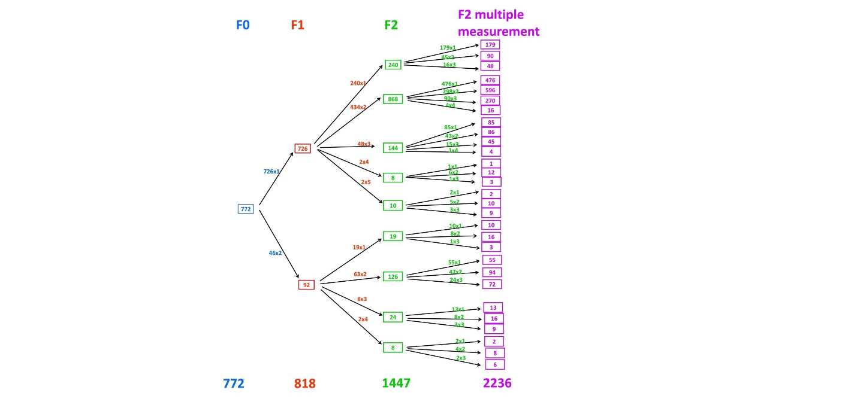

F1: cohort subject; F0: Parent of F1 generation; F2: children of F1 generation

Figure 2: Intergenerational change in height and BMI (internal cohort Z-scores) for F2 boys and girls: (a) Height; (b) BMI

(a)

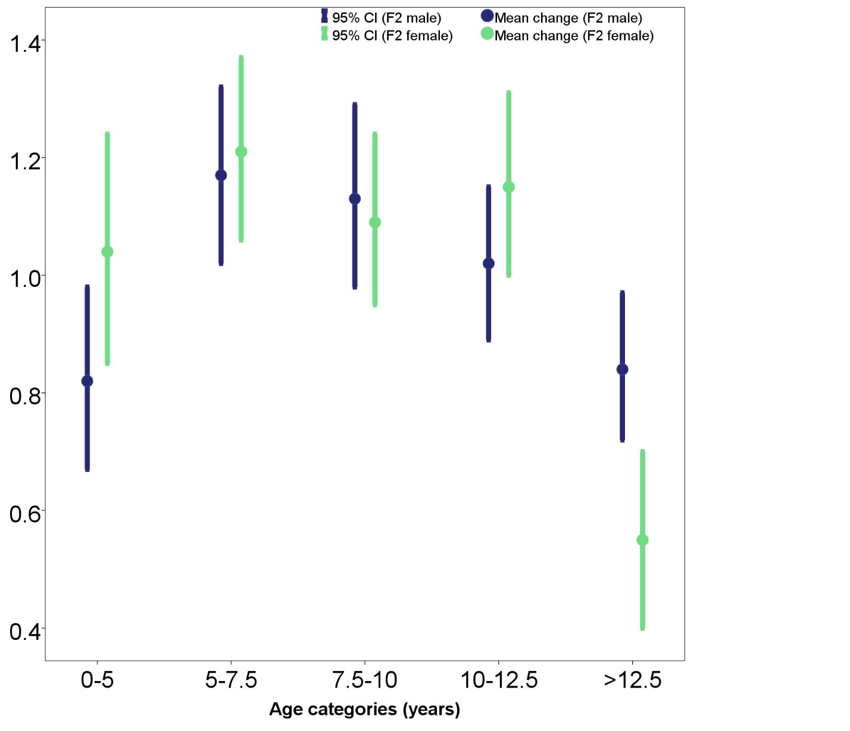

(b)
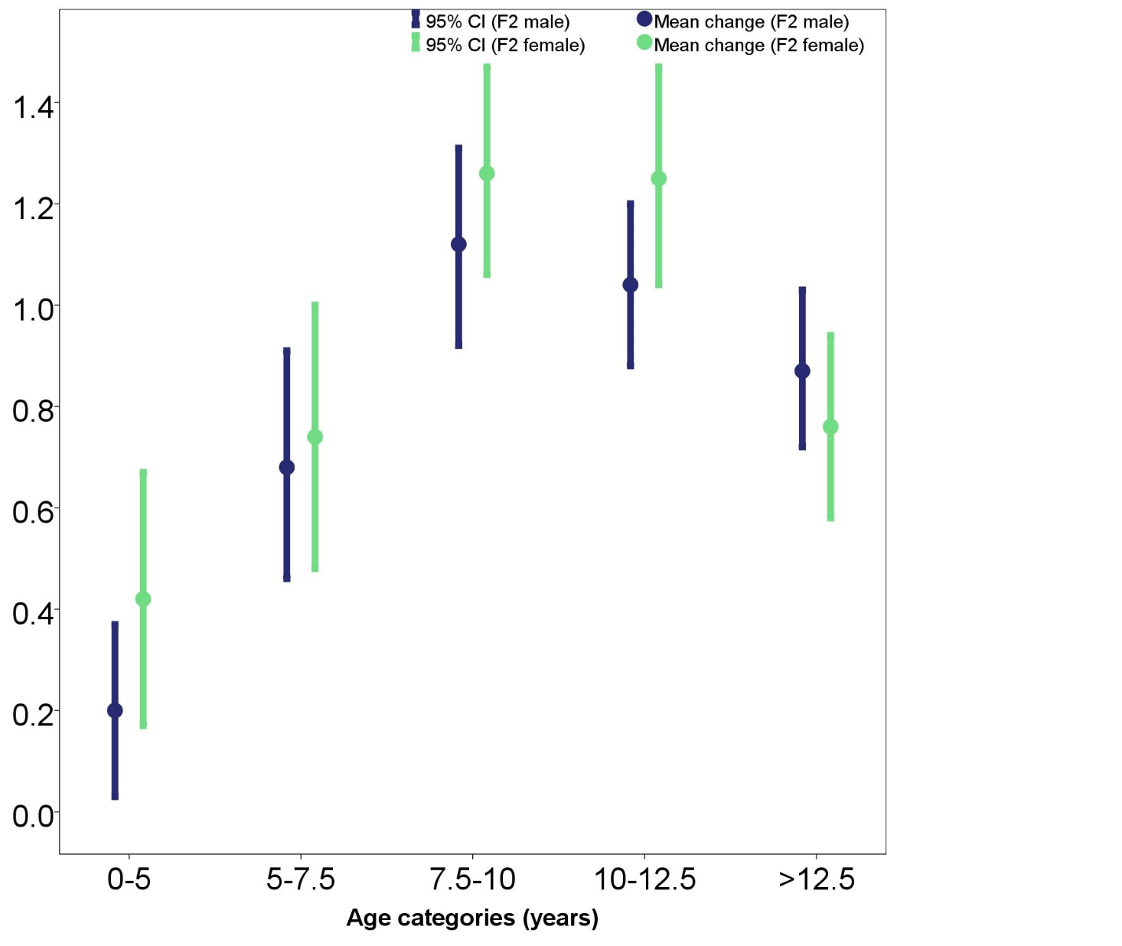
F2: children of cohort subjects
BMI: Body-mass-index

Supplementary Table S1: Socio-economic characteristics at the time of the parents’ (F1 generation) birth and child’s (F2 generation) measurement (N=818 for unique F1 subjects)

Variableª | At the time of parent (F1) birth |  | At the time of child (F2) measurement
 | N | Mean (SD) / n (%) | N | Mean (SD) / n (%)
Small pox vaccination | 506 | 489 (96.6)
BCG vaccination | 408 | 122 (29.9)
Delivery at healthcare facilities | 556 | 310 (55.8)
Nuclear family | 570 | 398 (69.8)
Type of house
Not owned Thatched hut | 568 | 1 (0.2)
Not owned Masonry building |  | 57 (10.0)
Owned Masonry building |  | 319 (56.2)
Not owned Flat |  | 91 (16.0)
Owned Flat |  | 89 (15.7)
Not owned Bungalow |  | 1 (0.2)
Owned Bungalow |  | 10 (1.8)
Supply of General water
Communal | 570 | 354 (62.1) | 807 | 8 (1.0)
Common |  |  |  | 134 (16.6)
Separate |  | 216 (37.9) |  | 665 (82.4)
Source of General water
Unprotected | 570 | 71 (12.5)
Both |  | 49 (8.6)
Protected |  | 450 (78.9)
Openwell/ Borewell/ Handpump |  |  | 809 | 128 (15.8)
Tap |  |  |  | 681 (84.2)
Supply of Drinking water
Communal |  |  | 809 | 15 (1.9)
Common |  |  |  | 85 (10.5)
Tanker/ Separate |  |  |  | 687 (84.9)
Mineral Water |  |  |  | 22 (2.7)
Source of Drinking water
Borewell or Handpump |  |  | 809 | 72 (8.9)
Tanker water/ Tap |  |  |  | 666 (82.3)
Mineral water |  |  |  | 71 (8.8)
Toilet facilities
Communal/ Common | 570 | 463 (81.2) | 807 | 30 (3.7)
Separate |  | 107 (18.8) |  | 777 (96.3)
Type of toilet
Open field | 570 | 90 (15.8)
Scavenger cleaned |  | 285 (50.0)
Pit |  | 5 (0.9)
Flush |  | 190 (33.3)
Crowding (members/room) | 570 | 3.6 (1.7) | 809 | 1.8 (0.8)
Maternal occupation
Homemaker |  |  | 801 | 576 (71.9)
Unskilled/ Semi-skilled/ Skilled manual, trained clerical, medium business, teacher |  |  |  | 176 (22.0)
Professional, big business, Class I, university teacher |  |  |  | 49 (6.1)
Paternal occupation
Unemployed | 807 | 2 (0.2) | 791 | 5 (0.6)
Unskilled manual labour |  | 15 (1.9) |  | 10 (1.3)
Semi-skilled manual. Rickshaw, army, carpenter etc |  | 86 (10.7) |  | 72 (9.1)
Skilled manual, small business/farmer |  | 190 (23.5) |  | 223 (28.2)
Trained clerical, medium business, mid level farmer, teacher |  | 394 (48.8) |  | 359 (45.4)
Professional, big business, Class I, university teacher |  | 120 (14.9) |  | 122 (15.4)
Education of parent (mother or father)^{b}
 |  | F0 mother |  | F1 father  (n=480) | F1 mother  (n=329)
Illiterate | 789 | 213 (27.0) | 809 | 0 (0.0) | 0 (0.0)
Primary |  | 156 (19.8) |  | 12 (2.5) | 5 (1.5)
Middle school |  | 144 (18.3) |  | 42 (8.8) | 12 (3.6)
High school certificate |  | 170 (21.5) |  | 86 (17.9) | 42 (12.8)
High school+ |  | 106 (13.4) |  | 88 (18.3) | 63 (19.1)
Other graduate |  |  |  | 201 (41.9) | 161 (48.9)
Professional degree |  |  |  | 51 (10.6) | 46 (14.0)
Household annual per capita income ()^{c} | 569 | 723 (1.8)
Material possession score^{d} |  |  | 804 | 13.2 (2.2)
ª Most of the variables were categorized differently at the time of F1 parent birth and F2 child measurement. Thus, the rows not applicable for F1 or F2 generations are blank.
^{b} Parent education refers to maternal (F0) education at the time of F1 birth and either maternal or paternal F1 education at the time F2 child measurement
^{c} Geometric mean from log transformed values
^{d} Material possession score is sum of possession of household materials (electricity, fan, cycle, radio, two wheeler, gas stove, television, cable TV, electric mixer, air cooler, washing machine, car, air conditioner, home computer, dish antenna, landline phone and mobile phone), categorized either as “0” (No) or “1” (Yes).

Supplementary Table S2: Comparison of intergenerational change in anthropometry among F2 boys and girls.

Age group (years) | n | Cohort (SD) |  | WHO (SD) |  | Absolute unitsª
 |  | Mean change | 95% CI | Mean change | 95% CI | Mean change | 95% CI
Height
Boys
0-5 | 227 | 0.82 | 0.67, 0.98 | 0.91 | 0.74, 1.09 | 3.78 | 3.11, 4.45
5-7.5 | 232 | 1.17 | 1.02, 1.32 | 1.23 | 1.08, 1.38 | 6.50 | 5.71, 7.28
7.5-10 | 249 | 1.13 | 0.98, 1.29 | 1.19 | 1.04, 1.34 | 7.12 | 6.23, 8.02
10-12.5 | 244 | 1.02 | 0.89, 1.15 | 1.14 | 1.00, 1.28 | 7.00 | 6.09, 7.92
>12.5 | 293 | 0.84 | 0.72, 0.97 | 0.94 | 0.81, 1.07 | 9.14 | 8.11, 10.18
Girls
0-5 | 173 | 1.04 | 0.85, 1.24 | 1.03 | 0.81, 1.25 | 3.12 | 2.29, 3.94
5-7.5 | 178 | 1.21 | 1.06, 1.37 | 1.14 | 0.98, 1.29 | 5.06 | 4.27, 5.84
7.5-10 | 213 | 1.09 | 0.95, 1.24 | 0.97 | 0.83, 1.11 | 5.69 | 4.84, 6.54
10-12.5 | 183 | 1.15 | 1.00, 1.31 | 1.04 | 0.88, 1.19 | 7.97 | 6.91, 9.03
>12.5 | 231 | 0.55 | 0.40, 0.70 | 0.49 | 0.34, 0.64 | 1.30 | 0.14, 2.47
BMI
Boys
0-5 | 221 | 0.20 | 0.03, 0.37 | 0.29 | 0.11, 0.46 | 0.43 | 0.20, 0.66
5-7.5 | 226 | 0.68 | 0.46, 0.91 | 0.67 | 0.46, 0.87 | 1.16 | 0.84, 1.49
7.5-10 | 247 | 1.12 | 0.92, 1.31 | 1.16 | 0.95, 1.37 | 2.18 | 1.80, 2.56
10-12.5 | 244 | 1.04 | 0.88, 1.20 | 1.28 | 1.09, 1.48 | 2.82 | 2.35, 3.30
>12.5 | 293 | 0.87 | 0.72, 1.03 | 0.92 | 0.72, 1.11 | 2.41 | 1.89, 2.94
Girls
0-5 | 171 | 0.42 | 0.17, 0.67 | 0.36 | 0.12, 0.60 | 0.42 | 0.07, 0.77
5-7.5 | 177 | 0.74 | 0.48, 1.00 | 0.52 | 0.32, 0.73 | 0.80 | 0.48, 1.13
7.5-10 | 213 | 1.26 | 1.06, 1.47 | 1.09 | 0.92, 1.27 | 2.05 | 1.67, 2.44
10-12.5 | 183 | 1.25 | 1.04, 1.47 | 1.29 | 1.07, 1.50 | 3.04 | 2.50, 3.57
>12.5 | 231 | 0.76 | 0.58, 0.94 | 1.08 | 0.88, 1.28 | 3.24 | 2.62, 3.86
BMI - Body-Mass Index
Adjusted for the sex of the parent
ª Intergenerational change in absolute units was quantified in cm for Height and in kg/m² for BMI
Supplementary Table S3: Relative weightings given to the contributing socio-economic variables to derive the first principal components for the F1 subjects at their birth and also for F2 subjects at their time of measurement.

Socio-economic  indicator | Interpretation of  higher value | Weighting
F1 birth
Maternal schooling | More education | 0.806
Type of family | Nuclear family | 0.154
Type of housing | Better housing condition | 0.230
Family income | Higher family income | 0.761
Crowding | More crowded | -0.468
Paternal occupation | Better occupation | 0.523
Small pox vaccination | Vaccinated for Small pox | -0.485
BCG vaccination | Vaccinated for BCG | 0.605
Healthcare facilities | Delivery at Healthcare facility | 0.626
Sanitation | Better type of toilet | 0.382
Sanitation facilities | Separate sanitation facility | 0.574
Water supply | Better source of water | 0.132
Water supply facilities | Separate general water facility | 0.369
F2 measurement
F1 parent education | More education | 0.871
Paternal occupation | Better Paternal occupation | 0.653
Maternal occupation | Better Maternal occupation | 0.454
Material Possession score | Privileged Material Possessions | 0.674
Crowding | More crowded | -0.560
Drinking Water (source) | Better source of drinking water | 0.240
Drinking Water (supply) | Better supply of drinking water ity | 0.328
General water (source) | Better source of general water | 0.184
General Water (supply) | Better supply of water facility | 0.257
Toilet | Separate sanitation facility | 0.280

The two resulting first principal components are scaled to have zero mean and unit variance. Higher values of the principal components are associated with greater privilege.

Supplementary Figure S1: Intergenerational change in anthropometry (internal cohort Z-scores) for boys and girls combined

