Submitted to Materials Letters (June 2021)
Special issue on Mechanics and Physics of Gradient Nanomaterials

An examination of strain weakening and self-annealing
in a Bi-Sn alloy processed by high-pressure torsion
Chuan Ting ${Баимова Ю.А.,}^{1}$Wang,¹ Terence G. Langdon.^{2,3*}
¹ School of Mechanical Engineering, Nanjing University of Science & Technology,
Nanjing 210094, China
² Departments of Aerospace & Mechanical Engineering and Materials Science,
University of Southern California, Los Angeles, CA 90089-1453, U.S.A.
³ Materials Research Group, Department of Mechanical Engineering,
University of Southampton, Southampton SO17 1BJ, U.K.

This paper is dedicated to the memory of Professor Alexander P. Zhilyaev who contributed so much to our understanding of ultrafine-grained materials after processing by severe plastic deformation, especially when using high-pressure torsion
Abstract
The high pressure torsion (HPT) process was performed on a Bi-Sn eutectic alloy up to 10 revolutions and the materials were stored at room temperature for durations up to 91 days in order to investigate the strain weakening and self-annealing behaviour of the alloy. The results show that HPT processing leads to significant grain refinement and enhanced superplasticity in the alloy. When the material is stored at room temperature, the grain size increases and the microhardness also increases producing a near linear relationship between grain size and microhardncess. This effect is attributed to the enhanced creep behaviour of the Bi-Sn alloy after HPT processing.
Keywords: Bi-Sn alloy; hardness; high-pressure torsion; self-annealing; superplasticity.
Corresponding author: Terence G. Langdon (langdon@soton.ac.uk)

Introduction
Ultrafine-grained materials processed by severe plastic deformation (SPD) are attracting considerable interest because of their improved mechanical and physical properties [1,2]. Most metallic materials show significant strain hardening behavior with decreasing grain size following the conventional Hall-Petch relationship. However, an unusual phenomenon of strain weakening has been observed in some materials. When these materials are subjected to SPD processing, their strength decreases with decreasing grain size and their strength also increases with increasing grain size during a post-deformation self-annealing process. Such materials include pure Al [3], Ni [4], Sn [5] and several alloys such as the Pb-Sn eutectic alloy [6,7] and the Zn-Al eutectoid alloy [6,8-10].
Several possibilities have been proposed to explain the strain weakening behavior. For example, the strain weakening of Zn-Al alloys is widely attributed to elemental decomposition during the SPD processing [11,12] but changes in the dislocations and grain boundary structure are also believed to play a role in the strain weakening of metals such as Al and Ni [3, 4]. The present investigation was conducted to investigate the mechanism of strain weakening in the Bi-Sn eutectic alloy following a comprehensive investigation of the processing of this alloy by high-pressure torsion (HPT) reported earlier [13].

Experimental material and procedures
Thin disk samples having diameters of 10 mm were machined from an as-cast ingot of the Bi-42% Sn eutectic alloy and the disks were then ground to final thicknesses between 0.80 and 0.85 mm.
Processing by HPT was performed under an applied pressure of 6.0 GPa and various total strains were imposed on the disks by processing through numbers, N, of 1, 5 and 10 revolutions under a constant rotation speed of 1 rpm. Following HPT, self-annealing was conducted by storing disks at room temperature (RT) for various times up to a maximum of 91 days. The microstructures of selected samples were observed with a scanning electron microscope (SEM) JEOL JSM-7001 F operating at a voltage of 15 kV with the samples etched using a solution of 25 ml H₂O, 5 ml HCl with a concentration of 37 % and 5 g of NH₄NO₃.
After HPT processing, microhardness values were recorded along selected diameters on the polished surfaces using an FM-1e Vickers hardness tester with a load of 50 gf and separate dwell times of 10 s for each indentation. Since the HPT disks were very small, two miniature tensile specimens with gauge lengths of 1 mm were prepared using electro-discharge machining from symmetrical off-center positions within the HPT disks as described earlier [14]. These miniature specimens were tested in tension to failure at RT using an Instron testing machine operating under conditions of constant cross-head displacement with initial strain rates from 1.0 × 10⁻⁴ to 1.0 × 10⁻⁻² s⁻¹.

Experimental results
Fig 1 shows the microstructure of the Bi-Sn alloy (a) in the as-cast condition and after HPT processing and storage at RT for (b) 1, (c) 7 and (d) 35 days. Inspection shows that there is a lamellar eutectic structure in the as-cast condition before HPT processing where large numbers of Bi precipitates are visible within the Sn phase due probably to a decrease in solubility while cooling from the melt. The phase spacing was estimated as ~3.5 ± 0.7 μm and, since no boundaries were visible within each phase, this value corresponds to the initial grain size. After HPT processing, the microstructures of both phases were significantly refined and the distributions of each exhibited a much improved homogeneity. Moreover, the grains of each phase showed clear and reasonably equiaxed configurations. It is also apparent that the grain size of the alloy increased with increasing storage time, thereby demonstrating that diffusive processes occur rapidly during storage at ambient temperature which corresponds to ~0.7 T_{m} where T_{m} is the absolute melting temperature of the alloy. Measurements gave average grain sizes of ~0.94 ± 0.18, ~1.27 ± 0.31 and ~1.37 ± 0.21 μm after storage for totals of 1, 7 and 35 days, respectively.
A Bi-Sn sample processed by HPT for 10 turns was used to evaluate the evolution of microhardness and grain size during storage at RT. Specifically, a microhardness indentation was recorded at a distance of 2.5 mm from the center of each disk sample and this measured value was then plotted against the mean grain size as shown in Fig. 2. The microhardness values for the Bi-Sn alloy were recorded as 12.24 ± 0.24, 17.35 ± 0.29, 20.00 ± 0.34 and 23.81 ± 0.42 Hv after 1, 7, 35 and 91 days of storage, respectively. The plot shows that there is grain growth during storage and the microhardness increases linearly with increasing grain size. This behaviour is clearly very different to conventional materials which generally follow the Hall-Petch relationship with increasing strength or hardness with decreasing grain size.
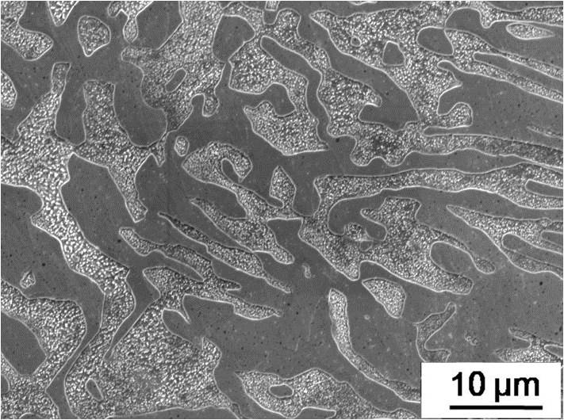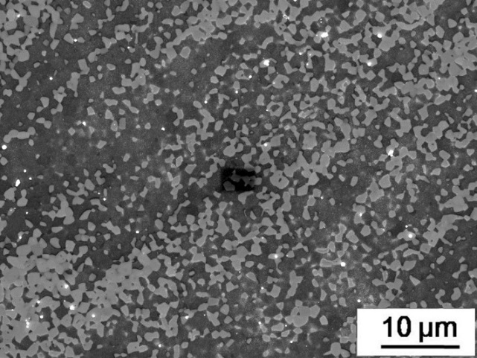
(a) (b)
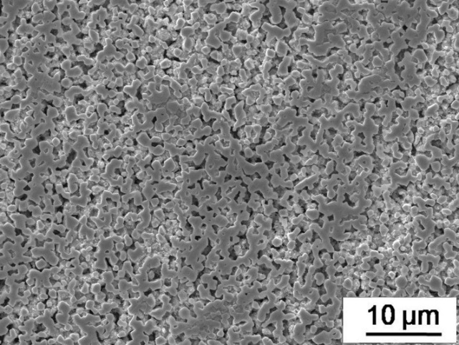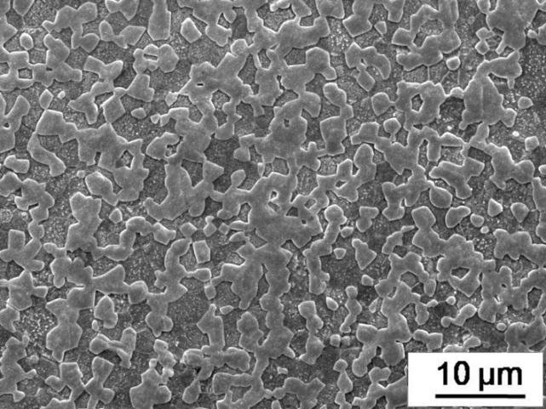
(c) (d)
Figure 1 Microstructure of Bi-Sn samples in (a) the as-cast condition and after HPT processing for 10 turns and then storage at RT for (b) 1, (c) 7 and (d) 35 days, respectively.

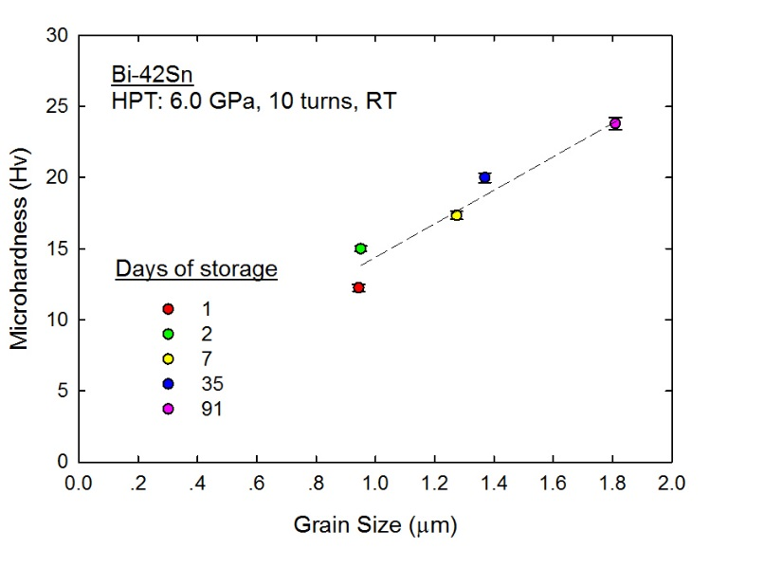
Figure 2 Microhardness of the Bi-Sn alloy after HPT processing and different days of storage versus the measured grain size.
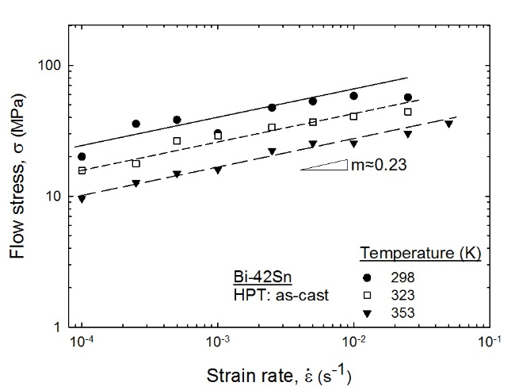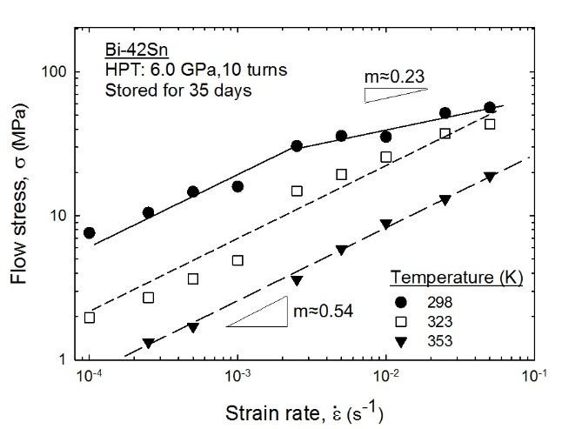
(a) (b)
Figure 3 Flow stress versus strain rate for (a) the as-cast Bi-Sn alloy and (b) the alloy processed by HPT through 10 turns and then stored at RT for 35 days:
the slopes denote the values of the strain rate sensitivity, m.

Tensile tests were conducted using the as-cast alloy and the alloy processed by HPT for 10 turns and then stored at RT for 35 days. As shown by the earlier microstructural observations in Fig. 1, the alloy reached a relatively stable state after storage at RT for 35 days. Therefore, the occurrence of any minor recovery during tensile testing may be neglected.
The tensile tests were performed at temperatures between 298 and 353 K under initial strain rates between 1.0 ×10⁻⁴ and 5.0 × 10⁻² s⁻¹. The flow stresses of both the as-cast and the HPT-processed alloy are shown in Figure 3 under various tensile testing conditions. Thus, under the same test condition the Bi-Sn alloy exhibited a lower flow stress after HPT processing and storage compared to the as-cast alloy where this is also consistent with the microhardness results shown in Fig. 2. The strain rate sensitivity, m, of the as-cast alloy was measured as ~0.23 while that of the Bi-Sn alloy after HPT and storage was ~0.54 for most conditions but decreased to ~0.23 at the lowest testing temperature and fastest strain rates. The value of m ≈ 0.54 after storage is consistent with the requirement of a strain rate sensitivity of ~0.5 for superplastic flow [15] and this suggests that the Bi-Sn alloy will exhibit superplastic behaviour after HPT processing and storage. This was further confirmed by measuring the elongation data for the samples. Thus, the Bi-Sn alloy gave an elongation of ~1220% at a strain rate of 1.0 × 10⁻⁴ s⁻¹ at 298 K after HPT processing and storage whereas the elongation for the as-cast alloy was only ~110% for the same tensile testing conditions.
- Discussion
The occurrence of a strain softening and self-annealing behaviour has been widely reported in pure metals and alloys having relatively low melting temperature, most significantly in the Zn-Al, Pb-Sn and Bi-Sn alloys [16]. Several factors of microstructural evolution have been observed during SPD processing and the subsequent storage of these materials. For example, second phase precipitates were dissolved during the strain processing and then they were reprecipitated with grain growth during the long duration of storage [6-8,13,17]. Direct evidence of grain boundary migration and recrystallization was reported in high purity Cu and Ag during storage after SPD processing. Such abnormal grain growth was attributed to the delayed recovery and annihilation of high densities of dislocation [18-21]. In the case of Cu and Ag it is worth noting that, together with grain growth and dislocation annihilation, the microhardness decreased by a small amount. Therefore, grain boundary strengthening and dislocation strengthening remained applicable to Cu and Ag. It was suggested also that the occurrence of enhanced diffusional creep, grain boundary sliding and grain rotation may be significant in ultra-fine grained materials leading to a softening behaviour [22-24].
A comprehensive equation was developed to describe the creep behaviour of polycrystalline materials under steady-state conditions including under conditions of superplastic flow [25,26]. When a material is in the steady-state region of creep, the creep rate, , is given by a relationship of the form:
(1)
where A is a dimensionless constant, D is the diffusion coefficient, G is the shear modulus of the material at the testing temperature, b is the Burgers vector, k is Boltzmann’s constant, T is the absolute temperature, d is the grain size, σ is the measured flow stress, p is the exponent of the inverse grain size which is normally taken as a value of 2 in superplastic flow and n is the stress exponent which corresponds to the reciprocal of the strain rate sensitivity, m.
It is possible to manipulate Eq. (1) to obtain a relationship between d and σ of the form
(2)
As shown by Eq. (2), if p is taken as 2 as in superplasticity controlled by grain boundary sliding [26] and with n given by the reciprocal of m which is 1/0.54 from Fig. 3(b) so that n ≈ 1.85, it follows directly that there is almost a linear relationship between flow stress and grain size as represented by Eq. (2). It is reasonable to expect, therefore, that grain boundary sliding was the main factor contributing to the increase in the microhardness of the HPT-processed Bi-Sn alloy with increasing grain size.
For comparison, in a similar study a Pb-Sn alloy was processed by HPT and stored at room temperature for up to 20 days and the grain size of the alloy was measured after various numbers of storage days together with the microhardness [17]. It was observed that HPT processing reduced the grain size to around 1.3 μm and the hardness to about 1.7 Hv but with increasing storage time at room temperature the grain size and the microhardness both increased. Thus, both the Bi-Sn alloy in the present investigation and the Pb-Sn alloy tested earlier [17] lead to near linear relationships between grain size and microhardness as shown in Fig. 4.
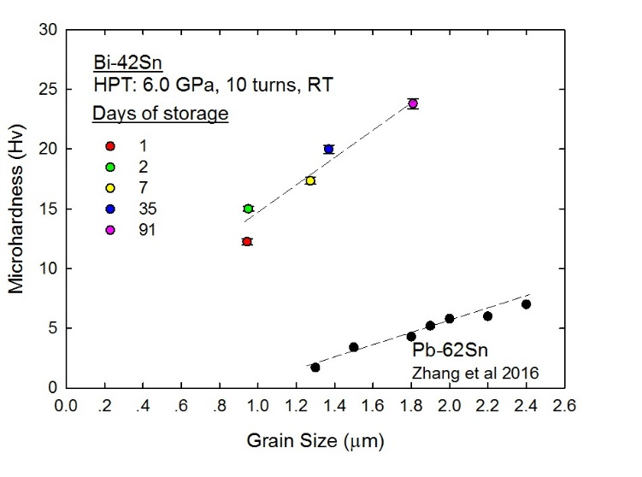
Figure 4 Microhardness of the Bi-Sn alloy and a Pb-Sn alloy [17] after HPT processing and different days of storage versus the measured grain size.
- Summary and conclusions
- Experiments on a eutectic Bi-Sn alloy showed that HPT processing leads to significant grain refinement and enhanced superplasticity.
- By storing at room temperature, the grain size increased and the microhardness also increased producing a near linear relationship between microhardncess and grain size. This is attributed to the enhanced creep behaviour of the alloy after HPT processing.

Acknowledgements
This work was supported in part by the National Science Foundation of the United States under Grant No. DMR-1160966 and in part by the European Research Council under ERC Grant Agreement No. 267464-SPDMETALS .
References
- R.Z. Valiev , T.G. Langdon, Prog. Mater. Sci. (2006) 51:881-981.
- A.P. Zhilyaev, T.G. Langdon, Prog. Mater. Sci. (2008) 53:893-979.
- X. Huang, N. Hansen, N. Tsuji, Science (2006) 312:249-251.
- X.Z. Liao, A.R. Kilmametov, R.Z. Valiev, H. Gao, X. Li, A.K. Mukherjee, J.F. Bingert, Y.T. Zhu, Appl. Phys. Lett. (2006) 88:021909.
- K. Edalati, Z. Horita, Mater. Sci. Eng. A (2011) 528:7514-7523.
- N.X. Zhang , M. Kawasaki, Y. Huang, T.G. Langdon, J. Mater. Sci. (2013) 48:4582–4591.
- N.X. Zhang, M. Kawasaki, Y. Huang, T.G. Langdon, Mater. Sci. Eng. A (2021) 802:140653.
- N.Q. Chinh, T. Csandi, T. Gyori, R.Z. Valiev, B.B. Straumal, M. Kawasaki, T.G. Langdon, Mater. Sci. Eng. A (2012) 543:117-120.
- B.B. Straumal, X. Sauvage, B. Baretzky, A.A. Mazilkin, R.Z. Valiev, Scripta Mater. (2014) 70:59-62.
- M. Borodachenkova, F. Barlat, W. Wen, A. Bastos, J.J. Gracio, Int. J. Plasticity (2015) 68:150-163.
- C.F. Yang, J.H. Pan, T.H. Lee, J. Alloys. Compd. (2009) 468:230-236.
- N.Q. Chinh, R.Z. Valiev, X. Sauvage, G. Varga, K. Havancsák, M. Kawasaki, B.B. Straumal, T.G. Langdon, Adv. Eng. Mater. (2014) 16:1000-1009.
- C.T. Wang, Y. He, T.G. Langdon, Acta Mater. (2020) 185:245-256.
- A. Loucif, R.B. Figueiredo, M. Kawasaki, T. Baudin, F. Brisset, R. Chemam, T.G. Langdon, J. Mater. Sci. (2012) 47:7815-7820.
- T.G. Langdon, J. Mater. Sci. (2009) 44:5998-6010.
- T.G. Langdon, Kovove Mater. (2015) 53:213-219.
- N.X. Zhang, N.Q. Chinh, M. Kawasaki, Y. Huang, T.G. Langdon, Mater. Sci. Eng. A (2016) 666:350-359.
- T. Konkova, S. Mironov, A. Korznikov, S.L. Semiatin, Mater. Sci. Eng. A (2011) 528:
7432-7443.
- O.V. Mishin, A. Godfrey, Metall. Mater. Trans. A (2008) 39A:2923-2930.
- G. Wang, S.D. Wu, L. Zuo, C. Esling, Z.G. Wang, G.Y. Li, Mater. Sci. Eng. A (2003) 346:83-90.
- J. Gubicza, N.Q. Chinh, J.L. Lábár, Z. Hegedüs, T.G. Langdon, Mater. Sci. Eng. A (2010) 527:752-760.
- B. Cai, Q.P. Kong, L. Lu, K. Lu, Scripta Mater. (1999) 41:755-759.
- N.Q. Chinh, P. Szommer, Z. Horita, T.G. Langdon, Adv. Mater. (2006) 18:34-39.
- Y.B. Wang, B.Q. Li, M.L. Sui, S.X. Mao, Appl. Phys. Lett. (2008) 92: 011903.
- T.G. Langdon, Metall. Mater. Trans. A (2002) 33A:249-259.
- T.G. Langdon, Acta Metall. Mater. (1994) 42: 2437-2443.

