Electrokinetic remediation of radionuclide contaminated land

Presenting author: Dr. Jamie M. Purkis

All authors: Purkis, J. M., Warwick, P. E., Hemming, S. D. and Cundy, A. B.*

School of Ocean and Earth Science, University of Southampton, National Oceanography Centre (Southampton), European Way, Southampton, SO14 3ZH, UK

Theme: Novel techniques

Electrokinetic Remediation, EKR, is an environmental remediation technology that uses electricity to remove pollutants from contaminated materials; Figure 1. It is a flexible and low-energy (< 1 V.cm-1) technique, that operates effectively in low permeability substrates (clayey soils, cements, etc.) which are often difficult to remediate by conventional means (e.g. soil washing, pump-and-treat). It can be combined with renewable power inputs and operate in-situ, providing effective, safe, and sustainable solutions in which worker exposure to hazardous materials is minimized while high remediation efficiencies are retained. However, EKR is limited mostly to the laboratory or pilot scale for nuclear industry applications, with reliable, meter-plus scale studies in real operating environments still lacking.

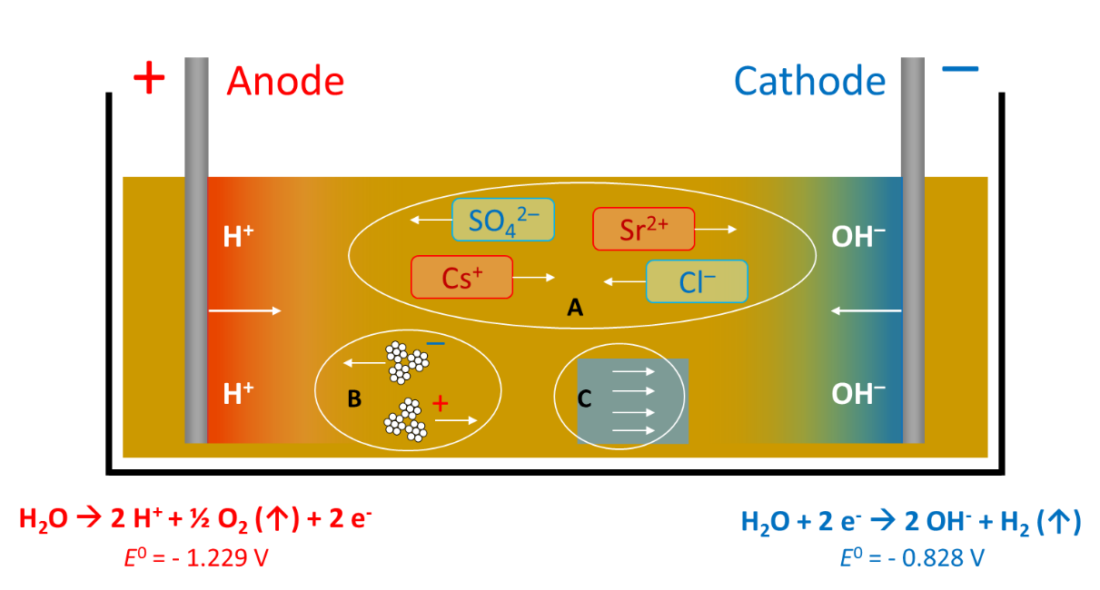

Figure 1 – EKR processes in a simplified cell, with acidic and basic fronts developing from the anodes/cathodes, respectively; A, electromigration of ions; B, electrophoresis of particulates (clays, etc.); and C, electro-osmosis of pore water. E⁰ values for the water electrolysis half-cell are quoted against the standard hydrogen electrode.

Here, we discuss EKR and its potential uses at nuclear sites. We begin by summarizing the key advantages offered by EKR over other, conventional remediation methods and, from this, review how EKR, singly or in combination with other technologies, can be or has been applied practically. We illustrate this using real examples at selected nuclear sites of international importance. Finally, we examine perspectives on tools to help the decision-making process for remediation at active nuclear sites, and how these tools could be used to support practical deployment of EKR for nuclear site decommissioning.

