# Electronic supplementary information

nBu2Sn(SnBu)2 and nBu3SnEnBu (E = S or Se) - effective single source precursors for the CVD of SnS and SnSe thermoelectric thin films

Fred Robinsona, Peter J. Curranb, C. H. (Kees) de Grootc, Duncan Hardie,b Andrew L. Hectora, Katherine Hollowaya, Ruomeng Huangc, Daniel W. Newbrook,c and Gillian Reida*



Figure S1- 1H NMR spectrum of [SnnBu3(SnBu)] (CDCl3)



Figure S2- 13C{1H} NMR spectrum of [SnnBu3(SnBu)] (CDCl3)



Figure S3- 119Sn{1H} NMR spectrum of [SnnBu3(SnBu)] (CDCl3)



Figure S4- 1H NMR spectrum of [SnnBu2(SnBu)2] (CDCl3)



Figure S5- 3C{1H} NMR spectrum of [SnnBu2(SnBu)2] (CDCl3)



Figure S6- 119Sn{1H} NMR spectrum of [SnnBu2(SnBu)2] (CDCl3)



Figure S7- 1H NMR spectrum of [SnnBu3(SenBu)] (CDCl3)



Figure S8- 13C{1H} NMR spectrum of [SnnBu3(SenBu)] (CDCl3)

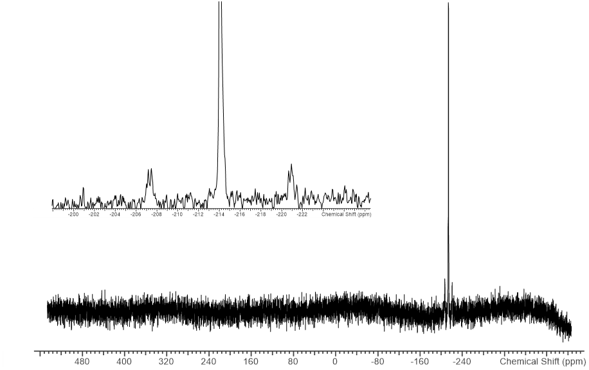

Figure S9- 77Se{1H} NMR spectrum of [SnnBu3(SenBu)] (CDCl3) (insert shows an expanded view with the 117/119Sn satellites clearly visible).

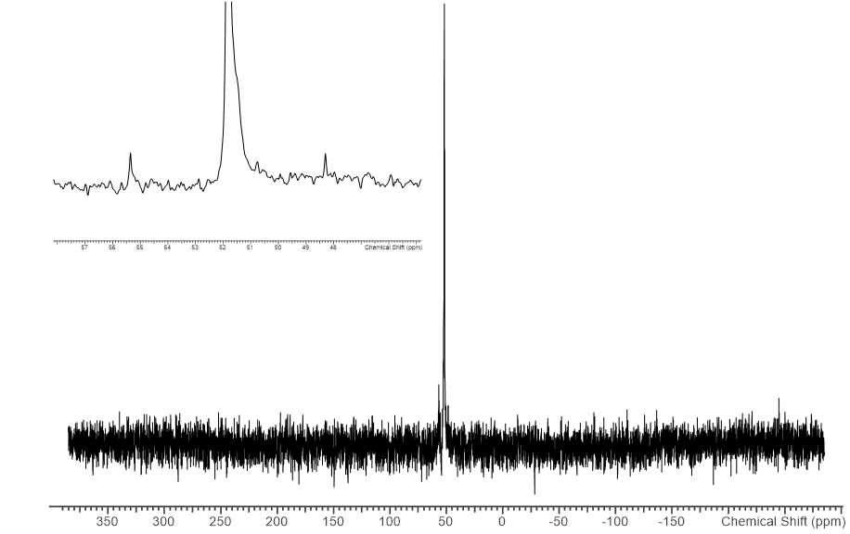

Figure S10- 119Sn{1H} NMR spectrum of [SnnBu3(SenBu)] (CDCl3) (insert shows an expanded view with the 77Se satellites clearly visible)

|  |  |  |  |  |  |
| --- | --- | --- | --- | --- | --- |
| Sample | Precursor | O% | Si% | S% | Sn% |
| Depn 1 tile 1 | (**1**) | 7.8 | 1.2 | 36.4 | 54.6 |
| Depn 2 tile 1 | (**1**) | - | - | 40.2 | 59.8 |
| Depn 2 tile 2 | (**1**) | - | - | 39.9 | 60.1 |
| Depn 3 tile 1 | (**2**) | 6.6 | 1.3 | 40.8 | 51.3 |
| Depn 4 tile 1 | (**2**) | - | 0.7 | 44.2 | 55.0 |
| Depn 5 tile 1 | (**2**) | 13.4 | 24.1 | 31.2 | 31.2 |
| Depn 5 tile 2 | (**2**) | 12.3 | 12.5 | 37.2 | 38.1 |

Table S1: Energy dispersive X-ray analysis results for some SnS films (atom % values); (**1**) = SnnBu3(SnBu); (**2**) = SnnBu2(SnBu)2

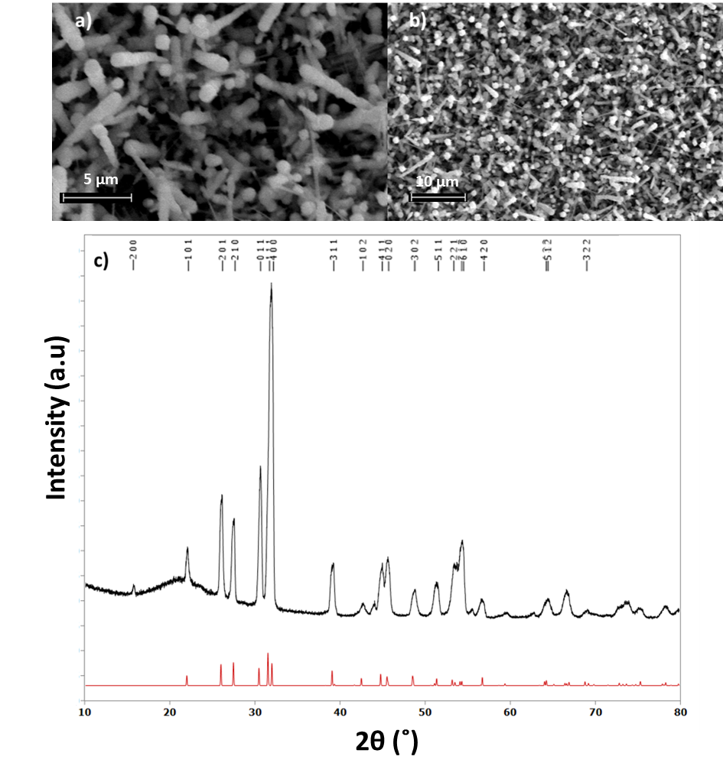

Figure S11: Top down SEM images a) and b) of two thin films of sulfur deficient SnS deposited using (**1**)and c) a GIXRD pattern (black) for the film seen in b) matched to a bulk literature pattern (red).15

|  |  |  |  |  |  |
| --- | --- | --- | --- | --- | --- |
| Sample | %C | %O | % Si | %Se | %Sn |
| depn 1 | - | 11.3 | 29.4 | 29.1 | 30.2 |
| depn 2 tile 1 | 17.4 | 10.1 | - | 35.4 | 37.1 |
| depn 2 tile 2 | - | 7.54 | 4.2 | 44.4 | 43.9 |
| depn 3 | 11.7 | 7.1 | - | 38.9 | 42.3 |
| depn 4 | 12.2 | 8.0 | 7.1 | 37.5 | 35.2 |

Table S2: Energy dispersive X-ray analysis results for SnSe thin films (atom % values)