What do trainee cognitive behavioural therapists need from supervision to develop their clinical skills in working with people with psychosis? A qualitative analysis

Rebecca Harrisª
Tess Maguireª
Katherine Newman-Taylorª
ªPsychology Department, University of Southampton, Shackleton Building, Highfield Campus, Southampton, SO17 1BJ, UK.
Rebecca Harris email: rjh4g15@soton.ac.uk; ORCID ID: 0000-0002-8537-7282
Tess Maguire email: t.l.maguire@soton.ac.uk
Katherine Newman-Taylor email: knt@soton.ac.uk; ORCID ID: 0000-0003-1579-7959
Corresponding author: Rebecca Harris, Psychology Department, University of Southampton, Shackleton Building, Highfield Campus, Southampton, SO17 1BJ, UK. Email: rjh4g15@soton.ac.uk.
Word count (incl. references and figures): 5120
Running head: What do CBTp trainees need from clinical supervision?
Acknowledgements: This research did not receive any specific grant from funding agencies in the public, commercial, or not-for-profit sectors

What do trainee cognitive behavioural therapists need from supervision to develop their clinical skills in working with people with psychosis? A qualitative analysis

Abstract
Background: Clinical supervision is assumed to be essential to the development of competent psychological therapists. While the evidence for effective psychological therapy training remains sparse, there is some support for the role of supervision and the experiential learning cycle in trainees’ progression. Despite a growing demand for cognitive behavioural therapy for psychosis (CBTp), no research has investigated the components of CBTp supervision necessary for skilful therapeutic practice.
Methods: We completed a qualitative thematic analysis of 385 supervision questions from trainee CBTp therapists.
Results: The analysis yielded three main themes – knowledge / content (What?) questions; procedure / process (How?) questions; and course requirements / assessment methods (Training) questions. What? questions decreased over the 20 weeks of supervision, How? questions were raised throughout, and Training questions increased prior to academic deadlines. The thematic analysis also showed that active experimentation (the final stage of the experiential learning cycle) may be omitted from supervisory practice.
Conclusions: These results indicate that CBTp supervision should prioritise knowledge, procedural learning and active experimentation, in training therapists to deliver high quality CBT for people with psychosis.

Keywords: CBT; CBTp; supervision; training; psychosis

Introduction
The role of supervision in psychological therapy training
Clinical supervision is defined as “the formal provision, by approved supervisors, of a relationship-based education and training that is work-focused and which manages, supports, develops, and evaluates the work of colleagues” (Milne, 2007, p.3). This systematic and continuous process is a primary means of therapeutic skill acquisition and development (British Psychological Society [BPS], 2017; Fleming & Steen, 2004; Milne, 2007). The aim is to improve clinical practice through regular discussion with experienced colleagues, develop autonomous decision-making through reflection and practice analysis, and attend to professional wellbeing and self-care (Hall, 2012). Clinical supervision is required for psychological therapy trainees and qualified clinicians to facilitate and maintain safe and effective therapeutic practice (BPS, 2017). In the UK, the UCL frameworks specify the competencies required for psychological therapies and their supervision, including CBT for psychosis (Roth & Pilling, 2008/2015; 2013).

The supervision process aligns with theoretical models of child (Vygotsky, 1978) and adult learning (Kolb, 1984). Psychological therapy supervisors who attend to their trainees’ zone of proximal development (Vygotsky, 1978) – the difference between what can be achieved independently and with expert guidance – are likely to extend their trainees’ skills most effectively (James et al., 2006). The ‘experiential learning cycle’ is based on the assumption that “learning is the process whereby knowledge is created through the transformation of experience” (Kolb, 1984, p. 38). By reflecting on our direct experience, we make sense of what has happened, and learn to negotiate future events more skilfully. When faced with the next comparable situation, this learning is tested, and the cycle repeats (see Figure 1). The purpose of psychological therapy supervision is to facilitate trainees’ learning through these four stages (Milne et al., 2008).

Insert figure 1 about here

Evidence for the role of cognitive behavioural therapy supervision
While there are many models of clinical supervision, a systematic review of the evidence for effective supervision found that 82% of published studies described mechanisms and outcomes consistent with the experiential learning cycle (Milne et al., 2008). Notwithstanding criticism that the model is generalised (Dennison, 2012), and that application to date is largely limited to Western settings (Forrest, 2004), Milne (2009) concludes that the experiential learning cycle can be used as an effective basis for cognitive behavioural therapy (CBT) supervision.

There is also evidence that particular strategies are differentially effective in the acquisition of knowledge and skills. In an expert review of CBT supervision and training methods, Bennett-Levy at al. (2009) found that reading, lectures and modelling were rated as most effective in declarative knowledge acquisition, and that active experimentation (e.g., role-play, using CBT skills oneself), modelling and reflective practice, were rated as most effective in procedural skills development. The importance of the reflective process is also highlighted by evidence that CBT training sessions are largely ineffective unless followed up by consultation or supervision, and that the more reflection involved in these sessions, the greater trainees’ learning (Bennett-Levy & Padesky, 2014; Haarhoff & Thwaites, 2016).

Gordon (2012) suggests that three question types are brought to CBT supervision. Trainees use information questions when seeking a didactic response (e.g., “is CBT suitable for this person?” and “which questionnaire should I use to measure paranoia?”). Feedback questions include requests for formative and summative evaluation (e.g., “did I reassure her too much?” and “could you give me some feedback on my agenda setting?”). Thirdly, learning questions constitute an open enquiry about therapy skills and processes (e.g., “how can I help him to set more meaningful goals?” and “how could I help her learn that she’s safe, even when feeling afraid?”). Gordon (2012) argues that this last category usually indicates a more sophisticated level of enquiry and willingness to reflect, conceptualise and experiment with new ideas (thereby completing all stages of the experiential learning model), which is in turn likely to promote a deeper level of learning than sharing of information or feedback.

In summary, the experiential learning model (Kolb, 1984) is widely recognised as the basis for effective adult learning, and has successfully been applied to CBT supervision and training (Bennett-Levy et al., 2009; Gordon, 2012). Despite this, there is limited research examining how CBT trainees learn these skills, and none related to working with people with psychosis.

CBT for psychosis
Psychosis is a mental health presentation that causes people to perceive or interpret reality differently from those around them (National Alliance on Mental Illness, 2020). The most common experiences associated with psychosis are delusions (firmly held beliefs that others do not share), hallucinations (sensory experiences not shared by others e.g., hearing voices), speech that is hard for others to follow, and behaviours that appear to others to be inappropriate to the situation (Cooke, 2017).

In the psychological literature, the term psychosis is increasingly used rather than schizophrenia, given the lack of scientific validity of traditional diagnostic classification systems in this area (Cooke, 2017). Psychotic-type experiences (for example, hearing a voice when there is nobody there) are common in the general population at ~10% (Johns et al., 2014), and clinical levels of psychosis (in which the person’s social and occupational functioning is significantly compromised) occur for approximately 1% of us at some point in our lives (Cooke, 2017; Schizophrenia Commission, 2012).

CBT is a recommended psychological therapy for people with a diagnosis of schizophrenia (NICE, 2014). While not unequivocal, there is evidence that CBT is effective in reducing distressing hallucinations and delusions (e.g., Turner et al., 2014) and may delay transition to psychosis in vulnerable groups (e.g., Hutton & Taylor, 2014; Stafford et al., 2013; van der Gaag et al., 2013). CBT seeks to clarify how people’s thoughts, emotions, physiological sensations, and behaviours are linked, contribute to the maintenance of distressing psychosis, and can be addressed to alleviate distress and improve functioning in line with individuals’ values and goals (Burns et al., 2014; Morrison et al., 2007; Turner et al., 2014). Despite the considerable personal, social and healthcare costs of psychosis, and best practice guidelines, the majority of people still do not have access to CBTp (46%; Royal College of Psychiatrists [RCP], 2019). Training clinicians in high quality CBTp is therefore a healthcare priority.

Current study
Clinical supervision is assumed to be essential to the acquisition of therapeutic skills. While supervision is arguably integral to CBTp (for which there is now evidence, as described above), and there is some support for the role of supervision in CBT training (Barrett et al., 2020; Bennett-Levy et al., 2009; Bennett-Levy & Padesky, 2014; James et al., 2006; Milne & James, 2002), the literature examining the role of supervision specifically has been slow to develop. Despite a growing demand for trained CBTp practitioners, no studies to date have investigated the key components of linked supervision. The current study comprised a thematic analysis of CBTp trainees’ supervision questions over the course of their training, to determine supervision priorities when learning to provide CBT to people with psychosis. We aimed to elicit key themes and any changes over time. It is important to note that supervisee priorities are not necessarily the same as the content of supervision, but do indicate the likely focus of supervisory discussions, and therefore valuable given the dearth of research in this area.

Materials and methods
Ethical considerations
The work described has been carried out in accordance with The Code of Ethics of the World Medical Association (Declaration of Helsinki) for experiments involving humans. The study was approved by the University of - Ethics Committee (ID -). As the study investigated trainees’ supervision questions (NHS staff in their role as CBT trainees) and no patient details, NHS Ethics approval was not required. CBT trainees gave consent for their supervision questions to be used for research purposes, and provided basic demographic information (age at the start of the course, ethnicity, and gender).

Participants
Participants were 11 trainees completing the Postgraduate Diploma in CBT for psychosis at the University of -. Three trainees were male and eight female, with a mean age of 38 years, 8.5 months (SD = 7 years, 1 month) at the start of their training. All trainees identified as White (nine White British, one white New Zealand, and one White Other). Trainees were clinical psychologists, community psychiatric nurses, social workers and occupational therapists. Entry criteria for the programme include a core profession (or demonstration of equivalence) and experience of CBT-informed clinical practice under supervision.

Structure of CBTp training
The study involved the secondary data analysis of material collected during CBTp trainees’ weekly group supervision sessions while completing their Postgraduate Diploma. The course is accredited by the national accrediting body for CBT in the UK, and trainees are required to evidence academic and clinical competence for the award to be conferred. Trainees complete three ten-week terms of taught and supervised practice. The first term focuses on generic therapeutic skills, and the second and third focus on CBT for psychosis. Trainees bring two cases to weekly university supervision, and submit two full therapy recordings each term for assessment (to ensure fidelity to the model) against an established CBT adherence scale (the CTS-R; Blackburn et al., 2001). The current study examined supervision questions brought to the second and third terms which focus specifically on CBTp. Trainees are supervised by experienced CBT trained clinical psychologists, in small groups of three (90 minutes) or two (60 minutes). Trainees are expected to bring one main supervision question each week. Following best practice guidelines for CBT supervision (Padesky, 1996), questions are recorded at the start of the session, and the time is then split between trainees who give concise background information, and share a recorded therapy excerpt prior to discussion focused on (but not limited to) the initial question.

Data analysis
The data were trainees’ supervision questions, handwritten by their supervisors each week, over the CBTp specific second and third terms. A thematic analysis of the material utilising the six-stage framework proposed by Braun and Clarke (2006) yielded key themes. This method was chosen over other qualitative approaches (such as interpretative phenomenological analysis and grounded theory) given the nature of the data and aims of the study; a rich thematic description was prioritised over depth and complexity, as recommended for under-researched areas (Braun & Clarke, 2006). The analysis was data driven, and open codes were used until themes emerged. A critical realist perspective was held throughout the analysis (Burr, 2015; Parker, 2004) to ensure the themes were grounded in the material and allowed for a critical, contextualised analysis.

The codebook collated verbatim material and interpretive notes, grouped by provisional themes and subthemes, with definitions for each subtheme (to avoid overlap), and illustrative quotes (following Howitt, 2013). Reflective notes were kept throughout the analysis to minimise reflexivity (Banister et al., 1994), and discussed within the research team to increase inter-rater reliability (Burr, 2015). The codebook was revised in an iterative process until a final agreed version was reached, following best practice in thematic analysis (Howitt, 2013).

Results
In total, 378 supervision questions were included in the analysis. In some sessions trainees brought more than one question. Occasionally trainees missed supervision due to sickness, and two trainees suspended their studies for personal reasons and did not complete the two ten-week blocks of supervision within the timeframe of the study. Figure 2 provides a thematic map of the analysis.

Insert Figure 2 about here

What?
This theme encompassed trainees’ requests for knowledge and guidance regarding CBT and CBTp, and Role as CBTp therapist. What? questions focussed on knowledge and function of CBT in general, rather than individualised application of skills (which are captured in How?). These questions decreased over the 20 weeks of supervision.

CBT and CBTp. This subtheme consisted of questions about specific elements of CBT and CBTp, guidance on the use of therapy skills, and incorporation of psychotic experience in psychological models utilised:
“What is paranoia – where would it fit in a ‘hot cross bun’ [model]?” (P10, W3)
“Image of rock crashing – where does this fit in [the] formulation?” (P2, W7)
“When does a coping strategy become a safety behaviour?” (P3, W15 )
“How much should we [tackle] safety behaviours in psychosis?” (P3, W8)
“When is ‘chaining’ appropriate?” (P8, W3)
“How to pull out core beliefs and rules for living, for people with psychosis?” (P1, W4)
This subtheme indicates that whilst trainees have some knowledge of CBT, they require guidance in applying these principles to psychosis, and in early clinical decision making.

Role as CBTp therapist. Trainees, who were typically clinical psychologists, community psychiatric nurses, social workers and occupational therapists, sought guidance on their role as CBTp therapist as distinct from other roles (and approaches used), for example as the team psychologist or care co-ordinator:
“Whether and how to separate therapist / care coordinator role?” (P1, W2)
“Can I ask a question about appropriate self-disclosure [in this role]?” (P11, W8)
“Is it okay to use values work from acceptance and commitment therapy?” (P10, W2)
These questions highlight the fact that the CBTp role is new, and trainees need guidance on clarifying and distinguishing this work from broader (and more familiar) roles in their organisations.

How?
This theme incorporated questions focused on the application of skills in the context of individualised (formulation driven) CBTp, alongside requests for feedback. Questions were grouped into three subthemes: Structuring and delivering therapy, Applying exploratory, formulation and change skills, and Responding to obstacles and unexpected events.
Structuring and delivering therapy. This subtheme comprised questions on how to structure and deliver CBTp to meet the needs of a particular person, including questions regarding agenda setting, treatment planning, reviewing goals and practice tasks, and managing the course of therapy:
“What could strengthen agenda setting?” (P2, W17)
“If new information comes in, how do I [incorporate] this without completely deviating from the agenda?” (P4, W8)
“Can I have some feedback on treatment plan and linking it with formulation?” (P9, W19)
“How can I be clearer regarding conceptualisation / homework task?” (P3, W12)
“How do I juggle the natural flow of therapy with [focusing on] his therapy goals?” (P10, W5)
“How to deal with emotion in the room and next steps in that moment?” (P1, W14)
“Am I being too directive?” (P8, W5)
“[XXX has] four sessions left – what would be most useful?” (P7, W16)
These questions were brought at a broadly consistent rate across the 20 weeks of supervision, though questions about goals and treatment plans were seen from week 5, suggesting that trainees initially focused on other aspects of therapy (engagement, assessment and preliminary formulation).

Applying exploratory, formulation and change skills. This was the most prominent subtheme across the data. Trainees sought guidance and feedback on applying these skills to meet the needs of the particular person accessing therapy, consistently across the 20 weeks of supervision:
“Fears he’ll go mad – should I explore this, how, benefits of doing this?” (P3, W19)
“Voices command to hurt mother (assessed no risk) – how to elicit cognitions?” (P3, W5)
“Can you help me to think about and practice my use of Socratic questions?” (P4, W6)
“How can I best formulate her experience of voices?” (P10, W4)
“How can I share the formulation and what shall I share?” (P5, W10)
“How to assist him to work out what he wants?” (P8, W4)
“[How] to help my client to be ready to go straight back to work after a session?” (P4, W5)
“Can you help me to clarify the behavioural experiment I’ve been working on with this client, especially regarding predictions and beliefs?” (P4, W10)
These questions highlight the work done to support the person to make sense of their experiences, through guided discovery and formulation, and then build on this to effect change in line with their values and goals. Trainees often sought feedback and specific guidance regarding next steps.

Responding to obstacles and unexpected events. This subtheme incorporated questions regarding unforeseen events that arose in therapy and how best to respond. This included use of substances, difficulties engaging the person, and how to maintain focus (e.g. due to variation in severity of psychosis experiences):
“How long do we roll with his high substance misuse?” (P2, W12)
“How do I move forward … given her difficulty coming to appointments?” (P11, W17)
“[Talked about experiences in sessions of the voices telling her not to explain or talk] – how do I address this?” (P9, W10)
“Is it ethical to continue with therapy if reduced symptoms?” (P8, W5)
This subtheme highlights trainees’ need for guidance on understanding events that commonly arise in therapy with people with psychosis, and linked clinical decision making.

Training
The final theme included questions regarding Course requirements and Assignments, which tended to occur in the weeks prior to academic deadlines.

Course requirements. Trainees were required to attend two ten-week blocks of group supervision, and bring at least one question per supervision session for reflection, discussion, and guidance. Questions focused on identifying people with whom trainees would be able to develop their CBTp skills, managing anxieties about this work, and monitoring progress as trainees:
“Are the same clients okay for two [supervision] blocks?” (P4, W2)
“Alternative [clients] – three possibilities, which one [to bring to university supervision]?” (P8, W12)
“How do I manage my concerns about starting case work and … how to manage any impact of this?” (P9, W2)
“How can I clarify my supervision goals?” (P4, W2)
“Can we review my supervision contract?” (P11, W17)

Assignments. The final subtheme described trainees’ questions about managing and completing course assessments:
“Final session Monday; how to capture measures in SMI [serious mental ill-health] case report?” (P8, W10)
“How to draw on clinical material in assignments?” (P8, W14)
“How to manage [my] anxiety about summative assignment with this lady?” (P11, W14)
“How can I shape my next session to pass the CTS-R [CBT adherence scale]?” (P10, W17)
This theme, and the Assignments subtheme in particular, highlight the impact on trainees of managing academic demands in addition to a focus on offering decent CBTp that is likely to be therapeutically beneficial.

Discussion
This qualitative study aimed to investigate what CBTp trainees need from clinical supervision in order to develop as skilful therapists. Supervision questions from trainees completing a Postgraduate Diploma in CBT for psychosis were thematically analysed to identify supervision priorities as trainees progressed through their training. Three main themes emerged from the data: What? – knowledge / content questions; How? – procedure / process questions; and Training – regarding course requirements and assessments. What? questions decreased over the 20 weeks of supervision, How? questions were raised throughout, and Training questions increased prior to academic deadlines.

What? questions sought to broaden trainees’ knowledge and understanding of the principles and practice of CBT, particularly in relation to psychosis. Trainees primarily asked information questions (Gordon, 2012) as they developed their understanding of CBTp and negotiated new roles as CBTp therapists as distinct from other professional roles (e.g. team psychologist or care co-ordinator). The decrease in frequency of these questions over time suggests that trainees were able to retain this information as they progressed through their training.

How? questions were asked most frequently, and raised throughout the 20 weeks of supervision. These questions elicited guidance on the process of structuring individualised therapy and applying therapeutic skills – exploring the person’s experience of psychosis, making sense of this through formulation, and working with them to effect change in line with personal values and goals – arguably the fundamental skills required for competent CBT (cf. Blackburn et al., 2001). Trainees sought both guidance and feedback on their use of skills in practice, consistent with Gordon’s (2012) observation that feedback requests are common among trainee and novice therapists, compared with more experienced clinicians. Additionally, we see some more open and exploratory questions within this theme, particularly when trainees are grappling with the complexities of therapy and obstacles that arise. These learning questions indicate a more sophisticated level of enquiry which is likely to promote a deeper level of learning (Gordon, 2012).

In Training, we return to information questions as trainees seek to clarify and meet the course requirements. Importantly, we also see that trainees sometimes use their limited supervision time to discuss anxieties about their work, highlighting the supportive function of supervision (Milne, 2007) and need for therapists to attend to their own wellbeing (Hall, 2012).

These findings are consistent with the assumption that novices need information and feedback in the earlier stages of skill acquisition, and the role of supervision in providing this, while shaping more sophisticated supervisory questions as trainees progress (Gordon, 2012). This change can be observed in trainees’ questions over time, for example, in week 5, P9 asked: “Are [our therapy] goals SMART enough?”, which becomes “How can I formulate more meaningful goals with this client?” in week 9. This suggests that effective learning has occurred, and that the trainee has extended their zone of proximal development (Vygotsky, 1978) and can now ask more complex questions likely to elicit rich discussion and learning.

The results of this study are also revealing in terms of what is not recorded. The experiential learning cycle (Kolb, 1984), which has been adopted widely as the basis for effective CBT supervision (Milne et al., 2008), assumes that direct experience, reflection, conceptualisation, and active experimentation, are all required for effective learning. The results of the current study illustrate use of the first three of these, but few questions indicate use of or seek active experimentation. Trainees’ questions typically derive from their concrete experience of CBTp therapy, which they then discuss in relation to an illustrative recorded excerpt in supervision, in order to conceptualise the issues and plan next steps. However, very few questions explicitly indicate use of this last stage prior to subsequent therapy sessions. While trainees did not seek active experimentation, supervisors may nevertheless have initiated role plays, self-practice etc to strengthen learning. However, this cannot be confirmed given the parameters of the current study (we did not analyse supervision discussion notes). Omission of this stage in the cycle would inadvertently undermine the development of therapeutic skills, and therefore requires further examination.

Limitations
We used supervision questions as a proxy for effective learning. Importantly, these questions tell us what trainees seek from supervision rather what might facilitate optimal learning, and do not take account of potential avoidance or blind spots. Skilled supervisors address both what is asked by trainees and what is not discussed (Padesky, 1996), though this was not the focus of the current study. We did not assess trainees’ progression. Future research might examine supervision discussions (beyond trainees’ questions) and associations with observer-rated competence over time, and therapeutic outcomes for people with psychosis.

In order to safeguard against risk of bias in qualitative data analysis (Banister et al., 1994), the first author (who is not CBT or clinical psychology trained) completed all initial coding, kept reflective notes, and discussed these and the emerging themes in supervision with the second and third authors (CBT trained clinical psychologists), to increase inter-rater reliability (Parker, 2004).

Our sample comprised trainees new to CBTp, and so the findings may not generalise to more experienced clinicians. Additionally, all trainees identified as White, and the majority White British. This also limits generalisability, and the study fails to address the critique that Kolb’s (1984) model may not be applicable cross-culturally (Forrest, 2004).

Conclusion
CBTp trainees seek guidance on CBTp knowledge, how to put these concepts and principles into practice, and managing the demands of training. Knowledge questions are most common early in trainees’ development. Active experimentation is not prompted by trainees’ questions, with the risk that this is omitted from supervision. These results indicate that CBTp supervision should prioritise knowledge, procedural learning and active experimentation, when training therapists to deliver skilful, collaborative CBT with people struggling with distressing psychosis.

Acknowledgements
Thanks to all our CBTp trainees who kindly agreed for their supervision questions to be analysed in this study.

Declaration of interest
The authors have no conflict of interest with respect to this publication. This research received no specific grant from any funding agency, commercial or not-for-profit sectors.

References
British Psychological Society. (2017). BPS practice guidelines. Retrieved from
https://www.bps.org.uk/sites/bps.org.uk/files/Policy/Policy%20-%20Files/BPS%20Practice%20Guidelines%20(Third%20Edition).pdf
Banister, P., Burman, E., Parker, I., Taylor, M., & Tindall, C. (1994). Qualitative methods in
psychology: a research guide. Buckingham: Open University Press.
Barrett, J., Gonsalvez, C., & Shires, A. (2020). Evidence-based practice within supervision during
psychology practitioner training: A systematic review. Clinical Psychologist, 24(1), 3-17. doi:
10.1111/cp.12196
Bennett-Levy, J., & Padesky, C. (2014). Use It or Lose It: Post-workshop Reflection Enhances Learning
and Utilization of CBT Skills. Cognitive and Behavioral Practice, 21(1), 12-19. doi: 10.1016/j.cbpra.2013.05.001
Bennett-Levy, J., McManus, F., Westling, B., & Fennell, M. (2009). Acquiring and refining CBT skills
and competencies: Which training methods are perceived to be most effective? Behavioral and Cognitive Psychotherapy, 37(5), 571-583. doi: 10.1017/s1352465809990270
Blackburn, I., James, I., Milne, D., Baker, C., Standart, S., Garland, A., & Reichelt, F. (2001). The
Revised Cognitive Therapy Scale (CTS-R): Psychometric properties. Behavioral and Cognitive Psychotherapy, 29(4), 431-446. doi: 10.1017/s1352465801004040
Braun, V., & Clarke, V. (2006). Using thematic analysis in psychology. Qualitative Research in
Psychology, 3, 77-101. doi: 10.1191/1478088706qp063oa
Burns, A., Erikson, D., & Brenner, C. (2014). Cognitive-Behavioral Therapy for medication-resistant
psychosis: A meta-analytic review. Psychiatric Services, 65(7), 874-880. doi: 10.1176/appi.ps.201300213
Burr, V. (2015). Social constructionism (3rd ed.). Hove: Routledge.
Cooke, A. (2017). Understanding psychosis and schizophrenia (2nd ed.). Leicester: British
Psychological Society Division of Clinical Psychology.
Dennison, P. (2012). Reflective practice: The enduring influence of Kolb’s Experiential Learning
Theory. Compass: Journal of Learning and Teaching, 1(1). doi: 10.21100/compass.v1i1.12
Fleming, I., & Steen, L. (2004). Supervision and clinical psychology. New York, N.Y.: Brunner
Routledge.
Forrest, C. (2004). Kolb’s learning cycle. Retrieved from http://www.structuredlearning.com/cx-content/uploads/Kolb_article_for_Train_the_Trainer.pdf
Gordon, P. (2012). Ten steps to cognitive behavioural supervision. The Cognitive Behaviour
Therapist, 5(4), 71-82. doi: 10.1017/s1754470x12000050
Guest, G., Bunce, A., & Johnson, L. (2006). How many interviews are enough?. Field Methods, 18(1),
59-82. doi: 10.1177/1525822x05279903
Haarhoff, B., & Thwaites, R. (2016). Reflection in CBT. London: SAGE Publications Ltd.
Hall, C. (2012). Working definition of clinical supervision. Retrieved 7 July, 2019, from
http://www.transformnursing.eu/working-definitions/clinical-supervision.aspx
Howitt, D. (2013). Introduction to qualitative methods in psychology (2nd ed.). Harlow, England:
Pearson.
Hutton, P., & Taylor, P. J. (2014). Cognitive behavioural therapy for psychosis prevention: a
systematic review and meta-analysis. Psychological Medicine, 44(3), 449.
James, I., Milne, D., Marie-Blackburn, I., & Armstrong, P. (2006). Conducting successful supervision:
Novel elements towards an integrative approach. Behavioural and Cognitive Psychotherapy, 35(02), 191. doi: 10.1017/s1352465806003407
Johns, L., Kompus, K., Connell, M., Humpston, C., Lincoln, T., & Longden, E. (2014). Auditory verbal
hallucinations in persons with and without a need for care. Schizophrenia Bulletin, 40(4). doi:
10.1093/schbul/sbu005
Kolb, D. (1984). Experiential learning. Englewood Cliffs, New Jersey: Prentice-Hall.
Kopelovich, S., Strachan, E., Sivec, H., & Kreider, V. (2019). Stepped Care as an Implementation and
Service Delivery Model for Cognitive Behavioral Therapy for Psychosis. Community Mental Health Journal, 55(5), 755-767. doi: 10.1007/s10597-018-00365-6
Milne, D. (2007). An empirical definition of clinical supervision. British Journal of Clinical Psychology,
46(4), 437-447. doi: 10.1348/014466507x197415
Milne, D. (2009). Can we enhance the training of clinical supervisors? A national pilot study of an
evidence-based approach. Clinical Psychology & Psychotherapy. doi: 10.1002/cpp.657
Milne, D., & James, I. (2002). The observed impact of training on competence in clinical supervision.
British Journal of Clinical Psychology, 41(1), 55-72. doi: 10.1348/014466502163796
Milne, D., Aylott, H., Fitzpatrick, H., & Ellis, M. (2008). How does clinical supervision work? Using a
“best evidence synthesis” approach to construct a basic model of supervision. The Clinical
Supervisor, 27(2), 170-190. doi: 10.1080/07325220802487915
Morrison, A., Renton, J., French, P., & Bentall, R. (2007). Think you’re crazy? Think again. A Resource
book for cognitive therapy for psychosis. London: Routledge.
National Alliance on Mental Illness. (2020). Early Psychosis and Psychosis. Retrieved 21 October
2020, from https://www.nami.org/About-Mental-Illness/Mental-HealthConditions/Psychosis
National Institute for Health and Clinical Excellence (Great Britain). (2014). Psychosis and
schizophrenia in adults: Treatment and management. National Institute for Health and Clinical Excellence (NICE).
National Institute of Mental Health. (2018). What is psychosis? Retrieved 29 June, 2019, from
https://www.nimh.gov/health/topics/schizophrenia/raise/what-is-psychosis.shtml
Padesky, C. (1996). Developing cognitive therapist competency: Teaching supervision models. In P.
Salkovskis, Frontiers of cognitive Therapy: The state of the art and beyond (pp. 266-292). London: Guilford Press.
Parker, I. (2004). Qualitative psychology: Introducing radical research. Maidenhead: Open University
Press.
Roth, A. D., & Pilling, S. (2013). A competence framework for psychological interventions with
people with psychosis and bipolar disorder. www.ucl.ac.uk/CORE.
Roth, A.D. , & Pilling , S. (2008/2015) . A competence framework for the supervision of psychological
therapies. www.ucl.ac.uk/clinical-psychology/CORE/supervision_framework.htm
Royal College of Psychiatrists (2019) National clinical audit of psychosis – National report for the
early intervention in psychosis Spotlight Audit 2018/2019. London: Healthcare Quality
Improvement Partnership. www.rcpsych.ac.uk/NCAP
Stafford, M., Jackson, H., Mayo-Wilson, E., Morrison, A., & Kendall, T. (2013). Early intervention to
prevent psychosis: Systematic review and meta-analysis. BMP, 346, 185-185. doi: 10.1136/bmj.f185
Turner, D., van der Gaag, M., Karyotaki, E., & Cujipers, P. (2014). Psychological Interventions for
psychosis: A meta-analysis of comparative outcome Studies. American Journal of Psychiatry, 171(5), 523-538. doi: 10.1176/appi.ajp.2013.13081159
Van der Gaag, M., Smit, F., Bechdolf, A., French, P., Linszen, D. H., Yung, A. R., ... & Cuijpers, P.
(2013). Preventing a first episode of psychosis: meta-analysis of randomized controlled prevention trials of 12 month and longer-term follow-ups. Schizophrenia Research, 149(1-3), 56-62.
Vygotsky, L. (1978). Mind in society: The development of higher psychological processes. Cambridge,
MA: Harvard University Press.

Figure 1. Experiential learning cycle as applied to CBT supervision (following Kolb, 1984)
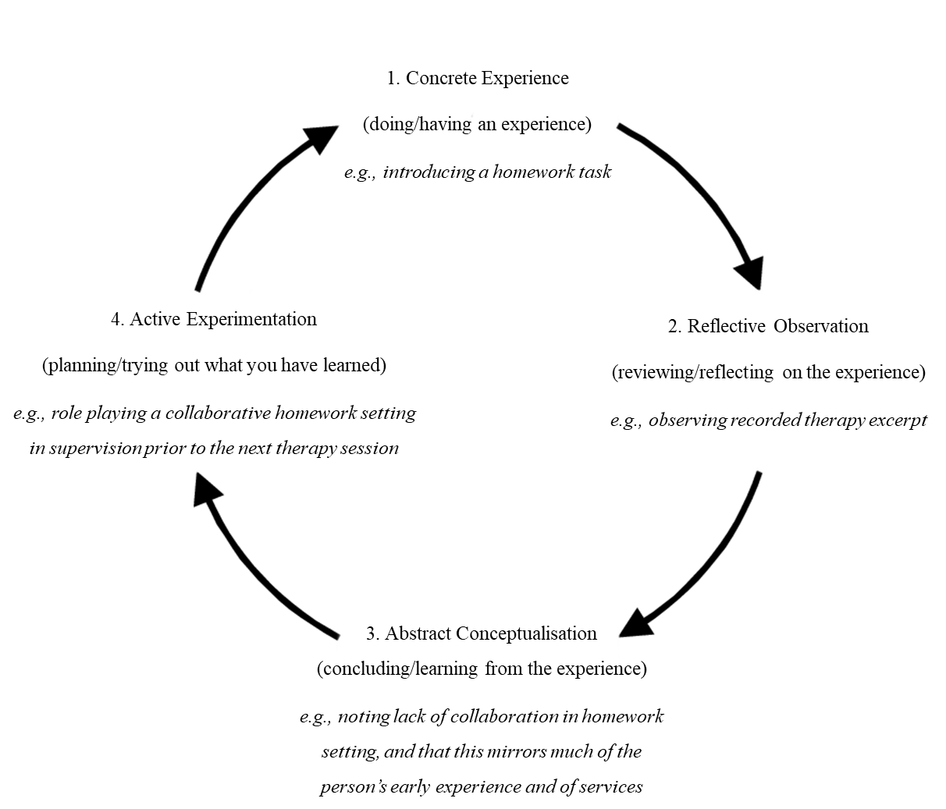

Figure 2. Map of themes describing CBTp trainees’ priorities for clinical supervision

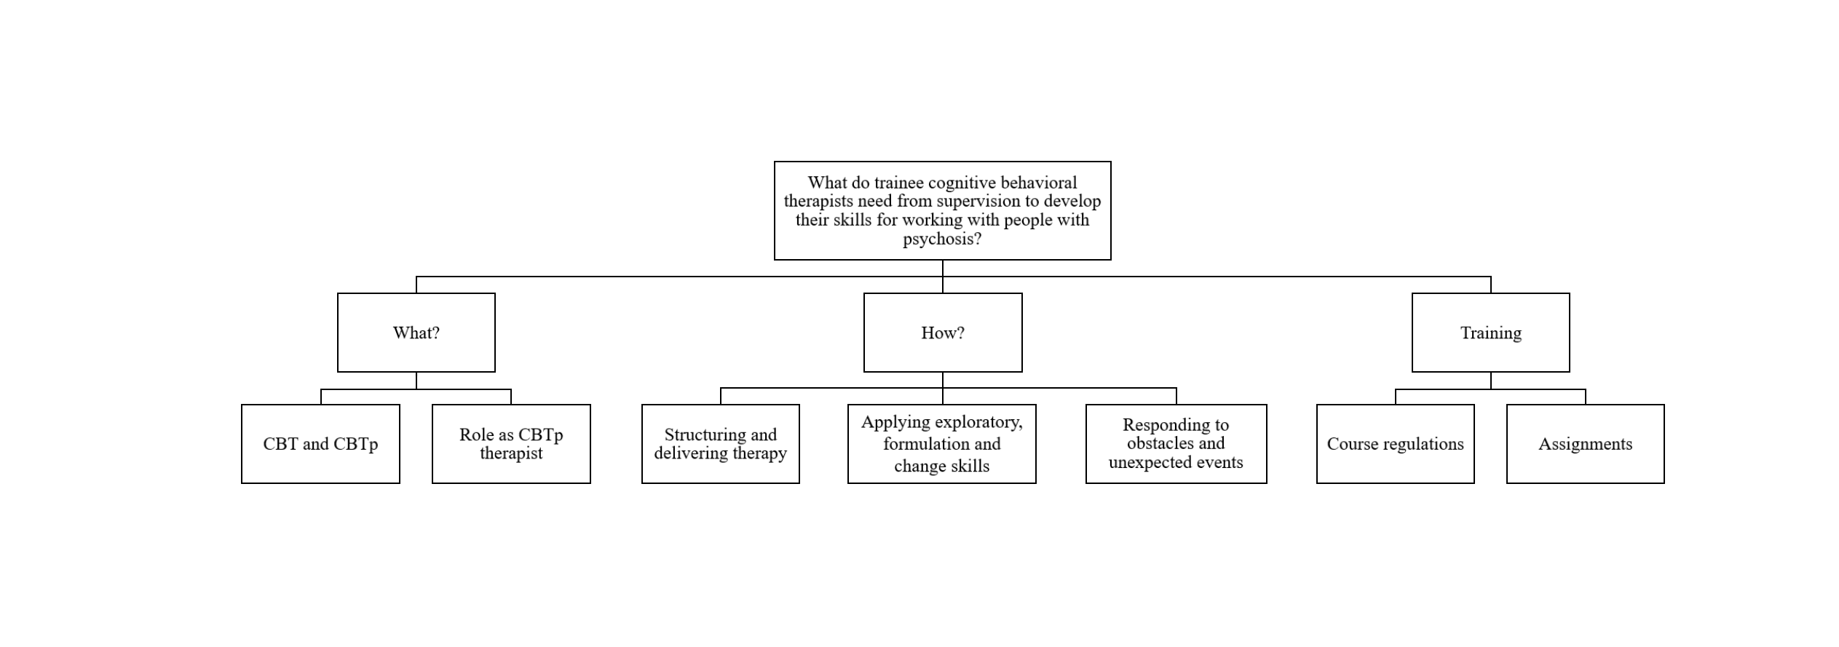

The number of participants is consistent with Guest et al. (2006) who suggest that data saturation typically occurs around 12 participants from a homogeneous group
Full codebook available on request

