DNA Gold Nanoparticle Motors Demonstrate Processive Motion with Bursts of Speed Up to 50 nm Per Second

Alisina Bazrafshan, Maria-Eleni Kyriazi, Brandon Alexander Holt, Wenxiao Deng, Selma Piranej, Hanquan Su, Yuesong Hu, Afaf H. El-Sagheer, Tom Brown, Gabriel A. Kwong, Antonios G. Kanaras, Khalid Salaita*

ABSTRACT: Synthetic motors that consume chemical energy to produce mechanical work oﬀer potential applications in many ﬁelds that span from computing to drug delivery and diagnostics. Among the various synthetic motors studied thus far, DNA-based machines oﬀer the greatest programm- ability and have shown the ability to translocate micrometer-distances in an autonomous manner. DNA motors move by employing a burnt-bridge Brownian ratchet mechanism, where the DNA “legs” hybridize and then destroy complementary nucleic acids immobilized on a surface. We have previously shown that highly multivalent DNA motors that roll oﬀer improved performance compared to bipedal walkers. Here, we use DNA- gold nanoparticle conjugates to investigate and enhance DNA nanomotor performance. Speciﬁcally, we tune structural parameters such as DNA leg density, leg span, and nanoparticle anisotropy as well as buﬀer conditions to enhance motor performance. Both modeling and experiments demonstrate that increasing DNA leg density boosts the speed and processivity of motors, whereas DNA leg span increases processivity and directionality. By taking advantage of label-free imaging of nanomotors, we also uncover Lev́y-type motion where motors exhibit bursts of translocation that are punctuated with transient stalling. Dimerized particles also demonstrate more ballistic trajectories conﬁrming a rolling mechanism. Our work shows the fundamental properties that control DNA motor performance and demonstrates optimized motors that can travel multiple micrometers within minutes with speeds of up to 50 nm/s. The performance of these nanoscale motors approaches that of motor proteins that travel at speeds of 100−1000 nm/s, and hence this work can be important in developing protocellular systems as well next generation sensors and diagnostics.

Nanomachines are ubiquitous in nature.[1,2] For example, the kinesin motors travel micrometer length distances on microtubules with nm/s velocities by hydrolyzing ATP.[3] Recapitulating the properties of these biological motors in synthetic systems has been a long-standing goal as these synthetic systems hold promise in the development of next generation sensors, molecular computers,and drug delivery platforms.[4−6]

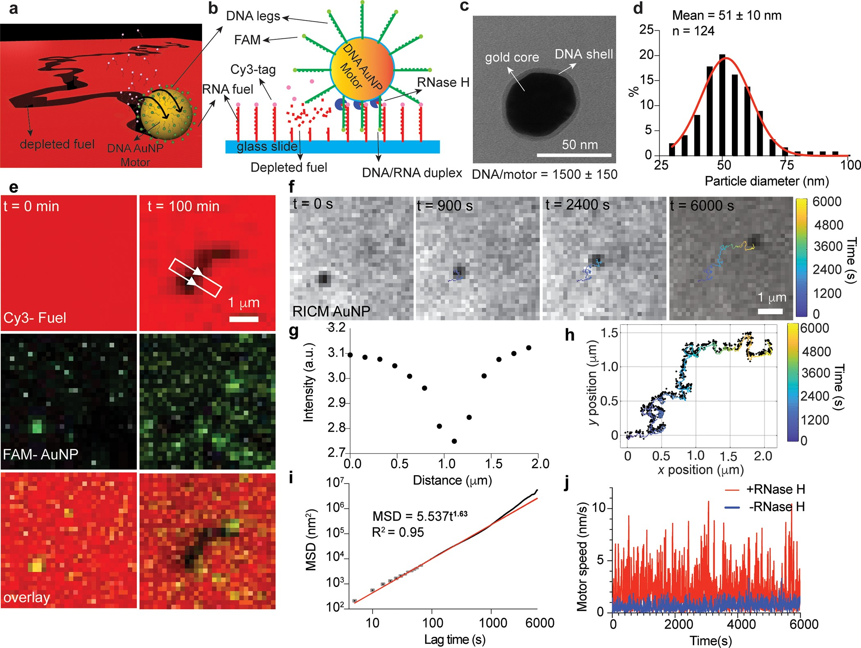

Figure 1. Design of DNA-AuNP nanoscale motors. (a) 3D illustration showing DNA-AuNP motor. (b) Side view scheme of motor highlighting the enzymatically driven mechanism of motion. RNase H speciﬁcally cleaves RNA hybridized to DNA legs but not single stranded RNA. (c) TEM image of 50 nm DNA AuNP motor stained with uranyl formate. (d) Histogram of DNA-AuNP diameters measured from TEM, n = 124 DNA-AuNP conjugates functionalized from two diﬀerent batches. (e) Fluorescence images of FAM-AuNP and Cy3-fuel and overlay of a single DNA-AuNP motor at initial and ﬁnal time points. (f) Timelapse RICM images of AuNP-motor. Colored line shows smoothed trajectory of a single motor obtained by ﬁnding the centroid from RICM time lapse. (g) Representative linescan proﬁle of the region highlighted by white box in (e) demonstrating RNase H dependent hydrolysis of Cy3-RNA fuel. (h) AuNP motor RICM based localizations (black dots) with smoothed trajectory (colored line). Color indicates time from 0 to 6000 s (100 min). (i) Plot of MSD vs time for the same particle in (e) and (f). This plot is used to infer the α value for this motor (α = 1.63). Black dots indicate average MSD for a given lag time, gray error bars represent the standard deviations of MSD for a given lag time. Red line shows the power ﬁt to the data. (j) A plot of motor speed vs time for two motors with (same particle in (e), (f), (h), and (i), red) and without (blue) RNase H.

In contrast to diﬀusional devices[7,8] and nanoscale switches[9] that can toggle between isoenergetic states and can undo their own “work”, nanoscale motors perform processive mechanical work. Commonly, nanomotors convert chemical energy into controlled nanomechanical motion through the burnt-bridge Brownian ratchet (BBR) mechanism. BBR is also harnessed by nature and is used to describe the enzymes involved in the partitioning of low copy number plasmids between daughter cells in bacteria.[10,11] This mechanism involves binding of the motor to a “foothold” site, followed by a hydrolysis step that diminishes aﬃnity to the occupied foothold, hence breaking symmetry and biasing motion to an adjacent unoccupied foothold site. The BBR mechanism is also chemically modular and has been shown to power nanomotors fueled through protein,[12] carbohydrate,[13] and nucleic acid chemical energy sources.
Among various BBR motors, DNA-based BBRs show great promise. This is because of the ability to tailor DNA into 3D structures with molecular precision using facile and highly accessible synthesis and self-assembly procedures. In addition, DNA hybridization and hydrolysis kinetics are highly tunable. The ﬁrst demonstrations of DNA BBR motors had one or two legs. These motors could only undertake 1−5 consecutive steps (∼10 nm).[14−17] Increasing the number of DNA legs leads to an increase in the processivity of DNA BBRs but at a cost of reduced speed.[18−20] This is due to the uncoordinated motion of individual DNA legs and points to a trade-oﬀ between polyvalency and speed. To increase the processivity of bipedal DNA walkers, Nir and co-workers used single molecule time-resolved FRET to reveal motor stepping dynamics and used this data to enhance motor design pushing the processivity from 7 to 32 consecutive steps with walking speed of 6 nm/h.[21] In a separate study, Ellington and co- workers increased the number of steps taken by a monoleg DNA walker[22] up to 38[23] and 47[24] steps/motor by increasing the number of legs[23] or introducing a cleat.[24]
Our group’s eﬀorts to create fast and eﬃcient DNA BBR motors has focused on increasing the speed of multileg (polyvalent) DNA motors. The strategy has relied on powering these multileg BBR motors using RNase H, which has a high kcat, and engineering nano- and microscale structures that allow for rolling.[25,26] Surreptitiously at ﬁrst, and later by structure- functional analysis and modeling, we found that rolling overcomes the fundamental trade-oﬀ between polyvalency and speed as it coordinates the motion of individual DNA legs.
In our previous work,[27] we used DNA origami self-assembly[28] to generate the motor chassis and experimentally test structures that enable rolling of nanoscale motors. We found that rolling DNA origami nanomotors demonstrate unidirec- tional motion for ∼μm distances within an hour.
Despite this progress, synthetic DNA BBR motors and even DNA-origami rolling motors remain ∼1 to 2 orders of magnitude slower than that of biological motors. Faster motors are desirable to foster the envisioned applications of nanoscale machines. Detailed investigations into the mechanism of chemical to mechanical energy conversion powering synthetic motors can optimize their eﬃciency, speed, and processivity.
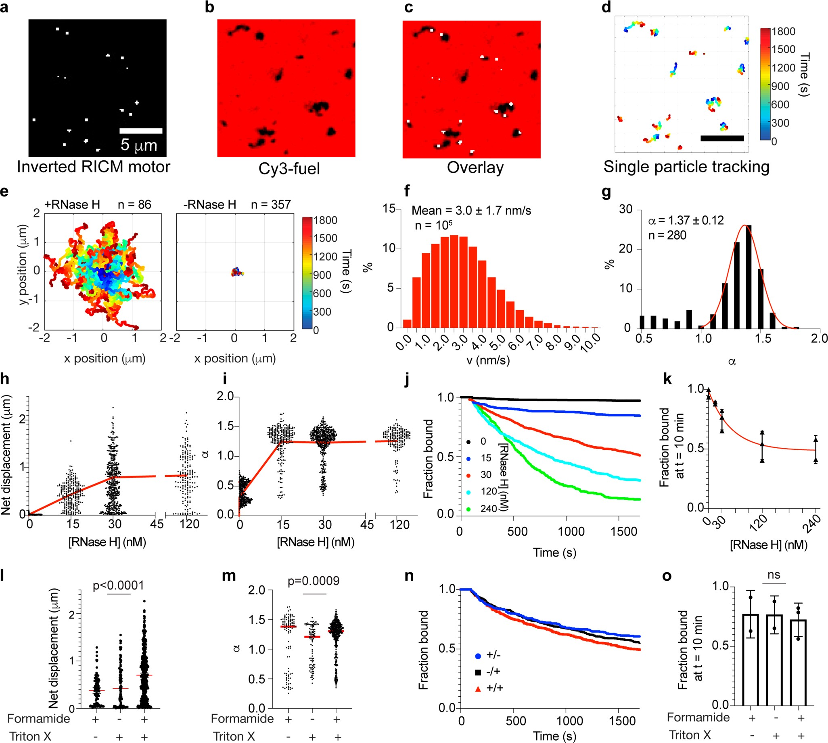

Figure 2. Ensemble tracking of motor behavior. (a) Inverted RICM showing the location of DNA-AuNP motors. (b) Cy3 channel image showing fuel depleted tracks. (c) Overlay of inverted RICM and Cy3 image showing colocalization and loss of fuel in wake of motor. (d) Single particle trajectories from a 30 min timelapse RICM movie from region highlighted (a)−(c). (e) Ensemble motor trajectories plotted from the center of coordinates (0,0) with 30 nM RNase H (left, n = 86) and without RNase H (right, n = 357). Color indicates time from 0 to 30 min. (f) Histogram of motor speed generated from 105 data points from hundreds of motors from three independent experiments. The histogram mean and standard deviation is calculated from the raw data. (g) Ensemble α values of motors demonstrating self-avoiding behavior. 85% of the motors have α>1. A Gaussian ﬁt to α>1 shows α = 1.37 ± 0.12 for superdiﬀusive motors in the presence of 30 nM RNase H. (h) Plot of net displacements and (i) α values for motors as a function of [RNaseH]. Each dot represents a single motor. The red line connects the means of each sample. n = 300, 218, 340, and 148 motors for 0, 15, 30, and 120 nM concentrations, respectively, generated from three independent experiments. (j) Plot of fraction of motors bound to surface as a function of time for motors with diﬀerent [RNaseH] (same trajectories from (i)) and (k) plot of fraction of motors bound at t = 10 min. Error bars represent the standard deviation from three (0, 15, 30, 120 nM RNase H) or two (240 nM RNaseH) independent experiments. (l) Plot of net displacements and (m) α values as a function of formamide/triton X addition. Each dot represents a single motor. The red line indicates the means of each sample. n = 103, 97, and 156 for +/-, -/+, and + /+ conditions, respectively. ANOVA summary p values for each plot are indicated above. (n) Plot of fraction of motors bound to surface as a function of formamide and triton X. (o) Plot of fraction of motors bound at t = 10 min. Error bars represent the standard deviation from three (+/+) or two (+/- and-/+) independent experiments

Herein, we generate DNA motors with a gold nanoparticle “chassis” (DNA-AuNP). Organizing DNA legs around a gold particle chassis aﬀords key advantages, which include the ability to generate high DNA leg density that would be very challenging to achieve using the origami technique[29] or using silica attachment chemistry.[30,31] The thiol gold bond is a labile dative bond that allows for reconﬁguration of DNA molecules to maximize packing density. Moreover, theoretical work by Schatz and colleagues suggests that the high local DNA density is accompanied by elevated local ionic strength and an enhanced collective on-rate of binding.[32] Another advantage of the AuNP chassis is that this scaﬀold provides a powerful label- free tag to visualize motor motions with high temporal (∼50− 500 ms) and spatial resolutions (∼10 nm) without concern for photobleaching. Lastly, the past few decades of nanoscience have generated facile procedures to synthesize and function- alize many diﬀerent shapes and sizes of particles, and while not explored thoroughly in this work, it can be tested in principle to allow for mechanistic studies of motor mechanism.[33−38]
DNA-AuNP motors presented herein are processive for hours, can travel micrometer distances with speeds of multiple nanometers per sec which is an order of magnitude faster than DNA-origami motors and on par with some biological motors. We conﬁrm that DNA-AuNP motors are eﬃcient due to their ability to roll. Through a combination of experiments and modeling, we optimized the parameters of DNA leg density and span of DNA legs to enhance motor speed and processivity. By observing the motors with high time resolution, we discovered that DNA-AuNP motors display Levy-type motion, which shows bursts of speed followed by periods of slower motion. To our knowledge, DNA AuNP motors show the highest speed and greatest distances traveled for a nanoscale DNA-based motor to date.

RESULTS AND DISCUSSION
Design and Characterization of DNA-AuNP Motors. A 3D illustration of our design is shown in Figure 1a. A gold nanoparticle is modiﬁed with DNA legs, which are complementary to a monolayer of single stranded RNA (ssRNA) immobilized on a glass slide (Supporting Information (SI) Figure S1). The ssRNA serves as the chemical fuel and is tagged with Cy3 to enable visualization of fuel consumption during BBR translocation (SI Tables S1 and S2). Figure 1b highlights the reactions that drive BBR translocation of the motor. Brieﬂy, the DNA legs hybridize to the complementary ssRNA fuel. This immobilizes the particle to the surface. Upon the addition of RNase H, RNA strands that are duplexed with the DNA legs are exclusively hydrolyzed, which frees the motor to hybridize to fresh ssRNA fuel sites. The net process of DNA leg hybridization, followed by RNA fuel consumption, and subsequent hybridization leads to a cycle that drives the motor to move forward away from consumed sites and toward untouched ssRNA fuel.
To facilitate detailed analysis of motor motion, we screened a range of nanoparticle sizes (SI Figures S2−S4) and found that 50 nm AuNPs (Figure 1c,d) were optimal oﬀering high contrast in reﬂection interference contrast microscopy (RICM). These 50 nm AuNPs were functionalized with thiolated DNA legs, as conﬁrmed by UV−vis (SI Figure S5), and TEM (Figure 1c). To determine DNA leg density, the DNA was tagged with a FAM ﬂuorophore (Figure 1b), and using a ﬂuorescence calibration curve, the DNA density was found to be 1500 ± 150 molecules per particle (∼1 DNA leg/5 nm² or 1.9 × 105DNA leg/μm2) (SI Figure S6). Importantly, this density is 7.2 times higher than the density of our previous DNA origami motors, which in principle, should lead to an enhancement in motor speed.
Introduction of DNA AuNP motors (∼10 pM) to the RNA monolayer led to motor binding within minutes as observed by RICM (SI Movie S1). Wideﬁeld ﬂuorescence microscopy showed bright FAM localizations of individual particles that colocalized with dark puncta observed in RICM (SI Figure S2, Figure 1e,f). After washing the excess unbound particles, DNA- AuNP motors remained immobile due to DNA-RNA hybridization (SI Movie S2). Upon addition of RNase H, time-lapse RICM movies showed particle translocation across the surface (Figure 1f, SI Movie S3). Nanomotor motion colocalized with the loss of Cy3-tagged RNA fuel (Figure 1e,g). We were able to localize the trajectory of the nanomotor based on the scattering of the gold particle motor observed using RICM (Figure 1f, 1h and SI Figure S7). MSD analyses of this track showed an α coeﬃcient of 1.6 (Figure 1i). MSD is proportional to timeα, where α is a scaling factor that is 1 for random (Brownian) diﬀusion, <1 for subdiﬀusive motion, and >1 (such as this trajectory) for superdiﬀusive motion.[39] Motors are also highly processive, as a plot of motor speed as a function of time shows that motion is maintained for ∼hours (Figure 1j). Motor speed was maintained despite the slow dissociation of DNA legs (∼30% loss in 1 h) due to thiol- displacement reaction with 10 μM DTT in the buﬀer which is required for RNase H activity (SI Figures S8 and S9). Note that the optimized conditions ([RNaseH], [formamide], [triton X]) used to conduct this experiment and the DNA leg sequence design (ﬂexible polyT linker length and density) were the result of iterative screening and optimization of motor performance using single particle tracking (vide infra).
Ensemble Tracking Shows That Motors Are Fast and Super Diﬀusive. Using the MOSAIC localization software[40 ]along with smoothing[41] (SI Figure S10), drift correction algorithms (SI Figure S11),[42] and custom MATLAB scripts we were able to analyze ensemble behavior of over 1000 motors at diﬀerent conditions (SI Figures S12−S14). Figure 2 shows a representative inverted RICM image oﬀering motor locations (Figure 2a), Cy3-fuel depleted tracks (Figure 2b), overlay (Figure 2c) and the result of single particle tracking (Figure 2d). These localizations are color coded by time (0−30 min) and provide motor speed, net displacement, and the duration of track attachment. Figure 2e (left) shows n = 86 trajectories overlaid with the origin as the start position. Trajectory lengths were negligible when RNase H was withheld (Figure 2e, right), which conﬁrms the role of RNase H in driving motion of these particles as well as the quality of our particle tracking algorithms. Histograms plotting motor speeds of hundreds of tracks show that motors can reach 10 nm/s with an average of 3.0 ± 1.7 nm/s (Figure 2f). This value is on par with the speed of biological motor proteins.[1,43] Furthermore, analyses of 280 motors conﬁrmed that most tracked particles (85%) were super diﬀusive with an average α = 1.37 (Figure 2g). A recent modeling study showed that in systems where motors progressively dissociate from the surface, selecting only the track-bound BBRs for analysis can lead to bias and an overestimate of α.[44] However, in our system, we observed that a subset of motors tend to stall as well as dissociate over longer observation times. Careful analysis of α conﬁrmed that most motors are superdiﬀusive throughout the 30 min acquisition and there is no overestimate bias of α (SI Figures S13 and S15).

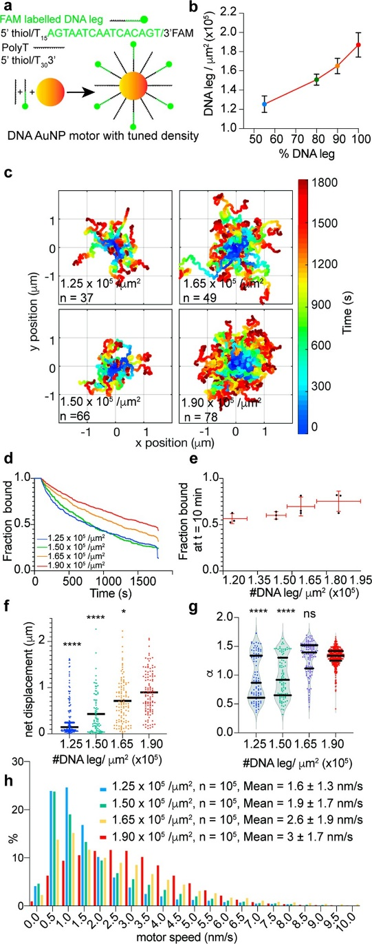

Figure 3. Eﬀect of DNA leg density on motor motion. (a) Schematic used to tune the density of DNA legs on 50 nm DNA gold particles. (b) Plot of density of DNA legs/μm² as a function of %DNA leg in DNA solution for AuNP functionalization. (c) Trajectories of motors with diﬀerent DNA leg density with color indicating time from 0 to 30 min. (d) Plot of fraction of motors bound to surface as a function of time for motors with diﬀerent DNA leg density and (e) plot of fraction of motors bound at t = 10 min. Vertical and horizontal error bars represent the standard deviation for three independent experiments. (f) Plot of motor net displacement and (g) α value as a function of DNA leg density. Each dot represents a single motor while the horizontal line represents the mean from (n = 99, 89, 114, and 121 for 1.25 × 10⁵, 1.5 × 10⁵, 1.65 × 10⁵, and 1.90 × 10⁵ DNA leg/μm2 samples, respectively generated from three independent experiments). ****, *, and ns indicate that p < 0.0001 and p = 0.019 and not statistically diﬀerent when compared to 1.90 × 10⁵ DNA leg/μm² density group. Horizontal black lines in (g) represent the median and quartiles of the distribution of α values. (h) Histograms of motor speeds for motors with diﬀerent DNA leg density. Each histogram is comprised of 10⁵ motor speed data points generated from trajectories of three independent experiments characterized in (d)−(g). The histogram mean and standard deviation is calculated from the raw data.
Optimizing Enzyme Concentration and Buﬀer Conditions.
We investigated the role of RNaseH concentration and buﬀer in tuning motor performance. Figure 2h shows the eﬀect of enzyme concentration on net displacements. This experiment revealed that net displacement increased with increasing RNaseH concentrations up to 30 nM. Greater concentrations of RNase H did not further boost the average net displacement of motors. Motor speed is limited by enzyme concentration in the regime of low [RNaseH]. At greater [RNaseH], net displacement saturates, suggesting that the rate limiting step is no longer the kcat, that is, the rate of RNA hydrolysis. Despite having diﬀerent net displacements, most motors were super diﬀusive (α > 1) in all conditions with RNase H present (Figure 2i).
Interestingly, enzyme concentrations also tune motor processivity as higher concentrations lead to more rapid surface dissociation (25% more motor dissociation at t = 10 min as RNase H increased from 30 to 240 nM) (Figure 2j,k). Modeling of DNA BBRs using a Monte Carlo & Gillespie algorithm also shows that motor speed increases with enzyme concentration up to a certain threshold (SI Materials and Methods - K, Figure S16). In the model, increasing enzyme concentration decreases the attachment time of particles, as more enzyme increases the probability of all DNA legs simultaneously occupying the unbound state. Accordingly, we proceeded with the 30 nM enzyme concentration for the remainder of this study. We subsequently tested the role of denaturant (formamide) and surfactant (triton X) in tuning motor performance. In the presence of both formamide and triton, motors generate twice the net displacement compared to a solution that includes either formamide or triton X only in the 1X RNase H buﬀer (Figure 2l). Regardless of the variations in net displacement, motors remain super diﬀusive in the presence of these additives (Figure 2m). Quantifying the fraction of motors that remain bound as a function of time showed that denaturant and surfactant (at the concentrations tested) have no signiﬁcant eﬀect on motor processivity (Figure 2n,o). These experiments show how optimizing buﬀer conditions can signiﬁcantly boost motor performance.
Increasing DNA Leg Density Boosts Motor Speed and Processivity.
Previous modeling by Forde and colleagues along with our experiments using DNA origami nanostructures suggested that increasing DNA leg density enhances motor speed.[45] The relationship between track attachment time (motor processivity) and DNA leg density is more complex, with two recent papers by Forde and colleagues suggesting that the relationship depends on the aﬃnity between the DNA legs and the consumed fuel site.[20,45] Our model (SI Figure S17), in agreement with Forde et al., predicts increasing density of DNA legs will lead to increased processivity because of the aﬃnity between DNA legs and partially hydrolyzed fuel sites. To test these predictions, we generated a library of motors modiﬁed with a binary mixture of two DNA strands- keeping the total thiol-DNA concentration constant- one that was the DNA leg and the second as a nonspeciﬁc DNA oligo (poly T). The advantage of this approach is that motor charge density and its chemical environment was maintained (Figure 3a). We quantiﬁed DNA leg density on each motor by gold dissolution and comparing FAM-DNA ﬂuorescence to that of a calibration standard. The library of AuNP motors had DNA leg densities ranging from 1.25 × 10⁵ to 1.90 × 10⁵ DNA legs/μm² (Figure 3b and SI Figure S18). Across these DNA leg densities, all motors were functional and translocated on the complemen- tary RNA chips (Figure 3c). Measurement of the fraction of particles remaining bound to the surface as a function of time after RNaseH addition showed that increasing DNA leg density led to a slight increase in processivity (Figure 3d). For example, 75 ± 9% of the highest DNA density motors (1.90 ×10⁵ DNA legs/μm²) remained bound at t = 10 min after initiating motion, while only 56 ± 5% of the low-density motors (1.25 × 10⁵ DNA legs/μm²) remained bound at the same time point (Figure 3e). By selecting the motors that remained processive for the duration of the 30 min video, we observed an increase in net displacement with increasing DNA leg density (Figure 3f). This increase in total displacement was accompanied by an increase in number of motors being super diﬀusive in the course of 30 min (α > 1, Figure 3g) as well as an increase in motor speed (Figure 3h).

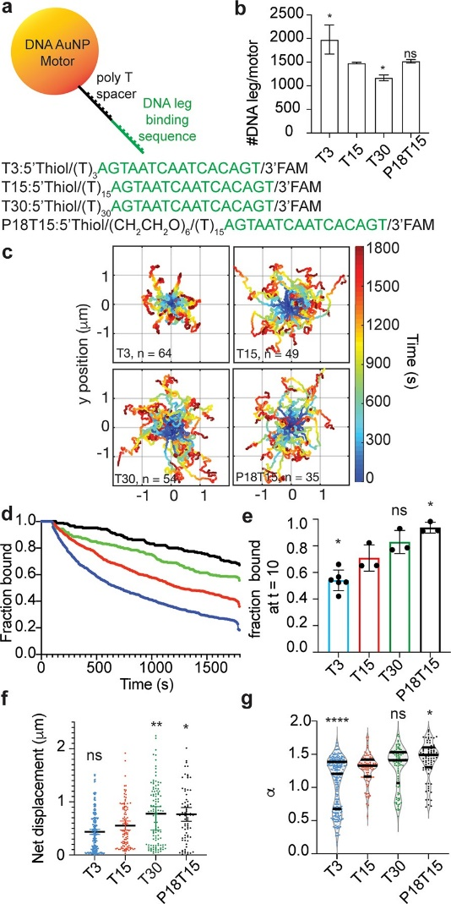

Figure 4. Eﬀect of DNA leg span on AuNP motor motion. (a) Schematic showing how DNA leg span was tuned using sequences with varying lengths of T spacers and PEG. (b) Plot of DNA copy number per motor for diﬀerent DNA legs. * indicates p = 0.019 (T3 vs T15), and p = 0.029 (T30 vs T15) and ns indicates not statistically diﬀerent (P18T15 vs T15). (c) Trajectories of motors with diﬀerent DNA leg span with color indicating time from 0 to 30 min. (d) Plot of fraction of motors bound to surface as a function of time and (e) plot of fraction of motors bound at t = 10 min. * and ns indicate p = 0.049 (T15 vs T3), 0.020 (T15 vs p18T15), and not statistically diﬀerent, respectively. Each dot represents one replicate, and the error bars indicate the standard deviation. (f) Plot of motor net displacement and (g) α value as a function of DNA leg span. Here, each dot represents a single motor while the horizontal line represents the mean from (n = 257, 99, 115, and 73 for T3, T15, T30, and P18T15 samples, respectively). The data for each DNA span category was pooled from three independent experiments, with the exception of the T3 which was pooled from six independent experiments. **, * and ns in (f) indicate that p = 0.002 (T15 vs T30), p = 0.019 (T15 vs p18 T15) and not statistically diﬀerent (T3 vs T15). Horizontal black lines in (g) represent the median and quartiles of the distribution of α values. ****, *, and ns indicate p < 0.0001, p = 0.038 and not statistically diﬀerent when compared to T15 group.

This experimental result conﬁrms the prediction that increasing leg density leads to a counterintuitive increase in motor speed (SI Figure S17). If viewed from the perspective of the DNA motor, a greater DNA leg density requires more catalytic turnovers to move the particle a set distance. However, if viewed from the perspective of the RNA monolayer, particle motion requires removal of a critical density of RNA to facilitate motion. Greater DNA leg density allows for parallel cleavage events to occur, and thus allowing the particle to move faster. These data show that increasing DNA leg density enhances the rate of RNA hydrolysis (by eﬀectively increasing the concentration of enzyme−substrate (E−S) complex). In addition, increasing leg density is also advantageous as it leads to improved processivity by reducing the probability of spontaneous dissociation from the track or stalling.
DNA Leg Span Increases Motor Processivity. DNA leg “span” is deﬁned as the number of RNA fuel sites that are accessible to a given DNA leg. We modeled how span impacts motor performance using our Monte Carlo and Gillespie algorithm (SI Figure S19). In our model, span was tuned by increasing the eﬀective particle size while maintaining the same polyvalency, and increasing this parameter led to a signiﬁcant enhancement in processivity (SI Figure S19). To experimentally test the role of DNA leg span, we generated AuNP with DNA legs linked to the motor chassis using a T3, T15, T30, and PEG18-T15 spacer (Figure 4a). Increasing the length of the T spacer in the DNA legs led to a decrease in surface density, as would be expected based on prior work (Figure 4b, SI Figure S18).[46] As an additional variant, we introduced a PEG linker (PEG18) since this maintains DNA density while providing additional span (SI Figure S18). By analyzing 10s of trajectories from each type of motor (Figure 4c), we found that motors with higher span were more processive (Figure 4d,e), and traveled greater distances (Figure 5f). Almost half of the T3 motors bound to the surface demonstrate a low α value due to premature stalling and greater spans also allowed for a slight increase in the α value (Figure 4g). These eﬀects were more pronounced for the PEG18-T15 DNA legs since DNA leg density was maintained at a level similar to the T15 for this group. Despite the 20% reduction in DNA density for T30 DNA legs group, the increase in leg span outweighed the eﬀect of reduced DNA leg density and generated greater processivity. The model explains these experimental results by predicting that increasing DNA span improves processivity by increasing the probability of foothold binding (SI Figure S19). Our results in studying the eﬀect of span are in agreement with previous modeling that increasing span leads to increase in track attachment time.[45] However, we did not see a decrease in α in the conditions tested through experiments and modeling; modeling by Forde et. al predicts that α will decrease with increasing span.[45] This prediction may hold if we increased span to distances of ∼50−100 nm which is comparable to the particle size.
High-Temporal Resolution Particle Tracking Shows Lev́y-Type Motion in AuNP Motors. An interesting observation in the trajectories generated by our simulation algorithm was that motors traveled in bursts of motion followed by slower diﬀusion (SI Figure S20). Taking advantage of label-free particle tracking with RICM, we are able to acquire time-lapse movies showing the motion of 50 nm AuNP motors with a frame rate as rapid as 2 Hz. This number of localizations is not possible when using ﬂuorescence microscopy because of the limited photon budget when employing conventional dyes. A control experiment using stalled motors showed that increasing the frame rate to 2 Hz had minimal eﬀect on localization precision (SI Figure S21). Thus, far, all imaging was performed at 0.2 Hz frame rate, and this showed that particles moved continuously (Figure 2g, Figure 5a). However, when tracking motors at 2 Hz, we discovered that their motion was not continuous. Rather, motors displayed intervals or bursts with large steps (15−35 nm) alongside periods of moving with small steps (2−5 nm) (Figure 5b, SI Figure S22). This is better represented by the distribution of individual steps (d, distance between two consecutive time points).

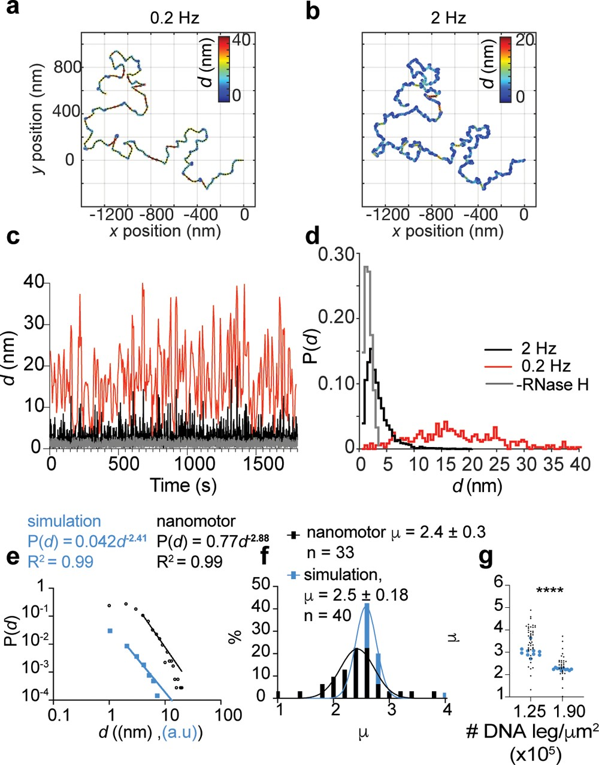

Figure 5. Motors display Lev́y type motion. Representative experimental motor trajectory for the same motor tracked at (a) 0.2 and (b) 2 Hz imaging rates. Trajectories are color coded by the size of the individual step (d) between two consecutive time points. (c) Plot of individual step size (d) vs time for an individual motor tracked at 0.2 (red) and 2 Hz (black) imaging rates and the step sizes of a motor tracked at 2 Hz in the absence of RNaseH (noise, gray). (d) Probability density function of step size (d) for diﬀerent imaging rates shows diﬀerent distributions depending on imaging rate. (e) The heavy tail of the probability distribution for step size of simulated (blue) and experimental (black) tracks show Lev́y type motion. (f) Histograms of Levy coeﬃcients (μ) for nanomotor experiments (black) and simulations (blue). Lines show Gaussian ﬁts to the histograms from which the mean and standard deviations are extracted. (g) Increase in Lev́y coeﬃcient (μ) with decreasing density of DNA legs. **** shows p < 0.0001. Each black dot represents the Levy coeﬃcient of a nanomotor, while each blue dot shows the Levy exponent for a simulated trajectory.

When motors are tracked at 0.2 Hz frame rate, almost all observed values of d (and accordingly motor speed in Figure 2j) are higher than the background noise, suggesting motor motion is continuous. However, when motors are tracked with the 2 Hz frame rate, 50% of the observed values of d, are comparable with background noise and the distribution of d shows a heavy tailed distribution (Figure 5c, SI Figure S22). Heavy tailed probability distributions of steps are known as Lev́y walks or Lev́y type motion which have been used to characterize the motion of marine vertebrates,[47] birds,[48] T cells,[49] and even swarming E. coli.[50] Mathematically, Lev́y-walks are drawn from a probability distribution with a power-law tail where P(d) of the tail is distributed as a function of step size (d) to the power of −μ. When 1 < μ ≤ 3, the motion is characterized as a Lev́y walk.[47,48,50] When analyzing the trajectory in Figure 5b, we found that the motor showed μ = 2.8. Ensemble analyses of nanomotor trajectories from n = 33 particles with [RNase H] = 30 nM exhibited a Lev́y-type motion with μ = 2.4 ± 0.3 for the population. Interestingly, we found that simulated particles exhibited μ = 2.5 ± 0.2 which is similar to our measured values (Figure 5f). Analyses of step sizes on motors with diﬀerent DNA leg densities revealed that μ decreases with increasing DNA density (Figure 5g). This result suggests that motors with greater DNA leg density display a higher probability of taking longer steps (SI Figure S23). This experimental ﬁnding is consistent with our observation that increasing DNA leg density enhances motor performance (processivity and speed) (Figure 3). Our model shows a similar trend (Figure 5g), and indicates that at higher DNA leg densities, large steps are driven by transient stalling of the motor until all proximal fuel sites are consumed, thus freeing the motor to take a step that can be as large as one body length (∼50 nm). Conversely, lower leg density reduces the probability of taking such large steps.
Motors Travel via a Rolling Mechanism. Previous work showed that polyvalent rolling micromotors[25] and nano- motors[27] with an anisotropic chassis can roll unidirectionally. To test if gold nanoparticle motors move by rolling, we aimed to generate an anisotropic motor chassis. One approach to engineer such anisotropic DNA-AuNP motors is by dimerizing the motors using hybridization-driven click chemistry.[35] A schematic of this approach is shown in Figure 6a. The rationale was that dimers of particles would function as two “wheels” linked through 24-mer double stranded DNA and hence would display more linear trajectories compared to the monomeric particles. TEM and UV−vis analyses of dimerized particles conﬁrmed dimerization of the structure (Figure 6b, SI Figure S24). Quantitative TEM analyses of hundreds of nanoparticles showed that ∼30% of AuNPs were dimerized, with the remaining particles primarily as monomers (SI Figure S24). The yield was relatively low compared to reported yields for smaller sized particles due to the challenges of purifying dimerized 50 nm AuNP via gel electrophoresis.[51] Upon addition of RNase H, we imaged the motors in the RICM and FAM channels and observed the depletion tracks using the Cy3 channel (Figure 6c). Analysis of the Cy3 depletion tracks revealed that a subset of the trajectories displayed a linear component with some motors traveling ballistically over multiple micrometers (Figure 6c, SI Figures S25 and S26). To quantify track linearity, we measured the motor Kuhn segment length from the RICM trajectories (Figure 6d).

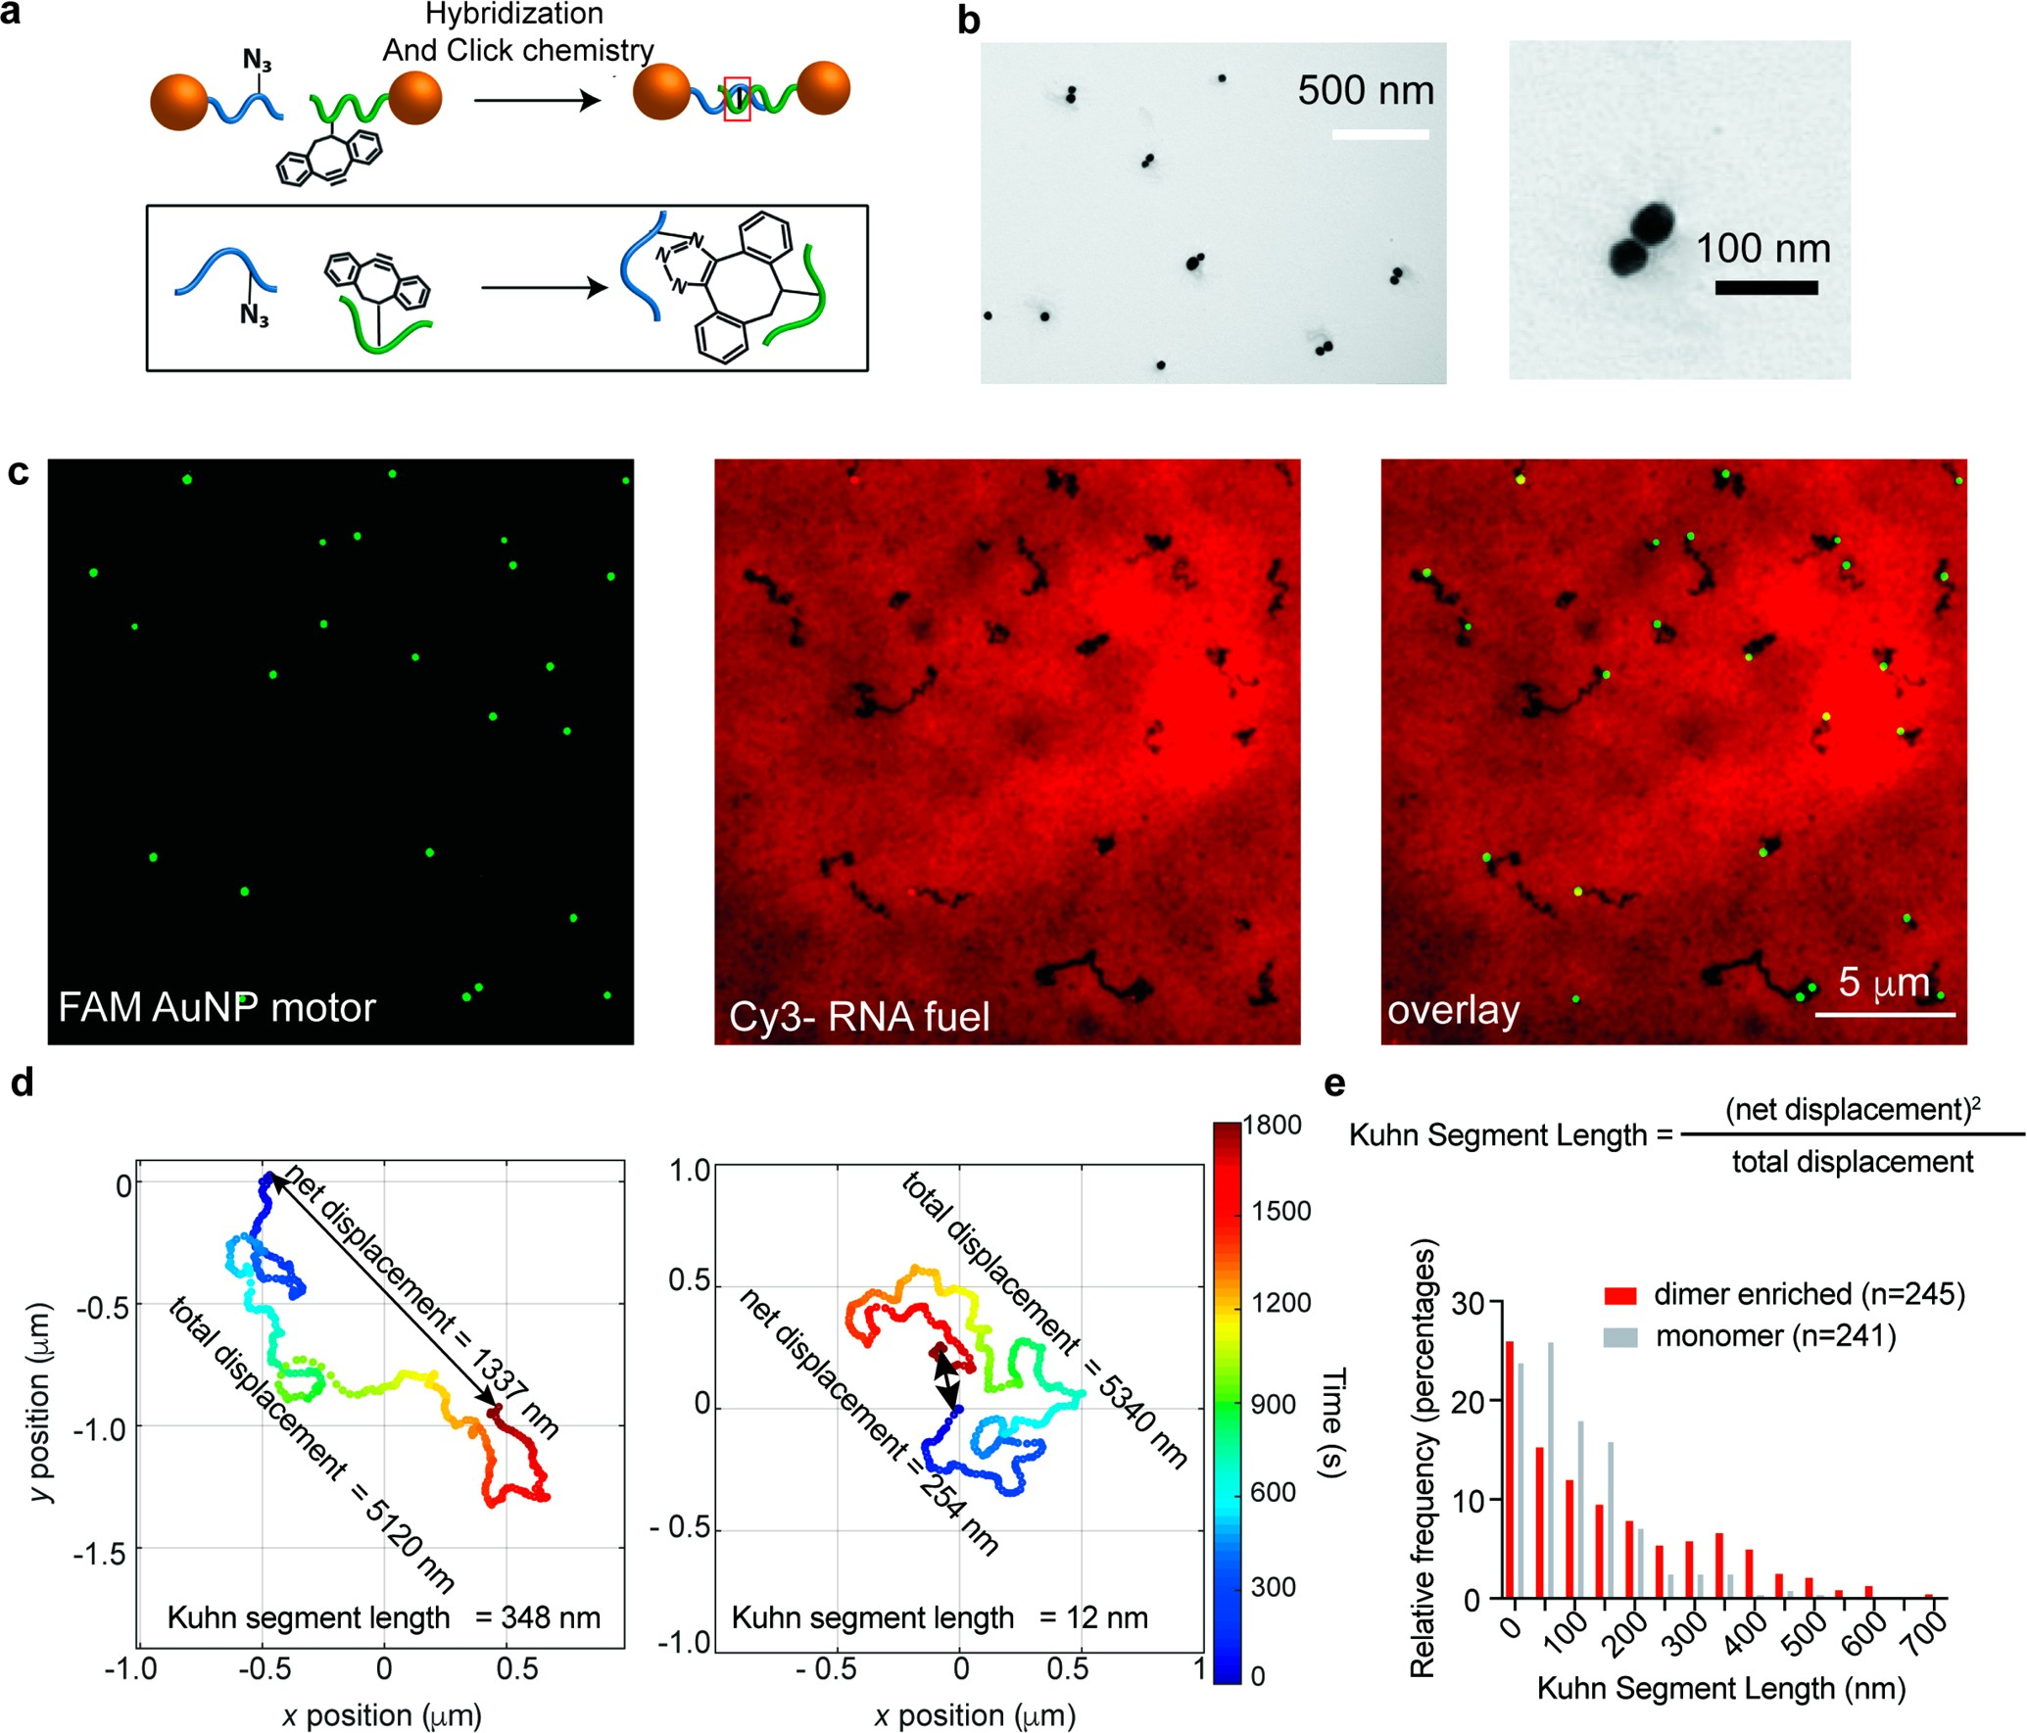

Figure 6. Anisotropic DNA-AuNP motors conﬁrm a rolling mechanism of motion. (a) Schematic showing the approach used to form chemically ligated DNA 50 nm gold nanoparticles utilizing copper free click chemistry. (b) TEM of dimerized sample highlighting a region of the grid with multiple examples of dimerized particles. Zoom-in shows a single dimer. (c) Representative SIM images (FAM, Cy3 and overlay) of FAM-labeled AuNP motors that were allowed to translocate for 1 h. (d) Two representative trajectories highlighting diﬀerent Kuhn segment values with color indicating time from 0 to 30 min. Data was obtained using RICM time lapse tracking as described in Materials and Methods section. (e) A histogram of Kuhn segment lengths for three runs from two particle batches. One batch was synthesized as monomeric AuNP motors (gray) while the second batch contained 30% dimer AuNP (red). Note that dimer enriched sample shows a population of trajectories with high (>250 nm) Kuhn segment lengths

Analyses of Kuhn segment lengths for populations of motors showed that in the dimer samples, 25% of the motors showed trajectories with a Kuhn segment length >250 nm. This subpopulation is minimal for the monomer nanoparticle motors and likely the result of AuNPs with high aspect ratio (Figure 6e, SI Figure S5d), which supports rolling as a mechanism of translocation.
We next analyzed the Cy3 depletion track widths as this metric provides additional evidence to the rolling mechanism, as dimer motors that roll should display a track width that matches the span of the DNA legs. Geometric modeling of dimers suggests that the dimers can span between 125−175 nm (SI Figure S27). Taking advantage of the enriched population of linear tracks, we used structured illumination microscopy (SIM) to quantify track widths. Analyses of Cy3- depleted tracks showed trackwidths ranging from 150 to 350 nm. Given the variation in particle size and noise of SIM measurement and the fact that the minimum track width was ∼150 nm, the data is consistent with a rolling mechanism (SI Figure S28).
As an additional control we blocked the remaining vacant DNA leg sites on monomeric DNA-AuNP motors after hybridizing to the RNA surface. In this experiment, we observed that blocked motors did not move and dissociated rapidly (SI Figure S29). Taken together, these multiple lines of evidence strongly support that AuNP motors primarily move through a rolling mechanism.

CONCLUSION
To the best of our knowledge, this work shows the fastest and most processive DNA nanomotor reported to date. By optimizing buﬀer and enzyme concentration, as well as DNA leg density and span, we have created a DNA nanomotor that can travel micrometer length distances within minutes, with bursts of speed reaching 50 nm/s. The label-free scattering- based imaging of 50 nm gold particle motors allows for tracking at high time and spatial resolution. By imaging at high time resolution, we discovered that motors display Lev́y type motion, where the motors show bursts of high speed punctuated by brief stalling periods in between. We also uncover the fundamental principles that may further boost speed, as increasing DNA leg density leads to a higher probability of larger steps.
Anisotropic shaped motors validate that motors primarily move by rolling. The data also strongly suggests that eﬃcient motor performance is mediated and enhanced by motor rolling as blocking the rolling mechanism leads to minimal trans- location and rapid motor dissociation. In closing, we note that gold nanoparticle motors now achieve speed and processivity that approaches that of biological motor proteins that move on a track with ∼100−1000 nm/sec speeds to move cargo in cells and drive locomotion of animals. Our work lays the foundation of how to further improve the performance of synthetic motors and given the programmability of DNA machines one can envision future applications in sensing, drug delivery and diagnostics.

MATERIALS AND METHODS
All chemicals were purchased from Sigma-Aldrich unless otherwise noted. Stock solutions were made using Nanopure water (Barnstead Nanopure system, resistivity = 18.2 MΩ, Thermoﬁsher, Waltham, MA), herein referred to as DI water. Oligonucleotides were custom synthesized by Integrated DNA Technologies (Coralville, IA) and are summarized in SI Tables S1 and S2. RNase H was obtained from Takara Clontech (Product No. 2150A). All motor translocation measurements were performed in IBIDI (Fitchburg, WI) sticky-Slide VI 0.4 channels (Product No. 80608) or in custom-made Delrin chambers. Delrin 1/4” × 12” × 12” Sheet (product no. 8573K15) and 2-sided optically clear mounting tape (product no. 7602A53) were purchased from McMaster Carr (Douglasville, GA). Azido-PEG4- NHS ester was purchased from Click Chemistry Tools (Scottsdale, AZ, product no. AZ103−1000).
Synthesis of Monomer Motors (50 nm DNA-AuNP Conjugates). Modiﬁcation of 50 nm gold nanoparticles with thiolated DNA was achieved using a recently published method.[52] Brieﬂy, 20 μL of 100 μM thiolated DNA was added to 180 μL of a solution of commercially purchased 50 nm diameter gold nanoparticles from Sigma-Aldrich (cat no. 753645) in DI water in a glass vial. The solution was cooled and frozen by placing it in a−30 °C freezer for 15 min. Subsequently, the 200 μL solution was allowed to thaw at room temperature for 30 min. Freeze−thaw cycles were repeated three times. Then, in order to remove unbound thiolated DNA legs, the solution was centrifuged (5000 rpm for 8 min) and washed with 1 mL of 1X PBS seven times. The resulting modiﬁed DNA-AuNPs were stored at 4 °C and used within 1 week after synthesis. Detailed methods of tuning leg density, preparation of dimer particles, quantiﬁcation of the number of DNA legs per motor and TEM acquisition of motors can be found in the Supporting Information and the supplementary Materials and Methods section.
RNA Monolayer Preparation. RNA monolayer preparation was performed following previously published protocols.[27] For details see SI Figure S1 and the supplementary Materials and Methods section. Optical Microscopy. A Nikon Ti Eclipse microscope was used for all wideﬁeld imaging of nanomotors. The microscope was equipped with an Intensilight epiﬂuorescence source (Nikon), a CFI Apo 100× NA 1.49 objective (Nikon). The microscope also included a Nikon Perfect Focus System, which allows the capture of multipoint and time-lapse images without loss of focus. FITC and Cy3 images were obtained using the Quad Cube (product no. 97327) and TRITC (product no. 96321) ﬁlter cube set supplied by Chroma. For time lapse experiments, using the ND acquisition toolbox in the Elements software package, one RICM image with 500 ms exposure time was captured every 5 s for 0.2 Hz frame rate. For 2 Hz frame rate, one RICM image with 500 ms exposure time was captured every 500 ms (continuous imaging using the “fast time lapse” add-on). The images were collected at 16-bit depth using an Andor EMCCD iXON DU897 512 × 512 camera. All imaging was conducted at room
temperature.
A Nikon Ti2 microscope was used to capture wide ﬁeld ﬂuorescence images of depletion tracks after the time lapse to quantify percent ﬂuorescence loss during motor motion and Kuhn segment analyses. This microscope was equipped with SOLA SE Light Engine. and Nikon Perfect Focus System. The images were collected at 16-bit depth using Prime 95B 25 mm Scientiﬁc CMOS 1608 × 1608 Camera (Photometrix, AZ). Methods for RICM tracking of 50 nm motors, analyses of trajectories and computational modeling of DNA motors are described in the Supporting Information and the supplementary Materials and Methods section.
Super-Resolution Imaging (SIM) of the Fluorescence- Depletion Tracks. A Nikon N-SIM system equipped with a CFI Apo 100× 1.49NA objective and an Andor iXon EMCCD (60 nm per pixel) was used to acquire SIM images. Nine images of a 3′-Cy3-RNA sample were acquired in diﬀerent phases using a 561 nm laser as an excitation source and were reconstructed to a single N-SIM image using the Nikon Elements software package.

ASSOCIATED CONTENT
Supporting Information
The Supporting Information is available free of charge at https://pubs.acs.org/doi/10.1021/acsnano.0c10658.
Movie S1: A representative time lapse video of DNA- AuNP motors binding to an RNA surface. Imaging was initiated after adding a 10 pM solution of DNA-AuNP motors in 1X RNase H buﬀer to the RNA surface. The images were acquired using a 100× 1.49 NA objective at a frequency of 1 Hz. Note that individual DNA coated nanoparticles are observed as dark puncta. Scale bar = 10 μm
Movie S2: A representative time lapse video of DNA- AuNP motors in the absence of RNase H. Particles are completely immobile due to RNA/DNA hybridization. Imaging was initiated after adding 100 uL of buﬀer containing 10% (v/v) formamide, 0.75% (v/v) triton X and 1X RNase H buﬀer. The images were acquired using a 100× 1.49 NA objective at a frequency of 0.2 Hz for 30 min. Scale bar is 10 μm
Movie S3: A representative time lapse video of DNA- AuNP motors in the presence of RNase H. Particles roll along the surface. Imaging was initiated after adding 100 uL of buﬀer containing 10% (v/v) formamide, 0.75% (v/v) triton X, 1X RNase H buﬀer and 30 nM of RNase H. The images were acquired using a 100× 1.49 NA objective at a frequency of 0.2 Hz for 30 min. Scale bar is 10 μm (MP4) Materials and Methods, supplementary data and analyses.

AUTHOR INFORMATION
Corresponding Author
Khalid Salaita − Department of Chemistry, Emory University, Atlanta, Georgia 30322, United States; Wallace H. Coulter Department of Biomedical Engineering, Georgia Institute of
Technology and Emory University, Atlanta, Georgia 30322, United States; orcid.org/0000-0003-4138-3477; Email: k.salaita@emory.edu

Authors
Alisina Bazrafshan − Department of Chemistry, Emory University, Atlanta, Georgia 30322, United States; orcid.org/0000-0002-3259-8196
Maria-Eleni Kyriazi − School of Physics and Astronomy, Faculty of Engineering and Physical Sciences, University of Southampton, Southampton SO171BJ, U.K.
Brandon Alexander Holt − Wallace H. Coulter Department of Biomedical Engineering, Georgia Institute of Technology and Emory University, Atlanta, Georgia 30322, United States
Wenxiao Deng − Department of Chemistry, Emory University, Atlanta, Georgia 30322, United States
Selma Piranej − Department of Chemistry, Emory University, Atlanta, Georgia 30322, United States
Hanquan Su − Department of Chemistry, Emory University, Atlanta, Georgia 30322, United States; orcid.org/0000- 0002-5029-580X
Yuesong Hu − Department of Chemistry, Emory University, Atlanta, Georgia 30322, United States
Afaf H. El-Sagheer − Department of Chemistry, University of Oxford, Chemistry Research Laboratory, Oxford OX1 3TA, U.K.; Chemistry Branch, Department of Science and Mathematics, Faculty of Petroleum and Mining Engineering, Suez University, Suez 43721, Egypt; orcid.org/0000- 0001-8706-1292
Tom Brown − Department of Chemistry, University of Oxford, Chemistry Research Laboratory, Oxford OX1 3TA, U.K.; orcid.org/0000-0002-6538-3036
Gabriel A. Kwong − Wallace H. Coulter Department of Biomedical Engineering, Georgia Institute of Technology and Emory University, Atlanta, Georgia 30322, United States;
orcid.org/0000-0002-6255-6755
Antonios G. Kanaras − School of Physics and Astronomy, Faculty of Engineering and Physical Sciences and Institute for Life Sciences, University of Southampton, Southampton SO171BJ, U.K.;orcid.org/0000-0002-9847-6706
AUTHOR CONTRIBUTIONS
A.B. and K.S. conceived of the project. A.B designed and performed most of the experiments. M.K. and A.G.K. provided AuNP dimers and monomers. B.A.H. helped with modeling of AuNP motors. W.D. helped with trajectory analyses. Y.H. helped with experiments measuring density of DNA on AuNP motors. All authors participated in discussions and revision of the paper. A.B. and K.S. wrote the manuscript.

NOTES
The authors declare no competing ﬁnancial interest.

ACKNOWLEDGMENTS
We thank Armina Fani for her help in creating the artwork demonstrating the Scheme in Figure 1a and the TOC ﬁgure. We thank Dr. Justin Burton for access to the laser cutter in his lab. Furthermore, we acknowledge support from Robert P. Apkarian Integrated Electron Microscopy Core and Emory University Integrated Cellular Imaging Microscopy Core. We thank Dr. Guram Gogia (Guga) for insightful conversations that led us to the literature and physical principles of Lévy ﬂights. K.S. acknowledges support from NSF DMR 1905947, NIH R01 GM124472, and NSF- CHE 2004126. A.G.K. acknowledges ﬁnancial support from the Biotechnology and Biological Sciences Research Council (BB/P017711/1). B.A.H. acknowledges support from the NSF GRFP and the Georgia Tech President’s Fellowship. This material is based upon work supported by the National Science Foundation Graduate Research Fellowship under Grant No. DGE-1650044 (B.A.H.). G.A.K. holds a Career Award at the Scientiﬁc Interface from the Burroughs Wellcome Fund.

REFERENCES
(1) Sato, O.; Komatsu, S.; Sakai, T.; Tsukasaki, Y.; Tanaka, R.; Mizutani, T.; Watanabe, T. M.; Ikebe, R.; Ikebe, M. Human Myosin VIIa Is a Very Slow Processive Motor Protein on Various Cellular Actin Structures. J. Biol. Chem. 2017, 292 (26), 10950−10960.
(2) Yildiz, A.; Forkey, J. N.; McKinney, S. A.; Ha, T.; Goldman, Y. E.; Selvin, P. R. Myosin V Walks Hand-Over-Hand: Single Fluorophore Imaging with 1.5-nm Localization. Science 2003, 300 (5628), 2061.
(3) Vale, R. D.; Funatsu, T.; Pierce, D. W.; Romberg, L.; Harada, Y.; Yanagida, T. Direct Observation of Single Kinesin Molecules Moving along Microtubules. Nature 2019, 380 (6573), 451.
(4) Shao, J.; Cao, S.; Williams, D. S.; Abdelmohsen, L. K. E. A.; van Hest, J. C. M. Photoactivated Polymersome Nanomotors: Traversing Biological Barriers. Angew. Chem., Int. Ed. 2020, 59, 16918.
(5) von Delius, M.; Leigh, D. A. Walking Molecules. Chem. Soc. Rev.2011, 40 (7), 3656−76.
(6) Valero, J.; Škugor, M. Mechanisms, Methods of Tracking and Applications of DNA Walkers: A Review. ChemPhysChem 2020, 21 (17), 1971−1988.
(7) Li, J.; Johnson-Buck, A.; Yang, Y. R.; Shih, W. M.; Yan, H.; Walter, N. G. Exploring the Speed Limit of Toehold Exchange with a Cartwheeling DNA Acrobat. Nat. Nanotechnol. 2018, 13 (8), 723−
729.
(8) Thubagere, A. J.; Li, W.; Johnson, R. F.; Chen, Z.; Doroudi, S.; Lee, Y. L.; Izatt, G.; Wittman, S.; Srinivas, N.; Woods, D.; Winfree, E.; Qian, L., A Cargo-Sorting DNA Robot. Science 2017, 357 (6356).eaan6558
(9) Willner, E. M.; Kamada, Y.; Suzuki, Y.; Emura, T.; Hidaka, K.; Dietz, H.; Sugiyama, H.; Endo, M. Single-Molecule Observation of the Photoregulated Conformational Dynamics of DNA Origami Nanoscissors. Angew. Chem., Int. Ed. 2017, 56 (48), 15324−15328.
(10) Hu, L.; Vecchiarelli, A. G.; Mizuuchi, K.; Neuman, K. C.; Liu, J. Directed and Persistent Movement Arises from Mechanochemistry of the ParA/ParB System. Proc. Natl. Acad. Sci. U. S. A. 2015, 112 (51), E7055.
(11) Hu, L.; Vecchiarelli, A. G.; Mizuuchi, K.; Neuman, K. C.; Liu, J. Brownian Ratchet Mechanism for Faithful Segregation of Low-Copy- Number Plasmids. Biophys. J. 2017, 112 (7), 1489−1502.
(12) Kovacic, S.; Samii, L.; Curmi, P. M. G.; Linke, H.; Zuckermann,
M. J.; Forde, N. R. Design and Construction of the Lawnmower, an Artificial Burnt-Bridges Motor. IEEE Transactions on NanoBioscience 2015, 14 (3), 305−312.
(13) Nakamura, A.; Okazaki, K.-i.; Furuta, T.; Sakurai, M.; Iino, R. Processive Chitinase Is Brownian Monorail Operated by Fast Catalysis after Peeling Rail from Crystalline Chitin. Nat. Commun. 2018, 9 (1), 3814.
(14) Sherman, W. B.; Seeman, N. C. A Precisely Controlled DNA Biped Walking Device. Nano Lett. 2004, 4 (7), 1203−1207.
(15) Shin, J. S.; Pierce, N. A. A Synthetic DNA Walker for Molecular Transport. J. Am. Chem. Soc. 2004, 126, 10834.
(16) Yin, P.; Yan, H.; Daniell, X. G.; J. Turberfield, A.; John, H. Reif A Unidirectional DNA Walker That Moves Autonomously along a Track. Angew. Chem., Int. Ed. 2004, 43 (37), 4906−4911.
(17) Bath, J.; Green, S. J.; Turberfield, A. J. A Free-Running DNA Motor Powered by a Nicking Enzyme. Angew. Chem., Int. Ed. 2005, 44 (28), 4358−4361.
(18) Lund, K.; Manzo, A. J.; Dabby, N.; Michelotti, N.; Johnson- Buck, A.; Nangreave, J.; Taylor, S.; Pei, R.; Stojanovic, M. N.; Walter,
N. G.; Winfree, E.; Yan, H. Molecular Robots Guided by Prescriptive Landscapes. Nature 2010, 465 (7295), 206−10.
(19) Cha, T.-G.; Pan, J.; Chen, H.; Salgado, J.; Li, X.; Mao, C.; Choi,
J. H. A Synthetic DNA Motor That Transports Nanoparticles along Carbon Nanotubes. Nat. Nanotechnol. 2014, 9 (1), 39.
(20) Samii, L.; Blab, G. A.; Bromley, E. H. C.; Linke, H.; Curmi, P.
M. G.; Zuckermann, M. J.; Forde, N. R. Time-Dependent Motor Properties of Multipedal Molecular Spiders. Phys. Rev. E 2011, 84 (3), 031111.
(21) Tomov, T. E.; Tsukanov, R.; Glick, Y.; Berger, Y.; Liber, M.; Avrahami, D.; Gerber, D.; Nir, E. DNA Bipedal Motor Achieves a Large Number of Steps Due to Operation Using Microfluidics-Based Interface. ACS Nano 2017, 11 (4), 4002−4008.
(22) Jung, C.; Allen, P. B.; Ellington, A. D. A Stochastic DNA Walker That Traverses a Microparticle Surface. Nat. Nanotechnol. 2016, 11 (2), 157−163.
(23) Yao, D.; Bhadra, S.; Xiong, E.; Liang, H.; Ellington, A. D.; Jung,
C. Dynamic Programming of a DNA Walker Controlled by Protons.
ACS Nano 2020, 14 (4), 4007−4013.
(24) Jung, C.; Allen, P. B.; Ellington, A. D. A Simple, Cleated DNA Walker That Hangs on to Surfaces. ACS Nano 2017, 11 (8), 8047− 8054.
(25) Yehl, K.; Mugler, A.; Vivek, S.; Liu, Y.; Zhang, Y.; Fan, M.; Weeks, E. R.; Salaita, K. High-Speed DNA-Based Rolling Motors Powered by RNase H. Nat. Nanotechnol. 2016, 11 (2), 184−190.
(26) Blanchard, A. T.; Bazrafshan, A. S.; Yi, J.; Eisman, J. T.; Yehl, K. M.; Bian, T.; Mugler, A.; Salaita, K. Highly Polyvalent DNA Motors Generate 100+ pN of Force via Autochemophoresis. Nano Lett. 2019, 19 (10), 6977−6986.
(27) Bazrafshan, A.; Meyer, T. A.; Su, H.; Brockman, J. M.; Blanchard, A. T.; Piranej, S.; Duan, Y.; Ke, Y.; Salaita, K. Tunable DNA Origami Motors Translocate Ballistically over μm Distances at nm/s Speeds. Angew. Chem., Int. Ed. 2020, 59 (24), 9514−9521.
(28) Wang, P.; Meyer, T. A.; Pan, V.; Dutta, P. K.; Ke, Y. The Beauty and Utility of DNA Origami. Chem. 2017, 2 (3), 359−382.
(29) Strauss, M. T.; Schueder, F.; Haas, D.; Nickels, P. C.; Jungmann, R. Quantifying Absolute Addressability in DNA Origami with Molecular Resolution. Nat. Commun. 2018, 9 (1), 1600.
(30) Lin, Z.; Strother, T.; Cai, W.; Cao, X.; Smith, L. M.; Hamers, R.
J. DNA Attachment and Hybridization at the Silicon (100) Surface. Langmuir 2002, 18 (3), 788−796.
(31) Liu, B.; Liu, J. Methods for Preparing DNA-Functionalized Gold Nanoparticles, a Key Reagent of Bioanalytical Chemistry. Anal. Methods 2017, 9 (18), 2633−2643.
(32) Long, H.; Kudlay, A.; Schatz, G. C. Molecular Dynamics Studies of Ion Distributions for DNA Duplexes and DNA Clusters: Salt Effects and Connection to DNA Melting. J. Phys. Chem. B 2006, 110 (6), 2918−2926.
(33) Hill, H. D.; Mirkin, C. A. The Bio-Barcode Assay for the Detection of Protein and Nucleic Acid Targets Using DTT-Induced Ligand Exchange. Nat. Protoc. 2006, 1 (1), 324−336.
(34) Liu, B.; Liu, J. Freezing Directed Construction of Bio/Nano Interfaces: Reagentless Conjugation, Denser Spherical Nucleic Acids, and Better Nanoflares. J. Am. Chem. Soc. 2017, 139 (28), 9471−9474.
(35) Heuer-Jungemann, A.; Kirkwood, R.; El-Sagheer, A. H.; Brown, T.; Kanaras, A. G. Copper-Free Click Chemistry as an Emerging Tool for the Programmed Ligation of DNA-Functionalised Gold Nano- particles. Nanoscale 2013, 5 (16), 7209−7212.
(36) Harimech, P. K.; Gerrard, S. R.; El-Sagheer, A. H.; Brown, T.; Kanaras, A. G. Reversible Ligation of Programmed DNA-Gold Nanoparticle Assemblies. J. Am. Chem. Soc. 2015, 137 (29), 9242− 9245.
(37) Kyriazi, M.-E.; Giust, D.; El-Sagheer, A. H.; Lackie, P. M.; Muskens, O. L.; Brown, T.; Kanaras, A. G. Multiplexed mRNA Sensing and Combinatorial-Targeted Drug Delivery Using DNA-Gold Nanoparticle Dimers. ACS Nano 2018, 12 (4), 3333−3340.
(38) Deal, B. R.; Ma, R.; Ma, V. P.-Y.; Su, H.; Kindt, J. T.; Salaita, K. Engineering DNA-Functionalized Nanostructures to Bind Nucleic Acid Targets Heteromultivalently with Enhanced Avidity. J. Am. Chem. Soc. 2020, 142 (21), 9653−9660.
(39) Saxton, M. J.; Jacobson, K. Single-Particle Tracking:Applica- tions to Membrane Dynamics. Annu. Rev. Biophys. Biomol. Struct. 1997, 26 (1), 373−399.
(40) Sbalzarini, I. F.; Koumoutsakos, P. Feature Point Tracking and Trajectory Analysis for Video Imaging in Cell Biology. J. Struct. Biol. 2005, 151 (2), 182−195.
(41) Michelotti, N.; de Silva, C.; Johnson-Buck, A. E.; Manzo, A. J.; Walter, N. G. A Bird’s Eye View Tracking Slow Nanometer-Scale Movements of Single Molecular Nano-Assemblies. Methods Enzymol. 2010, 475, 121−48.
(42) Tarantino, N.; Tinevez, J.-Y.; Crowell, E. F.; Boisson, B.; Henriques, R.; Mhlanga, M.; Agou, F.; Israël, A.; Laplantine, E. TNF and IL-1 Exhibit Distinct Ubiquitin Requirements for Inducing NEMO-IKK Supramolecular Structures. J. Cell Biol. 2014, 204 (2), 231−245.
(43) Twelvetrees Alison, E.; Pernigo, S.; Sanger, A.; Guedes-Dias, P.;
Schiavo, G.; Steiner Roberto, A.; Dodding Mark, P.; Holzbaur Erika,
L. F. The Dynamic Localization of Cytoplasmic Dynein in Neurons Is Driven by Kinesin-1. Neuron 2016, 90 (5), 1000−1015.
(44) Korosec, C. S.; Sivak, D. A.; Forde, N. R. Apparent Superballistic Dynamics in One-Dimensional Random Walks with Biased Detachment. Physical Review Research 2020, 2 (3), 033520.
(45) Korosec, C. S.; Zuckermann, M. J.; Forde, N. R. Dimensionality-Dependent Crossover in Motility of Polyvalent Burnt-Bridges Ratchets. Phys. Rev. E: Stat. Phys., Plasmas, Fluids, Relat. Interdiscip. Top. 2018, 98 (3), 032114.
(46) Sarah, J. H.; Abigail, K. R.; Lytton-Jean, a.; Mirkin, C. A. Maximizing DNA Loading on a Range of Gold Nanoparticle Sizes. Anal. Chem. 2006, 78 (24), 8313−8318.
(47) Sims, D. W.; Southall, E. J.; Humphries, N. E.; Hays, G. C.; Bradshaw, C. J. A.; Pitchford, J. W.; James, A.; Ahmed, M. Z.; Brierley, A. S.; Hindell, M. A.; Morritt, D.; Musyl, M. K.; Righton, D.; Shepard, E. L. C.; Wearmouth, V. J.; Wilson, R. P.; Witt, M. J.; Metcalfe, J. D. Scaling Laws of Marine Predator Search Behaviour. Nature 2008, 451 (7182), 1098−1102.
(48) Viswanathan, G. M.; Afanasyev, V.; Buldyrev, S. V.; Murphy, E. J.; Prince, P. A.; Stanley, H. E. Lev́y Flight Search Patterns of Wandering Albatrosses. Nature 1996, 381 (6581), 413−415.
(49) Harris, T. H.; Banigan, E. J.; Christian, D. A.; Konradt, C.; Tait Wojno, E. D.; Norose, K.; Wilson, E. H.; John, B.; Weninger, W.; Luster, A. D.; Liu, A. J.; Hunter, C. A. Generalized Lev́y Walks and the Role of Chemokines in Migration of Effector CD8+ T Cells. Nature 2012, 486 (7404), 545−548.
(50) Ariel, G.; Rabani, A.; Benisty, S.; Partridge, J. D.; Harshey, R. M.; Be’er, A. Swarming Bacteria Migrate by Lev́y Walk. Nat. Commun. 2015, 6 (1), 8396.
(51) Zanchet, D.; Micheel, C. M.; Parak, W. J.; Gerion, D.; Alivisatos, A. P. Electrophoretic Isolation of Discrete Au Nanocrystal/ DNA Conjugates. Nano Lett. 2001, 1 (1), 32−35.
(52) Liu, B.; Liu, J. Freezing-Driven DNA Adsorption on Gold Nanoparticles: Tolerating Extremely Low Salt Concentration but Requiring High DNA Concentration. Langmuir 2019, 35 (19), 6476− 6482.

