Otolith-derived field metabolic rates of myctophids (family Myctophidae) from the Scotia Sea (Southern Ocean)
Sarah R. Alewijnse^{1, 2} *, Gabriele Stowasser³, Ryan A. Saunders³, Anna Belcher³, Oliver A. Crimmen², Natalie Cooper², Clive N. Trueman¹

¹ Ocean and Earth Science, University of Southampton, National Oceanography Centre, European Way, Southampton, SO14 3ZH, United Kingdom
² Department of Life Sciences, Natural History Museum London, Cromwell Road, London, SW7 5BD, United Kingdom
³ British Antarctic Survey, High Cross, Madingley Road, Cambridge, CB3 0ET, United Kingdom

* s.r.alewijnse@soton.ac.uk

Key words: lanternfish, mesopelagic, stable isotope, oxygen consumption, respiration, carbon

Abstract
Myctophids (family Myctophidae, commonly known as the lanternfishes) are critical components of open ocean food webs and an important part of the ocean biological carbon pump, as many species actively transport carbon to the deep ocean through their diel vertical migrations. Estimating the magnitude of myctophids’ contribution to the biological carbon pump requires knowledge of their metabolic rate. Unfortunately, data on myctophid metabolic rates are sparse, as they rarely survive being captured and placed in a respirometer. Because of this, many studies estimate myctophid metabolic rates indirectly from body mass and temperature scaling relationships, often extrapolating regressions from global datasets to regional scales. To test the validity of these estimates, we employ a newly-developed proxy for mass-specific field metabolic rate (C_{resp}: the proportion of metabolically derived carbon in the otolith) based on the stable carbon isotope composition (δ¹³C) of otolith aragonite. We recovered estimates of C_{resp} for individuals of six species of myctophids from the Scotia Sea; giving a range in C_{resp} values from 0.123 to 0.248. We find that ecological and physiological differences among species are better predictors of variation in C_{resp} values than body mass and temperature. We compared our results to estimates of metabolic rates derived from scaling relationships and from measurements of electron transport system activity (ETS). When considering myctophids as a whole, we find estimates of oxygen consumption from different methods are broadly similar, however, there are considerable discrepancies at the species level. Our study highlights the usefulness of metabolic proxies where respirometry is currently unavailable, and provides valuable information on field metabolic rates of myctophids.

1 Introduction
Fishes living in the mesopelagic zone (~150 - 1000 m depth) are central to many ecosystems. They link primary consumers such as copepods to higher trophic level predators such as marine mammals, birds, and commercially important fishes (Trueman et al. 2014, Anderson et al. 2018, Saunders et al. 2019). Additionally, mesopelagic fishes make an active contribution to the oceanic biological carbon pump (Davison et al. 2013, Trueman et al. 2014, St. John et al. 2016, Anderson et al. 2018). Many species undertake diel vertical migrations, moving from depth to near-surface waters at night to feed on zooplankton under cover of darkness, before returning to deep waters before daybreak (Gjøsæter & Kawaguchi 1980). By predating on surface-dwelling zooplankton, mesopelagic fishes ingest surface carbon and export it to depth through respiration, excretion and mortality, where it is effectively sequestered (Hidaka et al. 2001, Davison et al. 2013, Anderson et al. 2018). Non-migratory mesopelagic fishes also contribute to the biological carbon pump by consuming migrating zooplankton when those zooplankton enter the mesopelagic zone (Davison et al. 2013).

Myctophids (family Myctophidae) are among the most abundant mesopelagic fishes in the global oceans (Gjøsæter & Kawaguchi 1980, Catul et al. 2011). Currently there is no commercial fishery for myctophids, however, there is increasing interest in harvesting them, driven by a requirement for fishmeal to sustain the global increase in aquaculture production (Catul et al. 2011, St. John et al. 2016, FAO 2018). As with all mesopelagic fish, myctophids are understudied compared to species which are currently more commercially relevant. If harvesting myctophids is to be sustainable, we must be able to estimate their biomass, understand their role in the food web, and estimate their contribution to the biological carbon pump (St. John et al. 2016). Quantifying myctophids’ metabolic rates can aid in filling these three knowledge gaps by enabling more robust energy and carbon budgets to be produced (Anderson et al. 2018).

Metabolic rate is the rate at which energy and nutrients are consumed and converted by an organism into power, biomass and waste products, and is often estimated by oxygen consumption rates (Brown et al. 2004). By knowing metabolic rates, we can calculate energy budgets and estimate feeding rates (Ikeda 1996), which are essential components of ecosystem models (Christensen & Walters 2004). Ecosystem models can in turn be used to assess biomass (Anderson et al. 2018), an essential piece of information for informing sustainable fishing practices. Metabolic rates are commonly described in terms of oxygen consumption rates measured using respirometry. Respirometry is problematic for myctophids, as they are delicate fish and often do not survive capture from mesopelagic depths (Torres et al. 1979, Torres & Somero 1988, Catul et al. 2011). Additionally, respirometry experiments typically determine standard or resting metabolic rates, however, in ecological studies estimates of time averaged field metabolic rates may be more relevant (Treberg et al. 2016, Trueman et al. 2016, Chung et al. 2019a, Chung et al. 2019b). As with standard metabolic rate, field metabolic rate includes energy expended on basal costs, but also incorporates the thermic effect of food (also called specific dynamic action), as well as energy expended for growth, reproduction, excretion and movement (Treberg et al. 2016, Chung et al. 2019a, Chung et al. 2019b). However, field metabolic rates are challenging to measure, especially for aquatic organisms. The activity of enzymes associated with electron transfer during respiration (ETS) within animal tissues provides an indirect proxy for the respiratory potential of tissues which can be calibrated to convert into units of field oxygen consumption rate (Ikeda 1989, Cammen et al. 1990, Ariza et al. 2015). Measurements of ETS activity can be performed on samples of fish tissue, which avoids the issue of needing to catch fit specimens for respirometry (Torres & Somero 1988, Ikeda 1989, Ariza et al. 2015, Belcher et al. 2020), however, ETS is sensitive to the temperature at which the assays are carried out (Cammen et al. 1990). Additionally, there are currently no direct calibrations between ETS and whole organism oxygen consumption available for myctophids, and measures of metabolic rates for myctophids remain sparse (Belcher et al. 2019).

Metabolic rate for myctophids can also be estimated assuming scaling relationships between metabolic rate and body mass and temperature (Hidaka et al. 2001, Hudson et al. 2014, Belcher et al. 2019). According to the metabolic theory of ecology, mass-specific metabolic rates scale negatively with body mass (Brown et al 2004). Under the same theoretical framework, metabolic rates (absolute and mass-specific) increase with temperature (Gillooly et al. 2001). This allometric approach was used to estimate the metabolic rates of myctophids from the Scotia Sea (Belcher et al. 2019); a highly productive area in the Atlantic sector of the Southern Ocean where myctophids are the dominant fishes in the upper mesopelagic (Collins et al. 2008, Collins et al. 2012). The resulting equation used wet mass (W, g) and temperature (T, ˚C) to estimate mass-specific metabolic rates (MR_{W}, μl O₂ mg WM⁻¹ h⁻¹):
$ln\left({MR}_{W}\right)=a+ b_{W} ×ln\left(W\right)+ b_{T} ×T$ (1)
Where a is the intercept and b_{W} and b_{T} are slopes relating to body mass and temperature, respectively (Belcher et al. 2019). However, this equation was parameterised based on a dataset of global myctophid metabolic rates (Torres et al. 1979, Donnelly & Torres 1988, Torres & Somero 1988, Ikeda 1989, Ariza et al. 2015), which may not be applicable at regional scales (Belcher et al. 2020).

Here we address some of the issues raised above by using stable carbon isotope compositions of otolith aragonite, which offer an alternative indirect proxy for recovering relative field metabolic rates of fishes (Kalish 1991, Sherwood & Rose 2003, Solomon et al. 2006, Trueman et al. 2013, Trueman et al. 2016, Chung et al. 2019a, Chung et al. 2019b, Chung et al. 2020). Otoliths are paired calcium carbonate (in the form of aragonite) structures found in the inner ears of teleost fishes. Carbon incorporated into the continuously-growing otolith is derived from carbon in the fish’s blood, which itself originates from two sources: respiratory or dietary carbon produced from the oxidation of food during cellular respiration, and dissolved inorganic carbon (DIC) ingested from the ambient water through the gills and gut (Solomon et al. 2006, Chung et al. 2019a). δ¹³C values of diet carbon in marine fishes are typically around 15 ‰ lower than those in DIC due to discrimination against the heavier carbon isotope during photosynthetic fixation (Tagliabue & Bopp 2008, Magozzi et al. 2017). The proportion of respiratory carbon in the fish’s blood, here termed C_{resp}, increases with the rate of oxidation of food (and therefore oxygen consumption rate) and can be inferred by isotopic mass balance, providing the isotopic composition of carbon in the diet and ambient water DIC are known or can be estimated. Note that in isotopic mixing mass balance models, the coefficient of mixing (C_{resp}) is often denoted by M, however, in a physiological context M can also refer to oxygen consumption in moles, or body mass, so following Chung et al. 2020, we use C_{resp} to avoid confusion. Otoliths also record an isotopic measure of the average temperature experienced by the individual during otolith deposition through oxygen isotope (δ¹⁸O) thermometry (Thorrold et al. 1997, Høie et al. 2004). Isotopic analyses of otoliths can therefore be used to estimate both the field metabolic rates and ambient temperature experienced by an individual fish, averaged over the time period of otolith growth contained in the isotope sample (Trueman et al. 2013, Trueman et al. 2016, Chung et al. 2019a, Chung et al. 2019b). Recent experimental studies have additionally provided calibrations between C_{resp} values and oxygen consumption rates in Atlantic cod (Gadus morhua; Chung et al. 2019b) and Australasian snapper (Chrysophrys auratus; Martino et al. 2020) providing empirical support for the use of C_{resp} as a metabolic proxy, and a potential method to express otolith derived estimates of field metabolic rates in units of oxygen consumption rates.

Here we apply the C_{resp} proxy to myctophids from the Scotia Sea. We use C_{resp} values to compare relative field metabolic rates between six species of myctophids common in the Scotia Sea: Electrona antarctica, Electrona carlsbergi, Gymnoscopelus braueri, Gymnoscopelus nicholsi, Protomyctophum bolini, and Krefftichthys anderssoni (Piatkowski et al. 1994, Collins et al. 2008, Collins et al. 2012). We summarize key ecological information available in the literature for each species in Table 1.

In this study, we investigate whether C_{resp} values exhibit linear scaling with body mass and temperature, both inter- and intra-specifically. Additionally, we compare estimates of mass-specific oxygen consumption generated using allometric scaling (equation 1) to values derived from C_{resp}, and to values derived from ETS (Belcher et al. 2020). Finally, we investigate whether estimates from equation 1 for individuals covary with C_{resp} values, as this should be the case if both accurately reflect field metabolic rates.

2 Methods

2.1 Samples
We obtained otoliths and muscle samples from fish collected during four cruises of the RRS James Clark Ross in the Scotia Sea during the austral summer (JR38, December 1998 - January 1999; JR177, December 2007 - February 2008; JR15004, January - February 2016; JR16003 December 2016 - January 2017). Fish were collected using 8 and 25 m³ rectangular midwater trawl nets (RMT8 and RMT25) and were stored frozen at -20˚C. Fish were defrosted, weighed, and standard length was measured before removing the otoliths and a sample of muscle. Muscle was refrozen and stored at -20˚C until freeze drying. We analysed individuals from six species of myctophids: Electrona antarctica (n = 19, sampling depth = 15 - 1000 m), Electrona carlsbergi (n = 17, sampling depth = 5 - 205 m), Gymnoscopelus braueri (n = 20, sampling depth = 15 - 1000 m), Gymnoscopelus nicholsi (n = 12, sampling depth = 0 - 720 m), Krefftichthys anderssoni (n = 20, sampling depth = 80 - 995 m) and Protomyctophum bolini (n = 20, sampling depth = 195 - 405 m). For a summary of metadata for myctophids examined in this study, see Table 2.

Due to a labelling error, one E. antarctica and seven E. carlsbergi individuals did not have corresponding body masses; therefore we omitted data from these individuals during body mass analyses.

2.2 Stable Isotope Analysis
Prior to stable isotope analysis, we cleaned each otolith in fresh tap water, then blotted it to remove excess water and allowed it to air dry. We mounted large otoliths (approximately >1mm diameter) onto a backing plate (Struers EpoFix resin). To obtain a sample of aragonite powder for analysis, we milled these larger otoliths on the lateral face of the otolith using an ESI New Wave Micromill, targeting the middle of the post metamorphic zone (Greely et al. 1999). The width of the milling points was 895 μm and the depth was 100 - 200 μm. We estimate that this corresponds with a time period of 1 - 3.5 years (Supplementary Information 1). G. nicholsi had substantially larger otoliths than other species, so we obtained samples for this species using a Dremel 4000 rotary tool, again on the lateral surface targeting the post metamorphic zone. We crushed small otoliths (approximately ≤1mm diameter - all K. anderssoni and two P. bolini) to obtain a single powder sample, incorporating otolith material throughout the fish’s life. Based on their size, most individuals were less than 2 years old (mean age 1.2 years; Table 2; Saunders et al. 2020), so the time incorporated is not too dissimilar to milled otoliths. Our supplementary analyses (Supplementary Information 2) are inconclusive as to whether this difference in preparation caused a significant difference in C_{resp} values, however, it may have unduly increased C_{resp} estimates for K. anderssoni, which we kept in mind when interpreting our results (see Discussion 4.3). We carried out the same analyses for the effect of preparation method on experienced temperature, and obtained similarly inconclusive results (Supplementary Information 2). There was no significant effect of the different preparation methods on C_{resp} values within P. bolini.
We freeze dried corresponding muscle tissue using a Heto PowerDry LL3000 freeze dryer for 24 - 48 hours, then crushed the tissue to a powder using a mortar and pestle.

Stable isotope analysis was carried out at the Stable Isotope Ratio Mass Spectrometry Laboratory (SEAPORT Laboratory, Southampton, UK). Stable isotope compositions of carbon and oxygen in otolith aragonite were analysed using a Kiel IV Carbonate device coupled with a MAT253 isotope ratio mass spectrometer. Replicates of the international standards NBS 19 and NBS 18, as well as the in-house standard GS1 (Carrara marble), were run for quality control and calibration. Stable isotope compositions of carbon in muscle tissue were analysed using a Vario Isotope select elemental analyser, coupled with an Isoprime 100 isotope ratio mass spectrometer. Replicates of the international standards USGS 40 and USGS 41, and the in-house standards acetanilide, glutamic acid and fish muscle were run for quality control and calibration. We report all stable isotope values in permil (‰) using delta notation (δ¹³C and δ¹⁸O), relative to Vienna Pee Dee Belemnite (VPDB). Standard deviations of quality controls averaged across runs were 0.01 ‰ for both δ¹³C and δ¹⁸O of otolith aragonite, and 0.14 ‰ for δ¹³C of fish muscle.

2.3 C_{resp}, Temperature and Oxygen Consumption
We estimated C_{resp} values, experienced temperature and oxygen consumption in R version 4.0.5 (R Development Core Team 2021) using the Bayesian framework JAGS (Plummer 2019), with 100,000 iterations, 50,000 burn-in, three chains and thinning parameter of 50. We used trace plots, Geweke’s diagnostic and the Gelman-Rubin diagnostic to check the models for mixing and convergence. We estimated the proportion of metabolic carbon in the blood, C_{resp}, using the following equation (Chung et al. 2019a, Chung et al. 2019b):
$C_{resp} = \frac{δ^{13}C_{oto} - δ^{13}C_{DIC-SW}}{δ^{13}C_{diet} - δ^{13}C_{DIC-SW}} + ε_{total}$ (2)
Where δ¹³C_{oto} is the δ¹³C of the otolith sample, δ¹³C_{DIC-SW} is the value for δ¹³C of dissolved inorganic carbon (DIC) in the ambient seawater ingested by the fish, δ¹³C_{diet} is the δ¹³C of the fish’s diet and ε_{total} is the total isotopic fractionation (i.e. fractionation from DIC and diet to blood, blood to endolymph and endolymph to otolith). To estimate C_{resp} we used MixSIAR version 3.1, with uninformative priors (Stock & Semmens 2016). We set δ¹³C_{DIC-SW} using an isoscape (Tagliabue & Bopp 2008) based on catch location, and adjusted for the Suess effect, which is the decrease in δ¹³C_{DIC-SW} over time due to anthropogenic carbon emissions since the industrial revolution (Tagliabue & Bopp 2008). We set δ¹³C_{diet} using muscle δ¹³C from the corresponding individual, minus a trophic enrichment factor for carbon (0.8 ‰ ± 1.1, DeNiro & Epstein 1978), which is the increase in δ¹³C of an animal’s body relative to its diet (DeNiro & Epstein 1978). We did not lipid extract or correct the δ¹³C from muscle, as δ¹³C_{diet} aims to capture the δ¹³C of all respired carbon, including that from lipids. Finally, we set ε_{total} to zero and assumed it was invariant among species (Solomon et al. 2006).

We reconstructed experienced temperature values (T, °C) from δ¹⁸O from otoliths using the following equation (Thorrold et al. 1997, Høie et al. 2004):
$T= \frac{\left(δ^{18}O_{oto}- δ^{18}O_{SW}\right) - a}{b}$ (3)
Where δ¹⁸O_{oto} is the δ¹⁸O value of the otolith, δ¹⁸O_{SW} is the δ¹⁸O value of the ambient seawater. a and b describe the linear relationship between oxygen isotope fractionation (δ¹⁸O_{oto} – δ¹⁸O_{SW}) and temperature, which we set according to Høie et al. (2004), so that a = 3.900 (± 0.240) and b = -0.200 (± 0.019). We estimated δ¹⁸O_{SW} from CTD measures of salinity (S, PSU) taken concurrently to net hauls, using the linear equation from LeGrande and Schmidt (2006):
$δ^{18}O_{SW}=aS+b$ (4)
where a and b are parameters set for the Southern Ocean according to LeGrande & Schmidt (2006), so that a = -8.450 (± 0.478) and b = 0.240 (± 0.014).

We used equation 1 with uninformative priors to estimate mass-specific oxygen consumption based on body mass and temperature scaling. We set the parameters according to Belcher et al. (2019), so that a = -1.315 (± 0.468), b_{W} = -0.267 (± 0.052), and b_{T} = 0.848 (± 0.011). These parameters were generated from a compilation of published myctophid metabolic rate data (Belcher et al. 2019).

To further enable us to compare our otolith-derived field metabolic rates to those estimated from equation 1, and to ETS-derived estimates of oxygen consumption rates (Belcher et al. 2020), we converted mean C_{resp} values for each species to oxygen consumption (mg O₂ kg⁻¹ h⁻¹) according to the following equation:
$Oxygen consumption= -\frac{\ln\left(1- \frac{C_{resp} }{C}\right)}{k}$ (5)
The relationship between C_{resp} values and oxygen consumption is an exponential decay curve where k is the decay constant and C is the upper bound of the percentage of metabolically derived carbon in the blood (C_{resp}; Trueman et al. 2016, Chung et al. 2019b). We set k and C using experimentally derived values for Chrysophrys auratus, so that k = 0.0040 and C = 0.2746 (Martino et al. 2020). We chose these values over those from Gadus morhua (Chung et al. 2019b) as C. auratus had higher C_{resp} values which better matched those in our study. Values of oxygen consumption rates from equation 1 and ETS were converted from μl O₂ kg⁻¹ h⁻¹ to mg O₂ kg⁻¹ h⁻¹ assuming an oxygen density of 1.4 kg m⁻³ (2˚C, 100 kPa). We also converted oxygen consumption rate estimates to equivalent C_{resp} values by rearranging equation 5 (Chung et al. 2019b):
$C_{resp}=C(1- e^{-k(Oxygen Consumption)})$ (6)

2.4 Statistical Analyses
We carried out all statistical analyses in R version 4.0.5 (R Development Core Team 2021). Scripts for data analysis and visualisation are available at github.com/sarah-alewijnse/myctophid-ears. We fitted Hamiltonian Monte Carlo (HMC) models in RStan version 2.21.2 (Stan Development Team 2020) using the rethinking package version 2.01 (McElreath 2020). We ran a single chain of 10,000 iterations, 5,000 warmup and a thinning parameter of one for each model, and checked models for mixing and convergence using traceplots, number of effective samples and the Gelman-Rubin diagnostic. We z-scored all predictors before adding them to the model. Therefore a is the expected value of the dependent variable (C_{resp}) at the mean values of the predictors, and b indicates the change in the dependent variable per standard deviation of the predictor.

To examine the effect of body mass and temperature on estimates of field metabolic rate, we modelled C_{resp} (proportion of respiratory carbon in the fish’s blood, from equation 2) as a linear function of log body mass (ln(W), g) and temperature (T, ˚C). We included species in the model as a random factor (a_Var_{Species}), both to address pseudoreplication, and to assess differences in C_{resp} among species while accounting for body mass and temperature variation:
$C_{resp}= a+b_{W}×ln⁡(W)+ b_{T} ×T+ {a_Var}_{Species}$ (7)
Here b_{W} and b_{T} are the effects of body mass and temperature on C_{resp}, respectively. The intercept a is the expected C_{resp} at the mean body mass and temperature, and a_Var_{Species} is the change in a for each species.

For each species, we ran same model, without the a_Var_{Species} term to test for intraspecific effects of body mass and temperature on C_{resp}:
$C_{resp}= a+b_{W}×ln⁡(W)+ b_{T} ×T$ (8)
We modelled C_{resp} as a linear function of estimated mass-specific metabolic rate from equation 1 (MR_{W}) using the following model:
$C_{resp}=a+b×{MR}_{W}$ (9)
Here the intercept a is the expected C_{resp} at the mean mass-specific metabolic rate.
We considered results to be statistically significant when the 95% highest density posterior intervals (HDPIs) for parameters did not overlap with zero.

3 Results

3.1 Interspecific C_{resp}
Individual C_{resp} values (our mass-specific proxy for field metabolic rate) ranged from 0.123 to 0.248. The model of C_{resp} with body mass, temperature and species (equation 7) showed that species was the only variable that had a significant influence on C_{resp} values (Figure 1). Among the six species of myctophids (Figure 2), Electrona antarctica had the highest species mean C_{resp} value (C_{resp} = 0.213 ± 0.015). Gymnoscopelus braueri (C_{resp} = 0.201 ± 0.016) and Krefftichthys anderssoni (C_{resp} = 0.191 ± 0.016) showed the next highest species mean C_{resp} values. Electrona carlsbergi (C_{resp} = 0.174 ± 0.016) and Protomyctophum bolini (C_{resp} = 0.169 ± 0.016) had slightly lower mean C_{resp} values, but this difference was not significant. Gymnoscopelus nicholsi had a significantly lower mean C_{resp} than all other species (C_{resp} = 0.150 ± 0.018; Figure 1, 2).

The body masses of the myctophids ranged from 0.5 to 38.7g wet weight. There was no significant effect of natural log body mass on C_{resp} values (Figure 3) when modelling all species together (equation 7), as indicated by the constant for body mass, b_{W}, overlapping with zero (Figure 1).

Individual mean otolith-derived experienced temperatures ranged from -0.30 to 2.89˚C. Despite an apparent decrease in C_{resp} values with temperature (Figure 4), there was no significant effect of temperature on C_{resp} values when modelling with species and body mass (Figure 1; equation 7). We also investigated the effect of life stage on C_{resp} values, but found no significant correlation (Supplementary Information 3).

3.2 Intraspecific C_{resp}
For G. braueri, C_{resp} values decreased with increasing body mass (b_{W} = 0.008 ± 0.004, Figure 5, 6). There were no significant effects of body mass (Figure 5, 6) or temperature (Figure 5, 7) on C_{resp} values within the other five species. There was no significant effect of year of capture on C_{resp} values within species, aside from P. bolini (Supplementary Information 4.1).

The double peak in the distribution of C_{resp} values of P. bolini (Figure 2) was caused by individuals sampled further south (n = 12, latitude -54.680 to -55.290, cruise JR16003) having higher C_{resp} values (b_{Lat} = -0.014 ± 0.005) than those sampled further north (n = 8, latitude -52.720 to -52.900, cruise JR177). This pattern is specific to P. bolini and was not seen when comparing latitude of capture among species (Supplementary Information 4.2).

Within G. nicholsi, we found that individuals captured from the shelf breaks around the South Orkney Islands had a lower C_{resp} values (mean = 0.138 ± 0.008) than those caught elsewhere (mean = 0.152 ± 0.009), however, this difference was not non-significant (Supplementary Information 4.3).

3.3 Comparison of C_{resp} values with allometrically-derived oxygen consumption
We found no significant correlation between estimates of mass-specific oxygen consumption rate derived from allometric scaling (equation 1) and C_{resp} values (equation 2; Figure 8, 9). Estimates of oxygen consumption rates for individuals derived from allometric relationships had larger posterior intervals than C_{resp} values, due to the uncertainty associated with calculating temperature from otolith δ¹⁸O values and the propagation of this uncertainty in our models.

Species mean oxygen consumption rate estimates from allometric scaling predicted species means within a similar range (184.37 – 407.59 mg kg⁻¹ h⁻¹) to those derived from C_{resp} values and converted to oxygen consumption based on equation 5 (197.55 – 373.66 mg kg⁻¹ h⁻¹), however, each method resulted in differences when comparing oxygen consumption rates among species (Table 3). Both C_{resp} values and allometric scaling approaches identified G. nicholsi as having the lowest mean oxygen consumption rate, with a difference of only 13.18 mg kg⁻¹ h⁻¹ (6.67 % of otolith-derived oxygen consumption rate) between the two methods (Table 3; Figures 8, 9). Differences between the two methods were greater for other species, with P. bolini having the greatest difference; allometrically-derived oxygen consumption rate was 162.87 mg kg⁻¹ h⁻¹ greater than otolith-derived oxygen consumption rate (68.17 % of otolith-derived oxygen consumption rate; Table 3; Figures 8, 9).

4 Discussion

4.1 Lack of influence of temperature and body mass on C_{resp} values
Despite being primary drivers of standard (basal) metabolic rate (Gillooly et al. 2001, Brown et al. 2004) and field metabolic rate among myctophids globally (Belcher et al. 2019), we found neither body mass nor temperature had significant relationships with C_{resp} values, our proxy for mass-specific field metabolic rate in Scotia Sea myctophids. In our interspecific analysis, species was the most useful variable in modelling C_{resp} values. Within species, temperature had no relationship with C_{resp} values, and body mass had a significant relationship with C_{resp} values only in Gymnoscopelus braueri. These results are unexpected according to the metabolic theory of ecology, but can be explained by considering differences in methodologies, and issues with applying allometric scaling to relatively limited body mass and temperature ranges.

Standard and maximum metabolic rate must increase with increasing temperature at least until optimal temperatures are exceeded (Gillooly et al. 2001, Brown et al. 2004), a pattern that is evident in the global myctophid dataset used to parameterise equation 1 (Belcher et al. 2019). However, this dataset had a much larger temperature range than that experienced by myctophids in our study (0.5 to 27.0˚C in Belcher et al. 2019, compared to -1.9 to 3.0˚C in this study). Furthermore, most of the metabolic rates from the compilation were from temperatures greater than 5˚C (Belcher et al. 2019, Belcher et al. 2020). In contrast, the Scotia Sea is a cold (<5˚C) relatively isothermal environment (Venables et al. 2012), which is reflected in the small range of temperatures experienced by myctophids in our study. It is therefore likely that equation 1 is not appropriate for determining field metabolic rate in our dataset, as it includes data from a larger range of temperatures than are encountered in the cold Scotia Sea.

Metabolic theory also predicts a decrease in mass-specific metabolic rate with increasing body mass (Kleiber 1947, Brown et al. 2004), however, we found no significant interspecific scaling relationship between body mass and C_{resp} values. Intraspecifically, the relationship between body mass and metabolic rate was inconsistent: all species aside from G. braueri showed no significant relationship between C_{resp} values and body mass. A study of electron transport system (ETS) derived metabolic rate found limited metabolic rate-body mass scaling in Scotia Sea myctophids as a whole (Belcher et al. 2020). This was primarily driven by a lack of scaling with body mass in Gymnoscopelus spp., similar to the lack of scaling seen in Gymnoscopelus nicholsi in our study. Belcher et al. (2020) attributed this lack of intraspecific scaling in Gymnoscopelus spp. to sampling a small range in body mass of their sample populations for this genus. In contrast, we did see scaling of C_{resp} within G. braueri, despite our sample of this species having a slightly smaller range in body size (3.5 - 16.3 g) than that of Belcher et al.’s Gymnoscopelus spp. (2020, 1.9 - 16.9 g). Inter- and intra-specifically, our sampling covered a wide range of body masses, though had a slightly smaller range compared to other studies. For example, the global myctophid dataset ranged from 0.026 to 40 g (Belcher et al. 2019), while ours covered 0.5 to 38.7 g. However, we found large variability in C_{resp} values among myctophids of similar body masses, both inter- and intraspecifically, something also evident through ETS (Belcher et al. 2020). Additionally, we found similar C_{resp} values among species with vastly different body masses, such as Protomyctophum bolini and G. nicholsi.

Field metabolic rates include the energetic costs of movement, feeding and digestion and reproduction superimposed over the energetic costs of maintenance (Treberg et al. 2016). For the myctophids studied here, we infer that energy demands associated with movement and reproduction do not covary with temperature and body mass, and are large enough to obscure body mass and temperature effects on respiration. This is particularly relevant to the relatively small ranges in body size and temperature encountered among adult Scotia Sea myctophids.

4.2 Ecological and physiological drivers of species differences in C_{resp} values
Interspecifically, species identity was the most useful variable for modelling C_{resp} values (equation 7), regardless of differences in body mass or temperature. We argue that this is due to differences in ecology and physiology among species, which may include differences in habitat, depth range and diel vertical migration, reproduction, and lipids, which are discussed below.

4.2.1 Differences in habitat
G. nicholsi had significantly lower species mean C_{resp} values than other species, which we attribute to a difference in habitat. While most species in our study are pelagic (Table 1), G. nicholsi becomes benthopelagic (living nearer to the seafloor) on reaching adulthood, at around 3 to 5 years of age (Linkowski 1985). Benthopelagic lifestyles are typically associated with less movement and lower metabolic rates than pelagic lifestyles (Killen et al. 2010, Killen et al. 2016), which may explain the lower species mean C_{resp} values observed in G. nicholsi compared to other myctophid species analysed in this study. As with other species, G. nicholsi individuals in our study were caught using midwater trawls (Table 2), but their size (124 - 154 mm standard length) indicates they are adults of ages estimated at 3.5 to 6.9 years (Table 2; Saunders et al. 2015b), meaning they are of the age where a benthopelagic lifestyle may occur (Linkowski 1985; Supplementary Information 4.3, 5). Additionally, several individuals (those captured in 2016; Table 2) were caught around the shelf-break area of the South Orkney Islands, an area where adult benthopelagic G. nicholsi are known to congregate (Duhamel et al. 2014). These individuals had lower C_{resp} values (mean = 0.138 ± 0.008) than those caught in open water (mean = 0.152 ± 0.009), though this was not a significant difference (Supplementary Information 4.3). It is therefore possible that at least a portion of the G. nicholsi individuals in our study were benthopelagic (i.e. those caught around the South Orkney Islands in 2016), contributing to their lower species mean C_{resp} value compared to other species.

4.2.2 Depth range and diel vertical migrations
Species of myctophids undertake diel vertical migrations to different extents, being either full, partial, or near-surface migrants, or non-migrants (Watanabe et al. 1999, Catul et al. 2011). The species studied here are either partial migrants - meaning a proportion of the populations performs diel vertical migrations to the upper 200 m while a proportion remains at depth - or near surface migrants - meaning individuals regularly migrate to the upper 200 m but rarely the upper 50 m (Watanabe et al. 1999, Duhamel et al. 2000).

The two species with the highest mean C_{resp} values, Electrona antarctica and G. braueri, have relatively broad core depth ranges (0 - 1000 m and 0 - 700 m respectively), and are partial migrants (Table 1; Piatkowski et al. 1994, Collins et al. 2008, Saunders et al. 2014, Saunders et al. 2015b). Krefftichthys anderssoni, which had the third-highest species mean C_{resp} value, also has a relatively broad core depth range (200 - 1000 m) and is a near-surface migrant (Table 1; Piatkowski et al. 1994, Lourenço et al. 2017, Saunders et al. 2018), lending support to the idea that the extent of diel vertical migration impacts C_{resp} values. However, this pattern is complicated by the inclusion of larval and juvenile material in our otolith samples for K. anderssoni, which will have increased C_{resp} values for this species compared to the other species studied here (Chung et al. 2019b).

In contrast, species with lower mean C_{resp} values have narrower depth ranges; E. carlsbergi and P. bolini are largely confined to the upper 400 m and therefore undertake shorter diel vertical migrations relative to species with higher mean C_{resp} values (Table 1; Kozlov et al. 1991, Pusch et al. 2004, Collins et al. 2008, Collins et al. 2012, Saunders et al. 2014, Saunders et al. 2015c). Furthermore E. carlsbergi is thought to have seasonal variation in its diel vertical migration, only doing so in the summer (Table 1; Kozlov et al. 1991, Collins et al. 2008, Collins et al. 2012, Saunders et al. 2014). As discussed above (section 4.2.1) it is likely that a proportion of the G. nicholsi examined in this study were benthopelagic, and therefore non-migrators (Linkowski 1985). G. nicholsi individuals living in the mesopelagic do perform diel vertical migration (Duhamel et al. 2000, Pusch et al. 2004, Saunders et al. 2015b), but their core depth range is restricted to above 400 m (Table 1; Collins et al. 2008, Saunders et al. 2015b, Saunders et al. 2018).
Given that vertical migration is an active undertaking for myctophids (Barham 1966, Kaartvedt et al. 2008), differences in the extent of vertical migrations may partially explain the variation among species means seen in C_{resp} values. Scotia Sea myctophids’ diets are dominated by species found in the upper 200 - 400 m (Saunders et al. 2015a, Saunders et al. 2018), therefore individuals living below those depths would have to migrate upwards to feed. Species with deeper core depth distributions (E. antarctica, G. braueri and K. anderssoni) are likely expending more energy to reach shallower waters than those with shallower depth distributions (E. carlsbergi, P. bolini and G. nicholsi), which may account for the higher mean C_{resp} seen in the former group. As well as energy expenditure, species with more active lifestyles may experience a higher metabolic rate due to the metabolic costs of an increased capacity for movement (Killen et al. 2016, Belcher et al. 2020). Determining whether increased energy expenditure or maintenance costs (or both) contribute to the higher mean C_{resp} values seen in migratory species is beyond the scope of our study.

4.2.3 Reproduction within the Scotia Sea
The species with the highest mean C_{resp} value, E. antarctica, is one of the few myctophid species that successfully spawns and recruits in the Scotia Sea (Table 1; Hulley 1981, McGinnis, 1982, Gon & Heemstra 1990, Oven, 1990, Saunders et al. 2017). Eleven out of the nineteen E. antarctica individuals in our study were above the species’ length at 50% maturity (Table 1, 2; 74 mm SL; Hulley 1981, Gon & Heemstra, 1990, Oven et al. 1990, Saunders et al. 2014), therefore it is possible that the metabolic costs associated with reproduction, a component of field metabolic rates (Treberg et al. 2016), may explain the higher species mean C_{resp} values for E. antarctica.

K. anderssoni is also known to spawn and recruit in the Scotia Sea in waters around the South Georgian shelf (Hulley 1981, Gon & Heemstra, 1990, Oven et al. 1990, Belchier & Lawson 2013, Saunders et al. 2017). Most K. anderssoni in our samples were relatively small, with only three out of twenty individuals being above length at 50% maturity (Table 1, 2; 54 mm SL; Hulley 1981, Gon & Heemstra, 1990, Oven et al. 1990, Lourenço et a. 2017). Therefore these K. anderssoni individuals may not yet have begun expending energy towards reproduction, which may explain why this species has a lower mean C_{resp} value than E. antarctica, despite this species also spawning within the Scotia Sea.

4.2.4 Lipids and C_{resp} values
Differences in how myctophid species store lipids (Table 1) may contribute to interspecific differences in C_{resp} values. In the species showing higher mean C_{resp} values (E. antarctica, G. braueri and K. anderssoni) the lipids of their tissue consist primarily of wax esters (Table 1; Reinhardt & Van Vleet 1986, Phleger et al. 1999, Lea et al. 2002, Stowasser et al. 2009, Connan et al. 2010). In contrast, triglycerides dominate the tissue lipid composition in species with lower C_{resp} values (E. carlsbergi, P. bolini and G. nicholsi; Table 1; Reinhardt & Van Vleet 1986, Phleger et al. 1999, Lea et al. 2002, Stowasser et al. 2009, Connan et al. 2010). Triglycerides retain their fluidity at lower temperatures, and are hydrolysed more quickly than wax esters, making triglycerides a more efficient source of energy (Sargent et al. 1977, Phleger et al. 1999, Connan et al. 2010), and potentially reducing metabolic costs for the species with triglyceride-rich lipid stores.

As well as having high levels of triglycerides in their tissues, species which had low mean C_{resp} values (E. carlsbergi, P. bolini and G. nicholsi) also show high levels of highly-unsaturated fatty acids (HUFAs; fatty acids with 20 or more carbon atoms and three or more double bonds; Bell & Tocher, 2009) in their tissues. HUFAs cannot be synthesised by fish and must be obtained from dietary sources (Bell & Tocher, 2009); in this case these species all prey largely on copepods (Table 1; Phleger et al. 1999, Lea et al. 2002, Stowasser et al. 2009, Connan et al. 2010, Saunders et al. 2015a). The relationship between diets high in HUFAs and metabolic rates is not consistent among studies: higher levels of HUFAs in fish diets have been shown to reduce minimum, resting or maximum metabolic rates (McKenzie 2001, Chatelier et al. 2006, Vagner et al. 2015), whereas some experiments showed no effect of HUFAs on metabolic rate (Silva-Brito et al. 2019, Vagner et al. 2019), and one showed a greater active metabolic rate for fish on a higher HUFA diet (Vagner et al. 2014). All of the aforementioned studies examined the effect of HUFAs in the diet within a species, so it is not clear how this would translate to interspecific effects particularly in wild fishes. Further investigation is required to definitively link high HUFA diets with reduced field metabolic rates across species.

4.3 Methodological Comparison and Considerations
Metabolic rates of fishes are typically estimated via respirometry, however, respirometry approaches are difficult in migrating mesopelagic species such as myctophids, and also can only estimate resting (standard) or maximum metabolic rates. Thus alternative proxies are useful for measuring metabolic rates in mesopelagic species, particularly field metabolic rates. Our study used otolith-derived estimates of field metabolic rate (C_{resp} values), and our species means for C_{resp} values are within the range measured by the same method in other non-myctophid species (C_{resp} values 0.10 - 0.28, Chung et al. 2019a, Martino et al. 2020). However, this is a relatively new technique, so comparisons with allometrically-derived oxygen consumptions (equation 1) and ETS, another proxy for field metabolic rate, are warranted.

The similar ranges between otolith-derived oxygen consumption rates and those from allometric scaling lend confidence to the use of C_{resp} values as a proxy for oxygen consumption in the field. Equation 1 estimates oxygen consumption rates based on body mass and temperature. Given the small temperature range in this study, equation 1 produces oxygen consumption estimates that are ranked in the same order as body mass, with the smallest species (K. anderssoni) having the highest allometrically-derived oxygen consumption rate, and the largest species (G. nicholsi) having the lowest allometrically-derived oxygen consumption rate. Contrary to this, body mass was not a significant predictor of our otolith-derived C_{resp} values, although all methods had G. nicholsi (or Gymnoscopelus spp.) as having the lowest field metabolic rate.

C_{resp} derived from otolith stable isotopes offers a useful proxy for investigating field metabolic rates in fishes, however, its key limitation is the same as that for ETS; the lack of myctophid-specific calibration between the proxy and oxygen consumption (Belcher et al. 2019, Belcher et al. 2020). In our study, we use experimentally derived calibration coefficients to convert between C_{resp} values and mass-specific oxygen consumption rates however, these coefficients are not specific to the species we measure here. The values of the upper bound (C) and decay constant (k) from equation 5 vary between the two species for which calibrations have been made (Chung et al. 2019b, Martino et al. 2020). Additionally, there may be a mass-specific component to the calibration, which may partly explain the lack of body-mass scaling seen in our data.

Comparing results between ETS (Belcher et al. 2020) and C_{resp} values (Table 3), K. anderssoni had the highest oxygen consumption rate as determined by ETS, but not when oxygen consumption rates were inferred from C_{resp} derived values. This is despite our sampling employing whole otoliths for the small K. anderssoni, which should result in a higher C_{resp} values than milled otoliths due to the incorporation of otolith material deposited during larval and juvenile life stages when mass-specific metabolic rate is high (Chung et al. 2019b). Discrepancies between ETS- and C_{resp}-derived oxygen consumption rates may be due to intraspecific variability, which is large in both methods. Future research should measure ETS and C_{resp} values on the same individuals to determine whether the two proxies for field metabolic rate covary. Additionally, ETS and otolith based approaches measure respiration on different timescales. ETS activity should be stable over the sampling process, likely reflecting the field metabolic rate in the hours prior to sampling (Gómez et al. 1996, Hernández-León et al. 2019). However, otolith based measurements integrate over much longer timescales of weeks to years, depending on how much otolith material is incorporated into a sample (Trueman et al. 2016, Chung et al. 2019a, Chung et al. 2019b, Chung et al. 2020). Therefore short term changes in individual respiration rates may partly explain why ETS derived and otolith derived rates do not covary (Figures 8, 9). Despite these methodological differences, the ranges of our C_{resp}-derived oxygen consumption rates and allometrically derived oxygen consumption rates are similar (Table 3), giving us confidence in C_{resp} as a metabolic proxy.

More accurately determining and parameterising ecological determinants of field metabolic rates would require a larger dataset than is available in this study. Future work could look to incorporate such factors into models estimating field metabolic rates; for example Ikeda (2016) estimated fish and cephalopod metabolic rate as a function of depth as well as body mass and temperature. Incorporating species-level effects appears to be essential to accurately estimate myctophid field metabolic rates, and may be required in order to determine their contribution to carbon flux as accurately as possible (St. John et al. 2016, Belcher et al. 2019).

4.4 Conclusions
Our research highlights that field metabolic rates of myctophids in the Scotia Sea vary beyond generic scaling relationships with body mass and temperature. Instead, species identity was the most important driver of variation in C_{resp} values, probably due to differences among species in habitat, migratory behaviour and diet.
Realised field metabolic rates, and therefore the role of myctophids, and likely other mesopelagic fishes, in active ocean carbon flux, may not be adequately described through these allometric scaling relationships. Estimating metabolic rates based on allometric scaling is especially problematic when scaling exponents are derived from global datasets and applied to multiple species with similar body masses and environmental temperatures.

Given the small number of species in our study, and the inherent complexity of their ecology, it is difficult to definitively say which factors have driven differences in C_{resp} values among species, and to what extent each factor has played a role. More work is needed across a wider range of teleost species to investigate how ecological differences affect field metabolic rates, and whether these differences are more or less useful than body-mass and temperature in explaining field metabolic rate variation in different contexts. Factors which should be considered include habitat (pelagic vs. benthopelagic) and the extent of migration and, potentially, the proportion of HUFAs in the diet. The use of proxies for oxygen consumption, such as C_{resp} and ETS, are especially important in understanding metabolic rate variation in species where respirometry is not currently feasible, such as myctophids.

5 Acknowledgements
This work was funded by the Natural Environmental Research Council [grant number NE/L002531/1 and the British Antarctic Survey’s Ecosystem Programme]. We thank the officers, crew and scientists of the R.R.S. James Clark Ross for collecting the samples used in this study. We thank Bastian Hambach and Megan Wilding for running the stable isotope analysis. We also thank Daniel Doran, Matthew Beverley-Smith and Joseph Jones for their assistance in preparing the otoliths, and Andrew Jackson for his assistance with the statistical analyses. We thank three anonymous reviewers for their comments on this manuscript.

6 References
Anderson TR, Martin AP, Lampitt RS, Trueman CN, Henson SA, Mayor DJ (2018) Quantifying carbon fluxes from primary production to mesopelagic fish using a simple food web model. ICES J Mar Sci 76:690-701
Andriashev A (1965) A general review of the Antarctic fish fauna. Biogeography and ecology in Antarctica:491-550
Ariza A, Garijo JC, Landeira JM, Bordes F, Hernández-León S (2015) Migrant biomass and respiratory carbon flux by zooplankton and micronekton in the subtropical northeast Atlantic Ocean (Canary Islands). Prog Oceanogr 134:330-342
Barham EG (1966) Deep Scattering Layer Migration and Composition: Observations from a Diving Saucer. Science 151:1399-1403
Belcher A, Saunders RA, Tarling GA (2019) Respiration rates and active carbon flux of mesopelagic fishes (Family Myctophidae) in the Scotia Sea, Southern Ocean. Mar Ecol Prog Ser 610:149-162
Belcher A, Cook K, Bondyale-Juez D, Stowasser G and others (2020) Respiration of mesopelagic fish: a comparison of respiratory electron transport system (ETS) measurements and allometrically calculated rates in the Southern Ocean and Benguela Current. ICES J Mar Sci
Belchier M, Lawson J (2013) An analysis of temporal variability in abundance, diversity and growth rates within the coastal ichthyoplankton assemblage of South Georgia (sub-Antarctic). Polar Biol 36:969-983
Bell MV, Tocher DR (2009) Biosynthesis of polyunsaturated fatty acids in aquatic ecosystems: general pathways and new directions. In: Lipids in aquatic ecosystems. Springer, p 211-236
Brown JH, Gillooly JF, Allen AP, Savage VM, West GB (2004) Toward a metabolic theory of ecology. Ecology 85:1771-1789
Cammen LM, Corwin S, Christensen JP (1990) Electron transport system (ETS) activity as a measure of benthic macrofaunal metabolism. Mar Ecol Prog Ser 65:171-182
Catul V, Gauns M, Karuppasamy PK (2011) A review on mesopelagic fishes belonging to family Myctophidae. Rev Fish Biol Fisher 21:339-354
Chatelier A, McKenzie D, Prinet A, Galois R, Robin J, Zambonino J, Claireaux G (2006) Associations between tissue fatty acid composition and physiological traits of performance and metabolism in the seabass (Dicentrarchus labrax). J Exp Biol 209:3429-3439
Christensen V, Walters CJ (2004) Ecopath with Ecosim: methods, capabilities and limitations. Ecol Modell 172:109-139
Chung MT, Trueman CN, Godiksen JA, Grønkjær P (2019a) Otolith δ13C values as a metabolic proxy: approaches and mechanical underpinnings. Mar Freshw Res 70
Chung MT, Trueman CN, Godiksen JA, Holmstrup ME, Grønkjær P (2019b) Field metabolic rates of teleost fishes are recorded in otolith carbonate. Comm Biol 2
Chung MT, Jørgensen KEM, Trueman CN, Knutsen H, Jorde PE, Grønkjær P (2020) First measurements of field metabolic rate in wild juvenile fishes show strong thermal sensitivity but variations between sympatric ecotypes. Oikos
Collins MA, Xavier JC, Johnston NM, North AW and others (2008) Patterns in the distribution of myctophid fish in the northern Scotia Sea ecosystem. Polar Biol 31:837-851
Collins MA, Stowasser G, Fielding S, Shreeve R and others (2012) Latitudinal and bathymetric patterns in the distribution and abundance of mesopelagic fish in the Scotia Sea. Deep Sea Res II 59-60:189-198
Connan M, Mayzaud P, Duhamel G, Bonnevie BT, Cherel Y (2010) Fatty acid signature analysis documents the diet of five myctophid fish from the Southern Ocean. Mar Biol 157:2303-2316
Davison PC, Checkley Jr DM, Koslow JA, Barlow J (2013) Carbon export mediated by mesopelagic fishes in the northeast Pacific Ocean. Prog Oceanogr 116:14-30
DeNiro MJ, Epstein S (1978) Influence of diet on the distribution of carbon isotopes in animals. Geochim Cosmochim Acta 42:495-506
Donnelly J, Torres JJ (1988) Oxygen consumption of midwater fishes and crustaceans from the eastern Gulf of Mexico. Mar Biol 97:483-494
Dornan T, Fielding S, Saunders RA, Genner MJ (2019) Swimbladder morphology masks Southern Ocean mesopelagic fish biomass. Proc Biol Sci 286
Duhamel G, Koubbi P, Ravier C (2000) Day and night mesopelagic fish assemblages off the Kerguelen Islands (Southern Ocean). Polar Biol 23:106-112
Duhamel G, Hulley PA, Causse R, Koubbi P and others (2014) Biogeographic patterns of fish. In: De Broyer C, Koubbi P, Griffiths H, Grant SA (eds) Biogeographic atlas of the Southern Ocean. Scientific Committee on Antarctic Research Cambridge
FAO (2018) The State of World Fisheries and Aquaculture 2018 - Meeting the sustainable development goals., Food and Agriculture Organization of the United Nations, Rome
Gillooly JF, Brown JH, West GB, Savage VM, Charnov EL (2001) Effects of size and temperature on metabolic rate. Science 293:2248-2251
Gjøsæter J, Kawaguchi K (1980) A review of the world resources of mesopelagic fish. FAO Fisheries Technical Paper No. 193. Food and Agriculture Organisation of the United Nations, Rome.
Gómez M, Torres S, Hernández-León S (1996) Modification of the electron transport system (ETS) method for routine measurements of respiratory rates of zooplankton. S Afr J Mar Sci 17:15-20
Gon O, Heemstra PC (1990) Fishes of the southern ocean, Vol 1. JLB Smith Institute of Ichthyology Grahamstown
Graeve M, Hagen W, Kattner G (1994) Herbivorous or omnivorous? On the significance of lipid compositions as trophic markers in Antarctic copepods. Deep Sea Res I 41:915-924
Greely T, Gartner Jr J, Torres J (1999) Age and growth of Electrona antarctica (Pisces: Myctophidae), the dominant mesopelagic fish of the Southern Ocean. Mar Biol 133:145-158
Hernández-León S, Calles S, de Puelles MLF (2019) The estimation of metabolism in the mesopelagic zone: Disentangling deep-sea zooplankton respiration. Prog Oceanogr 178:102163
Hidaka K, Kawaguchi K, Murakami M, Takahashi M (2001) Downward transport of organic carbon by diel migratory micronekton in the western equatorial Pacific: its quantitative and qualitative importance. Deep Sea Res I 48:1923-1939
Høie H, Otterlei E, Folkvord A (2004) Temperature-dependent fractionation of stable oxygen isotopes in otoliths of juvenile cod (Gadus morhua L.). ICES J Mar Sci 61:243-251
Hudson JM, Steinberg DK, Sutton TT, Graves JE, Latour RJ (2014) Myctophid feeding ecology and carbon transport along the northern Mid-Atlantic Ridge. Deep Sea Res I 93:104-116
Hulley PA (1981) Results of the research cruises of FRV" Walther Herwig" to South America. LVIII. Family Myctophidae (Osteichthyes, Myctophiformes).
Ikeda T (1989) Estimated respiration rate of myctophid fish from the enzyme activity of the electron-transport-system. J Oceanog Soc Jpn 45:167-173
Ikeda T (1996) Metabolism, body composition, and energy budget of the mesopelagic fish Maurolicus muelleri in the Sea of Japan. Fish Bull 94:49-58
Ikeda T (2016) Routine metabolic rates of pelagic marine fishes and cephalopods as a function of body mass, habitat temperature and habitat depth. J Exp Mar Biol Ecol 480:74-86
Kaartvedt S, Torgersen T, Klevjer TA, Røstad A, Devine JA (2008) Behavior of individual mesopelagic fish in acoustic scattering layers of Norwegian fjords. Mar Ecol Prog Ser 360:201-209
Kalish JM (1991) Oxygen and carbon stable isotopes in the otoliths of wild and laboratory-reared Australian salmon (Arripis trutta). Mar Biol 110:37-47
Killen SS, Atkinson D, Glazier DS (2010) The intraspecific scaling of metabolic rate with body mass in fishes depends on lifestyle and temperature. Ecol Lett 13:184-193
Killen SS, Glazier DS, Rezende EL, Clark TD, Atkinson D, Willener AST, Halsey LG (2016) Ecological Influences and Morphological Correlates of Resting and Maximal Metabolic Rates across Teleost Fish Species. Am Nat 187:592-606
Kleiber M (1947) Body size and metabolic rate. Physiol Rev 27:511-541
Kozlov A, Shust K, Zemsky A (1991) Seasonal and inter-annual variability in the distribution of Electrona carlsbergi in the Southern Polar Front area (the area to the north of South Georgia is used as an example). CCAMLR Sel Sci Pap 7:337-368
Lea MA, Nichols PD, Wilson G (2002) Fatty acid composition of lipid-rich myctophids and mackerel icefish (Champsocephalus gunnari)–Southern Ocean food-web implications. Polar Biol 25:843-854
LeGrande AN, Schmidt GA (2006) Global gridded data set of the oxygen isotopic composition in seawater. Geophys Res Lett 33
Linkowski T (1985) Population biology of the myctophid fish Gymnoscopelus nicholsi (Gillbert, 1911) from the western South Atlantic. J Fish Biol 27:683-698
Linkowski T (1987) Age and growth of four species of Electrona (Teleostei, Myctophidae) Proceedings of the 5th Congress of European Ichthyologists. Swedish Museum of Natural History Stockholm, p 435-442
Lourenço S, Saunders RA, Collins M, Shreeve R and others (2017) Life cycle, distribution and trophodynamics of the lanternfish Krefftichthys anderssoni (Lönnberg, 1905) in the Scotia Sea. Polar Biol 40:1229-1245
Lubimova T, Shust K, Popkov V (1987) Specific features in the ecology of Southern Ocean mesopelagic fish of the family Myctophidae. Biological resources of the Arctic and Antarctic Nauka Press, Moscow:320-337
Magozzi S, Yool A, Vander Zanden HB, Wunder MB, Trueman CN (2017) Using ocean models to predict spatial and temporal variation in marine carbon isotopes. Ecosphere 8:e01763
Martino JC, Doubleday ZA, Chung MT, Gillanders BM (2020) Experimental support towards a metabolic proxy in fish using otolith carbon isotopes. J Exp Biol 223
McElreath R (2020) rethinking: Statistical Rethining book package
McGinnis RF (1982) Biogeography of lanternfishes (Myctophidae) South of 30˚S.
McKenzie DJ (2001) Effects of dietary fatty acids on the respiratory and cardiovascular physiology of fish. Comp Biochem Physiol A 128:605-619
Oven L, Konstantinova M, Shevchenko N (1990) Aspects of reproduction and feeding of myctophids (Myctophidae) in the southwest Atlantic. J Ichthyol 30:115-127
Phleger CF, Nelson MM, Mooney BD, Nichols PD (1999) Wax esters versus triacylglycerols in myctophid fishes from the Southern Ocean. Antarct Sci 11:436-444
Piatkowski U, Rodhouse PG, White MG, Bone DG, Symon C (1994) Nekton community of the Scotia Sea as sampled by the RMT 25 during austral summer. Mar Ecol Prog Ser 112:13-28
Plummer M (2019) rjags: Bayesian Graphical Models using MCMC
Pusch C, Hulley PA, Kock KH (2004) Community structure and feeding ecology of mesopelagic fishes in the slope waters of King George Island (South Shetland Islands, Antarctica). Deep Sea Res I 51:1685-1708
R Development Core Team (2020) R: A language and environment for statistical computing. R Foundation for Statistical Computing, Vienna, Austria
Reinhardt SB, Van Vleet ES (1986) Lipid composition of twenty-two species of Antarctic midwater zooplankton and fish. Mar Biol 91:149-159
Ruck KE, Steinberg DK, Canuel EA (2014) Regional differences in quality of krill and fish as prey along the Western Antarctic Peninsula. Marine Ecology Progress Series 509:39-55
Sargent J, Gatten R, McIntosh R (1977) Wax esters in the marine environment—their occurrence, formation, transformation and ultimate fates. Mar Chem 5:573-584
Saunders RA, Collins MA, Foster E, Shreeve R, Stowasser G, Ward P, Tarling GA (2014) The trophodynamics of Southern Ocean Electrona (Myctophidae) in the Scotia Sea. Polar Biol 37:789-807
Saunders RA, Collins MA, Ward P, Stowasser G, Hill SL, Shreeve R, Tarling GA (2015a) Predatory impact of the myctophid fish community on zooplankton in the Scotia Sea (Southern Ocean). Mar Ecol Prog Ser 541:45-64
Saunders RA, Collins MA, Ward P, Stowasser G, Shreeve R, Tarling GA (2015b) Distribution, population structure and trophodynamics of Southern Ocean Gymnoscopelus (Myctophidae) in the Scotia Sea. Polar Biol 38:287-308
Saunders RA, Collins MA, Ward P, Stowasser G, Shreeve R, Tarling GA (2015c) Trophodynamics of Protomyctophum (Myctophidae) in the Scotia Sea (Southern Ocean). J Fish Biol 87:1031-1058
Saunders RA, Collins MA, Stowasser G, Tarling GA (2017) Southern Ocean mesopelagic fish communities in the Scotia Sea are sustained by mass immigration. Mar Ecol Prog Ser 569:173-185
Saunders RA, Collins MA, Shreeve R, Ward P, Stowasser G, Hill SL, Tarling GA (2018) Seasonal variation in the predatory impact of myctophids on zooplankton in the Scotia Sea (Southern Ocean). Prog Oceanogr 168:123-144
Saunders RA, Tarling GA, Hill S, Murphy EJ (2019) Myctophid fish (Family Myctophidae) are central consumers in the food web of the Scotia Sea (Southern Ocean). Front Mar Sci 6
Saunders RA, Lourenço S, Vieira RP, Collins MA, Assis CA, Xavier JC (2020) Age and growth of Brauer's lanternfish Gymnoscopelus braueri and rhombic lanternfish Krefftichthys anderssoni (Family Myctophidae) in the Scotia Sea, Southern Ocean. J Fish Biol 96:364-377
Saunders RA, Lourenço S, Vieira RP, Collins MA, Xavier JC (2021) Length–weight and otolith size to standard length relationships in 12 species of Southern Ocean Myctophidae: A tool for predator diet studies. J Appl Ichthyology 37:140-144
Schmidt-Nielsen K (1972) Locomotion: energy cost of swimming, flying, and running. Science 177:222-228
Shreeve R, Collins MA, Tarling GA, Main C, Ward P, Johnston N (2009) Feeding ecology of myctophid fishes in the northern Scotia Sea. Marine Ecology Progress Series 386:221-236
Sherwood GD, Rose GA (2003) Influence of swimming form on otolith d¹³C in marine fish. Mar Ecol Prog Ser 258:283-289
Silva-Brito F, Timóteo F, Esteves Â, Peixoto MJ, Ozorio R, Magnoni L (2019) Impact of the replacement of dietary fish oil by animal fats and environmental salinity on the metabolic response of European Seabass (Dicentrarchus labrax). Comp Biochem Physiol B 233:46-59
Solomon CT, Weber PK, Cech J, J. J., Ingram BL and others (2006) Experimental determination of the sources of otolith carbon and associated isotopic fractionation. Can J Fish Aquat Sci 63:79-89
St. John MA, Borja A, Chust G, Heath M and others (2016) A Dark Hole in Our Understanding of Marine Ecosystems and Their Services: Perspectives from the Mesopelagic Community. Front Mar Sci 3
Stan Development Team (2020) RStan: The R interface to Stan
Stock BC, Semmens BX (2016) MixSIAR GUI User Manual
Stowasser G, Pond DW, Collins MA (2009) Using fatty acid analysis to elucidate the feeding habits of Southern Ocean mesopelagic fish. Mar Biol 156:2289-2302
Tagliabue A, Bopp L (2008) Towards understanding global variability in ocean carbon‐13. Global Biogeochem Cycles 22
Thorrold SR, Campana SE, Jones CM, Swart PK (1997) Factors determining delta C-13 and delta O-18 fractionation in aragonitic otoliths of marine fish. Geochim Cosmochim Acta 61:2909-2919
Torres JJ, Belman BW, Childress JJ (1979) Oxygen consumption rates of midwater fishes as a function of depth of occureence. Deep-Sea Res A, Oceanogr Res Pap 26:185-197
Torres JJ, Somero GN (1988) Metabolism, enzymic activities and cold adaptation in Antarctic mesopelagic fishes. Mar Biol 98:169-180
Treberg JR, Killen SS, MacCormack TJ, Lamarre SG, Enders EC (2016) Estimates of metabolic rate and major constituents of metabolic demand in fishes under field conditions: Methods, proxies, and new perspectives. Comp Biochem Physiol 202:10-22
Trueman CN, Rickaby REM, Shephard S (2013) Thermal, trophic and metabolic life histories of inaccessible fishes revealed from stable- isotope analyses: a case study using orange roughy Hoplostethus atlanticus. Journal of Fish Biology 83:1613-1636
Trueman CN, Johnston G, O'Hea B, MacKenzie KM (2014) Trophic interactions of fish communities at midwater depths enhance long-term carbon storage and benthic production on continental slopes. Proc R Soc B 281:20140669
Trueman CN, Chung MT, Shores D (2016) Ecogeochemistry potential in deep time biodiversity illustrated using a modern deep-water case study. Philos Trans R Soc Lond B Biol Sci 371
Vagner M, Zambonino-Infante JL, Mazurais D, Imbert-Auvray N and others (2014) Reduced n-3 highly unsaturated fatty acids dietary content expected with global change reduces the metabolic capacity of the golden grey mullet. Mar Biol 161:2547-2562
Vagner M, Lacoue-Labarthe T, Infante J-LZ, Mazurais D and others (2015) Depletion of essential fatty acids in the food source affects aerobic capacities of the golden grey mullet Liza aurata in a warming seawater context. PLOS ONE 10:e0126489
Vagner M, Pante E, Viricel A, Lacoue-Labarthe T and others (2019) Ocean warming combined with lower omega-3 nutritional availability impairs the cardio-respiratory function of a marine fish. J Exp Biol 222
Venables H, Meredith MP, Atkinson A, Ward P (2012) Fronts and habitat zones in the Scotia Sea. Deep Sea Res II 59:14-24
Watanabe, H, Masatoshi M, Kawaguchi K, Ishimaru K, Ohno A (1999) Diel vertical migration of myctophid fishes (Family Myctophidae) in the transitional waters of the western North Pacific. Fish Oceanogr 8:115-127

7 Figures and Tables
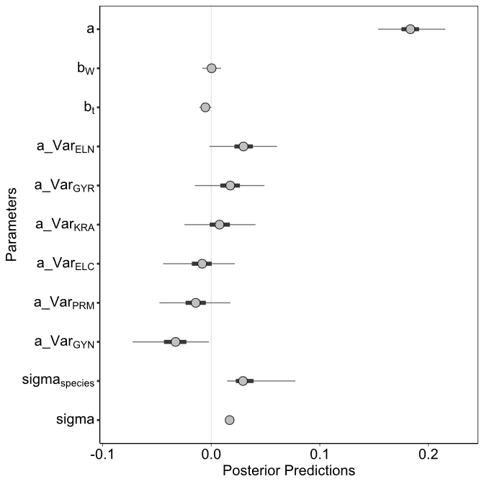
Figure 1 - Posterior predictions for equation 7 (C_{resp} = a + b_{W} * W + b_{T} * T + a_Var_{Species}). a is the intercept; b_{W} and b_{t} are the effects of body mass and temperature respectively (slopes). a_Var represents the variable intercept for each species: ELN = Electrona antarctica, GYR = Gymnoscopelus braueri, KRA = Krefftichthys anderssoni, ELC = E. carlsbergi, PRM = Protomyctophum bolini and GYN = G. nicholsi. sigma is overall residual error, and sigma_{species} is residual error of the species variable intercept. Circles are the mean of the posterior predictions. Thick lines show the 50% highest density posterior intervals, and thin lines show the 95% highest density posterior intervals. Results are considered statistically significant if the 95% highest density posterior intervals do not overlap with zero.
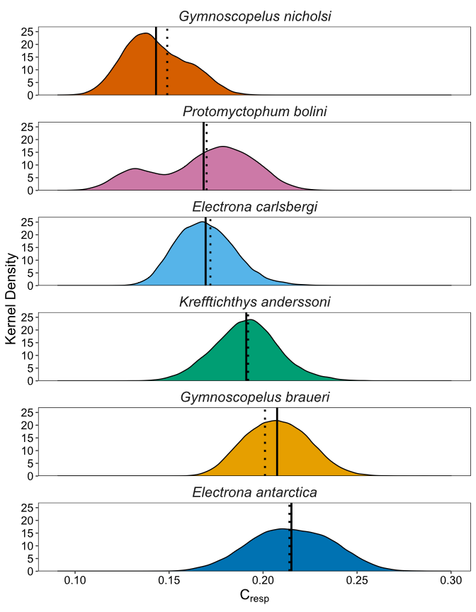
Figure 2 - Kernel density of posterior predictions of C_{resp} values for each individual, grouped by species. Solid lines show the mean C_{resp} value for each species. Dotted lines show species expected values of C_{resp} at mean body mass and temperature (intercept), according to equation 7 (C_{resp} = a + b_{W} * W + b_{T} * T + a_Var_{Species}).

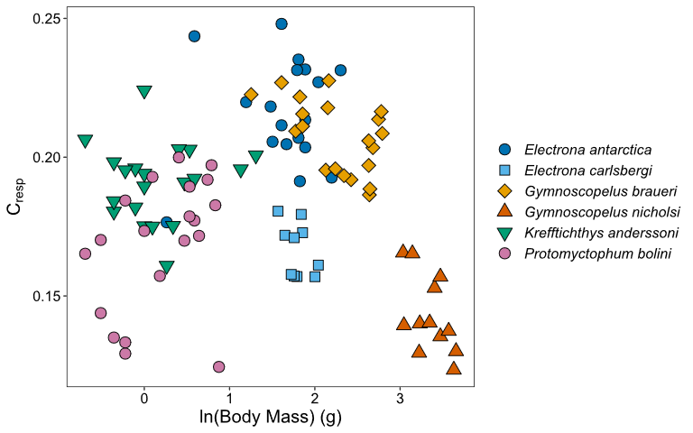
Figure 3 - Mean C_{resp} values against mean natural log body mass (g) for each individual of six myctophid species.

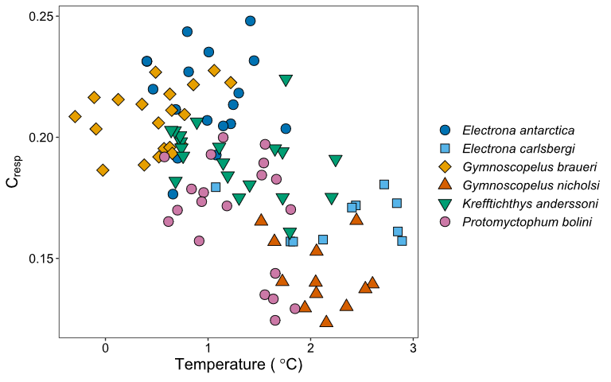
Figure 4 - Mean C_{resp} values against mean otolith-derived experienced temperature (°C) for each individual of six myctophid species.

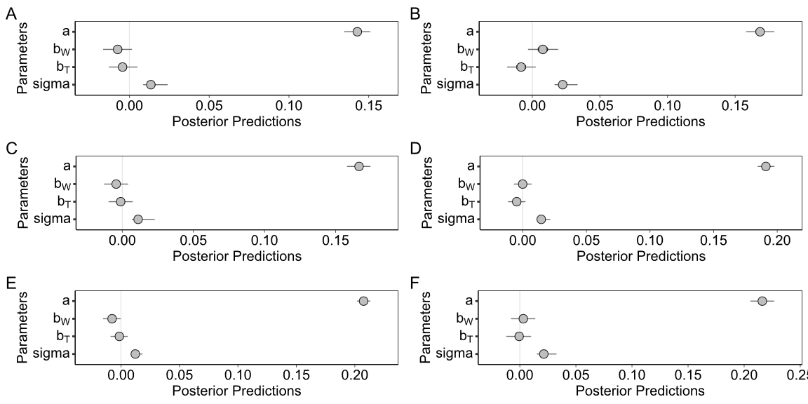
Figure 5: Posterior predictions for equation 8 (C_{resp} = a + b_{W} * W + b_{T} * T) within species (A = Gymnoscopelus nicholsi, B = Protomyctophum bolini, C = Electrona carlsbergi, D = Krefftichthys anderssoni, E = Gymnoscopelus braueri, F = Electrona antarctica). a is the intercept, b_{W} and b_{T} are effects of body mass and temperature respectively (slopes), and sigma is residual error. Circles are the mean of the posterior predictions. Thin lines show the 95% highest density posterior intervals. Results are considered statistically significant if the 95% highest density posterior intervals do not overlap with zero.

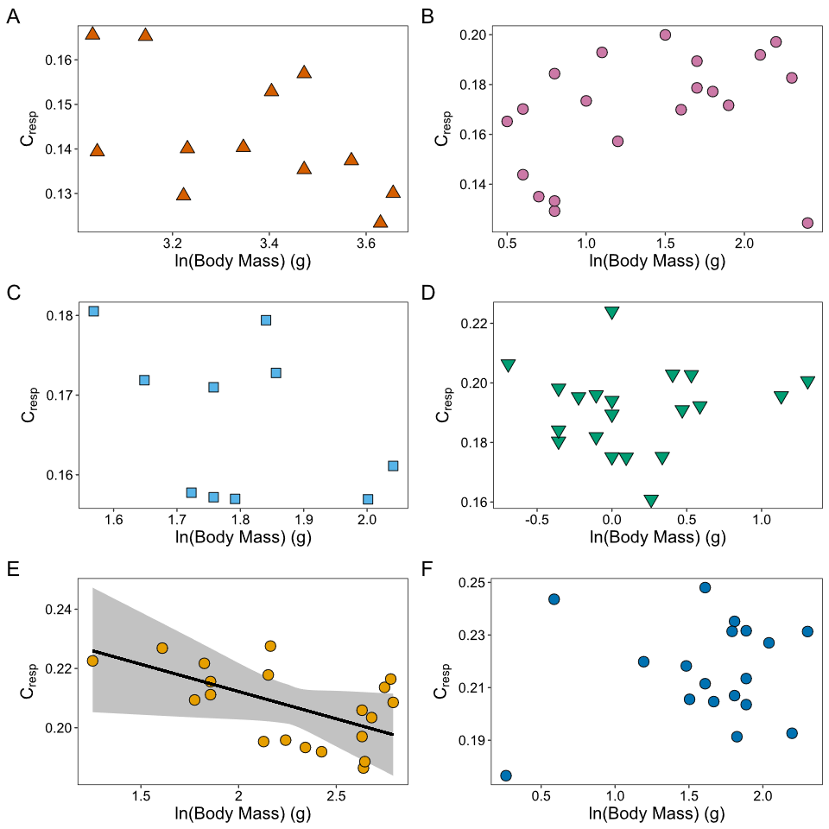
Figure 6: Mean C_{resp} values against mean natural log body mass (g) for six myctophid species (A = Gymnoscopelus nicholsi, B = Protomyctophum bolini, C = Electrona carlsbergi, D = Krefftichthys anderssoni, E = Gymnoscopelus braueri, F = Electrona antarctica) . The solid line on F indicates the significant relationship between C_{resp} and natural log of body mass for G. braueri, as determined by equation 8 (C_{resp} = a + b_{W} * W + b_{T} * T), with 95% confidence intervals shaded in grey.

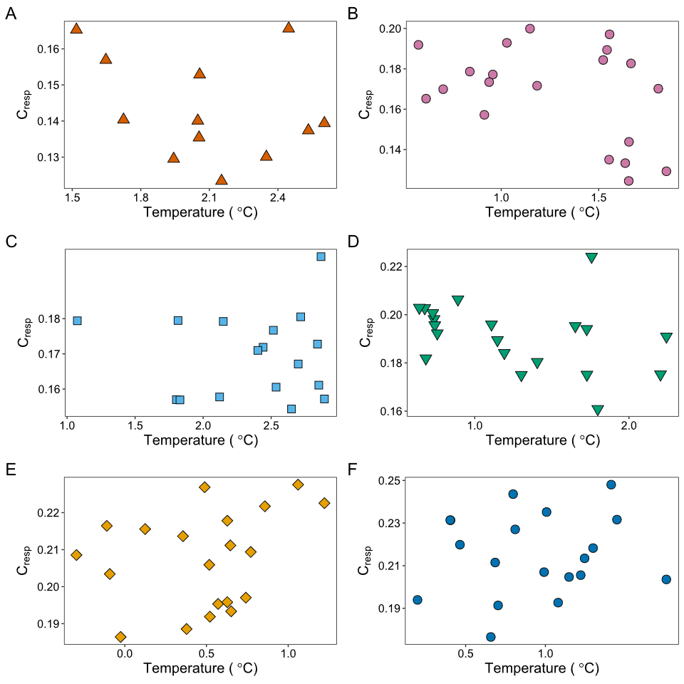
Figure 7: Mean C_{resp} values against mean otolith-derived experienced temperature (˚C) for each individual of six myctophid species (A = Gymnoscopelus nicholsi, B = Protomyctophum bolini, C = Electrona carlsbergi, D = Krefftichthys anderssoni, E = Gymnoscopelus braueri, F = Electrona antarctica).
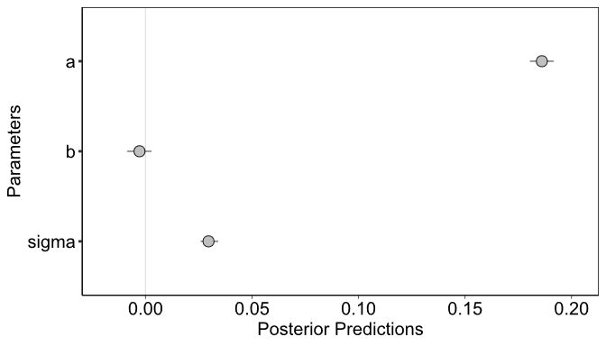

Figure 8: Posteriors predictions for equation 9 (C_{resp} = a + b * MR_{W}) comparing otolith derived C_{resp} values with allometrically estimated mass-specific metabolic rate (MR_{w}). a is the intercept b is the slope and sigma is residual error. Circles indicate the mean of the posterior predictions. Thin lines show 95% highest density posterior intervals. Results are considered statistically significant if the 95% highest density posterior intervals do not overlap with zero.

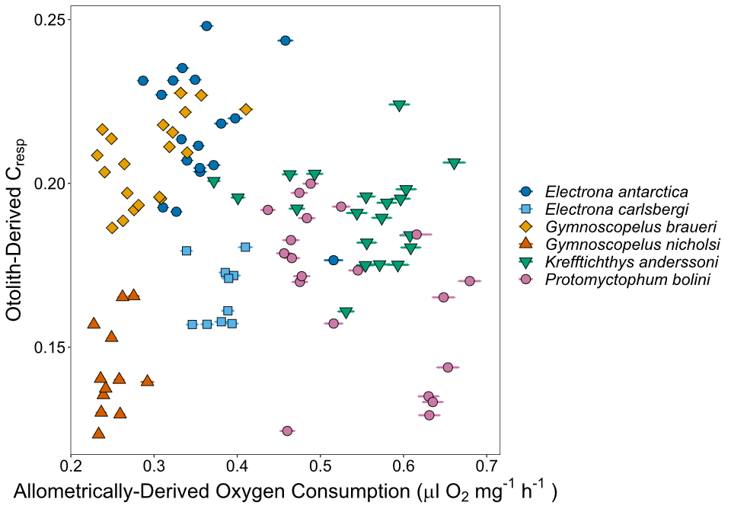
Figure 9: Mean otolith-derived C_{resp} values against mean allometrically-derived mass-specific oxygen consumption (ul O₂ mg⁻¹ h⁻¹, estimated using equation 1 after Belcher et al. 2019) for each individual of six myctophid species. Horizontal bars show the standard error of oxygen consumption estimates.

Table 1: Literature-derived ecological information for six species of myctophids examined in this study. Partial migrants are species in which part of the population migrates to the lower epipelagic at night (~200 m) while a proportion remains at the daytime depth. Near surface migrants are species which regularly migrate into mesopelagic zone of the upper 200 m, but rarely reach the upper 50 m (Watanabe et al. 1999, Catul et al. 2011). Values for % mass for primary prey groups are from Saunders et al. (2015a). Values for % NA of highly-unsaturated fatty acids (HUFAs) are from Stowasser et al. (2009). References: (1) Andriashev 1965; (2) Collins et al. 2008; (3) Collins et al. 2012; (4) Connan et al. 2010; (5) Duhamel et al. 2000; (6) Duhamel et al. 2014; (7) Gon & Heemstra 1990; (8) Hulley 1981; (9) Kozlov et al. 1991; (10) Lea et al. 2002; (11) Linkowski 1985; (12) Lourenço et al. 2017; (13) Lubimova et al. 1987; (14) McGinnis 1982; (15) Oven et al. 1990; (16) Phleger et al. 1999; (17) Piatkowski et al. 1994; (18) Pusch et al. 2004; (19) Reinhardt & Van Vleet 1986; (20) Ruck et al. 2014; (21) Saunders et al. 2014; (22) Saunders et al. 2015a; (23) Saunders et al. 2015b; (24) Saunders et al. 2015c; (25) Saunders et al. 2017; (26) Saunders et al. 2018; (27) Saunders et al. 2019; (28) Shreeve et al. 2009; (29) Stowasser et al. 2009.
Species | Electrona antarctica | Electrona carlsbergi | Gymnoscopelus braueri | Gymnoscopelus nicholsi | Krefftichthys anderssoni | Protomyctophum bolini | Sources
Maximum standard length (mm) | 115 | 93 | 162 | 165 | 74 | 66 | 2, 7, 12, 21, 23, 24, 28
Estimated standard length at maturity (mm) | 74 | 83 | 114 | 114 | 54 | 51 | 7, 8, 12, 15, 21, 23, 24
Depth range (m) | 0 - 1000  Day 400 - 1000  Night 0 - 1000 | 0 - 400 | 0 - 1000  Day 400 - 1000  Night 0 - 700 | 0 - 700  Day 400 - 700  Night 0 - 400 | 0 - 1000  Day 200 - 1000  Night 0 - 1000 | 0 - 700  Day 200 - 700  Night 0 - 400 | 2, 3, 5, 7, 12, 17, 21, 22, 23, 24, 26, 27, 28
Core depth range (m) | 0 - 1000 with seasonal variation | 0 - 400 with seasonal variation | 0 - 700 with seasonal variation | 0 - 400 | 200 - 1000 with seasonal variation | 200 - 400 | 2, 3, 21, 22, 23, 24, 26, 28
Habitat | Mesopelagic | Mesopelagic | Mesopelagic | Mesopelagic and benthopelagic | Mesopelagic | Mesopelagic | 7, 8, 11, 12, 21, 23, 24
Diel vertical migration type | Partial-migrant | Near-surface migrant (summer only) | Partial-migrant | Near-surface migrant (mesopelagic) and non-migrant (benthopelagic) | Near-surface migrant | Near-surface migrant | 2, 5, 9, 12, 17, 18, 21, 23, 24
Thermal realm | Antarctic | Sub-Antarctic | Broadly Antarctic | Broadly Antarctic | Broadly Antarctic | Broadly Antarctic | 6, 7, 8
Upper limiting temperature (˚C) | 3 | 5 | 5 - 6 | 9 | 2 - 5.6 | 6 - 7 | 1, 3, 6, 7, 8
Spawns in the Scotia Sea? | Yes | No | No | No | Yes | No | 7, 8, 12, 14, 15, 25
Primary lipid class | Wax ester | Triglycerides | Wax esters | Triglycerides | Wax esters | Triglycerides | 4, 10, 16, 19, 20, 29
Mean normalised area percentages (% NA) of HUFAs in tissue | 13.6 | 22.8 | 8.9 | 27.1 | 12.6 | 28.4 | 29
Primary prey classes groups (% mass) | Euphausiids (61%)  Amphipods (28%) | Copepods (63%)  Euphausiids (16%) | Euphausiids (58%)  Amphipods (18%)  Copepods (16%) | Euphausiids (75%)  Copepods (19%) | Copepods (59%)  Euphausiids (32%) | Copepods (70%)  Euphausiids (26%) | 12, 13, 21, 22, 23, 24, 26, 28, 29
Table 2: Summary table of metadata for myctophids examined in this study. Myctophids were captured using either rectangular midwater trawl 25 m² (RMT25) or 8 m² (RMT8) nets. Diet was estimated using individual uncorrected muscle δ¹³C and adjusted assuming a trophic enrichment factor of 1‰ (DeNiro & Epstein, 1978). Age estimates were obtained from rearranged length-at-age equations from Linkowski (1985, 1987), Saunders et al. (2020) and Saunders et al. (2021) (Supplementary Information 5). Unfortunately, no length-at-age parameters are available for Protomyctophum bolini. For information on how time incorporated in otolith samples was estimated see Supplementary Information 1.
Species | Electrona antarctica | Electrona carlsbergi | Gymnoscopelus braueri | Gymnoscopelus nicholsi | Krefftichthys anderssoni | Protomyctophum bolini
n | 19 | 17 | 20 | 12 | 20 | 20
Year of capture (n) | 2008 (3)  2016 (16) | 1998 (1)  2008 (16) | 2008 (7)  2016 (13) | 2008 (4)  2016 (8) | 2008 (1)  2016 (19) | 2008 (8)  2016 (12)
Gear type (n) | RMT25 (17)  RMT8 (2) | RMT25 (16)  RMT8 (1) | RMT25 | RMT25 | RMT25 | RMT25
Net depth range (m) | 15 - 1000 | 5 - 205 | 15 - 1000 | 0 - 720 | 80 - 995 | 195 - 405
Standard length mean and range (mm) | 72 (45 - 87) | 75 (71 - 81) | 107 (77 - 125) | 139 (124 - 154) | 47 (35 - 70) | 45 (36 - 56)
Wet mass mean and range (g) | 5.6 (1.3 - 10.0) | 6.1 (4.8 -7.7) | 10.4 (3.5 - 16.3) | 29.2 (20.8 - 38.7) | 1.3 (0.5 - 3.7) | 1.4 (0.5 - 2.4)
Estimated diet δ¹³C mean and range (‰) | -28.01 (-28.92 - -27.25) | -25.22 (-26.73 - -24.06) | -27.79 (-29.55 - -25.56) | -26.95 (-29.01 - -25.06) | -27.96 (-29.05 - -24.97) | -25.78 (-27.08 - -23.76)
Estimated age mean and range (years) | 5.1 (2.4 - 7.1) | 2.1 (1.8 - 2.7) | 5.9 (2.8 - 9.4) | 5.0 (3.5 - 6.9) | 1.2 (0.5 - 3.7) | Unavailable
Estimated time incorporated into otolith isotope samples (years) | 2.0 | 1.0 | 3.5 | 2.5 | 1.5 | 2.0
Otolith sampling method (n) | Micromill | Micromill | Micromill | Dremel | Crushed | Micromill (18)  Crushed (2)

Table 3: Estimates of mean oxygen consumption (mg O₂ kg⁻¹ h⁻¹) for species of myctophids, as determined by otolith derived metabolic rates from our study (C_{resp}, equation 7) and converted to oxygen consumption by equation 6 (C_{resp} = C(1- e^(-k(Oxygen Consumption)))), estimates derived from body mass and temperature scaling relationships (equation 1 from Belcher et al. 2019), and from electron transport system (ETS) measurements (Belcher et al. 2020).
Species | Otolith Derived (Our Study) |  | Derived from Scaling Relationships (equation from Belcher et al. 2019) |  | Measured from ETS (Belcher et al. 2020)
 | Oxygen Consumption (mg O₂ kg⁻¹ h⁻¹) | C_{resp} | Oxygen Consumption (mg O₂ kg⁻¹ h⁻¹) | C_{resp} | Oxygen Consumption (mg O₂ kg⁻¹ h⁻¹) | C_{resp}
Electrona antarctica | 373.66  (257.43 – 583.88) | 0.213 (0.177 – 0.248) | 266.56 (211.45 – 372.00) | 0.180  (0.157 – 0.213) | 190.29 (102.26 – 422.28) | 0.140 (0.092 – 0.224)
Gymnoscopelus braueri | 329.17 (283.97 – 441.07) | 0.201 (0.186 – 0.228) | 217.34 (172.42 – 301.70) | 0.159  (0.137 – 0.192)
Krefftichthys anderssoni | 297.32 (220.45 – 423.19) | 0.191 (0.161 – 0.224) | 407.59 (280.19 – 492.94) | 0.221  (0.185 – 0.236) | 672.88 (376.66 – 1023.11) | 0.249 (0.214 – 0.270)
Electrona carlsbergi | 253.54 (206.44 – 317.94) | 0.175 (0.154 – 0.198) | 283.02 (253.69 – 310.00) | 0.186  (0.175 – 0.195)
Protomyctophum bolini | 238.91 (150.90 – 325.52) | 0.169 (0.124 – 0.200) | 401.78 (325.12 – 510.12) | 0.220  (0.200 – 0.239)
Gymnoscopelus nicholsi | 197.55 (149.16 – 230.98) | 0.150 (0.123 – 0.166) | 184.37  (170.43 – 210.58) | 0.143  (0.136 – 0.156)
Gymnoscopelus spp. |  |  |  |  | 158.19 (20.59 – 940.80) | 0.107 (0.022 – 0.268)

