A systematic and bibliographic review of sustainability indicators for contaminated site remediation: a comparison between China and western nations
Xiaonuo Liª, Andrew B. Cundy^{b}, Weiping Chen^{a,c}⃰, Sidan Lyu^{d}

ª Laboratory of Soil Environmental Science and Technology, Research Center for Eco-Environmental Sciences, Chinese Academy of Sciences, Beijing 100085, China
^{b} School of Ocean and Earth Science, University of Southampton, Southampton, SO14 3ZH, U.K.
^{c} College of Resource and Environment, University of Chinese Academy of Sciences, Beijing 100085, China
^{d} Key Laboratory of Ecosystem Network Observation and Modeling, Institute of Geographic Sciences and Natural Resources Research, Chinese Academy of Sciences, Beijing 100101, China

Published in Environmental Research, 2021, https://doi.org/10.1016/j.envres.2021.111490

Abstract: Sustainable remediation, which promotes the use of more sustainable practices during environmental clean-up activities, is an area of intense international development. While numerous indicators related to sustainable remediation assessment have been utilized and published in the academic literature, these are difficult to unify, and vary in emphasis between countries. Following literature retrieval from CNKI, Springer, ScienceDirect, and Wiley Online databases, we present a systematic and bibliometric analysis of relevant national and international literature to define those indicators of sustainability that are most frequently considered, and which play important roles in selecting remediation technologies or site management methods from a sustainability perspective. Following the application of co-occurrence and Social Network Analysis, the results indicate that: 1) environmental criteria are most commonly used in evaluating remediation technologies, with significantly less emphasis on social criteria in Chinese publications in particular; 2) with an increasing number of publications in the last twenty years, sustainable remediation has gone through an initial stage, rising stage and burst or wider adoption stage, characterized by a transformation of the research theme from a predominantly risk-based management approach to a sustainability-based one, with risk management as an underpinning principle; 3) health, resource, cost and time are the most widely used indicators in terms of social, environmental, economic and technical criteria, respectively; 4) clear differences exist between China and other nations, particularly in the frequency of usage of each indicator, the application of social criteria, and preferred stakeholders. Notwithstanding this, China has made great progress and now makes an increasing contribution to sustainable remediation at an international level.

Keywords: Sustainable remediation; co-occurrence analysis; Social Network Analysis; contaminated site management; evaluation indicator

- Introduction
The concerns of decision makers in contaminated site management have changed significantly over the past 50 years. The late 1990s onwards in particular saw a shift from the primary use of removal to landfill, containment, or cover methods, to more treatment-based remediation strategies. This occurred alongside the widespread adoption of risk-based approaches to contaminated land management. More recently, there has been increasing recognition that poorly selected, designed or implemented remediation and site risk management activities may in fact cause greater impact than the contamination or other land issues that they seek to address, and that many traditional approaches may be considered as unsustainable as they only focus on remediation cost and time, the feasibility of remediation technologies, or efficiency to meet decontamination goals alone, with considerably less attention paid to the overall net benefits of remediation (Braun et al., 2019; Harclerode et al., 2015). Therefore, the concept of sustainable remediation has gained increased traction, in the context of the broader incorporation of environmental, social and economic considerations into contaminated site management practice (Hou and Al-Tabbaa, 2014; O'Connor and Hou 2018; Visentin et al., 2019).
Sustainable remediation is variably defined internationally, but there is a broad level of consensus on its underpinning principles, which take account of economic and social development with environmental benefits, and aim to balance all three pillars of sustainability through the judicious use of limited resources (Bardos et al., 2016; Cundy et al., 2013; Forum 2009; ITRC 2011). Concerted international efforts drawing together these underpinning principles have resulted in the derivation and publication of an international standard (ISO 18504:2017) on Soil Quality: Sustainable Remediation (ISO 2015). This standard is intended to inform consideration of the concept of sustainable remediation in local legal, policy, socio-economic and environmental contexts, rather than prescribing which methods of assessment or indicators to use. This is important as sustainable remediation is often approached by measuring very different social, economic and environmental indicators (including technical indicators), and then integrating these in to a comparison of overall benefit. These comparisons in turn apply a wide range of decision frameworks, evaluation methodologies and support tools to attempt to identify the more sustainable remediation alternative (Reddy and Adams, 2015; Ridsdale and Noble, 2016; SuRF-UK 2010; Zheng et al., 2019). To name just a few of these, Life Cycle Assessment (LCA), Cost-Benefit Analysis (CBA), Multi-criteria (Decision) Analysis (MC(D)A), and Analytic Hierarchy Processes (AHP) are often applied to quantify the performance of different remediation options with respect to sustainability, and allow consideration of the views of particular stakeholders (Harclerode et al., 2016; Huysegoms and Cappuyns, 2017; Li et al., 2018; Rosén et al., 2015; Søndergaard et al., 2018).
At present, there is no single best framework that can fully meet all criteria, and no universally accepted method that can standardize the evaluation process. Numerous indicators related to sustainable remediation have been utilized and published in the academic literature, and these are difficult to unify either in a completely quantitative way or by a single evaluation technique (Cappuyns 2016). An established set of well-defined and equally satisfied indicators is not currently available. In order to simultaneously encompass social, economic and environmental aspects when a decision has to be made for a site risk management strategy, practically the common approach has been to combine multiple methodologies to address all indicators in a more comprehensive way (Huysegoms et al., 2018; Rizzo et al., 2016; Song et al., 2018).
Although recent literature has made promising advances in regards to indicators that can be applied when assessing sustainable remediation scenarios, the adoption and acceptability of indicators still poses a significant challenge (Huysegoms et al., 2019). Some indicators are interrelated and overlap with others, some are qualitative, others quantitative or semi-quantitative. In addition, despite various attempts, quantifying the economic value of all potential benefits (and drawbacks) remains problematic (e.g. Li et al., 2019). Additionally, the indicator sets as well the indicator-based methodologies for sustainable remediation still struggle with an imbalance between the assessment of environmental, economic and social aspects, favoring environmental aspects or paying more attention to some indicators within each aspect (e.g. human health risk), while others (e.g. ethics and equality) are almost ignored (Huysegoms and Cappuyns, 2017). Thus, a systematic analysis to determine which indicators within each category are the most important, relevant, widely favored by practitioners and easily quantified to recommend the final priority order for the risk management methods available for particular site remediation projects would be extremely valuable.
With this point in mind, the present study provides a systematic and bibliometric analysis of relevant literature to define those indicators that are frequently considered and play important roles in selecting remediation technologies or site management methods from a sustainability perspective, with the intention of enabling a more comprehensive and robust evaluation for future decision making. The work is organized as follows: 1) presentation of a methodology and procedure used to develop a bibliographic portfolio (BP); 2) a systematic and bibliometric analysis of this BP to show the trends in publication numbers, publishing country, keywords, and involvement of stakeholders; 3) a combination of co-occurrence analysis and Social Network Analysis to find the indicators that play the most important role in the whole network, and the emerging indicators that exhibit potential application in assessing social, environmental, economic and technical aspects; 4) the main results and conclusions. We focus in particular on international differences in adoption and process, mainly between China and other nations.
- Methods
The literature-based research and summarization carried out and presented here is based on a process of knowledge construction known as the ProKnow-C method (Knowledge Development Process Intervention Instrument-Constructivist), which allows for the development of knowledge from a systematic literature review and comprises three steps: elaboration of a bibliographic portfolio (BP), systemic analysis and bibliometric analysis (Caiado et al., 2017; Viegas et al., 2016).
Through the elaboration of a BP, the involved data can be collected from primary and secondary sources based on the authors’ judgements on the relevance and representativeness of the publications in aligning with the research topic (Braun et al., 2019). Systemic analysis relies on the publications that constitute the final BP, and serves to visualize the “big picture” of a particular research topic, including the scientific production indices such as authors, countries and journals (Marcis et al., 2019; Visentin et al., 2019). Based on the gathered information in the BP database, bibliometric analysis can facilitate a deeper understanding of the conceptual structure of a research topic, major themes and trends in a certain discipline (Leung et al., 2017).
  - Delimitation of research
The research was delimited to: 1) only scientific papers, which are routinely submitted to a rigorous peer review process and readily available online. Thus, other areas of knowledge including books or chapters of books, conference papers, technical documents and working reports were not included in the literature review. Relevant dissertations from the CNKI database (see below) were however included, as these are a central component of this database, and have provided a core contribution to Chinese language research on sustainable remediation. 2) a date of publication before December 31, 2019, which involved the latest insights and case studies on the theme of sustainable remediation, up to the period of our assessment in 2020. 3) search language in both Chinese and English, as China has made visible recent efforts in the field of sustainable remediation and has contributed increasing publications to databases within China and internationally (Hou and Li, 2016). The addition of Chinese publications leads to a more comprehensive analysis compared to previous research. 4) one Chinese database and three English-language databases: CNKI in Chinese, and Springer, ScienceDirect, and Wiley Online in English. This choice was based on availability of databases to the China-based authors of this paper – the chosen databases cover however a very wide range of peer-reviewed literature from multidisciplinary fields.
Accurate definition of the research topic is essential to build knowledge in the BP selection process. In this analysis, the topic is defined as sustainable remediation through the perspectives of social, environmental, economic as well as technical considerations. The following terms: contaminated site, brownfield, sustainable/green remediation, remediation technology/alternative, and decision making, were combined with the Boolean operators “AND” and “OR” to include or exclude the search literature in selected databases. The use of the “AND” operator indicates that all the terms should appear in the publications, whereas, the “OR” operator would yield publications that include any of the terms. Fig. 1 presents the search pattern employed in this study.
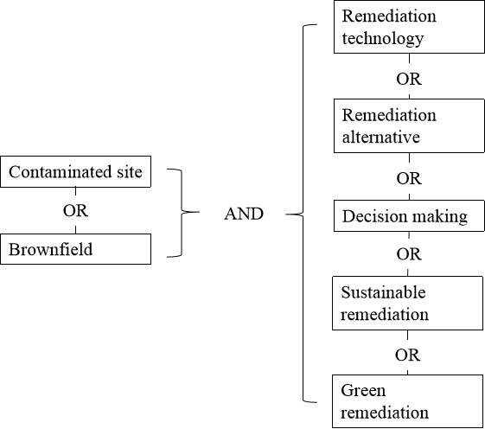
Fig. 1 Terms and operators used in the selected databases
The publications comprising the final BP in this research were selected following the PRISMA flow diagram in four steps (http://www.prisma-statement.org/): 1) identification: collect the publications by searching the research topic in databases; 2) screening: eliminate duplicate and redundant publications, including books, chapters of books, contributions to edited volumes, conference papers, technical documents and working reports; 3) eligibility: retain publications involving practical case studies rather than a descriptive analysis or a review through a thorough full text analysis; 4) included: identify all publications in the following qualitative and quantitative synthesis.
  - Bibliometrics analysis
Bibliometrics analysis is a useful tool to provide a statistical insight into patterns and dynamics in academic publications by quantitative and visual processes (Benckendorff and Zehrer, 2013; Yao and Zhang, 2018). Depending on the different types of information used in the analysis, bibliometrics analysis consists of various methods, among which, co-word analysis is extensively used to reveal the research “hotspot”, research direction and evolution over a period of time within a specific field (Du et al., 2015; Li et al., 2011). The basic principle of co-word analysis is to explore the potential relationships between keywords with high frequency, which are summarized as the core and concise ideas of the literature (Chen et al., 2019; Huang et al., 2019). The higher the frequencies of co-occurrences between keywords, the closer the interrelationship between them.
In this study, we make the first published attempt to apply co-word analysis in finding the interconnections between social, economic and environmental indicators used in sustainable remediation studies or assessments. To carry out the co-indicator analysis, indicators were organized in the following steps: (1) extract indicators: manually retrieve all indicators from publications in the BP; (2) delete indicators: delete duplicate or ambiguous indicators; (3) merge indicators: unify indicators that have similar meanings or differ slightly with others in a standard form, for example, stakeholder involvement and synonyms like stakeholder engagement were merged and renamed as participation; (4) identify indicators: all indicators or only indicators occurring in high frequencies were finally identified for further study depending on the authors’ judgement on the rationality of the analysis; (5) build a co-indicator matrix: by counting the frequency that two indicators within the same criteria occur in the same publication. The co-indicator matrix was established as a data input for Social Network Analysis (SNA, below). The process for identifying indicators is also transferable for analysis of other items, such as keywords.
  - Social Network Analysis (SNA)
Social Network Analysis (SNA) originates from human and social science research, and has become a powerful tool in multidisciplinary studies to describe the actors in a network and how they are interconnected in the form of a knowledge map (Chen et al., 2019; Huang et al., 2019; Kharanagh et al., 2020). The most important function of SNA is to find the most influential actor in the network and how this actor bridges or affects other actors by analyzing the structure of a network comprised of ties (relationship between nodes) between nodes (actors). In this study, we use “Centrality” to present the power and position of indicators in a network expressed by indices of degree centralization and betweenness centralization.
Degree centralization assesses the ability of an indicator to connect directly with other indicators in a network and the degree to which a network is influenced. A high degree centralization denotes the popularity of the indicator and its prevalent role in relation to a specific criterion (e.g. social criteria). Betweenness centralization denotes the proportionality of the shortest path connecting the other two indicators that passes through the indicator, to the shortest path connecting the other two indicators. A high betweenness centralization of the indicator indicates a more important role in maintaining network cohesion and controlling a specific criterion (e.g. social criteria) throughout the network.
- Results and discussion
  - Construction of the bibliographic portfolio
A systematic search for the primary data was initially performed using combinations of terms in the title, abstract and keywords of the publications in the selected databases. This generated 282 publications in total, of which, 58 publications were in CNKI, 114 publications in ScienceDirect, 53 publications in Springer and 57 publications in Wiley Online. Fig. 2 illustrates the development process for the BP following the PRISMA flow diagram.
Fig. 2 PRISMA flow diagram for developing the BP of scientific literature on sustainable remediation
As shown in Fig. 2, 93 publications were verified for inclusion in the BP, including 30 publications in Chinese and 63 publications in English (see Supplementary material). Subsequently, the number of publications, the publishing year, the publishing countries, the involved stakeholders, keywords and the sustainability indicators applied in each publication were analyzed to visualize the evolution of sustainable remediation within the wider research field of contaminated site remediation and management. We focused on China in particular, and its comparison with other countries, due to China’s relatively late adoption of sustainable remediation ideas, its rapid growth, complicated pollution scenarios and large number of contaminated sites.
  - Evolution of number of publications
Based on annual publication numbers from 2000 to 2019, sustainable remediation research has followed an upward publishing trend (with fluctuations), and has progressed through three different stages: an initial (exploratory and establishment) stage (2000-2006), a rising stage (2007-2010) and a burst or wider adoption stage (2011-2019) (Fig. 3).
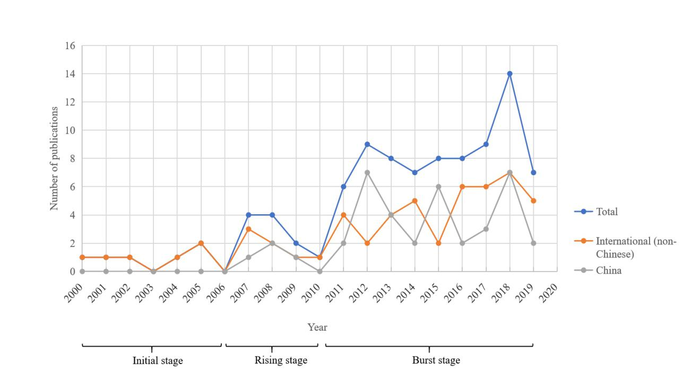
Fig.3 The number of publications over time involving sustainable remediation, based on the Bibliographic Portfolio derived in this study
In the initial stage (2000-2006), the first publication was observed in 2000, reflecting early discussions over sustainability perspectives in site remediation decision making (Rizzo et al. 2016). Publications increased by 1 per year, with a total of 6 publications in this period.
In the rising stage (2007-2010), national networks and initiatives worldwide on sustainable remediation, including via the American Society for Testing and Materials (ASTM), the Interstate Technology & Regulatory Council (ITRC), CL:AIRE, NICOLE and the Sustainable Remediation Forum (SURF), began to be initiated and to subsequently develop a number of guidance and decision tools to define implementation frameworks, assessment indicators and methods (Bardos 2014; Gu et al., 2015; Hou and Li, 2016). This increase in activity generated a total of 11 journal publications during four years. Compared with other countries, the number of Chinese publications remained low, which may be due to the fact that China began to work relatively late in this research domain and lacked sufficient experience at this stage (Wang 2019). In 2007, the first Chinese dissertation on sustainable remediation was published, which established a disposal technique selection route for POPs contaminated sites in China based on the method proposed by the USEPA (Yi 2007).
In the burst or wider adoption stage (2011-2019), there has been increased international focus on sustainable remediation, evidenced by an increase in publishing numbers from 2011. In 2018, the number of publications reached a maximum. Publications over the last 10 years have accounted for more than 80% of the total amount of publications since 2000, and have fluctuated at around 8 per year.
  - Published journals
The publications of the BP are randomly distributed in 45 different journals, including 28 English language journals and 17 Chinese journals, which are all highly focused on environmental sustainability. Journals with more publications implies a higher acceptance in regard to sustainable remediation. As shown in Fig.4, dissertation, Chinese Journal of Environmental Engineering and Environmental Pollution & Control are listed with the most publications, accounting for 53% of the total publications. The other 14 Chinese journals only have one publication each on the research topic. For English-language journals, five journals account for 56% of the total publications, including Science of the Total Environment (21%), Remediation Journal (11%), Journal of Environmental Management (10%), Journal of Hazardous Materials (8%) and Chemosphere (6%). The rest of the journals have no more than two publications each.
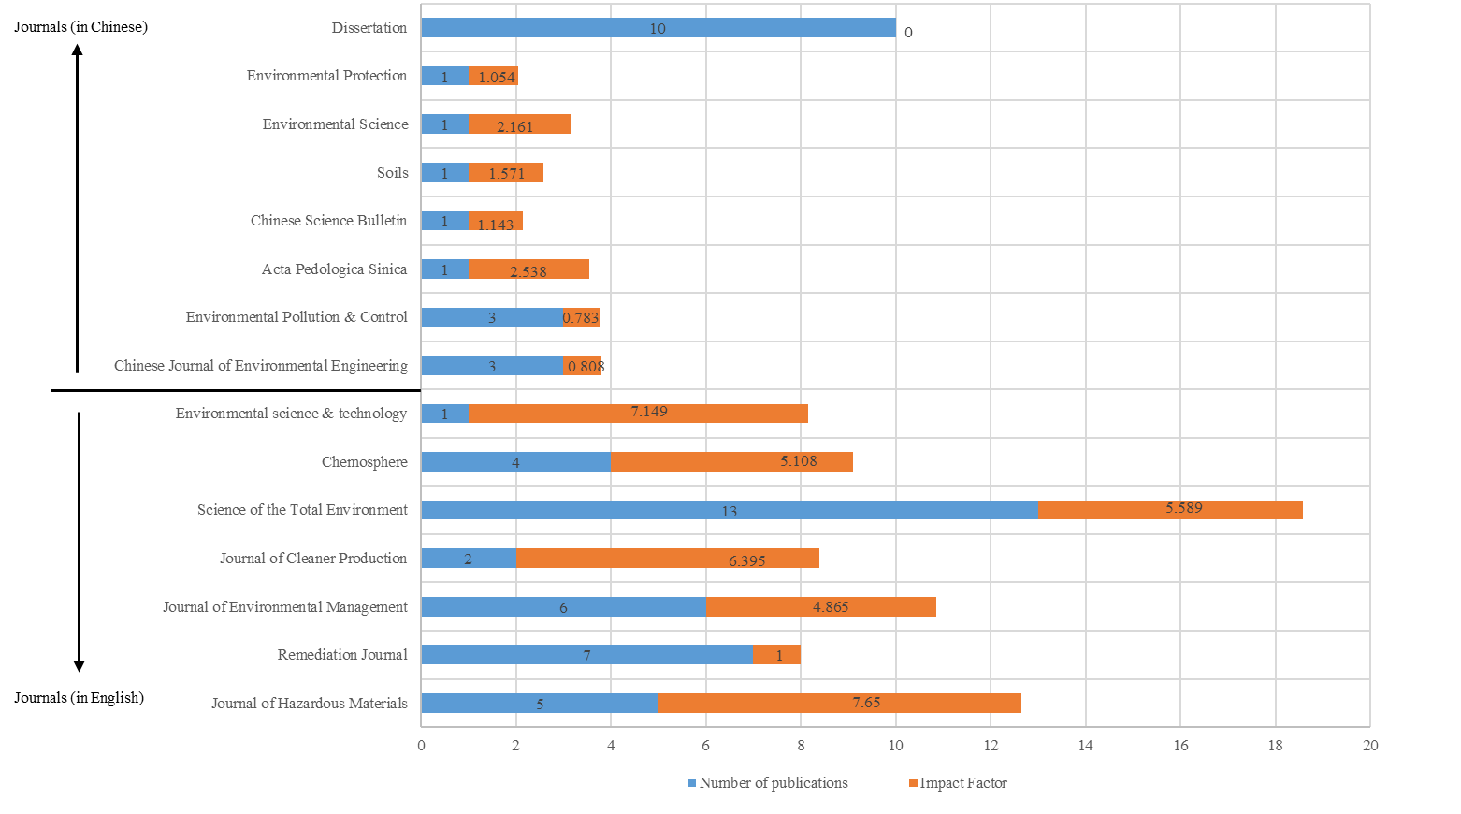
Fig.4 Journals with the highest number of publications related to sustainable remediation
The impact factor (IF) is an international metric widely used to rank scientific journals. Generally, the higher the IF, the greater the influence of journals. Based on the IF of the most recent available year (2018) depicted in Fig.4, it can be observed that there is no direct correlation between journals with higher numbers of publications and those with a higher IF. For example, the second-placed (by number of publications) Remediation Journal has a relatively low IF, which is around 1. In contrast, Environmental Science & Technology and Journal of Cleaner Production both have much higher IF, at more than 6, but only have 1 and 2 publications respectively. This suggests a tendency for publication to be focused in more specialist journals with slightly lower IF, targeting human-environment interactions, environmental management, and more applied research and contaminated land practice.
  - Countries
The authors of the publications are based or affiliated in 26 countries. The number of publications drafted by international cooperation accounts for 18% of the total. As early as 2001, scientists from five countries, including Norway, UK, Sweden, Greece and Hungary, collaborated for the first time to distinguish the key factors for the selection of an optimal risk-based approach to contaminated land management, which expressly stated sustainable development as a decisional factor (Vik et al., 2001). Given the work of various international societies and networks on sustainable remediation protocols (see above), publications with international cooperation shave increased since 2016, and those published between 2016 and 2019 account for about 60% of the total.
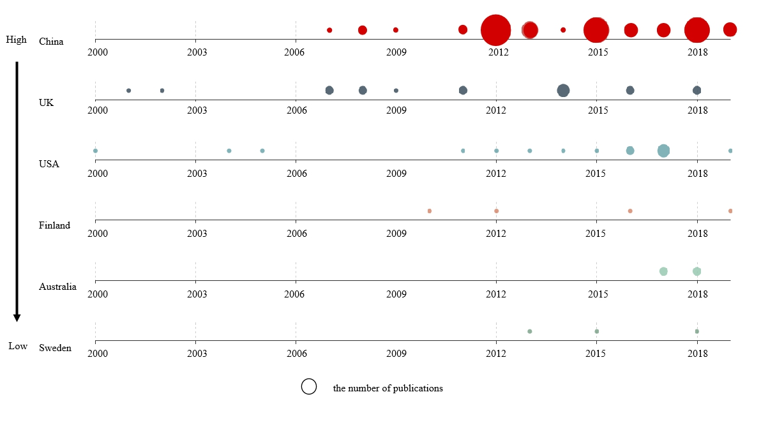
Fig.5 Countries with the highest number of publications in the sustainable remediation topic area. To avoid double counting, only the country that the first author is affiliated to is considered
Fig. 5 shows six countries (and their publication timelines) that stand out in their contributions to the number of publications. The number of publications is marked using differently sized circles (the larger the circle, the greater the number of publications). In Fig. 5, publications from the USA and the UK emerge earlier, around 2000, reflecting their early engagement and significant progress in developing sustainable remediation ideas and frameworks (Li et al., 2017). The process of contaminated site management in China has lagged far behind that in other industrialized countries, however, serious soil pollution, national action plans and a huge and emerging remediation market have prompted a large number of institutions and researchers to become engaged in remediation research and practices (Ma et al., 2018). Hence, China has surpassed other countries over the past decade with regard to the number of publications.
  - Keywords analysis
Following the five steps of data extraction defined previously, 241 keywords were initially retrieved from all publications in the BP. After exclusion of 23 inter-related keywords and integration of redundant keywords, 23 keywords were identified for further analysis. Based on the three stages defined in Fig. 3, the frequencies and changing trend in the use of 23 keywords at the initial stage (2000-2006), rising stage (2007-2010) and burst or wider adoption stage (2011-2019) are shown in Fig. 6. Broken lines, dotted lines and solid lines represent an increase, invariance or decrease of the frequency of each keyword, respectively.
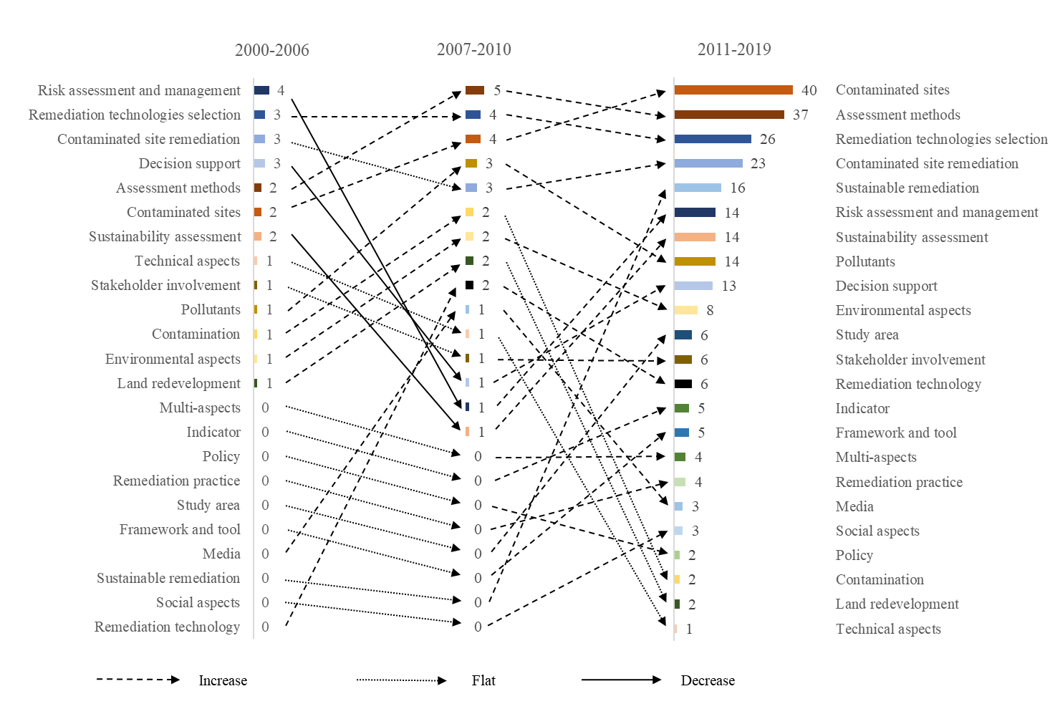
Fig.6 Evolution of keywords over time. Bars show frequency of occurrence, linking arrows show trend in frequency of each keyword (see text for further detail)
In the initial stage (2000-2006), the relatively low numbers of publications means that there is a low number and frequency of keywords. Four keywords appear with over 3 counts each representing 52% of the total 23 keywords, including “Risk assessment and management”, “Remediation technologies selection”, “Contaminated site remediation” and “Decision support”. Given that “Risk assessment and management” is the most frequent keyword while sustainability-related keywords rarely appear, for example, “Sustainable remediation” and “Social-environmental” with 0 counts, the core idea of contaminated site management in this stage focuses mainly on a risk-based conception rather than a sustainability-based decision.
In the rising stage (2007-2010), both the number and frequency of keywords show a clear change due to wider international attention on, and exploration of, sustainable remediation. Keywords of “Media” (e.g. soil and water) and “Remediation technology” begin to emerge in this stage. The frequency of “Risk assessment and management” decreases significantly, while instead, the keyword of “Assessment methods” ranks in first position with a frequency of 5, and shows the largest increase in frequency compared with that in the initial stage. The focus of contaminated site remediation in this stage undergoes a gradual transformation from risk-based management to a decision process relying more on the sustainable performance of remediation technologies, with risk management as an underpinning principle.
In the burst or wider adoption stage (2011-2019), contributed to by increasing publications from China, the total amount and frequency of keywords significantly increases, by 53% and 670% compared with the rising stage, respectively. In Fig. 6, the nine most high-frequency keywords, including “Contaminated sites”, “Assessment methods”, “Remediation technologies selection”, “Contaminated site remediation”, “Sustainable remediation”, “Sustainability assessment”, “Risk assessment and management”, “Pollutants” and “Decision support”, exceed 10 counts in frequency. The frequency of keywords of “Sustainable remediation” and “Sustainability assessment” substantially increased from 0 and 1 to 16 and 14, respectively. In addition, keywords relating to technical, social and economic sustainability also became more frequently used. Contaminated site management from a sustainability perspective has been more widely advocated and facilitated in this stage, aiming at a balance between multiple aspects of environmental, social, economic and technical sustainability in the decision-making process.
Covering the entire development history, the top 12 high-frequency keywords are listed in Table 1. As the most high-frequency keywords, “Contaminated sites”, “Assessment methods”, “Remediation technologies selection” and “Contaminated site remediation” contribute about 50% of the total frequency. Within “Assessment methods”, multi-criteria (decision) analysis (MCA/MCDA) is most commonly applied, and is employed in 34% of the total publications in the BP.
Table 1 Top 12 high-frequency keywords related to sustainable remediation
Keywords | Total frequency | Frequency in English language publications | Frequency in Chinese publications | Keywords | Total frequency | Frequency in English language publications | Frequency in Chinese publications
Contaminated sites | 46 | 18 | 28 | Sustainability assessment | 17 | 15 | 2
Assessment methods | 44 | 21 | 23 | Decision support | 17 | 10 | 7
Remediation technologies selection | 33 | 8 | 25 | Sustainable remediation | 16 | 12 | 4
Contaminated site remediation | 29 | 18 | 11 | Environmental aspects | 11 | 9 | 2
Risk assessment and management | 19 | 13 | 6 | Remediation technology | 8 | 4 | 4
Pollutants | 18 | 4 | 14 | Stakeholder involvement | 8 | 7 | 1

At a national level, there is no significant difference between the high-frequency keywords that appear in publications authored in China and those in other countries. Apart from the similar high-frequency keywords, studies in China focus more on “Risk assessment and management”, while other countries highlight sustainability-based remediation, thus the frequency of keywords of “Stakeholder Involvement”, “Sustainable remediation” and “Sustainability assessment” is higher than in publications from China. In the current context of China, contaminated site remediation is largely dependent on remediation cost and efficiency with the primary goal being to remove risks, and although sustainability considerations have been positively advocated for a number of years there is still a relatively large gap between dissemination and full implementation.
  - Stakeholder analysis
Stakeholder involvement has been identified as a crucial requirement for an effective decision-making process in sustainable remediation strategies (Cundy et al., 2013). Participation of a multitude of stakeholders enables a comprehensive consideration of multi-criteria derived from environmental, ecological, technological, economic and sociopolitical aspects (Stezar et al., 2014). Data in Fig. 7 show that the perceptions of various stakeholders, such as residents, remediation practitioners, developers, research institutes and academia, decisionmakers, landowners, NGOs and tourists or visitors, have been investigated for the identification and weighting of sustainability indicators in 61% of publications. Four types of stakeholder, covering research institutes and academia (33%), remediation practitioners (21%), residents (16%) and decision makers (16%), form the main focus in the literature, and make up 86% of total stakeholders. In this context of stakeholder integration, multicriteria (decision) analysis (MCA/MCDA) has become a widely used tool, consistent with previous studies (Rosén et al., 2015; Braun et al., 2019), allowing for the inclusion of various stakeholders’ perspectives in evaluating the sustainability of different remediation techniques.
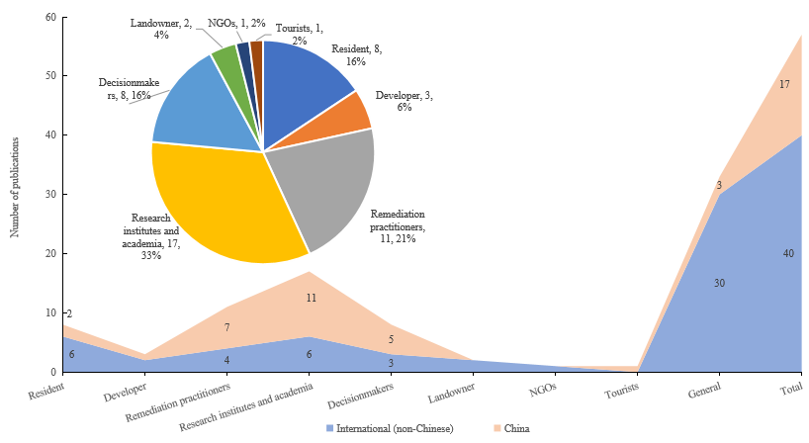 Fig.7 Stakeholder comparison between China and other countries
On a national level, only 44% of Chinese papers mention the necessity and importance of multi-stakeholders’ opinions for sustainability assessment of remediation technologies, compared to 75% in non-Chinese countries. Analysis of keywords for publications also highlights this point (see above and Table 1). Stakeholders that are most favored in the environmental management process in China are consistent with those in other countries, and can be grouped into research institutes and academia, remediation practitioners, residents and decision makers, with a total contribution of more than 80%. There is however a difference in the order of stakeholder categories, specifically, residents and research institutes and academia rank equally first among all stakeholders outside of China, while, in China, research institutes and academia occupy the same position but residents ranked fourth, following remediation practitioners and decision makers. Considering that residents or the wider public can provide alternative knowledge of risks and benefits that might be useful for developing sustainable remediation strategies, and that the engagement of these groups is critical in the realization of wider benefits during and after remediation, public engagement has been increasingly promoted for effective remediation policies worldwide (Prior and Rai 2017). The data here indicate that the public still only has relatively low-level involvement in current remediation activities in China, as shown in Fig. 7, where resident engagement is listed with a relatively low occurrence of 7.4%. This may be explained by a relative lack of information transparency and low public attention on contaminated site remediation in China (Li et al., 2015; Liu et al., 2018).
  - Analysis of sustainability indicators
- High-frequency indicators analysis
Effective decision-making in contaminated site management, from a sustainable remediation perspective, depends largely on the identification of representative criteria or indicators that are commonly used and understood, easily quantified (if a quantitative assessment is desired) and which can be integrated or operationalized into the decisional process (Ibáñez-Forés et al., 2014). In this study, assessment indicators retrieved in the BP have been classified into social, environmental, economic and technical criteria, according to the dominant dimensions to which they contribute. After extracting gross indicators, deleting repeating indicators and merging synonyms, in total 29 social, 32 environmental, 16 economic and 28 technical indicators can be identified. 84.9% of publications apply social criteria as an evaluation basis, while, for environmental, economic and technical criteria, the percentage is 94.6%, 83.9% and 70%, respectively. Under social criteria, 9 social indicators on average are used to represent the social performance, and 13, 8 and 9 indicators used for environmental, economic and technical performance respectively. It can be seen that there is a clear preference for the consideration of environmental sustainability in remediation decision-making, and environmental indicators are most commonly used to evaluate remediation technologies. Technical criteria are the least adopted.
Significant differences exist on an international level, i.e. between China and other nations. Publications by non China-based authors cover almost all social, environmental, economic and technical indicators, while, only 47%, 56%, 31% and 68% of these indicators are applied in Chinese publications. Secondly, environmental indicators are most preferred in international publications, followed by social, economic and technical indicators, while China-based researchers have focused more on environmental and economic aspects (90% of cases), with less attention on social aspects (77% of cases). Thirdly, technical indicators are more widely applied in China than internationally, with a popularity of 85% and 59% respectively. Another point to be highlighted is that in terms of average frequency per indicator, economic indicators and technical indicators in Chinese publications are both higher than in international publications. These international differences may reflect that currently, due to the massive number of contaminated sites, relatively immature technologies, limited funding and less developed management systems in China, the evaluation of remediation technologies in China focuses on economic and technical sustainability, with less emphasis on social sustainability, which is in line with the lack of public involvement confirmed previously (section 3.6).
In terms of the most commonly used indicators within each criteria in publications, Fig. 8 presents a graphical representation of 13 social indicators (frequency over 6), 16 environmental indicators (frequency over 9), 7 economic indicators (frequency over 6) and 14 technical indicators (frequency over 5). Each indicator is defined in Table 2. However, there are some overlapping indicators that are classified into different criteria because of the authors’ preference. For example, employment is a high-frequency indicator relating to social aspects, while in some cases this is considered to contribute to economic aspects. To avoid repetition or “double-counting”, it is necessary to define each item as representing a unique feature when selecting assessment indicators.

Table 2 Description of indicators that are most often employed in sustainable remediation
Criteria | Indicator | Definition | Criteria | Indicator | Definition
Social | Health | Long term/short term impacts on human health and safety from site activity (injuries, fatality, exposure risk to on-site workers and surrounding communities or public) | Environmental | Contaminant | Minimize contaminants left behind (toxicity, mobility, or volume)
 | Trust | Stakeholder confidence/satisfaction/acceptability |  | Energy | Energy consumption
 | Equality | Ethical or equity considerations (e.g. environmental justice for gender, inter-generational aspects) |  | Environment | General risk to the environment from site activity
 | Amenity | Improvement in aesthetic value and community use |  | Renewable | Use of renewable energy and natural resources
 | General | Overall impacts, including social side effects and community benefit | Economic | Cost | Total cost (direct and indirect cost, including equipment, operation, analysis, maintenance, etc.)
 | Participation | Encourage stakeholder participation |  | Benefit | Total benefit (direct and indirect benefit, including employment, land value increase, local business opportunities, etc.)
 | Policy | Compliance with regulations, guidelines and strategies |  | Employment | Job creation, opportunities for education and training
 | Uncertainty | The level of uncertainty over possible outcomes for an option being considered |  | Gearing | A process of bringing economic resources to a region or a project that may increase its attractiveness
 | Employment | Enhanced employment opportunities during and following the construction or remediation process |  | Life-span | Robustness and ability to cope with variation, affecting the duration of the remediation benefits
 | Prosperity | Bringing prosperity, including to vulnerable groups (e.g. increased tax revenue, education, security) |  | Property | Increase in property value
 | Disturbance | Detrimental impacts on local communities (nuisances and hindrance, e.g. dust, noise, odor, light, vibrations) |  | Effectiveness | Ratio of cost to benefit
 | Culture | Effects on cultural heritage | Technical | Time | Remediation time
 | Restriction | Physical restrictions during construction or remediation process (e.g. water supply, infrastructure, traffic) |  | Reuse | On-site potential reuse
Environmental | Surface water | Impact on surface water (quality/quantity) |  | Surrounding | Surrounding land reuse
 | Groundwater | Impact on groundwater (quality/quantity) |  | Management | Minimize long-term management (e.g. monitoring)
 | GHG | Impact on air quality (minimize GHG emission) |  | Lack | Lack of expertise/resource/training
 | Reuse | Enhance reuse and recycling (natural resources and wastes) |  | Property | Suitable for soil property (e.g. hydraulic conductivity) and pollutants
 | Resource | Minimize use of natural resources and materials |  | Maturity | Whether the technology is widely applied in successful projects
 | Air | Impact on air quality (e.g. smog, particulate) |  | Reliability | No need for frequent maintenance
 | Soil | Impact on soil (quality/structure/function/sustainability) |  | Location | Cleanup operation location (in-situ/ex-situ technology)
 | Ecology | Impact on habitat/ecology (change in population/mortality/reproduction/growth and development) |  | Effectiveness | The effectiveness in cleaning up/removing pollutants or managing site risk
 | Diversity | Degree of species diversity (flora and fauna) |  | Applicability | Ease or validity of implementation of technology under local site conditions
 | Intrusiveness | Impacts on the built environment, conservation issues, landscape, and also impacts from flooding |  | Availability | Expensive approaches to technical support
 | Waste | Minimize waste generation |  | Feasibility | Capable of being used successfully
 | Side-effect | Local scale secondary environmental impacts (noise/dust/odor/traffic) |  | Sustainability | Long-term effectiveness

As shown in Fig. 8 (a), 13 out of 29 social indicators have received the most attention with the highest frequency of application (85.3% of total). Except social trust, an overall tendency can be observed that the frequencies for social indicators applied internationally are all higher than in China. Since four indicators including equality, amenity, uncertainty and culture are difficult to be measured and quantified, they are not only excluded by Chinese researchers in evaluating the sustainability of remediation technologies, but also not widely considered in the publications of other countries. Other social indicators, such as stakeholder participation, employment opportunity, remediation disturbance and general effects, are more applied internationally than in China. Overall, in non-Chinese countries, human health, social trust, stakeholder participation, policy support and remediation disturbance are the most frequently applied social indicators. In China, human health, social trust, employment opportunity, policy support and remediation disturbance are the most often applied social indicators, accounting for 86.4% of the total frequencies. Based on this, the core differences in social indicators applied between non-Chinese countries and China are in stakeholder participation and employment opportunities.
As shown in Fig. 8 (b), 16 out of 32 environmental indicators have received the most attention with the highest frequency of application (93.4% of total). All environmental indicators show a higher frequency of application internationally than in China. With the exception of species diversity, the remaining environmental indicators have all been involved in selecting remediation technologies in China, although at a relatively low frequency. In particular, the frequency of environmental indicators based on GHG emission, waste reuse, resource consumption and ecological intrusiveness in international publications are all much higher in frequency (over 60% higher) than in China-based publications. Generally speaking, the most widely used environmental indicators in international publications are GHG emission, impact on ecology, resource consumption, and impact on groundwater and surface water, with a frequency of 37, 31, 30, 26 and 25 respectively. Conversely, due to land resource scarcity caused by population pressure, Chinese researchers focus more on impact on soil, which ranks in fourth position among all indicators, showing the same frequency as GHG emission and impact on air.
As shown in Fig. 8 (c), 7 out of 16 economic indicators have received the most attention with the highest frequency of application (90.6% of total). With the exception of total cost, the remaining economic indicators show a much higher frequency of application internationally than in China. There is a clear overall preference for the use of total cost in measuring economic sustainability.
As shown in Fig. 8 (d), 14 out of 28 technical indicators have received the most attention with the highest frequency of application (88.8% of total). The total frequency of all technical indicators in publications from China is slightly higher than internationally, as is the application of consideration of remediation time, effectiveness, availability, suitability, maturity, feasibility and duration of remediation technology indicators. The most often used indicators in publications internationally are remediation time, on-site potential reuse, remediation effectiveness, cleanup operation location and feasibility of technology, with a frequency of 19, 16, 15, 8 and 7 respectively. In China, remediation time is closely followed by the maturity of technology, along with an extensive application of effectiveness, feasibility and availability of technology.
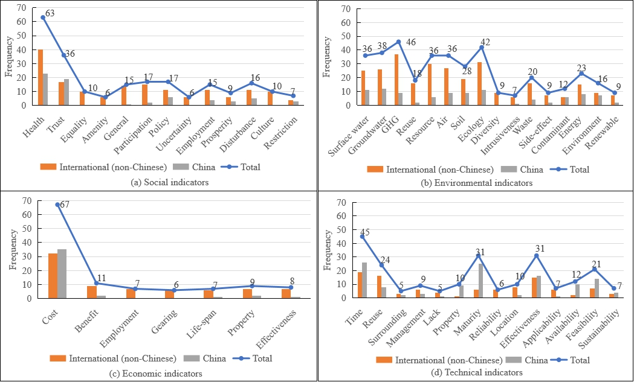
Fig.8 Criteria and high-frequency indicators for evaluating remediation technologies
- Evolution of criteria over time
The annual frequencies of social, environmental, economic and technical criteria appearing in publications internationally and from China follow the same general temporal trend as observed for the total number of publications, that is an initial stage (2000-2006), rising stage (2007-2010) and burst or wider adoption stage (2011-2019) (Fig. 9). In the initial stage, only non-Chinese countries contribute to the research on sustainable remediation with a similar frequency of each criterion (a frequency of 5 or 6). In the rising stage and burst stage, due to expansion of the sustainable remediation literature, the frequency of each criterion appearing in publications internationally and from China shows a rapid increase compared to that in the previous stage, which is directly affected by the number of publications. The proportion of publications simultaneously covering social, environmental, economic and technical criteria gradually grows by stage in China, from 0 in the initial stage to 25% in the rising stage, and to 54% in the burst stage. In contrast, internationally the proportion of publications covering all four facets is lowest in the burst stage (39%), which intuitively would be expected to show the highest proportion (as observed with Chinese publications).
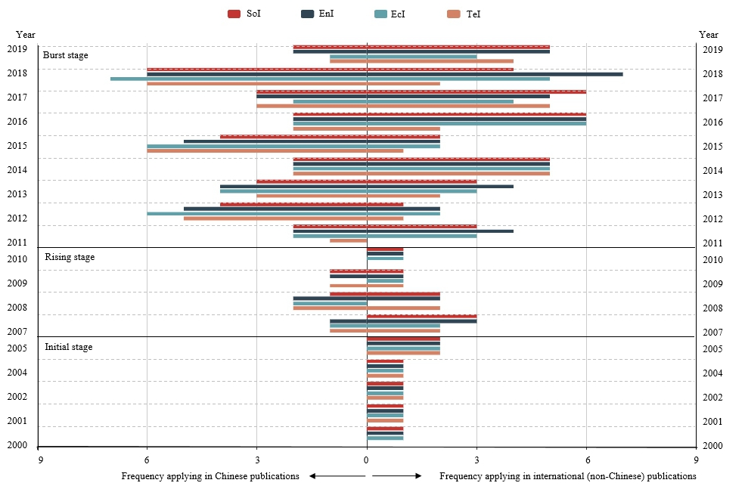
Fig.9 Evolution of criteria over time in China and internationally. Sol = social criteria, Enl = environmental criteria, Ecl = ecological criteria, and Tcl = technical criteria
As shown in Fig. 9, environmental criteria play a key role in evaluating remediation technologies across all three development stages. There is a significant difference in international attention on other criteria, specifically, social criteria are always more favored in non-Chinese countries with a comparable frequency to environmental criteria, while in China social criteria are the least employed, and instead economic criteria are given top priority. In recent years however, and especially since 2016, the use of social criteria is more balanced with other criteria, due to more attention to this aspect by decision makers and the improvement of public awareness in China.
- Co-occurrence analysis of indicators
Co-occurrence networks of social, environmental, economic and technical indicators were constructed using Ucinet 6.356 integrated with Netdraw for graph-visualization, based on a 29*29, 32*32, 16*16, 28*28 co-occurrence matrix of identified indicators respectively (Fig. 10 ~13). In Fig. 10~13, the size of the node provides a relative indication of the degree centralization of each indicator. The larger the node, the greater the degree centralization. The lines in a network represent the frequency that each pair of indicators are co-cited in publications. The thicker the line, the closer the connection between indicators. The color of the node represents the value of betweenness centralization. The colors of grey, blue, yellow and red are respectively assigned a value ≤1, 1~10 (including 10), 10~20 (including 20) and >20. Large nodes that are located close to the center of the network are more likely to denote important research issues, while small nodes on the periphery of the network might be considered as emerging themes or research frontiers.
In Fig. 10, the results of the normalized degree centralization show that health (impacts on human health and safety from site activity) has the highest degree of 28, which indicates that health is the most prevalent aspect in assessing social sustainability and has the strongest connection with other indicators, followed by employment (impacts on employment opportunity, 24), culture (impacts on cultural heritage, 21), trust (social satisfaction with remediation strategy, 21), and disturbance (disturbance to community, 21). In terms of betweenness centralization, health and employment play an important role in bridging other indicators in the social-indicator network with a betweenness of 61.83 and 34.72. Education value, area of influenced region and stakeholder preference are emerging as potential hotspots that might be worthy of more attention in future studies of social sustainability.
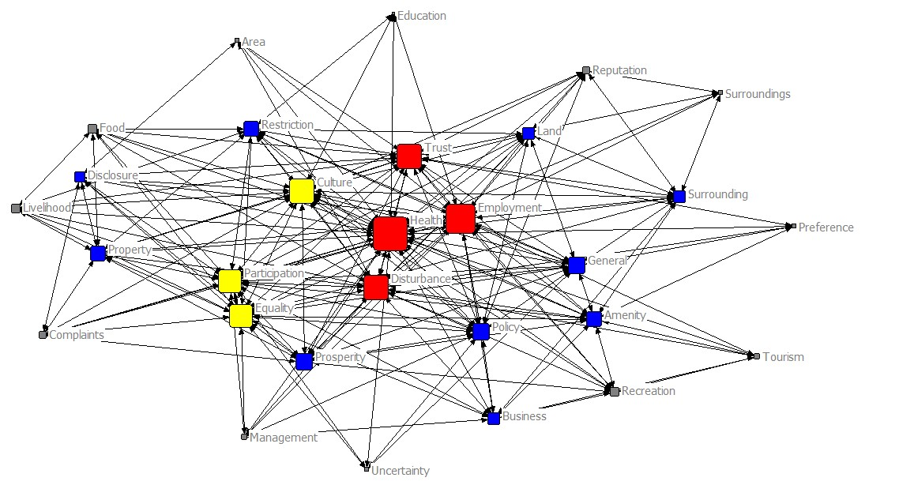
Fig.10 A co-occurrence network of social indicators
In Fig. 11, the results of the normalized degree centralization for environmental indicators show that resource (use of natural resources and materials) has the highest degree of 30, which indicates that resource use is the most prevalent aspect in assessing environmental sustainability and has the strongest connection with other indicators, followed by surface water (impacts on the quality and quantity of surface water, 28), GHG (impacts on GHG emission, 27), air (impacts on air pollution, 25) and ecology (impacts on habitat or ecology, 24). In terms of betweenness centralization, resource and surface water play an important role in bridging other indicators in the environmental-indicator network with a betweenness of 55.5 and 42.68. Risks at nearby schools and CAH (cultural, archaeological & historic resources)-related indicators, such as number and severity of impacted CAH and number of restored CAH, are emerging as potential hotspots that might be worthy of more attention in future studies of environmental sustainability.
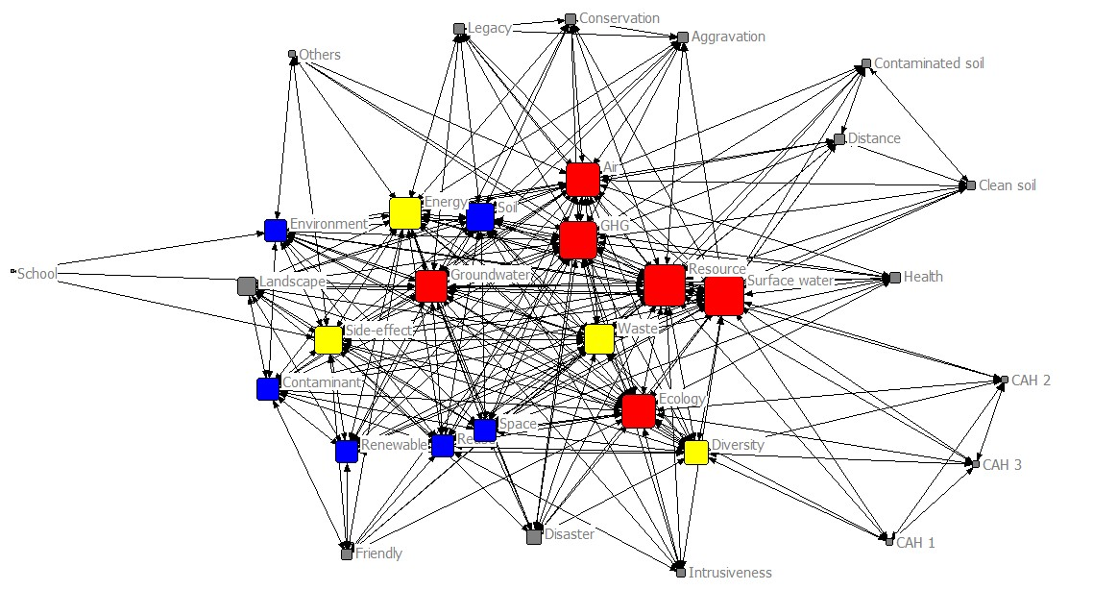
Fig.11 A co-occurrence network of environmental indicators
In Fig. 12, the results of the normalized degree centralization for economic indicators show that cost (total cost including equipment, operation, maintenance and labor, etc) has the highest degree of 9, which indicates that cost is the most prevalent aspect in assessing economic sustainability and has the strongest connection with other indicators, followed by effectiveness (ratio of cost to benefit, 8), employment (job creation during site activity, 7), benefit (total benefit including employment, property value increase and local business opportunities, etc, 7) and life-span (duration of the remediation benefits, 7). In terms of betweenness centralization, effectiveness, employment and cost play an important role in bridging other indicators in the economic-indicator network with a betweenness of 35.67, 24 and 21.33. Financing opportunities and economic side effects (e.g. closing of local amenities due to remediation works) are emerging as potential hotspots that might be worthy of attention in future studies of economic sustainability.
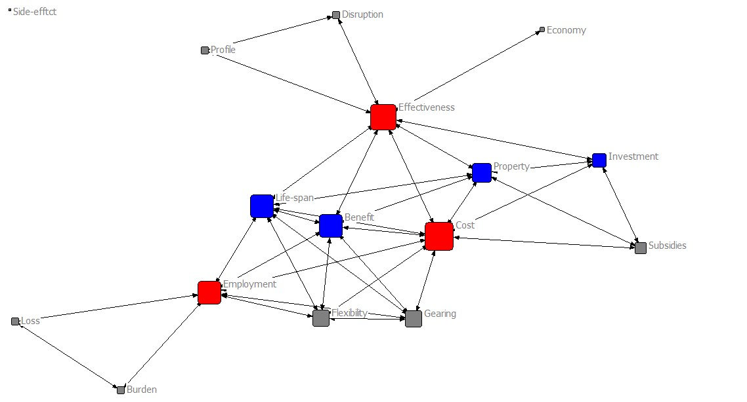
Fig.12 A co-occurrence network of economic indicators
Finally, in Fig. 13, the results of the normalized degree centralization for technical indicators show that time (remediation time) has the highest degree of 24, which indicates that time is the most prevalent aspect in assessing technical sustainability and has the strongest connection with other indicators, followed by effectiveness (the effectiveness to clean up pollutants, 23), maturity (widespread application of remediation technologies, 20), feasibility (capable of being used successfully, 18) and reuse (on-site potential reuse, 17). In terms of betweenness centralization, time, effectiveness and maturity play an important role in bridging other indicators in the technical-indicator network with a betweenness of 57.33, 40.16 and 30.32. Surrounding land reuse and resistance response (resistance to physical, chemical and biological processes based on the durability of for example cover structures) are emerging as potential hotspots that might be worthy of more attention in future studies of technical sustainability.
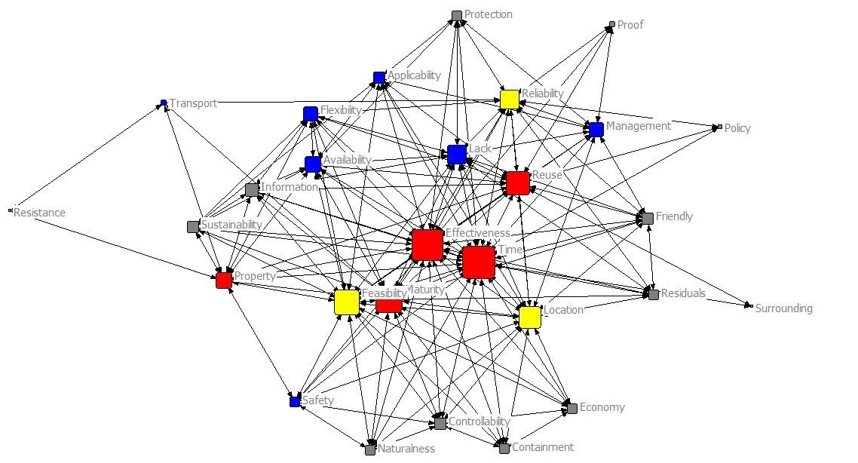
Fig.13 A co-occurrence network of technical indicators
In summary, the five key indicators used in assessing sustainability under each of the four categories or pillars of sustainable remediation are shown in Fig. 14 (the full definition of each indicator is given in Table 2). These are in effect the currently prevalent indicators (based on our co-occurrence-based Social Network Analysis, although we also note several emerging areas, see above), and provide a summary of the key indicators that can be applied to standardize or compare approaches, and better evaluate and compare the social, environmental, economic and technical performance of remediation technologies and their application.
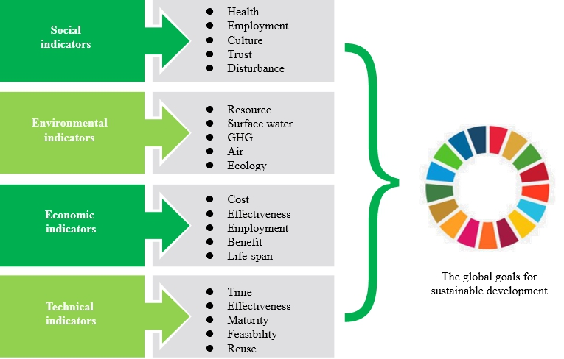
Fig.14 Summary of Social Network Analysis results: currently prevalent, or key, indicators used in the social, environmental, economic and technical “pillars” of sustainable remediation
- Conclusions
By applying a bibliometric analysis and a co-occurrence-based SNA of 93 publications, this study presents an assessment of key evaluation indicators, and their evolution over time, used for sustainable remediation approaches internationally, and in China. Key findings include:
- With increasing attention on sustainable remediation worldwide, the amount of publications over the last twenty years has shown a strongly upward trend, proceeding through an initial stage (2000-2006), a rising stage (2007-2010) and a burst or wider adoption stage (2011-2019). Due to China’s rapid progress in contaminated site management during the burst stage, China-based researchers have published the largest number of recent publications, followed by the UK and the USA.
- From the perspective of stakeholder involvement, perceptions from research institutes and academia, remediation practitioners, residents and decisionmakers are typically integrated to inform decisional strategies. However, resident engagement is listed with relatively low occurrence in China (compared to international studies). In the context of incorporation and integration of stakeholder inputs, MCA/MCDA has become the most commonly used tool in remediation evaluation, allowing for the inclusion of multi-criteria derived from environmental, ecological, technological, economic and sociopolitical aspects.
- From the perspective of keywords evolution over time, contaminated site management initially focused on a risk-based conception rather than a sustainability-based decision. Since 2007, the research theme has gradually transferred to consideration of “Assessment methods”, which allows for assessment of tradeoffs among several criteria to rank remediation alternatives from most to least preferred, and helps to improve the understanding of complicated decision-making processes based on a comprehensive measurement of environmental, social, economic and technical sustainability.
- Generally, environmental criteria have played a central role in evaluating remediation technologies over time, while technical criteria have been less applied. There is a significant difference in national attention to social criteria, which are widely used along with environmental criteria internationally, but are the least employed indicators in China. Since 2016, however, this discrepancy is less apparent due to increasing attention from decision makers and the improvement of public awareness in China.
- The frequency of social, environmental, economic and technical indicators appearing in publications from non-Chinese countries are almost all greater than those from China, indicating a broader consideration and application of indicators in these countries. There is no direct relationship between the indicators that are commonly used (high frequency), and those which dominate the central positions (high degree centralization) and have important roles (high betweenness centralization) in the networks constructed through SNA. Based on the co-occurrence network of each criteria, there is a clear depiction of indicators that are the currently prevalent ones, those that form potential emerging research fronts, and those which closely connect with or greatly affect other indicators.
- The results show that non-Chinese countries are still currently prominent with regard to a number of core aspects of the sustainable remediation of contaminated sites (i.e. number and frequency of indicators applied, involved stakeholders etc). However, with the increasing attention on sustainable remediation in China, and the recent release of Principles for Green and Sustainable Remediation guidance (CAEPI 2020), there is rapid development in aspects such as the number of publications, involvement of public perspectives, consideration of wider indicators, and emphasis on social cohesion.
Through a systematic and bibliographic review, this study on one hand improves the understanding of the evolution of sustainable remediation and its evaluation indicators, particularly from the perspective of national differences in approach, while on the other hand provides an indication of which key indicators can be applied to standardize or compare approaches, and better evaluate and compare the social, environmental, economic and technical performance of remediation technologies and their application. It also flags areas of emerging research interest and focus for each of the “pillars” of sustainability within sustainable remediation. Future work could usefully examine a wider variety of other publication types (including grey literature) to extend the scope of this assessment, and consider ease of quantification (in terms of equivalent economic benefit etc.) as a driver in the adoption of indicators.
Acknowledgements
This work was supported by the National Key R&D Program of China [grant number 2020YFC1807500]. We are grateful to Junjing Jie for his considerable contribution to the artworks and valuable feedback on the early stage of data processing.
Reference
- Bardos, P., 2014. Progress in sustainable remediation. Remediat. J. 25(1), 23-32. https://doi.org/10.1002/rem.21412.
- Bardos, R.P., Bone, B.D., Boyle, R., Evans, F., Harries, N.D., Howard, T., Smith, J.W.N., 2016. The rationale for simple approaches for sustainability assessment and management in contaminated land practice. Sci. Total Environ. 563-564, 755-768. http://dx.doi.org/10.1016/j.scitotenv.2015.12.001.
- Benckendorff, P., Zehrer, A., 2013. A network analysis of tourism research. Annals of Tour. Res. 43, 121-149. https://doi.org/10.1016/j.annals.2013.04.005.
- Braun, A.B., Trentin, A.W. da S., Visentin, C., Thomé, A., 2019. Sustainable remediation through the risk management perspective and stakeholder involvement: A systematic and bibliometric view of the literature. Environ. Pollut. 255(Part 1), 113221. https://doi.org/10.1016/j.envpol.2019.113221.
- Caiado, R.G.G., Dias, R. de F., Mattos, L.V., Quelhas, O.L.G., Filho, W.L., 2017. Towards sustainable development through the perspective of ecoefficiency - A systematic literature review. J. Clean. Prod. 165, 890-904. https://doi.org/10.1016/j.jclepro.2017.07.166.
- Cappuyns, V., 2016. Inclusion of social indicators in decision support tools for the selection of sustainable site remediation options. J. Environ. Manag. 184(Part 1), 45-56. https://doi.org/10.1016/j.jenvman.2016.07.035.
- Chen, H., Feng, Y., Li, S.S., Zhang, Y.Y., Yang, X.X., 2019. Bibliometric analysis of theme evolution and future research trends of the type a personality. Personal Individ. Differ. 150, 109507. https://doi.org/10.1016/j.paid.2019.109507.
- Cundy, A.B., Bardos, R.P., Church, A., Puschenreiter, M., Friesl-Hanl, W., Müller, I., Neu, S., Mench, M., Witters, N., Vangronsveld, J., 2013. Developing principles of sustainability and stakeholder engagement for “gentle” remediation approaches: The European context. J. Environ. Manage. 129, 283-291. https://doi.org/10.1016/j.jenvman.2013.07.032.
- Du, H.B., Li, B.L., Brown, M.A., Mao, G.Z., Rameezdeen, R., Chen, H., 2015. Expanding and shifting trends in carbon market research: a quantitative bibliometric study. J. Clean. Prod. 103, 104-111. https://doi.org/10.1016/j.jclepro.2014.05.094.
- Forum (U.S. Sustainable Remediation Forum), 2009. Sustainable remediation white paper-integrating sustainable principles, practices, and metrics into remediation projects. Remediat. J. 19 (3), 5-114. https://doi.org/10.1002/rem.20210.
- Gu, Q.B., Hou, D.Y., Wu, B., Jiang, X.Y., Li, F.S., 2015. Conception and project practice of green and sustainable site remediation and its implications for China. Chin. J. Environ. Eng. 9(8), 4061-4068.
- Harclerode, M.A., Lal, P., Miller, M.E., 2015. Quantifying global impacts to society from the consumption of natural resources during environmental remediation activities. J. Ind. Ecol. 20(3), 410-422. https://doi.org/10.1111/jiec.12380.
- Hou, D., Al-Tabbaa, A., 2014. Sustainability: a new imperative in contaminated land remediation. Environ. Sci. Pol. 39, 25-34. https://doi.org/10.1016/j.envsci.2014.02.003.
- Hou, D.Y., Li, G.H., 2016. Green and Sustainable Remediation of Contaminated Soil in China: Core Elements and Development Direction. Environ. Prot. 44(20), 16-18.
- Huang, M.X., Wang, Z.Z., Chen, T., 2019. Analysis on the theory and practice of industrial symbiosis based on bibliometrics and social network analysis. J. Clean. Prod. 213, 956-967. https://doi.org/10.1016/j.jclepro.2018.12.131.
- Huysegoms, L., Cappuyns, V., 2017. Critical review of decision support tools for sustainability assessment of site remediation options. J. Environ. Manag. 196, 278-296. https://doi.org/10.1016/j.jenvman.2017.03.002.
- Huysegoms, L., Rousseau, S., Cappuyns, V., 2018. Friends or foes? Monetized life cycle assessment and cost-benefit analysis of the site remediation of a former gas plant. Sci. Total Environ. 619 (4), 258-271. https://doi.org/10.1016/j.scitotenv.2017.10.330.
- Huysegoms, L., Rousseau, S., Cappuyns, V., 2019. Indicator use in soil remediation investments: Views from policy, research and practice. Ecol. Indic. 103, 70-82. https://doi.org/10.1016/j.ecolind.2019.03.048.
- Ibáñez-Forés, V., Bovea, M.D., Pérez-Belis, V., 2014. A holistic review of applied methodologies for assessing and selecting the optimal technological alternative from a sustainability perspective. J. Clean. Prod. 70, 259-281. https://doi.org/10.1016/j.jclepro.2014.01.082.
- ISO (International Standards Organisation), 2015. ISO/DIS 18504 Soil Quality -Guidance on Sustainable Remediation. Available online: http://www.iso.org/iso/home/store/catalogue_tc/catalogue_detail.htm?csnumber¼62688.
- ITRC (Interstate Technology & Regulatory Council), 2011. Green and sustainable remediation: state of the science and practice. GSR-1. Available online: http://www.itrcweb.org.
- Kharanagh, S.G., Banihabib, M.E., Javadi, S., 2020. An MCDM-based social network analysis of water governance to determine actors’ power in water-food-energy nexus. J. Hydrol. 581, 124382. https://doi.org/10.1016/j.jhydrol.2019.124382.
- Leung, X.Y., Sun, J., Bai, B., 2017. Bibliometrics of social media research: A co-citation and co-word analysis. Internal J. Hosp. Manag. 66, 35-45. https://doi.org/10.1016/j.ijhm.2017.06.012.
- Li, J.F., Wang, M.H., Ho, Y.S., 2011. Trends in research on global climate change: a Science Citation Index Expanded-based analysis. Glob. Planet. Chang. 77(1-2), 13-20. https://doi.org/10.1016/j.gloplacha.2011.02.005.
- Li, X., Li, J., Sui, H., He, L., Cao, X., Li, Y., 2018. Evaluation and determination of soil remediation schemes using a modified AHP model and its application in a contaminated coking plant. J. Hazard. Mater. 353, 300-311. https://doi.org/10.1016/j.jhazmat.2018.04.010.
- Li, X.N., Bardos, P., Cundy, A.B., Harder, M.K., Doick, K.J., Norrman, J., Williams, S., Chen, W.P. Using a conceptual site model for assessing the sustainability of brownfield regeneration for a soft reuse: A case study of Port Sunlight River Park (U.K.). Sci. Total Environ. 2019, 652, 810-821. https://doi.org/10.1016/j.scitotenv.2018.10.278.
- Li, X.N., Jiao, W.T., Xiao, R.B., Chen, W.P., Chang, A.C., 2015. Soil pollution and site remediation policies in China: A review. Environ. Rev. 23, 1-12. http://dx.doi.org/10.1139/er-2014-0073.
- Li, X.N., Jiao, W.T., Xiao, R.B., Chen, W.P., Liu, W., 2017. Contaminated sites in China: Countermeasures of provincial governments. J. Clean. Prod. 147, 485-496. https://doi.org/10.1016/j.jclepro.2017.01.107.
- Liu, K., Song, Y.N., Hou, D.Y., 2018. Social Sustainability of Contaminated Site Remediation and Public Awareness. Environ. Prot. 46(9), 37-42. http://dx.doi.org/10.14026/j.cnki.0253-9705.2018.09.008.
- Ma, Y., Dong, B.B., Bai, Y.Y., Zhang, M., Xie, Y.F., Shi, Y., Du, X.M., 2018. Remediation status and practices for contaminated sites in China: survey-based analysis. Environ. Sci. Pollut. Res. 25, 33216-33224. https://doi.org/10.1007/s11356-018-3294-2.
- Marcis, J., Bortoluzzi, S.C., de Lima, E.P., da Costa, S.E.G., 2019. Sustainability performance evaluation of agricultural cooperatives' oprations: a systemic review of the literature. Environ. Dev. Sustain. 21, 1111-1126. https://doi.org/10.1007/s10668-018-0095-1.
- O'Connor, D., Hou, D., 2018. Targeting cleanups towards a more sustainable future. Environ. Sci. Process. Impacts. 20 (2), 266-269. https://doi.org/10.1039/c7em00518k.
- Prior, J., Rai, T., 2017. Engaging with residents' perceived risks and benefits about technologies as a way of resolving remediation dilemmas. Sci. Total Environ. 601-602, 1649-1669. https://doi.org/10.1016/j.scitotenv.2017.05.187.
- Reddy, K.R., Adams, J.A., 2015. Sustainable remediation of contaminated sites. Momentum 879 Press, LLC, New York.
- Ridsdale, D.Re., Noble, B.F., 2016. Assessing sustainable remediation frameworks using sustainability principles. J. Environ. Manag. 184: 36-44. https://doi.org/10.1016/j.jenvman.2016.09.015
- Rizzo, E., Bardos, P., Pizzol, L., Critto, A., Giubilato, E., Marcomini, A., Albano, C., Darmendrail, D., Döberl, G., Harclerode, M., Harries, N., Nathanail, P., Pachon, C., Rodriguez, A., Slenders, H., Smith, G., 2016. Comparison of international approaches to sustainable remediation. J. Environ. Manag. 184, 4-17. https://doi.org/10.1016/j.jenvman.2016.07.062.
- Rosén, L., Back, P.E., Söderqvis, T., Norrman, J., Brinkhoff, P., Norberg, T., Volchko, Y., Norin, M., Bergknut, M., Döberl, D., 2015. SCORE: A novel multi-criteria decision analysis approach to assessing the sustainability of contaminated land remediation. Sci. Total Environ. 511, 621-638. http://dx.doi.org/10.1016/j.scitotenv.2014.12.058.
- Søndergaard, G.L., Binning, P.J., Bondgaard, M., Bjerg, P.L., 2018. Multi-criteria assessment tool for sustainability appraisal of remediation alternatives for a contaminated site. J. Soil. Sediment. 18 (11), 3334-3348. https://doi.org/10.1007/s11368-017-1805-2.
- Song, Y., Hou, D., Zhang, J., O'Connor, D., Li, G., Gu, G., Li, S., Liu, P., 2018. Environmental and socio-economic sustainability appraisal of contaminated land remediation strategies: A case study at a mega-site in China. Sci. Total Environ. 610-611, 391-401. https://doi.org/10.1016/j.scitotenv.2017.08.016.
- Stezar, I.C., Ozunu, A., Barry, D.L., 2014. The role of stakeholder attitudes in managing contaminated sites: survey of Romanian stakeholder awareness. Environ. Sci. Pollut. Res. 21, 787-800. http://dx.doi.org/10.1007/s11356-013-2238-0.
- SuRF-UK (Sustainable Remediation Forum from United Kingdom), 2010. A framework for assessing the sustainability of soil and groundwater remediation. CL:AIRE, London. Available online: http://www.claire.co.uk/surfuk.
- Viegas, C.V., Bond, A.J., Vaz, C.R., Borchardt, M., Pereira, G.M., Selig, P.M., Varvakis, G., 2016. Critical attributes of Sustainability in Higher Education: a categorization from literature review. J. Clean. Prod. 126, 260-276. https://doi.org/10.1016/j.jclepro.2016.02.106.
- Vik, E.A., Bardos, P., Brogan, J., Edwards, D., Gondi, F., Henrysson, T., Jensen, B.K., Jorge, C., Mariotti, C., Nathanail, P., Papassiopi, N., 2001. Towards a framework for selecting remediation technologies for contaminated sites. L. Contam. Reclama. 9(1), 119-127.
- Visentin, C., Trentin, A.W. da S., Braun, A.B., Thomé, A., 2019. Application of life cycle assessment as a tool for evaluating the sustainability of contaminated sites remediation: A systematic and bibliographic analysis. Sci. Total Environ. 672, 893-905. https://doi.org/10.1016/j.scitotenv.2019.04.034.
- Wang, X.H., 2019. Intelligent identification and precise risk control of site pollution driven by big data. Environ. Prot. 47(13), 14-16.
- Yao, H.L., Zhang, C.H., 2018. A bibliometric study of China’s resource recycling industry policies: 1978-2016. Resour. Conserv. Recycl. 134, 80-90. https://doi.org/10.1016/j.resconrec.2018.03.008.
- Yi, A.H. Research on DDT transport and transform in contaminated soil. Northwest A&F University, 2007.
- Zheng, Z.J., Lin, M.Y., Chiueh, P.T., Lo, S.L., 2019. Framework for determining optimal strategy for sustainable remediation of contaminated sediment: A case study in Northern Taiwan. Sci. Total Environ. 654, 822-831. http://dx.doi.org/10.1016/j.scitotenv.2018.11.152.
- CAEPI (the China Association of Environmental Protection Industry), 2020. Principles for Green and Sustainable Remediation (T/CAEPI 26-2020). Available online: http://img66.hbzhan.com/4/20200507/637244679442058102658.pdf.

⃰ Corresponding author. Tel.: +86 10 62843981; Fax: +86 10 62918177; E-mail address: wpchen@rcees.ac.cn.

