A smartphone app to support self-management of daytime urinary incontinence in adolescents: development and formative evaluation of URApp
Whale K¹, Beasant L¹, Wright A.J.², Yardley L^{3,4}, Wallace L.M.⁵, Moody L⁶, Joinson C¹.

¹ Centre for Academic Child Health, Bristol Medical School, University of Bristol
² Evelina London Children’s Hospital, Guy’s and St Thomas’, NHS Foundation Trust
³ School of Psychological Sciences, Faculty of Life Sciences, University of Bristol
⁴ School of Psychology, University of Southampton
⁵ Faculty of Wellbeing, Education, and Language Studies, The Open University
⁶ Centre for Arts, Memory, and Communities, Faculty of Arts and Humanities, Coventry University

Corresponding author
Dr Katie Whale
NIHR Bristol Biomedical Research Centre
Musculoskeletal Research Unit
Bristol Medical school, Translational Health Sciences, University of Bristol
Learning and Research Building, Level 1, Southmead Hospital, Bristol, BS10 5NB
Phone: 0117 4147995
Email: katie.whale@bristol.ac.uk

Abstract
Background: Daytime urinary incontinence (UI) is common in childhood and often persists into adolescence. UI in adolescence is associated with a range of adverse outcomes including depressive symptoms, peer victimisation, poor self-image, and problems with peer relationships. First line conservative treatment for UI is bladder training (standard urotherapy) which is aimed at establishing a regular fluid intake and a timed schedule of toilet visits. Success of bladder training is strongly dependent on good concordance, which can be challenging for young people.
Objectives: This paper describes the development of a smartphone app (URApp) which is aimed at improving concordance with bladder training in young people aged 11-19 years old.
Methods: URApp was designed using participatory co-design methods and was guided by the Person-Based Approach to intervention design. Core app functions were based on clinical guidance and included setting a ‘daily drinking goal’, recording fluid intake and toilet visits, reminders to drink and go to the toilet, and recording progress towards drinking goals. The development of URApp comprised four stages: (i) review of current smartphone apps for UI; (ii) participatory co-design workshops with young people with UI to gather user requirements and develop wireframes; (iii) development of URApp prototype; and (iv) user testing of the prototype, qualitative interviews with 23 young people aged 10-19 years with UI and/or urgency and eight clinicians. The app functions and additional functionality to support concordance and behaviour change were iteratively optimised throughout the app development process.
Results: Young people who tested URApp judged it to be a helpful way of supporting their concordance with a timed schedule of toilet visits and drinking. They reported high levels of acceptability and engagement. Preliminary findings indicated that some young people experienced improvements in their bladder symptoms including a reduction in UI. Clinicians reported that URApp was clinically appropriate and aligned to bladder training best practice guidelines. URApp was deemed age appropriate with all clinicians reporting that they would use it within their own clinics. Clinicians felt URApp would be of particular benefit for patients whose symptoms were not improving or were not engaging with their treatment plans.
Conclusion: The next stage is to evaluate URApp in a range of settings including paediatric continence clinics, primary care and schools. This research is needed to test whether URApp is an effective (and cost-effective) solution for improving concordance with bladder training; reducing bladder symptoms; and improving quality of life.

Key words: incontinence; urinary incontinence; digital intervention; child health; paediatric; paediatric incontinence; smartphone; intervention development

Introduction
Daytime urinary incontinence (UI), involuntary leakage of urine during the day, is common in childhood and is generally assumed to resolve with age. There is evidence from epidemiological studies, however, that childhood UI often persists into adolescence[1-5]. For example, in a UK-based cohort study, 4.2% of females and 1.3% of males reported experiencing daytime UI at 14 years[6].

UI in adolescence is associated with a range of adverse outcomes including depressive symptoms, peer victimisation, poor self-image, and problems with peer relationships[7]. Key concerns of young people with continence problems include the perceived stigma of incontinence, fear of bullying and social isolation, adverse impacts on academic achievement, and difficulties self-managing their continence problems at school (e.g. restricted access to toilets during lessons)[8].

The majority of cases of UI in children and adolescents are functional (i.e. with no underlying neurological, structural, or anatomic cause[9]) and first line conservative treatment is bladder training (standard urotherapy)[10, 11]. Bladder training is a behaviour modification intervention that aims to promote regular fluid intake throughout the day; establish a timed schedule of toilet visits (emptying the bladder every 2-3 hours); educate patients about how the bladder works and the causes of UI; and provide guidance on establishing optimal voiding behaviour (e.g. optimal toilet posture, relaxing the pelvic floor).

Bladder training can be an effective treatment for UI[12, 13], but success is strongly dependent on good concordance to the timed schedule of toileting and drinking[14]. Concordance is challenging for many young people, strongly depending on their level of maturity, self-motivation, and on-going support from clinicians[15]. Sub-optimal clinical care experiences in young people with incontinence (e.g. poor continuity in care, high rates of relapse and treatment failure) diminish their belief in the success of treatments and add to their distress[15]. There is evidence that young people with UI have a strong desire to be involved in decisions about their treatment and to feel supported to self-manage their bladder symptoms[15]. Promoting acceptance of chronic health conditions and the need for ongoing active management is linked to more positive coping strategies and greater treatment concordance [16-19]. There is some evidence that supplementing bladder training with a timer watch might aid concordance in children[11, 20], however, these watches can attract unwanted attention from peers. Our research with young people has highlighted the need to provide an age-appropriate self-management solution to help them to manage their bladder symptoms[8, 15]. This is further supported by literature on self-management of other health conditions, and the growing use of smartphone technology [21, 22].
This paper describes the development of a smartphone app (URApp [23]) for young people, aimed at improving their concordance to bladder training. URApp was co-designed with young people and clinicians and incorporates theoretically underpinned behaviour change techniques (BCTs)[24]. The development of URApp was informed by the Medical Research Council (MRC) guidance for developing and evaluating digital interventions[25], which recommends the use of theory for informing intervention design and delivery[26, 27]. There is evidence that embedding behaviour change theory in health interventions increases their effectiveness, and interventions that incorporate more BCTs are more effective[28]. The development of URApp was also guided by the ‘Person-Based Approach’ (PBA) for developing behavioural health interventions[29]. The PBA involves in-depth qualitative research with the user target population at every stage of the development process to understand and accommodate their needs. Interventions are iteratively optimised to improve their acceptability and feasibility and make them engaging for users.

The aim of this paper is to provide an overview of the development of URApp, including design, prototype development, and usability testing.

Methods
The development of URApp comprised four stages:
- Review of current smartphone apps for UI.
- Participatory co-design workshops with young people with UI to gather user requirements for the app and to develop the wireframes.
- Development of the app prototype.
- User testing of the app prototype comprising in-depth qualitative research with young people and clinicians to explore their views of URApp.

Methods and results for each stage are presented together to aid understanding of the app development process. A flow diagram of the methods sequence is shown in figure 1.

Ethical approval
Ethical approval for all stages of the development process was granted by the University of Bristol Research Ethics Committee.

Clinical input
Input from expert clinicians was obtained throughout the app development process to ensure URApp is compatible with clinical advice given to young people receiving treatment for UI. Clinical input was obtained from: (i) stakeholders on the study steering group including a Lead Consultant Paediatrician in charge of a specialist bladder clinic; a Specialist Bladder and Bowel Care Nurse; (ii) a clinical advisory group comprising two Specialist Nurses and a Nephrologist, and (iii) interviews with clinicians involved in continence care as part of the user testing stage.

Inclusion criteria
Participants were aged between 10 and 19 years; with current (or previous) experience of functional UI and/or urgency; able to provide informed consent (16-19 years) or assent (10-15 years), and able to speak and understand English. Young people taking part in the user testing were also required to have an Android or iOS smartphone.

Recruitment
Young people who took part in the participatory co-design workshops and user testing were recruited through adverts on the website of ERIC - The Children’s Bowel and Bladder Charity[30] and the ERIC Facebook and Twitter pages. The adverts provided an overview of the study and included links to allow potential participants (and their parents) to download the study information sheets.

Clinicians were recruited through the extensive network of clinical contacts established by ERIC and The Paediatric Continence Forum[31]. Purposive sampling was used in order to gain views of clinicians from a range of backgrounds including continence nurses, paediatricians, urologists, and GPs.

Consent and assent
Written, informed consent was gained from all participants. Parent consent and child assent was obtained for participants under 16 years old.

Patient and public involvement (PPI) and advisory groups
PPI in research is research carried out ‘with’ or ‘by’ members of the public, rather than ‘to’, ‘about’, or ‘for’ them[32]. It can include patients, carers, people who use health and social care services. Two PPI groups were formed to provide input into the running of the study and comprised (i) three young people from the ERIC Young People’s Advisory Group (YPAG) and (ii) three clinicians (GP, bowel and bladder nurse, and nephrologist). The clinician PPI group also provided feedback on the support pages in URApp to ensure that the information was consistent with clinical advice.
Figure 1: Flow diagram of the methods sequence

Participants
Participants included 23 young people with current or previous UI and/or urgency. Table 1 provides a summary of participant characteristics and the phase of the development process in which they were involved. Eight clinicians provided feedback about URApp in qualitative interviews (table 2).

Table 1: Demographic characteristics of the young people involved in the app development
Participant no. | Age | Gender | App development stage
W1 | 13 | Female | Workshops 1, 2 & 3
W2 | 10 | Female | Workshops 1, 2, & 3
W3 | 12 | Male | Workshop 2
W4 | 10 | Male | Workshop 3
W5 | 17 | Male | Workshops 2 & 3
W6 | 12 | Female | Workshop 1
W7 | 17 | Female | Workshop 1
W8 | 15 | Female | Workshops 2 & 3
W9 | 14 | Male | Workshop 2
W10 | 12 | Female | Workshops 1,2, & 3
W11 | 11 | Female | Workshop 3
P2 | 18 | Female | TA, RLT, IDI
P5 | 11 | Male | TA
P6 | 13 | Male | TA, RLT, IDI
P8 | 19 | Female | TA
P10 | 11 | Male | TA, RLT, IDI
P11 | 18 | Male | TA, RLT, IDI
P13 | 12 | Female | TA, RLT
P14 | 14 | Female | TA, RLT, IDI
P22 | 12 | Female | TA, RLT
P23 | 11 | Female | RLT, IDI
P26 | 12 | Female | RLT, IDI
P27 | 11 | Female | TA, RLT
TA = think aloud, RLT = real-life testing, IDI = in-depth interview

Table 2: Description of professional background of clinicians
Participant | Role
Clinician 1 | Clinical Nurse Specialist
Clinician 2 | GP
Clinician 3 | Clinical Nurse Specialist
Clinician 4 | School Nurse
Clinician 5 | Children’s Specialist Nurse
Clinician 6 | Paediatric Bowel and Bladder Care Service Clinical and Professional Lead
Clinician 7 | Consultant Urologist
Clinician 8 | Clinical Nurse Specialist

Stage 1: Review of current digital interventions to support young people with daytime wetting
In March 2017, we conducted a review of existing apps to ensure that none were specifically aimed at supporting self-management of bladder problems in young people. Existing apps were designed for young children and their parents to manage bedwetting; pregnant or post-partum women (mainly for stress incontinence), and older people with UI. The majority of apps provided only a bladder diary or reminders for pelvic floor exercises, and few were evidence-based or co-produced with stakeholders. This search was updated in April 2021, no relevant apps were identified. A list of reviewed apps is available on request.

Identifying the core app functions
We identified the core functions needed to support bladder training based on clinical guidance. Core app functions included setting a daily drinking goal; recording fluid intake and toilet visits; reminders to drink and go to the toilet; and recording progress towards drinking goals. Clinicians advised that the app should also allow users to record stool frequency and consistency, due to the comorbidity of constipation and UI[33].

A table outlining the key components of bladder training and target behaviour change is included in appendix 1.

Stage 2: Participatory co-design workshops

Stage 2 Methods
Stage 2 focused on designing an app which supported the core features of bladder training. We invited young people to take part in three participatory co-design workshops at the University of Bristol to identify user requirements for the app (workshop 1); explore which BCTs to use in the app to improve concordance (workshop 2), and to test an interactive wireframe created in UXPin[34] (workshop 3). Wireframes provide a two-dimensional blueprint of the app interface that allow testing of the app navigation and user journey, and gain feedback on content and layout.

The workshops were facilitated by researchers with expertise in health and developmental psychology, behaviour change, qualitative research, participatory co-design, and user experience. All workshops had a lead facilitator and were guided by a detailed schedule of the content and structure for each activity. We used a range of tools to elicit the views of young people e.g. large (A3) phone templates for sketching ideas for app functions and screen layout, and sticky notes with different colours and shapes to annotate designs (see figure one for example).

Before commencing the workshops, the research team had an initial meeting with the app development team (Natural Apptitude[35]) to discuss the purpose of the app and its core functions. Findings from each workshop were discussed with the app developers (Natural Apptitude) to ensure that the user requirements were feasible in terms of time and costs.

Stage 2 results

Workshop one: identification of user requirements and implementation of core functions (led by participatory co-design expert (LM) and a health psychologist (KW))
The plan for the session was presented to participants and they were given a brief explanation of the key elements of bladder training. We asked participants about their mobile phone use at home and at school/college; their preferred methods of recording toilet visits (wees and poos were their preferred terms) and drinking in the app; potential ways to receive reminders for drinking and toilet visits, and information that would be useful to record in a daily diary (e.g. mood, medications, life events). Young people were also asked to provide feedback on the existing apps we reviewed and reported that these did not meet their user requirements and were not age appropriate. Example results from workshop one are shown in figure one.

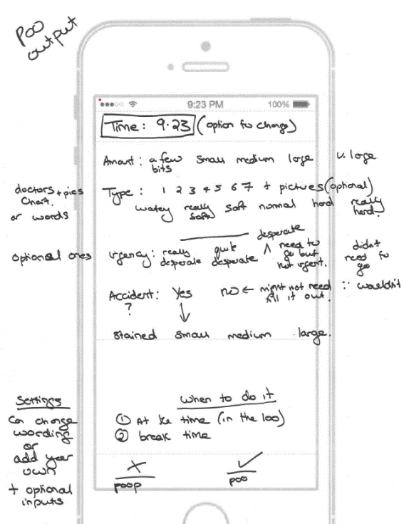
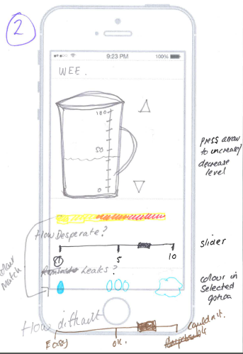
Figure 2: Workshop one activity examples
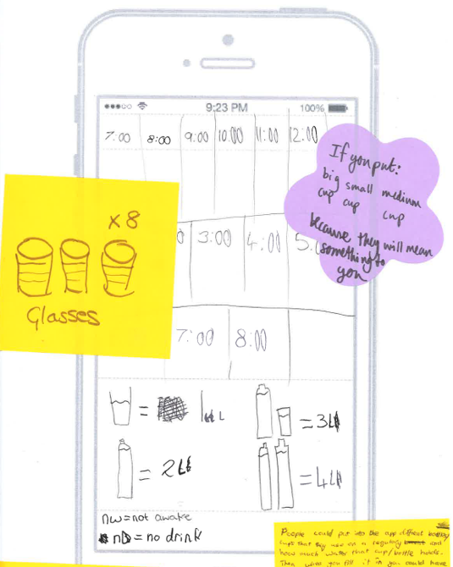

Workshop two: user engagement and behaviour change (led by behaviour change expert (LW))
The first aim of this workshop was to identify how to maximise user engagement with the app. Activities included identifying apps that were popular amongst young people; discussing why they liked these apps, and examining the app functions that motivated continued use.

The second aim was to obtain views on BCTs that could be implemented in the app to support self-management and improve concordance with bladder training. It was established that the app should provide rewards for changes in behaviour within the young person’s control i.e. recording drinks and toilet visits, and achieving daily drinking goals (recommended daily amount is six to eight glasses of water or dilute squash regularly spaced throughout the day). The app would not provide rewards for fewer ‘wetting accidents’ and ‘leaks’ because this could undermine motivation due to perceived lack of personal control and competence[36].

Participants provided ideas for daily rewards (e.g. collecting stars and trophies) and ‘streak rewards’ (for continuous daily use of the app, for example used in Snapchat) that could help to motivate them to keep using the app. They sketched ideas for recording progress towards daily drinking goals in the app (e.g. progress bar, charts) and other data they wished to record (e.g. number and type of daily toilet visits, number of wetting accidents). Figure two shows examples of the workshop two outputs.
The workshop findings relating to BCTs were reviewed against the Behaviour Change Taxonomy[24]. Optimal BCTs were identified as ‘graded goal setting and reviewing’ (modifying goals to make them more achievable); ‘action planning’ (i.e. setting goals for daily drinking and incrementally increasing fluid intake); prompts and cues (i.e. reminders to drink and use the toilet); rewards (i.e. for achieving drinking goals); and self-monitoring (i.e. charts and a daily diary to review progress). The BCTs chosen in the app align to self-determination theory[36] and are aimed at supporting users’ feelings of autonomy, competence and relatedness, all shown to promote intrinsic motivation[37]. The rewards BCT further aligns to theories of gamification[38, 39]. Further input on the BCTs was gained from a digital intervention and behaviour change expert (LY). The person-based approach to intervention design highlights the importance of responding to the user engaging with the app by providing personalised feedback[29], therefore this BCT was added to the URApp design. A full breakdown of the BCTs in URApp and how they are implemented is included in appendix 2.

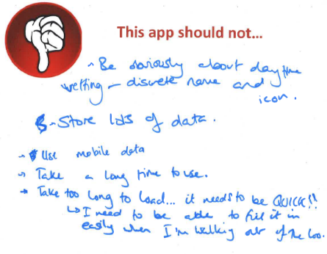
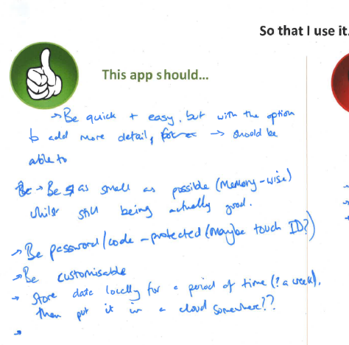
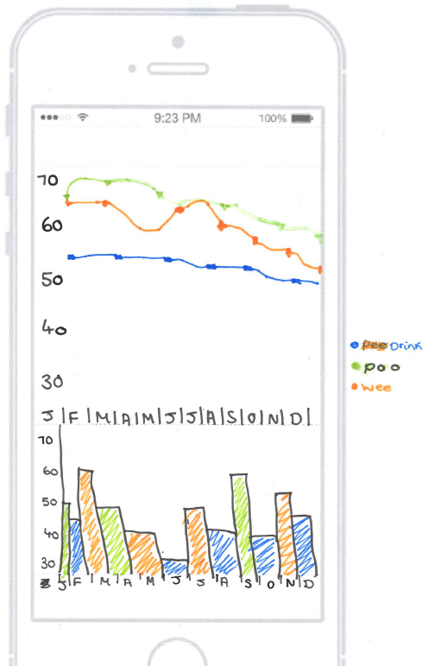
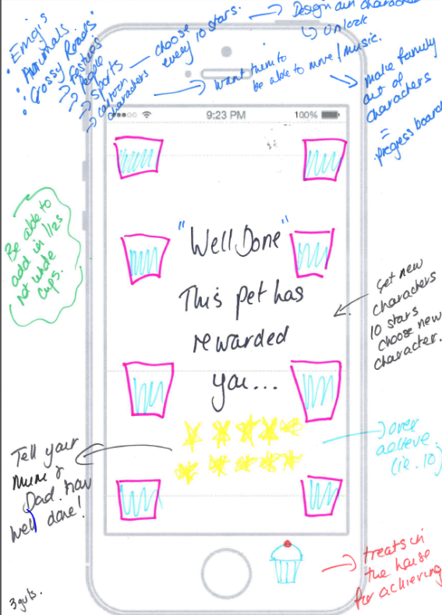
Figure 3: Workshop two activity examples

Following the first two workshops, an interactive wireframe was designed using UXPin. This is an essential stage in the design process and provides a visual guide for app layout, navigation between screens, and basic functionality.

Workshop three: feedback on the wireframe (led by an expert in user experience and prototyping (SC))
The aim of workshop three was to review the interactive wireframe; design the app set-up instructions and the drinks and reminders functions; and identify what information resources to include in the app. The wireframe was demonstrated (figure 3) on a large screen. Participants were provided with smartphones and tablets to test the wireframe a set of tasks aimed at navigating through the app screens and testing specific app functions (e.g. add a new drink). After completion of the workshop, adjustments were made to the wireframe based on user feedback (e.g. changing ‘loo visits’ to ‘visits’ for more privacy; storing and reopening unfinished drinks; library of recent drinks containers).

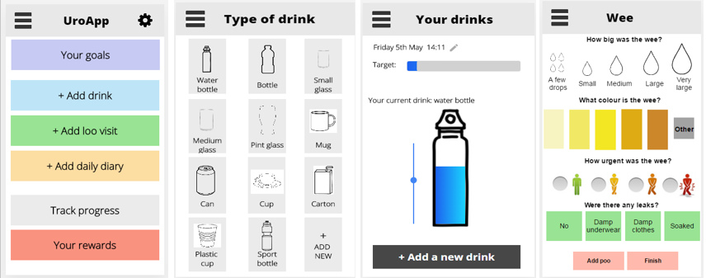
Figure 4: Example of the UXPin wireframe

Stage 3: Development of the app prototype

Stage 3 methods

Prototype development
Following completion of the workshops and adjustment to the wire frame, the research team collaborated with the app developers to produce the app prototype. A matrix was produced containing all the app functions; the purpose of each function, and how it should work. The priority of each function was defined using the MSCW framework (Must have, Should have, Could have, Would have). Decision were based on whether function was deemed to be core or additional; participants’ and clinicians’ rating of importance, and the feasibility, technical difficulty and cost of implementing each function in the app.

The developers shared regular videos to demonstrate progress with the app build and designs for each screen and had regular meetings with the research team to review each stage of the build.

The initial app prototype was tested at a workshop attended by the ERIC Young People’s Advisory Group. They were asked provide feedback on the app design, navigation and functionality. Feedback was discussed within the research team and proposed changes were sent to the developers. Updated versions of the app were then made available to the research team for review through a closed (beta) testing group and this iterative process continued throughout the app development process.

Stage 3 results: Design and content of prototype
A prototype of the app was produced with the following functions:

- Passcode for security
- Daily drinking goal set by the user and based on clinical guidance
- Customisable reminders for drinking and toilet visits
- An interactive homepage to record drinks and view daily drinking progress
- A range of standard drinks containers
- Option to add a customised container and use a picture of the user’s own container
- Toilet visit recording
- Progress charts, daily diary, and summary
- Rewards for reaching drinking goals
- Personalised feedback linked to support and advice pages
- Task centre for viewing notifications and completing tasks (e.g. viewing daily feedback, completing weekly evaluation)

Example screen shots of the drink recording page, range of drinking containers, and toilet visit recording are shown in appendix 3.

Stage 4: User testing

Stage 4 Methods

‘Think aloud’ interviews
Young people participated in ‘think aloud’ interviews to obtain their immediate reactions to every element of the app. This phase was key for optimising the design and function of the app prior to real-life testing. Feedback from young people was logged in a ‘table of changes’ and the coding framework described in Figure 7 was applied[29]. The table included positive and negative feedback on all functions of URApp; suggested changes; reason for changes; and MSCW priority. Potential changes were discussed with stakeholders and decisions were communicated to the developers who implemented these before the real-life user testing.

Real-life user testing
In the real-life testing phase young people were provided with the updated app prototype to use for a period of 4-6 weeks. This is the minimum time needed in order to see improvements in bladder symptoms as a result of a bladder training. At the end of the testing period participants were invited to take part in an in-depth interview (on Skype) about their experiences of using URApp. The in-depth interview was guided by a semi-structured topic guide including sections on: using URApp (general usability and function); BCTs included in the app; barriers to app use; health beliefs (understanding of bladder training, views on whether changes in drinking and toileting have impacted symptoms); and views on using the app in consultations with clinicians (e.g. specialist nurse, urologist). A deductive framework approach was used to analyse the interviews[40].

Interviews with clinicians
We conducted semi-structured interviews with clinicians involved in continence care to gain feedback on the app design and function, clinical use and appropriateness, and potential implementation within clinical care. Clinicians were guided through the initial app set up and functionality of the app. Specific feedback was sought on whether the app functions align to best practice bladder training guidelines. Interviews were conducted by phone due to clinician location and availability.

Table 3: Table of changes coding framework
Coding framework
Code | Stands for | Means
IMP | Important for behaviour change | This is an important change that is likely to impact behaviour change or a precursor to behaviour change (e.g. acceptability, feasibility, persuasiveness, motivation, engagement), and/or is in line with the Logic Model, and/or is in line with the Guiding Principles. For example, participants appear unconvinced by an aspect of the intervention, so you decide to add motivational examples.
EAS | Easy and uncontroversial | An easy and feasible change that does not involve any major design changes. For example, a participant was unsure of a technical term, so you add a definition.
REP | Repeatedly | This was said repeatedly, by more than one participant.
EXP | Experience | This is supported by experience. Please specify what kind of experience, for example:  - PPIs agree this would be an appropriate change.  - Experts (e.g. clinicians on your development team) agree that this would be an appropriate change.  - Literature: This is supported by evidence in the literature.
NCON | Does not contradict | This does not contradict experience (e.g. evidence), or the Logic Model, or the Guiding Principles
NC | Not changed | It was decided not to make this change. Please explain why (e.g. it would not be feasible; or only one person said this).

Stage 4 Results

User feedback
Ten young people took part in think aloud interviews and ten took part in the real-life testing (see table 1 for full details). Young people reported that they liked URApp’s appearance and functions and thought that it could be helpful for self-managing their bladder symptoms.

“It’s easy to use, it’s not confusing, the setup, the layout… I think I would use it” – P22

“Much better than paper diaries...I never got around to filling them out, whereas this would be on my phone, which I would have on me, so I think that’s a lot handier” – P8

App design
Participants found the design of the app pleasing and suitable for a wide age range. Younger participants said that they would like to have the option to customise the app and make it more personal to them.

“It looks good, they’re [the design graphics] simple, you don’t want them too flashy because it might take away from the actual purpose” – P2

“I think it needs more personalisation, because it’s something you’re going to go on quite a lot so you want it to be personal… so you could change the colours, or add photos, pictures…” – P15

Core functions
The core functions of the app, recording drinks and toilet visits, worked well. Users liked how quick it was to record toilet visits, and the interactive nature of recording drinks by pulling down the fluid level with their finger. However, some participants felt that this function needed to be made clearer.

“You can drag by moving the water…. Maybe make it a bit more obvious, I only knew because I accidentally touched it and it moved…maybe when you first download the App have a walk through” - P2

“Oh yeah you just drag it… Oh that’s cool! You drink it yourself! You do a virtual drinking, that’s so cool! And you get stars! This is a brilliant app!” – P10

Feedback highlighted that the ability to add drinks retrospectively should be made clearer.

“It wasn’t obvious how to change the time of the drink… maybe you could make it bigger?” – P14

Young people liked the toilet visit options and found the choices clear with nice graphics. Two areas for improvement were highlighted. Firstly, including ‘wee leak’ options for incontinence pad wearers (i.e. wet pad), and secondly, more information on how to judge stool consistency.

Data display
Data collected in URApp are displayed in three ways; a progress chart (line and bar graph), a daily diary, and a summary providing an overview for the chosen time period (e.g. wees have mostly been large). Feedback on how the data are displayed varied between participants e.g. older participants tended to like the progress charts and found them helpful in identifying patterns and tracking changes over time.

“It’s easier to spot patterns, you don’t have to work it out for yourself” – P8

“You can change what data is shown, it’s another nice way of being able to see” – P2

“I think it’s a good idea, you can see how much you’ve improved, if the app is helping you” – P22

Other participants preferred the summary and daily diary as they provided a simpler overview of the data. Key feedback was that users wanted a space to record events, mood, and any factors which might impact their symptoms, such as stressful events, change to medication, or certain drinks.

“…being able to track things using your own words as well and maybe being able to track your mood, because it’s something that’s closely linked to having a bladder or bowel condition” – P2

Rewards and feedback
Feedback on the rewards was very positive with young people reporting they liked both the streaks, stars, and trophies. Younger participants particularly liked the star and trophy rewards and thought this would encourage them to use the app and keep them motivated.

“It makes you feel more committed to achieving your goals… You achieve stuff… It makes you feel good about yourself. You have something to tell you that you’ve done it good” – P14

Young people also liked how similar the streak rewards were to other apps they used.

“The language (‘streaks’) makes it easy for kids to understand because it’s like other apps like Snapchat” – P8
Young people found the daily feedback on their drinking goal easy to understand and liked the large graphics. The feedback indicates the percentage of the daily drinking goal achieved and provides an appropriate encouraging message based on the percentage achieved. A few participants reported that they would like to be able to see if they went over their daily drinking goal, for example 110%.

There was less engagement with the weekly feedback with some young people not using this feature. A small number reported that the notification to complete the feedback was not obvious enough and they did not see the prompt. Those that did use the weekly feedback found the personalised feedback messages and linked support pages interesting but reported that they were too text heavy and long.

“There could be a few pictures in it, stick figures…” – P15

“…more pictures would be useful, because how your body works is quite difficult anyway, showing the bladder has muscles that contract too much” – P2

Clinician feedback
Eight clinicians provided feedback on the app (see table 2 for full details). Clinician feedback focused on the consistency of the app with bladder training best practice guidelines, how the app aligns with their own practice, data usage and integration with medical records, and using the app as part of clinical care.

Clinical use and appropriateness
The app design and content aligned with bladder training best practice guidelines. Clinicians were positive about the app functions and the customisability.

“I think that looks good, particularly being set up with a clinician. I think it’s really easy to use, I mean I’ve used it and I’m not tech savvy…They can set whatever reminder they want themselves” – Clinician 5

“I think that’s really good. I like the fact [the reminders are] every two hours, you’ve got the days of the week on there, they can do their own things with it. That’s what I’d say, you need to drink regular, these are the times you need to drink, with your breakfast, on your way to school” – Clinician 4
The range and size of the drinking containers was appropriate and fitted with the estimates used in their clinics. A small number of clinicians recommended adding a container for small bottles used by younger children, however they all agreed that a custom container could be made if needed.

“Oh that’s good! That’s quite good because it’s visual isn’t it, especially the water bottle and the can. The majority of children I see, the lunch time drop in, they’ve always got those plastic bottles.”- Clinician 4

Clinicians liked the functionality of recording drinks by pulling the fluid level down. They felt the interactive nature would appeal to young people.

“That’s clever [pull down to drink] because you say I’ve got this glass and I only drank half of it then it is a way of reflecting that, yeah that’s nice… yeah that’s really neat, I like the dragging down” – Clinician 7

Overall clinicians felt the app fitted very well with their clinical practice and the information they needed during appointments. Some reported that being able to record the type of drinks as well as the amount would be useful as this could affect symptoms, for example fizzy drinks, caffeine, or milk.

“My only comment is I would like to know what the child has had to drink…[for example] caffeine or fizz... Because I say to the kids avoid fizzy, avoid caffeine, milk doesn’t count as a drink” – Clinician 5

During discussion about the app functions it was decided that the option to record this in a free text diary would meet their needs as plotting this information on the charts would be highly complicated.

Data usage and integration with medical records
All clinicians said that URApp data would be of clinical use and relevance. Clinicians reported that it was challenging for patients to provide an accurate log of their drinking and toileting since their previous clinic visit and felt that an app would have more appeal to young people.

“It’s difficult to get young people to engage with recording diary information, including frequency/ volume charts, with something a bit more modern you’d get more engagement and more data” – Clinician 7

“Some of them are very easily distracted and don’t do their diaries and things. Especially the bigger ones they got no excuses because they’ve got phones on them all the time haven’t they. So they’ve got no excuse for not recording it” – Clinician 3

Views on how best to integrate the data with medical records varied. Some said being able to download the data would be the best option for them whereas others said they would use the data for discussion in their clinic and take written notes. The most acceptable solution for all clinicians was a screenshot of the data that could be shared with the user’s permission during the clinic session.

“We have to document everything anyway, I’d use it all. Would be good if you could have it on a printout because you could put it in your records… I’d like a picture of it, it can be scanned into the records.” – Clinician 4

Patient engagement
Feedback on anticipated patient engagement was optimistic. Clinicians felt that the interactive nature of URApp would appeal to young people, particularly the customisability and reward systems.

“I think we would use it on every single child that came to our clinic, anyone that came to bladder training, we would direct them all to it and say this is part of it, download this app we’re not going to give you an appointment until you’ve got some data on it…” – Clinician 7

Clinicians felt it would be especially beneficial to use with patients who were not making progress with their treatment or not engaging with their treatment plans.

“I’m already thinking of kids I could use this with. I’m just going through a load of telephone reviews and nothing has changed for these kids. It’s just exhausting really”- Clinician 6

“It’s sustainable and it’s something that will get their concentration. They like these sorts of things. Sitting in front of someone being nagged at all the time, if they can actually do the app themselves and tap in all the stuff, and hopefully there’s obviously research to show it does motivate people and keep them going” – Clinician 6

Final app modifications
Findings from the user testing were inputted into the table of changes and synthesised to identify key areas for modification. All potential changes were discussed within the research team and coded using the MSCW framework with an additional ‘no change’ code. Decisions were made based on repetition of feedback, importance for app functioning, importance for behaviour change, consistency with clinical treatment guidelines, and cost of change.

Nine key modifications were identified. Table 3 provides a summary of identified changes and app function area.

Table 4: summary of final app modifications
App function area | App modification
Recording new drinks | Pop-up message to explain how to pull down the fluid level on first use
Adding new drinks | Making the option to change the time of drink more obvious
Daily diary | Free text option for recording notes
Settings /about | Add a PDF link to instruction manual
Background and information pages | Reformat and reduce amount of text
Wees | Change leak text to include incontinence pad users
Poos | Pop-up with more information on stool consistency
Task centre | Pulsing red button on homepage to make this more obvious
Drinking goal feedback | Show goal completion over 100% if the user has exceeded their daily drinking goal

Discussion
URApp is the first smartphone app specifically designed to support young people with UI. User testing with young people with UI demonstrated that URApp is acceptable, usable, engaging, and potentially effective in supporting concordance with bladder training. Young people liked the design and style of URApp, and felt it was age appropriate. Younger participants expressed a desire to be able to personalise the design of URApp to a greater extent, for example through changing the theme colours or having seasonal backgrounds. Young people found the app quick and easy to use and liked the interactive nature of recording drinks.

All participants found URApp to be helpful in managing their drinking and toilet schedules, with many requesting to continue using the app beyond the study. Several reported they had been able to increase their drinking or maintain more regular drinking as a result of using URApp. These findings are encouraging and provide preliminary evidence that URApp could be a potentially effective solution to providing personalised support for young people to self-manage their bladder symptoms.

URApp was designed to be discreet and the mandatory passcode ensures privacy, a feature that was highly valued by the young people who tested the app. Previous research found that timer watches prompt unwanted attention from peers creating a barrier to use[8, 15]. URApp provides discreet prompts through the phone user’s text message notification sound and allow users to customise their reminder text.

Young people were positive about the reward functions in URApp and felt this would motivate them to keep using the app. This is important because continued concordance to the timed drinking and toileting schedule is crucial for successful bladder training[13].

Clinicians thought that URApp could provide an age-appropriate solution to aid concordance to bladder training in young people and could, therefore, be used as an adjunct to treatment. The option to customise reminder time and text was particularly commended as this could be tailored to each individual patient. Clinicians also reported that being able to record the type of drink is beneficial, because the certain types of drinks (e.g. fizzy, caffeinated) might have an adverse impact on bladder function in some patients.

Strengths and limitations
URApp was developed using a rigorous approach to intervention and app design, underpinned by behaviour change theory. Development methods were guided by MRC recommendations for development and evaluation digital interventions[27] and informed by the person-based approach to intervention development[29]. This is the optimal approach to developing digital health interventions to ensure usability and acceptability[41].

The end user population was included throughout the development process. This means that URApp is centrally designed around user needs and feedback. Engaging with the app development team from the project’s outset ensured that proposed design and functions of the app were feasible in terms of cost and delivery within the project timeline.

Although our results are encouraging this work does have limitations. User testing was restricted to young people with English as a first language, and with predominantly high levels of educational ability. Further testing and refinement of URApp is needed with young people from a range of educational, socio-economic, and ethnic backgrounds.

Young people included in the study had already engaged in treatment for UI, either through primary or secondary care. It is not clear if URApp would offer the same level of acceptability and utility to young people who had not yet engaged with treatment. This is an important area for further research, as the stigma of continence problems prevents many young people from seeking treatment.

Conclusion
This study provides initial support for the acceptability and usability of URApp. The next stage is to test whether URApp is effective in aiding concordance to bladder training, and therefore, improving bladder symptoms and enhancing well-being. URApp should be tested across a range of settings including paediatric continence clinics, primary care, and in schools (via school nurses). The cost effectiveness of using URApp to support bladder training in primary and secondary care settings and in the community also needs to be examined. An interactive website[23] has been developed where users can download URApp at no cost (available for iOS and Android devices) and access resources to support young people with UI.

Acknowledgements
We are extremely grateful to all the young people, doctors and nurses who help us to develop URApp and for the support of the people and organisations including: ERIC- The Children's Bowel & Bladder Charity; Bladder & Bowel UK; The Paediatric Continence Forum, and Stuart Church at Pure Usability. The software for URApp was developed by Natural Apptitude[35].

Funding
This work was supported by the Elizabeth Blackwell Institute for Health Research, University of Bristol, and the Wellcome Trust Institutional Strategic Support Fund (User-centred development of a prototype smartphone application to support the management of daytime urinary incontinence in young people - PI Joinson), and the Medical Research Council (Evaluating the usability, acceptability and potential effectiveness of a smartphone app to support the management of urinary incontinence and urgency in young people - PI Joinson).

Lucy Yardley is an NIHR Senior Investigator and her research programme is partly supported by NIHR Applied Research Collaboration (ARC)-West, NIHR Health Protection Research Unit (HPRU) for Behavioural Science and Evaluation, and the NIHR Southampton Biomedical Research Centre (BRC).

Conflicts of interest
The authors have no conflicts of interest to declare

Multimedia appendix 1: Core app functions to support bladder training and target behavioural change

Multimedia appendix 2: Behaviour change techniques used in URApp

Multimedia appendix 3: Examples of final prototype
References
1. Hellstrom A, E. H, Hansson S, Hjalmas K, Jodal U. Micturition habits and incontinence at age 17—reinvestigation of a cohort studied at age 7. British Journal of Urology. 1995;76(2):231-4.
2. Kyrklund K, Taskinnen S, Rintala RJ, Pakarinen MP. Lower Urinary Tract Symptoms from Childhood to Adulthood: A Population Based Study of 594 Finnish Individuals 4 to 26 Years Old. The Journal of Urology. 2012;188(2):588-93.
3. Swithinbank LV, Brookes ST, Shepherd AM, Abrams P. The natural history of urinary symptoms during adolescence. British Journal of Urology. 1998;81:90-3.
4. Yeung CK, Sreedhar B, Sihoe JD, Sit FK, Lau J. Differences in characteristics of nocturnal enuresis between children and adolescents: a critical appraisal from a large epidemiological study. BJU Int. 2006 May;97(5):1069-73. PMID: 16643494. doi: 10.1111/j.1464-410X.2006.06074.x.
5. Austin PF, Bauer SB, Bower W, Chase J, Franco I, Hoebeke P, et al. The standardization of terminology of lower urinary tract function in children and adolescents: Update report from the standardization committee of the International Children's Continence Society. Neurourol Urodyn. 2016 Apr;35(4):471-81. PMID: 25772695. doi: 10.1002/nau.22751.
6. Heron J, Grzeda MT, von Gontard A, Wright A, Joinson C. Trajectories of urinary incontinence in childhood and bladder and bowel symptoms in adolescence: prospective cohort study. BMJ Open. 2017 Mar 14;7(3):e014238. PMID: 28292756. doi: 10.1136/bmjopen-2016-014238.
7. Grzeda MT, Heron J, von Gontard A, Joinson C. Effects of urinary incontinence on psychosocial outcomes in adolescence. Eur Child Adolesc Psychiatry. 2017 Jun;26(6):649-58. PMID: 27943057. doi: 10.1007/s00787-016-0928-0.
8. Whale K, Cramer H, Joinson C. Left behind and left out: The impact of the school environment on young people with continence problems. Br J Health Psychol. 2018 May;23(2):253-77. PMID: 29228510. doi: 10.1111/bjhp.12284.
9. Hjalmas K. Functional daytime incontinence: definitions and epidemiology. Scandinavian Journal of Urology. 1992;141:39-46.
10. Chang S, Laecke EV, Bauer S, von Gontard A, Bagli D, Bower WF, et al. Treatment of daytime urinary incontinence: A standardization document from the International Children's Continence Society. Neurourology and Urodynamics. 2015;36(1):43-50.
11. Buckley BS, Sanders CD, Spineli L, Deng Q, Kwong JS. Conservative interventions for treating functional daytime urinary incontinence in children. Cochrane Database Syst Rev. 2019 Sep 18;9:CD012367. PMID: 31532563. doi: 10.1002/14651858.CD012367.pub2.
12. Schafer SK, Niemczyk J, von Gontard A, Pospeschill M, Becker N, Equit M. Standard urotherapy as first-line intervention for daytime incontinence: a meta-analysis. Eur Child Adolesc Psychiatry. 2018 Aug;27(8):949-64. PMID: 28948380. doi: 10.1007/s00787-017-1051-6.
13. Assis GM, Silva C, Martins G. Urotherapy in the treatment of children and adolescents with bladder and bowel dysfunction: a systematic review. J Pediatr (Rio J). 2019 Nov - Dec;95(6):628-41. PMID: 31009619. doi: 10.1016/j.jped.2019.02.007.
14. Mulders MM, Cobussen-Boekhorst H, de Gier RP, Feitz WF, Kortmann BB. Urotherapy in children: quantitative measurements of daytime urinary incontinence before and after treatment according to the new definitions of the International Children's Continence Society. J Pediatr Urol. 2011 Apr;7(2):213-8. PMID: 20541978. doi: 10.1016/j.jpurol.2010.03.010.
15. Whale K, Cramer H, Wright A, Sanders C, Joinson C. 'What does that mean?': a qualitative exploration of the primary and secondary clinical care experiences of young people with continence problems in the UK. BMJ Open. 2017 Oct 16;7(10):e015544. PMID: 29042374. doi: 10.1136/bmjopen-2016-015544.
16. Li L, Moore D. Acceptance of Disability and its Correlates. The Journal of Social Psychology. 1996;138(1):13-25.
17. Stuifbergen A, Becker H, Blozis S, Beal C. Conceptualization and development of the Acceptance of Chronic Health Conditions Scale. Issues Ment Health Nurs. 2008;29(2):101-14. PMID: 18293219. doi: 10.1080/01612840701792548.
18. Zugelj U, Zupancic M, Komidar L, Kenda R, Varda NM, Gregoric A. Self-reported adherence behavior in adolescent hypertensive patients: the role of illness representations and personality. J Pediatr Psychol. 2010 Oct;35(9):1049-60. PMID: 20430840. doi: 10.1093/jpepsy/jsq027.
19. Leventhal H, Philips LA, Burns E. The Common-Sense Model of Self-Regulation (CSM): a dynamic framework for understanding illness self-management. Journal of Behavioural Medicine. 2016;39:935-46.
20. Hagstroem S, Rittig S, Kamperis K, Djurhuus J. Timer Watch Assisted Urotherapy in Children: A Randomized Controlled Trial. The Journal of Urology. 2010;184(4):1482-8.
21. Thornton L, Gardner LA, Osman B, Green O, Champion KE, Bryant Z, et al. A Multiple Health Behavior Change, Self-Monitoring Mobile App for Adolescents: Development and Usability Study of the Health4Life App. JMIR Form Res. 2021 Apr 12;5(4):e25513. PMID: 33843590. doi: 10.2196/25513.
22. Roberts C, Sage A, Geryk L, Sleath B, Carpenter D. Adolescent Preferences and Design Recommendations for an Asthma Self-Management App: Mixed-Methods Study. JMIR Form Res. 2018 Sep 13;2(2):e10055. PMID: 30684424. doi: 10.2196/10055.
23. URApp. URApp Website. 2020; Available from: http://urapp.org.uk.
24. Michie S, Richardson M, Johnston M, Abraham C, Francis J, Hardeman W, et al. The behavior change technique taxonomy (v1) of 93 hierarchically clustered techniques: building an international consensus for the reporting of behavior change interventions. Ann Behav Med. 2013 Aug;46(1):81-95. PMID: 23512568. doi: 10.1007/s12160-013-9486-6.
25. Michie S, Yardley L, West R, Patrick K, Greaves F. Developing and Evaluating Digital Interventions to Promote Behavior Change in Health and Health Care: Recommendations Resulting From an International Workshop. J Med Internet Res. 2017 Jun 29;19(6):e232. PMID: 28663162. doi: 10.2196/jmir.7126.
26. Craig P, Dieppe P, Macintyre S, Michie S, Nazareth I, Petticrew M, et al. Developing and evaluating complex interventions: the new Medical Research Council guidance. BMJ 2008;337.
27. O'Cathain A, Croot L, Duncan E, Rousseau N, Sworn K, Turner KM, et al. Guidance on how to develop complex interventions to improve health and healthcare. BMJ Open. 2019 Aug 15;9(8):e029954. PMID: 31420394. doi: 10.1136/bmjopen-2019-029954.
28. Webb TL, Joseph J, Yardley L, Michie S. Using the internet to promote health behavior change: a systematic review and meta-analysis of the impact of theoretical basis, use of behavior change techniques, and mode of delivery on efficacy. J Med Internet Res. 2010 Feb 17;12(1):e4. PMID: 20164043. doi: 10.2196/jmir.1376.
29. Yardley L, Morrison L, Bradbury K, Muller I. The person-based approach to intervention development: application to digital health-related behavior change interventions. J Med Internet Res. 2015 Jan 30;17(1):e30. PMID: 25639757. doi: 10.2196/jmir.4055.
30. ERIC. The Children's Bowel and Bladder Charity. 2020; Available from: https://www.eric.org.uk/.
31. PCF. Paediatric Continence Forum. 2020.
32. INVOLVE N. What is public involvement in research? . 2020; Available from: https://www.invo.org.uk/find-out-more/what-is-public-involvement-in-research-2/.
33. Clayden G, Wright A. Constipation and incontinence in childhood: two sides of the same coin? Arch Dis Child. 2007 Jun;92(6):472-4. PMID: 17515614. doi: 10.1136/adc.2006.113738.
34. UXPin. 2020; Available from: https://www.uxpin.com.
35. Apptitude N. 2020; Available from: https://www.natural-apptitude.co.uk/.
36. Deci EL, Ryan RM. Self-determination theory: A macrotheory of human motivation, development, and health. Canadian Psychology/Psychologie canadienne. 2008;49(3):182-5. doi: 10.1037/a0012801.
37. Ng JY, Ntoumanis N, Thogersen-Ntoumani C, Deci EL, Ryan RM, Duda JL, et al. Self-Determination Theory Applied to Health Contexts: A Meta-Analysis. Perspect Psychol Sci. 2012 Jul;7(4):325-40. PMID: 26168470. doi: 10.1177/1745691612447309.
38. Kawachi I. It's All in the Game-The Uses of Gamification to Motivate Behavior Change. JAMA Intern Med. 2017 Nov 1;177(11):1593-4. PMID: 28973152. doi: 10.1001/jamainternmed.2017.4798.
39. Schmidt-Kraepelin M, Toussaint PA, Thiebes S, Hamari J, Sunyaev A. Archetypes of Gamification: Analysis of mHealth Apps. JMIR Mhealth Uhealth. 2020 Oct 19;8(10):e19280. PMID: 33074155. doi: 10.2196/19280.
40. Gale NK, Heath G, Cameron E, Rashid S, Redwood S. Using the framework method for the analysis of qualitative data in multi-disciplinary health research. BMC Medical Research Methodology. 2013;13.
41. Majeed-Ariss R, Baildam E, Campbell M, Chieng A, Fallon D, Hall A, et al. Apps and Adolescents: A Systematic Review of Adolescents' Use of Mobile Phone and Tablet Apps That Support Personal Management of Their Chronic or Long-Term Physical Conditions. J Med Internet Res. 2015 Dec 23;17(12):e287. PMID: 26701961. doi: 10.2196/jmir.5043.

