Enriching social media data allows a more robust representation of cultural ecosystem services
Abstract
Images and textual metadata from social media sites such as Flickr have been used to understand the drivers and distributions of cultural ecosystem services (CES). However, using all available data from social media sites may not provide an accurate representation of individual services. For example, an image of nature might be described negatively in the image’s description. Here, we present a novel approach to refining social media data to represent CES better, including filtering by keywords, photograph content and enriching the data by including a measure of the sentiment expressed in the textual metadata. We demonstrate that the distribution of an enriched dataset of Flickr images representing hiking in the USA can contribute to different results and conclusions than the full dataset. Furthermore, we classified the contents of these hiking images and, using latent semantic analysis, clustered the images into ten groups based on the similarity of their content. The groups provide rich information, such as the importance of geodiversity and biodiversity in supporting a positive hiking experience. The application of this method can help to enrich social media data for CES studies, allowing researchers to further untangle the complex socio-ecological interactions that drive CES distributions, benefits and values.
Keywords: Cultural ecosystem services, geosystem services, social media, Flickr, hiking
1 Introduction
Cultural ecosystem services (CES) are non-material benefits obtained from human-nature interactions including through recreation, cognitive development, aesthetic views and spiritual enrichment (Millennium Ecosystem Assessment 2005; Milcu et al. 2013). Though there are many different definitions and classifications used for CES, most literature focuses on the links between the biophysical environment and human wellbeing, while recognising that CES are intangible (Fish et al. 2016; Dickinson and Hobbs 2017). Here, we classify CES following Milcu et al., (2013), who divided CES into 11 subcategories; recreation and tourism, aesthetic values, spiritual and religious values, educational values, cultural heritage values, bequest, intrinsic and existence, inspiration, sense of place, knowledge systems, social relations, and cultural diversity. Furthermore, we note that CES benefits can be delivered through multiple pathways. King et al. (2017) identified six pathways to CES benefits that reoccur across CES literature: cognitive (benefits from the development of knowledge), creative (benefits from influences on aesthetic appreciation and artistic expression), intuitive (benefits from the influence on instincts and senses), retrospective (benefits from reflecting on past experiences), regenerative (benefits from opportunities for recreation, leisure and tourism) and communicative (benefits from social relations, cultural identity, and sense of place). However, for these pathways to be actualised, there is a need for people to first recognise the potential benefits of biophysical features and then utilise these potential benefits (Spangenberg et al. 2014). Therefore, CES, as with other ecosystem services (ES), are not provided by ecosystems independently of humans but are co-produced through our interactions with them (Fischer and Eastwood 2016).
Though the value of ES is generally provided by an economic metric, ES values can also be measured by its societal and cultural values and therefore the value of CES is often non-monetary (Haines-Young and Potschin, 2018; Reynaud and Lanzanova, 2017; Small, Munday and Durance, 2017). There are multiple methods of assessing CES value both, monetary (e.g. travel cost or willingness to pay) and non-monetary (photograph analysis or ranking methods) (Hirons et al. 2016). However, quantifying the benefits and values of CES are more difficult due to the perceptions of CES benefits being unique to individuals based on their social and cultural norms (Daniel et al. 2012; Havinga et al. 2020). Therefore, CES have been comparably under-researched compared to other ES and we, therefore, need to develop our understanding of the human-nature interactions that provide these services (Milcu et al. 2013; Dickinson and Hobbs 2017).
Previous literature assessing CES relationships, as well as wider ES relationships, tend to focus on the role of nature on CES production (Fischer and Eastwood 2016). Because people, culture and nature are so inherently interlinked, it can be difficult to disentangle what constitutes nature in the context of ES (Plumwood 2006; Hirons et al. 2016). Here, we view nature as the biophysical features of an ecosystem (Haines-Young and Potschin 2018), comprised of the interactions of biodiversity and geodiversity (Gray 2012; Gordon and Barron 2013; Fox et al. 2020a). There has been a particular focus on the role of biodiversity in CES production, with the role of geodiversity often omitted from studies (Fox et al. 2020a). Geodiversity can be viewed as the abiotic equivalent to biodiversity, representing the diversity of geological structures and processes, including rocks and minerals; geomorphology, including landforms and topography; sediments and soils, including formation processes; and hydrology, including marine, surface and subsurface waters (Gray 2004; Hjort et al. 2015; Fox et al. 2020a). Geodiversity can also provide CES in the absence of biodiversity. These “geosystem services” include CES such as recreational activities (e.g. water-based sports, rock climbing and caving), spiritual sites (e.g. Uluru, Australia and the Torres del Paine, Chile ), as well as providing opportunities for advancing scientific knowledge (e.g. the record of past climates and ecosystems contained in sediment, rock and ice cores) (Gray 2012; Kiernan 2014; Fox et al. 2020a). Often geodiversity is only assessed through landscapes types which are prescribed a general CES value, however, CES are not distributed randomly within a landscape, but are concentrated in hotspots that have specific features of biodiversity (e.g. forests and hedgerows) and geodiversity (waterbodies and geological formations) (Plieninger et al. 2013; van Berkel and Verburg 2014). It is therefore important that the relationship of the individual features of biodiversity and geodiversity to CES be assessed.
There is also a need to recognise that CES are co-produced and co-created by people and therefore only arise from the interaction of people with the biophysical environment (Chan et al. 2011; Fish et al. 2016). Though CES are inherently co-produced through human-nature interactions, these relationships are often omitted from studies in favour of assessing the links between biophysical nature and ES (Fischer and Eastwood 2016). CES are co-produced through a variety of different pathways including human, financial and manufactured capital (Raymond et al. 2018). For example, CES can be co-produced through the influences of culturally important buildings (e.g. places of worships), managed landscape (e.g. agricultural land), organisations (e.g. museums, parks and gardens), or purpose-built infrastructure (e.g. hiking trails) (Plieninger et al. 2013; van Berkel and Verburg 2014; Fischer and Eastwood 2016; Minkiewicz et al. 2016). There is a need to acknowledge the implications of the co-production for quantifying ES, and CES in particular, as a holistic approach to an understanding of these complex human-nature interactions can help to better shape their sustainable management (Bennet et al. 2015; Palomo et al. 2016).
To understand CES there is a need to for suitable datasets that can assess the complex relationship between biodiversity, geodiversity and society. However, globally, datasets on ES are sparse, meaning services are often mapped through proxies (Stephens et al. 2015), with the primary sources of data for CES mostly coming from either monetary assessments, social surveys such as stated preferences, or onsite surveys (Tenerelli et al. 2016; Figueroa-Alfaro and Tang 2017; Mayer & Woltering, 2018). Due to labour-intensive methods and high financial costs, implementing these over large spatial and time scales is not always feasible (Wood et al. 2013; Kim et al. 2019). Furthermore, management decisions need to be better informed through methods that reliably understand, identify, quantify and map CES (Tenerelli et al. 2016; Byczek et al. 2018). As CES are dynamic, methods also need to be able to reliably investigate changes over time (Figieroa-Alfaro and Tang 2017).
The potential of social media sites such as Flickr, Twitter and Facebook as a source of data for CES questions is starting to be realised (Kim et al. 2019). In contrast to social surveys, social media data is inexpensive, quick to gather and provides a means of mapping the distribution of CES and assessing changes over space and time (Fox et al. 2020b). Social media data has been used for CES studies, such as wildlife watching (Mancini et al. 2019), recreational services (Graham and Eigenbrod 2019; Sinclair et al. 2020a), aesthetic views (Van Berkel et al. 2018) and visitation rates in protected areas (Tenkanen et al. 2017, Kim et al. 2019; Sinclair et al. 2020b), providing key information for both tourism and conservation. However, social media data is often messy (Ghermandi and Sinclair 2019; Chen et al. 2020). Issues such as unknown or inaccurate spatial references (Figieroa-Alfaro and Tang 2017), unreliable image contents due to mistagged images or a mismatch between the content of a photograph and the location it was taken (Oteros-Rozas et al. 2018), and biases introduced by user groups (Langemeyer et al. 2018; Chen et al. 2020) therefore need to be accounted for.
To address the issues introduced by the vast volume of data on social media sites, CES studies tend to filter the returned results through several different approaches. For example, some studies filter results based on the geographic location the images were taken in - e.g. studies using the InVEST recreational model (Sharp et al. 2020). Searching for images within a given study site alone may return a large number of images not relevant to the specific ES of interest, or even to any ES at all. Other studies filter out images based on land cover types. For example, Tenerelli et al. (2019) excluded images of photographs found in urban areas. This method overlooks the fact that a photograph’s location does not always represent the subject of the image (Yan et al. 2019). A photograph taken within an urban area may be a long-distance image of a CES such as an aesthetic natural view, whilst photographs taken in a natural land cover may not be of a CES - e.g. photographs of a car’s interior. Furthermore, CES are not confined to specific land cover types and so excluding on this basis may exclude relevant services such as those provided by urban green spaces and trees (Kondo et al. 2018).
Another approach to deciding which images to include is to search for photographs based on a set of criteria - e.g. a study looking for photographs of hiking may limit returned photographs to those containing the word “hiking” in the textual metadata (Graham and Eigenbrod 2019). However, limiting images based on text alone does not guarantee that the image itself represents an ES. For instance, a search for photographs of “biking” may return photographs of equipment such as bikes and helmets. It therefore cannot be assumed that an image containing textual metadata related to the use of an ES is relevant for assessing CES.
Some authors are starting to acknowledge this, for example, Havinga et al. (2020), who used the distribution of photographs from Flickr to assess the aesthetic quality of landscapes, suggest that not all photographs may have relevance to the study. They therefore recommended assessing photograph contents. To ensure that photographs are suitable for their studies, researchers have analysed the contents of images and refined them to those that meet relevant criteria. Image classification can be either manual (subjective) or automatic through machine learning techniques (objective). For example, Oteros-Rozas et al. (2018), manually classified the contents of images, labelling them with landscape features and CES. These labels were then used to identify bundles of landscape features and CES. One method of automatic tagging is the Google Cloud Vision API, a machine learning algorithm that can identify the contents of images. Richards and Tunçer (2018) used the Google Cloud Vision API to label the contents of Flickr images and subsequently used this information to map the distribution of plants and animals, whilst Gosal et al. (2019) labelled photograph contents using the Google Cloud Vision API to find groups of recreational beneficiaries.
However, we argue that a combination of textual metadata confirming the presence of a targeted service (for example, an image tagged “hiking”), and an image containing features of the natural environment (for example, an image of a mountain), still does not confirm that the service user experienced a positive benefit indicating a CES. Indeed, it may have been a negative experience - e.g. a user could caption the image with a complaint about a boring walk. Furthermore, as sharing photographs is influenced by societal pressures, photographs shared may not show the user’s preferred features of nature (Moreno-Llorca et al. 2020). The textual metadata can contain “text-private” information that can convey emotions and opinions which could not be elicited from the image contents. By contrast, the image contents will often contain “image-private” information, such as features of the image and colours not mentioned in the text (Huang et al. 2019). In particular, a dichotomy between the textual metadata and image contents can exist as the textual metadata tends to be more heterogeneous and contain non-descriptive terms and phrases, whereas the classification methods used to label the content of images provides more homogenous single descriptive terms (Yan et al. 2019). Here, we suggest that by assessing the sentiment expressed in the textual metadata we can get additional information about the quality of the experience, meaning one can enrich the CES data. As the different types of data from Flickr contain different information (image content, spatial, temporal and textual metadata), studies could combine all these data sources to obtain more information about the benefits received.
We suggest that social media data can be enriched to better understand user experience, elicited through sentiment analysis of the textual metadata, and may provide a more robust dataset for CES assessments. Lexicon-based sentiment analysis is a natural language processing technique used to calculate the semantics, opinions or emotions of words or phrases from text (Wilson et al. 2019). One form of analysis is polarity classification, which classifies text as either positive or negative and can be used to assess social media datasets (Koto and Adriani 2015). Sentiment analysis for ES assessment has been broadly applied to social media datasets from Twitter (e.g. Becken et al. 2017; Wilson et al. 2019) and Instagram (e.g. Do 2019). There has also been some limited application of sentiment analysis to Flickr textual metadata. For example, Brindley et al. (2019) used sentiment analysis on Flickr textual data to assess the perception of green space.
Though the position of recreation as a final service has been questioned (Haines-Young and Potschin, 2018), recreational activities provide restorative benefits (e.g. increased physical wellbeing) and are therefore generally considered a CES (Millennium Ecosystem Assessment 2005; Milcu et al. 2012; Plieninger et al. 2013; King et al. 2017; Balzan and Debono 2018). In this article we will focus on hiking, a recreational activity that involves walking over an extended period, typically through natural or rural areas (Mitten et al. 2016). We consider hiking a CES here as it can directly provide restorative benefits, however, as the benefits from recreation may also be indirect (Balzan and Debono 2018), we recognize hiking could also be considered as a pathway to other CES (King et al. 2017) through co-production between human-nature interactions (Fischer and Eastwood 2016). For example, hiking may be undertaken for spiritual and religious motivations such as a pilgrimage, to experience aesthetic qualities of nature, or as a social activity with a sense of belonging (Collins‐Kreiner and Kliot 2017; Wilcer et al. 2019). From this viewpoint, hiking can also provide multiple pathways to other CES benefits, for example, providing a means of access to aesthetic views (creative pathway) or providing a sense of place (communicative pathway) (King et al. 2017). Hiking is one of the most popular recreational activities, both in the USA and worldwide, with participants from all age categories (Wilcer et al. 2019). Despite its popularity, research on the drivers of hiking remains limited (Wilcer et al. 2019). Hiking, as with other ES, is driven by co-production between ecosystems and people, such as the influences of cultural landmarks and landscapes or through the provision of infrastructure such as signposted trails (Plieninger et al. 2013; Fischer and Eastwood 2016).
In this article, we present an analysis that refines social media data from Flickr using content analysis and enriches the data using a measure of sentiment value expressed in the textual metadata, particularly for mapping the distribution and understanding the drivers of CES. We then demonstrate the use of our method for a more differentiated analysis of hiking as a CES, focusing on understanding which of geodiversity, biodiversity and human features contribute to a positive hiking experience.
2 Methods
2.1 Data collection
A reproducible R file for the data collection methods has been included in the supplementary material (S1). To comply with API terms and privacy policies all data sets were anonymised, stored with multiple layers of security and any unnecessary metadata was deleted.
We queried the Flickr API for photographs containing the text “hiking” in a photograph's title, description or tag metadata, in the contiguous 48 states of the USA, between 2015-01-01 and 2020-01-01. To ensure consistency and reproducibility in the study we used the photosearcher package (Fox et al. 2020b) within the R environment (R Core Team 2020). The photosearcher package allows searches of Flickr to be constrained by a shapefile. Here the search was limited to photographs taken and geotagged in the contiguous 48 states using a modified shapefile from the USAboundaries R package (Mullen and Bratt 2018). As the number of posts meeting these criteria can change over time (e.g. new photographs were taken during the study period but uploaded at a later date), we limited photographs to those uploaded before 2020-06-01 to increase the reproducibility of the search.
2.2 Content analysis
To ensure an image captures human-nature interactions, we categorized the contents of images to help filter out images that do not contain any biophysical features in their contents (e.g. indoor images). Here, the features within each image were automatically labelled using the Google Cloud Vision API (Google Cloud Vision 2020), accessed through the imgrec R package (Schwemmer 2019). The Google Cloud Vision API is a pre-trained machine learning model that can detect image contents including objects, faces and text. For each image, we requested the API to identify and label the 10 most dominant features of the image. The generated labels had an associated confidence score between 0 and 1. Here we only kept labels with a confidence score of >0.6 (Gosal et al. 2019). We assessed each unique label identified by the Google Cloud Vision API and categorized them as either biophysical nature or not. Here, we identified non-biophysical nature words as synthetic objects (e.g. buildings and cars), relating to people (e.g. a person), and descriptive terms (e.g. black, text), as well as non-biophysical aspects of nature such as weather phenomenon (e.g. sky and sun). Biophysical nature labels were any label that was a feature of biodiversity (e.g. tree or bird of prey), geodiversity (e.g. lake or geology), or an ecosystem (e.g. rainforest or grassland). Furthermore, we included generic descriptions of landscapes (e.g. wilderness and natural landscape) as biophysical nature. Supporting Information (Tables S2.1, S2.2) provides a full list of how each word was categorized. For each image, we calculated the percentage of labels categorized as a biophysical feature of nature.
2.3 Sentiment analysis
To ensure an image captures a positive human-nature interaction, and therefore a CES, we calculate the sentiment value expressed in the textual metadata. Here, we used the AFINN dictionary (Nielsen 2011) to summarise the sentiment of the textual metadata. The dictionary ranks words on a scale of -5 (the most negative words) to +5, (the most positive words), and can be an effective method for assessing social media datasets (Koto and Adriani 2015). For each image, the associated textual metadata was analysed using the AFINN dictionary and the overall sentiment value was calculated as the sum of all the positive and negative sentiment scores for that image. Each image was then categorized into two groups, (1) positive images - those with an overall positive sentiment score, (2) non-positive images - those with an overall negative sentiment score, an overall neutral sentiment score or where no sentiment was expressed in the textual metadata.
2.4 Impacts of refining the data
To understand the ramifications of refining data by contents and sentiment, we carried out two filtering processes: first selecting all images where the percentage of labels classified as biophysical nature exceeded a given threshold (e.g. 25% of the Google Vision Cloud API labels were of biophysical nature features), and second filtering only images with positive sentiment to ensure images were associated with a positive experience (Fig. 1). The final part of the analysis applied both filters, resulting in a final dataset representing images of human-natural interactions AND reflecting a positive experience. We extracted a random sample of 100 images from each category (confirmedNature, nonNature, confirmedPositive, nonpositive) to manually validate the automated process.
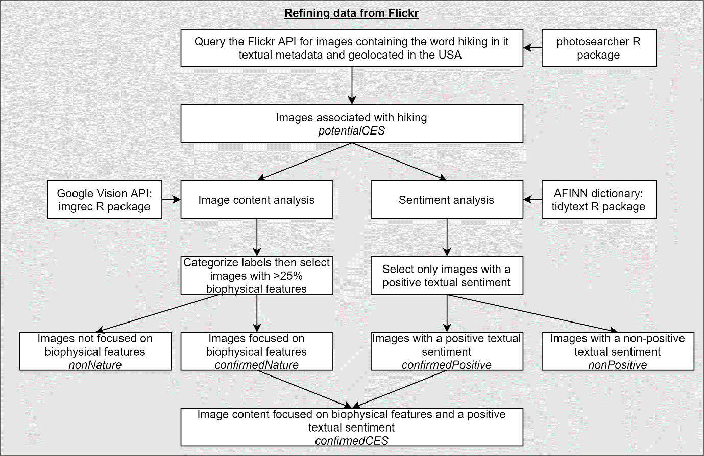
Figure 1. Processes applied to refining the Flickr dataset.
First, the full Flickr dataset was refined to images that were confirmedNature (thus removing any images that, whilst including the relevant activity in the associated textual data, were not taken within a natural or semi-natural setting and therefore did not represent an ES, for example, an image of somebody indoors with the caption "I wish I were hiking"). Two rasters were generated representing the number of uploads per pixel, one raster from the full dataset and one from the refined dataset. A moving window was used to assess localised differences in the two rasters (Figure 2). The moving window assesses a square of pixels (3 x 3 pixels) and calculates the deviance of their values from a 1:1 line. To do this, the values of two rasters within the window are normalized between 0 and 1 and the absolute difference between the two pixels at the same location within the window was calculated. If the two sets of images have a perfect correspondence in the distribution within the window, the standardised upload values would fall along a 1:1 line. The deviance score is calculated as the mean of the absolute values of these differences (to account for negative deviations from the 1:1 line, following Willcock et al. (2019)). The moving window approach allowed us to represent spatial differences in deviance by calculating the deviance value for the number of uploads within the window and creating a new raster in which the deviance value was assigned to the central pixel of the window (e.g. the pixel in the middle of the 3 x 3 moving window). If the full dataset is a good proxy for images of nature, we expect the local deviance (defined by the window size) value to be less than 0.3 (Willcock et al. 2019); indicating that the refined and full datasets share similar distributions and that the filtering is not necessary. Where the deviance value is greater than 0.3 there is not a good fit between the two datasets (Willcock et al. 2019).
As landscape characteristics can drive recreational activities at a range of scales, and Flickr is a good proxy for recreation at a range of scales up to 50km (Graham and Eigenbrod 2019), here we map the difference in distribution when the number of uploads is aggregated to 25km². We also map the differences in distribution using a 3 x 3-pixel window (where a pixel is the size of one pixel of the underlying raster as determined by the spatial resolution), a standard size for aggregating fine-scale data (Graham et al., 2019). Furthermore, we map the differences based on refining by a threshold of 25% biophysical labels. This threshold was chosen to ensure that the refined set of images captured human-nature interactions, without completely excluding images containing human features as these could help to provide insight into the co-production of CES. However, as any changes in distribution may be a facet of the filtering method, or the method of mapping and calculating the deviance, we conducted a sensitivity analysis using all possible combinations of three thresholds for considering an image to be of nature (images with 25%, 50% and 75% labels classed as biophysical nature), three different spatial resolutions (5km², 10km² and 25km²), and three sizes of moving window (3 x 3 pixels, 5 x 5 pixels and 7 x 7 pixels). This resulted in 27 datasets.
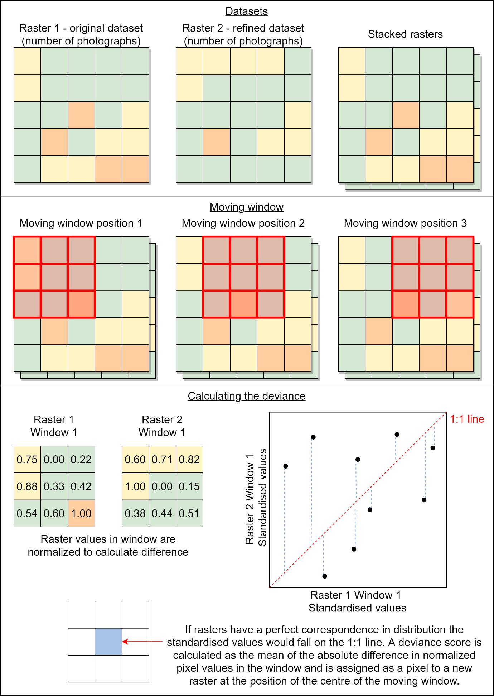
Figure 2. Methods for calculating the difference in distributions between the unrefined and refined datasets.
If there is a spatial pattern to the data (e.g. if all pixels that have high deviance values are spatially clustered such as in urban areas), the full data may be an applicable proxy if areas of anomalous data are accounted for in any analysis. However, if the distribution of deviance values is random the full dataset may not be a suitable proxy. We calculated the Moran's I for the local deviance maps. Moran's I can have a value of -1 to 1, with values closer to -1 showing a uniform distribution, values closer to 0 a random distribution and values closer to 1 a clustered distribution (Sankey 2017).
Second, we followed a similar process, filtering by the sentiment expressed in the textual metadata (thus removing any images that were not about a positive experience and therefore did not represent an ES, for example, an image with the caption "boring view"). In this case, we compared the number of images with positive sentiment, confirmedPositive, against the full dataset. In this case, we tested the sensitivity of the results to the chosen parameters by considering all combinations of the same three different pixel resolutions and three sizes of moving window (9 datasets in total). In this example, if the full dataset is a good representation of a positive experience, the local deviance values should be close to 0. We also tested for spatial patterns in local deviance using the Moran’s I.
Finally, we refined the original dataset to images containing biophysical features and positive textual sentiment (thus capturing CES as images of positive experiences occurring within a natural, or semi-natural setting). Here, we mapped the distribution of these confirmedCES images versus the full number of images and calculated the local deviance values of the two datasets, again using all the 27 possible combinations of three thresholds for considering an image to be of nature (images with 25%, 50% and 75% labels classed as nature), three different spatial resolutions (5km², 10km² and 25km²), and three sizes of moving window (3 x 3 pixels, 5 x 5 pixels and 7 x 7 pixels). Here, if the original full dataset was a good proxy for CES we would expect deviance values to be closer to 0 between the confirmedCES images versus all the images. We also tested the spatial uniformity of the local deviance values using Moran’s I.
2.5 Mapping distributions and sentiment
The point locations of the confirmedCES images were aggregated to a raster layer using a pixel size of 25km², a suitable size for assessing spatial relationships based on Flickr data (Graham and Eigenbrod 2019). We also mapped the mean sentiment score of images falling within each pixel. To test the relationship between the number of uploads of confirmedCES images and the mean sentiment score of confirmedCES images in an area we calculated Pearson's correlation between the two raster maps. If a high number of uploads is related to a high sentiment value, we would expect a Pearson's correlation value to be closer to one.
2.6 Assessing human-nature interaction in images
To assess the relationship between biodiversity and geodiversity we carried out latent semantic analysis (LSA) on the content labels (Fig. 3). LSA was carried out in the R environment, primarily using the lsa R package (Wild 2015). LSA is a natural language processing technique that is used to assess the relationship between a collection of documents (in this case a user’s photographs from one day) and the terms used in them (in this case Google Vision Cloud API labels) as a term-document matrix (TDM) and can be used to examine how closely terms are related in use (Gefen et al. 2017). LSA on a TDM has been previously used to help describe recreational activities (Monkman et al. 2018; Gosal et al. 2019). Here, where the LSA shows terms are more closely related, this indicates that those Google Vision Cloud API labels are more commonly photographed together, for example, one might expect the labels “forest” and “tree” to be frequently photographed together.
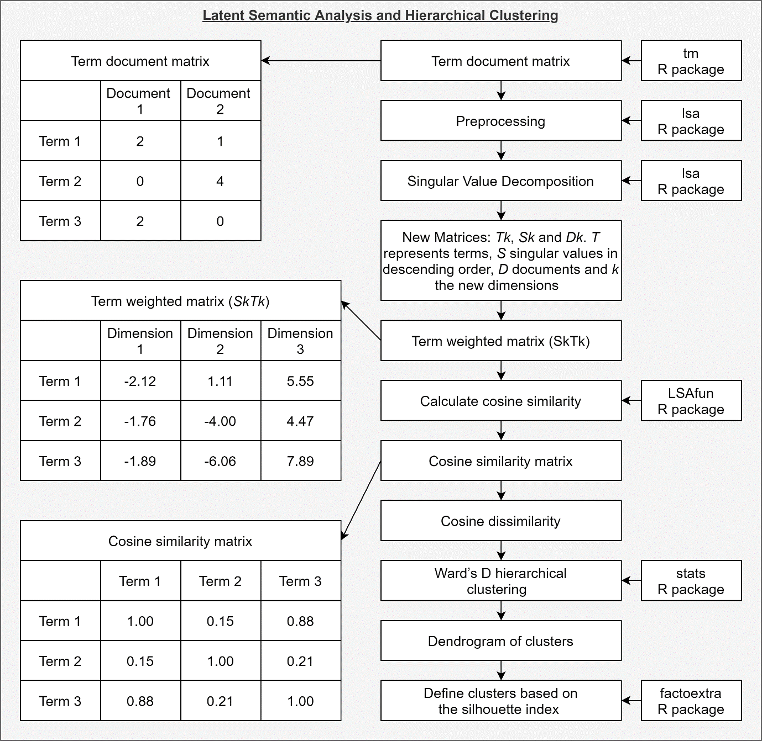
Figure 3. Example workflow for the methods of clustering photographs.
As LSA can be used to assess individual CES preference, we grouped all the labels from all images from a single user of a single day into a single document, building upon the photograph user-days (PUD) metric introduced by Wood et al. (2013). These new groupings were transformed into a term-document matrix (TDM) (Gosal et al. 2019). The TDM, M, contains the grouped photograph by a single user on a single day as the columns and the Google Vision Cloud API labels as the rows, with cells representing the frequency of the label appearing in that users photographs for that day. During the creation of the TDM we carried out several common LSA pre-processing procedures to ensure that only relevant words were kept (Evangelopoulos 2013; Gefen et al. 2017). First, we removed stop words, a list of around 400 common English words such as “the”, “of” and “them”. Second, to assess which features are most commonly photographed in association with hiking, we only selected labels that appear in at least 5% of the documents (the labels from each image, including non-nature labels). Third, we applied the “Term Frequency-Inverse Document Frequency” (TF-IDF) weighting to the TDM. The TF-IDF is one of the most commonly used weightings for LSA, where locally more weighting is given to terms that appear frequently in one document and globally less weighting is given to common terms and is necessary to control for the fact that some words appear far more frequently than others (Evangelopoulos 2013; Christian et al. 2016; Gefen et al. 2017).
After pre-processing the LSA was carried out on the weighted TDM. The LSA procedure carries out a singular value decomposition (SVD), a linear algebra method for the factorization of a matrix into a product of matrices. Here, the SVD takes our matrix M (an m x n matrix with m representing all images a user took in a day and n terms that the Google Vision Cloud API labelled in those images) and transforms this into three new matrices: T_{k}, S_{k} and D_{k}. T represents a term vector matrix, S represent a diagonal matrix containing singular values in descending order, D represents a document vector matrix and k the number of new dimensions (Gosal et al. 2019). The LSA process represents the data in k-dimensional semantic space, by reducing the original dimensions whilst preserving the most information. This method allows for the original space vector to be represented in the lower-dimensional term and document vectors. Here the dimensionality reduction (k) was automatically calculated using the standard “fraction of the sum of the selected singular values to the sum of all singular values” method (Gosal et al. 2019). This method selects the points on the diagonal matrix of descending singular values where the sum of the S singular values divided by the sum of all the S singular values are equal or greater than 0.5 (Gefen et al. 2017). From the new matrices, we calculated a term weighted matrix (S_{k}T_{k}). The term weighted matrix represents each term as a row and each dimension (or latent semantic factor) as a column (Evangelopoulos 2013).
By carrying out the SVD, the terms can now be projected in multidimensional space and the similarity between Google Vision Cloud API labels can be calculated using cosine similarity (Evangelopoulos 2013). Cosine similarity measures the angle between vectors in multi-dimensional space, with the resulting values ranging from 0 to 1, with 1 representing total similarity. The diagonal in the matrix will always be 1 as a word is always the same as itself. Here we calculated the cosine similarity between all terms. Cosine similarity of 1 means that the labels always appear together and 0 means they never appear together.
To understand what features (including biophysical and non-biophysical nature as well as human features) are most often taken in the same images, we used hierarchical clustering to group the Google Vision Cloud API labels based on their cosine similarity. As hierarchical clustering uses a distance measure, we calculated cosine dissimilarity (1 - cosine similarity). We then carried out hierarchical clustering using Ward’s D method, which has previously been shown to create unambiguous clusters for labels generated by the Google Cloud Vision API (Gosal et al. 2019). The Ward’s D method builds a dendrogram through a bottom-up approach to clustering. Each element in the tree starts as an individual cluster, two clusters are then merged so that variance within clusters is minimized. This process is repeated until all elements are clustered on the tree.
A dendrogram can then be cut at a chosen height to provide the final clusters, with the choice of height resulting in the selection of different final clusters. Though studies can choose an arbitrary height to cut the dendrogram and select the clusters, indices such as the silhouette index can be used to find the optimal number of clusters based on the given dendrogram (Wang and Xu 2019). Here, the dendrogram was cut into x clusters, based on the silhouette index, where each element is assigned a value between -1 and 1. Elements with higher numbers are closer to the other elements in their cluster than elements in other clusters (Pagnuco et al. 2016). The value of x with the highest silhouette index was chosen to be the number of clusters.
We summarised the types of images photographed when hiking based on the clusters. For each user's daily images, we calculated the number of Google Vision Cloud API labels belonging to each cluster then categorised the users daily images as which cluster was the most dominant (where labels of two or more clusters appear equally dominant in an image, that image was classified as a combination of those clusters). The mean sentiment of the images belonging to each cluster or combination of clusters was calculated.
3 Results
3.1 Full and enriched datasets
There were 179,700 geotagged photographs containing the text “hiking” in a photograph's title, description or tag metadata for the years 2015-2020 in the USA. The distribution of hiking images was largely concentrated in the west, the northeast, and some southern states (Fig. 4a). Here, the final refined dataset chosen to represent confirmedCES were images containing more than 25% of the image content labels being classified as nature and a positive sentiment expressed in textual metadata. There were 43,427 images that met these selection criteria, 24.17% of the full hiking dataset. The distribution of these confirmedCES images follows some similar patterns to the full dataset with the largest concentration of uploads along the west coast of the US in states such as Washington, southwest states, such as Arizona and Utah, northeastern states around the Great Lakes and along the Appalachians (Fig. 4b). Though there are similarities in the distribution of the confirmedCES images and the full dataset images, there are also areas where the distributions have different patterns for example, particularly with many regions having fewer uploads, such as southern California, Arkansas and the west coast of Florida.
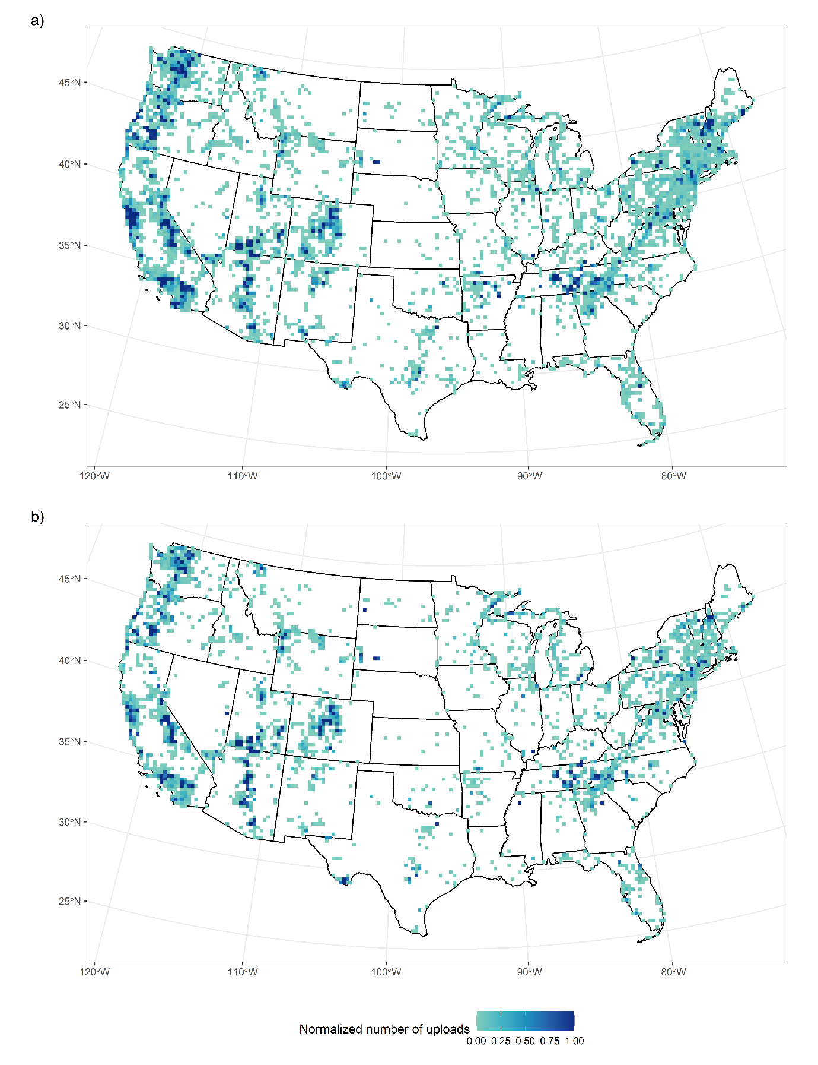
Figure 4. Number of images from Flickr in the USA between 2015-2020 with the term “hiking” in the images title, tag or description, results were normalized (spatial resolution 25km²). a) the full Flickr dataset, b) images categorized as confirmedCES (images where the percentage of content labels classified as nature were >25% and a positive sentiment was expressed in textural metadata).
The similarities in some of the large-scale distributions may be misinterpreted to mean that overall the distribution of uploads from confirmedCES and the full dataset images are similar. However, the local variation in the deviance from a 1:1 line differs spatially, with high and low deviance distributed across the whole of the United States (Fig. 5). Here, 20.81% of pixels had a deviance value of > 0.3 indicating that these regions did not have a strong relationship between the number of uploads that were confirmedCES and from the full dataset images. As the Moran’s I value for the local deviance distribution was 0.27, this indicates that the distribution is close to random, and therefore not spatially uniform. It may therefore not be possible to use the full dataset alone to select areas that represent a good proxy for a positive CES experience. The non-conformity between the full and filtered datasets is distributed across the US including in the northwestern states, around the Great Lakes, areas of California and throughout Florida.
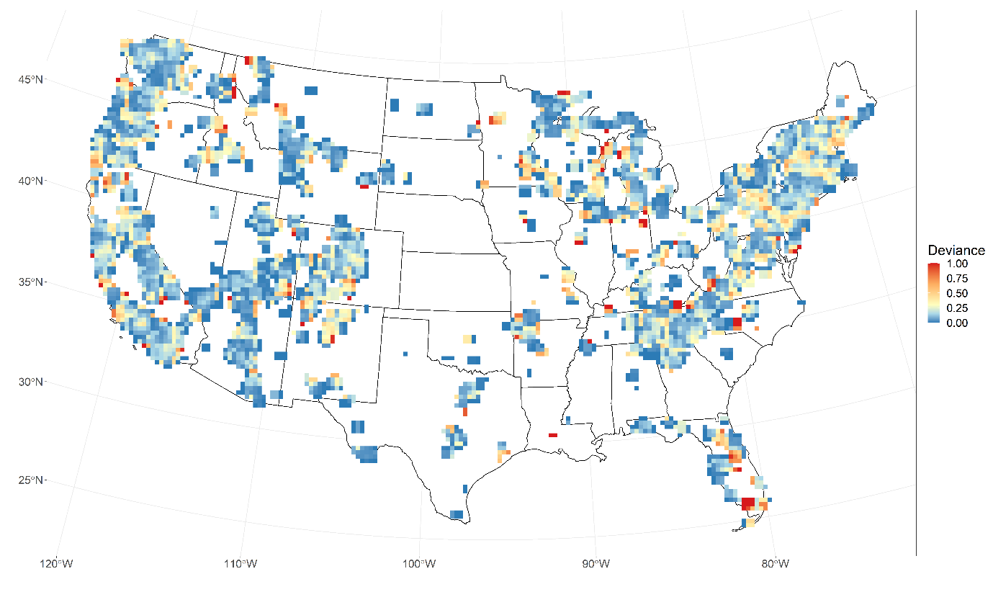
Figure 5. The local deviance in the scaled number of images from the full Flickr and confirmedCES images dataset (images where the percentage of content labels classified as nature were >25% and a positive sentiment was expressed in textural metadata) from the 1:1 line. Pixel size 25km²; window size 3 x 3; a break point of 0.3 was applied to indicate areas of high deviance.
The differences in the distribution of these local deviance values do not appear to be a facet of the chosen mapping techniques as the deviance scores are similar across the full range of spatial resolution, window size and nature threshold combinations (see supplementary material SI.3). When two variables are held the same (e.g. the same nature threshold and window size) and the other varies (e.g. differing pixel size), the deviance scores remain similar. We do note that there are some small changes based on the selection of each, for example, the larger the pixel size the smaller the overall deviance. However, this change is minimal and the overall deviance score remains similar, suggesting that the selection of mapping technique has had limited influence on the results drawn from the choices of aggregating to 25km², refining based on nature threshold of 25% and calculating deviance using a window size of 3 x 3. Therefore, although the absolute values of the deviance vary based on the threshold, window size and pixel size values chosen, the conclusions which are drawn are qualitatively the same.

3.2 Individual influence of filtering by content only
When filtering photographs by the percentage of nature labels based on a threshold of 25%, 160,873 images of nature remained, compared with 179,700 images before filtering. The deviance values vary depending on the threshold, window size and spatial resolution, but again here the conclusions drawn are the same. From the moving window analysis, the distribution of the confirmedNature images does not deviate greatly from the full dataset (Fig. 6). The deviance values are again not spatially uniform with a Moran’s I value of 0.26, indicating a random spatial pattern. Here, only 2.11% of the pixels are above a deviance value of 0.3 - indicating that images of hiking from Flickr may generally be a good proxy for images of human-nature interactions. The patterns of positive and negative local deviance values are similar overall for all combinations of the varied nature threshold, spatial resolution and window size, indicating that these choices did not influence the results when filtering by content alone (see supplementary material SI.4).
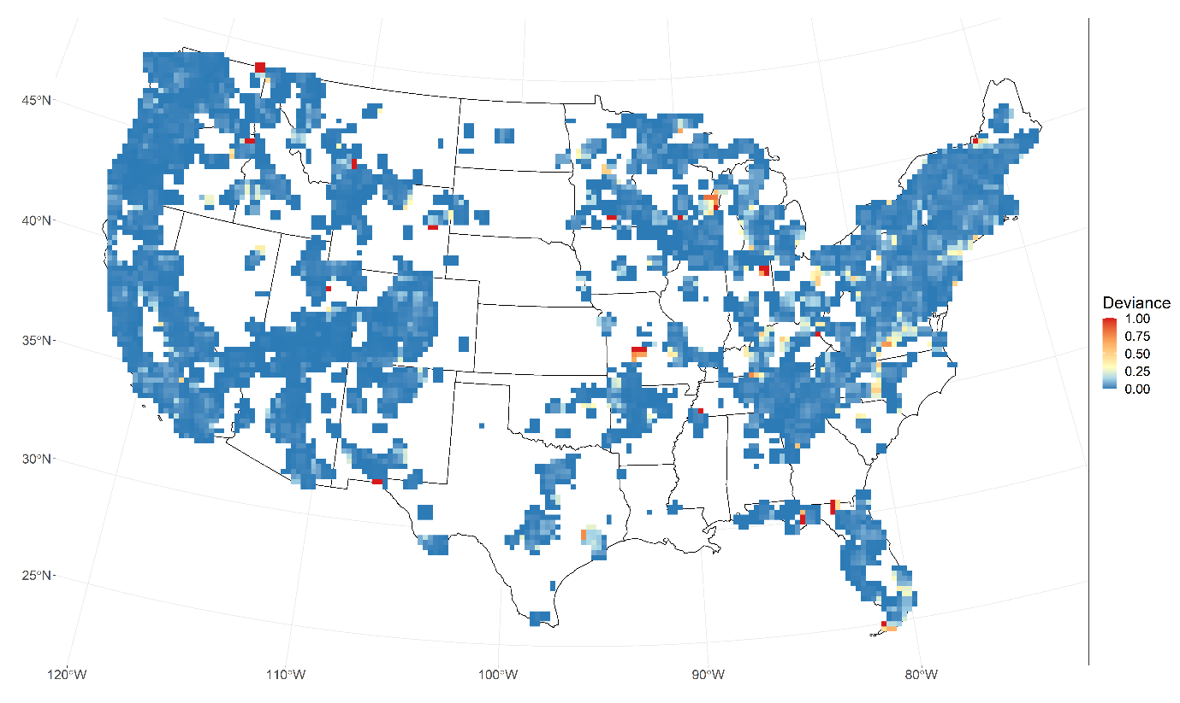
Figure 6. The local deviance in the scaled number of images from the full Flickr and confirmedNature images dataset (images where the percentage of content labels classified as nature were >25%) from the 1:1 line. Pixel size 25km²; window size 3 x 3; a break point of 0.3 was applied to indicate areas of high deviance.

3.3 Individual influence of filtering by sentiment only
Filtering out images with a non-positive sentiment removed a greater number of images than filtering by image contents. From the 179,700 images in the full dataset, 61,091 (34.00%) contained a non-null sentiment score, with 48,607 (27.05%) having a positive and 12,484 (6.95%) having a negative associated sentiment value. There was some difference in the local deviance values between the spatial distribution of the refined confirmedPositive and full dataset depending on the window size and pixel size.
Here, 19.08% of the pixels have a deviance value of greater than 0.3, indicating that in these locations, photographs of hiking on Flickr may not be a good proxy for positive images of hiking. Furthermore, the deviation of uploads from the confirmedPositive and full dataset is not uniform (Fig. 7), so it may not be possible to differentiate between areas where Flickr photographs are a good proxy for a positive experience and those where they are not. The random structure to the distribution (Moran’s I = 0.27) suggests that there is no spatial structure to the distribution of the locations which deviate between the full and filtered dataset. As with the previous examples, the patterns of local deviance are similar across spatial resolution and window size and therefore the choices in mapping the distribution have not impacted the results (see supplementary material SI.5). As there was little to no difference in spatial distribution when refining by nature threshold alone, but a larger difference when refining by sentiment alone, this indicates that differences observed in the analysis of the confirmedCES versus full dataset are primarily driven by the inclusion of refining by sentiment.
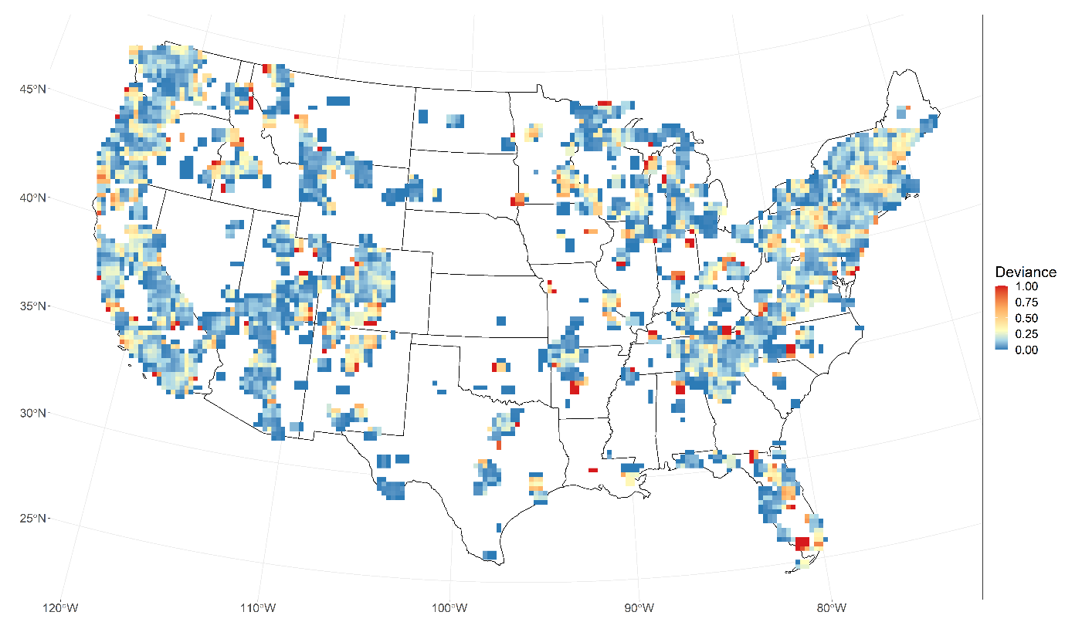
Figure 7. The local deviance in the scaled number of images from the full Flickr and confirmedPositive images dataset (images where a positive sentiment was expressed in textural metadata) from the 1:1 line. Pixel size 25km²; window size 3 x 3; a break point of 0.3 was applied to indicate areas of high deviance.
3.4 Validation of methods
The manual validation of the image content and textual sentiment analysis indicates that the automated methods have high accuracy. When assessing images classified as presenting human-nature interactions we agreed with 98% of the images categorised this way at the 25% biophysical nature label thresholds (confirmedNature): and 100% at 50% and 75% threshold (Table 1). However, when assessing images deemed not to be focused on human-nature interactions (nonNature) the method incorrectly included some images containing human-nature interactions, particularly when using a threshold of 50% and 75% biophysical labels. When using a 25% threshold, the images that were incorrectly labelled as confirmedNature were of artwork or indoors artificial water features. For the images that were incorrectly included as nonNature, the images tended to be where the biophysical nature features were out of focus (e.g. a photograph focused on a person in the foreground, with a small amount of scenery in the background) or where the image had been edited (e.g. in black and white or with text over the image). A threshold smaller than 25% would start to include more images, that though contain biophysical nature labels, do not relate to human-nature interactions as confirmedNature (e.g. images of pets, indoor plants or artificial water features). There was a range of correctly identified nonNature images including indoor images (e.g. furniture), non-hiking activities (e.g. indoor music events or an American football game inside a stadium), food and drink (e.g. packets of food), photographs of an object (e.g. a photograph of another photograph) or art (e.g. generated images), all having a biophysical nature label percentage of between 0 to 25%. In general, using a threshold of 25% therefore provides a good balance of excluding most images not related to human-nature interactions whilst not incorrectly excluding the large number of human-nature images that using thresholds of 50% and 75% did.
Table 1: Validation of automated filtering methods
 | confirmedNature |  | nonNature |  | Both
Threshold | True- positive | False-positive | True- negative | False- negative | Overall accuracy
25% biophysical nature labels | 98.00% | 2.00% | 70.00% | 30.00% | 84.00%
50% biophysical nature labels | 100.00% | 0.00% | 39.00% | 61.00% | 69.50%
75% biophysical nature labels | 100.00% | 0.00% | 26.00% | 74.00% | 63.00%

For the positive expressed sentiment there was a 96% agreement between the automated process and manual interpretation. Many posts contained positive sentiments (e.g. “beautiful”, “exciting” or “wonderful”). Where there were differences in our manual validation and the automated method, the posts tended to include a location name that was inherently expressing a positive sentiment but no indication of experience was given (e.g. “walk at Lucky Boy Vista”) or a mixed sentiment expressed in the text (positive and negative experience e.g. “nice view but overall the hike was terrible”). For the non-positive textual sentiments, the automated process was 92% accurate. Many posts contained no indication of sentiment, just simple descriptive phrases (e.g. “hiking along the river”), though some positive post were incorrectly included as the place or feature has an inherently non-positive connotation though the user expressed a positive view of it (e.g. “fun at Lost Creek Lake” or “beautiful poison oak”), or where users used a double negative (e.g. “this view is not bad”). Overall, the automated sentiment value provides a good indication of whether a positive sentiment expressed in the text.
3.5 Enriching spatial distribution
Through enriching the social media data with the inclusion of textual sentiments, we were not only able to plot the distribution of the number of uploads but assess which locations have the highest associated sentiment value (Fig. 8). The Pearson's correlation between the confirmedCES uploads and confirmedCES mean sentiment raster maps indicates a weak to no correlation (R = -0.004, t = -0.21, df = 2349, p-value = 0.83). This suggests that there is no correlation between areas with a high number of uploads and areas that have a high associated sentiment value.
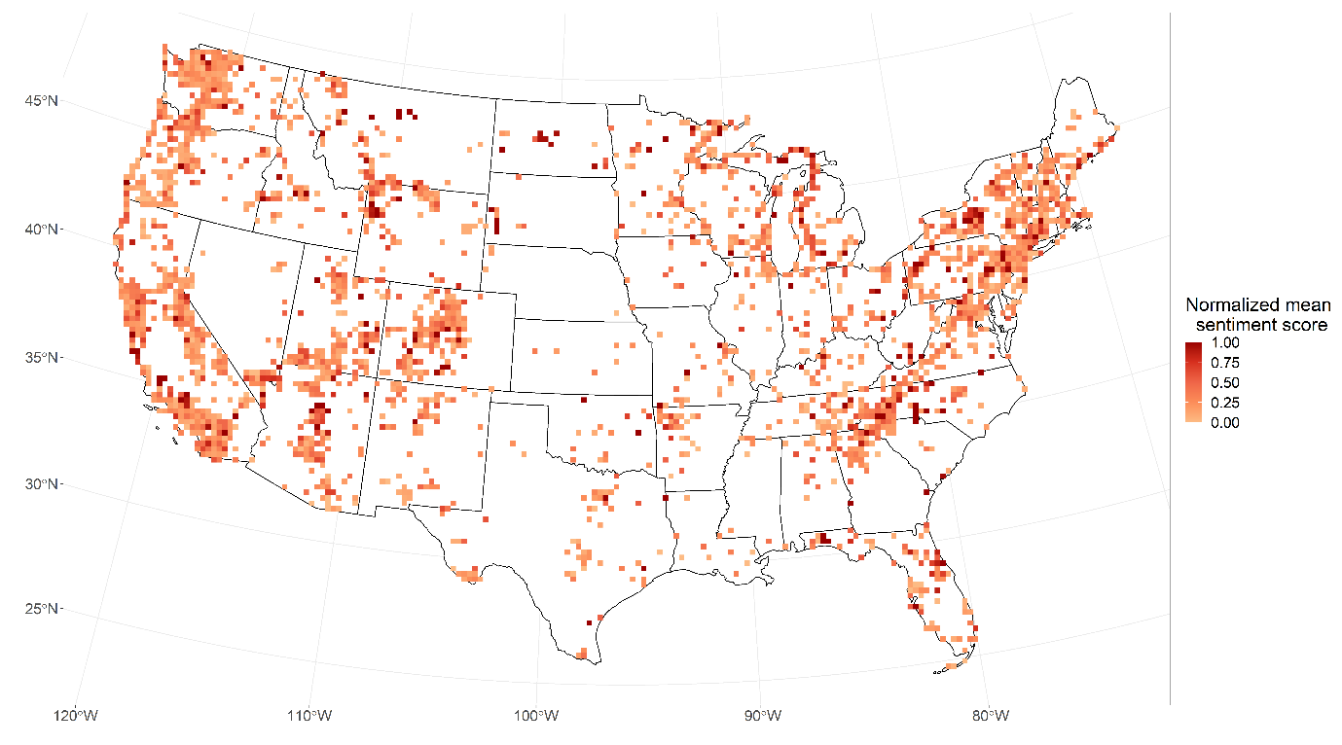
Figure 8. Mean sentiment value of confirmedCES images (images where the percentage of content labels classified as nature were >25% and a positive sentiment was expressed in textural metadata), results were normalized (pixel size 25km²)
3.6 Enriching content analysis
When grouping images by a single user in a single day, 67 labels appeared in at least 5% of these confirmedCES images. From the cosine dissimilarity coefficient of the labels, the silhouette index indicated that when using Ward’s D clustering, ten categories for the labels are suitable (Table 2). The ten classes can be summarized as: “mountains and hills”, “forests”, “views of lakes”, “snow covered mountains”, “vegetated trails and parks”, “hydrological features”, “geological or arid landscapes”, “human-geology interactions”, “grasses” and “flowers”. The individual clusters tend to only contain either biodiversity labels (e.g. “flowers”) or geodiversity labels (e.g. “mountains and hills”), indicating that the focus of images may only capture one aspect of biophysical nature.
Table 2. Google Vision Cloud API labels clustered into ten classes using Ward’s D clustering method.
Cluster | Google Vision Cloud API labels
Mountains and hills | Cloud, highland, hill, hill station, mountain, mountainous landforms, sky, wilderness
Forests | Biome, branch, forest, green, leaf, nature reserve, natural environment, northern hardwood forest, old-growth forest, tree, tropical and subtropical coniferous forests, woodland, woody plant, trunk
Views of lakes | Lake, Canidae, natural landscape, nature, reflection
Snow covered mountains | Alps, mountain range, ridge, snow, winter
Vegetated trails and parks | Adaptation, botany, landscape, plant, plant community, shrubland, soil, state park, trail, vegetation, wildlife
Hydrological features | Body of water, river, stream, water, watercourse, waterfall, water resources
Geological or arid landscapes | Badlands, canyon, formation, geological phenomenon, geology, national park, rock wadi
Human-geology interactions | Adventure, atmospheric phenomenon, bedrock, outcrop, recreation
Grasses | Grass, grassland
Flowers | Flower, flowering plant
When categorising images based on which cluster’s labels were most dominant in the photograph, there were 165 different combinations of the most dominant cluster (Figure 8). The clusters that were most frequently photographed were “mountains and hills”, “forests”, “geological or arid landscapes” and “hydrological features”. Many of the cluster combinations have large standard deviations, though some combination of clusters (e.g. “views of lake/human-geology interactions”) have relatively low standard deviation values.
Though the most photographed cluster was “mountains and hills”, this cluster has a relatively low sentiment score when the sole dominant class in the photograph. However, there is a high relative sentiment associated with images containing both geomorphological and hydrological features (e.g. “mountains and hills/views of lakes” and “mountains and hills/hydrological features”), indicating that interactions between these features may be important at driving a positive hiking experience. The cluster of images containing “forests/vegetated trails and parks/geological or arid landscapes” had the highest mean sentiment, suggesting that a combination of geodiversity, biodiversity and human features can interact to provide a highly positive hiking experience. There is a relatively low sentiment value associated with “forests” when on their own, however, there is a higher sentiment in images containing both forests in combination with other clusters (e.g “mountains and hills/forests/hydrological features” and “mountains and hills/forests/vegetated trails or parks”), indicating that forests alone may not provide a relatively positive hiking experience, but forests in combination with a trail or park, or with geomorphological features (such as mountains) may help to increase a positive hiking experience. Other aspects of biophysical nature, such as “geological or arid landscapes” and “hydrological features”, are both highly photographed with a relatively high mean sentiment score. Many of the cluster combinations have large standard deviations, though some combination of clusters (e.g. “views of lakes/human-geology interactions”) have relatively low standard deviation values.
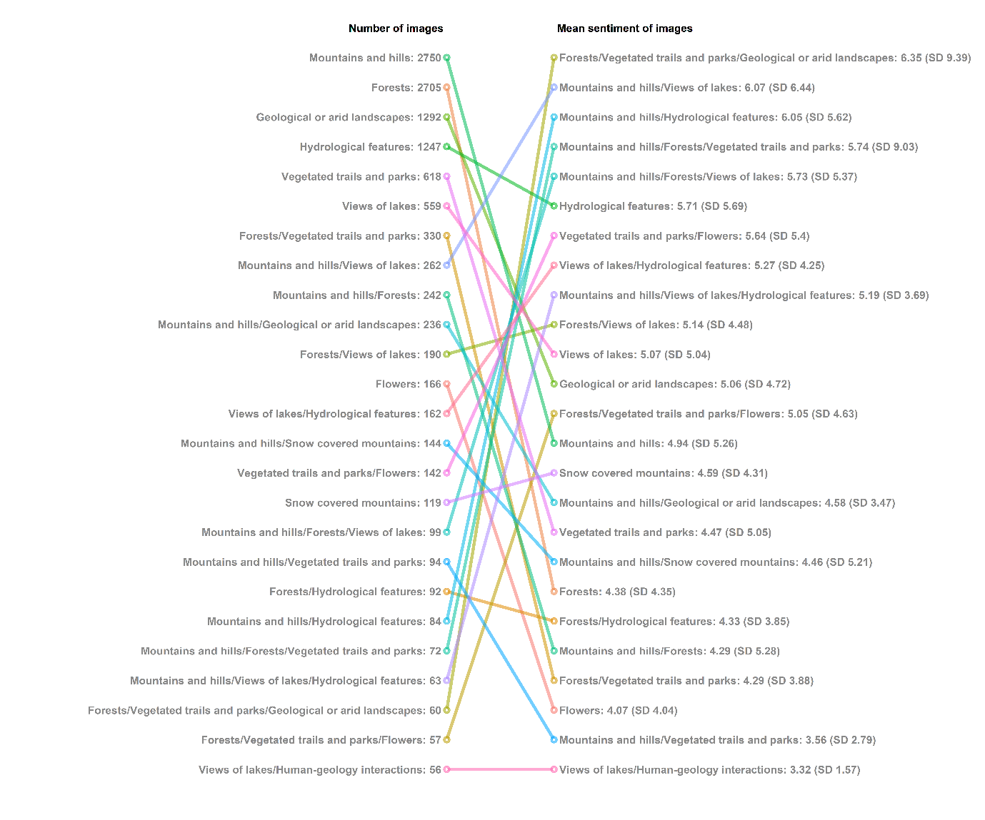Figure 8. Count of images, their mean sentiment value and standard deviation of sentiment value for the 25 most frequently photographed clusters, where a user’s images from a single day were categorised based on which cluster most of their assigned Google Vision Cloud API labels belonged to.
4 Discussion
Metadata from social media websites such as Flickr provide a source of big data for many CES applications. Being able to use the full dataset as a proxy for images of human-nature interactions may benefit researchers looking at general patterns by removing the need to manually or automatically tag image contents, which can be time-intensive or financially expensive (Richards and Tunçer 2018). However, this data may not accurately represent the CES and studies therefore need to refine data from social media and remove posts that are inappropriate for CES analysis (e.g. Oteros-Rozas et al. 2018). These studies assume that the content of the image is representative of a user’s interactions with CES (Langemeyer et al. 2018). Therefore, content analysis alone provides incomplete information and does not allow one to fully untangle the human-nature relationship that drives CES. Furthermore, filtering based on textual analysis can be useful to subset CES images (Ghermandi et al. 2020), but refining based on sentiment alone results in a dataset that includes non-CES images. Refining social media datasets by text alone also does not provide a complete and valid CES dataset (Chen et al. 2020). Through enriching the filtered images of nature with their associated textual sentiment value, we can start to provide a more robust understanding of CES distributions, and the aspects of nature that provide a positive experience.
For the content analysis, we aimed to refine our dataset to represent images of human-nature interactions, we therefore included images containing any aspects of biophysical nature. Studies with different aims should filter their images accordingly, for example, Oteros-Rozas et al. (2018) chose to include only images of landscapes in their study and removed images that featured animals. Some CES studies have stated a preference for using images from Panoramio as it prevents uploads of images of people and synthetic objects and therefore did not need to be refined (Casalegno et al. 2013; Pastur et al. 2016). However, as of 2016 Panoramio is no longer available. Here, we found little difference in the distribution of the confirmedNature and full datasets, with low deviance between the two groups for most of the US. This suggests that Flickr may therefore be a good proxy for images of biophysical features across a range of spatial scales. However, studies that use Flickr, or other social media sources, need to acknowledge that the returned dataset may contain images that are unsuitable for their specific CES assessment and should ensure these images are refined out accordingly. Overall, we found that a threshold of 25% of biophysical nature labels has provided a suitable set of images representing human-nature interactions, while generally excluding images that are not of CES. By not omitting all human features (e.g. Panoramio), a threshold of 25% biophysical nature labels can provide results that allow for more robust recommendations for improving the sustainable management of these complex human-nature interactions (Bennet et al. 2015; Palomo et al. 2016).
Overall, refining by sentiment value has a larger impact on the spatial distribution and size of the dataset than refining by image content. This suggests that the full Flickr dataset, at least for hiking, may be sufficient to show overall patterns of the distribution of images of human-nature interactions, but not necessarily a positive CES experience. Though there are some areas of low deviance between the number of uploads between the full Flickr and confirmedCES datasets, there are many areas of disagreement. Furthermore, as the spatial distribution of these areas is random it means that it may be difficult to account for the areas of high disagreement without refining the dataset. For example, if the distribution of high deviances were clustered, it may be appropriate to use the full dataset but filter out only the areas of high disagreement. The results for the confirmedPositive set of images were parallel to the confirmedCES images, with areas of high deviance randomly distributed across the US. The inclusion of sentiment therefore has implications for the number and distribution of images, (e.g. in the north western states where there was high deviance between the number of confirmedCES and the full number of images). To better understand positive human-nature interactions, we recommend that social media data be refined in a two-step process, filtering by content and enriching with sentiment value.
A more robust method of mapping CES occurrences, such as the one presented here, could help to inform policy and decision-makers (Clemente et al. 2019). For example, when the number of uploads is aggregated to a given location to understand visitation rates (e.g. national park, land cover or state level), it could be interpreted that these regions provide the largest supply of CES and are therefore the most important for future management strategies (e.g. Figueroa-Alfaro and Tang 2017). Here, we have highlighted a discrepancy between the number of images uploaded and the mean sentiment value expressed by textual metadata of the images in the area. Higher uploads of images taken in each area may indirectly be influenced by accessibility (Richards and Tunçer 2018), and therefore may not necessarily represent the sites with the highest sentiment value. By enriching the data with sentiment value, we can evaluate the distribution of CES in ways other than purely measuring the number of visitors. For example, as areas with a higher number of uploads are potentially more vulnerable to damage (Hausmann et al. 2019), mapping areas of high sentiment in combination with visitation rates means management decisions can be better targeted to alleviate pressure from overused locations (Clemente et al. 2019). Furthermore, the textual sentiment value could be used in conjunction with the temporal metadata to assess changes in visitor opinions over time (Becken et al. 2017).
Some of the clusters of image contents identified as being frequently photographed or having a high associated sentiment have already been widely explored in CES literature. For example, Van Zanten et al., (2016) found that some of the best predictors of recreational value at a landscape scale were geomorphological features such as hills and mountains and Oteros-Rozas et al. (2018) found that mountains are particularly associated with hiking. Furthermore, the impact of being close to water and vegetation on hiking has also been widely explored (e.g. Pastorella et al. 2017; Schirpke et al. 2018; Aiba et al. 2019). Photographs that contain a combination of clusters can provide information on the interactions between different biophysical features which give rise to CES. For instance, some hikers may prefer natural mountainous areas with forest cover and others may prefer natural mountainous areas closer to water (Pastorella et al. 2017; Schirpke et al. 2018).
By including a measure of sentiment we can start to understand how the interactions between biophysical and human features influence the hiking experience. For example, the high sentiment value associated with the cluster “forests/vegetated trails and parks/geological or arid landscapes” further demonstrates that a positive experience of CES may be enhanced through its co-production with people (Fischer and Eastwood 2016). The high standard deviations in sentiment value between images classified as different combination of clusters are unsurprising as CES experience is unique and varies between individuals (Daniel et al. 2012; Havinga et al. 2020). For example, the relationship between geomorphological features and hiking is complex, often with factors such as elevation, slope and landforms having site-specific influences on hiking experiences depending on people motivations for hiking (Chhetri 2015; Wilcer et al. 2016).
Some of the clusters identified here, particularly those relating to geodiversity features such as the geological features class, are not as well explored in CES literature, (Fox et al. 2020a). For example, the labels in the clusters associated with “geological or arid landscapes” resemble those of landscapes in southwestern states, such as Arizona and New Mexico, where there is a high number of confirmedCES images. For example, the Grand Canyon National Park in Arizona is dominated by iconic geodiversity landscapes and is one of the most visited tourist attractions, not just in the USA, but worldwide (Gray 2008). These landscapes are often dominated by canyons with exposed strata, a variety of slope morphologies and talus and scree on the canyon floor and are popular hiking destinations (Gray 2008). By enriching the social media data with the textual sentiment value we can start to understand the relative importance of these features to a positive hiking experience. Here, “geological or arid landscapes” were frequently photographed, they were less frequent than “forests”. It does however provide a relatively more positive hiking experience than “forest” when either was the sole dominant cluster. This suggests that within the USA, though hiking in vegetated areas may be more common than through geological landscapes, they both can provide a positive recreational experience. In other countries where geological or arid landscapes are the prevailing ecosystem, the relationship between geodiversity and biodiversity on the hiking experience may be different. Future work should therefore aim to quantify the relationship of these underrepresented landscape features to CES experience across different study sites.
Here, our analysis has shown that the grouped images (based on a single user’s photographs on a single day) can contain multiple different content label clusters. We note that here the individual clusters of labels focus on biodiversity and geodiversity features separately, though this may be a facet of the clustering procedure or the method in which the machine learning classifier labels images. As with other studies which clustered photograph content (e.g. Lee et al. 2019) photographs were frequently assigned multiple equally dominant clusters, indicating an interaction between geodiversity, biodiversity and human features. It may not always be possible to include features of the multiple clusters in a single image. For example, a hiker may be interested in photographing large scale vegetation such as a forest from the top of a mountain (Aiba et al. 2019), but these images may omit the mountain itself. We suggest that these relationships may not be properly captured by assessing single photographs and therefore, recommend that future studies assess each Flickr user's images from a single day, such as used here, or by grouping all photographs from a smaller study site as a collective.
Refining by different nature thresholds, spatial resolution and window size all had some impact on the deviance between the refined dataset and the remaining dataset. However, across all combinations of refined datasets, there were no major changes in the spatial distribution and range of values expressed by the local deviance values. The smaller deviance associated with decreasing resolution (increasing pixel size) is down to the aggregation of data – aggregation of data at the coarser resolution loses the spatial structure of the distribution and the pixel values become more homogenised (Bian and Butler 1999). This relationship is also true for larger moving windows producing lower deviances (Graham et al. 2019). We recommend that researchers be aware of the impacts of their mapping decision – if data aggregation is to be carried out researchers need to choose a suitable scale for the study (Graham and Eigenbrod 2019).
This study further demonstrates that social media data can easily provide large spatial-temporal dataset compared to traditional methods (Fox et al. 2020b), however, future work could implement this over small spatial scales to assess regional or local trends. One limitation of social media data is that not all demographics are well represented (Oteros-Rozas et al. 2018) and management and policy decisions should acknowledge this. Studies could therefore combine results of social media studies with other datasets such as survey data (Graham and Eigenbrod 2019; Moreno-Llorca et al. 2020; Sinclair et al. 2020). A further potential limitation of this multi-faceted filtering process is that although we can be more confident that the images we are assessing represent CES, there are substantially fewer suitable images in the refined dataset compared to the original dataset downloaded from Flickr. However, we still had a large sample size of 43,427 images for one activity over 5 years. Other studies have found success when using smaller subsamples of the full dataset (e.g. Langemeyer et al. 2018; Chen et al. 2020). We recommend that social media data can best capture CES when researchers refine their dataset by the content of the images and enrich the data with a measure of sentiment, which can provide a reliable representation of CES.
5 Conclusion
The method tested combining the analysis of the contents of social media (Flickr) images and the sentiment value expressed in their textual metadata reduces the amount of available data but provides a robust measure of CES for large scale spatio-temporal studies. Through the application of the refined dataset, images of hiking in the USA were clustered into groups representing the interactions between people and biophysical nature. Hiking as a CES is driven and maintained by complex interactions between biodiversity and, geodiversity and people, and by refining data on two levels, our methods allow us to start to unpack which feature contribute to a positive experience. The results of this study encourage future social media and CES studies to acknowledge that the full social media dataset may not be suitable for their chosen study, as though it may be a good proxy for images of nature it may not be a good proxy for a positive experience. It is suggested that future work enrich their social media datasets with a measure of textual sentiments to provide a more robust representation of positive human-nature interactions.
6 References
Aiba, M., Shibata, R., Oguro, M. and Nakashizuka, T., 2019. The seasonal and scale-dependent associations between vegetation quality and hiking activities as a recreation service. Sustainability Science, 14(1), pp.119-129. https://doi.org/10.1007/s11625-018-0609-7
Becken, S., Stantic, B., Chen, J., Alaei, A.R. and Connolly, R.M., 2017. Monitoring the environment and human sentiment on the Great Barrier Reef: assessing the potential of collective sensing. Journal of environmental management, 203, pp.87-97. https://doi.org/10.1016/j.jenvman.2017.07.007
Bian, L. and Butler, R., 1999. Comparing effects of aggregation methods on statistical and spatial properties of simulated spatial data. Photogrammetric engineering and remote sensing, 65, pp.73-84.
Balzan, M.V. and Debono, I., 2018. Assessing urban recreation ecosystem services through the use of geocache visitation and preference data: a case-study from an urbanised island environment. One Ecosystem, 3, p.e24490.
Bennett, E.M., Cramer, W., Begossi, A., Cundill, G., Díaz, S., Egoh, B.N., Geijzendorffer, I.R., Krug, C.B., Lavorel, S., Lazos, E. and Lebel, L., 2015. Linking biodiversity, ecosystem services, and human well-being: three challenges for designing research for sustainability. Current opinion in environmental sustainability, 14, pp.76-85.
Brindley, P., Cameron, R.W., Ersoy, E., Jorgensen, A. and Maheswaran, R., 2019. Is more always better? Exploring field survey and social media indicators of quality of urban greenspace, in relation to health. Urban Forestry & Urban Greening, 39, pp.45-54. https://doi.org/10.1016/j.ufug.2019.01.015
Byczek, C., Longaretti, P.Y., Renaud, J. and Lavorel, S., 2018. Benefits of crowd-sourced GPS information for modelling the recreation ecosystem service. PloS one, 13(10), p.e0202645. https://doi.org/10.1371/journal.pone.0202645
Casalegno, S., Inger, R., DeSilvey, C. and Gaston, K.J., 2013. Spatial covariance between aesthetic value & other ecosystem services. PloS one, 8(6), p.e68437. https://doi.org/10.1371/journal.pone.0068437
Chan, K.M., Goldstein, J., Satterfield, T., Hannahs, N., Kikiloi, K., Naidoo, R., Vadeboncoeur, N. and Woodside, U., 2011. Cultural services and non-use values. Natural capital: Theory and practice of mapping ecosystem services, pp.206-228.
Chen, Y., Caesemaecker, C., Rahman, H.T. and Sherren, K., 2020. Comparing cultural ecosystem service delivery in dykelands and marshes using Instagram: A case of the Cornwallis (Jijuktu'kwejk) River, Nova Scotia, Canada. Ocean & Coastal Management, 193, p.105254. https://doi.org/10.1016/j.ocecoaman.2020.105254
Chhetri, P., 2015. A GIS methodology for modelling hiking experiences in the Grampians National Park, Australia. Tourism Geographies, 17(5), pp.795-814. https://doi.org/10.1080/14616688.2015.1083609
Christian, H., Agus, M.P. and Suhartono, D., 2016. Single document automatic text summarization using term frequency-inverse document frequency (TF-IDF). ComTech: Computer, Mathematics and Engineering Applications, 7(4), pp.285-294.
Clemente, P., Calvache, M., Antunes, P., Santos, R., Cerdeira, J.O. and Martins, M.J., 2019. Combining social media photographs and species distribution models to map cultural ecosystem services: The case of a Natural Park in Portugal. Ecological Indicators, 96, pp.59-68. https://doi.org/10.1016/j.ecolind.2018.08.043
Collins‐Kreiner, N. and Kliot, N., 2017. Why Do People Hike? Hiking the Israel National Trail. Tijdschrift voor economische en sociale geografie, 108(5), pp.669-687. https://doi.org/10.1111/tesg.12245
Daniel, T.C., Muhar, A., Arnberger, A., Aznar, O., Boyd, J.W., Chan, K.M., Costanza, R., Elmqvist, T., Flint, C.G., Gobster, P.H. and Grêt-Regamey, A., 2012. Contributions of cultural services to the ecosystem services agenda. Proceedings of the National Academy of Sciences, 109(23), pp.8812-8819. https://doi.org/10.1073/pnas.1114773109
Do, Y., 2019. Valuating aesthetic benefits of cultural ecosystem services using conservation culturomics. Ecosystem Services, 36, p.100894. https://doi.org/10.1016/j.ecoser.2019.100894
Evangelopoulos, N.E., 2013. Latent semantic analysis. Wiley Interdisciplinary Reviews: Cognitive Science, 4(6), pp.683-692. https://doi.org/10.1002/wcs.1254
Figueroa-Alfaro, R.W. and Tang, Z., 2017. Evaluating the aesthetic value of cultural ecosystem services by mapping geo-tagged photographs from social media data on Panoramio and Flickr. Journal of Environmental Planning and Management, 60(2), pp.266-281. https://doi.org/10.1080/09640568.2016.1151772
Fischer, A. & Eastwood, A. (2016). Coproduction of ecosystem services as human-nature interactions—An analytical framework. Land Use Policy 52, 41-50. doi:10.1016/j.landusepol.2015.12.004
Fish, R., Church, A. and Winter, M., 2016. Conceptualising cultural ecosystem services: A novel framework for research and critical engagement. Ecosystem Services, 21, pp.208-217. https://doi.org/10.1016/j.ecoser.2016.09.002
Fox, N., Graham, L.J., Eigenbrod, F., Bullock, J.M. and Parks, K.E., 2020a. Incorporating geodiversity in ecosystem service decisions. Ecosystems and People, 16(1), pp.151-159. https://doi.org/10.1080/26395916.2020.1758214
Fox, N., Mancini, F., Graham, L.J., Sutter, L., August, T., 2020. photosearcher: Photo Searcher. R package version 1.0. https://docs.ropensci.org/photosearcher
Gefen, D., Endicott, J.E., Fresneda, J.E., Miller, J. and Larsen, K.R., 2017. A guide to text analysis with latent semantic analysis in R with annotated code: Studying online reviews and the stack exchange community. Communications of the Association for Information Systems, 41(1), p.21. https://doi.org/10.17705/1CAIS.04121
Ghermandi, A., Camacho-Valdez, V. and Trejo-Espinosa, H., 2020. Social media-based analysis of cultural ecosystem services and heritage tourism in a coastal region of Mexico. Tourism Management, 77, p.104002. https://doi.org/10.1016/j.tourman.2019.104002
Ghermandi, A. and Sinclair, M., 2019. Passive crowdsourcing of social media in environmental research: A systematic map. Global environmental change, 55, pp.36-47. https://doi.org/10.1016/j.gloenvcha.2019.02.003
Google Cloud Vision, 2020. Documentation for the Google Cloud Vision API [WWW Document]. URL www.cloud.google.com/vision/.
Gordon, J.E. and Barron, H.F., 2013. The role of geodiversity in delivering ecosystem services and benefits in Scotland. Scottish Journal of Geology, 49(1), pp.41-58. https://doi.org/10.1144/sjg2011-465
Gosal, A.S., Geijzendorffer, I.R., Václavík, T., Poulin, B. and Ziv, G., 2019. Using social media, machine learning and natural language processing to map multiple recreational beneficiaries. Ecosystem Services, 38, p.100958. https://doi.org/10.1016/j.ecoser.2019.100958
Graham, L.J. and Eigenbrod, F., 2019. Scale dependency in drivers of outdoor recreation in England. People and Nature, 1(3), pp.406-416. https://doi.org/10.1002/pan3.10042
Gray, M., 2008. Geodiversity: developing the paradigm. Proceedings of the Geologists' Association, 119(3-4), pp.287-298. https://doi.org/10.1016/S0016-7878(08)80307-0
Gray, M., 2004. Geodiversity: valuing and conserving abiotic nature. John Wiley & Sons.
Gray, M., 2012. Valuing geodiversity in an ‘ecosystem services’ context. Scottish Geographical Journal, 128(3-4), pp.177-194. https://doi.org/10.1080/14702541.2012.725858
Havinga, I., Bogaart, P.W., Hein, L. and Tuia, D., 2020. Defining and spatially modelling cultural ecosystem services using crowdsourced data. Ecosystem Services, 43, p.101091. https://doi.org/10.1016/j.ecoser.2020.101091
Hirons, M., Comberti, C. and Dunford, R., 2016. Valuing cultural ecosystem services. Annual Review of Environment and Resources, 41, pp.545-574.
Hjort, J., Gordon, J.E., Gray, M. and Hunter Jr, M.L., 2015. Why geodiversity matters in valuing nature's stage. Conservation Biology, 29(3), pp.630-639. https://doi.org/10.1111/cobi.12510
Hausmann, A., Toivonen, T., Fink, C., Heikinheimo, V., Tenkanen, H., Butchart, S.H., Brooks, T.M. and Di Minin, E., 2019. Assessing global popularity and threats to Important Bird and Biodiversity Areas using social media data. Science of the Total Environment, 683, pp.617-623. https://doi.org/10.1016/j.scitotenv.2019.05.268
Huang, F., Zhang, X., Zhao, Z., Xu, J. and Li, Z., 2019. Image–text sentiment analysis via deep multimodal attentive fusion. Knowledge-Based Systems, 167, pp.26-37. https://doi.org/10.1016/j.knosys.2019.01.019
Kiernan, K., 2015. Landforms as sacred places: implications for geodiversity and geoheritage. Geoheritage, 7(2), pp.177-193. https://doi.org/10.1007/s12371-014-0128-6
Kim, Y., Kim, C.K., Lee, D.K., Lee, H.W. and Andrada, R.I.T., 2019. Quantifying nature-based tourism in protected areas in developing countries by using social big data. Tourism Management, 72, pp.249-256. https://doi.org/10.1016/j.tourman.2018.12.005
King, H.P., Morris, J., Graves, A., Bradbury, R.B., McGinlay, J. and Bullock, J.M., 2017. Biodiversity and cultural ecosystem benefits in lowland landscapes in southern England. Journal of environmental psychology, 53, pp.185-197. https://doi.org/10.1016/j.jenvp.2017.08.002
Kondo, M.C., Fluehr, J.M., McKeon, T. and Branas, C.C., 2018. Urban green space and its impact on human health. International journal of environmental research and public health, 15(3), p.445. https://doi.org/10.3390/ijerph15030445
Koto, F. and Adriani, M., 2015, June. A comparative study on twitter sentiment analysis: Which features are good?. In International Conference on Applications of Natural Language to Information Systems (pp. 453-457). Springer, Cham. https://doi.org/10.1007/978-3-319-19581-0_46
Langemeyer, J., Calcagni, F. and Baro, F., 2018. Mapping the intangible: Using geolocated social media data to examine landscape aesthetics. Land use policy, 77, pp.542-552. https://doi.org/10.1016/j.landusepol.2018.05.049
Lee, H., Seo, B., Koellner, T. and Lautenbach, S., 2019. Mapping cultural ecosystem services 2.0–Potential and shortcomings from unlabeled crowd sourced images. Ecological Indicators, 96, pp.505-515. https://doi.org/10.1016/j.ecolind.2018.08.035
Mayer, M. and Woltering, M., 2018. Assessing and valuing the recreational ecosystem services of Germany’s national parks using travel cost models. Ecosystem services, 31, pp.371-386.
Mancini, F., Coghill, G.M. and Lusseau, D., 2019. Quantifying wildlife watchers’ preferences to investigate the overlap between recreational and conservation value of natural areas. Journal of Applied Ecology, 56(2), pp.387-397. https://doi.org/10.1111/1365-2664.13274
Milcu, A.I., Hanspach, J., Abson, D. and Fischer, J., 2013. Cultural ecosystem services: a literature review and prospects for future research. Ecology and society, 18(3). https://www.jstor.org/stable/26269377
Millennium Ecosystem Assessment., 2005. Millennium Ecosystem Assessment. Washington, DC: New Island Press, 13, p.520.
Minkiewicz, J., Bridson, K. and Evans, J. (2016), "Co-production of service experiences: insights from the cultural sector", Journal of Services Marketing, Vol. 30 No. 7, pp. 749-761. https://doi.org/10.1108/JSM-04-2015-0156
Mitten, D., Overholt, J.R., Haynes, F.I., D’Amore, C.C. and Ady, J.C., 2018. Hiking: A low-cost, accessible intervention to promote health benefits. American Journal of Lifestyle Medicine, 12(4), pp.302-310. https://doi.org/10.1177/1559827616658229
Monkman, G.G., Kaiser, M.J. and Hyder, K., 2018. Text and data mining of social media to map wildlife recreation activity. Biological Conservation, 228, pp.89-99. https://doi.org/10.1016/j.biocon.2018.10.010
Moreno-Llorca, R., Méndez, P.F., Ros-Candeira, A., Alcaraz-Segura, D., Santamaría, L., Ramos-Ridao, Á.F., Revilla, E., García, F.J.B. and Vaz, A.S., 2020. Evaluating tourist profiles and nature-based experiences in Biosphere Reserves using Flickr: Matches and mismatches between online social surveys and photo content analysis. Science of The Total Environment, p.140067. https://doi.org/10.1016/j.scitotenv.2020.140067
Mullen, L.A., Bratt, J., 2018. "USAboundaries: Historical and Contemporary Boundaries of the United States of America," Journal of Open Source Software 3(23), p.314. https://doi.org/10.21105/joss.00314
Nielsen, F.Å., 2011. A new ANEW: Evaluation of a word list for sentiment analysis in microblogs. arXiv preprint arXiv:1103.2903.
Oteros-Rozas, E., Martín-López, B., Fagerholm, N., Bieling, C. and Plieninger, T., 2018. Using social media photos to explore the relation between cultural ecosystem services and landscape features across five European sites. Ecological Indicators, 94, pp.74-86. https://doi.org/10.1016/j.ecolind.2017.02.009
Pagnuco, I.A., Pastore, J.I., Abras, G., Brun, M. and Ballarin, V.L., 2016, April. Analysis of genetic association in Listeria and Diabetes using Hierarchical Clustering and Silhouette Index. In Journal of Physics: Conference Series (Vol. 705, p. 012002). https://doi.org/10.1088/1742-6596/705/1/012002
Palomo, I., Felipe-Lucia, M.R., Bennett, E.M., Martín-López, B. and Pascual, U., 2016. Disentangling the pathways and effects of ecosystem service co-production. Advances in ecological research, 54, pp.245-283.
Pastorella, F., Giacovelli, G., De Meo, I. and Paletto, A., 2017. People’s preferences for Alpine forest landscapes: results of an internet-based survey. Journal of Forest Research, 22(1), pp.36-43. https://doi.org/10.1080/13416979.2017.1279708
Pastur, G.M., Peri, P.L., Lencinas, M.V., García-Llorente, M. and Martín-López, B., 2016. Spatial patterns of cultural ecosystem services provision in Southern Patagonia. Landscape Ecology, 31(2), pp.383-399. https://doi.org/10.1007/s10980-015-0254-9
Plieninger, T., Dijks, S., Oteros-Rozas, E. and Bieling, C., 2013. Assessing, mapping, and quantifying cultural ecosystem services at community level. Land use policy, 33, pp.118-129. https://doi.org/10.1016/j.landusepol.2012.12.013
R Core Team (2019). R: A language and environment for statistical computing. R Foundation for Statistical Computing, Vienna, Austria. URL https://www.R-project.org/.
Raymond, C.M., Giusti, M. and Barthel, S., 2018. An embodied perspective on the co-production of cultural ecosystem services: toward embodied ecosystems. Journal of Environmental Planning and Management, 61(5-6), pp.778-799.
Richards, D.R. and Tunçer, B., 2018. Using image recognition to automate assessment of cultural ecosystem services from social media photographs. Ecosystem services, 31, pp.318-325. https://doi.org/10.1016/j.ecoser.2017.09.004
Sankey, T., 2017. Statistical Descriptions of Spatial Patterns. In: Shekhar S., Xiong H., Zhou X. (eds) Encyclopedia of GIS. Springer, Cham. https://doi.org/10.1007/978-3-319-17885-1_1351
Schirpke, U., Meisch, C., Marsoner, T. and Tappeiner, U., 2018. Revealing spatial and temporal patterns of outdoor recreation in the European Alps and their surroundings. Ecosystem services, 31, pp.336-350. https://doi.org/10.1016/j.ecoser.2017.11.017
Schwemmer, C., 2019. imgrec: An Interface for Image Recognition. R package version 0.1.1. https://github.com/cschwem2er/imgrec
Sharp, R., Douglass, J., Wolny, S., Arkema, K., Bernhardt, J., Bierbower, W., Chaumont, N., Denu, D., Fisher, D., Glowinski, K., Griffin, R., Guannel, G., Guerry, A., Johnson, J., Hamel, P., Kennedy, C., Kim, C.K., Lacayo, M., Lonsdorf, E., Mandle, L., Rogers, L., Silver, J., Toft, J., Verutes, G., Vogl, A. L., Wood, S, and Wyatt, K. 2020, InVEST 3.8.7.post9+ug.ga50c7f5 User’s Guide. The Natural Capital Project, Stanford University, University of Minnesota, The Nature Conservancy, and World Wildlife Fund. https://storage.googleapis.com/releases.naturalcapitalproject.org/invest-userguide/latest/index.html
Sinclair, M., Mayer, M., Woltering, M. and Ghermandi, A., 2020a. Valuing nature-based recreation using a crowdsourced travel cost method: A comparison to onsite survey data and value transfer. Ecosystem Services, 45, p.101165. https://doi.org/10.1016/j.ecoser.2020.101165
Sinclair, M., Mayer, M., Woltering, M. and Ghermandi, A., 2020b. Using social media to estimate visitor provenance and patterns of recreation in Germany's national parks. Journal of Environmental Management, 263, p.110418. https://doi.org/10.1016/j.jenvman.2020.110418
Spangenberg, J., von Haaren, C. & Settele, J. (2014). The ecosystem service cascade: Further developing the metaphor. Integrating societal processes to accommodate social processes and planning, and the case of bioenergy. Ecological Economics 104, 22-32. doi:10.1016/j.ecolecon.2014.04.025
Stephens, P.A., Pettorelli, N., Barlow, J., Whittingham, M.J. and Cadotte, M.W., 2015. Management by proxy? The use of indices in applied ecology. Journal of applied ecology., 52(1), pp.1-6. https://doi.org/10.1111/1365-2664.12383
Tenerelli, P., Demšar, U. and Luque, S., 2016. Crowdsourcing indicators for cultural ecosystem services: A geographically weighted approach for mountain landscapes. Ecological Indicators, 64, pp.237-248. https://doi.org/10.1016/j.ecolind.2015.12.042
Tenkanen, H., Di Minin, E., Heikinheimo, V., Hausmann, A., Herbst, M., Kajala, L. and Toivonen, T., 2017. Instagram, Flickr, or Twitter: Assessing the usability of social media data for visitor monitoring in protected areas. Scientific reports, 7(1), pp.1-11. https://doi.org/10.1038/s41598-017-18007-4
Van Berkel, D.B., Tabrizian, P., Dorning, M.A., Smart, L., Newcomb, D., Mehaffey, M., Neale, A. and Meentemeyer, R.K., 2018. Quantifying the visual-sensory landscape qualities that contribute to cultural ecosystem services using social media and LiDAR. Ecosystem services, 31, pp.326-335. https://doi.org/10.1016/j.ecoser.2018.03.022
Wang, X. and Xu, Y., 2019, July. An improved index for clustering validation based on silhouette index and Calinski-Harabasz index. In IOP Conference Series: Materials Science and Engineering (Vol. 569, No. 5, p. 052024). IOP Publishing.
Wilcer, S.R., Larson, L.R., Hallo, J.C. and Baldwin, E., 2019. Exploring the Diverse Motivations of Day Hikers: Implications for Hike Marketing and Management. Journal of Park & Recreation Administration, 37(3). https://doi.org/10.18666/JPRA-2019-9176
Wild, F. 2015. lsa: Latent Semantic Analysis. R package version 0.73.1. https://CRAN.R-project.org/package=lsa
Willcock, S., Hooftman, D.A., Balbi, S., Blanchard, R., Dawson, T.P., O’Farrell, P.J., Hickler, T., Hudson, M.D., Lindeskog, M., Martinez-Lopez, J. and Mulligan, M., 2019. A continental-scale validation of ecosystem service models. Ecosystems, 22(8), pp.1902-1917. https://doi.org/10.1007/s10021-019-00380-y
Wilson, T., Lovelace, R. and Evans, A.J., 2019. A path toward the use of trail users’ tweets to assess effectiveness of the environmental stewardship scheme: an exploratory analysis of the Pennine Way National Trail. Applied spatial analysis and policy, 12(1), pp.71-99. https://doi.org/10.1007/s12061-016-9201-7
Wood, S.A., Guerry, A.D., Silver, J.M. and Lacayo, M., 2013. Using social media to quantify nature-based tourism and recreation. Scientific reports, 3(1), pp.1-7. https://doi.org/10.1038/srep02976
Yan, Y., Schultz, M. and Zipf, A., 2019. An exploratory analysis of usability of Flickr tags for land use/land cover attribution. Geo-spatial Information Science, 22(1), pp.12-22. https://doi.org/10.1080/10095020.2018.1560044

