Heterocyclic Nitrogen Donor Complexes of Aluminium, Gallium and Indium with Weakly Coordinating Triflate Anions

Kelsey R. Cairns, William Levason, Gillian Reid* and Wenjian Zhang
School of Chemistry, University of Southampton, Southampton SO17 1BJ. U.K. (G.Reid@soton.ac.uk)

Abstract
The reactions of M(OTf)₃ (M = Al, Ga, In; OTf = CF₃SO₃–) with 2,2’:6’,2’’- terpyridyl (terpy) in CH₂Cl₂ gave mer-[M(OTf)₃(terpy)], whilst with 2,2’-bipyridyl (bipy) and 1,10-phenanthroline (phen) the products isolated were cis-[M”(OTf)₂(bipy)₂]OTf (M” = Al, Ga), cis-[In(OTf)(H₂O)(bipy)₂][OTf]₂, cis-[Al(OTf)₂(phen)₂][OTf] and [In(H₂O)₂(phen)₂][OTf]₃. The X-ray structures of mer-[Al(OTf)₃(terpy)], cis-[Ga(OTf)₂(bipy)₂][OTf] and cis-[In(OTf)(H₂O)(bipy)₂][OTf]₂, along with those of the minor by-products, cis-[Ga(H₂O)₂(phen)₂][OTf]₃ and the hydroxide-bridged dimer [{In(terpy)(OTf)}₂(µ-OH)₂][OTf]₂ were also obtained, all of which show six-coordination at the metal ion. While the anhydrous complexes show κ¹-coordination of the triflate to the metal ion, those species with coordinated water (or hydroxide) ligands show significant H-bonding interactions between the water H atoms and the O-atoms from triflate anions. The complexes were characterised by IR, ¹H, ¹³C{¹H}, ¹⁹F{¹H} and ²⁷Al NMR spectroscopy, together with microanalysis. The ¹⁹F{¹H} NMR spectra suggest that in MeCN solution the coordinated triflates are displaced by the solvent, but the original complexes appear to reform on removal of the MeCN in vacuo.
Keywords: aluminium complexes; gallium complexes; indium complexes; diimine complexes; 2,2’:6’,2’’- terpyridyl.
1. Introduction
The coordination chemistry of the p-block metals developed much more slowly than that of the d-block elements and in the early years, complexes appeared rather limited both in scope and often also in stability [1,2]. Most were complexes of the heavier halides MX_{n} (X = Cl, Br, I), with weakly bound neutral ligands filling free coordination sites. Very little was known about complexes of the metal fluorides, which have only been explored in the last 15 years [3], and complexes with other anions were rather rare. The complexes had varying degrees of sensitivity to atmospheric dioxygen or water, and in solution at ambient temperatures, even in weakly-coordinating solvents, often partially dissociated the neutral ligand, or underwent fast ligand exchange. The relatively slow development of the field in earlier years was not unconnected with the difficulties of characterising the complexes with the existing techniques. Single crystal X-ray diffraction is the pre-eminent technique for characterising complexes of the main group elements in the solid state, but until the developments over the past 25 years, both in computing and in fast X-ray data acquisition, which have made data collection at low temperatures routine and data solution and refinement rapid, such information was very limited. Similarly, the use of multinuclear NMR spectroscopy to probe solution behaviour, depended upon the improved instrumentation available in recent years, although it remains challenging in some systems due to rapid ligand exchange in solution.
The chemistries of the Group 13 metals, aluminium, gallium and indium are dominated by the +3 oxidation state, although examples containing the +1 and more rarely the +2 oxidation state are known [2,4,5]. A further driver to explore Group 13 metal complexes has been applications in Lewis acid catalysis, as precursors to electronic materials, and as carriers for medicinal radioisotopes for imaging and therapy [2,3,4,5,6]. The strongly coordinating three heavier halides figure as counter anions in the majority of such complexes, and the present work was initiated with the aim of examining the effects of the weakly binding triflate, [CF₃SO₃]– (OTf⁻) anion on the stoichiometry, coordination environments and behaviour of the complexes formed. Hence this work focuses on exploring complexes of heterocyclic N-donor ligands where some triflate coordination is retained.
2. Experimental
Infrared spectra were recorded as Nujol mulls between CsI plates using a PerkinElmer Spectrum 100 spectrometer over the range 4000− 200 cm⁻¹. ¹H, ¹³C{¹H},¹⁹F{¹H}, ²⁷Al, ⁷¹Ga, and ¹¹⁵In NMR spectra were recorded from CD₃CN solutions using a Bruker AV400 spectrometer and referenced to TMS via the residual solvent resonance, external CFCl₃, [Al(H₂O)₆]³⁺, [Ga(H₂O)₆]³⁺, and [In(H₂O)₆]³⁺ in H₂O/D₂O at pH 1, respectively. Microanalyses were undertaken at London Metropolitan University or Medac. Hexane was dried prior to use, by distillation from sodium, and CH₂Cl₂ and MeCN from CaH₂. All preparations were carried out under anhydrous conditions via a dry dinitrogen atmosphere and standard Schlenk and glovebox techniques. Al, Ga and In triflates were obtained from Sigma-Aldrich. Although formulated as “anhydrous”, the IR spectra typically showed varying amounts of water, which was not completely removed even by prolonged drying in vacuo. These metal triflates were satisfactorily used in the syntheses, but the varying water content means the metal:ligand ratios deviate somewhat from those calculated, with a small excess of ligand.
2.1. mer-[Al(OTf)₃(terpy)]
Al(OTf)₃ (95 mg, 0.2 mmol) was dissolved in CH₂Cl₂ (10 mL) before addition of 2,2’:6’,2’’- terpyridyl (47 mg, 0.2 mmol) and stirred for 2 h. Some white solid was removed by filtration from a pink solution and discarded. The filtrate was taken to dryness producing a pale pink solid which was dried in vacuo. Yield: 95 mg, 67%. Required for C₁₈H₁₁AlF₉N₃O₉S₃ (707.46): C, 30.56; H, 1.57; N, 5.94. Found: C, 30.38; H, 1.74; N, 5.88%. ¹H NMR (295 K, CD₃CN): δ = 8.99 (br d, [2H]), 8.78 (d, [2H]), 8.59 (m, [4H]), 8.39 (dd, [H]), 8.03 (br t, [2H]) , 5.4 (s, CH₂Cl₂). ¹³C{¹H} NMR (295K, CD₃CN): δ = 148.99, 147.22, 146.87, 143.14, 142.38, 129.25, 126.44, 125.82. ¹⁹F{¹H} NMR (295 K, CD₃CN): δ = -79.39 (s). ²⁷Al NMR (295 K, CD₃CN): not observed. IR spectrum (ν/cm⁻¹): 1298, 1271, 1234, 1213, 1096, 1027.
2.2 mer-[Ga(OTf)₃(terpy)]
Ga(OTf)₃ (130 mg, 0.25 mmol) was dissolved in CH₂Cl₂ (10 mL) before addition of 2,2’:6’,2’’-terpyridyl (58 mg, 0.25 mmol) and stirred for 2 h. Some white solid was removed from a pink solution by filtration and discarded, and the removal of solvent from the filtrate resulted in a white solid. This was dried in vacuo. Yield: 128 mg, 68%. ¹H NMR (295 K, CD₃CN): δ = 8.81 (m, [2H]]), 8.66 (dt, [2H]), 8.48 (d, [2H]), 8.35 (td, [2H]), 8.23 (dd, [H]) 7.78 (m, [2H]), 5.4 (s, CH₂Cl₂). ¹³C{¹H} NMR (295 K, CD₃CN): δ = 151.84, 151.59, 147.19, 143.60, 141.62, δ 127.47, 124.65, 124.11. ¹⁹F{¹H} NMR (295 K, CD₃CN): δ = -79.40 (s). ⁷¹Ga NMR (295 K, CD₃CN): not observed. IR spectrum (ν/cm⁻¹): 1298, 1280, 1270, 1228, 1180, 1163, 1096.
2.3 mer-[In(OTf)₃(terpy)]
In(OTf)₃ (112 mg, 0.20 mmol) was dissolved in CH₂Cl₂ (10 mL) before addition of 2,2’:6’,2’’-terpyridyl (47 mg, 0.20 mmol) and stirred for 2 h. The solution was concentrated before addition of n-hexane (5 mL) resulting in a white precipitate, which was removed from the CH₂Cl₂ solution by filtration before being dried in vacuo. Yield: 108 mg, 68%. Required for C₁₈H₁₁F₉InN₃O₉S₃ (795.29): C, 27.18; H, 1.39; N, 5.28. Found: C, 27.14; H, 1.35; N, 5.67%. ¹H NMR (295 K, CD₃CN): δ = 9.07 (d, [2H]), 8.78 (m, [4H]), 8.72 (m, [H]), 8.57 (td, [2H]), 8.11 [ddd, [2H]), 5.4 (s, CH₂Cl₂). ¹³C{¹H} NMR (295 K, CD₃CN): δ = 150.19, 148.10, 147.24, 145.97, 145.39, 130.16, 125.63, 125.59. ¹⁹F{¹H} NMR (295 K, CD₃CN): δ = -79.23 (s). IR spectrum (ν/cm⁻¹): 1221, 1168, 1110, 1029.
2.4 cis-[Al(OTf)₂(bipy)₂][OTf]
Al(OTf)₃ (95 mg, 0.2 mmol) was dissolved in CH₂Cl₂ (10 mL) before addition of 2,2’-bipyridyl (63 mg, 0.4 mmol) and stirred for 2 h. Some white solid was removed from a pink solution and discarded, and removal of solvent resulted in a very pale pink solid, which was dried in vacuo. Yield: 141 mg, 83%. Required for C₂₃H₁₆AlF₉N₄O₉S₃⋅CH₂Cl₂ (871.49): C, 33.08; H, 2.08; N, 6.43. Found: C, 33.71; H, 2.80; N, 6.93%. ¹H NMR (295 K, CD₃CN): δ = 8.84 (m, [H]), 8.49 (m [2H]), 8.43 (m, [H]), 7.89 (m, [H]), 5.4 (s, CH₂Cl₂). ¹³C{¹H} NMR (295 K, CD₃CN): δ = 147.42, 147.09, 144.82, 128.69, 124.60. ¹⁹F{¹H} NMR (295 K, CD₃CN): δ = -79.34 (s). ²⁷Al NMR (295 K, CD₃CN): δ = +12.8 (s). IR spectrum (ν/cm⁻¹): 1293, 1250, 1226, 1168, 1028.
2.5 cis-[Ga(OTf)₂(bipy)₂][OTf]
Ga(OTf)₃ (130 mg, 0.25 mmol) was dissolved in CH₂Cl₂ (10 mL) before addition of 2,2’-bipyridyl (78 mg, 0.50 mmol) and stirred for 2 h. A white solid was removed by filtration from the pink solution before the removal of solvent in vacuo resulted in a pale pink product. Yield: 141 mg, 68%. Required for C₂₃H₁₆F₉GaN₄O₉S₃⋅CH₂Cl₂ (914.23): C, 31.53; H, 1.98; N, 6.13. Found: C, 31.59; H, 1.34; N, 5.67%. ¹H NMR (295 K, CD₃CN): δ = 8.81 (d, [H]), 8.48 (m, [H]), 8.37 (td, [H]), 7.84 (m, [H]), 5.4 (s, CH₂Cl₂). ¹³C{¹H} NMR (295 K, CD₃CN): δ = 147.96, 147.08, 143.90, 128.07, 123.91. ¹⁹F{¹H} NMR (295 K, CD₃CN): δ = −79.43 (s). IR spectrum (ν/cm⁻¹): 1315, 1294, 1254, 1226, 1168, 1147, 1028.
2.6 cis-[In(OTf)(H₂O)(bipy)₂][OTf]₂
In(OTf)₃ (56 mg, 0.1 mmol) was dissolved in CH₂Cl₂ (5 mL) before addition of 2,2’-bipyridyl (31 mg, 0.2 mmol) and stirred for 2 h. The solution was concentrated before addition of n-hexane (5 mL), resulting in a white precipitate, which was removed by filtration and dried in vacuo. Yield: 74 mg, 82%. Required for C₂₃H₁₈F₉InN₄O₁₀S₃ (892.41): C, 30.96; H, 2.03; N, 6.28. Found: C, 31.59; H, 1.34; N, 5.67%. ¹H NMR: (295 K, CD₃CN): δ = 8.78 (d, [H]), 8.58-8.53 (m, [2H]), 7.98 (m, [H]), 3.4 (br s, H₂O). ¹³C{¹H} NMR (295 K, CD₃CN): δ = 149.77, 147.64, 146.28, 130.38, 125.86. ¹⁹F{¹H} NMR (295 K, CD₃CN): δ = −79.43 (s). IR spectrum (ν/cm⁻¹): 3400br, 1615 (H₂O), 1343, 1277, 1263, 1236, 1204, 1164, 1277, 1164, 1029.
2.7 [Al(OTf)₂(phen)₂][OTf]
Al(OTf)₃ (95 mg, 0.2 mmol) was dissolved in CH₂Cl₂ (5 mL) before addition of 1,10-phenanthroline (72 mg, 0.4 mmol) and stirred for 2 h. The solution was concentrated before addition of n-hexane (5mL) resulted in a white precipitate, which was filtered off and dried in vacuo. Yield: 103 mg, 61.7%. Required for C₂₇H₁₆AlF₉O₉N₄S₃⋅0.5CH₂Cl₂ (877.10): C, 37.66; H 1.95; N, 6.39. Found: C, 37.26; H, 2.72; N, 6.45%. ¹H NMR (295 K, CD₃CN): δ = 9.20 (m, [H]), 8.96 (m, [H]), 8.27 (s, [H]), 8.16 (m, [H]), 5.4 (s, CH₂Cl₂). ¹³C{¹H} NMR (295 K, CD₃CN): δ = 148.21, 143.48, 138.54, 131.09, 128.70, 126.92. ¹⁹F{¹H} NMR (295 K, CD₃CN): δ = −79.4 (s). ²⁷Al NMR (295 K, CD₃CN): δ = +12.3 (s). IR spectrum (ν/cm⁻¹): 1283, 1260, 1238, 1157, 1028.
2.8 [In(H₂O)₂(phen)₂][OTf]₃
In(OTf)₃ (56 mg, 0.1 mmol) was dissolved in CH₂Cl₂ (5 mL) before addition of 1,10-phe-nanthroline (36 mg, 0.2 mmol) and stirred for 2 h. The solution was concentrated before addition of n-hexane (5 mL) resulting in a white precipitate, which was removed from the CH₂Cl₂ solution by filtration and dried in vacuo. Yield: 72 mg, 78%. Required for C₂₇H₂₀F₉InN₄O₁₁S₃ (958.47): C, 33.83; H, 2.10; N, 5.86. Found: C, 34.14; H, 2.85; N, 5.88%. ¹H NMR (295 K, CD₃CN): δ = 9.11 (m, [H]), 8.96 (m, [H]), 8.41 (s, [H]), 8.23 (m, [H]), 5.4 (s, CH₂Cl₂), 3.0 (br s, H₂O). ¹³C{¹H} NMR (295 K, CD₃CN): δ = 151.07, 145.10, 138.54, 131.30, 129.16, 128.04. ¹⁹F{¹H} NMR (295 K, CD₃CN): δ = −79.34 (s). IR spectrum (ν/cm⁻¹): 3306 br (H₂O), 1263, 1240, 1226, 1167, 1109, 1030.
2.9 X-Ray Experimental
Crystals of the complexes were grown from CH₂Cl₂ solutions of the complexes allowed to evaporate slowly in the glovebox. Data collections used a Rigaku AFC12 goniometer equipped with an enhanced sensitivity (HG) Saturn724+ detector mounted at the window of an FR-E+ SuperBright molybdenum (λ = 0.71073 Å) rotating anode generator with VHF Varimax optics (70 μm focus) with the crystal held at 100 K or an Agilent Xcalibur Gemini S diffractometer with a CCD plate detector using Mo-Kα (λ = 0.71073 Å) radiation with the crystal held at 100 K. Structure solution and refinement were performed using SHELX(S/L)97, SHELX-2013, or SHELX-2014/7 and were routine [7,8]. Details of the crystallographic parameters are given in Table 1. CCDC reference numbers for the crystallographic information files in cif format are: [In(OTf)₃(terpy)] 20854206, [{In(terpy)(OTf)}₂(µ-OH)₂][OTf]₂ 2085429, [Ga(OTf)₂(bipy)₂][OTf] 2085425, [In(OTf)(H₂O)(bipy)₂][OTf]₂ 2085427, [Ga(phen)₂(H₂O)₂][OTf]₃ 2085428. These can be obtained free of charge via www.ccdc.cam.ac.uk/data_request/cif, or by emailing data_request@ccdc.cam.ac.uk, or by contacting The Cambridge Crystallographic Data Centre, 12 Union Road, Cambridge CB2 1EZ, U.K.; fax: + 44 1223 336033.
3. Results and Discussion
Initial experiments to introduce the weakly coordinating OTf⁻ anion into Group 13 complexes explored abstraction of chloride ligands from previously reported complexes of the form [MCl₃(L)] (M = Al, Ga,In; L = phosphine, arsine or stibine) [9] using TMSOTf (Me₃SiO₃SCF₃). However, most of these proved inconclusive under the conditions used. Hence we modified our approach to explore the synthesis and properties of some complexes of terpy (2,2’:6’,2’’- terpyridyl), bipy (2,2’-bipyridyl) and phen (1,10-phenanthroline), made by direct reaction of the ligand with the three metal triflates, as illustrated in Schemes 1 and 2, and as described in the Experimental section.

Scheme 1 – Reaction of Group 13 metal triflates with terpy.

Scheme 2 – Reaction of Group 13 metal triflates with bipy and phen.
Care is required to obtain analytically and spectroscopically pure products, and under other solvent conditions triflate salts of protonated imines were also formed quite readily.
The reaction of M(OTf)₃ (M = Al, Ga, In) with terpy in a 1:1 molar ratio in anhydrous CH₂Cl₂ gave the [M(OTf)₃(terpy)] complexes as white powders. Corresponding complexes with halides, mer-[MX₃(terpy)] M = Al, Ga, In; X = Cl, Br, I), were characterised many years ago [10], and more recently mer-[MF₃(terpy)]⋅3H₂O have been obtained from hydrothermal reactions of MF₃⋅3H₂O and terpy in water at 180°C [11]. Crystals of [In(OTf)₃(terpy)] were grown from CH₂Cl₂ and shown to be the expected mer octahedral isomer (Fig. 1), with the six-coordination completed by three κ¹ –triflate anions, with relatively short In−O bond distances (2.144(6) − 2.202(5) Å). The octahedral geometry is distorted by the restricted bite of terpy, with < N−In−N ~ 74°, similarly to other Group 13 complexes containing this ligand [10,12,13,14] and the In−N bond lengths are also in line with these.
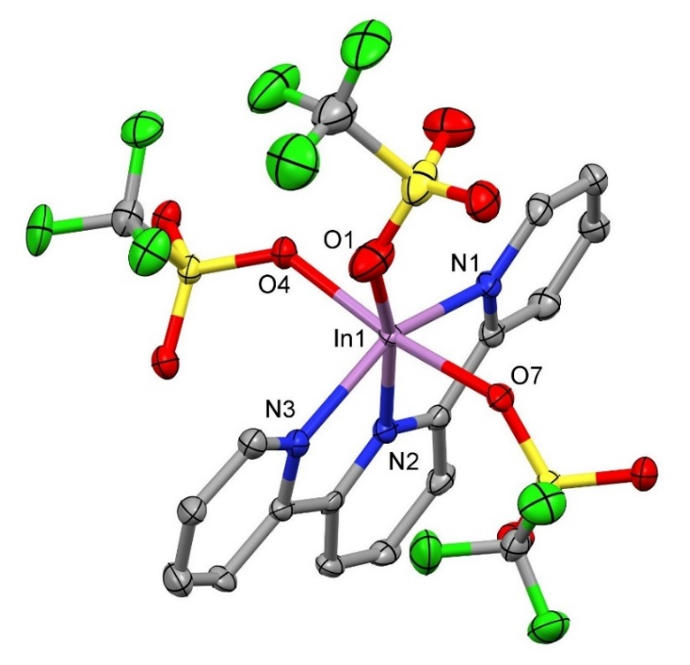
Fig. 1. Structure of mer-[In(OTf)₃(terpy)] showing the atom numbering scheme. Ellipsoids shown at 50% probability, hydrogen atoms omitted for clarity. Selected bond lengths (Å) and angles (°): In1—N1 = 2.247(6), In1—N2 = 2.176(5), In1—N3 = 2.227(5), In1—O1 = 2.144(6), In1—O4 = 2.160(4), In1—O7 = 2.202(5), N2—In1—N3 = 74.2(2), N2—In1—N1 = 73.9(2), N2—In1—O7 = 98.44(18), O7—In1—N3 = 90.61(18), O7—In1—N1 = 90.57(19), O4—In1—N1 = 91.79(18), O4—In1—N2 = 93.31(18), O1—In1—O7 = 83.1(2), O1—In1—N3 = 93.1(2), O1—In1—O4 = 85.7(2), O4—In1—N3 = 93.50(18).
Assignment of the IR spectra of metal triflate complexes is complicated by the presence of both the C-F and SO₃ stretching vibrations in the region 1300-1000 cm⁻¹ [15,16], and although sometimes attempted, it is an uncertain method of determining the coordination present, especially when both coordinated and ionic triflate are present, or where neutral ligand modes occur in the same region. Significant bands in this region are listed in the Experimental section as a ”fingerprint” for particular complexes, but are not therefore assigned. The [M(OTf)₃(terpy)] complexes are poorly soluble in weakly coordinating CH₂Cl₂ solvent, but dissolve readily in the stronger donor solvent MeCN, to give highly conducting solutions. CD₃CN was used for the NMR studies. The ¹⁹F{¹H} NMR spectra of these complexes show a single very sharp resonance at δ = -79.4, which indicates that the OTf– are displaced by the MeCN. However, removal of the MeCN solvent in vacuo results in re-isolation of [M(OTf)₃(terpy)] (IR spectroscopic evidence). The ¹H and ¹³C{¹H} NMR spectra show coordinated terpy resonances to high frequency of the ligand itself. Samples of the aluminium complex which had been in CD₃CN solution for some time, also showed evidence of some protonated terpy in the ¹H NMR spectrum, presumably a result of hydrolysis. None of the complexes exhibited an NMR resonance from the metal centre, probably due to fast relaxation of the quadrupolar nuclei (²⁷Al I = 5/2, ⁷¹Ga I = 3/2, ¹¹⁵In I = 9/2) in the relatively low symmetry coordination environment [17]; we also note that resonances for the metal nuclei were not observed in mer-[MF₃(terpy)] [11], for the same reasons.
A small number of crystals grown from a solution of mer-[In(OTf)₃(terpy)] in CH₂Cl₂ over several weeks were found by single crystal X-ray analysis to be the centrosymmetric hydroxy-bridged dimer, [{In(terpy)(OTf)}₂(µ-OH)₂][OTf]₂ (Fig. 2), in which two of the coordinated OTf⁻ ligands present in the original [In(OTf)₃(terpy)] complex have been replaced by the bridging OH⁻ groups. This complex is no doubt formed as a result of partial hydrolysis. This structure also shows H-bonding interactions between each of the hydroxides and a OTf⁻ anion, with a distance of 2.00(4) Å, but the In−N bond distances are essentially the same as in the tris-OTf parent complex above.
Fig. 2 Structure of the centrosymmetric cation in [{In(terpy)(OTf)}₂(µ-OH)₂][OTf]₂, showing the atom numbering scheme and both the coordinated and H-bonded OTf⁻ anions. Ellipsoids shown at 50% probability, hydrogen atoms omitted for clarity, except for the OH bridge. Selected bond lengths (Å) and angles: In1—O1= 2.0669(11), In1—O1’ 2.1482(11), In1—O2 = 2.1945(12), In1—N3 = 2.2463(13), In1—N2 = 2.1951(12), In1—N1 = 2.2396(12), O5⋅⋅⋅H1 = 2.00(4), O1⋅⋅⋅O5 = 2.743(2), O1— In1— O1’ = 75.98(5), O1—In1—O2 = 89.47(4), O1—In1—1N3 = 94.24(4), O1—In1—N2 = 94.71(4), O1—In1—N1 = 94.54(4), O2—In—1N3 = 91.76(5), O2—In1—N2 = 99.83(4), O2—In—1N1 87.82(5), N2—In1—N3 = 73.41(5), N2—In1—N1 = 73.39(4).
The reaction of M(OTf)₃ with two molar equivalents of bipy in CH₂Cl₂ gave very pale pink powders of [Al(OTf)₂(bipy)₂][OTf] and [Ga(OTf)₂(bipy)₂][OTf], or white [In(OTf)(H₂O)(bipy)₂][OTf]₂ , the water in the latter complex probably originating from that retained in the commercial In(OTf)₃ precursor. The complexes were identified by a combination of microanalysis and spectroscopy, and confirmed for [Ga(OTf)₂(bipy)₂][OTf] and [In(OTf)(H₂O)(bipy)₂][OTf]₂ by their X-ray crystal structures.
The structure of [Ga(OTf)₂(bipy)₂][OTf] (Fig. 3) reveals a cis octahedral cation, distorted by the small chelate bite of the bipy (< N—Ga—N = 80.8°), but with d(Ga-N) little affected by their relative positions, whether trans to N or trans to OTf.
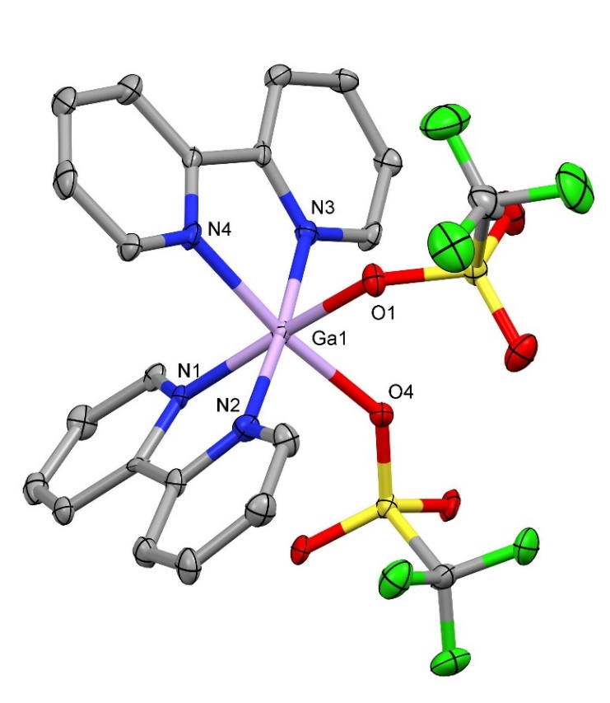
Fig. 3. Structure of the cation in cis-[Ga(OTf)₂(bipy)₂][OTf] showing the atom numbering scheme and two O-bound κ¹-OTf⁻ ligands. Ellipsoids shown at 50% probability, hydrogen atoms omitted for clarity. Selected bond lengths (Å) and angles (°): Ga1—O1 = 2.000(5), Ga1—N3 = 2.011(6), Ga1—N2 = 2.026(6), Ga1—O4 = 2.031(5), Ga1—N1 = 2.032(6), Ga1—N4 = 2.065(6), O1—Ga1—N3 = 90.5(2), O1—Ga1—N2 = 90.6(2), O1—Ga1—O4 = 88.1(2), N3—Ga1—O4 = 93.1(2), N2—Ga1—O4 = 91.5(2), N3—Ga1—N1 = 98.0(2), N2—Ga1—N1 = 80.8(3), O4—Ga1—N1 = 94.1(2), O1—Ga1—N4 = 87.5(2), N3—Ga1—N4 = 80.8(2), N2—Ga1—N4 = 94.6(2), N1—Ga1—N4 = 91.2(2).
The structure of [In(OTf)(H₂O)(bipy)₂][OTf]₂ was obtained from a very small crystal, and the metrical data should be interpreted in that light. It also contains a cis cation (Fig. 4); many examples of Ga and In complexes with bipy have been structurally characterised, e.g. [11,18,19,20,21] and the bond lengths in the present case are unexceptional. The [In(OTf)(H₂O)(bipy)₂][OTf]₂ shows In-OTf slightly longer (2.1789(11) Å) than In-OH₂ (2.1326(12) Å), but with d(In-N) little affected by the trans ligand. The water coordinated to [In(OTf)(H₂O)(bipy)₂][OTf]₂ is also hydrogen bonded to the two triflate counter ions.
Fig. 4. Structure of the cation in cis-[In(OTf)(H₂O)(bipy)₂][OTf]₂ showing the atom numbering scheme and the H-bonding to the two triflate anions Ellipsoids shown at 50% probability, hydrogen atoms omitted for clarity. Selected bond lengths (Å) and angles (°): In1—O1 = 2.1326(12), In1—O2 = 2.1789(11), In1—N2 = 2.2146(13), In1—N1 = 2.2202(13), In1—N3 = 2.2292(13), In1—N4 = 2.2293(13), H1 – O7 = 1.868(3), H2 – O8 = 1.760(2), O1—In1—O2 = 82.01(5), O1—In1—N2 = 100.24(5), O1—In1—N1 = 94.47(5), O2—In1—N1 = 89.22(5), N2—In1— N1 = 75.55(5), O2—In1—N3 = 94.03(4), N2—In1—N3 = 86.81(5), N1—In1—N3 = 97.64(5), O1—In1—N4 = 93.66(5), O2—In1—N4 = 92.55(5), N2—In1—N4 = 102.35(5), N3—In1—N4 = 74.30(5).
The bipy complexes dissolve readily in MeCN, and in CD₃CN solution the ¹⁹F{¹H} NMR spectra are sharp single resonances at δ -79.4, indicating the OTf– is fully dissociated in solution. In contrast to the [Al(OTf)₃(terpy] which did not show a ²⁷Al NMR resonance, [Al(OTf)₂(bipy)₂][OTf] exhibits an ²⁷Al resonance at δ +12.8, which is in the range characteristic of six-coordinate aluminium species [16] and probably due to the [Al(bipy)₂(MeCN)₂]³⁺ trication, but no metal NMR resonances were observed from the corresponding Ga and In complexes, due to fast relaxation or fast ligand exchange.
The reactions of M(OTf)₃ (M = Al, In) with the more rigid phen ligand in CH₂Cl₂ solution afforded compounds identified as [Al(OTf)₂(phen)₂][OTf] and [In(H₂O)₂(phen)₂][OTf]₃, but repeated attempts to isolate a pure gallium product were unsuccessful, with only mixtures produced, including significant amounts of protonated 1,10-phenanthroline, and these attempts were abandoned. However, a few crystals grown from one of these mixtures by slow evaporation of the CH₂Cl₂ solution, were identified by their X-ray crystal structure as cis-[Ga(H₂O)₂(phen)₂][OTf]₃ (Fig. 5a). Although the data were rather weak, and hence the overall structure quality rather modest, significant H-bonding interactions are also clearly evident in this species, between the coordinated H₂O ligands and the triflate anions, leading to a hydrogen-bonded dinuclear assembly as illustrated in Fig. 5b, with d(O⋅⋅⋅H) in the range 1.75 – 1.96 Å.
(a)
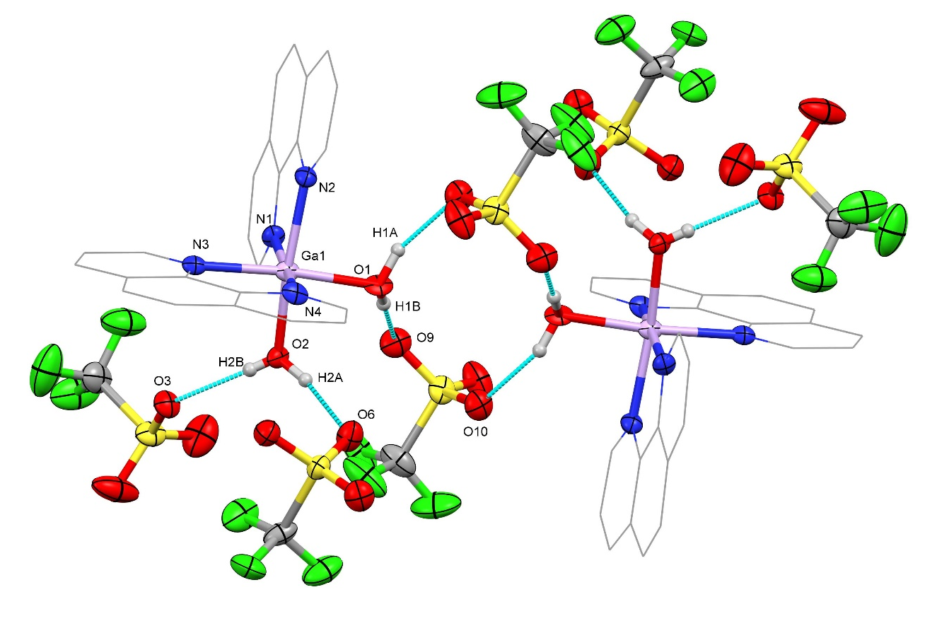
(b)
Fig. 5. (a) Structure of the trication in cis-[Ga(H₂O)₂(phen)₂][OTf]₃ showing the atom numbering scheme and (b) showing the dinuclear assembly formed via H-bonding interactions between the H₂O ligands and the OTf⁻ anions. Ellipsoids shown at 50% probability, hydrogen atoms omitted for clarity. Selected bond lengths (Å) and angles: Ga1—O1= 2.002(5), Ga1—O2 = 1.949(5), Ga1—N1 = 2.054(5), Ga1—N2 = 2.085(6), Ga1—N3 = 2.060(5), Ga1—N4 = 2.035(5), O1—Ga1—N1 = 92.4(2), O1—Ga1—N2 = 89.3(2), O1—Ga1—N4 = 92.5(2), O2—Ga1—O1 = 84.9(2), O2—Ga1—N1 = 92.6(2), O2—Ga1—N3 = 92.0(2), O2—Ga1—N4 = 94.9(2), N1—Ga1—N2 = 80.0(2), N1—Ga1—N3 = 94.8(2), N3—Ga1—N2 = 94.7(2), N4—Ga1—N2 = 92.9(2), N4—Ga—1N3 = 80.7(2).
The spectroscopic properties of [Al(OTf)₂(phen)₂][OTf] and [In(H₂O)₂(phen)₂][OTf]₃ are consistent with the formulations given, with the latter showing significant amounts of water in the IR and ¹H NMR spectra, and with the ¹⁹F{¹H} NMR spectra of both complexes in CD₃CN exhibiting sharp single resonances at δ = –79.4, attributed to discrete OTf– anions. The ²⁷Al NMR spectrum of [Al(OTf)₂(phen)₂][OTf] is a broad resonance at +12.3 ppm, consistent with six-coordinate aluminium, probably [Al(phen)₂(MeCN)₂]³⁺ [17].
Conclusions
The tri- and di-imine ligands react with the metal triflates in a 1:1 or 2:1 ligand : metal ratio respectively to produce M^{III}(terpy) or M^{III}(diimine)₂ cores, with the remaining coordination sites filled with triflate and/or water ligands to achieve six-coordination, with significant H-bonding interactions between coordinated water and anionic triflate. The results also show that the coordinated triflates are easily displaced in donor solvents such as MeCN and hence these types of complexes may provide a route for the synthesis of more elaborate mixed donor neutral ligand complexes. Alternatively, it may be possible to replace the triflate ligands with more strongly coordinating anions. In this context, introducing fluoride would be of interest in connection with radiolabelling with ¹⁸F⁻ to create potential new candidate complexes for PET imaging applications. Presently group 13 metal fluoride complexes are often prepared directly, requiring harsh hydrothermal methods [11,22], which are unsuitable when fragile organic groups are present in the diagnostic agent.
Conflict of interest.
The authors have none to declare.
Acknowledgements
We thank the EPSRC for funding via the ADEPT programme grant (EP/N035437/1) and EP/R513325/1.
Appendix A. Supplementary Information
Contains the supplementary crystallographic data for this paper. CCDC numbers -[In(OTf)₃(terpy)] 20854206, [{In(terpy)(OTf)}₂(µ-OH)₂][OTf]₂ 2085429, [Ga(OTf)₂(bipy)₂][OTf] 2085425, [In(OTf)(H₂O)(bipy)₂][OTf]₂ 2085427, [Ga(phen)₂(H₂O)₂][OTf]₃ 2085428. These data can be obtained free of charge via http://www.ccdc.cam.ac.uk/conts/retrieving.html, or from the Cambridge Crystallographic Data Centre, 12 Union Road, Cambridge CB2 1EZ UK. Other supplementary materials include IR and NMR spectra for the complexes. Supplementary data associated with this article can be found in the online version, at http://.......

Table 1 Crystallographic data.ª
Compound | [In(OTf)(H₂O)(bipy)₂][OTf]₂⋅½CH₂Cl₂ | [In(OTf)₃(terpy)] | [Ga(OTf)₂(bipy)₂][OTf]
Formula | C_{23.5}H₁₉ClF₉InN₄O₁₀S₃ | C₁₈H₁₁F₉InN₃O₉S₃ | C₂₃H₁₆F₉GaN₄O₉S₃
M | 927.86 | 795.30 | 829.30
Crystal system | Monoclinic | Triclinic | Triclinic
Space group (no.) | C 2/c (15) | P-1 (2) | P-1 (2)
a /Å | 37.0587(6) | 8.8580(4) | 8.3516(3)
b /Å | 8.96670(10) | 12.0801(5) | 9.9145(3)
c /Å | 26.5744(4) | 12.8951(6) | 18.5808(6)
α /° | 90.00 | 71.426(4) | 104.726(3)
β /° | 130.506(2) | 79.615(4) | 93.321(3)
γ/° | 90.00 | 86.099(4) | 97.344(3)
U /Å³ | 6714.17 | 1286.47(10) | 1469.21(8)
Z | 1 | 2 | 2
μ(Mo-ⱪ_{α}) /mm^{–1} | 1.079 | 1.283 | 12.67
F(000) | 3700 | 780 | 828
Total number reflns | 35771 | 28216 | 45445
R_{int} | 0.021 | 0.060 | 0.094
Unique reflns | 6594 | 5023 | 5773
No. of params, restraints | 474, 0 | 397, 12 | 442, 0
GOF | 1.043 | 1.186 | 1.166
R₁, wR₂ [I > 2σ(I)]^{b} | 0.019, 0.044 | 0.067, 0.151 | 0.089, 0.237
R₁, wR₂ (all data) | 0.020, 0.045 | 0.070, 0.153 | 0.093, 0.239
ª common data: wavelength (Mo-K_{α}) = 0.71073 Å; θ(max) = 27.5°; ^{b} R₁ = Σ||F_{o}|-|F_{c}||/Σ|F_{o}|; wR₂=[Σw(F_{o}²-F_{c}²)²/ΣwF_{o}⁴]^{1/2}

Compound | [Ga(OH₂)₂(phen)₂][OTf]₃⋅0.5CH₂Cl₂ | [{In(OTf)(terpy)}₂(µ-OH)₂][OTf]₂
Formula | C_{27.5}H₂₁ClF₉GaN₄ O₁₁S₃ | C₃₄H₂₄F₁₂In₂N₆O₁₄S₄
M | 955.83 | 1326.47
Crystal system | Triclinic | Triclinic
Space group (no.) | P-1 (2) | P-1 (2)
a /Å | 10.1427(7) | 9.16570(10)
b /Å | 19.6800(8) | 11.40740(10)
c /Å | 19.9648(11) | 12.3845(2)
α /° | 113.997(5) | 100.4730(10)
β /° | 103.715(6) | 103.2660(10)
γ/° | 91.841(5) | 106.1590(10)
U /Å³ | 3499.6(4) | 1168.00(3)
Z | 4 | 1
μ(Mo-ⱪ_{α}) /mm^{–1} | 1.155 | 1.306
F(000) | 1916 | 665
Total number reflns | 45496 | 7679
R_{int} | 0.093 | 0.034
Unique reflns | 13709 | 7380
No. of params, restraints | 1037, 19 | 329, 0
GOF | 1.076 | 1.053
R₁, wR₂ [I > 2σ(I)]^{b} | 0.090, 0.190 | 0.026, 0.070
R₁, wR₂ (all data) | 0.140, 0.213 | 0.0270, 0.070

References.
[1] Comprehensive Coordination Chemistry, ed. G. Wilkinson, J. A. McCleverty, R. D. Gillard, Pergamon, Oxford, 1988.
[2] A. J. Carty, D. G. Tuck, Progr. Inorg. Chem. 19 (1975) 243.
[3] W. Levason, F. M. Monzittu, G. Reid, Coord. Chem. Rev. 391 (2019) 90.
[4] The Group 13 Metals Aluminium, Gallium, Indium and Thallium: Chemical Patterns and Peculiarities, A. J. Downs, S. Aldridge (Eds), Wiley, New York, 2011.
[5] The Chemistry of Aluminium, Gallium, Indium and Thallium. A. J. Downs (Ed) Blackie, London 1993.
[6] P. J. Blower, R. Cusnir, A. Darwesh, N. J. Long, M. T. Ma, B. E. Osborne, T. W. Price, G. Reid, R. Southworth, G. J. Stasiuk, S. Y. A. Terry, R. T. M. de Rosales, Adv. Inorg. Chem. (2021) in press. doi.org/10.1016/bs.adioch.2021.04.002.
[7] G. M. Sheldrick, Acta Crystallog. Sect. C 71 (2015) 3.
[8] G. M. Sheldrick, Acta Crystallog., Sect. A: Found. Crystallogr. 64 (2008) 112.
[9] K. R. Cairns, V. K. Greenacre, L. A. Grose, W. Levason, G. Reid, F. Robinson, J. Organomet. Chem. 912 (2020) 121176.
[10] G. Beran, K. Dymock, H. A. Patel, A. J. Carty, P.M. Boorman, Inorg. Chem. 11 (1972) 896.
[11] R. Bhalla, W. Levason, S. K. Luthra, G. McRobbie, F. M. Monzittu, J. Palmer, G. Reid, G. Sanderson, W. Zhang, Dalton Trans. 44 (2015) 9569.
[12] R. J. Butcher, C. George, N. Muratore, A. P. Purdy, Acta Crystallogr. Sect. E Struct. Reports Online 59 (2003) m1107.
[13] I. V. Kazakov, M. Bodensteiner, A. Y. Timoshkin, Acta Crystallogr. Sect. C, Struct. Chem. 70 (2014) 312.
[14] G. Beran, A. J. Carty, H. A. Patel, G. J. Palenik, J. Chem. Soc. D (1970) 222.
[15] G. A. Lawrance, Chem. Rev. 86 (1986) 17.
[16] D. H. Johnston, D. F. Shriver, Inorg. Chem. 32 (1993) 1045.
[17] Multinuclear NMR, J. Mason (Ed), Plenum New York, 1987.
[18] R. Restivo, G. J. Palenik, J. Chem. Soc., Dalton Trans. (1972) 341.
[19] R. J.Baker, C. Jones, M. Kloth, D. P. Mills, New J. Chem. 28 (2004) 207.
[20] X. Zhou, R. Fan, X. Du, S. Hao, R. Fang, P. Wang, K. Xing, A. Wang, Y. Yang, Z. Liu, Inorg. Chem. Comm. 90 (2018) 39.
[21] M. A. Malyarick, S. P. Petrosyants, A. B. Ilyuhin, Polyhedron 11 (1992) 1067.
[22] R. Bhalla, C. Darby, W. Levason, S. K. Luthra, G. McRobbie, G. Reid, G. Sanderson, W. Zhang, Chem. Sci. 5 (2014) 381.

