The role of SnO₂ in the bifunctional mechanism of CO oxidation at Pt-SnO₂ electrocatalysts
Haoliang Huang^{[a]}, Edward T.C. Hayes^{[a]}, Diego Gianolio^{[b]}, Giannantonio Cibin^{[b]}, Fredrik S. Hage^{[c], [d]}, Quentin M. Ramasse^{[c], [e]} and Andrea E. Russell*^{[a]}

[a] Dr. H. Huang, Mr. E.T.C. Hayes, Prof. A.E. Russell
School of Chemistry, University of Southampton, Highfield, Southampton SO17 1BJ, United Kingdom
E-mail: a.e.russell@soton.ac.uk
[b] Dr. D. Gianolio and Dr. G. Cibin
Diamond Light Source Ltd, Diamond House, Harwell Campus, Didcot OX11 0DE, United Kingdom
[c] Dr. F.S. Hage and Prof. Q.M. Ramasse
SuperSTEM Laboratory, SciTech Daresbury Campus, Daresbury WA4 4AD, United Kingdom
[d] Dr. F.S. Hage
Department of Physics / Centre for Materials Science and Nanotechnology, University of Oslo, NO-0318 Oslo, Norway
[e] Prof. Q.M. Ramasse
School of Physics and Astronomy and School of Chemical and Process Engineering, University of Leeds, Leeds LS2 9JT, United Kingdom

Supporting information for this article is given via a link at the end of the document.((Please delete this text if not appropriate))

Abstract: Pt-Sn bimetallic catalysts, especially Pt-Sn alloys, are considered highly CO-tolerant and are thus candidates for reformate derived hydrogen oxidation and for direct oxidation of fuel cell molecules. However, it remains unclear if this CO-tolerance originates from Sn in the Pt-Sn alloy or whether SnO₂, present as a separate phase, also contributes. In this work, a carbon-supported Pt-SnO₂ was carefully synthesized to avoid the formation of Pt-Sn alloy phases. The resulting structure was analysed by scanning transmission electron microscopy (STEM) and detailed X-ray absorption spectroscopy (XAS). CO oxidation voltammograms of the Pt-SnO₂/C and other SnO₂-modified Pt surfaces unambiguously suggest that a bifunctional mechanism is indeed operative at such Pt-SnO₂ catalysts for stable CO oxidation at low overpotentials. The results from these studies suggest that the bifunctional mechanism can be attributed to the co-catalysis role of SnO₂, in which the surface hydroxide of SnO₂ (Sn-OH) reacts with CO adsorbed on Pt surface (Pt-CO_{ads}) and regenerates via a Sn^{II}/Sn^{IV} reversible redox couple (-0.2–0.3 V vs. reversible hydrogen electrode).
Introduction
Carbon monoxide oxidation remains an important reaction in proton-exchange membrane (PEM) fuel cells, as CO is present as an impurity from reformate gas^{[1]} and is also an intermediate or incomplete oxidation product of small fuel molecules (methanol, ethanol, etc.)^{[2]}. CO poisons Pt surfaces and thus severely retards the oxidation of fuel molecules^{[3]}. Amongst CO-tolerant catalysts, Pt-Sn alloys stand out^{[4]}, due to a combination of the following promotional effects: (i) bifunctional effects, through which the Sn sites provide the adsorbed hydroxide (OH_{ads}) reactant at much lower potential than at Pt^{[5]}; (ii) electronic/ligand effects, through which alloyed Sn atoms alter the electronic properties of Pt and thus weaken the Pt-CO interaction^{[4d, 6]}; and (iii) ensemble effects, through which the binding site geometry of CO on Pt is altered because the Pt surface is diluted by CO-inert but hydrophilic Sn atoms^{[6]}. Nevertheless, for practical applications, the instability of the active Pt-Sn alloy surfaces and Sn dissolution narrow the useful upper limit of the potential window to 0.5~0.6 V (vs. the standard hydrogen electrode, which will be used as the reference for all potentials referred to in the introduction) in acidic electrolytes^{[7]}. Additionally, the ensemble effects of surface-alloyed Sn have been shown to inhibit C-H bond dissociation in methanol oxidation^{[8]} and to lower the CO₂ selectivity in ethanol oxidation^{[2a, 8a, 9]}.
Pt modified SnO₂, Pt-SnO₂, in which the contributions from the ligand and ensemble effects no longer exist, has been shown to promote the oxidation of CO and other site-blocking intermediates via a bifunctional mechanism similar to that for the Pt-Sn alloy ^{[4b, 10]}. Our group^{[11]} reported a study of well-characterized Pt-Sn nanoparticles, in which the SnO₂-to-alloyed Sn ratio was changed by heat treatment in different atmospheres. We found that whilst the onset potential of CO stripping increased, it was not proportional to the fraction of SnO₂ (~0.39 V for the sample with ~92 at % SnO₂ out of total Sn), implying that both SnO₂ and alloyed Sn may facilitate CO oxidation on Pt^{[11]}. This relationship is supported by other studies on Pt-Sn bimetallic catalysts^{[12]}, and the promoted CO oxidation can be also found on Sn modified Pt nanoparticles, in which the Sn was suggested to exist as SnO₂^{[9b, 13]}. In addition, the surfaces of Pt-Sn alloys tend to segregate into Pt-Sn⁴⁺ or Pt-SnO₂ due to the instability to air exposure^{[14]}, as observed during low-temperature CO oxidation ^{[15]}, suggesting that the bifunctional effects reported on Pt-Sn bimetallic catalysts may be partly attributed to SnO₂.
If a bifunctional mechanism is active for Pt-SnO₂ catalysts, a redox couple corresponding to the formation and dissociation of Sn-OH should exist, as Hayden et al.^{[5a]} found on Pt(111)/Sn surface alloys. Cathro^{[16]} proposed that increased activity of a Pt-Sn catalyst, electrodeposited from a mixed solution of H₂PtCl₆ and SnCl₄ at 0.05 V, for the oxidation of C₁ fuel molecules oxidation could be ascribed to the Sn(OH)₃⁺/Sn²⁺ couple (0.142 V^{[17]}). On the other hand, Rabis et al.^{[18]} showed two irreversible redox couples on a SnO₂ thin film, the presence of which depends on the (reducing or oxidising) synthesis conditions; SnO₂ prepared under reducing conditions at ~0.1 V/~0.4 V and that prepared under oxidising conditions at ~-0.2 V/~-0.3 V. Lim et al.^{[19]} reported an irreversible redox couple at ~0.7 V/~0.5 V of partially alloyed PtSn and attributed this to the absorption and desorption of oxygen-containing species of SnO₂. Matsui et al.^{[20]} observed a similar redox couple on a SnO_{x} supported Pt catalyst.
Although bifunctional effects from SnO₂ are likely to exist and have comparable enhancement for CO oxidation to that of the alloys, unambiguous evidence of the bifunctional effects is still lacking. To ascertain the contribution of the bifunctional mechanism from SnO₂, a catalyst Pt-SnO₂ in which no Pt-Sn alloying is present is required. The study reported herein has been carefully designed to achieve such a catalyst to enable unambiguous exploration of the contributions of SnO₂ to the bifunctional mechanism.
To obtain such an unalloyed Pt-SnO₂ catalyst, the choice of Sn precursors and the reducing condition need to be taken into careful consideration to avoid the formation of the strong Pt-Sn intermetallic bond whilst increasing the number of Pt-SnO₂ interfaces. First, the commonly used stannous chloride (SnCl₂) should be avoided, because the oxidation state of Sn is not the targeted one, and more importantly because SnCl₂ can form a Pt-SnCl₃ complex with Pt precursors^{[21]}. Secondly, the reducing agent should be of modest strength, so as to selectively reduce only the Pt ions and should not contain organic residues that complicate the interpretation of results. Considering these two factors, sodium stannate (Na₂SnO₃) and stannic chloride (SnCl₄) could be good choices for the Sn precursor, and room-temperature reduction in a H₂(g) atmosphere could reduce Pt (hydro)oxides (PtO_{x}) to metallic Pt whilst leaving the SnO₂ unaltered, based on the differences between the standard electrode potentials of Pt, Sn, and H, in which the reducing potential of H₂/H⁺ (0 V) is much lower than that of Pt^{II}O /Pt or Pt^{IV}O₂/Pt (both ~1.0 V) but higher than that of SnO₂/Sn⁰ (both ~-0.1 V) ^{[17]}. Room temperature reduction is also used to prevent intermixing Sn and Pt atoms, as heat treatment (≥200 °C) is required for the formation of Pt-Sn alloy nanoparticles ^{[11, 22]}.
In this work, a Pt-SnO₂ nanoparticle catalyst supported on carbon (Pt-SnO₂/C) is synthesised based on the above considerations. The distribution of Pt and SnO₂ and the morphology are studied by analytical electron microscopic techniques and the Sn speciation is interrogated by detailed X-ray absorption spectroscopy analysis. On Pt-SnO₂/C, CO oxidation at low overpotentials is promoted and capable of proceeding without being poisoned, supporting our hypothesis that bifunctional effects from SnO₂ are active in CO oxidation. The bifunctional mechanism of SnO₂ is also supported by mixtures of commercial Pt/C and SnO₂ nanoparticles and is further studied by depositing SnO₂ nanoparticles on Pt disc electrodes and carbon electrodes.
Results and Discussion

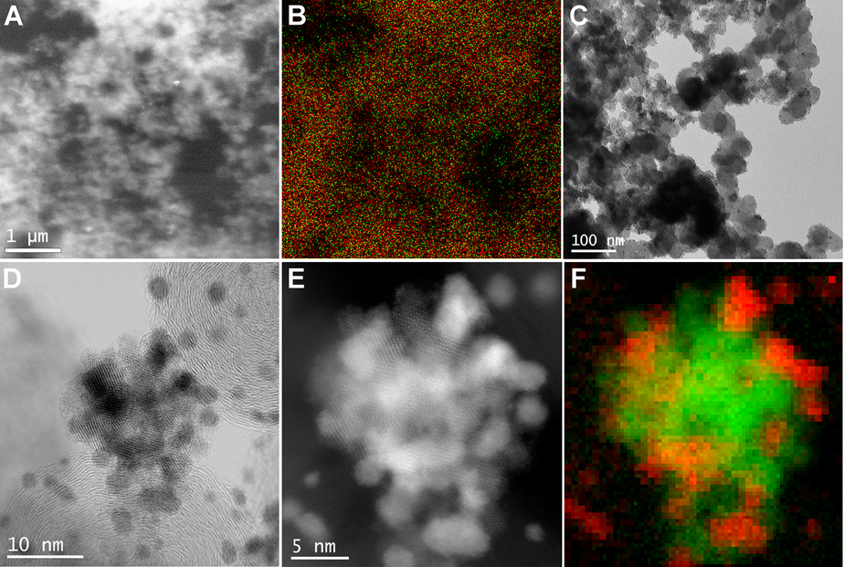
Figure 1. Elemental distribution and morphology of Pt-SnO₂/C. (A) A SEM image and (B) the corresponding EDS mapping image of Pt M_{α1} (red) and Sn L_{α1} (green). (C) An overview TEM image, (D) BF and (E) HAADF STEM images zooming in on a mixed Pt-SnO₂ region, and (F) the corresponding STEM-EELS composite map, using Pt M_{4,5} edge (red), and overlapping Sn M_{4,5} and O K edges (green). The SEM sample was drop-casted as a thin film on a carbon-coated Cu grid.
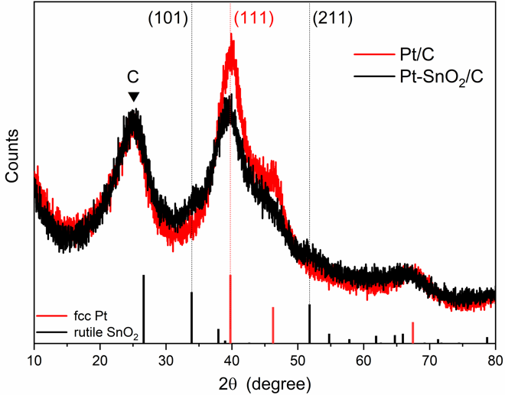
The elemental distribution and morphology of the as-prepared samples were studied using analytical electron microscopic techniques. Figure 1 shows a SEM secondary electron (SE) image (Figure 1A) and corresponding EDS map of a Pt-SnO₂/C sample (Figure 1B). The sample was deposited as a thin film on a carbon-coated Cu grid to minimize particle stacking. At this large field of view (~ 5 μm), the Sn and Pt signal appear to co-locate, suggesting that, on the whole, SnO₂ in Pt-SnO₂/C distributes evenly, rather than forming large-scale agglomerates and separating from Pt and carbon. Figures 1C-D show representative bright field (BF) (S)TEM images of Pt-SnO₂/C with fields of view ~600 nm and ~40 nm, respectively, displaying that the nanoparticles are uniformly deposited on the carbon support in the form of isolated nanoparticles (~1.9 nm, Figure S3) and nanoparticle clusters (~10 nm). The well-dispersed and isolated nanoparticles are found to be pure Pt, i.e., with no detectable Sn or O STEM electron energy loss spectroscopy (EELS) signal (Figure S4 and Figure S5). These isolated Pt particles dominate in the as-prepared Pt/C (Figure S6). Close-up BF and high angle annular dark field (HAADF) STEM images (Figure 1D-E, Figure S7A-B for another region) reveal that the nanoparticle clusters of Pt-SnO₂/C are assemblies of nanocrystals. STEM-EELS results, see both elemental maps (Figure 1F, S7C, S8B) and EEL spectra from selected regions (Figure S8C-E), suggest that the nanoparticle clusters consist of Pt and tin oxide nanoparticles with comparable particle sizes, and that these two types of particles are in intimate contact.
Figure 2. XRD patterns of Pt-SnO₂/C and Pt/C powder samples, along with the standard patterns of fcc Pt (JCPDS No. 04-0802) and rutile SnO₂ (JCPDS No. 41-1445). The peak ascribed to the carbon support is indicated. The Pt loading of Pt/C is ~12.6 wt%, and the Pt and SnO₂ loadings of Pt-SnO₂/C are ~12.3 wt% and 4.0 wt%, respectively.
Crystalline phases of the as-prepared samples were also identified using powder X-ray diffraction (XRD). Figure 2 shows XRD patterns of Pt-SnO₂/C and Pt/C, along with standard peak positions of face-centred cubic (fcc) Pt and rutile SnO₂ as vertical bars in the diagram. Pt-SnO₂/C largely shares a pattern with Pt/C, with a broad diffraction peak (~25°) from Vulcan XC-72R carbon (Figure S11) and a set of peaks (~40°, 46° and ~67°) from fcc Pt. The only mismatches found on Pt-SnO₂/C are the weak yet discernible peaks at ~34° and ~52°, which can be indexed to SnO₂(101) and SnO₂(211), respectively. The SnO₂ diffraction peaks are also observed in the precursor of Pt-SnO₂/C before H₂ reduction (Figure S11A), and they become more dominant and more defined when the SnO₂ loading is increased (Figure S11B). Thus, the weak signal of the SnO₂ phase in Pt-SnO₂/C is possibly due to the nanocrystalline nature of the SnO₂ and the low concentration of SnO₂ (~4 wt%). Other than those from Pt, SnO₂ and carbon, no extra diffraction peaks relating to crystalline Pt₃Sn phases or other Pt-Sn alloys are observed, indicating that the crystalline Sn of Pt-SnO₂/C is in the form of SnO₂ rather than alloyed Sn. In addition, from the width of the Pt (111) diffraction peak, average Pt crystallite sizes of Pt-SnO₂/C and Pt/C were estimated to be ~1.8 nm and ~2.1 nm, respectively, which are in agreement with the particle size measured from the corresponding TEM images.
Figure 3. Fourier transforms without phase correction of k³-weighted EXAFS spectra of Pt-SnO₂/C at (A) Pt L₃ edge and (B) Sn K edge, compared to those of the reference samples, Pt/C at Pt L₃ edge, SnO₂ nanopowder at Sn K edge and Pt-Sn alloy/C at both edges. The comparison is also shown in both k space and the real part of R space (Figure S12 for the Pt edge data and Figure S13 for the Sn edge data). The samples were measured as BN pellets and in H₂(g), except for the SnO₂ nanopowder and one of Pt-SnO₂/C samples, which were measured in air.
Table 1. Structural parameters of Pt-SnO₂/C, Pt-SnO₂/C_air (Pt-SnO₂/C measured in air), Pt-Sn alloy/C, Pt/C, SnO₂ nanopowder, and Pt foil, obtained from EXAFS fitting. Double dataset fitting was conducted on Pt-Sn alloy/C^{[e]}.
Sample | Edge ^{[a]} | Scattering path* | R (Å) ^{[b]} | N ^{[c]} | σ² (x10³ Å²) ^{[d]} | ΔE₀ (eV) | R factor (%)
Pt-SnO₂/C | Pt L₃ | Pt–Pt | 2.754(2) | 8.8(3) | 6.5(2) | 5.6(4) | 0.68
 | Sn K | Sn–O | 2.054(7) | 5.6(3) | 4.3(8) | 5(1) | 1.2
 |  | Sn–Sn | 3.21(2) | 2(1) | 7(3)
Pt-SnO₂/C_air | Sn K | Sn–O | 2.052(4) | 6.1(2) | 4.2(5) | 4.2(6) | 0.4
 |  | Sn–Sn | 3.21(1) | 1.6(7) | 6(2)
Pt-Sn alloy/C | Pt L₃ | Pt–Pt | 2.779(1) | 8.2(2) | 6.9(1) | 4.9(2) | 0.88
 |  | Pt–Sn | 2.788(5) ^{[e]} | 2.2(2) | 12(1) ^{[e]}
 | Sn K | Sn–O | 2.02(3) | 1(1) | 4(8) | 3(1)
 |  | Sn–Pt | 2.788(5) ^{[e]} | 9(2) | 12(1) ^{[e]}
Pt/C | Pt L₃ | Pt–Pt | 2.756(2) | 9.3(3) | 6.2(2) | 6.8(3) | 0.57
SnO₂ | Sn K | Sn–O | 2.055(4) | 6.0(2) | 4.0(5) | 4.2(6) | 0.33
 |  | Sn–Sn | 3.201(7) | 1.2(5) | 2(2)
Pt foil ^{[f]} | Pt L₃ | Pt–Pt | 2.765(1) | 12 | 4.9(1) | 7.2(3) | 1.6
[a] For the Pt L₃ edge data, only the first coordination shell is presented;
[b] R, the average distance of absorber–backscatterer pair scattering; [c] N, the coordination number of the scattering; [d] σ², the mean square relative displacement of the R.
[e] For Pt-Sn alloy/C data, Pt–Sn and Pt–Sn scatterings were constrained to have an equal R and σ²;
[f] The coordination numbers of different shells were kept the same as the theoretical model (ICSD No. 52250).

Although only SnO₂ and no crystalline Pt-Sn alloy could be found by XRD, this evidence alone is insufficient to assert that no Pt-Sn alloy phase exists in Pt-SnO₂/C. If there were alloyed Sn species, they might be oxidized after exposure to air^{[14]}, and/or at concentrations below the detection limit of XRD. Thus, the Sn speciation of Pt-SnO₂/C was further characterised from aspects of local coordination environment and oxidation state and by combining XAS spectra obtained at the Pt L₃ and Sn K edges. The spectra were collected in H₂(g) to mimic the synthesis condition, which minimises the air-induced oxidation and dealloying of potential Pt-Sn alloy phases.
At the Pt L₃ edge, Pt-SnO₂/C shows a Fourier-transformed (FT) extended X-ray absorption fine structure (EXAFS) spectrum matching that of Pt/C but with slightly decreased magnitude (Figure 3A), which is also reflected in the k space and the real part of the R space plots (Figure S12), suggesting similarity in the Pt coordination environment. Quantitative results of Pt coordination were found from the corresponding multiple-shell fitting using a constrained model, where the symmetry of Pt fcc structure is used to minimise the number of variables. The fits of both Pt-SnO₂/C and Pt/C yield good R-factors (<0.7%), with Pt–Pt distances (R) within the error of fitting, 2.754(2) Å vs. 2.756(2) Å, respectively (Figure S14 and Table 1). As the fitted values for the mean square relative displacement (σ²) are also similar, the decreased FT magnitude for the Pt-SnO₂ is attributed to the lower coordination number (CN) of Pt–Pt (~8.8 for the first-shell) than Pt/C (~9.3), which is consistent with the smaller Pt particle size of Pt-SnO₂/C indicated by TEM and XRD. In contrast, the Pt-Sn alloy/C data show a Pt–Sn scattering path, R (~2.79 Å) (Figure 3A), due to the alloying of Sn atoms^{[9b, 11]} and a Pt–Pt distance (~2.779 Å) which is significantly longer than that of Pt/C (~2.756 Å, Figure S15 and Table 1).
The contrasting Sn speciation of Pt-SnO₂/C and Pt-Sn alloy/C can be more readily distinguished from the perspective of Sn. At the Sn K edge, the FT of the EXAFS for the Pt-SnO₂/C shows a similar profile to that for the SnO₂ nanopowder (Figure 3B and Figure S13), whilst that for the alloy sample is dominated by a unique Sn–Pt scattering path (~2.79 Å, Figure S15 and Table 1), which cannot be detected or fitted for the Pt-SnO₂/C data (Figure S16). Further examination reveals that the FT magnitude of Pt-SnO₂/C is lower than that of the SnO₂ in two regions, the Sn–O region (1.0–2.0 Å) and the high R region (2.5–3.8 Å). The lower magnitude in the former region yields a CN of 5.6(3), less than the theoretical value of SnO₂ (CN = 6, Figure S17), which indicates that the SnO₂ of Pt-SnO₂/C is unexpectedly reduced to a limited extent. To clarify the origin of the reduced SnO₂, Pt-SnO₂/C was also measured in air. A good match with SnO₂ nanopowder is shown in the Sn–O region (Figure 3B), with the fit yielding a CN of 6.1(2), suggesting that the SnO₂ in the as-prepared Pt-SnO₂/C is fully oxidized with a SnO₆ first shell coordination. For the high R region, the decreased FT magnitude of Pt-SnO₂/C (measured in air and in H₂) is attributed to the crystallite size of SnO₂. Sn–Sn scattering paths between neighbouring SnO₆ units dominate in this region, and such a decrease is also observed when the SnO₂ nanopowder (8–10 nm) is compared with a SnO₂ standard sample (Figure S18). The small crystallite size of SnO₂ in Pt-SnO₂/C is consistent with the nanocrystalline nature observed by STEM (~2–3 nm). Thus, the mismatches between Pt-SnO₂/C and SnO₂ in the Sn K edge EXAFS spectra originate from a combination of the measurement atmosphere and the size of the SnO₂ particles, rather than the presence of alloyed Sn in the as-prepared Pt-SnO₂/C.
Figure 4. Sn K edge XANES spectra and (the inset) their first derivatives of Pt-SnO₂/C and the reference samples SnO₂ nanopowder, SnO, Pt-Sn alloy/C and Sn foil. The spectra of Pt-SnO₂/C, Pt/C and Pt-Sn alloy/C were collected in H₂(g), and the others in air.

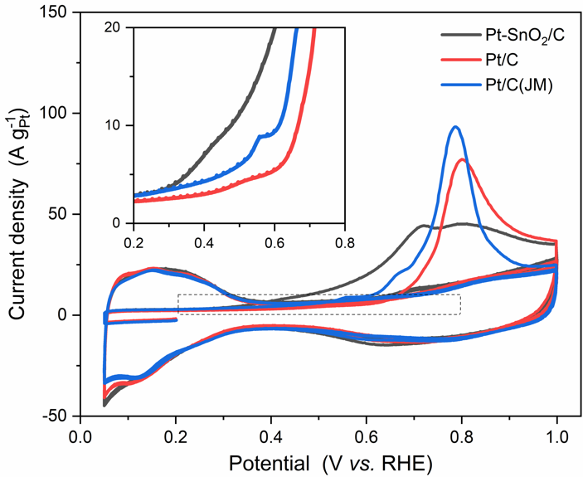
The dominance of SnO₂ in the Sn speciation of Pt-SnO₂/C is corroborated by X-ray absorption near-edge structure (XANES) spectra at Sn K edge (Figure 4). Compared to Sn references (SnO₂ nanopowder, Pt-Sn alloy/C, SnO and Sn foil), Pt-SnO₂/C samples, measured in air and in H₂(g), show a nearly identical spectrum to that of the SnO₂ in terms of white line intensity (the sharp feature at the top of the rising edge), peak position (selected as the maximum of the first derivative, the inset of Figure 4) and other fine structures above the edge (29250–29400 eV), consistent with the EXAFS results. The concentration of each possible Sn species in the as-prepared Pt-SnO₂/C (measured in air) was estimated by linear combination fitting (LCF) using two components, SnO₂ and the other Sn references. The fitting suggests that the Sn species of the Pt-SnO₂/C are comprised of 100% SnO₂. We note for completeness that X-ray absorption spectroscopy (XAS) is unable to exclude the presence of trace amounts of alloyed Sn in the sample. STEM-EELS microanalysis of one region (see Figure S9, Figure S10 and the related discussion in the supporting information) shows that Sn, most likely in the form of bulk alloyed Sn, was present in Pt particles in contact with SnO₂, the exact origin of which is unclear. Thus, based on the differences between SnO₂ and alloyed Sn in XANES and the nearly identical spectra of Pt-SnO₂/C and SnO₂, we estimate that >99.9 % Sn atoms exist as SnO₂ in the as-prepared Pt-SnO₂/C.
Figure 5. CO stripping voltammograms of Pt-SnO₂/C, Pt/C and Pt/C (Johnson Matthey) in N₂-saturated 0.1 M HClO₄ solution at a scan rate of 20 mV s⁻¹. A saturated CO adlayer was adsorbed by potential hold at 0.2 V for at least 15 min, followed by displacement of dissolved CO from the solution by N₂.

Further inspection of the Pt-SnO₂/C XANES spectra reveals a slight reduction of the SnO₂ when the spectra were measured in H₂(g), consistent with the EXAFS data, and LCF yields (99.1 ± 1.5)% SnO₂ and (0.9 ± 1.5)% reduced SnO₂, using Pt-Sn alloy/C as the component of the reduced species (Figure S19). The possible speciation of the reduced SnO₂ is then discussed. Careful comparison of the FT EXAFS spectra measured in H₂(g) and air (Figure 3B and Figure S13) reveals a small yet discernible mismatch in position at a radial distance of ~2.3 Å, which would suggest a new scattering path. Such a mismatch is supported in the fit of Pt-SnO₂/C (Figure S16), in which the scattering paths were generated using rutile SnO₂ (ICSD No.647469) as the input file, present as a peak at ~2.2 Å in the residual plot (Figure S20). However, the mismatch at ~2.3 Å and the residual peak at ~2.2 Å cannot be attributed to the formation of new phases, as the common Sn references like alloyed Sn and SnO show no major scattering path in these two regions (Figure S20 and Figure S21). We therefore suggest, as the most likely explanation, that the reduced SnO₂ arises from surface oxygen vacancies on SnO₂, in which oxygen-containing ligands were partly depleted by H₂. This suggestion is consistent with the surface composition and structure of SnO₂: low index SnO₂ surfaces under reducing conditions tend to lose surface lattice oxygen and relax into a Sn^{II} state termination^{[23]}. One may notice that this surface Sn^{II} can be easily oxidised under ambient conditions, as shown in the XAS data measured in air. This dual valency gives us the first indication that a redox couple may exist on the SnO₂ surface.
Figure 5 shows the CO-stripping voltammograms of the as-prepared samples, Pt-SnO₂/C and Pt/C, as well as a commercial Pt/C (20 wt%) (Johnson Matthey (JM)). After a saturated CO adlayer was formed at 0.2 V in 0.1 M HClO₄, the potential was swept backwards to 0.05 V in CO-free electrolyte and cycled from 0.05 – 1.0 V for three cycles. The hydrogen adsorption/desorption (H_{ads/des}) features from Pt (0.05 – 0.35 V) are absent in the first cycle, as the Pt surface is completely blocked by the adsorbed CO (CO_{ads}) and appear in the 2nd and 3rd cycles when the CO_{ads} is stripped off. The H_{ads/des} pseudocapacitive current of Pt-SnO₂/C largely overlaps that of the Pt/C catalysts with comparable charge, whilst those of Pt-Sn alloy/C are considerably smaller (Figure S22 and Table S1).
For the 1st CO stripping sweeps, whilst the Pt/C catalysts show a main peak at ~0.8 V and small pre-peaks between 0.4 V and 0.7 V (the inset of Figure 5), and compared to the prepared Pt/C the larger contribution of the pre-peak and the earlier onset of CO stripping observed for the commercial Pt/C can be attributed to the agglomeration of Pt particles and the larger particle size (Figure S6 and Figure S23)^{[24]}. In contrast to the Pt/C catalysts, Pt-SnO₂/C gives a broad peak, from 0.3 V to 1 V, with significantly more contribution from the pre-peaks and less from the main peak. Two CO stripping features of Pt-SnO₂/C are noteworthy. The first is the low onset potential (~0.3 V), which is close to the reported value for Pt-Sn alloys^{[5a, 6a]} and Sn-modified Pt^{[25]}, indicating that CO oxidation at the Pt-SnO₂ catalyst is indeed promoted. The second is the broad peak shape, suggesting that highly active and less active sites (pure Pt sites) coexist on Pt-SnO₂/C. The multiplicity of active sites is consistent with the STEM results revealing that some Pt particles are isolated from SnO₂. The percentage of highly active sites can be estimated by a CO pre-stripping voltammogram (Figure S24), in which ~36% CO_{ads} was removed by potential hold at 0.5 V prior to CO stripping.
Figure 6. CO stripping voltammograms of electrodes modified by 60 wt% Pt/C (Johnson Matthey) and SnO₂ nanopowder with different (A) SnO₂ contents and (B) microstructures. (A) Physical mixtures of the Pt/C and the SnO₂ (Pt:Sn molar ratios of 3:1, 1:1 and 1:3), with a constant Pt loading on the electrodes (~61 μg_{Pt} cm⁻²) and with the SnO₂ loadings of 0 μg cm⁻² (black), ~15 μg cm⁻² (red), ~46 μg cm⁻² (blue) and ~138 μg cm⁻² (green). Arrow shows increasing SnO₂ loading. (B) Layer-on-layer structures formed via drop-casting sequences (a Pt/C layer on a SnO₂ layer, and vice versa), keeping the Pt and SnO₂ loading constant, ~61 μg cm⁻² and ~46 μg cm⁻², respectively. The voltammograms were conducted in N₂-saturated 0.1 M HClO₄ solution with a scan rate of 20 mV s⁻¹, and the insets magnify the first sweeps of the voltammograms at the onset of CO_{ads} oxidation.

The CO stripping voltammogram features of Pt-SnO₂/C are reproducible in sulfuric acid electrolyte (Figure S25), and for catalysts comprising physical mixtures of two commercial components, Pt/C (60 wt%, JM) and SnO₂ nanopowders (8–10 nm), prepared over a range of molar ratios of Pt to SnO₂ (3:1, 1:1 and 1:3, Figure 6A). A consistent trend is clearly obtained; increased SnO₂ loading is accompanied by a greater change to the pre-peak region. As a control the promoted SnO₂ was replaced by Al₂O₃, resulting in no promotion of the CO oxidation (Figure S26). The charge in the pre-peak region decreases significantly when the configuration of thin-film electrodes was changed from physical mixtures to layer-by-layer structures (a SnO₂ layer on a Pt/C layer and vice versa), suggesting that the promotion effects from SnO₂ depend not simply on the presence or content of SnO₂, but also on the contact between Pt and SnO₂ (Figure 6B).
Since SnO₂ itself is inert for CO oxidation (Figure S27), the CO stripping voltammograms of the Pt-SnO₂/C and the physical mixtures of Pt/C and SnO₂ clearly indicate that CO adlayer oxidation at the Pt surface is facilitated by Sn^{IV}O₂. The conventional bifunctional mechanism from alloyed Sn, in which water molecules are activated by the oxidation of the Sn sites^{[5a, 6a]}, fails to explain the promotional effect from SnO₂. One may argue that the mechanism is still applicable at SnO₂ by forming OH_{ads} adsorbed on SnO₂, as hypothesised by many previous studies^{[10, 19a, 26]}. We argue otherwise that it is the OH species on the SnO₂ surface, (SnO₂)Sn-OH, that are the active species for the bifunctional mechanism from SnO₂. Our reasons are twofold. First, Sn^{IV} of SnO₂ is in the highest oxidation state of Sn and has a saturated first coordination shell, as ascertained by XAS above. These two factors do not allow the addition of OH coordination by further oxidation of Sn^{IV}. Second, the presence of surface hydroxyl species on SnO₂ has been previously verified and found to be formed by the absorption and dissociation of water ^{[23, 27]}. In heterogeneous catalysis the surface hydroxyl on SnO₂ has been found to participate in CO oxidation on Pt at low temperature^{[28]}. Thus, based on the widely accepted Langmuir-Hinshelwood (L-H) type reaction of CO oxidation on Pt^{[2d, 4a, 29]}, the bifunctional mechanism from SnO₂ can be tentatively written as
Pt-CO_{ads} + (SnO₂)Sn-OH + H₂O → CO₂ + H₃O⁺ + e⁻ + Pt + (SnO₂)Sn* (eq. 1)
where (SnO₂)Sn* represents surface oxygen vacancy sites of SnO₂, possibly as the reduced SnO₂ measured by XAS in H₂(g), and thus the reaction rate is the product of a rate constant and the coverage of Pt-CO_{ads} and (SnO₂)Sn-OH at Pt-SnO₂ interfaces. However, the surface defect site of SnO₂ may or may not form back to Sn-OH under the experimental conditions. If not, or with slow kinetics, the Sn-OH would be consumed, and the reaction would be discontinued.
To further investigate the regeneration of the Sn-OH species, CO oxidation at Pt-SnO₂ was studied by CO continuous oxidation voltammetry. The measurements were carried out in a CO-saturated electrolyte, and the mass transport of the dissolved CO was controlled by rotating disc electrode (RDE) configuration, so that the CO_{ads} coverage is kept constant. The upper limits of the potential windows were chosen to emphasise the pre-peak characteristic, i.e., 0.6 V for Pt-SnO₂/C and 0.7 V for the Pt/C catalysts.
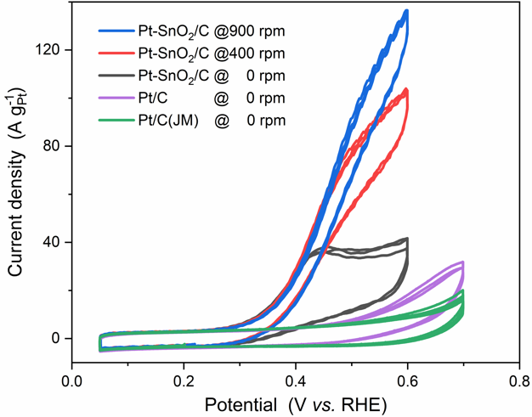
Figure 7 shows the CO continuous oxidation voltammograms of Pt-SnO₂/C, Pt/C and commercial Pt/C. As Pt surface sites are continuously blocked by CO_{ads} in CO-saturated electrolyte, the voltammograms show no H_{ads/des} features in all three cycles. Compared to the 1st sweep of CO stripping voltammograms, the CO oxidation currents are enhanced with the continuous supply of CO, but the extent of enhancement varies with the catalyst (Figure S28). Pt-SnO₂/C shows the most enhancement under stationary conditions, especially at the onset of CO oxidation, and the current can be further enhanced by increasing the rotation rate (Figure 7), which is not observed on the Pt/C catalysts even when the upper limit of the potential windows were extended to 0.9 V (Figure S29 and Figure S30). The rotation rate-dependent current indicates that the CO oxidation kinetics on Pt-SnO₂/C are so fast that the diffusion of dissolved CO becomes the rate-determining step when the potential is ≥ 0.4 V. Such fast kinetics at such a low potential have rarely been reported. Gasteiger et al.^{[1a]} reported similar rotation rate-dependent CO oxidation current on a well-characterised Pt₃Sn electrode but over a narrower potential windows (< 0.5 V) to avoid Sn dissolution.
Figure 8. (A) CO stripping voltammograms of SnO₂ nanopowder on a polycrystalline Pt disc electrode (5 mm diameter) with a scan rate of 50 mV s⁻¹ and with the SnO₂ loading varied by adding different amounts of SnO₂. The inset magnifies the H_{ads/des} region on the first cycles of the voltammograms. The voltammogram of Al₂O₃ on Pt is also present for comparison. (B) The window-opening and (C) scan-rate-dependent cyclic voltammograms of SnO₂ nanopowder on a glassy carbon electrode (GC, 5 mm diameter), with the inset showing the linear relationship between the current at 0 V and the corresponding scan rate. In the window-opening experiment, the scan rate is 200 mV s⁻¹ and the blank (GC) data is also present as a reference.
Figure 7. CO continuous (dissolved) oxidation voltammograms of Pt-SnO₂/C, Pt/C and Pt/C (Johnson Matthey) in CO-saturated 0.1 M HClO₄ solution with a scan rate of 20 mV s⁻¹. The rotation rates are indicated in the figure legend. The CO oxidation currents of the Pt/C catalysts show no enhancement with rotation rate (Figure S28).
From the kinetically controlled portion of the voltammogram, a constant Tafel slope of ~134 mV dec⁻¹ was obtained for the low potential CO oxidation (over 6–50 A g_{Pt}⁻¹, Figure S31). The value is similar to those in two previously reports, one for the pre-peak CO oxidation on Pt(111) in an alkaline electrolyte (130 mV dec⁻¹)^{[30]} and another simulated on Pt in an acidic electrolyte when OH coverage is saturated and potential-independent (120 mV dec⁻¹)^{[31]}. Both cases consider the L-H reaction between Pt-CO_{ads} and OH_{ads} to be the rate-determining step of CO oxidation.
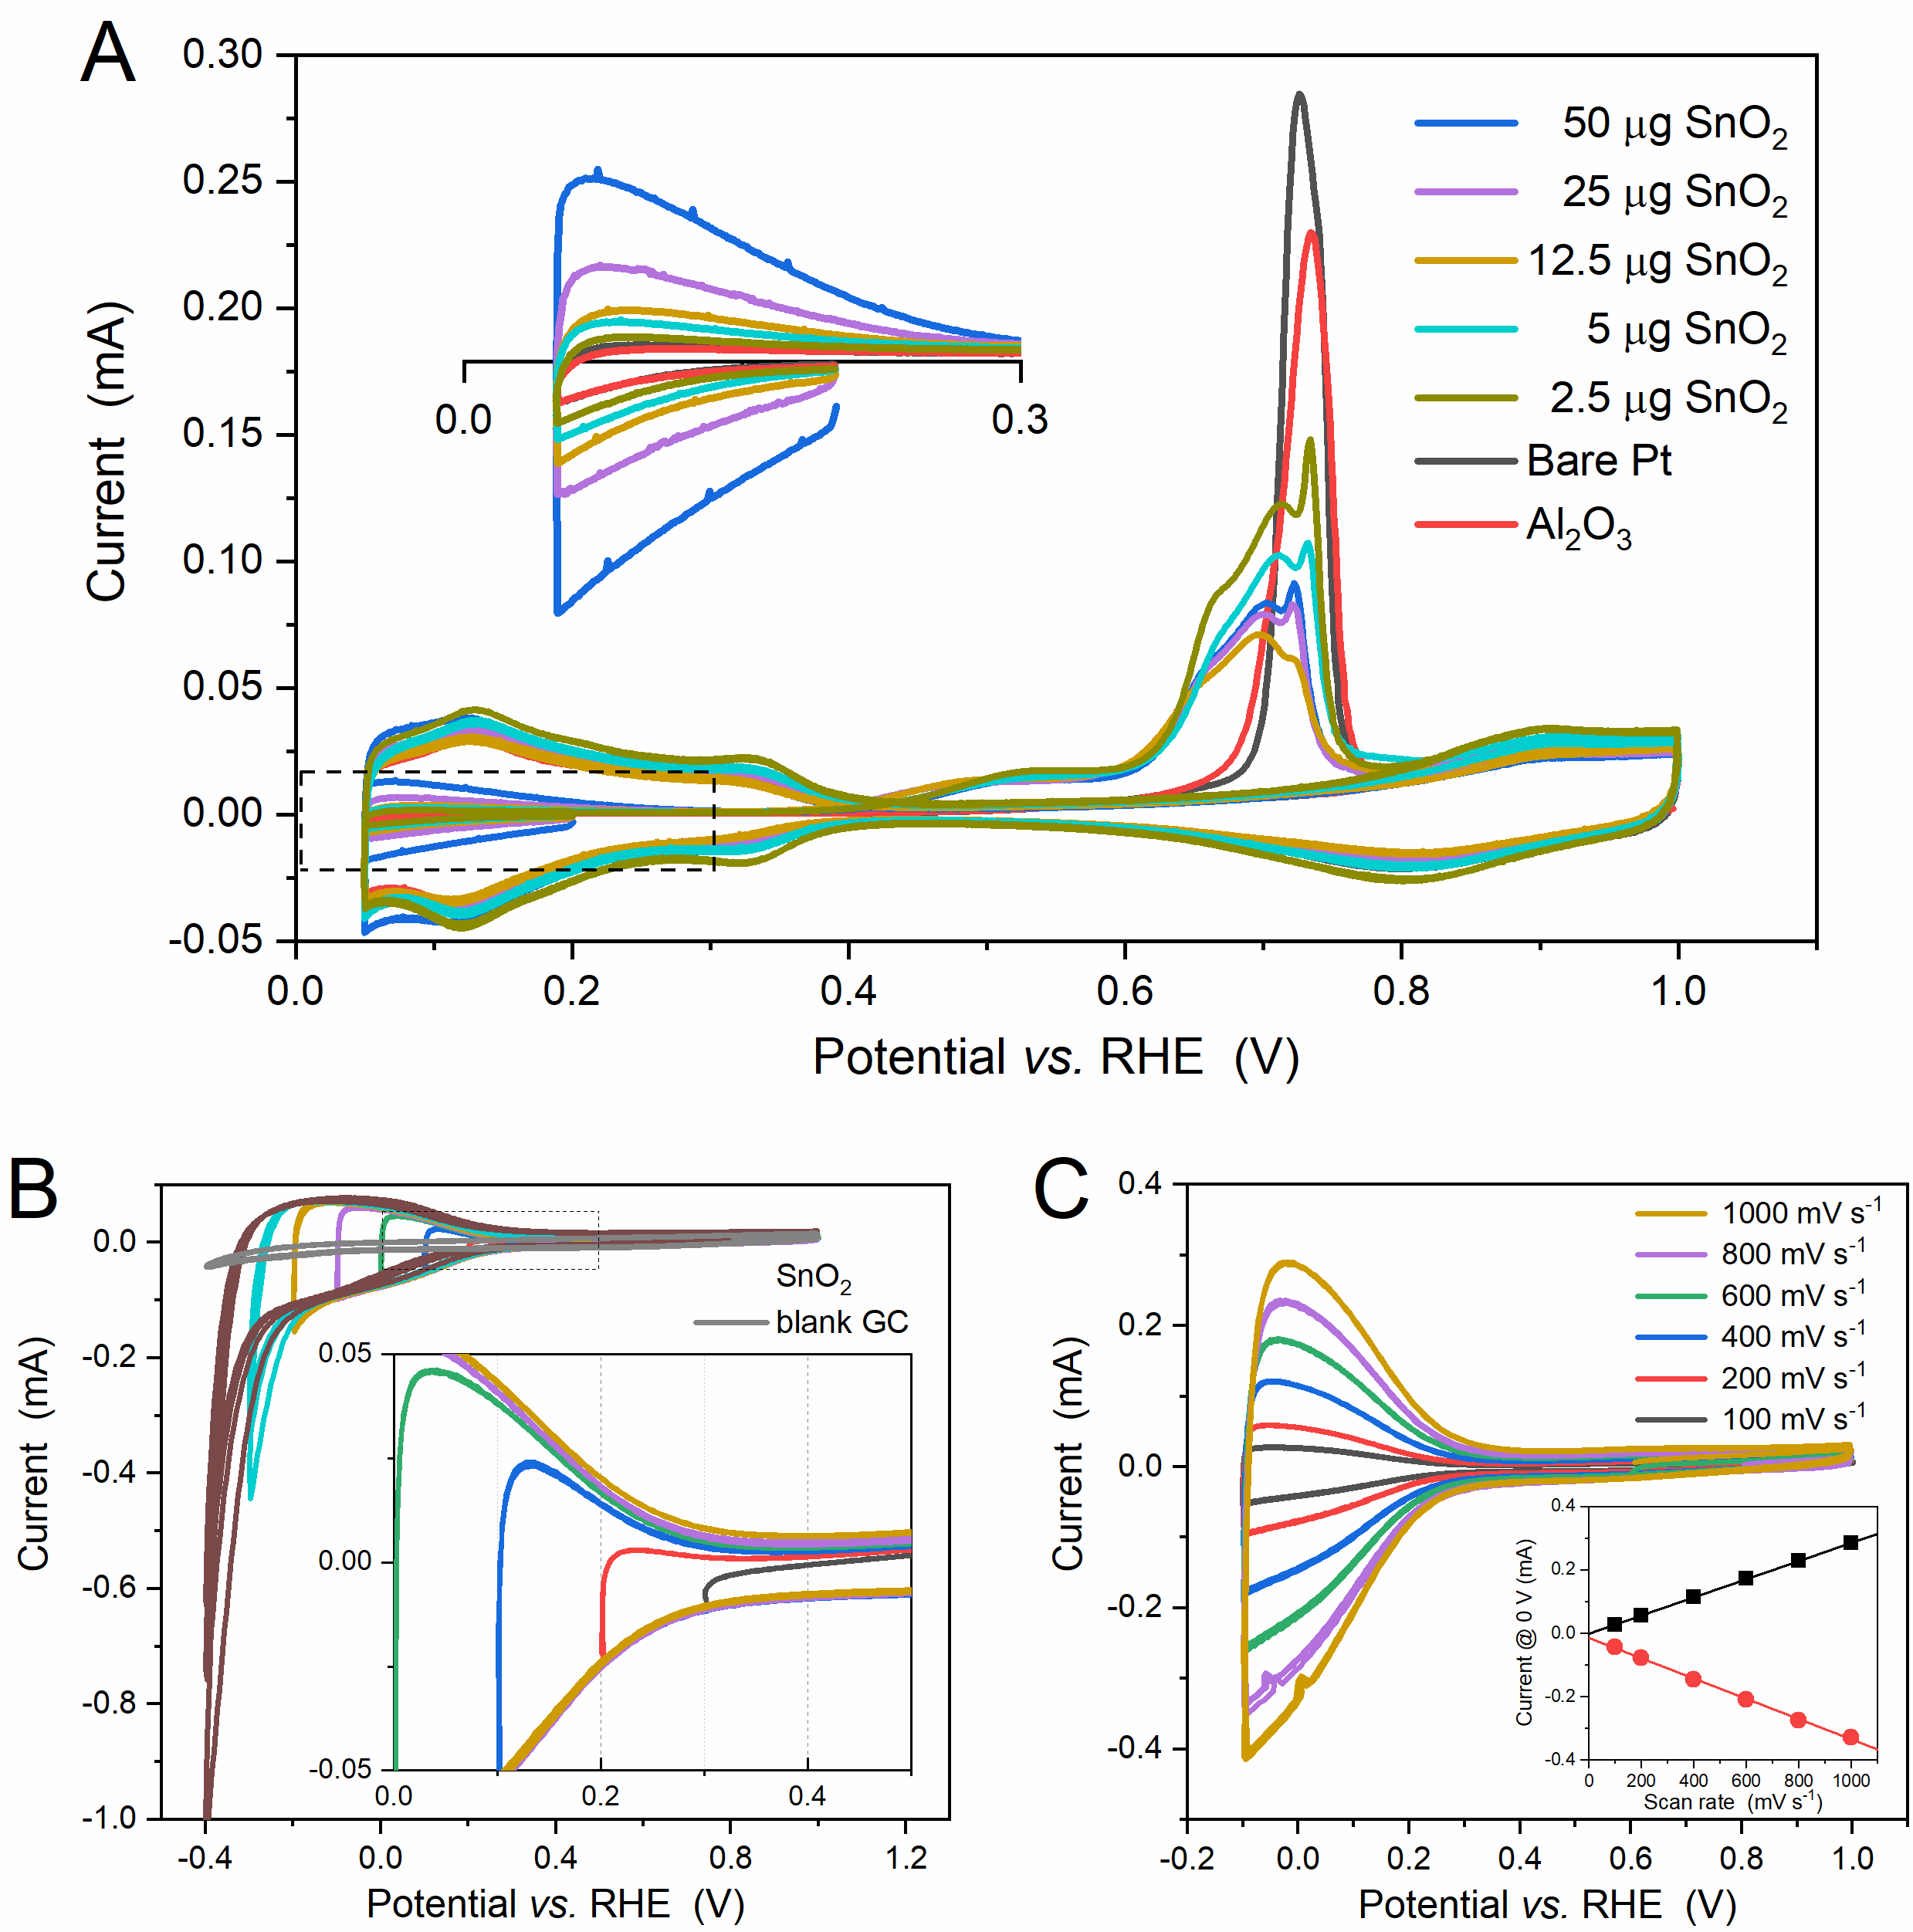
In addition to the enhanced current, no shift is observed in the CO continuous oxidation voltammograms for Pt-SnO₂/C during the sequence of successive cycles at different rotation rates (Figure 7 and Figure S28), compared to a continuous positive shift observed for the Pt/C catalyst (Figure S29 and Figure S30). The deactivation of Pt/C has been attributed to the reconstruction of surface defects^{[32]}. The stable CO oxidation at Pt-SnO₂/C was supported by chronoamperometry with a steady current for 0.5 h at 0.4 V (Figure S32). Transferring the rotation-rate-dependent and stable CO continuous oxidation on Pt-SnO₂ to the proposed mechanism in eq. 1 reveals that the (SnO₂)Sn-OH and (SnO₂)Sn* are interconvertible with relatively fast kinetics during CO oxidation in a potential window of 0.3 – 0.6 V.
Now the question turns to the electrochemistry of the SnO₂ surface. As suggested by the proposed bifunctional mechanism of Pt-SnO₂, a redox reaction of (SnO₂)Sn-OH and (SnO₂)Sn* is expected at potentials around the onset of CO oxidation (~0.3 V), but neither Pt-SnO₂/C nor the physical mixtures between SnO₂ and Pt/C shows any evidence relating to SnO₂ in the voltammograms. The double-layer charging from the carbon support may obscure the voltammetric features. Thus, commercial SnO₂ nanopowders were directly loaded on Pt and glassy carbon (GC) electrodes.
Figure 8A shows CO stripping voltammograms of SnO₂ deposited on a Pt disc electrode with different loadings of SnO₂ nanopowders. On the whole, similar effects of SnO₂, as observed for Pt-SnO₂/C and the Pt/C-SnO₂ physical mixtures, are found on these SnO₂-modified Pt electrodes (unaffected H_{ads/des} features in shape, low onset potentials for CO_{ads} oxidation, and a SnO₂-coverage-induced charge distribution between the main peak and the pre-peak). Closer examination of the H_{ads/des} features region of the first sweep, in which Pt electrochemistry is completely blocked by CO_{ads}, reveals an unconventional pseudo-capacitance, the charge of which increases proportionally to the SnO₂ loading.
The electrochemistry of SnO₂ was then studied on a SnO₂-modified glassy carbon (GC) electrode. Figure 8B and 8C show window-opening and scan-rate dependent voltammograms, respectively. The pseudo-capacitance of SnO₂ is repeatable on GC in the same potential region and found to be related to a highly reversible and surface-bounded redox couple. The redox couple is operative between -0.2 – 0.3 V, and its kinetics allows a symmetric peak shape to be maintained at sweep rates up to 1 V s⁻¹. According to the well-accepted dual valency of Sn in tin oxide chemistry^{[23, 27a]} and the standard electrode potential data of Sn^{[17]}, the redox couple is attributed to the reversible interconversion between Sn^{IV} and Sn^{II} on the SnO₂ surface. Further decreasing the potential drives the irreversible transformation from Sn^{IV} to Sn^{II}, or even Sn^{II} to Sn⁰. The presence of the reversible Sn^{IV}/Sn^{II} redox couple is in agreement with the surface reduction of SnO₂ in H₂(g) as suggested by XAS, and more importantly corroborates the proposed bifunctional mechanism from SnO₂. Thus, the regeneration of Sn-OH, following the L-H reaction of CO oxidation (eq.1), can tentatively be written as
Figure 9. Catalysis cycle of CO oxidation on Pt with the co-catalyst SnO₂.
(SnO₂)Sn^{IV}(OH)₂ + 2 H⁺ + 2e⁻ ⇌ (SnO₂)Sn^{II} + 2 H₂O (eq.2)
It should be noted that the exact coordination structure of this Sn^{IV}/Sn^{II} couple is unclear and that the double coordinated OH in Sn^{IV}(OH)₂ is only used to balance the change of the Sn oxidation state in eq. 2.
From the voltammetry studies presented above, SnO₂ is suggested to enable CO oxidation at a low overpotential by providing Sn-OH. Assuming the SnO₂ component of the Pt-SnO₂ interface has a similar nature to that of plain SnO₂, the bifunctional mechanism at Pt-SnO₂ can be attributed to the co-catalysis of SnO₂, in which the Sn-OH is constantly supplied by a reversible redox couple located on the surface of SnO₂. By such a mechanism, the catalysis cycle of CO oxidation, disconnected on the pure Pt surface due to unfavourable formation of Pt-OH_{ads} at low potential^{[2d, 4a]}, is completed on Pt-SnO₂ (Figure 9). Dissolved CO molecules chemisorb on active Pt sites, forming Pt-CO_{ads} (step ①), and then the CO_{ads} reacts with Sn-OH species (step ②), releasing CO₂, a free Pt site and a Sn^{II} that can be oxidised back to Sn-OH species at the same potential (step ③).
As both the SnO₂-promoted CO oxidation and the redox reaction of Sn^{IV}/Sn^{II} involve the formation/cleavage of Sn^{IV}-OH, the appropriate Sn^{IV}-OH energetics, or matching between these reactions in potential, may be responsible for the unique property of SnO₂ for CO oxidation at low overpotentials. To support this hypothesis, two other metal oxide nanoparticles, Al₂O₃ (Figure 8A) and TiO₂ (P25, Figure S33) deposited on Pt disc electrodes were measured. The deposition of these two metal oxides shows site-blocking effects on Pt rather than any promotional effects. On TiO₂-modified GC electrodes a reversible redox couple relating to Ti^{IV}/Ti^{III} ^{[33]} is found at a potential close to but more negative (< -0.1 V) than that of SnO₂ (Figure S34), suggesting that a stronger driving force is required to dissociate the Ti^{IV}-OH bond. Similarly, the effects of other oxides have previously been investigated. CeO₂, which has a redox couple of Ce^{IV}/Ce^{III} > 1 V^{[34]}, was reported to show no promotional effect when being loaded on Pt^{[35]}. Recently, Olu et al. studied enhanced CO oxidation activity on Pt electrodes modified by RuO₂ nanosheets ^{[36]} and by WO₃ nanoparticles^{[37]}, but different promotional mechanisms were found. The RuO₂ forms ‘Ru metal-like’ sites that provide ligand effects to Pt and additional sites for CO absorption^{[36]}, and the WO₃, the hydroxyl formation on which is less reversible than that of SnO₂, can only assist in the removal of weakly adsorbed CO_{ads} via a bifunctional-type reaction ^{[37]}.
Conclusion
A Pt-SnO₂/C catalyst was designed to study the role of SnO₂ in the bifunctional mechanism of CO oxidation. Using the analytical capabilities of electron microscopy and the equipped spectroscopies, the distribution of the Pt and SnO₂ nanoparticles were observed and found to be present as two forms, isolated Pt nanoparticles on carbon and Pt-SnO₂ nanoparticles clusters, comprising ~2 nm Pt and SnO₂ nanoparticles in contact with each other. The Sn speciation of Pt-SnO₂/C was interrogated by XRD and detailed XAS analysis. XRD and XAS (measured in air) suggest that in the as-prepared samples SnO₂ is the dominate Sn species (>99 at% out of total Sn), and when measured in H₂(g) the XAS suggests that the SnO₂ was reduced, corresponding to surface-reduced SnO₂ species rather than alloyed Sn or SnO.
CO stripping voltammetry on the Pt-SnO₂/C shows that the CO oxidation is strongly promoted, with an onset potential of ~0.3 V and significant contribution in the pre-peak region. Such promotional effects of SnO₂ were corroborated by comparison to Pt-SnO₂ surfaces constructed from mixtures of Pt/C and SnO₂ nanoparticles and SnO₂-modified Pt electrodes. CO continuous oxidation voltammetry of Pt-SnO₂/C suggests that CO oxidation on Pt-SnO₂ at low overpotentials is so fast that the diffusion of dissolved CO becomes the rate-determining-step beyond ~0.4 V, and that a redox couple continuously supplying the necessary Sn-OH species exists at Pt-SnO₂ to maintain the diffusion-determined current. The presence of a reversible Sn^{IV}/Sn^{II} redox couple between -0.2–0.3 V was found in voltammetric studies on SnO₂-modified GC electrodes. We, therefore, propose that the bifunctional mechanism of Pt-SnO₂ originates from the co-catalysis role of SnO₂, in which Sn-OH species are consumed in reacting Pt-CO_{ads} at the interface and regenerated by dissociating water. The unique promotional effect of SnO₂ were then discussed in relation to the appropriate energetics of the metal-hydroxide bond. As the promotional effect does not rely on the modification of the Pt electronic structure, the CO-tolerant Pt-SnO₂ is expected to have unique catalytical properties for alcohol oxidation.
Experimental Section
Hexachloroplantic acid (H₂PtCl₆·6H₂O, 99.999% metals basis) and tin(IV) oxide nanopowder (SnO₂, >99.9%, 8-10 nm) were purchased from Alfa Aesar. Representative results from X-ray diffraction (XRD) and transmission electron microscopy (TEM) imaging analysis of the SnO₂ nanopowder are shown in Figure S1. Sodium stannate trihydrate (Na₂SnO₃·3H₂O, 95%), sodium hydroxide (NaOH, ≥98%) and Nafion perfluorinated resin solution (5 wt%) were purchased from Sigma Aldrich. Vulcan XC-72R carbon and commercial Pt/C (20 wt%) were supplied by Cabot and Johnson Matthey, respectively. High-purity N₂ (≥99.998%), H₂ (≥99.999%), and CO (≥99.9%) were supplied by BOC. All materials were used as received.
100 mg Vulcan XC-72R carbon was dispersed into 200 mL ultrapure water (18.2 MΩ) by sonication for 1 h. To the colloid solution, a H₂PtCl₆ solution (~0.2 M), NaOH solution (~0.2 M) at 4 molar equivalent to H₂PtCl₆, and Na₂SnO₃ solution were introduced stepwise with an interval of 5 min sonication and 30 min stirring. The resultant solution was heated under reflux at 90 °C for 1 h, then allowed to settle overnight. The solid product was collected via centrifugation and washed three times with water before being dried under vacuum. The total metal loading (Pt + Sn) on the carbon was controlled to be 20 wt%. Using the same method, PtO_{x}-SnO₂/C catalysts with nominal Pt/Sn molar ratios of 3/1 and 1/3, as well as PtO_{x}/C, were synthesised.
PtO_{x}/C and PtO_{x}-SnO₂/C were reduced into Pt/C and Pt-SnO₂/C, respectively, by exposure to H₂ (g) at room temperature. The reduction was carried out in an air-tight cell fitted to a flow regulator and gas bubbler (Figure S2). N₂, H₂, and N₂ gases (40 mL min⁻¹) were purged through each sample consecutively for 20 min periods. The resultant samples were stored in air-tight vials. Caution – the reduced sample in H₂ should not be directly exposed to air – fire risk.
Scanning electron microscopy (SEM) together with energy-dispersive X-ray (EDX) analysis (SEM-EDX, FEI XL30 ESEM equipped with an Ultradry detector and JEOL JSM5400 SEM equipped with an Oxford INCA x-sight 7418 EDS probe) and thermogravimetric analysis (Netzch TG209) under 40 mL min⁻¹ O₂/Ar were carried out to determine the composition and metal loading of the as-prepared samples. For our targeted sample Pt-SnO₂/C, the atomic ratio of Pt to Sn, and the loadings of Pt and SnO₂ are 2.62 ± 0.12, ~12.3 wt% and ~4.0 wt%, respectively. The morphology and the size of the deposited metal nanoparticles were imaged using a transmission electron microscope (TEM; FEI, Tecnai T12) at 80 kV. X-ray diffraction (XRD) patterns were obtained using a Bruker D2 Phaser diffractometer with Cu K_{α} radiation (λ = 1.5418 Å) and a LYNXEYE detector.
Scanning transmission electron microscopy (STEM) measurements were carried out on an aberration-corrected Nion UltraSTEM 100MC at the SuperSTEM Laboratory (Daresbury, UK). The microscope was operated with an accelerating voltage of 60 kV, using a 31.5 mrad beam convergence semi-angle for an electron probe size of about 1 Å. The electron energy loss (EEL) spectrometer collection semi-angle was 44 mrad and, the bright field (BF) and high-angle annular dark field (HAADF) detector angular ranges were 0-14 mrad and 100-230 mrad, respectively. Sn M_{4,5} (onset 485 eV) and O K (onset 532 eV) ionization edge spectrum images were acquired with an energy dispersion of 0.6 eV per channel and an acquisition time of 0.02 s per spectrum. Due to its high energy onset at 2202 eV, it was more practical to acquire Pt M_{4,5} edge spectrum images separately from those covering the Sn M_{4,5} and O K edges, maintaining the same dispersion (0.6 eV per channel), but increasing the exposure time to 0.5 s. EELS spectrum images were de-noised using Principal Component Analysis (PCA) as implemented in the MSA plugin for Gatan’s Digital Micrograph Suite. The MSA plugin is commercially available from HREM research. EELS signal maps were obtained by integrating the intensity over a window of 485–530 eV for Sn M_{4,5} and of 2150–2300 eV for Pt M_{4,5}, after background subtraction using a conventional power-law model over a window of 420–480 eV for Sn M_{4,5} and of 2000–2100 eV for Pt M_{4,5}. Red (Pt M_{4,5}) and green (Sn M_{4,5} and O K) colour maps in Figure 1F, Figure S7C, Figure S8B and Figure S9C are superimposed from the complementary datasets from the same sample regions.
X-ray absorption spectra were acquired at the B18 beamline of the Diamond Light Source (UK) using a Quick EXAFS mode with a ring energy of 3.0 GeV and a ring current of 299–302 mA. Each sample was finely ground and mixed with boron nitride to form a homogeneous mixture, and then compressed into a pellet. The pellets were measured in transmission mode by ionization chambers at the Pt L₃ and Sn K edges, along with a corresponding foil in the reference channel. The measurements were conducted in an airtight gas cell under H₂(g), unless otherwise indicated and for the oxide reference samples, which were measured in air. The measured spectra were processed and analysed using ATHENA and ARTEMIS (both in the Demeter software package)^{[38]}, respectively. The energy shift of each spectrum was calibrated in two steps: choosing the first peak in the derivative of both the sample spectrum and the corresponding reference spectrum as E₀, and then assigning the E₀ of the reference spectrum to the tabulated value provided by ATHENA. The edge step of each sample was normalized by subtracting the linear pre-edge and quadratic post-edge function, and the ranges of pre-edge and post-edge are chosen as the same for each edge. The background in the extended X-ray absorption fine structure (EXAFS) region was subtracted using the AUTOBKG algorithm. The multiple-shell EXAFS fitting was carried out on Pt L₃ edge data using a model based on the face-cubic structure of Pt. The same model was applied to a Pt foil spectrum to obtain the amplitude reduction factor of Pt, 0.84. Similarly, the amplitude reduction factor of Sn is 1.03, obtained by a two-shell fit of a SnO₂ reference sample. The Fourier transformation from EXAFS spectra in k space to those in R space was conducted over a k range of 3.0–15.0 Å⁻¹ for the Pt L₃ edge and a k range of 3.5–13.4 Å⁻¹ for the Sn K edge. The spectra in R space, presented in the text, are not phase-corrected.
Electrochemical measurements were performed on a standard three-electrode cell connected to a PGSTAT12 potentiostat (Metrohm Autolab, with a SCANGEN module). A Pt gauze was used as the counter electrode, and a home-made reversible hydrogen electrode (RHE) equipped with a Luggin capillary as the reference electrode. The RHE consists of a Pt gauze electrode over which a slow yet continuous stream of H₂ (g) bubbles were passed, using the same electrolyte as the main cell compartment. The values of potentials in the text are referenced against this RHE, unless stated otherwise.
For powder catalysts, the working electrode was prepared by drop-casting 10 μL of a catalyst ink onto an inverted polished glassy carbon (GC) electrode (5 mm diameter, Pine) and drying at 700 rpm and under an IR lamp (250 W). The catalyst ink was prepared by dispersing 2 mg of each sample into 1 mL isopropanol alcohol (IPA) aqueous solution (20 vol% of IPA). The catalyst inks of Pt/C-SnO₂ physical mixtures were prepared by dispersing SnO₂ into a commercial Pt/C ink whilst maintaining the concentration of Pt/C as 2 mg mL⁻¹. Prior to measurements, the prepared working electrodes were conditioned in N₂-purged 0.1 M HClO₄ (Suprapur, Merck) by cycling between 50 mV and 800 mV for at least 10 cycles with a scan rate of 100 mV s⁻¹.
For the CO stripping voltammetry, CO was bubbled into degassed 0.1 M HClO₄ for 20 min whilst the potential of the prepared working electrode was held at 0.2 V. Subsequently, N₂ was purged for another 20 min to remove CO from the electrolyte and the potential was then swept to 0.05 V at a scan rate of 20 mV s⁻¹ and then cycled between 0.05 V and 1 V for 3 cycles with the same scan rate.
Oxide modified Pt and GC electrodes were also used as working electrodes. Each metal oxide, SnO₂ (8–10 nm, Alfa Aesar), Al₂O₃ (0.05 μm, BUEHLER) or TiO₂ (P25), was loaded onto a Pt electrode (5 mm diameter, Pine) or a polished glassy carbon (GC) electrode (5mm diameter) using the drop-casting method as described above. Metal oxide suspensions were prepared by sonicating 5 mg of each metal oxide in 1 mL IPA aqueous solution (40 vol% of IPA). Each bare Pt electrode was polished and then conditioned by cycling between 0.05–1.40 V in N₂-purged 0.1 M HClO₄ with 200 mV s⁻¹ for at least 40 cycles. Before electrochemical measurements, the modified Pt and GC electrodes were conditioned over a narrower potential window (0.05–1.0 V). The CO stripping voltammetry on the Pt electrodes was carried out at a scan rate of 50 mV s⁻¹.

Acknowledgements
HH acknowledges Fellowship support from the China Scholarship Council (201608440295) and the University of Southampton. XAS data were collected at Diamond on B18 as part of the UK Catalysis Hub BAG allocation (SP15151-9 and SP15151-10). SuperSTEM is the UK National Research Facility for Advanced Electron Microscopy, supported by the Engineering and Physical Sciences Research Council (EPSRC).
Keywords: Bifunctional mechanism • Pt-SnO₂ • SnO₂ • CO oxidation • electrocatalysts
[1] a) H. A. Gasteiger, N. M. Markovic, P. N. Ross, J. Phys. Chem. 1995, 99, 8945-8949; b) H. A. Gasteiger, N. M. Marković, P. N. Ross, Catal. Lett. 1996, 36, 1-8.
[2] a) Q. Wang, G. Q. Sun, L. H. Jiang, Q. Xin, S. G. Sun, Y. X. Jiang, S. P. Chen, Z. Jusys, R. J. Behm, Phys. Chem. Chem. Phys. 2007, 9, 2686-2696; b) S. X. Liu, L. W. Liao, Q. Tao, Y. X. Chen, S. Ye, Phys. Chem. Chem. Phys. 2011, 13, 9725-9735; c) M. Heinen, Z. Jusys, R. J. Behm, in Handbook of Fuel Cells, 2010; d) M. T. M. Koper, S. C. S. Lai, E. Herrero, in Fuel Cell Catalysis, 2009, pp. 159-207.
[3] G. Garcia, M. T. Koper, ChemPhysChem 2011, 12, 2064-2072.
[4] a) N. Markovic, Surf. Sci. Rep. 2002, 45, 117-229; b) E. Antolini, E. R. Gonzalez, Electrochim. Acta 2010, 56, 1-14; c) Y. Liu, D. Li, V. R. Stamenkovic, S. Soled, J. D. Henao, S. Sun, ACS Catal. 2011, 1, 1719-1723; d) Z. Liu, G. S. Jackson, B. W. Eichhorn, Angew. Chem., Int. Ed. 2010, 49, 3173-3176.
[5] a) B. E. Hayden, M. E. Rendall, O. South, J. Am. Chem. Soc. 2003, 125, 7738-7742; b) M. Watanabe, M. Shibata, S. Motoo, J. Electroanal. Chem. Interfacial Electrochem. 1985, 187, 161-174.
[6] a) V. R. Stamenkovic, M. Arenz, C. A. Lucas, M. E. Gallagher, P. N. Ross, N. M. Markovic, J. Am. Chem. Soc. 2003, 125, 2736-2745; b) V. Stamenkovic, M. Arenz, B. B. Blizanac, K. J. J. Mayrhofer, P. N. Ross, N. M. Markovic, Surf. Sci. 2005, 576, 145-157.
[7] a) B. E. Hayden, M. E. Rendall, O. South, J. Mol. Catal. A: Chem. 2005, 228, 55-65; b) A. N. Haner, P. N. Ross, J. Phys. Chem. 1991, 95, 3740-3746; c) G. Stalnionis, L. Tamašauskaitė-Tamašiūnaitė, V. Pautienienė, A. Sudavičius, Z. Jusys, J. Solid State Electrochem. 2004, 8, 892-899.
[8] a) E. Antolini, E. R. Gonzalez, Catal. Today 2011, 160, 28-38; b) X. Lu, Z. Deng, C. Guo, W. Wang, S. Wei, S. P. Ng, X. Chen, N. Ding, W. Guo, C. M. Wu, ACS Appl. Mater. Interfaces 2016, 8, 12194-12204.
[9] a) J. M. Jin, T. Sheng, X. Lin, R. Kavanagh, P. Hamer, P. Hu, C. Hardacre, A. Martinez-Bonastre, J. Sharman, D. Thompsett, W. F. Lin, Phys. Chem. Chem. Phys. 2014, 16, 9432-9440; b) L. Calvillo, L. Mendez De Leo, S. J. Thompson, S. W. T. Price, E. J. Calvo, A. E. Russell, J. Electroanal. Chem. 2018, 819, 136-144.
[10] a) Y. Lin, S. Zhang, S. Yan, G. Liu, Electrochim. Acta 2012, 66, 1-6; b) M. Arenz, V. Stamenkovic, B. Blizanac, K. Mayrhofer, N. Markovic, P. Ross, J. Catal. 2005, 232, 402-410; c) F. Ye, J. Li, T. Wang, Y. Liu, H. Wei, J. Li, X. Wang, J. Phys. Chem. C 2008, 112, 12894-12898.
[11] H. Huang, A. Nassr, V. Celorrio, S. F. R. Taylor, V. K. Puthiyapura, C. Hardacre, D. J. L. Brett, A. E. Russell, Faraday Discuss. 2018, 208, 555-573.
[12] a) G. Wang, T. Takeguchi, T. Yamanaka, E. N. Muhamad, M. Mastuda, W. Ueda, Appl. Catal., B 2010, 98, 86-93; b) D. R. M. Godoi, J. Perez, H. M. Villullas, J. Power Sources 2010, 195, 3394-3401.
[13] E. M. Crabb, R. Marshall, D. Thompsett, J. Electrochem. Soc. 2000, 147, 4440-4447.
[14] S. Speller, U. Bardi, in The Chemical Physics of Solid Surfaces, Vol. 10 (Ed.: D. P. Woodruff), Elsevier, 2002, pp. 184-224.
[15] a) W. D. Michalak, J. M. Krier, S. Alayoglu, J.-Y. Shin, K. An, K. Komvopoulos, Z. Liu, G. A. Somorjai, J. Catal. 2014, 312, 17-25; b) J. L. Margitfalvi, I. Borbáth, M. Hegedűs, E. Tfirst, S. Gőbölös, K. Lázár, J. Catal. 2000, 196, 200-204; c) M. Vandichel, A. Moscu, H. Grönbeck, ACS Catal. 2017, 7, 7431-7441.
[16] K. J. Cathro, J. Electrochem. Soc. 1969, 116, 1608-1611.
[17] P. Vanysek, in CRC handbook of chemistry and physics, Vol. 87, 1998.
[18] A. Rabis, D. Kramer, E. Fabbri, M. Worsdale, R. Kötz, T. J. Schmidt, J. Phys. Chem. C 2014, 118, 11292-11302.
[19] a) D.-H. Lim, D.-H. Choi, W.-D. Lee, H.-I. Lee, Appl. Catal., B 2009, 89, 484-493; b) D.-H. Lim, D.-H. Choi, W.-D. Lee, D.-R. Park, H.-I. Lee, Electrochem. Solid-State Lett. 2007, 10, B87-B90.
[20] T. Matsui, K. Fujiwara, T. Okanishi, R. Kikuchi, T. Takeguchi, K. Eguchi, J. Power Sources 2006, 155, 152-156.
[21] a) M. S. Holt, W. L. Wilson, J. H. Nelson, Chem. Rev. 1989, 89, 11-49; b) O. I. Milner, G. F. Shipman, Anal. Chem. 1955, 27, 1476-1478.
[22] a) D. Y. DeSario, F. J. DiSalvo, Chem. Mater. 2014, 26, 2750-2757; b) W. Du, G. Yang, E. Wong, N. A. Deskins, A. I. Frenkel, D. Su, X. Teng, J. Am. Chem. Soc. 2014, 136, 10862-10865; c) F. Humblot, F. Lepeltier, J. P. Candy, J. Corker, O. Clause, F. Bayard, J. M. Basset, J. Am. Chem. Soc. 1998, 120, 137-146.
[23] M. Batzill, U. Diebold, Prog. Surf. Sci. 2005, 79, 47-154.
[24] a) A. López-Cudero, J. Solla-Gullón, E. Herrero, A. Aldaz, J. M. Feliu, J. Electroanal. Chem. 2010, 644, 117-126; b) S. Guerin, B. E. Hayden, C. E. Lee, C. Mormiche, J. R. Owen, A. E. Russell, B. Theobald, D. Thompsett, J Comb Chem 2004, 6, 149-158.
[25] a) M. J. S. Farias, W. Cheuquepán, A. A. Tanaka, J. M. Feliu, ACS Catal. 2017, 7, 3434-3445; b) R. Rizo, E. Pastor, M. T. M. Koper, J. Electroanal. Chem. 2017, 800, 32-38.
[26] T. Takeguchi, A. Kunifuji, N. Narischat, M. Ito, H. Noguchi, K. Uosaki, S. R. Mukai, Catal. Sci. Technol. 2016, 6, 3214-3219.
[27] a) S. Das, V. Jayaraman, Prog. Mater. Sci. 2014, 66, 112-255; b) H. Tamura, K. Mita, A. Tanaka, M. Ito, J. Colloid Interface Sci. 2001, 243, 202-207.
[28] a) D. R. Schryer, B. T. Upchurch, B. D. Sidney, K. G. Brown, G. B. Hoflund, R. K. Herz, J. Catal. 1991, 130, 314-317; b) D. R. Schryer, B. T. Upchurch, J. D. Van Norman, K. G. Brown, J. Schryer, J. Catal. 1990, 122, 193-197.
[29] S. Gilman, J. Phys. Chem. 1964, 68, 70-80.
[30] J. S. Spendelow, J. D. Goodpaster, P. J. Kenis, A. Wieckowski, J. Phys. Chem. B 2006, 110, 9545-9555.
[31] C. A. Angelucci, E. Herrero, J. M. Feliu, J. Phys. Chem. C 2010, 114, 14154-14163.
[32] a) D. S. Strmcnik, D. V. Tripkovic, D. van der Vliet, K. C. Chang, V. Komanicky, H. You, G. Karapetrov, J. P. Greeley, V. R. Stamenkovic, N. M. Markovic, J. Am. Chem. Soc. 2008, 130, 15332-15339; b) J. Inukai, D. A. Tryk, T. Abe, M. Wakisaka, H. Uchida, M. Watanabe, J. Am. Chem. Soc. 2013, 135, 1476-1490; c) A. V. Rudnev, A. Kuzume, Y. Fu, T. Wandlowski, Electrochim. Acta 2014, 133, 132-145.
[33] a) L. A. Lyon, J. T. Hupp, J. Phys. Chem. B 1999, 103, 4623-4628; b) K. R. Reyes-Gil, Z. D. Stephens, V. Stavila, D. B. Robinson, ACS Appl. Mater. Interfaces 2015, 7, 2202-2213.
[34] a) S. A. Hayes, P. Yu, T. J. O’Keefe, M. J. O’Keefe, J. O. Stoffer, J. Electrochem. Soc. 2002, 149, C623-C630; b) N. Padmanathan, S. Selladurai, Ionics 2014, 20, 409-420.
[35] Y. Katayama, T. Okanishi, H. Muroyama, T. Matsui, K. Eguchi, ACS Catal. 2016, 6, 2026-2034.
[36] P.-Y. Olu, T. Ohnishi, D. Mochizuki, W. Sugimoto, J. Electroanal. Chem. 2018, 810, 109-118.
[37] P.-Y. Olu, T. Ohnishi, Y. Ayato, D. Mochizuki, W. Sugimoto, Electrochem. Commun. 2016, 71, 69-72.
[38] B. Ravel, M. Newville, J. Synchrotron Radiat. 2005, 12, 537-541.

Entry for the Table of Contents

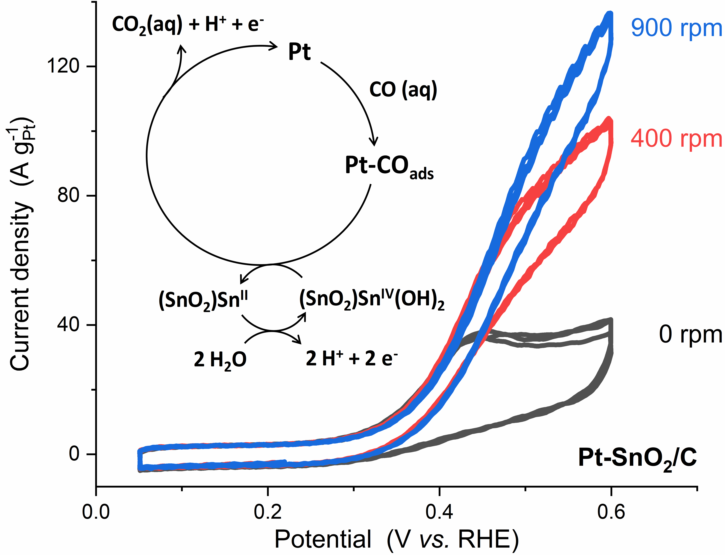

The CO oxidation is strongly promoted on Pt-SnO₂ interfaces (Pt-SnO₂/C, mixtures of Pt/C and SnO₂ nanoparticles, and SnO₂-modified Pt electrodes). The kinetics at low overpotential is so fast that the diffusion of dissolved CO becomes the rate-determining-step beyond ~0.45 V_{RHE}. By identifying a redox couple of Sn^{IV}/Sn^{II} on the SnO₂ surface, the promotional mechanism of Pt-SnO₂ is attributed to the co-catalysis role of SnO₂.

