Tris(oxalato)chromate(III) hybrid salts templated by pyridinium and mixed pyridinium-ammonium cations: synthesis, structures and magnetism

Coustel M. N. Choubeuª, Bridget N. Ndosiriª, Hervé Vezin^{b}, Claire Minaud^{c}, James B. Orton^{d}, Simon J. Coles^{d} and Justin Nenwaª
ªInorganic Chemistry Department, University of Yaounde 1, P.O. Box 812, Yaounde, Cameroon; ^{b}Université de Lille, LASIRE CNRS UMR 8516, 59655 Villeneuve d’Ascq, Lille, France; ^{c}Université de Lille, Institut Chevreul CNRS FR2638, 59655 Villeneuve d’Ascq, Lille, France; ^{d}School of Chemistry, Faculty of Engineering and Physical Sciences, University of Southampton, Southampton, SO17 1BJ. UK

Corresponding author: Justin Nenwa
E-mail: jnenwa@yahoo.fr

Abstract
By modifying the stoichiometric ratio of starting materials, two tris(oxalato)chromate(III) salts, namely, (C₇H₁₁N₂)₃[Cr(C₂O₄)₃] (1) and (C₅H₈N₃)₂(NH₄)[Cr(C₂O₄)₃]·2H₂O (2) {(C₇H₁₁N₂)⁺ = 2-amino-4,6-dimethylpyridinium, (C₅H₈N₃)⁺ = 2,6-diaminopyridinium}, were synthesized and characterized by elemental and thermal analyses, single-crystal X-ray diffraction, IR and UV-Vis spectroscopies, EPR and SQUID measurements. Salt 1 exhibits a 3D supramolecular framework based on the [Cr(C₂O₄)₃]³⁻ anions and 2-amino-4,6-dimethylpyridinim cations, (C₇H₁₁N₂)⁺, via hydrogen bonds of the type N–H∙∙∙O. Interestingly, π–π stacking interactions between pyridine rings contribute to the stabilization of the crystal packing. In contrast to salt 1, no π–π stacking interactions are observed in the mixed-cation salt 2 and its crystal packing is consolidated by N–H∙∙∙O and O–H∙∙∙O hydrogen bonds. EPR spectra of 1 and 2 are in line with the oxidation state +3 of the chromium centre in an octahedral environment. Temperature-dependence of the magnetic susceptibility data investigated in the temperature range 2–300 K revealed the existence of the zero-field splitting effects (ZFS) for Cr(III) ions in both compounds.

Keywords: Hybrid salts; oxalate chromium(III) complex; stoichiometry; crystal structures; magnetism

1. Introduction
Organic-inorganic hybrid salts (OIHSs) currently represent a topic of intense research in the field of crystal engineering [1,2]. They provide the possibility of combining suitable organic cations and inorganic counter-parts within a single crystal, leading to unique electronic [3], magnetic [4,5], catalytic [6], metallic conductivity [7] and optical [8,9] properties. In general, transition metal complexes provide useful anionic building blocks for the construction of OIHSs. In this respect, among the tris(oxalato)metalates [M(C₂O₄)₃]³⁻ (M = Fe^{III}, Co^{III}, Cr^{III}), the [Cr(C₂O₄)₃]³⁻ unit is with no doubt, the most intensively investigated, given the stable electronic configuration (t_{2g})³(e_{g})⁰ of its central metal ion [10-13]. However, control over the formation of these OIHSs resulting from the self-assembly of [M(C₂O₄)₃]³⁻ units and organic cations remains a challenging task. Tris(oxalato)metalate(III) hybrid salts can be prepared following a handful of strategies, one of which is the salt metathesis approach. This strategy can formally generate the target compound if appropriate precursors salts are chosen. The outcome often is influenced by the pH of the medium, the synthesis method and, more importantly, the stoichiometric ratio of the starting materials [14,15].
Recent reports by our research group on a series of OIHSs with general formula (Org-H)₃[M^{III}(C₂O₄)₃]·nH₂O (Org-H⁺ = iminium cations) clearly demonstrated the crucial role of the stoichiometric ratio of the starting materials in organizing individual entities into supramolecular 3-dimensional frameworks [16,17]. Hence, the interesting architectural features and magnetic properties of these OIHSs and the relatively unexplored structural chemistry of their Cr(III) complexes prompted us to undertake the present study. Herein, we report the crystal structures, thermal analyses and magnetic properties of two Cr(III) hybrid salts, (C₇H₁₁N₂)₃[Cr(C₂O₄)₃] (1) and (C₅H₈N₃)₂(NH₄)[Cr(C₂O₄)₃]·2H₂O (2) {(C₇H₁₁N₂)⁺ = 2-amino-4,6-dimethylpyridinium, (C₅H₈N₃)⁺ = 2,6-diaminopyridinium}. The overall magnetic behaviour of 1 and 2 suggests the presence of the zero-field splitting effects (ZFS) for Cr(III) ions.

2. Experimental
2.1. Materials and physical measurements
All chemicals used in the synthesis were reagent grade, commercially available (Aldrich, Prolabo and Merck), and were used without further purification. The precursor salt (NH₄)₃[Cr(C₂O₄)₃]·3H₂O was synthesized based on literature method [18]. Elemental analyses (CHN) were performed on a Perkin–Elmer 240C analyser. Infrared spectra were recorded in the range 4000–400 cm⁻¹ on a Perkin-Elmer 2000 spectrometer. Electronic spectra were measured in aqueous solutions using a UV-Vis HACH/Series DR 3900 spectrophotometer. Thermogravimetric analysis (TGA) was carried out on a LINSEIS STA PT-1000 thermal analyser. The powdered sample (ca. 20 mg) was heated in air from 25 to 500 °C at a scan rate of 10 °C min⁻¹. Powder X-ray diffraction experiments were carried out on a Bruker D8 diffractometer using Cu Kα radiation. The sample was ground to a fine powder and loaded into an aluminium tray with the conditions: angular range: 5-80°; step: 0.02; integration time: 0.5 s. Where available these spectra were compared with those determined from the single crystal structures. Electron paramagnetic resonance (EPR) measurements were carried out with a Bruker ELEXYS E500 spectrometer operating at 9 GHz. The samples, each containing around 30 mg of loose powder, were placed into 4 mm diameter quartz tubes. The measurements were performed at room temperature with a microwave power of 0.3 mW and an amplitude modulation of 3G. Variable temperature magnetic susceptibilities were measured with a Quantum Design PPMS Dynacool 9T magnetometer. Measurements were done at 0.1 T down to 2 K on polycrystalline samples. Diamagnetic corrections were made with Pascal’s constants for all the constituent atoms [19].

2.2. Syntheses
2.2.1. Synthesis of (C₇H₁₁N₂)₃[Cr(C₂O₄)₃] (1)
To a solution of oxalic acid (0.63 g, 5.0 mmol, slight excess) in water (50 mL), 2-amino-4,6-dimethylpyridine (1.23 g, 10 mmol) was added. The mixture was stirred for 1 h at 50 °C. To this solution, a freshly prepared (NH₄)₃[Cr(C₂O₄)₃]·3H₂O salt (1.06 g, 2.5 mmol) was added in successive small portions and a purple solution was formed. After 30 min of stirring at 50 °C, the mixture was cooled to room temperature and filtered. The filtrate was allowed to evaporate in a hood at room temperature. Two weeks later, purple block crystals suitable for X-ray diffraction were harvested. Yield: 1.5 g (87.7 % based on (NH₄)₃[Cr(C₂O₄)₃]·3H₂O). Anal. Calcd. for C₂₇H₃₃CrN₆O₁₂ (1) (%): C, 47.25; H, 4.81; N, 12.25. Found (%): C, 47.04; H, 4.80; N, 12.19. IR data (cm⁻¹): 3327 (w), 3168 (w), 3085 (w), 1703 (s), 1633 (s); 1386 (s), 1254 (s), 538 (s); 512 (s), 472 (s) (Figure S1). UV–Vis (H₂O solution, nm): 419, 571 (Figure S2).

2.2.2. Synthesis of (C₅H₈N₃)₂(NH₄)[Cr(C₂O₄)₃]∙2H₂O (2)
2,6-diaminopyridine (0.83 g, 7.5 mmol) was added to an aqueous solution (50 mL) of oxalic acid (0.48 g, 3.75 mmol). The mixture was stirred for 1 h at 50 °C. A freshly prepared (NH₄)₃[Cr(C₂O₄)₃]·3H₂O salt (1.06 g, 2.5 mmol) was added in successive small portions to the previous solution. After 30 min of stirring at 50 °C, the mixture was cooled to room temperature and filtered. The filtrate was allowed to evaporate in a hood at room temperature. Two weeks later, dark-orange block crystals suitable for X-ray diffraction were obtained. Yield: 1.30 g (88.13 % based on (NH₄)₃[Cr(C₂O₄)₃]·3H₂O). Anal. Calcd. for C₁₆H₂₄CrN₇O₁₄ (2) (%): C, 32.51; H, 4.06; N, 16.59. Found (%): C, 32.72; H, 4.07; N, 16.77. IR data (cm⁻¹): 3559 (w), 3424 (w), 3326 (w), 3164 (w), 1702 (s), 1680 (s), 1369 (s), 1255 (s), 534 (s), 466 (s), 403 (s) (Figure S3). UV–Vis (H₂O solution, nm): 418, 569 (Figure S4).

2.3. Crystal structure determination
The data for compounds 1 and 2 were collected at 100(2) K on a Rigaku FRE+ diffractometer using graphite-monochromated Mo Kα radiation (λ = 0.71075 Å). The dataset coverage and collection strategy were based on the strategy calculation in the program CrysAlisPro 1.171.40.47a [20]. The structures were solved with the SHELXT program [21] using the intrinsic phasing solution method. The model was refined with SHELXL-2018/3 [22] using least squares minimization. All non-hydrogen atoms were refined anisotropically and all N–H and O–H atoms were located from the electron density difference map and refined with their thermal parameters linked to their parent atoms. The positions of the remaining C–H atoms were calculated geometrically and refined using riding models. The material used for publication was prepared within the Olex2 software package [23]. The crystallographic data and structure refinement details are summarized in Table 1.

3. Results and discussion
3.1. Formation of 1 and 2
In order to obtain salt (C₇H₁₁N₂)₃[Cr(C₂O₄)₃] (1) with the expected general formula (Org-H)₃[M^{III}(C₂O₄)₃]·nH₂O (Org-H⁺ = iminium cations), the ion-exchange strategy was carried out by reacting (NH₄)₃[Cr(C₂O₄)₃]⋅3H₂O with (C₇H₁₁N₂)₂C₂O₄, in 1:2, instead of the normal 1:1.5 molar ratio in water. The slight excess of the precursor salt (C₇H₁₁N₂)₂C₂O₄ played a key role in the formation of the target salt 1. By contrast, combining (NH₄)₃[Cr(C₂O₄)₃]⋅3H₂O with bis(2,6-diaminopyridinium) oxalate, (C₅H₈N₃)₂C₂O₄, in normal 1:1.5 molar ratio in water resulted in the partial exchange of ammonium cations by 2,6-diaminopyridinium cations to yield not the expected salt, but rather the mixed 2,6-diaminopyridinium-ammonium salt (C₅H₈N₃)₂(NH₄)[Cr(C₂O₄)₃]∙2H₂O (2). It is worth noting at this stage that for successful preparation of both materials to prevail, care must also be taken to work in slightly acidic medium (pH ≈ 3–4) in order to avoid destruction of the anionic building block [Cr^{III}(C₂O₄)₃]³⁻. If the organic molecules (Org) are protonated using a strong acid like (H₃O⁺Cl⁻) (pH ≤ 2), the reaction is bound to fail, leading to a diversity of unexpected structures [14, 15, 17]. This result shows that the outcome of these ion-exchange reactions is strongly influenced by both the stoichiometric ratio of the starting precursor salts and the pH of the medium. Elemental analysis (CHN) nicely agrees with the chemical composition of 1 and 2.
3.2. Structural description of 1
Salt 1 crystallises in the triclinic P$\overline{1}$ space group. As shown in Figure 1a, the asymmetric unit consists of one tris(oxalato)chromate(III) complex anion [Cr(C₂O₄)₃]³⁻ and three 2-amino-4,6-dimethylpyridinium cation (C₇H₁₁N₂)⁺. Selected bond lengths and bond angles are listed in Table 2. Salt (C₇H₁₁N₂)₃[Cr(C₂O₄)₃] (1) and its homologue (C₇H₁₁N₂)₃[Fe(C₂O₄)₃] [17] are isostructural. The pseudo-octahedral coordination in the complex anion [Cr(C₂O₄)₃]³⁻ is similar to the chiral geometries. The Cr–O distances range from 1.9568(12) to 1.9810(12) Å and the O–Cr–O angles from 82.18(5) to 173.96(5)º. These geometric parameters compare within experimental error with those reported for similar structures [16, 17, 24]. The bulk structure of 1 is consolidated by a 3-D network of intermolecular N–H∙∙∙O [2.7243(19) to 3.034(2) Å] hydrogen bonds linking (C₇H₁₁N₂)⁺ cations and [Cr(C₂O₄)₃]³⁻ anions (Figure 2a, Table 3).
The crystal packing of 1 illustrating columns of cations and anions, is depicted in Figure 3a. The stabilizing effect of the long-range hydrogen bonding is reinforced by π–π stacking interactions between pyridine rings, the centroid-to-centroid distances ranging from 3.54(3) to 3.66(3) Å (Figure S5). Similar π–π interactions with a centroid-centroid distance of 3.66(2) Å have been found in some salts containing iminium cations [16, 17, 25]. The great steric hindrance provided by the 2-amino-4,6-dimethylpyridinium cation in comparison with the small 2,6-diaminopyridium cation is likely to justify the absence of water molecules of crystallization in the structure of 1 [17].

3.3. Structural description of 2
Salt 2 crystallises in the monoclinic C2/c space group. As shown in Figure 1b, the asymmetric unit contains a half tris(oxalato)chromate(III) complex anion [Cr(C₂O₄)₃]³⁻, one 2,6-diaminopyridinium cation (C₅H₈N₃)⁺, one ammonium cation (NH₄)⁺ and one crystal water. Selected bond lengths and bond angles are listed in Table 2. As in salt 1, the Cr(III) atom has a distorted octahedral coordination geometry defined by six O atoms from three chelating oxalato(2–) ligands. The Cr–O distances range from 1.9646(9) to 1.9870(9) Å and the chelate O–Cr–O angles from 82.66(4) to 174.18(5)º. These geometric parameters are in good agreement with those found in literature [16, 17, 24]. Hydrogen bond lengths (Å) and bond angles (°) in 2 are listed in Table 3. The 3-D framework is stabilized by intermolecular N–H∙∙∙O [2.88(2) to 2.98(1) Å] and O–H∙∙∙O [2.86(1) to 2.94(1) Å] hydrogen bonds linking the coordination sphere, the cationic species and crystal water molecules (Figure 2b).
A projection of the unit cell of 2 on the bc plane is highlighted in Figure 3b. In contrast to salt 1, adjacent pyridine rings in 2 are 5.47 Å apart and are shifted from one another. As a result, no π–π stacking interactions are observed in salt 2.
A partial view of the structure of 2 highlighting the 50:50% disorder of the ammonium ion over a 2-fold rotation axis is highlighted in Figure S6 and atomic occupancies for atoms that are not fully occupied are listed in Table 4.
Structural differences between 1 and 2 ought to be linked essentially to two facts: a) charge balancing organic cations are identical in 1, but are different in 2; b) water of crystallization is absent in the former with the sterically demanding organic cations, but is present in the latter salt.

3.4. PXRD patterns and Thermal behaviour of 1 and 2
From the PXRD patterns of compounds 1 and 2 (Figure S7), the peak positions agree well with their simulated ones, which indicates that the products have been successfully obtained as pure crystalline phases.
Thermal stability of powder samples of 1 and 2 were studied by thermogravimetric analysis (TGA) from 20 to 700 °C under a heating rate of 10 °Cmin⁻¹ (Figure 4). The TGA curve of 1 shows no obvious weight loss from room temperature to around 280 °C, thus confirming the absence of water molecules of crystallization in 1. Upon further heating, a rapid and significant weight loss of 68.2% is observed in the range of 280–350 °C, which corresponds to the decomposition of the framework. In the case of salt 2, the TGA curve shows in the range of 100–150 °C, a weight loss of 6.2%, corresponding to the release of two water molecules of crystallization (calcd. 6.1%) to give the anhydrous derivative (C₅H₈N₃)₂(NH₄)[Cr(C₂O₄)₃]. Upon further heating, the anhydrous derivative undergoes two continuous weight loss processes between 250–300 °C and 325–375 °C, respectively, leading to the decomposition of the framework.

3.5. Magnetic properties of 1 and 2
EPR spectra of powdered samples of the two salts measured at room temperature are practically similar (Figure 5). In both cases, the anisotropy of g parameters is present along the three principal axes. The spectra of 1 and 2 display an anisotropy of g factors (g_{x} = 3.69, g_{y} = 2.89 and g_{z} = 2.03) and (g_{x} = 3.55, g_{y} = 2.80 and g_{z} = 2.15), respectively. No additional EPR line is observed for 1 and 2, and this supports the absence of the hyperfine interaction of chromium(III) ions [26]. The g anisotropy with three different Eigen values indicates an octahedral distortion around the chromium(III) complex in both targeted salts. Similar EPR spectra were observed for the compound SrK_{0.5}Ag_{0.5}[Cr(C₂O₄)₃] with g factor (g_{x} = 3.70, g_{y} = 3.01 and g_{z} = 2.18) at room temperature [27].
Magnetic susceptibilities of both salts 1 and 2 were measured down to 2 K, and the χ_{M}T vs temperature plots, where χ_{M} is the molar magnetic susceptibility, are depicted in Figure 6. The two compounds show similar magnetic behaviour with a slight increase of the χ_{M}T values upon cooling to reach a maximum at ~20 K and then decreases at low temperatures (T < 20 K). Increase of χ_{M}T upon cooling is often associated with ferromagnetic interactions [28-30] and its decrease upon cooling with antiferromagnetic interactions [31-34]. But here, the shortest Cr∙∙∙Cr distances in compounds 1 and 2 are 9.298 and 7.483 Å, respectively. Thus, the Cr(III) spin carriers in compounds 1 and 2 are relatively far away and the interaction should be very weak and could not lead to the increase or to the decrease of χ_{M}T. Therefore, the temperature dependence of χ_{M}T on the overall temperature domain (increase-decrease) can be attributed to the effect of zero-field splitting (ZFS) of the Cr(III) ions [35], rather than intermolecular interactions due to long distances between the Cr(III) ions.

4. Conclusion
In summary, using a stoichiometry-controlled strategy, we have synthesized two tris(oxalato)chromate(III) salts templated by pyridinium and mixed pyridinium-ammonium cations. Thermal behaviour investigations indicate that both salts possess good thermal stabilities. EPR results confirmed the oxidation state +3 of the chromium centre in an octahedral environment. Magnetic susceptibility measurements revealed the existence of the zero-field splitting effects (ZFS) for Cr(III) ions in both compounds.
The isolation of these compounds not only expands the relatively small family of tris(oxalato)chromate(III) hybrid salts involving iminium cations, but also confirms that the structural architecture of the target products is strongly dependent on the stoichiometric ratio of starting materials. The synthetic procedure used in the present work may be extended so as to access a wide range of highly interesting homologous materials, especially with respect to their solid state magnetic properties.

Supplementary material
CCDC 1937022 and 1937023 contain supplementary crystallographic data for 1 and 2. These data can be obtained free of charge from the Cambridge Crystallographic Data Centre via http://www.ccdc.cam.ac.uk/data_request/cif., or from the Cambridge Crystallographic Data Centre, 12 Union Road, Cambridge CB2 1EZ, UK; fax: (+44) 1223 336 033; or e-mail: deposit@ccdc.cam.ac.uk.

Acknowledgements
The authors thank Prof. Augustin Ephraim Nkengfack (Organic Chemistry Department, University of Yaounde I, Cameroon) for the donation of organic reagents.

Disclosure Statement
No potential conflict of interest was reported by the authors.

Funding
This work was financially supported by the UK Engineering and Physical Sciences Council funding for the UK National Crystallography Service.

References
[1] | I. Matulkova, J. Cihelka, M. Pojarova, K. Fejfarova, M. Dušek, P. Vaneˇk, J. Kroupa, R. Krupkova, J. Fabry, I. Neˇmec. CrystEngComm, 14, 4625 (2012).
[2] | B. Zhang, Y. Zhang, Z. Wang, S. Gao, Y. Guo, F. Liu, D. Zhu. CrystEngComm, 15, 3529 (2013).
[3] | E. Coronado, P. Day. Chem. Rev., 104, 5419 (2004).
[4] | P.G. Lacroix, I. Malfant. Chem. Mater., 13, 441 (2001).
[5] | M. Clemente-Leon, E. Coronado, C. Marti-Gastaldo, F.M. Romero. Chem. Soc. Rev., 40, 473 (2011).
[6] | O.M. Yaghi, M. O’Keeffe, N.W. Ockwig, H.K. Chae, M. Eddaoudi, T. Kim. Nature, 423, 705 (2003).
[7] | E. Coronado, J. Galan-Mascaros, C.J. Gomez-Garcia, V. Laukhin. Nature, 408, 447 (2000).
[8] | I. Matulková, J. Cihelka, K. Fejfarová, M. Dušek, M. Pojarová, P. Vaneˇk, J. Kroupa, M. Šála, R. Krupková, I. Neˇmec. CrystEngComm., 13, 4131 (2011).
[9] | M. Clemente-Leon, E. Coronado, J.R. Galan-Mascaros, E. Canadell. Inorg. Chem., 39, 5394 (2000).
[10] | H. Tamaki, Z.J. Zhong, N. Matsumoto, S. Kida, M. Koikawa, N. Achiwa, Y. Hashimoto, H. Okawa. J. Am. Chem. Soc., 114, 6974 (1992).
[11] | S. Decurtins, H.W. Schmalle, H.R. Oswald, A. Linden, J. Ensling, P. Gütlich, A. Hauser. Inorg. Chim. Acta, 216, 65 (1994).
[12] | R. Andrés, M. Brissard, M. Gruselle, C. Train, J. Vaissermann, B. Malézieux, J.P. Jamet, M. Verdaguer. Inorg. Chem., 40, 4633 (2001).
[13] | S. Bénard, E. Rivière, P. Yu, K. Nakatani, J.F. Delouis. Chem. Mater., 13, 159 (2001).
[14] | L. Wang, W. Wang, D. Guo, A. Zhang, Y. Song, Y. Zhang, K. Huang. CrystEngComm, 16, 5437 (2014).
[15] | Y. Sun, Y. Zong, H. Ma, A. Zhang, K. Liu, D. Wang, W. Wang, L. Wang. J. Solid. State Chem., 237, 225 (2016).
[16] | N.M. ma Houga, F. Capet, J. Nenwa, G. Bebga, M. Foulon. Acta Cryst., E71, 1408 (2015).
[17] | C.F.N. Nguemdzi, F. Capet, J. Ngouné, G. Bebga, M. Foulon, J. Nenwa. J. Coord. Chem., 71, 1484 (2018).
[18] | J.C. Bailar, J.M. Jones. Inorg. Synth., 35, 8 (1939).
[19] | A. Earnshaw. Academic Press London, (1968).
[20] | CrysAlisPro Software System. Rigaku Oxford Diffraction, (2019).
[21] | G.M. Sheldrick. ShelXT. Acta Cryst., A71, 3 (2015).
[22] | G.M. Sheldrick. ShelXL. Acta Cryst., C71, 3 (2015).
[23] | O.V. Dolomanov, L.J. Bourhis, R.J. Gildea, J.A.K. Howard, H. Puschmann. OLEX2. J. Appl. Cryst., 42, 339 (2009).
[24] | L. Golic, N. Bulc. Acta. Cryst., C44, 2065 (1988).
[25] | M.R. Asaruddin, H.A. Wahab, N. Mohamed, M.M. Rosli, H.K. Fun. Acta Cryst., E66, o2496 (2010).
[26] | T.G. Prokhorova, S.S. Khasanov, L.V. Zorina, L.I. Buravov, V.A. Tkacheva, A.A. Baskakov, R.B. Morgunov, M. Gener, E. Canadell, R.P. Shibaeva, E.B. Yagubskii. Adv. Funct. Mater., 13, 403 (2003).
[27] | A.N. Nana, D. Haynes, H. Vezin, C. Minaud, P. Shankhari, B.P.T. Fokwa, J. Nenwa. J. Mol. Struct., 1220, 128642 (2020).
[28] | A. Iino, T. Suzuki, S. Kaizaki. Dalton Trans., 4640 (2003).
[29] | D. Belo, M.J. Figueira, J.P.M. Nunes, I.C. Santos, L.C. Pereira, V. Gama, M. Almeida, C. Rovira. J. Mater. Chem., 16, 2746 (2006).
[30] | J.Vallejo, I. Castro, J.F. Soria, M.D.P.D. Hernández, C.R. Pérez, F. Lloret, M. Julve, R.R. Garcia, J. Cano. Inorg. Chem., 50, 2073 (2011).
[31] | E. Pardo, C. Train, K. Boubekeur, G. Gontard, J. Cano, F. Lloret, K. Nakatani, M. Verdaguer. Inorg. Chem., 51, 11582 (2012).
[32] | R. Dridi, C. Dhieb, S.N. Cherni, N.C. Boudjaka, N.S. Zouaoui, M.F. Zid. J. Mol. Struct., 1152, 294 (2018).
[33] | J. Jia, R.L. LaDuca. Z. Anorg. Allg. Chem., 645, 1317 (2019).
[34] | C.L.F. Dazem, B.N. Ndosiri, E.N. Nfor, R. Köferstein, P. Shankhari, B.P.T. Fokwa, J. Nenwa. J. Mol. Struct., 1203, 127399 (2020).
[35] | O. Kahn, Molecular Magnetism, VCH publishers, New York, USA, (1993).

Tables
Table 1. Crystal data and structure refinements for 1 and 2.
Table 2. Selected bond lengths (Å) and bond angles (°) within the coordination spheres around the metal centres in 1 and 2.
Table 3. Hydrogen bond lengths (Å) and bond angles (°) for 1 and 2.
Table 4. Atomic occupancies for all atoms that are not fully occupied in 2.

Table 1. Crystal data and structure refinements for 1 and 2.
Compound | 1 | 2
Empirical formula | C₂₇H₃₃CrN₆O₁₂ | C₁₆H₂₄CrN₇O₁₄
Formula weight | 685.59 | 590.42
Temperature (K) | 100(2) | 100(2)
Wavelength (Å) | 0.71075 | 0.71075
Crystal system | Triclinic | Monoclinic
Space group | P$\overline{1}$ | C2/c
a (Å) | 11.0141(2) | 10.0801(1)
b (Å) | 11.3782(3) | 19.8755(2)
c (Å) | 12.6695(3) | 12.3914(2)
α (°) | 93.3946(19) | 90
β (°) | 92.3602(19) | 108.8250(10)
γ (°) | 96.5092(18) | 90
V (Å³) | 1572.91(6) | 2349.78(5)
Z | 2 | 4
D_{calc} (g/cm³) | 1.448 | 1.669
µ (mm⁻¹) | 0.435 | 0.574
F(000) | 714 | 1220
Crystal size (mm) | 0.260 x 0.160 x 0.080 | 0.349 x 0.180 x 0.120
Ɵ Range for data collection (°) | 1.9 − 27.5 | 2.1 − 27.5
Index ranges | −14 ≤ h ≤ 13, −14 ≤ k ≤ 14, −16 ≤ l ≤ 16 | −13 ≤ h ≤ 13, −25 ≤ k ≤ 25,  −16 ≤ l ≤ 16
Total reflections | 35161 | 25716
Unique reflections (R_{int}) | 7222 [R(int) = 0.0452] | 2697 [R(int) = 0.0357]
Refinement method | Full-matrix least squares on F² | Full-matrix least squares on F²
Data/restraints/parameters | 7222/0/448 | 2697/0/205
Goodness-of-fit on F² | 1.04 | 1.03
Final R indices [I > 2σ(I)] | R₁ = 0.0375, wR₂ = 0.0845 | R₁ = 0.0253, wR₂ = 0.0691
R indices (all data) | R₁ = 0.0483, wR₂ = 0.0909 | R₁ = 0.0275, wR₂ = 0.0704
Largest diff. peak and hole  (e/Å³) | 0.551 and −0.439 | 0.441 and −0.373

Table 2. Selected bond lengths (Å) and bond angles (°) within the coordination spheres around the metal centres in 1 and 2.
(C₇H₁₁N₂)₃[Cr(C₂O₄)₃] (1)
Cr1–O1 | 1.9789(12) | O5–Cr1–O1 | 94.12(5)
Cr1–O3 | 1.9726(12) | O5–Cr1–O3 | 93.75(5)
Cr1–O5 | 1.9627(12) | O5–Cr1–O9 | 94.01(5)
Cr1–O7 | 1.9568(12) | O5–Cr1–O11 | 173.04(5)
Cr1–O9 | 1.9795(12) | O7–Cr1–O1 | 173.96(5)
Cr1–O11 | 1.9810(12) | O7–Cr1–O3 | 92.70(5)
O1–Cr1–O9 | 90.10(5) | O7–Cr1–O5 | 82.97(5)
O1–Cr1–O11 | 91.76(5) | O7–Cr1–O9 | 95.37(5)
O3–Cr1–O1 | 82.18(5) | O7–Cr1–O11 | 91.50(5)
O3–Cr1–O9 | 169.42(5) | O9–Cr1–O11 | 82.26(5)
O3–Cr1–O11 | 90.72(5)
(C₅H₈N₃)₂(NH₄)[Cr(C₂O₄)₃]·2H₂O (2)

Cr1–O1¹ | 1.9646(9) | O1¹–Cr1–O5 | 92.33(4)
Cr1–O1 | 1.9646(9) | O1–Cr1–O5¹ | 92.33(4)
Cr1–O3 | 1.9648(9) | O1¹–Cr1–O5¹ | 92.03(4)
Cr1–O3¹ | 1.9648(9) | O1–Cr1–O5 | 92.02(4)
Cr1–O5¹ | 1.9870(9) | O3–Cr1–O3¹ | 94.27(5)
Cr1–O5 | 1.9869(9) | O3¹–Cr1–O5¹ | 172.30(4)
O1¹–Cr1–O1 | 174.18(5) | O3–Cr1–O5¹ | 91.60(4)
O1¹–Cr1–O3¹ | 82.66(4) | O3–Cr1–O5 | 172.30(4)
O1–Cr1–O3¹ | 93.36(4) | O3¹–Cr1–O5 | 91.60(4)
O1¹–Cr1–O3 | 93.36(4) | O5–Cr1–O5¹ | 83.01(5)
O1–Cr1–O3 | 82.67(4)
Symmetry transformations used to generate atoms for 2: ¹1-x,+y,3/2-z.
Table 3. Hydrogen bond lengths (Å) and bond angles (°) for 1 and 2.
D‒H∙∙∙A | d(D‒H) | d(H∙∙∙A) | d(D∙∙∙A) | < (D‒H∙∙∙A)
(C₇H₁₁N₂)₃[Cr(C₂O₄)₃] (1)
N1‒H1∙∙∙O2 | 0.84(2) | 1.97(2) | 2.779(2) | 160(2)
N2‒H2A∙∙∙O4 | 0.89(2) | 2.03(2) | 2.906(2) | 169(2)
N2‒H2B∙∙∙O11¹ | 0.91(2) | 2.01(2) | 2.913(2) | 176(2)
N3‒H3∙∙∙O8² | 0.84(2) | 1.92(2) | 2.724(2) | 161(2)
N4‒H4A∙∙∙O6² | 0.87(2) | 2.05(2) | 2.898(2) | 166(2)
N4‒H4B∙∙∙O9³ | 0.85(2) | 2.21(2) | 3.034(2) | 164(2)
N5‒H5∙∙∙O12 | 0.84(2) | 2.03(2) | 2.827(2) | 160(2)
N6‒H6A∙∙∙O10 | 0.86(2) | 2.21(2) | 2.979(2) | 148(2)
N6‒H6B∙∙∙O1³ | 0.88(2) | 2.06(2) | 2.926(2) | 168(2)
(C₅H₈N₃)₂(NH₄)[Cr(C₂O₄)₃]·2H₂O (2)
N1‒H1∙∙∙O5 | 0.84(1) | 2.15(1) | 2.984(1) | 169(2)
N2‒H2A∙∙∙O6 | 0.84(2) | 2.04(2) | 2.883(1) | 175(2)
N2‒H2B∙∙∙O7 | 0.85(1) | 2.03(2) | 2.881(1) | 172(2)
N3‒H3A∙∙∙O3¹ | 0.80(2) | 2.26(2) | 2.978(1) | 149(2)
N3‒H3B∙∙∙O2² | 0.83(2) | 2.17(1) | 2.891(1) | 145(2)
O7‒H7A∙∙∙O1³ | 0.80(2) | 2.14(2) | 2.941(1) | 179(2)
O7‒H7B∙∙∙O3⁴ | 0.84(2) | 2.06(2) | 2.857(1) | 158(2)
Symmetry transformations used to generate equivalent atoms (D, donor; A, acceptor):
¹1-x,1-y,1-z; ²1+x,1+y,+z; ³1-x,1-y,-z for 1 and ¹1-x,+y,3/2-z; ²1-x,1-y,1-z; ³3/2-x,3/2-y,1-z; ⁴3/2-x,1/2+y,3/2-z for 2.

Table 4. Atomic occupancies for all atoms that are not fully occupied in 2.
Atoms | N4 | H4A | H4B | H4C | H4D
Occupancies | 0.5 | 0.5 | 0.5 | 0.5 | 0.5

Figure captions

Figure 1. Asymmetric units of 1 (a) and 2 (b), thermal ellipsoids drawn at the 50% probability level.
Figure 2. Hydrogen bonding (dashed lines) within 1 (a) and 2 (b).
Figure 3. Packing diagrams of 1 (a) and 2 (b)
Figure 4. TGA curves for salts 1 (blue) and 2 (red).
Figure 5. EPR spectra for salts 1 (a) and 2 (b).
Figure 6. Temperature dependences of the χ_{M}T product for 1 and 2.

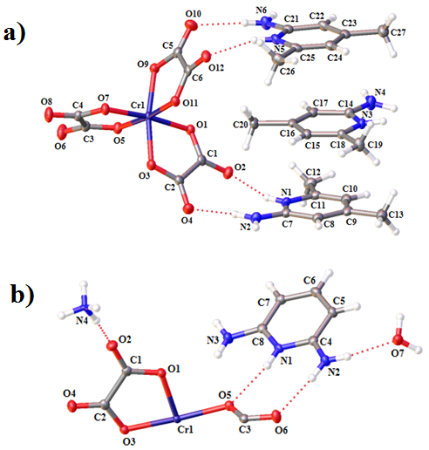
Figure 1. Asymmetric units of 1 (a) and 2 (b), thermal ellipsoids drawn at the 50% probability level.

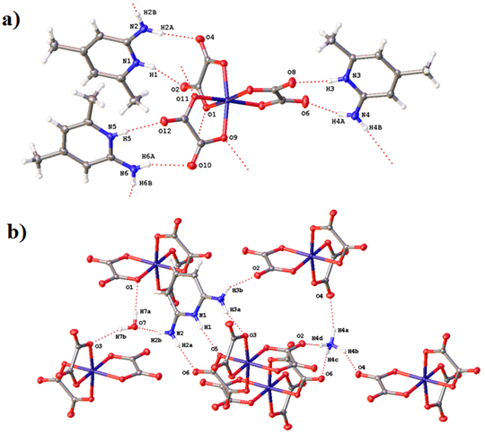
Figure 2. Hydrogen bonding (dashed lines) within 1 (a) and 2 (b).

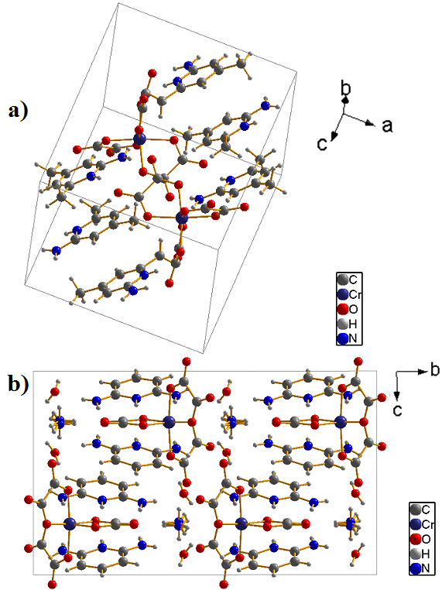
Figure 3. Packing diagrams of 1 (a) and 2 (b)

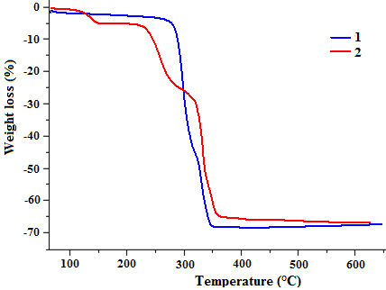
Figure 4. TGA curves for salts 1 (blue) and 2 (red).

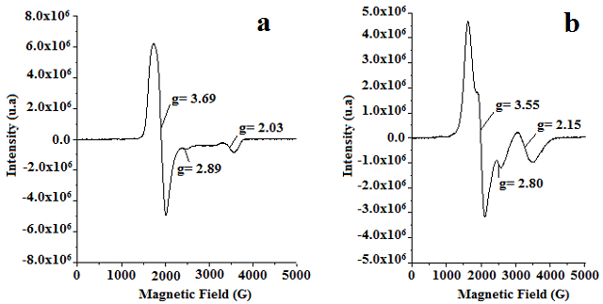
Figure 5. EPR spectra for salts 1 (a) and 2 (b).

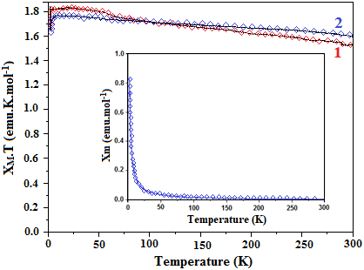
Figure 6. Temperature dependences of the χ_{M}T product for 1 and 2.

