Isolating the contributions of surface Sn atoms in the bifunctional behaviour of PtSn CO oxidation electrocatalysts

Haoliang Huang¹, Oliver F. Blackman¹, Veronica Celorrio² and Andrea E. Russell¹*

¹School of Chemistry, University of Southampton, Highfield, Southampton, SO17 1BJ
² Diamond Light Source Ltd. Diamond House. Harwell Campus. Didcot, OX11 0DE, UK

Corresponding authors:
*Email: a.e.russell@soton.ac.uk (AER)

Abstract
The bifunctional mechanism is well-acknowledged for the promoted CO oxidation on Pt-based bimetallic electrocatalysts. However, the direct identification of the active oxygenated species and the nature and electrochemistry of the second component are still a matter of debate. Herein, Sn_{ad}-Pt/C catalysts, where Sn ad-atoms are exclusively on the surface of Pt nanoparticles at low coverages ranging from 0.0033 to 0.2 monolayers to avoid sub-surface Sn and alloy formation, were prepared as a model system to resolve these issues using a surface organometallic chemistry approach. Effects of the Sn ad-atoms on CO oxidation were studied by CO stripping voltammograms as a function of Sn coverage. Using in situ XAS measurements, the Sn average oxidation state is estimated to increase from +0.2 to +3.1 as the potential increases from 0 to 0.8 V_{RHE}, with the number of the oxygen neighbours increasing stepwise. Pt_{4.5}-Sn-(OH)_{1.5} is revealed as the active species responsible for the bifunctional mechanism at low overpotentials and is generated via a redox couple corresponding to Pt_{4.5}-Sn*/Pt_{4.5}-Sn-(OH)_{1.5}.

Keywords: bifunctional mechanism, in situ XAS, CO oxidation, Pt-Sn, ad-atoms

Introduction
The addition of a second metal to form bimetallic electrocatalysts offers a means of enhancing electrocatalytic activity through promotional effects and/or improving the atom-economy for precious metal-based electrocatalysts. The promotional effects of the second component (which may or may not be active) on the catalytic activity of the active host metal are usually attributed to the following mechanisms, or a combination of them: (i) the ligand mechanism, where the electronic structure of the host metal is modified by the neighbouring second component, so that the interactions with adsorbates and reaction intermediates[1-3] are changed; (ii) the strain mechanism, where the atomic spacing of the host metal on the surface is altered by the second component underneath, producing similar effects as the ligand mechanism[4, 5]; (iii) the ensemble mechanism, where the surface ensemble of the host metal is diluted by the inert component, thus changing the reaction pathway[3, 6, 7]; and (iv) the bifunctional mechanism, where the second component acts as a co-catalyst, providing one of the necessary reactive intermediates[8-10]. Amongst these mechanisms, the bifunctional mechanism plays a major role in promoting sluggish anodic reactions on Pt, such as CO oxidation in acidic solution[11-17] and H₂ oxidation in alkaline solution[18, 19]. For oxidation reactions, an oxophilic second component is often chosen so that oxygenated species are able to nucleate from water dissociation at potentials more negative than that on pure Pt, hence allowing the adsorbed species (Pt-CO_{ad}/H_{ad}) to be oxidatively removed at a much lower overpotential.
Although the bifunctional mechanism is well-acknowledged, debates are ongoing regarding the nature and electrochemistry of the second component, in particular determining at which potential the oxygenated species are present as well as their exact speciation. Take the well-studied Pt-Sn system for CO oxidation as an example. The nature of the active Sn species may differ in the oxidation state of the Sn and in the nature of the oxygenated ligands (adsorbed OH, H₂O, or the formation of a distinct oxide phase). On practical Pt-Sn nanoparticle catalysts the presence of Sn in any forms (whether alloyed[20], as SnO₂[21, 22], or as mixtures of these[23-25]) is found to negatively shift the onset potential by a common value; ~0.4 V relative to the standard Pt/C. The details of the active oxygenated Sn species are thus unclear, which hinders the subsequent understanding of how these species generate from water dissociation. In a study of well-defined Pt(111)/Sn surface alloys where the Sn species are equal in nature, Hayden et al.[10] observed a redox couple at 0.28 V_{RHE}/0.15 V_{RHE} and associated it with the adsorption/desorption of hydroxide on the Sn sites, respectively. This redox couple assignment was supported by the coincidence with the onset of CO oxidation current and by ex situ photoelectron spectroscopy, which indicated the oxidation of alloyed Sn (0.1 V_{RHE}) to Sn^{II} (0.4 V_{RHE}). However, such a redox couple was not found on a Pt₃Sn(111) alloy surface[17, 26], the surface of which had the same atomic arrangement as one of the Pt(111)/Sn surface alloys. In addition, an in situ infrared spectroscopy study on Pt₃Sn(111) suggested that continuous oxidative removal of CO_{ad} begins at ~0.1 V_{RHE} [26], which is lower than the reduction peak of the proposed redox couple.
The redox of Sn on a Pt surface can be also assessed by monitoring the underpotential deposition (upd) process of Sn. Sobkowski et al.[27] measured the surface coverage of upd Sn using an in situ radiotracer method, and by correlating the surface coverage with its effects on the charge of an additional oxidation peak at ~0.6 V, they proposed the upd Sn is mainly Sn^{II}. Bittins-Cattaneo et al.[28] measured the charge required for Sn upd as a function of adsorption potential. By combining these results with the data from Sobkowski et al., the number of electrons required for the formation of an adsorbed Sn atom at each potential was obtained, suggesting that the oxidation state of the upd Sn gradually increases from Sn⁰ (<0.25 V_{RHE}) to Sn^{II} and then to Sn^{IV}. Interestingly, from their cyclic voltammograms, no other extra redox peak can be associated with the Sn⁰/Sn^{II} transition, apart from a characteristic redox couple at ~0.7 V_{RHE} commonly attributed to Sn^{II}/Sn^{IV}.
To probe the chemical nature of each component of a bimetallic material, X-ray adsorption spectroscopy (XAS) has unique advantages over other techniques, because it provides both electronic structure and local coordination specific to the element of interest, and it can be carried out in situ under electrochemical conditions[29, 30]. However, it also should be acknowledged that XAS is a bulk-averaging technique, unable to provide information exclusive to electrode surface unless the experiment is properly designed[30-32]. Such in situ XAS measurements of the Pt-Sn system were first carried out by Mukerjee et al.[33] using upd Sn on Pt/C as a surface-sensitive probe. The oxidation state of Sn was found to increase with applied potential, but without the accompanying change in the number of oxygen neighbours. No Sn-Pt interaction was detected at potentials less than 0.25 V, which disagreed with Bittins-Cattaneo et al.’s finding described above. Seo et al.[34] recently performed a similar measurement but with Sn²⁺ dissolved in the acidic electrolyte. Compared with Mukerjee et al.’s study, they found that both the oxidation state of Sn and the number of oxygen nearest neighbours consistently increase with potential, and that the Sn-Pt interaction exists at potentials ≤ 0.25 V_{RHE}. Correlating the changes of the oxidation state and coordination with the dominant Sn^{II}/Sn^{IV} redox peak in the voltammogram reveals a mismatch between the spectroscopy and the electrochemistry that the former occurs at a much lower potential range than the latter (-0.05–0.45 V_{RHE} vs. 0.5–0.9 V_{RHE}). This possibly arose from further Sn deposition (> 1 monolayer) after long polarisation in the Sn²⁺-containing solution at potentials < 0.2 V_{RHE} [35], which can be also inferred from the presence of Sn-Sn interaction.
A consistent picture correlating structure and electrochemistry is needed, in order to truly understand how the Sn behaves on Pt under potential control and the nature/role of adsorbed oxygenated species of the bifunctional mechanism. To achieve this, it is ideal to perform in situ XAS measurements on a model catalyst exclusively with surface Sn ad-atoms on Pt, which avoids the interference from the bulk alloyed Sn and simplifies the quantitative study of the effect of Sn on XAS and electrochemical measurements. This model catalyst can be synthesized using a well-established surface organometallic chemistry (SOMC) approach[36-39]. In this approach, naked, isolated and coverage-controllable Sn ad-atoms are able to be obtained by complete hydrogenolysis of an organotin complex by chemisorbed hydrogen on Pt surface. The Sn ad-atoms without oxygenated ligands can offer an ideal starting point and standard for studying the Sn speciation.
In this study, such a model catalyst, Sn ad-atoms on Pt/C, was prepared, and the proposed structure was confirmed by powder X-ray diffraction (XRD), scanning transmission electron microscopy-electron energy loss spectroscopy (STEM-EELS), and XAS. Effects of the Sn ad-atoms on CO oxidation were studied by CO stripping voltammograms as a function of Sn coverage. The oxidation state and local coordination of the Sn ad-atoms as a function of applied potential were assessed by in situ XAS. The combined analysis of the voltammetry, ex situ XAS, and in situ XAS results reveals the Sn species responsible for the bifunctional mechanism and the identity of the redox couple that generates this Sn species.

Experimental

Preparation of Sn_{ad}-Pt/C
Sn_{ad}-Pt/C was prepared by depositing Sn ad-atoms on the commercial Pt/C (60 wt%, Johnson Matthey, ~3 nm in diameter for the Pt particle size, Figure S1) using the surface organometallic chemistry (SOMC) approach[37, 40]. The synthesis was carried out in a gas-tight Schlenk tube equipped with a gas-inlet, a gas-outlet (connected to an oil-bubbler) and a septum. The atmosphere of the tube was controlled to be either N₂ or H₂ using a three-way valve, and the gas flow of both gases was regulated to be 40 ml min⁻¹. Into the reaction tube 120 mg of the Pt/C was loaded, and the air inside the tube was replaced by flowing N₂ for 20 min. Then, the gas was switched to H₂ (FIRE RISK, never let Pt nanoparticles meet H₂ and air at the same time) and maintained in constant H₂ flow for 20 min to reduce surface oxides of the Pt nanoparticles. To remove the resulting water vapour, the residual H₂ was first replaced by N₂ for 20 min at room temperature, and then the tube was heated to ~100 °C and maintained at the temperature for 30 min under N₂ flow. The reduced and dried Pt/C was cooled down under N₂ flow. Then, 2 ml anhydrous heptane solution containing the calculated amount of tetrabutyltin (SnBu₄, 96%, ACROS Organics) was added into the reaction tube using a syringe. The suspension was stirred for 10 min at room temperature in N₂. The atmosphere was then switched to H₂, followed by 30 min stirring at room temperature, 30 min at 50 °C and 2 hours at 90 °C. After the reaction the solid product was allowed to cool down to room temperature. The residual H₂ inside the reaction tube was replaced by 20 min N₂ flow, and the gas out-let of the reaction tube was open to ambient atmosphere overnight, to passivate the synthesized catalyst by a small amount of air leaking into the reaction vessel (FIRE RISK, never expose the freshly reduced sample to air directly). The sample was stored in a gas-tight vial.
The Sn_{ad}-Pt/C samples with Sn coverage from 0.0033 ML to 0.2 ML were synthesized by varying the volume of the Sn(Bu)₄ heptane solution. The Sn coverage was relative to a saturated layer of adsorbed H on the Pt/C (assumed to be 1 ML) measured by cyclic voltammetry (yielding a charge density of ~120 C/g_{Pt}). The amount of Sn(Bu)₄ required for each coverage can be calculated using Faraday’s law. The structural characterizations shown below were obtained using the sample with 0.2 ML Sn coverage, unless stated otherwise.

Structural characterisations

Ex situ measurements
The overview morphology of the starting Pt/C and the size of Pt nanoparticles were imaged using a transmission electron microscope (TEM; FEI, Tecnai T12) at 80 kV. X-ray diffraction (XRD) patterns were obtained using a Bruker D2 Phaser diffractometer with Cu K_{α} radiation (λ = 1.5418 Å) and a LYNXEYE detector. Scanning transmission electron microscopy (STEM) measurements were carried out on an aberration-corrected Nion UltraSTEM 100MC at the SuperSTEM laboratory (Daresbury, UK). The microscope was operated with an accelerating voltage of 60 kV. EELS spectrum images were de-noised using Principle Component Analysis (PCA) as implemented in the MSA plugin for Gatan’s Digital Micrograph Suite. The MSA plugin is commercially available from HREM research. EELS signal maps were obtained by integrating the intensity over a window of 490–600 eV for Sn M_{4,5} (onset 485 eV) and of 2210–2600 eV for Pt M_{4,5} (onset 2202 eV), after background subtraction using a conventional power-law model.
X-ray absorption spectra (XAS) were acquired at the B18 beamline of Diamond Light Source (UK) using a Quick EXAFS mode with a ring energy of 3.0 GeV and a ring current of 299–302 mA. For ex situ measurements, each sample was finely ground and mixed with boron nitride to form a homogeneous mixture, and then compressed into a pellet. The pellets of the Sn_{ad}-Pt/C samples were loaded in an airtight and high-throughput gas cell, which enabled the measurements to be conducted in air and in H₂(g). The XAS spectra were measured at the Sn K edge in transmission using ionization chambers and fluorescence using a 36-element Ge detector, along with a Sn foil in the reference channel for energy calibration. Oxide reference samples (SnO and SnO₂) were measured in air in transmission. The measured spectra were processed and analysed using ATHENA and ARTEMIS (both in the Demeter software package)[41], respectively. The energy shift of each spectrum was calibrated in two steps: choosing the first peak in the derivative of both the sample spectrum and the corresponding reference spectrum as E₀, and then assigning the E₀ of the reference spectrum to the tabulated value provided by ATHENA. The edge step of each sample was normalized by subtracting the linear pre-edge and quadratic post-edge function, and the ranges of pre-edge and post-edge are chosen as the same for each edge. The background in the extended X-ray absorption fine structure (EXAFS) region was subtracted using the AUTOBKG algorithm. The amplitude reduction factor of Sn is 1.03, obtained by a two-shell fit of a SnO₂ reference sample. The spectra in R space, presented herein, are not phase-corrected.

Electrochemical measurements
Electrochemical measurements were performed in a standard three-electrode cell connected to a PGSTAT101 potentiostat (Metrohm Autolab). A Pt gauze was used as the counter electrode, and a reversible hydrogen electrode (RHE, HydroFlex, Gaskatel GmbH) equipped with a Luggin capillary as the reference electrode. The values of potential in the text are referenced against RHE, unless stated otherwise.
The working electrode was prepared by drop-casting 10 μL of a catalyst ink onto an inverted polished glassy carbon (GC) electrode (5 mm diameter, Pine) and drying at 700 rpm and under an IR lamp (250 W) to obtain an even thin film. The catalyst ink (2 mg mL⁻¹) was prepared by dispersing each sample into isopropanol alcohol (IPA) aqueous solution (25 vol% of IPA). Before measurements, the prepared working electrodes were conditioned in N₂-purged 0.1 M HClO₄ (TraceSELECT, Honeywell) by cycling between 50 mV and 900 mV for 20 cycles with a scan rate of 100 mV s⁻¹.
For the CO stripping voltammetry, CO was bubbled into N₂-purged 0.1 M HClO₄ for 20 min whilst the potential of the prepared working electrode was held at 0.1 V. Subsequently, the residual CO in the electrolyte was removed by purging N₂ for 20 min, and then the potential was swept to 0.05 V and cycled between 0.05 V and 0.9 V for 3 cycles with a scan rate of 20 mV s⁻¹. CO bulk oxidation voltammograms were collected in CO-saturated 0.1 M HClO₄ under rotation control.

In situ XAS measurements
Sn_{ad}-Pt/C electrodes for the in situ XAS measurements were prepared with special care, so as to balance the needs of the electrochemistry and the spectroscopy and to avoid structural changes of the Sn ad-atoms. A catalyst paste (50 mg mL⁻¹ in H₂O) was applied on one side of a carbon paper (TGP-H-60, Toray, with a microporous carbon layer), and then smoothened and dried mostly by sandwiching the electrode between a clean Kapton film (catalyst side) and a paper towel (carbon paper side). A few drops of Nafion solution (1 wt% in 25 vol% IPA aqueous solution) were dropcast on top of the catalyst layer, and then dried mostly under an IR lamp. The electrode was pressed at 60°C to obtain a smooth layer, and then completely dried in a vacuum desiccator. The catalyst loading was calculated by subtracting the mass of the electrode with and without the catalyst layer. The catalyst loading of the electrode present in the text is ~5.8 mg cm⁻² and the corresponding Sn loading is ~108 µg cm⁻², unless stated specifically.
The above preparation procedure and the catalyst loading were tested electrochemically using the parent Pt/C to make sure that all Pt nanoparticles are electrically connected to carbon paper and accessible to electrolyte during the in situ XAS measurement. Pt/C test electrodes with a catalyst loading ≤ 6.4 mg cm⁻² were found to produce similar electrochemical active surface areas in the in situ cell (see below) as that obtained for thin film-modified glassy carbon electrodes in a conventional electrochemical cell (Figure S2). This suggests that the prepared Sn_{ad}-Pt/C electrodes can be considered as fully utilized in the in situ XAS measurements.
XAS spectra as a function of applied potentials were collected using a customized spectro-electrochemistry cell[42]. A flattened Au wire was used as a contact to the catalyst electrode, and a Pt coil as the counter electrode and a commercial RHE electrode (HydroFlex, Gaskatel GmbH) as the reference electrode. Before being loaded in the cell, each in situ electrode was flooded by water in a vacuum desiccator. The N₂-purged 1 M HClO₄ (TraceSELECT, Honeywell) was circulated through the cell using a peristaltic pump. The CV of the Sn_{ad}-Pt/C from thin-film electrodes was reproduced in the spectro-electrochemistry cell (Figure S3).
The XAS spectra were measured under potential control. The potential was stepped from 0 V to 0.8 V in 0.2 V steps. The XAS spectra were collected after each step reached a plateau (Figure S3). Whilst both fluorescence and transmission spectra were collected at the Sn K edge, only fluorescence data will be presented for better signal-to-noise ratio. The self-adsorption effects in the fluorescence spectra were suggested as insignificant in our data by comparing the spectra from: (i) a pellet sample that had 2 times higher Sn loading than the current in situ electrode, where we found that the transmission and fluorescence spectra overlapped (Figure S4, ~0.02 vs. ~0.01 in the edge step of transmission) and (ii) another electrode with decreased Sn loading, which produced identical but noisier spectra (Figure S5). The spectrum from a Sn foil placed in the reference channel was obtained simultaneously to allow energy calibration.

Results and discussion

XRD, TEM and Aberration-corrected STEM-EELS microanalysis
Sn ad-atoms were deposited on a commercial Pt/C catalyst (60 wt%, JM), where 3~4 nm Pt nanoparticles are evenly distributed on the Ketjen black carbon support with a small amount of agglomeration (Figure S1). Figure 1A compares XRD patterns of Sn_{ad}-Pt/C and Pt/C, along with the standard peak positions of face-centred-cubic (fcc) Pt. Sn_{ad}-Pt/C shows a nearly identical pattern as the starting material Pt/C, with a weak and broad peak of graphitized carbon at ~25° and a set of well-defined diffraction peaks assigned to the fcc Pt. The similarity in XRD pattern suggests that the long-range order of the Pt nanoparticles are unaltered after Sn deposition, and that the Sn species of Sn_{ad}-Pt/C are unlikely to exist as crystallized SnO₂ or alloyed Sn, which are the two main forms of Sn reported in Pt-Sn bimetallic nanoparticles[23, 43, 44]. Also, no obvious change in particle size and distribution is discernible in the TEM images before and after Sn deposition (Figure S1 and Figure 1B). From the width of the (220) peak, the crystallite size of Pt is estimated as ~3.2 nm for both Pt/C and Sn_{ad}-Pt/C, which is within the error of the particle size obtained from analysis of the TEM images (Figure S1 and Figure 1B).
The presence and location of Sn in Sn_{ad}-Pt/C were studied using aberration-corrected STEM microanalysis. Figure 1C and Figure 1D show a nanoparticle on the edge of a carbon particle. On this nanoparticle a Pt-core and Sn-shell configuration is clearly shown (Figure 1E), with an even shell of sub-nanometer thickness. A similar configuration was consistently obtained in the data for two other regions (Figure S8 and Figure S9). The nature of the surface Sn atoms was estimated by EELS. Figure 1F shows a typical Sn M_{4,5} edge EELS spectrum of a selected area on the edge of the particles, and same spectra can be found along the edge (Figure S7). The spectra show features comparable to the Sn thin film reference (Figure S7), without the characteristic sharp peaks from O K-edge (~550 eV). The atomic thin Sn layer on the Pt nanoparticles and the absence of oxygen with Sn (at least under the electron microscopic conditions) are consistent with the mostly unaffected XRD patterns and TEM images before and after Sn deposition, providing direct evidence of the formation of Sn ad-atoms on Pt nanoparticles.

Ex situ XAS
After the general structure of Sn_{ad}-Pt/C was revealed, the detailed nature (speciation, oxidation state and coordination) of the Sn ad-atoms was further studied from the perspective of Sn using XAS. The XAS measurements were carried out at the Sn K-edge in air and in H₂(g). H₂(g) is used to reduce the surface oxides of the metallic nanoparticles and to mimic the environment used in the Sn deposition. Sn_{ad}-Pt/C samples with Sn coverage of 0.033 ML, 0.1 ML and 0.2 ML were studied by XAS, and their spectra were found to be largely similar (Figure S11 and Figure S12).
The XAS spectra of Sn_{ad}-Pt/C are extremely sensitive to the measurement atmosphere. Figure 2 shows effects of air and H₂ in the XANES and EXAFS regions. The spectra measured in air are similar to those of SnO₂ in both XANES and EXAFS, but show much less intensity in the high k (>9 Å⁻¹) and high R regions (>2.2 Å). The fully oxidized Sn species of Sn-modified Pt/C in air was also previously reported using XPS[21]. Since the components of SnO₂ in these two regions can be mainly ascribed to two Sn–Sn scattering paths, as shown in the unit cell of rutile SnO₂ (Figure S13), the simple oscillation of the air data indicates that the Sn adatoms, although oxidised in air, lack long-range order, which is consistent with the XRD result. The coordination of Sn was quantitatively analysed by EXAFS fitting (Figure S14 and Table 1, Table S1 for samples with other Sn coverage). The Sn is saturated with ~6 oxygen neighbours in the first coordination shell as for rutile SnO₂, hence denoted as [Sn^{IV}O₆]. A disordered Sn–Sn scattering path with a slightly longer R than that of SnO₂ was also found, 3.27(1) Å vs. ~3.200(9) Å. The CN of the Sn–Sn increased with Sn coverage (~0.8 for 0.033 ML, ~1.3 for 0.1 ML and ~1.6 for 0.2 ML), which indicates that the [Sn^{IV}O₆] species are relatively isolated on Pt, with little connectivity to each other.
When in H₂, the [Sn^{IV}O₆] is reduced and transformed completely (Figure 2). The XANES shows a sharp decrease in whiteline intensity and a negative shift in edge position, which indicates a significant decrease in the oxidation state of Sn, and a unique spectrum is found with comparable whiteline intensity and edge position as those of SnO and Sn foil, respectively. In the EXAFS, the dominant Sn–O measured in air diminishes, and a new scattering path becomes dominant at ~2.5 Å, which is attributed to Sn–Pt with CN = 4.5 and R = 2.69 Å (Figure S14 and Table 1). Sn–Sn scattering paths in the first shell are completely absent because the formation of strong intermetallic bonds between Pt and Sn is favourable[3, 45], as also found in other Pt-Sn nanoparticles with low Sn content[23, 24, 36, 46]. Thus, the fully oxidized [Sn^{IV}O₆] in air is completely reduced into Sn⁰(Pt) in H₂(g). This starkly contrasting response in air and H₂(g) provides a strong evidence that all the Sn atoms of Sn_{ad}-Pt/C are reducible by H₂(g) and/or H atoms dissociated from H₂(g) on Pt surface, and thus are located on the Pt surface. These two extreme cases can thus be used as intrinsic references for the in situ XAS studies described below. The location of the Sn is also supported by the low CN of Sn–Pt (~4.5) relative to that of Pt₃Sn (12).
Further inspection of the structural parameters reveals that the CN of Sn–Pt decreases monotonously with the Sn coverage, 5.7(9) for 0.033 ML, 4.8(4) for 0.1 ML and 4.5(4) for 0.2 ML (Table S1). This suggests that the Sn may be preferentially deposited on surface sites that maximise the coordination with Pt. From a structural model of Pt nanoparticles determined by atomic resolution STEM[47], the preferential order for Sn deposition could start from vacancy sites (CN=7~9) and step sites (CN = 5~6), followed by (111)/(100) terrace sites (CN=3~4). Thus, it is suggested that the Sn is mainly located at the vacancy sites and step sites when the Sn coverage ≤ 0.033 ML, and that the Sn starts to be deposited on (100) terrace sites when the coverage increases. Similar site-preferential deposition can also be found in studies of the electrodeposition of Sn[48, 49] (and other p-block metals[50]) on stepped Pt surfaces.

Table 1 Structural parameters of Sn_{ad}-Pt/C (measured in air and in H₂), obtained from EXAFS fittingª. Plots of the data and the corresponding fits are shown in Figure S14.
Sample | Scattering path | R (Å) | N | σ² (x10³ Å²) | ΔE₀ (eV) | R factor (%)
Sn_{ad}-Pt/C_Air | Sn–O | 2.051(3) | 6.4(2) | 6.6(4) | 2.2(4) | 0.26
 | Sn–Sn | 3.272(9) | 1.6(4) | 9(2)
Sn_{ad}-Pt/C _H₂ | Sn–Pt | 2.690(7) | 4.5(4) | 8.8(6) | -3(1) | 1.17
SnO₂ | Sn–O | 2.053(5) | 6.1(4) | 4.0(7) | 4.0(8) | 0.79
 | Sn–Sn₁ | 3.200(9) | 1.2(5) | 3(2)
 | Sn–Sn₂ | 3.725(7) | 2.2(8) | 2(2)
Pt₃Sn^{b} | Sn–Pt | 2.829 | 12 | N.A. | N.A. | N.A.
ª R is the distance between the absorber–scatterer pair, N is the coordination number, σ² is the Debye-Waller (disorder) factor, ΔE₀ is the shift in the edge energy, and R factor is a measure of the goodness of fit.
^{b} calculated from Pt₃Sn crystal (ICSD 105796) using Feff6.

CO stripping
The promotional role of these potentially redox-active Sn ad-atoms for the CO oxidation was then studied using CO stripping voltammetry. On each catalyst-modified electrode a saturated CO adlayer was adsorbed at 0.1 V, and then oxidatively removed by sweeping to 0.9 V in N₂-saturated 0.1 M HClO₄ solution. The completeness of the stripping was assessed by monitoring successive CV cycles. On all samples, the peaks associated with the desorption of underpotential deposited H is completely suppressed by adsorbed CO (CO_{ad}) in the 1st sweep (Figure 3A) and re-emerges in the successive cycles (Figure 3B, Figure S18). The parent Pt/C catalyst shares a typical CO stripping voltammogram with polycrystalline Pt, showing negligible Faradaic current before ~0.65 V and a single but composite peak at ~0.8 V with a shoulder at ~0.72 V. The shoulder can be attributed to the slight aggregation of Pt nanoparticles due to the high Pt loading (60 wt%)[51-53] as shown in the TEM image.
With the addition of Sn ad-atoms, the CO adlayer oxidation on Pt is highly promoted and becomes more complicated. Generally, the onset potential is shifted to ~0.25 V (Figure 3 inset), which is ~0.4 V lower than that of Pt/C, and instead of a single sharp peak the voltammograms become a doublet or even a triplet stretching over a potential range of ~0.6 V. At high Sn coverage (≥0.1 ML), the voltammetric profiles are in line with those of Pt-Sn alloy nanoparticles[20, 24, 54], with the main peak of CO oxidation being shifted to ~0.7 V and an additional shoulder at ~0.5 V. Decreasing the Sn coverage, although producing few changes in the main peak at 0.7 V, has obvious effects on the wave at ~0.5 V and the Pt peak at ~0.8 V. Whilst the decreased charge of the Pt peak can be easily understood by the decreased number of pure Pt ensembles as the Sn coverage increases, the coverage-dependence of the wave in terms of charge and onset potential indicates the direct involvement of the Sn ad-atoms in CO oxidation at low potential, probably via the bifunctional mechanism. Note that the origin of the features at ~0.7 V is complex and may include decreased CO coverage due to the wave at lower potential, and the presence of oxygenated species, the formation of which are promoted by the neighboring Sn atoms. However, the features at ~0.7 V is not the focus of the study described herein.
After the CO_{ad} from sites influenced by the Sn ad-atoms and from sites unperturbed by the Sn were completely oxidatively removed from the 1st sweep of the CO stripping voltammetry, the surface electrochemistry of Sn_{ad}-Pt/C without CO_{ad} was then studied by the successive cycles (Figure 3B). The voltammogram of Pt/C shows a typical profile of polycrystalline Pt in HClO₄ solution, which can be divided into three regions, a pseduocapacitance in 0.05–0.4 V for reversible adsorption and desorption of underpotential deposited H on Pt (denoted as H_{upd} region), a redox couple at ~0.8 V for irreversible Pt oxide formation and reduction (denoted as oxide region) and double layer charging current in between (~0.5 V, denoted as DL region).
All these potential regions are altered by the presence of Sn ad-atoms, and the extent depends on the Sn coverage. Starting with the oxide region, a new irreversible redox peak develops with increasing the Sn coverage in terms of charge and potential, at ~0.72 V in the forward sweep and ~0.66 V in the backward sweep for low Sn coverages (<0.1 ML), and a ~0.7 V/~0.55 V pair for high Sn coverages (≥0.1 ML), which is characteristic of Sn-modified Pt surfaces[27, 35, 55-57] and of Pt₃Sn alloys[20, 58, 59]. Opposite to this trend, the charge of the pristine Pt oxide formation at ~0.85 V decreases with Sn coverage.
For the DL region, the increased charge with Sn coverage becomes obvious when the coverage is higher than 0.01 ML. Compared with the previous CO stripping sweeps, the DL capacitance shown in 0.05–0.2 V remains constant with Sn coverage. In addition, from the above TEM and XRD results no discernible difference of general structure can be found on Pt/C before and after Sn modification. Thus, the increased charge at ~0.5 V is probably not due to double layer charging, but instead to the Faradaic current relating to another redox process of the Sn ad-atoms. This electrochemically activity of the Sn ad-atoms in the DL region may also be inferred from literature in studies of the stepwise stripping of Sn ad-atoms[28, 55, 56]. However, the early Sn oxidation before the obvious one at ~0.7 V, which could be crucial to understanding the bifunctional mechanism of CO oxidation at low potential, has not previously been discussed in detail.
In contrast to the oxide region and the DL region, the pseduocapacitance of the H_{upd} region decreases with Sn coverage, which is as expected because Sn ad-atoms block the H adsorption sites of Pt and weaken the H adsorption of Pt atoms adjacent to the Sn[60]. Further inspection reveals that the extent of the decrease is more pronounced at the peak related to (110) sites (~0.12 V) [61], supporting the preferential deposition of Sn ad-atoms found from the EXAFS fitting.
It is well-established that CO oxidation on Pt follows a Langmuir–Hinshelwood (L-H) mechanism (eq. 1)[12-16], via which adsorbed CO on a Pt site (Pt-CO_{ads}) reacts with the adjacent hydroxide species on metal sites (M-OH_{ads}), yielding a free Pt site and a free metal sites (M*), and the CO_{ads} and OH_{ads} may or may not form at the same site, even on pure Pt surfaces[13, 62].
Pt-CO_{ads} + M-OH_{ads} + H₂O→ Pt + M* + CO₂(aq) + H₃O⁺ + e⁻ (eq. 1)
With the modification of Sn ad-atoms, the situation gets even more complex, as shown in the CO stripping voltammograms. The active M-OH species on the Pt-Sn surface could be Sn-OH from the water dissociation on the Sn ad-atoms (i.e. the bifunctional mechanism)[10, 17] or Pt-OH, the formation of which could be promoted by the neighboring Sn that lowers the local work function of Pt atoms[17, 43, 63](i.e. the ligand mechanism, also see examples of other p-block metals on Pt surface[50, 64, 65]). These two cases, although both possible, operate in different potential ranges and the CO oxidation at low potential (0.2–0.5 V) is mainly attributed to the bifunctional mechanism of Sn-OH. If, however, the Pt-OH participates at such low potentials, then Pt-OH would co-exist with Pt-H at the terrace sites. In contrast, participation of Pt-OH at the step/defect sites is unlikely as these are occupied by Sn ad-atoms at high Sn coverage as shown in blank CV and ex situ EXAFS fitting. Also, DFT calculations on Pt₃Sn (111) suggest that OH interacts preferentially with the Sn compared to Pt[63, 66]. Thus, the main operative route for CO oxidation at low potential is via the bifunctional mechanism with Sn-OH species.

In situ XAS on Sn_{ad}-Pt/C
The identity and electrochemistry of the Sn-OH are now questions of interest, especially at low potential when the Sn-OH is the sole active species. Examining the CO stripping voltammograms of Sn_{ad}-Pt/C (Figure 3), the onset potential of CO_{ad} oxidation is ~0.4 V lower than that of the characteristic redox peaks for surface Sn (0.6–0.7 V), indicating that the commonly believed redox couple cannot be attributed to the CO oxidation at low potential. Alternatively, a Faradaic process happening in the DL region may be responsible for providing Sn-OH species. Due to the overlap of the pseduocapacitance of H_{upd}, the process may start in the H_{upd} region or even lower. To ascertain the nature of the electrochemically active Sn ad-atoms, in situ XAS measurements were carried out in N₂-saturated 1 M HClO₄ under potential control from 0 V to 0.8 V with 0.2 V steps. In both XANES and EXAFS regions the spectra measured under potential control fall in-between the spectra measured in H₂ and in air (Figure 4 and Figure S19), indicating that the Sn ad-atoms in the potential range are neither fully reduced nor fully oxidized.
A potential dependence is clearly observed in the in situ XAS data. In the XANES, the whiteline intensity changes little between 0 V and 0.2 V (~1.17), increases gradually from 0.2 V to 0.6 V (~1.25), and jumps to the maximum at 0.8 V (~1.43), consistent with the positive shift of the edge position (Figure 4A inset). Assuming the oxidation states of the Sn ad-atoms are proportional to the whiteline intensity, the average Sn oxidation states under potential control can be estimated using the ex situ data as the references for 0 and +4 oxidation state, gradually increasing from ~0.2 to ~3.1 for the Sn from 0 to 0.8 V (Figure 5A). The oxidation extent of the Sn ad-atoms was also quantified electrochemically, and the number of electrons lost per Sn atom (N_{eL}) is estimated using eq. 2:
N_{eL} = C/(C₀ × θ_{Sn}) (eq. 2)
Where the C is the charge difference between Sn_{ad}-Pt/C and Pt/C in a given potential range (Figure 5A), C₀ is the charge corresponding to the transfer of one electron per Pt atom on the surface, obtained from the H_{upd} desorption (assumed to be 1 ML), and θ_{Sn} is the Sn coverage. N_{eL} was found to be ~ 0.7 over the potential range of 0.4–0.6 V and ~2.0 between 0.6–0.8 V, in good agreement with the difference of the average oxidation state in the same potential range (Figure 5A) and with Bittins-Cattaneo et al.’s work on the upd process of Sn⁴⁺ on Pt[28].
In the EXAFS (Figure 4B), whilst the Sn–O oscillation (1–2 Å in the real part of the Fourier transform) increases with potential in terms of amplitude, the Sn–Pt oscillation (2–3 Å) is largely unaffected from 0 V to 0.4 V and is distorted at 0.6 V. Further examination of the Fourier transform shows that the Sn–Pt contribution is replaced by Sn–Sn at 0.8 V. When the potential is stepped from 0.8 V back to 0 V, the spectral features of the 0 V data can be reproduced (Figure S20 and Figure S21). From the potential dependence in both XANES and EXAFS, some puzzles from the voltammetric studies can be answered. From 0.05–0.2 V no observable electrochemical reaction occurs on Sn, whilst in the DL region the additional charge is shown to correspond to the partial oxidation and oxygenation of Sn ad-atoms. The oxidation peak at ~0.7 V then corresponds to the further oxidation of the Sn ad-atoms, which is accompanied by loss of the Sn–Pt interaction.
The speciation of the Sn ad-atoms under potential control was further identified using EXAFS fitting. The fits are shown in Figure S22–Figure S24 with the obtained structural parameters listed in Table 2. The discussion of the data below is divided into three potential regions, 0–0.2 V, 0.4–0.6 V and 0.8 V. Because of the similarity at 0 V and 0.2 V, only spectra at 0.2 V are described.
At 0/0.2 V, the Sn ad-atoms share a similar local coordination environment with that in H₂, with the same number of Pt neighbors (~4.5), but also have ~1.5 oxygen neighbors. Both the Sn-Pt and Sn-O bonds are weakened as evidenced by the increase in R(Sn–Pt) is ~2.73 Å, 0.04 Å longer than that of Sn⁰(Pt), and R(Sn–O) is ~2.08 Å, 0.03 Å longer than that of the [Sn^{IV}O₆]. These differences in bond distance suggest that the Sn species at 0/0.2 V is not a simple physical mixture of [Sn^{IV}O₆] and Sn⁰(Pt). The identity of the oxygenated ligand can be inferred from R(Sn–O), which could be either Sn-OH or Sn-(H₂O). Whilst the bond distance between water and metal ions/metal surface is generally 0.1~0.2 Å longer than that with OH[67, 68], only an increase of 0.01~0.02 Å was found in R(Sn–O) of the intermediates compared to Na₂Sn(OH)₆ (2.08~2.09 Å vs. 2.071 Å). Thus, the oxygenated ligand is likely to be Sn-OH rather than Sn-(H₂O). To summarise, the intermediates at 0 to 0.2 V can be estimated to have an averaged composition as Pt_{4.5}Sn-(OH)_{1.5} (henceforth denoted as Pt-Sn-OH for simplicity). Transferring this speciation to the electrochemistry indicates that this Pt-Sn-OH, the only oxygenated species available around the onset of CO oxidation, is responsible for the bifunctional mechanism in this low potential region (eq. 3).
Pt-CO_{ads} + Pt-Sn-OH → Pt + Pt-Sn* + CO₂(aq) + H₃O⁺ + e⁻ (eq. 3)
When the potential increases to 0.4 V and 0.6 V, the Pt-Sn-OH is further oxidized, with an increase of CN(Sn–O) at the expense of CN(Sn–Pt). The Pt-Sn part of the intermediate becomes distorted at 0.6 V, suggested by increase of the bond length and Debye Waller (disorder) factor of the Sn-Pt.
Further increasing potential to 0.8 V transforms Sn-Pt into Sn-O. However, the oxidation to [Sn^{IV}O₆] is not complete, with only ~4.7 oxygen neighbors found. Based on the similarity with the Sn-O and Sn-Sn scattering paths of the ex situ air data, the Sn species at 0.8 V can be considered as SnO_{4.7}, a partly reduced form of [Sn^{IV}O₆] with an unsaturated oxygen shell and decreased oxidation state (henceforth denoted as SnO_{x} for simplicity). Since the Pt-Sn bonds, a direct interaction between Sn and Pt are not observed at this potential, the SnO_{x} species may or may not stay on the Pt surface, which could cause Sn dissolution as reported on Pt-Sn catalysts at similar potentials[25, 49, 55]. However, on our Sn_{ad}-Pt/C the loss of Sn signal is indiscernible during the collection of the spectra at 0.8 V (~20 min, Figure S25), and the Pt|SnO_{x} can be transformed back to the Pt-Sn-OH configuration when the potential is applied back to 0 V (Figure S24 and Table 2). This suggests that the SnO_{x} largely remains its original location at 0.8 V and that oxygen-bridges are likely to exist between the Sn ad-atoms and the substrate Pt even after the destruction of Sn-Pt bonds, forming Pt|SnO_{x}.

Table 2 Structural parameters of Sn_{ad}-Pt/C (0.2 ML) under potential control from 0 V to 0.8 V, obtained from EXAFS fitting. The fitting k range is 2.3–12.2 Å⁻¹ unless specified. Plots of the data and the corresponding fits are shown in Figure S22 and Figure S24
Sample | Scattering path | R (Å) | N | σ² (x10³ Å²) | ΔE₀ (eV) | R factor (%)
0 V | Sn – O | 2.09(1) | 2.1(7) | 22(8) | 4.2(7) | 2.9
 | Sn – Pt | 2.718(7) | 4.5(4) | 9.1(9)
0.2 V | Sn – O | 2.083(6) | 1.6(2) | 9(2) | 4.5(4) | 1.0
 | Sn – Pt | 2.728(4) | 4.4(3) | 9.0(6)
0.4 V | Sn – O | 2.048(8) | 2.2(3) | 9(2) | 3.3(9) | 1.8
 | Sn – Pt | 2.703(8) | 3.1(4) | 8(1)
0.6 V | Sn – O | 2.051(9) | 2.6(2) | 5(1) | 5.4(9) | 2.1
 | Sn – Pt | 2.75(2) | 2.3(9) | 15(6)
0.8 V | Sn – O | 2.056(6) | 4.7(2) | 3.6(8) | 5.5(6) | 0.93
 | Sn – Sn | 3.27(2) | 2(1) | 9(4)
0 V_back | Sn – O | 2.084(9) | 1.8(4) | 18(5) | 3.7(5) | 1.4
 | Sn – Pt | 2.720(5) | 4.7(3) | 10.0(7)

CO bulk oxidation
As shown above, the Sn atoms for Sn_{ad}-Pt/C are oxygenated throughout 0–0.8 V but the extent of oxygenation is stepwise and potential-dependent, starting from Pt-Sn-OH in 0–0.2 V and being oxidized to Pt|SnO_{x} at 0.8 V (Figure 5B). If the Sn species in 0.4–0.6 V is considered as a part of reaction from the Pt-Sn-OH to Pt|SnO_{x}, the electrochemistry of the Sn ad-atoms can be written as two redox couples, Pt-Sn*/Pt-Sn-OH and Pt-Sn-OH/Pt|SnO_{x}. Whilst the latter represents an irreversible redox couple in the DL and oxide regions, as identified by the above in situ XAS spectra, the former that generates one of the reactants of the bifunctional mechanism (Pt-Sn-OH) is not confirmed, i.e., once consumed via eq.3, Pt-Sn-OH may or may not be regenerated. Note that in the in situ XAS measurements the Pt-Sn-OH was formed by the reduction of the fully oxidized Sn_{ad}-Pt/C by potential hold at 0 V.
If the bifunctional mechanism from Pt-Sn/Pt-Sn-OH is able to operate in a continuous fashion at low overpotential (Figure 6), the two reactants have to be supplied from the corresponding channels, from the Pt-Sn/Pt-Sn-OH redox couple generating hydroxide species and from the regeneration of Pt-CO_{ads}, which includes mass-transport of dissolved CO to the electrode surface (eq. 4) and the subsequent adsorption of the CO on the available Pt sites (eq. 5, Figure 6).
CO(aq) ⇌ CO_{surface} (eq. 4)
CO_{surface} + Pt → Pt-CO_{ads} (eq. 5)
To probe the Pt-Sn/Pt-Sn-OH redox couple, the CO channel needs to be saturated. Figure 7A shows CO bulk oxidation voltammograms of the Sn_{ad}-Pt/C in a rotating disc experiment in CO-saturated 0.1 M HClO₄ solution, in which the mass transport of CO(aq) is controlled by the rotating disc (Figure S26 for each sample). With constant supply of CO(aq), the Sn_{ad}-Pt/C samples show stable currents over many cycles and produce rotation-rate-dependent currents at high overpotentials, indicating that the Pt-Sn-OH is not depleted by CO oxidation but can be regenerated from the proposed Pt-Sn/Pt-Sn-OH redox couple by water dissociation (eq. 6, Figure 6).
Pt-Sn* + 2H₂O → Pt-Sn-OH + H₃⁺O + e⁻ (eq. 6)
Compared to CO adlayer oxidation, where the CO coverage decreases with potential sweeping, the bulk CO oxidation current is highly promoted with constant supply of CO in a potential window of 0.05 – 0.6 V (Figure S26). This positive reaction order of CO coverage indicates that the rate-determining step (RDS) of charge transfer is not Pt-Sn-OH formation (eq. 6) but the L-H reaction (eq. 3). If the opposite holds true, then the CO bulk oxidation current would not increase by increasing the mass transport of CO (Figure S26).
Further inspection reveals that CO bulk oxidation voltammograms are highly dependent on the Sn coverage in terms of the rotation-rate-dependent current, the potential shift and Tafel slope (Figure 7B and Figure S27). The increased current can be attributed to the increased number of Sn-OH with Sn coverage as per the rate-determined L-H step. The decreased Tafel slope at low Sn coverage (0.01 ML and 0.0033 ML) then presumably results from the coverage-dependent coordination environments of Sn suggested by the ex situ EXAFS data, which changes the geometry of the Pt-CO_{ad} + Pt-Sn-OH active sites[26, 56]. However, the negative shift of voltammetric profiles with Sn coverage cannot be simply rationalized by the Sn-OH part of the L-H reaction, but is probably due to the Pt-CO part. Considering the Sn ad-atoms at low potential interact with both Pt and OH, the Pt-CO bond can be weakened by a combination of ligand effects from strong Sn-Pt intermetallic bonds[63, 69, 70] and intermolecular repulsion between the co-adsorbed Pt-CO and Sn-OH[17]. Such a negative shift of onset potential for CO oxidation can also be found on Sn-modified Pt(110)[56] and Pt stepped surfaces[48, 49].

Conclusion
A consistent picture correlating structure, electrochemistry and in situ XAS is presented in order to understand how Sn ad-atoms behave on Pt under potential control and the nature and role of the adsorbed oxygenated species on Sn in the bifunctional mechanism. A model catalyst, where Sn ad-atoms are exclusively on the surface of Pt nanoparticles (Sn_{ad}-Pt/C), was prepared using the SOMC approach and characterized unambiguously using STEM-EELS and XAS. The measurement atmosphere of XAS affects the Sn ad-atoms in terms of oxidation state and local coordination, with fully oxidized [Sn^{IV}O₆] observed in air and fully reduced Sn⁰(Pt) in H₂(g). These redox active Sn ad-atoms were found to highly promote the CO adlayer oxidation on Pt, with the onset potential shifted to ~0.25 V, in agreement with the reported Pt-Sn electrocatalysts. Sn-coverage-dependent CO stripping voltammograms suggest that the Sn ad-atoms are directly involved in the onset wave of CO oxidation (<0.5 V) and are electrochemically active in the DL region.
In situ XAS measurements at the Sn K-edge show potential dependence in both XANES and EXAFS. Using the ex situ XAS data as the internal references, the oxidation of the Sn ad-atoms is quantified as 0.2, 0.4, 0.7, 1.2 and 3.1 for the Sn at 0, 0.2, 0.4, 0.6 and 0.8 V, respectively, in agreement with the additional charge (than the Pt/C) in the corresponding potential range obtained from voltammetry. The speciation of the Sn ad-atoms under potential control was revealed using EXAFS fitting. The Sn ad-atoms are oxygenated throughout 0 – 0.8 V but the extent of oxygenation is stepwise and potential-dependent, starting from Pt-Sn-(OH) coordinated with both Pt and O in 0–0.2 V and being oxidized to Pt|SnO_{x} with the destruction of Sn-Pt interaction at 0.8 V. The electrochemistry of the Sn ad-atoms on Pt is proposed to consist of two redox couples, Pt-Sn*/Pt-Sn-OH and Pt-Sn-OH/Pt|SnO_{x}. That the former generates one of the reactants of the bifunctional mechanism at low potential (Pt-Sn-OH) was ascertained by CO bulk oxidation. From the Sn coverage dependence of CO bulk oxidation, CO oxidation at low potential is also promoted by weakening Pt-CO via a combination of ligand effects from strong Sn-Pt intermetallic bonds and intermolecular repulsion between the co-adsorbed Pt-CO and Sn-OH.

Declaration of interests
The authors declare that they have no known competing financial interests or personal relationships that could have appeared to influence the work reported in this paper.

Acknowledgement
The XAS data were collected at Diamond on B18 as part of the UK Catalysis Hub BAG allocation (SP19850-4, SP19850-5 and SP19850-6). We thank Fredrik Hage and Quentin Ramasse for instrument access and the STEM measurements. SuperSTEM is the UK National Research Facility for Advanced Electron Microscopy, supported by the Engineering and Physical Sciences Research Council (EPSRC). HH acknowledges Fellowship support from the China Scholarship Council (201608440295) and the University of Southampton.

References
[1] T. Bligaard, J.K. Nørskov, Ligand effects in heterogeneous catalysis and electrochemistry, Electrochim. Acta, 52 (2007) 5512-5516.
[2] F. Calle-Vallejo, M.T. Koper, A.S. Bandarenka, Tailoring the catalytic activity of electrodes with monolayer amounts of foreign metals, Chem. Soc. Rev., 42 (2013) 5210-5230.
[3] W.M.H. Sachtler, Ensemble and Ligand Effects in Metal Catalysis, Handbook of Heterogeneous Catalysis 2008, pp. 1585-1593.
[4] M. Luo, S. Guo, Strain-controlled electrocatalysis on multimetallic nanomaterials, Nat. Rev. Mater., 2 (2017) 17059.
[5] Z. Xia, S. Guo, Strain engineering of metal-based nanomaterials for energy electrocatalysis, Chem. Soc. Rev., 48 (2019) 3265-3278.
[6] A. Cuesta, At least three contiguous atoms are necessary for CO formation during methanol electrooxidation on platinum, J. Am. Chem. Soc., 128 (2006) 13332-13333.
[7] A. Cuesta, M. Escudero, B. Lanova, H. Baltruschat, Cyclic voltammetry, FTIRS, and DEMS study of the electrooxidation of carbon monoxide, formic acid, and methanol on cyanide-modified Pt(111) electrodes, Langmuir, 25 (2009) 6500-6507.
[8] M. Watanabe, S. Motoo, Electrocatalysis by ad-atoms, J. Electroanal. Chem. Interfacial Electrochem., 60 (1975) 267-273.
[9] M. Watanabe, M. Shibata, S. Motoo, Electrocatalysis by ad-atoms, J. Electroanal. Chem. Interfacial Electrochem., 187 (1985) 161-174.
[10] B.E. Hayden, M.E. Rendall, O. South, Electro-oxidation of carbon monoxide on well-ordered Pt(111)/Sn surface alloys, J. Am. Chem. Soc., 125 (2003) 7738-7742.
[11] C. Lu, C. Rice, R.I. Masel, P.K. Babu, P. Waszczuk, H.S. Kim, E. Oldfield, A. Wieckowski, UHV, Electrochemical NMR, and Electrochemical Studies of Platinum/Ruthenium Fuel Cell Catalysts, J. Phys. Chem. B, 106 (2002) 9581-9589.
[12] Mechanistic aspects of carbon monoxide oxidation, Handbook of Fuel Cells2010.
[13] H. Wang, Z. Jusys, R.J. Behm, H.D. Abruña, New Insights into the Mechanism and Kinetics of Adsorbed CO Electrooxidation on Platinum: Online Mass Spectrometry and Kinetic Monte Carlo Simulation Studies, J. Phys. Chem. C, 116 (2012) 11040-11053.
[14] M.T.M. Koper, S.C.S. Lai, E. Herrero, Mechanisms of the Oxidation of Carbon Monoxide and Small Organic Molecules at Metal Electrodes, Fuel Cell Catalysis2009, pp. 159-207.
[15] N. Markovic, Surface science studies of model fuel cell electrocatalysts, Surf. Sci. Rep., 45 (2002) 117-229.
[16] S. Gilman, The Mechanism of Electrochemical Oxidation of Carbon Monoxide and Methanol on Platinum. II. The “Reactant-Pair” Mechanism for Electrochemical Oxidation of Carbon Monoxide and Methanol, J. Phys. Chem., 68 (1964) 70-80.
[17] V.R. Stamenkovic, M. Arenz, C.A. Lucas, M.E. Gallagher, P.N. Ross, N.M. Markovic, Surface chemistry on bimetallic alloy surfaces: adsorption of anions and oxidation of CO on Pt₃Sn(111), J. Am. Chem. Soc., 125 (2003) 2736-2745.
[18] D. Strmcnik, M. Uchimura, C. Wang, R. Subbaraman, N. Danilovic, D. van der Vliet, A.P. Paulikas, V.R. Stamenkovic, N.M. Markovic, Improving the hydrogen oxidation reaction rate by promotion of hydroxyl adsorption, Nat. Chem., 5 (2013) 300-306.
[19] J. Li, S. Ghoshal, M.K. Bates, T.E. Miller, V. Davies, E. Stavitski, K. Attenkofer, S. Mukerjee, Z.F. Ma, Q. Jia, Experimental proof of the bifunctional mechanism for the hydrogen oxidation in alkaline media, Angew. Chem., Int. Ed., 56 (2017) 15594-15598.
[20] Y. Liu, D. Li, V.R. Stamenkovic, S. Soled, J.D. Henao, S. Sun, Synthesis of Pt₃Sn Alloy Nanoparticles and Their Catalysis for Electro-Oxidation of CO and Methanol, ACS Catal., 1 (2011) 1719-1723.
[21] E.M. Crabb, R. Marshall, D. Thompsett, Carbon Monoxide Electro-oxidation Properties of Carbon-Supported PtSn Catalysts Prepared Using Surface Organometallic Chemistry, J. Electrochem. Soc., 147 (2000) 4440-4447.
[22] T. Matsui, K. Fujiwara, T. Okanishi, R. Kikuchi, T. Takeguchi, K. Eguchi, Electrochemical oxidation of CO over tin oxide supported platinum catalysts, J. Power Sources, 155 (2006) 152-156.
[23] H. Huang, A. Nassr, V. Celorrio, S.F.R. Taylor, V.K. Puthiyapura, C. Hardacre, D.J.L. Brett, A.E. Russell, Effects of heat treatment atmosphere on the structure and activity of Pt₃Sn nanoparticle electrocatalysts: a characterisation case study, Faraday Discuss., 208 (2018) 555-573.
[24] L. Calvillo, L. Mendez De Leo, S.J. Thompson, S.W.T. Price, E.J. Calvo, A.E. Russell, In situ determination of the nanostructure effects on the activity, stability and selectivity of Pt-Sn ethanol oxidation catalysts, J. Electroanal. Chem., 819 (2018) 136-144.
[25] S. Stevanović, D. Tripković, V. Tripković, D. Minić, A. Gavrilović, A. Tripković, V.M. Jovanović, Insight into the Effect of Sn on CO and Formic Acid Oxidation at PtSn Catalysts, J. Phys. Chem. C, 118 (2014) 278-289.
[26] V. Stamenkovic, M. Arenz, B.B. Blizanac, K.J.J. Mayrhofer, P.N. Ross, N.M. Markovic, In situ CO oxidation on well characterized Pt₃Sn(hkl) surfaces: A selective review, Surf. Sci., 576 (2005) 145-157.
[27] J. Sobkowski, K. Franaszczuk, A. Piasecki, Influence of tin on the oxidation of methanol on a platinum electrode, J. Electroanal. Chem. Interfacial Electrochem., 196 (1985) 145-156.
[28] B. Bittins-Cattaneo, T. Iwasita, Electrocatalysis of methanol oxidation by adsorbed tin on platinum, J. Electroanal. Chem. Interfacial Electrochem., 238 (1987) 151-161.
[29] A.I. Frenkel, Applications of extended X-ray absorption fine-structure spectroscopy to studies of bimetallic nanoparticle catalysts, Chem. Soc. Rev., 41 (2012) 8163-8178.
[30] A.E. Russell, A. Rose, X-ray absorption spectroscopy of low temperature fuel cell catalysts, Chem. Rev., 104 (2004) 4613-4636.
[31] R.R. Adžić, J.X. Wang, B.M. Ocko, J. McBreen, EXAFS, XANES, SXS, Handbook of Fuel Cells 2010.
[32] H. Huang, A.E. Russell, Approaches to achieve surface sensitivity in the in situ XAS of electrocatalysts, Curr. Opin. Electrochem., In press.
[33] S. Mukerjee, J. McBreen, An In Situ X‐Ray Absorption Spectroscopy Investigation of the Effect of Sn Additions to Carbon‐Supported Pt Electrocatalysts: Part I, J. Electrochem. Soc., 146 (1999) 600-606.
[34] M. Seo, H. Habazaki, M. Inaba, M. Yokomizo, T. Nakayama, In situ X-ray absorption spectroscopy of Sn species adsorbed on platinized platinum electrode in perchloric acid solution containing stannous ions, J. Solid State Electrochem., 23 (2019) 2261-2275.
[35] M.M. Stefenel, T. Chierchie, C. Mayer, On the Underpotential Deposition of Tin on Platinum in Acid Solution, Zeitschrift für Physikalische Chemie, 135 (1983) 251-257.
[36] F. Humblot, F. Lepeltier, J.P. Candy, J. Corker, O. Clause, F. Bayard, J.M. Basset, Surface Organometallic Chemistry on Metals: Formation of a Stable ⋮Sn(n-C₄H₉) Fragment as a Precursor of Surface Alloy Obtained by Stepwise Hydrogenolysis of Sn(n-C₄H₉)₄ on a Platinum Particle Supported on Silica, J. Am. Chem. Soc., 120 (1998) 137-146.
[37] G.F. Santori, M.L. Casella, G.J. Siri, H.R. Adúriz, O.A. Ferretti, Hydrogenation of crotonaldehyde on Pt/SiO₂ catalysts modified with tin added via surface organometallic chemistry on metals techniques, Appl. Catal., A, 197 (2000) 141-149.
[38] J.-M. Basset, R. Psaro, D. Roberto, R. Ugo, Modern surface organometallic chemistry, John Wiley & Sons2009.
[39] K. Pelzer, J.-P. Candy, G. Godard, J.-M. Basset, Surface Organometallic Chemistry on Metal: Synthesis, Characterization and Application in Catalysis, Nanoparticles and Catalysis2007, pp. 553-620.
[40] Controlled Preparation of Heterogeneous Catalysts for Chemo- and Enantioselective Hydrogenation Reactions, Modern Surface Organometallic Chemistry, pp. 239-291.
[41] B. Ravel, M. Newville, ATHENA, ARTEMIS, HEPHAESTUS: data analysis for X-ray absorption spectroscopy using IFEFFIT, J. Synchrotron Radiat., 12 (2005) 537-541.
[42] A.M. Wise, P.W. Richardson, S.W.T. Price, G. Chouchelamane, L. Calvillo, P.J. Hendra, M.F. Toney, A.E. Russell, Inhibitive effect of Pt on Pd-hydride formation of Pd@Pt core-shell electrocatalysts: An in situ EXAFS and XRD study, Electrochim. Acta, 262 (2018) 27-38.
[43] E. Antolini, E.R. Gonzalez, The electro-oxidation of carbon monoxide, hydrogen/carbon monoxide and methanol in acid medium on Pt-Sn catalysts for low-temperature fuel cells: A comparative review of the effect of Pt-Sn structural characteristics, Electrochim. Acta, 56 (2010) 1-14.
[44] D.R.M. Godoi, J. Perez, H.M. Villullas, Alloys and oxides on carbon-supported Pt–Sn electrocatalysts for ethanol oxidation, J. Power Sources, 195 (2010) 3394-3401.
[45] M. Galeotti, A. Atrei, U. Bardi, G. Rovida, M. Torrini, Surface alloying at the Sn-Pt(111) interface: a study by X-ray photoelectron diffraction, Surf. Sci., 313 (1994) 349-354.
[46] W. Du, G. Yang, E. Wong, N.A. Deskins, A.I. Frenkel, D. Su, X. Teng, Platinum-tin oxide core-shell catalysts for efficient electro-oxidation of ethanol, J. Am. Chem. Soc., 136 (2014) 10862-10865.
[47] J. Aarons, L. Jones, A. Varambhia, K.E. MacArthur, D. Ozkaya, M. Sarwar, C.K. Skylaris, P.D. Nellist, Predicting the Oxygen-Binding Properties of Platinum Nanoparticle Ensembles by Combining High-Precision Electron Microscopy and Density Functional Theory, Nano Lett., 17 (2017) 4003-4012.
[48] M.J.S. Farias, W. Cheuquepán, A.A. Tanaka, J.M. Feliu, Nonuniform Synergistic Effect of Sn and Ru in Site-Specific Catalytic Activity of Pt at Bimetallic Surfaces toward CO Electro-oxidation, ACS Catal., 7 (2017) 3434-3445.
[49] P. Berenz, S. Tillmann, H. Massong, H. Baltruschat, Decoration of steps at Pt single crystal electrodes and its electrocatalytic effect, Electrochim. Acta, 43 (1998) 3035-3043.
[50] V. Climent, N. Garca-Arez, J.M. Feliu, Clues for the Molecular-Level Understanding of Electrocatalysis on Single-Crystal Platinum Surfaces Modified by p-Block Adatoms, Fuel Cell Catalysis2009, pp. 209-244.
[51] A. López-Cudero, J. Solla-Gullón, E. Herrero, A. Aldaz, J.M. Feliu, CO electrooxidation on carbon supported platinum nanoparticles: Effect of aggregation, J. Electroanal. Chem., 644 (2010) 117-126.
[52] E.G. Ciapina, S.F. Santos, E.R. Gonzalez, Electrochemical CO stripping on nanosized Pt surfaces in acid media: A review on the issue of peak multiplicity, J. Electroanal. Chem., 815 (2018) 47-60.
[53] R.M. Arán-Ais, F.J. Vidal-Iglesias, M.J.S. Farias, J. Solla-Gullón, V. Montiel, E. Herrero, J.M. Feliu, Understanding CO oxidation reaction on platinum nanoparticles, J. Electroanal. Chem., 793 (2017) 126-136.
[54] G. Wang, T. Takeguchi, T. Yamanaka, E.N. Muhamad, M. Mastuda, W. Ueda, Effect of preparation atmosphere of Pt–SnO_{x}/C catalysts on the catalytic activity for H₂/CO electro-oxidation, Appl. Catal., B, 98 (2010) 86-93.
[55] G. Stalnionis, L. Tamašauskaitė-Tamašiūnaitė, V. Pautienienė, A. Sudavičius, Z. Jusys, Modification of a Pt surface by spontaneous Sn deposition for electrocatalytic applications, J. Solid State Electrochem., 8 (2004) 892-899.
[56] R. Rizo, E. Pastor, M.T.M. Koper, CO electrooxidation on Sn-modified Pt single crystals in acid media, J. Electroanal. Chem., 800 (2017) 32-38.
[57] S.A. Campbell, R. Parsons, Effect of Bi and Sn adatoms on formic acid and methanol oxidation at well defined platinum surfaces, J. Chem. Soc., Faraday Trans., 88 (1992) 833-841.
[58] S. García-Rodríguez, F. Somodi, I. Borbáth, J.L. Margitfalvi, M.A. Peña, J.L.G. Fierro, S. Rojas, Controlled synthesis of Pt-Sn/C fuel cell catalysts with exclusive Sn–Pt interaction, Appl. Catal., B, 91 (2009) 83-91.
[59] T. Herranz, S. García, M.V. Martínez-Huerta, M.A. Peña, J.L.G. Fierro, F. Somodi, I. Borbáth, K. Majrik, A. Tompos, S. Rojas, Electrooxidation of CO and methanol on well-characterized carbon supported Pt_{x}Sn electrodes. Effect of crystal structure, Int. J. Hydrogen Energy, 37 (2012) 7109-7118.
[60] B.E. Koel, Structure, Characterization and Reactivity of Pt–Sn Surface Alloys, in: R. Rioux (Ed.) Model Systems in Catalysis, Springer New York, New York, NY, 2010, pp. 29-50.
[61] J. Solla-Gullon, P. Rodriguez, E. Herrero, A. Aldaz, J.M. Feliu, Surface characterization of platinum electrodes, Phys. Chem. Chem. Phys., 10 (2008) 1359-1373.
[62] N.P. Lebedeva, M.T.M. Koper, E. Herrero, J.M. Feliu, R.A. van Santen, CO oxidation on stepped Pt[n(111)×(111)] electrodes, J. Electroanal. Chem., 487 (2000) 37-44.
[63] P. Liu, A. Logadottir, J.K. Nørskov, Modeling the electro-oxidation of CO and H₂/CO on Pt, Ru, PtRu and Pt₃Sn, Electrochim. Acta, 48 (2003) 3731-3742.
[64] T.J. Schmidt, B.N. Grgur, R.J. Behm, N.M. Markovic, J.P.N. Ross, Bi adsorption on Pt(111) in perchloric acid solution: A rotating ring–disk electrode and XPS study, Phys. Chem. Chem. Phys., 2 (2000) 4379-4386.
[65] N. Garcia-Araez, V. Climent, J.M. Feliu, Evidence of water reorientation on model electrocatalytic surfaces from nanosecond-laser-pulsed experiments, J. Am. Chem. Soc., 130 (2008) 3824-3833.
[66] T.E. Shubina, M.T.M. Koper, Quantum-chemical calculations of CO and OH interacting with bimetallic surfaces, Electrochim. Acta, 47 (2002) 3621-3628.
[67] E. Magnusson, N.W. Moriarty, Binding Patterns in Single-Ligand Complexes of NH₃, H₂O, OH⁻, and F⁻ with First Series Transition Metals, Inorg. Chem., 35 (1996) 5711-5719.
[68] T. Schiros, L.Å. Näslund, K. Andersson, J. Gyllenpalm, G.S. Karlberg, M. Odelius, H. Ogasawara, L.G.M. Pettersson, A. Nilsson, Structure and Bonding of the Water−Hydroxyl Mixed Phase on Pt(111), J. Phys. Chem. C, 111 (2007) 15003-15012.
[69] I. Pašti, S. Mentus, Electronic properties of the Pt_{x}Me_{1−x}/Pt(111) (Me=Au, Bi, In, Pb, Pd, Sn and Cu) surface alloys: DFT study, Materials Chemistry and Physics, 116 (2009) 94-101.
[70] Š. Pick, On the electronic structure of surface Pt–Sn alloys, Surf. Sci., 436 (1999) 220-226.

Figure captions
Figure 1 Structural characterisations of Sn_{ad}-Pt/C (0.2 ML). (A) XRD patterns of the Pt/C and the Sn_{ad}-Pt/C, along with the standard pattern of Pt (No. 04-0802, JCPDS database). The diffraction peak from carbon supports is highlighted by a star, and the patterns in 60°–75° are magnified in the inset. (B) A representative TEM image, along with (inset) the size distribution of the nanoparticles. (C) A BF-STEM image, (D) the corresponding HAADF-STEM image and (E) a STEM-EELS mapping image of Pt and Sn for a selected area (the green square in D, corrected by spatial drift, uncorrected images shown in Figure S6). (F) a representative EELS at Sn M_{4,5} edge at the edge of the particle in E (see Figure S7 for other EELS spectra and the corresponding areas). A similar distribution of Pt and Sn can be found from other regions as shown in Figure S8 and Figure S9.
Figure 2 (A) XANES spectra and (B) Fourier transforms of k²-weighted EXAFS spectra (the amplitude and the real part) of Sn_{ad}-Pt/C, measured in air and in H₂(g), along with those for the Sn references. The whiteline region is magnified in the inset. The Fourier transformation was carried out over a k range of 3.4–14.0 Å⁻¹, and the real part plots of Fourier transforms are shifted -0.6 Å⁻³ for clarity. The comparison of the EXAFS of the samples with two other Sn references can be found in Figure S10. The Fourier transforms are not phase-corrected.
Figure 3 CO stripping voltammograms of Sn_{ad}-Pt/C samples (Sn coverage from 0 ML to 0.2 ML). (A) 1st forward sweeps and (B) 2nd CV voltammograms of Sn_{ad}-Pt/C in N₂-saturated 0.1 M HClO₄ solution with a scan rate of 20 mV s⁻¹. The saturated CO adlayer was adsorbed by potential hold at 0.1 V, followed by displacement of dissolved CO from the solution by at least 30 min N₂ purge.
Figure 4 (A) In situ XANES spectra and (B) Fourier transforms of k₂-weighted EXAFS spectra ( the real part) of a Sn_{ad}-Pt/C (0.2 ML) painted electrode under potential control in N₂-satureated 1 M HClO₄ solution, along with Sn_{ad}-Pt/C pellet samples measured in air and in H₂(g). The applied potentials are against RHE. The Sn loading on the electrode is ~108 µg_{Sn}/cm². The Fourier transformation was carried out over a k range of 3.4–12.2 Å⁻¹.
Figure 5 Potential-dependence of Sn_{ad}-Pt/C. (A) CN(Sn–O), CN(Sn–Pt), oxidation state and current as a function of applied potentials. The voltammograms was also present for comparison, and the voltammograms were collected using RDE measurements in N₂-saturated 0.1 M HClO₄ solution with a scan rate of 20 mV s⁻¹. (B) Schematic illustration of the speciation of the Sn ad-atoms as a function of applied potentials.
Figure 6 Schematic illustration of the bifunctional mechanism of Pt-Sn bimetallic catalysts.
Figure 7 (A) CO continuous oxidation voltammograms of Sn_{ad}-Pt/C (0.2 ML) with the rotation rates from 400 rpm to 2500 rpm, along with the Pt/C data (400 rpm and 900 rpm, current independent on the rotation rate, Figure S26), and (B) the voltammograms of Sn_{ad}-Pt/C with Sn coverage from 0.0033 ML to 0.2 ML at 2500 rpm. The measurements were carried out in CO-saturated 0.1 M HClO₄ solution with a scan rate of 20 mV s⁻¹ in all cases three cycles are shown. The voltammograms of each sample with different rotation rates are shown in Figure S26.
Figures
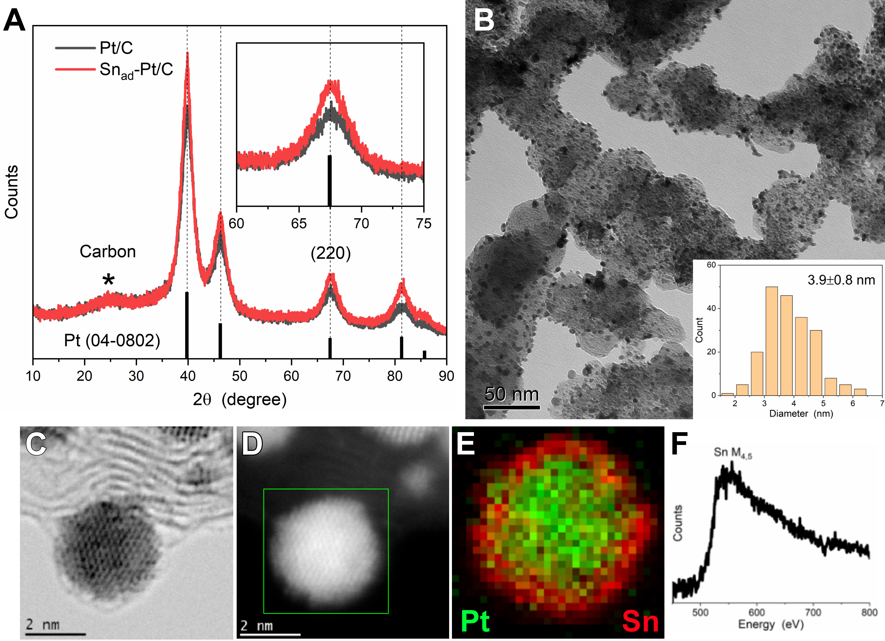
Figure 1

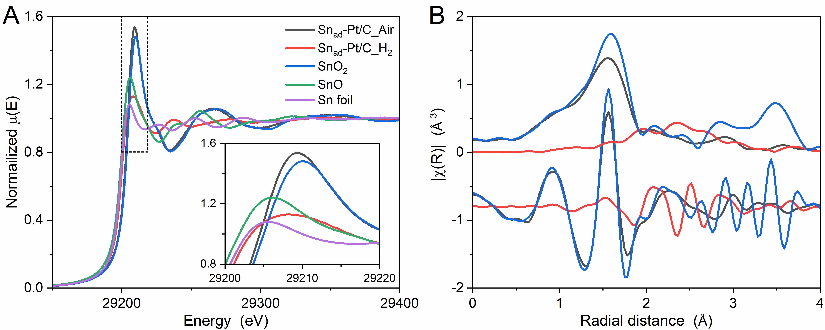
Figure 2

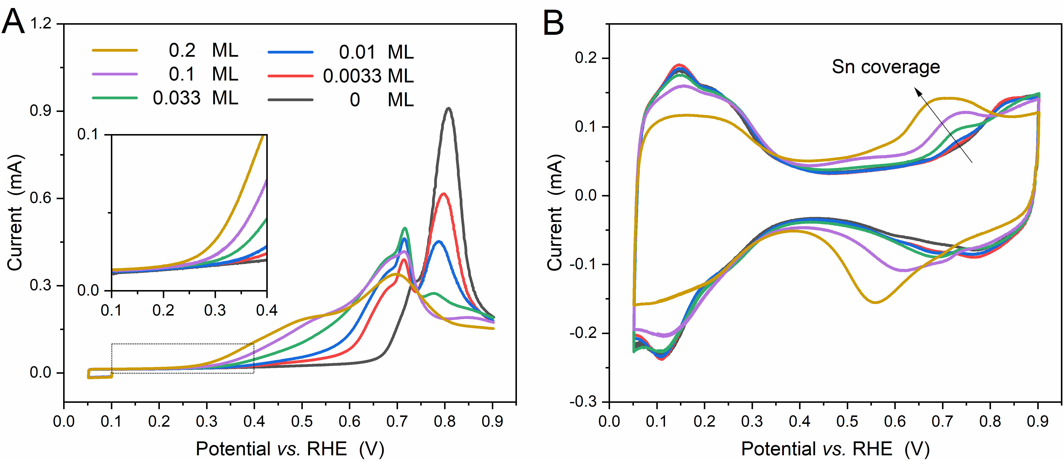
Figure 3

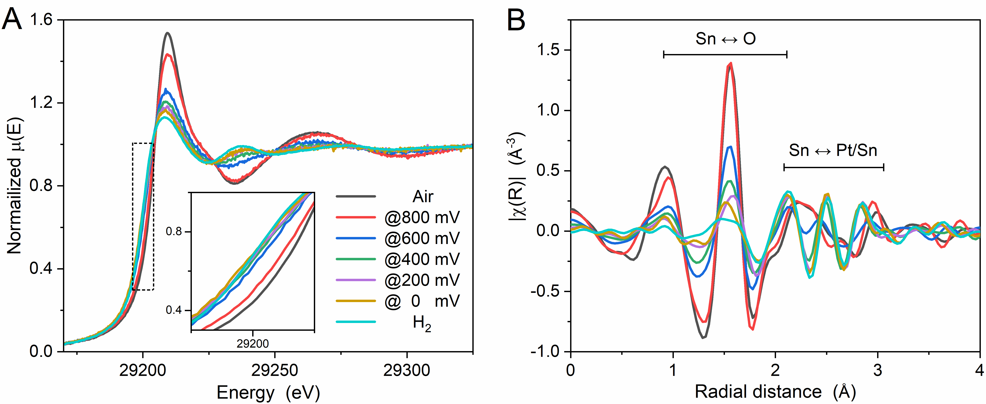
Figure 4

Figure 5
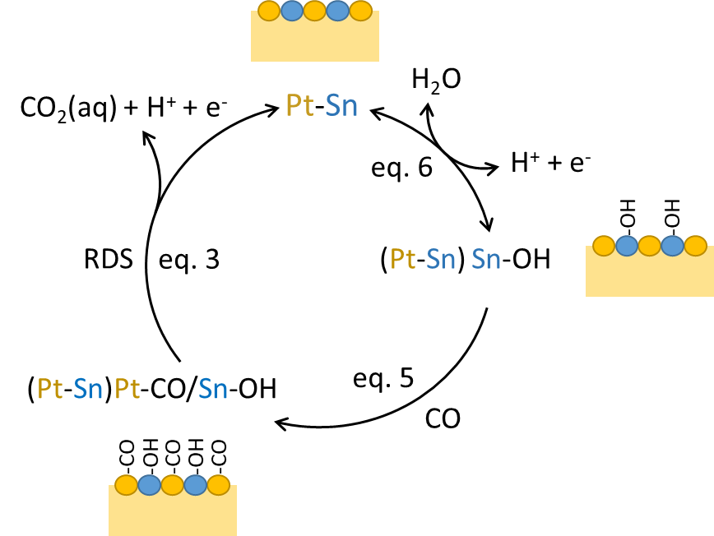
Figure 6

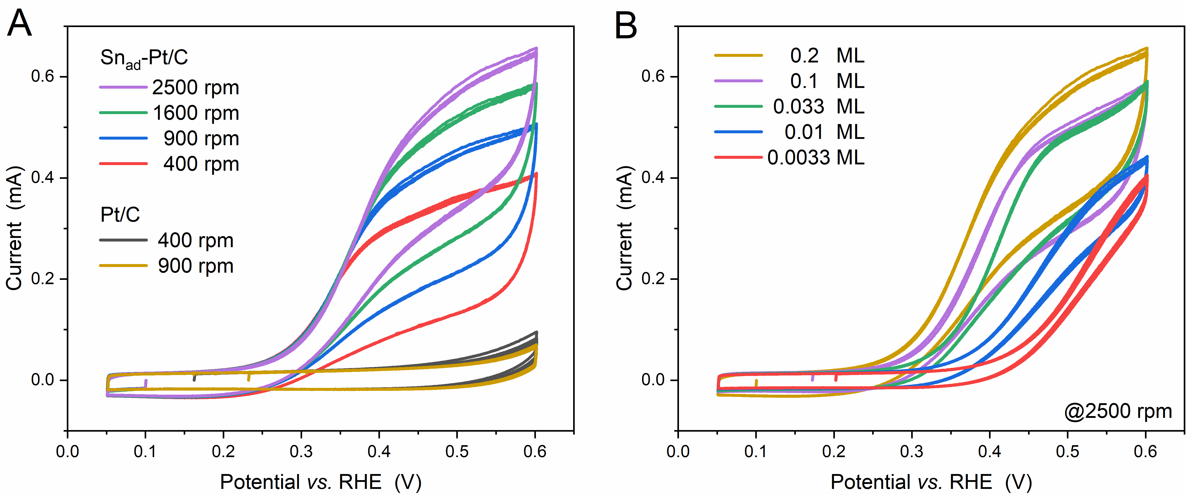
Figure 7

